“Description of Poecilobdella budhoi sp. nov. from Arunachal Pradesh, India”

Abstract
The global diversity of leeches (Hirudinea) exceeds 721 species, with 90 species recorded from India. Within the revised genus Poecilobdella (formerly Hirudinaria), 11 aquatic species are currently recognized worldwide. Based on a fully matured hermaphroditic specimen collected from the Kurung River, Kurung Kumey District, Arunachal Pradesh, India (27°47' N, 92°51' E; 1015 m a.s.l.) on 07.08.2025 by Gurumayum and Temjenmongla. So new species, Poecilobdella budhai, is described here. The holotype (Reg. No. An 8611/2) is deposited in the General Non-Chordata Section, Zoological Survey of India. Detailed comparative morphology using binocular microscopy and slide caliper measurements clearly differentiates P. budhai from all 11 valid congeners based on ocular position, total somite count, pigmentation pattern, and reproductive architecture. Specifically, P. budhai lacks dorsal stripes (shared only with P. sukhendui), possesses gonopores separated by 4 annuli (distinct from 6 in P. lakshmikantai, 7 in P. javanica, and 5 in other congeners), features a moderately sized vaginal stalk (distinguishing it from species lacking a stalk, bearing a very short stalk, or possessing a large stalk), and exhibits a short-to-medium vaginal caecum. Given its large body dimensions, P. budhai holds potential as a source of hirudin for therapeutic applications, such as paralysis management, aligning with ongoing pharmacological investigations into Indian Poecilobdellid medicinal leeches.

Keywords: Annelida, Hirudinea, Poecilobdella budhai, new species, Arunachal, India.
INTRODUCTION
Nomenclatural History and Generic Diagnosis The genus Poecilobdella Blanchard, 1893 encompasses taxa previously assigned to Sanguisuga Savigny, 1820, Hirudo Lesson, 1842, and Hirudinaria Moore, 1927. Members of Poecilobdella are medium to very large, robust leeches that are widest near the midbody and taper toward both extremities. Body pigmentation varies from brown to reddish-brown, green, or black, with dorsal metameric spots and stripes that often break and fade ontogenetically. Cephalic ocular arrangement typically consists of five pairs of large eyes arranged in a curve, extending up to nine pairs in Poecilobdella aligarhensis. The jaws are armed with over 100 acute teeth. While primarily sanguivorous, species occasionally ingest earthworms and aquatic insect larvae. Gonopores are separated by 4 to 7 annuli (e.g., 5 to 7 in Poecilobdella javanica).
Therapeutic Significance Hirudin extracted from medicinal leeches exhibits significant clinical utility, notably in managing paralytic conditions, promoting wound healing, and treating chronic dermatological disorders via targeted bloodletting.
Diversity and Global Taxonomy Global leech diversity comprises approximately 721 recognized species, with India currently harboring 83 species (Balakrishna et al., 2024). Within the genus Poecilobdella, 11 aquatic species are recognized globally:
- P. hubeiensis Yang, 1980 (China)
- P. nanjingensis Nakano & Lai, 2016 (Taiwan; junior synonym of P. granulosa Savigny, 1820)
- P. blanchardi (Moore, 1927) (Kerala, India; synonym of P. manilensis [Lesson, 1842])
- P. aligarhensis Mandal et al., 2021 (Aligarh, India)
- P. kananbalaae Mandal et al., 2025 (Karnataka, India)
- P. granulosa Savigny, 1820 (Pondicherry, India)
- P. javanica (Wahlberg, 1856) (Java)
- P. manilensis (Lesson, 1842) (Philippines)
- P. viridis Moore, 1927 (Travancore, Kerala, India)
- P. sukhendui Mandal et al., 2024
- P. tarubalaae Mandal et al., 2025
- P. manashiae Mandal et al., 2026
- P. lakshmikantai Mandal et al., 2026
Taxonomic Context of Indian Hirudinea Global foundation in leech systematics was established by Linnaeus (1767), Savigny (1820), Tennent (1859), Whitman (1886), Soós (1965), Sawyer (1986), and Nesemann & Neubert (1999). In South Asia, early investigations were conducted by Annandale (1913), Kaburaki (1921), Harding & Moore (1924, 1927), and Bhatia (1940).
In India, foundational systematic monographs by Harding & Moore (1927) were supplemented by regional and national taxonomic treatments by Soota & Ghosh (1977), Sanjeeva Raj & Gladstone (1981), Chandra (1982, 1984, 1991), and Ghosh (1998). Prior to 2003, 60 leech species were documented from India; subsequent additions include 30 species described by C. K. Mandal (Balakrishna et al., 2024; Banerjee et al., 2024, Mandal et al., 2025 and 2026).
Discovery of Poecilobdella budhai Surveys in Arunachal Pradesh, India, yielded a distinct taxon described herein as Poecilobdella budhai sp. nov. The species is readily differentiated from all 11 valid congeners by specific internal anatomical traits—including the configuration of the vaginal duct and vaginal sac—as well as external characters, such as the relative position of genital apertures, stripe patterning, total somite count, and ocular distribution.
MATERIALS AND METHODS
Sampling Methodology & Gear Specimens were sampled from the Kurung River, Kurung Kumey District, Arunachal Pradesh, utilizing a specialized dip net (leech net)(Figure 1). The sampling apparatus comprised:
- A 3-foot iron handle,
- A circular iron frame (1.5 feet in diameter), and
- A 2-foot suspended net bag constructed of fine mosquito netting.
Field collection involved wading into the water to a depth of approximately 2 feet and agitating the water column with the net to elicit a host-seeking response from the leeches toward the collector. As specimens emerged from deeper water, they were captured by sweeping the dip net beneath them.
Specimen Preparation, Fixation & Preservation
Washing: Collected specimens were initially rinsed in fresh water to remove surface debris.
Narcotization: Leeches were gradually relaxed in a 1-litre container filled with one-third fresh water by stepwise addition of 70% ethanol: an initial 10 mL aliquot, followed by a second 10 mL aliquot after 30 minutes, and a final 10 mL aliquot after 1 hour to achieve complete narcotization.
Cleaning & Fixation: Mucus and regurgitated blood released during relaxation were rinsed away with fresh water. Relaxed specimens were then fixed in 4% formalin for 24 hours to ensure tissue rigidity for anatomical dissection.
Long-Term Storage: Fixed material was permanently preserved in 70% ethanol.
Morphological Examination & Deposition: A representative specimen was dissected to evaluate internal taxonomic characters and somatic morphology. The material was deposited in the National Zoological Collections, General Non-Chordata (GNC) Section Type Repository, Zoological Survey of India (ZSI), for future taxonomic reference.
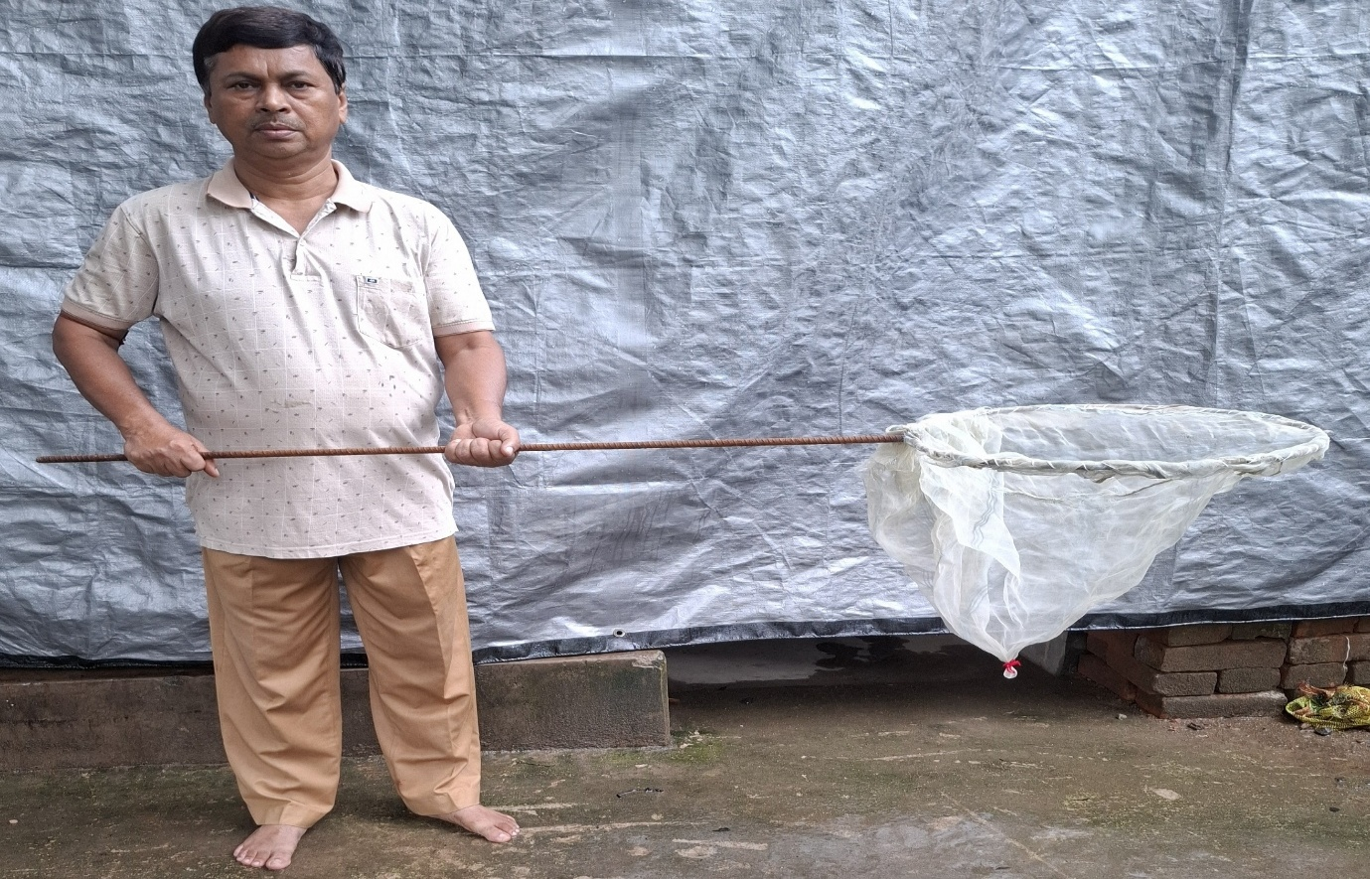

Figure 1.. Dip Net (Leech Net).

Material Examined: Arunachal Pradesh, India. (Latitude 27° 47 N, Longitude 92° 51 E and Altitude 1015 metres). Holotype- 01ex. (ZSI-GNC-An 8611/2), Kurung River, Kurung kumey, Arunachal Pradesh. Date of Collection -07.08.2025, Collector- Temjenmongla & Party.

Results and Discussion:
Phylum: Annelida Lamarck, 1809
Class: Clitellata
Subclass: Hirudinea
Order: Arhynchobdellida
Family: Hirudinidae
Genus: Poecilobdella Blanchard, 1893
Globally, the freshwater genus Poecilobdella comprises 11 recognized species: P. hubeiensis Yang, 1980, P. nanjingensis Yang, T. 1996 (synonymous with P. granulosa Savigny, 1820), P. blanchardi (Moore, 1927; a junior synonym of P. manilensis [Lesson, 1842]), P. aligarhensis Mandal et al., 2021, P. javanica Wahlberg, 1856, P. viridis Moore, 1927, P. sukhendui Mandal et al., 2025, P. kananbalaae Mandal et al., 2025, P. tarubalaae Mandal et al., 2025, P. manashiae Mandal et al., 2026, and P. lakshmikantai Mandal et al., 2026.
Taxonomic Evaluation and Species Designation Leech specimens collected for research purposes from Kurung Kumey, Arunachal Pradesh, by S. D. Gurumayum and Temjenmongla were submitted to the Zoological Survey of India (ZSI) for identification and deposition. Upon examination by the first author, a single example was identified as a distinct taxon and is proposed herein as a new species to science, Poecilobdella budhai sp. nov. The holotype (01 ex., Reg. No. ZSI-GNC-An 8611/2) was collected from the freshwater habitat of the Kurung River, Kurung Kumey District, Arunachal Pradesh. Because the collected specimen is fully grown and hermaphroditic, all morphological and diagnostic characters are distinctly expressed and clearly differentiate it from all other known species of the genus, justifying its designation as a new species.

Diagnostic Characters (Plate 1 & 2): Poecilobdella budhai sp. nov.
The holotype specimen of Poecilobdella budhai sp. nov. from Arunachal Pradesh exhibits a total body length of 13 cm. In life, the body is brownish-blue, fading post-preservation, with nearly uniform dorsal and ventral coloration completely devoid of longitudinal stripes. The tegument is smooth, lacking the characteristic roughness of Poecilobdella granulosa. Morphometrically, the head measures 3 cm in diameter, exceeding the midbody diameter of 2.3 cm. The anterior sucker is 9 mm in breadth, whereas the posterior sucker measures 2.3 cm in breadth and possesses 64 sucker rays divided into two distinct zones, of which 13 constitute the central rays. The body comprises 112 total segments/annuli organized into five distinct regions: the anterior portion is subdivided into two parts, with the cephalic region containing 43 segments, while the remaining body is divided into three posterior parts.
Cephalic structures include indistinctly visible eyes and a buccal cavity housing three jaws equipped with well-developed acute teeth and numerous salivary papillae. The alimentary tract features six pairs of crop caeca, with the second pair of crop caeca being nearly equal in size. The reproductive system is characterized by a large to medium-sized prostate gland, a short to very small vaginal stalk, and a small to moderate vaginal caecum. The male genital pore (2 mm in diameter) is situated anteriorly on annulus 31, while the female genital pore (3 mm in diameter) opens intersegmentally between segments 35 and 36, resulting in a gonopore separation of 4 annuli.

Table 1. Showing comparison Poecilobdella Poecilobdella budhoi sp. nov. with the other 11 species of the genus Poecilobdella in the world.
Characters | Poecilobdella manillensis | Poecilobdella granulosa | Poecilobdella viridis | Poecilobdella javanica | Poecilobdella aligarhensis | Poecilobdella kananbalaae | Poecilobdella hubeiensis | Poecilobdella tarubalaae | Poecilobdella sukhendui | Poecilobdella manashiae | Poecilobdella lakshmikantai | Poecilobdella budhai sp.nov
Stripe | Stripes-Three pairs yellow stripes. One black median broken stripe. | Two pairs yellow stripes. One black line. One pair sub marginal stripes. | Presence of marginal orange stripes and metameric spots. | Dorsal dark stripes and metameric spots. | Dorsal stripes 7. medial is paler than other six dorso-lateral stripes. | Three pairs black dorsal stripe. Most lateral one pair breaking black stripe. | Two  Black  Squired  stripe | One medial black stripe. 2 black spotted line. | Absence of  any stripe  on both  dorsal and  ventral | 5 stripes on dorsal side | 5 black broken stripes | No stripe.
Colour | Colour-Dorsal is Brown in ventral is green | Dorsally olive green ventrally reddish | Dorsally olive green and ventrally greyish green | Dorsally olive green and yellow marginally | Brown coloured | Brown dorsally yellowish ventrally | Dark  brown  dorsally  dark green  ventrally | Dark brown dorsally dark green ventrally | Dorsally brown,  ventral l greyish | Dorsally brownish ventrally whitish | Reddish brown | Brownish blue.
Body length | Length-12.2cm | 9.4cm. | 11.1cm. | 10.6cm. | 42mm. | 9.9cm | _ | 4cm. | 14.5 cm. | 89 mm. | 35 mm. | 13cm
Breadth | Breadth-2.7cm. | 2.2cm. | 2.3cm. | 2.1cm. | 8mm. | 1.4cm. | _ | 5mm. | 3.5 cm. | 10mm | 8mm. | 3cm
Breadth of anterior sucker | 1.8mm. | 1.9mm. | 1.7mm. | 1.3mm. | 2mm in diameter, | 6 cm | - | 3.5mm. | Caudal sucker ten times larger than anterior. | 5mm. | 1mm. | 9mm.
Breadth of posterior sucker | Caudal sucker- large | Almost equal | Caudal sucker smaller than anterior sucker | Caudal suckers larger almost equal of the body | Posterior sucker third time larger than the anterior sucker. | 1.1cm | Large | 3mm. | 2.3cm. Sucker  rays 110. | 8mm. | 3mm. diameter, | 2..3cm
Clitellum | Clitellum-Prominent | Prominent | Not prominent | Prominent | Moderate | 33-39  7 annuli | Somite  XI-XII | 32-38  7 annuli | 37-45 annuli,  9 annuli | 33-39 annuli | 31-38 annuli  8 annuli | 30-36  7 annuli
Gonophores separated by | Gonopores- 5 annuli | 5 annuli | 5 annuli | 7 annuli | 5 annuli. | 33-39  7 annuli  5 annuli | 5 annuli | Gonopores separated by 5 annuli | Male pore between  29- 30 annuli  female pore 34-35. | Male and female pores separated by 5 annuli. | 6 annuli | Male pore on 31 annuli, Female pore 35-36 annuli  Gonopores separated by 4 annuli
Vaginal Stalk and crop caecum | Vaginal Stalk-Absent | Equal in length | Double in length | Absent | Larger | Very short | Short | absent | Shorter than  vaginal caecum. | Very short | Short | Moderate in size
Breading season | Breading Season-June -July | July-August | June-July | June-August | April-July | July- September | - | August-September | May-July | June-August | July-September | Julu-September
Eyes | 5 pairs | 5 pairs | 5 pairs | Five pairs eyes on 2,3,4,6 and 9th annuli. | Nine pairs of eyes on rings 3, 4, 6, 8 and 11th rings. | Five pairs | Five  pairs 2,  3, 4, 5,  6 | Five pairs on 2,4, 5, 7 and 10th annuli | Five pairs  eyes on  2,3,5,6  and 8th annuli. | Five pairs  on 4,5, 6, 8 and 11th annul | Five pairs  on 3,4, 5, 7 and 10th annuli | Eyes are not distinctly visible
Ring | 112 | 101 | 107 | 105 | 108(including 5 rings of posterior sucker). | 110 | Within  85- 97 | 113 | 113 | 109 | 110 rings | 112
Reference | References-(Lesson, 1842) | ( Sevigny, 1820) | Moore, 1927 | (Wahlberg, 1856) | Mandal et.al., 2021 | Mandal et.al., 2025 | Yang, 1980 | Mandal et.al., 2025 | Mandal et.al., 2025 | Mandal et.al., 2026 | Mandal et.al., 2026 | Recent authors

Distribution: Arunachal Pradesh, India.
Etymology: The specific name is proposed in the name of Budha Mandal, Nick name (Birth-18.11. 2002, Passes away 05.09.2022 Son of Dr. Chandra Kanta Mandal, Scientist C, ZSI, The specific name is proposed in memory of Budha Mandal (Birth-18.11.2002, Journey to Heaven- 05.09.2022) Son of Dr Chandra Kanta Mandal Scientist B ZSI, Young excellent Zoological specimen collector, Social worker, who made a personal Museum at his own House Madhyamgram collecting zoological specimens from different states of India and made a Record of “Single Thriller Motorcycle Journey” from Madhyamgram Kolkata to Sarchu Ladakh India only by 36.30 hours. He expired without help of anyone within three hours after fell down from Motor Cycle and lack of Super speciality Hospital in Ladakh.
Habitat: Riverine.
Differential Diagnosis Within the genus Poecilobdella, dorsal pigmentation stripes are present across all known species with the exception of Poecilobdella sukhendui and Poecilobdella budhai (Table 1). Gonopore separation serves as a robust diagnostic character: the male and female pores are separated by 4 annuli in P. budhai, 6 annuli in P. lakshmikantai, 7 annuli in P. javanica, and 5 annuli in the remaining congeners. Variation in the female reproductive architecture further differentiates the genus; the vaginal stalk is absent in P. manilensis, P. tarubalaae, and P. javanica, very short in P. kananbalaae, moderately sized in P. budhai, and large in the remaining species. Additionally, the vaginal caecum reaches its greatest dimensions in P. manashiae, whereas it remains short to medium in all other congeners. Somite counts are identical between P. manilensis and P. sukhendui, while differing among the other species of the genus.
Remarks Poecilobdella budhai is currently known only from Arunachal Pradesh, India. As leeches are hermaphroditic organisms exhibiting complete reproductive morphology upon maturity, a single well-preserved holotype is sufficient for the establishment of the new species. Future investigations will aim to incorporate molecular DNA analysis to further substantiate its phylogenetic position.

COMPETING INTERESTS DISCLAIMER:
Authors have declared that they have no known competing financial interests OR non-financial interests OR personal relationships that could have appeared to influence the work reported in this paper.
Conclusion
Gonopores of Poecilobdella budhoi separated by 4 annuli. Male genital pore is on the anterior than the female genital pore. Male pore situated between 30-32 annuli, Female pore is on between 35-36 segment. Sucker rays 64. The leeches were originally of brownish blue, fades up after preservation. Total segments 112. Total length of the body 13 cm. Sucker rays divided into two parts. Both the dorsal and ventral body almost same in colour. The body is not rough like Poecilobdella granulosa. Body is divided in 5 parts. Anterior part divided into two parts. It looks like snake hood. Head region contains 43 segments. Remaining parts are divided in three parts. Anterior sucker 9mm. in breadth. Posterior sucker 2.3cm. in breadth. Middle body 2.3 cm in diameter. Head breadth is 3cm in diameter.
Declaration of AI Use
This manuscript was prepared through the intellectual contributions of the author(s) to the study design, data analysis, interpretation of results, and scholarly content. Grammarly and ChatGPT were used solely to assist with grammatical refinement and reference formatting during manuscript revision. The author(s) accept full responsibility for the accuracy, integrity, and final content of the manuscript.

References:

Annandale, N. 1913. The leeches of the lake of Tiberias. Journal and Proceedings of the Asiatic Society of Bengal, (n.s.) 9(6): 211–214.

Balakrishnan, S., Tamal Mondal, Chandra Kanta Mandal, Shakoor Ahmed, Yogesh Kumar,
J.S., Sivaleela, G. and Raghunathan, C. (2025). Fauna of India Checklist, Annelida: Polychaete:
Sipuncula: Clitella:Hirudinida: Crassiclitellata: Moniligastrida. Online Version 1.0.
Zoological Survey of India. DOI: https://doi.org/10.26515/Fauna/1/2024/Annelida:
Polychaeta, Sipuncula, Clitella, Hirudinida, Crassiclitellata,Moniligastrida.

Banerjee D., Raghunathan C., Rizvi A. N., Sengupta J. 2024. Animal Discoveries, New species/New Records. Zoological Survey of India. Page 1-386 (251-252).
Blanchard, 1893. Poecilobdella. Bollettino dei Musei di Zoologia ed Anatomia Comparata della R. Università di Torino. 7 (145): 1- 32.
Bhatia, M. L. 1940. On Haemopis indlcus sp. nov. A new Arhynchobdellid carnivorous leech from Kashmir. Proceedings of the National Academy of Sciences, India 10(4): 133–144.
Chandra, M. 1984. The leech fauna of Jammu region of Jammu and Kashmir State, India. Records of the Zoological Survey of India, 81(1-2): 289–298.
Chandra, M. (1982). A Check-List of Leeches of India. Records of the Zoological Survey of India, 80(3-4), 265–290.
Chandra, M. (1991). The Leeches of India. A Hand Book. Zoological Survey of India, 1-117.

Ghosh, G.C. 1998. Leech fauna of West Bengal. State Fauna Series 3. Zoological Survey of India, Part 10: 227249.
Lesson, 1842. Hirudo manillensis, Revue Zoologigue Societe Cruierieme, 8.
Mandal, C.K. 2004. Paraclepsis gardensis (Hirudinea: Glossiphonidae) a new species of Leech from West Bengal, India. Records of the Zoological Survey of India: 103 (Part1-2): 111-114.
Mandal, C. K, Mridha, S., Yasir, M., Kalam, A., JameeL, M., Anwar, M., Ghosh, S. 2021. Poecilobdella aligarhensis A new leech (Clitellata: Hirudinida) from Aligarh, India. Journal of Applied Zoological Researches. 32 (2).145-149.
Manda C. K., Mridha, S., SHarma, P., BOSE, M., Hassan, N., SACHI, A., and GHOSH, S. 2025. Poecilobdella kananbalaae A New Species of Leech from Karnataka, India. Uttar Pradesh Journal of Zoology. Volume 46, Issue 23, Page 201-210, 2025; Article no. UPJOZ. 5588.ISSN: 0256-971X (P).
Mandal, C. K., P. Sharma, M. Bose, S. Mridha, N. Hasan, R. Sikdar, A. Sachi, and S. Ghosh. 2026. “Morphological Description and Taxonomic Notes on Poecilobdella Tarubalaae Sp. Nov. from Karnataka, India”. UTTAR PRADESH JOURNAL OF ZOOLOGY 47 (3):63-72. https://doi.org/10.56557/upjoz/2026/v47i35486.
Mandal, C. K., Bose, M., Sharma, P., Mridha, S., Sikdar, R., Hasan, M. N., & Ghosh, S. (2026). Poecilobdella manashiae, A New Species of Leech from Tripura, India. UTTAR
PRADESH JOURNAL OF ZOOLOGY, 47(13), 87–96.
https://doi.org/10.56557/upjoz/2026/v47i135730.

Mandal, C. K., Bose, M., Sharma, P., Mridha, S., Sikdar, R., Hasan, M. N., & Ghosh, S. (2026). Poecilobdella lakshmikantai, A New Leech from Arunachal Pradesh, India. UTTAR PRADESH JOURNAL OF ZOOLOGY, 47(14), 73–82. https://doi.org/10.56557/upjoz/2026/v47i145753
Moore, 1927. Hirudiaria (Poecilobdella) granulosa. The Fauna of British India, Hirudinea, 226-238.
Moore, 1927. Hirudinaria (Poecilobdella) viridis. The Fauna of British India, Hirudinea, 239-243.
Harding, W.A. & Moore, J.P. 1927. Fauna of British India, Hirudinea. London: Taylor & Francis, pp. 185–189.
Lesson, 1842. Hirudo manillensis. Revue Zoologigue Societe Cruieriem, 8. (Type –Locality: Luzon, Phillippines Island; Type- Deposited: Not Known).
Moore, J.P. 1924. Notes on some Asiatic leeches (Hirudinea) principally from China, Kashmir and British India. Proceedings of the Academy of Natural Sciences of Philadelphia.
76: 343–388.
Nesemann, H. & Neubert, E. (1999). Annelida, Clitellata: Branchiobdellidae, Acanthobdellea, Hirudinea. Süsswasser fauna von Mitteleuropa 6/2 (eds J. Schwoerbel & P. Zwick). Spektrum, Heidelberg. 178 pp
Kaburaki, T. 1921. Glossiphonia reticulata Kaburaki, 1921. On some leeches from the Chilka lake. Memoirs of the Indian Museum. 5: 661–675.
Linnaeus, C. 1767. Systema naturae sive regna tria naturae, secundum classes, ordines, genera,
species, cum characteribus, differentiis, synonymis, locis. Laurentii Salvii, Holmiae. 12th
ed. 1(2): 533–1327.
Nakano, T., & Lai, Y. (2016). First Record of Poecilobdella nanjingensis (Hirudinida: Arhynchobdellida: Hirudinidae) from Taiwan and its Molecular Phylogenetic Position within the Family. Species Diversity, 21(2), 127–134. https://doi.org/10.12782/sd.21.2.127
Sanjebva Raj, P. J. and Gladstone, M. 1981. On a new species of the land-leech of the genus
Haemadipsa Tennent, 1859 from the peninsular India. is the Records of the Zoological Survey of India 79: 1–18.
Savigny, J.C. (1820). Système des Annélides, princialment de celles des cotes de l’Ègypte et de la Syrie, offrant les caractères tant distinctift que naturels des orders, familles et genres, avec la description des espèces. Paris: Description de l’Ègypte 1(3): 1–128.
Savigny, 1820. Sanguisuga granulosa Systeme des Annelides, Paris. (Type Locality: Pondichery: Type –Deposited: Not Known).
Sawyer, R.T. (1986) Leech Biology and Behaviour. Oxford: Clarendon Press. 685 p.
Soós, A. 1965. Identification key to the leech (Hirudinoidea) genera of the World, with a Catalogue of the species. 111-1V. Acta Zoologica Academiae Scientiarum Hungaricae. 11(3-4): 415-464.
Soos, 1970. Poecilobdella manillensis. Opuscula Zoologica Instituti Zoosystematici et Oecologici Universitatis., 10(2): 313-324.
Soota, T. D. And Ghosh, G.C. 1977. On some Indian Leeches. Newsletter - Zoological Survey of India: 3(6): 359- 360.
Tennent, Sir, J.E. 1859. Ceylon; an account of the island physical, historical and topographical, with notices of its natural history, antiquities, and productions. London: Longman, Green, Longman and Roberts, 2 volumes.
Wahlberg, 1856. Sanguisuga javanica, Öfversigt af Kongl Vetenskaps-akademiens förhandlingar, 233-234.
whitman, C.O. 1886. The leeches of Japan. Quarterly Journal of Microscopical Science. 26: 317–416.
Yang, T. 1980. Records of two new species of Hirudidae from China. Acta Zootaxonomica Sinica, 5(3): 267–268.
Yang, T. 1996. Fauna Sinica. Annelida Hirudinea. Science Press, Beijing, 261 pp.

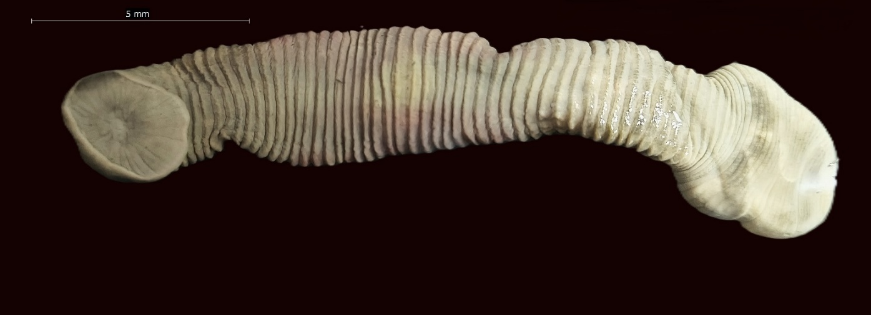
AS
PS
PS
(a)
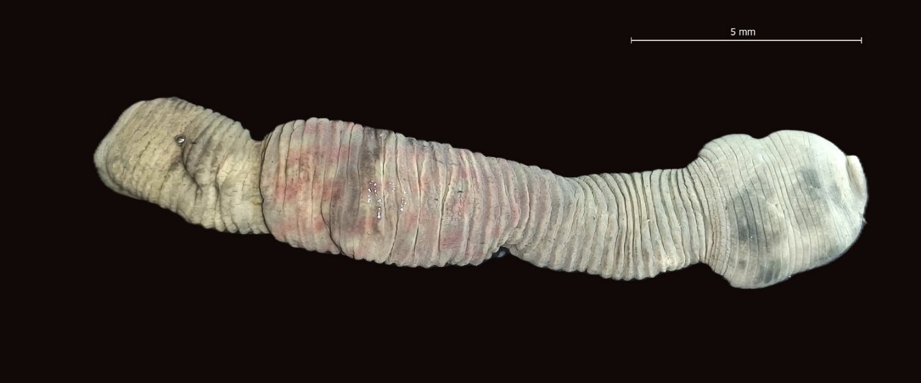
AS
PS
(b)

Figure 2. (a) Plate-1A Dorsal view of Poecilobdella budhoi (Anterior sucker and Posterior sucker); (b) Plate-1 B Ventral view of Poecilobdella budhoi (Anterior sucker and Posterior sucker)

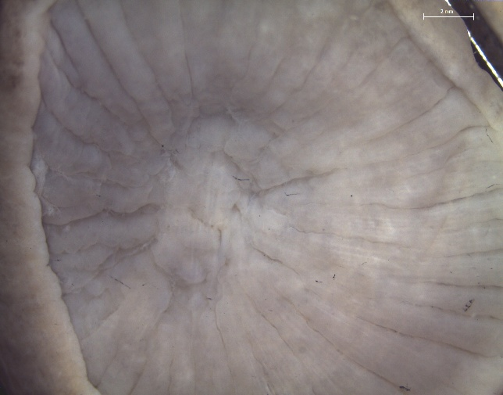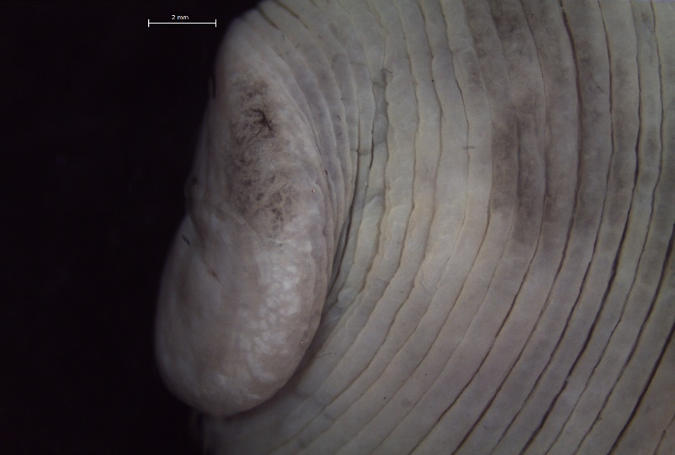
- Poecilobdella budhoi (Posterior sucker rays)

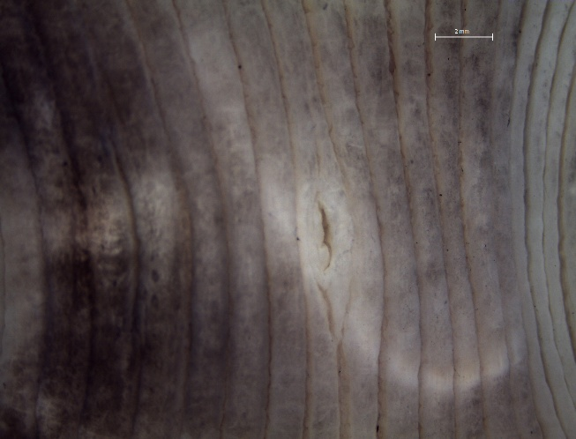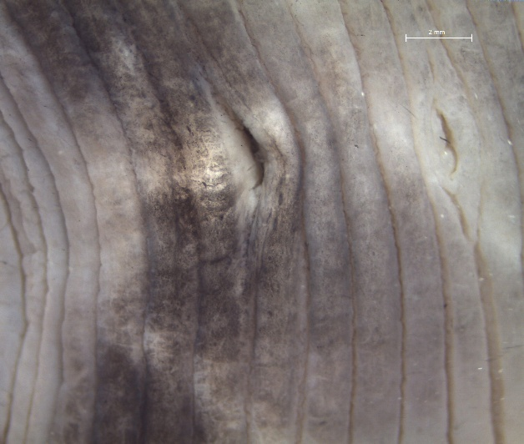
MP
FP
- Poecilobdella budhoi (Male pore &Female pore)

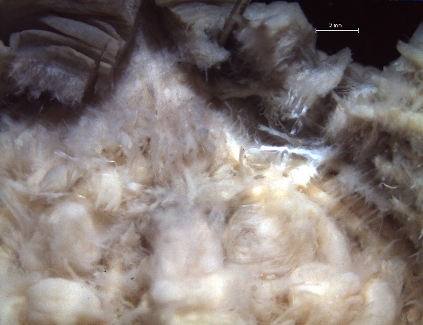
B
A
- Poecilobdella budhoi (Dissected Anterior part)

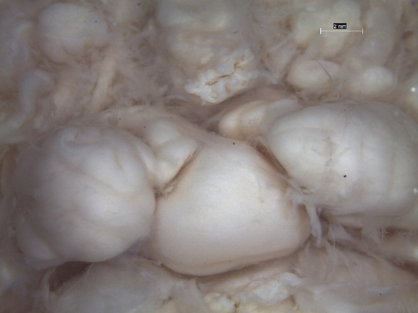
(d) Poecilobdella budhoi (A. Epididymis, B.Prostate)
Figure 3. Plate-2: (a) Poecilobdella budhoi posterior sucker; (b)male and female pore; (c) anterior part; (d) Pepididymis and prostate

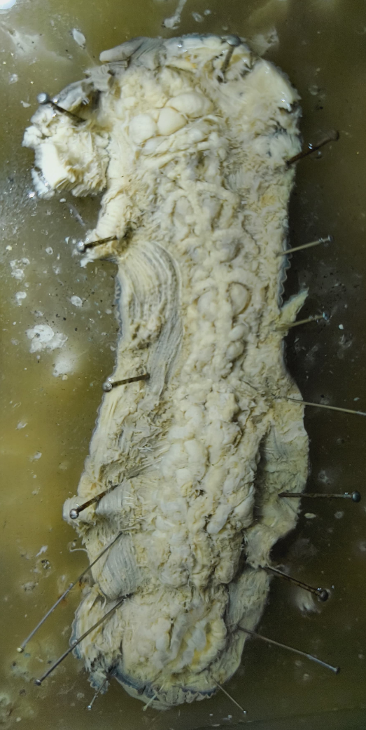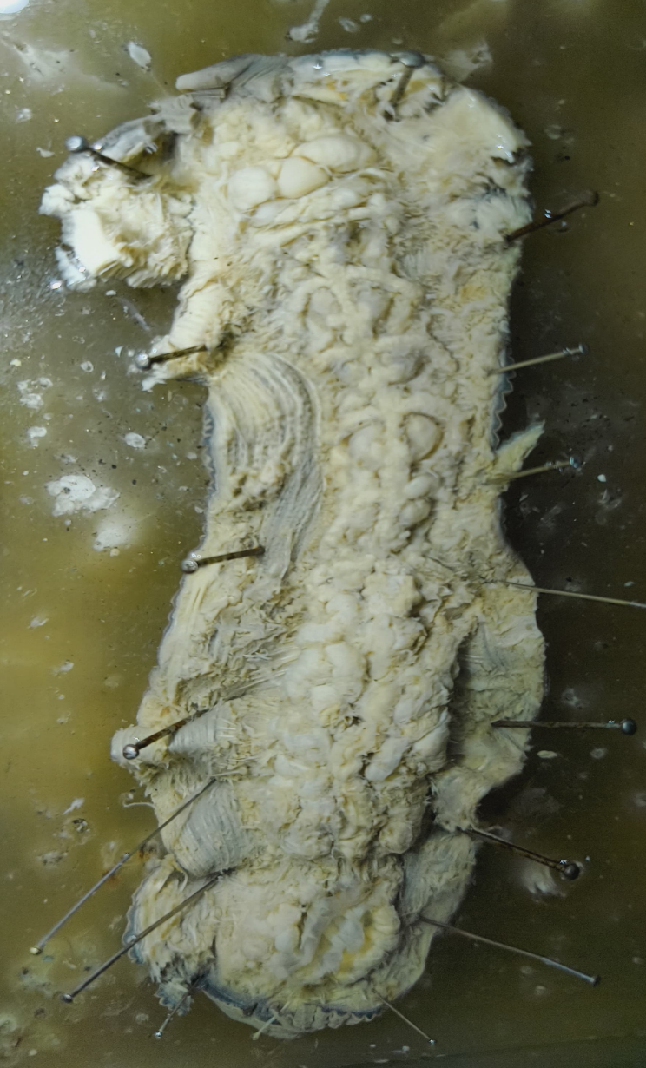
H
G
F
E
D
C
B
A
Figure 4. Plate-3. Poecilobdella budhoi [Six pair Stomach caecae (C-H), Testicles bet, Epididymis (A) and Prostate (B), Vaginal caecum].

