Gene expression analysis of major antioxidant genes in PBMC during various stages of lactation in Pandharpuri buffalo

_______________________________________________________________________
Abstract
Lactation in the indigenous Pandharpuri buffalo (Bubalus bubalis) is a physiologically demanding period characterized by drastic metabolic shifts that generate excess reactive oxygen species (ROS), leading to oxidative stress. This study aimed to evaluate the relative gene expression of major antioxidant genes within Peripheral Blood Mononuclear Cells (PBMCs) across non-lactating (dry), early, mid, and late lactation stages. PBMCs serve as an effective, minimally invasive sensor for observing systemic physiological status and cellular stress responses. Blood samples were collected from four groups of eight female buffaloes to measure the transcript abundance of Catalase (CAT), Superoxide Dismutases (SOD1, SOD2, SOD3), and Glutathione Peroxidases (GPX1, GPX2, GPX3). Using non-lactating buffaloes as a baseline, the data revealed a highly coordinated, stage-specific antioxidant response. The early lactation phase emerged as the most oxidatively challenging window, characterized by a massive upregulation of frontline defense genes. Specifically, GPX1 exhibited the most robust induction, spiking to a 7.69-fold increase. Similarly, mitochondrial SOD2 and CAT peaked during early lactation at 3.77-fold and 2.85-fold, respectively. As lactation progressed, expression patterns shifted; cytoplasmic SOD1 accumulated linearly to peak at 4.59-fold during late lactation, while extracellular SOD3 peaked at 3.22-fold in mid-lactation. In contrast, GPX3 showed an initial early peak of 1.84-fold but was subsequently downregulated in later stages. These findings indicate that while acute mitochondrial stress is managed early postpartum, systemic oxidative stress persists heavily into late lactation. Characterizing this transcriptomic profile provides critical insights into the metabolic resilience of the Pandharpuri breed and highlights the potential for stage-specific nutritional interventions to mitigate oxidative stress and preserve animal health.
___________________________________________________________________________
Introduction-
The Pandharpuri buffalo represents an invaluable indigenous genetic resource belonging to the riverine category of Bubalus bubalis. Predominantly reared in the semi-arid regions of southern Maharashtra, this breed exhibits a distinct phenotype, notable for its long, sword-shaped horns and a remarkable capacity to tolerate long, irregular milking intervals without a sudden cessation of milk yield.
Lactation is a physiologically demanding period in dairy livestock, characterized by drastic metabolic shifts and cellular adaptations to sustain milk synthesis. Lactation is split into three core physiological stages, each posing distinct homeorhetic adjustments: Early Lactation stage Span immediately from parturition up to day 60–90 postpartum, this stage demands sudden mobilization of energy and fat reserves to support peak milk yield, frequently causing a state of negative energy balance (NEB). High Energy Demand, Peak ROS & Oxidative Stress. Mid Lactation stage extends from day 90 to 200 postpartum, this period represents a homeostatic plateau where nutrient intake balances milk production requirements. Late Lactation stage in buffalo span from day 200 to the end of the lactation cycle (approximately 305–350 days in Pandharpuri buffaloes), this phase transitions the animal toward mammary gland involution and preparation for the subsequent gestation/lactation cycle. Mammary Involution & Immune Activity Shifting., these metabolic challenges are highly pronounced. The transition from the non-lactating state through early, mid, and late lactation is accompanied by a massive increase in oxygen consumption by the mammary gland, generating an excess of reactive oxygen species (ROS). When the production of ROS exceeds the systemic neutralizing capacity, oxidative stress ensues, causing cellular injury, lipid peroxidation, and diminished immune capability.
Lactation research in livestock faces difficulty due to limitation in extracting tissue directly via mammary gland biopsies vargas, et al. (2013). While evaluating transcripts shed into milk fat globules (MFGs) offers a non-invasive look at mammary-specific expression, it fails to capture the broader systemic stress profile and cellular immunity of the animal Faheem et al (2024). The study by Beghelli et al.(2022) demonstrated that dietary antioxidant supplementation in lactating Mediterranean buffaloes significantly increases total milk yield without increasing milk antioxidant enzyme levels. Han et al., (2026) carried out multi-tissue transcriptomic study of river buffalo (Bubalus bubalis) to revealed insights into lactation performance and tissue-specific gene networks. Patel, O. V., et al. (2020) demonstrated physiological shifts such as calving, peak milk yield, and seasonal variations simultaneously alter the relative expression of heat shock proteins and antioxidant genes (SOD, CAT) in indigenous Indian river buffaloes in blood.
Peripheral Blood Mononuclear Cells (PBMCs) serve as a reliable, minimally invasive biological window to observe systemic physiological status, immune fitness, and cellular stress responses. Peripheral Blood Mononuclear Cells (PBMCs) comprising lymphocytes (T-cells, B-cells, and NK cells) and monocytes circulate continuously through all peripheral organ systems. PBMCs function as early-warning biological sensors. Changes in the transcript abundance of antioxidant enzymes within PBMCs directly reflect the animal's systemic homeostatic adjustments, offering a clear view of how subclinical oxidative stress influences Consequently, their transcriptomic configuration is highly responsive to blood chemistry alterations, endocrine fluxes, circulating non-esterified fatty acids (NEFAs), and pro-inflammatory cytokines. Saro et al. (2021) investigated the antioxidant and inflammatory gene expression profiles specifically within PBMCs of dairy cows, demonstrating the reliability of these cells in reflecting systemic physiological and nutritional interventions. In transcriptomic profiling, The defensive network against oxidative injury is governed by major antioxidant enzymes, including Superoxide Dismutase (SOD), Catalase (CAT), and Glutathione Peroxidase (GPx).
Superoxide dismutase catalyzes the dismutation of highly reactive superoxide anions and molecular oxygen . The family consists of three distinct isoforms characterized by their sub-cellular localization and metal cofactors. SOD1 (Cu/Zn-SOD): Located primarily in the cytoplasm, it acts as the primary defense against radicals generated in the cytosol. SOD2 (Mn-SOD): Localized within the mitochondrial matrix, its transcription is tightly linked to mitochondrial electron transport chain efficiency, making it highly sensitive to changes in metabolic activity. SOD3 (Extracellular SOD): An extracellular enzyme that scavenges radicals in the extracellular matrix and vascular environment. Catalase is a tetrameric, heme-containing enzyme located primarily within peroxisomes. It directly reduces hydrogen peroxide .CAT has an exceptionally high turnover rate but a relatively low affinity for , meaning it is primarily mobilized during surges of heavy peroxide generation. Glutathione peroxidases reduce both free hydrogen peroxide and organic hydroperoxides into water or corresponding alcohols using reduced glutathione (GSH) as an electron donor: The GPX1 isoform is the most abundant intracellular selenoprotein, acting as a crucial sensor for steady-state peroxide clearance in erythrocytes and PBMCs. Schogor et al. (2013) investigated mammary gene expression and antioxidant activity, noting that cellular glutathione peroxidases (like GPX1) serve as a primary frontline defense in mammary tissues. They found that these enzymes rapidly clear peroxides to preserve cellular membrane integrity during peak metabolic throughput. Kapila et al. (2019) & Sharma et al. (2023): conducted comparative transcriptome analyses of murrha buffaloes. Kapila et al. compared early, mid, and late lactation stages via the milk transcriptome, while Sharma et al.(2023) utilized whole-blood transcriptome analysis to pinpoint key genes regulating milk production traits. Present work was conducted to study the levels of antioxidant gene expression in various stages of lactation in pandharpuri buffalos to assess the antioxidant status of animal during various stages of lactation.
Material Method-
Total 32 blood samples were collected from pandharpuri buffalo.Four groups consisting of 8 female pandharpuri buffalos in each were grouped according to their lactation stage as early (60–90 postpartum), Mid (90 -200 days postpartum) and late lactation stage (200 -305 days postpartum) and 4th group consisting of non-lactating female pandharpuri buffalo. Peripheral Blood Mononuclear Cells (PBMCs) are isolated from whole blood using density gradient centrifugation, standardly utilizing medium Histopaque-1077 (density 1.077 g/mL).while cell at the interface were collected in separate tubes and used for gene expression study.T otal RNA from PBMC were isolated by trizol method. Total RNA was quantified by nanodrop spectrophotometer (Thermo).cDNA was synthesized by using Takara Primescript first strand cDNA synthesis kit. Sequence for target antioxidant gene and endogenous control GAPDH were extracted from NCBI Nucleotide database. De Novo primers were designed using Genescript primer design software and procured using custom oligosynthesis service. Sequence of the designed primers is provided in table 1
Sr. No | Gene | Accession No | Primer sequence | Product Size
1 | Catalase | JF901935.1 | F TCGTGGCTTTGCAGTGAAAT | 172
1 | Catalase | JF901935.1 | R CCAGAAGTCCCAGACCATGT | 172
2 | SOD1 | NM_001290973.1 | F GAGAGGCATGTTGGAGACCT | 153
2 | SOD1 | NM_001290973.1 | R TCTGCCCAAGTCATCTGGTT | 153
3 | SOD2 | XM_025294324.2 | F GCCATCCAAAGTGGCTTTCA | 117
3 | SOD2 | XM_025294324.2 | R ACAAGTGGTCACACAACTGC | 117
4 | SOD3 | XM_006041480.4 | F TTCTTCCACCTTGAGGGCTT | 191
4 | SOD3 | XM_006041480.4 | R TACTTCCAGACCTGGCCATC | 191
5 | GPx1 | MF817512.1 | F CAACGACGTCTCCTGGAACT | 122
5 | GPx1 | MF817512.1 | R GGGACAGCAGGGTTTCAATG | 122
6 | GPx2 | JF901938.1 | F TCCTTCTACGACCTCAGTGC | 136
6 | GPx2 | JF901938.1 | R CGTTGAGTTGGGTGAAGTCC | 136
7 | GPx3 | XM_025292396.2 | F AACAGCTGTGTGCTGTGAAG | 194
7 | GPx3 | XM_025292396.2 | R CACTTCTGGGTGGTGTTTGG | 194
8 | GADPH | BC102589 | F TGGAAAGGCCATCACCATCT | 66
8 | GADPH | BC102589 | R CCCACTTGATGTTGGCAG | 66
Table 1: Sequence of the designed primers
Real time PCR Study- Each sample was run in duplicate for the target & reference control gene.The 20 µL reaction was carried out in duplicates using 50 ng of the template and 0.5 mM primer concentrations.
Table 2: Composition and volume of components used for the real-time PCR reaction.
Component | Volume per reaction
cDNA template | 1µl
Forward Primer | 1µl
Reverse Primer | 1µl
Real time PCR Master Mix(2X) | 10µl
Nuclease free water | 7µl
Total | 20 µl
No template control (NTC) was put for gene quantification for checking the contamination in the reaction component other than the cDNA. To ensure the cDNA samples were not contaminated with genomic DNA. Reactions were set up using 10 ng of non-reverse transcribed RNA in place of cDNA. Failure to generate a detectable signal signified the samples as DNA-free. In the negative control, only the real-time master mix and primers were added. The melt curve analysis was performed to check the non-specific amplification. The real-time qPCR reaction conditions were:
Table 3: Thermal cycling conditions used for real-time PCR amplification and dissociation curve analysis.
Segment | Remark | Thermal Profile | Time | No of cycles
1 | Hot start PCR | 95⁰C | 15 min | 1
2 | Denaturation | 95⁰C | 10 sec | 35
2 | Annealing | 58⁰C | 30 Sec | 35
2 | Extension | 72⁰C | 30 sec | 35
3 | Dissociation curve analysis | 95⁰C | 1 min | 1
3 | Dissociation curve analysis | 65⁰C | 30 sec | 1
3 | Dissociation curve analysis | 65⁰C -95⁰C | 2 degree per min | 1
3 | Dissociation curve analysis | 95⁰C | 30 sec | 1
After the run has ended, cycle threshold (Ct) values and amplification plot for all determined. Agarose gel electrophoresis of amplified PCR product was done using 100 bp DNA ladder and melt curve analysis was used to confirm specific PCR amplification
Relative gene expression is the 2^{-ΔΔct} (Livak) method, which compares the threshold cycle ct values of a target antioxidant gene to a reference gene GAPDH (housekeeping gene) between three lactational stages relative to non lactating group of pandharpuri buffalo. Gene expression changes were expressed as mean linear fold change and Mean log fold change for the respective group.
Results and discussion-
All the 8 genes tested using Real time PCR were shown the expected size of PCR product length. Melt curve analysis conducted after real-time PCR amplification run revealed a single Melt peak in all tested target genes.
Fig 1: Agarose gel electrophoresis of amplified PCR products of antioxidant genes in Pandharpuri buffaloes, showing the expected amplicon sizes for GPX3, Catalase, SOD1, GPX1, GPX2 and SOD3.
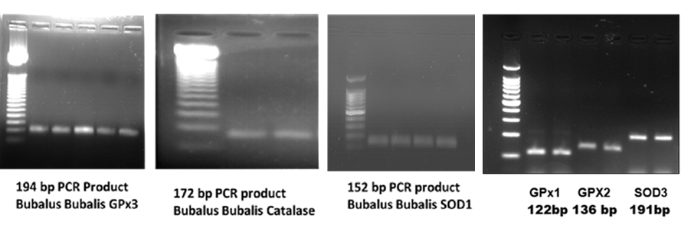
Table 4: Gene expression Mean fold (2^-ΔΔct) change and Log2 fold change of target antioxidant genes in various groups relative to non-lactating pandharpuri buffalo
Gene | Group | Mean dCt | Mean FC | SEM (FC) | Mean Log2FC | SEM (Log)
Catalase | 1) Non Lactating Pandharpuri buffalo | -2.055 | 1.0000 | 0.3050 | -0.0000 | 0.3893
Catalase | 2) Early lactation | -3.568 | 2.8547 | 0.7503 | 1.5133 | 0.2740
Catalase | 3) Mid Lactation | -2.837 | 1.7191 | 0.4114 | 0.7817 | 0.3226
Catalase | 4) Late Lactation | -2.208 | 1.1121 | 0.3380 | 0.1533 | 0.4614
SOD1 | 1) Non Lactating Pandharpuri buffalo | -3.753 | 1.0000 | 0.4258 | -0.0000 | 0.4680
SOD1 | 2) Early lactation | -3.987 | 1.1755 | 0.1927 | 0.2333 | 0.2318
SOD1 | 3) Mid Lactation | -4.928 | 2.2579 | 0.4222 | 1.1750 | 0.2551
SOD1 | 4) Late Lactation | -5.952 | 4.5895 | 1.0367 | 2.1983 | 0.2750
SOD2 | 1) Non Lactating Pandharpuri buffalo | -3.810 | 1.0000 | 0.2159 | -0.0000 | 0.4412
SOD2 | 2) Early lactation | -5.725 | 3.7711 | 0.6929 | 1.9150 | 0.2416
SOD2 | 3) Mid Lactation | -5.105 | 2.4538 | 0.5968 | 1.2950 | 0.3097
SOD2 | 4) Late Lactation | -4.442 | 1.5494 | 0.2004 | 0.6317 | 0.1710
SOD3 | 1) Non Lactating Pandharpuri buffalo | -4.485 | 1.0000 | 0.2196 | -0.0000 | 0.2589
SOD3 | 2) Early lactation | -5.722 | 2.3565 | 2.1206 | 1.2367 | 0.8531
SOD3 | 3) Mid Lactation | -6.170 | 3.2154 | 1.0568 | 1.6850 | 0.5496
SOD3 | 4) Late Lactation | -5.653 | 2.2475 | 1.7833 | 1.1683 | 0.5178
GPX1 | 1) Non Lactating Pandharpuri buffalo | -3.448 | 1.0000 | 0.4486 | -0.0000 | 0.4148
GPX1 | 2) Early lactation | -6.392 | 7.6919 | 2.5468 | 2.9433 | 0.3701
GPX1 | 3) Mid Lactation | -6.017 | 5.9312 | 0.8115 | 2.5683 | 0.2222
GPX1 | 4) Late Lactation | -4.302 | 1.8067 | 0.6327 | 0.8533 | 0.4523
GPX2 | 1) Non Lactating Pandharpuri buffalo | -1.965 | 1.0000 | 0.5340 | -0.0000 | 0.4828
GPX2 | 2) Early lactation | -2.122 | 1.1147 | 1.2945 | 0.1567 | 0.8288
GPX2 | 3) Mid Lactation | -2.517 | 1.4658 | 0.7230 | 0.5517 | 0.5114
GPX2 | 4) Late Lactation | -1.232 | 0.6015 | 0.2248 | -0.7333 | 0.3860
GPX3 | 1) Non Lactating Pandharpuri buffalo | -2.915 | 1.0000 | 0.5760 | -0.0000 | 0.8841
GPX3 | 2) Early lactation | -3.793 | 1.8383 | 1.5337 | 0.8783 | 0.8308
GPX3 | 3) Mid Lactation | -2.493 | 0.7466 | 0.4550 | -0.4217 | 0.6086
GPX3 | 4) Late Lactation | -2.398 | 0.6990 | 0.2037 | -0.5167 | 0.4483

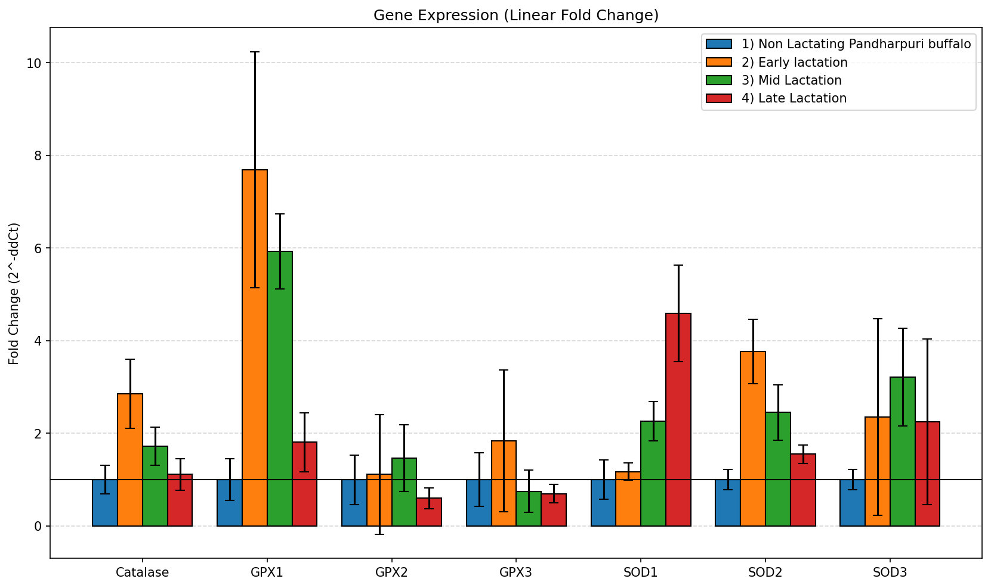
Fig 2: Relative expression of antioxidant genes expressed as linear fold change (2⁻ΔΔCt) during non-lactating, early, mid and late lactation stages in Pandharpuri buffaloes.
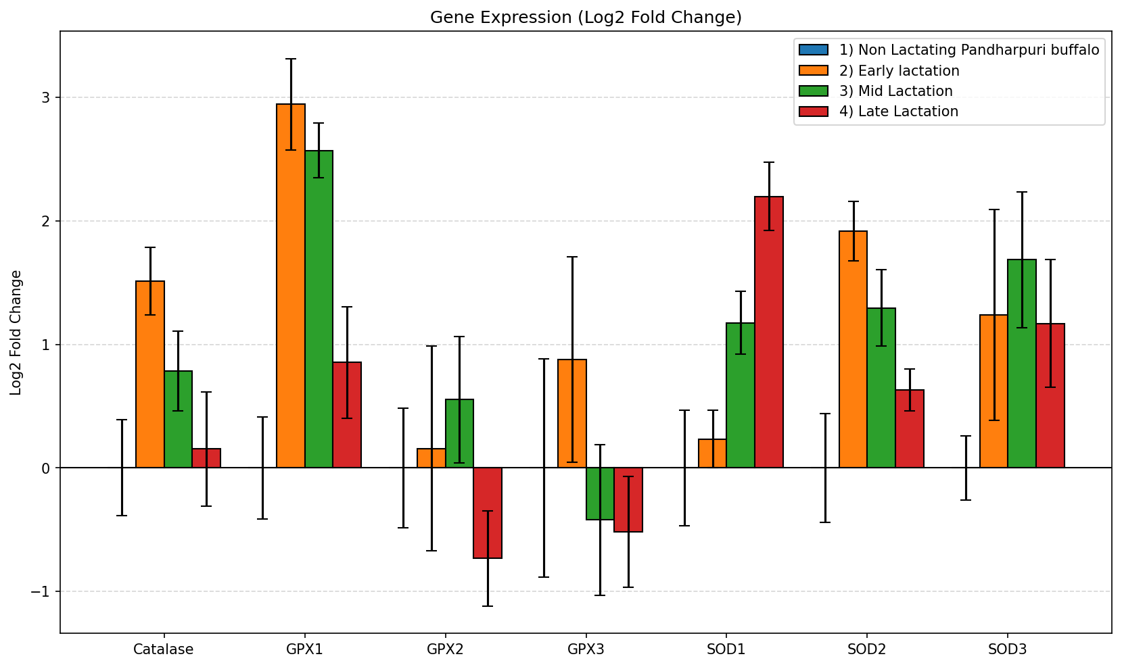
Fig 3: Relative expression of antioxidant genes expressed as log₂ fold change during non-lactating, early, mid and late lactation stages in Pandharpuri buffaloes.
This study evaluates the expression patterns of major antioxidant enzyme genes viz Catalase, Superoxide Dismutases (SOD1, SOD2, SOD3), and Glutathione Peroxidases (GPX1, GPX2, GPX3) in Pandharpuri buffaloes across different physiological stages. Using Non-Lactating buffaloes as the control baseline (Fold Change = 1.00) , gene expression was quantified during Early, Mid, and Late lactation phases to understand cellular oxidative stress responses during milk production. Several key antioxidant genes show a sharp, dramatic upregulation immediately at the onset of lactation: GPX1 exhibits the highest overall induction in the study, spiking to a 7.69-fold increase in early lactation before gradually declining. GPX1 (Cytoplasmic Glutathione Peroxidase): Exhibits the most robust induction in the entire study, spiking to a 7.69-fold increase during early lactation. This massive surge aligns with findings by Kour et al. (2024), who monitored transition-period buffaloes and established that dairy animals experience peak systemic oxidative stress immediately postpartum due to negative energy balance. The dry (non-lactating) phase involves pregnancy-related changes, the initiation of lactation and tissue repair triggers a substantial surge in metabolic demand. After calving, a buffalo's milk production increases rapidly while her feed intake is limited. This deficit forces her body to break down body fat (lipolysis), a highly metabolic process that releases massive amounts of free radicals. Clinical studies show that crucial oxidative stress indicators, such as malondialdehyde (MDA), are significantly higher during the early postpartum lactation stage compared to the stable dry period
Schogor et al. (2013) similarly noted that cellular glutathione peroxidases serve as a primary frontline defense in mammary tissues, rapidly clearing peroxides to preserve cellular membrane integrity during peak metabolic throughput. SOD2 (Mitochondrial) reaches its peak expression early on (3.77-fold). Because early lactation demands a massive metabolic surge in mammary tissue mitochondria, this upregulation is likely a defense mechanism against a spike in superoxide radicals. Catalase gene expression was found to follows a similar pattern, peaking early at 2.85-fold to neutralize hydrogen peroxide before tapering back toward baseline levels by late lactationParallels this early protective response, peaking at 2.85-fold. This directly complements the SOD2 elevation; as SOD2 converts superoxides into H2O2, Catalase acts downstream to rapidly cleave H2O2into water and oxygen. This synchronized upregulation of CAT and SOD during early lactation validates the findings of Tufarelli et al. (2023), who documented that high-yielding dairy animals experience a significant elevation in core antioxidant enzyme activities immediately following parturition to mitigate tissue damage from elevated respiratory rates.
Interestingly, Cytoplasmic SOD1 expression increases progressively as lactation advances, reaching its maximum in late lactation (4.59-fold). Extracellular SOD3 peaks during mid-lactation (3.22-fold) and remains elevated. This suggests a transition from acute, organelle-specific stress management to long-term, systemic cytoplasmic and extracellular defense. SOD1 (Cytoplasmic) & SOD3 Unlike mitochondrial SOD2 (which steadily declines after early lactation), SOD1 increases progressively over time, maximizing during late lactation at 4.59-fold. Concurrently, SOD3 peaks during mid-lactation at 3.22-fold and remains highly elevated into late lactation (2.25-fold). While acute mitochondrial stress stabilizes, systemic cytoplasmic and extracellular fluid oxidative stress continues to accumulate across the entire lactation cycle. This linear accumulation of SOD1 and SOD3 tracks with observations by Tufarelli et al. (2023), who reported that chronic, lactation-driven oxidative stress accumulates in tissues over time, requiring sustained, long-term systemic enzymatic upregulation even as daily milk volumes begin to taper. GPX2: Displays a modest, delayed upregulation peaking in mid-lactation (1.47-fold) before dropping below baseline in late lactation. GPX3: Unlike its counterparts, GPX3 shows minimal changes. It peaks lightly in early lactation (1.84-fold) but undergoes distinct downregulation during mid-lactation (0.75-fold) and late lactation (0.70-fold), as evidenced by the negative Log2 Fold Change values. This suggests that plasma/extracellular glutathione peroxidase may play a less critical role or is actively suppressed in later stages of lactation. These finding heavily supported by transition-period ruminant health studies (Kour et al., 2024; Tufarelli et al., 2023).
The onset of lactation marks the most volatile stage for antioxidant gene regulation. At parturition and during early lactation, the dramatic escalation in milk production drives a steep increase in metabolic rate, leading to elevated concentrations of Malondialdehyde (MDA), a key biomarker of lipid peroxidation. Concurrently, serum values and PBMC mRNA expression levels of SOD1, SOD2, CAT, and GPX1 typically experience a noticeable decline. This downregulation points to an overarching systemic exhaustion of the antioxidant defense system, as the high rate of free radical generation outpaces the cell's transcriptional machinery. In Pandharpuri buffaloes, this stress is compounded by the animal’s unique physiological adaptation for intermittent milking, which demands rapid structural remodeling of mammary tissue and puts additional stress on circulating leucocytes.
As the buffalo transitions into mid-lactation, dry matter intake rises to match the energy demands of milk production, resolving the negative energy balance. During this stage, oxidative markers like MDA begin to decline, while the mRNA expression of SOD, CAT, and GPX1 in PBMCs exhibits a significant, compensatory upregulation. This transcriptional rebound reflects the stabilization of the animal's metabolic state, allowing its cellular machinery to restore homeostatic balance and build up defenses against ongoing oxidative stress.
In the final stages of lactation, the expression patterns of antioxidant genes diverge from those seen in earlier phases. The expression of SOD2 and GPX1 often remains elevated or stabilizes to protect PBMCs from the inflammatory signaling cascades that accompany mammary gland involution and the initial stages of the next pregnancy cycle. Similar pattern was observed by El-Zaiat et al.,(2024) in ewes in late lactation stages.
Conclusion
The data highlights a highly coordinated, stage-specific antioxidant response in Pandharpuri buffaloes. The massive initial surge in GPX1, SOD2, and Catalase indicates that early lactation is the most oxidatively challenging phase for the animal. Conversely, the steady rise of SOD1 suggests that the physiological burden shifts but persists heavily into late lactation. The qPCR data maps a highly coordinated, stage-specific antioxidant response in Pandharpuri buffaloes. The sharp early spikes in GPX1, SOD2, and Catalase validate early lactation as the most hazardous window for cellular oxidative injury,. Meanwhile, the linear accumulation of SOD1 reveals a lingering metabolic toll that persists into late lactation. This metabolic profile can be utilized to optimize nutritional and management strategies to alleviate oxidative stress in lactating dairy buffaloes. This collaborative profile suggests that antioxidant interventions (such as dietary supplementation with Vitamin E, Selenium, or plant-derived polyphenols) are most critical during the transition to early lactation to cushion the acute GPX1/SOD2 spike, but should be sustained structurally to support the animal's ongoing cytoplasmic defense (SOD1) in later stages. Developing targeted, stage-specific nutritional strategies (such as strategic antioxidant and trace mineral supplementation) to support the animal's native antioxidant expression during peak lactation.

Declaration of AI Use

This manuscript was prepared through the intellectual contributions of the author(s) to the study design, data analysis, interpretation of results, and scholarly content. Grammarly and ChatGPT were used solely to assist with grammatical refinement and reference formatting during manuscript revision. The author(s) accept full responsibility for the accuracy, integrity, and final content of the manuscript.

10. References
- Beghelli, D., Pontieri, E., Siveri, G., Polidori, P., & Vincenzetti, S. (2022). Effect of antioxidant supplementation on milk yield and quality in dairy ruminants: A comparative review. Metabolites, 12(8), 670. https://pmc.ncbi.nlm.nih.gov/articles/PMC9330241/
- El-Zaiat, H. M., Soltan, Y. A., & Sallam, S. M. (2024). Metabolic profile, hematological parameters, and gene expression pattern of cytokines in ewes during late pregnancy and early lactation stages. BMC Veterinary Research, 20(1), 192. https://pmc.ncbi.nlm.nih.gov/articles/PMC11100279/
- Faheem, M., Khan, R., & Su, J. (2024). Advancements in genetic biomarkers and exogenous antioxidant protection against heat-stress-induced oxidative stress and apoptosis in mammalian reproductive cells. Antioxidants, 13(3), 325. https://pmc.ncbi.nlm.nih.gov/articles/PMC10967571/
- Ghasimi, S., & Shiri, M. (2013). Differential gene expression analysis using coexpression and RNA-Seq data packages: Comparison of methods and biological inferences. Bioinformatics, 29(17), 2153–2160. https://academic.oup.com/bioinformatics/article/29/17/2153/242408
- Han, X., Yang, Y., & Liu, Z. (2026). A multi-tissue transcriptomic atlas of river buffalo (Bubalus bubalis) reveals insights into lactation performance and tissue-specific gene networks. International Journal of Molecular Sciences, 27(9), 4032. https://www.mdpi.com/1422-0067/27/9/4032
- Jamwal, S., Sharma, N., & Kumar, P. (2024). Identification and validation of putative biomarkers by in silico and biochemical analysis of oxidative stress markers during transition period in water buffaloes (Bubalus bubalis). Animal Bioscience, 37(3), 415–427. https://pmc.ncbi.nlm.nih.gov/articles/PMC10915197/
- Kapila, N., Kishore, A., & Sodhi, M. (2019). Buffalo milk transcriptome: A comparative analysis of early, mid and late lactation stages in Murrah buffaloes. Scientific Reports, 9(1), 5941. https://pmc.ncbi.nlm.nih.gov/articles/PMC6461664/
- Kour, S., Sharma, N., Guttula, P. K., Gupta, M. K., Santos, M. V. D., Bacic, G., Macesic, N., Pathak, A. K., & Son, Y. O. (2024). Identification and validation of putative biomarkers by in silico analysis, mRNA expression and oxidative stress indicators for negative energy balance in buffaloes during transition period. Animal Bioscience, 37(3), 522-535.
- Kumar, R., Sahu, A., & Vohra, V. (2026). Genome-wide insights into intermittent milking behavior of Pandharpuri buffalo (Bubalus bubalis) using whole-genome resequencing approaches. Cellular and Molecular Biology Letters, 31(1), 45. https://pmc.ncbi.nlm.nih.gov/articles/PMC12839739/
- Livak, K. J., & Schmittgen, T. D. (2001). Analysis of relative gene expression data using real-time quantitative PCR and the 2^{-ΔΔct} method. Methods, 25(4), 402–408.
- Patel, O. V., Joshi, V., & Mishra, S. (2020). Physiological shifts alter the relative expression of heat shock proteins and antioxidant genes in indigenous Indian river buffaloes (Bubalus bubalis). Journal of Thermal Biology, 89, Article 102551.
- Saro, C., Ranilla, M. J., & Carro, M. D. (2021). Antioxidant and inflammatory gene expression profiles of peripheral blood mononuclear cells derived from dairy cows fed spirulina as a protein substitute. Antioxidants, 10(5), 814. https://www.mdpi.com/2076-3921/10/5/814
- Schogor, A. L. B., Palin, M. F., dos Santos, G. T., Benchaar, C., Lacasse, P., & Petit, H. V. (2013). Mammary gene expression and activity of antioxidant enzymes and oxidative indicators in the blood, milk, mammary tissue and ruminal fluid of dairy cows fed flax meal. British Journal of Nutrition, 110(10), 1743-1750.
- Sharma, A., Kumar, S., & Sodhi, M. (2023). Whole blood transcriptome analysis of lactating Murrah buffaloes reveals key candidates regulating milk production traits. Frontiers in Animal Science, 4, 1135429. https://www.frontiersin.org/journals/animal-science/articles/10.3389/fanim.2023.1135429/full
- Tufarelli, V., Colonna, M. B., Losacco, C., & Puvača, N. (2023). Biological Health Markers Associated with Oxidative Stress in Dairy Cows during Lactation Period. Metabolites, 13(3), 405.
- Vargas-Bello-Pérez, E., Launders, N., & Loor, J. J. (2013). Mammary gene expression and activity of antioxidant enzymes and oxidative stability of milk from dairy cows fed fish meal. Journal of Dairy Science, 96(11), 6950–6962. https://pubmed.ncbi.nlm.nih.gov/23578516

