Original Research Article

Assessment of Crop Losses Due to Wild Boar, Sus scrofa Linnaeus in Cropping System of Vadodara District

Abstract

Aims: To assess the extent and pattern of crop damage caused by wild boar (Sus scrofa Linnaeus) in major cropping systems of Vadodara district, Gujarat, with emphasis on both direct feeding and indirect damage caused by S. scrofa.

Place and Duration of Study: The investigation was conducted in four blocks, viz., Desar, Karjan, Padra and Sinor of Vadodara district (Gujarat), during September 2024 to October 2025.

Methodology: A total of 143 agricultural fields were surveyed through field observations, quadrat sampling, farmer interviews and questionnaire. Crop damage was estimated using the quadrat method for closely spaced crops, whereas complete plant counts were used for widely spaced fruit crops. The nature of damage, including feeding, trampling and lodging was also recorded, along with information on farmers perceptions of wild-boar damage.

Results: The highest mean crop damage was recorded in maize (15.84%), followed by banana (14.44%) and pearl millet (13.95%). Direct feeding damage was comparatively low, whereas substantial losses were associated with trampling and lodging during wild-boar movement. Damage was more pronounced in fields located near forest edges and roosting habitats. Majority of the interviewed farmers reported that crop damage was primarily caused by animal movement rather than feeding.

Conclusion: The study revealed that indirect damage caused by S. scrofa, particularly through trampling and lodging, contributes significantly to agricultural crop losses. Therefore, assessment and management strategies should be considered both direct feeding and indirect movement-related damage, particularly in agricultural fields adjoining forested and wild boar-prone habitats.

Keywords: Wild boar, crop damage, vertebrate pests, quadrat method
1. INTRODUCTION
Agriculture is one of the most important sectors supporting global food security, rural livelihoods and economic development. It provides food, fiber, fodder and raw materials for numerous industries while serving as the primary source of income for millions of farming households worldwide. However, agricultural productivity is continually challenged by a range of biotic and abiotic factors that adversely affect crop growth and yield. Recent past, among the biotic constraints, damage caused by vertebrate pests has emerged as a significant concern, resulting in considerable economic losses and reduced agricultural productivity. Agriculture is frequently affected by vertebrate pests, which cause significant losses in crop production worldwide. Among mammalian vertebrate pests, the wild boar, S. scrofa is regarded as one of the most destructive species because of its omnivorous feeding behaviour, high reproductive rate, adaptability and wide ecological distribution (Massei and Genov, 2004; Barrios-Garcia and Ballari, 2012). The wild boar is a highly adaptable animal and inhabit dense forests, scrublands, riverbanks, hilly regions, as well as agricultural fields. It thrives particularly in areas where water, grass and food are easily available. During crop maturity periods, it prefers to raid fields at night in search of food (Bhuva et al., 2025). In India, increasing interactions between wild boars and agricultural landscapes have resulted in significant economic losses to farmers, particularly in areas adjoining forest ecosystems (Jathanna et al., 2003; Chauhan et al., 2009; Pandey et al., 2019). Crop damage by wild boars take place through direct consumption of plant material as well as indirect effects, including rooting, digging, trampling and lodging of standing crops. The direct feeding damage has received considerable attention, losses resulting from trampling and the movement of wild boars through agricultural fields may represent a significant proportion of total crop damage (Schley and Roper, 2003; Barrios-Garcia and Ballari, 2012). Crop depredation is particularly severe in maize, paddy, pearl millet, groundnut, sugarcane, banana and various horticultural crops because of their high nutritional value and accessibility (Massei et al., 2015). In India, wild boars are protected under Schedule III of the Wildlife Protection Act, 1972, which prohibits lethal control methods.
Recent field- and landscape-scale studies indicate that wild boar crop damage is spatially heterogeneous and is influenced by the proximity of refuge habitat, crop accessibility, landscape structure and human disturbance. Such findings support the use of spatially explicit field assessment when identifying agricultural areas at elevated risk of crop raiding (Saito et al., 2011; Cappa et al., 2021; Ding et al., 2023).
Damage patterns can also vary among seasons and crop types because the attractiveness and availability of cultivated foods change with crop phenology and the surrounding resource environment. Long-term and multi-season assessments therefore provide a more robust basis for interpreting crop-specific losses and prioritising mitigation than assessments that assume uniform damage through time (Bobek et al., 2017; Nasiadka et al., 2025).
Consequently, reports of crop depredation have increased from several states including Karnataka, Maharashtra, Kerala, Himachal Pradesh and Tamil Nadu (Jathanna et al., 2003; Karanth et al., 2012). In Gujarat, vertebrate pests pose a significant challenge to agricultural production. According to Desai et al. (2021) wild boar (Sus scrofa), blue bull (Boselaphus tragocamelus) and Indian wild ass (Equus hemionus khur) are the most destructive wildlife species causing crop damage followed by chinkara (Gazella bennettii). These species inflict substantial economic losses across a wide range of crops. Assessment of crop damage is essential for estimating economic losses, identifying vulnerable crops and designing effective vertebrate pest management strategies. Field-based methods such as quadrat sampling, direct plant counts and farmer interviews are widely used for estimating crop losses caused by wildlife because they provide reliable quantitative estimates under field conditions (Chauhan et al., 2009). Although wild boar damage has been reported from several parts of India, systematic information on the extent of crop losses and farmers management practices in Gujarat remains limited. Therefore, the present investigation was undertaken to assess wild boar damage in major cropping systems of Desar, Karjan, Padra and Sinor blocks of Vadodara district.
2. METHODOLOGY
The study was conducted to estimate the wild boar damage in cultivated land of four blocks i.e. Desar, Karjan, Padra and Sinor of Vadodara district from September, 2024 to October, 2025. The crop fields were monitored regularly and observations on number of damaged plants, total plants stand and measures were taken to manage the wild boar damage. The survey was also conducted by various methods starting from the farmers interviews and questionnaire method. To know about the farming trends, formation of farm holding sizes, cropping pattern, trend analysis of their crop pattern etc. In addition to the crop details, damages to crops caused by wild boar, percentage of crop damages and the methods or preventive measures were taken by the farmers for reduced the crop damage were also noted. Besides these methods, the local farmers also shared the level of damage and the damage caused by the wild boars on crops. In addition to these, knowing about the traditional knowledge of the farmers to identify the practices that are not preferred by the wild boars was the key for the survey conducted. The geographical locations of wild boar occurrence and crop damage were recorded during field surveys using a device/mobile Global Positioning System (GPS) with geographic coordinates (latitude and longitude). The collected latitude and longitude data were imported into QGIS software 3.44.12 and converted into a point layer using the appropriate geographic coordinate. Following two methods were employed to estimate the damage by wild boar in crop fields.
1. Quadrat method: In this method quadrats of 1m X 1m length was laid in the crop fields randomly and the damaged percentage was calculated by counting the damaged plants in the quadrats.
Formula:
$$Damage \left(\%\right)=\frac{Total number of damaged plants in all quadrats }{Total number of \left(plants in all \right)quadrats studied}X 100$$
$$Frequency =\frac{Number of quadrats in which the damage noticed }{Total number of quadrats studied}X 100$$

2. This method was used for fruit crops that having larger spacing, damaged plants in the selected crop field was counted and the damaged plants were divided by the total planted plants or seed rate of that crop of the particular selected field.
3. RESULT AND DISCUSSION:
3.1 Seasonal pattern and early-stage crop damage
The monitoring of vertebrate pest damage in crop was conducted in Vadodara district since September-2024 to October-2025. Crop damage was higher during the post-monsoon season, primarily due to the depletion of natural food and water resources, which compelled animals to raid agricultural fields in groups. The direct plant damage observed in quadrat method. In majority of surveyed fields, wild boar feeding damage was negligible and mainly confined to dig up sown seeds and feeding on tender leaves during the early crop growth stage.
The observed post-monsoon concentration of damage is consistent with evidence that wild boar depredation varies temporally with crop availability, crop developmental stage and seasonal changes in alternative food resources. Studies from agricultural landscapes have documented marked seasonal shifts in the frequency and composition of crop damage, indicating that the timing of monitoring is important when interpreting field-level loss estimates (Bobek et al., 2017; Cappa et al., 2021; Nasiadka et al., 2025).
3.2 Spatial distribution and landscape context
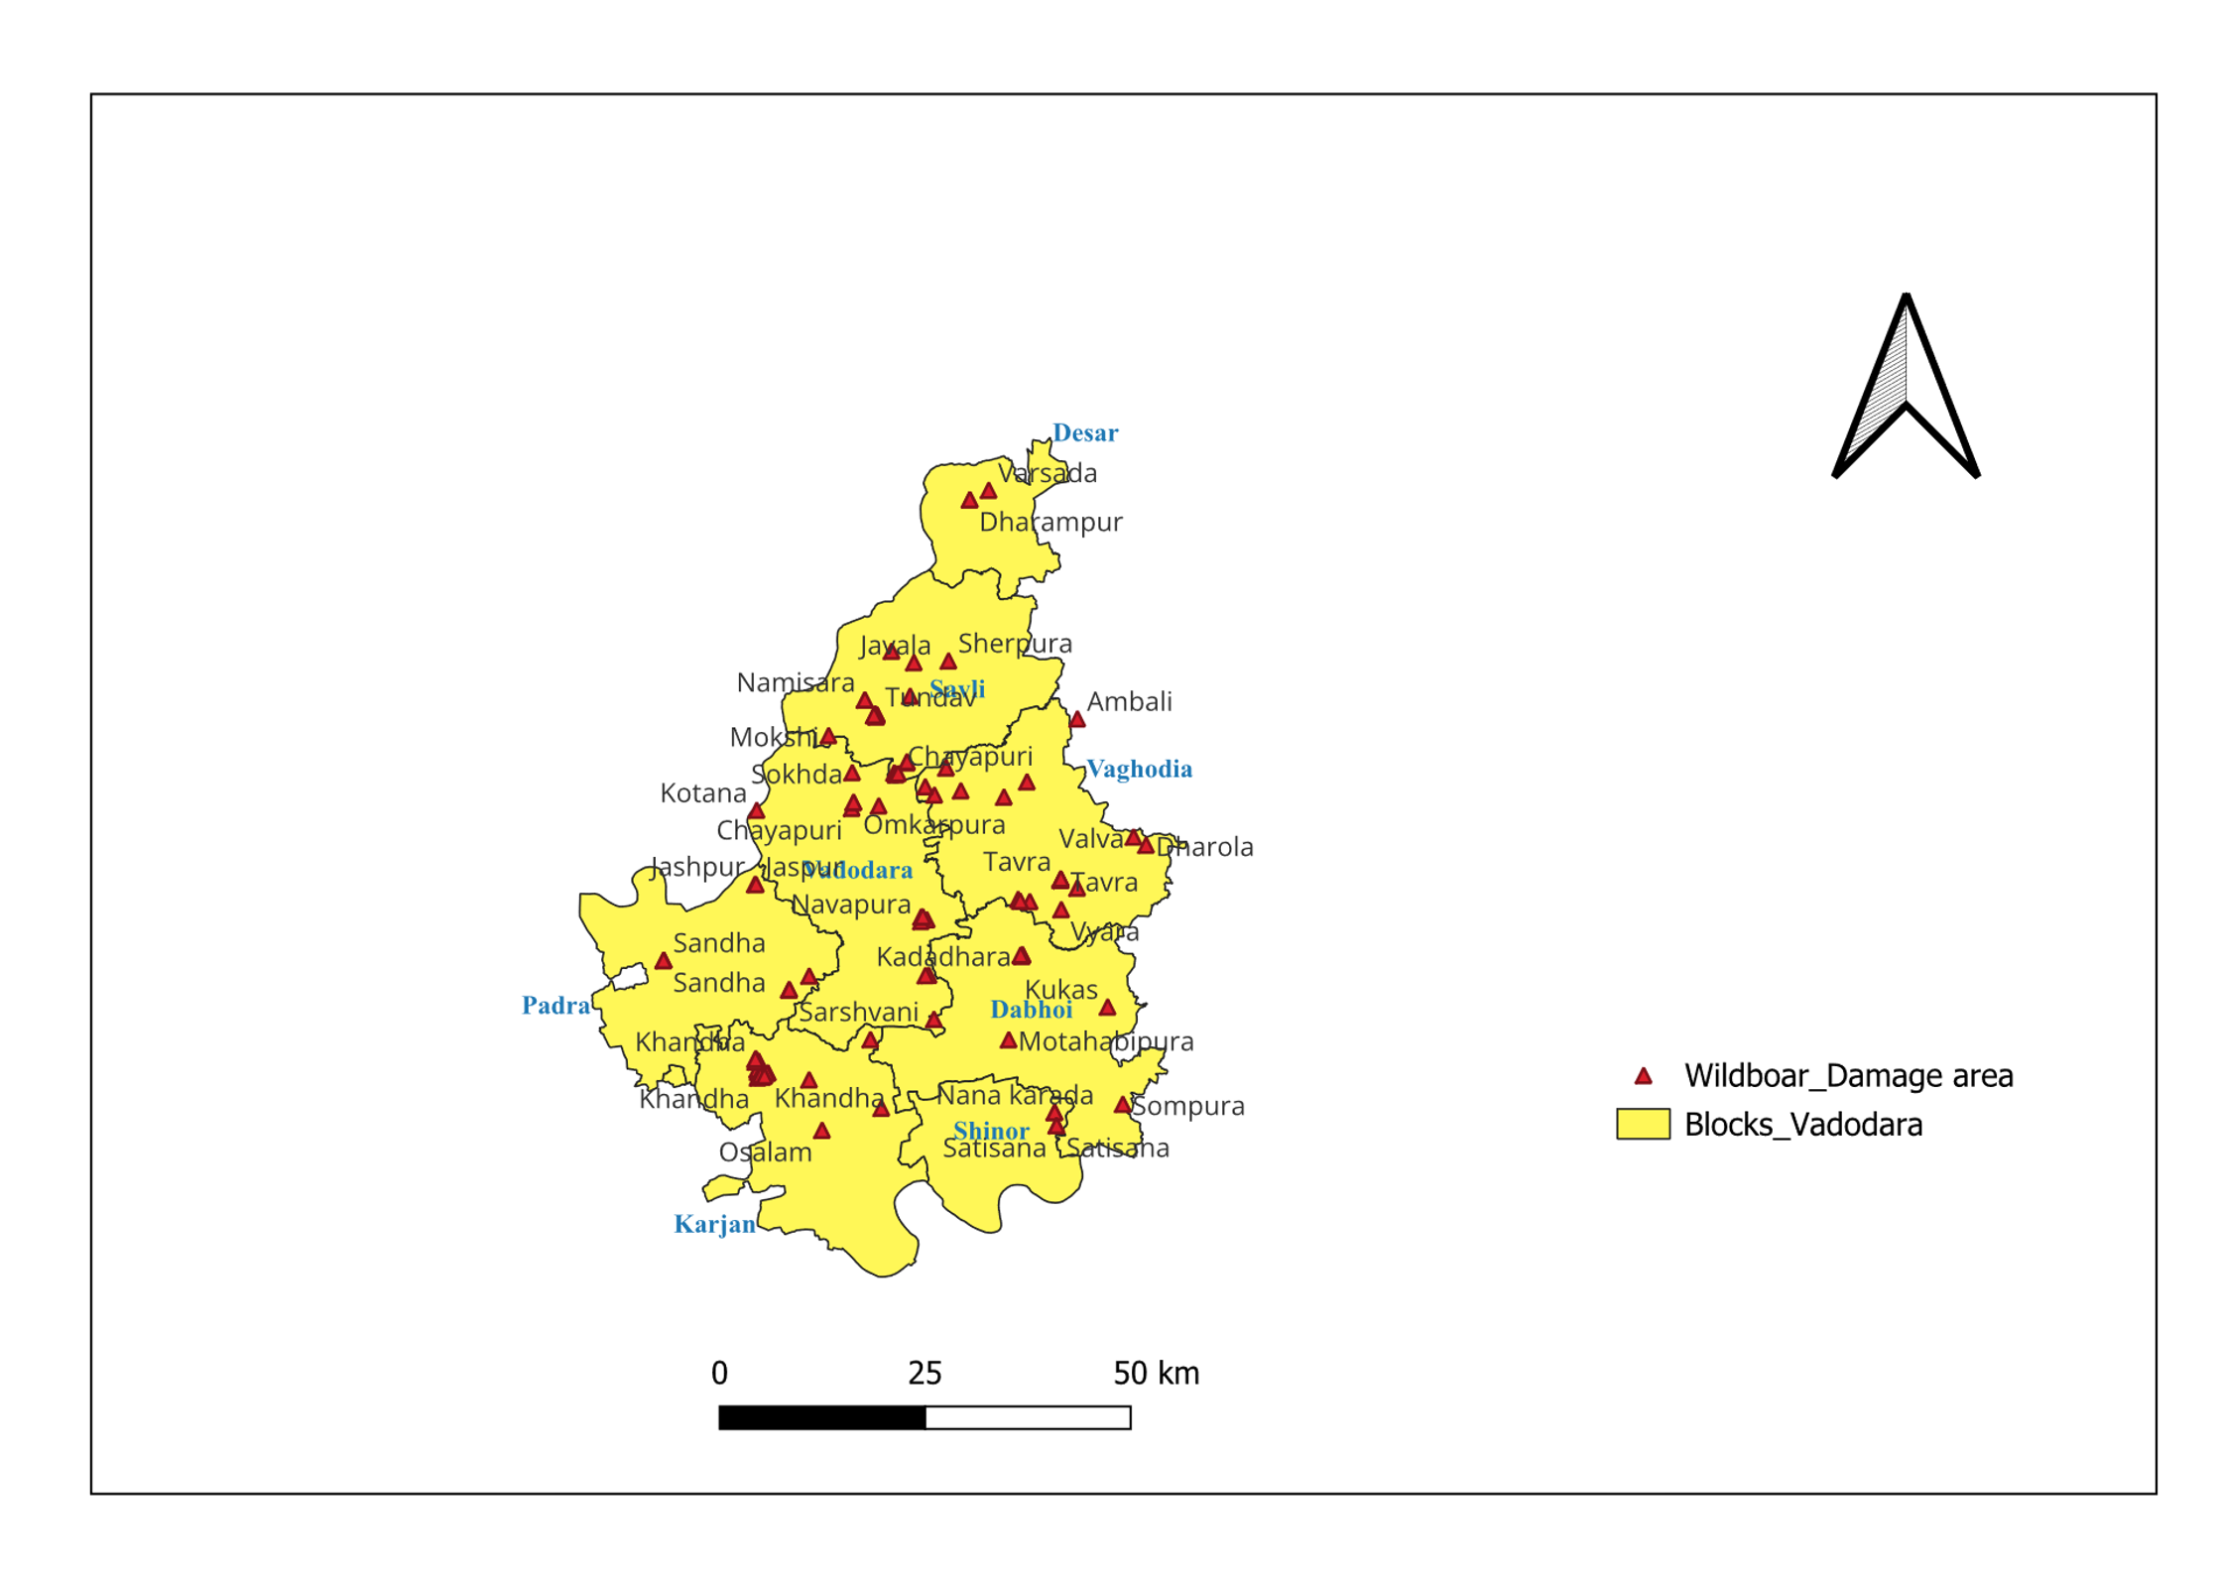
During the survey in Vadodara district, wild boar occurrences were recognized at multiple locations within the surveyed agricultural landscape. The spatial pattern of these records indicated that wild boar was widely distributed rather than confined to a particular locality, with occurrences recorded across different agricultural areas of the district. Geographic coordinates collected during field observations were used to map these locations and visualize the distribution of wild boar in relation to agricultural areas (Fig. 1). The presence of wild boar in croplands may be influenced by the availability of crops as food sources and the accessibility of nearby shelter and refuge habitats. Agricultural fields situated close to forest patches, riverine habitats and other relatively undisturbed areas may offer favourable conditions by providing both food and cover, thereby facilitating frequent movement of wild boar into crop fields. Variation in the occurrence pattern may further be related to crop type, crop growth stage, water availability and surrounding habitat conditions.
Fig. 1: Distribution pattern mapping of wild boar using GPS

The spatial association with forest patches, riverine habitats and other refuge areas is supported by studies showing that wild boar crop-damage risk is often related to forest-edge proximity, landscape configuration and access to cover. GPS- and GIS-based investigations have further demonstrated that damage risk can be concentrated at habitat–farmland interfaces, although the relative importance of individual landscape variables may differ among regions (Thurfjell et al., 2009; Saito et al., 2011; Ding et al., 2023; Eshtiaghi et al., 2024).

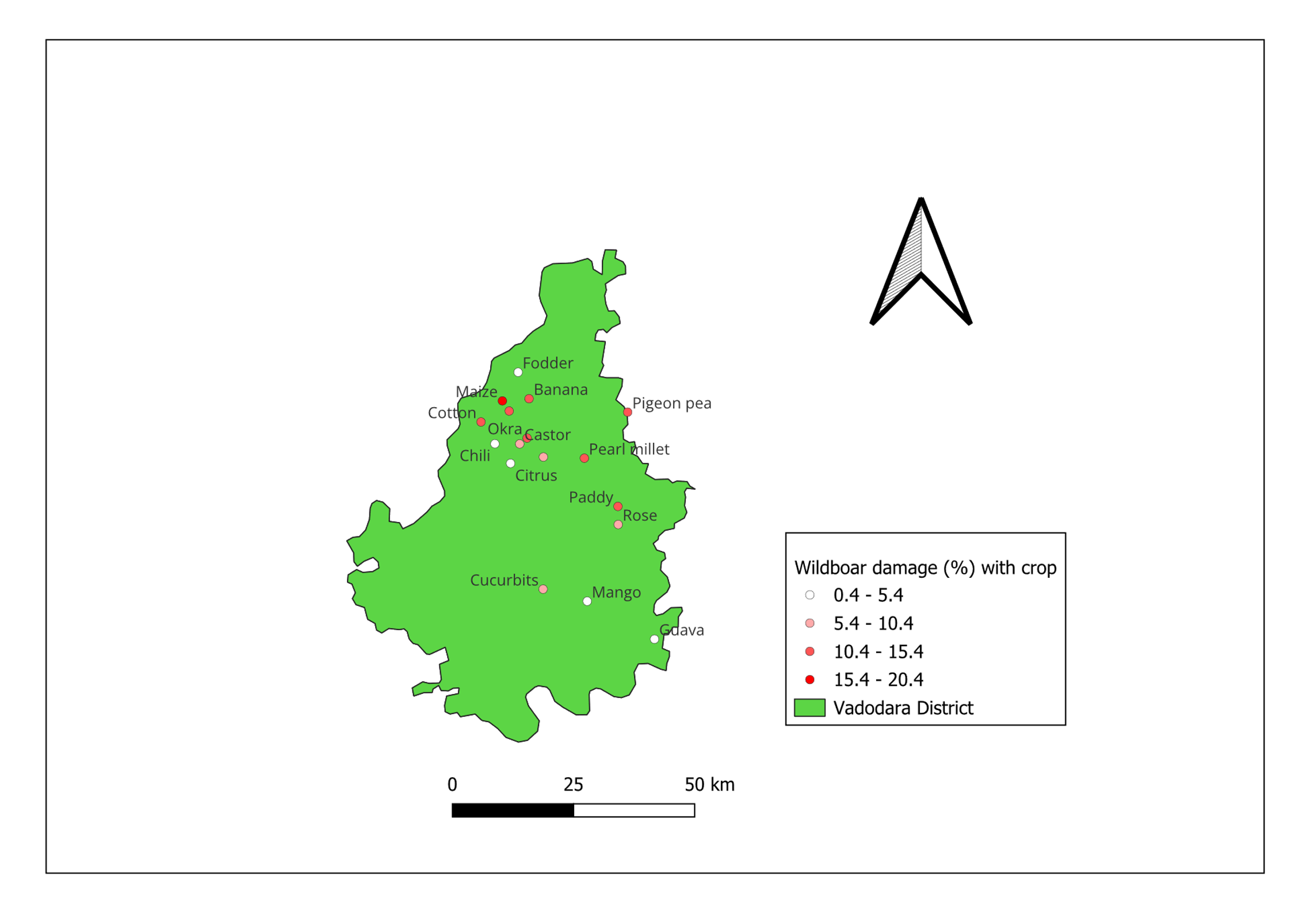
Fig. 2: Crop and location specific damage pattern by wild boar using GPS
3.3 Crop-specific damage magnitude
The distribution map of Vadodara district provides a baseline for identifying areas with a higher likelihood of wild boar occurrence. Moreover, assessment based on crop type and damage intensity revealed that crop damage was both location and crop-specific with substantial variation in the level of damage recorded among agricultural fields. Total 143 fields were further surveyed for boar damage in different crops. The wild boar damage to banana plants was monitored in 18 fields and mean damage found due to wild boar was 14.44 per cent (Table 1 and Fig. 2). The mean damage to maize crop (7 fields) due to wild boar was 15.84 per cent. As per the Amici et al. (2012) cereals were the most frequently damaged crops (46.48%) and of these, maize was the most affected (22.98% of cases) followed by durum wheat (13.84%), oats (4.18%), barley (3.52%) and soft wheat (1.96%). The wild boar damage to pearl millet crop was monitored in 6 fields. The mean damage to pearl millet crops due to wild boar was 13.95 per cent. Baduni et al. (2025) observed wild pigs used to injure or harm humans, with the highest number of casualties noticed in forest areas (67.8%) followed by agricultural fields (19.7%) and a smaller percentage in villages (5.8%). In Rajasthan wild boar caused greater losses than nilgai in bajara (18.9%) and green gram [(13.9%) (Anonymous, 2025]. According to, Sunitha et al. (2026) at Hyderabad resulted that the damage due to wild boar infestation ranged from 17 to 48 per cent depending on crop type and season.
The relatively high mean damage recorded in maize, banana and pearl millet should be interpreted as crop- and site-specific rather than as a universal ranking of susceptibility. Previous studies have reported substantial variation in damage among cereals, grasslands and other crop categories, with maize frequently representing an important component of wild boar damage where it is available; however, the magnitude of loss depends on local crop composition, phenology, field configuration and wild boar abundance (Bobek et al., 2017; Cappa et al., 2021; Nasiadka et al., 2025).

Table 1: Damage by wild boar to agricultural crops
Sr.  No. | Name of the crop cultivated | No. of field surveyed |  | Total trees / quadrates | Plant  (s)/ m² | Total plants in quadrates | Total No. of damaged plants in all quadrat | Damage (%) | Frequency | Range
Sr.  No. | Name of the crop cultivated | No. | Area (ha)
1 | Banana | 18 | 45 | 90000 | -- | -- | 13000 | 14.44 | 10.0 | 0.0-15.0
2 | Citrus | 03 | 08 | 8070 | -- | -- | 100 | 1.24 | 5.0 | 0.0-5.0
3 | Guava | 03 | 23 | 1250 | -- | -- | 10 | 0.80 | 3.0 | 0.0-3.0
4 | Mango | 15 | 74 | 8000 | -- | -- | 200 | 2.50 | 5.0 | 0.0-5.0
5 | Papaya | 07 | 21 | 57500 | -- | -- | 5000 | 8.70 | 10.0 | 0.0-10.0
6 | Pearl millet | 06 | 3.5 | 30 | 22.22 | 666.60 | 93 | 13.95 | 16.6 | 0.0-18.0
7 | Cucurbits | 16 | 78 | 80 | 0.67 | 53.60 | 5 | 9.33 | 6.2 | 0.0-10.0
8 | Chili | 14 | 22 | 70 | 2.78 | 194.60 | 10 | 5.14 | 7.1 | 0.0-8.0
9 | Cotton | 06 | 15 | 30 | 5.56 | 166.80 | 23 | 13.79 | 8.3 | 0.0-14.0
10 | Fodder | 09 | 09 | 45 | 80.0 | 3600.00 | 14 | 0.39 | 5.0 | 0.0-2.0
11 | Maize | 07 | 19 | 35 | 8.33 | 291.50 | 52 | 15.84 | 9.0 | 0.0-16.0
12 | Castor | 12 | 45 | 60 | 1.39 | 83.40 | 5 | 6.00 | 5.0 | 0.0-6.0
13 | Okra | 06 | 10 | 30 | 5.56 | 166.80 | 20 | 11.99 | 8.3 | 0.0-12.0
14 | Paddy | 08 | 32 | 40 | 25.0 | 1000.00 | 120 | 12.00 | 10.0 | 0.0-12.0
15 | Pigeon pea | 08 | 20 | 40 | 1.33 | 53.20 | 8 | 15.04 | 12.5 | 0.0-16.0
16 | Rose | 03 | 01 | 15 | 2.00 | 30.00 | 3 | 10.00 | 10.0 | 0.0-10.0
17 | Sorghum | 02 | 1.5 | 10 | 10.0 | 100.00 | 14 | 14.00 | 10.0 | 0.0-14.0
 | Total / Average | 143 | 427 | -- | -- | -- | -- | 9.33 | 8.25 | 0-16

3.4 Nature of damage and farmer management practices
Also, Rao et al. (2015) at Hyderabad reported that the damage to agricultural crops by wild boar was enormous and widespread. The overall incidence of damage at the regional scale was found to be minimal. However, crop fields located near the animals roosting areas were more vulnerable due to their frequent movements. The observed damage mainly included trampling and lodging of crops with only minor feeding on tender leaves during the early growth stage and on panicles during the reproductive stage. Farmers were also interviewed to gather their perceptions of crop damage and management practices. Majority of the respondents reported that direct feeding damage by wild boars was negligible but their movement through the fields caused considerable lodging, crop damage and yield losses. The most of farmers relied primarily on two management methods nighttime-watching, scaring and the use of electric wire fencing to protect their fields from wild boar damage.
The predominance of trampling and lodging observed in the surveyed fields indicates that crop loss should not be attributed solely to consumption. Movement, rooting and repeated access to fields can contribute to total damage, and management effectiveness is consequently influenced by both animal behaviour and the placement and maintenance of deterrents. Evidence from field studies indicates that well-maintained fencing and management focused on high-risk field edges can reduce damage, whereas effectiveness may decline where barriers are poorly maintained or where landscape conditions facilitate repeated access (Thurfjell et al., 2009; Saito et al., 2011; Cappa et al., 2021).
4. CONCLUSION
The wild boar is a major vertebrate pest affecting agricultural crops in Vadodara district of Gujarat. Among the surveyed crops, maize recorded the highest mean damage, followed by banana and pearl millet. Although direct feeding damage by wild boar was relatively low, substantial crop losses resulted from trampling, lodging and movement through crop fields, particularly in farms located near forest edges. Therefore, location-specific vertebrate pest management strategies combining physical barriers, community-based crop protection and improve farmer awareness are essential to mitigate human–wildlife conflict and reduce crop losses in agricultural landscapes.
Declaration of AI Use

This manuscript was prepared through the intellectual contributions of the author(s) to the study design, data analysis, interpretation of results, and scholarly content. Grammarly and ChatGPT were used solely to assist with grammatical refinement and reference formatting during manuscript revision. The author(s) accept full responsibility for the accuracy, integrity, and final content of the manuscript.

COMPETING INTERESTS DISCLAIMER:
Authors have declared that they have no known competing financial interests OR non-financial interests OR personal relationships that could have appeared to influence the work reported in this paper.

REFERENCES
Amici, A., Serrani, F., Rossi, C. M., & Primi, R. (2012). Increase in crop damage caused by wild boar (Sus scrofa L.): the “refuge effect”. Agronomy for sustainable development, 32(3), 683-692.
Anonymous, (2025). All India network project on vertebrate pest management. Annual report, 2024-25.
Baduni, P., Maikhuri, R. K., & Singh, G. (2025). Impact assessment and mitigation strategies of wild boar-induced crop damage in hill farming of Central Himalaya, Uttarakhand. Journal of Mountain Research, 20(2), 356-367.
Barrios-Garcia, M. N., & Ballari, S. A. (2012). Impact of wild boar (Sus scrofa) in its introduced and native range: a review. Biological Invasions, 14(11), 2283–2300. https://doi.org/10.1007/s10530-012-0229-6
Bobek, B., Furtek, J., Bobek, J., Merta, D., & Wojciuch-Płoskonka, M. (2017). Spatio-temporal characteristics of crop damage caused by wild boar in north-eastern Poland. Crop Protection, 93, 106–112. https://doi.org/10.1016/j.cropro.2016.11.030
Bhuva, K. J., Nayi, A., Dand, J. J., & Waghunde, R. R. (2025). The rising threats of wild boar to agriculture, Agri-India Today. 5(11), 164-168.
Cappa, F., Bani, L., & Meriggi, A. (2021). Factors affecting the crop damage by wild boar (Sus scrofa) and effects of population control in the Ticino and Lake Maggiore Park (North-western Italy). Mammalian Biology, 101(4), 451–463. https://doi.org/10.1007/s42991-021-00125-2
Chauhan, N. P. S., Barwal, K. S., & Kumar, D. (2009). Human-wild pig conflict in selected states in India and mitigation strategies. Acta Silvatica et Lignaria Hungarica: An International Journal in forest, wood and Environmental sciences, 5, 189-197.
Desai, S., Talluri, H., & Dharaiya, N. (2021). An assessment of farmers’ attitudes towards crop damage by wildlife and its prevention methods in the arid landscape of Gujarat. Uttar Pradesh Journal of Zoology, 42(21), 52-60.
Ding, N., Atzeni, L., Chen, Y., Lyu, Z., & Shi, K. (2023). Mapping crop damage by wild boars using multi-scale risk modeling in Northeast China. The Journal of Wildlife Management, 87(6), e22418. https://doi.org/10.1002/jwmg.22418
Eshtiaghi, A., Naderi, S., Mohammadi, A., & Wan, H. Y. (2024). Identifying wild boar (Sus scrofa) crop damage hotspots to mitigate human-wild boar conflicts in northern Iran. Global Ecology and Conservation, 54, e03065. https://doi.org/10.1016/j.gecco.2024.e03065
Jathanna, D., Karanth, K. U., & Johnsingh, A. J. T. (2003). Estimation of large herbivore densities in the tropical forests of southern India using distance sampling. Journal of Zoology, 261(3), 285-290.
Karanth, K. K., Gopalaswamy, A. M., DeFries, R., & Ballal, N. (2012). Assessing patterns of human-wildlife conflicts and compensation around a central Indian protected area. PloS one, 7(12), e50433.
Massei, G., & Genov, P. V. (2004). The environmental impact of wild boar. Galemys, 16, 135–145.
Massei, G., Kindberg, J., Licoppe, A., Gačić, D., Šprem, N., Kamler, J., & Náhlik, A. (2015). Wild boar populations up, numbers of hunters down? A review of trends and implications for Europe. Pest management science, 71(4), 492-500.
Nasiadka, P., Klich, D., Olech, W., & Sobczuk, M. (2025). Symmetry of wild boar damage to agricultural crops: Results of over 20 years of damage monitoring in Central Europe. Animals, 15(11), 1587. https://doi.org/10.3390/ani15111587
Pandey, L., Arunachalam, A., & Joshi, N. (2019). Challenges of hill farming due to crop raiding by wild pigs in the Indian Himalayan region. Current Science, 116(6), 1015-1019.
Rao, V. V., Naresh, B., Reddy, V. R., Sudhakar, C., Venkateswarlu, P., & Rao, D. R. (2015). Traditional management methods used to minimize wild boar (Sus scrofa) damage in different agricultural crops at Telangana state, India. International Journal of Multidisciplinary Research and Development, 2(2), 32-36.
Saito, M., Momose, H., & Mihira, T. (2011). Both environmental factors and countermeasures affect wild boar damage to rice paddies in Boso Peninsula, Japan. Crop Protection, 30(8), 1048–1054. https://doi.org/10.1016/j.cropro.2011.02.017
Schley, L., & Roper, T. J. (2003). Diet of wild boar, Sus scrofa in Western Europe, with particular reference to consumption of agricultural crops. Mammal review, 33(1), 43-56.
Sunitha, V., Aruna Sri, I., Somireddy, S., Panuganti, R., Mandla, R., & Chaudhary, V. (2026). Integrated approaches for the management of wild boar (Sus scrofa) infestation: Insights from a decadal study in Telangana, India. Journal of Environmental Biology, 47(3), 653-660.
Thurfjell, H., Ball, J. P., Åhlén, P.-A., Kornacher, P., Dettki, H., & Sjöberg, K. (2009). Habitat use and spatial patterns of wild boar Sus scrofa (L.): Agricultural fields and edges. European Journal of Wildlife Research, 55(5), 517–523. https://doi.org/10.1007/s10344-009-0268-1

