First Record of Lepas (Lepas) indica Annandale, 1909 (Cirripedia: Lepadidae) from the West Coast of India, with a Taxonomic Key to the Indian Species of the Genus Lepas

Abstract
This study documents Lepas (Lepas) indica Annandale, 1909 (Cirripedia: Lepadidae) from specimens recovered on a single piece of driftwood washed ashore at Karwar, Uttara Kannada District, Karnataka, India (14.8311° N, 74.1250° E) on 1 September 2025. Sixty-eight specimens deposited in the Crustacea Division of the Zoological Survey of India (registration no. CR878) were examined morphologically. Identification is supported by the laterally compressed subtriangular capitulum, strongly arched carinal margin bearing two or more prominent sinuous projections, quadrilateral scutum with an internal tooth on the left scutum and external basal ridges, characteristic lateral appendages, and mouthpart morphology. Published Indian material-based records cited in the taxonomic literature are from Odisha and Tamil Nadu on the east coast; within the published sources verified for this study, the Karwar material therefore represents the first documented west-coast Indian recovery of the species. Because the specimens were recovered from stranded driftwood, the observation demonstrates occurrence at Karwar but does not establish the geographic origin of attachment, a resident local population, or a specific east-to-west transport route. A concise diagnosis, differential diagnosis, distributional account, and key to the four Indian species of Lepas are provided.
Keywords: barnacle; Lepadidae; distribution record; stranded driftwood; Karnataka; taxonomic key.

Introduction
The genus Lepas Linnaeus, 1758 (Cirripedia: Lepadidae) comprises epipelagic stalked barnacles commonly known as goose barnacles. Species of Lepas attach to natural and anthropogenic floating substrates, including driftwood and marine debris, and rafting can facilitate dispersal over substantial distances (Gil & Pfaller, 2016; Schiffer & Herbig, 2016). This association with mobile substrates contributes to broad geographic distributions but also complicates interpretation of a stranded specimen as evidence of local establishment or attachment origin.
In the modern higher-level classification of barnacles, Lepas is placed within Lepadidae, Lepadoidea, and Scalpellomorpha; Chan et al. (2021) estimated 17 species in the genus. Four species are documented from Indian waters: Lepas anatifera Linnaeus, 1758, Lepas anserifera Linnaeus, 1767, Lepas pectinata Spengler, 1793, and Lepas indica Annandale, 1909 (Trivedi, Patel, et al., 2021). Lepas indica was originally described as Lepas anatifera indica by Annandale (1909) from off the Ganjam coast, Odisha, and was subsequently recorded from the Madras (present-day Chennai) coast by Daniel (1956).
Outside India, Lepas indica has been reported from the Mozambique Channel adjacent to Madagascar and from the South China and East China seas (Jones & Hosie, 2016; Liu & Ren, 2007; Ren, 1989). The taxonomically validated synthesis of Indian barnacle records by Trivedi, Patel, et al. (2021) retains the species as Lepas indica and identifies its Indian type locality on the east coast. The published Indian sources examined for the present study did not identify a material-based west-coast record prior to the Karwar collection.
The objectives of the present study are to document the Karwar material, provide an updated morphological diagnosis and differential diagnosis, summarise the documented Indian and global distribution of Lepas indica, and present a practical key to the four Lepas species reported from Indian waters. The term “first documented record” is used here specifically with reference to the material-based records located in the cited published literature.

Materials and Methods
During a coastal field survey at Karwar, Karnataka, a piece of driftwood bearing stalked barnacles was found washed ashore. The attached barnacles were examined and carefully detached using forceps and a scalpel to minimise damage to the capitular plates and soft body parts. Fresh material was photographed using a Nikon P900 camera and subsequently preserved in 70% ethanol. In the laboratory, specimens were examined under a Leica EZ4 stereo-zoom binocular microscope for qualitative morphological identification.
Taxonomic assessment was based on capitular shape and plates, the carinal margin, scutum, tergum and carina, peduncle, cirri, lateral appendages, and mouthparts, with comparison to the original description and relevant modern accounts (Annandale, 1909; Trivedi, Doshi, et al., 2021; Trivedi, Patel, et al., 2021). The 68 specimens of Lepas indica reported below derive from the same stranded-driftwood recovery event and are treated as a single occurrence rather than as independent geographic records. The examined material is deposited in the Crustacea Division, Zoological Survey of India, Kolkata, under registration no. CR878.
For the distributional statement, the Indian record was cross-checked on 7 September 2026 against the primary historical records cited herein and the taxonomically validated Indian synthesis of Trivedi, Patel, et al. (2021), together with relevant modern taxonomic literature. No earlier material-based west-coast Indian record of Lepas indica was identified in these published sources.

Results

Taxonomy
Classification follows Chan et al. (2021).
Order: Scalpellomorpha Buckeridge & Newman, 2006
Superfamily: Lepadoidea Chan, Dreyer, Gale, Glenner, Ewers-Saucedo, Pérez-Losada, Kolbasov, Crandall & Høeg, 2021
Family: Lepadidae Darwin, 1852
Genus: Lepas Linnaeus, 1758
Lepas (Lepas) indica Annandale, 1909
Type locality: Off the Ganjam coast, Odisha (then Orissa), India (Annandale, 1909; Trivedi, Patel, et al., 2021).
Material examined: 68 specimens from one piece of stranded driftwood, Karwar, Uttara Kannada District, Karnataka, India, 14.8311° N, 74.1250° E; collected by S. Mitra and Md. Shahbaz on 1 September 2025; Crustacea Division, Zoological Survey of India, registration no. CR878.
Diagnosis: Capitulum laterally compressed and subtriangular, with a truncate apex (Fig. 3A, B). Carinal margin strongly arched, bearing two or more prominent sinuous projections (Fig. 3D). Valves thick and white, covered by a thin membrane and separated by reddish to dark purplish membranous tissue. Tergal occludent margin straight, terminating in a tooth-like projection at the junction with the scutal margin; radiating ridges prominent. Scutum quadrilateral, with a slightly convex base and a nearly smooth surface; an internal tooth is present on the left scutum, and an external basal ridge occurs on both scuta (Fig. 3C). Carina narrow, with parallel tooth-like or pectinate projections (Fig. 3D). Peduncle shorter than the capitulum. Six pairs of elongate cirri are present; the articles bear clusters of short, soft setae, and colour in life ranges from dark purple to brown and yellow (Fig. 3E). Cirrus I is not widely separated from cirrus II (Fig. 3F). Two lateral appendages occur on each side, one on the prosoma and one at the base of cirrus I; the appendage at the base of cirrus I is longer. Penis shorter than cirrus VI, slender, and densely setose. Labrum distinct. Maxilla with a notch near the upper margin (Fig. 3G). Mandible slender, with six teeth including the inner angle, stout setae along the lower margin, and finer setae along the upper margin (Fig. 3H). The combination of the strongly arched, conspicuously sinuous carinal margin and the scutal and appendage characters is consistent with the original diagnosis of the taxon (Annandale, 1909).
Differential diagnosis: Among the four Lepas species recorded from India, Lepas indica is most readily separated by the strongly arched carinal margin bearing conspicuous sinuous or pectinate projections. Lepas anatifera has five comparatively smooth, thin capitular plates and a generally smooth carina, whereas Lepas anserifera has distinctly striated plates and a strongly convex or protuberant scutal occludent margin (Sundara Raj, 1927; Trivedi, Doshi, et al., 2021). Lepas pectinata also has conspicuous radial sculpture, but differs from L. indica in lacking the characteristic series of prominent sinuous carinal-margin projections; the tergum is characteristically notched near the scutal margin in the diagnostic scheme used below. These features provide a practical external separation of L. indica from the other Indian congeners.
Colour in life: Shells predominantly off-white to cream, with bright red to yellow semicircular bands extending from the carinal side towards the opposite margin (Fig. 2). Some individuals show dark brown to black areas. The peduncle is dark brown.
Distribution in India: Karnataka, west coast (present study; Fig. 1); Odisha and Tamil Nadu, east coast (Annandale, 1909; Daniel, 1956; Trivedi, Patel, et al., 2021).
Global distribution: India; Mozambique Channel adjacent to Madagascar (Ren, 1989); South China Sea and East China Sea/China (Jones & Hosie, 2016; Liu & Ren, 2007; Trivedi, Patel, et al., 2021).

Discussion
Four species of Lepas are documented from Indian waters: L. anatifera, L. anserifera, L. pectinata, and L. indica (Trivedi, Patel, et al., 2021). Lepas anatifera has been reported from both the western and eastern sectors of India, including Gujarat, Tamil Nadu, Odisha, West Bengal, and the Andaman and Nicobar Islands (Annandale, 1909; Daniel, 1956; Krishnamoorthy, 2007; Nilsson-Cantell, 1938; Ramakrishna et al., 2003; Trivedi, Doshi, et al., 2021). Lepas anserifera has likewise been reported from Gujarat on the west coast and from Tamil Nadu, Odisha, the Godavari Delta, and the Andaman and Nicobar Islands on the eastern side of the country (Krishnamoorthy, 2007; Nilsson-Cantell, 1938; Parmar et al., 2018; Sundara Raj, 1927; Trivedi, Doshi, et al., 2021). Lepas pectinata has a more restricted published Indian record, including Tamil Nadu and the Andaman Islands (Daniel, 1956; Nilsson-Cantell, 1938).
The Karwar collection adds a documented west-coast Indian occurrence of Lepas indica to the previously published Indian records from Odisha and Tamil Nadu. The 68 specimens provide substantial material for morphological assessment, but they all originated from one piece of stranded driftwood and therefore constitute a single faunistic recovery event. Accordingly, the present record should not be interpreted as evidence of a resident breeding population at Karwar, as proof of the location at which the barnacles initially settled, or as multiple independent geographic observations.
Rafting nevertheless provides a biologically plausible explanation for the arrival of Lepas on stranded floating material. Oceanic Lepas commonly colonise mobile natural and artificial substrates, and studies of barnacle assemblages on floating debris demonstrate that such substrata can mediate long-distance transport (Bérgamo et al., 2023; Gil & Pfaller, 2016). The present driftwood-associated occurrence is compatible with this broader dispersal mechanism. However, because the origin and trajectory of the driftwood were not determined, no specific transport pathway between the Bay of Bengal and the Arabian Sea can be inferred from the present material.
Lepas indica remains infrequently represented in the published Indian literature. Morphological similarity and intraspecific variability within Lepas can complicate identification, while molecular work has demonstrated previously unrecognised diversity within widespread Lepas lineages (Schiffer & Herbig, 2016). In the present specimens, the conspicuously sinuous carinal margin, together with the scutal, appendage, and mouthpart characters, provides the principal morphological basis for identification. Future targeted coastal surveys, explicit documentation of raft substrates, and integration of morphology with molecular sequence data would help determine whether L. indica is regularly present along the west coast and clarify its dispersal history.

Key to the Indian Species of Lepas
The following key synthesises diagnostic characters used in Annandale (1909), Sundara Raj (1927), Trivedi, Doshi, et al. (2021), and the present material.
1a. Carinal margin strongly arched, bearing two or more prominent sinuous or pectinate projections - Lepas (Lepas) indica Annandale, 1909.
1b. Carinal margin without prominent sinuous projections - go to 2.
2a. Capitular plates smooth or with only weak radial striation; carina generally smooth or only weakly barbed - Lepas (Lepas) anatifera Linnaeus, 1758.
2b. Capitular plates with clear radial striation or furrowing - go to 3.
3a. Tergum with a notch on the scutal margin near the occludent angle; scutal occludent margin slightly to evenly convex - Lepas (Lepas) pectinata Spengler, 1793.
3b. Tergum without a corresponding scutal-margin notch; scutal occludent margin strongly convex and protuberant - Lepas (Lepas) anserifera Linnaeus, 1767.

Conclusion
Specimens of Lepas (Lepas) indica recovered from stranded driftwood at Karwar, Karnataka, constitute the first documented west-coast Indian occurrence identified in the published material-based records verified for this study. The finding expands the documented Indian occurrence of the species from previously published east-coast records to Karnataka, while the stranded-raft context requires a cautious biogeographic interpretation. The material does not establish local population persistence, the origin of attachment, or a specific east-to-west transport pathway. The revised diagnosis, differential diagnosis, and identification key provide practical morphological criteria for recognising L. indica among Indian congeners. Continued coastal sampling, careful documentation of floating substrates, and molecular analyses are needed to assess the frequency, connectivity, and dispersal history of this rarely reported pelagic barnacle in Indian waters.

Declaration of AI Use

This manuscript was prepared through the intellectual contributions of the author(s) to the study design, data analysis, interpretation of results, and scholarly content. Grammarly and ChatGPT were used solely to assist with grammatical refinement and reference formatting during manuscript revision. The author(s) accept full responsibility for the accuracy, integrity, and final content of the manuscript.

References
Annandale, N. (1909). An account of the Indian Cirripedia Pedunculata. Part I—Family Lepadidae (sensu stricto). Memoirs of the Indian Museum, 2(2), 61–137.
Bérgamo, D. B., Craveiro, N., Magalhães, K. M., Yogui, G. T., Soares, M. O., Zanardi-Lamardo, E., Rojas, L. A. V., de Lima, M. C. S., & Rosa Filho, J. S. (2023). Tar balls as a floating substrate for long-distance species dispersal. Marine Pollution Bulletin, 196, 115654. https://doi.org/10.1016/j.marpolbul.2023.115654
Chan, B. K. K., Dreyer, N., Gale, A. S., Glenner, H., Ewers-Saucedo, C., Pérez-Losada, M., Kolbasov, G. A., Crandall, K. A., & Høeg, J. T. (2021). The evolutionary diversity of barnacles, with an updated classification of fossil and living forms. Zoological Journal of the Linnean Society, 193(3), 789–846. https://doi.org/10.1093/zoolinnean/zlaa160
Daniel, A. (1956). The Cirripedia of the Madras Coast. Bulletin of the Madras Government Museum, New Series, Natural History Section, 6(2), 1–40.
Gil, M. A., & Pfaller, J. B. (2016). Oceanic barnacles act as foundation species on plastic debris: Implications for marine dispersal. Scientific Reports, 6, 19987. https://doi.org/10.1038/srep19987
Jones, D. S., & Hosie, A. M. (2016). A checklist of the barnacles (Cirripedia: Thoracica) of Singapore and neighbouring waters. Raffles Bulletin of Zoology, Supplement 34, 241–311. https://lkcnhm.nus.edu.sg/app/uploads/2017/06/S34rbz241-311.pdf
Krishnamoorthy, P. (2007). Cirripedes. In K. Venkataraman, J. T. Jothinayagam, & P. Krishnamoorthy (Eds.), Fauna of Chennai Coast (Marine Ecosystem Series No. 1, pp. 57–60). Zoological Survey of India.
Liu, R. Y., & Ren, X. Q. (2007). Crustacea: Cirripedia: Thoracica (Fauna Sinica: Invertebrata, Vol. 42). Science Press.
Nilsson-Cantell, C. A. (1938). Cirripedes from the Indian Ocean in the collection of the Indian Museum, Calcutta. Memoirs of the Indian Museum, 13(1), 1–81.
Parmar, H. H., Joshi, D. M., Salvi, H., & Kamboj, R. D. (2018). Diversity and distribution of Cirripedia from Gujarat Coast, India. International Journal of Scientific Research in Biological Sciences, 5(5), 25–29. https://doi.org/10.26438/ijsrbs/v5i5.2529
Ramakrishna, Sarkar, J., & Talukdar, S. (2003). Marine invertebrates of Digha coast and some recommendations on their conservation. Records of the Zoological Survey of India, 101(3–4), 1–23. https://doi.org/10.26515/rzsi/v101/i3-4/2003/159540
Ren, X. (1989). On a collection of Cirripedia Thoracica from Madagascar and adjacent waters. Bulletin du Muséum national d’Histoire naturelle, Section A, 11(2), 431–468. https://doi.org/10.5962/p.288299
Schiffer, P. H., & Herbig, H.-G. (2016). Endorsing Darwin: global biogeography of the epipelagic goose barnacles Lepas spp. (Cirripedia, Lepadomorpha) proves cryptic speciation. Zoological Journal of the Linnean Society, 177(3), 507–525. https://doi.org/10.1111/zoj.12373
Sundara Raj, B. (1927). Cirripedia. In The littoral fauna of Krusadai Island in the Gulf of Mannar (pp. 111–116). Bulletin of the Madras Government Museum, New Series, Natural History Section, 1(1).
Trivedi, J. N., Doshi, M., Patel, K. J., & Chan, B. K. K. (2021). Diversity of intertidal, epibiotic, and fouling barnacles (Cirripedia, Thoracica) from Gujarat, northwest India. ZooKeys, 1026, 143–178. https://doi.org/10.3897/zookeys.1026.60733
Trivedi, J., Patel, K., Chan, B. K. K., Doshi, M., & Padate, V. (2021). Diversity of Indian barnacles in marine provinces and ecoregions of the Indian Ocean. Frontiers in Marine Science, 8, 657651. https://doi.org/10.3389/fmars.2021.657651

Figures
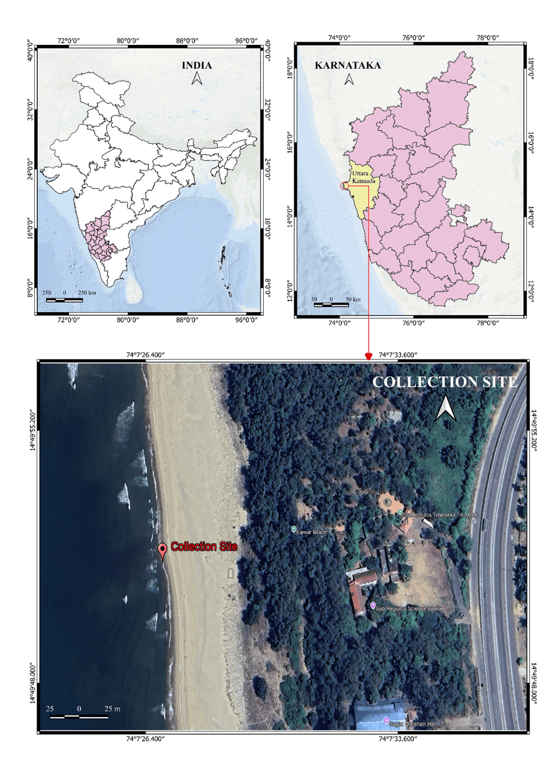
Figure 1. Collection locality of Lepas (Lepas) indica Annandale, 1909 at Karwar, Uttara Kannada District, Karnataka, India (14.8311° N, 74.1250° E).

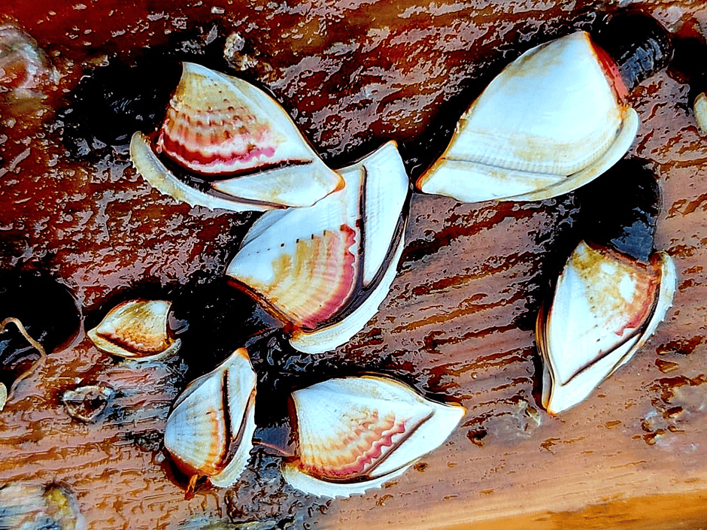
Figure 2. Freshly collected Lepas specimens illustrating the external contrast between Lepas (Lepas) indica Annandale, 1909, with a conspicuously spinous/sinuous carinal margin, and Lepas (Lepas) anatifera Linnaeus, 1758, with a comparatively smooth carinal margin.

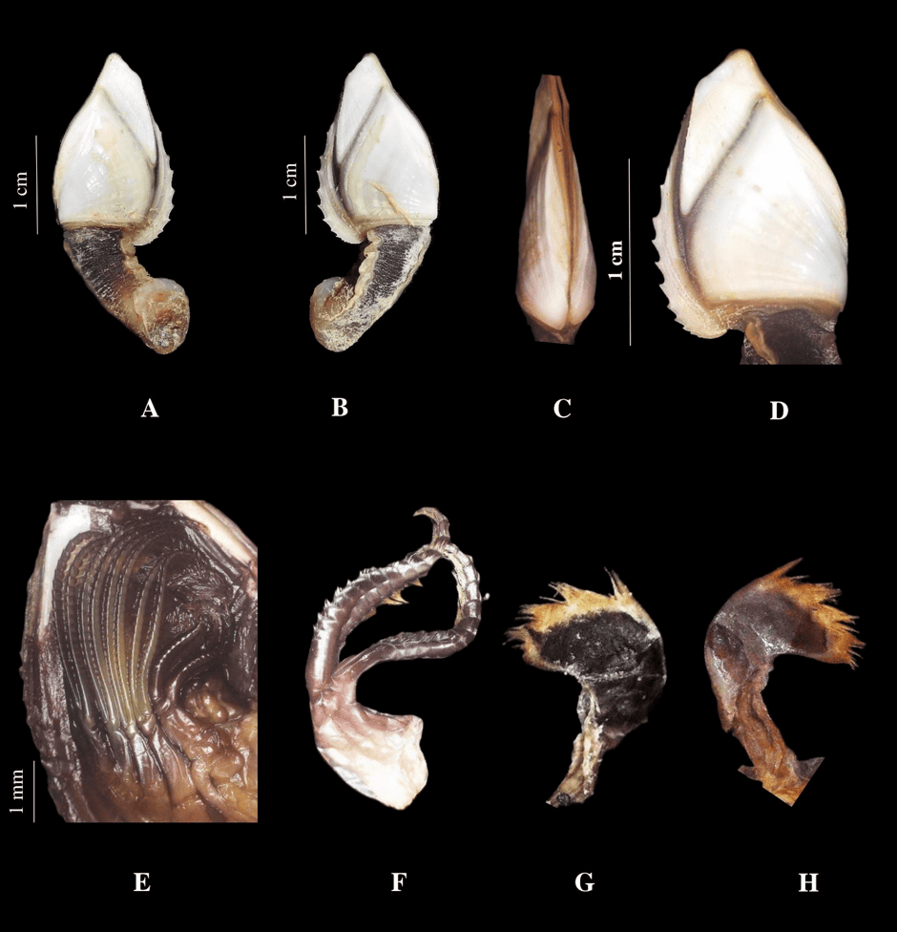
Figure 3. Lepas (Lepas) indica Annandale, 1909. A, overall left view; B, overall right view; C, ventral view after removal of the carina; D, enlarged carina showing the spinous/sinuous edge; E, cirri; F, enlarged first and second cirri; G, maxilla; H, mandible. Scale bars are as shown in the figure.

