Comparative Effects of Chronic Stevia, Saccharin, and Sucralose Consumption on Body Weight, Blood Glucose, Serum Cholesterol, and Histopathological Alterations in the Liver and Kidneys of Male Wistar Rats

Abstract
The increasing use of natural and artificial sweeteners as alternatives to sucralose has raised concerns regarding their long-term safety. This study examines the adverse effects of chronic administration of artificial sweeteners ( Stevia, saccharin, and sucralose) on body weight, blood glucose, serum cholesterol, followed by histopathological examination of the liver and kidneys.. Twenty adult male wistar rats were randomly assigned to four groups (n = 5): control, Stevia, saccharin, and sucralose. Treatments were administered orally once daily for eight weeks. Stevia- and saccharin-treated rats showed significantly greater body weight gain than the sucralose group (P < 0.05). Saccharin significantly reduced blood glucose and cholesterol levels, whereas sucralose produced the highest glucose levels. Histopathological examination revealed hepatocellular degeneration, fatty changes, vascular congestion, and renal tubular degeneration with inflammatory cell infiltration in all treated groups. These findings indicate that prolonged consumption of both natural and artificial sweeteners induce hepatic and renal tissue damage despite improvements in some metabolic parameters, highlighting the need for further investigations into their long-term safety.
Keywords: Stevia; Saccharin; Sucralose; Histopathology; Liver; Kidney; Wistar rats.
Introduction
The global prevalence of obesity, diabetes mellitus, and cardiovascular diseases has increased substantially over recent decades, prompting a growing demand for sugar substitutes as healthier alternatives to sucralose. Excessive dietary sugar intake has been strongly associated with metabolic disorders, leading both consumers and the food industry to adopt natural and artificial sweeteners in an effort to reduce caloric intake while maintaining palatability.
Saccharin is one of the most widely used non-nutritive artificial sweeteners because of its high sweetening potency and negligible caloric value. Although it has long been considered safe within the recommended acceptable daily intake, accumulating evidence suggests that prolonged consumption may induce oxidative طstress, inflammation, metabolic disturbances, and structural alterations in several organs, particularly the liver and kidneys.
Stevia (Stevia rebaudiana Bertoni) is a natural, non-caloric sweetener that has gained considerable attention as a potential healthier alternative to both sucralose and synthetic sweeteners. Its major bioactive constituents, stevioside and rebaudioside A, have been reported to possess antihyperglycemic, antioxidant, anti-inflammatory, and lipid-lowering properties. Nevertheless, the long-term safety of Stevia remains controversial, as some experimental studies have reported adverse histopathological changes following prolonged exposure.
Because the liver and kidneys play central roles in the metabolism, detoxification, and excretion of dietary compounds, they are particularly susceptible to injury induced by chronic exposure to sweetening agents. Histopathological evaluation provides a sensitive approach for detecting tissue alterations that may occur before biochemical abnormalities become evident.Although numerous studies have independently investigated the biological effects of sucralose, saccharin, and Stevia, direct comparisons of their metabolic and histopathological effects under identical experimental conditions remain limited. Therefore, the present study aimed to compare the effects of chronic administration of Stevia, saccharin, and sucralose on body weight, blood glucose, serum cholesterol, and histopathological changes in the pancreas, liver, and kidneys of male wistar rats.
Materials and methods
Experimental design
Twenty healthy adult male Wistar rats (Rattus norvegicus), weighing 230–250 g, were obtained from the Animal House, Faculty of Science, University of Kufa, Iraq. Animals were housed under standard laboratory conditions (22 ± 2°C, relative humidity 50–60%, and a 12 h light/12 h dark cycle) with free access to a standard laboratory diet and drinking water. All rats were acclimatized for one week before the experiment commenced. The animals were divided into four groups each grtpup contain five rats :
- Group I : Control group received 1.5 mL sterile distilled water.
- Group II : Rats received orally 15 mg of Stevia dissolved in 1.5 mL sterile distilled water.
- Group III : Rats received orally 15 mg/kg of saccharin dissolved in 1.5 mL sterile distilled water.
- Group IV: Rats received 15 mg/kg of sucralose dissolved in 1.5 mL sterile distilled water.
All treatments was administered once daily by oral gavage for eight consecutive weeks. The selected dose was based on the protocol described by Saraswathy and Mishra (2018).
liver, and kidneys were collected , after animal euthanized, fixed in 10% processed routinely, embedded in paraffin wax, sectioned at approximately 4 µm thickness using a rotary microtome, and stained with hematoxylin and eosin (H&E).
Measurement of Body Weight
Body weight was recorded at baseline (Week 0) and subsequently at Weeks 4 and 8 using a calibrated electronic balance. Body weight gain was calculated by comparing the measurements obtained during the experimental period.
Blood sampling and Biochemical Analysis
Blood samples was collected at 0, 4, and 8, weeks aseptically from the tail vein. Serum was separated by centrifugation and used for the determination of blood glucose and total cholesterol concentrations using commercially available diagnostic kits according to the manufacturers' instructions.
Statistical Analysis Data were analyzed using IBM SPSS Statistics version 26.0 (IBM Corp., Armonk, NY, USA). results were evaluated using the One-Way ANOVA test; all results were expressed as mean ± SD, and values were considered significant at P ≤ 0.05. Comparisons among experimental groups were performed using one-way analysis of variance (one-way ANOVA), followed by Tukey's post hoc multiple comparison test.
Ethical Statement
All animal handling and experimental procedures were carried out in accordance with the guidelines for the care and use of laboratory animals of the Faculty of Veterinary Medicine, University of Kufa, Iraq. Every effort was made to minimize animal suffering and to use the minimum number of animals required to achieve the objectives of the study.
Results & Discussion
The results shown in Table (1) indicate significant differences in body weight gain were observed among the experimental groups through the study (P < 0.05). Rats receiving Stevia and saccharin exhibited greater body weight gain than those in the sucralose-treated group, whereas the control group maintained a normal pattern of weight gain.
Table 1: Body weight measurement
Time /mean ±stander deviation |  |  | Groups
weight8week | weight4week | weight1week
183±1.5bd | 154±10.5bd | 117±21.9b |  | Water(G1)
193±10.3acd | 185±7.9ad | 155.6±10.2ad |  | Stevia(G2)
184.6±1.1bd | 176±3.8d | 151.2±14.6acd |  | Saccharine (G3)
152.2±3.1abc | 118.2±29.9abc | 127.4±16.8bc |  | Sucrose(G4)
178.2±16.6 | 158.4±30.4 | 137.8±22.3 |  | Total
.000* | .000* | .005* |  | ANOVA Test.

Sample size (n) is 5 for each group. * -Indicates significant difference among all groups at p < 0.05 as tested by ANOVA Test. Superscript letters (a, b, c and d) indicate significant differences compared to group 1, 2,3 and 4 respectively at p < 0.05 as tested by Tukey post hoc multiple comparisons.
Time /mean +_stander deviation |  |  | Groups
sugar level 8 week | sugar level 4 week | sugar level 1 week | Groups
119.6±1.1 ^{bc} | 107.8±1.6bc | 97±1.2 | Water (G1)
±4.5 ^{ac d} 106.8 | 117.6±6 ª d | 97±1.2 | Stevia (G2)
±4.6 ^{a bd} 99.4 | 120±2.9 ^{a d} | 96.4±0.5 | Saccharine (G3)
± 0.5 bc 122.6 | 103.2±1.3 ^{bc} | 97±1.2 | Sucrose (G4)
±10.1 112.1 | 112.1±7.7 | 96.8±1 | Total
.000* | .000* | .772 | ANOVA Test.

Table 2: Sugar level Measurement

Table (2) showed no significant differences among the groups at baseline. While in four weeks of treatment, blood glucose levels increased significantly in the Stevia- and saccharin-treated groups compared with the control and sucralose groups (P < 0.05). However, by the end of the eighth week, glucose concentrations had significantly decreased in both the Stevia and saccharin groups, whereas the sucralose-treated group exhibited the highest blood glucose level (P < 0.05).
On the other hand, the results in Table (3) No statistically significant differences were observed among the groups during the first week of the experiment. After four weeks, the saccharin-treated group showed a significant increase in serum cholesterol compared with the Stevia and sucralose groups (P = 0.005). At the end of the experimental period, serum cholesterol levels were significantly lower in the saccharin-treated group than in the control and Stevia-treated groups (P < 0.05).
Table 3: cholesterol level measurement
Time /mean +_stander diviation |  |  | Groups
cholesterol level 8 week | cholesterol level 4 week | cholesterol level 1 week | Groups
±1.1c 117.4 | ± 1.1bd 124.6 | 120.2 ± 2.2 | Water (G1)
± 1.3c 116.8 | ±2.7ac 118.2 | 121.4 ± 2.4 | Stevia (G2)
114.4 ± 1.1abd | ± 2.3bd 124.4 | 122.4± 2.1 | Saccharine (G3)
± 1.1c 116.4 | ±1.3ac 118.2 | 121.4 ± 2.4 | Sucrose (G4)
±1.5 116.2 | ±3.7 121.3 | 121.3 ± 2.2 | Total
.006 | .000 | .538 | ANOVA

Histopathology
The histopathology results of liver showed normal hepatic lobular architecture in control group (Fig. 1). However, the histopathology results showed hepatocellular degeneration with disruption of hepatic cords in stevia treated group (Fig. 2). However, Saccharin-treated group, pyknotic nuclei were observed in hepatocytes, indicating cellular injury (Fig. 3). While sucralose-treated group showed fatty degeneration characterized by cytoplasmic vacuolation of hepatocytes (Fig. 4).
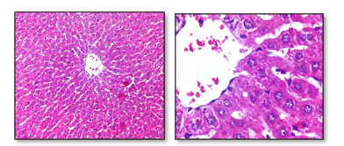
Figure 1:Photomicrograph of liver of control negative group rats.
A&B/ Normal architecture of hepatic tissue. Note the arrangement of hexagonal lobule arrow) and acini. hexagonal lobules are centered on the central vein. Hematoxylin and Eosin. A:100X and B:400x.
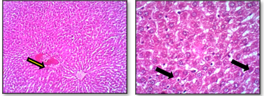
Figure 2 : Photomicrograph of Liver of stevia treated group rats.
A&B/ Severe fatty change of hepatic cells appear as vacuoles(black arow) and congestion (yellow arrow) was observed in affected area of hepatic tissue. Hematoxylin and Eosin. A:100X and B:400x.
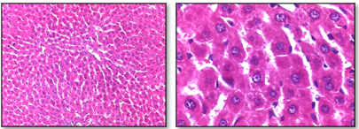
Figure 3 :Photomicrograph of Liver Saccharin-treated group rats.
A&B/ Normal histology of hepatic tissue was observed. Hematoxylin and Eosin. A:100X and B:400X.

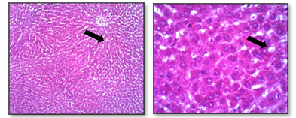
Figure 4: Photomicrograph of liver of sucralose treated group rats.
A&B/ Mild Fatty change formed vacuoles (black arrow) in hepatic tissue was observed. Hematoxylin and Eosin. A:100X and B:400X.
Finally, Kidney sections of the control negative group showed normal renal cortical and medullary architecture (Figs. 5 and 6). In the Stevia-treated group, renal tissue exhibited degeneration and necrosis of tubular epithelial cells accompanied by inflammatory cell infiltration within the cortex, together with degenerative changes in the loops of Henle (Figs. 7 and 8). The saccharin-treated group demonstrated degeneration of proximal and distal renal tubules with hemorrhagic lesions in the renal medulla (Figs. 9 and 10). Similar pathological alterations were observed in the sucralose-treated group, including tubular epithelial degeneration and hemorrhage within the renal medulla (Figs. 10 and 11).
; 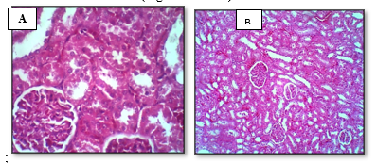
Figure 9: Photomicrograph of kidney of control negative group rats.
A&B/ Normal architecture of renal cortex was observed. Note the renal glomeruls (black arrow) and renal tubules . Hematoxylin and Eosin. A:100X and B:400X.
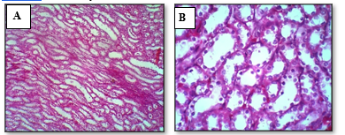
Figure 10:Photomicrograph of kidney of control negative group rats.
A&B/ Normal architecture of renal medulla was observed. Hematoxylin and Eosin. A:100X and B:400x.
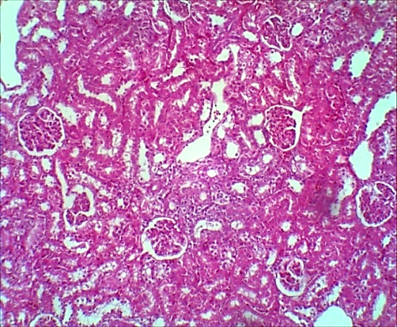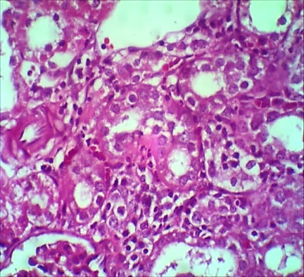
B
A
Figure 11: Photomicrograph of Kidney post stevia treatment group rats .
A&B/
Necrosis of epithelial cells of renal tubules (black arow) filled with inflammatory cell infiltration (yellow arrow) was observed in renal cortex. Hematoxylin and Eosin. A:100X and B:400X.

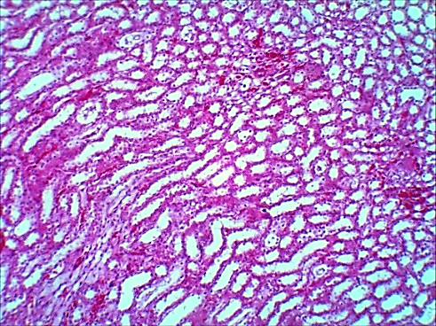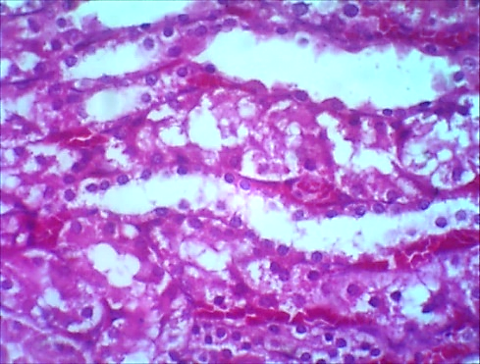
A
B
Figure 12: Photomicrograph of Kidney post stevia treatment group rats .
A&B/ Destruction of epithelial cells of loop henle tubules was observed in renal medulla. Hematoxylin and Eosin. A:100X and B:400X.
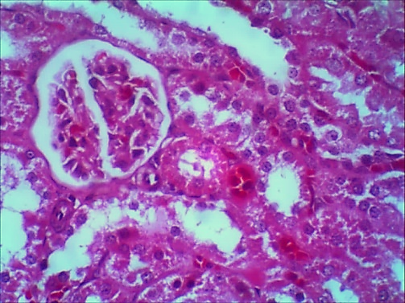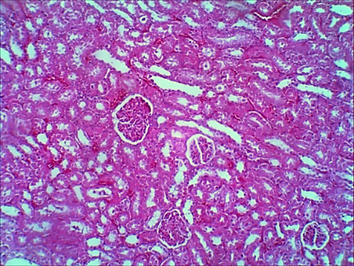
B
A
Figure 13: Photomicrograph of of Kidney post Saccharine treatment group rats .
A&B/ Destruction of epithelial cells (black arrow) of individual renal tubules was observed in renal cortex. Hematoxylin and Eosin. A:100X and B:400X.
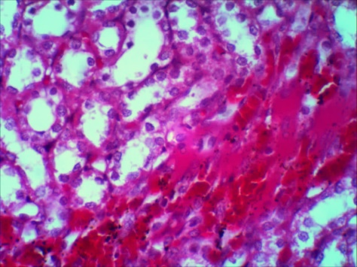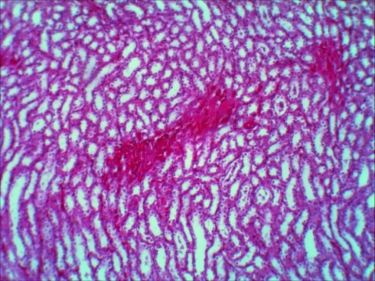
A
B
Figure 14: Photomicrograph of of Kidney post Saccharine treated group rats .
A&B/ Hemorrhage formed numerous as clusters was observed in renal medulla. Hematoxylin and Eosin. A:100X and B:400X.
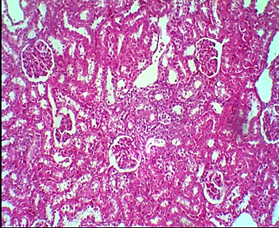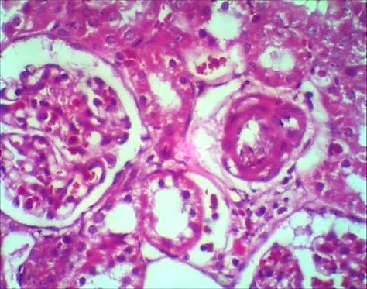
Figure 15: Photomicrograph of kidney post sucrose treatment group rats.
A&B/ Destruction of epithelial cells (black arrow)of individual renal tubules was observed in renal cortex. Hematoxylin and Eosin. A:100X and B:400X.
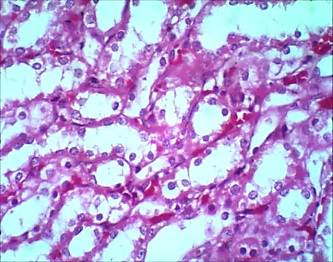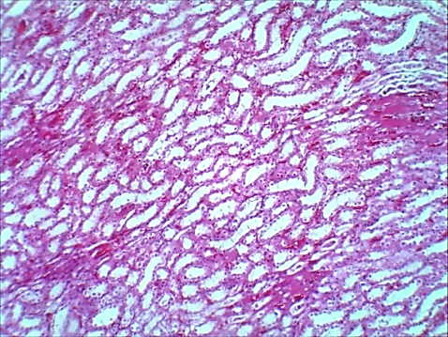
Figure 16: Photomicrograph of Kidney of sucrose treated group rats.
A&B/ Destruction of epithelial cells (black arrow) of loop henle renal tubules with hemorrhage (yellow arrow) present between tubules was observed in renal medulla. Hematoxylin and Eosin. A:100X and B:400X.
The present study compared the effects of chronic administration of Stevia, saccharin, and sucralose on body weight, blood glucose, serum cholesterol, and histopathological alterations in the liver and kidneys of male Wistar rats. Although Stevia and saccharin produced favorable effects on selected metabolic parameters, histopathological examination demonstrated that all tested sweeteners induced varying degrees of hepatic and renal injury.
The significant increase in body weight observed in the Stevia- and saccharin-treated groups compared with the sucralose-treated group suggests that non-nutritive sweeteners may influence energy balance and metabolic regulation independently of their caloric content. Similar findings have been reported by Swithers et al. (2013), who proposed that artificial sweeteners may alter physiological mechanisms involved in appetite regulation and energy homeostasis.

Biochemical analysis revealed that saccharin significantly reduced blood glucose and serum cholesterol concentrations by the end of the experimental period. These findings agree with previous studies suggesting that non-nutritive sweeteners may improve glycemic control by reducing dietary sugar intake and modulating glucose metabolism (Ionescu et al., 1988; Amin et al., 2016). In contrast, the sucralose-treated group exhibited the highest blood glucose concentration, consistent with the well-established metabolic effects of excessive sucralose consumption.
Despite these metabolic improvements, histopathological examination demonstrated that chronic exposure to all tested sweeteners resulted in structural alterations in hepatic tissue. Stevia administration induced hepatocellular degeneration, whereas saccharin caused nuclear pyknosis, indicating irreversible cellular injury. Sucralose treatment resulted in fatty degeneration and cytoplasmic vacuolation, suggesting impaired lipid metabolism and hepatocellular damage. These observations are consistent with previous reports describing oxidative stress, inflammatory responses, and lipid peroxidation as major mechanisms underlying sweetener-induced liver injury (Farid et al., 2020; Finamor et al., 2021).
Renal histopathological findings further confirmed the adverse effects of prolonged sweetener consumption. Degeneration of renal tubular epithelial cells, inflammatory cell infiltration, and hemorrhagic lesions were observed in the treated groups, particularly following saccharin and sucralose administration. These pathological alterations may reflect direct nephrotoxic effects associated with chronic exposure to sweetening agents and their metabolites. Similar renal lesions have been reported by Toskulkao et al. (1994) and Amin et al. (2016), who demonstrated that prolonged sweetener administration may impair renal function through oxidative damage and tubular degeneration.Overall, the present findings indicate that improvements in biochemical parameters should not be interpreted as evidence of complete biological safety. Histopathological assessment revealed significant tissue alterations that may precede clinically detectable organ dysfunction. Therefore, long-term consumption of both natural and artificial sweeteners should be approached with caution, and further studies using larger sample sizes, longer exposure periods, and additional molecular and biochemical markers are recommended to better clarify their safety profile.

Conclusion
Chronic administration of Stevia, saccharin, and sucralose to male Wistar rats was associated with differences in body weight, blood glucose, and serum cholesterol, together with variable histopathological alterations in the liver and kidneys. Although some treatments were associated with favorable changes in selected biochemical parameters, histological examination demonstrated hepatic and renal abnormalities in treated animals. These findings suggest that changes in metabolic indicators alone may not adequately reflect tissue-level effects during prolonged exposure. Interpretation should remain cautious because of the small experimental groups and the predominantly qualitative histopathological assessment. Further controlled studies with larger sample sizes, clearly standardized dose regimens, quantitative histopathological evaluation, and additional biochemical markers are required to clarify the biological significance and long-term safety implications of these observations.
Declaration of AI Use

This manuscript was prepared through the intellectual contributions of the author(s) to the study design, data analysis, interpretation of results, and scholarly content. Grammarly and ChatGPT were used solely to assist with grammatical refinement and reference formatting during manuscript revision. The author(s) accept full responsibility for the accuracy, integrity, and final content of the manuscript.

COMPETING INTERESTS DISCLAIMER:
Authors have declared that they have no known competing financial interests OR non-financial interests OR personal relationships that could have appeared to influence the work reported in this paper.

References
- Alsunni, A. A. (2020). Effects of artificial sweetener consumption on glucose homeostasis and its association with type 2 diabetes and obesity. International Journal of General Medicine, 13, 775–785. https://doi.org/10.2147/IJGM.S274116
- Amin, K. A., Al-Muzafar, H. M., & Abd Elsttar, A. H. (2016). Effect of sweetener and flavoring agent on oxidative indices, liver and kidney function levels in rats. Indian Journal of Experimental Biology, 54(1), 56–63.
- Archibald, A. J., Dolinsky, V. W., & Azad, M. B. (2018). Early-life exposure to non-nutritive sweeteners and the developmental origins of childhood obesity: Global evidence from human and rodent studies. Nutrients, 10(2), Article 194. https://doi.org/10.3390/nu10020194
- Farid, A., Hesham, M., El-Dewak, M., & Amin, A. (2020). The hidden hazardous effects of Stevia and artificial sweeteners consumption in male and female albino mice in comparison with sucralose. Saudi Pharmaceutical Journal, 28(10), 1290–1300. https://doi.org/10.1016/j.jsps.2020.08.020
- Fawzi, D. F., & Jassim, B. A. (2021). Histological study and some biochemical parameters of the effects of Stevia on pancreas in white mice. Medical Journal of Pharmaceutical Sciences, 8(2), 116–128.
- Finamor, I. A., Bressan, C. A., Torres-Cuevas, I., Rius-Pérez, S., da Veiga, M., Rocha, M. I., Pérez, S., & Boveris, A. (2021). Long-term aspartame administration leads to fibrosis, inflammasome activation, and gluconeogenesis impairment in the liver of mice. Biology, 10(2), Article 82. https://doi.org/10.3390/biology10020082
- Gardener, H., & Elkind, M. S. V. (2019). Artificial sweeteners, real risks. Stroke, 50(3), 549–551. https://doi.org/10.1161/STROKEAHA.119.024445
- Ionescu, E., Rohner-Jeanrenaud, F., Proietto, J., Rivest, R. W., & Jeanrenaud, B. (1988). Taste-induced changes in plasma insulin and glucose turnover in lean and genetically obese rats. Diabetes, 37(6), 773–779. https://doi.org/10.2337/diab.37.6.773
- Iman, M. M. (2011). Effect of aspartame on some oxidative stress parameters in liver and kidney of rats. African Journal of Pharmacy and Pharmacology, 5(6), 678–682.
- Kundi, H., Waseem, N., & Yousaf, M. (2018). Effect of an artificial sweetener on rat's pancreas and body weight. Journal of Islamabad Medical & Dental College, 7(2), 84–87.
- Journal of Islamabad Medical & Dental College+ 1
- Lelyana, R. (2016). Effect of coffee daily consumption on uric acid level and body weight to prevent metabolic syndrome. Journal of Nanomedicine & Nanotechnology, 7(5), Article 1000398. https://doi.org/10.4172/2157-7439.1000398
- Luna, L. G. (1968). Manual of histologic staining methods of the Armed Forces Institute of Pathology (3rd ed.). McGraw-Hill.
- McKenzie, E., & Lee, S. Y. (2022). Sucralose reduction methods and their application in confections: A review. Food Science and Biotechnology, 31(4), 387–398. https://doi.org/10.1007/s10068-022-01035-7
- Pang, M. D., Goossens, G. H., & Blaak, E. E. (2021). The impact of artificial sweeteners on body weight control and glucose homeostasis. Frontiers in Nutrition, 7, Article 612832. https://doi.org/10.3389/fnut.2020.612832
- Romo-Romo, A., Aguilar-Salinas, C. A., Brito-Córdova, G. X., Gómez-Díaz, R. A., Vilchis-Valentín, D., & Almeda-Valdes, P. (2016). Effects of non-nutritive sweeteners on glucose metabolism and appetite-regulating hormones: A systematic review of observational prospective studies and clinical trials. PLoS ONE, 11(8), Article e0161264. https://doi.org/10.1371/journal.pone.0161264
- Saraswathy, S., & Mishra, S. (2018). Effect of artificial sweeteners on blood glucose concentration. Journal of Medical Academy, 1(2), 81–85.
- Sclafani, A., Bahrani, M., Zukerman, S., & Ackroff, K. (2010). Stevia and saccharin preferences in rats and mice. Chemical Senses, 35(5), 433–443. https://doi.org/10.1093/chemse/bjq033
- Sharma, A., Amarnath, S., Thulasimani, M., & Ramaswamy, S. (2016). Artificial sweeteners as a sugar substitute: Are they really safe? Indian Journal of Pharmacology, 48(3), 237–240. https://doi.org/10.4103/0253-7613.182888
- Swithers, S. E., Sample, C. H., & Davidson, T. L. (2013). Adverse effects of high-intensity sweeteners on energy intake and weight control in male rats and obesity-prone female rats. Behavioral Neuroscience, 127(2), 262–274. https://doi.org/10.1037/a0031717
- Toskulkao, C., Deechakawan, W., Leardkamolkarn, V., Glinsukon, T., & Buddhasukh, D. (1994). The low-calorie natural sweetener stevioside: Nephrotoxicity and its relationship to urinary enzyme excretion in the rat. Phytotherapy Research, 8(5), 281–286. https://doi.org/10.1002/ptr.2650080507

