Ichthyofaunal diversity of Tammileru reservoir of Andhra Pradesh during 2016-2018

Abstract:
Tammileru is a medium-sized, seasonal river forms the boundary between Krishna and Eluru districts of Andhra Pradesh state. The river originates in the Eastern Ghats, from Bethupalli in Khamam district reaches Kolleru Lake after passing through Nagireddygudem reservoir in Chintalapuddi Mandal. The river is a significant freshwater source for the Ramsar wetland Kolleru Lake, crucial for diverse migratory and resident fish species which connected to the Kolleru Lake ecosystem. It primarily acts as a breeding and feeding ground for various fish species. A dam was constructed on Tammileru river at Nagireddygudem village of Chintalapudi Mandal and this reservoir is the principal site for my study area, where fish species were collected and used for this study. There are no fishermen regularly operating in this reservoir and the fishing is carried out by part-time fishermen who employ gill nets, cast nets and rod and line for raising extra income. Generally, local fishermen catching the fishes on daily basis but on weekends, Saturday the catch was more to sell for Sunday. So, I visited the local fish market twice in a month during weekends to report the fish species diversity and take necessary measurements. Fish diversity is characterized by orders such as Cypriniformes, Siluriformes, Perciformes, and Channiformes, with a mix of indigenous and commercial species. The dominant fish fauna comprises in this river are Wallago attu, Channa marulius, Mystus spp., Chela sp., Ompok sp., Heteropneustes fossils, Puntius spp., Etroplus spp., and Labeo spp. The transplanted carps, Labeo rohita, Cirrhinus mrigala and Cyprinus carpio appear in the abundance catches. In the absence of any regular stocking, the wild populations are being exploited by the fishermen. A change in population structure of fishes has been reported due to rapid eutrophication, carp species giving way to air breathing fishes and catfishes.
Keywords: Eastern Ghats, Eutrophication, Gill nets, Kolleru Lake, Resident fish species.
Introduction: India has an extensive riverine water resource, known for comprising rich fish diversity and its production potential. The Indian’s 29,000 km of riverine resources which includes 14 major rivers (catchment area >20,000 km²), 44 medium rivers (catchment area between 2,000 and 20,000 km²), and innumerable minor rivers (catchment area <2000 km²) (Das et al., 2021).
The Tammileru river is a non-perennial medium sized river originating from Bethupalli Cheruvu (Betupalli tank) in the Khammam district of Telangana and flowing roughly 130 km and finally discharged into Kolleru Lake, Andhra Pradesh. There is a dam on the Tammileru river at Nagireddigudem village of Chintalpudi mandal of West Godavari district, A.P., and it was 60km away from the river origin site. From the site of reservoir, the river travels 40km and enters in to Eluru town and from there it travels 15km and enters in to Kolleru lake, the largest freshwater lake of India and a Ramsar convention site (Rao et al., 2018).
Tammileru flows through the Eluru district, and is notorious for frequently breaching its banks and causing severe flooding in the city of Eluru during heavy rain seasons before draining into Kolleru lake. Hence, this river widely considers the Dukkadayini (river of sorrow or bringer of distress) of Eluru. To protect the surrounding people from these floods and as well as meet their agricultural needs, this dam was constructed in 1980 by the Government of Andhra Pradesh. The reservoir’s total area covers 900 hectares and having 236 square miles of catchment area with 3 TMC (Thousand Million cubic feet) storage capacity and providing irrigation facilities to surrounding villages with an ayacut of 9169 acres. The length of the earth dam was 6.4 kilometres with Full reservoir limit of 355 feet. The reservoir acting as a decisive irrigation source for over 3720 hectares (9192.32 acres) of upland areas across the Chintalpudi, Lingapalem and Chatrai mandals in the Eluru and Krishna districts. Totally, 9 villages Thalarlapalli, Errampalli, Edavalli, Kalynampadu, Mankollu, Polavaram, Chatrai, Thummagudem and Somavaram are benefitting under this irrigation and flood control project (District Survey Report for Eluru District, APSAC, 2023; Lianthuamluaia et al., 2020)
Regular estimation of fish species diversity from the aquatic ecosystems is a prerequisite for proper management and conservation of the respective resources. The study site, the Tammileru reservoir was visited at an interval of fifteen days from March 2016 to February 2018. Total 48 visits were made during this study period. Fish diversity showed high species richness, with studies identifying over 30 recorded species, dominated by orders such as Cypriniformes, Siluriformes, Perciformes and Channiformes, with a mix of indigenous and commercial species. The dominant fish fauna comprises in this river are Wallago attu, Channa marulius, Mystus spp., Chela sp., Ompok sp., Heteropneustes fossils, Puntius spp., Etroplus spp., and Labeo spp. The transplanted carps, Labeo rohita, Cirrhinus mrigala and Cyprinus carpio appear in the abundance catches. A comprehensive study on the fish and fisheries of Lake Kolleru and recorded 52 fish species of which 40 are primarily freshwater species belonging to 11 genera reported by Dutt and Murthy in 1976. In another study on the capture fishery of Lake Kolleru reported 11 additional species from the lake and a status position was given and an approach document for the eco-development of the lake was proposed (Dutt, 1983). Rao et al., (1987) reported 61 species of fish together with 12 prawn species. After restorations of the lake, there were 92 fish species reported from the lake (Rao et al., 2013; Raju et al., 2014).
The communications record the fish fauna of the resident fish population of the lake, in view of the changes in the lake habitat due to anthropogenic activities. Understanding the fish diversity of a particular region is crucial for the effective management of its ichthyofaunal resources and the formulation of appropriate conservation measures. Moreover, detailed knowledge of the existing fish fauna is fundamental for the sustainable utilization of fishery resources and serves as a basis for the scientific development and expansion of aquaculture (Hiddink et al., 2008). Although a large number of researchers have studied the ichthyofauna of lotic and lentic waters in various riverine systems, relatively few studies have focused on specific regions, leaving significant gaps in our understanding of their fish biodiversity (Jan et al., 2023). The present work provides an inventory of ichthyofauna of Tammileru reservoir, Eluru District. This will serve as a baseline of the ichthyofaunal diversity of the river and will facilitate future fish faunal surveys, monitoring and biodiversity studies.
Material and methods: Fishing is usually done by dugout boats of flat bottom made locally. Their sizes vary in length, width and depth. They are usually meant for one to three men. Locally available woods are used to construct the boat. It is usually “Sal” (Shorea robusta). The fishing boats used in the study area are locally referred to as Donga or Dinghi. Fishers in the Tammileru Reservoir employ a wide range of fishing nets to capture fish from their natural habitats. The selection and use of fishing gear vary depending on the type of aquatic ecosystem, such as reservoirs, rivers, ponds, and other water bodies, reflecting differences in habitat characteristics and fishing practices. The major types of fishing gears used in the study area are described below:
Gill nets: Gill nets are locally called as “Fasla Jaal”. Two types of gill nets are used: Floating gill nets and Stationary gill nets. The latter one has floats attached to the head twine and sinkers attached to the foot twine. The nets are made of nylon. These nets are of varying mesh sizes, which are tied across the river from one end to the other end on surface. It is kept overnight and taken out early morning. This is the main gear used in reservoirs.
Cast nets: It is locally known as “Saukhi” or “Jholi”. It is used in shallow areas. Sinkers are made of cast iron and thread is usually of nylon. Most of the fishermen personally own one cast net. Two types of cast nets are used in the area: (a) Stringed type as prevalent in northern India and (b) Non-Stringed type as prevalent in West Bengal and locally known as “Bangali Saukhi”.
Drag nets: They are locally called as “Mahajaal”. They are generally made up of nylon. Various mesh sizes are used in rivers, ponds, tanks etc. Dragnets are used in shallow water areas only. In reservoirs they are used on the periphery along the banks.
Fish sampling: Fishes were collected during the period of March 2016 to February 2018. Direct sampling of fish specimen was made in three steps on prefixed sites. Sampling was done in two ways:
• By Nets:- The fish specimens were sampled from their natural habitats.
• By Market:- From the local fish market fishermen.
Preservation, labelling and identification of sample: Preservation of fish specimens were necessary to confirm identification of fish species. The collected fish specimens were preserved in 10% formaldehyde solution at the sampling site itself. Every sample was labelled and entered in a field diary against a number. These details included locality, date and time of collection and other related information of specimen. A strong plastic label was used with serial number. Before preservation, colour of specimen was also recorded in the field diary.
Fish specimens were identified based on a combination of external morphological, morphometric, and meristic characteristics. Morphological features such as body shape, colouration, body size, and the shape and position of fins were carefully examined. Meristic characters, including the number of fin rays, scale counts in specific series, the presence or absence of scales in particular regions, and distinctive features such as barbels and the lateral line, were also considered for accurate identification. Morphometric measurements, particularly body proportions such as the ratio of head length to total body length, were used to support species identification. Both fresh and preserved specimens were examined during the identification process. Fresh specimens were primarily used to observe colour patterns, whereas preserved specimens were used for detailed morphometric and meristic analyses.
Results: This study reported the presence of thirty fish species belong to 8 orders, 10 families, 20 genera and 30 species (showed in the table 3 & figure 4) during study period. Monthly wise, seasonal wise, percentage wise and order wise observations of recorded fish species from Tammileru River shown in table 1, 2, 3 and 4 and figure 1, 2a, 2b and 3 respectively. Order Cypriniformes which contains Labeo rohita, Catla catla, Cirrihinus mrigala and Cyprinus carpio were dominant represented 11 species with 65.75 % contribution of the total fish species followed by Perciformes contains three species viz., Channa punctatus, C. striatus and Glossobius guiris were represented 9.17%, two species from Siluriformes, Wallago attu and Mystus vittatus which were about 17.50 %, Synbranchiformes represented single species, Mastacembulus armatus, reported about 2.75 % and other fish species were shown 5%.
Seasonal wise observations showed that Cypriniformes found more in monsoon (66.50%) season followed by pre-monsoon (65.50 %) season and post-monsoon (65.25 %) season, whereas Perciformes found more in post-monsoon (9.75 %) followed by monsoon (9.00 %) and pre-monsoon (8.75 %) season. Further, Siluriformes reported more in post- monsoon (17.75 %) season followed by pre-monsoon (17.50 %) and monsoon (17.25 %) season. Synbranchiformes were found more in post monsoon (3.00 %) season followed by pre-monsoon (3.00 %) and monsoon (2.25 %) season and remaining other fresh water fish species found more in pre-monsoon (5.75 %) season followed by monsoon (5.25 %) season and post-monsoon (4.00 %) season respectively.
Month wise observations of fish species from Tammileru reservoir also reported. Cirrihinus mrigala found more in the month of July followed by May and September; least in the month of October. Labeo rohita found more in the month of December followed by April and November; least in the month of October and Catla catla found more in October month and less percentage found in December month. Wallago attu found more in the month of June followed by February and March least percentage found in the month of December. And Cyprinus carpio found more in October and less in the months of June and December. Mystus sps., found more in the month of August followed by July and September and Channa sps., found highest percentage in the month of October followed by May, July and August. Glossobius guiris found more percentage in the month of February followed by January and April and November. Mastacembulus sps., found more in the month of October followed by January, June and December, and sometimes not available in the month of February and September, other fresh water fish species found more in the month of October and less percentage in the month of January, July and December which were shown in table 2.

Species | Pre-monsoon (%) | Monsoon (%) | Post-monsoon (%)
Cirrihinus mrigala | 5.00 | 4.50 | 4.25
Labeo rohita | 43.00 | 37.75 | 44.25
Catla catla | 9.50 | 14.00 | 8.00
Wallago attu | 10.00 | 6.50 | 10.00
Cyprinus carpio | 8.00 | 10.25 | 8.75
Mystus sps. | 7.50 | 10.75 | 7.75
Channa sps. | 4.50 | 5.75 | 3.75
Glossobius | 3.75 | 3.00 | 5.75
Mastacembulus sps. | 3.00 | 2.25 | 3.00
Others | 5.75 | 5.25 | 4.00
Table 1. Percentage of fish species in a seasonal wise catch composition.
Order | Pre-monsoon (%) | Monsoon (%) | Post-monsoon (%)
Cypriniformes | 65.50 % | 66.50 % | 65.25 %
Perciformes | 8.75 % | 9.00 % | 9.75 %
Siluriformes | 17.50 % | 17.25 % | 17.75 %
Synbranchiformes | 3.00 % | 2.25 % | 3.00 %
Others | 5.75 % | 5.25 % | 4.00 %
Table 2. Order wise fish species in a seasonal wise catch composition
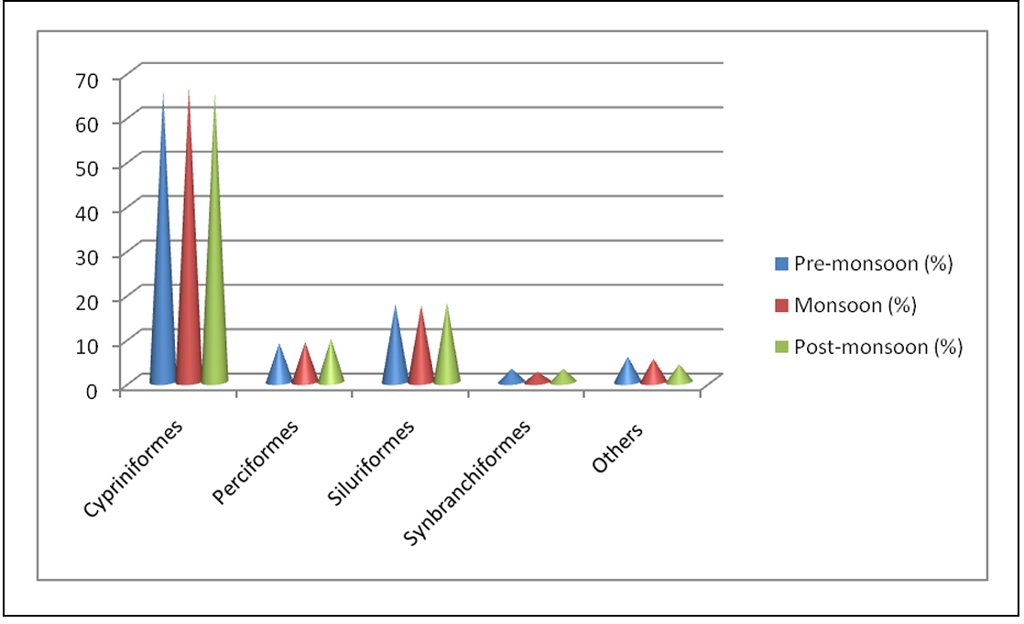
Figure 1. Order wise fish species in a seasonal wise catch composition
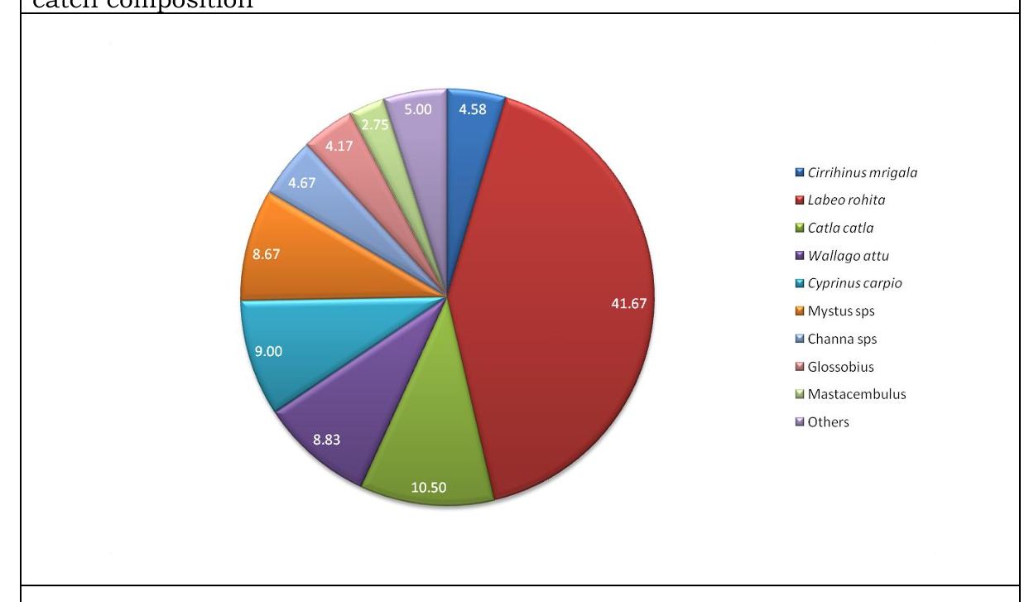
2a
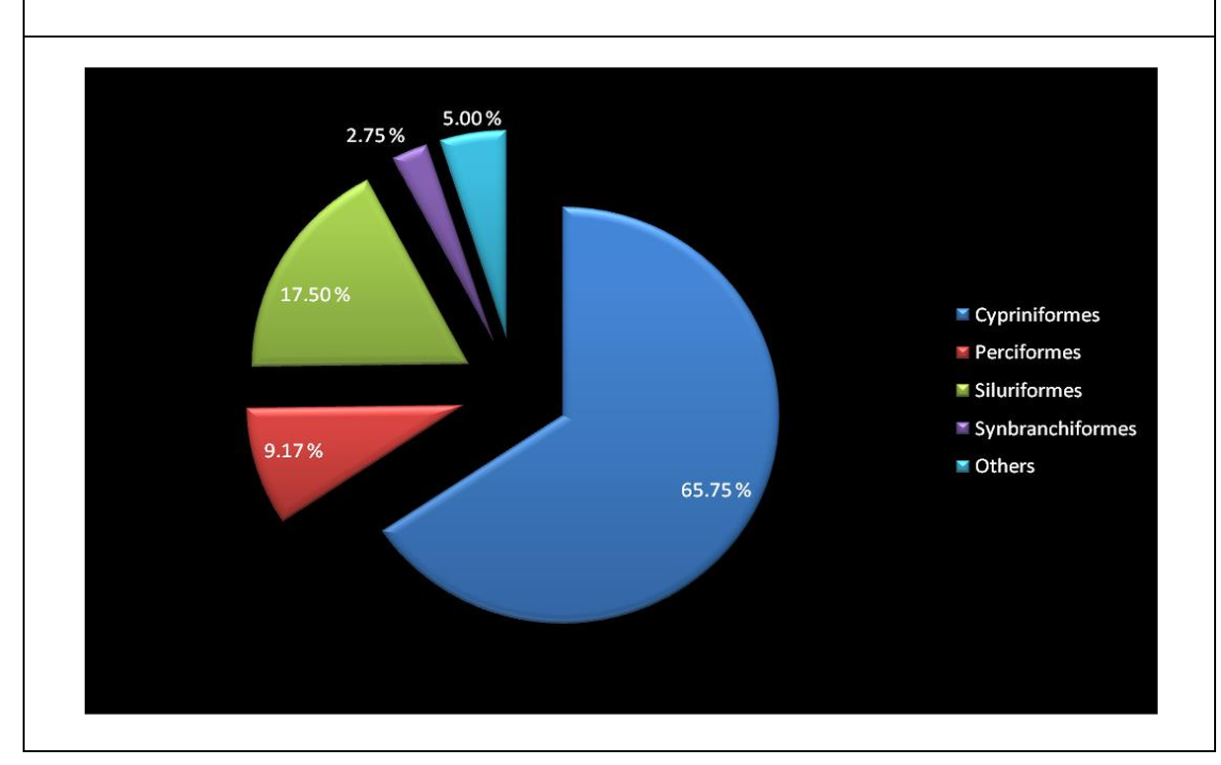
2b
Figure 2a & 2b. Species wise and order wise fish species in a seasonal wise catch composition.
S. No | Order | Family | Genus | Species | Common Name
1 | Cypriniformes | Cyprinidae | Labeo | rohita | Rohu
 |  |  |  | calbasu | Kaki botche
 |  |  |  | bata | Bata chepa
 |  |  |  | fimbriatus | fringed-lipped peninsula carp/yerra-gandumenu
1 | Cypriniformes | Cyprinidae | Catla | catla | Botcha
1 | Cypriniformes | Cyprinidae | Cirrhinus | mrigala | Gaddi chepa
 |  |  |  | reba | Reba carp
1 | Cypriniformes | Cyprinidae | Cyprinus | carpio | Common carp
1 | Cypriniformes | Cyprinidae | Osteobrama | cotio | Dhela / cotio
1 | Cypriniformes | Cyprinidae | Systomus | sarana | Olive barb / sarana barb
1 | Cypriniformes | Cyprinidae | Ctenopharyngodon | idella | Grass carp
2 | Siluriformes | Siluridae | Wallago | attu | Valuga
2 | Siluriformes | Siluridae | Ompok | bimaculatus | Two spotted butter catfish
 |  |  |  | pabda | Pabdah catfish
2 | Siluriformes | Bagridae | Mystus | vittatus | Erra jella
 |  |  |  | cavasius | Guddi jella
2 | Siluriformes | Bagridae | Clarius | batrachus | Walking catfish/Marpu
3 | Perciformes | Channidae | Channa | punctatus | Spotted snakehead
 |  |  |  | striatus | Striped snakehead
 |  |  |  | marulius | Great snake head/ Bullseye snake head/ Cobra snake head
3 | Perciformes | Cichlidae | Etroplus | maculatus | Orange chromide
3 | Perciformes | Cichlidae | Oreochromis | mossambicus | Mozambique tilapia
4 | Synbranchiformes | Mastacembelidae | Mastacembelus | armatus | Spiny eel
4 | Synbranchiformes | Mastacembelidae | Macrognathus | pancalus | Spiny eel
 |  |  |  | aral | One -stripe spiny eel
5 | Anguilliformes | Anguillidae | Anguilla | bengalensis | Mottled eel
 |  |  |  | bicolor | Shortfin eel
6 | Osteoglossiformes | Notopteridae | Notopterus | notopterus | Featherbacks / knife fishes
7 | Gobiiformes | Gobiidae | Glossogobius | giuris | tank goby/ bar-eyed goby
8 | Beloniformes | Belonidae | Xenentodon | cancila | Needle fish
Table 3. Fresh water fish species reported from Tammileru River, West Godavari District.
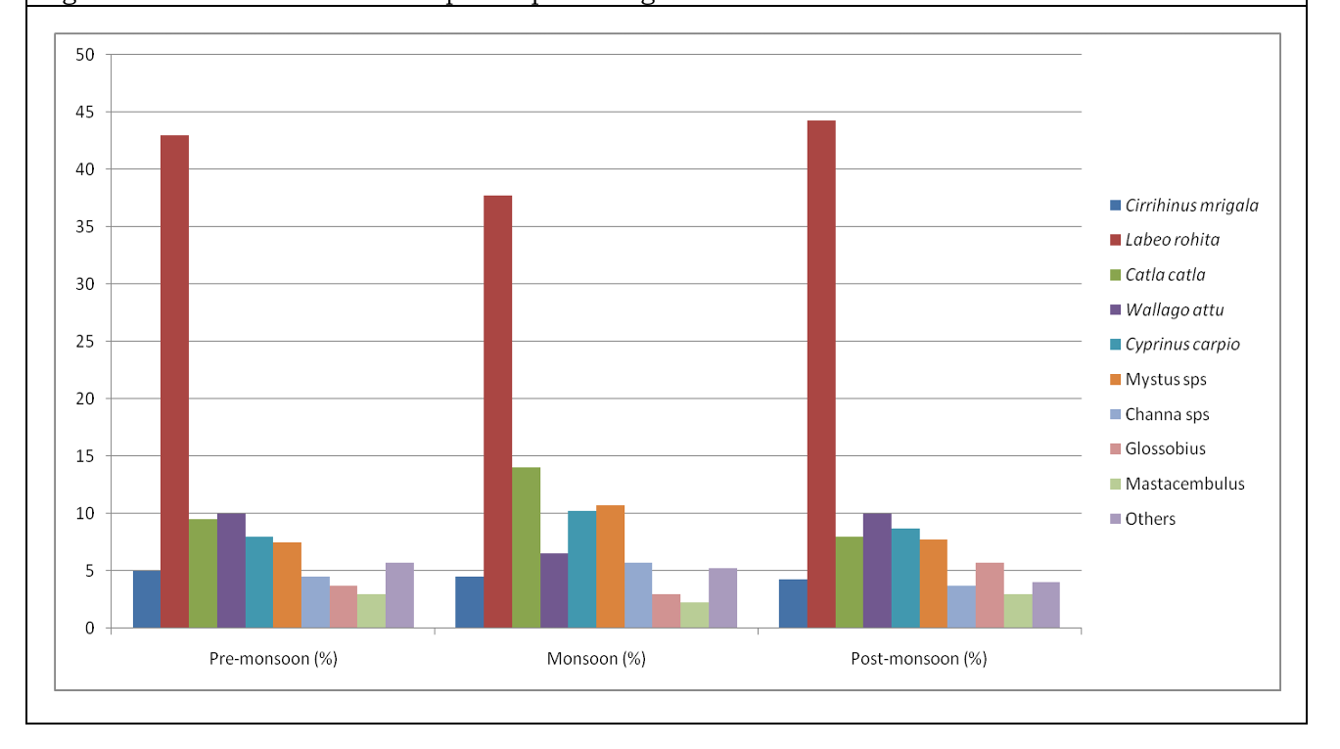
Figure 3. Seasonal variation of species percentage of fresh water fishes in Tammileru river
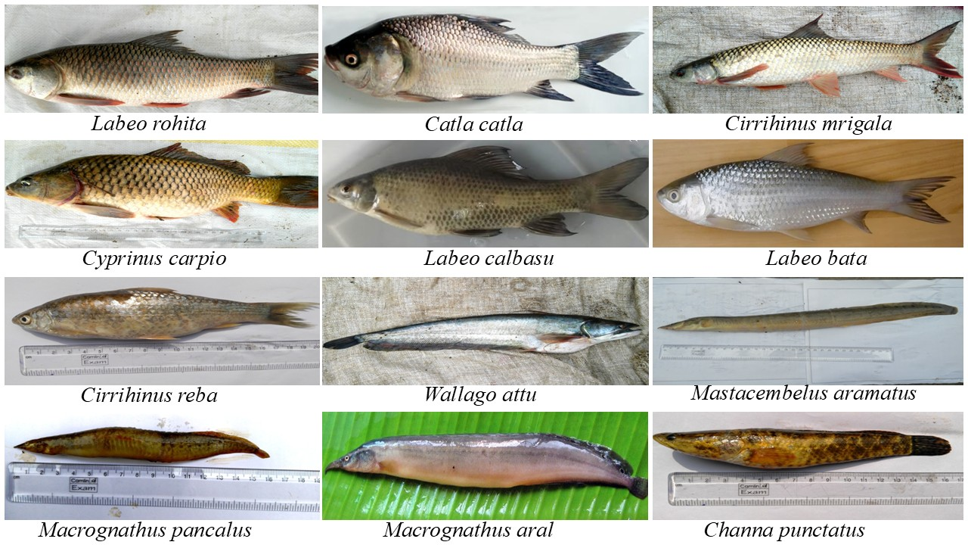
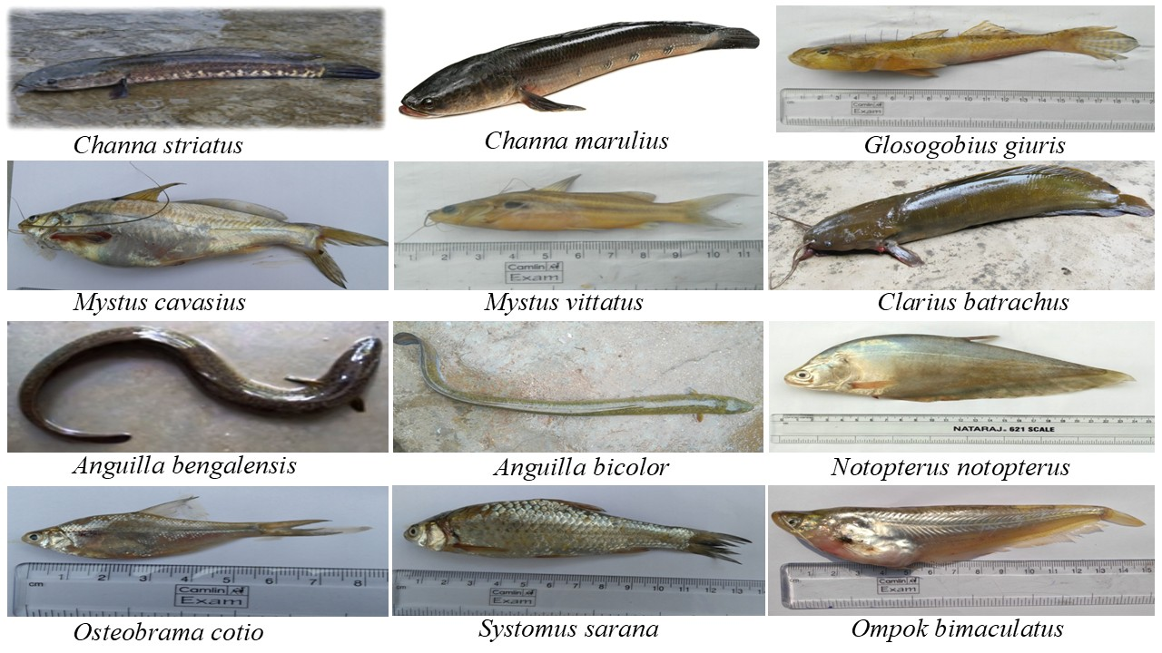
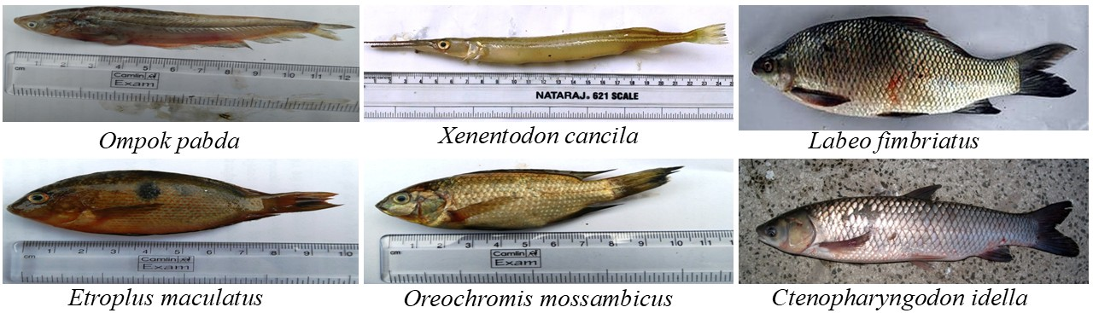
Fig. 4 A diverse freshwater ichthyofaunal community of Tammileru river of Andhra Pradesh.
Discussion: Fish diversity of a wetland is crucial for maintaining ecological balance, supporting food security, and driving nutrient cycling. Ichthyofaunal assemblages help regulate populations of algae and aquatic insects, provide critical income and nutrition for surrounding communities, and enhance the overall resilience of the habitat (Dudgeon et al., 2006). They also provide vital nutrition and income for millions, while enhancing habitat resilience against environmental changes and supporting high biodiversity. Wetlands such as the Tammileru reservoir therefore conserve not only species of commercial fisheries value but also those relevant to ornamental trade and conservation planning (FAO, 2024).
The monthly, seasonal, and percentage-wise composition of families, genera, and species recorded from Tammileru reservoir during the present study are summarized in Tables 1-3 and Figures 1-3. Cypriniformes emerged as the most dominant order, a pattern consistent with earlier studies from the connected Kolleru Lake ecosystem (Barman, 2004; Krishna et al., 2013; Rao et al., 2013). This recurring dominance across independent surveys of the same catchment suggests that Cypriniformes – and particularly the major and minor carps – form the ecological and economic backbone of this river system, likely reinforced by decades of carp stocking in reservoirs across the region (Lakshmi et al., 2015; Krishna et al., 2016). Krishna et al., (2013) similarly reported 14 species of Siluriformes from Kolleru Lake, and catfish diversity in the same lake has also been documented by Rao et al., (2013) and Lakshmi et al., (2015), broadly corroborating the present findings.
In the present investigation, 30 species were recorded belonging to 8 Orders among which order Cypriniformes were dominant by contributing 11 species. The 11 species of Cypriniformes are Labeo rohita, L. calbasu, L. bata, L. fimbriatus, Catla cattla, Cirrhinus mrigala, C. reba, Cyprinus carpio, Osteobrama cotio, Systomus sarana, Ctenopharyngodon Idella. All the 11 species of this order belonging to Cyprinidae family. Order Siluriformes consists of 6 species belonging to two families, viz., Siluridae and Bagridae. Wallogo attu, Ompok bimaculatus, O. pabda species belongs to Siluridae family and Clarias batrachus, Mystus vittatus, M. cavasius species belongs to Bagridae family. Order, traditionally Perciformes (modern classification) Channiformes consists of three species Channa punctatus, C. striatus and C. marulius belongs to family Channidae. Etropus maculatus and Oreochromis mossambicus belongs to Cichlidae family of Perciformes order. Mastacembelus armatus, Macrognathus pancalus, M. aral belongs to family Mastacemblidae and order Synbranchiformes or Mastacembeliformes. Anguilla bengalensis and A. bicolor belongs to Anguillidae family and Anguilliformes order. Order Osteoglossiformes consists of one species Notopterus notopterus belongs to family Notopteridae; order Gobiformes consists of one species Glosogobius giuris giuris belongs to family Gobiidae, and order Belontiformes consists of one species Xenontodon cancilla belongs to family Belonidae (Table-1 and Fig-1).
The seasonal shift was observed in the present study – with Cypriniformes peaking during the monsoon and Siluriformes and air-breathing fishes increasing during the post-monsoon period – likely reflects breeding-related upstream migration of carps triggered by monsoon inflow, followed by a corresponding rise in catfish and air-breathing species as water levels recede in the post-monsoon reservoir. The similar results were reported by Zhao et al., (2020). This pattern is consistent with the trend noted in the Abstract, where prolonged eutrophication in the reservoir is associated with a decline in carp populations in favour of air-breathing fishes and catfishes – species better adapted to low-oxygen, nutrient-enriched water. Taken together, these findings suggest that the present species composition may itself be an early indicator of gradually changing water quality in the reservoir, rather than a stable baseline (Jayasankar, 2018; Sugunan, 2000).
The presence of C. carpio and C. idella among the dominant catch is prominent, as both are exotic species rather than native to this river system. Their persistence in the catch in the absence of regular restocking suggests that these populations are now self-sustaining or repeatedly replenished through escape from upstream aquaculture activity, and their continued dominance may be exerting competitive pressure on native cyprinids such as Labeo and Cirrhinus species (Vilizzi and Tarkan, 2015). Monitoring the relative abundance of exotic versus native carp populations in subsequent years would help clarify whether this represents stable coexistence or a gradual displacement of native fish fauna.
It is also important to note that the present sampling strategy combined direct net-based collection with periodic visits to the local fish market, since no fishermen operate in the reservoir on a full-time basis. While this approach was necessary given the part-time nature of local fishing activity, it may have introduced a bias toward larger, commercially preferred species, while under-representing smaller or non-commercial fish less likely to reach the market (Ghosh et al., 2024). Future studies using standardized, gear-independent sampling across all size classes, together with quantitative diversity indices such as Shannon-Wiener and Margalef's richness index, would allow more precise year-on-year comparison and strengthen conservation assessments for this river system (Morris et al., 2014).
In case of Tammileru reservoir, a critical freshwater source feeding the Ramsar-designated Kolleru Lake, the ichthyofaunal composition documented here has management relevance beyond the reservoir itself. The dominance of hardy, tolerant taxa – catfishes, air-breathing fishes, and exotic carps – alongside comparatively limited representation of sensitive native cyprinids, reinforces the need for controlled stocking practices, water quality monitoring, and regulation of fishing gear, particularly fine-mesh gill nets that can indiscriminately capture juveniles, in order to conserve the native ichthyofaunal diversity of this river. This study provides a baseline inventory of the ichthyofauna of Tammileru reservoir that can inform future faunal surveys, monitoring programs, and biodiversity conservation planning for the wider Kolleru Lake ecosystem.

Conclusions
The study recorded 30 freshwater fish species from Tammileru reservoir, representing 8 orders, 10 families and 20 genera. Cypriniformes was the most dominant order, followed by Siluriformes, Perciformes, Synbranchiformes and other groups. The observed seasonal variation indicates that fish composition in the reservoir changes across pre-monsoon, monsoon and post-monsoon periods. The occurrence of both native and commercially important fish species suggests that the reservoir supports local fisheries and contributes to regional freshwater biodiversity. The findings provide baseline information that may support future ichthyofaunal surveys, conservation planning and sustainable management of fishery resources in the Tammileru–Kolleru ecosystem.

Declaration of AI Use

This manuscript was prepared through the intellectual contributions of the author(s) to the study design, data analysis, interpretation of results, and scholarly content. Grammarly and ChatGPT were used solely to assist with grammatical refinement and reference formatting during manuscript revision. The author(s) accept full responsibility for the accuracy, integrity, and final content of the manuscript.

COMPETING INTERESTS DISCLAIMER:
Authors have declared that they have no known competing financial interests OR non-financial interests OR personal relationships that could have appeared to influence the work reported in this paper.
Reference:
- Barman RP (2004). The fishes of the Kolleru Lake, Andhra Pradesh, India with comments on their conservation record zoological Survey India. 103(1-2):83-89.
- Das BK, Dibakar B, Lohith Kumar, Sangeetha M. Nair, Satish K, Koushlesh, Sajina AM, Roshith CM, Samanta S (2021). Ichthyofaunal diversity of the major Indian rivers: A review. Journal of Inland Fishery Society of India. 53 (1&2): 22-35. https://dx.doi.org/10.47780/jifsi.53.1&2.2021.115769.
- District Survey Report for Eluru District, Andhra Pradesh Space Applications Centre (APSAC). (2023). District Survey Report: Eluru District. Government of Andhra Pradesh.
- Dudgeon D, Arthington AH, Gessner MO, Kawabata ZI, Knowler DJ, Lévêque C, Naiman RJ, Prieur-Richard AH, Soto D, Stiassny MLJ, Sullivan CA (2006). Freshwater biodiversity: Importance, threats, status and conservation challenges. Biological Reviews. 81(2):163–182. https://doi.org/10.1017/S1464793105006950.
- Dutt S (1983). Fishes of Lake Kolleru. In: Ecodevelopment of Kolleru lake. Status and approach document of INCOR, Visakhapatnam.
- Dutt S, and Murthy VS (1976). On the fish and fisheries of lake Kolleru, Andhra Pradesh. Memoirs of the Society of Zoology, Guntur 1: 17-27.
- FAO (2024). A review of the inland fisheries of India. Food and Agriculture Organization of the United Nations.
- Ghosh S, Anju P, Pattanayak R, Sahu NC (2024). Fisheries and aquaculture in wetland ecosystems: A review of benefits, risks, and future prospects in India. Journal of Coast Research. 40(3): 598–612. https://doi.org/10.2112/JCOASTRES-D-23-00045.1
- Hiddink JG, MacKenzie BR, Rijnsdorp AD, Dulvy NK, Nielsen EE, Bekkevold D, Heino M, Lorance P, & Ojaveer H (2008). Importance of fish biodiversity for the management of fisheries and ecosystems. Fisheries Research. 90(1–3): 6–8. https://doi.org/10.1016/j.fishres.2007.11.025.
- Jan S, Gul S, Iqbal G, Bhat FA (2023). Risk factors in the natural habitat of fish: A review. Asian Journal of Agriculture Extension, Economics & Sociology. 41(9): 691–698. https://doi.org/10.9734/AJAEES/2023/v41i92093.
- Jayasankar P (2018). Present status of freshwater aquaculture in India – A review. Indian Journal of Fisheries. 6. 5(4): 157–165.
- Krishna PV, Madhusudhana RK, Sunitha Prabhavathi K (2013). Impact of the habitat destruction and pollution effect on fish faunal diversity of the Lake Kolleru, Andhra Pradesh, India, BIOINFO Environment and Pollution. 3(1):29-31.
- Krishna PV, V Panchakshari, P Suresh, K Prabhavathi and K Anil Kumar (2016). Ichthyofaunal diversity of siluriformis from Kolleru Lake, Andhra Pradesh, India. International Journal of Fisheries and Aquatic sciences. 4(6): 420-424.
- Lakshmi BB, Naidu PY, Rao KR (2015). Ichthyo faunal diversity and conservation of Kolleru lake- a Ramsar site in Andhra Pradesh. Journal of Pharmacy and Biological Sciences.10(2):13-21.
- Lianthuamluaia L, Das BK, Karnatak G, et al. (2020). Status, potential, prospects, and issues of floodplain wetland fisheries in India: Synthesis and review for sustainable management. Reviews in Fisheries Science & Aquaculture. 29(1):1–32.
- Morris EK et al. (2014). Choosing and using diversity indices: Insights for ecological applications from the German Biodiversity Exploratories. Ecology and Evolution 4(18):3514–3524.
- Raju CHS, Rao JCS and Chalam GS (2014). Biodiversity and Conservation status of Ichthyofauna of Lake Kolleru, Andhra Pradesh, India. International Journal of Science and Research. 3(5): 555-563.
- Rao JCS, Simhachalam G and Raju CS (2013). A study on ichthyofaunal diversity, conservation status and anthropogenic stress of river Champavathi, Vizianagaram District (AP) India. Asian Journal of Experiment Biological Science. 4(3): 418 425.
- Rao K, Chandana I, Dhanamjayarao E, Murty P (2018). Textural Characteristics of the Sediments from Kolleru Lake and Tammileru River, Andhra Pradesh, India. International Journal of basic and applied research. 8(12): 928-943.www.pragatipublication.com.
- Rao KJ, Rao KV, Rama Raju TS and Rao KS (1987). Studies on the position and prospectus of fisheries of Kolleru lake with special reference to the management of resources. Journal of Indian Society Coastal Agricultural Research. 5(1): 215- 221.
- Rao SCJ, Simhachalm G, Raju SCH (2013). Ornamental fish diversity of Lake Kolleru, the only Ramsar site in Andhra Pradesh, India, Bulletin of Environment, Pharmacology and Life Sciences. 2(7):48-55.
- Sugunan VV (2000). Ecology and Fishery Management of Reservoirs in India. Hydrobiologia 430:121–147. https://doi.org/10.1023/A:1004081316185.
- Vilizzi L, Tarkan AS (2015). Experimental Evidence for the Effects of Common Carp (Cyprinus carpio) on Freshwater Ecosystems. Journal of Limnology and Freshwater Fisheries Research. 1(3):123-123. DOI:10.17216/LimnoFish-5000130907.
- Zhao Y, Zhang L, Wang C, Xie C (2020). Biology and Ecology of Grass Carp in China: A Review and Synthesis. North American Journal of Fisheries Management. 40: 1379–1399.

