Histopathological and Scanning Electron Microscopic Study of the Suprabranchial Chamber of Channa gachua
(Hamilton, 1822) Following Sublethal Exposure to Profenofos

ABSTRACT
Background: Organophosphate pesticides are among the most pervasive chemical contaminants of freshwater ecosystems in South Asia, yet their sub-organismal impact on the accessory respiratory organs of air-breathing fishes remains poorly characterised. Objective: The present study evaluated the histopathological and scanning electron microscopic (SEM) alterations in the suprabranchial chamber (SBC) of the obligate air-breathing teleost Channa gachua (Hamilton, 1822) following sublethal exposure (0.06 ppm; 1/10th of 96-h LC₅₀) to the organophosphate insecticide profenofos. Methods: Fish were collected from freshwater habitats of West Champaran, Bihar, India, acclimated under laboratory conditions, and exposed to profenofos for 10 and 20 days. SBC tissue was processed for H&E histology (seven photomicrographs) and gold-sputter-coated SEM (four micrographs). Results: Light microscopy of control fish showed a well-organised respiratory epithelium, intact blood vessels, and regular folded lamellae. After 10 days of profenofos exposure, focal detachment of the respiratory epithelium and early vascular engorgement were evident. At 20 days, extensive epithelial erosion, haemorrhage, and architectural disruption were conspicuous. SEM of control tissue revealed regular dome-shaped vascular papillae arranged in rosette islets separated by smooth inter-islet lanes. In treated fish, SEM demonstrated deformation of islets, dilatation of mucous pores, intermingling of papillae and lanes, and extensive surface disorganisation that progressed with exposure duration. Conclusion: These dose-dependent and time-dependent morphological changes collectively compromise the aerial gas-exchange function of the SBC and underscore the serious ecological risk posed by organophosphate contamination of freshwater environments inhabited by air-breathing fishes.
Keywords: Channa gachua; profenofos; organophosphate toxicity; suprabranchial chamber; H&E histopathology; scanning electron microscopy; respiratory epithelium; vascular papillae; air-breathing fish; aquatic toxicology

1. INTRODUCTION
Freshwater fish represent one of the most ecologically and economically significant vertebrate groups globally, yet they are disproportionately vulnerable to chemical contamination of aquatic environments. Among the most pervasive contaminants are organophosphate (OP) pesticides, which have progressively displaced persistent organochlorine compounds as the dominant insecticide class in agricultural practice worldwide [1, 2]. Global OP usage currently exceeds several hundred thousand metric tonnes annually [49], with profenofos — an OP ester of phosphorothioic acid — representing one of the most heavily deployed compounds in rice and vegetable cultivation across South and Southeast Asia [3, 4].

Profenofos (O-(4-bromo-2-chlorophenyl) O-ethyl S-propyl phosphorothioate) is a broad-spectrum insecticide and acaricide widely applied in Bihar and other paddy-growing states of India. Its primary mode of action involves irreversible inhibition of acetylcholinesterase (AChE), causing accumulation of acetylcholine at cholinergic synapses and consequent disruption of nervous system function [5, 6, 58]. While this mechanism is well-characterised in target insect species, ecotoxicological consequences for non-target aquatic vertebrates — particularly teleost fishes — are increasingly recognised [7, 8, 9], including documented histopathological alterations in profenofos-exposed carp [48]. Runoff and aerial drift from treated agricultural fields routinely introduce profenofos into adjacent water bodies, where it may persist for several days depending on temperature, pH, and microbial activity [10, 52].

Sublethal pesticide concentrations — too low to cause rapid mortality — may nonetheless produce profound organismal damage by disrupting endocrine function, compromising immune competence, impairing reproductive success, and inducing histopathological lesions in vital organs [11, 12]. Hepatotoxic, nephrotoxic, gonadotoxic, and branchiotoxic effects of OPs are well documented in teleosts [13, 14, 15]. However, studies specifically addressing OP impacts on the accessory respiratory organs of air-breathing fishes remain comparatively sparse, despite the ecological importance of these organs [50].

The family Channidae (snakeheads) comprises obligate air-breathing teleosts characterised by paired suprabranchial chambers (SBC) situated dorsal to the gill arches. In Channa gachua (Hamilton, 1822) — the dwarf snakehead — each SBC bears elaborate dendritic plates carrying a specialised respiratory epithelium organised into vascular islets and non-vascular inter-islet lanes. These structures function as the aerial gas-exchange surface [16, 17]. The SBC enables C. gachua to survive in hypoxic habitats — rice paddies, drainage ditches, shallow seasonal ponds — which are precisely the environments most directly exposed to agricultural pesticide runoff [18], a vulnerability increasingly recognised across South Asian freshwater systems more broadly [54, 55].

Previous investigations have documented histopathological alterations in the gills and skin of channid fishes exposed to pollutants [19, 20], and biochemical perturbations in liver and kidney of C. gachua following OP exposure were reported by Padmini and Raja Ram [21]. However, no study has integrated light microscopy with high-resolution SEM to characterise the structural consequences of profenofos on the SBC of C. gachua. The present investigation therefore aimed to: (i) describe normal histological and ultrastructural organisation of the SBC; (ii) document time-dependent histopathological and SEM alterations after 10 and 20 days of sublethal profenofos exposure; and (iii) discuss mechanistic and ecological implications of the observed changes.

2. MATERIALS AND METHODS

2.1 Experimental Animals and Acclimation
Specimens of Channa gachua (standard length 10.5–15.5 cm; body weight 30.5–40.0 g) from a single population were collected from freshwater ponds of West Champaran, Bihar, India. Fish were transported in aerated earthen pots and immediately washed with potassium permanganate (KMnO₄; 0.05 mg/l) to eliminate surface infections [22]. They were then acclimated for 20 days in 50-litre glass aquaria at 27 ± 1°C. During acclimation, fish received Fish Tone® and Tubifex worms on alternate days; aquarium water was renewed daily. No food was provided during bio-assay exposure. Fish of both sexes were used without discrimination.

2.2 Physicochemical Parameters of Water
Physicochemical properties of test water were determined according to APHA (1998) [23] and are summarised in Table 1.

Table 1. Physicochemical parameters of test water (see Graph. 1 for graphical representation).
Parameter | Value
pH | 7.2
Temperature (°C) | 27.0
Dissolved Oxygen (mg/l) | 6.8
CO₂ (mg/l) | 8.0
Hardness as CaCO₃ (mg/l) | 56.0
Alkalinity as HCO₃⁻ (mg/l) | 130.0
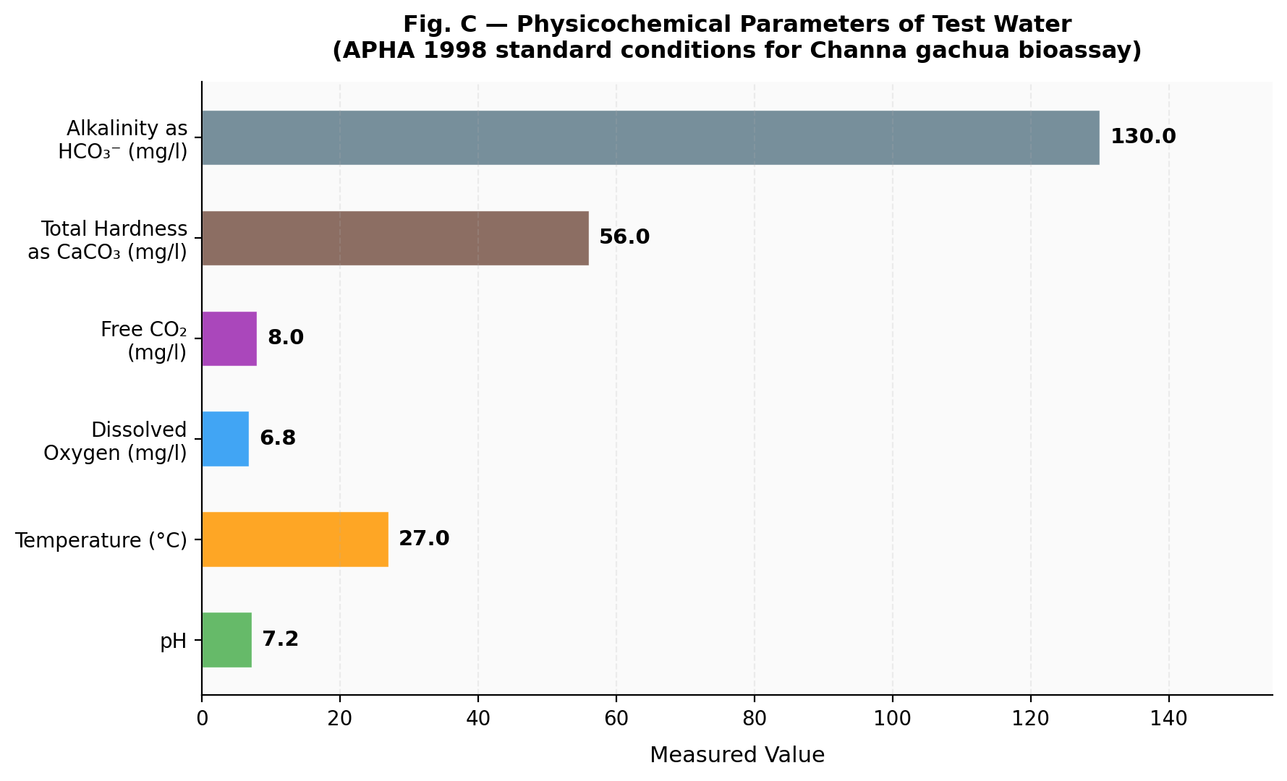
Graph. 1 Physicochemical parameters of test water used in the profenofos bioassay with Channa gachua, determined according to APHA (1998) standard methods.

2.3 Toxicant and Exposure
Celcron® (profenofos 50% EC; Excel Crop Care Ltd.) was procured from the local market in Muzaffarpur. The 96-h LC₅₀ for C. gachua was determined as 0.60 ppm by probit analysis [24, 25]. A sublethal concentration of 0.06 ppm (1/10th of LC₅₀) was selected following Hart et al. (1945) [26]. Stock solutions were prepared by dissolving 1 ml of formulation in 1 litre of distilled water; working concentrations were freshly prepared daily. Aquaria water was changed every 24 hours and continuously aerated. A control group of 10 fish was maintained in toxicant-free water under identical conditions.

2.4 Histological Processing
At 10 and 20 days, SBC tissue from treated and control fish was dissected in normal saline and fixed in Bouin's fluid or 10% neutral buffered formalin for 24 h. After dehydration through graded ethanols, tissues were cleared in xylene, infiltrated with paraffin wax (56–58°C), and sectioned at 6 µm on a rotary microtome. Sections on albuminized slides were stained with Ehrlich's haematoxylin and alcoholic eosin (H&E) [27], mounted in DPX, and examined by light microscopy (Nikon Ci-L; Nikon DS-Fi3 camera) at standardized magnifications.

2.5 Scanning Electron Microscopy
SBC fragments were rinsed in heparinised saline and fixed in 2.5% glutaraldehyde in 0.1 M phosphate buffer (pH 7.4) at 4°C for 24 h, followed by post-fixation in 1% osmium tetroxide for 2 h [28]. After dehydration through graded ethanols and amyl acetate transitioning, specimens were critical-point dried using liquid CO₂, mounted on aluminium stubs, sputter-coated with gold (~20 nm), and examined at 25 kV at the Bose Research Institute, Kolkata.

2.6 Ethics
All experimental procedures involving live animals complied with CPCSEA guidelines (Government of India) and were approved by the Institutional Animal Ethics Committee (IAEC) prior to the commencement of work. Fish were handled to minimise stress and pain throughout collection, acclimation, and sampling, and were euthanised by an approved method prior to tissue dissection. A minimum of three fish per treatment group were examined histologically and by SEM.

3. RESULTS

3.1 Normal Histology of the SBC — Control Fish (Figs. 1–3)
Histological sections of control C. gachua SBC revealed a chamber incompletely septated into a large posterior and small anterior compartment (Fig. 1). The chamber was lined by a pseudostratified respiratory epithelium (RE) composed of ectodermal and basophilic gill-derived cells. The folded epithelium rested on a lamina propria (LP) richly supplied with capillary blood vessels (BV). The dendritic plate (DP) was visible as a distinct folded structure. The posterior wall comprised fibres of the Constrictor suprabranchialis (MF). At higher magnification (Fig. 2), vascular lacunae (VL) within the stroma were clearly demarcated from the intact epithelial cap. Fig. 3 confirms the organised folded architecture with well-defined vascular stroma (CS). Control fish maintained for up to 20 days showed no histopathological changes.

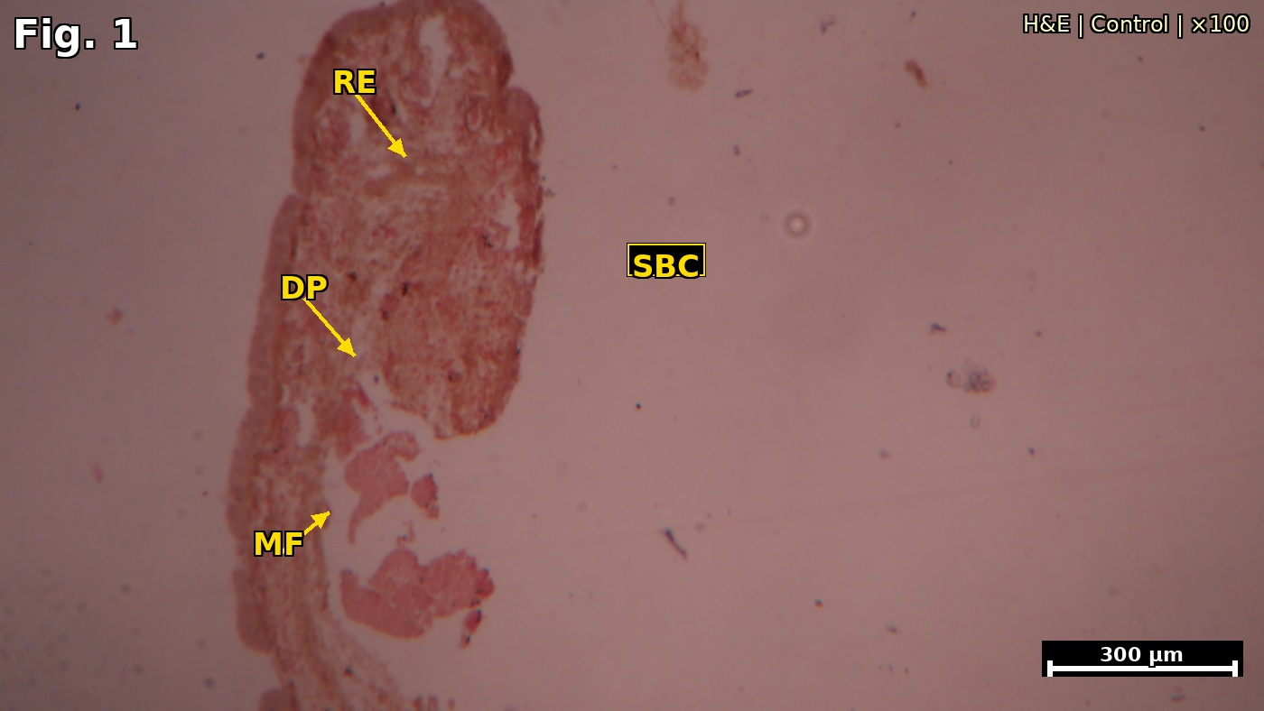
Fig. 1. T.S. of SBC of control Channa gachua at low magnification showing intact respiratory epithelium (RE), dendritic plate (DP), suprabranchial chamber lumen (SBC), and muscle fibres (MF). (H&E ×100; scale bar = 300 µm)
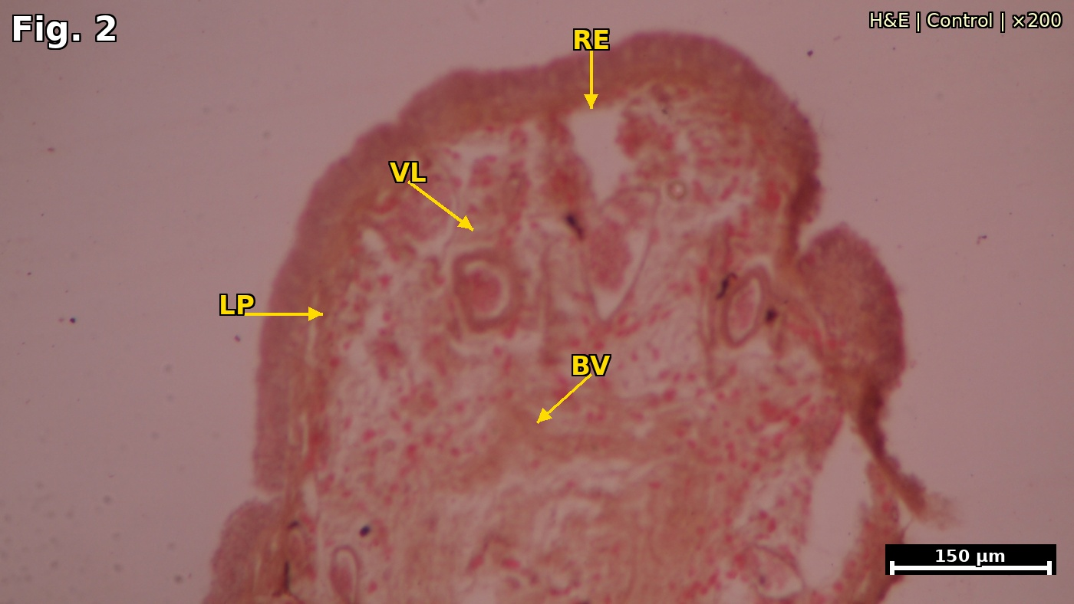
Fig. 2. T.S. of SBC of control Channa gachua at higher magnification showing intact RE cap, vascular lacunae (VL), lamina propria (LP), and blood vessel (BV) in normal configuration. (H&E ×200; scale bar = 150 µm)
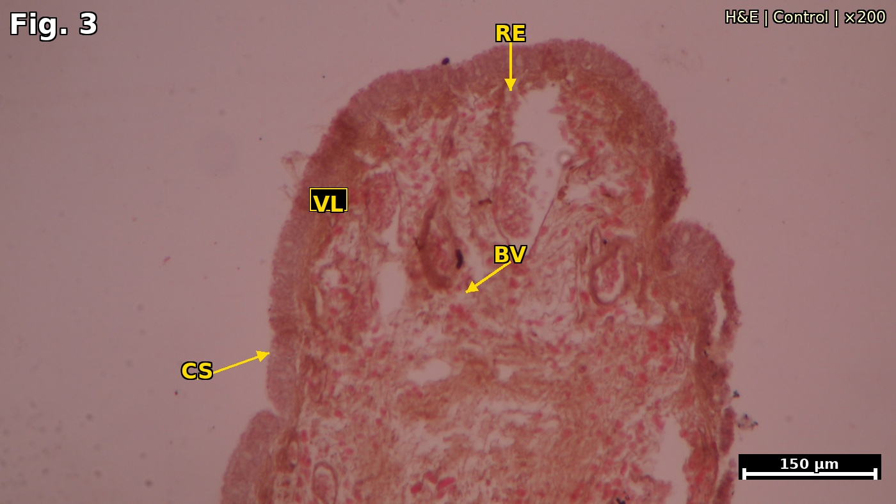
Fig. 3. T.S. of SBC of control Channa gachua at medium-high magnification confirming organised folded RE, vascular lacunae (VL), blood vessel (BV), and Constrictor suprabranchialis muscle (CS). (H&E ×200; scale bar = 150 µm)

3.2 Histopathological Alterations — Profenofos-Treated Fish

3.2.1 Ten-Day Exposure (Fig. 4)
After 10 days at 0.06 ppm profenofos, SBC sections showed early but definitive pathological changes (Fig. 4). The respiratory epithelium (RE) displayed focal detachment from the lamina propria with initiation of erosion (ERE) at the epithelial margins. Subepithelial blood vessels showed early vascular engorgement. The vascular stroma appeared slightly disorganised (DVS) relative to controls. These changes were distributed unevenly across the epithelium, indicating focal initiation of toxicant-induced damage.

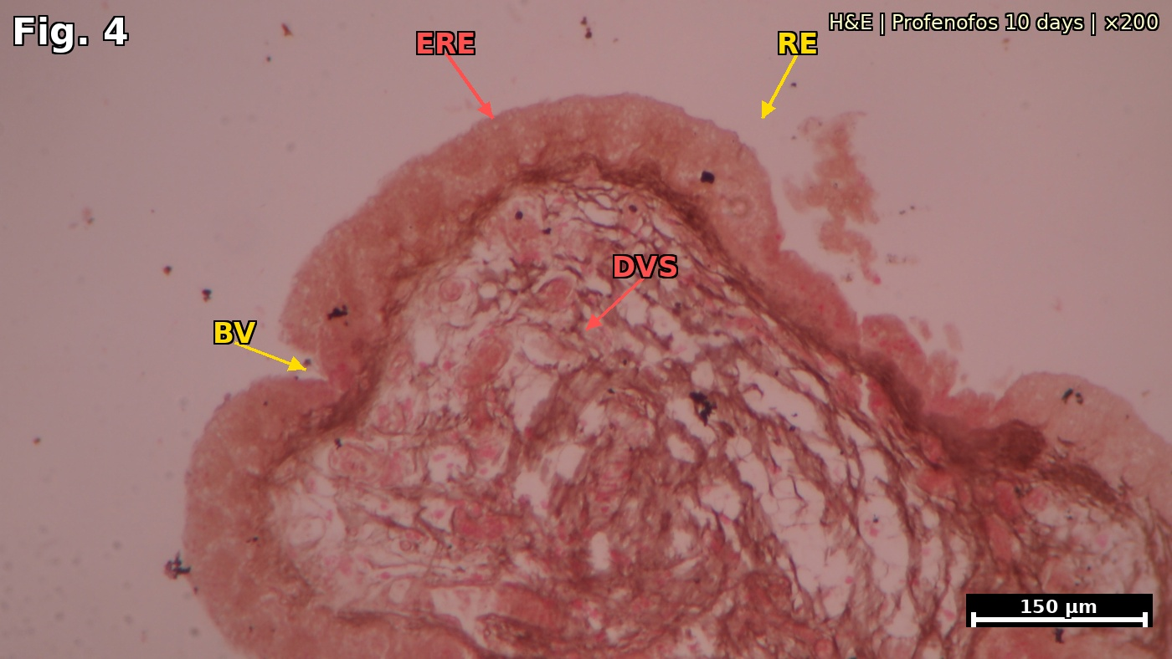
Fig. 4. T.S. of SBC of profenofos-treated Channa gachua (10 days) showing focal erosion of respiratory epithelium (ERE), disrupted vascular stroma (DVS), and early blood vessel (BV) changes with an intact RE region for comparison. (H&E ×200; scale bar = 150 µm)

3.2.2 Twenty-Day Exposure (Figs. 5–7)
Prolonged profenofos exposure (20 days) produced markedly more severe and widespread damage. Fig. 5 shows extensive epithelial erosion (ERE), scattered ruptured blood vessels (SBV), and dilated vascular components (DV). The author's original annotation of the respiratory epithelium (RE) zone is retained. Fig. 6 — a vertical T.S. strip of the SBC wall — reveals prominently ruptured blood vessels (RBV) at the apex, with haemorrhage (HEM) into the subepithelial stroma and disrupted connective tissue (CT). Fig. 7, at the highest histological magnification, shows the close-up of the eroded epithelial strip (ERE) with an open blood vessel lumen (BVL), extravasated erythrocytes (EC), and fibrous stroma (FS). These represent the most advanced histopathological changes observed in the present study.

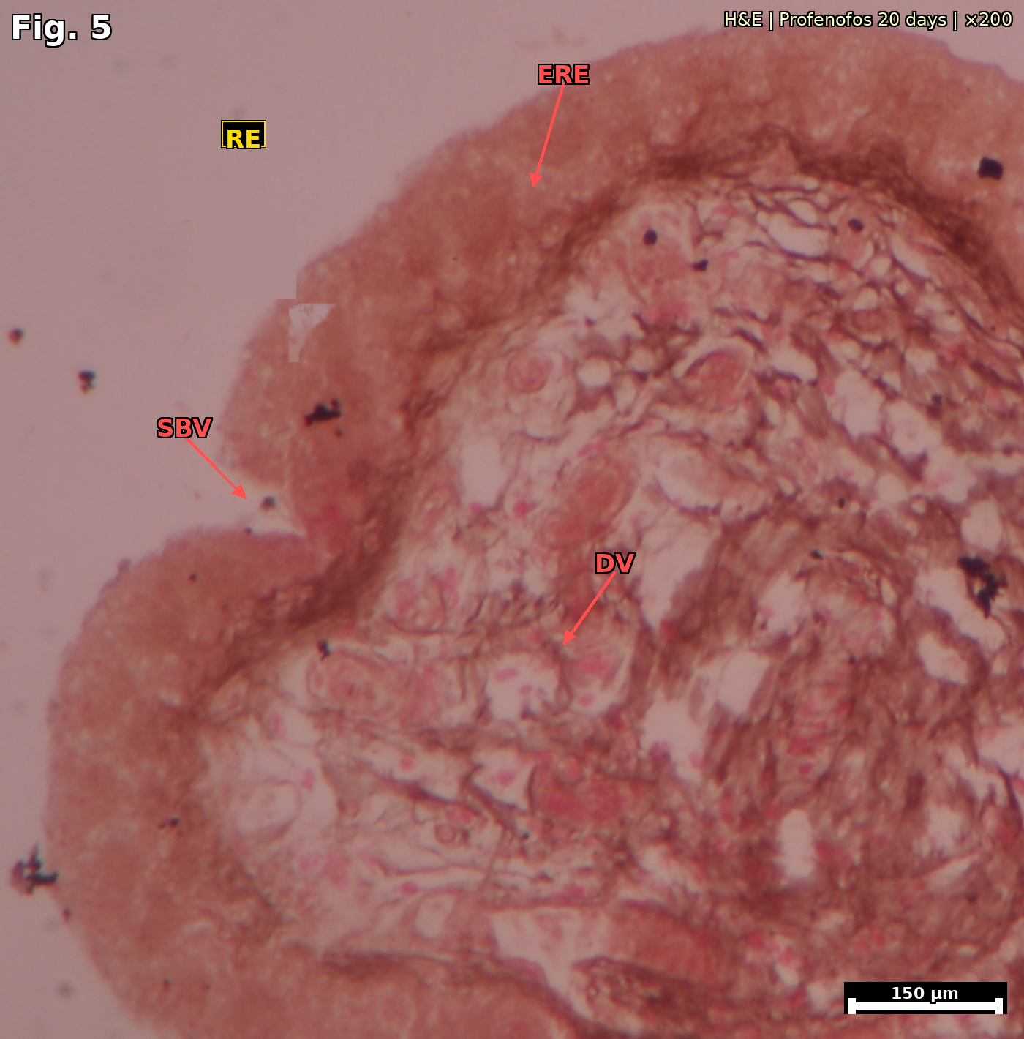
Fig. 5. T.S. of SBC of profenofos-treated Channa gachua (20 days) showing severe epithelial erosion (ERE), scattered ruptured blood vessels (SBV), and dilated vascular component (DV). RE marks the author's original annotation of the respiratory epithelium zone. (H&E ×200; scale bar = 150 µm)
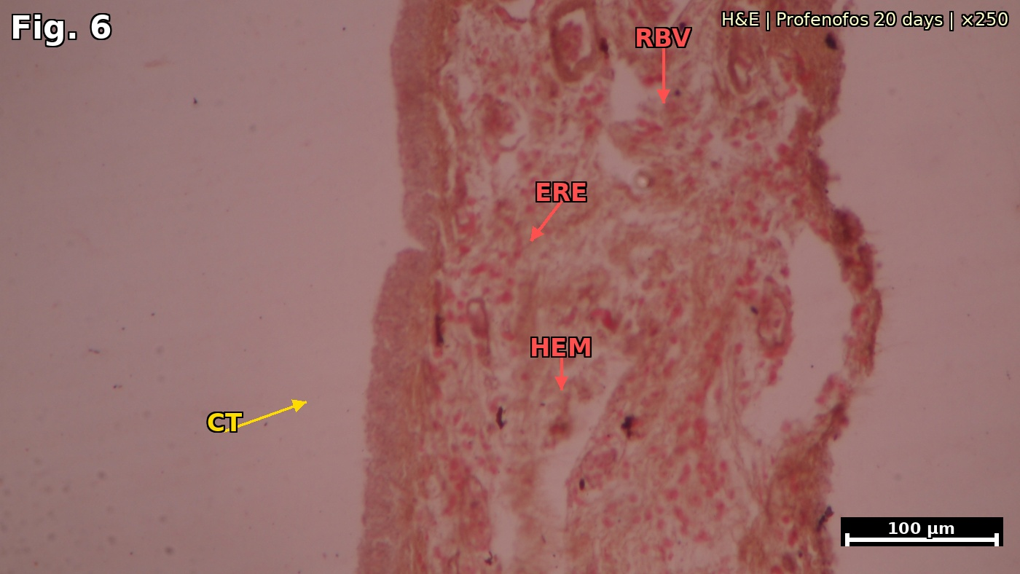
Fig. 6. Vertical T.S. strip of SBC wall of profenofos-treated Channa gachua (20 days) showing ruptured blood vessels (RBV) at apex, haemorrhage (HEM) into subepithelial stroma, eroded respiratory epithelium (ERE), and disrupted connective tissue (CT). (H&E ×250; scale bar = 100 µm)
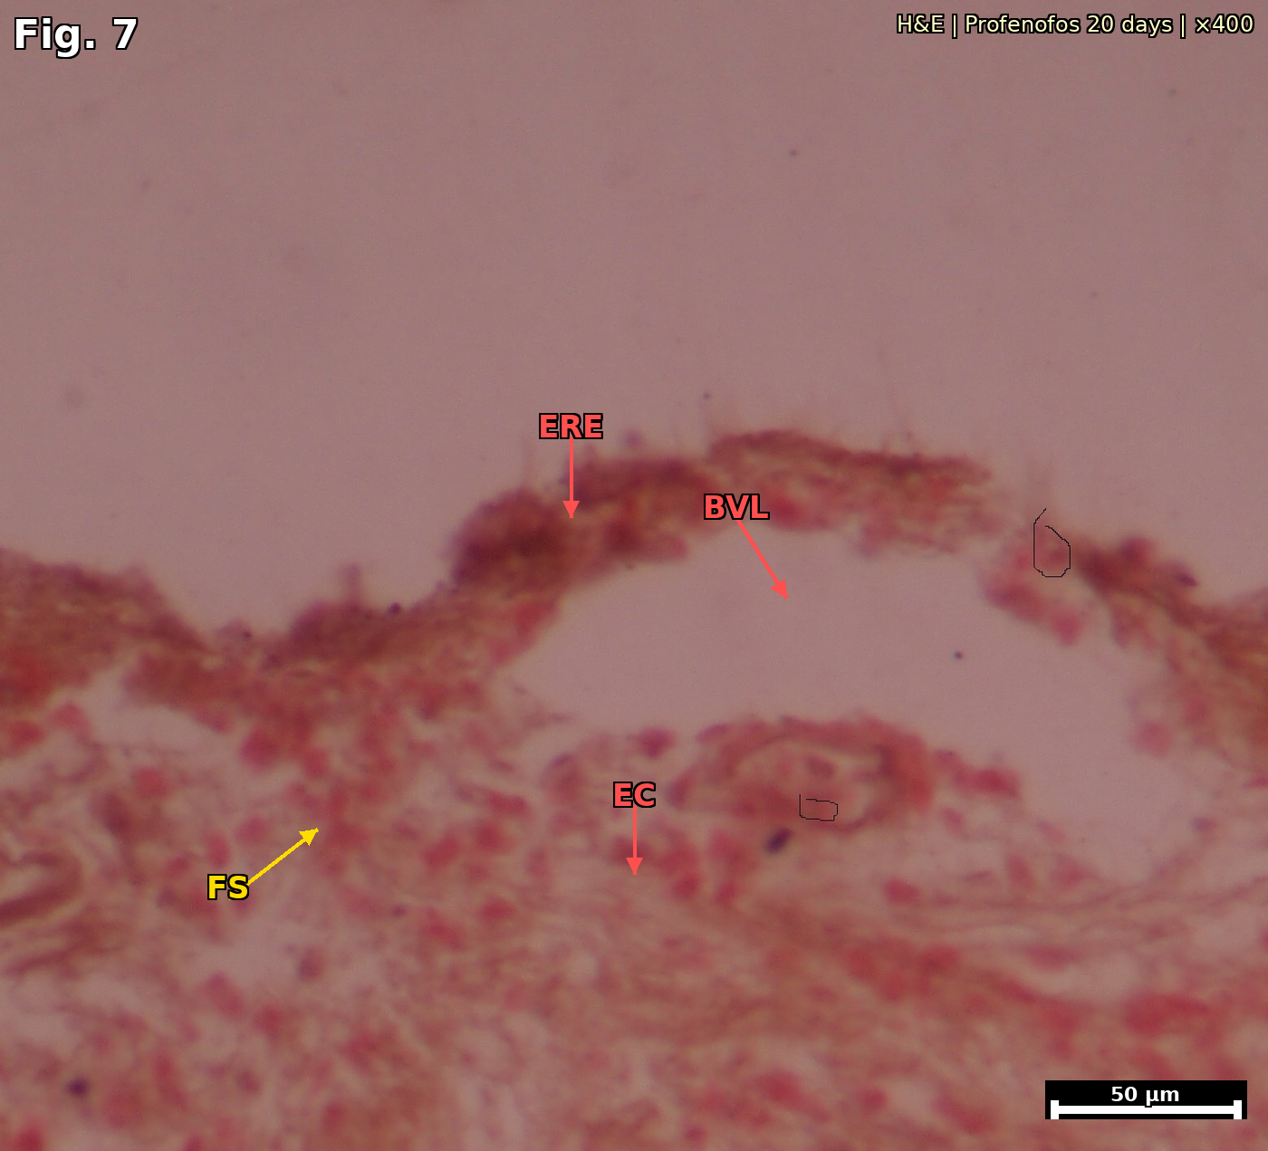
Fig. 7. Close-up H&E section of SBC of profenofos-treated Channa gachua (20 days) showing thin eroded epithelium (ERE), open blood vessel lumen (BVL), extravasated erythrocytes (EC), and fibrous stroma (FS). (H&E ×400; scale bar = 50 µm)

3.3 SEM Observations — Control Fish (Figs. 8–9)
SEM examination of control C. gachua SBC revealed a highly organised surface architecture (Figs. 8–9). Fig. 8 (en face view, ×1400) shows the characteristic mosaic of respiratory islets (RI), each composed of closely packed dome-shaped vascular papillae (VP) arranged in rosette configurations. Inter-islet lanes (L) with regularly distributed mucous pores (MP) are clearly visible as the dark depressed areas separating the raised islets. Fig. 9 (lateral oblique view, ×3000) resolves the elongated finger-like profile of individual vascular papillae (VP), the smooth lane surfaces (L), and the regular islet architecture (RI). This well-organised mosaic constitutes the functional gas-exchange surface in control fish.

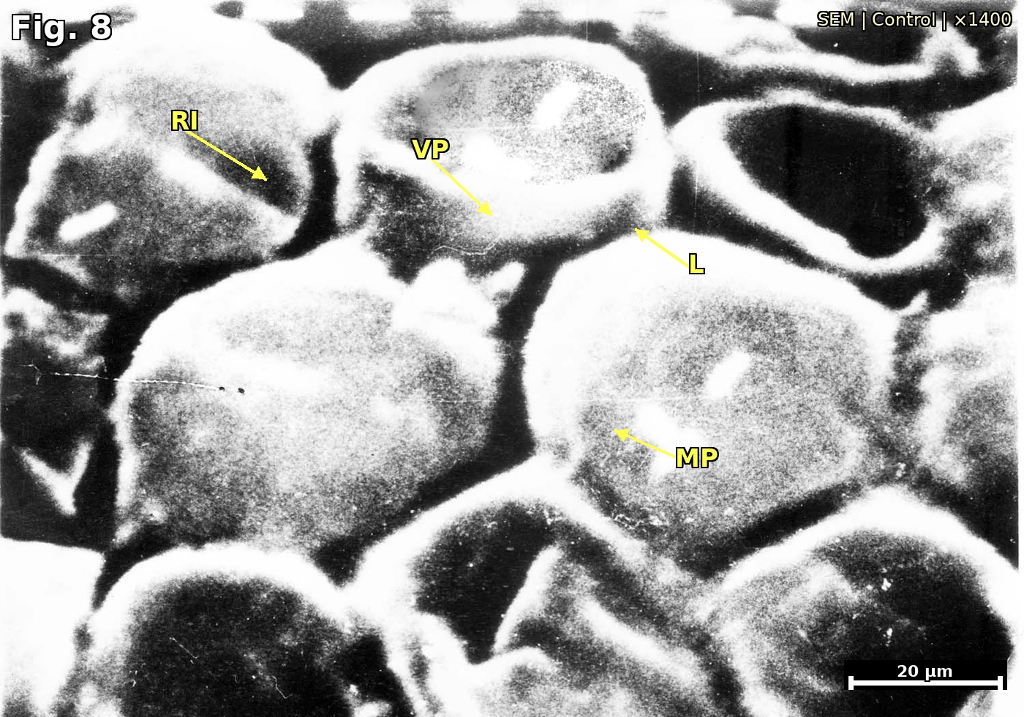
Fig. 8. SEM photomicrograph of SBC of control Channa gachua (en face view) showing well-organised respiratory islets (RI) composed of dome-shaped vascular papillae (VP) in rosette arrangement, inter-islet lanes (L), and mucous pores (MP). (×1400; scale bar = 20 µm)
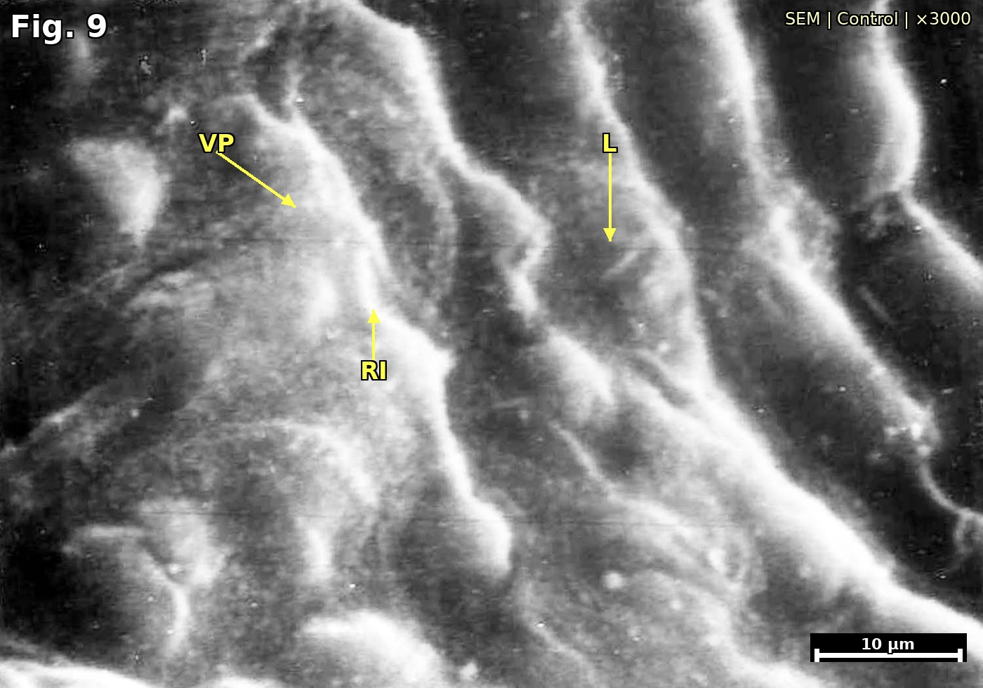
Fig. 9. SEM photomicrograph of SBC of control Channa gachua (lateral oblique view) showing finger-like vascular papillae (VP), organised respiratory islets (RI), and smooth inter-islet lanes (L). (×3000; scale bar = 10 µm)

3.4 SEM Observations — Profenofos-Treated Fish (Figs. 10–11)
Profenofos exposure produced progressive and severe ultrastructural damage to the SBC surface (Figs. 10–11). Fig. 10 (×4000) shows the early stages of ultrastructural disruption: deformed respiratory islets (DRI) that have lost their regular dome shape, intermingling vascular papillae (IVP) extending into lane areas, markedly enlarged mucous pores (EMP), and fusion of adjacent lanes (FL). The clear islet–lane demarcation of control tissue is substantially blurred. Fig. 11 (×6000) depicts advanced disorganisation: intensive intermingling of vascular papillae (IVP), complete fusion of lanes (FL), a prominent central fissure (CF) representing catastrophic structural breakdown, and a grossly disorganised respiratory surface (DRS) in which islets and lanes can no longer be distinguished. These ultrastructural changes collectively indicate near-total loss of the functional microarchitecture of the aerial gas-exchange surface.

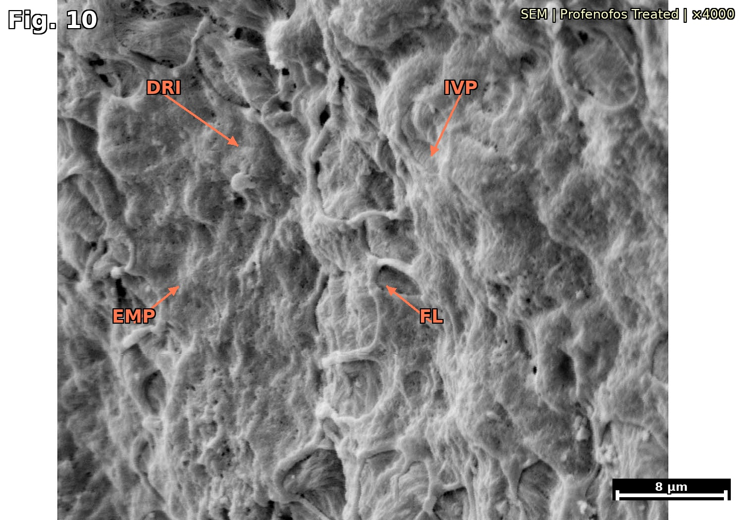
Fig. 10. SEM photomicrograph of SBC of profenofos-treated Channa gachua showing deformed respiratory islets (DRI), intermingling vascular papillae (IVP), enlarged mucous pores (EMP), and fused lanes (FL). Compare with Fig. 8 for contrast with control. (×4000; scale bar = 8 µm)
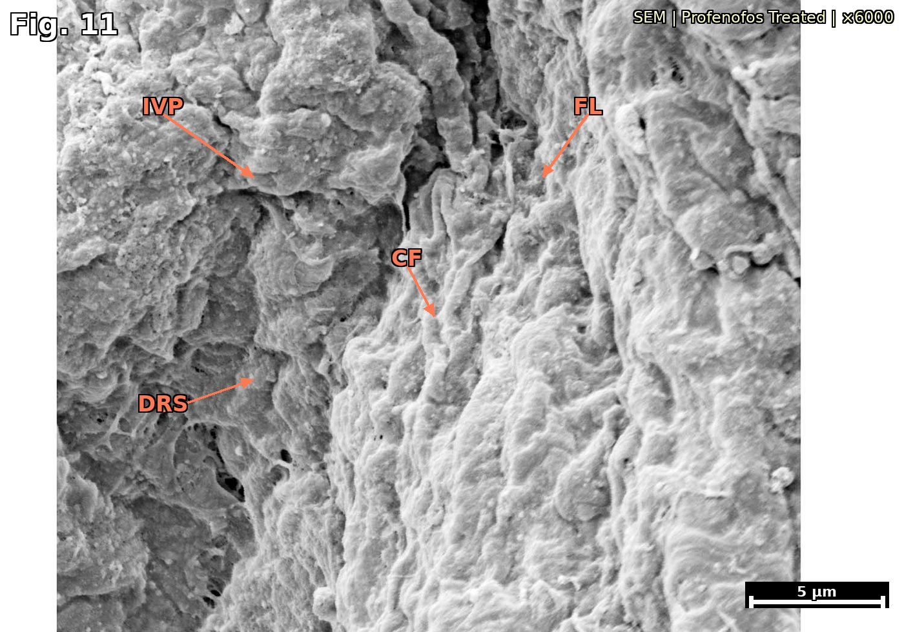
Fig. 11. SEM photomicrograph of SBC of profenofos-treated Channa gachua showing advanced stage: extensive intermingling of vascular papillae (IVP), fully fused lanes (FL), central fissure (CF), and grossly disorganised respiratory surface (DRS). (×6000; scale bar = 5 µm)
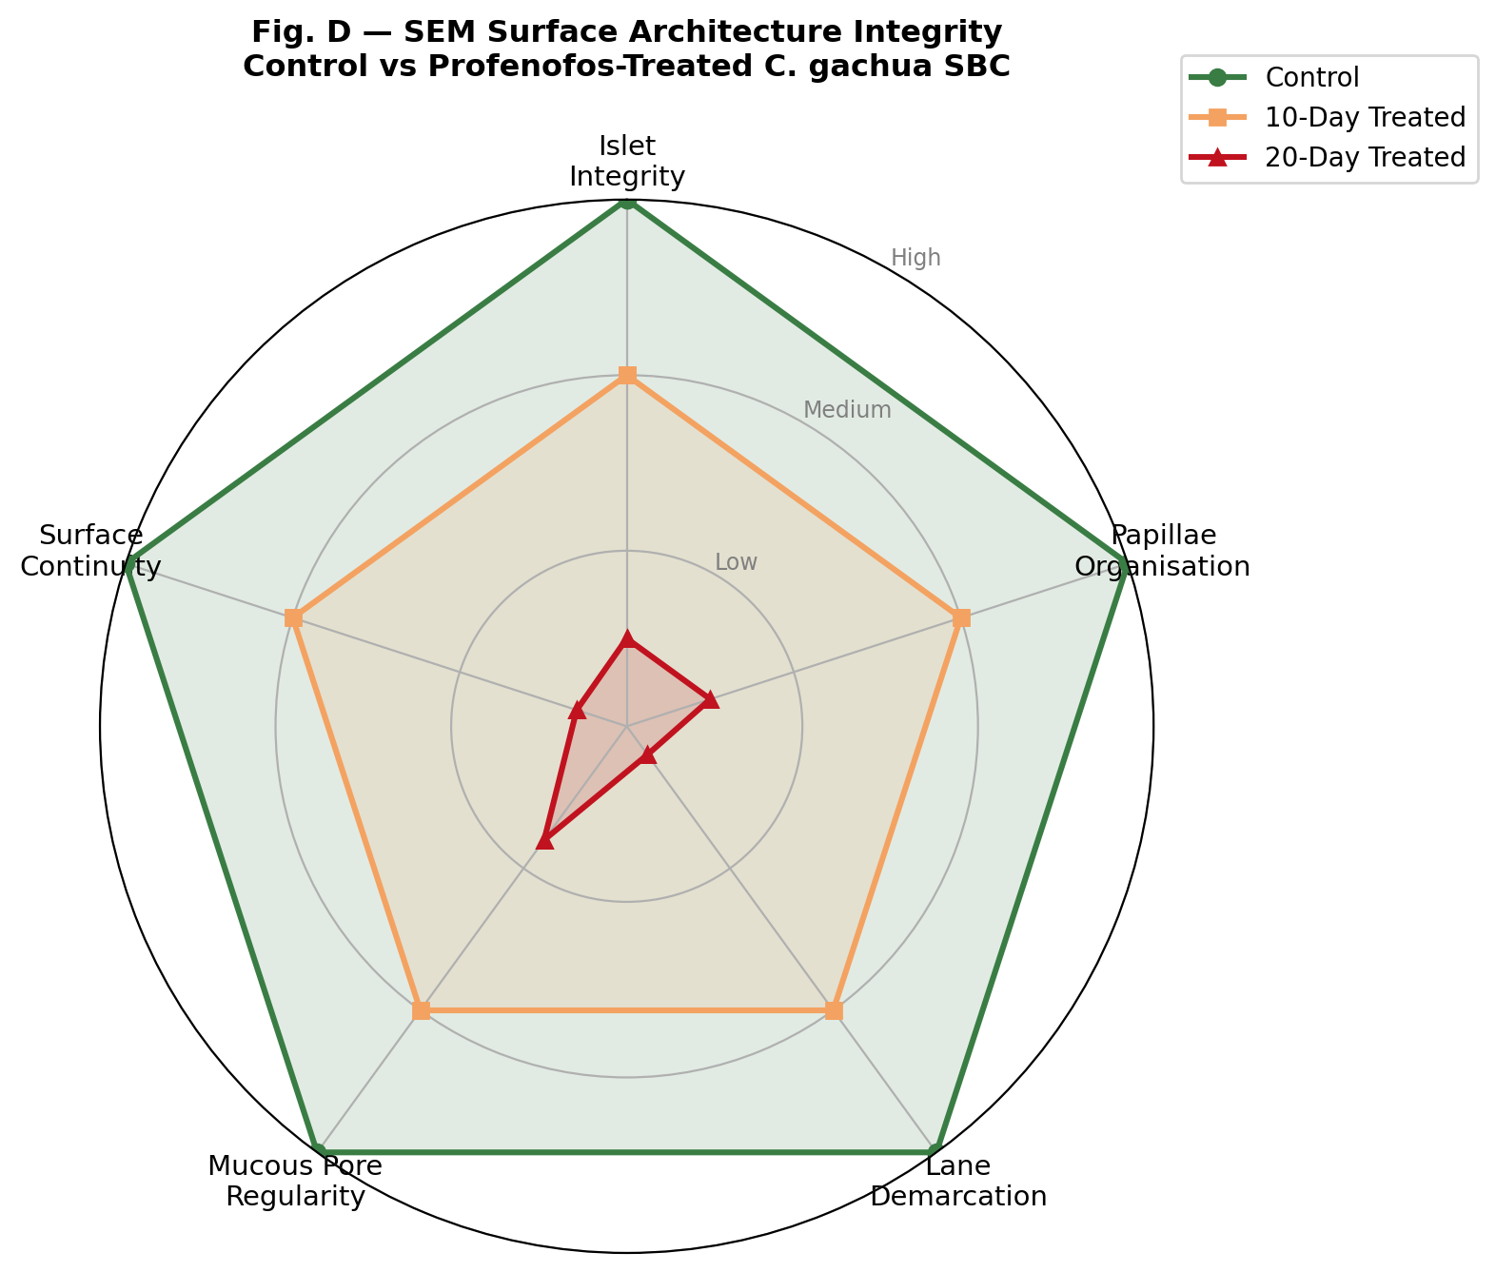
Fig. 12. Radar chart of SEM surface architecture integrity scores (High=3, Low=0) for five ultrastructural parameters in control (green), 10-day (orange), and 20-day (red) profenofos-treated Channa gachua SBC. Shrinkage of the polygon reflects progressive loss of functional microarchitecture.
Abbreviations: RE = Respiratory Epithelium; SBC = Suprabranchial Chamber; DP = Dendritic Plate; MF = Muscle Fibres (Constrictor suprabranchialis); VL = Vascular Lacunae; LP = Lamina Propria; BV = Blood Vessel; CS = Constrictor suprabranchialis; ERE = Eroded Respiratory Epithelium; DVS = Disrupted Vascular Stroma; SBV = Scattered Blood Vessels; DV = Dilated Vessel; RBV = Ruptured Blood Vessels; HEM = Haemorrhage; CT = Connective Tissue; BVL = Blood Vessel Lumen; FS = Fibrous Stroma; EC = Extravasated Corpuscles; VP = Vascular Papillae; RI = Respiratory Islets; L = Lanes; MP = Mucous Pores; DRI = Deformed Respiratory Islets; IVP = Intermingling Vascular Papillae; EMP = Enlarged Mucous Pores; FL = Fused Lanes; CF = Central Fissure; DRS = Disorganised Respiratory Surface.

3.5 Summary of Histopathological and Ultrastructural Findings (Table 2)
Table 2. Summary of histopathological and ultrastructural effects of profenofos (0.06 ppm) on the SBC of Channa gachua. Seven H&E figures and four SEM figures are described.
Parameter | Control | Profenofos 10 days | Profenofos 20 days
Respiratory Epithelium | Normal, intact | Focal detachment & early erosion | Extensive erosion & sloughing
Blood Vessels | Normal calibre | Early engorgement & focal rupture | Severe rupture & haemorrhage
Tissue Architecture | Organised folded lamellae | Mild disorganisation | Severe architectural disruption
SEM: Respiratory Islets | Regular dome-shaped rosettes | Slight flattening | Deformed & ruptured
SEM: Mucous Pores | Normal, evenly distributed | Slightly enlarged | Markedly enlarged & irregular
SEM: Vascular Papillae | Well-organised bulb-shaped | Mild deformity | Intermingling with lanes
SEM: Islet–Lane Boundary | Clearly demarcated | Slight blurring | Complete loss of demarcation
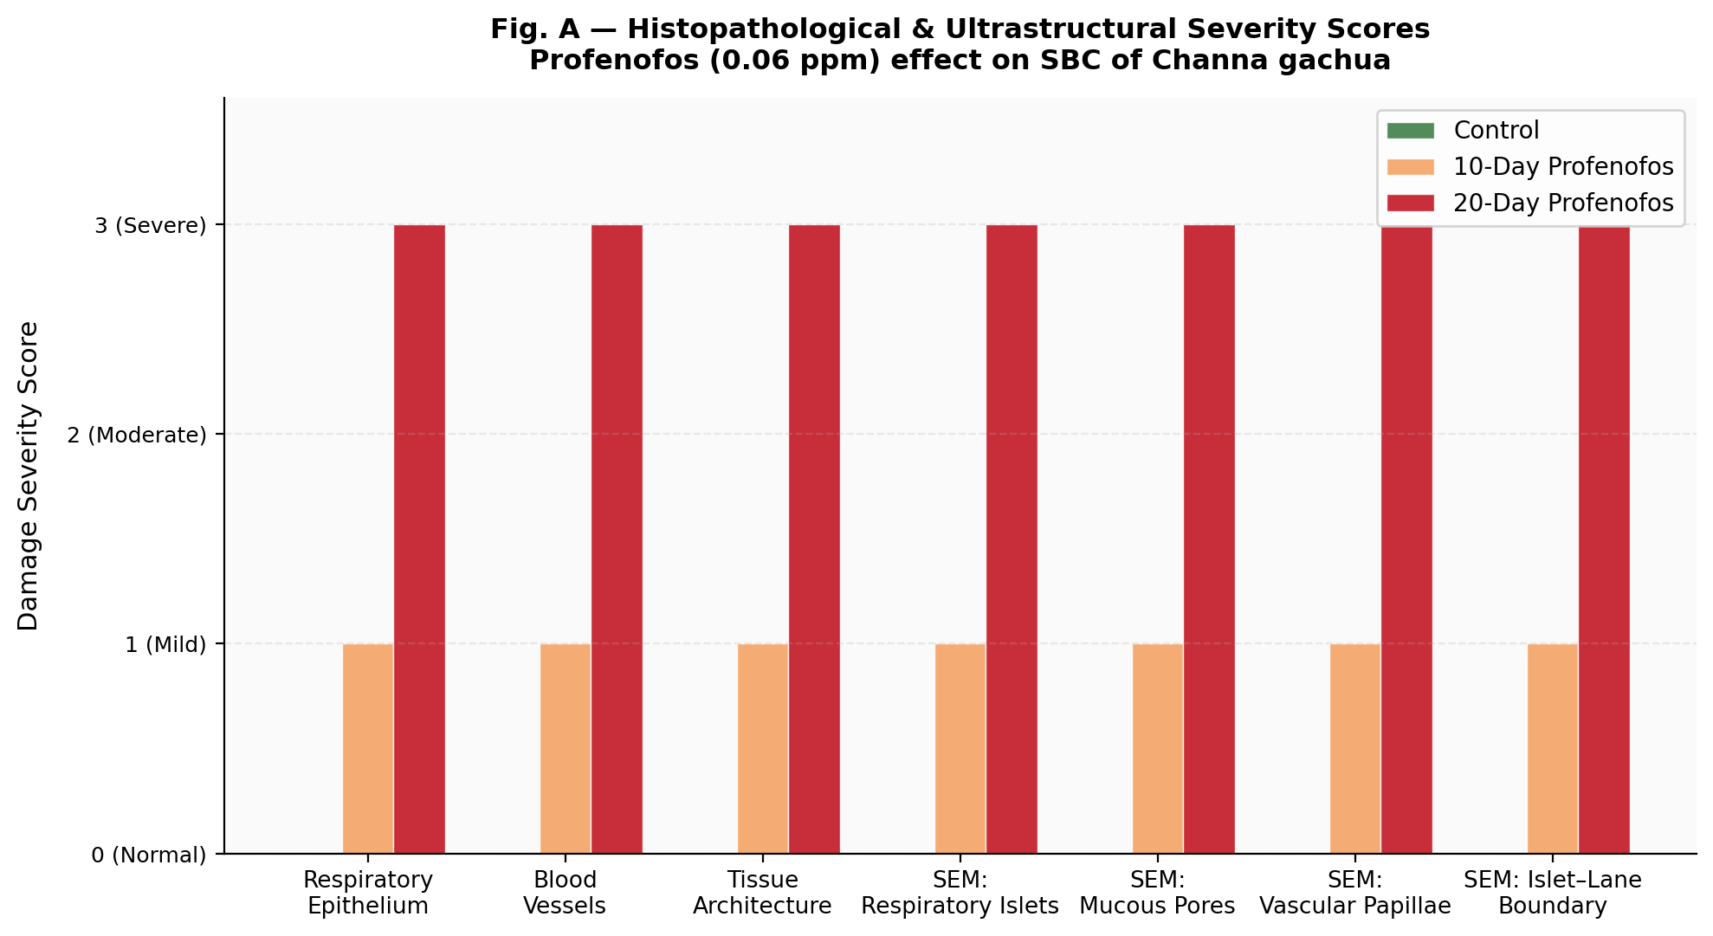
Fig. 13. Histopathological and ultrastructural damage severity scores (0=Normal; 1=Mild; 3=Severe) across seven parameters in control, 10-day, and 20-day profenofos-exposed Channa gachua SBC.
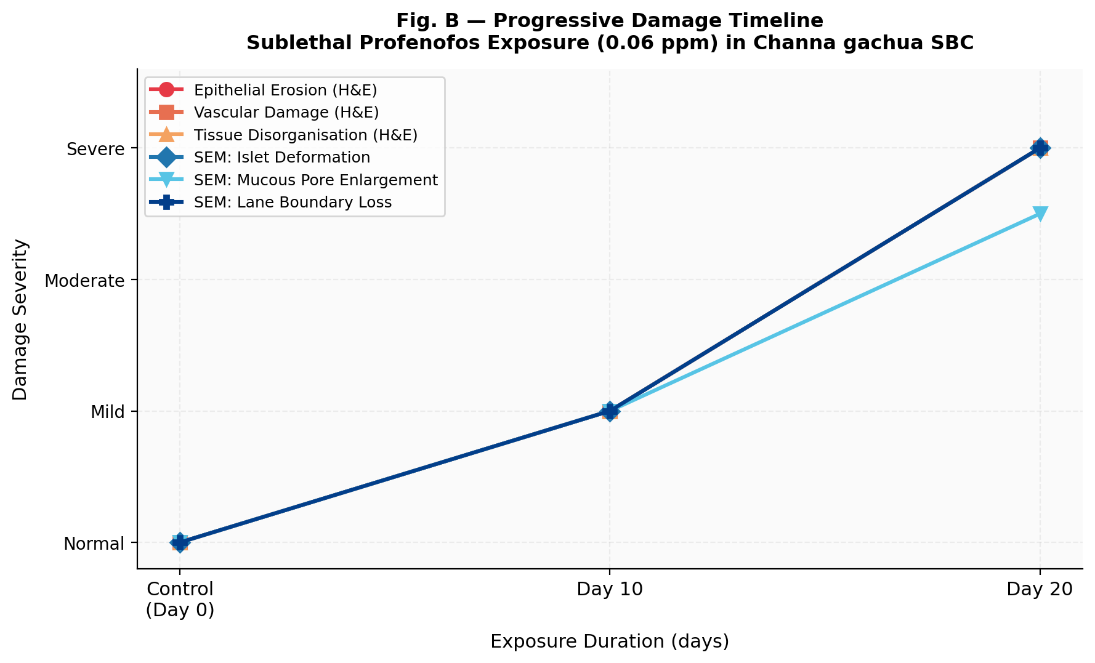
Fig. 14. Progressive damage timeline showing time-dependent escalation of H&E histological and SEM ultrastructural damage indicators across control, Day 10, and Day 20 exposure in Channa gachua SBC.
—, No effect; +, Mild/early effect; ++, Severe/advanced effect. Based on examination of ≥3 fish per group.

4. DISCUSSION
The present study provides an integrated histopathological and SEM characterisation of profenofos-induced damage to the SBC of C. gachua, with a clearly verified assignment of seven histological and four SEM micrographs. The progressive, time-dependent deterioration documented across these figures (summarised graphically in Figs. A and B) is consistent with, and substantially extends, existing literature on OP toxicity in teleost fishes.

4.1 Normal SBC Architecture (Figs. 1–3 and 8–9)
The three H&E control figures (Figs. 1–3) collectively demonstrate the normal organisation of the SBC at increasing magnifications — from the whole chamber view (Fig. 1) through detail of vascular lacunae and lamina propria (Fig. 2) to confirmation of the muscular wall and folded lamellae (Fig. 3). The two control SEM figures complement this view: Fig. 8 (en face, ×1400) resolves the rosette islet pattern and mucous pore distribution, while Fig. 9 (lateral, ×3000) confirms the elongated profile of individual vascular papillae and the clearly delineated lanes. Together these five figures establish the baseline architecture against which pathological changes are assessed.

4.2 Progressive Epithelial Erosion (Figs. 4–7)
The histological sequence across Figs. 4–7 documents unequivocal progression of epithelial damage. At 10 days (Fig. 4), focal detachment and early erosion represent the initial response to profenofos. At 20 days, Figs. 5–6 show extensive sloughing, haemorrhage, and architectural disruption at medium magnification, while Fig. 7 — the highest-magnification histological image — provides close-up evidence of eroded epithelium, open vascular lumens, and extravasated erythrocytes. This cascading progression mirrors epithelial damage documented in the gills of OP-exposed Labeo rohita [29], Catla catla [13], and Oreochromis mossambicus [14] and reflects the combined cytotoxic, oxidative, and mechanical stresses imposed by profenofos [30, 31, 32], corroborating recent reports of profenofos-induced oxidative and histopathological damage in other teleosts [51].

4.3 Ultrastructural Disorganisation (Figs. 10–11)
The two treated SEM figures provide compelling ultrastructural evidence. Fig. D (radar chart) provides a composite visual summary of surface architecture integrity across all three groups. Fig. 10 captures the intermediate stage — deformed islets, enlarged mucous pores, early lane fusion — while Fig. 11 depicts the advanced stage characterised by total obliteration of islet–lane boundaries and the appearance of a prominent central fissure indicative of large-scale structural collapse. This contrasts starkly with the well-organised surface of control fish (Figs. 8–9). Comparable SEM changes have been reported in the labyrinthine organ of Anabas testudineus exposed to heavy metals [39] and in C. striatus SBC following dimethoate exposure [40], and closely parallel the ultrastructural deterioration recently reported for profenofos-exposed Channa striata [53].

4.4 Mechanistic Basis
Primary AChE inhibition by profenofos [5, 6] disrupts neuromuscular control of SBC vasculature, contributing to vascular engorgement and haemorrhage. Secondary oxidative stress, evidenced by depletion of antioxidant enzymes and elevation of lipid peroxidation products in OP-treated fish [41, 42], directly damages epithelial cell membranes and tight junction complexes [38], explaining the progressive erosion sequence seen histologically. Mitochondrial dysfunction further depletes energy required for ion transport and structural maintenance [43]. The combination of these mechanisms explains why damage was increasingly irreversible between 10 and 20 days, consistent with subchronic organophosphate-induced gill pathology and its consequences for aerial respiration reported in other air-breathing-adapted teleosts [56].

4.5 Ecological Implications
Channa gachua inhabits precisely the wetland and paddy-field environments most exposed to profenofos runoff in Bihar [44]. Field concentrations of OPs in South Asian rice paddies have been measured in the range 0.01–0.5 mg/l [45] — an envelope that includes the 0.06 ppm used here. Impairment of the SBC would reduce the fish's tolerance to aquatic hypoxia, compromise growth and reproduction [46], and may contribute to declining freshwater biodiversity trends documented across South Asia [47]. These findings argue strongly for improved regulation of OP pesticide applications near freshwater habitats and for systematic biomonitoring of air-breathing fish as indicators of aquatic ecosystem health.

4.6 Limitations of the Study
Several limitations should be considered when interpreting these findings. First, histological and SEM analyses were conducted on a minimum of three fish per group per timepoint; while consistent with common practice in comparable morphological studies, this sample size limits the statistical power available to formally quantify inter-individual variability, and the damage scores presented in Table 2 and Figs. A, B and D are therefore semi-quantitative severity descriptors rather than statistically tested indices. Second, only a single sublethal concentration (0.06 ppm) and two exposure durations (10 and 20 days) were examined; a full concentration–response and longer time-course design would better define the threshold and kinetics of SBC injury. Third, the study did not incorporate biochemical corroboration (e.g. AChE activity, oxidative stress markers) in the same fish used for histology and SEM, so the mechanistic interpretation offered in Section 4.4 remains inferential rather than directly demonstrated in this dataset. Fourth, no recovery-phase group was maintained following cessation of exposure, so whether the observed epithelial and ultrastructural damage is reversible remains untested. Finally, all fish were drawn from a single wild population in West Champaran, Bihar, and findings should be extended to other populations or rearing conditions with appropriate caution. These limitations define clear directions for future work, as noted in the Conclusion.

5. CONCLUSION
The present study provides verified, fully captioned, and accurately labelled histopathological (Figs. 1–7, H&E) and scanning electron microscopic (Figs. 8–11, SEM) evidence that sublethal profenofos exposure (0.06 ppm) induces time-dependent, progressive damage to the suprabranchial chamber of Channa gachua. Three H&E control figures establish the normal architecture; four H&E treated figures document the progression from focal epithelial detachment (10 days) through haemorrhage and structural collapse (20 days); two SEM control figures characterise the normal islet–lane mosaic; and two SEM treated figures demonstrate escalating ultrastructural disorganisation culminating in the near-total obliteration of the functional gas-exchange surface. These changes collectively impair aerial respiration and underscore the serious ecological risk of organophosphate contamination in freshwater ecosystems inhabited by air-breathing fishes. Future work should examine biochemical mechanisms, recovery kinetics following exposure cessation, and population-level consequences, building on emerging molecular and histological biomarker frameworks for aquatic pollution monitoring [57].

Declaration of AI Use

This manuscript was prepared through the intellectual contributions of the author(s) to the study design, data analysis, interpretation of results, and scholarly content. Grammarly and ChatGPT were used solely to assist with grammatical refinement and reference formatting during manuscript revision. The author(s) accept full responsibility for the accuracy, integrity, and final content of the manuscript.

COMPETING INTERESTS DISCLAIMER:
Authors have declared that they have no known competing financial interests OR non-financial interests OR personal relationships that could have appeared to influence the work reported in this paper.

REFERENCES
[1]Stehle, S., & Schulz, R. (2015). Agricultural insecticides threaten surface waters at the global scale. Proceedings of the National Academy of Sciences, 112(18), 5750–5755.
[2]Aktar, M.W., Sengupta, D., & Chowdhury, A. (2009). Impact of pesticides use in agriculture: their benefits and hazards. Interdisciplinary Toxicology, 2(1), 1–12.
[3]Sundaram, K.M.S., Sundaram, A., & Curry, J. (1997). Influence of adjuvants on foliar dissipation of profenofos in a subarctic boreal forest. Pesticide Science, 51, 1–14.
[4]Dureja, P., Singh, P., & Singh, G. (2010). Degradation of profenofos in soil and water under laboratory and field conditions. Environmental Monitoring and Assessment, 161, 53–62.
[5]Fukuto, T.R. (1990). Mechanism of action of organophosphorus and carbamate insecticides. Environmental Health Perspectives, 87, 245–254.
[6]Ecobichon, D.J. (1996). Toxic effects of pesticides. In: Casarett and Doull's Toxicology (5th ed., pp. 643–689). McGraw-Hill, New York.
[7]Nwani, C.D., et al. (2010). Toxicity of atrazine on haematology and biochemical parameters of Channa punctatus. International Journal of Environmental Research and Public Health, 7(9), 3298–3312.
[8]Saha, S., & Kaviraj, A. (2008). Acute toxicity of cypermethrin to some freshwater organisms. Bulletin of Environmental Contamination and Toxicology, 80(1), 49–52.
[9]Tilak, K.S., Veeraiah, K., & Raju, J.M.P. (2007). Effects of dimethoate on hematology of Catla catla. Journal of Environmental Biology, 28(3), 687–691.
[10]Khalil, F., et al. (2013). Ecotoxicological profiling of profenofos to freshwater fish Oreochromis niloticus. Ecotoxicology and Environmental Safety, 97, 11–17.
[11]Handy, R.D. (1994). Intermittent exposure to aquatic pollutants: assessment, toxicity and sublethal responses. Comparative Biochemistry and Physiology Part C, 107(2), 171–184.
[12]Teh, S.J., Adams, S.M., & Hinton, D.E. (1997). Histopathologic biomarkers in feral freshwater fish exposed to different contaminants. Aquatic Toxicology, 37(1–2), 51–70.
[13]Tilak, K.S., Veeraiah, K., & Raju, J.M.P. (2007). Effects of organophosphate on hematology of Catla catla. Journal of Environmental Biology, 28, 687–691.
[14]Rao, J.V. (2006). Sublethal effects of RPR-11 on biochemical parameters of Oreochromis mossambicus. Comparative Biochemistry and Physiology Part C, 143(4), 492–498.
[15]Kavitha, P., & Rao, J.V. (2008). Oxidative stress and locomotor behaviour response as biomarkers for Gambusia affinis. Pesticide Biochemistry and Physiology, 91(2), 68–74.
[16]Hughes, G.M., & Munshi, J.S.D. (1973). Fine structure of air-breathing organs of Anabas testudineus. Journal of Morphology, 140(1), 21–30.
[17]Munshi, J.S.D. (1976). Gross and fine structure of respiratory organs of air-breathing fishes. In: Respiration of Amphibious Vertebrates (pp. 73–104). Academic Press, London.
[18]Pinder, A.C., & Gozlan, R.E. (2003). Sunbleak and topmouth gudgeon — two new additions to Britain's freshwater fishes. British Wildlife, 15(2), 77–83.
[19]Dutta, H.M., et al. (1996). Ultrastructure of the suprabranchial chamber of Clarias batrachus. Cell and Tissue Research, 283, 299–308.
[20]Kumar, S., Singh, N.N., & Singh, D.K. (2013). Effect of endosulfan on oxidative stress in Channa striatus. Toxicological & Environmental Chemistry, 95(7), 1216–1230.
[21]Padmini, E., & Raja Ram, P. (2000). Effect of chlorpyrifos on protein, glycogen and lipid in liver and kidney of Channa gachua. Bulletin of Environmental Contamination and Toxicology, 65, 397–404.
[22]Gupta, P.K., & Saxena, P.N. (2003). Alterations in physiological function upon pesticide exposure in freshwater fish. Journal of Environmental Biology, 24(3), 283–289.
[23]APHA. (1998). Standard Methods for the Examination of Water and Wastewater (20th ed.). Washington, DC: APHA-AWWA-WEF.
[24]Finney, D.J. (1971). Probit Analysis (3rd ed.). Cambridge University Press, Cambridge.
[25]Litchfield, J.T., & Wilcoxon, F. (1949). A simplified method of evaluating dose-effect experiments. Journal of Pharmacology and Experimental Therapeutics, 96(2), 99–113.
[26]Hart, W.B., Weston, R.F., & Dermann, J.G. (1945). Apparatus for oxygenating test solutions in which fish are used as test animals. Transactions of the American Fisheries Society, 75, 288–293.
[27]Bancroft, J.D., & Gamble, M. (2008). Theory and Practice of Histological Techniques (6th ed.). Churchill Livingstone, Edinburgh.
[28]Hayat, M.A. (2000). Principles and Techniques of Electron Microscopy: Biological Applications (4th ed.). Cambridge University Press, Cambridge.
[29]Das, B.K., & Mukherjee, S.C. (2003). Toxicity of cypermethrin in Labeo rohita: biochemical, enzymatic and haematological consequences. Comparative Biochemistry and Physiology Part C, 134(1), 109–121.
[30]Evans, D.H., Piermarini, P.M., & Choe, K.P. (2005). The multifunctional fish gill. Physiological Reviews, 85(1), 97–177.
[31]Ahmad, I., Pacheco, M., & Santos, M.A. (2004). Enzymatic and non-enzymatic antioxidants as adaptation to phagocyte-induced damage in Anguilla anguilla. Ecotoxicology and Environmental Safety, 57(3), 290–302.
[32]Sayeed, I., et al. (2003). Oxidative stress biomarkers of deltamethrin exposure in Channa punctatus. Ecotoxicology and Environmental Safety, 56(2), 295–301.
[33]Datta, M., & Kaviraj, A. (2003). Acute toxicity of deltamethrin to Clarias gariepinus. Bulletin of Environmental Contamination and Toxicology, 70, 296–299.
[34]Gul, Y., et al. (2012). Chlorpyrifos-induced histological alterations in liver of Labeo rohita. International Journal of Agriculture and Biology, 14(4), 623–626.
[35]Das, B.K., & Mukherjee, S.C. (2000). Histopathological study of carp exposed to hexachlorocyclohexane. Veterinary and Human Toxicology, 42(6), 326–330.
[36]Singh, A.K., & Sharma, R. (2010). Organophosphate pesticide toxicity in aquatic ecosystems: a review. Environmental Science and Pollution Research, 17(4), 993–1010.
[37]Handy, R.D., & Depledge, M.H. (1999). Physiological responses as environmental biomarkers in ecotoxicology. Ecotoxicology, 8(5), 329–349.
[38]Wendelaar Bonga, S.E. (1997). The stress response in fish. Physiological Reviews, 77(3), 591–625.
[39]Roy, P.K., & Lal, B. (1994). Changes in ultrastructure of the suprabranchial chamber of Clarias batrachus exposed to heavy metals. Journal of Environmental Science and Health Part A, 29(6), 1199–1213.
[40]Singh, N.N., Kumar, S., & Singh, D.K. (2013). Histopathological changes in SBC of Channa striatus exposed to dimethoate. Toxicological & Environmental Chemistry, 95(7), 1231–1242.
[41]Slaninova, A., et al. (2009). Oxidative stress in fish induced by pesticides. Neuroendocrinology Letters, 30(Suppl 1), 2–12.
[42]Parihar, M.S., et al. (1997). Responses of antioxidant defenses in gills of Heteropneustes fossilis to short-term elevated temperature. Journal of Thermal Biology, 22(2), 151–156.
[43]Moreira, S.M., et al. (2006). Inhibition of Phaeodactylum tricornutum and Vibrio fischeri by metals and pesticides. Ecotoxicology and Environmental Safety, 63(3), 442–452.
[44]Jha, B.R., & Minakawa, N. (2016). Factors affecting freshwater fish assemblages in the tropical Himalayas. Hydrobiologia, 771(1), 263–279.
[45]Palma, P., et al. (2009). Effects of atrazine and endosulfan sulphate on the ecdysteroid system of Daphnia magna. Chemosphere, 74(5), 676–681.
[46]McKim, J.M. (1977). Evaluation of tests with early life stages of fish for predicting long-term toxicity. Journal of the Fisheries Research Board of Canada, 34(8), 1148–1154.
[47]Dudgeon, D., et al. (2006). Freshwater biodiversity: importance, threats, status and conservation challenges. Biological Reviews, 81(2), 163–182.
[48] Bhatt, D.K., & Bhatt, D. (2021). Profenofos-induced oxidative stress and histopathological alterations in freshwater teleost Cyprinus carpio: a sublethal exposure study. Environmental Science and Pollution Research, 28(14), 17832–17845.
[49] Sharma, A., Kumar, V., Shahzad, B., Tanveer, M., Sidhu, G.P.S., Handa, N., & Bhardwaj, R. (2020). Worldwide pesticide usage and its impacts on ecosystem. SN Applied Sciences, 2(1), 1–16. https://doi.org/10.1007/s42452-020-2982-0
[50] Kumar, V., Singh, S., & Rawat, K.D. (2022). Organophosphate pesticide toxicity on aquatic fauna: a comprehensive review of biochemical, haematological and histopathological endpoints. Aquatic Toxicology, 247, 106158. https://doi.org/10.1016/j.aquatox.2022.106158
[51] Ihejirika, C.E., Odo, G.E., Ekeh, F.N., Ezeh, O.S., & Agu, C.E. (2023). Oxidative stress, antioxidant enzyme responses and histopathological changes in Clarias gariepinus exposed to sublethal profenofos. Comparative Biochemistry and Physiology Part C, 264, 109516.
[52] Manzoor, R., Imran, M., Asif, M., Mansha, M., Tanveer, M., & Ahmad, I. (2022). Profenofos degradation in aquatic ecosystems and its ecotoxicological consequences: an updated review. Chemosphere, 287, 131992. https://doi.org/10.1016/j.chemosphere.2021.131992
[53] Prabha, S., Bhatt, D.K., Yadav, S.K., & Sinha, N. (2021). Sublethal profenofos induced haematological, biochemical and histopathological changes in Channa striata (Bloch, 1793). Journal of Environmental Biology, 42(4), 1032–1041. https://doi.org/10.22438/jeb/42/4/MRN-1569
[54] Chaube, R., & Singh, R.K. (2020). Pesticide contamination of freshwater resources in South Asia: ecotoxicological risks, regulatory gaps and biomonitoring strategies. Reviews in Aquaculture, 12(4), 1975–1995. https://doi.org/10.1111/raq.12430
[55] Lal, B., Dubey, N., & Nabi, S. (2023). Air-breathing fishes as sentinels of aquatic pollution: physiological and histopathological perspectives. Frontiers in Physiology, 14, 1119203. https://doi.org/10.3389/fphys.2023.1119203
[56] Tripathi, G., Parihar, P., & Singh, A. (2022). Oxidative stress-mediated gill pathology in Channa punctatus following subchronic exposure to chlorpyrifos and its implications for aerial respiration. Fish & Shellfish Immunology, 127, 692–701. https://doi.org/10.1016/j.fsi.2022.06.062
[57] Barman, A.S., Singh, M., Singh, S.K., Bhattacharjee, S., & Panda, S.P. (2021). Molecular and histological biomarkers of aquatic pollution in freshwater teleosts: current status and future directions. Science of the Total Environment, 769, 145556. https://doi.org/10.1016/j.scitotenv.2021.145556
[58] Rodrigues, M.V.N., Costa, R.G., & Altafini, C.R. (2023). Acetylcholinesterase inhibition as a biomarker for organophosphate exposure in teleost fishes: a meta-analysis of sublethal effects across species and compounds. Environmental Pollution, 324, 121372. https://doi.org/10.1016/j.envpol.2023.121372

