The Efficacy of Ginkgo Biloba and Fenugreek as Hepatoprotective Agents Against Carbon Tetrachloride-Induced Liver Injury in Male Rats

ABSTRACT

BACKGROUND
Liver diseases represent a major global health burden and are associated with considerable morbidity and mortality worldwide. Carbon tetrachloride (CCl₄)-induced hepatotoxicity is a well-established experimental model commonly used to evaluate the hepatoprotective potential of natural products and therapeutic agents.

OBJECTIVES
This study aimed to evaluate the hepatoprotective effects of Ginkgo biloba and Trigonella foenum-graecum (fenugreek) extracts, administered individually or in combination, against CCl₄-induced liver injury in male rats.

METHODS
Fifty adult male rats were randomly allocated into five experimental groups. Hepatic injury was induced using carbon tetrachloride (CCl₄). Treatment groups received Ginkgo biloba extract, fenugreek extract, or a combination of both. Serum biochemical markers including aspartate aminotransferase (AST), lactate dehydrogenase (LDH), malondialdehyde (MDA), and superoxide dismutase (SOD) were evaluated. Histopathological examination of liver tissues was performed using Masson's Trichrome staining.

RESULTS
Administration of CCl₄ resulted in significant elevation of AST, LDH, and MDA levels, accompanied by a significant reduction in SOD activity compared with the control group (P ≤ 0.05). Treatment with Ginkgo biloba and fenugreek extracts improved liver function biomarkers and oxidative stress parameters. Histopathological findings revealed marked restoration of hepatic architecture in treated groups, particularly in rats receiving the combined treatment.

CONCLUSIONS
Ginkgo biloba and fenugreek extracts exhibited significant hepatoprotective and antioxidant effects against CCl₄-induced liver injury. Combined administration of both extracts provided greater protection than either treatment alone and may represent a promising natural therapeutic strategy for preventing hepatic damage.
Keywords: Carbon tetrachloride (CCl₄), Fenugreek, Ginkgo biloba, Hepatitis, Hepatoprotective effect
INTRODUCTION
Hepatitis B virus (HBV) is one of the main etiological agents of chronic liver problems, and hepatitis is regarded as one of the major viral diseases affecting the liver (Seeger and Mason, 2015). Long-term HBV infection can result in serious liver problems such cirrhosis and hepatocellular cancer (Ganem and Prince, 2004; Lok and McMahon2007).
Because of their physiological and pathological resemblance to humans, experimental rats are frequently used in biomedical research, especially in toxicological and The therapeutic potential of medicinal plants in avoiding oxidative stress and tissue damage has garnered significant scientific attention in recent years. According to Fabricant and Farnsworth (2001), herbal remedies are thought to be viable substitutes for the creation of hepatoprotective drugs.
Antioxidant, anti-inflammatory, anti-allergic, anticancer, and cytoprotective properties are among the many pharmacological activities of ginkgo biloba. Furthermore, prior research has shown its positive effects on respiratory and cardiovascular processes (Smith and Luo, 2004; Diamond and Bailey, 2013; Zhang and Schini-Kerth, 2014; Rojas and Romero, 2020).metabolic studies (Couinaud, 1999; Wu et al., 2002).
Traditional medicine has long used fenugreek (Trigonella foenum-graecum L.), an annual medicinal herb in the Fabaceae family (Basch et al., 2003). The therapeutic benefit of fenugreek seeds is attributed to a variety of biologically active components, including flavonoids, alkaloids, steroidal saponins, amino acids, and volatile oils (Srinivasan, 2006; Jalal et al., 2015; Sowmya and Rajyalakshmi, 1999).
Numerous substances produced from plants have been shown to have hepatoprotective and antioxidant properties against liver damage. According to earlier studies, fenugreek and ginkgo biloba both have preventive properties against oxidative liver damage (El-Beshbishy et al., 2011; Raju and Bird, 2006). Therefore, the present study was conducted to evaluate the hepatoprotective efficacy of these two medicinal plants, individually and in combination, against CCl₄-induced liver injury in male rats.

MATERIALS AND METHODS

Plant Materials and Extract Preparation
The Ginkgo biloba extract dosage of 120 mg/kg body weight/day was chosen based on research that has already been published (Canevelli et al., 2014; Verma et al., 2020). 240 mg of Ginkgo biloba extract were dissolved in 10 mL of distilled water and gently heated in a water bath to create the hydroalcoholic extract. The prepared solution was taken orally once a day at a dose of 1 mL/100 g body weight. In the Iraqi province of Najaf, local marketplaces provided the fenugreek seeds. Using a Soxhlet extraction device, the seeds were crushed into a fine powder and extracted using 70% ethanol. In accordance with the procedure outlined by Lim et al. (2002), the solvent was evaporated under reduced pressure using a rotary evaporator to produce the dry extract, which was then stored at 4°C until use. For 28 days, a daily dose of 15 mg/kg body weight of fenugreek extract was given orally.
Experimental Animals and Design
In this experiment, fifty adult male rats in good health were used. Ten rats were allocated to each of the five groups into which the animals were divided at random. The institutional ethical rules for laboratory animal experiments were followed in all animal-related procedures.
Experimental groups
- For four weeks, Group 1, the control group, was given intraperitoneal injections of olive oil twice a week (Basch et al., 2003).
-For four weeks, Group 2 received intraperitoneal injections of carbon tetrachloride (CCl₄) diluted in olive oil at a concentration of 0.5 mg/kg body weight in order to cause liver damage (Zhang et al., 2014).
-For 28 days in a row, Group 3 was given oral Ginkgo biloba extract at a dose of 120 mg/kg body weight one hour prior to CCl₄ delivery (Verma et al., 2020).
-For 28 days, Group 4 received fenugreek extract orally at a dose of 15 mg/kg body weight every day prior to CCl₄ injection.
-Ginkgo biloba and fenugreek extracts were administered in combination to Group 5 before CCl₄ was administered during the trial.
Biochemical and histopathological analysis
Blood samples were taken in order to measure oxidative stress indicators like MDA and SOD as well as serum biochemical markers like AST and LDH. ELISA kits from Elascience Company were used for all biochemical measurements.
In order to assess fibrosis and structural hepatic changes, liver specimens were removed and processed for histological analysis using Masson's Trichrome staining procedure.

Ethical Considerations
All animal experimental procedures were conducted in accordance with the ethical guidelines for the care and use of laboratory animals adopted by the Faculty of Veterinary Medicine, University of Kufa, Iraq.

Statistical Analysis
Data were expressed as Mean ± Standard Error (SE). Statistical analysis was performed using one-way analysis of variance (ANOVA) followed by an appropriate post hoc multiple comparison test. Differences among groups were considered statistically significant when P ≤ 0.05.

RESULTS

Biochemical parameters
Statistical analysis revealed significant differences among the experimental groups (P ≤ 0.05) in serum aspartate aminotransferase (AST), lactate dehydrogenase (LDH), malondialdehyde (MDA), and superoxide dismutase (SOD) levels. Overall, administration of carbon tetrachloride (CCl₄) produced a pronounced biochemical pattern of hepatic injury characterized by increased markers of hepatocellular damage and oxidative stress, together with impairment of the endogenous antioxidant defense system. Treatment with Ginkgo biloba extract, Trigonella foenum-graecum (fenugreek) extract, or their combination significantly attenuated most of these CCl₄-induced alterations.
Serum MDA levels were significantly higher in the CCl₄-treated group than in the normal control group (P < 0.05), indicating increased lipid peroxidation and oxidative stress. In contrast, administration of G. biloba, fenugreek, or the combined extracts significantly reduced MDA concentrations compared with the untreated CCl₄ group (P < 0.05). The reduction in MDA was particularly pronounced in the combined-treatment group, indicating a greater attenuation of lipid peroxidation when both extracts were administered together.
A similar pattern was observed for serum LDH activity. CCl₄ administration resulted in a significant elevation of LDH activity compared with the normal control group. This increase is consistent with hepatocellular membrane damage and leakage of intracellular enzymes into the circulation. Treatment with either G. biloba or fenugreek extract significantly reduced LDH activity compared with the untreated CCl₄ group. The combined treatment resulted in a greater normalization of LDH activity, suggesting more effective preservation of hepatocellular integrity.
Serum AST activity was also significantly increased following CCl₄ exposure compared with the control group (P < 0.05). The elevation of AST is consistent with hepatocellular injury and disruption of hepatocyte membrane integrity. Administration of G. biloba and fenugreek extracts significantly reduced AST activity compared with the untreated CCl₄ group. The greatest improvement was observed in the combined-treatment group, in which AST activity showed a stronger tendency toward the control condition.
In contrast to AST, LDH, and MDA, SOD activity was significantly decreased in CCl₄-exposed rats compared with the normal control group. This reduction indicates impairment of the endogenous antioxidant defense system following CCl₄ exposure. Treatment with G. biloba or fenugreek significantly restored SOD activity compared with the untreated CCl₄ group. The combined treatment produced the greatest apparent restoration of SOD activity, suggesting enhanced antioxidant defense following simultaneous administration of both extracts.
Taken together, the biochemical findings demonstrated a consistent pattern of CCl₄-induced hepatic injury associated with increased lipid peroxidation and reduced antioxidant capacity. Treatment with the tested plant extracts reversed these changes to different degrees, with the combined treatment producing the most pronounced overall biochemical improvement.

Histopathological findings
Histopathological examination further supported the biochemical findings. Masson's trichrome staining demonstrated clear differences in hepatic morphology among the experimental groups.
Liver sections from the normal control group showed preserved hepatic architecture, regularly arranged hepatocyte cords, intact sinusoidal spaces, and an absence of obvious degenerative, necrotic, inflammatory, or fibrotic changes (Figure 1A and B).
In contrast, the CCl₄-treated group showed marked pathological alterations characterized by architectural distortion, hepatocellular degeneration, centrilobular necrosis, sinusoidal congestion, inflammatory cell infiltration, and increased collagen deposition (Figure 1C and D). These changes indicate substantial hepatic structural injury following CCl₄ exposure. The increased collagen deposition observed in this group was consistent with the development of fibrotic changes associated with chemically induced hepatic injury.
Treatment with G. biloba extract resulted in a clear attenuation of the pathological alterations induced by CCl₄. Liver sections showed partial restoration of the normal hepatic architecture, reduced hepatocellular degeneration, and decreased collagen fiber deposition compared with the untreated CCl₄ group (Figure 2).
Similarly, administration of T. foenum-graecum extract markedly improved the hepatic morphology. The treated sections showed restoration of hepatic architecture, reduced hepatocellular degeneration, minimal fatty changes, and attenuated inflammatory infiltration compared with the CCl₄ group (Figure 4).
The most pronounced morphological improvement was observed in the combined-treatment group receiving G. biloba and T. foenum-graecum. Liver sections from this group demonstrated near-normal hepatic architecture, markedly reduced degenerative changes, and minimal collagen deposition (Figure 3). These findings indicate substantial structural recovery compared with the severe hepatic lesions observed in the CCl₄ group.
The histopathological observations were therefore consistent with the biochemical findings. The reduction in degenerative and inflammatory lesions, together with decreased collagen deposition, was most apparent in the combined-treatment group. These results provide morphological evidence supporting the hepatoprotective effects of both plant extracts against CCl₄-induced hepatic injury.

DISCUSSION
The present study demonstrated that CCl₄ administration produced substantial hepatic injury in male rats, as evidenced by significant alterations in serum AST, LDH, MDA, and SOD, together with pronounced histopathological abnormalities. In contrast, administration of Ginkgo biloba and Trigonella foenum-graecum extracts significantly attenuated these biochemical and morphological changes. The combined treatment produced the greatest overall improvement, suggesting that the two extracts may exert complementary hepatoprotective effects.
Carbon tetrachloride is a well-established experimental hepatotoxicant because its metabolic activation generates highly reactive free-radical intermediates. CCl₄ is primarily metabolized by cytochrome P450 enzymes, particularly CYP2E1, producing the trichloromethyl radical (CCl₃•). In the presence of oxygen, this radical can form the trichloromethyl peroxyl radical (CCl₃OO•), which initiates lipid peroxidation and damages cellular membranes. These events contribute to hepatocellular degeneration, necrosis, inflammation, and, with repeated exposure, fibrotic remodeling.
The marked increase in AST observed in the CCl₄ group in the present study is consistent with hepatocellular membrane injury. AST is predominantly intracellular, and disruption of hepatocyte membranes facilitates the release of intracellular enzymes into the circulation. Therefore, the elevation of AST provides biochemical evidence of CCl₄-induced hepatocellular damage. The subsequent reduction in AST following treatment with G. biloba and fenugreek suggests that both extracts contributed to the preservation of hepatocyte integrity.
The increase in LDH further supports the occurrence of cellular injury. LDH is a cytoplasmic enzyme released into the circulation following cellular membrane disruption and tissue damage. The simultaneous elevation of AST and LDH in the CCl₄ group therefore indicates substantial hepatocellular injury rather than an isolated alteration in one biochemical marker. The reduction of both enzymes following administration of the plant extracts suggests attenuation of CCl₄-induced cellular damage.
The significant increase in MDA in CCl₄-treated rats represents an important indicator of oxidative injury. MDA is a commonly used marker of lipid peroxidation and reflects oxidative damage to cellular membrane lipids. The elevation of MDA in the present study is consistent with the established mechanism of CCl₄ toxicity, whereby reactive metabolites attack polyunsaturated fatty acids and initiate lipid peroxidation. The resulting membrane damage can further increase cellular permeability, impair organelle function, and contribute to hepatocyte death.
The significant reduction in MDA following treatment with G. biloba provides evidence that the extract attenuated lipid peroxidation. This finding agrees with previous experimental research demonstrating the protective effect of Ginkgo preparations against CCl₄-induced hepatic injury. Earlier studies reported reductions in AST and MDA together with improvement in hepatic histology following Ginkgo treatment.
More importantly, recent evidence provides further support for the antioxidant activity of G. biloba. Pu et al. (2024) demonstrated that Ginkgo biloba extract reduced CCl₄-associated AST and MDA alterations while increasing SOD and catalase activities. The same study reported attenuation of inflammatory mediators and suggested involvement of the PI3K/AKT signaling pathway in the protective response. These observations are highly consistent with the present findings, particularly the simultaneous reduction in MDA and restoration of SOD activity.
The antioxidant effect of G. biloba may be related to its complex phytochemical composition, particularly flavonoid and terpene constituents. These compounds may act as free-radical scavengers and contribute to the maintenance of cellular antioxidant capacity. The recent LC-MS and pathway analysis reported by Pu et al. identified multiple bioactive constituents of Ginkgo and suggested a multi-component, multi-target mechanism involving PI3K/AKT and other signaling pathways. Although these molecular mechanisms were not directly examined in the present study, they provide a plausible explanation for the biochemical and histological protection observed.
The reduction in MDA following fenugreek treatment is also consistent with previous experimental evidence. Fenugreek seeds contain polyphenols, flavonoids, polysaccharides, and other bioactive constituents with antioxidant properties. Mbarki et al. demonstrated that fenugreek supplementation significantly reduced the biochemical disturbances produced by CCl₄ and improved antioxidant-related parameters in male rats. Similarly, an experimental study using aqueous fenugreek extract reported that CCl₄ increased serum transaminases and lipid peroxidation, whereas fenugreek administration ameliorated these changes and improved antioxidant enzyme activity.
The current findings therefore support the concept that fenugreek protects hepatic tissue, at least in part, through attenuation of oxidative stress. The antioxidant constituents of fenugreek may reduce reactive oxygen species and lipid peroxidation, thereby limiting membrane damage and subsequent leakage of intracellular enzymes. The improvement in AST and LDH observed in the fenugreek-treated group is compatible with this mechanism.
The reduction of SOD activity in the CCl₄ group represents another important feature of the oxidative imbalance induced by CCl₄. SOD is a major endogenous antioxidant enzyme that catalyzes the conversion of superoxide radicals into hydrogen peroxide and molecular oxygen. Excessive production of reactive oxygen species may overwhelm antioxidant defenses and contribute to depletion or impairment of endogenous antioxidant enzymes. The decreased SOD activity observed in the present study therefore indicates compromised antioxidant protection.
Treatment with G. biloba and fenugreek restored SOD activity, suggesting improvement of the endogenous antioxidant defense system. The finding is particularly relevant because it occurred together with a reduction in MDA. Thus, treatment did not simply reduce an isolated marker of oxidative damage but was associated with simultaneous improvement in both oxidative injury and antioxidant defense. Similar changes in SOD and MDA have been reported in experimental studies of Ginkgo and fenugreek against chemically induced liver injury.
The histopathological findings provide important morphological confirmation of these biochemical effects. The CCl₄-treated group exhibited severe architectural distortion, hepatocellular degeneration, centrilobular necrosis, sinusoidal congestion, inflammatory infiltration, and increased collagen deposition. These findings are consistent with the recognized pathological consequences of CCl₄-induced oxidative and inflammatory hepatic injury. CCl₄ toxicity is known to involve not only lipid peroxidation but also inflammatory signaling, apoptosis, necrosis, and fibrogenic responses.
The presence of increased collagen deposition in the CCl₄ group is particularly relevant because persistent hepatic injury can activate fibrogenic pathways and promote extracellular matrix accumulation. Previous studies have shown that Ginkgo extract can attenuate CCl₄-induced hepatic fibrosis and reduce fibrosis-associated markers, including TGF-β1, α-SMA, and collagen-related parameters. The reduction in collagen deposition observed following Ginkgo treatment in the present study is therefore consistent with the previously described anti-fibrotic potential of this plant.
The Ginkgo-treated group showed partial restoration of hepatic architecture and reduced collagen deposition. This morphological improvement corresponds well with the observed reductions in AST, LDH, and MDA and the restoration of SOD. The agreement among biochemical and histological endpoints strengthens the interpretation that Ginkgo exerted a genuine hepatoprotective effect.
Fenugreek treatment similarly improved the histological appearance of the liver. Reduced hepatocellular degeneration, minimal fatty changes, and attenuated inflammatory infiltration were observed compared with the untreated CCl₄ group. These findings are consistent with previous studies showing hepatoprotective and antioxidant effects of fenugreek against CCl₄ and other chemical hepatotoxicants.
The most notable finding of the present study was the greater overall improvement observed after combined administration of G. biloba and fenugreek. The combination resulted in the most pronounced improvement in AST, LDH, MDA, and SOD and was accompanied by near-normal hepatic architecture and minimal collagen deposition. This suggests that the two extracts may act through complementary mechanisms involving oxidative stress reduction, preservation of hepatocellular membranes, enhancement of antioxidant defense, and attenuation of tissue injury.
The superior response to combined treatment may be related to the different but potentially overlapping phytochemical profiles of the two plants. Ginkgo contains flavonoid glycosides and terpene-related compounds, whereas fenugreek contains polyphenols, flavonoids, polysaccharides, and other bioactive constituents. The simultaneous presence of these compounds could provide broader antioxidant and cytoprotective activity than either extract alone.
However, the present findings should not be interpreted as definitive evidence of pharmacological synergy. Although the combination produced greater apparent protection than either extract alone, demonstration of true synergy requires a specific interaction analysis or experimental design. Therefore, the current findings are more appropriately interpreted as indicating a greater protective effect and potentially complementary actions of the two extracts. This terminology provides a scientifically conservative interpretation of the observed results.
The biochemical and histological findings together suggest that oxidative stress is an important target of the hepatoprotective activity of both extracts. CCl₄ exposure increased MDA and reduced SOD, indicating an imbalance between oxidative damage and antioxidant defense. Treatment reversed both changes. Because oxidative stress contributes to membrane injury, inflammation, mitochondrial dysfunction, and fibrogenic responses, attenuation of oxidative stress may represent a central mechanism underlying the observed hepatic recovery.
Recent mechanistic evidence also supports the possibility that Ginkgo acts through multiple cellular pathways. Pu et al. (2024) reported that Ginkgo extract modulated PI3K/AKT-related signaling and reduced inflammatory mediators in a CCl₄-induced liver injury model. The PI3K/AKT pathway is involved in cell survival, metabolism, growth, and apoptosis; modulation of this pathway may therefore contribute to the ability of Ginkgo to protect hepatocytes from toxic injury. Nevertheless, because PI3K/AKT signaling was not directly measured in the present experiment, this mechanism should be considered a plausible interpretation rather than a demonstrated mechanism of the current study.
The present findings are also compatible with the established relationship between oxidative stress and inflammation in CCl₄-induced liver injury. Reactive oxygen species can activate inflammatory pathways, while inflammatory cells may generate additional reactive species, creating a self-amplifying cycle of tissue injury. The reduction in inflammatory infiltration observed histologically following treatment may therefore be partly related to the antioxidant effects of the extracts. However, direct measurement of cytokines such as TNF-α, IL-1β, and IL-6 would be required to confirm this mechanism in the present experimental model.
An additional important observation was the reduction in collagen deposition in the treated groups, particularly following combined administration. Although Masson's trichrome staining provides morphological evidence of collagen deposition, quantitative determination of collagen content or fibrosis scoring would provide stronger evidence for an anti-fibrotic effect. Therefore, the current findings support attenuation of histological fibrotic changes but should not be interpreted as definitive proof of an anti-fibrotic molecular mechanism.
Overall, the consistency between biochemical and histopathological findings represents an important strength of the present study. AST and LDH provided evidence of hepatocellular injury, MDA reflected lipid peroxidation, and SOD provided information regarding endogenous antioxidant defense. Histopathological examination demonstrated the corresponding structural consequences of CCl₄ exposure and the subsequent recovery following treatment. The simultaneous improvement across these different endpoints strengthens the evidence for the hepatoprotective activity of G. biloba and fenugreek.
The current findings also contribute to the existing experimental evidence regarding plant-derived hepatoprotective agents. Previous studies have demonstrated the protective effects of Ginkgo and fenugreek separately against CCl₄-induced injury. The present investigation extends these observations by examining both extracts separately and in combination and by evaluating biochemical oxidative-stress markers together with histopathological changes.
Nevertheless, further studies are required to determine the precise mechanisms responsible for the superior response to combined treatment. Future investigations should include quantitative fibrosis assessment, additional antioxidant markers such as catalase, glutathione, and glutathione peroxidase, and inflammatory mediators such as TNF-α, IL-1β, and IL-6. Molecular evaluation of pathways including PI3K/AKT, MAPK, TGF-β/Smad, and apoptosis-related signaling would also provide a more comprehensive understanding of the protective mechanisms.
In conclusion, the present study demonstrates that Ginkgo biloba and Trigonella foenum-graecum extracts significantly attenuated CCl₄-induced hepatic injury in male rats. Their protective effects were characterized by reductions in serum AST, LDH, and MDA, restoration of SOD activity, and improvement of hepatic histological architecture. The reduction in collagen deposition and degenerative lesions further supported the tissue-protective effects of the extracts. Combined administration produced the greatest overall biochemical and histopathological improvement, suggesting potentially complementary hepatoprotective actions. These findings support further investigation of the combined botanical approach using quantitative fibrosis assessment and molecular analyses to establish the mechanisms underlying the observed protection.

CONCLUSION
The present study demonstrated that carbon tetrachloride administration induced severe hepatic injury characterized by elevated serum AST, LDH, and MDA levels together with reduced SOD activity. Treatment with Ginkgo biloba and fenugreek extracts significantly improved biochemical and histopathological indicators of liver injury. The combined administration of both extracts produced superior hepatoprotective effects compared with individual treatments, suggesting a synergistic protective action against oxidative stress and hepatic tissue damage.

ETHICS APPROVAL
All experimental procedures involving animals were reviewed and approved by the Ethical Committee of the Faculty of Veterinary Medicine, University of Kufa, Iraq. Animal handling and experimental protocols were conducted in accordance with the institutional guidelines for the care and use of laboratory animals and complied with internationally accepted standards for animal welfare.

Declaration of AI Use

This manuscript was prepared through the intellectual contributions of the author(s) to the study design, data analysis, interpretation of results, and scholarly content. Grammarly and ChatGPT were used solely to assist with grammatical refinement and reference formatting during manuscript revision. The author(s) accept full responsibility for the accuracy, integrity, and final content of the manuscript.

COMPETING INTERESTS DISCLAIMER:

Authors have declared that they have no known competing financial interests OR non-financial interests OR personal relationships that could have appeared to influence the work reported in this paper.

REFERENCES
Al-Khazrajy HA, Mahmood RM, Salman AS. Hepatoprotective effects of fenugreek seed extract in CCl₄-induced liver damage in rats. Al-Mustansiriyah J Pharm Sci. 2024;24(1):55–63.
Basch E, Ulbricht C, Kuo G, et al. Therapeutic applications of fenugreek. Altern Med Rev. 2003;8(1):20–27.
Chen Y, Wang T, Liu R, Zhao Q. Multi-target effects of Ginkgo biloba in liver protection. Heliyon. 2024;10:e19112.
Couinaud C. Liver anatomy and segmentation. In: Blumgart LH, editor. Surgery of the Liver, Biliary Tract and Pancreas. Saunders; 1999.
Diamond BJ, Bailey MR. Ginkgo biloba: indications, mechanisms, and safety. Psychiatr Clin North Am. 2013;36(1):73–83.
El-Beshbishy HA, Bahashwan SA, Aly HAA, Banjar ZM. Hepatoprotective effect of Ginkgo biloba extract against carbon tetrachloride-induced hepatotoxicity in rats. J Appl Toxicol. 2011;31(8):758–765.
Fabricant DS, Farnsworth NR. The value of plants used in traditional medicine for drug discovery. Environ Health Perspect. 2001;109(Suppl 1):69–75.
Ganem D, Prince AM. Hepatitis B virus infection: natural history and clinical consequences. N Engl J Med. 2004;350(11):1118–1129.
Jalal R, Bagheri SM, Moghimi A, Rasoulian B. Hepatoprotective activity of fenugreek seed extract. Pharm Biol. 2015;53(10):1370–1376.
Lim SH, Park SY, Kim SM, et al. Fenugreek seed extract: metabolic effects. J Ethnopharmacol. 2002;81(3):337–345.
Lok ASF, McMahon BJ. Chronic hepatitis B. Hepatology. 2007;45(2):507–539.
Pu J, Zhang W, Li L, Chen Y. Ginkgo biloba extract alleviates CCl₄-induced hepatotoxicity via PI3K/AKT signaling. Heliyon. 2024;10:e18321.
Raju J, Bird RP. Alleviation of hepatic injury by fenugreek seed extract in rats treated with carbon tetrachloride. J Med Food. 2006;9(3):405–410.
Recknagel RO, Glende EA, Dolak JA, Waller RL. Mechanisms of carbon tetrachloride toxicity. Pharmacol Ther. 1989;43(1):139–154.
Seeger C, Mason WS. Hepatitis B virus biology. Microbiol Mol Biol Rev. 2015;79(1):17–29.
Srinivasan K. Fenugreek: a review of health beneficial effects. Food Rev Int. 2006;22(2):203–224.
Weber LWD, Boll M, Stampfl A. Hepatotoxicity of carbon tetrachloride. Crit Rev Toxicol. 2003;33(2):105–136.
Zhang Z, Schini-Kerth VB. Protective role of Ginkgo biloba extract in cardiovascular diseases. J Cardiovasc Pharmacol. 2014;63(4):301–312.
Zhao M, Wang J, Xu F. Role of superoxide dismutase in liver disease. Free Radic Biol Med. 2022;183:56–68.
Pu X, Fu Y, Yang Y, Xu G. Ginkgo biloba extract alleviates CCl₄-induced acute liver injury by regulating PI3K/AKT signaling pathway. Heliyon. 2024;10(4):e26093.
Fareed MM, Khalid H, Khalid S, Shityakov S. Deciphering molecular mechanisms of carbon tetrachloride-induced hepatotoxicity: a brief systematic review. Curr Drug Metab. 2024;24(9):1124–1134.
Mbarki S, Alimi H, Bouzenna H, et al. Phytochemical study and protective effect of Trigonella foenum graecum (fenugreek seeds) against carbon tetrachloride-induced toxicity in liver and kidney of male rat. Biomed Pharmacother. 2017;88:19–26.
Recknagel RO, Glende EA Jr, Dolak JA, Waller RL. Mechanisms of carbon tetrachloride toxicity. Pharmacol Ther. 1989;43(1):139–154.
Weber LWD, Boll M, Stampfl A. Hepatotoxicity and mechanism of action of haloalkanes: carbon tetrachloride as a toxicological model. Crit Rev Toxicol. 2003;33(2):105–136..

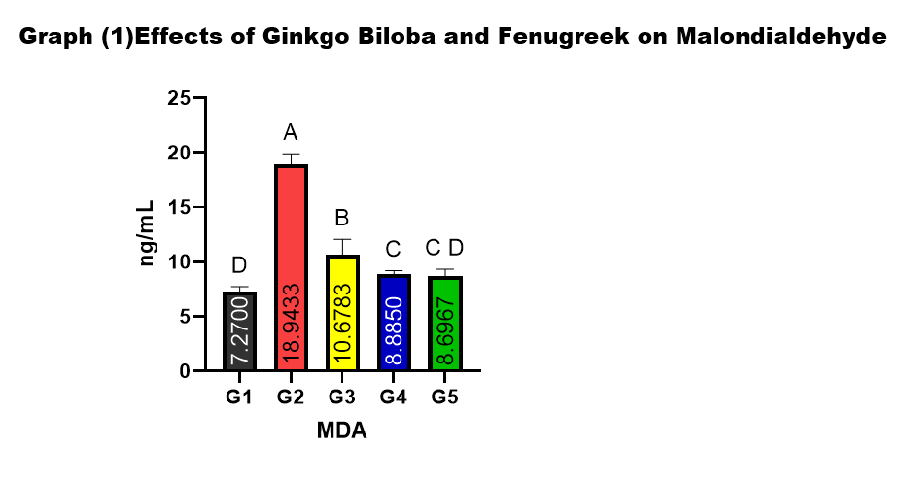

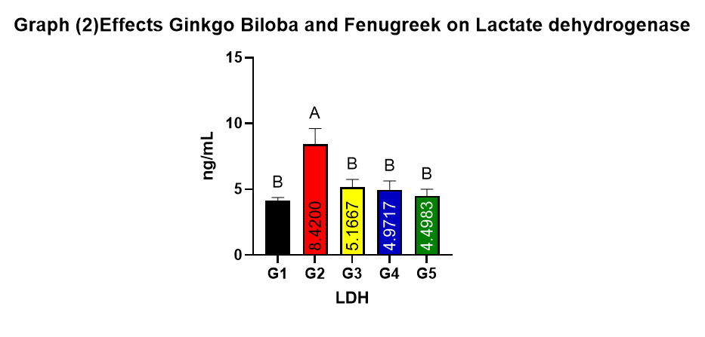
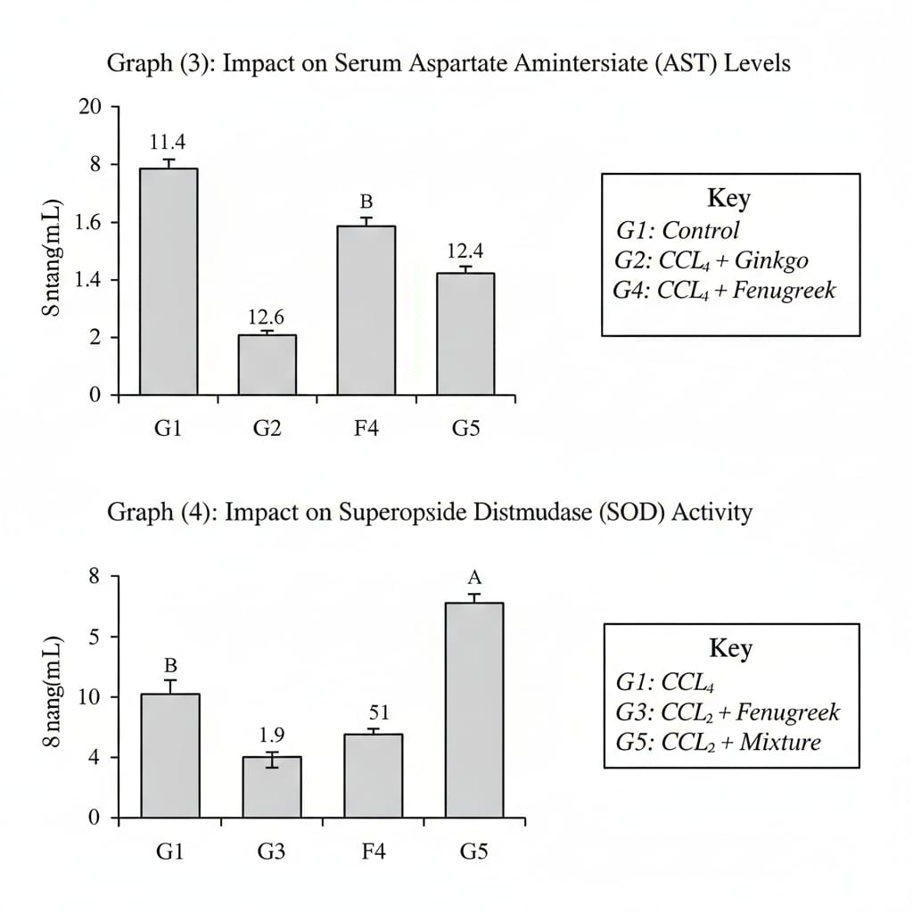

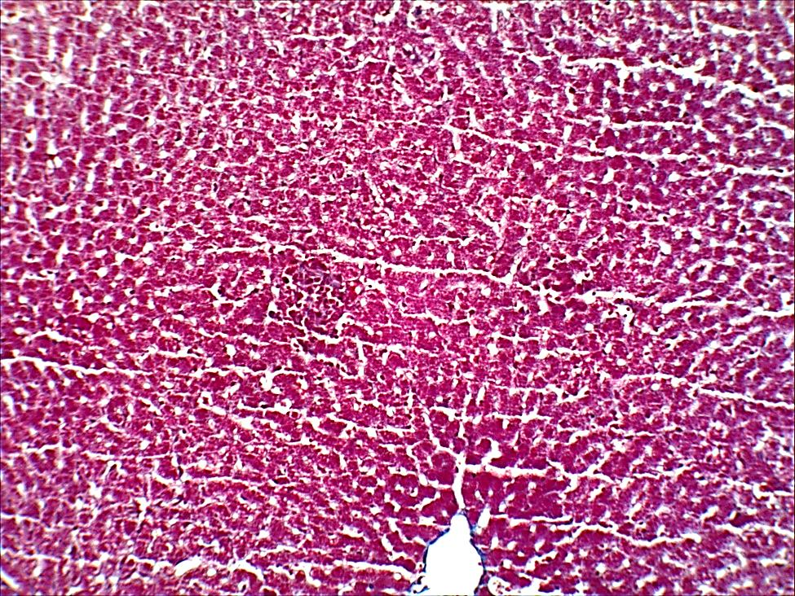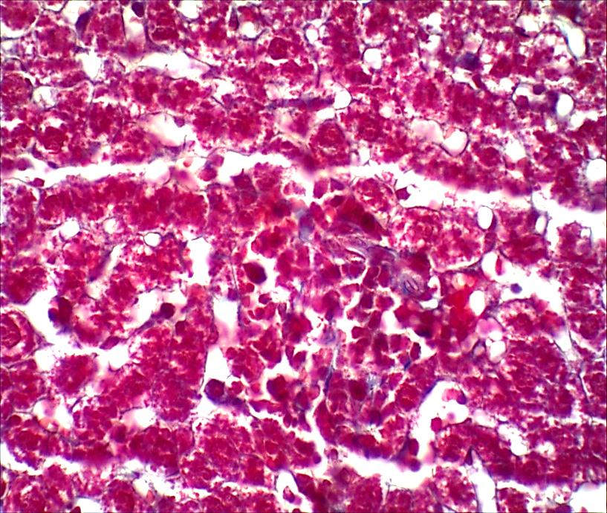
Figure 1. Histopathological features of liver tissue in control and CCl₄-treated rats.
Masson’s trichrome–stained liver sections show normal hepatic architecture in control rats with intact hepatocyte cords and sinusoids (A, B), whereas CCl₄-treated rats exhibit marked architectural disruption, hepatocellular degeneration and necrosis, inflammatory infiltration, and increased collagen deposition indicative of fibrosis (C, D).
Magnification: A, C = 100×; B, D = 400×.

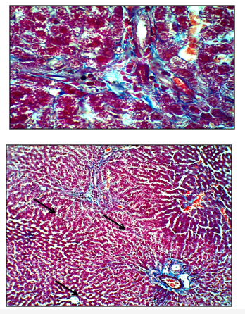
Figure 2. Liver histology of CCl₄ + Ginkgo biloba–treated rats.
Masson’s trichrome staining demonstrates attenuation of CCl₄-induced hepatic injury, with partial restoration of liver architecture and reduced collagen fiber deposition compared with the CCl₄ group.
Magnification: A = 100×; B = 400×.

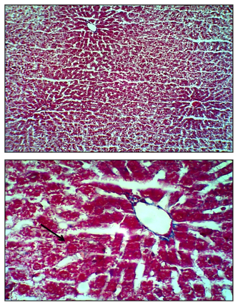

Figure 3. Liver histology of CCl₄ + Ginkgo biloba + Trigonella foenum-graecum–treated rats.
Masson’s trichrome staining shows near-normal hepatic architecture with minimal collagen deposition, indicating marked reversal of CCl₄-induced liver injury.
Magnification: A = 100×; B = 400×.
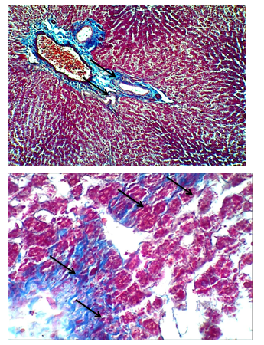

Figure 4.Liver sections of CCl₄-treated rats exhibit marked hepatic injury, evidenced by architectural distortion, hepatocellular fatty degeneration, centrilobular necrosis, sinusoidal congestion, and inflammatory infiltration.
Magnification: A = 100×; B = 400×
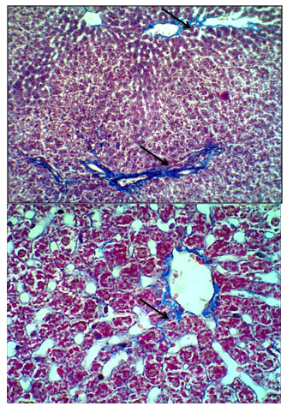
Figure 5.
Liver sections from rats treated with CCl₄ plus Trigonella foenum-graecum show marked histological improvement, with restoration of hepatic architecture, reduced hepatocellular degeneration, minimal fatty changes, and attenuated inflammatory infiltration compared with the CCl₄ group.
Magnification: A = 100×; B = 400×./

