Amelioration of Metabolic and Hepatic Alterations by Caralluma fimbriata in High-Fat Diet-Fed Obese Rats

ABSTRACT
Background The present study evaluated the effects of Caralluma fimbriata extract (CFE) on fat deposition, oxidative stress, inflammation, and fibrosis in the liver of high-fat diet (HFD)-induced obese rats. Thirty male Wistar rats were divided into five groups (n = 6): Control (C), Control+CFE, HFD, HFD+CFE (200 mg/kg/day for 150 days; preventive model), and obese+CFE (OBS+CFE; 200 mg/kg/day after 60 days; therapeutic model).
Results HFD-fed rats showed significant increases in body weight, plasma glucose, insulin resistance (HOMA-IR), leptin, lipid profile, and hepatic markers. Elevated lipid peroxidation and protein oxidation, along with reduced antioxidant enzyme activities (GPx, GR, GST, SOD, CAT) and HDL cholesterol levels, were also observed. CFE supplementation significantly improved body weight, hyperglycemia, insulin resistance, hyperleptinemia, and dyslipidemia. It increased HDL-C levels and restored antioxidant enzyme activities in both preventive and therapeutic groups. Additionally, CFE significantly (p < 0.05) reduced plasma and hepatic lipids, including triglycerides, total cholesterol, and free fatty acids, while improving phospholipid levels.
Conclusion Histopathological findings supported these results. Overall, CFE ameliorated liver dysfunction in HFD-fed rats by reducing oxidative stress and inflammation, indicating its potential protective and therapeutic role.
Keywords: Caralluma fimbriata, oxidative stress, insulin resistance, high-fat diet, hepatic transaminases
Background
Obesity is increasingly recognized as a chronic, relapsing, and multifactorial disease with complex genetic and environmental determinants. It has emerged as a major global health challenge affecting both developed and developing countries [1]. A long-term high-fat diet (HFD) is a key contributor to obesity and is associated with several metabolic complications, including dyslipidemia, hypertension, non-alcoholic fatty liver disease, cardiovascular disorders, and reduced life expectancy [2]. Previous studies have demonstrated that prolonged consumption of an HFD rapidly induces obesity and insulin resistance, highlighting unhealthy dietary habits as a major risk factor [3-5].
Chronic obesity is also linked to an increased risk of various cancers, particularly colorectal and prostate cancers [6]. Prolonged HFD intake promotes inflammation by upregulating Toll-like receptor 4 (TLR4), leading to increased production of pro-inflammatory cytokines and alterations in metabolic hormones such as insulin and leptin [7-8]. These changes disrupt glucose homeostasis and contribute to insulin resistance [9-10]. Experimental studies have further shown that HFD induces hyperglycemia, hyperinsulinemia, and hyperleptinemia in animal models [11-13].
Given the growing burden of obesity-related complications, there is an urgent need to develop effective strategies for prevention and management. In this context, Caralluma fimbriata, an edible succulent plant with known appetite-suppressing and antioxidant properties, has gained attention. It contains bioactive compounds that may reduce energy intake, enhance thermogenesis, and regulate lipid metabolism [11-13]. Therefore, the present study investigates the protective and therapeutic effects of Caralluma fimbriata extract on oxidative stress, inflammation, and tissue damage in HFD-induced obese rats.
METHODS
Chemicals
Reduced and oxidized glutathione, thiobarbituric acid (TBA), 1-chloro-2,4-dinitrobenzene (CDNB), and pyrogallol were purchased from SISCO Research Laboratories (P) Ltd, Mumbai, India. All other chemicals and solvents were of analytical grade and were purchased from Sisco Research Laboratories (P) Ltd. in Mumbai, India.
Preparation of plant extract
The extract of Caralluma fimbriata was prepared from the aerial parts of the plant using 40% aqueous alcohol (40 parts alcohol and 60 parts water). Approximately 12 kg of dried plant material was obtained from 100 kg of fresh plant, yielding 1 kg of final extract.
The hydroalcoholic extract of C. fimbriata (CFE; light brown, dry powder; batch number: CFE/10011) was supplied by Green Chem Herbal Extracts and Formulations, Bangalore, India. The plant material used for extraction was originally collected from the Kolli Hills and subsequently cultivated at the company’s farm in Hosur, Tamil Nadu, India. Prior to administration, the extract was dissolved in distilled water.
Experimental Animals and Diet
A total of thirty male Wistar rats (8 weeks old), weighing 160–170 g, were procured from Biogen Laboratory Animal Facility, Bangalore, India, and housed in the Animal House, Department of Zoology. Animals were maintained under standard laboratory conditions at a temperature of 23 ± 2°C with a 12 h light/12 h dark cycle. They were provided ad libitum access to a standard pellet diet or high-fat diet (HFD) and drinking water. Prior to the commencement of the experiment, all animals were acclimatized for one week. Throughout the experimental period, rats were maintained under sedentary conditions without any enforced physical activity. The dose of Caralluma fimbriata extract (CFE) used in this study was based on previously reported studies [11-13].
The HFD was formulated as a lard-based diet containing 60 kJ% energy from fat, 20 kJ% from protein, and 20 kJ% from carbohydrates, in accordance with Diet-Induced Obesity (DIO) diet standards (New Brunswick, NJ, USA).
Obesity Induction and Treatment in Rats
Male Wistar rats were randomly divided into five groups (n = 6 per group) as follows:
- Group C (Control): Rats were fed a standard pellet diet containing 65% carbohydrates, 8% fat, 13% protein, 12.75% fiber, and 1.25% vitamins and minerals, along with distilled water, for 150 days.
- Group C+CFE: Rats received a standard pellet diet along with Caralluma fimbriata extract (CFE; 200 mg/kg body weight) administered concurrently for 150 days.
- Group HFD: Rats were fed a high-fat diet (HFD) for 150 days to induce obesity.
- Group HFD+CFE (Protective model): Rats received HFD along with CFE (200 mg/kg body weight) simultaneously for 150 days.
- Group OBS+CFE (Therapeutic model): Rats were fed HFD for 90 days to induce obesity, followed by co-administration of HFD and CFE (200 mg/kg body weight) for the subsequent 60 days.

Body Weight and Organ Weights

Body weight was recorded for all animals throughout the experimental period. At the end of the study, the absolute and relative weights of the liver, abdominal fat, and epididymal fat pads were measured in all experimental groups. Relative organ weights were calculated with respect to the final body weight of each animal.
Biochemical Analysis
During the experimental period, blood samples were collected at 30-day intervals from 12-hour fasted rats via the retro-orbital plexus using capillary tubes. Samples were collected into fresh vials containing EDTA (10 mg/mL) as an anticoagulant. The blood samples were centrifuged at 3,000 rpm for 5 minutes using an Eppendorf Centrifuge 5805R (Germany). The separated plasma was aliquoted and stored at appropriate freezing conditions for the estimation of glucose, insulin, leptin, adiponectin, and lipid profile parameters. At the end of the experimental period, animals were fasted overnight and euthanized by cervical decapitation. The abdominal cavity was opened, and the liver was carefully excised, rinsed in ice-cold saline, and processed for further biochemical analyses.
Biochemistry of Serum/Plasma
Plasma glucose concentration was measured using the glucose oxidase method with a commercial kit from Excel Diagnostics, India. Plasma insulin levels were determined by radioimmunoassay (RIAK-1) obtained from the Bhabha Atomic Research Centre, Mumbai, following the method of [14]. Insulin resistance (IR) was assessed using the homeostasis model assessment (HOMA) and glucose–insulin (GI) index [15]. The HOMA index was calculated using the formula: HOMA = [insulin (μU/mL) × glucose (mmol/L)] / 22.5. Plasma leptin levels were measured using a sandwich ELISA kit (Mouse and Rat Leptin ELISA) from BioVendor Laboratory Medicine, Czech Republic.
Lipid Profile Analysis
Plasma triglyceride (TG) levels were determined using the glycerol-3-phosphate oxidase–phenol aminophenazone (GPO–PAP) enzymatic method with a commercial kit from Excel Diagnostics, India. Total cholesterol (TC) and high-density lipoprotein cholesterol (HDL-C) were measured using standard enzymatic methods with kits from the same manufacturer. Very low-density lipoprotein cholesterol (VLDL-C) and low-density lipoprotein cholesterol (LDL-C) levels were calculated using the Friedewald equation [16] as follows: VLDL-C = TG / 5 and LDL-C = TC − (HDL-C + VLDL-C). The atherogenic index (AI) was calculated according to Liu et al. [17] using the formula: AI = TC / HDL-C.
Liver Functional Tests
Serum activities of alkaline phosphatase (ALP), alanine transaminase (ALT), and aspartate transaminase (AST) were measured using kinetic methods recommended by the International Federation of Clinical Chemistry (IFCC). The assays were performed using commercial diagnostic kits from Erba Diagnostics Mannheim GmbH, Mumbai, India.
Hepatic Transaminases
A 10% (w/v) liver homogenate was prepared in 0.1 M Tris-HCl buffer (pH 7.4) and centrifuged at 18,514 × g for 45 minutes using a Eppendorf Centrifuge 5804R equipped with rotor No. 14030. The resulting clear supernatant was collected and used for the estimation of hepatic transaminases. The activities of glutamate oxaloacetate transaminase (GOT) and glutamate pyruvate transaminase (GPT) were determined according to the method described by Reitman and Frankel [18].
Hepatic Lipids
Liver lipids were extracted according to the method of Folch et al. [19]. The levels of total cholesterol (TC) and triglycerides (TAG) were determined using enzymatic kits from Excel Diagnostics, India. Free fatty acids (FFA) were estimated by the method of Duncombe [20]. Phospholipids (PL) were determined according to Connerty et al. [21], while total lipids (TL) were quantified using the method described by Folch et al. [19].
Hepatic Oxidative Stress Markers
Lipid peroxidation (LPO) in liver tissue was assessed by measuring thiobarbituric acid reactive substances (TBARS) according to the method of Utley et al. [22], using a 10% liver homogenate prepared in 0.15 M KCl. The results were expressed as nanomoles of malondialdehyde (MDA) formed per minute per milligram of protein. Protein oxidation was evaluated by estimating protein carbonyl (PC) content using the method of Levine et al. [23]. Reduced glutathione (GSH) levels were determined according to the method of Ellman [24]. Total protein content in the liver homogenate was measured using the method of Lowry et al. [25] for normalization of biochemical parameters.
Hepatic Antioxidant Enzyme Assay
A 10% (w/v) liver tissue homogenate was prepared in ice-cold 0.15 M KCl and centrifuged at 12,000 rpm for 45 minutes using a Sigma 3K18 Laboratory Centrifuge (Rotor No. 12150). The resulting clear supernatant was collected and used for the estimation of antioxidant enzyme activities. The activities of glutathione peroxidase (GPx; EC 1.11.1.9) were determined by the method of Rotruck et al. [26], glutathione-S-transferase (GST; EC 2.5.1.18) by Habig et al. [27], and glutathione reductase (GR; EC 1.8.1.7) by Pinto and Bartley [28]. Superoxide dismutase (SOD; EC 1.15.1.1) activity was measured according to Soon and Tan [29], while catalase (CAT; EC 1.11.1.6) activity was estimated using the method of Beers and Sizer [30].
Histological Assessment of the Liver
Liver tissues were collected from all experimental groups and fixed in 10% neutral buffered formalin. The samples were processed, paraffin-embedded, and sectioned at a thickness of 5 µm. The sections were stained with hematoxylin and eosin (H&E) and examined under a light microscope for histopathological evaluation.
Statistical Analysis
Data are expressed as mean ± standard error (SE) for six animals in each group. Statistical analysis was performed using Duncan’s Multiple Range Test (DMRT) as described by Duncan [31], with the aid of SPSS (version 13.0 for Windows; SPSS Inc., USA). A value of p < 0.05 was considered statistically significant.
RESULTS
Effects of CFE on Liver and Epididymal Fat Pad Weight
The absolute and relative weights of the liver and epididymal fat pads are presented in Table 1. The HFD group showed a significant increase in both absolute and relative liver (25.5% and 28.8%) and epididymal fat weights (66.3% and 88.3%) compared to the control group. Co-administration of CFE in HFD+CFE and OBS+CFE groups significantly prevented these increases. No notable differences were observed between C and C+CFE groups.

Table 1
Protective and therapeutic effects of CFE on absolute and relative organ weights in five experimental groups

Tissues | Groups
 | Group-C | Group-C+CFE | Group-HFD+CFE | Group-HFD | Group-OBS+CFE
Liver tissue weight (g)
Absolute | 8.38 ± 0.32ª | 8.30 ± 0.42ª | 8.45 ± 0.31ª | 10.52 ± 0.56^{b} | 9.10 ± 0.48ª
Relative | 2.29 ± 0.08ª | 2.52 ± 0.09ª | 2.66 ± 0.11^{b} | 2.95 ± 0.13^{b} | 2.64 ± 0.08ª
Epidymal fat pads (g)
Absolute | 5.35 ± 0.41ª | 5.58 ± 0.25ª | 6.77 ± 0.32^{bc} | 8.90 ± 0.64^{d} | 7.88 ± 0.47^{c}
Relative | 1.28 ± 0.06ª | 1.78 ± 0.03ª | 2.02 ± 0.11^{b} | 2.41 ± 0.09^{b} | 2.28 ± 0.12^{b}

Data are mean ± S.E.M. values of six rats per each group. Means in the same column with different superscripts are significantly different (P < 0.05). ^{a,b,c,d,e:} significant differences between groups. control rats; C+CFE, control rats treated with Caralluma fimbriata; HFD, high-fat diet fed rats; HFD+CFE, high-fat diet rats treated with Caralluma fimbriata (protective model); OBS+CFE, high-fat diet fed animals treated with Caralluma fimbriata (therapeutic model).

Effects of CFE on Body Weight
HFD-fed rats exhibited a significant increase in body weight (29%) compared to controls. CFE treatment significantly reduced weight gain in HFD+CFE (24.4%) and OBS+CFE (14.3%) groups. Additionally, CFE-treated groups showed reduced body weight gain compared to controls, indicating its protective and therapeutic efficacy (Fig. 1).
Effects of CFE on Plasma Glucose, Insulin, Leptin and HOMA
HFD significantly increased plasma glucose (108.1%), insulin (241.9%), and HOMA index (612.2%) compared to controls. CFE supplementation significantly reduced these parameters in both HFD+CFE and OBS+CFE groups, although values remained higher than controls. The C+CFE group maintained near-normal levels (Fig. 1). Plasma leptin levels were significantly elevated in HFD rats. CFE treatment reduced leptin levels in both HFD+CFE and OBS+CFE groups (Fig. 2A). The C+CFE group showed a slight reduction compared to controls, indicating protective effects of CFE against high fat diet induced abnormalities in Wistar rats.
Fig. 1. Changes in body weight (A) plasma glucose (B), plasma insulin (C) and HOMA (D) in HFD fed rats

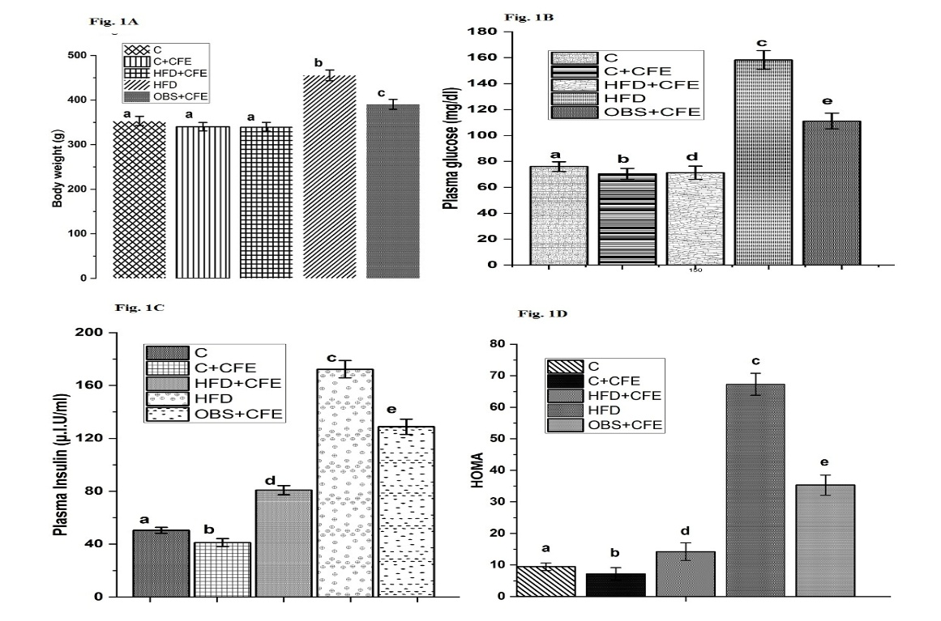
Group- C, C+CFE, control rats treated with Caralluma fimbriata; HFD, high-fat diet fed rats; HFD+CFE, high-fat diet rats treated with Caralluma fimbriata (protective model); OBS+CFE, high-fat diet fed animals treated with Caralluma fimbriata (therapeutic model). (Values are mean ± SEM (n=6 animals in each group). a-e Significant differences between groups-C, C+CFE, HFD, HFD+CFE and OBS+CFE.
Effects of CFE on Lipid Profile
HFD significantly increased TG, TC, LDL-C, VLDL-C, and atherogenic index, while decreasing HDL-C. CFE supplementation effectively reversed these alterations in both treatment groups. The C+CFE group also showed improved lipid profile, suggesting anti-atherogenic effects (Fig. 2A & 3D).
Fig. 2. Changes in fasting plasma leptin (A), fasting plasma triglycerides (B), and fasting plasma cholesterol (C) in HFD fed rats

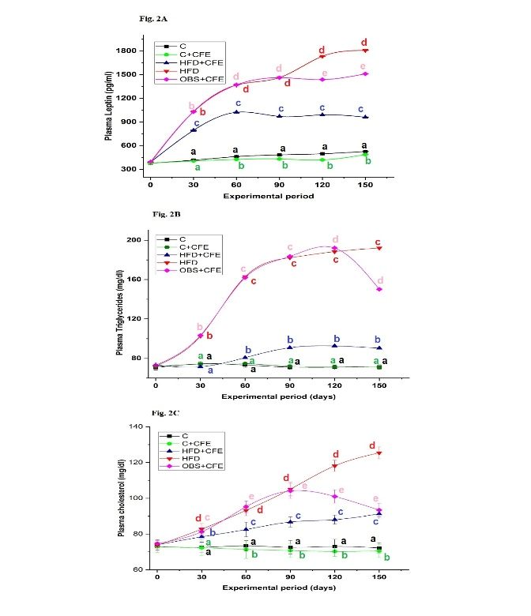
Group-C, C+CFE, control rats treated with Caralluma fimbriata; HFD, high-fat diet fed rats; HFD+CFE, high-fat diet rats treated with Caralluma fimbriata (protective model); OBS+CFE, high-fat diet fed animals treated with Caralluma fimbriata (therapeutic model). (Values are mean ± SEM (n=6 animals in each group).
Fig. 3. Changes in VLDL-C (A), LDL-C (B), HDL-C (C) and Atherogenic Index (AI) in HFD fed rats
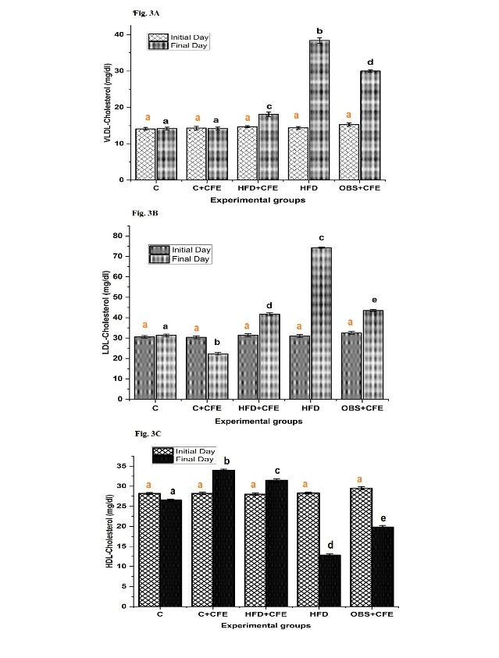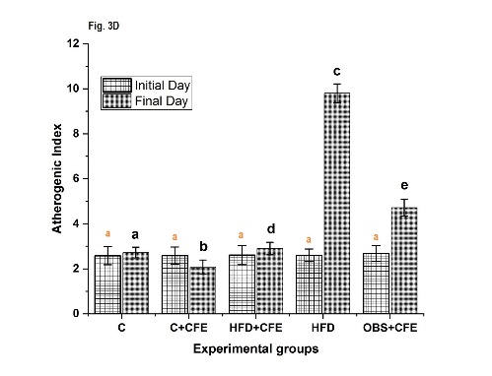
Group-C, C+CFE, control rats treated with Caralluma fimbriata; HFD, high-fat diet fed rats; HFD+CFE, high-fat diet rats treated with Caralluma fimbriata (protective model); OBS+CFE, high-fat diet fed animals treated with Caralluma fimbriata (therapeutic model). (Values are mean ± SEM (n=6 animals in each group). a-e Significant differences between groups-C, C+CFE, HFD, HFD+CFE and OBS+CFE.
Effects of CFE on Hepatic Lipid Content
As shown in Table 2, rats fed a high-fat diet (HFD) exhibited a significant increase in hepatic total cholesterol (38.7%), triglycerides (75%), total lipids (45.7%), and free fatty acids (100%), along with a significant decrease in phospholipids (24.4%) compared to the control group. Co-administration of CFE in both protective (HFD+CFE) and therapeutic (OBS+CFE) groups significantly attenuated these alterations. In contrast, the C+CFE group showed no significant changes in hepatic total lipids, total cholesterol, triglycerides, or free fatty acids, with only a slight variation in phospholipid levels compared to the control group.
Table 2: Protective and therapeutic effects of CFE on hepatic lipids in five experimental groups
Experimental Groups | Total lipids (mg/g tissue) | Triglyceride (mg/g tissue) | Total Cholesterol (mg/g tissue) | Phospholipids (mg/g tissue) | Free fatty acids (mg/g tissue)
C | 48.6±0.02ª | 5.6±0.03ª | 3.1±0.03ª | 26.6±0.03ª | 0.90±0.04ª
C+CFE | 47.3±0.02ª | 5.5±0.03ª | 2.9±0.04ª | 28.1±0.02^{d} | 0.89±0.04ª
HFD+CFE | 49.0±0.06ª | 6.0±0.02^{b} | 3.2±0.03ª | 28.0±0.03^{d} | 1.00±0.02^{b}
HFD | 70.8±0.03^{c} | 9.8±0.03^{d} | 4.3±0.01^{c} | 20.1±0.02^{c} | 1.80±0.04^{d}
OBS+CFE | 54.1±0.03^{b} | 8.7±0.05^{c} | 3.9±0.03^{b} | 25.2±0.03^{b} | 1.30±0.02^{c}
Data are mean ± S.E.M. values of six rats per each group. Means in the same column with different superscripts are significantly different (P < 0.05). ^{a,b,c,d,e:} significant differences between groups. control rats; C+CFE, control rats treated with Caralluma fimbriata; HFD, high-fat diet fed rats; HFD+CFE, high-fat diet rats treated with Caralluma fimbriata (protective model); OBS+CFE, high-fat diet fed animals treated with Caralluma fimbriata (therapeutic model).
Effects of CFE on Serum and hepatic Transaminases
HFD significantly elevated serum SGOT, SGPT, and SALP activities, indicating liver damage. CFE supplementation markedly reduced these enzyme levels in treated groups. As shown in Fig. 4 & 5, rats in the high-fat diet (HFD) group exhibited a significant increase in hepatic transaminase activities, with glutamate oxaloacetate transaminase (GOT) and glutamate pyruvate transaminase (GPT) elevated by 25.6% and 22.4%, respectively, compared to the control group. Co-administration of CFE in both protective (HFD+CFE) and therapeutic (OBS+CFE) groups significantly attenuated these increases. GOT activity was reduced by 17.9% and 15.4%, while GPT activity decreased by 10.7% and 8.3% in HFD+CFE and OBS+CFE groups, respectively, compared to the HFD group. No significant differences in hepatic transaminase activities were observed between the control (C) and C+CFE groups.

Fig. 4. Effect of CFE on serum transaminases in HFD fed rats
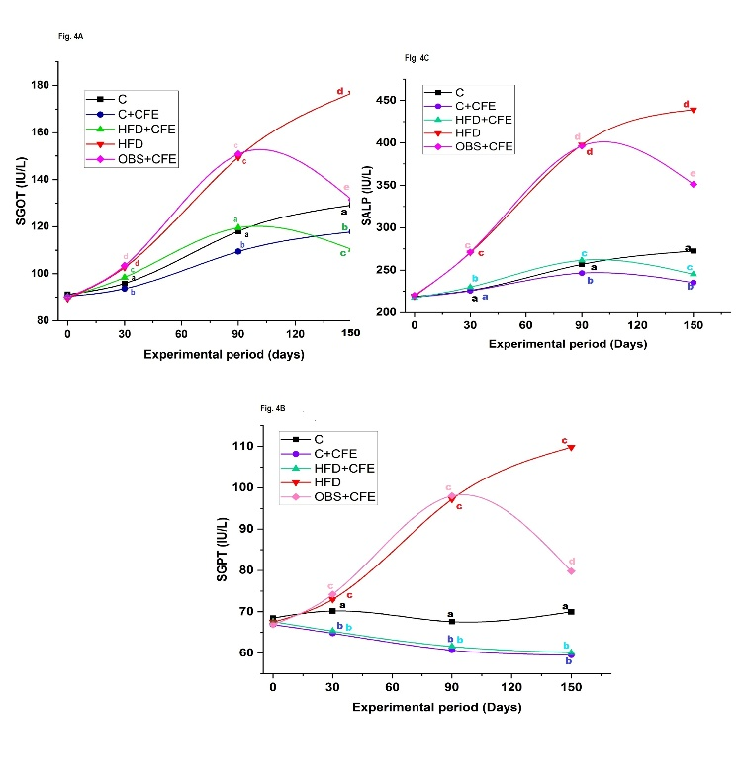
Fig. 5. Effect of CFE on hepatic transaminases in HFD fed rats
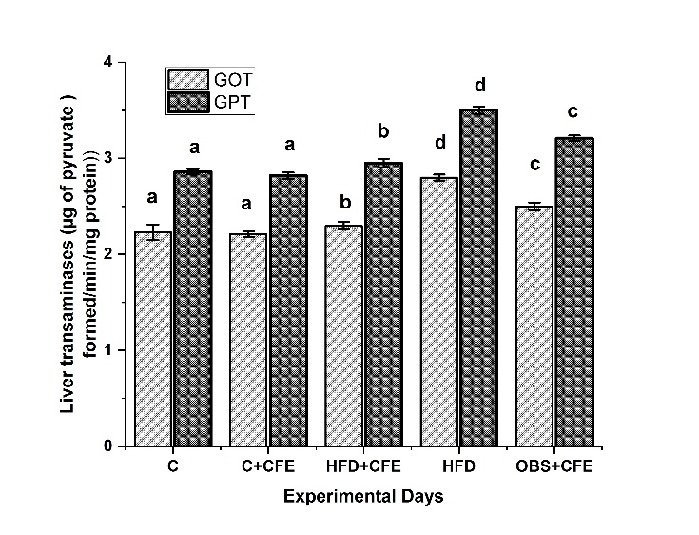
Group-C, C+CFE, control rats treated with Caralluma fimbriata; HFD, high-fat diet fed rats; HFD+CFE, high-fat diet rats treated with Caralluma fimbriata (protective model); OBS+CFE, high-fat diet fed animals treated with Caralluma fimbriata (therapeutic model). (Values are mean ± SEM (n=6 animals in each group). a-e Significant differences between groups-C, C+CFE, HFD, HFD+CFE and OBS+CFE.
Effects of CFE on Hepatic Oxidative Stress Markers
Oxidative stress was evaluated by measuring lipid peroxidation (LPO), protein oxidation (PO), and reduced glutathione (GSH) levels in liver tissue (Table 3). Rats fed a high-fat diet (HFD) showed a significant increase in LPO (214.0%) and PO (72.4%) levels, along with a marked decrease in GSH (47.2%) compared to the control group. Co-administration of CFE in both protective (HFD+CFE) and therapeutic (OBS+CFE) groups significantly reduced LPO (63.7% and 46.0%) and PO (41.7% and 29.3%) levels, while increasing GSH levels (81% and 18.4%), respectively, compared to the HFD group.
Experimental animals | Lipid peroxidation (nmol MDA formed/min/mg protein) | Protein oxidation (µmol of protein carbonyls/mg protein) | Reduced Glutathione (µg of GSH/mg protein)
C | 24.95±0.04ª | 1.74±0.03ª | 7.20±0.02ª
C+CFE | 23.00±0.04^{b} | 1.65±0.03^{b} | 7.84±0.04^{b}
HFD+CFE | 28.40±0.03^{d} | 1.75±0.03ª | 6.88±0.04^{d}
HFD | 78.35±0.01^{c} | 3.00±0.02^{c} | 3.80±0.02^{c}
OBS+CFE | 42.30±0.03e | 2.12±0.02^{d} | 4.50±0.04e
Table 3
Protective and therapeutic effects of CFE on oxidative stress markers in five experimental animals
Data are mean ± S.E.M. values of six rats per each group. Means in the same column with different superscripts are significantly different (P < 0.05). ^{a,b,c,d,e:} significant differences between groups. control rats; C+CFE, control rats treated with Caralluma fimbriata; HFD, high-fat diet fed rats; HFD+CFE, high-fat diet rats treated with Caralluma fimbriata (protective model); OBS+CFE, high-fat diet fed animals treated with Caralluma fimbriata (therapeutic model).
Effects of CFE on Hepatic Antioxidant Enzymes
The activities of antioxidant enzymes i.e., glutathione peroxidase (GPx), glutathione-S-transferase (GST), glutathione reductase (GR), superoxide dismutase (SOD), and catalase (CAT) were significantly reduced in HFD-fed rats by 54.8%, 19.2%, 45.6%, 32.2%, and 18.6%, respectively, compared to controls (Figs. 6A and B). CFE supplementation in both HFD+CFE and OBS+CFE groups significantly restored these enzyme activities. Increases were observed in GPx (46.4% and 15.7%), GST (21.2% and 12.0%), GR (67.0% and 20.5%), SOD (46.5% and 26.8%), and CAT (20.0% and 9.8%) compared to the HFD group, indicating improved antioxidant defense.
Fig. 6. Effect of CFE on antioxidant enzymes in HFD fed rats
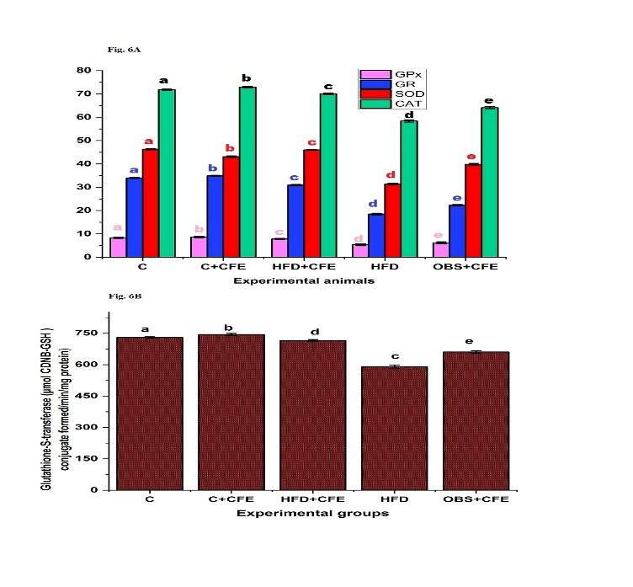
Group-C, C+CFE, control rats treated with Caralluma fimbriata; HFD, high-fat diet fed rats; HFD+CFE, high-fat diet rats treated with Caralluma fimbriata (protective model); OBS+CFE, high-fat diet fed animals treated with Caralluma fimbriata (therapeutic model). (Values are mean ± SEM (n=6 animals in each group). a-e Significant differences between groups-C, C+CFE, HFD, HFD+CFE and OBS+CFE. GPx (µg of GSH consumed/min/mg protein), GR (µmol NADPH oxidized/min/mg protein), SOD (U/mg protein), and CAT (mmol H₂O₂ consumed/min/mg protein).
Effects of CFE on Hepatic Steatosis
Fig. 7 presents representative photomicrographs of liver sections from all experimental groups. The control group (C) exhibited normal hepatic architecture, characterized by well-arranged hepatocytes, intact portal triads, and clearly defined sinusoids, with no evidence of lipid accumulation (Fig. 7A).
Fig. 7. Effect of CFE treatment on high fat diet induced hepatic damage in rats (H & E stain) at 10X.

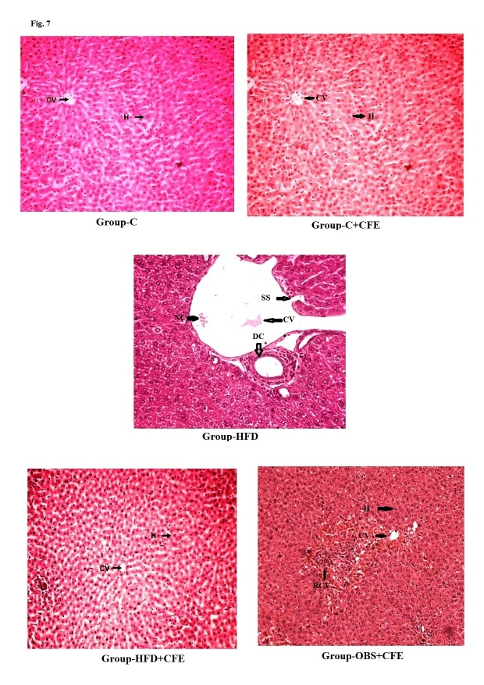
(A) Group-C: control group; (B) Group-C+CFE: treated with Caralluma fimbriata (200 mg/kg body weight) in distilled water orally for 150 days (C+CFE); (C) Group-HFD: High fat diet fed rats; (D) Group-HFD+CFE: HFD fed rats treated with Caralluma fimbriata (200 mg/kg body weight) in distilled water orally by gastric intubation for 150 days (HFD+CFE) (protective model); (E) Group-OBS+CFE: High Fat diet fed rats treated with Caralluma fimbriata (200 mg/kg body weight) in distilled water orally for 60 days (OBS+CFE) (therapeutic model). SS- sinusoids space; CV, central vein; V, vacuolization; NC, necrotic changes; DC, degenerative changes; RCV; Regeneration Central Vein

DISCUSSION
The present study demonstrates that Caralluma fimbriata extract (CFE) exerts both protective and therapeutic effects against high-fat diet (HFD)-induced metabolic syndrome and hepatic injury. These findings are consistent with earlier reports indicating the antioxidative and metabolic regulatory potential of CFE in multiple tissues [3-4; 11-13]. The results suggest that CFE effectively attenuates key features of metabolic syndrome, including hyperglycemia, hyperinsulinemia, insulin resistance, dyslipidemia, and liver dysfunction.
Insulin resistance (IR) is widely recognized as a central mechanism underlying metabolic syndrome. In the present study, HFD feeding significantly increased body weight, plasma glucose, insulin levels, HOMA index, and leptin levels, confirming the development of obesity and IR [32]. These changes were exacerbated with prolonged HFD exposure [33]. However, CFE administration significantly reduced body weight gain and improved glycemic control and insulin sensitivity in both preventive and therapeutic models. The ability of CFE to maintain normoglycemia and lower insulin levels suggests enhanced insulin sensitivity, which may be attributed to its bioactive constituents [11-13].
The liver plays a central role in lipid metabolism, and its dysfunction is a hallmark of obesity-related disorders [34]. HFD-fed rats showed elevated plasma and hepatic lipid levels, including TC, TG, LDL-C, and free fatty acids, along with reduced HDL-C levels. These alterations were accompanied by histological evidence of hepatic steatosis and inflammation [35]. CFE treatment significantly improved lipid profiles and reduced hepatic lipid accumulation, indicating its antihyperlipidemic effect [13]. This may be partly due to reduced intestinal lipid absorption and modulation of lipid metabolism pathways.Elevated serum transaminases observed in HFD rats indicate hepatocellular damage, which was further supported by histopathological findings [36-42]. CFE administration effectively normalized these enzyme levels, suggesting hepatoprotective activity. The reduction in hepatic GOT and GPT activities further confirms the protective role of CFE against liver injury.
Oxidative stress is a critical factor linking obesity to metabolic and hepatic disorders [43-44]. In the present study, HFD significantly increased lipid peroxidation and protein oxidation while reducing antioxidant defenses such as GSH and enzymatic antioxidants (SOD, CAT, GPx, GST, and GR). These findings indicate impaired redox balance due to excessive reactive oxygen species (ROS) production [41-42]. CFE supplementation markedly reduced oxidative stress markers and restored antioxidant enzyme activities, highlighting its strong antioxidant potential. This effect may be attributed to the presence of bioactive compounds such as flavonoids, saponins, and phenolic compounds [12-13].
Histopathological analysis further supported the biochemical findings. Severe hepatic steatosis, inflammation, and cellular degeneration observed in HFD rats were markedly attenuated by CFE treatment, although not completely reversed. This indicates that while CFE has significant protective effects, prolonged damage may require extended intervention. Overall, the findings suggest that CFE mitigates HFD-induced metabolic and hepatic alterations through multiple mechanisms, including improvement of insulin sensitivity, regulation of lipid metabolism, reduction of oxidative stress, and enhancement of antioxidant defense systems. Therefore, CFE may serve as a promising natural therapeutic agent for the management of obesity-related metabolic disorders and prevention of fatty liver disease progression.
Conclusion
The present study demonstrates that a HFD induces obesity-associated metabolic disturbances, leading to oxidative stress, inflammation, and hepatic injury. Supplementation with CFE effectively ameliorated these alterations in both preventive and therapeutic models. CFE significantly improved body weight regulation, reduced oxidative stress and inflammatory responses, and protected against liver dysfunction. These findings highlight the potential of CFE as a natural therapeutic agent for managing obesity-related metabolic and hepatic disorders. However, further studies, particularly well-designed clinical trials in humans, are required to validate its efficacy and safety.

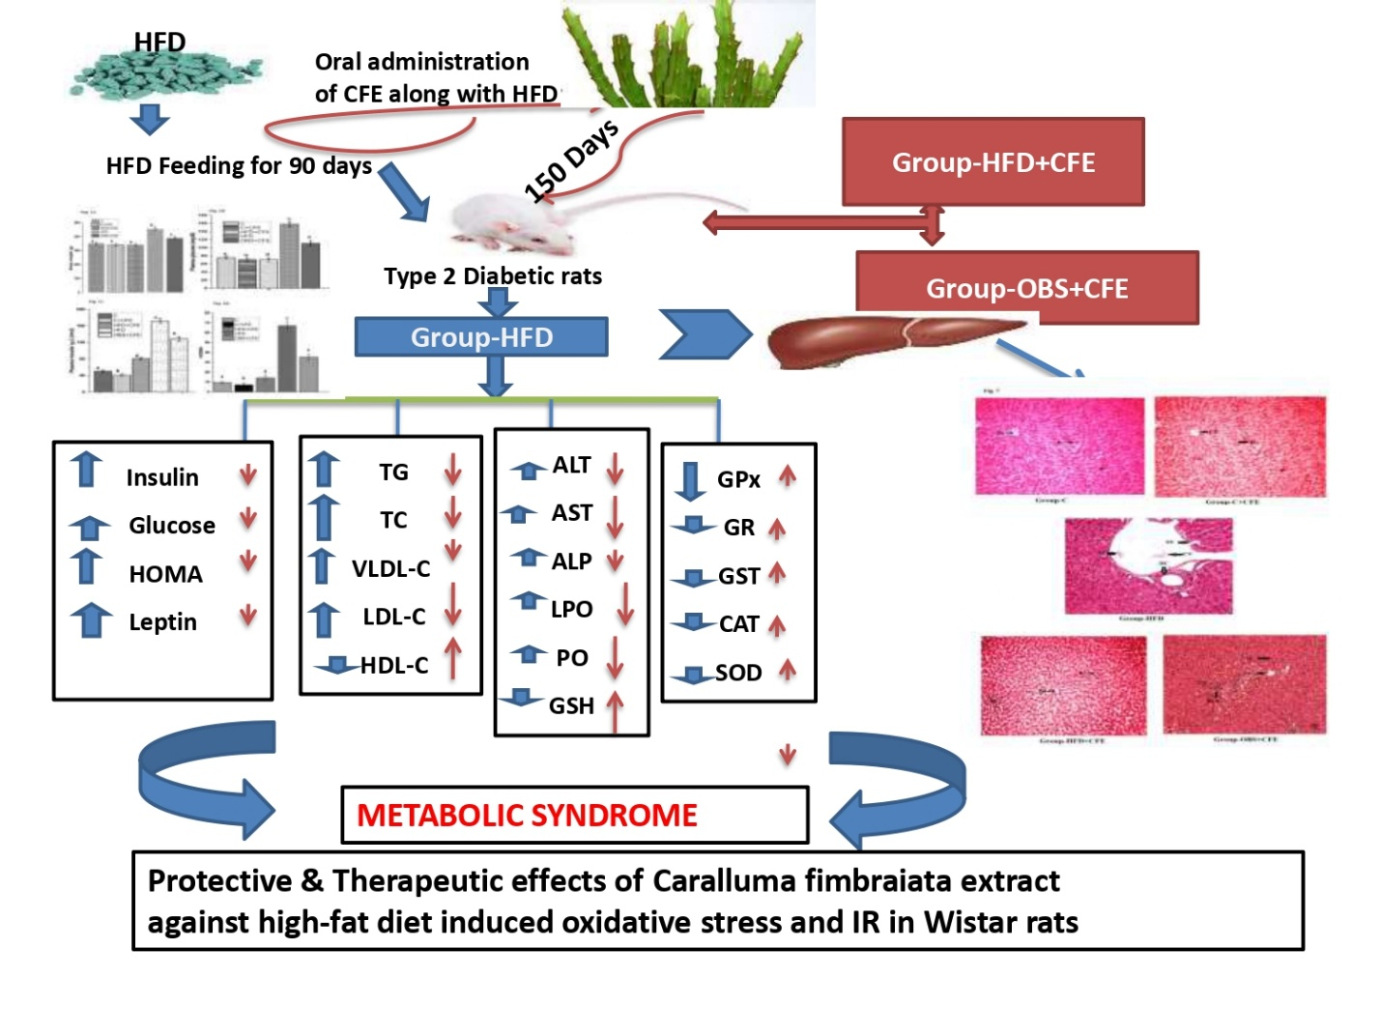
Fig 8.
Disclosure statement
The authors report that they have no conflicts of interest.
Ethical Approval
All experimental protocols involving laboratory animals were conducted in accordance with the guidelines of the Committee for the Purpose of Control and Supervision of Experiments on Animals (CPCSEA), Government of India (Regd. No: 1889/GO/Re/S/16/CPCSEA, dated 23 October 2021). The study was approved by the Institutional Animal Ethics Committee (IAEC), S.K. University (Regd. No: SKU/IAEC/01/2022).
Undertaking Declaration
The authors hereby declare that the manuscript is an original work and has not been published previously, nor is it under consideration for publication elsewhere, either in whole or in part.

Declaration of AI Use

This manuscript was prepared through the combined contributions of all author(s), including contributions to the study design, data, content development, results, interpretation, and related scholarly work. The author(s) acknowledge the use of Grammarly and ChatGPT to assist with grammar checking, language refinement, reference formatting. These AI-assisted tools were not used as authors and did not replace the intellectual contributions or scholarly judgment of the author(s). All AI-assisted outputs, including content, references, and interpretations, were carefully reviewed, revised, verified, and approved by the author(s). The author(s) accept full responsibility for the accuracy, integrity, and final content of the manuscript.

COMPETING INTERESTS DISCLAIMER:
Authors have declared that they have no known competing financial interests OR non-financial interests OR personal relationships that could have appeared to influence the work reported in this paper.

REFERENCES
- Młynarska E, Bojdo K, Bulicz A, Frankenstein H, Gąsior M, Kustosik N, Rysz J, Franczyk B. Obesity as a Multifactorial Chronic Disease: Molecular Mechanisms, Systemic Impact, and Emerging Digital Interventions. Curr Issues Mol Biol. 2025 Sep 23;47(10):787. doi: 10.3390/cimb47100787.
- Kyrou, I., Randeva, H.S., Tsigos, C., Kaltsas, G., Weickert, M.O. Clinical Problems Caused by Obesity. In Endotext; Feingold KR, Anawalt B, Boyce A, Chrousos G, de Herder WW, Dhatariya K, Dungan K, Hershman JM, Hofland J, Kalra S, et al., Eds.; 2000; MDText.com, Inc.: South Dartmouth, MA, USA.
- Sudhakara, G., Mallaiah, P., Sreenivasulu, N., Sasi Bhusana Rao, B., Rajendran, R., Saralakumari, D. Beneficial effects of hydro-alcoholic extract of caralluma fimbriata against high-fat diet-induced insulin resistance and oxidative stress in wistar male rats. J Physiol Biochem. 2014;70(2):311-320.
- Sudhakara, G., Mallaiah, P., Rajendran, R., Saralakumari, D. Caralluma fimbriata and metformin protection of rat pancreas from high fat diet induced oxidative stress. Biotech Histochem. 2018; 93(3):177-187.
- Gujjala S, Bangeppagari M, Devarakonda VLNP, Bellamkonda R, Bhadramraju R, Kameswaran S, Ramaswamy R, Desireddy S. Pleiotropic effects of Salacia reticulata and Simvastatin on oxidative stress and insulin resistance in a rat model. Biomed Pharmacother. 2023 Aug;164:114960. doi: 10.1016/j.biopha.2023.114960.
- Olatona, F.A., Onabanjo, O.O., Ugbaja, R.N,, Nnoaham, K.E., Adelekan, D.A. Dietary habits and metabolic risk factors for non-communicable diseases in a university undergraduate population. J Health Popul Nutr. 2018; 16;37(1):21.
- Xu, M., Jung, X., Hines, O.J., Eibl, G., Chen, Y. Obesity and Pancreatic Cancer: Overview of Epidemiology and Potential Prevention by Weight Loss. Pancreas. 2018; 47(2):158-162.
- Pati, S., Irfan, W., Jameel, A., Ahmed, S., Shahid, R.K. Obesity and Cancer: A Current Overview of Epidemiology, Pathogenesis, Outcomes, and Management. Cancers. 2023;15(2):485.
- Tramullas, M., Finger, B.C., Dinan, T.G., Cryan, J.F. Obesity Takes Its Toll on Visceral Pain: High-Fat Diet Induces Toll-Like Receptor 4-DependentVisceral Hypersensitivity. PLoS One. 2016; 9;11(5):e0155367.
- Galicia-Garcia, U., Benito-Vicente, A., Jebari, S., Larrea-Sebal, A., Siddiqi, H., Uribe, K.B., Ostolaza, H., Martín, C. Pathophysiology of Type 2 Diabetes Mellitus. Int J Mol Sci. 2020; 30;21(17):6275.
- Gujjala, S., Putakala, M., Nukala, S., Bangeppagari, M., Ramaswamy, R., Desireddy, S. Renoprotective effect of caralluma fimbriata against high-fat diet-induced oxidative stress in Wistar rats. J Food Drug Anal. 2016; 24(3):586-593.
- Gujjala, S., Putakala, M., Nukala, S., Bangeppagari, M., Rajendran, R., Desireddy, S. Modulatory effects of Caralluma fimbriata extract against high-fat diet induced abnormalities in carbohydrate metabolism in Wistar rats. Biomed Pharmacother. 2017; 92:1062-1072.
- Gujjala, S., Putakala, M., Bongu, S.B.R., Ramaswamy, R., Desireddy, S. Preventive effect of Caralluma fimbriata against high-fat diet induced injury to heart by modulation of tissue lipids, oxidative stress and histological changes in Wistar rats. Arch Physiol Biochem. 2019; 128(2):474-482.
- Yalow, R.S., Berson, S.A. Immunoassay of plasma insulin in man. Diabetes. 1961; 10:339-344.
- Pickavance, L.C., Tadayyon, M., Widdowson, P.S., Buckingham, R.E., Wilding, J.P. Therapeutic index for rosiglitazone in dietary obese rats. Separation of efficacy and haemodiluation. Br J Pharmacol. 1999;128 (7);1570–1576.
- Friedewald, W.T., Levy, R.I. Fredrickson DS. Estimation of the concentration of low-density lipoprotein cholesterol in plasma, without use of the preparative ultracentrifuge. Clin Chem. 1972;18(6):499502.
- Liu, C.S., Lin, C.C., Li, T.C. The relation of white blood cell count and atherogenic index ratio of LDL-cholesterol to HDL-cholesterol in Taiwan school children. Acta Paediatr Taiwan. 1999;40(5):319-24.
- Reitman, S., Frankel, S. Practical Biochemistry in clinical medicine. Am J Clin Path; 1957; 25: 56. In: Nath RL. 2nd 543 edition, 1990, Academic Publisher, Calcutta, pp. 155–161.
- Folch, J., Lees, M., Sloane Stanley, G.H. A simple method for the isolation and purification of total lipides from animal tissues. J Biol Chem. 1957;226(1):497-509.
- Duncombe, W.G. The colorimetric micro-determination of long-chain fatty acids. Biochem J. 1963; 88(1):7-10.
- Connerty, H.V., Briggs, A.R., Eaton, E.H. Jr. Simplified determination of the lipid components of blood serum. Clin Chem. 1961; 7:37-53.
- Utley, H.G., Bernheim, F., Hochstein, P. Effect of sulfhydryl reagents on peroxidation in microsomes. Arch Biochem Biophys, 1967;34:406e8.
- Levine, R.L., Garland, D., Oliver, C.N., Amici, A., Climent, I., Lenz, A.G., Ahn, B.W., Shaltiel, S., Stadtman, E.R. Determination of carbonyl content in oxidatively modified proteins. Methods Enzymol.1990;186:464-78.
- Ellman, G.L. Tissue sulfhydryl groups. Arch Biochem Biophys. 1959;82(1):70-7.
- Lowry, O.H., Rosebrough, N.J., Farr, A.L., Randall, R.J. Protein measurement with the Folinphenol reagent. J Biol Chem. 1951; 193(1):26575.
- Rotruck, J.T., Pope, A.L., Ganther, H.E., Swanson, A.B., Hafeman, D.G., Hoekstra, W.G. Selenium: biochemical role as a component of glutathione peroxidase. Science. 1973;179(4073):588-90.
- Habig, WH., Pabst, M.J., Jakoby, W.B. Glutathione S-transferases. The first enzymatic step in mercapturic acid formation. J Biol Chem. 1974;249(22):71309.
- Pinto, R.E., Bartley, W. The effect of age and sex on glutathione reductase and glutathione peroxidase activities and on aerobic glutathione oxidation in rat liver homogenates. Biochem J. 1969;112(1):109-15.
- Soon, Y.Y., Tan, B.K. Evaluation of the hypoglycemic and anti-oxidant activities of Morinda officinalis in streptozotocin-induced diabetic rats. Singapore Med J. 2002;43(2):077-85.
- Beers, R.F., Sizer, J.W. A spectrophotometric method for measuring the breakdown of hydrogen peroxide by catalase. J Biol Chem.1952;195(1):133-40.
- Duncan, D.B. Multiple range and multiple tests. Biometrics. 1955;42, 1–42.
- Moller, D.E. New drug targets for type 2 diabetes and the metabolic syndrome. Nature. 2001;414(6865):821-7.
- Labib, M. acp Best Practice No 168. The investigation and management of obesity. J Clin Pathol. 2003;56(1):17-25.
- Kraegen, E.W., Clark, P.W., Jenkins, A.B., Daley, E.A., Chisholm, D.J., Storlien, L.H. Development of muscle insulin resistance after liver insulin resistance in high-fat-fed rats. Diabetes. 1991; 40(11):1397-403.
- Bray, G.A. Medical consequences of obesity. J Clin Endocrinol Metab.2004;89(6):2583-9.
- Khoursheed, M., Miles, P.D., Gao, K.M., Lee, M.K., Moossa, A.R., Olefsky, J.M. Metabolic effects of troglitazone on fat-induced insulin resistance in the rat. Metabolism.1995; 44(11):1489-94.
- Wilkes, J.J., Bonen, A., Bell, R.C. A modified high-fat diet induces insulin resistance in rat skeletal muscle but not adipocytes. Am J Physiol. 1998; 275(4):E679-86.
- Cohen, J.A., Kaplan, M.M. The SGOT/SGPT ratio--an indicator of alcoholic liver disease. Dig Dis Sci. 1979;24(11):835-8.
- Giannini, E.G., Testa, R., Savarino, V. Liver enzyme alteration: a guide for clinicians. CMAJ. 2005;172(3):367-79.
- Rockey, D.C. Hepatic blood flow regulation by stellate cells in normal and injured liver. Semin Liver Dis. 2001; 21:337-349.
- Manna, P., Jain, S.K. Obesity, Oxidative Stress, Adipose Tissue Dysfunction, and the Associated Health Risks: Causes and Therapeutic Strategies. Metab Syndr Relat Disord. 2015;13(10):423-44.
- Batistaa, A.G., Lenquiste, S.A., Betim Cazarina, C.B., Kelly da Silvaa, J., Luiz-Ferreirab, A., Bogusz, S. Jr., Hantaod, L.W., de Souzad, R.N., Augustod, F., Alexandre Pradoa, M., Marostica, M.R. Jr. Intake of jaboticaba peel attenuates oxidative stress in tissues and reduces circulating saturated lipids of rats with high-fat diet-induced obesity. Journal of Functional Foods. 2014; 6:450–461.
- Bechmann, L.P., Hannivoort, R.A., Gerken, G., Hotamisligil, G.S., Trauner, M., Canbay, A. The interaction of hepatic lipid and glucose metabolism in liver diseases. J Hepatol. 2012; 56(4):952-64.
- Alves-Bezerra, M., Cohen, D.E. Triglyceride Metabolism in the Liver. Compr Physiol. 2017; 8(1):1-8.

