A new leech on Poecilobdella budhoi sp. nov. from Arunachal Pradesh, India

ABSTRACT: S. D. Gurumayum and Temjenmogla collected some leeches from Kurung kumey, District, Arunachal Pradesh for research purpose, Identification have been done under the Binocular LEICA EZ4 HD in ZSI and compaired with the other leeches of Poecilobdella genus in the world. As a result authors came to know that it is a new leech of the genus. Structure of Vaginal duct, Vaginal sac, Position of male and female pore, pattern of stripe, number of total segments, positions of eyes, all are different from other 9 aquatic species of the genus Poecilobdella. It may be used as medicinal leech in the world. The world is having more than 721 species of leeches and India possesses 88 species of leech. Dinobdella ferox (Blanchard, 1896) and species of Poecilobdella genus are used as medicinal leech in India. There are 9 leech species of Poecilobdella genus in the world. These leeches are freshwater and used as medicinal purposes. Poecilobdella hubeiensis Yang, 1980 from China, Poecilobdella nanjingensis Nnkano & Lai (2016) from Taiwan same as Poecilobdella granulosa, Poecilobdella blanchardi (Moore, 1927) from Kerala Synonyms of Poecilobdella manillensis, Poecilobdella aligarhensis Mandal et al., 2021. Poecilobdella kananbalaae Mandal et al., 2025. Poecilobdella granulosa Savigny, 1820, Poecilobdella javanica Wahlberg, 1856, Poecilobdella manilensis Lesson, 1842, Poecilobdella viridis Moore, 1927. Here the opportunity to discover a new leech Poecilobdella budhoi from Arunachal Pradesh, India.
KEY WORDS: Annelida, new leech, Poecilobdella budhoi from Arunachal Pradesh, India.
INTRODUCTION:
As each and every organism has importance in this universe. Leeches are also beneficial for human beings. It cures the old wounds and skin diseases by sucking blood. Most interesting thing is paralytic patient cured by the hirudin injection. About 721 leech found in the world, and India has 84 species still now. There are 9 Poecilobdellid leeches in the world. Poecilobdella hubeiensis Yang, 1980 from China, Poecilobdella nanjingensis Nakano & Lai (2016) from Taiwan same as Poecilobdella granulosa, Poecilobdella blanchardi (Moore, 1927) from Kerala India, Synonyms of Poecilobdella manillensis, (Lesson, 1842), Poecilobdella aligarhensis Mandal et al., 2021 from Aligarh India, Poecilobdella kananbalaae Mandal et al., 2025 from Karnataka India, Poecilobdella granulosa Savigny, 1820 from Pondichery India, Poecilobdella javanica (Wahlberg, 1856) from Java, Poecilobdella manilensis (Lesson, 1842) from Philippines, Poecilobdella viridis Moore, 1927 from Travancore Kerala India, used as medicinal leech. Leeches of the Poecilobdella genus are medium to large in size, Colour variable brown, green, reddish. Dorsal area possesses black stripes metameric spots. Eyes large, 5 pairs to 9 pairs (Poecilobdella aligarhensis). Gonopores separated by 5 to 7 annuli (Poecilobdella javanica). Recently the authors have the opportunity to record a species Poecilobdella budhoi from Arunachal Pradesh India which is new to science. Because structure of internal organs such as, vaginal sac, duct, superficial characters such as position of genital aperatures, pattern of stripes, total segments, eyes distribution, all are different from other 9 aquatic leech species of the genus Poecilobdella in the world.
Most of the taxonomic work on leeches done by Harding & Moore (1927) in India. Chandra made checklist of leeches (1982). Total 60 leech species established in India up to 2003. Mandal contributed 24 leeches (2004 -2025). Ghosh (1998) provided valuable work on leech taxonomy in West Bengal, India. Soota and Ghosh (1977), Chandra (1984) and Sanjeeva Raj and Glandstone (1981) provided great contribution on classification of Indian leech. Chandra (1991) has done check list Indian leeches. Mandal (2025) worked on taxonomy of a new medicinal leech. Harding & Moore's (1924, 1927) from India. Bhatia (1940), Annandale (1913) and Kaburaki (1921) has done great job on leech taxonomy in south Asia. Soós (1965) had done the pioneer work on leech taxonomy in the world. Sawyer (1986), Nesemann, & Neubert, (1999), Savigny, (1820), Linnaeus (1767), Savigny (1820), Tennent's (1859), Whitman's (1886) had done excellent work on leech from abroad.
Materials and Methods: These leeches were collected by dip net 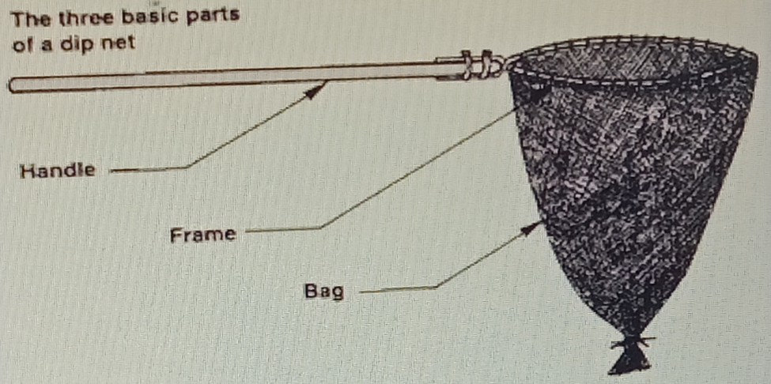

Fig 1. Parts of Dip Net
from Kurung kumey district, Arunachal Pradesh by one of the author. Collectors have to go into the water first almost 2 feet deep, then have to wave water by dip net. Due to waving, leeches come out from deep water to suck human beings. During this time the collector dips the net below and takes the leeches out from the water. After collection, leeches are cleaned in fresh water. The collected leeches are narcotized by pouring 70% alcohol into one litter bottle filled with fresh water up to one third portion. First 10 ml will be added slowly. After half an hour again we will add another 10 ml. After one hour again 10 ml is added if the leech is not narcotized fully. Following this the specimen is cleaned by fresh water because mucous and blood comes out after narcotization. This cleaned specimen is kept in 4 percent formalin for 24 hours as it facilitates for good dissection. Finally, the specimen is preserved in 70 percent alcohol. It is then dissected and its taxonomical characters are studied in detail. The specimens are deposited in ZSI Type Repository of General Non-Chordata section, for reference of future scientists.

Material Examined: Arunachal Pradesh, India. (Latitude 27° 47 N, Longitude 92° 51 E and Altitude 1015 metres). Holotype- 01ex. (ZSI-GNC-An 8611/2), Kurung River, Kurung kumey, Arunachal Pradesh. Date of Collection -07.08.2025, Collector- Temjenmongla & Party.

Results and Discussion:
Poecilobdella genus having 9 species of leeches in the world. Poecilobdella hubeiensis Yang, 1980, Poecilobdella nanjingensis Yang, T. 1996 which is same as Poecilobdella granulosa, Poecilobdella blanchardi (Moore, 1927) Synonyms of Poecilobdella manillensis, Poecilobdella aligarhensis Mandal et al., 2021, Poecilobdella kananbalaae Mandal et al., 2025, Poecilobdella granulosa Savigny, 1820, Poecilobdella javanica Wahlberg, 1856, Poecilobdella manillensis (Lesson, 1842), Poecilobdella viridis Moore, 1927. S. D. Gurumayum and Temjenmogla collected some leeches from Kurung kumey, Arunachal Pradesh for research purpose, He send it in ZSI for identification and deposition. 1st author identified it as Poecilobdella budhoi which is proposed as new leech to science. All the leeches of Poecilobdella genus are found in freshwater habitat. Due to inclusion of the species the number of species of the Genus Poecilobdella will be 9 in India and 10 in the world.
Diagnostic characters (plate-1 & 2): poecilobdella budhoi sp. nov.
The specimens of leeches were collected from Arunachal Pradesh. Teeth well developed. Salivary papillae on jaws numerous. Prostate large in size. Vaginal stalk short, vaginal caecum small. Gonopores separated by 4 annuli. The leeches were originally of brownish blue, fades up after preservation. Both the dorsal and ventral body almost same in colour. The body is not rough like Poecilobdella granulosa. Total segments 112. Total length of the body 13 cm. Male genital pore is on the anterior than the female genital pore. Male pore situated between 30-32 annuli, Female pore is on between 35-36 segment. Sucker rays 64. Sucker rays divided into two parts, central rays are 13 in number. Body is divided in 5 parts. Anterior part divided into two parts. It looks like snake hood. Head region contains 43 segments. Remaining parts are divided in three parts. Anterior sucker 9mm. in breadth. Posterior sucker 2.3cm. in breadth. Middle body 2.3 cm in diameter. Head breadth is higher than middle body breadth. It is 3cm in diameter. Male pore 2mmin diameter, female pore 3 mmi dimeter Jaws is three into the mouth cavity. Three jaws are in the deep of the anterior sucker. The length on this specimen were about 4 cm and width approximately 5 mm. Anterior sucker 4mm. in diameter on the other hand posterior sucker 5mm. There are no species of the genus in the world as it is having. Prostate medium in size. Vaginal stalk very little, vaginal caecum moderate in size. Crop caeca 6 pairs, crop caecum 2 almost equal in size.
Distribution: Arunachal Pradesh, India.
Table-I. Showing comparison Poecilobdella Poecilobdella budhoi sp. nov. with the other Seven species of the genus poecilobdella in the world.
Characters | Poecilobdella manillensis | Poecilobdella granulosa | Poecilobdella viridis | Poecilobdella javanica | Poecilobdella aligarhensis | Poecilobdella kananbalaae | Poecilobdella hubeiensis |  | Poecilobdella tarubalaae |  |  |  | Poecilobdella sukhendui | Poecilobdella tarubalae sp.nov
Stripe | Stripes-Three pairs yellow stripes. One black median broken stripe. | Two pairs yellow stripes. One black line. One pair sub marginal stripes. | Presence of marginal orange stripes and metameric spots. | Dorsal dark stripes and metameric spots. | Dorsal stripes 7. medial is paler than other six dorso-lateral stripes. | Three pairs black dorsal stripe. Most lateral one pair breaking black stripe. | Two  Black  Squired  stripe | One medial black stripe. 2 black spotted line. |  |  | Absence of  any stripe  on both  dorsal and  ventral |  |  | One medial black stripe. Two white spotted line and 2 black spotted line.
Colour | Colour-Dorsal is Brown in ventral is green | Dorsally olive green ventrally reddish | Dorsally olive green and ventrally greyish green | Dorsally olive green and yellow marginally | Brown coloured | Brown dorsaly yellowish ventrally | Dark  brown  dorsally  dark green  ventrally | Dark brown dorsally dark green ventrally |  |  | Dorsally  brown,  ventral  lgreyish |  |  | Grayish green Dorsal, Blackish background ventral with white spots.
Body length | Length-12.2cm | 9.4cm. | 11.1cm. | 10.6cm. | 42mm. | 9.9cm | _ | 4cm. |  |  | 14.5 cm. |  |  | 4cm.
Breadth | Breadth-2.7cm. | 2.2cm. | 2.3cm. | 2.1cm. | 8mm. | 1.4cm. | _ | 5mm. |  |  | 3.5 cm. |  |  | 5mm.
Breadth of anterior sucker | 1.8mm. | 1.9mm. | 1.7mm. | 1.3mm. | 2mm in diameter, | 6cm | - | 3.5mm. |  |  | Caudal sucker  ten times  larger than anterior. |  |  | 3.5mm
Breadth of posterior sucker | Caudal sucker- large | Almost equal | Caudal sucker smaller than anterior sucker | Caudal suckers larger almost equal of the body | Posterior sucker third time larger than the anterior sucker. | 1.1cm | Large | 3mm. |  |  |  | 2.3cm. Sucker  rays 110. |  | 3mm
Clitellum | Clitellum-Prominent | Prominent | Not prominent | Prominent | Moderate | 33-39  7 annuli | Somite  XI-XII | 32-38  7 annuli |  |  |  | 37-45 annuli,  9 annuli |  | 32-38  7 annuli
Gonophores separated by | Gonopores- 5 annuli | 5 annuli | 5 annuli | 7 annuli | 5 annuli. | 33-39  7 annuli  5 annuli | 5 annuli | Gonopores separated by 5 annuli |  |  |  | Male pore between  29- 30 annuli  female pore 34-35. |  | Gonopores separated by 5 annuli
Vaginal Stalk and crop caecum | Vaginal Stalk-Absent | Equal in length | Double in length | Absent | Larger | Very short | Short |  | absent |  | Shorter than  vaginal caecum. |  |  | absent
Breading season | Breading Season-June -July | July-August | June-July | June-August | April-July | July- September | - |  | August-September |  | May-July |  |  | August-September
Eyes | 5 pairs | 5 pairs | 5 pairs | Five pairs eyes on 2,3,4,6 and 9th annuli. | Nine pairs of eyes on rings 3, 4, 6, 8 and 11th rings. | Five pairs | Five  pairs 2,  3, 4, 5,  6 |  | Five pairs on 2,4, 5, 7 and 10th annuli |  | Five pairs  eyes on  2,3,5,6  and 8th annuli. |  |  | Five pairs on 2,4, 5, 7 and 10th annuli
Ring | 112 | 101 | 107 | 105 | 108(including 5 rings of posterior sucker). | 110 | Within  85- 97 |  |  | 113 | 113 |  |  | 113
Reference | References-(Lesson, 1842) | ( Sevigny, 1820) | Moore, 1927 | ( Wahlberg, 1856) | Mandal et.al., 2021 | Mandal et.al., 2025 | Yang, 1980 |  |  | Mandal et.al., 2025 | Mandal et.al., 2025 |  |  | Recent authors

Conclusion
Gonopores of Poecilobdella budhoi separated by 4 annuli. Male genital pore is on the anterior than the female genital pore. Male pore situated between 30-32 annuli, Female pore is on between 35-36 segment. Sucker rays 64. The leeches were originally of brownish blue, fades up after preservation. Total segments 112. Total length of the body 13 cm. Sucker rays divided into two parts. Both the dorsal and ventral body almost same in colour. The body is not rough like Poecilobdella granulosa. Body is divided in 5 parts. Anterior part divided into two parts. It looks like snake hood. Head region contains 43 segments. Remaining parts are divided in three parts. Anterior sucker 9mm. in breadth. Posterior sucker 2.3cm. in breadth. Middle body 2.3 cm in diameter. Head breadth is 3cm in diameter.

COMPETING INTERESTS DISCLAIMER:
Authors have declared that they have no known competing financial interests OR non-financial interests OR personal relationships that could have appeared to influence the work reported in this paper.

References:

Annandale, N. 1913. The leeches of the lake of Tiberias. J. Proc. Asiat. Soc. Bengal (n.s.) 9(6): 211–214.
Bhatia, M. L. 1940. On Haemopis indlcus sp. nov. A new Arhynchobdellid carnivorous leech from Kashmir. Proc. nat. Acad. Sci. India 10(4): 133–144.
Chandra, M. 1984. The leech fauna of Jammu region of Jammu and Kashmir State, India. Rec. Zool. Surv. India, 81(1-2): 289–298.
Chandra, M. (1982). A Check-List of Leeches of India. Records of the Zoological Survey of India, 80(3-4), 265–290.
Chandra, M. (1991). The Leeches of India. A Hand Book. Zoological Survey of India, 1-117.
Ghosh, G.C. 1998. Leech fauna of West Bengal. State Fauna Series 3. Zool. Surv. India Part 10: 227249.
Lesson, 1842. Hirudo manillensis, Revue Zoologigue Societe Cruierieme, 8.
Mandal, C.K. 2004. Paraclepsis gardensis (Hirudinea: Glossiphonidae) a new species of Leech from West Bengal, India. Rec. zool. Surv. India: 103 (Part1-2): 111-114.
Mandal, C. K, Mridha, S., Yasir, M., Kalam, A., JameeL, M., Anwar, M., Ghosh, S. 2021. Poecilobdella aligarhensis A new leech (Clitellata: Hirudinida) from Aligarh, India. J. Appl Zool. Res. 32 (2).145-149.
Manda C. K., Mridha, S., SHarma, P., BOSE, M., Hassan, N., SACHI, A., and GHOSH, S. 2025. Poecilobdella kananbalaae A New Species of Leech from Karnataka, India. Uttar Pradesh Journal of Zoology. Volume 46, Issue 23, Page 201-210, 2025; Article no. UPJOZ. 5588.ISSN: 0256-971X (P).
Moore, 1927. Hirudinaria (Poecilobdella) viridis. Fauna Brit. India, Hirudinea, 239-243.
Harding, W.A. & Moore, J.P. 1927. Fauna of British India, Hirudinea. London: Taylor & Francis, pp. 185–189.
Moore, J.P. 1924. Notes on some Asiatic leeches (Hirudinea) principally from China, Kashmir and British India. Proc. Acad. Nat. Sci. 76: 343–388.
Nesemann, H. & Neubert, E. (1999). Annelida, Clitellata: Branchiobdellidae, Acanthobdellea, Hirudinea. Süsswasserfauna von Mitteleuropa 6/2 (eds J. Schwoerbel & P. Zwick). Spektrum, Heidelberg. 178 pp
Kaburaki, T. 1921. Glossiphonia reticulata Kaburaki, 1921. On some leeches from the Chilka lake. Mem. Indian Mus. 5: 661–675.
Linnaeus, C. 1767. Systema naturae sive regna tria naturae, secundum classes, ordines, genera,
species, cum characteribus, differentiis, synonymis, locis. Laurentii Salvii, Holmiae. 12th
ed. 1(2): 533–1327.
Nakano, T., & Lai, Y. (2016). First Record of Poecilobdella nanjingensis (Hirudinida: Arhynchobdellida: Hirudinidae) from Taiwan and its Molecular Phylogenetic Position within the Family. Species Diversity, 21(2), 127–134. https://doi.org/10.12782/sd.21.2.127
Sanjebva Raj, P. J. and Gladstone, M. 1981. On a new species of the land-leech of the genus Haemadipsa Tennent, 1859 from the peninsular India. Rec. Zool. Surv. India 79: 1–18.
Savigny, J.C. (1820) 1822. Système des Annélides, princialment de celles des cotes de l’Ègypte et de la Syrie, offrant les caractères tant distinctift que naturels des orders, familles et genres, avec la description des espèces. Paris: Description de l’Ègypte 1(3): 1–128.
Sawyer, R.T. (1986) Leech Biology and Behaviour. Oxford: Clarendon Press. 685 p.
Soós, A. 1965. Identification key to the leech (Hirudinoidea) genera of the World, with a Catalogue of the species. 111-1V. Acta. Zool. Acad. Hungary 11(3-4): 415-464.
Soota, T. D. AND GHOSH, G.C. 1977. On some Indian Leeches. Newsl. Zool. Surv. India: 3(6): 359- 360.
Tennent, SIR J.E. 1859. Ceylon; an account of the island physical, historical and topographical, with notices of its natural history, antiquities, and productions. London: Longman, Green, Longman and Roberts, 2 volumes.
Wahlberg, 1856. Sanguisuga javanica, Ofversigt Kongl. Vet. Akad., Forth, 233-234.
whitman, C.O. 1886. The leeches of Japan. Quart. J. Micro. Sci. 26: 317–416.
Yang, T. 1980. Records of two new species of Hirudidae from China. Acta Zootaxonomica Sinica, 5(3): 267–268.
Yang, T. 1996. Fauna Sinica. Annelida Hirudinea. Science Press, Beijing, 261 pp.

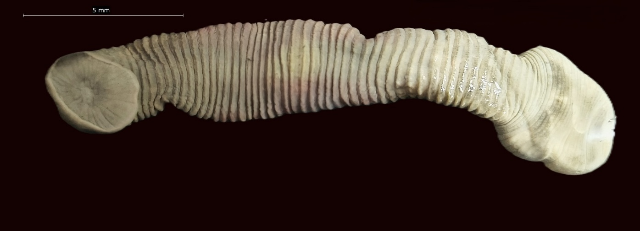
AS
PS
PS
Plate-1A Dorsal view of Poecilobdella budhoi (Anterior sucker and Posterior sucker)
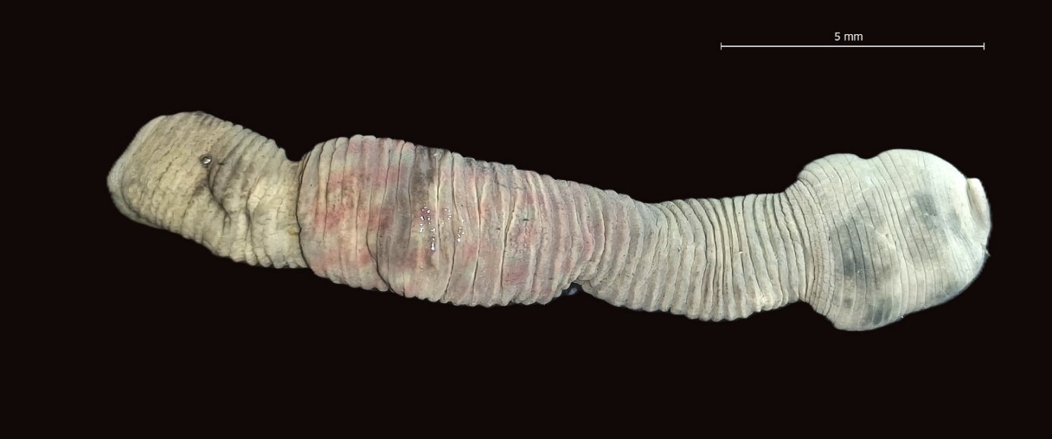
AS
PS
Plate-1 B Ventral view of Poecilobdella budhoi (Anterior sucker and Posterior sucker)

Plate-2: Posterior sucker, Male and female pore, Anterior part, Epididymis and Prostate of Poecilobdella budhoi
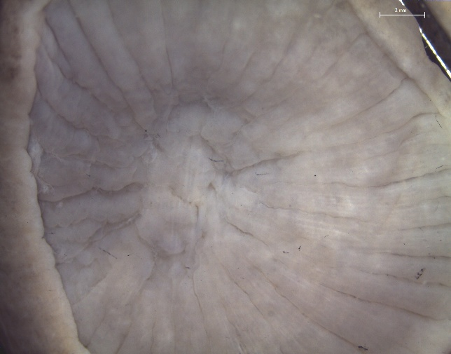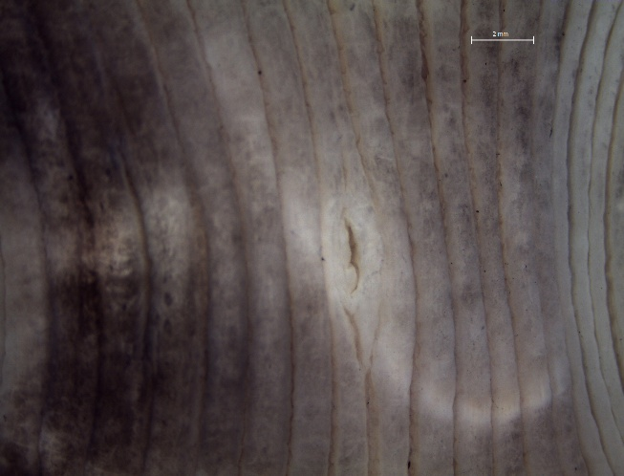
Poecilobdella budhoi (Posterior sucker rays) Poecilobdella budhoi (Male pore &Female pore)
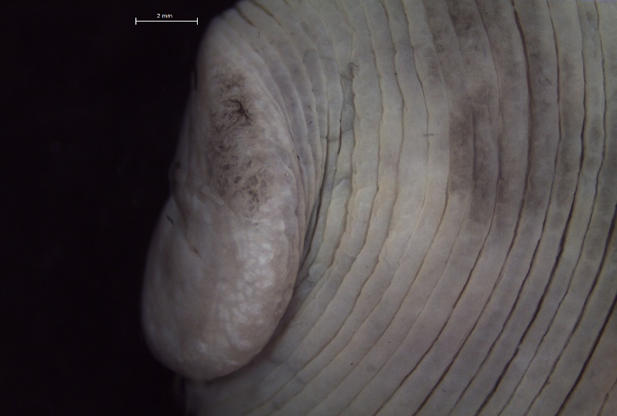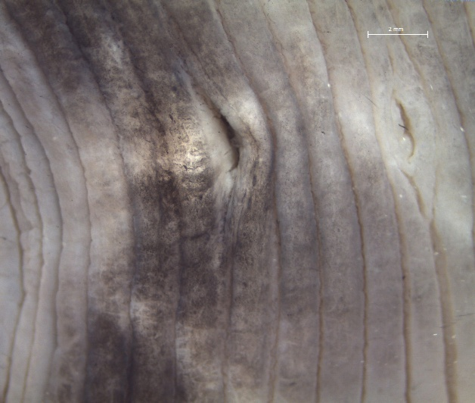
MP
FP
Poecilobdella budhoi (Posterior sucker) (Male pore &Female pore)

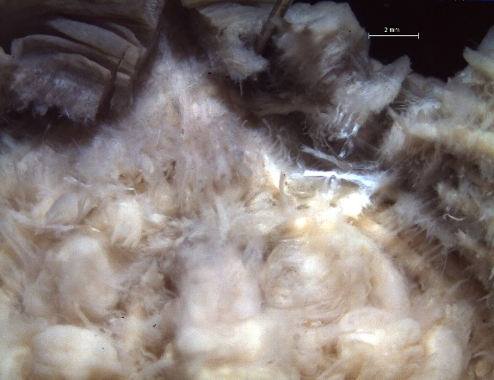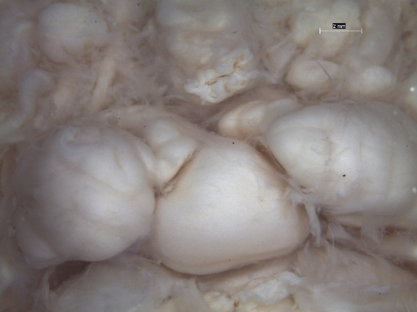
B
A
Poecilobdella budhoi (Dissected Anterior part) Poecilobdella budhoi (A. Epididymis B.Prostate)

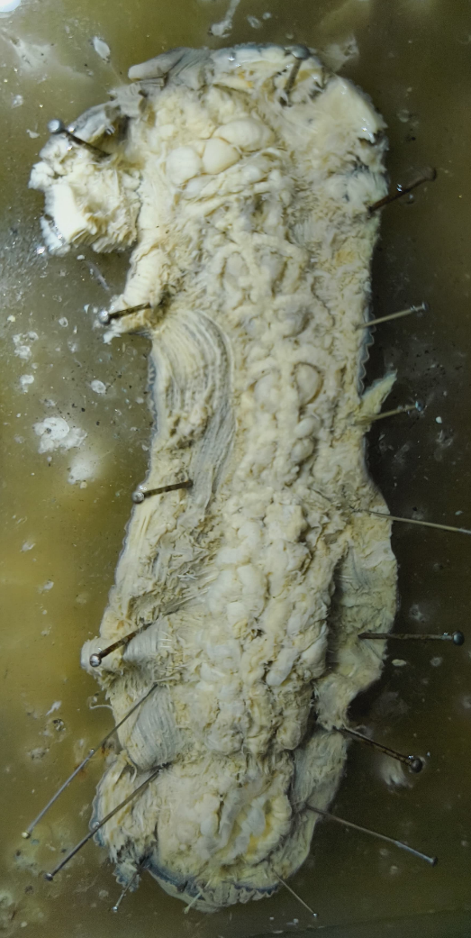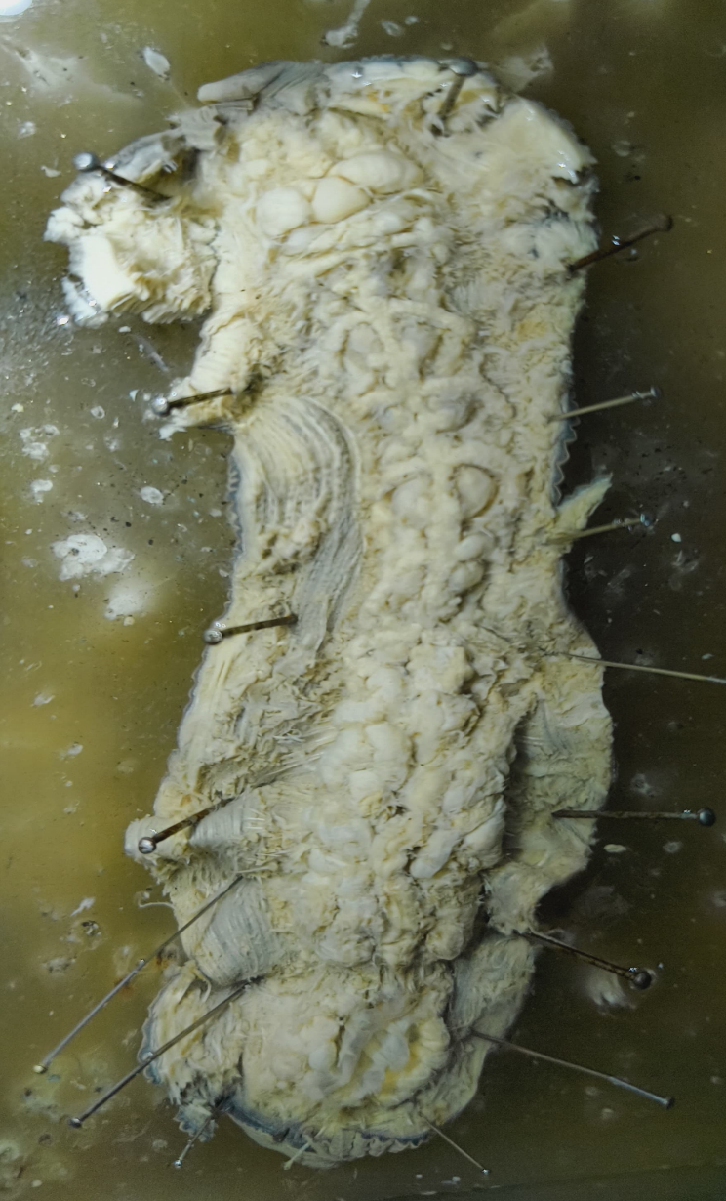
H
G
F
E
D
C
B
A
Plate-3. Poecilobdella budhoi [Six pair Stomach caecae (C-H), Testicles bet, Epididymis (A) and Prostate (B), Vaginal caecum].

