Original Research Article
Taxonomic study of Geometrinae moths (Lepidoptera: Geometridae) from the Northernmost Western Ghats of Nashik, Maharashtra, India

Abstract
Geometrinae moths in the northernmost Western Ghats of Maharashtra remain insufficiently documented at a focused taxonomic level. This study assessed Geometrinae diversity in Nashik district using specimens and observations obtained from seven localities between June 2021 and December 2024. The seven sampling localities ranged from 309 to 1,243 m in elevation, with six to 15 visits per site. Nocturnal surveys employed a light-sheet method, with selected specimens examined using external morphology, wing venation, and external genitalia. Seventeen species representing 13 genera and five tribes—Agathiini, Comibaenini, Geometrini, Hemitheini, and Pseudoterpnini—were documented. Hemitheini was the most species-rich tribe, with seven species. Thirteen species were recorded as new regional records for Nashik district. Recorded wingspans ranged from 14 to 42 mm. Examination of wing venation showed a consistent pattern across the studied species, with no marked deviation observed among the taxa. External genitalia were examined for all 17 species and, together with published diagnostic descriptions and illustrations, supported species-level identification. The findings provide locality-based taxonomic and distributional information for Geometrinae in the northernmost Western Ghats and establish a regional baseline for subsequent systematic work. Continued surveys across seasons, localities, and elevations, together with complementary larval host-plant and molecular data, would improve understanding of Geometrinae diversity and distribution in this part of Maharashtra.
Keywords: Geometrinae; Geometridae; emerald moths; Lepidoptera; taxonomy; wing venation; external genitalia; Western Ghats; Nashik; Maharashtra; regional records.
Introduction
The northernmost Western Ghats of Maharashtra, particularly within Nashik district, represent an ecologically diverse yet comparatively underexplored region for lepidopteran studies. The present study focuses on geometrid moth diversity across this landscape, characterising a network of mountain ranges and associated habitats. The field surveys were undertaken between June 2021 and December 2024 across selected key localities, including Salher-Mulher in the north, Vikramgad and Jawhar in the west, Bhandardara and Akole in the south, and Chandwad in the east. Sampling locations such as Peth-Harsul, Kasara, Kalmuste, Kalsubai, Belgaon Dhaga, Waghere-Harsul, and Saptashrungi-Gad (Vani) were selected to represent a gradient of ecological conditions. These locations encompass semi-evergreen, moist deciduous, and high-altitude forest patches, thereby providing a heterogeneous landscape suitable for assessing moth diversity and distribution in the northern Western Ghats.
Recent Indian field studies have documented substantial variation in geometrid moth richness and distribution across elevational zones, supporting the value of geographically focused surveys for resolving regional faunal patterns (Lotani & Negi, 2026).
The superfamily Geometroidea is among the most diverse groups within Lepidoptera, comprising more than 24,000 described species distributed worldwide (Ding et al., 2023). A distinguishing synapomorphy that sets moths of the superfamily Geometroidea apart from other lepidopteran lineages is the presence of paired abdominal tympanal organs. Geometroidea comprises five families, viz. Geometridae, Uraniidae, Sematuridae, Epicopeiidae, and Pseudobistonidae (Wang et al., 2019). Of these families, Geometridae Stephens, 1829, is the second most species-rich family of Lepidoptera and is globally represented by nine subfamilies, viz. Sterrhinae, Larentiinae, Archiearinae, Desmobathrinae, Oenochrominae, Geometrinae, Orthostixinae, Epidesmiinae, and Ennominae (Ding et al., 2023). The family demonstrates exceptional morphological and ecological variation, with larvae frequently referred to as inchworms or loopers because of their distinctive movement style caused by the reduction of prolegs.
The subfamily Geometrinae is known as the emerald moths because of its vibrant light- to bluish-green coloration, which closely resembles the gemstone emerald (Cook, 1993). The green colour helps them camouflage by allowing them to blend into leafy environments for protection from predators (Ude et al., 2024). Globally, the subfamily Geometrinae includes over 2,600 described species, mostly tropical, slender-bodied moths with delicate wings that are often held flat at rest. Of these, 294 species have been reported from India (Shubhalaxmi, 2018; Kirti et al., 2019; Kaur & Qayoom, 2021). Moreover, Geometrinae is undergoing dynamic taxonomic revision and the description of new species, highlighting its dynamic and evolving classification (Plotkin & Kawahara, 2020; Plotkin et al., 2025).
Recent phylogenomic analyses have continued to refine higher-level relationships and classification within Geometridae, providing a broader systematic context for morphology-based taxonomic assessments (Murillo-Ramos et al., 2023; Õunap et al., 2025).
The earliest documentation of geometrid moths in India dates back to the 18th century, when Linnaeus described the species Militarius in 1758. Later, Hampson (1895, 1896), in the Fauna of British India, described over 1,061 species belonging to 160 genera representing six subfamilies (Kaur & Qayoom, 2021). Subsequently, Hampson (1895, 1898, 1902, 1907, and 1912) made several publications and contributed substantially to the Indian geometrid fauna. Recently, Singh et al. (2026) provided a comprehensive and detailed account of the family Geometridae in a catalogue of Geometroidea and reported that the family Geometridae is represented by over 2,100 species in India, with the subfamily Geometrinae accounting for a total of 309 species from 82 genera. Geometrid moths are indicators of habitat quality and environmental alterations owing to their sensitivity to vegetation composition and climatic factors. Despite its ecological significance, taxonomic knowledge of Geometrinae is inconsistent across various regions, with several biodiversity-rich landscapes still inadequately explored.
A recent study from Jalgaon district in North Maharashtra documented biological characteristics of a geometrid moth, further demonstrating continuing regional research attention to Geometridae (Sawarkar, 2025).
The Western Ghats, a globally recognised biodiversity hotspot, support high endemism and species richness due to their complex topography, climatic factors, and lush, diverse vegetation. The northern Western Ghats of Maharashtra serve as a transitional zone characterised by a diverse array of habitats, including moist deciduous forests, semi-evergreen forests, and montane ecosystems. Recent faunal assessments have shown that this area contains a diverse assemblage of geometrid moths, including species from several subfamilies, highlighting its importance for lepidopteran diversity (Shubhalaxmi et al., 2011; Kirti et al., 2012; Gurule & Nikam, 2013; Gurule et al., 2025). However, focused taxonomic studies specifically addressing Geometrinae from this region remain limited. In this context, the present study aims to provide a taxonomic account of Geometrinae from the northernmost Western Ghats of Maharashtra by studying wing morphology, venation, and external genitalia, thereby contributing to the understanding of Geometrinae diversity.

Material and Methods
Field Survey and collection:
The study was conducted across seven localities in the northernmost Western Ghats of Maharashtra: Saptashrungi Vani (SV), Waghere–Harsul (WH), Kalmuste (KM), Belgaon Dhaga (BD), Kasara (KS), Peth–Harsul (PT), and Kalsubai (KL). All field observations and specimen collections were carried out under valid research permits issued by the Principal Chief Conservator of Forest (PCCF), Maharashtra (Ref. No. Desk-22(8)/Research/CR-47/3098/22-23) and the Maharashtra State Biodiversity Board (Ref. No. MSBB/Desk-5/Research 617/2023-24).
Table 1: Details of sites of observation.
Sites | Abbreviation | Latitude | Longitude | Elevation | No. of Visits
Saptashrungi Vani | SV | 20.3911°N | 73.9167°E | 1179 | 8
Waghere–Harsul | WH | 20.1058°N | 73.4592°E | 369 | 8
Kalmuste | KM | 20.1036°N | 73.3883°E | 628 | 15
Belgaon Dhaga | BD | 19.9669°N | 73.7036°E | 655 | 7
Kasara | KS | 19.6427°N | 73.4689°E | 309 | 8
Peth–Harsul | PT | 20.2589°N | 73.5058°E | 619 | 6
Kalsubai | KL | 19.6003°N | 73.7064°E | 1243 | 8

Nocturnal surveys were conducted between 18:30 and 02:30 h using a non-invasive light-sheet method (Gurule & Nikam, 2013) in selected localities in the northernmost Western Ghats of Maharashtra in Nashik district. Mercury vapour lamps (240 W; Philips and Osram), powered by a petrol generator, along with a LepiLED Maxi light powered by a power bank, were employed for moth attraction. Opportunistic photographic records were obtained using a Nikon D7500 DSLR camera with a Tamron 90 mm macro lens. Selected specimens were collected using entomological vials. Data were recorded from June 2021 to December 2024.

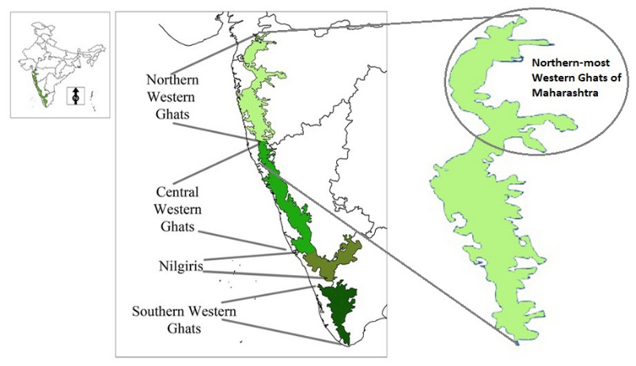
Figure 1: Map showing the study area the Northern Western Ghats of Maharashtra.
(Source: Edited from image available on lotusarise.com).

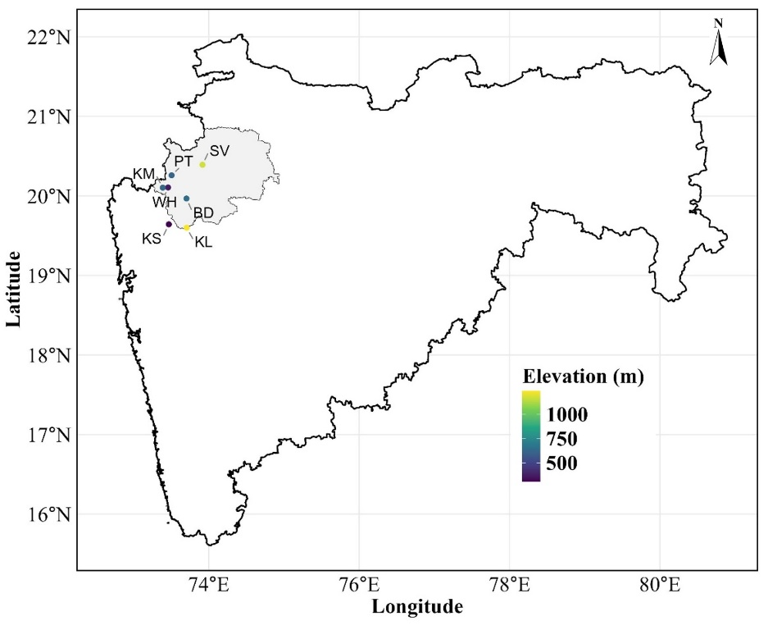
Figure 2. Sampling sites from Northernmost Western Ghats of Maharashtra, India. Abbreviations: Saptashrungi Vani (SV), Waghere–Harsul (WH), Kalmuste (KM), Belgaon Dhaga (BD), Kasara (KS), Peth–Harsul (PT), and Kalsubai (KL).

Specimen Handling and preservation:
Collected specimens were euthanised using chloroform, pinned through the mesothorax using entomological pins (sizes 000 and 00), and mounted on spreading boards. Wings and appendages were appropriately stretched on spreading boards using butter paper and setting pins, and curated specimens were dried in an electric oven at 60°C for 48 hours (Gurule, 2013). Dried specimens were sorted taxonomically, labelled, and preserved in airtight insect cabinets along with naphthalene balls under controlled conditions for long-term storage and examination.
Wing Venation and external genitalia Preparation and examination:
Permanent slide preparations of the wings were made to facilitate detailed venational analysis. For this purpose, the method outlined by Common (1970) and later supported by Zimmerman (1978) was followed. The right or left undamaged pair of wings was removed from the dry specimens and processed for venation studies. The detached wings were first softened in 70% alcohol for 1 h and then subjected to descaling using a 4% sodium hypochlorite solution for 1 minute. Following this, the wings were rinsed with distilled water and subsequently stained in 70% alcoholic eosin for a period of 12–14 h. After staining, the wings were dehydrated through ascending grades of alcohol, cleared in xylene, and mounted in DPX under a coverslip. Permanent slides of wing venation were photographed using a Nikon D3000 DSLR camera mounted on a stereomicroscope; the slides were labelled, stored in slide boxes, and submitted to the Museum of the Department of Zoology & Research Center of K.T.H.M. College, Nashik, for future reference. The terminology used for wing venation was proposed by Comstock and Needham (1899), with subsequent modifications according to Imms (1957) and Miller (1970).
Genitalia of all 17 species were dissected following Clarke (1941) and Robinson (1976). The abdomen was removed and macerated in 10% KOH, followed by thorough washing with distilled water and removal of the soft tissues using fine forceps and a camel-hair brush under a COSLAB stereomicroscope. The genital structures were dissected and examined in glycerol, and diagnostic characters were compared with published taxonomic descriptions and illustrations for species confirmation. The examined genitalia were preserved in glycerol in Eppendorf tubes associated with the respective voucher specimens.

Identification
Identification of specimens was carried out using standard keys, checklists, and available references: Hampson (1895, 1896); Holloway (1996); Shubhalaxmi et al. (2011); Shubhalaxmi (2018); Gurule and Nikam (2013); Gurule (2013); Kirti et al. (2019); Gurule and Brookes (2021); and Sondhi (2024). Photographic documentation supported the diagnostic process, and species confirmation was validated through expert taxonomic consultation.

Results
The present study documented a total of 17 species of the subfamily Geometrinae from the northernmost Western Ghats of Maharashtra (Nashik district), representing 13 genera and five tribes, viz. Agathiini, Comibaenini, Geometrini, Hemitheini, and Pseudoterpnini. Among these, Hemitheini was the most species-rich tribe, contributing seven species to the total Geometrinae assemblage.
Taxonomic illustration
Family Geometridae Leach, 1815
Key to major subfamilies of family Geometridae
- Vein M₂ absent in Hindwing ………………….………………. Ennominae
- Vein M₂ present in Hindwing …………………………………. 2
- Vein M₂ arising from just above the middle of discocellulars… Geometrinae
- Vein M₂ arising from below middle of discocellulars ………… Sterrhinae
Systematic account of Geometrinae
Note: Species marked with an asterisk (*) indicate new regional records.
Subfamily Geometrinae Stephens, 1829
Moths of the subfamily Geometrinae are characterised by emerald-green pigment scales. In the forewing, medial vein M₂ arises from the upper angle of the cell; radial veins R2–R5 are stalked, often together with M1 and R1, and the areole is absent. In the hindwing, medial vein M2 arises just above the middle of the discocellulars; Sc+R₁ bends down and touches the cell at the base, then rapidly diverges.
Tribe: Agathiini
- *Agathia angustilimes Prout, 1926 (Photo Plate 1:1; 2:18; 4:35)
Agathia angustilimes Prout, 1926, Mem. Dep. Agric. India (Ent.) 9(8): 247. Type-locality: Pusa, Bihar, India.
Material Examined: India. 1♀; Belgaon Dhaga, Nashik; 19.9669°N; 73.7036°E; 655 m a.s.l.; Light sheet method; 23-vii-2022; SG91. 1♀; Saptashrungi Vani, Nashik; 20.3911°N; 73.9167°E; 1179 m a.s.l.; Light sheet method; 09 xi 2022; SGA215.
Diagnosis: Wing span: ♀, 32 mm. The head and wings are emerald green; the thorax and abdomen are brown. Forewings have a basal rufous patch and a greyish costa; the medial band is somewhat outwardly oblique, slightly angled below the cell, and then runs straight to the inner margin; the rufous postmedial line is outwardly oblique and meets the marginal fascia; the green patch below the apex of the forewing is oval. This species is distinguished from others by having a narrower marginal band. Hindwings lack a medial line; the submarginal rufous fascia has a dentate inner edge; a large green patch occurs at the centre of the margin; the green spots towards the inner margin are rarely developed; the margin at the centre is produced, with a triangular black spot on it.
Distribution in India: Bihar (Pusa), Nilgiris, Delhi, Tamil Nadu (Nilgiri Hills).
Elsewhere: Unknown.
*Remark: First record from Nashik (Belgaon Dhaga, Saptashrungi Vani), Maharashtra.

- Agathia laetata (Fabricius, 1794) (Photo Plate 1:2; 2:19; 4:36)
Phalaena laetata Fabricius, 1794; Ent. Syst. 3(2): 164; Moore, Lep. Ceyl. 3, Pl. 197, Figs. 1a, b (larva); C.&S. no. 3522. Type-locality: India.
Material Examined: India. 1♀; Belgaon Dhaga, Nashik; 19.9669°N; 73.7036°E; 655 m a.s.l.; Light sheet method; 23-vii-2022; SG92.
Diagnosis: Wing span: ♀, 31 mm. The thorax and abdomen are pale brown; the wings are emerald green. Forewings have a greyish costa and a basal rufous patch; the medial band of the forewing is reduced to a small tooth from the costal fascia; the slightly dentate rufous postmedial line is outwardly oblique and meets the marginal fascia; the inner edge of the outer rufous area is evenly curved on the forewing; the green patch below the apex of the forewing is oval. Hindwings lack a medial line; the submarginal rufous fascia has a dentate inner edge; a green patch occurs at the centre of the margin; green spots towards the inner margin of the hindwing are rarely developed; the hindwing margin is produced at the centre, with a black spot on it.
Distribution in India: Arunachal Pradesh, Assam, Chhattisgarh, Goa, Karnataka, Maharashtra, Meghalaya, Tamil Nadu, West Bengal, Andaman and Nicobar Islands.
Elsewhere: Askold Island, Siberia, Japan, Sri Lanka, Myanmar (Burma); Borneo, New Guinea, Australia.

Tribe: Comibaenini
- *Argyrocosma inductaria (Guenée, 1857) (Photo Plate 1:3; 2:20; 4:37)
Phodoresma [sic] inductaria Guenée, 1857; Hist. nat. Ins., Spec. gén. Lépid. 9: 370. Type-locality: Sarawak (Borneo).
Material Examined: India. 1♀; Saptashrungi Vani, Nashik; 20.3911°N; 73.9167°E; 1179 m a.s.l.; Light sheet method; 31-x-2021; SG191. 1♂; Kalmuste, Nashik; 20.1036°N; 73.3883°E; 628 m a.s.l.; Light sheet method; 23-vii-2022; SG857.
Diagnosis: Wing span: ♀, 18 mm. The wings are yellowish-green; the frons is pink and white. The vertex of the head and abdomen are pink with white spots. The forewing has a pinkish costa with a white strip that expands at the antemedial and postmedial white spots; a pink-ringed white antemedial spot occurs on M₃; a marginal pink band embraces white spots, among which the spots on M₃ and the inner margin are larger. The hindwing has a pink speck on the discal cell.
Distribution in India: Arunachal Pradesh, Himachal Pradesh, Nagaland, Tamil Nadu, Uttarakhand, West Bengal, Andhra Pradesh, Assam, Karnataka, Kerala, Meghalaya, Tripura, Nilgiri Hills, Dalhousie, Dharmasala.
Elsewhere: Borneo, Sri Lanka, Peninsular Malaysia.
*Remark: First record from Nashik (Saptashrungi Vani, Kalmuste), Maharashtra.

- *Comibaena attenuata (Warren,1896) (Photo Plate 1:4; 2:21; 4:38)
Probolosceles attenuate Warren, 1896; Novit. Zool. 3: 369. Type-locality: Mt. Mulu, North Borneo.
Material Examined: India. 1♀; Kalsubai foothills, Nashik; 19.6003°N; 73.7064°E; 1243 m a.s.l.; Light sheet method; 10-ix-2023; SG1560.
Diagnosis: Wing span: ♀, 26 mm. The wings are deep emerald green. The forewing has a white costa; the forewing and hindwing have a dark speck at the end of the discal cell and a large black-brown patch at the outer angle of the forewing and apex of the hindwing, varying in shape and size; both wings have a slightly wavy marginal band with a series of white specks; obscure pale lines on the hindwing are absent from the forewing. The female has a black-brown submarginal patch on the forewing above vein M₃. The underside is whitish, with a small tuft of rufous scales at the end of the discal cell of the forewing.
Distribution in India: Tamil Nadu, Tripura, Arunachal Pradesh, Assam, Meghalaya, West Bengal, Karnataka, Maharashtra.
Elsewhere: Sri Lanka, Myanmar (Burma), Borneo, Sundaland, Philippines, Indonesia.
*Remark: First record from Nashik (Saptashrungi Vani, Kalmuste), Maharashtra.

- *Comibaena cassidara (Guenée, 1858) (Photo Plate 1:5; 2:22; 4:39)
Phodoresma [= Phorodesma] cassidara Guenée, 1857; Hist. nat. Ins., Spec. gén. Lépid. 9: 370. Type-locality: Inde centrale (Central India).
Geometra detenta Walker, 1861; List Spec. Lepid. Insects Colln. Br. Mus. 22: 521. Type-locality: Nepal.
Material Examined: India. 2♂; Waghere Harsul, Nashik; 20.1058°N; 73.4592°E; 369 m a.s.l.; Light sheet method; 29-x-2022; SG1086 & SG1121. India. 1♂; Kalmuste, Nashik; 20.1036°N; 73.3883°E; 628 m a.s.l.; Light sheet method; 1-i-2022; SG545.
Diagnosis: Wing span: ♂, 18 mm. The wings are bright yellow-green; the palpi and abdomen have a rufous tinge. The forewing has a white costa; outwardly oblique antemedial and postmedial lines can be marked; the postmedial line is slightly recurved towards the costa; both wings have a slightly wavy marginal band with a series of white specks, and it expands at the outer angle of the forewing and apex of the hindwing. The forewing and hindwing have a dark speck at the end of the discal cell. The underside is whitish, with a small tuft of rufous scales at the end of the discal cell of the forewing; both wings have an indistinct postmedial green line.
Distribution in India: Assam, Gujarat, Karnataka, Maharashtra, Rajasthan, Tamil Nadu, Uttar Pradesh, Uttarakhand, West Bengal, Punjab; North India; Central India.
Elsewhere: China, Thailand, Singapore, Indonesia, Malaysia (Borneo).
*Remark: First record from Nashik (Saptashrungi Vani, Kalmuste), Maharashtra.

Tribe: Geometrini
- *Chlorozancla falcatus (Butler, 1889) (Photo Plate 1:6; 2:23; 4:40)
Tanaorrhinus falcatus Hampson, 1895; Fauna Br. India (Moths) 3: 494. Type-locality: Sikkim (India).
Material Examined: India. 1♂; Kalmuste, Nashik; 20.1036°N; 73.3883°E; 628 m a.s.l.; Light sheet method; 1-i-2022; SG538.
Diagnosis: Wing span: ♂, 27 mm. The wings are dull grey-green; the vertex of the head is white; the forewing has a yellowish costa and basal part up to the antemedial region; a pale, straight, erect postmedial line is present; a yellow fascia below the costa towards the apex of the wing has a hyaline spot. The hindwing has a hyaline medial band, wider and with yellow edges towards the inner margin, and an obscure straight submarginal line. Both wings have a thin, paler marginal line with grey-green cilia.
Distribution in India: Sikkim, Maharashtra (Bombay), Kerala (Travancore), Chhattisgarh, Karnataka.
Elsewhere: Nepal.
*Remark: First record from Nashik (Kalmuste), Maharashtra.

Tribe: Hemitheini
- *Comostola chlorargyra (Walker, 1861) (Photo Plate 1:7; 3:24; 4:41)
Comibaena chlorargyra Walker, 1861; List Spec. Lepid. Insects Colln Br. Mus. 22: 577. Type-locality: Sarawak (Borneo).
Material Examined: India. 1♀; Waghere Harsul, Nashik; 20.1058°N; 73.4592°E; 369 m a.s.l.; Light sheet method; 29-x-2022; SG1085.
Diagnosis: Wing span: ♀, 26 mm. The wings are bright emerald green and opaque, with a silver-white tinge. The vertex of the thorax and the abdomen are pinkish, with a thin dorsal white stripe. The costa of the forewing and the cilia are ochreous, with some fuscous colour at the base of the costa. A pale red-white beaded border occurs on the margin of both wings. An oblique band extends from the middle of the costa towards the expansion of the marginal markings at the outer angle; this oblique band may be broken into two spots; a costal spot occurs near the apex, to which the marginal band sometimes runs right around and is conjoined. The hindwing is uniform and lacks a speck at the end of the cell.
Distribution in India: Andaman and Nicobar Islands, Maharashtra, West Bengal, Andhra Pradesh, Assam, Meghalaya, Tamil Nadu.
Elsewhere: Borneo, Java, Philippines, Sulawesi, Sri Lanka.
*Remark: First record from Nashik (Kalmuste), Maharashtra.

- *Episothalma robustaria (Guenée, 1858) (Photo Plate 1:8; 3:25; 4:42)
Hemithea robustaria Guenée, 1857; Hist. nat. Ins., Spec. gén. Lépid. 9: 383. Type-locality: Central India.
Material Examined: India. 1♀; Kalmuste, Nashik; 20.1036°N; 73.3883°E; 628 m a.s.l.; Light sheet method; 23-xii-2022; SG836.
Diagnosis: Wing span: ♀, 42 mm. The wings have a blue-green ground colour. Both wings have brown cell specks and a crenulate olive postmedial line angled at M₃; the cilia lack dark tips. The underside of the wings is greenish-white, with faded cell specks and a crenulate postmedial line.
Distribution in India: Arunachal Pradesh, Chhattisgarh, Karnataka, Kerala, Maharashtra, Manipur, Meghalaya, Mizoram, West Bengal, Uttar Pradesh, Himachal Pradesh, Central India.
Elsewhere: Sundaland, China, Myanmar, Thailand, Vietnam, Nepal, Malaysia, Indonesia.
*Remark: First record from Nashik (Kalmuste), Maharashtra.

- *Hemithea marina (Butler, 1878) (Photo Plate 1:9; 3:26; 4:43)
Thalassodes marina Butler, 1878; Ann. Mag. Nat. Hist. (5) 1 (5): 399. Type-locality: Yokohama, Japan.
Material Examined: India. 1♂; Kalmuste, Nashik; 20.1036°N; 73.3883°E; 628 m a.s.l.; Light sheet method; 4-xii-2021; SG429.
Diagnosis: Wing span: ♂, 28 mm. The wings are yellowish bluish-green; the vertex of the head is white; the abdomen has some red and white patches dorsally on the 3rd to 5th segments. The costa of the forewing is ochreous and dark-speckled; there is a wavy white antemedial line, and both wings have a somewhat obscure wavy white postmedial line. The forewing has an obscure speck at the middle end of the discal cell. This species differs from tritonaria in lacking a dark marginal line on both wings; the marginal specks are white, and the cilia are greenish-grey.
Distribution in India: Himachal Pradesh, Indian Sub-region.
Elsewhere: Japan, Indochina, China, Sundaland, Sulawesi and Seram, Sri Lanka.
*Remark: First record from Nashik (Kalmuste), Maharashtra.

- *Idiochlora caudularia (Guenée, 1857) (Photo Plate 1:10; 3:27; 4:44)
Nemoria caudularia, Guenée [1858] Phal. i, p. 349; C. & S. no. 3488. Type-locality: Northern India.
Material Examined: India. 1♂; Kalmuste, Nashik; 20.1036°N; 73.3883°E; 628 m a.s.l.; Light sheet method; 11-xii-2021; SG481. 1♀; Waghere Harsul, Nashik; 20.1058°N; 73.4592°E; 369 m a.s.l.; Light sheet method; 29-x-2022; SG1128.
Diagnosis: Wing span: ♂, 14 mm. The wing ground colour is yellow-green. The frons is olive; the vertex of the head is white; both wings have dentate white antemedial and postmedial lines; the postmedial line of the hindwing is excurved between veins Cu₂ and M₃. The underside is whitish.
Distribution in India: Northern India, Maharashtra, Central India, Sikkim, Nilgiris.
Elsewhere: Sri Lanka.
*Remark: First record from Nashik (Kalmuste), Maharashtra.

- Maxates acutissima (Walker, 1861) (Photo Plate 1:11; 3:28; 4:45)
Thalera acutissima Walker, 1861, List Spec. Lepid. Ins. Colln. Br. Mus., 22: 596. Type-locality: Ceylon (Sri Lanka).
Material Examined: India. 2♀; Waghere Harsul, Nashik; 20.1058°N; 73.4592°E; 369 m a.s.l.; Light sheet method; 16-vii-2023; SG1308 & SG1311. 1♀; Saptashrungi Vani, Nashik; 20.3911°N; 73.9167°E; 1179 m a.s.l.; Light sheet method; 1-vi-2023; SG1380. 1♀; Peth, Nashik; 20.2589°N; 73.5058°E; 618 m a.s.l.; Light sheet method; 13-viii-2023; SG1412. 2♀; Kasara, Nashik; 19.6427°N; 73.4689°E; 309 m a.s.l.; Light sheet method; 20-viii-2023; SG1499 & SG1509. 1♀; Kalmuste, Nashik; 20.1036°N; 73.3883°E; 628 m a.s.l.; Light sheet method; 24-vi-2022; SG689.
Diagnosis: Wing span: ♀, 31 mm. The wings are greenish-white and semihyaline; the frons and forelegs are crimson; the vertex of the head is white. The abdomen is suffused with brown scales. The forewing has an ochreous costa and an indistinct, straight, oblique antemedial pale line; both wings have an oblique pale postmedial line, a fine dark marginal line, and ochreous cilia; the underside is white. The hindwing has the same ground colour as the forewing.
Distribution in India: Meghalaya (Khasis), West Bengal (Kolkata), Maharashtra (Khandala), Karnataka, Gujarat, Nilgiris.
Elsewhere: Sri Lanka, China, South-East Asia.

- *Maxates veninotata (Warren, 1894) (Photo Plate 1:12; 3:29; 4:46)
Thalerura veninotata Warren, 1894; Novit. Zool. 1(4): 678. Type-locality: Khasi Hills.
Material Examined: India. 1♀; Kalmuste, Nashik; 20.1036°N; 73.3883°E; 628 m a.s.l.; Light sheet method; 1-x-2022; SG1024.
Diagnosis: Wing span: ♀, 27 mm. The wings are green and translucent. The vertex of the head is white; the abdomen is suffused with brown scales. The forewing has an ochreous costa. Both wings have a wavy postmedial line, sometimes reduced to specks, and an obscure speck at the end of the discal cell. The hindwing tail is acute, with a fine, even ochreous marginal line and cilia on both wings.
Distribution in India: North-East Himalaya, Assam, Arunachal Pradesh, Nagaland, Meghalaya (Khasi Hills).
Elsewhere: Borneo, South-East Asia.
*Remark: First record from Nashik (Kalmuste), Maharashtra.

- *Microloxia indecretata (Walker, [1863]) (Photo Plate 2:13; 3:30; 4:47)
Nemoria indecretata (Walker, [1863] 1862): 1555; C. & S. no. 3529. (Geometra?) Type-locality: South Hindostan.
Material Examined: India. 2♀, 2♂; Belgaon Dhaga, Nashik; 19.966978°N; 73.703611°E; 655 m a.s.l.; Light sheet method; 18-ix-2021 & 8-xi-2021; SG261, SG263, SG1119 & SGA09.
Diagnosis: Wing span: ♀, 18 mm. The wings are pale green; the frons and forelegs are reddish-brown; the vertex of the head is white. The forewing has a pale-white costa. An oblique pale-white postmedial line crosses both wings; it may be narrow or developed into a band and is usually straight, but is rarely slightly curved at the costa of the forewing.
Distribution in India: Maharashtra, Himachal Pradesh (Dharamshala, Shimla), Chandigarh, Chhattisgarh, Gujarat, Karnataka, Nilgiris.
Elsewhere: Southwest Asia (Pakistan).
*Remark: First record from Nashik (Kalmuste), Maharashtra.

- Thalassodes quadraria (Guenée, [1858]) (Photo Plate 2:14; 3:31; 4:48)
Thalassodes quadraria Guenée, [1858]; Hist. nat. Ins., Spec. gén. Lépid.), 9: 360. Type-locality: Inde centrale (Central India).
Material Examined: India. 1♀; Waghere Harsul, Nashik; 20.1058°N; 73.4592°E; 369 m a.s.l.; Light sheet method; 16-vii-2023; SG1301. 1♀; Peth, Nashik; 20.2589°N; 73.5058°E; 618 m a.s.l.; Light sheet method; 13-viii-2023; SG1431.
Diagnosis: Wing span: ♀, 30 mm. The frons and palpi are reddish; the vertex of the head is white; the wings are green with numerous pale striae. The forewing has a fulvous costa and indistinct pale, straight, oblique antemedial and postmedial lines. The hindwing has an indistinct postmedial line, produced to a point and angled at vein Cu₁; both wings have cilia that are ochreous at the tips or completely ochreous.
Distribution in India: Throughout India, Sikkim (Tadong, E. Sikkim), Manipur (Chandel, Tamenglong districts).
Elsewhere: Sri Lanka, Myanmar, Malayan sub-region and Australian region.

Tribe: Pseudoterpnini
- Pingasa chlora (Stoll, 1782) (Photo Plate 2:15; 3:32; 4:49)
Phalaena chlora Stoll, 1782, in Cramer, Uitl. Kapellen (Papillons exot.), 4 (32-32): 233, 248, pl. 398. Type-locality: Amboina, Moluccas, Indonesia.
Material Examined: India. 1♀; Waghere-Harsul, Nashik; 20.1058°N; 73.4592°E; 369 m a.s.l.; Light sheet method; 29-ix-2023; SG1617. 1♂; Saptashrungi Vani, Nashik; 20.3911°N; 73.9167°E; 1179 m a.s.l.; Light sheet method; 9-xi-2022; SGA212.
Diagnosis: Wing span: ♀, 41 mm. The wings are white, densely irrorated with brown. The forewing has a crenulate antemedial line; the postmedial line is excurved from vein M₃ to Cu₂ and is regularly crenulate; the area beyond it is slightly suffused with pink. The underside has no, or hardly any, trace of yellow at the base of the wings; the outer narrow black band has patches of white on the outer margin; the forewing has a black band on the discocellulars.
Distribution in India: Sikkim, Mizoram, Meghalaya (Khasi Hills), Chhattisgarh, Jharkhand, Madhya Pradesh, Uttarakhand, West Bengal, Karnataka, Kerala.
Elsewhere: Sri Lanka, Myanmar (Burma), Indonesia (Nias-Island, Java), N. Australia, Papua New Guinea (Duke of York Island).

- *Cacochloris uvidula (Swinhoe, 1885) (Photo Plate 2:16; 3:33; 4:50)
Stegania uvidula Swinhoe, 1885, Proc. Zool. Soc. Lond., 1885, 860, Euchloris. Type-locality: Poona (Pune, Maharashtra).
Material Examined: India. 2♂; Belgaon Dhaga, Nashik; 19.966978°N; 73.703611°E; 655 m a.s.l.; Light sheet method; 18-ix-2021 & 8-xi-2021; SG81 & SG1120.
Diagnosis: Wing span: ♂, 20 mm. The wings are ochreous and striated with orange. The forewings have a curved antemedial fulvous line; both wings have a dark lunule on the discal cell, a curved postmedial fulvous line bent inwards at vein Cu₂, and a fulvous marginal line.
Distribution in India: Maharashtra (Poona, Bombay), Rajasthan (Ajmer), Madhya Pradesh (Jabalpur), Himachal Pradesh (Subathu).
Elsewhere: Sri Lanka.
*Remark: First record from Nashik (Belgaon Dhaga), Maharashtra.

- *Cyclothea disjuncta (Walker, 1861) (Photo Plate 2:17; 3:34; 4:51)
Thalera disjuncta Walker, 1861, List. Lep. Ins. B.M., 22:22; 595; Moore, Lep. Ceyl. iii, pl. 196, fig.5; C.&S. no.3480. Type-locality: Sri Lanka.
Material Examined: India. 1♂; Belgaon Dhaga, Nashik; 19.966978°N; 73.703611°E; 655 m a.s.l.; Light sheet method; 8-xi-2021; SG235. 1♂; Saptashrungi Vani, Nashik; 20.3911°N; 73.9167°E; 1179 m a.s.l.; Light sheet method; 31-x-2021; SGA172.
Diagnosis: Wing span: 19 mm. The wings are emerald green; the palpi are red; the vertex of the head and the shaft of the antennae are white. The forewing has an ochreous, dark-speckled costa; both wings have brown, ochreous-ringed cell spots and a postmedial series of white specks at the veins; the cilia and underside are whitish.
Distribution in India: Sikkim, Meghalaya (Khasi Hills), Odisha (Ganjam), Karnataka (Canara), Kerala, Maharashtra, Nilgiri Hills.
Elsewhere: Japan, Sri Lanka.
*Remark: First record from Nashik (Belgaon Dhaga, Saptashrungi Vani), Maharashtra.

In the present study, taxonomic investigation was carried out using morphological studies, wing venation, and dissections of external genitalia. The wingspan of the recorded species ranged from 14 mm (Idiochlora caudularia) to 42 mm (Episothalma robustaria). Most species fell within the medium wingspan category (25–35 mm), indicating the dominance of moderately sized moths in the study area. Detailed examination of wing morphology revealed a consistent venation pattern across all species. The forewing showed the presence of veins C, Sc, R₁, R₂, R₃, R₄, R₅, M₁, M₂, M₃, Cu₁, Cu₂, and 2A. Similarly, the hindwing exhibited Sc+R₁, Rs, M₁, M₂, M₃, Cu₁, Cu₂, and 2A veins. Uniformity in wing venation (Photo Plates 2 & 3) across all species was a key result, confirming the diagnostic feature of Geometrinae and also supporting their systematic classification. No significant deviation in venation was observed among the studied taxa, suggesting structural uniformity within the subfamily. The species were distributed across multiple genera, including Agathia, Comibaena, and Maxates, indicating a diverse taxonomic composition.
External genitalia were examined for all 17 Geometrinae species recorded during the study. Comparative examination of the dissected structures, together with published diagnostic descriptions and illustrations, confirmed the identification of species. Species-specific variations in the configuration of the uncus, gnathos, valvae, aedeagus, and associated structures were useful in corroborating identifications, particularly where external morphology and wing patterns showed similarities. The genitalia of the examined species are provided in Photo Plate 4: 35–51, providing supplementary evidence for the taxonomic treatment.

Discussion
The findings of this study highlight the ecological importance of the Western Ghats as a habitat for Geometrinae moths. The presence of 17 species of Geometrinae representing 13 genera and five tribes within the survey area suggests that the region supports suitable microhabitats, host plants, and climatic conditions for these moths. Representatives of Agathiini, Comibaenini, Geometrini, Hemitheini, and Pseudoterpnini were found in the surveyed terrain, indicating substantial taxonomic representation. Hemitheini was the most species-rich tribe, accounting for seven of the 17 recorded species.
Several species recorded in the study have previously been known from different parts of India, including the northeastern region, southern India, central India, and the Himalayas. For instance, Comibaena cassidara, Episothalma robustaria, Idiochlora caudularia, and Microloxia indecretata exhibit rather extensive distributions across India, whereas taxa such as Maxates veninotata have previously been associated mainly with northeastern and Himalayan regions. Their occurrence in Nashik extends the known distribution of these species within peninsular India. The existence of taxa exhibiting such divergent distribution patterns indicates that the northern Western Ghats could serve as a significant regional interface for Geometrinae diversification.
Knowledge of the composition of Geometrinae in the northern Western Ghats has gradually improved compared with earlier regional inventories. Shubhalaxmi et al. (2011) identified 418 moth taxa from 28 families over eight sites in the northern Western Ghats, with Geometridae accounting for 65 species. Within Geometrinae, their inventory included representatives of Dysphaniini, Pseudoterpnini, Geometrini, and Comibaenini, but several taxa were identified only at the genus level, reflecting the taxonomic limitations of a broad regional inventory. Kirti et al. (2012) subsequently reported 101 species of Geometridae from various localities of the Western Ghats, including all major subfamilies; however, the study did not specifically focus on the northernmost sector or on resolving Geometrinae at a detailed taxonomic level. Further, Gurule (2013) and Gurule and Nikam (2013) provided broader taxonomic assessments of moths from North Maharashtra and reported 405 moth species, with the principal objective of establishing regional baseline data in the form of a checklist and resolving the taxonomic status of the area’s moth fauna. Their studies reported a total of 31 Geometridae species, of which Geometrinae accounted for only seven species. In comparison, the present study specifically targeted Geometrinae and documented 17 species representing 13 genera and five tribes, providing species-level diagnoses. Furthermore, this result agrees with the 17 Geometrinae species reported in the recent comprehensive inventory of the northernmost Western Ghats (Gurule et al., 2025), while the present treatment provides a more detailed taxonomic framework for these species. Importantly, the present study combines external morphology with detailed wing venation, external genitalia, and illustrated species diagnoses, thereby providing greater taxonomic resolution than earlier broad inventories. Singh et al. (2026) recognised 309 species of Geometrinae in 82 genera from India and emphasised the need for continued exploration and documentation of Indian Geometroidea. In this context, the present study provides a focused regional contribution through specimen-based taxonomic identification, documenting 17 species from the northernmost Western Ghats of Maharashtra.
A noteworthy outcome of the present study is the documentation of several species as new records for the northernmost Western Ghats in Nashik district. These include Agathia angustilimes, Argyrocosma inductaria, Comibaena attenuata, Comibaena cassidara, Chlorozancla falcatus, Comostola chlorargyra, Episothalma robustaria, Hemithea marina, Idiochlora caudularia, Maxates veninotata, Microloxia indecretata, Cacochloris uvidula, and Cyclothea disjuncta. This number of new regional records demonstrates how incomplete the distributional knowledge of Geometrinae in the northern Western Ghats of Maharashtra currently is. Importantly, these records do not always imply recent range expansion; instead, they could reflect insufficient earlier sampling and limited taxonomic examination of the region. The occurrence of Cacochloris uvidula in the present study is noteworthy because its type locality is Pune, Maharashtra, and the present record extends its range to Nashik. Similarly, Agathia angustilimes was originally described from Pusa, Bihar, and is also known from northern and southern parts of India; it is here recorded from Belgaon Dhaga and Saptashrungi-Vani. This locality-level information is valuable for refining data on species distributions and establishing a more accurate regional checklist.
Flight is undoubtedly a key characteristic of all Lepidoptera (Davis & Holden, 2015). Wing venation is one of the most stable morphological characteristics used in insect taxonomy. In moths, the arrangement of wing veins provides valuable information for classification, species identification, differentiation of genera, comparison of morphological differences among taxa, and understanding evolutionary relationships. Veins serve several important functions, including structural support, haemolymph circulation, flight mechanics, and taxonomic identification (Salcedo & Socha, 2020).
Morphological examination further demonstrated the diagnostic value of wing venation in the identification and systematic assessment of the studied taxa. The forewing consistently exhibited C, Sc, R₁, R₂, R₃, R₄, R₅, M₁, M₂, M₃, Cu₁, Cu₂, and 2A, while the hindwing possessed Sc+R₁, Rs, M₁, M₂, M₃, Cu₁, Cu₂, and 2A veins. The uniform wing venation pattern observed across all taxa emphasises the conserved morphological traits within the subfamily. Such structural consistency is crucial for taxonomic identification and supports existing classifications in Geometrinae. It also suggests evolutionary stability in wing structure despite diversity in size and genus. However, the conserved venation pattern also indicates that species-level identification should not rely exclusively on wing venation and should be integrated with external morphology and genital characters. Taxonomic identification of all 17 Geometrinae species was further validated by examining external genitalia. The dissected genital structures were compared with diagnostic descriptions and illustrations in the available literature (Holloway, 1996; Kirti et al., 2019), confirming the species-level identifications. This approach strengthened the reliability of the present dataset and provides a robust morphological basis for future taxonomic studies of Geometrinae in the northern Western Ghats of Maharashtra.
The findings highlight the value of targeted taxonomic surveys in the northern Western Ghats, where focused subfamily-level studies remain limited. The present study complements broader geometrid inventories by providing locality-specific records and morphological documentation of Geometrinae. Further surveys across seasons, localities, and elevations, combined with larval host-plant data and molecular tools such as DNA barcoding, will help resolve cryptic diversity and improve understanding of Geometrinae distribution and taxonomy in the Western Ghats.

Conclusion
Targeted surveys in the northernmost Western Ghats of Nashik district documented 17 Geometrinae species belonging to 13 genera and five tribes. Hemitheini was the most species-rich tribe, represented by seven species, while 13 species constituted new regional records for Nashik. The recorded taxa showed substantial variation in external morphology and wingspan, whereas the examined wing venation remained structurally consistent across the species studied. Examination of external genitalia provided additional morphological evidence for confirming species-level identifications. Together, these observations demonstrate the value of combining adult external morphology, wing venation, and genital characters in focused taxonomic assessment. The locality-specific records also refine the available distributional information for Geometrinae in northern Maharashtra and provide a baseline for future work in the northernmost Western Ghats. Further systematic surveys across seasons, elevations, and additional localities, supported where possible by larval host-plant information and molecular approaches such as DNA barcoding, would help clarify distribution patterns and potential cryptic diversity without extending the present conclusions beyond the sampled area.
Limitation

This study was restricted to seven localities in the northernmost Western Ghats and to observations and collections made between June 2021 and December 2024. Sampling effort varied among sites, with six to 15 visits, and the taxonomic assessment relied on adult external morphology, wing venation, and external genitalia. Larval host-plant associations and molecular data were not included. Accordingly, the documented 17 species should be regarded as a locality-based taxonomic baseline rather than a complete inventory of Geometrinae diversity across the wider Western Ghats.
Declaration of AI Use
This manuscript was prepared through the intellectual contributions of the author(s) to the study design, data analysis, interpretation of results, and scholarly content. Grammarly and ChatGPT were used solely to assist with grammatical refinement and reference formatting during manuscript revision. The author(s) accept full responsibility for the accuracy, integrity, and final content of the manuscript.
COMPETING INTERESTS DISCLAIMER:
Authors have declared that they have no known competing financial interests OR non-financial interests OR personal relationships that could have appeared to influence the work reported in this paper.

Acknowledgement
Authors are thankful to the Principal and Head, Department of Zoology & Research Centre of M.V.P. Samaj’s K. R.T. Arts, B. H. Commerce and A.M. Science (K.T.H.M.) College, Nashik, for providing the necessary laboratory facilities. The authors acknowledge the Principal Chief Conservator of Forest (PCCF) (letter no. Desk-22(8)/Research/CR-47/3098/22-23 Nagpur) and Maharashtra State Biodiversity Board (Letter no. MSBB/Desk-5/Research 6/7/2023-24) for granting permission to conduct nocturnal surveys and collect moth specimens. The second author acknowledges the IQAC of Savitribai Phule Pune University for the ASPIRE Research Mentorship Grant (24TEC000415) to undertake this research. The authors are thankful to Jayesh Patil, Sanket Shelar, and Deepak Mahajan for their assistance in the field during nocturnal surveys.

Financial support: The present work is partly funded by the ASPIRE Research Mentorship Grant (24TEC000415) of IQAC, Savitribai Phule Pune University, Pune, in the subject of Zoology under the Faculty of Science and Technology, awarded to the second author.

References
Clarke, J. F. G. (1941). The preparation of slides of the genitalia of Lepidoptera. Bulletin of the Brooklyn Entomological Society, 36(4), 149–161.
Common, I. F. B. (1970). Lepidoptera (moths and butterflies). In I. M. Mackerras (Ed.), The insects of Australia: A textbook for students and research workers (pp. 765–866). Melbourne University Press.
Comstock, J. H., & Needham, J. G. (1899). The wings of insects. The American Naturalist, 33(395), 845–860. https://doi.org/10.1086/277462
Cook, M. (1993). The systematics of emerald moths (Geometridae, Geometrinae) [Doctoral dissertation, University of Oxford]. Oxford University Research Archive. https://doi.org/10.5287/ora-r1zybe1wb
Davis, A. K., & Holden, M. T. (2015). Measuring intraspecific variation in flight-related morphology of monarch butterflies (Danaus plexippus): Which sex has the best flying gear? Journal of Insects, 2015, 591705. https://doi.org/10.1155/2015/591705
Ding, W., Xu, H., Wu, Z., Hu, L., Huang, L., Yang, M., & Li, L. (2023). The mitochondrial genomes of the Geometroidea (Lepidoptera) and their phylogenetic implications. Ecology and Evolution, 13, e9813. https://doi.org/10.1002/ece3.9813
Gurule, S. A., & Nikam, S. M. (2013). The moths (Lepidoptera: Heterocera) of northern Maharashtra: A preliminary checklist. Journal of Threatened Taxa, 5(12), 4693–4713. https://doi.org/10.11609/JoTT.o2555.4693-713
Gurule, S. A. (2013). Taxonomic study of moths (Lepidoptera: Heterocera) from North Maharashtra (India) [Doctoral thesis, University of Pune].
Gurule, S. A., & Brookes, R. D. (2021). A preliminary study of moths (Insecta: Lepidoptera) of Goa University Campus, Goa. Records of the Zoological Survey of India, 121(1), 101–116. https://doi.org/10.26515/rzsi/v121/i1/2021/152996
Gurule, S. A., Rajput, J. A., & Shere-Kharwar, A. S. (2025). Diversity of geometrid moths (Lepidoptera: Geometroidea) from northernmost Western Ghats of Maharashtra, India, with notes on range extension [Data set]. Gokhale Education Society. https://doi.org/10.15468/cdma93
Hampson, G. F. (1895). The fauna of British India, including Ceylon and Burma: Moths (Vol. 3). Taylor and Francis. https://doi.org/10.5962/bhl.title.100745
Hampson, G. F. (1896). The fauna of British India, including Ceylon and Burma: Moths (Vol. 4). Taylor and Francis. https://doi.org/10.5962/bhl.title.100745
Hampson, G. F. (1898). The moths of India: Supplementary paper to the volumes in the Fauna of British India, Part III. Journal of the Bombay Natural History Society, 11, 698–750.
Hampson, G. F. (1902). The moths of India: Supplementary paper to the volumes in the Fauna of British India, Series II, Part V. Journal of the Bombay Natural History Society, 14(1), 103–117.
Hampson, G. F. (1907). The moths of India: Supplementary paper, Series III, Part IX. Journal of the Bombay Natural History Society, 18(1), 27–53.
Hampson, G. F. (1912). The moths of India: Supplementary paper to the volumes in the Fauna of British India, Series IV, Parts III–V. Journal of the Bombay Natural History Society, 21(2–4), 411–446, 878–911, 1222–1272.
Holloway, J. D. (1996). The moths of Borneo, Part 9: Family Geometridae: Subfamilies Oenochrominae, Desmobathrinae, Geometrinae. Malayan Nature Journal, 49(3–4), 147–326.
Imms, A. D. (1957). A general textbook of entomology: Including the anatomy, physiology, development and classification of insects (9th ed.; O. W. Richards & R. G. Davies, Revs.). Methuen.
Kaur, R., & Qayoom, I. (2021). Composition and diversity of geometrid moth fauna in India: A review. Annals of Entomology, 39(1), 7–14. https://connectjournals.com/01462.2021.39.7
Kirti, J. S., Chandra, K., Saxena, A., & Singh, N. (2019). Geometrid moths of India. Nature Books India.
Kirti, J. S., Goyal, T., & Kaur, M. (2012). An inventory of family Geometridae (Lepidoptera) from Western Ghats of India. Journal of Entomological Research, 36(1), 83–94. https://indianjournals.com/article/jer-36-1-016
Lotani, N. S., & Negi, C. S. (2026). Diversity and distribution pattern of geometrid moths (Insecta: Lepidoptera: Geometridae) along the altitudinal gradient, Kumaun Himalaya, India. Journal of Threatened Taxa, 18(3), 28495–28509. https://doi.org/10.11609/jott.9730.18.3.28495-28509
Miller, L. D. (1970). Nomenclature of wing veins and cells. Journal of Research on the Lepidoptera, 8(2), 37–48. https://doi.org/10.5962/p.333547
Murillo-Ramos, L., Twort, V., Wahlberg, N., & Sihvonen, P. (2023). A phylogenomic perspective on the relationships of subfamilies in the family Geometridae (Lepidoptera). Systematic Entomology, 48(4), 618–632. https://doi.org/10.1111/syen.12594
Õunap, E., Nedumpally, V., Yapar, E., Lemmon, A. R., & Tammaru, T. (2025). Molecular phylogeny of north European Geometridae (Lepidoptera: Geometroidea). Systematic Entomology, 50(1), 32–67. https://doi.org/10.1111/syen.12638
Plotkin, D., Breinholt, J. W., & Kawahara, A. Y. (2025). A target capture-based phylogeny of emerald moths (Lepidoptera: Geometridae: Geometrinae) provides new insights into tribal-level classification. Systematic Entomology, 50(4), 920–939. https://doi.org/10.1111/syen.12689
Plotkin, D., & Kawahara, A. Y. (2020). Review of recent taxonomic changes to the emerald moths (Lepidoptera: Geometridae: Geometrinae). Biodiversity Data Journal, 8, e52190. https://doi.org/10.3897/BDJ.8.e52190
Robinson, G. S. (1976). The preparation of slides of Lepidoptera genitalia with special reference to the Microlepidoptera. Entomologist’s Gazette, 27(2), 127–132.
Salcedo, M. K., & Socha, J. J. (2020). Circulation in insect wings. Integrative and Comparative Biology, 60(5), 1208–1220. https://doi.org/10.1093/icb/icaa124
Sawarkar, A. B. (2025). Biological characteristics and life cycle of the neem looper, Cleora cornaria (Lepidoptera: Geometridae) in Jalgaon District, North Maharashtra, India. Asian Journal of Biology, 21(1), 8–16. https://doi.org/10.9734/ajob/2025/v21i1471
Shubhalaxmi, V. (2018). Birdwing field guide to Indian moths. Birdwing Publishers.
Shubhalaxmi, V., Kendrick, R. C., Vaidya, A., Kalagi, N., & Bhagwat, A. (2011). Inventory of moth fauna (Lepidoptera: Heterocera) of the northern Western Ghats, Maharashtra, India. Journal of the Bombay Natural History Society, 108(3), 183–205. http://www.cabdirect.org/abstracts/20133057227.html
Singh, N., Sarkar, A., Mollah, K. B., Singh, M., Singh, H., Lenka, R., Ahmad, J., & Joshi, R. (2026). A catalogue of Geometroidea (Lepidoptera) from India. Zootaxa, 5850(1), 1–294. https://doi.org/10.11646/zootaxa.5850.1.1
Sondhi, S. (2024). Moths of India: A field guide. Titli Trust.
Ude, K., Õunap, E., Kaasik, A., Davis, R. B., Javoiš, J., Nedumpally, V., Foerster, S. I. A., & Tammaru, T. (2024). Evolution of wing shape in geometrid moths: Phylogenetic effects dominate over ecology. Journal of Evolutionary Biology, 37(5), 526–537. https://doi.org/10.1093/jeb/voae033
Wang, H., Holloway, J. D., Wahlberg, N., Wang, M., & Nylin, S. (2019). Molecular phylogenetic and morphological studies on the systematic position of Heracula discivitta reveal a new subfamily of Pseudobistonidae (Lepidoptera: Geometroidea). Systematic Entomology, 44(1), 211–225. https://doi.org/10.1111/syen.12326
Zimmerman, E. C. (1978). Insects of Hawaii: Vol. 9. Microlepidoptera. University Press of Hawaii. https://scholarspace.manoa.hawaii.edu/handle/10125/7338

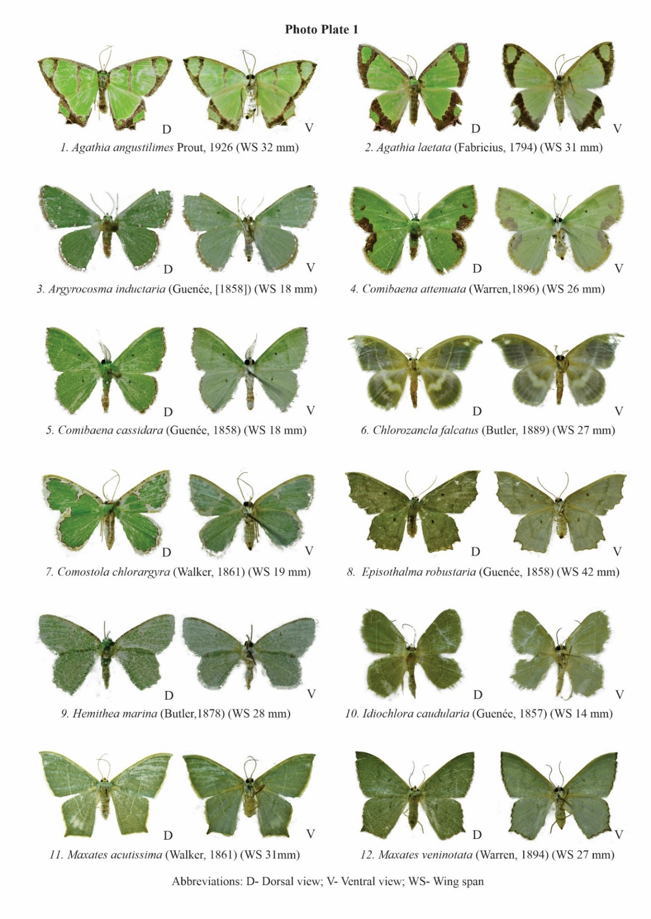
Photo Plate 1. Adult morphology of Geometrinae moths recorded from the northernmost Western Ghats of Maharashtra: 1. Agathia angustilimes; 2. Agathia laetata; 3. Argyrocosma inductaria; 4. Comibaena attenuata; 5. Comibaena cassidara; 6. Chlorozancla falcatus; 7. Comostola chlorargyra; 8. Episothalma robustaria; 9. Hemithea marina; 10. Idiochlora caudularia; 11. Maxates acutissima; 12. Maxates veninotata. D = dorsal view; V = ventral view; WS = wing span.
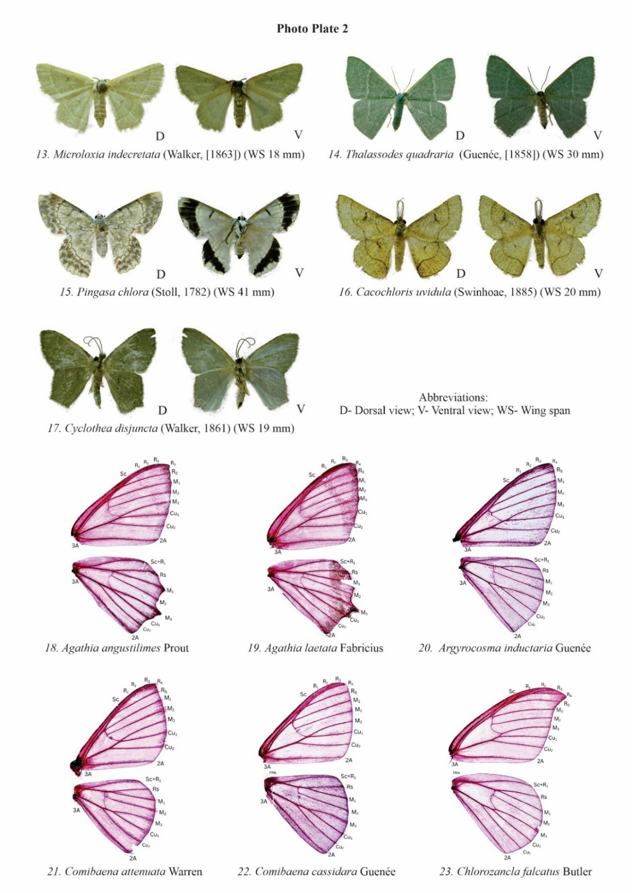
Photo Plate 2. Adult morphology and wing venation of Geometrinae moths recorded from the northernmost Western Ghats of Maharashtra: 13. Microloxia indecretata; 14. Thalassodes quadraria; 15. Pingasa chlora; 16. Cacochloris uvidula; 17. Cyclothea disjuncta; wing venation of 18. Agathia angustilimes; 19. Agathia laetata; 20. Argyrocosma inductaria; 21. Comibaena attenuata; 22. Comibaena cassidara; 23. Chlorozancla falcatus. D = dorsal view; V = ventral view; WS = wing span.
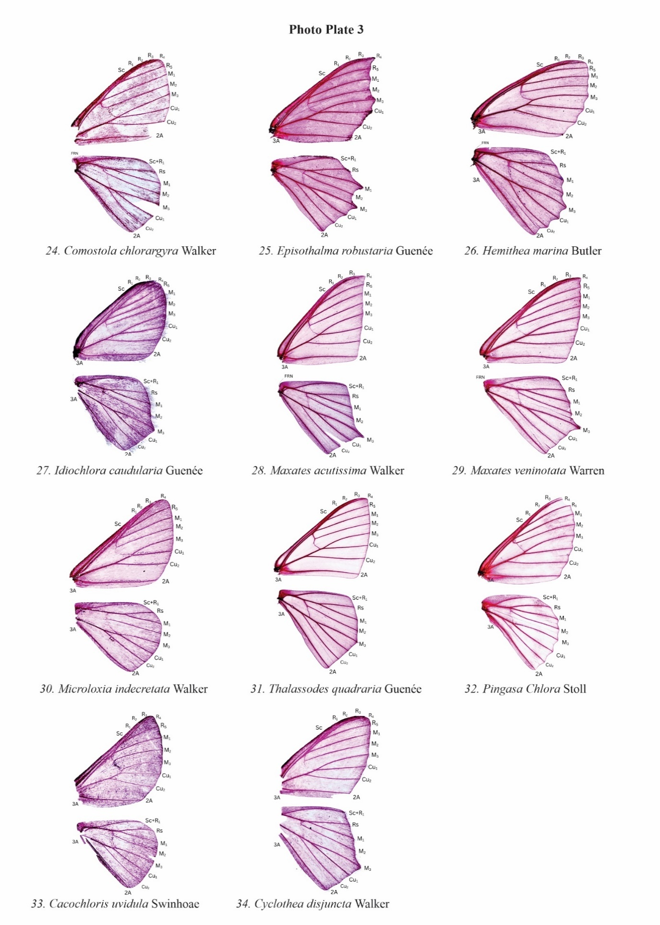
Photo Plate 3. Wing venation of Geometrinae moths recorded from the northernmost Western Ghats of Maharashtra: 24. Comostola chlorargyra; 25. Episothalma robustaria; 26. Hemithea marina; 27. Idiochlora caudularia; 28. Maxates acutissima; 29. Maxates veninotata; 30. Microloxia indecretata; 31. Thalassodes quadraria; 32. Pingasa chlora; 33. Cacochloris uvidula; 34. Cyclothea disjuncta.
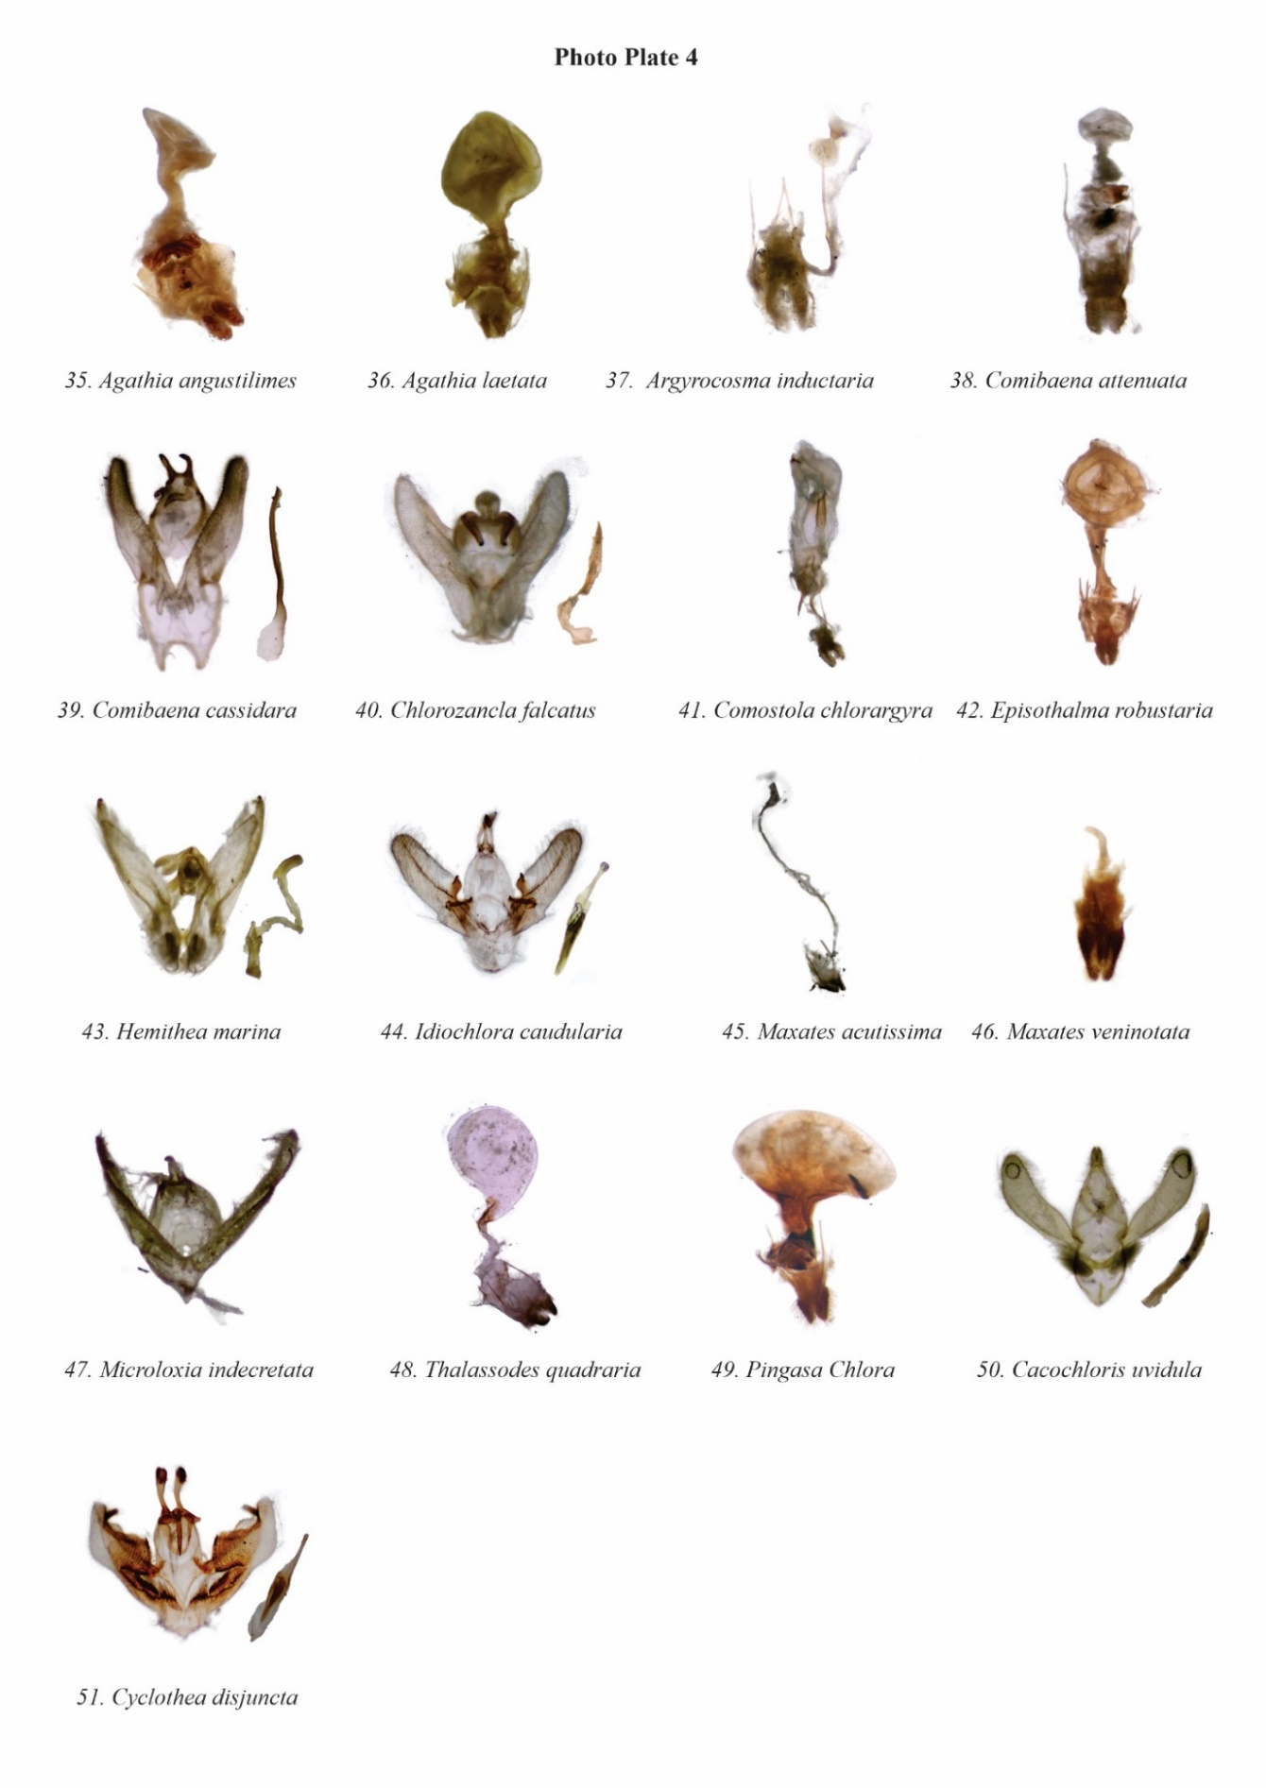
Photo Plate 4. External genitalia of Geometrinae moths recorded from the northernmost Western Ghats of Maharashtra: 35. Agathia angustilimes; 36. Agathia laetata; 37. Argyrocosma inductaria; 38. Comibaena attenuata; 39. Comibaena cassidara; 40. Chlorozancla falcatus; 41. Comostola chlorargyra; 42. Episothalma robustaria; 43. Hemithea marina; 44. Idiochlora caudularia; 45. Maxates acutissima; 46. Maxates veninotata; 47. Microloxia indecretata; 48. Thalassodes quadraria; 49. Pingasa chlora; 50. Cacochloris uvidula; 51. Cyclothea disjuncta.

