Original Research Article
Evaluation of antistress and neuroprotective potential of Ichnocarpus frutescens (L.) W. T. Aiton root extract in Drosophila melanogaster

ABSTRACT
Oxidative stress contributes to cellular dysfunction and is associated with chronic and neurodegenerative disorders, prompting interest in plant-derived antioxidant agents. This study evaluated the antistress and neuroprotective potential of the ethyl acetate (EA) root extract of Ichnocarpus frutescens using Drosophila melanogaster. HPLC profiling identified rutin, kaempferol, lupeol, colchicine and quercetin, with rutin and kaempferol as the predominant detected constituents. Developmental safety was assessed through survivorship and progression from larval to pupal stages across extract concentrations of 1.0–2.5 mg mL⁻¹. No larval mortality was recorded during the observation period. Behavioural effects were assessed using larval crawling and adult climbing assays. The 2.0 mg mL⁻¹ treatment showed the highest locomotor performance, including a crawling distance of 4.3 ± 0.41 cm at 15 min. Molecular analysis of stress-related genes AChE and GstD1 and antioxidant genes Cu/Zn-SOD and Mn-SOD showed reduced expression in extract-treated flies relative to controls. Taken together, the findings indicate that the EA root extract of I. frutescens was associated with preserved developmental viability, improved locomotor performance and reduced expression of selected stress- and antioxidant-related genes under the conditions of this study. The observed effects are consistent with the antioxidant phytochemical profile of the extract and support further evaluation of its antistress and neuroprotective potential.

Key words: Drosophila melanogaster, Oxidative stress, Ichnocarpus frutescens, HPLC, Crawling, negative geotaxis, RT-qPCR
1. INTRODUCTION
Stress has become an unavoidable part of modern life, arising from environmental pressures, lifestyle changes and psychological burdens. When the body is exposed to prolonged stress, it disrupts normal physiological balance and triggers excessive production of reactive oxygen species (ROS). This condition, known as oxidative stress, is a major contributor to ageing and the development of several chronic diseases, including neurodegenerative disorders, diabetes, cardiovascular disease and cancer, and it damages vital biomolecules such as lipids, proteins and DNA (Premnath & Veerappapillai, 2026). Because of its wide-ranging impact on health, there is growing interest in identifying safe and effective agents that can help the body cope with stress and restore redox balance.
In this context, medicinal plants have long been recognised as a natural source of healing and resilience. Traditional medicine systems continue to play a crucial role in disease prevention and primary healthcare, with nearly 80% of the global population relying on plant-based medicine in the form of crude drugs, extracts or herbal formulations (Latif & Nawaz, 2026). More than fifty thousand plant species are used worldwide in traditional medicine, and many of these have also contributed to the development of modern allopathic medicines (Kumar et al., 2026). Among the various medicinal plant families, Apocynaceae holds a special place because of its abundance of pharmacologically active compounds. This family has also been widely reported to exhibit antioxidant, antidiabetic, anti-inflammatory, antimicrobial, anticancer and neuroprotective properties, making it valuable in both traditional and modern medicine (Naik, 2026; Ghodke & Sharma, 2026). One such important medicinal plant is Ichnocarpus frutescens (L.) W. T. Aiton, commonly known as black creeper, belonging to the family Apocynaceae. In Ayurvedic medicine, it is recognised as Sariva and has been widely used since ancient times for its therapeutic properties. In Ayurveda, it is regarded as a substitute for Hemidesmus indicus (Kumarappan et al., 2015). The roots of I. frutescens contain a wide range of bioactive compounds, including phenols, flavonoids, sterols, coumarins, saponins, glycosides and triterpenoids. These phytoconstituents exhibit a wide range of pharmacological activities, including hepatoprotective, analgesic, antidiabetic and antitumorigenic activities (Dwivedi et al., 2025). Moreover, they have shown potential in managing complex conditions such as cancer, cardiovascular disease and neurological disorders (Mohsina et al., 2022). Among these biological properties, antioxidants play a crucial role in protecting cells from oxidative stress. Natural antioxidants derived from medicinal plants can reduce oxidative stress by scavenging reactive oxygen species and enhancing endogenous defence mechanisms. Consequently, plant-derived antioxidant compounds have gained increasing attention as potential anti-ageing and antistress agents (Nowak-Perlak et al., 2025).
Recent studies using D. melanogaster have shown that plant-derived preparations and phytochemicals can modify oxidative-stress responses and locomotor performance under experimentally induced stress, supporting the use of this model for evaluating antioxidant and neuroprotective effects (Iorjiim et al., 2025; Adedara et al., 2024; Kalra et al., 2024). Dietary white tea extract has likewise been reported to improve oxidative-stress resistance, climbing performance and antioxidant-related gene responses in D. melanogaster (Yang et al., 2025).
Despite the reported pharmacological activities of I. frutescens, its antistress potential remains insufficiently explored, particularly in relation to developmental safety, locomotor behaviour, and stress- and antioxidant-related gene expression within a single experimental framework. Evidence specifically addressing the ethyl acetate root extract across these complementary endpoints in D. melanogaster remains limited.
To evaluate such biological effects, Drosophila melanogaster (common fruit fly) has emerged as a powerful and reliable experimental model for evaluating the biological effects of natural products because of its strong genetic similarity to humans. Approximately 60% of the Drosophila genome is homologous to the human genome, and nearly 77% of human disease-related genes have homologues in D. melanogaster. The fly also possesses a short life cycle, a high reproductive rate, ease of maintenance and well-characterised genetics (Mirzoyan et al., 2019; Adhikary & Deb, 2022). These features make D. melanogaster particularly suitable for lifespan, stress-resistance, developmental-toxicity and behavioural studies. Therefore, the present study aimed to characterise the phytochemical constituents of the ethyl acetate (EA) root extract of I. frutescens and evaluate its antistress potential using D. melanogaster as an experimental model through developmental, behavioural and stress-related gene-expression analyses.

2. MATERIALS AND METHODS
2.1 Quantification of phytocompounds
2.1.1 Extraction method
The root extract of Ichnocarpus frutescens was prepared following the successive solvent-extraction procedure described in our previous study (Kattilaparambil et al., 2025). In that study, the root extracts were subjected to phytochemical quantification to determine the secondary metabolite content, and their antioxidant activity was evaluated using DPPH and ABTS radical-scavenging assays. Based on the phytochemical composition and antioxidant activity results, the ethyl acetate (EA) root extract exhibited the highest antioxidant potential and was therefore selected for the present study to evaluate its antistress activity in Drosophila melanogaster.
2.1.2 High-Performance Liquid Chromatography (HPLC) Analysis
The EA root extract of I. frutescens was analysed using high-performance liquid chromatography (HPLC; Shimadzu, Japan). Separation was carried out on a C18 column (4.6 × 250 mm, 5 µm particle size). The mobile phase consisted of solvent A (water: formic acid, 99.9:0.1 v/v) and solvent B (methanol: acetonitrile, 45:40 v/v). The gradient programme was initiated with 95% solvent A and 5% solvent B and maintained for the first 2 min. The proportion of solvent B was then gradually increased to 25%, 40%, 50%, 60%, 70% and 80% at 10, 20, 30, 40, 0 and 80 min, respectively, following the method described by Das et al. (2018), with slight modifications. The flow rate was maintained at 0.8 mL min⁻¹, and the injection volume was 20 µL. Detection was performed using a diode-array detector (DAD) at a wavelength of 210 nm, as used for the standards (Fig. 1).
2.2 Drosophila Toxicity study
2.2.1 Drosophila melanogaster media preparation
An agar-yeast medium was used for the culture and maintenance of Drosophila melanogaster. The medium was prepared by dissolving 800 mg agar, 1.5 g malt extract, 8 g corn flour, 4 g sucrose, 1.5 g yeast and 70 mg methyl paraben in 100 mL of distilled water. The mixture was heated with continuous stirring until all the components were completely dissolved and thoroughly blended. After cooling slightly, propionic acid and orthophosphoric acid were added, and the final volume was adjusted appropriately. Approximately 15 mL of the prepared medium was dispensed into each of seven culture vials. The medium was allowed to solidify completely, after which the vials were plugged with sterile cotton and used for the experimental studies.
2.2.2 Fly collection
A ripe banana and a tomato were peeled and placed in an uncovered container, which was kept in an open environment to attract fruit flies. After 2-3 h, adult Drosophila were observed around the fruits. The flies were carefully collected using an aspirator or a suitable collection method and transferred into a culture container. The container was then covered with a paper towel secured with a rubber band and maintained until use in the experiments.
2.2.3 Experimental design and treatment for larval D. melanogaster
The studies were carried out using wild-type D. melanogaster at the larval stage. Larvae were maintained on a standard artificial diet prepared with agar-yeast medium. The test compound used in this study was the EA root extract of Ichnocarpus frutescens. The extract was incorporated into the diet at four concentrations: 1.0, 1.5, 2.0 and 2.5 mg mL⁻¹ per vial. A total of six experimental groups were established: four treatment groups receiving I. frutescens EA extract, a solvent-control group containing EA solvent, and an untreated control group receiving the standard diet only. Each concentration was tested in a single replicate, with ten larvae introduced into each vial.
2.3 Behavioural assays
2.3.1 Crawling assay
Larvae were gently collected using fine forceps and transferred to a Petri dish containing distilled water for washing. The cleaned larvae were then placed individually on a Petri dish containing 2% agarose positioned over graph paper. The number of grid lines crossed by each larva within 1 min was recorded. Peristaltic contractions, defined as one complete anterior-to-posterior body movement, were also counted for 1 min under a dissecting microscope. To ensure accuracy, larvae were washed thoroughly after selection or treatment to remove any residual food and were allowed to acclimatise on the agar surface for 1 min before recording. The agar plates were maintained at room temperature for at least 1 h prior to the assays, as low temperatures may influence larval locomotor activity (Nichols et al., 2012).
2.3.2 Climbing assay (Negative Geotaxis)
The climbing assay was performed using Drosophila flies to assess locomotor behaviour. A group of flies from each treatment was transferred into a graduated measuring cylinder. The cylinder was gently tapped 2-4 times to bring all flies to the bottom simultaneously. Immediately after tapping, the climbing activity of the flies was recorded using a mobile-phone camera for 10⁻¹5 s (Manjila & Hasan, 2018). The measuring cylinder was divided into five equal sections based on 10 mL graduations and numbered from 0 to 5. The number of flies present in each section at the end of the observation period was recorded. A climbing score was calculated based on the distribution of flies across the sections. This assay was used to evaluate the effect of I. frutescens root EA extract on the locomotor performance of D. melanogaster.
2.4 Molecular analysis
2.4.1 RNA isolation
Total RNA was isolated from D. melanogaster collected from the 2.5 mg mL⁻¹ extract-treated group and the untreated control group. Ten flies from each group were homogenised in 1 mL of RDP trio reagent using a sterile mortar and pestle. The homogenate was mixed with an additional 300 µL of RDP reagent and 200 µL of chloroform, followed by vigorous vortexing to ensure thorough mixing. The mixture was allowed to stand at room temperature for 10 min. The samples were then transferred to fresh microcentrifuge tubes and centrifuged at 12000 rpm for 10 min at 4 ⁰C. After centrifugation, the upper aqueous phase containing RNA was carefully transferred to new tubes, while the interphase was retained separately for subsequent DNA isolation. To precipitate the RNA, 0.5 mL of isopropanol was added to each sample and mixed gently. The samples were incubated at room temperature for 10 min and centrifuged again at 12000 rpm for 10 min at 4 ⁰C. The supernatant was discarded, and the resulting RNA pellet was washed with 75% ethanol. After centrifugation at 10,000 rpm for 10 min at room temperature, the ethanol was removed, and the RNA pellets were briefly air-dried. Finally, the purified RNA was resuspended in 100 µL of RNase-free water and stored for further analysis (Allen, 2016).
2.4.2 cDNA synthesis
Complementary DNA (cDNA) was synthesised from the isolated RNA using a reverse-transcription reaction. Initially, 2 µL of random hexamer primer was added to 8 µL of the RNA sample, and the mixture was incubated at 70 ⁰C for 4 min in a thermal cycler. The tubes were immediately placed on ice for 2 min and briefly centrifuged to collect the condensed liquid. The reverse-transcription reaction mixture was then prepared by adding the required reverse-transcription reagents according to the manufacturer’s protocol. The reaction was carried out under appropriate thermal conditions, followed by incubation at 95 ⁰C for 5⁻¹0 min to inactivate the reverse-transcriptase enzyme. The synthesised cDNA was either stored at 20 ⁰C or used immediately for PCR amplification (Ståhlberg et al., 2004).
2.4.3 RT-qPCR amplification
Reverse-transcription quantitative PCR (RT-qPCR) was performed according to the method described by Pfaffl (2001), with slight modifications, to assess the expression of stress-related and antioxidant genes in D. melanogaster. Total RNA was extracted and converted to cDNA, which served as the template for RT-qPCR analysis. Gene-specific primers were used to amplify target genes, including the stress-related genes acetylcholinesterase (AChE) and glutathione S-transferase D1 (GstD1), as well as the antioxidant genes Cu-Zn superoxide dismutase (Cu-Zn SOD) and Mn-superoxide dismutase (Mn-SOD) (Table 1). The PCR reaction mixture was prepared in a total volume of 50 µL containing 5.0 µL of 10x PCR buffer with 15 mM Mgcl₂, 0.5 µL each of forward and reverse primers, 1.0 µL of dNTP mixture, template DNA/cDNA with nuclease-free water, and 0.10 µL of Taq DNA polymerase (5 U µL⁻¹). The reaction mixture was mixed thoroughly and centrifuged, then subjected to amplification in a thermal cycler. The PCR programme consisted of an initial denaturation at 94 ⁰C for 1 min, followed by 30 cycles of denaturation at 94 ⁰C for 1 min, annealing at 55 ⁰C for 1 min and extension at 72 ⁰C for 1 min for products less than 500 bp or 3 min for products greater than 500 bp. A final extension was carried out at 72 ⁰C for 7 min. After amplification, 2.5 µL of loading dye was added to each PCR sample, and the amplified fragments were analysed by agarose gel electrophoresis using an appropriate agarose concentration. The PCR products were either analysed immediately or stored at 4 ⁰C for subsequent use.
Table :1 Gene specific primer sequence used for quantitative PCR (qPCR) analysis of stress related and antioxidant genes in Drosophila melanogaster
Name of the gene | Primer Sequence
GstD1 | Forward5’ GACTCCCTGTACCCTAAGTGC 3’  Reverse5’ TCGGCTACGGTAAGGGAGTCA 3’
AChE | Forward 5’ GTGGAAAACCAGGATTGGAA 3’  Reverse 5’ TGCGCAAAGTTCTGAATGTC 3’
Cu-Zn SOD | Forward 3’ GCGGCGTTATTGGCATTG 5’  Reverse 3’ ACTAACAGACCACAGGCTATG 5’
Mn- SOD | Forward 3’ CACATCAACCACACCATCTTC 5’  Reverse 3’ CGTCTTCCACTGCGACTC 5’

2.4.4 Agarose gel Electrophoresis
Agarose gel electrophoresis was performed to analyse the PCR-amplified products. A 1 x TAE (Tris acetate EDTA) buffer was prepared by diluting 0.4 mL of 50 x TAE stock solution to a final volume of 200 mL with distilled or demineralised water. A 1% agarose gel was prepared by dissolving 0.5 g of agarose in 50 mL of 1 x TAE buffer. The mixture was heated until the agarose dissolved completely and a clear solution was obtained. The gel-casting tray was assembled, and the comb was positioned approximately 2 cm from the cathode end of the tray. Ethidium bromide (EtBr) was added to the molten agarose to obtain a final concentration of 0.5 µg mL⁻¹ from a 10 mg mL⁻¹ stock solution. The solution was mixed gently and allowed to cool to approximately 60 ⁰C before being poured into the casting tray. The gel was allowed to solidify at room temperature, resulting in a gel thickness of approximately 0.5-0.9 cm. After solidification, the gel was placed in the electrophoresis tank and submerged in 1 x TAE buffer until the buffer level was approximately 0.5-0.8 cm above the gel surface. The comb was carefully removed to create intact sample wells. The electrophoresis unit was connected to the power supply, with the red lead connected to the anode and the black lead connected to the cathode. PCR samples were mixed with 6 x Tri track loading dye and loaded into the wells in the desired order, which was recorded for reference. Electrophoresis was carried out at 50 V until the tracking dye migrated approximately three-fourths of the length of the gel. After electrophoresis, the DNA bands were visualised under a UV transilluminator, where the ethidium bromide-stained DNA appeared as fluorescent bands.
2.5 Statistical analysis
All experiments were carried out in triplicate (n=3), and data were expressed as mean ± standard deviation (SD).
3. RESULTS AND DISCUSSION
3.1 Phytocompound characterization by HPLC analysis
In the root EA extract, five bioactive compounds were detected, including rutin, colchicine, quercetin, kaempferol and lupeol (Fig. 2). Rutin exhibited the highest concentration, 9.230 mg g⁻¹, among all compounds analysed, indicating that it is a major phenolic constituent of the root extract. Kaempferol was the second most abundant compound, at 3.1765 mg g⁻¹. Lupeol was present at a concentration of 0.3480 mg g⁻¹, while colchicine and quercetin were present in comparatively lower amounts, with concentrations of 0.1127 mg g⁻¹ and 0.0530 mg g⁻¹, respectively (Table 2). Overall, HPLC profiling revealed marked differences in the phytochemical composition of the root EA extract of I. frutescens. The predominance of rutin suggests that the root is a rich source of flavonoids. Rutin, lupeol and kaempferol have been extensively reported to possess antioxidant, anti-inflammatory and antistress activities (Alrumaihi et al., 2024; Al Hoque et al., 2025), while quercetin is recognised for its strong free-radical-scavenging and neuroprotective potential (Adnan et al., 2025).
Table 2: HPLC quantification of bioactive compounds in I. frutescens root EA extract
Bioactive compounds | Retention Time (RT) | Area | Height | Mg g⁻¹
Rutin | 4.088 | 147454 | 41799 | 9.230037
Colchicine | 4.519 | 68239 | 10297 | 0.112672
Quercetin | 5.284 | 39802 | 12461 | 0.053047
Kaempferol | 21.302 | 499448 | 48100 | 3.17648
Lupeol | 42.647 | 21209 | 20359 | 0.348029

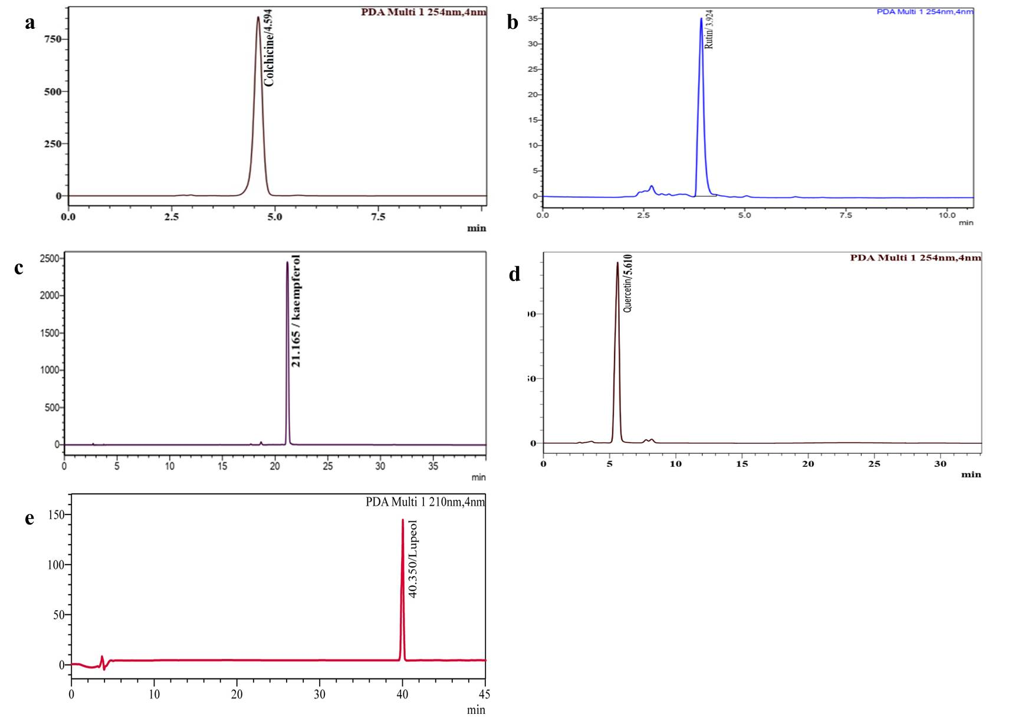
Fig. 1. HPLC chromatogram of standards. (a) Colchicine (b) Rutin (c) Kaempferol (d) Quercetin (e) Lupeol
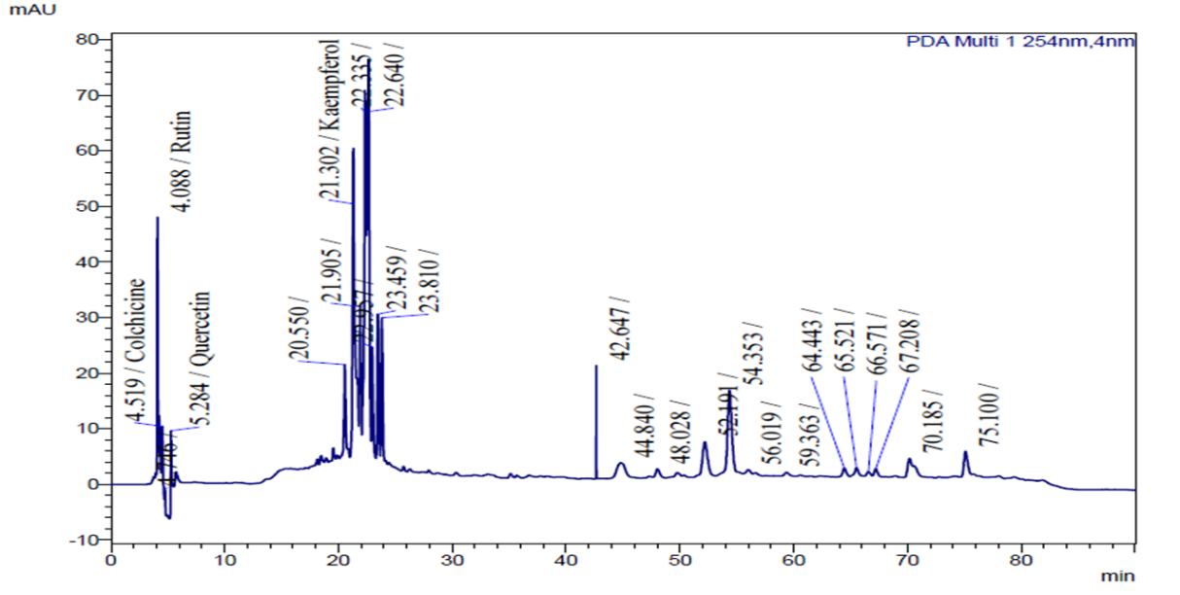

Fig. 2. HPLC chromatogram of ethyl acetate extract of I. frutescens root

3.2 Effect of EA root extract of I. frutescens on the viability and survival of D. melanogaster
The survivorship and development of D. melanogaster were evaluated over an 8-day period in larvae and pupae fed different concentrations of I. frutescens root EA extract. Survivorship in the untreated control and solvent control (EA) groups was also recorded. The percentage survival of larvae and pupae is presented in Table 3, and representative developmental stages are shown in Fig. 3. Ten larvae were introduced into each vial containing different concentrations of the EA extract (1.0, 1.5, 2.0 and 2.5 mg mL⁻¹). Throughout the first six days of observation, all larvae remained viable in every treatment and control group, indicating that none of the tested extract concentrations caused larval mortality. From day 7 onwards, the onset of metamorphosis was observed in all groups, with a gradual transition from larval to pupal stages. In the 1.0 mg mL⁻¹ and 1.5 mg mL⁻¹ treatments, 9 larvae and 1 pupa were recorded, while the 2.0 and 2.5 mg mL⁻¹ treatments showed a slightly higher rate of pupation, with 8 larvae and 2 pupae each. The EA control group remained largely unaffected, showing 10 larvae with no significant developmental shift, whereas the untreated control exhibited 9 larvae and 1 pupa. By day 8, a marked progression towards pupation was evident in all experimental groups. The 1.0 mg mL⁻¹, 1.5 mg mL⁻¹ and 2.0 mg mL⁻¹ treatments each showed an equal distribution of 5 larvae and 5 pupae, indicating synchronised developmental advancement. Importantly, no larval mortality was recorded in any treatment or control vial throughout the experimental period. The findings demonstrate that the EA root extract of I. frutescens did not exhibit toxic effects on D. melanogaster. Larvae treated with the highest concentration (2.5 mg mL⁻¹) exhibited developmental progression comparable to that of the untreated control, whereas the solvent control showed relatively delayed pupation. Since developmental progression in Drosophila is highly sensitive to oxidative stress and metabolic disturbances, the maintenance of normal pupation rates suggests that the extract does not disrupt cellular homeostasis. The absence of developmental toxicity in the present study establishes the safety of the root extract and supports its suitability for further behavioural and molecular investigations.
Table 3: Survival and developmental progression of Drosophila melanogaster larvae treated with EA root extract of Ichnocarpus frutescens over a one-week observation period
Survival and Development Data (10 Larvae introduced into each treatment vial)
Days | Vial 1  1mg | Vial2 1.5mg mL⁻¹ | Vial 3  2 mg mL⁻¹ | Vial 4 2.5mg mL⁻¹ | Negative control  (Ethyl acetate) | Control
Day 1 | 10 | 10 | 10 | 10 | 10 | 10
Day 2 | 10 | 10 | 10 | 10 | 10 | 10
Day 3 | 10 | 10 | 10 | 10 | 10 | 10
Day 4 | 10 | 10 | 10 | 10 | 10 | 10
Day 5 | 10 | 10 | 10 | 10 | 10 | 10
Day 6 | 10 | 10 | 10 | 10 | 10 | 10
Day 7 | 9 Larvae;  1 Pupa | 9 Larvae; 1  Pupa | 8 Larvae;  2 Pupae | 8 Larvae;  2 Pupae | 10 | 9 Larvae;1  Pupa
Day 8 | 5 Larvae;  5 Pupae | 5 Larvae; 5  Pupae | 5 Larvae; 5  Pupae | 4 Larvae; 6  Pupae | 9 Larvae; 1  Pupa | 4 Larvae;6  Pupae
Values represent the number of surviving larvae and pupae observed on each day of the experiment. Negative control: EA (Ethyl acetate solvent); Control: Standard culture medium without extract or solvent.
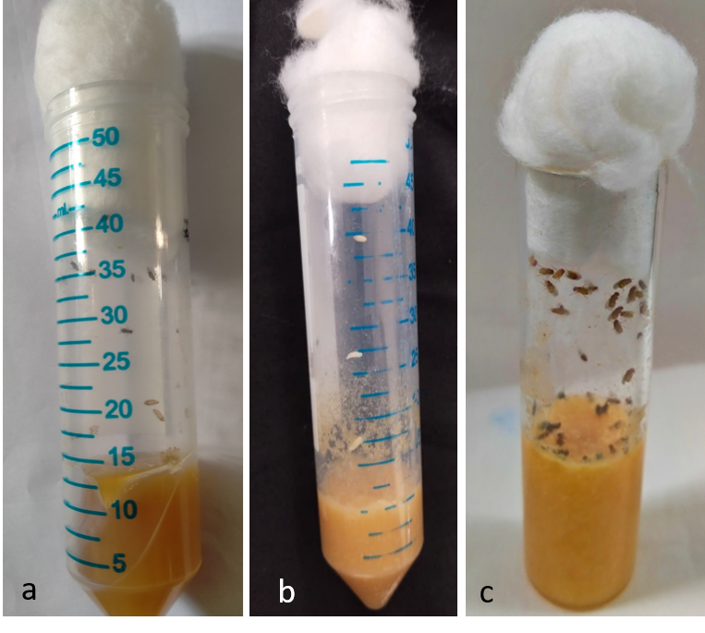
Fig. 3. Developmental stages of Drosophila melanogaster. (a) Larval stage, (b) Pupal stage, (c) Adult stage.

3.3 Behavioural assay
3.3.1 Crawling assay
In the present study, D. melanogaster larvae were reared on culture media supplemented with different concentrations of I. frutescens root extract. The crawling activity of the larvae was assessed after treatment, and the results are presented in Table 4. Crawling activity increased progressively with time in all treatment groups. Among the tested concentrations, the 2.0 mg mL⁻¹ extract treatment exhibited the highest crawling performance throughout the observation period (Fig. 4a). At 5 min, larvae treated with 2.0 mg mL⁻¹ showed a crawling distance of 1.2 ±0.30 cm, which increased to 2.3 ±0.17 cm at 10 min and reached 4.3± 0.41 cm at 15 min. This was markedly higher than the untreated control, which recorded 0.8 ± 0.25cm, 1.4 ±0.26 cm and 2.6 ±0.10 cm at the corresponding time intervals. The increase in crawling activity indicates improved larval locomotion following treatment with the extract. Overall, the results indicate that treatment with 2.0 mg mL⁻¹ of I. frutescens root EA extract significantly enhanced larval crawling performance compared with the control and solvent-control groups, suggesting a positive effect of the extract on larval locomotor activity. This improvement in locomotor behaviour is likely associated with the antioxidant flavonoids identified in the root extract, particularly rutin, kaempferol and quercetin. These compounds have been reported to reduce oxidative damage in neuronal tissues, preserve mitochondrial function and improve cellular energy metabolism, thereby supporting normal neuromuscular activity (Debnath et al., 2025; Shadman et al., 2025).
Table 4: Crawling performance of Drosophila melanogaster larvae treated with EA root extract of Ichnocarpus frutescens
Time (cm/minutes) | Concentrations
Time (cm/minutes) | 1(mg/mL) | 1.5(mg mL⁻¹) | 2(mg mL⁻¹) | 2.5(mg mL⁻¹) | EA (100%) | Control
5 | 0.6±0.05 | 0.8±0.35 | 1.2±0.30 | 0.6±0.15 | 0.3±0.57 | 0.8±0.25
10 | 1.5±0.26 | 2.6±0.20 | 2.3±0.17 | 2.2±0.20 | 0.7±0.15 | 1.4±0.26
15 | 2.1±0.3 | 2.4±0.25 | 4.3±0.41 | 3.5±0.25 | 1.3±0.20 | 2.6±0.1
Values are expressed as mean±SD (n=3). Crawling distance was measured in centimeters (cm) at 5,10 and 15 minutes. Negative control: EA (Ethyl acetate solvent); Control: Standard culture medium without extract or solvent.
3.3.2 Climbing assay
The climbing ability of adult D. melanogaster flies was evaluated approximately one week after adult emergence. The locomotor performance of the flies was recorded by observing the height reached within a graduated measuring cylinder (Fig. 4b), and the results are presented in Table 5. Among all the treatment groups, flies treated with 2.0 mg mL⁻¹ of I. frutescens root extract showed the highest climbing activity (5.2 ± 0.64 cm) compared with both the untreated control and the solvent-control groups. The solvent control exhibited the poorest climbing activity, with the highest number of flies remaining in the 0⁻¹0 mL level (3.6 ± 0.57). The untreated control group showed intermediate climbing ability, with a small proportion of flies reaching the upper level. Overall, the results demonstrated that treatment with 2.0 mg mL⁻¹ of I. frutescens root EA extract significantly improved the climbing performance of D. melanogaster compared with the controls. Improved climbing behaviour reflects enhanced locomotor function and better preservation of neuronal integrity. Oxidative stress is a major contributor to locomotor impairment in Drosophila (Patel & Nagda, 2026). The flavonoids and triterpenoids detected in the root extract are capable of scavenging reactive oxygen species, reducing lipid peroxidation and protecting neuronal cells from oxidative damage.
Table 5: Climbing performance of Drosophila melanogaster larvae treated with EA root extract of Ichnocarpus frutescens
Level of measuring cylinder (cm) | Concentrations
Level of measuring cylinder (cm) | 1(mg mL⁻¹) | 1.5(mg mL⁻¹) | 2(mg mL⁻¹) | 2.5(mg mL⁻¹) | EA (100%) | Control
0-10 | 4.0±0.57 | 4.3±0.23 | 5.2±0.64 | 5.11±0.21 | 3.6±0.57 | 4.6±0.57
10-20 | 3.3±0.57 | 3.3±0.57 | 3.3±0.08 | 2.6±0.57 | 2.6±0.57 | 2.6±0.52
20-30 | 2.3±0.57 | 2.6±0.57 | 2.5±0.57 | 2.3±0.57 | 1.0±0.01 | 2.3±0.57
30-40 | 1.0±0.11 | 2.2±0.13 | 1.1±0.73 | 1.36±0.57 | 0±0.00 | 0.6±0.57
40-50 | 0±0.00 | 0.3±0.57 | 1.6±0.15 | 0.5±0.00 | 0±0.00 | 0.6±0.15
Values are expressed as mean±SD (n=3). Negative control: EA (Ethyl acetate solvent); Control: Standard culture medium without extract or solvent.

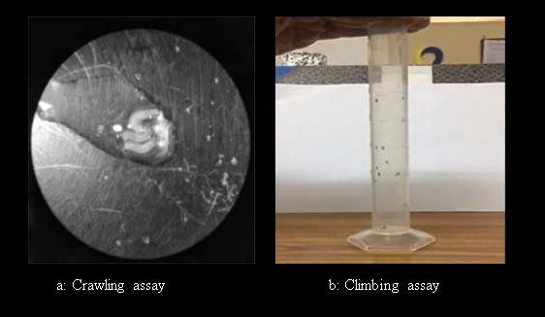
Fig. 4. Behavioural assays of Drosophila melanogaster treated with the EA root extract of Ichnocarpus frutescens. (a) Crawling assay, (b) Climbing assay.

3.4 cDNA synthesis and stress gene expression analysis
The stress-related genes AChE and GstD1 showed strong expression in the control flies, whereas their expression was markedly reduced or absent in flies treated with 2.0 mg mL⁻¹ of I. frutescens root extract. PCR analysis revealed distinct bands at 147 bp for AChE and 172 bp for GstD1 in the control group, while these bands were faint or undetectable in the treated flies. The reduced expression of these stress-responsive genes suggests that the phytoconstituents present in the root extract may suppress or modulate stress-related gene activity. Similarly, the antioxidant genes Cu/Zn-SOD and Mn-SOD exhibited higher expression in the control flies than in the extract-treated group (Fig. 5). Superoxide dismutase genes are typically upregulated when intracellular reactive oxygen species accumulate. Therefore, their reduced expression following treatment indicates that the extract likely diminished oxidative stress either through direct free-radical scavenging or by limiting reactive oxygen species generation. The lower expression of these genes in treated flies may indicate that the phytochemicals present in the root extract reduced oxidative stress, thereby decreasing the requirement for elevated antioxidant enzyme expression (Sanni et al., 2024). This interpretation is consistent with the HPLC results, which identified potent antioxidant compounds, including rutin, kaempferol and quercetin. Previous studies have shown that flavonoid-rich plant extracts can regulate antioxidant gene expression by maintaining intracellular redox balance and reducing oxidative stress (Sarkar et al., 2022; Bas, 2026).
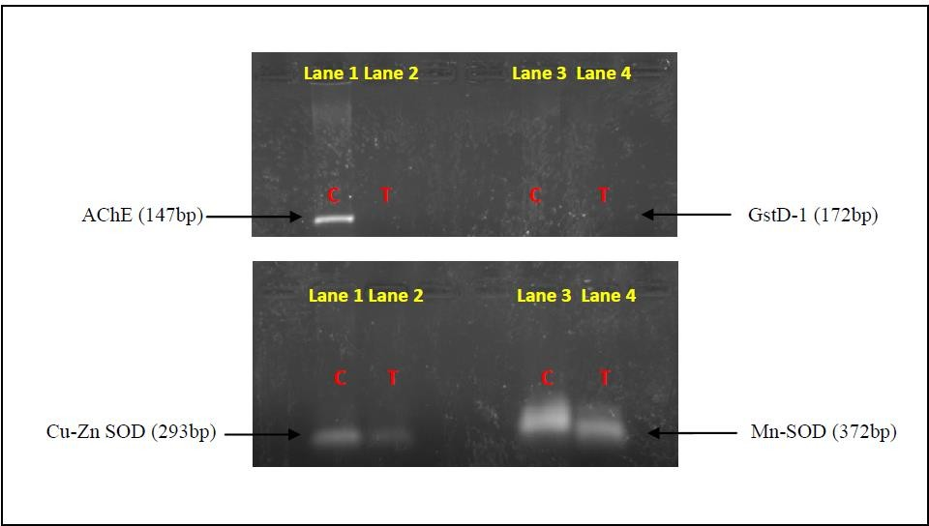
Fig. 5. Agarose gel electrophoresis of stress and antioxidant gene amplification in Drosophila melanogaster treated with Ichnocarpus frutescens root extract.
(a) Amplification of stress related gens, acetylcholinesterase (AchE) and glutathione S-transferase D1 (GstD-1). (b)Amplification of antioxidant genes, Cu-Zn superoxide dismutase (Cu-Zn SOD); and Mn superoxide dismutase (Mn- SOD). C- Control; T- 2.0 mg mL⁻¹ EA root treated.

4. CONCLUSION
The present study indicates that the ethyl acetate root extract of Ichnocarpus frutescens contains several antioxidant-associated phytoconstituents, with rutin and kaempferol occurring at the highest detected concentrations. Across the tested concentration range, the extract did not cause larval mortality during the developmental observation period and supported progression from larval to pupal stages. Behavioural assays showed improved locomotor performance, with the 2.0 mg mL⁻¹ treatment producing the strongest crawling and climbing responses among the tested groups. In addition, reduced expression of AChE, GstD1, Cu/Zn-SOD and Mn-SOD in extract-treated flies was consistent with a lower stress-associated molecular response under the experimental conditions. Collectively, the developmental, behavioural and molecular findings suggest that the EA root extract of I. frutescens has antistress and neuroprotective potential in Drosophila melanogaster. These results provide a basis for further investigation of the identified phytoconstituents and their contribution to the observed biological effects. Further evaluation in complementary experimental systems would help define the relevance and reproducibility of these observed effects.
Limitations
This study was conducted in Drosophila melanogaster and evaluated a defined concentration range of the EA root extract; therefore, the findings should be interpreted within this experimental model. Molecular assessment was limited to selected stress- and antioxidant-related genes, while HPLC profiling focused on the detected phytoconstituents reported in the manuscript. Further studies using complementary molecular and biochemical endpoints would help clarify the relationship between the extract’s phytochemical profile and the observed developmental and locomotor responses.

Declaration of AI Use

This manuscript was prepared through the intellectual contributions of the author(s) to the study design, data analysis, interpretation of results, and scholarly content. Grammarly and ChatGPT were used solely to assist with grammatical refinement and reference formatting during manuscript revision. The author(s) accept full responsibility for the accuracy, integrity, and final content of the manuscript.

COMPETING INTERESTS DISCLAIMER:
Authors have declared that they have no known competing financial interests OR non-financial interests OR personal relationships that could have appeared to influence the work reported in this paper.

REFERENCES

Adedara, A. O., Bressan, G. N., Dos Santos, M. M., Fachinetto, R., Abolaji, A. O., & Barbosa, N. V. (2024). Antioxidant responses driven by hesperetin and hesperidin counteract Parkinson's disease-like phenotypes in Drosophila melanogaster. NeuroToxicology, 101, 117–127. https://doi.org/10.1016/j.neuro.2024.02.006
Adhikary, A., & Deb, D. (2022). A preliminary study on the behaviour of Drosophila melanogaster larva to different oil samples. Uttar Pradesh Journal of Zoology, 43(24), 311–315. https://doi.org/10.56557/upjoz/2022/v43i243326
Adnan, M., Siddiqui, A. J., Bardakci, F., Surti, M., Badraoui, R., & Patel, M. (2025). Neuroprotective potential of quercetin in Alzheimer’s disease: Targeting oxidative stress, mitochondrial dysfunction, and amyloid-β aggregation. Frontiers in Pharmacology, 16, 1593264. https://doi.org/10.3389/fphar.2025.1593264
Allen, E. (2016). RNA extraction from Drosophila tissues using TRIzol reagent. protocols.io. https://doi.org/10.17504/protocols.io.fgrbjv6
Al Hoque, A., Begum, S., & Dutta, D. (2025). Occurrence, chemical nature, and medicinal benefits of flavonoids: Rutin, kaempferol, quercetin, anthocyanidins, catechins, and flavones. In B. Mukherjee (Ed.), Dietary supplements and nutraceuticals (pp. 185–208). Springer. https://doi.org/10.1007/978-981-96-8622-3_5
Alrumaihi, F., Almatroodi, S. A., Alharbi, H. O. A., Alwanian, W. M., Alharbi, F. A., Almatroudi, A., & Rahmani, A. H. (2024). Pharmacological potential of kaempferol, a flavonoid in the management of pathogenesis via modulation of inflammation and other biological activities. Molecules, 29(9), 2007. https://doi.org/10.3390/molecules29092007
Bas, T. G. (2026). Dietary polyphenols (flavonoids) derived from plants for use in therapeutic health: Antioxidant performance, ROS, molecular mechanisms, and bioavailability limitations. International Journal of Molecular Sciences, 27(3), 1404. https://doi.org/10.3390/ijms27031404
Das, N., Bhattacharya, A., Mandal, S. K., Debnath, U., Dinda, B., Mandal, S. C., Sinhamahapatra, P. K., Kumar, A., Dutta Choudhury, M., Maiti, S., & Palit, P. (2018). Ichnocarpus frutescens (L.) R. Br. root derived phyto-steroids defends inflammation and algesia by pulling down the pro-inflammatory and nociceptive pain mediators: An in-vitro and in-vivo appraisal. Steroids, 139, 18–27. https://doi.org/10.1016/j.steroids.2018.09.005
Debnath, I., Ghosh, S., Jha, S. K., Bhunia, S., Nayak, A., Basak, S., Nandi, S., & Bhattacharjee, S. (2025). Mechanistic insights and therapeutic potential of quercetin in neuroprotection: A comprehensive review of pathways and clinical perspectives. BIO Integration, 6(1), 1–31. https://doi.org/10.15212/bioi-2025-0073
Dwivedi, J., Wal, P., Gupta, A., Chakraborthy, G., Srivastava, A., Sharma, M. C., & Gunjal, S. D. (2025). A delve into the chemical diversity, pharmacological targets, and biological mechanisms of Ichnocarpous frutescens Linn R. Br.: A review on the current status of knowledge. Current Organic Chemistry, 29(14), 1092–1106. https://doi.org/10.2174/0113852728337563241202080158
Iorjiim, W. M., Omale, S., & Alemika, E. T. (2025). Moringa oleifera L. leaf fractions improve survival and ameliorate antiretroviral drug-induced toxicities in the Canton-S Drosophila melanogaster. European Journal of Medicinal Plants, 36(4), 140–153. https://doi.org/10.9734/ejmp/2025/v36i41287
Kalra, S., Sachdeva, H., Pant, A. B., & Singh, G. (2024). Acorus calamus Linn.: A novel neuroprotective approach for traumatic brain injury in Drosophila melanogaster. Brain Research, 1836, 148953. https://doi.org/10.1016/j.brainres.2024.148953
Kattilaparambil, R., Sathasivam, V., Muthukrishnan, S., Vedagiri, H., Iyaswamy, A., Muthukrishnan, A., Raman, A., Gunasangkaran, G., Murugesan, J., & Packiaraj, G. (2025). Antiproliferative effects of phytocompounds from Ichnocarpus frutescens (L.) W.T. Aiton against breast cancer cell line MDA MB-231 by in vitro and in silico analysis. Pharmacological Research - Reports, 4, 100058. https://doi.org/10.1016/j.prerep.2025.100058
Kumar, I., Vishwakarma, S. K., Singh, P. K., Kumar, U., Singh, R. P., Madheshiya, P., Dwivedi, A., Singh, P., & Sharma, R. K. (2026). Ethnopharmacological exploration of Indian medicinal plants: From traditional knowledge to modern medicine. Phytochemistry Reviews. https://doi.org/10.1007/s11101-026-10234-w
Kumarappan, C., Srinivasan, R., Jeevathayaparan, S., Rajinikanth, R., Naveen Kumar, H. S., Senthilrajan, S., & Subhash, C. M. (2015). Ichnocarpus frutescens: A valuable medicinal plant. PharmacologyOnLine, 2, 18–37. https://pharmacologyonline.silae.it/front/archives_2015_2
Latif, R., & Nawaz, T. (2026). Medicinal plants and human health: A comprehensive review of bioactive compounds, therapeutic effects, and applications. Phytochemistry Reviews, 25(3), 2299–2342. https://doi.org/10.1007/s11101-025-10194-7
Manjila, S. B., & Hasan, G. (2018). Flight and climbing assay for assessing motor functions in Drosophila. Bio-protocol, 8(5), e2742. https://doi.org/10.21769/BioProtoc.2742
Mirzoyan, Z., Sollazzo, M., Allocca, M., Valenza, A. M., Grifoni, D., & Bellosta, P. (2019). Drosophila melanogaster: A model organism to study cancer. Frontiers in Genetics, 10, 51. https://doi.org/10.3389/fgene.2019.00051
Mohsina, F. P., Quazi, A., Faheem, I. P., Anuradha, M., Mukim, M., & Patil, A. (2022). Botanical, ethnopharmacological, phytochemical & pharmacological standards of plant Ichnocarpus frutescens. Research & Review: Drugs and Drugs Development, 4(1), 1–12. https://doi.org/10.46610/RRDDD.2022.v04i01.001
Naik, D. L. (2026). Exploring phytochemistry and pharmacology of the Apocynaceae family: A comprehensive review. The Journal of Phytopharmacology, 15(1), 99–107. https://doi.org/10.31254/phyto.2026.15114
Nichols, C. D., Becnel, J., & Pandey, U. B. (2012). Methods to assay Drosophila behavior. Journal of Visualized Experiments, (61), e3795. https://doi.org/10.3791/3795
Nowak-Perlak, M., Olszowy, M., & Woźniak, M. (2025). The natural defense: Anti-aging potential of plant-derived substances and technological solutions against photoaging. International Journal of Molecular Sciences, 26(16), 8061. https://doi.org/10.3390/ijms26168061
Patel, P., & Nagda, G. (2026). Behavioural and physiological impacts of varying doses of methotrexate on Drosophila melanogaster. Naunyn-Schmiedeberg's Archives of Pharmacology, 399(9), 13245–13256. https://doi.org/10.1007/s00210-026-05203-1
Premnath, V., & Veerappapillai, S. (2026). Basic understanding of oxidative stress and the pathophysiology of chronic diseases in human. In K. Kasinathan & A. Muthukumaran (Eds.), Recent advances in oxidative stress associated chronic diseases volume 1: A review of the health benefits and risks of the substance (pp. 199–218). Springer. https://doi.org/10.1007/978-981-96-9670-3_9
Pfaffl, M. W. (2001). A new mathematical model for relative quantification in real-time RT-PCR. Nucleic Acids Research, 29(9), e45. https://doi.org/10.1093/nar/29.9.e45
Sanni, J. A., Saliu, J. A., Apata, S. A., Olubode, S. O., Adenuga, O. O. O., Adenuga, V. O., & Atibor, R. A. (2024). Influence of ethyl acetate fraction of Cananga odorata on diabetic model of Drosophila melanogaster. SSRN Electronic Journal. https://doi.org/10.2139/ssrn.5036678
Sarkar, C., Chaudhary, P., Jamaddar, S., Janmeda, P., Mondal, M., Mubarak, M. S., & Islam, M. T. (2022). Redox activity of flavonoids: Impact on human health, therapeutics, and chemical safety. Chemical Research in Toxicology, 35(2), 140–162. https://doi.org/10.1021/acs.chemrestox.1c00348
Shadman, J., Haghi-Aminjan, H., Alipour, M. R., & Panahpour, H. (2025). The neuroprotective mechanisms of kaempferol in experimental ischemic stroke: A preclinical systematic review. Molecular Neurobiology, 62(8), 9527–9544. https://doi.org/10.1007/s12035-025-04848-y
Ståhlberg, A., Håkansson, J., Xian, X., Semb, H., & Kubista, M. (2004). Properties of the reverse transcription reaction in mRNA quantification. Clinical Chemistry, 50(3), 509–515. https://doi.org/10.1373/clinchem.2003.026161
Ghodke, A. S., & Sharma, B. P. (2026). Cardioprotective metabolites of Apocynaceae: Therapeutic potential and future perspectives. Journal of Biodiversity and Conservation, 10(2), 212–222. https://doi.org/10.5281/zenodo.21051320
Yang, Y., Ye, T., Yu, J., Fan, L., Ma, C., Zhang, B., & Tan, T.-C. (2025). Evaluation of the antioxidant and longevity-promoting effects of white tea extract in Drosophila melanogaster. Frontiers in Nutrition, 12, 1702854. https://doi.org/10.3389/fnut.2025.1702854

