Original Research Article
Avian Diversity of Lal Bahadur Shastri Mahavidyalaya Campus, Dharmabad, Maharashtra: A Comprehensive Checklist

.
ABSTRACT

The present study was undertaken to assess bird diversity on the campus of Lal Bahadur Shastri Mahavidyalaya, Dharmabad, Nanded, Maharashtra, India. A well-organised survey was conducted at various locations on the campus from August 2025 to July 2026. A total of 41 bird species representing 12 orders, 27 families, and 36 genera were reported during the study period. The order Passeriformes was dominant, with 16 bird species. The family Sylviinae was the most abundant. Birds are important biotic components of ecosystems and contribute to various ecological services, including pollination, seed dispersal, biological control, and food chains. Birds play a crucial role in ecological functioning and are highly sensitive to climate change and habitat destruction. They occupy diverse habitats, including agricultural land, grassland, scrubland, woodland, water bodies, natural cliffs, and rural and urban areas. Most bird species belonged to the insectivorous feeding guild, followed by omnivores and carnivores, with nectarivores being the least represented. In addition, three mixed feeding guilds were recorded: granivore–frugivore, granivore–insectivore, and frugivore–insectivore. The IUCN status of all recorded birds was Least Concern (LC), indicating that the species were reported as well adapted, stable, and protected within the college campus area. Because the campus contains diverse habitats, it provides feeding areas, nesting sites, breeding habitats, and extensive foraging grassland for resident bird species. This study establishes baseline information on bird diversity, habitat use, migratory status, occurrence, feeding guild, endemicity, and IUCN status on the campus. The abundance of birds reflects the richness of the habitat, the eco-friendly environment, and the availability of natural resources such as water bodies, grasslands, teakwood plantations, amla plantations, and forest patches.

Keywords: Avifauna; campus biodiversity; bird checklist; habitat use; feeding guild; migratory status; occurrence; endemicity; IUCN status;

1. INTRODUCTION

Birds are important bioindicators of the environment because they are ecologically well adapted and inhabit diverse habitats (Marinov et al., 2026). Lal Bahadur Shastri Mahavidyalaya, Dharmabad, is located in Nanded district, Maharashtra State. The college is located near the Godavari River basin and therefore supports a great diversity of flora and fauna. Naturally, the college campus contains ecologically rich habitats and extensive vegetation. A new bird checklist recognises 11,131 bird species worldwide, classified within 252 families (BirdLife International, 2025). The total number of bird species in the Indian Subcontinent is 1,458 (Praveen & Jayapal, 2025). According to Avibase (2026), Maharashtra State supports 682 bird species, of which 39 are globally threatened. Considerable research has been undertaken to assess bird diversity in different regions of India, Maharashtra, and Nanded district. Bagal et al. (2025) found nearly 103 bird species inhabiting the Tillari Conservation Reserve in Maharashtra; 237 bird species were recorded from Pench Tiger Reserve, Madhya Pradesh (Wagh et al., 2026); 150 bird species were recorded from Mangalore University, Karnataka (Rodrigues et al., 2023); 129 bird species were recorded from Ramdhari village, Bhavnagar, Gujarat (Gohil et al., 2024); 224 bird species were recorded from Loharghat Forest Range, Assam (Talwar et al., 2024); and 168 bird species were recorded from the Godavari River Basin in Nanded District, Maharashtra (Chavan et al., 2015). Recent studies on Indian institutional campuses likewise indicate that educational green spaces can support diverse avian assemblages and provide baseline information for local monitoring (Patel et al., 2025; Ali et al., 2025; Imran et al., 2025).

Birds serve as essential agents of pollination, seed dispersal, and insect population control (Talwar et al., 2024; Malik et al., 2023). Regular bird counts enable ornithologists and researchers to monitor bird populations, migration, and various environmental factors and to implement different conservation approaches (Quyoom et al., 2024; Martínez‑Núñez et al., 2023). Some bird species, such as vultures, play important roles as scavengers in maintaining clean and healthy ecosystems (Wagh et al., 2026). The presence of either flowing or static water bodies attracts large numbers of birds (Singh et al., 2020). Birds are major indicators of water quality (Zala et al., 2022; Rao et al., 2019). Wetland ecosystems provide essential habitats for planktonic organisms, which attract many migratory birds (Ali et al., 2026). Wetlands also provide shelter for many waterbirds, whose presence indicates the health of the wetland ecosystem (Hussain et al., 2025). Some bird species are seasonal migrants, whereas others are resident in a specific region (Sayyed, 2016). Migratory birds have positive impacts on the environment because of their ecological importance (Ali et al., 2024; Chetry et al., 2024). Birds are well adapted to natural as well as human-made habitats (Mahanta et al., 2025). In urban green spaces, vegetation characteristics and surrounding disturbance have also been associated with bird diversity and feeding-guild structure (Kumari et al., 2024).

Human-made activities such as mining, deforestation, agricultural expansion, urbanisation, poaching, and hunting lead to a severe loss of avifaunal diversity (Bharos et al., 2023). Human–wildlife conflict results in habitat destruction, increasing threats to vulnerable groups and eventually reducing their population sizes (Sureja et al., 2022). Changes in vegetation cover directly alter the populations of bird species inhabiting an area (Vinayak & Mali, 2018). Bird populations also fluctuate as the seasons change (Satose et al., 2018). Environmental factors such as temperature, humidity, light, rainfall, and air conditions also affect bird distribution (Sharma et al., 2018). A site-specific survey from Rajasthan similarly reported bird diversity in relation to local habitat and environmental conditions, reinforcing the value of location-based avifaunal inventories (Tijjani & Garu, 2024).

A checklist of birds from this region provides an inventory for the Forest Department, Government of Maharashtra, and various wildlife conservation organisations to implement conservation plans, strategies, schemes, and wildlife projects to safeguard natural flora and fauna. Thus, this is the first report presenting a checklist of bird species from the college campus, including scientific names, authority names, and local (Marathi) names. It will provide a valuable avifaunal database for ornithologists, scientists, research scholars, teachers, and students for study and research purposes.

Despite the avifaunal studies available from other regions, a campus-specific baseline integrating species identity, habitat use, feeding guild, occurrence, migratory status, endemicity and IUCN status is not available for Lal Bahadur Shastri Mahavidyalaya, Dharmabad. The present study addresses this local documentation gap by compiling these attributes in a single campus-based checklist.

Objectives:

- To prepare a preliminary checklist of birds from the Lal Bahadur Shastri Mahavidyalaya campus.
- To determine the migratory status, occurrence, and habitats utilised by bird species.
- To understand the feeding guilds of different bird species.
- To determine the endemicity and IUCN status of birds.

2. Materials and methods

2.1 Study area:
The present study was conducted at various sites within the Lal Bahadur Shastri Mahavidyalaya campus in Dharmabad, Maharashtra (18.90°N, 77.85°E), as described at https://lbsmd.ac.in. The college campus is rich in natural habitats such as open grasslands, scrubland, water bodies, teakwood plantations, neem plantations, amla plantations, and mixed forest areas. These different habitats offer ideal niches for the avifauna. The campus has abundant flora and fauna and is home to many endemic plant and animal species. Therefore, this area has a significant role in maintaining ecological balance.

2.2 Bird Survey:
The study was carried out from August 2025 to July 2026. Bird counts were conducted in different habitats, including open grassland, shrubland, water bodies, teakwood plantations, amla plantations, neem plantations, and forest areas present on the campus. Bird observations were made during active periods, from early morning (6:00 a.m. to 10:00 a.m.) and in the evening (4:00 p.m. to 6:00 p.m.), using Olympus Explorer S binoculars. Bird species were identified and classified to the species level by an expert ornithologist. Birds were also identified online using authentic websites such as https://maharashtanaturepark.org, https://avibase.bsc-eoc.org, https://birdcount.in, https://ebird.org, and https://www.birdsofindia.org, and with the help of books such as ‘The Book of Indian Birds’ by Salim Ali (Ali, 1996). Field identification was also undertaken using various field guides, such as ‘Birds of India’ by the Zoological Survey of India and ‘Birds of the Indian Subcontinent’ by the Bombay Natural History Society.

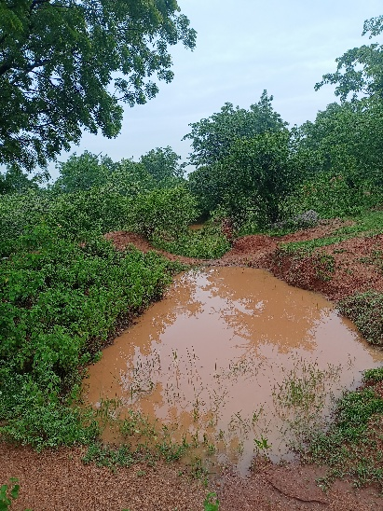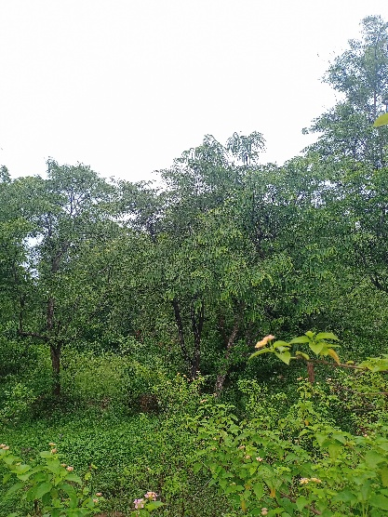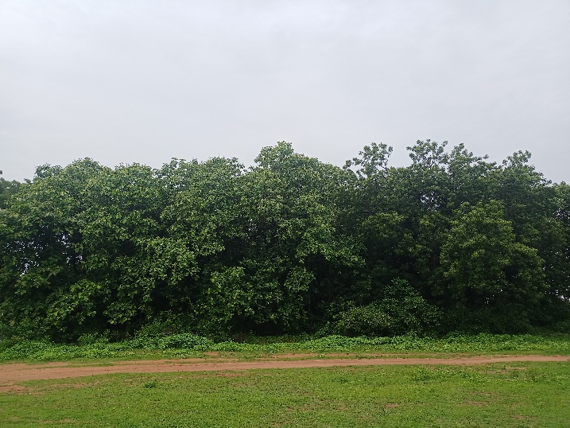
Fig 1. Water body Fig 2. Amla tree plantation Fig 3. Teakwood plantation

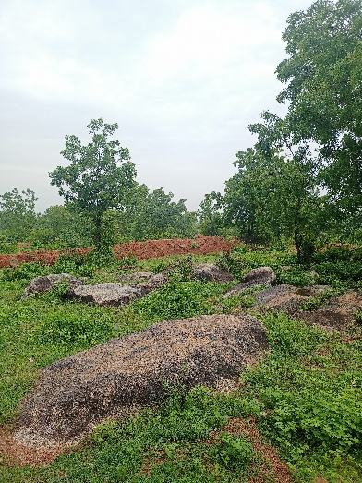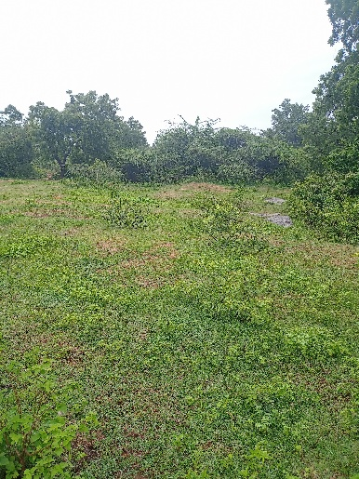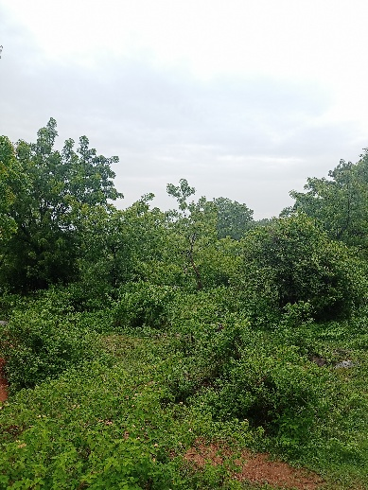
Fig 4. Natural Cliff with rocky area Fig 5. Grassland Fig 6. Forest area

3. results and discussion

A total of 41 bird species belonging to 12 orders, 27 families, and 36 genera were reported in the study area. Among all orders, Passeriformes (16 species) was the most abundant and dominant, followed by Coraciiformes (4 species); Gruiformes, Ciconiformes, Falconiformes, Columbiformes, and Cuculiformes (3 species each); Charadriformes (2 species); and Podicipediformes, Psittaformes, Stigiformes, and Apodiformes (1 species each).

With regard to the habitats utilised by bird species, nearly 11 species were found in agricultural fields, 10 species were observed in open grassland, 5 species were found in scrubland, 3 species were found in woodland and water bodies, and 1 species was found in each of the natural cliff and stony and rocky ground habitats.

Feeding guilds varied among species. Nearly 18 species were insectivores, 6 were omnivores, 6 were carnivores, 3 were granivores, 3 were granivore–insectivores, and 1 species each was classified as a nectarivore, granivore–frugivore, insectivore–carnivore, or frugivore–insectivore.

In terms of occurrence, 26 bird species were common, 8 were occasional, 4 were abundant, and 2 were rare.

Bird species such as Pavo cristatus, Venellus mulbaricus, Ammomanes phoenicura, Dicrurus caerulescens, Acredotheres tristis, Corvus splendens, Pycnonotus cafer, Argya malcolmi, Prinia socialis, Copsychus fulicata, and Leptocoma zeylonica were endemic to the Indian Subcontinent and were commonly found in this area.

According to the IUCN status, all birds were classified as Least Concern (LC) (International Union for Conservation of Nature [IUCN], 2026), which indicates a healthy and stable ecosystem for the growth, development, and breeding of bird species.

Many species utilised these habitats as breeding sites, including Pavo cristatus, Venellus mulbaricus, Francolinus pondicerianus, Eudynamys scolopacea, Copsychus fulicata, Ammomanes phoenicura, Pycnonotus cafer, Argya malcolmi, Orthotomus sutorius, and Ploceus philippinus.

Given the rich biodiversity and availability of abundant resources in the study area, almost all species are adapted to the local environment and have become resident and non-migratory. Lal Bahadur Shastri Mahavidyalaya campus is home to different bird species because they have access to abundant natural food and water resources. Therefore, the campus has a special attraction for ornithologists and bird lovers who wish to observe these species. Moreover, the campus has natural beauty and is rich in biodiversity. In addition to bird diversity, the college campus provides shelter for various insects, amphibians, reptiles, and mammals. Protecting this natural habitat from harmful anthropogenic activities is therefore an important responsibility. Thus, every individual has a responsibility to participate in wildlife protection activities to safeguard the environment.

The following is the checklist of bird species recorded from the Lal Bahadur Shastri Mahavidyalaya, Dharmabad campus:

Table 1. Checklist of bird species recorded from Lal Bahadur Shastri Mahavidyalaya, Dharmabad Campus, with their taxonomic classification, local names, IUCN status, habitat, feeding guild, occurrence, and endemicity.
Sr. No. | Order | Family | Scientific name | Authority | Common name | Local name  (Marathi) | IUCN status | Habitat | Feeding guild | Occurrence | Endemicity
1 | Apodiformes | Apodidae | Apus affinis | (J. E. Grey, 1830) | Little Swift | पाकोळी | LC | Natural cliffs | Insectivore | Common | Non-endemic
2 | Charadriformes | Charadriidae | Venellus indicus | (Linnaeus, 1758) | Red Wattled Lapwing | टिटवी | LC | Agricultural field | Insectivore | Common | Non-endemic
2 | Charadriformes |  | Venellus mulbaricus | (Linnaeus, 1758) | Yellow Wattled  Lapwing | माळटिटवी | LC | Grasslands | Insectivore | Occasional | Indian  Subcontinent
3 | Ciconiformes | Ardeidae | Ardeola grayii | (Sykes, 1832) | Indian Pond Heron | ढोकरी | LC | Water bodies | Carnivore | Abundant | Non-endemic
3 | Ciconiformes | Ardeidae | Bubulcus ibis | (Linnaeus, 1758) | Cattle Egret | गाय बगळा | LC | Grassland | Insectivore | Abundant | Non-endemic
3 | Ciconiformes | Ardeidae | Mesophoyx intermedia | (Wagler, 1829) | Median Egret | मध्यम बगळा | LC | Grassland | Carnivore | Abundant | Non-endemic
4 | Columbiformes | Columbidae | Columba livia | (J. F. Gmelin, 1789) | Blue Rock Pigeon | कबूतर | LC | Agricultural Field | Granivore | Common | Non-endemic
4 | Columbiformes | Columbidae | Streptopelia decaocto | (Frivaldszky, 1838) | Eurasian Collared  Dove | राण होला | LC | Agricultural Field | Granivore | Common | Non-endemic
4 | Columbiformes | Columbidae | Streptopelia senegalensis | (Linnaeus, 1766) | Laughing Dove | भोवरी | LC | Agricultural Field | Granivore | Common | Non-endemic
5 | Coraciiformes | Alcidinidae | Alcedo atthis | (Linnaeus, 1758) | Common Kingfisher | छोटा खंड्या | LC | Water bodies | Carnivore | Common | Non-endemic
5 | Coraciiformes | Alcidinidae | Halcyon smyrnensis | (Linnaeus, 1758) | White Breasted  Kingfisher | खंड्या | LC | Agricultural field | Insectivore-carnivore | Common | Non-endemic
5 | Coraciiformes | Coraciidae | Coracias benghalensis | (Linnaeus, 1758) | Indian Roller | नीलकंठ | LC | Agricultural field | Insectivore | Occasional | Non-endemic
5 | Coraciiformes | Meropidae | Merops orientalis | (Lathum, 1801) | Little Green Bee eater | रानपोपट | LC | Grasslands | Insectivore | Common | Non-endemic
6 | Cuculiformes | Cuculidae | Centropus sinensis | (Stephens, 1815) | Greater Coucal | भारद्वाज | LC | Lowland | Omnivore | Common | Non-endemic
6 | Cuculiformes | Cuculidae | Eudynamys scolopacea | (Linnaeus, 1758) | Common koel | कोकीळ | LC | Woodland | Frugivore | Common | Non-endemic
6 | Cuculiformes | Cuculidae | Hierococcyx varius | (Vahl, 1797) | Brain Fever Bird | पावशा | LC | Woodland | Insectivore | Common | Non-endemic
7 | Falconiformes | Accipitridae | Accipiter badius | (Gmelin, 1788) | Shikra | शिक्रा | LC | Dense forest | Carnivore | Rare | Non-endemic
7 | Falconiformes | Accipitridae | Malvus migrans | (Boddaert, 1783) | Black Kite | घार | LC | Open grassland | Carnivore | Common | Non-endemic
7 | Falconiformes | Falconidae | Falco perigrinus | (Tunstall, 1771) | Pregrine Falcon | बहिरी ससाणा | LC | High cliffs | Carnivore | Rare | Non-endemic
8 | Gruiformes | Phasinidae | Francolinus pondicerianus | (Linnaeus, 1766) | Gray Francolin | चित्तर | LC | Grassland | Omnivore | Common | Non-endemic
8 | Gruiformes | Phasinidae | Pavo cristatus | (Linnaeus, 1758) | Indian Peafowl | मोर | LC | Scrubland | Omnivore | Abundant | Indian Subcontinent
8 | Gruiformes | Rallidae | Amauromis phoenicurus | (Pennant,1769) | White breasted waterhen | लाजरी पाणकोंबडी | LC | Water bodies | Omnivore | Common | Non-endemic
9 | Passeriformes | Alaudidae | Ammomanes phoenicura | (Franklin, 1831) | Rufous tailed Finch lark | तांबूस-शेपटीचा चंडोल | LC | Stony and rocky ground | Granivore-insectivore | Common | Indian  Subcontinent
9 | Passeriformes | Corvidae | Corvus splendens | (Vieillot, 1817) | House Crow | कावळा | LC | Woodland | Omnivore | Common | Indian  Subcontinent
9 | Passeriformes | Dicruridae | Dicrurus caerulescens | (Linnaeus, 1758) | White Bellied Drongo | पांढरपोट्या कोतवाल | LC | Scrublands | Insectivore | Occasional | Indian  Subcontinent
9 | Passeriformes |  | Dicrurus macrocercus | (Vieillot, 1817) | Black Drongo | कोतवाल | LC | Agricultural field | Insectivore | Common | Non-endemic
9 | Passeriformes | Hirundinidae | Hirundo smithii | (Leach, 1818) | Wire tailed Swallow | तारवाली पाकोळी | LC | Grasslands | Insectivore | Occasional | Non-endemic
 |  | Leiothrichidae | Argya malcolmi | (Sykes, 1832) | Large Grey Babbler | सातभाई | LC | Scrublands | Insectivore | Common | Indian  Subcontinent
 |  | Muscicapidae | Copsychus fulicata | (Linnaeus, 1776) | Indian Robin | चीरक | LC | Grasslands | Insectivore | Common | Indian Subcontinent
 |  | Nactariniidae | Leptocoma zeylonica | (Sykes, 1832) | Purple- rumped Sunbird | शिंजीर | LC | Scrublands | Nectarivore | Common | Indian  Subcontinent
 |  | Passeridae | Passer domesticus | (Linnaeus, 1758) | House Sparrow | चिमणी | LC | Urban and rural places | Granivore-insectivore | Common | Non-endemic
 |  | Ploceidae | Ploceus philippinus | (Linnaeus, 1766) | Baya weaver | सुगरण पक्षी | LC | Grasslands | Granivore-insectivore | Common | Non-endemic
 |  | Pycnonotidae | Pycnonotus cafer | (Linnaeus, 1766) | Red-Vented Bulbul | लाल बुडाचा बुलबुल | LC | Agricultural field | Frugivore-insectivore | Common | Indian  Subcontinent
 |  | Sturnidae | Acredotheres tristis | (Linnaeus, 1766) | Common Myna | साळुंकी | LC | Agricultural field | Omnivore | Common | Indian  Subcontinent
 |  | Sylviinae | Prinia buchanani | (Blyth, 1844) | Rufus fronted  Prinia | तांबूस डोक्याचा वटवट्या | LC | Scrublands | Insectivore | Occasional | Non-endemic
 |  | Sylviinae | Prinia inornata | (Sykes, 1832) | Plain Prinia | साधा वटवट्या | LC | Grasslands | Insectivore | Occasional | Non-endemic
 |  | Sylviinae | Prinia socialis | (Sykes, 1832) | Ashy Wren Warble | राखी वटवट्या | LC | Agricultural field | Insectivore | Occasional | Indian  Subcontinent
10 | Podicipediformes | Podicipidae | Tachybaptus ruficollis | (Pallas, 1764) | Little Grebe | टिबुकली | LC | Water bodies | Insectivore | Common | Non-endemic
11 | Psittaciformes | Psittacidae | Psittacula krameri | (Scopoli, 1769) | Rose Ringed Parakeet | पोपट | LC | Agricultural Field | Granivore-frugivore | Occasional | Non-endemic
12 | Stigiformes | Strigidae | Athene brama | (Temminck, 1821) | Spotted Owlet | पिंगळा | LC | Agricultural field | Insectivore | Common | Non-endemic

Fig 7. Column graph representing number of bird species present in each order

Fig 8. Pie-chart representing Feeding guild of different bird species

4. Conclusion

The survey documents a diverse avian assemblage within the Lal Bahadur Shastri Mahavidyalaya campus and demonstrates the use of multiple campus habitats by bird species with different feeding guilds, occurrence patterns, migratory characteristics, endemicity, and conservation status. The presence of grasslands, scrublands, water bodies, plantations, forest patches, agricultural areas, and rocky habitats provides a range of feeding, foraging, nesting, and breeding opportunities. Passeriformes was reported as the dominant order, while insectivorous birds formed the principal feeding guild. Most species were recorded as common, and several species were identified as endemic to the Indian Subcontinent. The manuscript reports all recorded species as Least Concern. By compiling these ecological and taxonomic attributes in a single checklist, the study establishes a local baseline for the Lal Bahadur Shastri Mahavidyalaya campus. Continued observation of the campus avifauna may support future comparisons of species occurrence and habitat use and can contribute to awareness of the ecological value of maintaining diverse campus habitats.
Limitation

This study was confined to a single institutional campus and covered one annual survey cycle from August 2025 to July 2026. Bird observations were restricted to specified morning and evening periods and to the habitats surveyed within the campus. Consequently, the checklist reflects species detected under these spatial and temporal survey conditions. The findings are most appropriately interpreted as a site-specific baseline for the study period, and future repeated surveys across additional years and seasons would help assess temporal changes in species occurrence and habitat use.
Declaration of AI Use

This manuscript was prepared through the intellectual contributions of the author(s) to the study design, data analysis, interpretation of results, and scholarly content. Grammarly and ChatGPT were used solely to assist with grammatical refinement and reference formatting during manuscript revision. The author(s) accept full responsibility for the accuracy, integrity, and final content of the manuscript.

COMPETING INTERESTS DISCLAIMER:
Authors have declared that they have no known competing financial interests OR non-financial interests OR personal relationships that could have appeared to influence the work reported in this paper.

References
Ali, S. (1996). The book of Indian birds (12th ed.). Bombay Natural History Society. https://www.bnhs.org/publication
Ali, N., Chetry, V., Singha, P. K., & Boro, M. (2025). Preliminary checklist of avifauna from All India Institute of Medical Sciences, Guwahati, Assam, India. Journal of Threatened Taxa, 17(3), 26697–26703. https://doi.org/10.11609/jott.9390.17.3.26697-26703
Avibase. (2026, February 17). Avibase—Bird checklists of the world: Maharashtra. https://avibase.bsc-eoc.org/checklist.jsp?region=INswmh
Bagal, A., Thakur, R., & Kamble, A. (2025). The checklist of bird species around the “Tillari Conservation Reserve” in Maharashtra, India. Sustainability and Biodiversity Conservation, 4(1), 62–73. https://doi.org/10.5281/zenodo.14968108
Bharos, A. M. K., Vishwakarma, A., Bharos, A., & Naidu, R. (2023). Diversity and conservation status of avifauna in the Surguja region, Chhattisgarh, India. Journal of Threatened Taxa, 15(8), 23710–23728. https://doi.org/10.11609/jott.7314.15.8.23710-23728
BirdLife International. (2025, June 11). AviList unites the world’s bird species. https://www.birdlife.org/news/2025/06/11/avilist-unites-the-worlds-bird-species/
Chavan, S. P., Dudhmal, D., Hambarde, S., & Kulkarni, A. N. (2015). Birds from Godavari River Basin in Nanded District of Maharashtra State, India: Annotated status and new reports. International Journal of Current Research and Academic Review, 3(4), 328–351. https://www.ijcrar.com/vol-3-4/Shivaji%20P.%20Chavan,%20et%20al.pdf
Chetry, V., Saikia, P. K., Mahananda, P., Saikia, M. K., & Sarma, K. (2024). An annotated avian checklist of Bornadi Wildlife Sanctuary, Assam, India. Check List, 20(3), 665–691. https://doi.org/10.15560/20.3.665
Wagh, G., Borode, N., Kasambe, R., & Chaudhari, P. (2026). Bird diversity of Pench Tiger Reserve, Madhya Pradesh, India, with a significant record of the lesser adjutant stork (Leptoptilos javanicus Horsfield, 1821). International Journal of Fauna and Biological Studies, 13(3), 73–84. https://doi.org/10.22271/23940522.2026.v13.i3a.1217
Gohil, B., Kanabar, R., Trambadiya, K., Poriya, P., & Visavadia, M. (2024). An annotated checklist of avifauna from Ramdhari village, Bhavnagar, Gujarat, India. Munis Entomology & Zoology, 19(Suppl.), 3176–3189. https://www.munisentzool.org/Issue/publish/an-annotated-checklist-of-avifauna-from-ramdhari-village-bhavnagar-gujarat-india_14270
Hussain, A., Hussain, Z., & Ali, M. (2025). An avifaunal checklist of the Zanskar Region, Ladakh Himalaya, India. Journal of Threatened Taxa, 17(3), 26669–26679. https://doi.org/10.11609/jott.9288.17.3.26669-26679
Imran, S., Kumari, M., Mondal, T., Kumari, D., Senapaty, S. S., Azeez, P. A., Singha, H., & Singh, R. P. (2025). A comprehensive avifaunal checklist of Central University of South Bihar, Gaya, India. Discover Life, 55, Article 26. https://doi.org/10.1007/s11084-025-09707-3
International Union for Conservation of Nature. (2026). The IUCN Red List of Threatened Species (Version 2026-1). https://www.iucnredlist.org
Kumari, D., Srivastava, A., & Hore, U. (2024). Urban park characteristics defining avian community structure in Delhi, India. Ecological Frontiers, 44(6), 1149–1157. https://doi.org/10.1016/j.ecofro.2024.05.002
Mahanta, G., Panda, R. M., & Palita, S. K. (2025). Avian diversity and habitat preferences in scrubland ecosystems of the Eastern Ghats of southern Odisha, India. Land, 14(3), Article 511. https://doi.org/10.3390/land14030511
Malik, W. S., Quyoom, I., & Sheikh, T. (2023). Study on avian diversity in the forests of District Ramban, Jammu and Kashmir, India. Munis Entomology & Zoology, 18(2), 1723–1735. https://www.munisentzool.org/Issue/2023-vol-18-number-2-65
Marinov, M., Doroșencu, A.-C., Alexe, V., Bolboacă, L.-E., & Kiss, J. B. (2026). An updated checklist of bird species in the Danube Delta Biosphere Reserve (Romania). Scientific Annals of the Danube Delta Institute, 31, 1–14. https://doi.org/10.3897/saddi.31.161357
Martínez-Núñez, C., Martínez-Prentice, R., & García-Navas, V. (2023). Land-use diversity predicts regional bird taxonomic and functional richness worldwide. Nature Communications, 14, Article 1320. https://doi.org/10.1038/s41467-023-37027-5
Patel, Z., Patel, M., & Vyas, T. K. (2025). Diversity of avifauna in the campus of Navsari Agricultural University, Navsari, Gujarat, India. Asian Journal of Environment & Ecology, 24(1), 36–48. https://doi.org/10.9734/ajee/2025/v24i1649
Praveen, J., & Jayapal, R. (2025). Taxonomic updates to the checklists of birds of India and the South Asian region—2026. Indian BIRDS, 21(6), 165–166. https://indianbirds.in/south-asia/
Quyoom, I., Bhat, B. A., Malik, W. S., Sheikh, T., & Lone, A. N. (2024). An avifaunal checklist of the Bani Wildlife Sanctuary, Jammu & Kashmir, India. Journal of Threatened Taxa, 16(5), 25137–25146. https://doi.org/10.11609/jott.8894.16.5.25137-25146
Rao, G. B., Babu, S., Quadros, G., & Anoop, V. (2019). Bird diversity in the coastal talukas of Sindhudurg District, Maharashtra, India. Journal of Threatened Taxa, 11(9), 14166–14186. https://doi.org/10.11609/jott.4007.11.9.14166-14186
Rodrigues, K. M., Kumar, K. V., Hasyagar, V., Krishna, M. C. P., & Naik, D. (2023). A checklist of avifauna of Mangalore University, Karnataka, India. Journal of Threatened Taxa, 15(1), 22430–22439. https://doi.org/10.11609/jott.7503.15.1.22430-22439
Satose, V., Choursiya, V., Deulkar, R., & Menon, S. (2018). Avian fauna of Amboli Ghat, Sindhudurg District, Maharashtra State, India. Journal of Threatened Taxa, 10(13), 12805–12816. https://doi.org/10.11609/jott.2886.10.13.12805-12816
Sayyed, A. (2016). Faunal diversity of Satara District, Maharashtra, India. Journal of Threatened Taxa, 8(13), 9537–9561. https://doi.org/10.11609/jott.3162.8.13.9537-9561
Sharma, N., Rana, S. K., Raina, P., Amir, R., & Kichloo, M. A. (2018). An annotated checklist of the birds of upper Chenab catchment, Jammu & Kashmir, India. Journal of Threatened Taxa, 10(7), 11869–11894. https://doi.org/10.11609/jott.3464.10.7.11869-11894
Sureja, N., Radadia, H., Trivedi, B., Varagiya, D., & Gadhavi, M. (2022). The checklist of birds of Rajkot District, Gujarat, India with a note on probable local extinction. Journal of Threatened Taxa, 14(8), 21508–21528. https://doi.org/10.11609/jott.6458.14.8.21508-21528
Singh, J., Antil, S., Goyal, V., & Malik, V. (2020). Avifaunal diversity of Tilyar Lake, Rohtak, Haryana, India. Journal of Threatened Taxa, 12(8), 15909–15915. https://doi.org/10.11609/jott.4700.12.8.15909-15915
Talwar, T., Abraham, L. M., Rabha, B., & Rabha, M. (2024). An annotated checklist of the birds in Loharghat Forest Range, Assam, India. Journal of Threatened Taxa, 16(1), 24568–24583. https://doi.org/10.11609/jott.8638.16.1.24568-24583
Tijjani, A. A., & Garu, U. (2024). Bird diversity in Gangrar, Chittorgarh Rajasthan, India. Journal of Biology and Nature, 16(2), 101–111. https://doi.org/10.56557/joban/2024/v16i29005
Vinayak, D. C., & Mali, S. V. (2018). A checklist of bird communities in Tamhini Wildlife Sanctuary, the northern Western Ghats, Maharashtra, India. Journal of Threatened Taxa, 10(3), 11399–11409. https://doi.org/10.11609/jott.3377.10.3.11399-11409
Ali, Z. K., Wagh, G. A., & Ali, M. S. (2026). Assessment of wetland bird diversity and species richness at Chatri Lake, Amravati, Maharashtra. International Journal of Fauna and Biological Studies, 13(3), 28–37. https://doi.org/10.22271/23940522.2026.v13.i3a.1207
Ali, Z. K., Wagh, G., & Chaudhari, P. (2024). Diversity and abundance of wetland avifauna at Malkhed Lake of Amravati region, Maharashtra, India. International Journal of Fauna and Biological Studies, 11(4), 50–58. https://doi.org/10.22271/23940522.2024.v11.i4a.1038
Zala, U. J., Raval, J. V., Nimavat, R. S., & Hun, N. K. (2022). A study of avifauna from Girnar Wildlife Sanctuary, Junagadh, Gujarat, India. Journal of Animal Diversity, 4(4), 74–90. https://doi.org/10.61186/JAD.4.4.74

