Original Research Article
Evaluation of the Microbiological Quality of Water in Different Tilapia Rearing Structures in Côte d’Ivoire

Abstract
The intensification of tilapia aquaculture in Côte d’Ivoire increases the importance of monitoring the microbiological quality of rearing water. This study evaluated water used to rear Nile tilapia (Oreochromis niloticus) in three rearing structures: earthen ponds, concrete tanks and aquariums. Water samples were analysed using culture-based methods for bacterial indicators, potentially pathogenic bacteria and microfungal groups. The detected microorganisms included total coliforms, intestinal enterococci, Aeromonas spp., Aeromonas hydrophila, Salmonella spp., Escherichia coli, Staphylococcus aureus, Saprolegnia spp., Aspergillus spp., unidentified yeasts and unidentified moulds. Microbial loads varied among the rearing structures. Tank water showed the highest bacterial contamination, with Salmonella spp. reaching 14,000 ± 350 CFU/100 mL, and also recorded the highest total coliform, Staphylococcus aureus, unidentified yeast and unidentified mould loads. Pond water showed intermediate bacterial contamination and the highest Saprolegnia spp. load (200 ± 10 CFU/100 mL). Aquarium water showed the lowest detection of the investigated microorganisms. Total coliforms were detected at 500 ± 40 CFU/100 mL, whereas the other investigated bacterial and microfungal groups were recorded at 0 ± 0 CFU/100 mL. These findings indicate distinct microbial profiles among the three rearing structures. Regular sanitation, adequate water renewal and systematic microbiological monitoring are recommended to support fish health and strengthen biosafety in tilapia production systems.
Keywords: Aquaculture; microbiological quality; Oreochromis niloticus; pond, tank.

1. Introduction
Aquaculture is increasingly recognised as a key sector for food security and income generation in sub-Saharan Africa. In Côte d’Ivoire, fish is the main source of animal protein. However, national production remains far below domestic demand. According to the Food and Agriculture Organization of the United Nations (FAO, 2025), Côte d’Ivoire produced about 92,000 tonnes of fish in 2023, whereas national consumption reached about 534,000 tonnes. This gap explains the growing interest in aquaculture development. Among farmed species, Nile tilapia (Oreochromis niloticus) occupies a central place because of its rapid growth, hardiness, and high market acceptance (Reyes, 2024; FAO, 2025).
The success of tilapia farming depends strongly on water quality. In aquaculture systems, water is not only a physical medium. It is also a biological environment that directly affects fish growth, health, and survival. Most farm monitoring programmes focus on physico-chemical parameters such as temperature, pH, and dissolved oxygen. However, microbiological quality is equally important. Culture water may contain indicator bacteria, opportunistic pathogens, and other microorganisms of sanitary importance. Under intensive or poorly managed conditions, microbial proliferation may increase fish stress and disease risk. Recent freshwater evidence likewise identifies dissolved oxygen, pH, electrical conductivity, and related water-quality variables as relevant to fish physiological performance and aquaculture management (Singh et al., 2026). Fish-pond effluent studies have also assessed bacterial indicators, including total coliforms and Escherichia coli, together with physicochemical water parameters, supporting integrated microbiological and water-quality assessment in culture systems (Odesiri-Eruteyan & Urhibo, 2022).
Recent studies have highlighted this issue in tilapia farming. In Côte d’Ivoire, Kra et al. (2026) reported the presence of cultivable opportunistic bacteria in both rearing water and O. niloticus from semi-intensive systems. Their study showed that water can act as an important reservoir of microorganisms of sanitary concern. These findings support the need for regular microbiological monitoring in local aquaculture systems. Recent analysis of tilapia and associated water samples has further documented diverse bacterial taxa, including zoonotic and antimicrobial-resistant isolates, reinforcing the value of microbiological surveillance in aquaculture environments (Mursalim et al., 2026).
The type of rearing structure may also influence microbial water quality. Ponds, tanks, and aquariums differ in water renewal, sediment interaction, organic matter accumulation, and management intensity. Delamare-Deboutteville et al. (2025) showed that pond- and tank-reared tilapia harbour different microbial communities, confirming that the rearing environment shapes microbiological dynamics. Similarly, studies on managed aquarium systems have shown that these environments remain biologically dynamic and may also present sanitary risks if maintenance is inadequate (Vanderzwalmen et al., 2022). Temporal monitoring in red tilapia ponds has shown that bacterial community composition can vary with water-quality conditions during the culture period, illustrating the dynamic nature of pond microbiology (Liu et al., 2025). Experimental work in red tilapia biofloc systems also indicates that water-management conditions can influence both water quality and pathogenic bacterial loads (Abdel-Rahim et al., 2024).
In Côte d’Ivoire, comparative information on the microbiological quality of water in different tilapia rearing structures remains limited. Yet such information is essential for improving biosecurity and health management. Therefore, the present study aimed to assess the microbiological quality of water in ponds, tanks, and aquariums used for Oreochromis niloticus culture in Côte d’Ivoire.

2. Materials and Methods

2.1 Study Area
The study was conducted at SRPAC, located in the Kongodékro classified forest of Bouaké, Côte d’Ivoire, 3 km from the Bouaké-Abidjan highway (Assémien et al., 2025). The station encompasses 80 earthen ponds, 50 concrete tanks and an aquarium facility (Figure 1). Ponds and tanks are supplied by surface water from the Kan dam, while aquariums use borehole water (Assémien et al., 2025). The region has a tropical savanna climate with a rainy season from April to October (Konan, 2017).
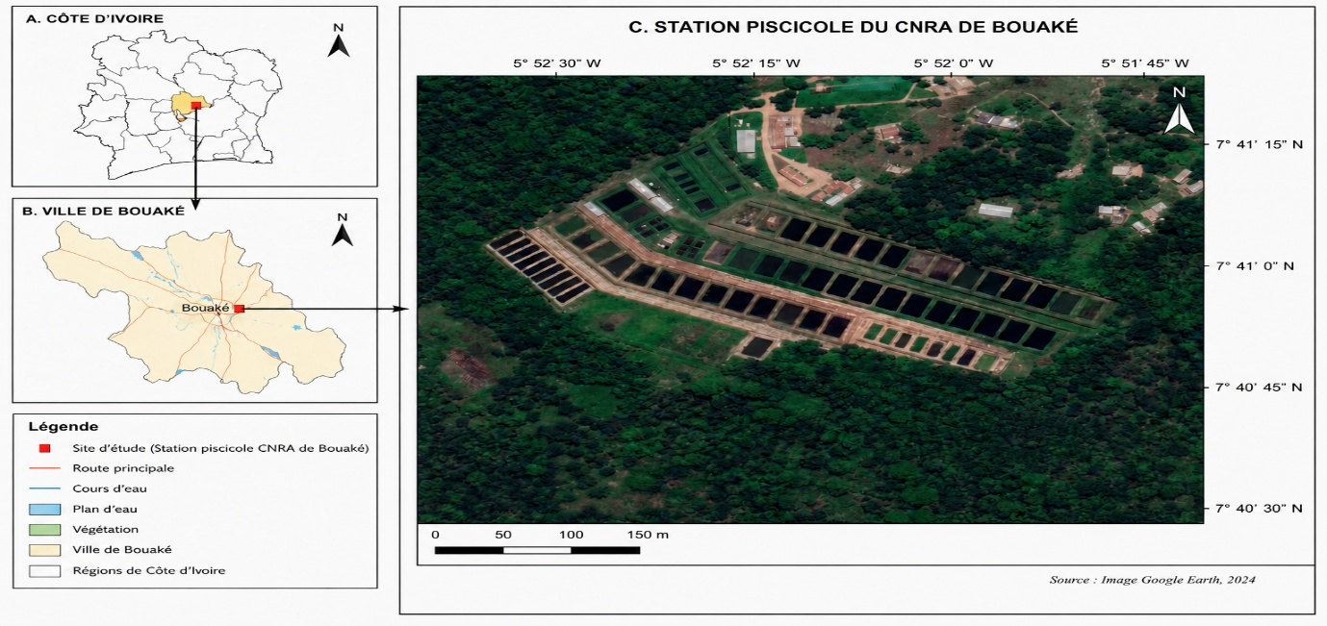
Figure 1: Localization of Study area (SRPAC).

2.2 Water Sampling
Water samples were collected from all three rearing structures (pond, tank and aquarium) in March 2026. The fish had a similar mean body weight of 45 ± 3.5 g and received the same ration. Ponds, tanks and aquariums were stocked at 3, 15 and 100 fish/m², respectively. The ponds were stocked at a density of 3 fish/m². The tanks were stocked at 15 fish/m². The aquariums were stocked at 100 fish/m². All rearing structures were supplied with borehole water and water from Lake Kan. Samples were collected in sterile 500-mL polypropylene bottles. Each bottle was sealed and labelled with the sampling date, site and rearing structure. The samples were immediately placed in an insulated cooler maintained at 1–8 °C and transported to the Central Soils, Water and Plants Laboratory for analysis.

2.3 Microbiological Analysis
Bacteriological analysis targeted total coliforms, Escherichia coli (E. coli), intestinal enterococci, Aeromonas spp., Salmonella spp. and Staphylococcus aureus. Total coliforms and E. coli were enumerated by membrane filtration on RAPID’E. coli 2 agar according to NF EN ISO 9308-1:2014 (International Organization for Standardization [ISO], 2014). Intestinal enterococci were detected and enumerated by membrane filtration according to NF ISO 7899-2:2000 (ISO, 2000). Salmonella spp. were detected according to ISO 19250:2010 (ISO, 2010). Aeromonas spp. were isolated and enumerated by membrane filtration using selective ampicillin-dextrin agar with vancomycin, following EPA Method 1605 (U.S. Environmental Protection Agency [EPA], 2001). Presumptive Aeromonas hydrophila (A. hydrophila) colonies were purified and biochemically confirmed by Gram staining, motility, oxidase and catalase reactions, indole production, citrate utilisation, glucose fermentation, TSI profile, and API 20E characterisation. Isolates showing a compatible biochemical profile were identified as A. hydrophila (Janda & Abbott, 2010). Presumptive Staphylococcus aureus colonies grown on Baird-Parker agar were confirmed by Gram staining, catalase, coagulase, and DNase tests. Gram-positive cocci in clusters showing positive catalase, coagulase, and DNase reactions were identified as S. aureus (ISO, 2021).

Yeasts and moulds were enumerated by membrane filtration. Water samples were filtered through sterile 0.45 µm membranes, which were placed on Sabouraud dextrose agar supplemented with chloramphenicol and incubated at 25 ± 2 °C for 5 to 7 days. Results were expressed as colony-forming units per 100 millilitres (CFU/100 mL). Colonies with morphological characteristics of Aspergillus were purified and identified microscopically after lactophenol cotton blue staining. For Saprolegnia detection, a hemp-seed baiting technique was used. Colonised baits were transferred onto selective agar and examined for typical coenocytic hyphae. Because molecular confirmation was not performed, isolates were reported as Aspergillus spp. and Saprolegnia spp. In the absence of molecular confirmation, isolates were reported as Aspergillus spp. and Saprolegnia spp. (Eszterbauer et al., 2020).

Microbial load was calculated using:
Ml = Nc × d / V
where Ml = microbial load (CFU/100 ml); Nc = number of colony-forming units; d = dilution factor; V = volume of inoculated water (ml).

2.4 Statistical Analysis
Data were entered in Microsoft Excel and analysed using R software (version 4.5.1). Comparisons between structures were performed using non-parametric tests. Results were considered significant at p < 0.05. Spearman rank correlations were calculated for 15 quantitative variables using n = 9 rows. Statistical significance was assessed at α = 0.05.

3. Results

3.1 Physicochemical parameters of water according to rearing structures
Physicochemical parameters of water from the three rearing structures presented in Table 1 showed that there were no significant differences in dissolved oxygen, temperature and pH. However, conductivity differed significantly among the rearing structures. Mean dissolved oxygen values varied from 4.18 ± 1.62 to 5.53 ± 2.08 mg/L. The highest mean value was recorded in tank water, whereas pond water showed the lowest value. Mean pH values were 7.80 ± 0.21, 7.94 ± 0.19 and 6.98 ± 0.08 in pond, tank and aquarium water, respectively. Temperatures ranged from 25.73 ± 0.33 in aquarium water to 26.38 ± 0.87 °C in tank water. The highest mean value was recorded in tank water, whereas aquarium water showed the lowest temperature value. Regarding conductivity, pond and tank water showed similar values of 359.3 ± 4.0 and 363.7 ± 5.1 µS/cm, respectively. Aquarium water showed a significantly lower conductivity value of 140.0 ± 15.0 µS/cm.

Table 1. Physicochemical parameters of water according to rearing structures
Parameters | Pond water | Tank water | Aquarium water
Dissolved oxygen (mg/L) | 4.18 ± 1.62 | 5.53 ± 2.08 | 4.95 ± 1.52
pH | 7.80 ± 0.21 | 7.94 ± 0.19 | 6.98 ± 0.08
Temperature (°C) | 26.10 ± 0.77 | 26.38 ± 0.87 | 25.73 ± 0.33
Conductivity (µS/cm) | 359.3 ± 4.0ª | 363.7 ± 5.1ª | 140.0 ± 15.0^{b}
Values are means of three replicates ± standard deviation. Within the same row, values bearing different letters are significantly different (ANOVA, P < 0.05).

3.2. Diversity of Pathogenic Microorganisms
Microbiological analyses of the three tilapia rearing structures identified bacterial and microfungal groups of sanitary importance. The bacteria detected were total coliforms, intestinal enterococci, Aeromonas spp., Salmonella spp., Aeromonas hydrophila, Escherichia coli and Staphylococcus aureus. Microfungal groups included Saprolegnia spp., Aspergillus spp., yeasts (unidentified) and moulds (unidentified).

3.3. Bacterial Loads by Rearing Structure
Bacterial loads varied according to the rearing structure (Table 2). The highest value was recorded for Salmonella spp. in tank water (14 000 ± 350 CFU/100 ml), whereas the corresponding pond-water value was 400 ± 33 CFU/100 ml and the aquarium-water value was 0 ± 0 CFU/100 ml. Total coliform loads were 560 ± 45, 860 ± 105 and 500 ± 40 CFU/100 ml in pond, tank and aquarium water, respectively.
Aeromonas hydrophila was detected at 510 ± 33 CFU/100 ml in pond water, 500 ± 67 CFU/100 ml in tank water and 0 ± 0 CFU/100 ml in aquarium water. Escherichia coli loads were 100 ± 52, 150 ± 31 and 0 ± 0 CFU/100 ml in pond, tank and aquarium water, respectively. Staphylococcus aureus loads were 450 ± 19, 600 ± 37 and 0 ± 0 CFU/100 ml in pond, tank and aquarium water, respectively.
Intestinal enterococci were measured at 150 ± 27, 100 ± 15 and 0 ± 0 CFU/100 ml in pond, tank and aquarium water, respectively. Aeromonas spp. were measured at 430 ± 41, 500 ± 30 and 0 ± 0 CFU/100 ml, respectively.

Table 2. Bacterial loads in water according to rearing structures
Microorganism | Pond water (CFU/100 ml) | Tank water (CFU/100 ml) | Aquarium water (CFU/100 ml)
Total coliforms | 560±45ᵃ | 860±105ᵇ | 500±40ᵃ
Aeromonas hydrophila | 510±33ᵃ | 500±67ᵃ | 0±0ᵇ
Escherichia coli | 100±52ᵃ | 150±31ᵃ | 0±0ᵇ
Staphylococcus aureus | 450±19ᵃ | 600±37ᵃ | 0±0ᵇ
Intestinal enterococci | 150±27ᵃ | 100±15ᵃ | 0±0ᵇ
Unidentified Aeromonas spp. | 430±41ᵃ | 500±30ᵃ | 0±0ᵇ
Salmonella spp. | 400±33ᵃ | 14 000±350ᵇ | 0±0ᶜ
Values are means of three replicates ± standard deviation. Within the same row, values bearing different letters are significantly different (ANOVA, P < 0.05).

3.4. Microfungal loads
Microfungal loads presented in Table 3 differed among the rearing structures. Yeasts (unidentified) showed the highest load in tank water (400 ± 100 CFU/100 ml), followed by moulds (unidentified) (350 ± 100 CFU/100 ml). Their corresponding pond-water values were 100 ± 0 and 100 ± 0 CFU/100 ml, respectively, whereas both groups were recorded as 0 ± 0 CFU/100 ml in aquarium water. Saprolegnia spp. loads were 200 ± 10 CFU/100 ml in pond water, 150 ± 20 CFU/100 ml in tank water and 0 ± 0 CFU/100 ml in aquarium water. Aspergillus spp. loads were 10 ± 0 CFU/100 ml in pond water, 25 ± 0 CFU/100 ml in tank water and 0 ± 0 CFU/100 ml in aquarium water.

Table 3. Microfungal loads in water according to rearing structures
Microfungal group | Pond water (CFU/100 ml) | Tank water (CFU/100 ml) | Aquarium water (CFU/100 ml)
Saprolegnia spp. | 200±10ᵃ | 150±20ᵇ | 0±0ᶜ
Aspergillus spp. | 10±0ᵃ | 25±0ᵇ | 0±0ᶜ
Yeasts (unidentified) | 100±0ᵃ | 400±100ᵇ | 0±0ᶜ
Moulds (unidentified) | 100±0ᵃ | 350±100ᵇ | 0±0ᶜ
Values are means of three replicates ± standard deviation. Within the same row, values bearing different letters are significantly different (ANOVA, P < 0.05).

3.5. Correlation rank between parameters
Spearman analysis identified predominantly positive monotonic associations among the physicochemical, bacterial and microfungal variables (Figure 2). The strongest relationships included pH–conductivity (ρ = 0.983, p = 0.000002), Staphylococcus aureus - Salmonella spp. (ρ = 1.000, p < 0.001), intestinal enterococci - Saprolegnia spp. (ρ = 1.000, p < 0.001) and unidentified yeasts - unidentified moulds (ρ = 1.000, p < 0.001). These associations should be interpreted as exploratory because n = 9 rows were analysed and the data may reflect differences among rearing structures. No causal inference can be drawn from the correlations. Dissolved oxygen was strongly and positively associated with temperature. Positive monotonic relationships were also observed between temperature and pH, temperature and conductivity, and pH and conductivity. pH showed strong positive monotonic associations with total coliforms, Aeromonas hydrophila, Escherichia coli, Staphylococcus aureus, Aeromonas spp. and Salmonella spp. Conductivity was similarly associated with total coliforms, A. hydrophila, E. coli, S. aureus, Aeromonas spp. and Salmonella spp. The strongest relationships included Staphylococcus aureus with Aeromonas spp. and Salmonella spp., E. coli with Aeromonas spp., and Aeromonas spp. with Salmonella spp. Total coliforms were also strongly associated with E. coli, S. aureus, unidentified Aeromonas spp. and Salmonella spp. pH was positively correlated with Saprolegnia spp., Aspergillus spp., unidentified yeasts and unidentified moulds. Conductivity was associated with Saprolegnia spp., Aspergillus spp., unidentified yeasts and unidentified moulds.

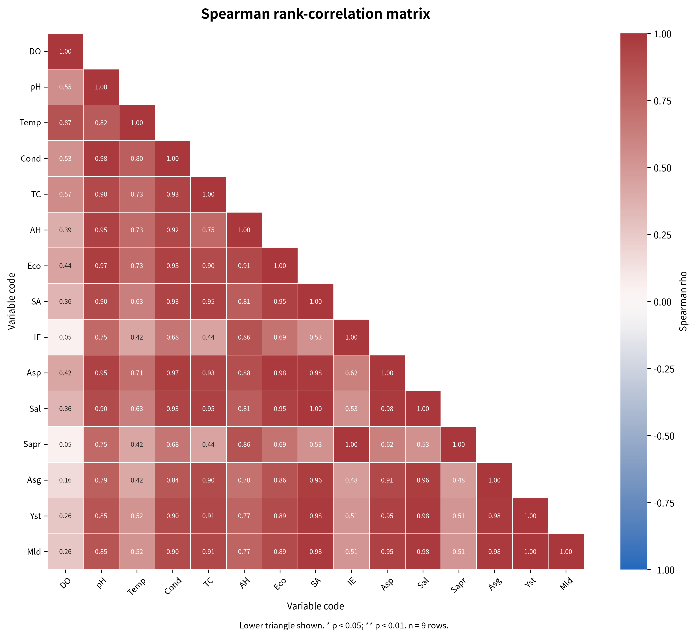
Figure 2. Spearman rho heatmap with variable
Dissolved oxygen (DO), pH (pH), Temperature (Temp), Conductivity (Cond), Total coliforms (TC), Aeromonas hydrophila (AH), Escherichia coli (Eco), Staphylococcus aureus (SA), Intestinal enterococci (IE), Unidentfied Aeromonas spp. (Asp), Salmonella spp. (Sal), Saprolegnia spp. (Sapr), Aspergillus spp. (Asg), Unidentified yeasts (Yst), Unidentified moulds (Mld)

4. Discussion
Overall, the observed dissolved oxygen, pH and temperature values were within the ranges considered suitable for Nile tilapia growth and culture, as reported by Makori et al. (2017). No significant differences were observed for dissolved oxygen, pH or temperature. This similarity is likely related to the fact that all structures were supplied from the same water source, which would provide a broadly similar initial chemical composition. In contrast, conductivity differed significantly among the rearing structures. Because all structures received water from the same source, this difference was unlikely to result solely from the initial water supply. It may instead reflect differences in water substrate interactions, contact with pond sediment, tank-wall materials, organic matter accumulation, mineral release, water volume or water-renewal conditions. The similar conductivity values observed in pond and tank water suggest comparable ionic enrichment, whereas the lower value in aquarium water may indicate lower mineral exchange or more controlled water management.
The three structures held fish of similar mean weight and received the same feeding ration. They were supplied with the same borehole and Lake Kan water. Differences in microbial loads may therefore reflect structure-specific conditions, including stocking density, water retention, sediment contact, biofilm development and organic matter accumulation. Tank water showed the highest bacterial contamination. Stocking density alone cannot explain this pattern, since tanks contained 15 fish/m², whereas aquariums contained 100 fish/m² but showed no detectable Aeromonas, Escherichia coli, Staphylococcus aureus or Salmonella spp. Water management and system design may therefore have influenced microbial accumulation more strongly than density alone. Aquarium water showed the lowest overall microbial detection despite its higher stocking density. This pattern suggests that controlled water handling, reduced contact with sediments and more effective water renewal may have limited microbial persistence. Water-quality management, including regular cleaning, organic-matter control, adequate water renewal and microbiological monitoring, is essential for reducing disease risks in tilapia aquaculture (Kelany et al., 2024). The influence of system design and environmental conditions on microbial communities and fish health has also been highlighted in tilapia aquaculture (Debnath et al., 2023). Pond water had the highest Saprolegnia spp. load, whereas tank water had the highest yeast and mould loads. These patterns may reflect differences in organic substrates, sediment contact and biofilm development. Saprolegnia is an important oomycete pathogen in aquaculture, particularly under stressful environmental conditions (Lindholm-Lehto & Pylkkö, 2024).
The Spearman analysis identified predominantly positive monotonic associations among the physicochemical parameters and the bacterial and microfungal variables. These associations indicate that the physicochemical variables tended to vary in the same order across the nine rows. Such co-variation is compatible with the recognised importance of temperature, dissolved oxygen, pH and conductivity in tilapia culture, where non-optimal water conditions can affect fish stress and susceptibility to disease (Kelany et al., 2024; Mukwabi et al., 2019). These results suggest that higher pH and conductivity values occurred in the same observations as higher bacterial counts. Studies of farmed Nile tilapia have similarly treated temperature, pH, dissolved oxygen and electrical conductivity as relevant environmental variables when assessing bacterial pathogens and fish health (Mukwabi et al., 2019; Kelany et al., 2024). The bacterial variables formed a coherent positive association pattern. This is consistent with the interpretation of several organisms as indicators of common contamination or common exposure pathways rather than as independent events. The co-occurrence of Aeromonas and other bacterial groups may reflect shared organic enrichment or water-management conditions. Research on tilapia aquaculture has emphasised the interaction between environmental conditions, potential pathogens and fish health, particularly for Aeromonas-related disease (Mukwabi et al., 2019; Abdella et al., 2024). The microfungal variables were positively associated with several physicochemical and bacterial indicators. Among microbial groups, the association between intestinal enterococci and Saprolegnia spp. was perfect in the present dataset (ρ = 1.000000, p < 0.001), as was the association between unidentified yeasts and unidentified moulds (ρ = 1.000000, p < 0.001). The observed associations are therefore useful for generating hypotheses about shared environmental conditions, but they require confirmation with independent samples and taxonomically resolved fungal measurements.

5. Conclusion
This study evaluated the microbiological quality of water used to rear Oreochromis niloticus in earthen ponds, concrete tanks and aquariums in Côte d’Ivoire. The rearing water contained bacterial and microfungal groups of sanitary importance, and their loads differed among the investigated structures. Concrete tank water showed the highest overall bacterial and microfungal loads, particularly for Salmonella spp., unidentified yeasts and unidentified moulds, while pond water had the highest Saprolegnia spp. load. Aquarium water showed the lowest detection of most investigated microorganisms, although total coliforms were detected. The observed differences are consistent with structure-specific variation in water management, sediment contact, biofilm development and organic-matter accumulation, but the exploratory correlations do not establish causality. The findings support regular cleaning and disinfection, adequate water renewal, control of organic matter and systematic microbiological monitoring in tilapia production systems. Further investigations with broader sampling and molecular confirmation would help clarify the microbial patterns observed across rearing structures.

6. Limitations

The study was conducted at a single research station, and the correlation analysis was based on nine rows of observations. Microbial enumeration relied on culture-based methods, while several isolates were not confirmed molecularly. Accordingly, the findings primarily characterise the cultivable microorganisms detected under the investigated conditions and should be generalised cautiously to other tilapia production settings. The exploratory correlations may also reflect differences among rearing structures and require confirmation using broader, independent sampling.

Declaration of AI Use

This manuscript was prepared through the intellectual contributions of the author(s) to the study design, data analysis, interpretation of results, and scholarly content. Grammarly and ChatGPT were used solely to assist with grammatical refinement and reference formatting during manuscript revision. The author(s) accept full responsibility for the accuracy, integrity, and final content of the manuscript.

COMPETING INTERESTS DISCLAIMER:
Authors have declared that they have no known competing financial interests OR non-financial interests OR personal relationships that could have appeared to influence the work reported in this paper.

References
Abdella, B., Shokrak, N. M., Abozahra, N. A., Elshamy, Y. M., Kadira, H. I., & Mohamed, R. A. (2024). Aquaculture and Aeromonas hydrophila: A complex interplay of environmental factors and virulence. Aquaculture International, 32, 7671–7681. https://doi.org/10.1007/s10499-024-01535-y
Abdel-Rahim, M. M., Elhetawy, A. I. G., Shawky, W. A., El-Zaeem, S. Y., & El-Dahhar, A. A. (2024). Enhancing Florida red tilapia aquaculture: Biofloc optimization improves water quality, pathogen bacterial control, fish health, immune response, and organ histopathology across varied groundwater salinities. Veterinary Research Communications, 48, 2989–3006. https://doi.org/10.1007/s11259-024-10433-w
Assémien, O. E. D., Anvo, M. P. M., Ani, A. P., & Sotti, K. S. (2025). Reproductive performance of Nile tilapia Oreochromis niloticus, Linnaeus, 1758 Akosombo strain in a controlled environment in Côte d’Ivoire. World Journal of Advanced Research and Reviews, 28(2), 912–921. https://doi.org/10.30574/wjarr.2025.28.2.3780
Debnath, S. C., McMurtrie, J., Temperton, B., Delamare-Deboutteville, J., Mohan, C. V., & Tyler, C. R. (2023). Tilapia aquaculture, emerging diseases, and the roles of the skin microbiomes in health and disease. Aquaculture International, 31(5), 2945–2976. https://doi.org/10.1007/s10499-023-01117-4
Delamare-Deboutteville, J., Mahmuddin, M., Gan, H. M., Rodde, C., Khor, L., Verner-Jeffreys, D., Mohan, C. V., & Benzie, J. A. H. (2025). Microbiome dynamics in tank- and pond-reared Genetically Improved Farmed Tilapia (GIFT). Frontiers in Microbiomes, 4, 1567816. https://doi.org/10.3389/frmbi.2025.1567816
Eszterbauer, E., Hardy, T., Rónai, Z., Sipos, D., & Zsigmond, G. (2020). Cryopreservation of three Saprolegnia species (Oomycota): Preliminary evidence for the long-term archiving of water mould species. Fungal Biology, 124(7), 682–687. https://doi.org/10.1016/j.funbio.2020.04.005
Food and Agriculture Organization of the United Nations. (2025, May 15). Meeting demand for tasty tilapia in Côte d’Ivoire. https://www.fao.org/newsroom/story/meeting-demand-for-tasty-tilapia-in-c%C3%B4te-divoire/en
International Organization for Standardization. (2000). ISO 7899-2:2000 Water quality—Detection and enumeration of intestinal enterococci—Part 2: Membrane filtration method. https://www.iso.org/standard/14854.html
International Organization for Standardization. (2010). ISO 19250:2010 Water quality—Detection of Salmonella spp. https://www.iso.org/standard/43448.html
International Organization for Standardization. (2014). ISO 9308-1:2014 Water quality—Enumeration of Escherichia coli and coliform bacteria—Part 1: Membrane filtration method for waters with low bacterial background flora. https://www.iso.org/standard/55832.html
International Organization for Standardization. (2021). ISO 6888-1:2021 Microbiology of the food chain—Horizontal method for the enumeration of coagulase-positive staphylococci (Staphylococcus aureus and other species)—Part 1: Method using Baird–Parker agar medium. https://www.iso.org/standard/76672.html
Janda, J. M., & Abbott, S. L. (2010). The genus Aeromonas: Taxonomy, pathogenicity, and infection. Clinical Microbiology Reviews, 23(1), 35–73. https://doi.org/10.1128/CMR.00039-09
Kelany, N. F., Abdel-Mohsein, H. S., Kotb, S. A. H., & Ismail, A. E.-M. A. (2024). Significant impact of physicochemical water parameters in tilapia aquaculture. Journal of Advanced Veterinary Research, 14(6), 1060–1064. https://advetresearch.com/index.php/AVR/article/view/1926
Konan, J.-M. K. A. (2017). Compétition entre bâti et agriculture dans la conquête des bas-fonds de la ville de Bouaké : Le savoir-faire ou les actions stratégiques des citadins-agriculteurs pour préserver les espaces agricoles. VertigO, Hors-série 28. https://doi.org/10.4000/vertigo.18302
Kra, O. K., Konan, F. K., Diane, M. K., Cisse, M., Ouattara, A., & Guessennd, N. K. (2026). Cultivable opportunistic bacterial diversity and seasonal patterns in water and tilapia (Oreochromis niloticus) from semi-intensive aquaculture systems in Côte d’Ivoire: Case of Anyama and Aboisso. Journal of Applied & Environmental Microbiology, 14(1), 24–29. https://doi.org/10.12691/jaem-14-1-4
Lindholm-Lehto, P. C., & Pylkkö, P. (2024). Saprolegniosis in aquaculture and how to control it? Aquaculture, Fish and Fisheries, 4, e200. https://doi.org/10.1002/aff2.200
Liu, Z., Li, J., Luo, L., Yu, Y., Yan, J., Sun, C., Miao, X., & Li, W. (2025). Regime shifts in microbial and water quality dynamics in red tilapia ponds. Microorganisms, 13(7), 1553. https://doi.org/10.3390/microorganisms13071553
Makori, A. J., Abuom, P. O., Kapiyo, R., Anyona, D. N., & Dida, G. O. (2017). Effects of water physico-chemical parameters on tilapia (Oreochromis niloticus) growth in earthen ponds in Teso North Sub-County, Busia County. Fisheries and Aquatic Sciences, 20, Article 30. https://doi.org/10.1186/s41240-017-0075-7
Mukwabi, D. M., Okemo, P. O., Otieno, S. O., Oduor, R. O., & Macharia, C. M. (2019). Temperature and pH influence on bacterial pathogens infecting farmed Nile tilapia in aquaculture systems in Bungoma County, Kenya. International Journal of Fisheries and Aquatic Studies, 7(1), 190–197. https://www.fisheriesjournal.com/archives/?ArticleId=1807&issue=1&part=C&vol=7&year=2019
Mursalim, M. F., Raharjo, H. M., Kholilulloh, Z. A., Azis, H. Y., Nurdin, M. A., Mar’ah, N., Hartanti, A. P. N., Amalia, U., Risal, M. J. S., Mabrok, M., & Aljasir, S. F. (2026). Tilapia aquaculture as a reservoir of antimicrobial resistance and zoonotic bacteria: Evidence from Makassar, Indonesia. Polish Journal of Veterinary Sciences, 29(2), 179–189. https://doi.org/10.24425/pjvs.2026.1261
Odesiri-Eruteyan, E., & Urhibo, V. (2022). Bacteriological and physicochemical analysis of fish pond effluents in Warri and its environs, Nigeria. Journal of Advances in Microbiology, 22(8), 92–100. https://doi.org/10.9734/jamb/2022/v22i830493
Reyes, A. T. (2024). Comparison of Fulton’s condition factor of Nile tilapia (Oreochromis niloticus L.) reared in ponds in Lubao, Pampanga, Philippines during the dry season. Uttar Pradesh Journal of Zoology, 45(15), 406–416. https://doi.org/10.56557/upjoz/2024/v45i154257
Singh, A., Kumar, K., Yadav, V. K., & Singh, J. (2026). The effect of freshwater quality parameters on the physiological processes of fish. Asian Research Journal of Current Science, 8(1), 53–62. https://doi.org/10.56557/arjocs/2026/v8i1164
U.S. Environmental Protection Agency, Office of Water. (2001). Method 1605: Aeromonas in finished water by membrane filtration using ampicillin-dextrin agar with vancomycin (ADA-V) (EPA/821/R-01/034). https://nepis.epa.gov/Exe/ZyPDF.cgi?Dockey=P1002D47.PDF
Vanderzwalmen, M., Sánchez Lacalle, D., Tamilselvan, P., McNeill, J., Delieuvin, D., Behlouli, K., Hursthouse, A., McLellan, I., Alexander, M. E., Henriquez, F. L., Snellgrove, D., & Sloman, K. A. (2022). The effect of substrate on water quality in ornamental fish tanks. Animals, 12(19), 2679. https://doi.org/10.3390/ani12192679

