A Preliminary Assessment of Orthoptera Diversity in Agricultural Fields and Field Margins of Bazpur, Udham Singh Nagar, Uttarakhand, India

.
ABSTRACT

Orthopteran insects, including grasshoppers, crickets, and katydids, are important components of terrestrial ecosystems and agricultural landscapes, where they contribute to nutrient cycling, herbivory, food-web dynamics, and ecosystem functioning. Owing to their sensitivity to habitat characteristics and environmental changes, they are widely regarded as useful indicators of ecological conditions. Despite their ecological significance, information on Orthoptera inhabiting agricultural habitats of the Terai region of Uttarakhand remains limited. The present study was undertaken to document the diversity, abundance, and community structure of Orthoptera in selected agricultural and semi-natural habitats of Bazpur, Udham Singh Nagar district, Uttarakhand, India. Field surveys were conducted from July to September 2025 at six sampling sites representing different habitat conditions, including mixed-vegetation field margins, agricultural fields, and grass-dominated habitats. Orthopteran species were recorded through direct observations and photographic documentation. Diversity and community structure were assessed using abundance (N), species richness (S), Shannon diversity index (H′), Simpson diversity index (1−D), and Pielou’s evenness index (J′). Habitat-wise comparisons were performed to evaluate variations in species composition and diversity across the study area. A total of 127 individuals belonging to 18 taxa and four families were recorded during the study period. Acrididae was the dominant family, contributing the highest species richness and abundance, followed by other orthopteran groups represented in the surveyed habitats. Diversity indices revealed noticeable variation among sites. Site A1, characterised by heterogeneous vegetation and semi-natural habitat features, exhibited the highest species richness and diversity, whereas Site C2 recorded the lowest richness and diversity values. Patterns of abundance and species distribution indicated that habitat heterogeneity and vegetation complexity played an important role in shaping orthopteran assemblages. Sites associated with greater structural diversity supported comparatively richer and more evenly distributed communities than relatively simplified habitats. The present study provides baseline information on Orthoptera associated with agricultural landscapes of the Uttarakhand Terai and contributes to the growing knowledge of insect biodiversity in the region. The findings highlight the importance of maintaining habitat heterogeneity and semi-natural vegetation within agroecosystems for the conservation of orthopteran diversity. The study also establishes a reference dataset for future biodiversity assessments, ecological monitoring, and conservation-oriented investigations in the agricultural landscapes of northern India.
Keywords: Orthoptera; agricultural landscape; field margins; species richness; abundance; diversity indices; habitat heterogeneity
1. INTRODUCTION
Orthoptera is an important order of insects that includes grasshoppers, locusts, katydids and crickets. They occur in a wide range of terrestrial habitats and form an important component of many terrestrial ecosystems. Most orthopterans are herbivorous and influence vegetation through their feeding activities, while also serving as an important food resource for birds, reptiles, mammals and predatory arthropods. Grasshoppers are also closely associated with vegetation structure and habitat conditions, and their distribution and abundance may vary with food availability and environmental conditions (Mulkern, 1967; Latchininsky et al., 2011). Because of their close relationship with vegetation and habitat characteristics, orthopteran assemblages can also provide useful information about changes in habitat quality (Bazelet & Samways, 2011).
Agricultural landscapes can support diverse assemblages of Orthoptera because cultivated crops and associated non-crop vegetation provide food, shelter and suitable microhabitats. The composition and abundance of orthopterans may vary with crop type, vegetation structure and habitat management. Studies from Indian agricultural ecosystems have documented diverse grasshopper and orthopteran assemblages associated with rice and other crops. Sanjayan (1994) reported relationships between grasshopper occurrence and different crops in an agroecosystem of Tamil Nadu, while Kandibane et al. (2004) documented orthopteran diversity in irrigated rice ecosystems. Similarly, studies from rice-growing areas of Uttar Pradesh have reported considerable grasshopper diversity associated with paddy fields (Akhtar et al., 2012; Akhtar & Usmani, 2014).
Recent evidence from field-margin and grassland systems further indicates that vegetation structure and semi-natural habitat elements can influence arthropod and grasshopper assemblages within agricultural landscapes (Pérez Roig et al., 2023; Poniatowski et al., 2024; Frank et al., 2026).
India has a diverse Orthoptera fauna, with species occurring across a range of natural, semi-natural and agricultural habitats. The Annotated Checklist of Orthoptera from India documented 1,033 species and subspecies belonging to 398 genera and 21 families, highlighting the substantial diversity of the order in the country (Shishodia et al., 2010). Subsequent regional studies have contributed to knowledge of Orthoptera from different parts of India, including Tamil Nadu, Bihar, Uttar Pradesh, Punjab and Karnataka (Muralirangan et al., 1992; Shrinivasan & Muralirangan, 1992; Mayya et al., 2005; Usmani & Nayeem, 2012). These studies demonstrate considerable regional variation in species composition and distribution and emphasise the importance of local surveys for documenting the Orthoptera fauna of different agricultural and natural landscapes. Recent surveys from different regions of India have revealed substantial spatial variation in Orthoptera diversity and distribution, highlighting the importance of local-scale inventories for documenting species assemblages and establishing baseline data for future ecological studies (Pati et al., 2025; Acharya et al., 2025; Meena et al., 2026).
A recent synthesis of Orthoptera records from Bihar similarly emphasised the value of regional inventories for identifying distributional patterns and remaining knowledge gaps (Ranjan et al., 2025).
Uttarakhand represents an important region for documenting Orthoptera because of its varied topography and vegetation, extending from the Himalayan foothills to the Terai plains. However, information on the diversity and distribution of Orthoptera is still uneven across the state. Rana and Kumar (2020) recorded 18 grasshopper species belonging to 17 genera and three families from Uregi and Dobha villages of Pauri Garhwal. Their study also reported Orthoptera from cultivated fields and other vegetated habitats, indicating the importance of agricultural and semi-natural areas for these insects. Thus, further surveys from different parts of Uttarakhand are necessary to improve the understanding of the regional Orthoptera fauna. The Terai region of Uttarakhand, including Udham Singh Nagar district, is characterised by extensive agricultural activity and a mosaic of cultivated fields and adjoining field margins. Such landscapes can provide suitable conditions for a range of orthopteran species, but local information on their composition and abundance remains limited. A notable contribution was made by Naz et al. (2021), who documented the diversity, species composition and distribution patterns of acridoid grasshoppers in areas of Udham Singh Nagar district, including Bazpur. They reported only 3 acridoid species from Bazpur. However, information on site-level variation in Orthoptera communities associated with agricultural fields and field margins in Bazpur remains limited. Accordingly, a specific research gap remains regarding site-level baseline information comparing Orthoptera abundance, richness and community structure across mixed-vegetation margins, rice fields and sugarcane fields within Bazpur under a common sampling framework. The present study was undertaken to document the diversity, abundance and distribution of Orthoptera at six selected agricultural sites in Bazpur, Udham Singh Nagar, Uttarakhand, during a short three-month survey. The study included agricultural fields and associated margins representing mixed vegetation, rice and sugarcane cultivation, and provides baseline information on the Orthoptera fauna of this agricultural landscape.
2. material and methods
The study was conducted in Bazpur, Udham Singh Nagar district, Uttarakhand, India, in the Terai region. Six agricultural sites were selected for the survey, comprising cultivated fields and their associated field margins. The surveyed sites represented mixed vegetation, rice and sugarcane agricultural settings. The sites were distributed across selected localities of Bazpur and were surveyed weekly during the three-month study period.
Six sampling sites were included in the study: A1 represented mixed vegetation at Bhonaislam, Bazpur; A2 represented mixed vegetation at Birha, Bazpur; B1 represented a rice field at Bhonaislam, Bazpur; B2 represented rice fields at Paharpur, Bazpur; C1 represented a sugarcane field at Bhonaislam, Bazpur; and C2 represented sugarcane fields at Paharpur, Bazpur. The coordinates of the sites in Bazpur are as follows: Bhonaislam (Lat 29.175153°, Long 79.150966°), Birha (Lat 29.185487°, Long 79.166068°) and Paharpur (Lat 29.211193°, Long 79.186768°). Orthoptera were surveyed weekly during the three-month study period. Observations were made during two daily observation periods, from 08:00–12:00 h in the morning and 15:00–18:00 h in the afternoon/evening.
Orthoptera were recorded through direct visual encounters in the selected agricultural fields and field margins. Both hand collection and sweep-netting were used to obtain specimens. Most of the recorded individuals were collected for identification, while several individuals were documented photographically without collection. Photographic documentation included both geotagged photographs and macro photographs, depending on the field conditions and specimen characteristics.
Collected specimens and photographic records were examined for identification using relevant taxonomic literature and available identification resources. Specimens that could not be reliably identified to species level were retained under the appropriate generic designation, such as Gryllus sp. or Teleogryllus sp. The taxonomic arrangement and nomenclature of Orthoptera were checked against published Indian taxonomic resources, including the annotated checklist of Orthoptera from India (Shishodia et al., 2010) and subsequent taxonomic resources.
The recorded data were organised according to species, family and sampling site. Species richness (S), total abundance (N), and relative abundance (%) were used to describe the Orthoptera assemblage recorded during the survey. Species occurrences across the six sampling sites were also compared to describe their distribution within the surveyed agricultural landscape. Diversity indices were calculated where appropriate from the site-wise abundance data.
3. RESULTS AND DISCUSSION
A total of 127 individuals representing 18 taxa of Orthoptera belonging to four families were recorded from the six agricultural sampling sites during the three-month survey. The recorded families were Acrididae, Gryllidae, Tettigoniidae and Pyrgomorphidae. Acrididae was the most species-rich family, comprising seven species, followed by Tettigoniidae (six species), Gryllidae (four species) and Pyrgomorphidae (one species). Acrididae also contributed the highest number of individuals and was the dominant component of the Orthoptera assemblage across the study area. The dominance of Acrididae observed in the present study agrees with previous studies on Indian Orthoptera, which have reported acridids as a major component of grasshopper communities in agricultural and other terrestrial habitats (Muralirangan et al., 1992; Shrinivasan & Muralirangan, 1992; Usmani & Nayeem, 2012). Similar observations were made by Naz et al. (2021) in the Terai region of Uttarakhand, where Acrididae represented the most diverse acridoid group. Orthoptera were recorded from all six sampling sites, although their abundance and species richness varied considerably among locations. Site A1 recorded the highest abundance (47 individuals) and species richness (18 species), followed by A2 with 32 individuals and 16 species. Sites B1, B2, C1 and C2 recorded 17, 11, 12 and 8 individuals, respectively, while their species richness was 10, 8, 9 and 6 species, respectively. The relatively higher abundance and richness observed at A1 and A2 may be associated with greater habitat heterogeneity and vegetation availability at these sites. However, vegetation characteristics and agricultural management practices were not quantified during the present study; therefore, no direct causal relationship can be established. Agricultural fields and their associated margins often provide food resources, shelter and microhabitats for orthopterans, and previous studies from India have documented diverse grasshopper assemblages associated with cultivated crops and surrounding vegetation (Sanjayan, 1994; Kandibane et al., 2004; Paulraj et al., 2009).
Site-wise analysis revealed marked variation in abundance and diversity among the sampling locations (Table 2; Fig. 2). Site A1 exhibited the highest abundance (47 individuals), species richness (18 species) and Shannon diversity (H′ = 2.847), followed by A2 (32 individuals, 16 species, H′ = 2.662). The lowest abundance and diversity were recorded at C2 (8 individuals, 6 species, H′ = 1.733). Simpson diversity values ranged from 0.812 to 0.940, while Pielou's evenness remained consistently high (0.948–0.985) across all sites, indicating a relatively even distribution of individuals among species despite differences in abundance and richness. The higher diversity observed at sites A1 and A2 may be attributed to greater habitat heterogeneity and availability of vegetation resources, whereas lower diversity at sites C1 and C2 may reflect comparatively less favourable habitat conditions.
The abundance of individual species varied from three to nine individuals. Xenocatantops humilis and Oxya fuscovittata were the most abundant species, each represented by nine individuals during the survey. Other relatively abundant species included Choroedocus sp., Trilophidia annulata, Acrida sp., Conocephalus maculatus, Teleogryllus sp., Gryllus bimaculatus and Atractomorpha crenulata (eight individuals each), followed by Heteracris pulchra, Mecopoda elongata, Xenogryllus marmaratus, and Gryllus sp. (seven individuals each). In contrast, Orthelimea sp. was the least abundant species, represented by only three individuals. Such variation in species abundance is commonly observed in local insect assemblages and may reflect differences in habitat preference, resource availability and local distribution patterns. However, these factors were not quantified in the present study and therefore require further investigation.
The diversity indices also revealed variation among the six sampling sites (Table 2). Shannon diversity (H′) ranged from 1.733 at C2 to 2.847 at A1, while Simpson diversity (1−D) ranged from 0.812 to 0.940. Site A1 exhibited the highest values for both diversity measures, whereas C2 showed the lowest. Pielou's evenness (J′) remained consistently high across all sites, ranging from 0.948 to 0.985. The high evenness values indicate that the orthopteran assemblages at individual sites were not characterised by strong numerical dominance of a few species. Consequently, differences in Shannon and Simpson diversity among sites appear to be influenced primarily by variations in species richness and community composition rather than by pronounced dominance patterns.
The 18 species recorded in the present study add to the available information on Orthoptera from Uttarakhand. Rana and Kumar (2020) recorded 18 grasshopper species belonging to 17 genera and three families from Uregi and Dobha villages in Pauri Garhwal. The present survey was conducted in the Terai agricultural landscape of Udham Singh Nagar and therefore contributes information from a different geographical and habitat setting within the state. The difference in species numbers among these studies should not be interpreted as a direct difference in overall regional diversity because the studies differed in sampling period, geographical coverage, habitat and methodology.
The present observations also support the importance of agricultural landscapes in local Orthoptera inventories. Studies from different parts of India have documented grasshoppers and other orthopterans in cultivated systems, including rice and other crop habitats (Sanjayan, 1994; Kandibane et al., 2004; Akhtar et al., 2012; Akhtar & Usmani, 2014). The occurrence of Orthoptera at all six sites in the present study similarly indicates that cultivated areas and their associated margins support a measurable component of the local orthopteran fauna. However, the present survey does not allow comparison of the quality of individual crop habitats or identification of the environmental factors responsible for differences in assemblage structure.
The results should also be considered in relation to the short duration of the survey. Orthopteran abundance and activity can vary seasonally, and species with restricted seasonal occurrence may not have been detected during the three-month sampling period. Consequently, the 18 species recorded here should be regarded as a baseline inventory for the surveyed landscape rather than a complete list of the Orthoptera fauna of Bazpur. Longer-term surveys covering different seasons and incorporating vegetation characteristics, crop type, field-margin structure and agricultural management practices would provide a stronger basis for evaluating habitat associations and temporal changes in Orthoptera assemblages.
4. Conclusion
The present three-month survey documented 18 taxa (13 species and 5 unidentified species-level taxa) belonging to four families of Orthoptera from six agricultural sites in Bazpur, Udham Singh Nagar, Uttarakhand. Acrididae was the most species-rich and abundant family, while Orthoptera were recorded across all surveyed sites. Species richness, abundance and diversity varied among sites, with the mixed-vegetation site A1 showing the highest observed richness and abundance. The study provides baseline information on Orthoptera associated with agricultural fields and their margins in the Terai region of Uttarakhand. As the survey covered only three months and six sites, the results should not be considered a complete assessment of the regional Orthoptera fauna. Further seasonal and longer-term surveys involving a larger number of sites and measurements of vegetation and agricultural management practices are needed to better understand temporal changes, habitat associations and distribution patterns of Orthoptera in the region.

Limitation

The study was limited to six agricultural sampling sites surveyed over three months. Consequently, seasonal variation and taxa with restricted periods of activity may not have been fully represented. Vegetation characteristics, field-margin structure, crop-related habitat features and agricultural management practices were not quantified, preventing direct evaluation of the factors associated with site-level differences in Orthoptera assemblages. The findings therefore provide a preliminary baseline for the surveyed landscape rather than a complete assessment of Orthoptera diversity in Bazpur or the wider Terai region.
ACKNOWLEDGEMENT
The authors express sincere gratitude to the Principal, Government P.G. College Bazpur, for institutional support and encouragement.
Declaration of AI Use
This manuscript was prepared through the intellectual contributions of the author(s) to the study design, data analysis, interpretation of results, and scholarly content. Grammarly and ChatGPT were used solely to assist with grammatical refinement and reference formatting during manuscript revision. The author(s) accept full responsibility for the accuracy, integrity, and final content of the manuscript.
COMPETING INTEREST
Authors declare that no competing interests exist.
REFERENCES

Acharya, R. K., Pradhan, P., Pattnaik, K., Majhi, V., Biswal, B. R., Sahu, P., Thakur, S., Parida, S. R., & Panigrahi, S. K. (2025). Diversity and distribution of orthopteran species in Kalahandi District, Odisha: A comprehensive survey. Uttar Pradesh Journal of Zoology, 46(9), 60–68. https://doi.org/10.56557/upjoz/2025/v46i94924
Akhtar, M. H., Usmani, M. K., Nayeem, M. R., & Kumar, H. (2012). Species diversity and abundance of grasshopper fauna (Orthoptera) in rice ecosystem. Annals of Biological Research, 3(5), 2190–2193. https://www.scholarsresearchlibrary.com/articles/species-diversity-and-abundance-of-grasshopper-fauna-orthoptera-in-rice-ecosystem.pdf
Akhtar, M. H., & Usmani, M. K. (2014). Taxonomic studies on the grasshopper fauna (Orthoptera: Acrididae) recorded from paddy fields in Uttar Pradesh, India. Journal of the Bombay Natural History Society, 111(3), 180–192. https://doi.org/10.17087/jbnhs/2014/v111i3/82371
Bazelet, C. S., & Samways, M. J. (2011). Identifying grasshopper bioindicators for habitat quality assessment of ecological networks. Ecological Indicators, 11(5), 1259–1269. https://doi.org/10.1016/j.ecolind.2011.01.005
Frank, T., Giesler, A., Walcher, R., & Hussain, R. I. (2026). Grasshopper diversity in agricultural grasslands: Evaluating flower strips as a restoration strategy. Global Ecology and Conservation, 69, e04321. https://doi.org/10.1016/j.gecco.2026.e04321
Kandibane, M., Raguraman, S., Ganapathy, N., & Gunathilagaraj, K. (2004). Orthopteran diversity in irrigated rice ecosystem in Madurai, Tamil Nadu. Zoos’ Print Journal, 19(10), 1663–1664. https://doi.org/10.11609/JoTT.ZPJ.1023.1663-4
Latchininsky, A., Sword, G., Sergeev, M., Cigliano, M. M., & Lecoq, M. (2011). Locusts and grasshoppers: Behavior, ecology, and biogeography. Psyche, 2011, Article 578327. https://doi.org/10.1155/2011/578327
Mayya, S., Sreepada, K. S., & Hegde, M. J. (2005). Survey of short-horned grasshoppers (Acrididae) from Dakshina Kannada District, Karnataka. Zoos’ Print Journal, 20(9), 1977–1979. https://doi.org/10.11609/JoTT.ZPJ.1068.1977-9
Meena, P., Kumawat, N., Kumari, V., & Meena, S. (2026). Spatial distribution patterns of Orthoptera fauna in semiarid eastern plain, Rajasthan. Indian Journal of Entomology, 88(3), 706–712. https://doi.org/10.55446/IJE.2025.2636
Mulkern, G. B. (1967). Food selection by grasshoppers. Annual Review of Entomology, 12, 59–78. https://doi.org/10.1146/annurev.en.12.010167.000423
Muralirangan, M. C., Shrinivasan, C., & Suresh, P. (1992). Studies on short-horned grasshoppers (Acridoidea) of Tamil Nadu. Part II: Hemiacridinae, Oxyinae, Coptacridinae, Tropidopolinae, Caloptinae, Eyprepocnemidinae, Catantopinae and Cyrtacanthacridinae. Hexapoda (Insecta Indica), 4(2), 149–166.
Naz, H., Usmani, M. K., Ali, M., Mobin, S., & Khan, M. I. (2021). Acridoid diversity, species composition and distributional pattern in Terai region of Uttarakhand, India. International Journal of Tropical Insect Science, 41(1), 547–553. https://doi.org/10.1007/s42690-020-00239-z
Pati, A., Paul, I., & Dutta, S. (2025). Survey of Orthoptera in the Desert National Park, Rajasthan, India. Journal of Threatened Taxa, 17(1), 26421–26425. https://doi.org/10.11609/jott.9114.17.1.26421-26425
Paulraj, M. G., Anbalagan, V., & Ignacimuthu, S. (2009). Distribution of grasshoppers (Insecta: Orthoptera) among different host plants and habitats in two districts of Tamil Nadu, India. Journal of Threatened Taxa, 1(4), 230–233. https://doi.org/10.11609/JoTT.o1878.230-3
Pérez Roig, C., González, E., & Videla, M. (2023). Agroecological transition increases arthropod diversity and decreases herbivore abundance on field margins. Agricultural and Forest Entomology, 25(3), 404–415. https://doi.org/10.1111/afe.12562
Poniatowski, D., Weißgräber, V., Drung, M., Freienstein, F. M., Kettermann, M., Scherer, G., & Fartmann, T. (2024). Grassland nature reserves safeguard a high species richness and biomass of grasshoppers. Journal of Applied Ecology, 61(11), 2739–2750. https://doi.org/10.1111/1365-2664.14774
Rana, S., & Kumar, K. (2020). Diversity of grasshopper (Insect: Orthoptera) fauna of Uregi and Dobha villages in Pauri Garhwal, Uttarakhand, India. Journal of Mountain Research, 15(1), 189–196. https://doi.org/10.51220/jmr.v15i1.22
Ranjan, R., Kumar, R. S., Kumar, R., & Kumari, V. (2025). Diversity and distribution of orthopteran insects in Bihar, India. Journal of Applied Life Sciences International, 28(4), 46–53. https://doi.org/10.9734/jalsi/2025/v28i4696
Sanjayan, K. P. (1994). Relationship between grasshoppers and crops in an agroecosystem of Tamil Nadu, India. Beiträge zur Entomologie = Contributions to Entomology, 44(1), 231–241. https://doi.org/10.21248/contrib.entomol.44.1.231-241
Shishodia, M. S., Chandra, K., & Gupta, S. K. (2010). An annotated checklist of Orthoptera (Insecta) from India (Occasional Paper No. 314). Zoological Survey of India. https://zsi.gov.in/PDFVolumes/occpapers/314/index.pdf
Shrinivasan, C., & Muralirangan, M. C. (1992). Studies on short-horned grasshoppers (Acridoidea) of Tamil Nadu. Part I: Acridinae, Truxalinae, Gomphocerinae and Locustinae. Hexapoda, 4(1), 13–26.
Usmani, M. K., & Nayeem, M. R. (2012). Studies on taxonomy and distribution of Acridoidea (Orthoptera) of Bihar, India. Journal of Threatened Taxa, 4(13), 3190–3204. https://doi.org/10.11609/JoTT.o3010.3190-204

S.No | Species composition | Site  A1 | Site  A2 | Site  B1 | Site  B2 | Site  C1 | Site  C2 | Total
Family : Acrididae
1 | Oxya fuscovittata | 2 | - | 2 | 3 | 1 | 1 | 9
2 | Choroedocus sp | 2 | 2 | 1 | - | 1 | 2 | 8
3 | Xenocatantops humilis | 2 | 1 | 3 | - | 2 | 1 | 9
4 | Trilophidia annulata | 3 | 1 | 2 | 1 | - | 1 | 8
5 | Heteracris pulchra | 2 | 2 | 1 | 2 | - | - | 7
6 | Aulacobothrus luteipes | 3 | 2 | - | - | - | - | 5
7 | Acrida sp. | 2 | 3 | 1 | - | 2 | - | 8
Family : Tettigoniidae
8 | Conocephalus melaenus | 2 | 1 | - | 1 | 2 | - | 6
9 | Conocephalus maculatus | 3 | 2 | 2 | 1 | - | - | 8
10 | Mecopoda elongata | 4 | 3 | - | - | - | - | 7
11 | Ducetia japonica | 4 | 2 | - | - | - | - | 6
12 | Letana megastridula | 3 | 1 | - | - | 1 | - | 5
13 | Orthelimea sp. | 1 | - | - | 1 | 1 | - | 3
Family : Gryllidae
14 | Teleogryllus sp. | 3 | 2 | 2 | 1 | - | - | 8
15 | Xenogryllus marmaratus | 2 | 1 | 1 | - | 1 | 2 | 7
16 | Gryllus sp. | 3 | 2 | - | 1 | 1 | - | 7
17 | Gryllus bimaculatus | 3 | 2 | 2 | - | - | 1 | 8
Family : Pyrgomorphidae
18 | Atractomorpha crenulata | 3 | 5 | - | - | - | - | 8
Table1. Species composition and abundance of Orthoptera recorded at six agricultural sampling sites in Bazpur, Udham Singh Nagar, Uttarakhand.

Site | Abundance (N) | Species richness (S) | Shannon (H) | Simpson (1-D) | Pielou (J’)
A1 | 47 | 18 | 2.847 | 0.940 | 0.985
A2 | 32 | 16 | 2.662 | 0.922 | 0.960
B1 | 17 | 10 | 2.232 | 0.886 | 0.969
B2 | 11 | 8 | 1.972 | 0.843 | 0.948
C1 | 12 | 9 | 2.138 | 0.875 | 0.973
C2 | 8 | 6 | 1.733 | 0.812 | 0.967
Table 2. Abundance, species richness and diversity indices of Orthoptera recorded at the six sampling sites. Note: N = total abundance; S = species richness; H′ = Shannon diversity index; 1−D = Simpson diversity index; J′ = Pielou’s evenness index.
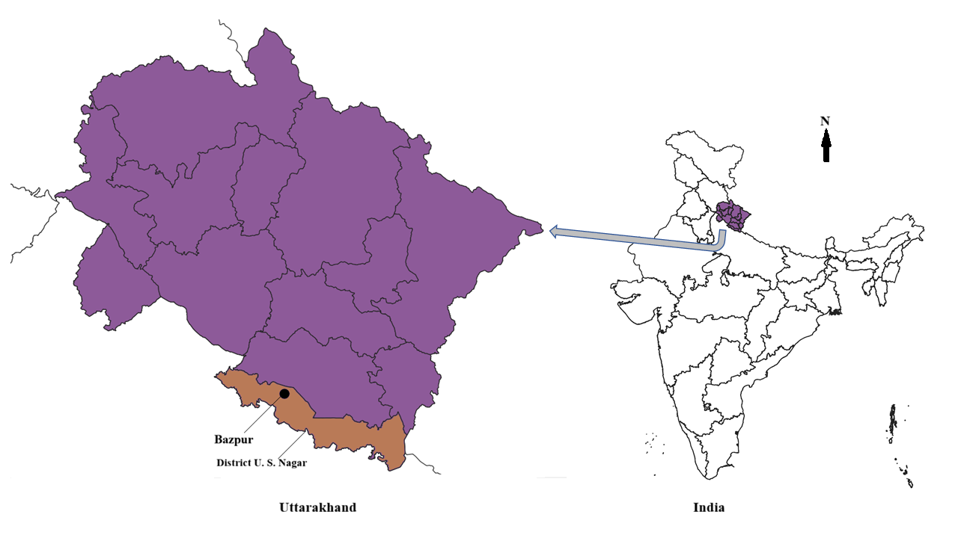

Fig. 1. Location of the study area showing Bazpur in Udham Singh Nagar district, Uttarakhand, India. Maps prepared based on data of Survey of India using QGIS. Annotations added using MS paint.

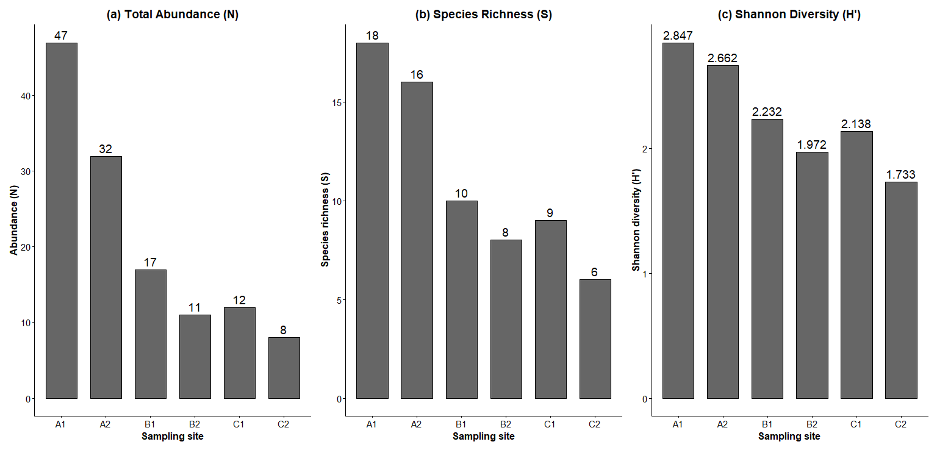
Fig. 2. Site-wise variation in (a) total abundance (N), (b) species richness (S), and (c) Shannon diversity (H′) of Orthoptera recorded from the six agricultural sampling sites.

