Original Research Article
Habitat Selection and Tree Preferences of the Great Slaty Woodpecker (Mulleripicus pulverulentus harterti) in Garbhanga Reserve Forest, Assam, India
Abstract
Habitat fragmentation and human disturbance may affect habitat use by canopy-dependent forest birds. This year-long study examined the spatial and seasonal occurrence, foraging-tree selection, social organisation, and proximity to human disturbance of the Great Slaty Woodpecker (Mulleripicus pulverulentus harterti) in Garbhanga Reserve Forest, Assam, India. Field surveys were conducted from 18 May 2025 to 30 April 2026 across 10 fixed transects totalling 33 km in the Lokhra, Basistha, and Satargaon sectors, using line-transect surveys, visual encounters, and focal behavioural observations. Fifty sightings were recorded, of which 44 occurred in Lokhra, two in Basistha, and four in Satargaon. Foraging was recorded only in mature, old-growth stands: 86% of foraging encounters occurred on Sal (Shorea robusta) and 14% on Tetrameles nudiflora. Selected trees had a mean DBH of 47.46 ± 1.82 cm and a mean height of 37.06 ± 1.15 m. Four-individual groups were the most frequent social unit, representing 38% of sightings, and sentry behaviour was observed in larger groups. Twenty-seven sightings (54%) occurred within 300 m of peripheral disturbance corridors, although abandonment of nesting and foraging sites was observed following heightened human activity. The findings indicate a strong association with mature, large-diameter trees and suggest that maintaining old-growth forest structure and low-disturbance interior areas is important for local conservation.
Keywords: Mulleripicus pulverulentus harterti; Garbhanga Reserve Forest; Shorea robusta; Foraging microhabitat; Human disturbance; Old-growth forest
- Introduction
Birds are important components of ecosystems and are widely used as bioindicators of environmental quality because they are sensitive to environmental change. An estimated 1,313 bird species occur in the Indian subcontinent, while Assam supports 950 species, of which 17 are endemic to the state (Thapa et al., 2024). Among the birds found in Assam, woodpeckers are notable for excavating cavities in tree trunks and for providing cavities for secondary cavity nesters (Virkkala, 2006). Prominent woodpecker species found in Assam include the Fulvous-breasted Woodpecker, Black-rumped Flameback, Bay Woodpecker, and Great Slaty Woodpecker. In our study area, Garbhanga Reserve Forest, the Great Slaty Woodpecker (GSW hereafter) is the only Vulnerable woodpecker recorded and is the largest woodpecker observed; it belongs to the family Picidae, which contains approximately 240–250 species (Mahananda et al., 2023). The Great Slaty Woodpecker weighs about 400 g and is listed as Vulnerable on the International Union for Conservation of Nature (IUCN) Red List (BirdLife International, 2023). Two subspecies of the Great Slaty Woodpecker are recognised: Mulleripicus pulverulentus pulverulentus and Mulleripicus pulverulentus harterti. M. pulverulentus harterti is a subspecies of M. pulverulentus distributed across South and Southeast Asia and is the subject of this study (Lammertink et al., 2009). The Great Slaty Woodpecker is highly dependent on tall, mature trees for foraging and nesting, which are abundant in our study area, Garbhanga Reserve Forest (GRF hereafter). Its cavity-making behaviour is important for supporting forest biodiversity (Thakuri et al., 2025). Sal (Shorea robusta) is strongly preferred by the study species for its day-to-day activities (Thakuri et al., 2025). However, a major reason for its vulnerability is its strict dependence on mature Sal stands, which are frequently degraded and cut down across human-dominated landscapes (Lammertink et al., 2009; Thakuri et al., 2025). Logging has contributed to an estimated decline of about 90% in the global GSW population (Lammertink et al., 2009). Clear sightings of GSW have also been recorded from GRF, where Sal, a tree species preferred by GSW, is dominant (Mahananda et al., 2023). Recent distribution modelling of another Indian forest-associated bird has likewise emphasised the value of species-specific habitat assessment for conservation planning (Singh & Sharma, 2026). Independent work in an Indian protected forest has documented substantial anthropogenic pressures on vegetation, including tree cutting and other resource-use disturbances, supporting the evaluation of habitat condition together with human activity (Pawar & Mule, 2025). Recent species-specific evidence further shows that Great Slaty Woodpeckers excavate nests in large live Sal trees, reinforcing the ecological relevance of retaining mature Sal stands (Kumar et al., 2026). At the broader woodpecker-community level, loss of broad-leaved forest has been associated with reduced woodpecker abundance and related cavity-mediated ecosystem functions (Yasuda et al., 2025). Despite the species records already available for GRF, site-specific field information remains limited on season-wise occurrence, foraging-tree selection, social grouping, and responses to human activity across the reserve. Therefore, the objective of this study is to investigate the spatial and temporal patterns and habitat selection of M. p. harterti in GRF. Specifically, our study aims to assess the occurrence and season-wise sighting patterns of the species, identify the characteristics of its preferred habitat, and evaluate the extent to which human activities inside and around the forest influence its distribution and habitat use. Furthermore, this study seeks to bridge the regional knowledge gap in the ecology of M. p. harterti in Northeast India. The findings of this study will provide baseline ecological data on the species, contributing to a better understanding of its habitat requirements and probable threats and aiding the formulation of evidence-based mitigation strategies. Finally, this study will serve as a reference for future long-term monitoring programmes and help identify priority areas for conservation and restoration within GRF.
Study objective: The objective of this study is to characterize the spatial and seasonal occurrence, habitat and foraging-tree selection, social patterns, and association with human activity of M. p. harterti in Garbhanga Reserve Forest.
2. Methodology:
2.1 Study Area:
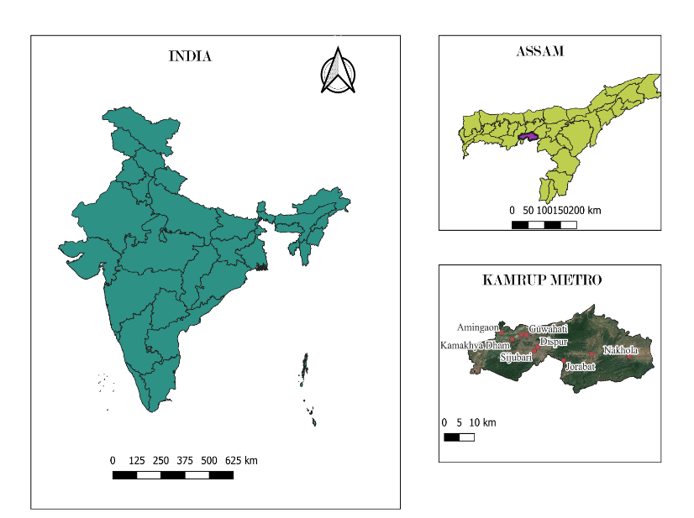

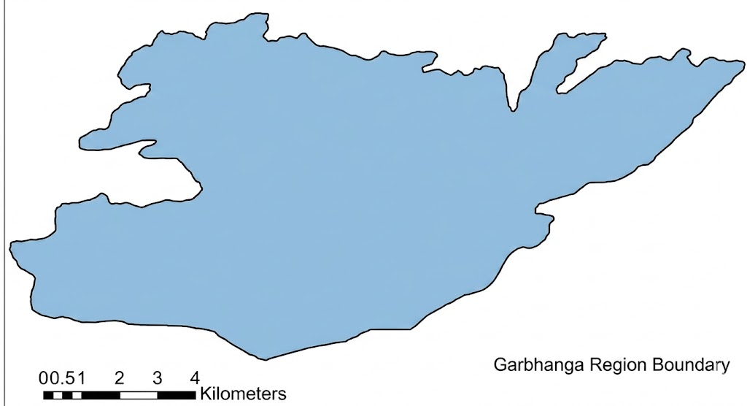

Garbhanga Reserve Forest

Fig. 1 Study area map showing Garbhanga Reserve Forest and surveyed sectors.

The GRF is a tropical mixed moist deciduous forest located on the southern bank of the River Brahmaputra. Meghalaya borders the reserve to the north and east, while the Deeporbeel Wildlife Sanctuary borders its northwestern side. The reserve is located close to Nongkhyllem Wildlife Sanctuary, and together these areas represent important repositories of biodiversity within the Indo-Burma biodiversity hotspot (Mahananda et al., 2023; Fig. 1).
The GRF is a mosaic of core, edge, and anthropogenically disturbed habitats, making it a crucial site for addressing this regional knowledge gap regarding GSW (Champion & Seth, 1968). Tree species commonly found in the forest include Shorea robusta, Tectona grandis, Schima wallichii, Michelia champaca, Ficus religiosa, and Tetrameles nudiflora (Mahananda et al., 2023). The reserve was once dominated by Sal (Shorea robusta), which is strongly preferred by GSW because the species forages on large-diameter, old-growth trees (Thakuri et al., 2025). Although excessive logging has replaced forest vegetation with secondary bamboo thickets dominated by Dendrocalamus hamiltonii (Champion & Seth, 1968; Barua, 2008), contiguous, mature old-growth Sal stands remain well preserved along specific interior-edge gradients, notably along the 13–14 km Lokhra corridor (Fig. 2).
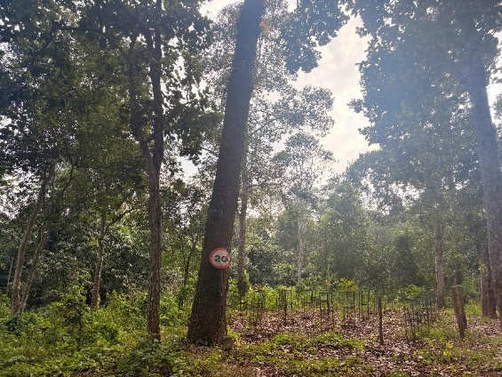
Fig.2 Habitat structure at the 13-14 km mark along the Lokhra trail corridor
The forest experiences four distinct seasons: pre-monsoon, monsoon, retreating monsoon, and winter. The reserve receives annual rainfall of 3,000–4,500 mm, with temperatures ranging from 11°C to 36°C and maximum humidity frequently reaching 80–90% (Kakati, 2002; Mahananda et al., 2023). This tropical monsoon climate supports dense, decaying-wood habitats used by species such as the GSW.
2.2 Sampling Design:
Field surveys were conducted over a 12-month period from 18 May 2025 to 30 April 2026 across four distinct seasons: pre-monsoon, monsoon, retreating monsoon, and winter. We implemented fixed-route line-transect sampling and visual encounter surveys because these methods provided a reliable, standardised protocol for detecting low-density, highly vocal canopy specialists across linear trail networks where off-trail movement was severely obstructed by dense undergrowth.
Surveys were conducted along established routes across three primary sectors (Fig. 3):
- Lokhra sector: Five continuous 5-km transects totalling 25 km of survey effort (T1–T5; Fig. 3a).
- Basistha sector: Two 1-km transects totalling 2 km of survey effort (T6a, T6b; Fig. 3b).
- Satargaon sector: Three 2-km transects totalling 6 km of survey effort (T7-T9; Fig. 3c).
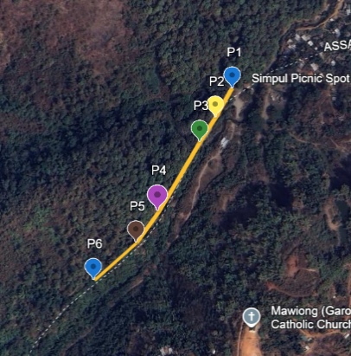
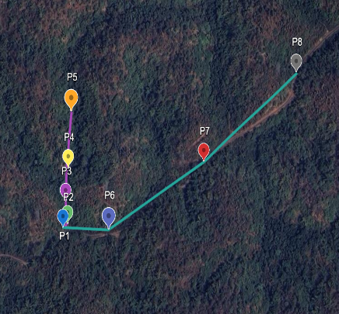
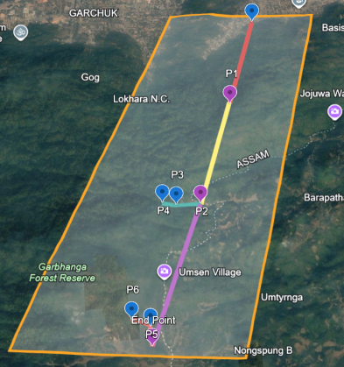
c
a
b
Fig. 3 Spatial distribution of line transects and sampling points across (a) Lokhra, (b) Basistha, and (c) Satargaon sectors.
Total sampling effort across the reserve encompassed 33 km across 10 surveyed transects (Table 1). Fixed GPS point locations were marked along these routes (Fig. 3) at intervals of 1–2 km to serve as standardised visual and auditory scanning waypoints. Systematic surveys were restricted to forest edges and access trails because of steep, untracked interior terrain and the seasonal presence and movement of Asian Elephants (Elephas maximus), which specifically restricted interior access along the Satargaon sector (Fig. 3c).
Across the 10 surveyed transects, observations were distributed as follows: T3 (n = 22) along the intact 13–14 km corridor, followed by T1 (n = 9), T2 (n = 7), T4 (n = 4), and T5 (n = 2) in the Lokhra sector (n = 44, total); T6a (n = 1) and T6b (n = 1) in the Basistha sector (n = 2, total); and T7 (n = 2), T8 (n = 1), and T9 (n = 1) in the Satargaon sector (n = 4, total).
2.3 Data Collection and Documentation
Surveys were carried out during peak avian activity windows (07:00-09:00 h and 15:00-17:00 h). Upon visual or auditory detection of Mulleripicus pulverulentus, the exact date, time, GPS coordinates, and group size were recorded.
To quantify microhabitat selection, occupied tree species were identified. Diameter at breast height (DBH, cm) was measured directly at 1.37 m above the ground using a forestry measuring tape, and total tree height (m) was measured using a handheld rangefinder from a measured baseline distance to the tree base. To quantify disturbance tolerance, the horizontal distance (in metres) from the bird's occupied tree to the nearest active anthropogenic feature, specifically rural settlement boundaries, motorable roads traversing the forest, or temporary human-made access trails, was recorded using a handheld GPS receiver (Garmin eTrex 22x) by logging waypoint coordinates at the tree location and measuring the spatial distance to digitised trail and settlement layers.
Avian behavioural activity budgets were documented using focal animal sampling following standard ethological protocols (Altmann, 1974). Once sighted, individual behaviour was continuously tracked and time-logged using a digital stopwatch across three discrete behavioural categories:
- Foraging: Active searching, trunk scanning, bark probing, climbing, and mechanical pecking or excavation to locate concealed prey items.
- Feeding: Direct handling, consumption, and ingestion of exposed invertebrate prey at a targeted patch.
- Nest-building: Active excavation of tree cavities or physical clearing and preparation of nesting chambers.
Group interactions, sentry positioning, and patch-sharing dynamics were recorded from non-disruptive observation distances using 8×42 binoculars and documented with a DSLR camera (Nikon D7500, 70–300 mm lens).
2.4 Data Analysis
Field data were compiled and analysed using descriptive summary statistics. Sighting frequencies, cumulative counts, and encounter rates (mean sightings per km) across the three trail sectors were calculated to evaluate spatial distribution. Foraging substrate specialisation was evaluated by calculating the percentage of foraging encounters allocated to each tree species. Morphometric parameters of selected trees (DBH and height) and behavioural session durations were expressed as mean values. Disturbance tolerance was assessed by plotting encounter frequencies across categorised distance buffers from human activity corridors.
3. Results
3.1 Spatiotemporal Occurrence and Group Dynamics
We recorded 50 sightings of Mulleripicus pulverulentus harterti across 7 of the 10 surveyed transects. All sightings were recorded in GRF over 12 months (18 May 2025 to 30 April 2026). The encounters were localised along the Lokhra trail sector (n = 44), with very few sightings recorded in the Basistha (n = 2) and Satargaon (n = 4) sectors (Table 1).
The highest number of encounters occurred in July 2025 and April 2026, with cumulative counts of 24 and 20 individuals, respectively, during the monsoon and pre-monsoon survey periods. The highest single group size (n = 5) was recorded in May 2025.
In larger groups (4–5 individuals), distinct spatial positioning was observed, with at least one individual positioned 5–20 m away from the active foraging cluster and perched higher in the sub-canopy while uttering repetitive vocalisations (Fig. 7c). Patch-sharing frequency increased as group size grew from 2 to 4 individuals but decreased when group size reached 5 individuals.

Table 1: Sampling effort, sighting counts, and encounter rates across surveyed sectors
Trail Site | Total Survey Length (km) | Number of Transects | Sightings Recorded | Mean Sightings per km (±SE)
Lokhra | 25 | 5 (5 km each) | 44 | 1.76 ± 0.18
Basistha | 2 | 2 (1 km each) | 2 | 1.00 ± 0.00
Satargaon | 6 | 3 (2 km each) | 4 | 0.67 ± 0.33
Total/Overall Mean | 33 | 10 | 50 | 1.52 ± 0.14

3.2 Foraging Ecology and Habitat Preference
During our study, foraging encounters were recorded exclusively within mature, old-growth forest stands across the reserve. The majority of foraging sessions (86%, n = 43) occurred on Sal (Shorea robusta), whereas the remaining 14% (n = 7) were recorded on Tetrameles nudiflora (Fig. 4).
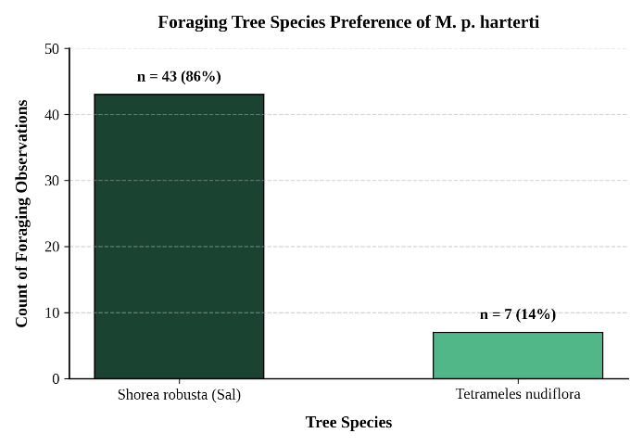
Fig. 4 Proportional foraging tree species selection of Mulleripicus pulverulentus harterti (n = 50).
Across all selected foraging trees, the mean diameter at breast height (DBH) was 47.46 ± 1.82 cm, and the mean total height was 37.06 ± 1.15 m (range: 24.0–48.0 m). When analysed by individual tree species:
- Shorea robusta stands: Utilised trees had a mean DBH of 46.80 cm and a mean height of 36.50 m. Foraging was primarily concentrated along the main trunk boles (62%) and primary canopy scaffold branches (38%).
- Tetrameles nudiflora stands: Utilised trees exhibited larger structural dimensions, with a mean DBH of 51.50 cm and a mean height of 40.50 m; birds were observed foraging predominantly on the upper trunk and large lateral limbs.
No foraging attempts were recorded on juvenile, pole-stage trees (DBH < 30 cm) or within secondary bamboo thickets during the survey period.
3.3 Behavioural Patterns
Behavioural observations showed that foraging was the most frequently recorded activity (n = 28), averaging 27.36 minutes per session. Feeding sessions were shorter, with an average duration of 17.10 minutes per session. Nest-building was the rarest of the three behaviours (n = 2), averaging 7.5 minutes per session (Fig. 5). Subsequent field visits to these peripheral trail locations confirmed that the active nesting and foraging sites were later abandoned following heightened human foot traffic and trail activity.
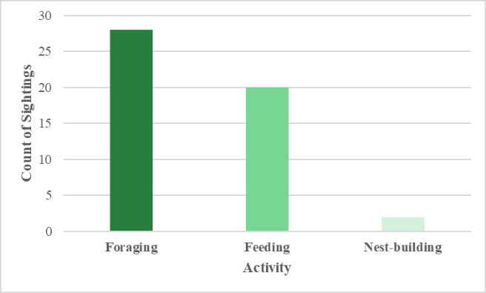
Fig. 5 Frequency distribution of primary behavioural activities recorded during focal observations.
3.4 Encounter Rate and Sociality Patterns
Recorded encounters exhibited clear variation across social group sizes, categorised into solitary individuals, small groups, and large family groups (Fig. 6). Large groups (n = 4–5 individuals) formed the majority of sightings (46%, n = 23), with four-individual groups representing the most frequent single social unit (n = 19, 38%) and five-individual groups recorded on four occasions (8%) during the post-breeding period (Fig. 6). Small groups (n = 2–3 individuals) accounted for 14 encounters (28%), while solitary individuals (n = 1) accounted for 13 encounters (26%, Fig. 6).
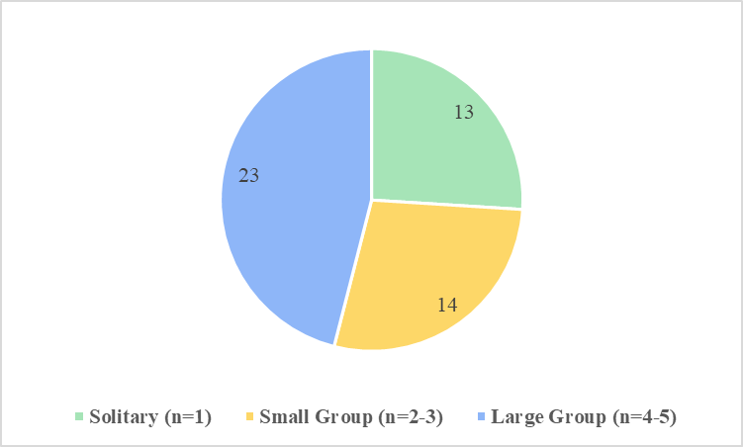
Fig. 6 Proportion of observed social group sizes of Mulleripicus pulverulentus harterti.
Field observations documented a range of collaborative behaviours within these multi-individual groups (Fig. 7). In groups of 4–5 birds, individuals engaged in coordinated canopy flight movements (Fig. 7d) and shared vertical trunk foraging space (Fig. 7b). Cavity-inspection behaviours were recorded on mature tree trunks (Fig. 7a). Furthermore, groups exhibited distinct sentry behaviour, with one individual perching higher on adjacent branches while maintaining vocal contact during active foraging bouts by conspecifics (Fig. 7c).
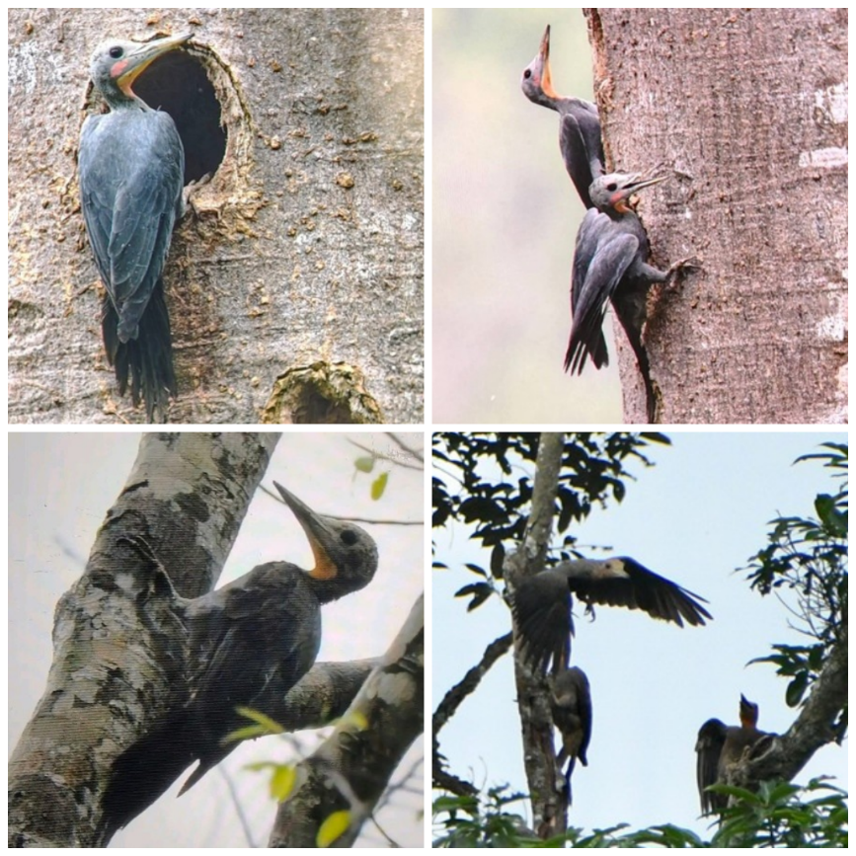
b
a
c
d
Fig.7 Field documentation of Mulleripicus pulverulentus harterti behaviours: (a) Cavity inspection; (b) Vertical forage-sharing; (c) Sentry posture; (d) Canopy flight coordination.
3.5 Tolerance to Anthropogenic Disturbance
A total of 27 sightings (54%) were recorded within 300 m of peripheral disturbance corridors (trails or forest edges). The mean distance from disturbance was 453.6 m, with family groups recorded at distances up to 1,000 m within core forest tracts (Fig. 8).

Fig. 8 Frequency of sightings relative to distance from human disturbance corridors.
4. Discussion
Our 12-month survey indicates that Mulleripicus pulverulentus harterti maintains a highly localised and specialised presence within Garbhanga Reserve Forest. The distinct seasonal surge in sightings during July and April aligns with the species' broader breeding and post-breeding activity window (March to August), during which increased vocalisations and active family-group foraging significantly increase canopy detectability (Lammertink, 2004; Kaur et al., 2024).
The clear dominance of four-individual groups reflects typical nuclear family units, consistent with the documented group size of 3–6 individuals in the Great Slaty Woodpecker (Lammertink, 2004; Kumar & Shahabuddin, 2012; Dasgupta et al., 2026). These social configurations indicate that collective foraging and sentry behaviour may function as strategies to reduce predation risk and optimise resource use (Lammertink, 2004). In larger groups of 4–5 individuals, sentry behaviour was observed, with an elevated individual maintaining vigilance and emitting distinct vocalisations 5–20 m away from foraging conspecifics (Fig. 7c). This behaviour may provide an anti-predator mechanism that supports group persistence along vulnerable forest fringes (Short, 1973; Lammertink, 2004). Furthermore, the observed decline in single-patch sharing as group size increased to five individuals may reflect a transition that reduces intra-familial feeding competition across common substrates (Lammertink, 2004).
Our structural vegetation analysis highlights a strong reliance on old-growth forest characteristics. The marked microhabitat preference for mature Shorea robusta (86%) and Tetrameles nudiflora (14%), with substantial dimensions (mean DBH = 47.46 cm, mean height = 37.06 m), may be associated with the structural availability of concentrated colonial invertebrate prey, such as ants, termites, and stingless bees (Lammertink, 2004; Lammertink et al., 2009). This morphometric dependence helps explain the species' vulnerability to localised timber extraction and structural tree removal (Lammertink et al., 2009; Dasgupta et al., 2026).
The high concentration of sightings within 300 m of human-use paths indicates a resource-disturbance trade-off. Mulleripicus pulverulentus harterti appears capable of tolerating moderate peripheral human presence, provided that large, old-growth foraging trees remain standing (Lammertink et al., 2009; Dasgupta et al., 2026). However, this tolerance has limits. While routine daily feeding occurred along peripheral trails, acute anthropogenic disturbance during sensitive phases was associated with marked behavioural shifts. This vulnerability was observed along the Lokhra trail corridor (13–14 km mark; Fig. 2), where active nesting and foraging sites were abandoned following heightened local foot traffic and human proximity. Specialised woodpeckers typically retreat into interior core zones to minimise observer disturbance and predation pressure during breeding (Lammertink, 2004; Kaur et al., 2024). Furthermore, along the heavily degraded Basistha trail, intense logging and canopy fragmentation were associated with a near-total absence of sightings (Table 1; Lammertink, 2004; Kaur et al., 2024; Dasgupta et al., 2026).
As a preliminary assessment for this region, this study highlights important conservation gaps and logistical constraints in Northeast India (Dasgupta et al., 2026). As synthesised by Dasgupta et al. (2026), the regional evidence base for M. pulverulentus has historically been limited by the absence of standardised density estimates and dedicated field assessments in eastern sub-Himalayan and moist deciduous tracts. Owing to difficult terrain and safety risks associated with the movements of Asian Elephants (Elephas maximus), particularly along the Satargaon sector (Fig. 3c), interior core zones could not be systematically sampled. Consequently, while peripheral trails serve as routine foraging corridors, maintaining unbroken canopy connectivity between edge and core tracts and safeguarding quiet, undisturbed interior old-growth stands remain important for preserving nesting refuges for this species across the wider landscape (Dasgupta et al., 2026).
5. Conclusion
This year-long study provides baseline field data on the habitat selection, foraging ecology, and social dynamics of the vulnerable Great Slaty Woodpecker (Mulleripicus pulverulentus harterti) in Garbhanga Reserve Forest, Assam. Our results indicate that the species relies heavily on old-growth forest, spending 86% of its foraging time on large Sal (Shorea robusta) trees and also using major broadleaved emergents such as Tetrameles nudiflora. Across all 50 recorded foraging trees (Shorea robusta and Tetrameles nudiflora combined), the mean DBH was 47.46 cm and the mean total height was 37.06 m. Although family units utilise peripheral forest corridors such as the Lokhra sector for routine feeding, localised anthropogenic disturbance during sensitive breeding phases was associated with abandonment of nesting and foraging sites. These observations indicate that suitable foraging substrates may not offset acute human disturbance during reproductive periods.
Effective conservation of this species in fragmented landscapes requires targeted management interventions. Forest authorities should prioritise the protection of undisturbed interior core zones to preserve essential nesting refuges while curbing the selective removal of mature, large-diameter Sal and emergent trees along peripheral boundaries. Given that complex terrain and seasonal movements of Asian Elephants restricted sampling along deep interior routes such as Satargaon, future research could integrate autonomous passive acoustic monitoring and telemetry. These non-invasive tools could facilitate systematic home-range mapping and multi-season occupancy modelling to support evidence-based conservation frameworks across Northeast India.

Limitation
Systematic sampling was restricted mainly to established trails and forest edges because steep terrain and seasonal movements of Asian Elephants limited access to interior areas, particularly in Satargaon. Consequently, encounter rates may not fully represent use of inaccessible core habitat. The study relied on descriptive summaries rather than detection-corrected occupancy or density estimates, and the 12-month sampling period represents a single annual cycle. Observed associations with human disturbance should therefore be interpreted as site-specific patterns rather than causal effects.

Declaration of AI Use

This manuscript was prepared through the intellectual contributions of the author(s) to the study design, data analysis, interpretation of results, and scholarly content. Grammarly and ChatGPT were used solely to assist with grammatical refinement and reference formatting during manuscript revision. The author(s) accept full responsibility for the accuracy, integrity, and final content of the manuscript.

COMPETING INTERESTS DISCLAIMER:
Authors have declared that they have no known competing financial interests OR non-financial interests OR personal relationships that could have appeared to influence the work reported in this paper.
References:
Altmann, J. (1974). Observational study of behavior: Sampling methods. Behaviour, 49(3–4), 227–267. https://doi.org/10.1163/156853974x00534
Barua, K. K. (2008). Diversity and habitat selection of Papilionidae in a protected forest reserve in Assam, Northeast India [Doctoral dissertation, Georg-August-Universität Göttingen]. https://doi.org/10.53846/goediss-3389
BirdLife International. (2023). Mulleripicus pulverulentus. The IUCN Red List of Threatened Species 2023, e.T22681585A241500854. https://doi.org/10.2305/IUCN.UK.2023-1.RLTS.T22681585A241500854.en
Champion, H. G., & Seth, S. K. (1968). A revised survey of the forest types of India. Manager of Publications. https://agris.fao.org/search/en/providers/122535/records/65de0f6963b8185d9ca6b0cf
Dasgupta, P., Baglari, S., & Thapa, M. K. (2026). A critical review of the conservation status and ecology of the Great Slaty Woodpecker Mulleripicus pulverulentus, with particular reference to North-East India. Uttar Pradesh Journal of Zoology, 47(16), 335–360. https://doi.org/10.56557/upjoz/2026/v47i165826
Kakati, D. (2002). Studies on conservation biology of swallowtail butterflies of Kamrup district, Assam [Doctoral dissertation, Gauhati University].
Kaur, S., Gopi, G. V., & Uniyal, V. P. (2024). Grouping and home-range of the Vulnerable Great Slaty Woodpecker Mulleripicus pulverulentus in the western Himalaya. Indian Birds, 19(6), 180–184. https://indianbirds.in/pdfs/IB_19_6_PrintReady.pdf
Kumar, R., Lammertink, M., & Alam, T. (2026). Reproductive ecology of the threatened Great Slaty Woodpecker Mulleripicus pulverulentus. Acta Ornithologica, 60(1), 81–89. https://doi.org/10.3161/00016454AO2025.60.1.007
Kumar, R., & Shahabuddin, G. (2012). Assessing the status and distribution of the Great Slaty Woodpecker Mulleripicus pulverulentus (Temminck, 1826) in sub-Himalayan Uttarakhand, India. Journal of the Bombay Natural History Society, 109(1–2), 17–22. https://www.bnhsjournal.in/index.php/bnhs/article/view/156167
Lammertink, M. (2004). Grouping and cooperative breeding in the Great Slaty Woodpecker. The Condor, 106(2), 309–319. https://doi.org/10.1093/condor/106.2.309
Lammertink, M., Prawiradilaga, D. M., Setiorini, U., Naing, T. Z., Duckworth, J. W., & Menken, S. B. J. (2009). Global population decline of the Great Slaty Woodpecker (Mulleripicus pulverulentus). Biological Conservation, 142(1), 166–179. https://doi.org/10.1016/j.biocon.2008.10.010
Mahananda, P., Jelil, S. N., Bohra, S. C., Mahanta, N., Saikia, R. B., & Purkayastha, J. (2023). Terrestrial vertebrate and butterfly diversity of Garbhanga Landscape, Assam, India. Journal of Threatened Taxa, 15(4), 23029–23046. https://doi.org/10.11609/jott.8334.15.4.23029-23046
Pawar, P., & Mule, M. (2025). Vegetation patterns and anthropogenic influence in Gautala Autramghat Wildlife Sanctuary (GAWLS): An analysis of species diversity and ecological status. Journal of Global Ecology and Environment, 21(2), 37–50. https://doi.org/10.56557/jogee/2025/v21i29180
Short, L. L. (1973). Habits of some Asian woodpeckers (Aves, Picidae). Bulletin of the American Museum of Natural History, 152(5), 255–364. https://ci.nii.ac.jp/ncid/BA17066007
Singh, P., & Sharma, A. (2026). Distribution modelling of the endemic Indian Spotted Creeper (Salpornis spilonota) in India. Asian Journal of Research in Zoology, 9(3), 117–125. https://doi.org/10.9734/ajriz/2026/v9i3294
Thakuri, D. C., Basnet, H., Poudyal, L. P., & Aryal, P. C. (2025). Investigating the trend of the Great Slaty Woodpecker (Mulleripicus pulverulentus) population status in western Nepal. Ecology and Evolution, 15(7), e71671. https://doi.org/10.1002/ece3.71671
Thapa, M. K., Dutta, S., Das, H. J., Pradhan, T. K., Mahanta, D., Tossa, S., Kalita, R., & Sharma, K. (2024). Avifaunal diversity and status in and around Ranga Reserve Forest, Lakhimpur, Assam, India. Munis Entomology & Zoology, 19(2), 543–555. https://doi.org/10.5281/zenodo.11408465
Virkkala, R. (2006). Why study woodpeckers? The significance of woodpeckers in forest ecosystems. Annales Zoologici Fennici, 43(2), 82–85.
Yasuda, K., Kato, D., Naoe, S., Amano, T., Yoshikawa, T., Tochigi, K., & Koike, S. (2025). Does forest loss and fragmentation reduce woodpecker-associated ecosystem functions? Global Ecology and Conservation, 57, e03366. https://doi.org/10.1016/j.gecco.2024.e03366

