Original Research Article

A Preliminary Assessment of Butterfly Diversity in and around Bongaigaon Tea Estate, Bongaigaon, Assam, India
____________________________________________________________________________
Abstract
Butterflies are ecologically important organisms and are widely recognised as useful bio-indicators of environmental changes. The present study aimed to document butterfly diversity in and around Bongaigaon Tea Estate, Bongaigaon, Assam, India, where locality-specific information on butterfly assemblages was previously unavailable. A 12-month survey was conducted from August 2025 to July 2026 across the approximately 1.55 km² study area. Line transects and visual encounter surveys were employed for field documentation, while photographic evidence was obtained using an iPhone 16 and a Canon 3000D equipped with a 300 mm zoom lens. A total of 42 butterfly species belonging to six families were recorded. Nymphalidae was the most species-rich family, comprising 18 species, followed by Lycaenidae (7), Papilionidae (6), Pieridae (6), Hesperiidae (4), and Riodinidae (1). Lemon Pansy (Junonia lemonias), Common Mormon (Papilio polytes), Common Evening Brown (Melanitis leda), and Great Eggfly (Hypolimnas bolina) were among the commonly observed species. Conservation-status assessment indicated that several recorded species are categorised as Least Concern under the IUCN Red List, while others currently lack a global assessment. Five recorded species were identified as legally protected: Papilio clytia, Troides aeacus, Troides helena, Euploea mulciber, and Baoris farri. Despite the relatively small size and human-modified nature of the study area, the occurrence of 42 species highlights the potential of the tea-estate landscape and surrounding vegetation to support local butterfly diversity. However, noticeable habitat fragmentation and habitat loss associated with ongoing development may threaten the persistence of this diversity. As a preliminary faunal assessment, the study provides baseline information for Bongaigaon Tea Estate and can serve as a reference for future monitoring, comparative studies, and landscape-level conservation planning.
Keywords: Butterflies . bio-indicators .. habitat fragmentation . habitat loss . protected species . tea estate . urban ecology

- INTRODUCTION
The order Lepidoptera, comprising butterflies and moths, is among the most taxonomically and ecologically prominent components of terrestrial biodiversity. With approximately 160,000–174,250 described species distributed across 126 families and 46 superfamilies, the order constitutes 10% of all known species of living organisms and occurs on every continent except Antarctica (Adams et al., 2016; Perveen & Khan, 2024). Lepidoptera is the second-largest insect order after Coleoptera, and its evolutionary radiation has been closely intertwined with angiosperm diversification and long-standing plant–herbivore co-evolutionary dynamics (Adams et al., 2016; Narango et al., 2020). Members of this order are also among the most widely used bio-indicators of environmental quality across both natural and human-modified landscapes because they are highly sensitive to changes in their surroundings (Ray et al., 2025).
Recent synthesis further indicates that the value of butterflies as ecological indicators depends on habitat quality, host-plant availability, microclimate, land-use intensity, and sampling design, requiring context-specific interpretation of observed responses (Kumar, 2026).
Throughout their global distribution, members of Lepidoptera are responsible for a broad suite of ecological functions. Butterflies are important pollinators that support many flowering plants, while their predominantly herbivorous larvae help transfer energy from plants to higher trophic levels, more than all other insect herbivores combined, thereby anchoring the structure of terrestrial food webs in temperate and tropical regions (Bazinet et al., 2013; Adams et al., 2016; Narango et al., 2020). Apart from herbivory and pollination, Lepidoptera constitute a major prey base for insectivorous birds, bats, reptiles, amphibians, and predatory arthropods and also contribute to nutrient cycling through the frass-mediated transfer of carbon and nitrogen from the canopy to the soil (Kagata & Ohgushi, 2012; Habel et al., 2019; Narango et al., 2020). Moreover, the order's sensitivity to microclimate, vegetation structure, and a range of anthropogenic factors has been formally documented, supporting its long-established role in biodiversity monitoring programmes (Kremen, 1992; Mauricio da Rocha et al., 2010; Chowdhury et al., 2023; Bhawnani et al., 2025). These functions are intimately conditioned by specialised larval–host-plant relationships, as the conservation of particular plant genera helps to maintain local lepidopteran richness (Futuyma, 1976; Altermatt & Pearse, 2011; Narango et al., 2020).
The ecological importance of Lepidoptera has drawn attention to their well-documented global declines, a matter of considerable scientific and societal concern. Long-term biomonitoring in protected areas has revealed reductions of over 75% in total flying insect biomass over 27 years. A 50% decline in European grassland butterfly populations between 1990 and 2011 has also been noted (Hallmann et al., 2017). The primary factors associated with these losses include habitat loss, habitat fragmentation, agricultural intensification, pesticide use, climate change, the introduction of invasive species, and atmospheric nitrification. These factors do not act independently but interact across spatial scales to erode ecosystem resilience (Wagner, 2020). The resulting effects threaten ecosystems by hampering pollination services, food-web stability, and the maintenance of vertebrate insectivore populations and have emerged as a defining dimension of the Anthropocene biodiversity crisis (Habel et al., 2019; Narango et al., 2020; Wagner, 2020).
Recent evidence from southern India shows that urban habitat fragments can retain distinct butterfly assemblages, highlighting the conservation relevance of heterogeneous green spaces within developed landscapes (Molleman & Aydin, 2026).
In Assam, a recent urban-gradient study in Guwahati also documented variation in butterfly diversity and abundance along urbanisation gradients, reinforcing the importance of fine-scale habitat context in northeastern Indian landscapes (Moran et al., 2026).
India is recognised as a diversity-rich nation, hosting 1,501 butterfly species and over 13,199 Lepidoptera in total. However, the country's north-eastern region functions as a particularly species-rich reservoir, contributing approximately two-thirds of the country's butterfly species, i.e. 962 species (Bhuyan et al., 2005; Sidhu, 2023; Singh et al., 2025). Although the eight north-eastern states occupy only about 8% of India's land area, they collectively support about 32.92% of the country's documented Lepidoptera, which supports the inclusion of the region within the Indo-Burma Biodiversity Hotspot, where Palaearctic and Oriental biogeographic elements converge (Soibam et al., 2016; Gogoi et al., 2023; Malsawmtluanga et al., 2025). Situated on the north bank of the Brahmaputra, Assam reflects this richness. Studies from eastern Assam have recorded up to 237 butterfly species, of which 33 are protected under the Wild Life (Protection) Act, 1972. Additionally, individual protected areas such as Dehing Patkai National Park and Borajan-Bherjan-Podumani Wildlife Sanctuary support diverse assemblages of 92 and 89 species, respectively (Bhuyan et al., 2005; Singh, 2017; Gogoi et al., 2023; Das, 2026). Despite these growing records, considerable gaps in taxonomic and ecological knowledge persist, and locality-specific baseline data remain scarce for many places in Assam.
Recent locality-scale surveys from Assam and northern West Bengal have likewise documented diverse Lepidoptera or butterfly assemblages in human-modified habitat mosaics, supporting the usefulness of site-specific baseline assessments (Nath et al., 2026; Saha et al., 2024).
Bongaigaon district of Assam is known for the endangered and endemic Golden Langur (Trachypithecus geei) and its mosaic of moist deciduous forest, wetlands, and riverine habitat. A preliminary checklist of 46 butterfly species belonging to five families has recently been compiled from three main forest regions of the district, with Nymphalidae (19 species) being the dominant family, followed by Lycaenidae, Papilionidae, Pieridae, and Hesperiidae (Ray et al., 2025). However, district-level data cannot capture butterfly assemblages within a particular tea estate, and no earlier study has documented the butterfly species occurring in and around Bongaigaon Tea Estate. Therefore, our objectives are to: (a) prepare a checklist of butterflies occurring in and around the tea estate; (b) assess family-level dominance; and (c) provide site-specific baseline data for long-term monitoring. Our findings are expected to enhance local and regional biodiversity databases and support landscape-level conservation planning.
- MATERIALS AND METHODS
2.1 STUDY AREA
Bongaigaon city is situated within the Aie Valley of the Brahmaputra River basin (Ray et al., 2025) and the North Eastern Himalayan sub-region of India (Government of Assam, 2026). Our study area (Figure 1) comprises Bongaigaon Tea Estate and its surrounding locality, covering approximately 1.55 km². The coordinates of our study location are 26°28'37.3"N 90°34'07.8"E. The study area experiences a humid subtropical climate characterised by a heavy monsoon and hot summers. It has an estimated minimum temperature of 13°C, a maximum temperature of 32°C, and average annual rainfall of 2,500–3,500 mm (Government of Assam, 2026). Rainfall peaks from June to September. To the west of our study location lies Bongaigaon Police Station; to the south is Bageswari Hill Temple; and to the north lies the Bongaigaon crematorium. Some of the prominent flora supporting the butterfly assemblages observed at this location include Gulmohar (Delonix regia), Hill glory bower (Clerodendrum infortunatum), Jamun tree (Syzygium cumini), Pinwheel flower (Tabernaemontana divaricata), and others (Figure 2).

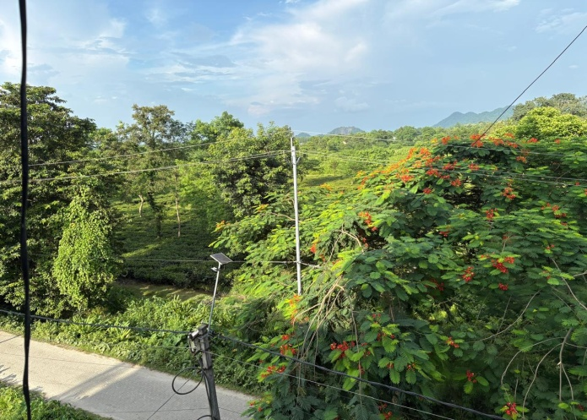
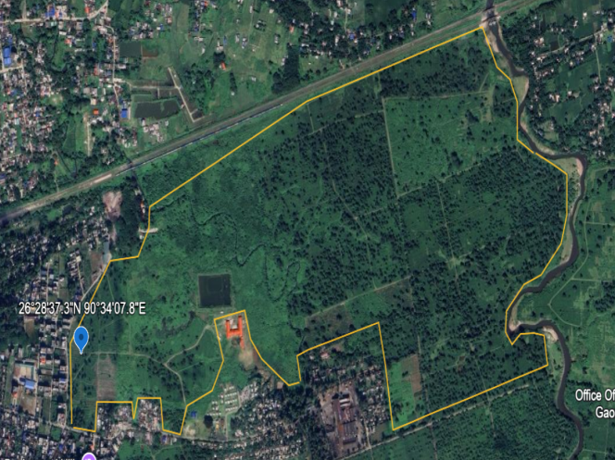
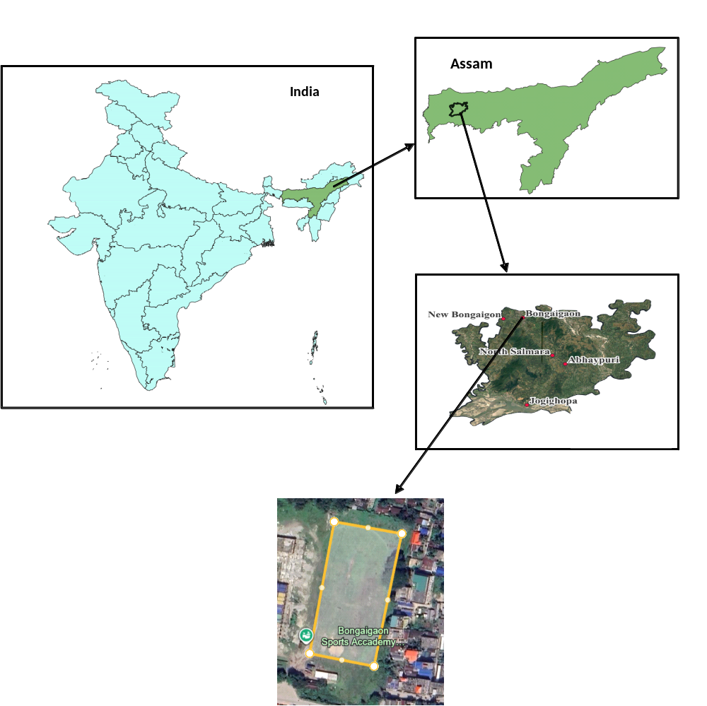

Figure 1. Map showing Bongaigaon Tea Estate and its surrounding areas

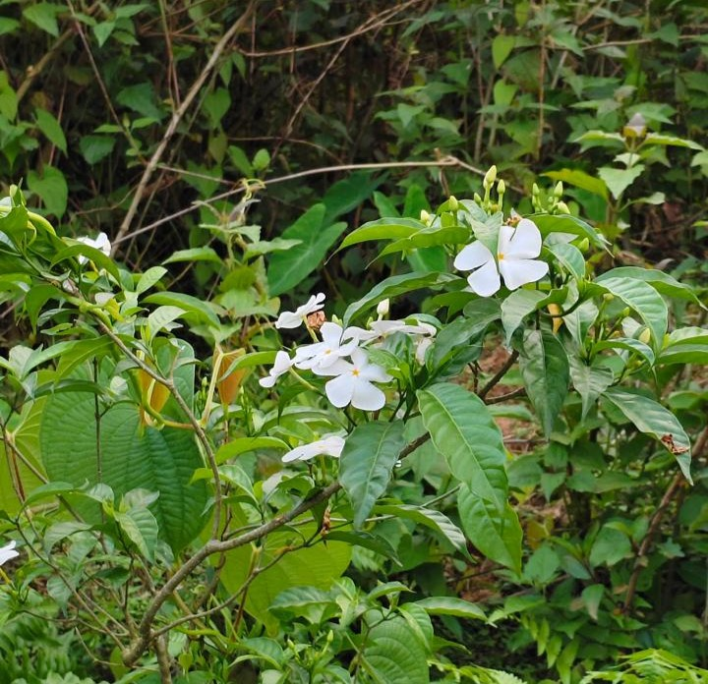
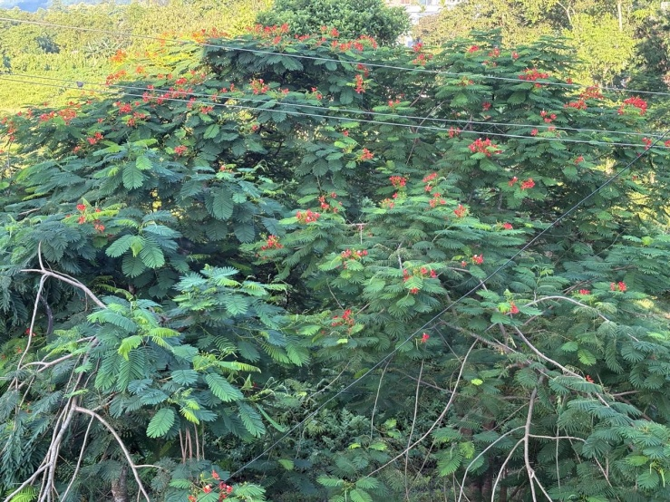
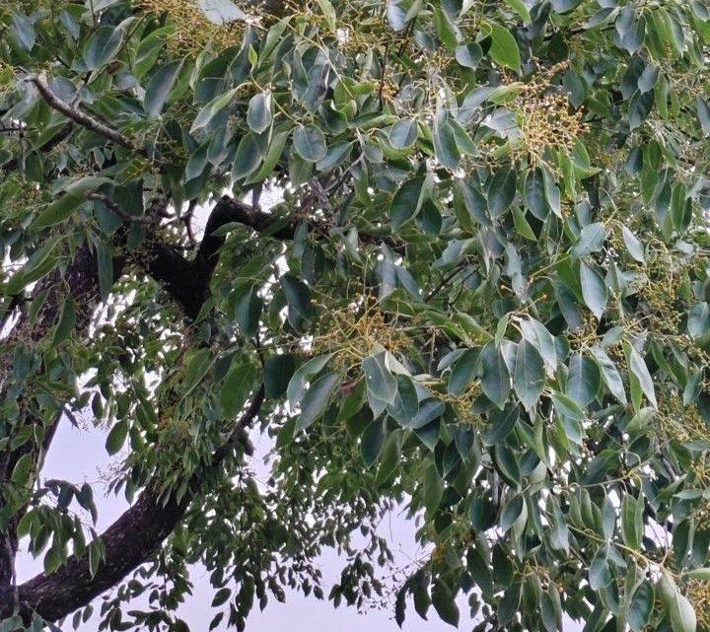
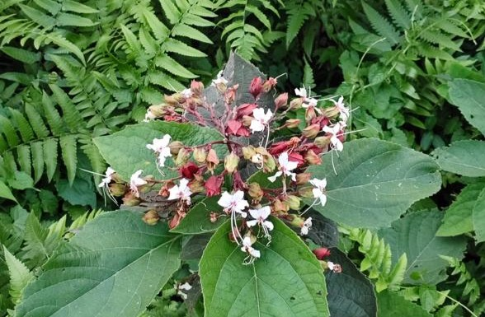
(a) (b)
(c) (d)
Figure 2. Some of the prominent flora observed in and around Bongaigaon Tea Estate (a) Gulmohar (Delonix regia) (b) Pinwheel flower (Tabernaemontana divaricata) (c) Hill glory bower (Clerodendrum infortunatum) (d) Jamun tree (Syzygium cumini)

2.2 METHOD OF THE STUDY
Our study was conducted to record the butterflies present in and around Bongaigaon Tea Estate. We used the line-transect method (Crum et al., 2021) and visual encounter surveys (Boynton et al., 2021) to accomplish our aims and gather quantitative data. The study area map was created using QGIS software, and the pie chart was created using MS Office Excel (2007).

2.3 STUDY DESIGN
The study was conducted for a period of twelve months, from August 2025 to July 2026. Butterfly surveys were conducted regularly throughout the study period, primarily during the early morning hours when butterfly activity was relatively high. Approximately three hours of field observation were targeted per survey day, with Saturdays and Sundays excluded from routine observations. Line-transect walks were conducted through accessible portions of Bongaigaon Tea Estate and its surrounding habitats, supplemented by visual encounter surveys to document species that were observed outside the immediate transect route. Photographic records were obtained whenever possible to support subsequent identification.
As the present investigation was primarily designed for preliminary faunal documentation and the preparation of a baseline checklist of butterflies in and around the tea estate, standardised measurements of transect length and width and the exact spatial coordinates of individual transect routes were not recorded during the original field surveys. Consequently, the present study is interpreted as a preliminary species-occurrence assessment rather than a standardised distance-sampling or quantitative population-abundance study. This limitation is considered when interpreting the results.
2.4 DATA COLLECTION AND IDENTIFICATION
Data were collected systematically by recording the observed species. Photographic evidence was captured using an iPhone 16 and a Canon 3000D paired with a 300 mm zoom lens. Observed butterflies were categorised by family and IUCN status and identified with the help of a field guide (Neog, 2026) and published articles. In some instances, personal knowledge was also applied.
- 3. RESULTS AND DISCUSSION
3.1 Species richness and family-wise composition
Our study recorded 42 butterfly species belonging to six families of the order Lepidoptera (Table 1). The families were Nymphalidae, Lycaenidae, Papilionidae, Pieridae, Riodinidae, and Hesperiidae. The largest number of recorded species belonged to Nymphalidae (18). The family-wise pattern was Nymphalidae (18) > Lycaenidae (7) > Papilionidae (6) > Pieridae (6) > Hesperiidae (4) > Riodinidae (1) (Figure 3). The most commonly observed butterflies included Lemon Pansy (Junonia lemonias), Common Mormon (Papilio polytes), Common Evening Brown (Melanitis leda), and Great Eggfly (Hypolimnas bolina). Among the 42 recorded species, five species, Papilio clytia, Troides aeacus, Troides helena, Euploea mulciber, and Baoris farri, were identified as legally protected under relevant schedules of the Wild Life (Protection) Act, as amended in 2022 (Ministry of Law and Justice, 2022; Table 2). The IUCN Red List status varied among the recorded species, with some assessed as Least Concern and others currently not evaluated (International Union for Conservation of Nature [IUCN], 2026). The occurrence of 42 recorded species in the study area indicates its potential to support butterfly diversity, and efforts should be made to maintain this diversity in the future.
The finding of 42 species across six families indicates that the tea estate and adjacent habitats support a measurable but preliminary butterfly assemblage within a human-modified landscape. Similar use of modified or urban-associated landscapes by butterfly communities has been reported from organic tea estates and urban landscapes in northeastern India, where the availability of nectar plants, larval host plants and semi-natural vegetation influenced observed richness (Pradhan & Khaling, 2020; Bohra & Purkayastha, 2021; Dutta et al., 2025). Therefore, the present checklist should be interpreted as baseline evidence of local species occurrence rather than as a complete estimate of regional butterfly diversity.
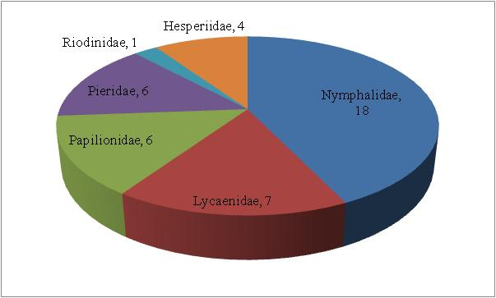

Figure 3. Pie chart showing number of species recorded for each family.
Table 1. Annotated list of observed butterflies
Sl. No. | Family | Common name | Scientific name | IUCN Red List status
1 | Papilionidae | Common Mormon | Papilio polytes | NE
2 | Papilionidae | Golden Birdwing | Troides aeacus | LC
3 | Papilionidae | Common Mime | Papilio clytia | NE
4 | Papilionidae | Paris Peacock | Papilio paris | NE
5 | Papilionidae | Common Lime Butterfly | Papilio demoleus | NE
6 | Papilionidae | Common Birdwing | Troides helena | LC
7 | Pieridae | Common Emigrant | Catopsilia pomona | NE
8 | Pieridae | Mottled Emigrant | Catopsilia pyranthe | NE
9 | Pieridae | Common Grass Yellow | Eurema hecabe | NE
10 | Pieridae | Three-spot Grass Yellow | Eurema blanda | NE
11 | Pieridae | Psyche | Leptosia nina | NE
12 | Pieridae | Indian Cabbage White | Pieris canidia | NE
13 | Lycaenidae | Dark Grass Blue | Zizeeria karsandra | NE
14 | Lycaenidae | Pale Grass Blue | Pseudozizeeria maha | NE
15 | Lycaenidae | Lesser Grass Blue | Zizina otis | NE
16 | Lycaenidae | Common Pierrot | Castalius rosimon | LC
17 | Lycaenidae | Slate Flash | Rapala manea | NE
18 | Lycaenidae | Copper Flash | Rapala pheretima | NE
19 | Lycaenidae | Common Climate Blue | Anthene definita | NE
20 | Riodinidae | Punchinello | Zemeros flegyas | NE
21 | Nymphalidae | Tawny Coster | Acraea terpsicore | NE
22 | Nymphalidae | Common Five-ring | Ypthima baldus | NE
23 | Nymphalidae | Peacock Pansy | Junonia almana | LC
24 | Nymphalidae | Grey Pansy | Junonia atlites | NE
25 | Nymphalidae | Yellow Pansy | Junonia hierta | LC
26 | Nymphalidae | Chocolate Pansy | Junonia iphita | NE
27 | Nymphalidae | Common Evening Brown | Melanitis leda | LC
28 | Nymphalidae | Dark Evening Brown | Melanitis phedima | NE
29 | Nymphalidae | Duffer | Discophora sp. | Not assignable to species level
30 | Nymphalidae | Knight | Lebadea martha | NE
31 | Nymphalidae | Commander | Moduza procris | NE
32 | Nymphalidae | Common Sergeant | Athyma perius | NE
33 | Nymphalidae | Common Sailer | Neptis hylas | NE
34 | Nymphalidae | Lemon Pansy | Junonia lemonias | NE*
35 | Nymphalidae | Great Eggfly | Hypolimnas bolina | NE
36 | Nymphalidae | Striped Blue Crow | Euploea mulciber | NE
37 | Nymphalidae | Colour Sergeant | Athyma nefte | NE
38 | Nymphalidae | Bushbrowns | Mycalesis sp. | Not assignable to species level
39 | Hesperiidae | Fulvous Pied Flat | Pseudocoladenia dan | NE
40 | Hesperiidae | Paintbrush Swift | Baoris farri | NE
41 | Hesperiidae | Common Bush Hopper | Ampittia dioscorides | NE
42 | Hesperiidae | Common Red-eye | Matapa aria | NE

LC: Least Concern; NE: Not Evaluated
Table 2. List of protected species from the overall recorded 42 species
Sl. No. | Common name | Scientific name | Schedule under which the species is protected
1 | Common Mime | Papilio clytia | Schedule II
2 | Golden Birdwing | Troides aeacus | Schedule II
3 | Common Birdwing | Troides helena | Schedule IV
4 | Striped Blue Crow | Euploea mulciber | Schedule IV
5 | Paintbrush Swift | Baoris farri | Schedule IV

The Indo-Burma Biodiversity Hotspot is well known for supporting diverse life forms and makes a major contribution to regional biodiversity. Our study area in Bongaigaon also falls within this hotspot, and the results of our study are consistent with this broader context. Although our study was preliminary for this particular location, it recorded 42 butterfly species during the study year, of which five were identified as protected species. However, we did not record any endemic species. The observed diversity indicates that the tea-estate landscape can support a range of butterfly taxa. Nymphalidae contributed the largest number of recorded species, with 18 species. The family-wise pattern was Nymphalidae (18) > Lycaenidae (7) > Papilionidae (6) > Pieridae (6) > Hesperiidae (4) > Riodinidae (1).
3.2 Regional comparison and dominance of Nymphalidae
The observed pattern is similar to findings from other regions of Assam. Thapa et al. (2025), in a study of butterfly diversity and distribution in Rani-Garbhanga Reserve Forest, also reported dominance of Nymphalidae. Similarly, Gogoi et al. (2023) reported Nymphalidae as the dominant family in a study of butterfly diversity in Dehing-Patkai National Park. Comparable family-level dominance has been reported in other studies from Assam, including Joshi and Dhyani (2014) and Konwar and Bortamuly (2021), as well as outside Assam by Lodh and Agarwala (2016) and Pradhan and Khaling (2020). This pattern has also been reported in studies from other parts of the world. Ray et al. (2025), in a study of lepidopteran diversity across three forest areas of Bongaigaon district, recorded 46 butterfly species, with Nymphalidae as the dominant family, similar to the present results. The occurrence of 42 recorded taxa within a single study area indicates substantial local richness. As reported by Pradhan and Khaling (2020), tea estates can retain considerable biodiversity.
The dominance of Nymphalidae in the present assemblage is consistent with regional studies from Assam and eastern Himalayan tea landscapes, where Nymphalidae frequently represents the largest proportion of recorded butterfly species (Gogoi et al., 2023; Pradhan & Khaling, 2020; Dutta et al., 2025). This pattern may be related to the wide habitat breadth and diverse larval host-plant associations of many nymphalid species, although the present study did not quantify host-plant use or seasonal abundance. Hence, family-level dominance should be treated as a descriptive community pattern and not as evidence of habitat preference without further ecological sampling.
3.3 Habitat condition and conservation implications
The study area is an organic tea estate located at the edge of the city, where disturbance is low to moderate and the extent of built-up area is limited; these conditions are considered important for retaining diversity (Bisht & Arya, 2024). It also contains diverse flora that provide important microhabitats for butterflies. Together, these factors may have influenced our results. As butterflies are bio-indicators of environmental stress (Ray et al., 2025), our results may suggest that environmental quality in and around the study area is comparatively favourable. Although rapid urbanisation is occurring more broadly, the present study area appears to be relatively less affected. However, this situation may change in the coming years because patches of the tea estate are gradually being sold, reducing habitat availability and increasing habitat fragmentation, both of which are established drivers of biodiversity loss (Wagner, 2020). If this process continues, the current diversity may decline in the future, and the issue warrants attention.
The association of butterflies with heterogeneous vegetation and less-disturbed habitat patches is consistent with broader evidence that habitat complexity, forest fragments, and managed green spaces can retain butterfly assemblages in human-modified landscapes (Koh & Sodhi, 2004; Hamer et al., 1997; Tscharntke et al., 2005). At the same time, butterflies should be used as environmental indicators with caution because indicator value can vary among species, spatial scales and disturbance types (Thomas, 2005; Fleishman & Murphy, 2009; Bonebrake et al., 2010). For Bongaigaon Tea Estate, retention of nectar resources, larval host plants, shaded edges and small uncultivated patches would be a practical basis for future monitoring and conservation-oriented management.
  - Limitations of the study
The present study provides preliminary baseline information on butterfly fauna in and around Bongaigaon Tea Estate; however, certain limitations should be considered when interpreting the findings. First, although line transects and visual encounter surveys were used for field documentation, standardised measurements of transect length and width, the exact number of transects, and the spatial coordinates of individual transects were not systematically recorded during the original field surveys. Therefore, the present observations should not be interpreted as standardised distance-sampling estimates of butterfly abundance or population density. Second, the study primarily focused on documenting species occurrence and photographic evidence, and individual abundance was not systematically quantified for each recorded species. Consequently, ecological indices based on standardised abundance data were not calculated. Third, the checklist represents observations made in and around the selected study area and should not be considered a complete representation of the butterfly diversity of the wider Bongaigaon district. Differences in detectability, weather conditions, seasonal activity, and habitat use may also influence the number of species observed during field surveys. Despite these limitations, the twelve-month observation period provides useful preliminary information on the butterfly assemblage of the tea-estate landscape and establishes a baseline for future studies employing standardised transects, abundance measurements, and quantitative ecological analyses. Future research should incorporate fixed and geo-referenced transects, standardised sampling effort, individual abundance records, seasonal comparisons, and detailed habitat variables to provide a more comprehensive assessment of butterfly diversity and population patterns in the region.
- CONCLUSION

Butterflies are ecologically important organisms and are widely recognised as useful bio-indicators because of their sensitivity to environmental changes. The present study aimed to document the butterfly fauna occurring in and around Bongaigaon Tea Estate and provide baseline information for this locality. A total of 42 butterfly species belonging to six families were recorded during the twelve-month observation period. Nymphalidae was the most species-rich family, with 18 species, followed by Lycaenidae (7), Papilionidae (6), Pieridae (6), Hesperiidae (4), and Riodinidae (1). Among the recorded species, five were identified as legally protected, while several species have been assessed as Least Concern under the IUCN Red List and others currently lack a global assessment. The occurrence of 42 species within and around the tea-estate landscape highlights its potential to support butterfly diversity in a human-modified environment. However, the findings should be interpreted as a preliminary faunal assessment rather than a comprehensive quantitative evaluation of butterfly abundance or population status, as individual abundance was not systematically recorded and ecological indices were not calculated. Noticeable habitat fragmentation and habitat loss around the study area remain important concerns that may affect the persistence of butterfly diversity in the future. Therefore, maintaining suitable vegetation and minimising further habitat fragmentation should receive attention, while future studies should employ standardised transects, individual abundance records, and quantitative ecological analyses to strengthen long-term monitoring and conservation planning.

Declaration of AI Use
This manuscript was prepared through the intellectual contributions of the author(s) to the study design, data analysis, interpretation of results, and scholarly content. Grammarly and ChatGPT were used solely to assist with grammatical refinement and reference formatting during manuscript revision. The author(s) accept full responsibility for the accuracy, integrity, and final content of the manuscript.

COMPETING INTERESTS DISCLAIMER:
Authors have declared that they have no known competing financial interests OR non-financial interests OR personal relationships that could have appeared to influence the work reported in this paper.

REFERENCES
Adams, M.-O., Seifert, C. L., Lehner, L., Truxa, C., Wanek, W., & Fiedler, K. (2016). Stable isotope signatures reflect dietary diversity in European forest moths. Frontiers in Zoology, 13(1), 37. https://doi.org/10.1186/s12983-016-0170-0
Altermatt, F., & Pearse, I. S. (2011). Similarity and specialization of the larval versus adult diet of European butterflies and moths. The American Naturalist, 178(3), 372–382. https://doi.org/10.1086/661248
Bazinet, A. L., Cummings, M. P., Mitter, K. T., & Mitter, C. W. (2013). Can RNA-Seq resolve the rapid radiation of advanced moths and butterflies (Hexapoda: Lepidoptera: Apoditrysia)? An exploratory study. PLOS ONE, 8(12), e82615. https://doi.org/10.1371/journal.pone.0082615
Bhawnani, J., Mahur, M., & Sankhla, V. (2025). Ecological importance and factors influencing diversity distribution and abundance pattern of Lepidoptera (butterflies) at the global level: A review. Annals of Entomology, 43(2), 81–88. https://doi.org/10.59467/AE.2025.43.81
Bhuyan, M., Bhattacharyya, P. R., & Kanjilal, P. B. (2005). Butterflies of the Regional Research Laboratory Campus, Jorhat, Assam. Zoos’ Print Journal, 20(6), 1910–1911. https://doi.org/10.11609/JoTT.ZPJ.1010.1910-1
Bisht, S., & Arya, M. K. (2024). Lepidopteran diversity and seasonal variations in a mountainous scrubland ecosystem of Kumaun Himalaya, India. Journal of Animal Diversity, 6(4), 38–50. https://doi.org/10.22034/JAD.2024.6.4.4
Bohra, S. C., & Purkayastha, J. (2021). An insight into the butterfly (Lepidoptera) diversity of an urban landscape: Guwahati, Assam, India. Journal of Threatened Taxa, 13(2), 17741–17752. https://doi.org/10.11609/jott.6122.13.2.17741-17752
Bonebrake, T. C., Ponisio, L. C., Boggs, C. L., & Ehrlich, P. R. (2010). More than just indicators: A review of tropical butterfly ecology and conservation. Biological Conservation, 143(8), 1831–1841. https://doi.org/10.1016/j.biocon.2010.04.044
Boynton, M. K., Toenies, M., Cornelius, N., & Rich, L. N. (2021). Comparing camera traps and visual encounter surveys for monitoring small animals. California Fish and Wildlife Journal, 107(2), 99–117. https://doi.org/10.51492/cfwj.107.9
Chowdhury, S., Dubey, V. K., Choudhury, S., Das, A., Jeengar, D., Sujatha, B., Kumar, A., Kumar, N., Semwal, A., & Kumar, V. (2023). Insects as bioindicator: A hidden gem for environmental monitoring. Frontiers in Environmental Science, 11, 1146052. https://doi.org/10.3389/fenvs.2023.1146052
Crum, N. J., Neyman, L. C., & Gowan, T. A. (2021). Abundance estimation for line transect sampling: A comparison of distance sampling and spatial capture-recapture models. PLOS ONE, 16(5), e0252231. https://doi.org/10.1371/journal.pone.0252231
Das, N. (2026). Patterns of diversity, abundance and species richness of butterfly fauna in Borajan-Bherjan-Podumani Wildlife Sanctuary, Assam. Himalayan Journal of Basic & Applied Sciences, 2(1), 1–14. https://doi.org/10.5281/zenodo.19939948
Dutta, U., Dey, S., & Moran, D. (2025). A study on the diversity of butterflies in selected landscapes of the Indian Institute of Technology, Guwahati campus, Assam, India. Journal of Threatened Taxa, 17(2), 26515–26529. https://doi.org/10.11609/jott.8254.17.2.26515-26529
Fleishman, E., & Murphy, D. D. (2009). A realistic assessment of the indicator potential of butterflies and other charismatic taxonomic groups. Conservation Biology, 23(5), 1109–1116. https://doi.org/10.1111/j.1523-1739.2009.01246.x
Futuyma, D. J. (1976). Food plant specialization and environmental predictability in Lepidoptera. The American Naturalist, 110(972), 285–292. https://doi.org/10.1086/283064
Gogoi, R., Chetry, A., & Bhuyan, A. (2023). Diversity and species richness of butterfly in Soraipung Range of Dehing Patkai National Park, Assam, India. The Journal of Basic and Applied Zoology, 84(1), 6. https://doi.org/10.1186/s41936-023-00327-9
Government of Assam. (2026, July 4). District profile. Bongaigaon District. https://bongaigaon.assam.gov.in/about-us/district-profile
Habel, J. C., Trusch, R., Schmitt, T., Ochse, M., & Ulrich, W. (2019). Long-term large-scale decline in relative abundances of butterfly and burnet moth species across south-western Germany. Scientific Reports, 9(1), 14921. https://doi.org/10.1038/s41598-019-51424-1
Hallmann, C. A., Sorg, M., Jongejans, E., Siepel, H., Hofland, N., Schwan, H., Stenmans, W., Müller, A., Sumser, H., Hörren, T., Goulson, D., & de Kroon, H. (2017). More than 75 percent decline over 27 years in total flying insect biomass in protected areas. PLOS ONE, 12(10), e0185809. https://doi.org/10.1371/journal.pone.0185809
Hamer, K. C., Hill, J. K., Lace, L. A., & Langan, A. M. (1997). Ecological and biogeographical effects of forest disturbance on tropical butterflies of Sumba, Indonesia. Journal of Biogeography, 24(1), 67–75. https://doi.org/10.1111/j.1365-2699.1997.tb00051.x
International Union for Conservation of Nature. (2026). The IUCN Red List of Threatened Species (Version 2026-1). https://www.iucnredlist.org
Joshi, R. K., & Dhyani, S. (2014). Butter flies diversity, distribution and threats in Dibru-Saikhowa Biosphere Reserve Assam North-East India: A review. World Journal of Zoology, 9(4), 250–259. https://doi.org/10.5829/idosi.wjz.2014.9.4.85225
Kagata, H., & Ohgushi, T. (2012). Carbon to nitrogen excretion ratio in lepidopteran larvae: Relative importance of ecological stoichiometry and metabolic scaling. Oikos, 121(11), 1869–1877. https://doi.org/10.1111/j.1600-0706.2012.20274.x
Koh, L. P., & Sodhi, N. S. (2004). Importance of reserves, fragments, and parks for butterfly conservation in a tropical urban landscape. Ecological Applications, 14(6), 1695–1708. https://doi.org/10.1890/03-5269
Konwar, A., & Bortamuly, M. (2021). Observations on butterflies of non-protected areas of Titabar, Assam, India. Journal of Threatened Taxa, 13(5), 18364–18377. https://doi.org/10.11609/jott.4126.13.5.18364-18377
Kremen, C. (1992). Assessing the indicator properties of species assemblages for natural areas monitoring. Ecological Applications, 2(2), 203–217. https://doi.org/10.2307/1941776
Kumar, S. (2026). Butterflies and dragonflies as ecological barometers of environmental change: A critical review. BIONATURE, 46(2), 160–178. https://doi.org/10.56557/bn/2026/v46i22133
Lodh, R., & Agarwala, B. K. (2016). Rapid assessment of diversity and conservation of butterflies in Rowa Wildlife Sanctuary: An Indo-Burmese hotspot—Tripura, N.E. India. Tropical Ecology, 57(2), 231–242.
Malsawmtluanga, H., Chitra, N., Soundararajan, R. P., Santosh, G. P., Kumaraperumal, R., Balasubramani, V., & Dilipsundar, N. (2025). A review on lepidopteran studies in Mizoram: Overview, present status, hurdles and prospects, along with a compiled checklist of moths. Plant Science Today, 12(sp1), 1–13. https://doi.org/10.14719/pst.8997
Mauricio da Rocha, J. R., De Almeida, J. R., Lins, G. A., & Durval, A. (2010). Insects as indicators of environmental changing and pollution: A review of appropriate species and their monitoring. Holos Environment, 10(2), 250–262. https://doi.org/10.14295/holos.v10i2.2996
Ministry of Law and Justice. (2022). The Wild Life (Protection) Amendment Act, 2022 (Act No. 18 of 2022). Government of India. https://www.indiacode.nic.in/ViewSelectedActDetailsServlet?act_name=Wildlife+%28Protection%29+Amendment+Act+2022&handleid=123456789%2F1362
Molleman, F., & Aydin, B. C. (2026). Fragments of open- and closed-canopy habitat host significant fruit-feeding butterfly diversity in a large city in Southern India. Urban Ecosystems, 29, 13. https://doi.org/10.1007/s11252-025-01879-0
Moran, N., Gogoi, R., & Sharma, N. (2026). Impact of urbanisation on the diversity and abundance of butterflies along an urban gradient in Guwahati, Assam, India. Urban Ecosystems, 29, 158. https://doi.org/10.1007/s11252-026-02018-z
Narango, D. L., Tallamy, D. W., & Shropshire, K. J. (2020). Few keystone plant genera support the majority of Lepidoptera species. Nature Communications, 11(1), 5751. https://doi.org/10.1038/s41467-020-19565-4
Nath, R. K., Das, K., Choudhury, M., Sarma, B., Deka, P., & Sarma, R. (2026). Diversity of Lepidoptera in SCS College of Agriculture and It Surrounding Areas, Assam, India. Journal of Advances in Biology & Biotechnology, 29(4), 328–337. https://doi.org/10.9734/jabb/2026/v29i43794
Neog, S. (2026). Butterflies of Gibbon Wildlife Sanctuary (2nd ed.). Photo Musings Colour Lab.
Perveen, F. K., & Khan, A. (2024). Introductory chapter: Lepidoptera biodiversity and conservation in the twenty-first century. In F. K. Perveen (Ed.), Biodiversity and ecology of Lepidoptera: Insights and advances. IntechOpen. https://doi.org/10.5772/intechopen.1002432
Pradhan, A., & Khaling, S. (2020). Butterfly diversity in an organic tea estate of Darjeeling Hills, eastern Himalaya, India. Journal of Threatened Taxa, 12(11), 16521–16530. https://doi.org/10.11609/jott.5716.12.11.16521-16530
Ray, M. K., Dutta, A. V., Sarmah, A. A., & Deka, H. (2025). A preliminary checklist of butterfly fauna from Bongaigaon District of Assam, India. Uttar Pradesh Journal of Zoology, 46(11), 305–312. https://doi.org/10.56557/upjoz/2025/v46i115031
Saha, A., Das, P., & Saha, D. (2024). A preliminary assessment of butterfly diversity from Mekhliganj town, Cooch Behar District, West Bengal, India. Journal of Threatened Taxa, 16(2), 24786–24794. https://doi.org/10.11609/jott.8137.16.2.24786-24794
Sidhu, A. K. (2023). Lepidoptera of India: A review. Journal of Entomology and Zoology Studies, 11(2), 105–114. https://doi.org/10.22271/j.ento.2023.v11.i2b.9162
Singh, A. P. (2017). Butterflies of eastern Assam, India. Journal of Threatened Taxa, 9(7), 10396–10420. https://doi.org/10.11609/jott.3177.9.7.10396-10420
Singh, N., Sidhu, A. K., Pathania, P. C., Kalawate, A., Palot, J., Talukdar, A., Lenka, R., & Joshi, R. (2025). Checklist of fauna of India: Arthropoda: Insecta: Lepidoptera (Version 2.0). Zoological Survey of India. https://doi.org/10.26515/Fauna/2/2025/Arthropoda:Insecta:Lepidoptera
Soibam, B. S., Huidrom, H., & Irungbam, J. S. (2016). A century later: Tricolored Pied Flat Coladenia indrani uposathra Fruhstorfer, 1911 (Hesperiidae: Pyrginae) and Crenulate Oakblue Apporasa atkinsoni Hewitson, 1869 (Lycaenidae: Theclinae) reported from Manipur, India. Journal of Threatened Taxa, 8(7), 9030–9033. https://doi.org/10.11609/jott.2732.8.7.9030-9033
Thapa, M. K., Saikia, M. K., & Saikia, P. K. (2025). Diversity and distribution of butterflies (Lepidoptera: Rhopalocera) in Rani-Garbhanga Reserve Forest of Kamrup, Assam, India. Asian Journal of Conservation Biology, 14(2), 183–194. https://doi.org/10.53562/ajcb.85117
Thomas, J. A. (2005). Monitoring change in the abundance and distribution of insects using butterflies and other indicator groups. Philosophical Transactions of the Royal Society B: Biological Sciences, 360(1454), 339–357. https://doi.org/10.1098/rstb.2004.1585
Tscharntke, T., Klein, A. M., Kruess, A., Steffan-Dewenter, I., & Thies, C. (2005). Landscape perspectives on agricultural intensification and biodiversity–ecosystem service management. Ecology Letters, 8(8), 857–874. https://doi.org/10.1111/j.1461-0248.2005.00782.x
Wagner, D. L. (2020). Insect declines in the Anthropocene. Annual Review of Entomology, 65, 457–480. https://doi.org/10.1146/annurev-ento-011019-025151

PICTURE 1. Photographic evidence of recorded species (Family wise)
Family: Papilionidae
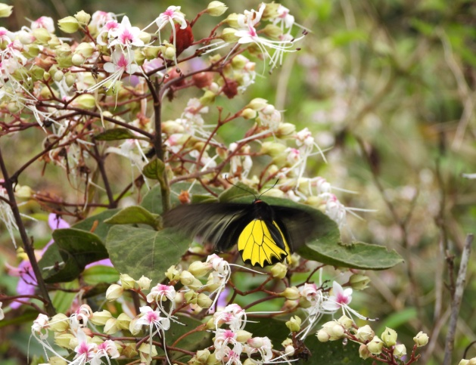
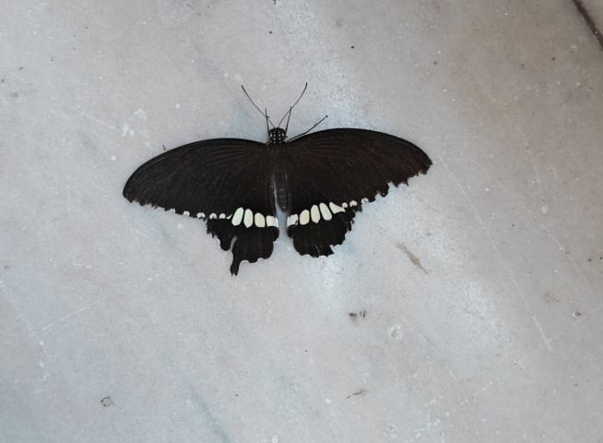

Common Mormon Golden Birdwing

Family: Pieridae
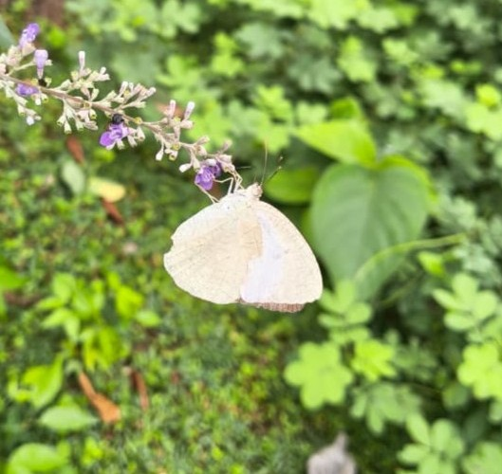
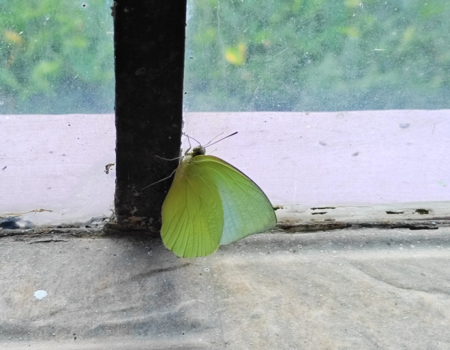

Common Emigrant Mottled Emigrant

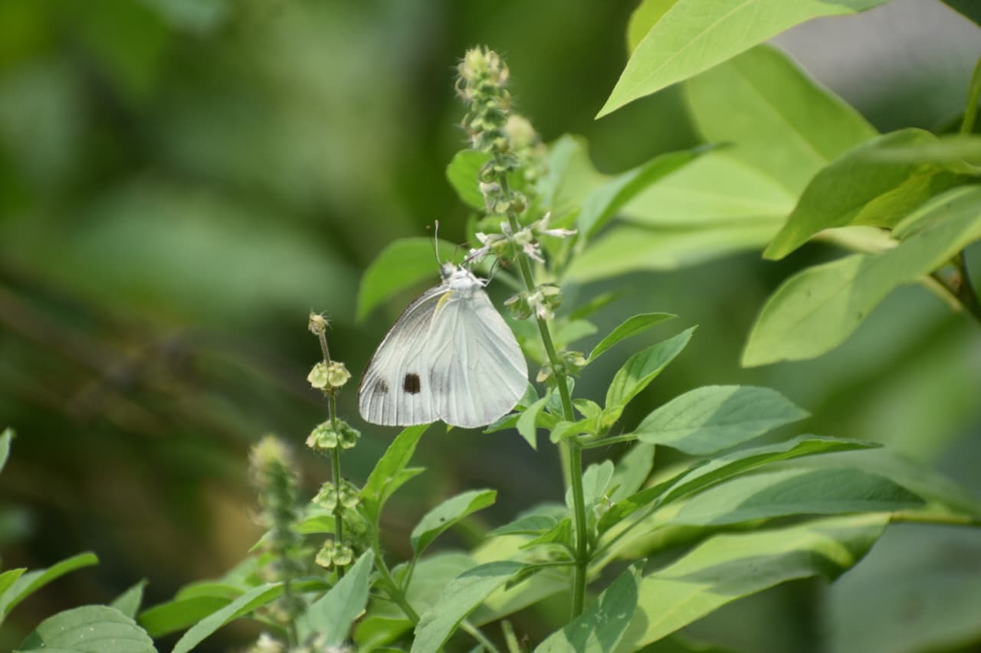
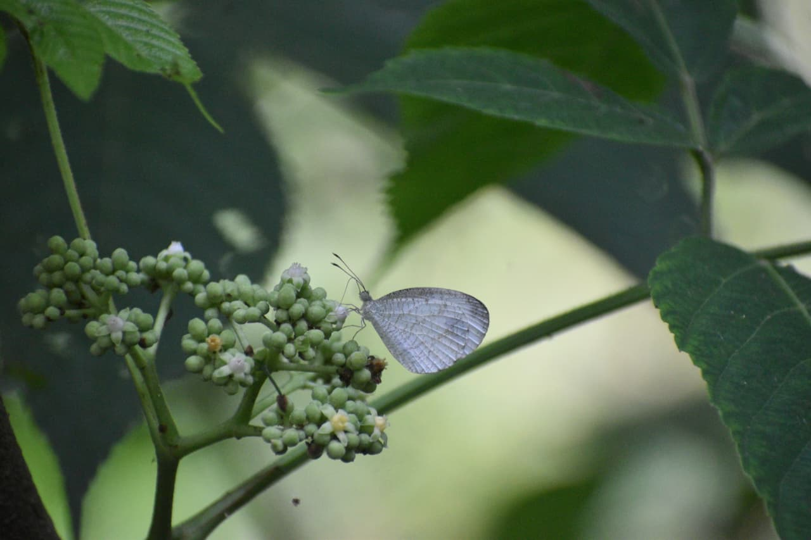

Psyche Indian Cabbage White
Family: Lycaenidae
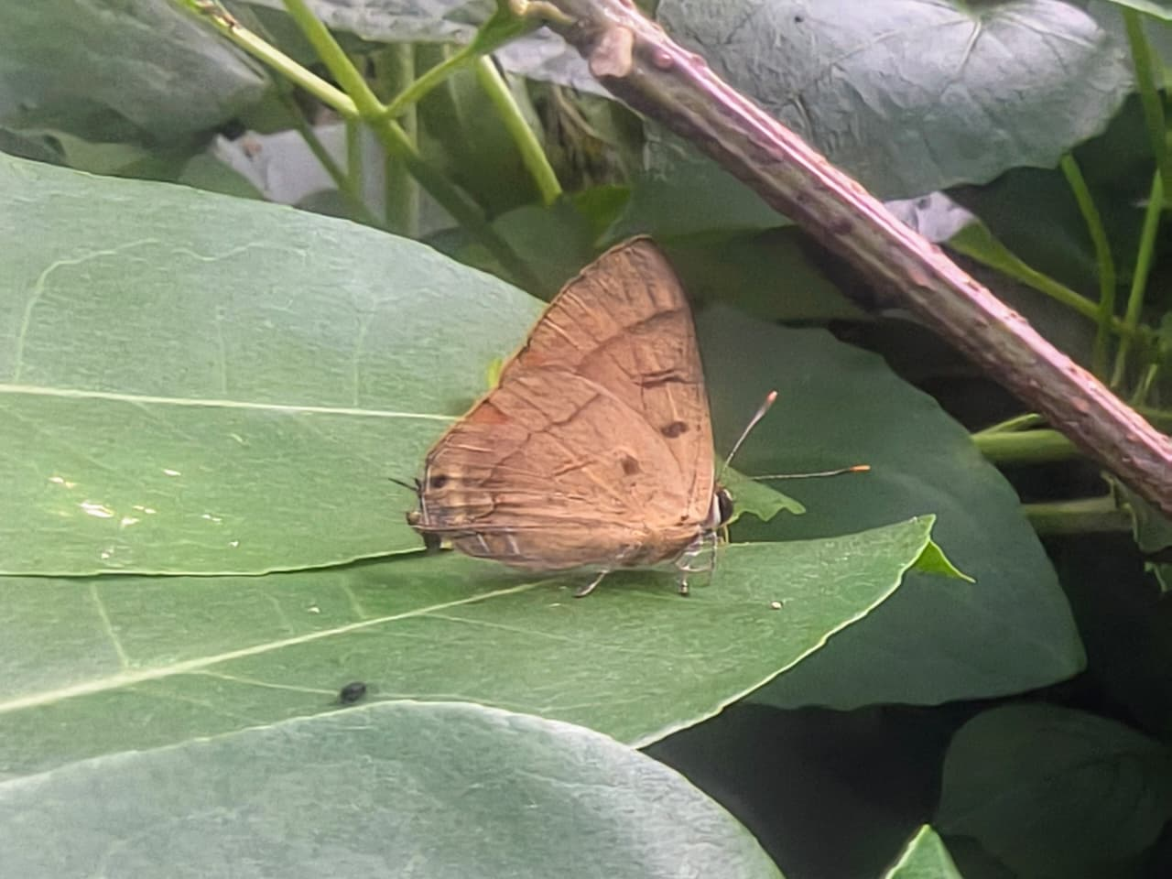
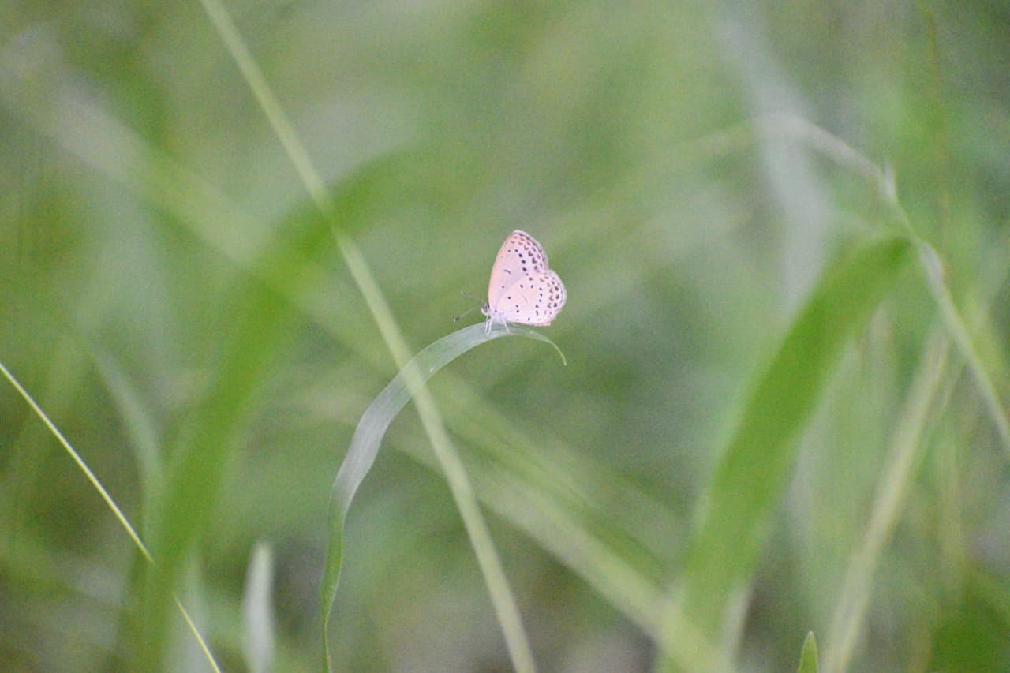

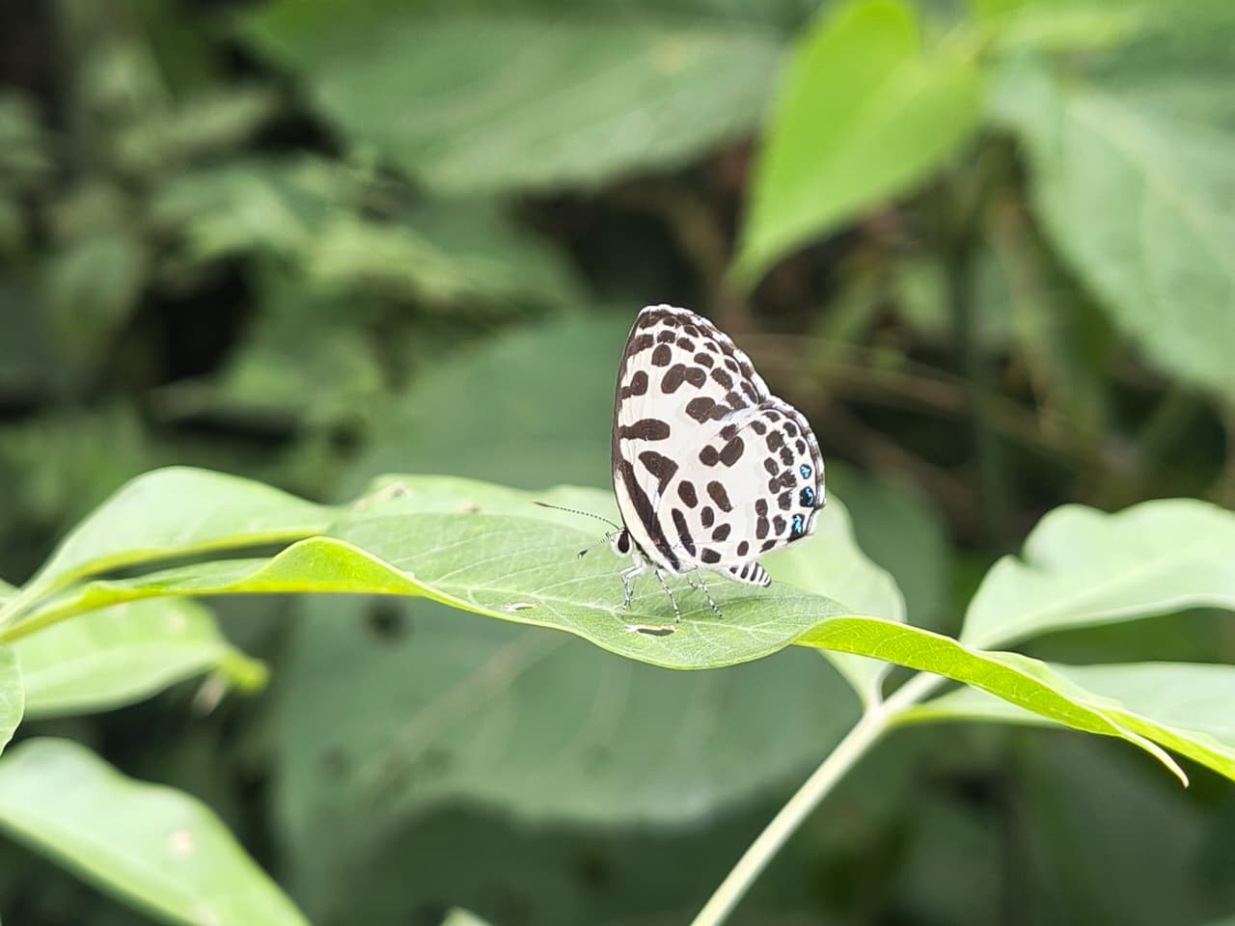
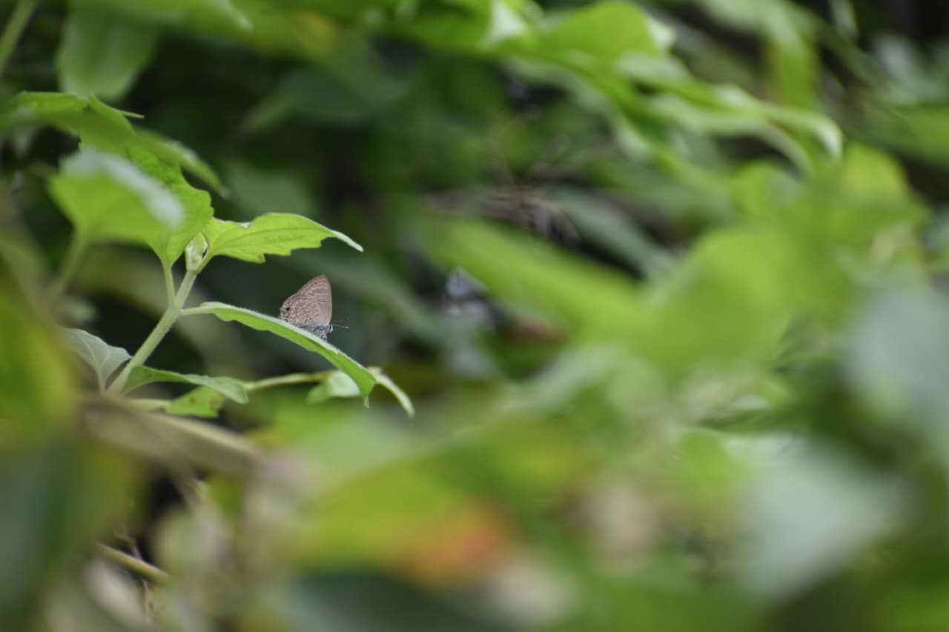
Pale Grass Blue Copper Flash

Common Pierrot Common Climate Blue
Family: Nymphalidae
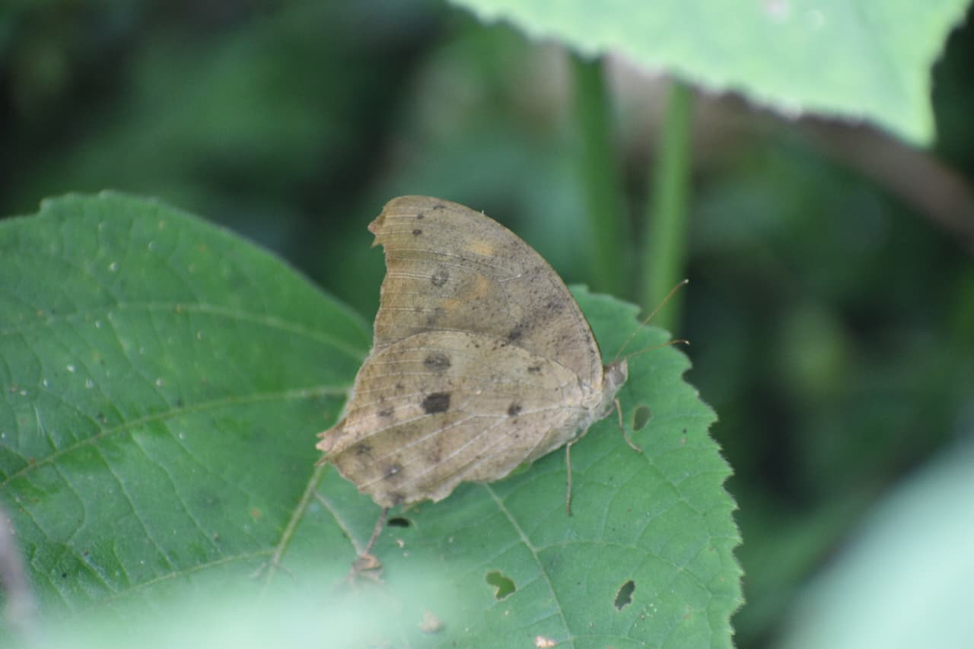
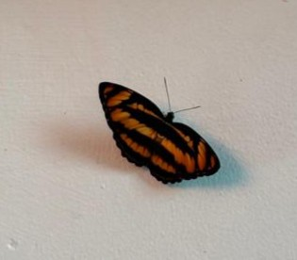

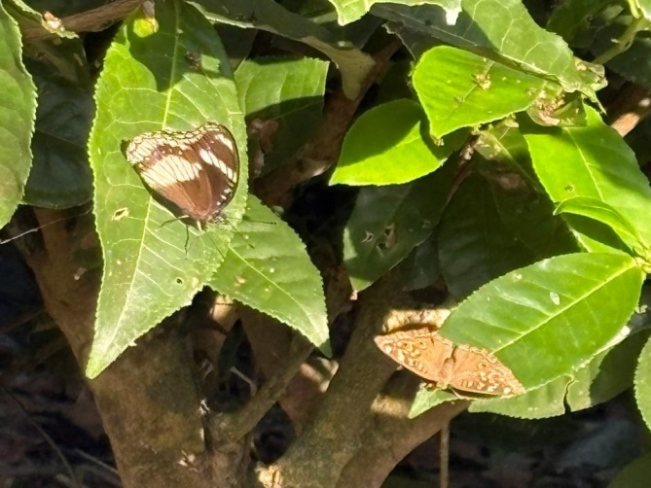
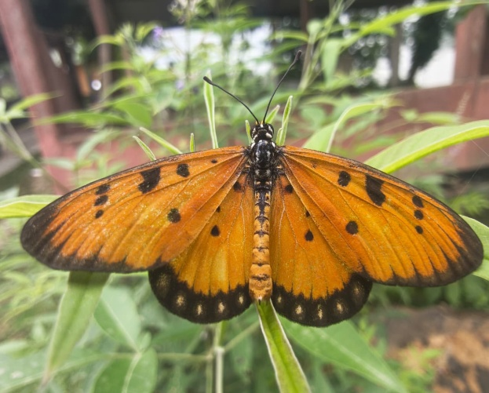
Colour Sergeant Common Evening Brown

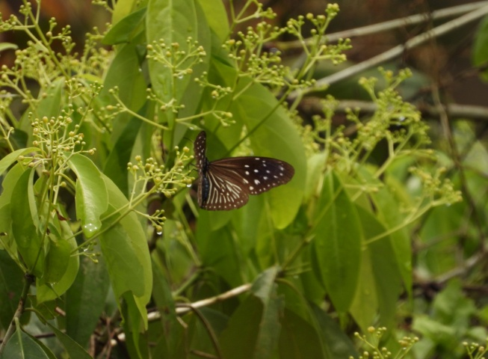
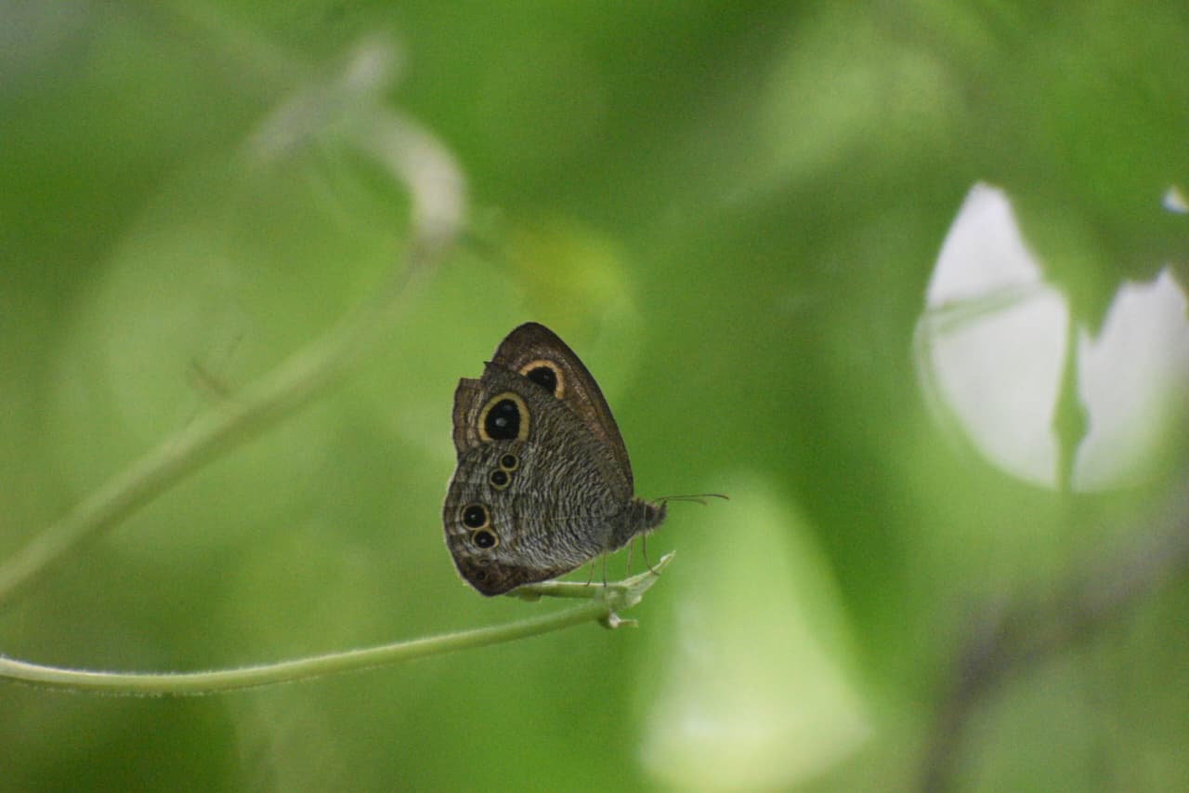
Tawny Coster Great Eggfly& Lemon Pansy

Common Five-ring Striped Blue Crow
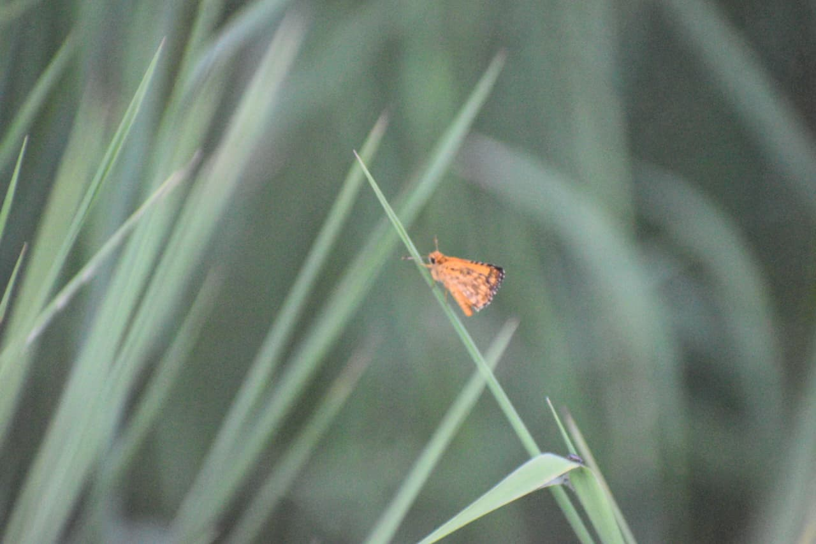
Family:Hesperiidae
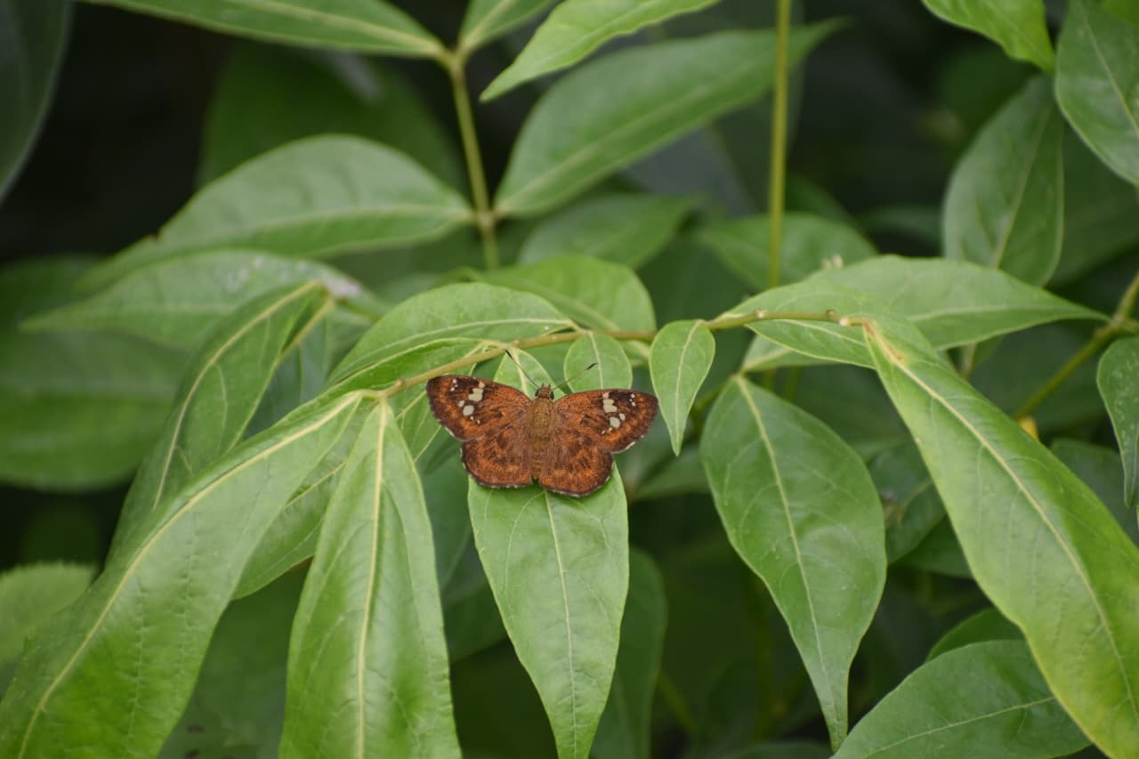
Fulvous Pied Flat Common Bush Hopper

