Original Research Article
Range Extension and New Record of Labeo rajasthanicus (Datta & Majumdar, 1970) (Cypriniformes: Cyprinidae) in the Bhima River Basin, Maharashtra, India

Abstract
Labeo rajasthanicus (Datta & Majumdar, 1970) was originally described from Jaisamand Lake, Rajasthan, and was later considered taxonomically uncertain due to the absence of subsequent records and the loss of the original type material. The species was subsequently confirmed to be valid following a reassessment of the Labeo gonius subgroup and the designation of a neotype. The present study reports the occurrence of L. rajasthanicus from the Bhima River basin, Maharashtra, India, based on two specimens collected from the confluence region of the Mula Mutha and Bhima rivers at 18°34'01.7"N and 74°20'34.1"E. Morphometric and meristic characters were examined using standard taxonomic procedures. The specimens measured 172.88–179.61 mm in standard length and showed diagnostic characters consistent with L. rajasthanicus, including 57–58 lateral-line scales, 19–20 predorsal scales, 24–26 circumpeduncular scale rows, 41–47 circumferential scale rows, and a dorsal-fin formula of iii-12. These features distinguish the specimens from closely related congeners such as L. shivamogaensis, L. dussumieri, L. boggut, and L. gonius. The present record extends the known distribution of L. rajasthanicus from its previously documented range in Rajasthan to the Bhima River basin in Maharashtra. This finding adds to current knowledge of the species’ distribution and highlights the need for further ichthyofaunal surveys in Indian river systems.
KEYWORDS: Cyprinidae, Labeo, Bhima River, Western Ghats, Peninsular India.

- INTRODUCTION
The genus Labeo Cuvier, 1816, comprises 28 species widely distributed across South and South-East Asia (Jayaram, 2010). Within this genus, the gonius subgroup is characterised by high lateral-line scale counts exceeding 50 (Jayaram & Dhas, 2000). Labeo rajasthanicus was first described by Datta and Majumdar (1970) based on a single specimen from Jaisamand Lake, Udaipur, Rajasthan. For many years, its taxonomic status was unstable due to the lack of subsequent reports and the loss of the original holotype, leading some authorities to synonymise it with L. boggut (Jayaram & Dhas, 2000; Talwar & Jhingran, 1991). However, detailed morphological and molecular analyses (Lal et al., 2015) confirmed its status as a valid species, distinct from L. gonius and L. boggut. Although previously thought to be endemic to Western Rajasthan, it is considered rare and difficult to capture (Jayaram & Dhas, 2000; Pethiyagoda, 1991). The primary research gap lies in the undocumented distribution of Labeo rajasthanicus outside its historically assumed endemic range in Western Rajasthan, which has limited understanding of its biogeography and conservation needs in Peninsular India. The documentation of such geographical range extensions is critical, as contemporary ichthyofaunal checklists across Western Ghats river systems continue to uncover high levels of endemism alongside escalating anthropogenic threats (Tandel et al., 2026). Significant findings, such as the first record of the Sri Lankan endemic Labeo fisheri from the upstream reaches of the Tamiraparani River within the Kalakkad Mundanthurai Tiger Reserve (Anusha et al., 2017), further emphasise the necessity for ongoing exploration of specialised riverine ecosystems. These records illustrate that the distributions of rare species may extend far beyond their historically assumed ranges, as seen with the range of L. fisheri extending from the mountain streams of Sri Lanka to peninsular India. Recent basin- and site-scale studies of freshwater fishes in the Bhima River, other Western Ghats rivers, and river confluences in Maharashtra similarly support continued ichthyofaunal documentation and distributional assessment (Dwivedi & De, 2024; Hanna & George, 2026; Narasimmarajan et al., 2025; Talmale & Bansod, 2026). Recent taxonomic work within the genus Labeo in peninsular India also provides additional context for the value of detailed taxonomic assessment in resolving species-level diversity (Kumar et al., 2026). Consequently, the objective of this study is to report a significant new record and major range extension of L. rajasthanicus from the Bhima River basin in Maharashtra. By providing essential morphological and meristic evidence, this research confirms the taxonomic presence of the species within the Western Ghats biodiversity hotspot, fundamentally updating its known biogeography.
2. STUDY AREA
The occurrence of L. rajasthanicus is reported from the Bhima River, Maharashtra, with specimens collected in the Western Ghats at coordinates 18°34'01.7"N and 74°20'34.1"E, situated just above the confluence of the Mula Mutha and Bhima rivers (Figure 1). This location is geographically distant from the species’ previously known habitats, which included the Mahi-Som River system (Tidi River and Jaisamand Lake) and the Yamuna-Ganga tributary system (Chambal River) in Rajasthan.

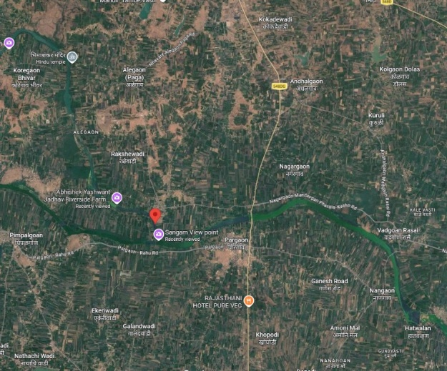

Figure 1. Sampling location of Bhima River, Maharashtra, India.
3. METHODOLOGY
Fish specimens were collected using cast nets and gill nets of varying mesh sizes (8–16 mm) and preserved in 10% formalin. Morphometric measurements were taken point-to-point using digital calipers following the methods of Hubbs and Lagler (1964). Fish collections were made between 2022 and 2023 at river sites by P. Sivakumar and J. Anusha. Preanal scales (Jayaram, 1991) are the scales from the anus to the isthmus. The meristic character of lateral transverse scale (L.tr.) rows was described by Day (1889) as the “number of longitudinal rows of scales between the back and abdomen, usually counted, unless some other part of the side is specified, from the anterior end of the dorsal fin to the ventral”. Morphometric characters 9, 18-25, 29-31, and 35-36 represent additional truss characters (Strauss & Bookstein, 1982). Body measurements are expressed as a percentage of standard length (%SL), and head measurements as a percentage of head length (%HL). Total length (TL) was also used for comparison.
Abbreviations used are: ZSI/SRS (Zoological Survey of India, Southern Regional Station, Chennai), CUKMNHF (Central University of Kerala, Museum of Natural History, Kasargod), MCMNH (Madura College, Museum of Natural History, Madurai), and CPSK (Collection of P. Sivakumar).

Materials examined and comparative materials:
Labeo rajasthanicus MCMNH, 354 (2 ex.), 172.88 - 179.61 mm SL, confluence of the Mula Mutha and Bhima rivers, Maharashtra (18°34'01.7"N and 74°20'34.1"E), collected by P. Sivakumar and J. Anusha, 2023.
Labeo shivamogaensis sp. nov.: CUKMNHF1, 138.7 mm SL; India: Bhadra Reservoir, Shimoga, Karnataka; collected by Arunachalam and P. Sivakumar.
Labeo shivamogaensis: CPSK 397, F 4, 108.2-131.74 mm SL; India: Bhadra Reservoir, Shimoga, Karnataka; collected by Arunachalam and P. Sivakumar.
Labeo dussumieri: CMA 355 (12 ex.), 84.61-97.98 mm SL, Alappuzha, Kerala (N 9° 29' 53.43”, E 76° 20’03.52”), collected by M. Arunachalam, P. Sivakumar, and C. Vijayakumar, 22 November 2011.
Labeo boggut: ZSI/SRS unregistered (1 ex.), 189.5 mm SL, fish market at Wari, Satara District, Krishna River, Maharashtra (N 17° 41', E 74° 0' 3.3768''), collected by KCJ & Party, 9 March 1990.
Labeo gonius: CPSK 351 (6 ex.), 113.21 – 142.12 mm SL, Charadwar market, Dhemaji District, Brahmaputra River, Assam (N 27° 17’11”, E 94º 35' 05''), collected by M. Arunachalam, P. Sivakumar, and C. Vijayakumar, 12 November 2010.
Labeo gonius: CPSK 353 (1 ex.), 90.34 mm SL, Manorama River, Pakhra post, Basti District, Uttar Pradesh (N 26º 44' 19.3'', E 82º38' 02.7''), collected by M. Arunachalam, P. Sivakumar, and C. Vijayakumar, 26 March 2011.
4. RESULTS
Labeo rajasthanicus
(Figure 2; Tables 1-3)
4.1 Diagnosis: Labeo rajasthanicus is distinguished from its congeners by possessing 57–58 lateral-line scales without a red tinge, whereas L. shivamogaensis, L. dussumieri, L. boggut, and L. gonius exhibit counts of 50–51, 52–54, 62, and 76–82, respectively. It is specifically differentiated from L. shivamogaensis (Arunachalam et al., 2018) by having fewer predorsal scales (19–20 vs. 22–24), fewer circumpeduncular scale rows (24–26 vs. 26–29), and fewer circumferential scale rows (41–47 vs. 56–63). From L. dussumieri, it is distinguished by a higher number of circumpeduncular scale rows (24–26 vs. 22–23) and more upper transverse rows (10.5–11.5 vs. 8.5–9.5). Compared to L. boggut, this species possesses fewer predorsal scales (19–20 vs. 23–24), fewer circumpeduncular scale rows (24–26 vs. 30), and significantly fewer pre-anal scale rows (43–45 vs. 65–66). It is further separated from L. gonius by its lower counts of upper transverse scale rows (10.5–11.5 vs. 15.5–17.5) and circumpeduncular scale rows (24–26 vs. 30–35). Additionally, morphometric characters distinguish it from L. gonius, specifically a shorter distance from the dorsal-fin origin to the pectoral-fin insertion (19.17–19.99% vs. 21.95–26.79% SL) and a shorter upper jaw length (24.60–25.89% vs. 24.64–31.95% HL).
The specimens collected from Maharashtra (172.88–179.61 mm SL) exhibit a gently arched dorsal profile and a body depth of 23.27–24.78% SL.
Figure 2. Labeo rajasthanicus: (a) Original drawing by Datta and Majumdar (1970), (b) lateral view, (c) ventral view of mouth, SL. 172.88 mm.

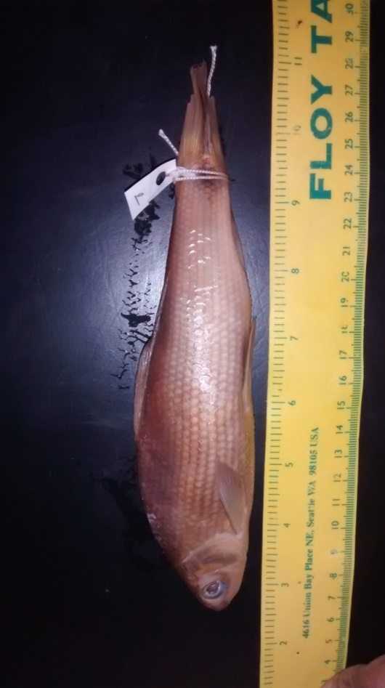
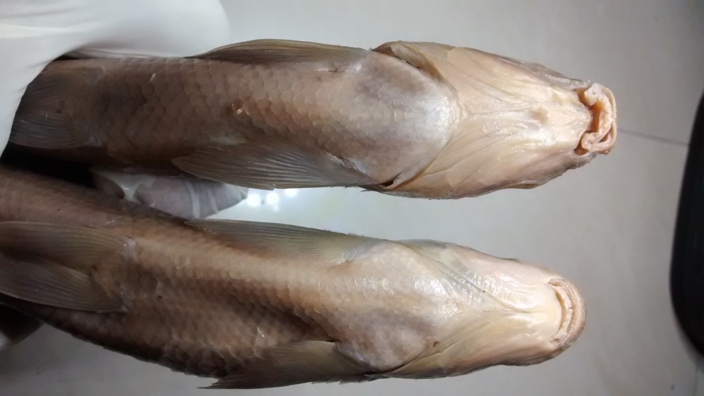
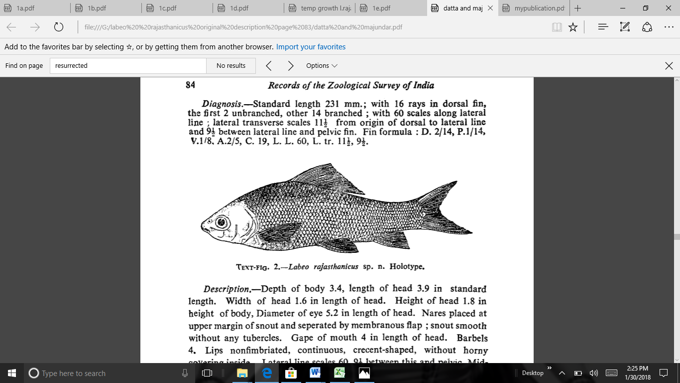
aigures 3 Labeo gonius: (a) Original drawing by Hamilton (1822), (b) Lateral view,
(c) Ventral view .of mouth
.
b
c

4.2 Description
Counts and measurements are based on 2 specimens measuring 172.88 to 179.61 mm SL (Table 1). The dorsal profile is gently arched, with a body depth of 23.27 - 24.78 (24.03±0.76) %SL; the dorsal-fin origin is vertically anterior to the pelvic-fin insertion by a distance of 4 scale rows; the pre-dorsal distance is 43.87 - 46.58 (45.23±1.36) %SL; the pre-pelvic distance is 49.58 - 52.26 (50.92±1.34) %SL; the pre-anal length is 76.25 - 78.75 (77.50±1.25)% SL; the pre-pectoral length is 23.94 - 24.73 (24.34±0.40) % SL; and the distance from the pelvic-fin insertion to the anal-fin origin is 21.41 - 23.91 (22.66±1.25)%SL. The nape is convex, following a concavity in the margin at the occiput. The caudal peduncle is moderately deep, with a depth at its narrowest region of 10.39 - 11.31 (10.85±0.46) %SL; the caudal-peduncle length is 14.03 - 14.95 (14.49±0.46) %SL.
The head is short, 25.54 - 25.89 (25.72±0.18) %SL, with a short cranium of 69.67 - 75.51 (72.59±2.92) %HL; head depth at the nostril is 29.99 - 34.96 (32.48±2.49) %HL, at the orbit 53.32 - 54.53 (53.93±0.61) %HL, and at the occiput 66.70 - 68.54 (67.62±0.92) %HL. The preopercle is straight, with a snout-to-opercle distance of 66.87 - 66.89 (66.88±0.01) % HL. The interorbital space is more or less flat, with a width of 47.13 - 48.08 (47.61±0.47) %HL. The eye is moderate, 22.83 - 24.85 (23.84±1.01) % HL. The snout is produced and depressed, with tubercles; snout length is 34.43 - 36.08 (35.26±0.82) % HL, and numerous pores are present on the snout. The lips are thick, with a distinct inner fold around the entire circumference, and both are fringed. Gape width is 21.09 - 23.96 (22.53±1.44) %HL. A cartilaginous covering is present on the inner side of both jaws. The length of the maxillary barbel is 9.01 - 12.36 (10.69±1.68) %HL, and that of the rostral barbel is 1.36 - 4.34 (2.85±1.49) %HL (Table 2).

Table 1 Proportional values of morphometric body characters are represented as % standard length of Labeo rajasthanicus from the confluence of Mula Mutha and Bhima River (n=2).

Measurements from point to point | 1 | 2 | Min. | Max. | Avg. | SD.
Standard length (mm) | 179.61 | 172.88 | 172.88 | 179.61
% of Standard length
Snout to urocentrum | 95.31 | 96.24 | 95.31 | 96.24 | 95.78 | 0.46
Pre-anal length | 76.25 | 78.75 | 76.25 | 78.75 | 77.50 | 1.25
Pre-dorsal length | 43.87 | 46.58 | 43.87 | 46.58 | 45.23 | 1.36
Pre-pelvic length | 52.26 | 49.58 | 49.58 | 52.26 | 50.92 | 1.34
Pre-pectoral length | 24.73 | 23.94 | 23.94 | 24.73 | 24.34 | 0.40
Caudal peduncle length | 14.95 | 14.03 | 14.03 | 14.95 | 14.49 | 0.46
Dorsal-fin origin to pelvic-fin insertion | 25.72 | 25.27 | 25.27 | 25.72 | 25.50 | 0.23
Dorsal spinous height | 11.13 | 13.08 | 11.13 | 13.08 | 12.11 | 0.98
Anal fin height | 17.17 | 16.84 | 16.84 | 17.17 | 17.01 | 0.17
Depth of caudal peduncle | 10.39 | 11.31 | 10.39 | 11.31 | 10.85 | 0.46
Caudal fin length | 28.59 | 31.09 | 28.59 | 31.09 | 29.84 | 1.25
Dorsal fin height | 20.28 | 20.84 | 20.28 | 20.84 | 20.56 | 0.28
Pectoral fin length | 18.97 | 21.11 | 18.97 | 21.11 | 20.04 | 1.07
Pelvic fin length | 17.08 | 18.75 | 17.08 | 18.75 | 17.92 | 0.84
Pelvic axillary scale length | 3.89 | 5.95 | 3.89 | 5.95 | 4.92 | 1.03
Occiput to dorsal origin | 24.84 | 29.48 | 24.84 | 29.48 | 27.16 | 2.32
Occiput to pectoral-fin insertion | 19.17 | 19.99 | 19.17 | 19.99 | 19.58 | 0.41
Occiput to pelvic-fin insertion | 41.63 | 42.14 | 41.63 | 42.14 | 41.89 | 0.25
Dorsal-fin insertion to pelvic-fin insertion | 22.60 | 22.40 | 22.40 | 22.60 | 22.50 | 0.10
Dorsal-fin origin to pectoral-fin insertion | 25.52 | 26.98 | 25.52 | 26.98 | 26.25 | 0.73
Dorsal-fin origin to anal origin | 39.52 | 42.02 | 39.52 | 42.02 | 40.77 | 1.25
Dorsa-fin insertion to caudal fin | 32.51 | 33.70 | 32.51 | 33.70 | 33.11 | 0.60
Dorsal-fin insertion to anal-fin origin | 20.82 | 20.92 | 20.82 | 20.92 | 20.87 | 0.05
Dorsal-fin insertion to anal-fin insertion | 23.86 | 24.70 | 23.86 | 24.70 | 24.28 | 0.42
Dorsal-fin base length | 20.87 | 24.64 | 20.87 | 24.64 | 22.76 | 1.89
Anal-fin base length | 7.09 | 6.74 | 6.74 | 7.09 | 6.92 | 0.18
Pectoral-fin insertion to pelvic-fin insertion | 29.09 | 25.84 | 25.84 | 29.09 | 27.47 | 1.63
Pectoral-fin insertion to anal-fin origin | 50.59 | 50.42 | 50.42 | 50.59 | 50.51 | 0.09
Pelvic-fin insertion to anal-fin origin | 21.41 | 23.91 | 21.41 | 23.91 | 22.66 | 1.25
Total length (mm) | 123.77 | 127.71 | 123.77 | 127.71 | 125.74 | 1.97
Post-dorsal length | 52.49 | 57.84 | 52.49 | 57.84 | 55.17 | 2.68
Body depth | 23.27 | 24.78 | 23.27 | 24.78 | 24.03 | 0.76
Distance between pectoral fin and vent | 48.04 | 49.58 | 48.04 | 49.58 | 48.81 | 0.77
Distance between pelvic fin and vent | 20.20 | 23.52 | 20.20 | 23.52 | 21.86 | 1.66

Table 2 Proportional values of morphometric head characters are represented as % head length of Labeo rajasthanicus from the confluence of Mula Mutha and Bhima River (n=2).
Measurements from point to point | 1 | 2 | Min. | Max. | Avg. | SD.
Head length (mm) | 46.51 | 44.15 | 44.15 | 46.51
% of Head length
Pre-occipital length | 75.51 | 69.67 | 69.67 | 75.51 | 72.59 | 2.92
Snout to opercle | 66.87 | 66.89 | 66.87 | 66.89 | 66.88 | 0.01
Upper jaw length | 24.60 | 25.89 | 24.60 | 25.89 | 25.25 | 0.65
Snout length | 36.08 | 34.43 | 34.43 | 36.08 | 35.26 | 0.82
Pre- nasal length | 25.74 | 25.39 | 25.39 | 25.74 | 25.57 | 0.17
Orbit width | 24.85 | 22.83 | 22.83 | 24.85 | 23.84 | 1.01
Inter-orbital width | 48.08 | 47.13 | 47.13 | 48.08 | 47.61 | 0.47
Inter -nasal width | 30.38 | 31.60 | 30.38 | 31.60 | 30.99 | 0.61
Head width | 58.85 | 59.23 | 58.85 | 59.23 | 59.04 | 0.19
Gape width | 21.09 | 23.96 | 21.09 | 23.96 | 22.53 | 1.44
Lower jaw to isthmus | 56.59 | 49.24 | 49.24 | 56.59 | 52.92 | 3.68
Head depth at nostril | 34.96 | 29.99 | 29.99 | 34.96 | 32.48 | 2.49
Head depth at pupil | 54.53 | 53.32 | 53.32 | 54.53 | 53.93 | 0.61
Head depth at occiput | 66.70 | 68.54 | 66.70 | 68.54 | 67.62 | 0.92
Maxillary barbel length | 12.36 | 9.01 | 9.01 | 12.36 | 10.69 | 1.68
Rostral barbel length | 4.34 | 1.36 | 1.36 | 4.34 | 2.85 | 1.49

4.3 Fins
Dorsal-fin rays iii-12 (2); pectoral-fin rays i-15 (2); pelvic-fin rays i-8 (2); anal-fin rays iii-5 (2); caudal-fin rays 10+9 (2) (Table 3). Dorsal-fin height is 20.28 - 20.84 (20.56±0.28) %SL; the fin is sharply pointed at its apex, commences much nearer to the snout than to the base of the caudal fin, and has a dorsal-spine length of 11.13 - 13.08 (12.11±0.98) %SL. The anal fin is short, 16.84 - 17.17 (17.01±0.17) %SL, and when depressed does not reach the caudal-fin base. The distal margin of the anal fin is straight when the fin is erect; the last two posterior rays are equal in length, and the tip of the longest ray is not rounded. The length of the anal-fin base is 6.74 - 7.09 (6.92±0.18)%SL. The pelvic fin is moderately long, 17.08 - 18.75 (17.92±0.84) %SL; the pectoral fin is moderately long, 18.97 - 21.11 (20.04±1.07) %SL, extending to 5 scales anterior to the pelvic-fin origin. The caudal fin is long and moderately forked, 28.59 - 31.09 (29.84±1.25) %SL, at 2.53 - 2.75 times the length of the shortest ray at the fin median.

Table 3 Meristic characters of Labeo rajasthanicus from the confluence of Mula Mutha and Bhima River (n=2).

Meristic counts | 1 | 2 | Min. | Max.
Unbranched dorsal fin rays | 3 | 3 | 3 | 3
Branched dorsal fin rays | 12 | 12 | 12 | 12
Unbranched anal fin rays | 3 | 3 | 3 | 3
Branched anal fin rays | 5 | 5 | 5 | 5
Unbranched pelvic fin rays | 1 | 1 | 1 | 1
Branched pelvic fin rays | 8 | 8 | 8 | 8
Unbranched pectoral fin rays | 1 | 1 | 1 | 1
Branched pectoral fin rays | 15 | 15 | 15 | 15
Caudal fin upper lobe | 6+9 | 6+9 | 6+9 | 6+9
Caudal fin lower lobe | 5+8 | 5+8 | 5+8 | 5+8
Lateral line scales | 57 | 58 | 57 | 58
Pre-dorsal scales | 20 | 19 | 19 | 20
Upper transverse rows | 10.5 | 11.5 | 10.5 | 11.5
Lateral line to pelvic scale rows | 7.5 | 7.5 | 7.5 | 7.5
Circumpeduncular scale rows | 24 | 26 | 24 | 26
Circumferential scale rows | 41 | 47 | 41 | 47
Transverse breast scale rows | 13 | 14 | 13 | 14
Anal scale rows | 3 | 3 | 3 | 3
Pre-anal scale rows | 43 | 45 | 43 | 45
Pre- pelvic scale rows | 26 | 27 | 26 | 27
Anal fin to lateral line scale rows | 7.5 | 8.5 | 7.5 | 8.5
Lateral transverse rows(L.tr.) | 11/7 | 12/8 | 11/7 | 12/8

4.4 Scales
The scales are relatively large; lateral-line scales 57(1), 58(1); pre-dorsal scales 19 (1), 20 (1); upper transverse scale rows 10.5 (1), 11.5 (1); scales from lateral-line to pelvic fin 7.5 (2); scales from lateral-line to anal fin 7.5 (1), 8.5 (1); circumpeduncular scale rows 24 (1), 26 (1); circumferential scale rows 41 (1), 47 (1); transverse breast scale rows 13 (1), 14 (1); pre-anal scales (anus to isthmus) 43 (1), 45 (1); anal scales (anus to anal fin) 3 (2) (Table 3).

4.5 Colour
In the preserved specimens, the colour is dark brown and light yellow beneath. On the dorsal surface, the scales are densely pigmented with fine melanophores, with a crescent of closely spaced melanophores at the posterior border of the exposed part of each scale, whereas all scales are pigment-free along the ventral scale row. Stripes parallel to the lateral line pass from the shoulder to the tip of the caudal peduncle, with a black blotch on either side of the caudal-fin base. The dorsal and caudal fins are dusky (Figure 2).
Distribution: India: Mahi-Som River system (Tidi River and Jaisamand Lake) and the Yamuna-Ganga tributary system (Chambal River) in Rajasthan. This species is currently recorded for the first time from the Bhima River, an east-flowing river in the Western Ghats of peninsular India.
Habitat and Ecology: Large-sized species in the genera Hypselobarbus, Tor and Labeo prefer deep-pool habitats in rivers (Sivakumar et al., 2024, 2025). Species of Labeo are essentially benthic feeders. The present collection of Labeo rajasthanicus is also from a deep pool with a depth range of 0.5-2.0 m.
5. DISCUSSION
The documentation of Labeo rajasthanicus in the Bhima River basin represents a major extension of its known geographical range into Peninsular India, fundamentally challenging the previous assumption that the species was endemic to isolated river systems in Western Rajasthan (Lal et al., 2015). Originally described by Datta and Majumdar (1970) from a single specimen in Jaisamand Lake, the species remained taxonomically unrecognised for nearly half a century and was frequently treated as a synonym of L. boggut (Jayaram & Dhas, 2000). The recent resurrection of the species and the designation of a neotype from the Tidi River by Lal et al. (2015) confirmed its status as a valid and distinct member of the gonius subgroup.
Morphologically, the specimens obtained from the confluence of the Mula Mutha and Bhima rivers exhibit a high degree of consistency with the neotype description provided by Lal et al. (2015). Notably, both the Maharashtra specimens and the neotype possess a dorsal-fin formula of iii, 12 (3 unbranched and 12 branched rays), showing no deviation in this critical meristic character despite the vast geographical distance between the populations. This alignment reinforces the taxonomic stability of the species across its expanded range. Furthermore, diagnostic characters such as 57–58 lateral-line scales and 19–20 predorsal scales distinguish it from related congeners such as L. shivamogaensis, L. dussumieri, L. boggut, and L. gonius (Arunachalam et al., 2018).
Ecologically, L. rajasthanicus prefers specialised deep-pool habitats (0.5–2.0 m) characterised by rocky substrates and low water velocity, a trait shared with other large benthic-feeding Labeo species (Arunachalam et al., 2005; Sivakumar et al., 2025). The broader genus Labeo is globally significant, representing nearly 19.6% of Asian cyprinid composition, yet natural populations are declining due to anthropogenic pressures such as overfishing and habitat degradation (Gupta & Banerjee, 2015; Sarma et al., 2017; Sivakumar et al., 2024, 2025). Furthermore, recent assessments of fish diversity patterns in Maharashtra emphasise that habitat degradation from activities such as mining and wastewater discharge remains a critical challenge for the conservation of indigenous species (Tandel et al., 2026). Additionally, laboratory studies by Paliwal et al. (2016) indicate that the species, locally known as "sarsi", has specific thermal requirements, with optimal growth occurring at temperatures near 30°C. This discovery in the Western Ghats suggests a much wider adaptive capacity and biogeographical presence than previously understood, making the preservation of these specialised riverine habitats a priority for regional biodiversity conservation.

6. CONCLUSION
The present study documents Labeo rajasthanicus in the Bhima River basin of Maharashtra on the basis of two specimens assessed through morphometric and meristic characters. The observed combination of 57–58 lateral-line scales, 19–20 predorsal scales, 24–26 circumpeduncular scale rows, 41–47 circumferential scale rows, and a dorsal-fin formula of iii-12 supports the identification of the specimens as L. rajasthanicus and differentiates them from the congeners examined for comparison. This occurrence extends the documented distribution of the species beyond its previously reported range in Rajasthan and adds information on its presence in Peninsular India. The finding is relevant to understanding the geographical distribution of this rarely recorded species, but its broader distribution and population status cannot be established from the present material alone. Additional ichthyofaunal surveys across the Bhima basin and adjoining river systems, using larger samples and broader spatial coverage, are required. Molecular confirmation, where feasible, would further support future assessments of the species’ distribution and taxonomic occurrence.
Limitation
The study is based on two specimens collected from a single locality in the Bhima River basin. Consequently, the available material is insufficient to assess within-population variation, population status, or the full geographic extent of the species in Maharashtra. Identification in the present study is based on morphometric and meristic evidence. Broader sampling across additional sites and seasons, together with molecular confirmation where feasible, would strengthen future assessment of the distribution and taxonomic occurrence of Labeo rajasthanicus.
ACKNOWLEDGEMENTS
The authors sincerely thank the SERB-Core Research Grant (Sanction No. SERB/CRG/2021/001711, dated 04.01.2022) for financial support for this study. We also thank Dr K. G. Sivaramakrishnan and Dr K. Venkatraman for their valuable encouragement, which enabled the successful completion of this work.

DECLARATION
The species investigated, Labeo rajasthanicus (locally known as "sarsi"), is a common minor carp that is regularly harvested for human consumption and holds significant market value in its regional fisheries. As the study utilized common food fish obtained from local fishermen (commercial sources) and does not involve the use of endangered or protected fauna for laboratory experimentation, formal institutional animal ethics clearance was not mandatory for this research.

COLLECTION PERMISSIONS:
Field collections for this study were conducted at riverine sites within the Bhima River basin in Maharashtra. Forest permission was not required as the collection sites are situated in open water bodies and do not fall under the jurisdiction of any protected area, national park, or reserved forest. All specimens were obtained through traditional collection methods.
Declaration of AI Use
This manuscript was prepared through the intellectual contributions of the author(s) to the study design, data analysis, interpretation of results, and scholarly content. Grammarly and ChatGPT were used solely to assist with grammatical refinement and reference formatting during manuscript revision. The author(s) accept full responsibility for the accuracy, integrity, and final content of the manuscript.
COMPETING INTERESTS DISCLAIMER:
Authors have declared that they have no known competing financial interests OR non-financial interests OR personal relationships that could have appeared to influence the work reported in this paper.
REFERENCES
Anusha, J., Arunachalam, M., & Sivakumar, P. (2017). New record of a Sri Lankan endemic species Labeo fisheri (Jordan and Starks, 1917; Cypriniformes: Cyprindae) from Kalakkad Mundanthurai Tiger Reserve, Tamil Nadu, India. Trends in Fisheries Research, 6(2), 19–23.
Arunachalam, M., Anusha, J., & Sivakumar, P. (2018). New species of Labeo Cuvier (Cypriniformes: Cyprinidae) from Bhadra River, Karnataka region of Western Ghats, peninsular India. Trends in Fisheries Research, 7(3), 50–56.
Arunachalam, M., Sivakumar, P., & Muralidharan, M. (2005). Habitat evaluation of pristine headwater streams of Western Ghats mountain ranges, peninsular India. In M. S. Johal (Ed.), Proceedings of the National Seminar: New Trends in Fishery Development in India (pp. 253–286). Panjab University.
Datta, A. K., & Majumdar, N. (1970). Fauna of Rajasthan, India. Part 7. Fishes. Records of the Zoological Survey of India, 62(1–2), 63–100. https://www.gbif.org/species/5206046
Day, F. (1889). The fauna of British India, including Ceylon and Burma: Fishes (Vols. 1–2). Taylor & Francis. https://zsi.gov.in/fauna-of-india-fi-books-list
Dwivedi, A. K., & De, K. (2024). Spatial distribution patterns and beta diversity of fish communities in a tropical river basin of Deccan Plateau. Ecohydrology, 17(8), e2717. https://doi.org/10.1002/eco.2717
Gupta, S., & Banerjee, S. (2015). A review on Labeo calbasu (Hamilton) with an emphasis on its conservation. Journal of Fisheries, 3(3), 301–308. https://doi.org/10.17017/j.fish.107
Hanna, A., & George, R. P. (2026). Preliminary checklist of freshwater fishes from the Eraviperoor region of the Manimala River, Kerala, India. Asian Journal of Research in Zoology, 9(3), 9–16. https://doi.org/10.9734/ajriz/2026/v9i3284
Hubbs, C. L., & Lagler, K. F. (1964). Fishes of the Great Lakes region. University of Michigan Press. https://www.fishbase.se/References/FBRefSummary.php?ID=36769&database=FB
Jayaram, K. C. (1991). Revision of the genus Puntius Hamilton from the Indian region (Pisces: Cypriniformes, Cyprinidae, Cyprininae). Records of the Zoological Survey of India, Occasional Paper, 135, 1–178. https://zsi.gov.in/PDFVolumes/occpapers/135/index.pdf
Jayaram, K. C. (2010). The freshwater fishes of the Indian region (2nd rev. ed.). Narendra Publishing House. https://www.si.edu/object/siris_sil_962769
Jayaram, K. C., & Dhas, J. J. (2000). Revision of the genus Labeo Cuvier from the Indian region with a discussion on its phylogeny and zoogeography (Pisces: Cypriniformes, Cyprinidae, Cyprininae). Records of the Zoological Survey of India, Occasional Paper, 183, 1–143. https://faunaofindia.nic.in/PDFVolumes/occpapers/183/index.pdf
Kumar, R. G., Ravi, C., Krishnaprasoon, N. P., & Basheer, V. S. (2026). Labeo kaage sp. nov., a new species of cyprinid fish (Teleostei: Cyprinidae) from the Cauvery River basin, India. Journal of Fish Biology, 108(6), 2148–2158. https://doi.org/10.1111/jfb.70446
Lal, K. K., Gupta, B. K., Punia, P., Mohindra, V., Saini, V. P., Dwivedi, A. K., Singh, R. K., Dhawan, S., Luhariya, R. K., Basheer, V. S., & Jena, J. K. (2015). Revision of gonius subgroup of the genus Labeo Cuvier, 1816 and confirmation of species status of Labeo rajasthanicus (Cypriniformes: Cyprinidae) with designation of a neotype. Indian Journal of Fisheries, 62(4), 10–22. https://epubs.icar.org.in/index.php/IJF/article/view/39118
Narasimmarajan, K., Atkore, V., Palanivel, S., Mathai, M. T., & Johnson, J. A. (2025). Fish diversity and habitat preference of a few endemic and threatened freshwater fishes of Western Ghats's Moyar River, India. Tropical Ecology, 66(4), 611–621. https://doi.org/10.1007/s42965-025-00405-9
Paliwal, D., Saini, V. P., Sharma, O. P., Ojha, M. L., & Jain, H. K. (2016). The effect of rearing temperature on growth and survival of Labeo rajasthanicus spawn. International Journal of Fisheries and Aquatic Studies, 4(3), 599–603. https://www.fisheriesjournal.com/archives/?ArticleId=799&issue=3&part=H&vol=4&year=2016
Pethiyagoda, R. (1991). Freshwater fishes of Sri Lanka. Wildlife Heritage Trust of Sri Lanka. https://www.fishbase.se/references/FBRefSummary.php?id=6028&speccode=286&syncode=22942
Sarma, K. J., Prajapati, M., & Mankodi, P. C. (2017). Morphological description and taxonomic account of Labeo species (Cypriniformes, Family: Cyprinidae) from Gujarat, India. Journal of Entomology and Zoology Studies, 5(4), 1120–1125.
Sivakumar, P., Anusha, J., Vijayakumar, C., Prasada Rao, A. V., Premjith Jinham, A., & Kumar, K. (2024). Fish assemblages and stream habitat types in South Indian streams. Journal of Advanced Zoology, 45(S3), 44–54. https://doi.org/10.53555/jaz.v45iS3.4252
Sivakumar, P., Anusha, J., Walter Devaa, J. C., & Shanthipreya, N. (2025). Habitat utilization and preference of cyprinid fishes in the Western Ghats streams of South India. Journal of Advanced Zoology, 46(2), 109–125. https://doi.org/10.53555/jaz.v46i2.5230
Strauss, R. E., & Bookstein, F. L. (1982). The truss: Body form reconstructions in morphometrics. Systematic Zoology, 31(2), 113–135. https://doi.org/10.1093/sysbio/31.2.113
Talmale, A. D., & Bansod, D. S. (2026). Diversity, threats, and conservation of catfishes (Siluriformes) at the Wainganga-Chulbandh River confluence, Soni-Chapral, Maharashtra, India. Journal of Biology and Nature, 18(2), 257–269. https://doi.org/10.56557/joban/2026/v18i210863
Talwar, P. K., & Jhingran, A. G. (1991). Inland fishes of India and adjacent countries (Vols. 1–2). Oxford & IBH Publishing.
Tandel, L., Sukham, M., Choudhary, S., Mandal, S., Ramteke, K., Sajina, A. M., & Singh, A. (2026). An annotated checklist of freshwater fishes of the Ulhas River, Western Ghats, India: Diversity patterns, habitat associations and conservation implications. Indian Journal of Animal Research. Advance online publication. https://doi.org/10.18805/IJAR.B-5756

