Acute Cadmium Toxicity and Behavioural Responses in Channa gachua (Hamilton): A 96-h Probit Bioassay

Abstract
Background: Cadmium (Cd) is a persistent, non-essential heavy metal that enters aquatic ecosystems through industrial, agricultural, and urban effluents, posing a severe threat to freshwater fish. Channa gachua (Hamilton), a facultative air-breathing snakehead widely distributed across South and Southeast Asian wetlands, is repeatedly exposed to surface-water contaminants owing to its aerial respiration behaviour, yet no published study has determined the acute toxicity of cadmium chloride (CdCl₂) in this species. Methods: A static-renewal 96-h acute toxicity bioassay was conducted using five nominal CdCl₂ concentrations (28, 30, 32, 34 and 36 mg/L) in triplicate, with 10 fish per replicate aquarium (30 fish per concentration). Mortality was recorded at 24, 48, 72 and 96 h, and median lethal concentrations (LC50) were estimated by Finney’s probit method (Finney, 1971). Behavioural and morphological alterations were monitored qualitatively throughout the exposure period, and representative photographs were recorded. Results: Mortality increased in a clear concentration- and time-dependent manner. The 96-h LC50 was estimated at 28.8 mg/L (regression: y = −18.82 + 16.32x; log-probit basis), with LC50 declining progressively from 38.7 mg/L (24 h, extrapolated) to 34.1 mg/L (48 h) and 31.5 mg/L (72 h). Exposed fish showed concentration-dependent behavioural disturbances consistent with those reported for the congener Channa punctatus. Conclusion: Channa gachua displays a clear dose- and time-dependent acute toxicity response to CdCl₂, with a 96-h LC50 of 28.8 mg/L, which is positioned within the wide 6.19–80.62 mg/L range reported across independent congeneric determinations for Channa punctata, reflecting both genuine interspecific variation and substantial methodological heterogeneity in the existing literature that merits further controlled, side-by-side investigation.
Keywords: Acute toxicity; Behavioural toxicology; Cadmium chloride; Channa gachua; LC50

1. Introduction
Heavy metal contamination of freshwater ecosystems has become a major environmental concern worldwide, driven by industrial discharge, mining effluents, agricultural run-off and untreated urban waste. Among these pollutants, cadmium (Cd) is of particular toxicological significance: it is non-essential to biological systems, persists indefinitely in aquatic sediments, bioaccumulates along the food chain, and exerts toxic effects on fish even at low, environmentally realistic concentrations (Yu et al., 2024; World Health Organization, 1992). Fish are especially vulnerable to waterborne cadmium because of continuous gill-mediated exposure, and acute cadmium toxicity has been documented to disrupt osmoregulation, haematopoiesis, hepatic and renal function, and neurobehavioural performance across numerous freshwater species. Complementing this evidence, acute cadmium exposure in Nile tilapia has been associated with haematological alterations, while a recent Asian seabass study documented tissue-specific cadmium accumulation (Isiyaku & Mohammed, 2021; Raj et al., 2025).
Comparative evidence indicates that acute cadmium sensitivity in freshwater fishes is influenced by both intrinsic and extrinsic factors, including body size, respiratory strategy, ionic conditions, and branchial physiology. A systematic analysis of freshwater-fish LC50 data found substantial variation among respiratory groups, while experimental studies have shown that waterborne cadmium can interfere with branchial calcium uptake and ion regulation. Accordingly, species-specific LC50 values are most appropriately interpreted within the physicochemical and physiological context of the test system rather than as fixed properties of the toxicant alone (Ferro et al., 2021; Garcia-Santos et al., 2006; Verbost et al., 1987). Recent studies in Channa punctatus and rainbow trout have also documented oxidative and tissue-level responses to cadmium exposure, further underscoring the need for species-specific interpretation (Saxena et al., 2025; Taysı, 2024).
Channa gachua (Hamilton, 1822), commonly known as the dwarf/frail snakehead, is a small, facultatively air-breathing fish widely distributed across the wetlands, ponds, and slow-moving streams of the Indian subcontinent and Southeast Asia. It possesses a suprabranchial accessory respiratory chamber that permits atmospheric air-breathing, supplementing branchial respiration under hypoxic conditions (Olson et al., 1994). This physiological trait, combined with its benthic, sluggish habit in shallow, often anthropogenically disturbed waters, makes Channa gachua an ecologically important bioindicator species that is physiologically distinct from obligate water-breathers (Tarigan et al., 2016). Because air-breathing fish must periodically surface to gulp air, they experience repeated direct contact with the air–water interface, a zone in which many waterborne contaminants – including heavy metals – tend to concentrate; comparative toxicological work has shown that air-breathing fish can display distinct, and sometimes heightened, ethological and haematological responses to metal toxicants relative to non-air-breathing species (Dhara et al., 2021).
Regarding its geographic status, Channa gachua is not an endemic species; it instead exhibits one of the broadest natural distributions within the genus Channa, occurring across at least 15 countries from Iran and Iraq in the west, through Afghanistan, Pakistan, Nepal, India, Bangladesh, Bhutan, Myanmar, Thailand, Laos, Cambodia and Vietnam, to Malaysia, Indonesia and southern China in the east (Froese & Pauly, 2019). Reflecting this wide range and ecological tolerance, the species is currently assessed as Least Concern on the IUCN Red List (Chaudhry, 2010). It should be noted, however, that C. gachua is now recognised as a species complex: populations formerly identified as C. gachua in Sri Lanka have since been reclassified as the locally endemic Channa kelaartii, and the morphologically similar Channa orientalis is likewise endemic to Sri Lanka, underscoring that regional taxonomic resolution within this complex remains incomplete and that toxicological reference values generated for mainland Indian populations, such as those used here, may not extrapolate uniformly across the species' full range.
Beyond its ecological role, Channa species, including Channa gachua, have considerable economic value across South and Southeast Asia. Snakeheads are among the most important staple food fishes of the region, prized for their taste, high protein content, low intramuscular bone content, and traditional use in wound-healing and post-operative recovery preparations (Ng & Lim, 1990). Small-bodied, brightly patterned species such as C. gachua additionally support a growing domestic and international ornamental fish trade: India's live Channa exports increased roughly six-fold between 2014 and 2019, and dwarf species are specifically sought after for community aquaria owing to their manageable size and colouration (Sharma et al., 2022). Consequently, cadmium-driven mortality or sub-lethal impairment of this species has tangible relevance not only for ecosystem health but also for the subsistence fisheries and ornamental trade that depend on it.
With respect to its abundance and distribution in the present study area, Channa gachua is a regularly recorded, locally common constituent of the small indigenous fish (SIF) fauna of the Gangetic floodplain wetlands of Bihar, the state from which the test specimens for this study were sourced (local fish vendor, Bazar Samiti, Patna). In a systematic ichthyofaunal survey of floodplain wetlands (mauns and chaurs) in Samastipur district, North Bihar, the family Channidae constituted 9.3% of all fish species recorded – the second-most represented family after Cyprinidae (37.2%) – indicating that snakeheads, including C. gachua, remain a regular component of the regional catch despite an overall documented decline in wetland fish abundance across North Bihar in recent decades (Saroj & Prasad, 2020). This is further corroborated by a range-wide morphometric survey that specifically sampled C. gachua populations from the Gangetic Plains – including Uttar Pradesh, Bihar, and West Bengal – confirming the species' established, continuous presence across this stretch of the Gangetic basin (Kumar et al., 2020). Although dedicated, contemporary abundance data specific to Patna district are not available, the species' broad presence across North Bihar wetlands and its Least Concern IUCN status together indicate that the population used in this study is drawn from an ecologically representative, non-threatened regional stock rather than a rare or geographically isolated one. Recent field evidence from the middle Ganga at Patna has documented cadmium contamination in water, sediment, and commercially important fishes, providing relevant regional context for cadmium-focused ecotoxicological work (Sulaiman & Kumari, 2025).
Several previous studies have examined the toxicological responses of Channa gachua to other environmental stressors, including nickel (Kawade, 2020), mercuric chloride and copper chloride (Deore & Wagh, 2012), agricultural pesticides (Singh & Siddique, 2018; Singh, 2021), and biofertiliser run-off (Kumari & Pandit, 2019), collectively establishing this species as a responsive and ecologically relevant bioindicator for aquatic pollution. However, despite cadmium being one of the most widespread and hazardous heavy metal contaminants of Indian freshwater systems, no published study to date has determined the acute (96-h) median lethal concentration (LC50) of cadmium chloride specifically for Channa gachua, nor has any published study systematically documented its behavioural and morphological toxicity syndrome in this species. This represents a clear and significant gap in the species-specific ecotoxicological literature.
Building on this gap, we hypothesized that Channa gachua, owing to its facultative air-breathing physiology and periodic surfacing behaviour, would exhibit a cadmium sensitivity profile distinct from that of its obligate water-breathing congener Channa punctata. Specifically, we predicted that the 96-h LC50 of cadmium chloride for Channa gachua would differ measurably from previously reported congeneric values, and that exposed fish would display a concentration-dependent, quantifiable behavioural and morphological toxicity syndrome analogous to that documented in other freshwater teleosts.
The present study therefore aimed to (i) determine the 24, 48, 72 and 96-h median lethal concentrations (LC50) of cadmium chloride (CdCl₂) for Channa gachua using the internationally recognised probit analysis method of Finney (Finney, 1971), with the bioassay conducted in accordance with the general framework of OECD Test Guideline No. 203 for acute fish toxicity testing (OECD, 2019); and (ii) qualitatively characterise the concentration-dependent behavioural and morphological alterations exhibited by the fish during the exposure period, supported by photographic documentation; and (iii) test the stated hypothesis by comparing the resulting LC50 and toxicity profile of C. gachua with published data for Channa punctata. These findings are intended to establish reference toxicity data for Channa gachua and to enable a comparative assessment of cadmium sensitivity within the genus Channa.
Objectives: The objectives of this study were to determine the 24-, 48-, 72-, and 96-h median lethal concentrations (LC50) of cadmium chloride for Channa gachua; to qualitatively characterise concentration-dependent behavioural and morphological alterations during exposure; and to compare the resulting LC50 and toxicity profile with published data for Channa punctata.

2. Materials and Methods

2.1 Test Animal and Acclimatization
Healthy, uniformly sized specimens of Channa gachua (total length 6–9 cm; body weight 8–15 g; mean ± SD) were obtained from a local fish vendor at Bazar Samiti, Patna, Bihar, India. A total of 210 fish were collected, comprising 180 for the definitive 96-h bioassay (five nominal CdCl₂ concentrations plus control, each in triplicate at 10 fish per replicate aquarium; Section 2.3) and the remainder for the two-stage preliminary range-finding trial (Section 2.2.1). All fish were collected and subjected to a prophylactic dip treatment in potassium permanganate (KMnO₄) solution to eliminate surface dermal and gill parasites/pathogens prior to laboratory introduction. Fish were then acclimatized to laboratory conditions in dechlorinated, well-aerated freshwater for 14 days prior to the start of the experiment, during which no mortality or signs of disease were observed. Fish were fed a nutritionally rich diet once daily, with feeding withheld 24 h before and throughout the exposure trials, following standard toxicological practice. The overall experimental workflow – fish collection, KMnO₄ prophylactic treatment, acclimatization, and the definitive 96-h bioassay – together with representative photographs of each stage, is illustrated in Figure 1.

2.1.1 Ethical Statement and Animal Welfare
All procedures involving live fish were reviewed and approved by the Institutional Animal Ethics Committee (IAEC) prior to the start of the study were carried out in accordance with the Committee for the Purpose of Control and Supervision of Experiments on Animals (CPCSEA) guidelines and the institution's standard operating procedures for the use of fish in toxicological research. Handling was minimized and conducted gently to reduce stress. Fish were continuously observed during exposure so that individuals showing signs of severe, irreversible distress (e.g., complete loss of righting response with no recovery) could be recorded as moribund and humanely euthanized by an approved method (rapid immersion in an overdose of an appropriate anaesthetic, e.g., MS-222 or clove oil, followed by confirmation of cessation of opercular movement) rather than left to expire from cadmium toxicity, consistent with humane endpoint principles for lethality testing. Mortality, rather than a sub-lethal humane endpoint, remained the primary study endpoint because determination of the LC50 is the specific aim of an acute fish toxicity test under the OECD 203 framework (OECD, 2019); this framework, together with the 3Rs principle (Replacement, Reduction, Refinement), informed the sample sizes used (Section 2.3) and the use of a preliminary range-finding trial (Section 2.2.1) to avoid unnecessary animal use at concentrations far outside the lethal range. At the end of the study, surviving fish were humanely euthanized using the same approved anaesthetic-overdose method and were not returned to the wild, to prevent release of cadmium-exposed animals into natural water bodies.

2.2 Test Chemical
Analytical-grade cadmium chloride monohydrate (CdCl₂·H₂O; molecular weight 201.31 g/mol, Cd content 55.84% w/w) was used to prepare a 10,000 mg/L (ppm) Cd stock solution by dissolving 17.91 g of CdCl₂·H₂O in 1 L of dechlorinated distilled water. From this stock, the required nominal test concentrations were obtained by direct volumetric dilution into each 40-L glass test aquarium, using the standard dilution relationship C₁V₁ = C₂V₂ (stock concentration × stock volume added = target concentration × tank volume). For example, the definitive-test concentrations of 28, 30, 32, 34 and 36 mg/L were obtained by adding 112, 120, 128, 136 and 144 mL of the 10,000 mg/L stock, respectively, to 40 L of dechlorinated water in each test aquarium, with the same procedure used for the range-finding concentrations reported below.

2.2.1 Range-Finding Test
Because no prior acute cadmium toxicity data were available for Channa gachua, and reported 96-h LC50 values for the congener C. punctata were judged too variable across the literature to be used directly, a preliminary range-finding trial was conducted prior to the definitive test, broadly following the staged approach recommended by OECD (2019). An initial trial used a wide, arithmetically spaced series of nominal concentrations (5, 10, 20, 30, 40, 50, 60 and 70 mg/L CdCl₂, prepared from the same 10,000 mg/L stock by adding 20–280 mL to each 40-L aquarium), with a small number of fish per concentration and no replication at this exploratory stage. No mortality was observed at 5 mg/L, and complete (100%) mortality was observed at 40 mg/L within 96 h, bracketing the lethal range. This range was then narrowed in a second range-finding trial, which established no mortality at 26 mg/L and complete mortality at 38 mg/L. On this basis, five nominal concentrations spanning this refined range at approximately equal arithmetic intervals (28, 30, 32, 34 and 36 mg/L) were selected for the definitive, replicated 96-h bioassay described in Section 2.3.

2.3 Experimental Design
A static-renewal acute toxicity bioassay was conducted broadly following the OECD 203 guideline for fish acute toxicity testing (OECD, 2019). Ten acclimatized fish were randomly distributed into each of three replicate glass test aquaria per treatment (30 fish per concentration in total) for five nominal CdCl₂ concentrations (28, 30, 32, 34 and 36 mg/L), alongside an untreated control group tested in triplicate. Mortality was recorded independently in each replicate aquarium at 24, 48, 72 and 96 h of exposure; mortality counts were consistent across the three replicates at each concentration and time point, and were pooled for probit analysis (Section 2.6). Dead fish (identified by cessation of opercular movement and absence of response to gentle mechanical stimulation) were removed immediately upon observation to prevent water quality deterioration. No feeding was carried out during the exposure period, consistent with standard acute toxicity testing practice (OECD, 2019).

Figure 1
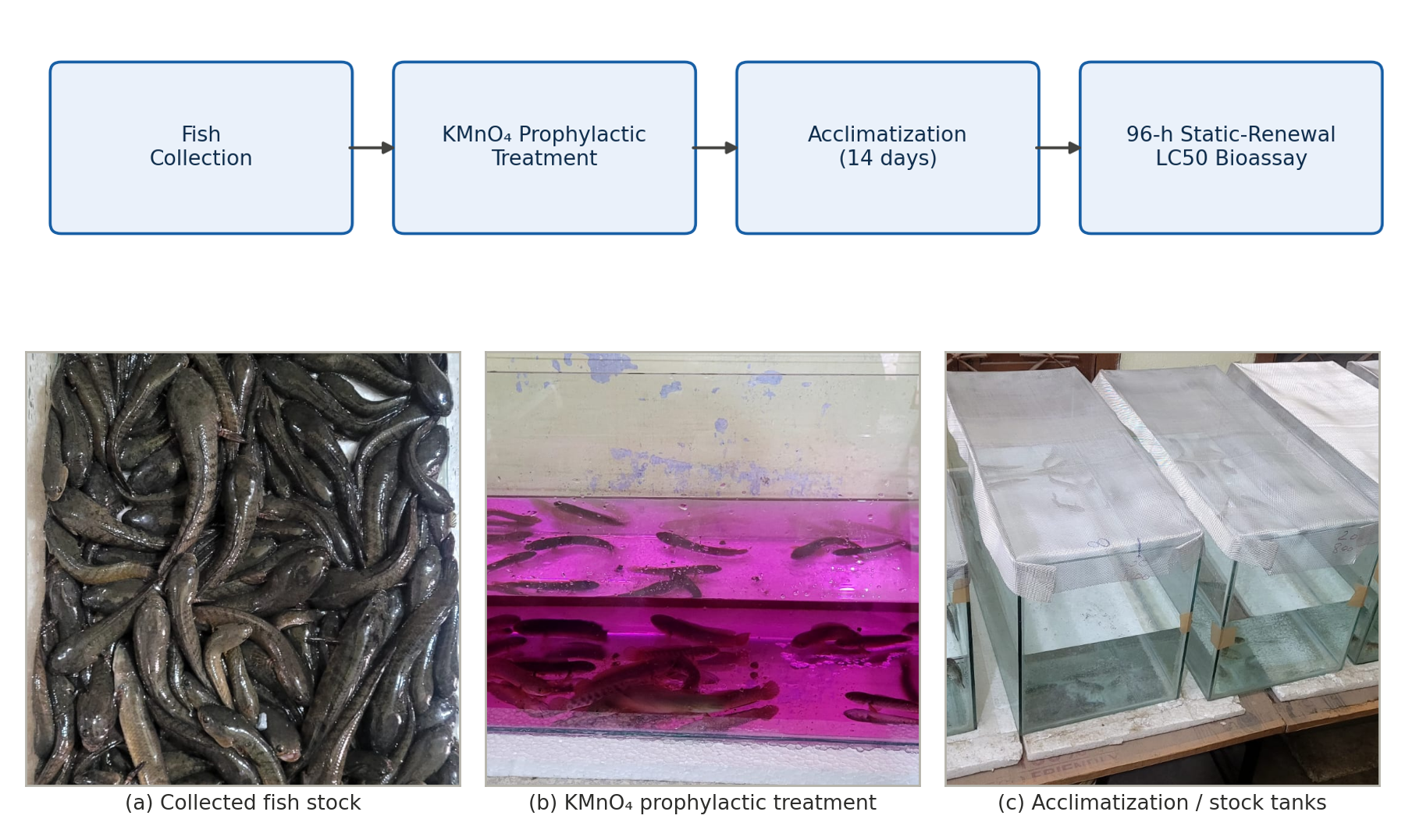
Figure 1. Experimental workflow and setup. Top: schematic of the bioassay protocol (fish collection → KMnO₄ prophylactic treatment → 14-day acclimatization → 96-h static-renewal LC50 bioassay). Bottom: representative photographs of (a) the collected Channa gachua stock, (b) the KMnO₄ prophylactic treatment tank, and (c) fish held in glass aquaria during acclimatization/exposure.

2.4 Water Quality Parameters
Physicochemical parameters of the test medium were monitored at 0, 24, 48, 72 and 96 h in each test and control aquarium following standard methods (American Public Health Association, 2017): temperature (mercury thermometer), pH (digital pH meter), dissolved oxygen (DO meter), and total hardness (titrimetric method). The pH remained relatively stable across the exposure period (6.9–7.1), while dissolved oxygen and total hardness declined modestly (6.5→5.7 mg/L and 145→125 mg/L, respectively), consistent with routine biological and metabolic loading over a 96-h static-renewal exposure (Table 1). Ambient temperature rose from 27 °C at 0 h to 33 °C by 96 h; although this 6 °C drift exceeds the ±2 °C stability window generally recommended for controlled acute toxicity testing (OECD, 2019), all recorded values remained within the broader range tolerated by freshwater channid species (temperature 26–30 °C typically cited as optimal; Muslim & Syaifudin, 2012), and no mortality attributable to water quality deterioration was observed in the control group at any time point. This temperature drift is acknowledged as a potential confounding factor in Section 4.
Table 1. Water quality parameters recorded at 24-h intervals during the 96-h CdCl₂ bioassay (mean ± SD across control and treatment aquaria)
Time | Temperature (°C) | pH | Dissolved oxygen (mg/L) | Total hardness (mg/L CaCO₃)
0 h | 27 | 7.1 | 6.5 | 145
24 h | 27 | 7.1 | 6.3 | 140
48 h | 30 | 7.0 | 6.1 | 130
72 h | 32 | 6.9 | 5.8 | 128
96 h | 33 | 6.9 | 5.7 | 125
Values to be completed by the authors from their daily monitoring log; overall observed ranges across the exposure period are reported in the text above.

2.5 Behavioural and Morphological Observations
Fish in each concentration group were continuously observed throughout the 96-h exposure period for concentration-dependent behavioural and morphological alterations, following criteria adapted from established cadmium-toxicity ethograms reported for the congener Channa punctatus and other freshwater teleosts (Singh & Saxena, 2020; Bishop & McIntosh, 1981; Atchison et al., 1987). Parameters monitored included swimming pattern (normal, erratic, or loss of equilibrium), surfacing/air-gulping frequency, opercular (ventilatory) movement rate, mucus secretion, body colouration and pigmentation, skin/fin integrity, and overall responsiveness to external stimuli. Representative photographs of control and exposed fish were taken at each observation interval to document external morphological change.

2.6 Statistical Analysis
Percentage mortality at each concentration and time point was corrected for 0% and 100% response using the standard Bliss correction [0% → 100 × (0.25/n); 100% → 100 × (n−0.25)/n; n = 30, pooled across the three replicate aquaria per concentration] and converted to probit values using Finney's standard probit table (Finney, 1971). A linear regression of probit (y) against log₁₀ concentration (x) was fitted for each exposure duration (y = a + bx), and the LC50 was obtained by solving for x at y = 5 (the probit value for 50% mortality), followed by back-transformation: LC50 = antilog[(5 − a)/b]. All calculations were performed in Python (NumPy/Matplotlib).

3. Results & Discussion

3.1 Mortality Response
Cumulative mortality of Channa gachua increased progressively with both increasing CdCl₂ concentration and increasing exposure duration (Table 2, Table 3). No mortality was observed in the control group throughout the 96-h period.
The observed increase in mortality with concentration and exposure time is consistent with the general pattern of acute cadmium toxicity reported in freshwater fishes. However, direct comparison of LC50 values among species requires caution because body size, respiratory strategy, water chemistry, and ionoregulatory physiology can materially influence apparent cadmium sensitivity. This context is particularly relevant for air-breathing channids and for comparisons with tilapia and other teleosts tested under different hardness and exposure conditions (Ferro et al., 2021; Garcia-Santos et al., 2006; Liu et al., 2022).
Table 2. Raw cumulative mortality data recorded (number of dead fish out of 10)
Aq. No. | No. of test fish | Concⁿ (mg/L) | 24 h | 48 h | 72 h | 96 h
1 | 10 | 28 | 0 | 1 | 3 | 5
2 | 10 | 30 | 0 | 1 | 4 | 6
3 | 10 | 32 | 3 | 5 | 6 | 7
4 | 10 | 34 | 3 | 5 | 6 | 8
5 | 10 | 36 | 2 | 6 | 7 | 10
Table 3. Percentage mortality of Channa gachua exposed to CdCl2
Concⁿ (mg/L) | 24 h | 48 h | 72 h | 96 h
28 | 0% | 10% | 30% | 50%
30 | 0% | 10% | 40% | 60%
32 | 30% | 50% | 60% | 70%
34 | 30% | 50% | 60% | 80%
36 | 20% | 60% | 70% | 100%

3.2 Probit Regression and Median Lethal Concentration
Linear regression of probit mortality against log₁₀ concentration yielded highly consistent fits at all four exposure durations (Table 4, Table 5; Figure 2). The 96-h LC50 was estimated at 28.8 mg/L. LC50 values declined progressively with increasing exposure duration, from an extrapolated 38.7 mg/L at 24 h to 28.8 mg/L at 96 h (Figure 4), consistent with the expected time-dependent nature of acute metal toxicity.
The progressive reduction in estimated LC50 with longer exposure is biologically plausible because lethal response may increase as toxicant exposure is prolonged. Comparable acute cadmium studies in freshwater fishes also report marked interspecific differences in 96-h lethality, reinforcing the need to interpret the present estimate as species- and test-condition-specific (Ferro et al., 2021; Garcia-Santos et al., 2006; Galiba et al., 2024). Because the 24-h LC50 lies outside the tested concentration interval, that value should remain explicitly identified as an extrapolated estimate rather than being treated as equivalent in certainty to estimates obtained within the experimental concentration range. The observed 96-h concentration-mortality relationship is additionally presented in Figure 3.
Table 4. Log-concentration and corrected probit values used for regression
Concⁿ (mg/L) | log₁₀(Concⁿ) | 24 h probit | 48 h probit | 72 h probit | 96 h probit
28 | 1.447 | 3.04 | 3.72 | 4.48 | 5.00
30 | 1.477 | 3.04 | 3.72 | 4.75 | 5.25
32 | 1.505 | 4.48 | 5.00 | 5.25 | 5.52
34 | 1.531 | 4.48 | 5.00 | 5.25 | 5.84
36 | 1.556 | 4.16 | 5.25 | 5.52 | 6.96
Table 5. Regression equations and estimated LC50 at each exposure duration
Exposure time | Regression equation (y = a + bx) | LC50 (mg/L) | Remarks
24 h | y = −16.77 + 13.71x | ≈ 38.7* | Extrapolated – max. observed mortality only 30%
48 h | y = −19.49 + 15.98x | ≈ 34.1 | Within tested range
72 h | y = −9.24 + 9.51x | ≈ 31.5 | Within tested range
96 h | y = −18.82 + 16.32x | ≈ 28.8 | Most reliable – full 50–100% mortality spread
*24-h value falls outside the tested concentration range and should be treated as an approximate extrapolation.

Figure 2
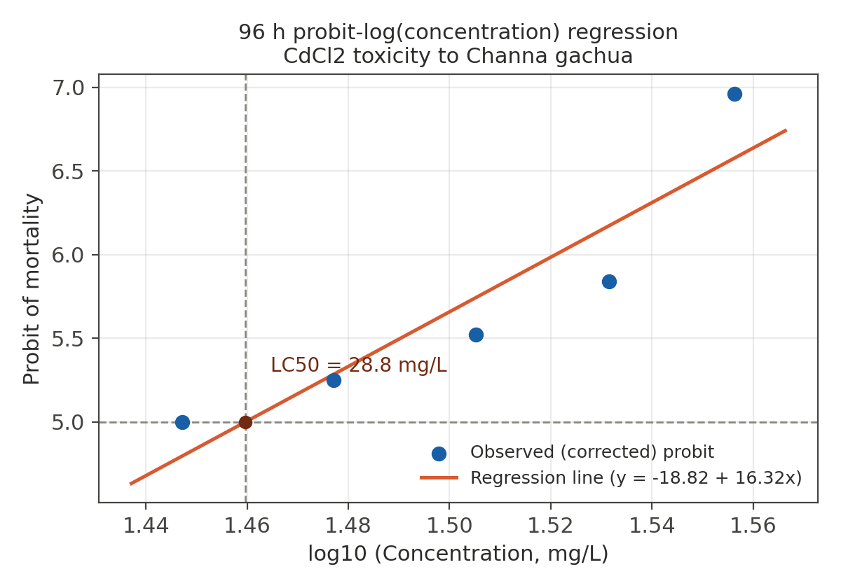
Figure 2. Log(concentration)–probit regression line for 96-h mortality data. Dashed lines mark the probit-5 (50% mortality) level, intersecting the regression line at LC50 = 28.8 mg/L.

Figure 3
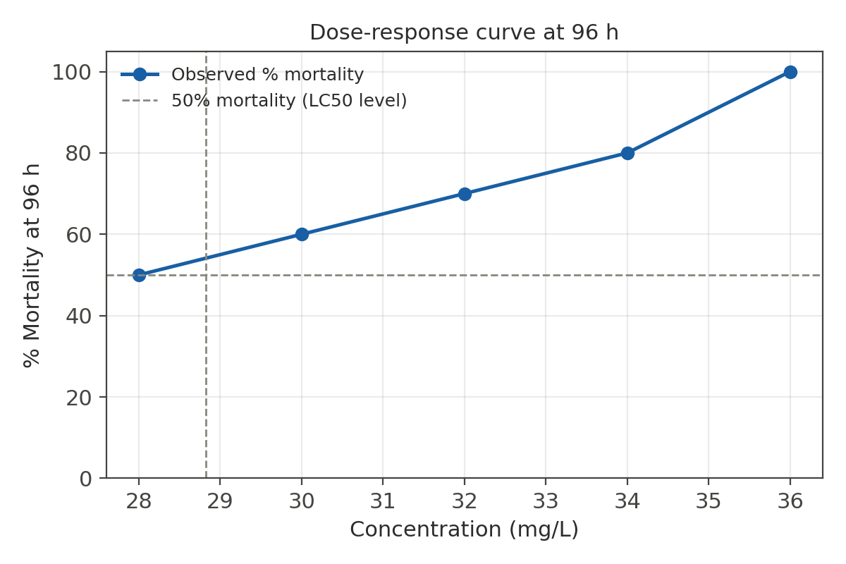
Figure 3. Observed dose-response (% mortality) curve of Channa gachua exposed to CdCl2 for 96 h.

Figure 4
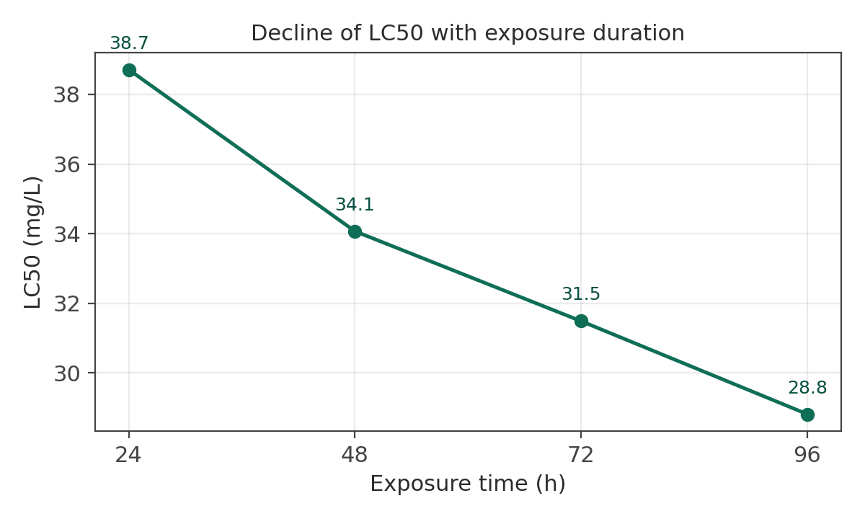
Figure 4. Decline in LC50 with increasing exposure duration, illustrating the time-dependence of acute cadmium toxicity.

3.3 Behavioural and Morphological Alterations
Fish exposed to CdCl₂ exhibited a clear, concentration-dependent progression of behavioural and morphological disturbance, broadly consistent with the cadmium-toxicity syndrome previously described for the congener Channa punctatus (Singh & Saxena, 2020; Eissa et al., 2010; Almeida et al., 2009).
Behavioural disturbances such as loss of equilibrium, altered activity, respiratory difficulty, frequent surfacing, and increased mucus secretion have been reported in other fish exposed to cadmium, although the intensity and sequence of responses vary among species and exposure conditions. Mechanistically, branchial cadmium exposure can impair calcium transport and alter gill epithelial function, providing a plausible physiological basis for ventilatory and stress-related responses without implying a specific mechanism from behavioural observations alone (Galiba et al., 2024; Verbost et al., 1987; Wong & Wong, 2000).
Table 6. Behavioural and morphological observation record (template – to be completed with author’s field data)
Sign observed | Control | Low (~28–30 mg/L) | Mid (~32–34 mg/L) | High (~36 mg/L)
Erratic / darting swimming | Absent | - | + | ++
Loss of equilibrium | Absent | − | + | ++
Surfacing / air-gulping frequency | Normal | + | ++ | ++
Opercular (ventilatory) rate | Normal | + | ++ | +++
Excess mucus secretion | Absent | + | ++ | +++
Body discoloration / pigmentation change | Absent | + | ++ | ++ (pigmented patches)
Skin/fin haemorrhage or lesion | Absent | − | − | +
Response to external stimuli | Normal | Slightly reduced | Reduced | Markedly reduced
Lying motionless at surface (pre-mortality sign) | Absent | − | + | ++
Grade using a simple scale, e.g., – (absent), + (mild/occasional), ++ (moderate/frequent), +++ (severe/persistent), consistent with the scoring approach used in comparable cadmium-behavioural studies.

3.4 Photographic Observations
Representative photographs taken during the exposure period are presented in Figure 5, illustrating the external morphological condition of control fish alongside fish exposed to sub-maximal and near-lethal CdCl₂ concentrations at 96 h.
The photographs provide qualitative visual documentation of external conditions across the exposure groups and are best interpreted as complementary evidence to the mortality and behavioural observations. Published cadmium-exposure studies have documented concentration-related behavioural abnormalities and structural gill injury, but external photographs alone cannot establish histopathological lesions or tissue-specific mechanisms. Accordingly, the visible changes in Figure 5 should be described conservatively as external morphological observations pending histological or tissue-level confirmation (Galiba et al., 2024; Liu et al., 2022; Wong & Wong, 2000).

Figure 5
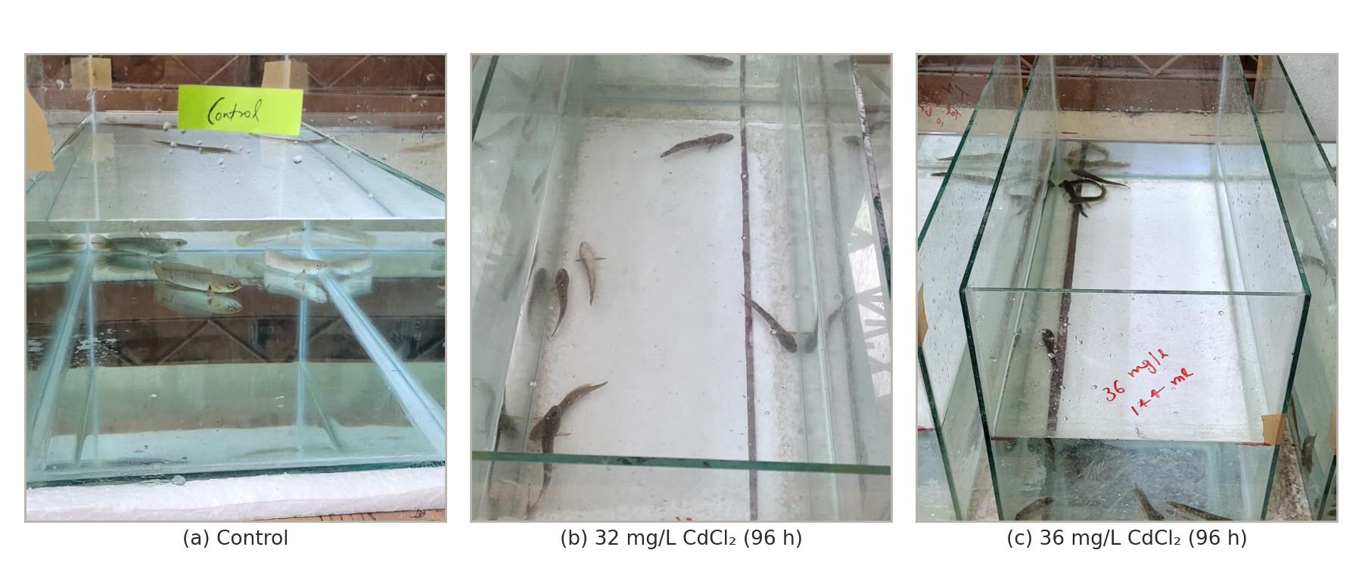
Figure 5. Representative photographs of Channa gachua at 96 h: (a) control, (b) 32 mg/L CdCl₂, and (c) 36 mg/L CdCl₂, illustrating concentration-dependent external morphological changes.

The present study establishes, for the first time, the acute toxicity profile of cadmium chloride in Channa gachua, with a 96-h LC50 of 28.8 mg/L. Mortality increased in a clear concentration-dependent and time-dependent manner, consistent with the classical acute toxicity pattern reported for cadmium across freshwater teleosts (Yu et al., 2024; World Health Organization, 1992).
Comparison with the congeneric species Channa punctata is informative, but must be interpreted carefully in light of the substantial inter-study variability documented for this species (see Table 7 and discussion below). Taking the most frequently cited value, Chandra (2023) reported a 96-h LC50 of 14.95 mg/L for CdCl₂ in C. punctata – roughly half the 96-h LC50 obtained here for Channa gachua (28.8 mg/L). However, as detailed below, other independent determinations for the same species and toxicant span nearly an order of magnitude, and our value falls broadly within, rather than clearly outside, this documented range. A broadly comparable pattern of higher cadmium tolerance in Channa gachua is also suggested when set against cadmium toxicity data for other freshwater species, such as Oreochromis niloticus (Al-Asgah et al., 2015). This apparent inter- and intra-generic difference in cadmium sensitivity may reflect genuine physiological factors – including differences in body size, gill surface area to body mass ratio, mucus production, or the relative contribution of accessory air-breathing to overall gas exchange and metal uptake pathways – rather than a methodological artefact, and merits dedicated comparative investigation. It is also possible that differences in water hardness, temperature, or fish size between studies contributed to the observed variation, as these factors are well known to modulate the acute toxicity of cadmium to fish.
Table 7. Reported 96-h LC50 values for various heavy metals across Channa species
Species | Metal / Compound | 96-h LC50 (mg/L) | Source
Channa gachua | CdCl₂ | 28.8 | This study
Channa gachua | Pb(NO₃)₂ | 15.2 | Authors’ companion bioassay (unpublished)
Channa punctata/punctatus | CdCl₂ | 6.19 | Sulaiman et al., 2024
Channa punctata/punctatus | CdCl₂ | 9.91 | Chandra & Verma, 2021
Channa punctata/punctatus | CdCl₂ | 14.95 | Chandra, 2023
Channa punctata/punctatus | CdCl₂ | 80.62 | Singh & Saxena, 2020
Channa punctatus | K₂Cr₂O₇ (Cr⁶⁺) | 41.75 | Mishra & Mohanty, 2008
Channa punctatus | HgCl₂ | 0.44 | Sulaiman et al., 2024
Channa marulius | CdCl₂ | 75.70 | Batool et al., 2014
Channa marulius | Copper (CuSO₄) | 32.96 | Batool et al., 2014
Notably, the 96-h cadmium LC50 of C. punctata/punctatus is often treated in the literature as an ‘established’ benchmark value, yet closer examination reveals striking inconsistency across independent determinations for this single species and toxicant: reported 96-h LC50 values for CdCl₂ range more than tenfold, from 6.19 mg/L (Sulaiman et al., 2024) and 9.91 mg/L (Chandra & Verma, 2021), to 14.95 mg/L (Chandra, 2023) and as high as 80.62 mg/L (Singh & Saxena, 2020) (Table 7). This spread most likely reflects genuine methodological heterogeneity rather than measurement error alone – differences in test protocol (static versus semi-static renewal), statistical estimation method (manual Finney probit versus SPSS-based probit versus Trimmed Spearman-Kärber), water hardness and temperature (which modulate free Cd²⁺ ion bioavailability and competitive uptake at branchial calcium channels), fish provenance/population, body size, and acclimatization duration. This observation carries an important methodological lesson for interspecific comparison: rather than anchoring our comparative claim to any single published C. punctata value, the present 96-h C. gachua LC50 of 28.8 mg/L should be understood as falling broadly within, rather than clearly outside, the documented congeneric range of cadmium sensitivity (6.19–80.62 mg/L). The true magnitude of any air-breathing-related tolerance difference between these two species therefore cannot be resolved from existing literature alone, and would require a controlled, side-by-side bioassay of both species under identical test conditions – a natural extension of the present work. The broader comparison across the genus in Table 7 also illustrates that cadmium toxicity varies considerably even among congeners (C. gachua 28.8 mg/L; C. marulius 75.70 mg/L; C. punctata/punctatus 6.19–80.62 mg/L), reinforcing that LC50 is not a fixed species trait but a context-dependent outcome of test conditions, physiology, and population history.
The concentration-dependent behavioural alterations noted in the present study – including surfacing/air-gulping changes, altered opercular movement, and abnormal swimming – mirror the toxicity syndrome described in C. punctatus exposed to cadmium (Singh & Saxena, 2020), and are consistent with the broader literature on cadmium’s disruptive effects on fish ventilatory and locomotory behaviour (Bishop & McIntosh, 1981; Atchison et al., 1987; Eissa et al., 2010). Cadmium is known to interfere with branchial ion transport and gill epithelial integrity, provoking compensatory increases in ventilation and surfacing behaviour, while central and peripheral neurotoxic effects likely underlie the loss of equilibrium and erratic swimming observed at higher concentrations (Yu et al., 2024). Increased mucus secretion and surface discolouration, when observed, are consistent with a generalised stress and epidermal irritation response reported across cadmium-exposed fish species, including changes in aggressive behaviour and stress markers documented in cadmium-exposed tilapia (Almeida et al., 2009).
Because Channa gachua relies on periodic surfacing for aerial respiration through its suprabranchial chamber (Olson et al., 1994), it is plausible that this species experiences disproportionate exposure to cadmium concentrated at the air–water interface relative to strictly water-breathing fish, an ecological consideration previously highlighted in comparative toxicity work on this species (Dhara et al., 2021). This physiological trait strengthens the ecological relevance of Channa gachua as a sentinel species for surface-water metal contamination in shallow wetland habitats, even though its acute LC50 in the present study did not indicate exceptional sensitivity relative to its congener.
Limitations of the present study include the absence of internal (tissue) cadmium bioaccumulation data and histopathological confirmation of the observed external signs; these represent natural extensions for future work, alongside the planned sub-lethal, 15-day chronic exposure trial at 1/4th of the determined LC50 to characterise haematological, hepatic and renal biomarker responses in this species, following a design comparable to recent sub-lethal cadmium studies in the congener Channa punctata (Choudhury et al., 2024). In addition, ambient test temperature rose by approximately 6 °C over the 96-h exposure period (Table 1); as elevated temperature can independently increase both cadmium bioavailability and metabolic rate in ectotherms, this drift cannot be fully excluded as a contributing factor to the observed mortality pattern, particularly at the later (72–96 h) time points, and temperature-controlled replication is recommended in future studies.

4. Conclusion
The 96-h static-renewal bioassay demonstrated a concentration- and time-dependent acute response of Channa gachua to nominal cadmium chloride concentrations of 28–36 mg/L. Mortality increased as exposure progressed, and the estimated LC₅₀ declined from 38.7 mg/L at 24 h to 28.8 mg/L at 96 h; the 24-h estimate remained outside the tested concentration range and should therefore be interpreted as extrapolated. Exposed fish also displayed qualitative behavioural and external morphological alterations, including changes in swimming activity, equilibrium, surfacing or air-gulping, opercular movement, mucus production, responsiveness, and body appearance. Under the laboratory conditions used, the 96-h LC₅₀ provides a species-specific acute toxicity estimate for Channa gachua. Comparison with published data for related species should remain cautious because reported cadmium toxicity varies substantially among studies and test conditions. Further controlled investigations using verified exposure concentrations, stable temperature conditions, tissue cadmium measurements, and histopathological assessment would strengthen interpretation of the acute toxicological response and support more reliable comparisons within the genus Channa.
Limitation
The study was limited by the absence of measured tissue cadmium concentrations and histopathological confirmation of the observed external changes. Ambient temperature increased by approximately 6 °C during the 96-h exposure, which may have influenced the later mortality response and limits strict attribution of all effects to cadmium exposure alone. In addition, the behavioural and morphological observations were qualitative. Future temperature-controlled studies with verified exposure concentrations, tissue measurements, and histopathological assessment would provide stronger confirmation of the observed acute responses.
Ethics Approval

All animal procedures were approved by the Institutional Animal Ethics Committee (IAEC) and conducted in accordance with CPCSEA guidelines.

Declaration of AI Use
This manuscript was prepared through the intellectual contributions of the author(s) to the study design, data analysis, interpretation of results, and scholarly content. Grammarly and ChatGPT were used solely to assist with grammatical refinement and reference formatting during manuscript revision. The author(s) accept full responsibility for the accuracy, integrity, and final content of the manuscript.

COMPETING INTERESTS DISCLAIMER:
Authors have declared that they have no known competing financial interests OR non-financial interests OR personal relationships that could have appeared to influence the work reported in this paper.

References
Al-Asgah, N. A., Abdel-Warith, A. W. A., Younis, E. S. M., & Allam, H. Y. (2015). Haematological and biochemical parameters and tissue accumulations of cadmium in Oreochromis niloticus exposed to various concentrations of cadmium chloride. Saudi Journal of Biological Sciences, 22(5), 543–550. https://doi.org/10.1016/j.sjbs.2015.01.002
Almeida, J. A., Barreto, R. E., Novelli, E. L. B., Castro, F. J., & Moron, S. E. (2009). Oxidative stress biomarkers and aggressive behavior in fish exposed to aquatic cadmium contamination. Neotropical Ichthyology, 7(1), 103–108. https://doi.org/10.1590/S1679-62252009000100013
American Public Health Association. (2017). Standard methods for the examination of water and wastewater (23rd ed.). https://www.standardmethods.org/
Atchison, G. J., Henry, M. G., & Sandheinrich, M. B. (1987). Effects of metals on fish behavior: A review. Environmental Biology of Fishes, 18(1), 11–25. https://doi.org/10.1007/BF00002324
Batool, M., Abdullah, S., & Javed, M. (2014). Behavioral intoxication of Channa marulius and Wallago attu during acute exposure of cadmium and copper. Pakistan Journal of Life and Social Sciences, 12(1), 7–15. https://www.researchgate.net/publication/287340474
Bishop, W. E., & McIntosh, A. W. (1981). Acute lethality and effects of sublethal cadmium exposure on ventilation frequency and cough rate of bluegill (Lepomis macrochirus). Archives of Environmental Contamination and Toxicology, 10, 519–530. https://doi.org/10.1007/BF01054876
Chandra, A., & Verma, A. K. (2021). Determination of median tolerance limit (LC50) of Channa punctata (Bloch) for cadmium chloride. International Journal on Biological Sciences, 12(2), 106–109. https://doi.org/10.53390/ijbs.v12i2.9
Chandra, A., & Verma, A. K. (2023). Impact of cadmium on haematological parameters of freshwater snakeheaded fish, Channa punctata (Bloch). Journal of Experimental Zoology India, 26(1), 345–348. https://doi.org/10.51470/jez.2023.26.1.345
Chaudhry, S. (2010). Channa gachua. The IUCN Red List of Threatened Species 2010, e.T166123A6179047. https://doi.org/10.2305/IUCN.UK.2010-4.RLTS.T166123A6179047.en
Choudhury, M., Deka, P., & Purkayastha, D. (2024). Sub-lethal toxic effect of cadmium chloride (CdCl2) on freshwater murrel Channa punctata (Bloch). International Journal of Fisheries and Aquatic Studies, 12(1), 63–66. https://doi.org/10.22271/fish.2024.v12.i1a.2893
Deore, S. V., & Wagh, S. B. (2012). Heavy metal induced histopathological alterations in liver of Channa gachua (Ham.). Journal of Experimental Sciences, 3(3), 35–38. https://updatepublishing.com/journal/index.php/jes/article/download/2840/2808/3200
Dhara, K., Saha, S., Mukherjee, D., & Saha, N. C. (2021). Comparative acute toxicity of mercury to air breathing fish, Channa gachua (Ham.) and non-air breathing fish Cyprinus carpio (Linn.): Ethological and haematological consideration. Indian Journal of Ecology, 48(5), 1243–1253. https://indianecologicalsociety.com/indian-journal-ecology/?issue=Issue+5&volume=Volume+48&yr=2021
Eissa, B. L., Ossana, N. A., Ferrari, L., & Salibián, A. (2010). Quantitative behavioral parameters as toxicity biomarkers: Fish responses to waterborne cadmium. Archives of Environmental Contamination and Toxicology, 58, 1032–1039. https://doi.org/10.1007/s00244-009-9434-4
Ferro, J. P., Ferrari, L., & Eissa, B. L. (2021). Acute toxicity of cadmium to freshwater fishes and its relationship with body size and respiratory strategy. Comparative Biochemistry and Physiology Part C: Toxicology & Pharmacology, 248, 109109. https://doi.org/10.1016/j.cbpc.2021.109109
Finney, D. J. (1971). Probit analysis (3rd ed.). Cambridge University Press.
Froese, R., & Pauly, D. (Eds.). (2019). Channa gachua. FishBase. https://www.fishbase.se/summary/Channa-gachua.html
Galiba, A., Eshik, M. M. E., & Rahman, M. S. (2024). Toxic effects of cadmium chloride on behavior and histopathology of butter catfish Ompok pabda (Hamilton, 1822). Journal of Bangladesh Academy of Sciences, 48(2), 217–230. https://doi.org/10.3329/jbas.v48i2.73000
Garcia-Santos, S., Fontaínhas-Fernandes, A., & Wilson, J. M. (2006). Cadmium tolerance in the Nile tilapia (Oreochromis niloticus) following acute exposure: Assessment of some ionoregulatory parameters. Environmental Toxicology, 21(1), 33–46. https://doi.org/10.1002/tox.20152
Isiyaku, M. S., & Mohammed, R. (2021). Haematological profile of Oreochromis niloticus (Burchell, 1822) exposed to cadmium chloride. Asian Journal of Fisheries and Aquatic Research, 12(2), 40–47. https://doi.org/10.9734/ajfar/2021/v12i230232
Kawade, S. (2020). Histopathological alterations in the liver of freshwater fish, Channa gachua (Ham.) on acute exposure to nickel. Journal of Emerging Technologies and Innovative Research, 7, 1025–1030. https://www.jetir.org/papers/JETIR2010137.pdf
Kumar, R., Jaiswar, A. K., Sharma, R., & Prasad, L. (2020). Quantification of morphological variations among populations of Channa gachua (Hamilton, 1822) from different geographical locations in India. Indian Journal of Fisheries, 67(2), 114–119. https://doi.org/10.21077/ijf.2019.67.2.93891-16
Kumari, S., & Pandit, D. N. (2019). Histopathological changes in the liver of Channa gachua (Bloch) exposed to biofertilizer. International Journal of Science and Research, 8(10), 22–25. https://doi.org/10.21275/ART20201558
Liu, Y., Chen, Q., Li, Y., Bi, L., Jin, L., & Peng, R. (2022). Toxic effects of cadmium on fish. Toxics, 10(10), 622. https://doi.org/10.3390/toxics10100622
Mishra, A. K., & Mohanty, B. (2008). Acute toxicity impacts of hexavalent chromium on behavior and histopathology of gill, kidney and liver of the freshwater fish, Channa punctatus (Bloch). Environmental Toxicology and Pharmacology, 26(2), 136–141. https://doi.org/10.1016/j.etap.2008.02.010
Muslim, M., & Syaifudin, M. (2012). Pemeliharaan benih ikan gabus (Channa striata) pada media budidaya (waring) dalam rangka domestikasi. In Prosiding Seminar Nasional Industrialisasi Perikanan dan Kelautan I, Pekanbaru, 27–28 September 2012 (pp. 1–6). Fakultas Ilmu Perikanan dan Kelautan, Universitas Riau. https://repository.unsri.ac.id/30918/1/24.PEMELIHARAANBENIHIKANGABUSChannastriata.pdf
Ng, P. K. L., & Lim, K. K. P. (1990). Snakeheads (Pisces: Channidae): Natural history, biology and economic importance. In L. M. Chou & P. K. L. Ng (Eds.), Essays in zoology: Papers commemorating the 40th anniversary of the Department of Zoology (pp. 127–152). Department of Zoology, National University of Singapore.
OECD. (2019). Test No. 203: Fish, acute toxicity test (OECD Guidelines for the Testing of Chemicals, Section 2). OECD Publishing. https://doi.org/10.1787/9789264069961-en
Olson, K. R., Roy, P. K., Ghosh, T. K., & Munshi, J. S. D. (1994). Microcirculation of gills and accessory respiratory organs from the air-breathing snakehead fish, Channa punctata, C. gachua, and C. marulius. The Anatomical Record, 238(1), 92–107. https://doi.org/10.1002/ar.1092380111
Raj, V. M., Thirunavukkarasu, A. R., Kailasam, M., Subburaj, R., & Thiagarajan, G. (2025). A study on cadmium accumulation in the fingerlings of Asian seabass Lates calcarifer (Bloch). Asian Journal of Current Research, 10(3), 1–9. https://doi.org/10.56557/ajocr/2025/v10i39422
Saroj, K. S., & Prasad, J. (2020). Diversity status of fishes in Mauns and Chaurs of Samastipur, N. Bihar. Applied Ecology and Environmental Sciences, 8(1), 21–24. https://doi.org/10.12691/aees-8-1-3
Saxena, V., Bakhasha, J., Arya, N., Singh, R., Singh, R., Khan, R., Singh, R., Trivedi, S. P., Kumar, M., Yadav, K. K., & Trivedi, A. (2025). The cascade of cadmium toxicity: From cellular damage to pyroptotic responses in fish Channa punctatus. Fish Physiology and Biochemistry, 51, Article 26. https://doi.org/10.1007/s10695-024-01434-2
Sharma, N., Sarkar, U. K., Yengkokpam, S., Bordoloi, D., Ray, B. C., & Das, B. K. (2022). Exploring potentials of snakehead fishes (Channidae) of Northeast India with emphasis on their ornamental value and conservation status. Journal of the Inland Fisheries Society of India, 54(2), 104–113. https://doi.org/10.47780/jifsi.54.2.2022.138250
Singh, B. M. (2021). Histopathological study of Channa gachua exposed to sublethal concentration of malathion. International Journal of Fisheries and Aquatic Studies, 9(3), 174–179. https://doi.org/10.22271/fish.2021.v9.i3c.2472
Singh, N., & Saxena, B. (2020). Behavioral and morphological changes in fresh water fish, Channa punctatus under the exposure of cadmium. Environment Conservation Journal, 21(3), 187–193. https://doi.org/10.36953/ECJ.2020.21323
Singh, N. P., & Siddique, M. R. (2018). Effects of certain pesticides on the histopathology of gills of an air breathing fish Channa gachua (Bloch). Journal of Emerging Technologies and Innovative Research, 5(12), 599–604. https://www.jetir.org/papers/JETIR1812C87.pdf
Sulaiman, M. A., & Kumari, A. (2025). Unveiling the rising threat of cadmium pollution and alarming health risks associated with the consumption of 15 commercially important fish species in the middle stretch of River Ganga, at Patna, India. Biological Trace Element Research, 203, 422–441. https://doi.org/10.1007/s12011-024-04164-x
Sulaiman, M. A., Zafar, M. M., Divya, Anjum, S., & Kumari, A. (2024). Investigating the 96h LC50 of mercury and cadmium on Channa punctatus (Bloch): A comparative acute toxicity bioassay. Journal of Ecophysiology and Occupational Health, 24(1), 89–98. https://doi.org/10.18311/jeoh/2024/36093
Tarigan, R. R., Widodo, M. S., & Kilawati, Y. (2016). Physiological studies of snakehead fish (Channa gachua) maintained in controlled containers. International Journal of ChemTech Research, 9(7), 404–411. https://sphinxsai.com/2016/ch_vol9_no7/2/%28404-411%29V9N7CT.pdf
Taysı, M. R. (2024). Assessing the effects of cadmium on antioxidant enzymes and histological structures in rainbow trout liver and kidney. Scientific Reports, 14, 27453. https://doi.org/10.1038/s41598-024-78835-z
Verbost, P. M., Flik, G., Lock, R. A. C., & Wendelaar Bonga, S. E. (1987). Cadmium inhibition of Ca2+ uptake in rainbow trout gills. American Journal of Physiology-Regulatory, Integrative and Comparative Physiology, 253(2), R216–R221. https://doi.org/10.1152/ajpregu.1987.253.2.R216
Wong, C. K. C., & Wong, M. H. (2000). Morphological and biochemical changes in the gills of tilapia (Oreochromis mossambicus) to ambient cadmium exposure. Aquatic Toxicology, 48(4), 517–527. https://doi.org/10.1016/S0166-445X(99)00060-0
World Health Organization. (1992). Cadmium: Environmental aspects (Environmental Health Criteria 135). https://iris.who.int/bitstreams/4a24e649-2250-4d93-aacc-460e3d2b5a3a/download
Yu, Y. B., Lee, J. W., Jo, A. H., Choi, Y. J., Choi, C. Y., Kang, J. C., & Kim, J. H. (2024). Toxic effects of cadmium exposure on hematological and plasma biochemical parameters in fish: A review. Toxics, 12(10), 699. https://doi.org/10.3390/toxics12100699

