Original Research Article
Molecular Detection and Phylogenetic Analysis of the cpb2 Gene in Clostridium perfringens Isolates Recovered From Poultry With Suspected Necrotic Enteritis
ABSTRACT

Necrotic enteritis (NE) is an economically important enteric disease of poultry associated with pathogenic Clostridium perfringens strains. The beta2 toxin gene, cpb2, has been detected in isolates from several host species, but its contribution to avian NE remains uncertain. This descriptive study evaluated the occurrence of cpb2 among C. perfringens isolates recovered from poultry with clinical or pathological findings suggestive of NE and characterised two partial cpb2 sequences. A total of 62 samples, comprising 54 intestinal samples and eight cloacal swabs, were collected from affected poultry in Maharashtra, India. C. perfringens was isolated using conventional anaerobic bacteriological methods and confirmed by species-specific polymerase chain reaction (PCR) targeting the 16S rRNA gene. Confirmed isolates were screened for cpb2 by PCR. Amplicons from two cpb2-positive isolates were sequenced, aligned with selected GenBank reference sequences, and evaluated by Maximum Parsimony phylogenetic analysis. C. perfringens was recovered from 57 of 62 samples (91.9%), including 52 of 54 intestinal samples (96.3%) and five of eight cloacal swabs (62.5%). All 57 culture-positive isolates yielded the expected 481-bp 16S rRNA amplicon. Five of the 57 confirmed isolates (8.8%) yielded the expected 548-bp cpb2 amplicon. The two partial cpb2 sequences showed relatedness to previously reported reference sequences. In the phylogenetic tree, PZ547701 grouped with the poultry sequence AY884035 with 77% bootstrap support, whereas PZ547700 grouped with the cattle sequence DQ525205 with 62% support and joined AJ537534 within a broader node supported at 89%. These findings document cpb2 carriage in a minority of the C. perfringens isolates examined and indicate that the two partial sequences fall within previously reported cpb2 diversity. Because the study did not include an unaffected control group, toxin-expression assays, or a complete toxinotyping panel, the results do not establish a causal role for CPB2 in NE and do not support assignment of a C. perfringens toxinotype. Further studies incorporating netB, complete toxinotyping, toxin-expression analysis, and appropriate comparison groups are warranted.

Keywords: Necrotic enteritis; poultry; Clostridium perfringens; cpb2; beta2 toxin; polymerase chain reaction; molecular detection; phylogenetic analysis; toxin gene
Introduction
Necrotic enteritis (NE) is an economically important enteric disease of poultry, particularly broiler chickens, and can present as acute intestinal disease with increased mortality or as a subclinical condition associated with impaired nutrient utilisation and reduced production performance. Clostridium perfringens is the principal bacterial agent, but the organism can also occur in the intestinal microbiota of clinically healthy birds; disease expression depends on the presence of virulent strains together with host, dietary, and environmental predisposing factors (Fathima et al., 2022; Timbermont et al., 2011; Van Immerseel et al., 2004). Recent syntheses of avian NE challenge models likewise emphasise that disease expression is multifactorial and strongly influenced by the virulence of the challenge strain and predisposing conditions (Shamshirgaran & Golchin, 2024).
Clostridium perfringens is a Gram-positive, spore-forming anaerobe with a diverse toxin repertoire. The expanded toxinotyping scheme recognises toxinotypes A to G according to the major toxin genes present, and NetB-producing strains associated with avian NE are designated type G (Rood et al., 2018). Experimental studies have established NetB as an important virulence determinant in at least some avian NE strains (Keyburn et al., 2008). Consequently, detection of C. perfringens alone does not establish toxinotype or identify the virulence factor responsible for disease. Recent in vivo evaluation of diverse C. perfringens strains further indicates that virulence cannot be inferred solely from netB status, supporting cautious interpretation of individual toxin-gene findings (Deslauriers et al., 2024).
Beta2 toxin (CPB2), encoded by cpb2, was first characterised from a C. perfringens strain isolated from a piglet with necrotising enteric disease, and the gene was localised to a large plasmid (Gibert et al., 1997). cpb2-positive isolates have subsequently been reported from diverse animal hosts (Garmory et al., 2000). However, gene carriage does not necessarily predict toxin expression or clinical significance, and reviews have emphasised that a direct pathogenic role for CPB2 cannot be inferred from cpb2 detection alone (Schotte et al., 2004; van Asten et al., 2010). Molecular approaches have also been applied to the identification and toxin-focused characterisation of clostridial pathogens in veterinary research (Khiav et al., 2020).
In poultry, reported cpb2 frequencies vary widely. Tolooe et al. (2011) detected cpb2 in 94.4% of isolates from diseased flocks, whereas Praveen Kumar et al. (2019) detected the gene in 57.25% of cpa-positive isolates from birds suspected of NE, and Rana et al. (2023) detected no cpb2-positive isolates in their study population. These differences underscore the need for region-specific descriptive data and careful interpretation. Accordingly, the occurrence of cpb2 and the genetic relatedness of cpb2-positive C. perfringens isolates recovered from affected poultry in Maharashtra require region-specific characterisation. The present study therefore aimed to determine the occurrence of cpb2 among C. perfringens isolates recovered from poultry with clinical or pathological findings suggestive of NE and to describe the genetic relatedness of two partial cpb2 sequences. Because no unaffected control group, toxin-expression assay, or complete toxinotyping panel was included, the study was designed to describe occurrence rather than establish a causal association.
Materials and Methods
Sample collection
A total of 62 samples were collected from poultry with findings suggestive of NE. These comprised 54 intestinal samples from dead birds showing gross lesions including intestinal ballooning, mucosal sloughing, and a thin or friable intestinal wall, together with eight cloacal swabs from ailing birds showing depression and diarrhoea. Samples were collected from different regions of Maharashtra, India, placed in sterile labelled containers, transported to the laboratory under chilled conditions, and stored at -20°C until further processing.
Isolation and identification of Clostridium perfringens
Samples were inoculated into freshly prepared Robertson's cooked meat medium (RCMM) and incubated anaerobically at 37°C for 48 h. Enriched cultures were streaked onto Perfringens agar base supplemented with tryptose sulfite cycloserine (TSC) and incubated anaerobically at 37°C for 24 h. Black colonies associated with sulfite reduction were considered presumptive C. perfringens. Pure cultures were evaluated by Gram staining and conventional biochemical characteristics, including oxidase, catalase, motility, and stormy clot fermentation reactions.
Bacterial DNA preparation
For each presumptive isolate, approximately four to five colonies were suspended in 100 µL of sterile nuclease-free water. The suspension was boiled for 10 min, chilled on ice for 10 min, and centrifuged at 12,000 rpm for 10 min. The supernatant was retained as the DNA template and stored at -20°C until PCR testing.
DNA concentration was estimated using a NanoDrop spectrophotometer (Thermo Fisher Scientific, USA). Approximately 100-150 ng of template DNA was used for molecular confirmation and cpb2 screening.
Molecular confirmation of Clostridium perfringens by 16S rRNA PCR
Phenotypically identified isolates were confirmed using a species-specific 16S rRNA PCR with the primer pair reported by Nazki et al. (2017). Primer sequences and the expected amplicon size are presented in Table 1.
Table 1. Oligonucleotide primers used for species-specific detection of Clostridium perfringens by 16S rRNA PCR
Target gene | Primer sequence (5′–3′) | Product size (bp) | Reference
16S rRNA (F) | TAACCTGCCTCATAGAGT | 481 | Nazki et al. (2017)
16S rRNA (R) | TTTCACATCCCACTTAATC | 481 | Nazki et al. (2017)

PCR was performed in a final volume of 20 µL using a commercial PCR master mix containing Taq DNA polymerase, MgCl2, and dNTPs, with forward and reverse primers at a final concentration of 1 µM each, approximately 100 ng of DNA template, and nuclease-free water. Cycling consisted of an initial denaturation at 94°C for 2 min; 35 cycles of denaturation at 94°C for 30 s, annealing at 56°C for 30 s, and extension at 72°C for 1 min. Amplified products were resolved by electrophoresis on a 1.5% agarose gel stained with ethidium bromide.
Molecular detection of the cpb2 gene
The cpb2 gene was detected using the primer pair shown in Table 2. PCR was performed in a 25 µL reaction containing 12.5 µL of commercial master mix, 6.5 µL of nuclease-free water, 1 µL each of forward and reverse primers (10 pmol), and 4 µL of DNA template. The cycling programme comprised initial denaturation at 95°C for 15 min, denaturation at 94°C for 30 s, annealing at 49°C for 90 s, extension at 72°C for 90 s, and a final extension at 72°C for 10 min. PCR products were resolved on a 1.5% agarose gel stained with ethidium bromide.
Table 2. Oligonucleotide primers used for detection of the Clostridium perfringens cpb2 gene
Target gene | Primer sequence (5′–3′) | Product size (bp) | Reference
CPB2 (F) | AAATATGATCCTAACCAACAA | 548 | Nazki et al. (2017)
CPB2 (R) | CCAAATACTCTAATYGATGC | 548 | Nazki et al. (2017)

Sequence alignment and phylogenetic analysis of cpb2
PCR products from two cpb2-positive C. perfringens isolates recovered from separate affected flocks were selected for sequencing by a commercial facility (Genomic, Pune, India). The resulting partial sequences were designated PZ547700 and PZ547701.
The two study sequences were compared with selected cpb2 reference sequences retrieved from GenBank. Deduced amino acid alignments were visualised using Jalview 2.11.5.2 (Waterhouse et al., 2009). Nucleotide sequences were manually trimmed and aligned using BioEdit 7.2.5 (Hall, 1999).
Phylogenetic analysis was performed using the Maximum Parsimony method in MEGA11 (Tamura et al., 2021), with bootstrap support estimated from 1,000 replicates. The final tree contained the two study sequences and 20 selected reference sequences spanning 440 aligned nucleotide positions. Reference accessions included AY609162, AY730631, AY730634, AY884035-AY884041, KX924463, HQ853334, MF471364, MF471365, GU581183-GU581185, DQ525205, AJ537534, and L77965.
Data analysis
Results were summarised descriptively as counts and percentages. Because the study used samples from clinically or pathologically affected birds and did not include an unaffected comparison group, no inferential analysis of association between cpb2 and NE was performed.
Results and Discussion
Occurrence of Clostridium perfringens
Of the 62 samples examined, 57 (91.9%) were culture positive for C. perfringens, including 52 of 54 intestinal samples (96.3%) and five of eight cloacal swabs (62.5%). Growth in RCMM was characterised by marked turbidity and pink discolouration of the meat particles. On TSC-supplemented Perfringens agar, presumptive isolates produced characteristic black colonies associated with sulfite reduction (Photo 1). Isolates were Gram-positive rods, oxidase negative, catalase negative, nonmotile, and produced stormy clot fermentation. These findings were consistent with the expected phenotype of C. perfringens. Because samples were purposively collected from affected birds, these proportions describe the study sample and should not be interpreted as population prevalence.
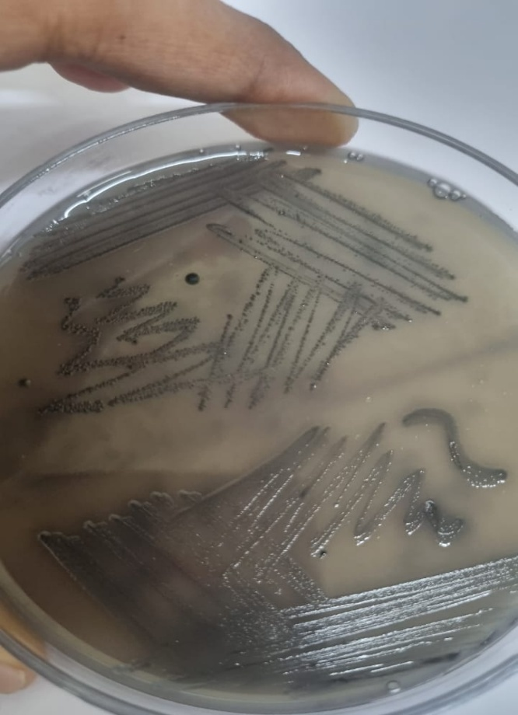
Photo 1. Representative black colonies of Clostridium perfringens on Perfringens agar containing TSC supplement.
Molecular confirmation of Clostridium perfringens
All 57 culture-positive isolates yielded the expected 481-bp product in the species-specific 16S rRNA PCR (Figure 1), providing molecular confirmation of the isolates under the assay used. The same primer pair has been applied in published molecular characterisation studies of C. perfringens (Nazki et al., 2017; Rana et al., 2023).
Figure 1 shows the 100-bp DNA ladder, positive control, and representative positive isolates. The molecular result strengthens the identification obtained by conventional bacteriology, but species confirmation alone does not determine toxinotype or establish the specific virulence mechanism responsible for the observed intestinal disease.
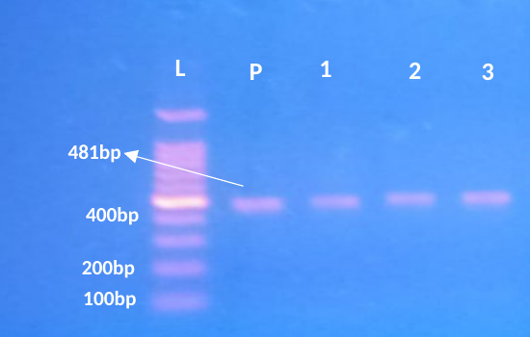
Figure 1. Agarose gel showing the expected 481-bp 16S rRNA PCR product of Clostridium perfringens. Lane L, 100-bp DNA ladder; lane P, positive control; lanes 1–3, representative positive isolates.
Detection of the cpb2 gene
Five of the 57 confirmed C. perfringens isolates (8.8%) yielded the expected 548-bp cpb2 amplicon (Figure 2). This proportion is substantially lower than the 94.4% reported among isolates from diseased flocks by Tolooe et al. (2011) and the 57.25% reported among cpa-positive isolates from suspected NE cases by Praveen Kumar et al. (2019). In contrast, Rana et al. (2023) reported no cpb2-positive isolates among the chicken isolates in their study. Variation among studies may reflect differences in sampling framework, poultry population, geography, strain composition, case definition, and molecular detection conditions.
The present 8.8% result therefore documents cpb2 carriage among the tested isolates but does not demonstrate that CPB2 contributed to NE. This distinction is important because cpb2-positive strains do not invariably express detectable toxin, and clinical importance cannot be inferred from gene detection alone (Schotte et al., 2004; van Asten et al., 2010). Figure 2 displays a representative gel with four cpb2-positive sample lanes; five isolates were positive in the complete screening set.
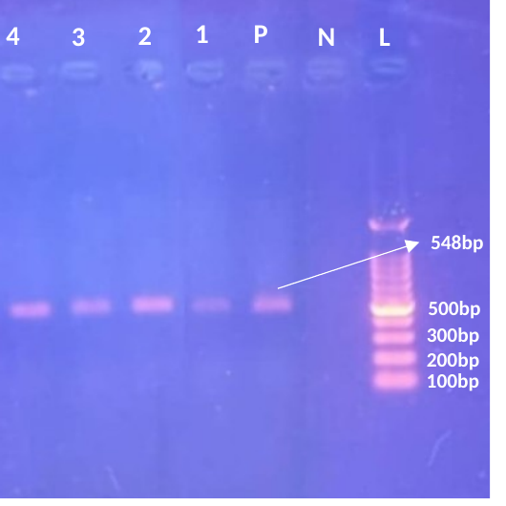
Figure 2. Agarose gel showing the expected 548-bp cpb2 PCR product of Clostridium perfringens. Lane L, 100-bp DNA ladder; lane N, negative control; lane P, positive control; lanes 1–4, representative cpb2-positive isolates.
Multiple sequence alignment
Two cpb2-positive isolates, PZ547700 and PZ547701, were subjected to partial sequence analysis. In the displayed amino acid alignment, PZ547701 retained broad similarity to the reference CPB2 sequences, whereas PZ547700 showed a greater number of mismatches, gaps, and ambiguous positions in the aligned fragment (Figure 3). Several conserved blocks were visible across the reference sequences and PZ547701.
Because the sequences were derived from partial amplicons and the alignment contains gap-bearing and ambiguous positions, the differences observed in PZ547700 should be interpreted conservatively as variation within the available sequence read rather than as evidence of altered toxin function. The alignment display includes columns introduced by gaps during alignment; therefore, alignment-column coordinates do not represent the raw translated length of the 548-bp PCR amplicon.

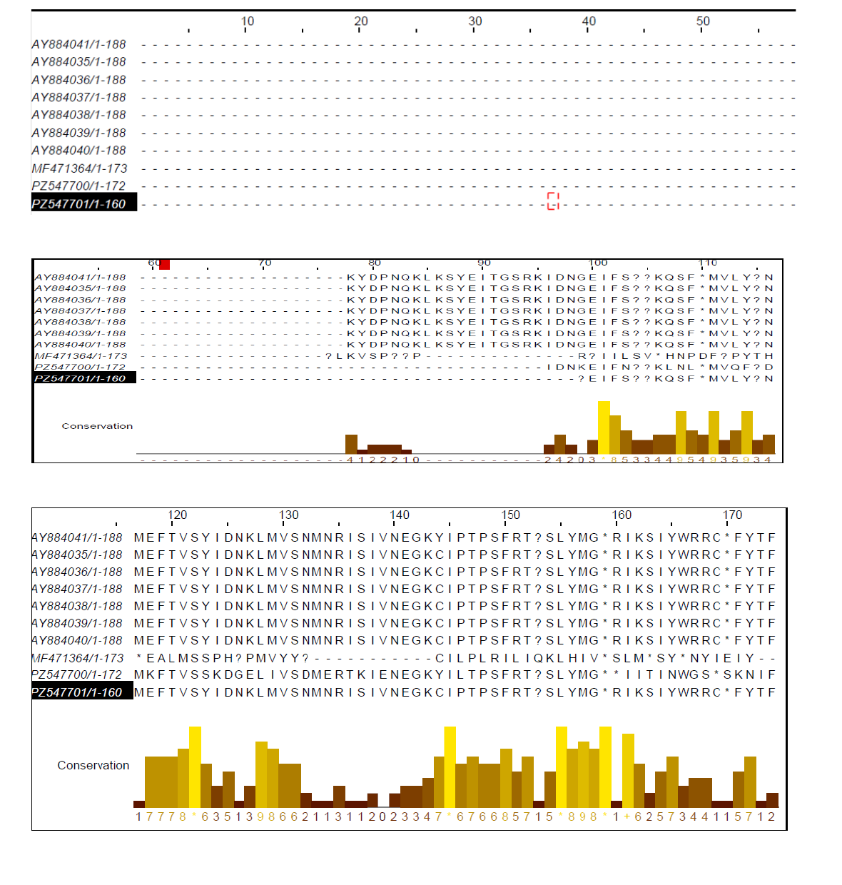

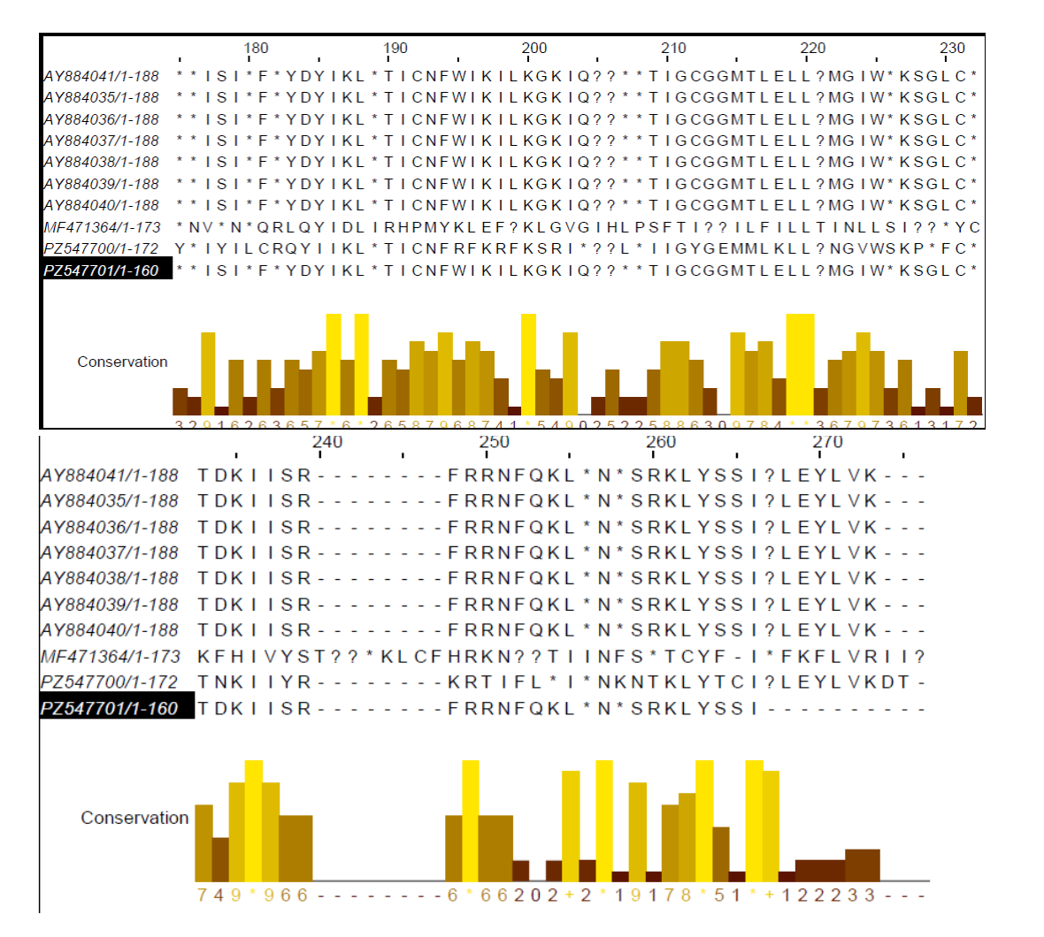
Figure 3. Multiple amino acid sequence alignment of beta2-toxin fragments from the two study isolates (PZ547700 and PZ547701) and selected reference CPB2 sequences.
Phylogenetic analysis of cpb2
Phylogenetic analysis of 22 partial cpb2 nucleotide sequences across 440 aligned nucleotide positions produced several clusters containing isolates from multiple hosts and geographic regions (Figure 4). The topology included poultry-, human-, horse-, cattle-, goat-, sheep-, and non-porcine-associated reference sequences, indicating that host origin alone did not determine clustering.
PZ547701 grouped with the U.S. poultry sequence AY884035 with 77% bootstrap support. The broader node linking this pair with HQ853334 had 44% support and was therefore considered weak.
PZ547700 grouped with the cattle sequence DQ525205 with 62% bootstrap support; that pair joined the horse sequence AJ537534 within a broader node supported at 89%. These results place both study sequences within previously described cpb2 diversity rather than as isolated lineages.
Several other internal branches had bootstrap support below 50%, whereas some deeper branches reached 93-100%. Accordingly, low-support branches were not used to make strong evolutionary claims. The tree does not support a simple poultry-specific or geography-specific lineage pattern.
The mixed clustering of sequences from different hosts is consistent with the broad host distribution of cpb2 described in earlier molecular surveys (Garmory et al., 2000; Tolooe et al., 2011). Nevertheless, only two newly sequenced isolates were included in the present analysis, so the tree should be interpreted as a descriptive comparison rather than a population-level phylogeographic analysis.
Overall, the sequence analyses indicate that the two study isolates are related to previously characterised cpb2 sequences from different hosts and regions. The available data support sequence relatedness but do not establish host specificity, geographic transmission pathways, or functional differences in CPB2.
The phylogenetic results therefore complement the PCR findings by documenting the genetic context of two cpb2-positive isolates while remaining consistent with the limited sample size and the variable bootstrap support observed across the tree.
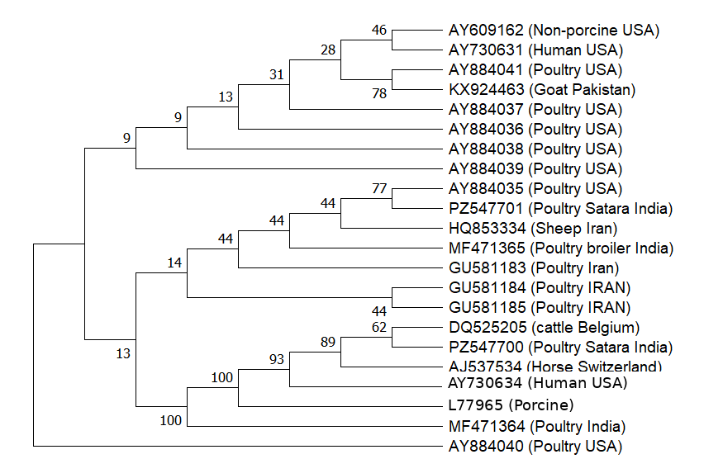
Figure 4. Maximum Parsimony phylogenetic analysis of partial cpb2 nucleotide sequences from the two study isolates and selected GenBank reference sequences. The analysis included 22 sequences and 440 aligned nucleotide positions. Branch labels indicate bootstrap support (%) from 1,000 replicates. L77965 is a porcine consensus cpb2 reference sequence.
Study limitations
This study has several limitations. Samples were collected from clinically or pathologically affected birds without a healthy comparison group; consequently, cpb2 positivity cannot be interpreted as an epidemiological association with NE. The isolates were not subjected to a complete contemporary toxinotyping panel, and netB was not assessed; therefore, no toxinotype assignment is made. Gene expression, CPB2 protein production, and experimental pathogenicity were not evaluated. In addition, only two cpb2-positive isolates were sequenced, limiting inference about local genetic diversity. These limitations do not invalidate the descriptive detection data but constrain causal and population-level interpretation.
Conclusion
Clostridium perfringens was recovered from 57 of 62 samples collected from poultry with clinical or pathological findings suggestive of NE, and all 57 isolates were confirmed by species-specific 16S rRNA PCR. The cpb2 gene was detected in five of 57 isolates (8.8%). Partial sequence analysis of two positive isolates placed them within the diversity of previously reported cpb2 sequences from multiple hosts and geographic regions, although one sequence contained more ambiguous and divergent alignment positions. The study therefore supports the presence of cpb2 among a minority of C. perfringens isolates from affected poultry in Maharashtra but does not establish a causal role for CPB2 or assign toxinotype. Future studies should incorporate unaffected controls, complete toxinotyping including netB, toxin-expression or protein assays, and larger sequence datasets.
Declaration of AI Use
Grammarly and ChatGPT were used during manuscript revision to assist with language editing, organisation, and reference verification and formatting. Experimental data and primary laboratory analyses were not generated by AI. The authors remain responsible for the scientific content and final submitted version.
Competing Interests
The authors declare that they have no known competing financial interests, non-financial interests, or personal relationships that could have influenced the work reported in this manuscript.
References
Deslauriers, N., Maduro, L., Lepp, D., Gong, J., Abdul-Careem, M. F., & Boulianne, M. (2024). Determination of the virulence status of Clostridium perfringens strains using a chicken intestinal ligated loop model is important for understanding the pathogenesis of necrotic. Poultry Science, 103(3), 103433. https://doi.org/10.1016/j.psj.2024.103433
Fathima, S., Al Hakeem, W. G., Shanmugasundaram, R., & Selvaraj, R. K. (2022). Necrotic enteritis in broiler chickens: A review on the pathogen, pathogenesis, and prevention. Microorganisms, 10(10), 1958. https://doi.org/10.3390/microorganisms10101958
Garmory, H. S., Chanter, N., French, N. P., Bueschel, D., Songer, J. G., & Titball, R. W. (2000). Occurrence of Clostridium perfringens beta2-toxin amongst animals, determined using genotyping and subtyping PCR assays. Epidemiology and Infection, 124(1), 61–67. https://doi.org/10.1017/S0950268899003295
Gibert, M., Jolivet-Reynaud, C., & Popoff, M. R. (1997). Beta2 toxin, a novel toxin produced by Clostridium perfringens. Gene, 203(1), 65–73. https://doi.org/10.1016/S0378-1119(97)00493-9
Hall, T. A. (1999). BioEdit: A user-friendly biological sequence alignment editor and analysis program for Windows 95/98/NT. Nucleic Acids Symposium Series, 41, 95–98. https://ndlsearch.ndl.go.jp/en/books/R100000136-I1572543025612760320
Keyburn, A. L., Boyce, J. D., Vaz, P., Bannam, T. L., Ford, M. E., Parker, D., Di Rubbo, A., Rood, J. I., & Moore, R. J. (2008). NetB, a new toxin that is associated with avian necrotic enteritis caused by Clostridium perfringens. PLoS Pathogens, 4(2), e26. https://doi.org/10.1371/journal.ppat.0040026
Khiav, L. A., Paradise, A., Pilehchian Langroudi, R., & Khaki, P. (2020). Clostridial vaccine for veterinary use in Iran: A review. Microbiology Research Journal International, 30(12), 12–22. https://doi.org/10.9734/mrji/2020/v30i1230285
Nazki, S., Wani, S. A., Parveen, R., Ahangar, S. A., Kashoo, Z. A., Hamid, S., Dar, Z. A., Dar, T. A., & Dar, P. A. (2017). Isolation, molecular characterization and prevalence of Clostridium perfringens in sheep and goats of Kashmir Himalayas, India. Veterinary World, 10(12), 1501–1507. https://doi.org/10.14202/vetworld.2017.1501-1507
Praveen Kumar, N., Vinod Kumar, N., & Karthik, A. (2019). Molecular detection and characterization of Clostridium perfringens toxin genes causing necrotic enteritis in broiler chickens. Tropical Animal Health and Production, 51(6), 1559–1569. https://doi.org/10.1007/s11250-019-01847-9
Rana, E. A., Nizami, T. A., Islam, M. S., Barua, H., & Islam, M. Z. (2023). Phenotypical identification and toxinotyping of Clostridium perfringens isolates from healthy and enteric disease-affected chickens. Veterinary Medicine International, 2023, Article 2584171. https://doi.org/10.1155/2023/2584171
Rood, J. I., Adams, V., Lacey, J., Lyras, D., McClane, B. A., Melville, S. B., Moore, R. J., Popoff, M. R., Sarker, M. R., Songer, J. G., Uzal, F. A., & Van Immerseel, F. (2018). Expansion of the Clostridium perfringens toxin-based typing scheme. Anaerobe, 53, 5–10. https://doi.org/10.1016/j.anaerobe.2018.04.011
Schotte, U., Truyen, U., & Neubauer, H. (2004). Significance of beta 2-toxigenic Clostridium perfringens infections in animals and their predisposing factors—A review. Journal of Veterinary Medicine Series B: Infectious Diseases and Veterinary Public Health, 51(10), 423–426. https://doi.org/10.1111/j.1439-0450.2004.00802.x
Shamshirgaran, M. A., & Golchin, M. (2024). A comprehensive review of experimental models and induction protocols for avian necrotic enteritis over the past 2 decades. Frontiers in Veterinary Science, 11, 1429637. https://doi.org/10.3389/fvets.2024.1429637
Tamura, K., Stecher, G., & Kumar, S. (2021). MEGA11: Molecular Evolutionary Genetics Analysis version 11. Molecular Biology and Evolution, 38(7), 3022–3027. https://doi.org/10.1093/molbev/msab120
Timbermont, L., Haesebrouck, F., Ducatelle, R., & Van Immerseel, F. (2011). Necrotic enteritis in broilers: An updated review on the pathogenesis. Avian Pathology, 40(4), 341–347. https://doi.org/10.1080/03079457.2011.590967
Tolooe, A., Shojadoost, B., & Peighambari, S. M. (2011). Molecular detection and characterization of cpb2 gene in Clostridium perfringens isolates from healthy and diseased chickens. Journal of Venomous Animals and Toxins Including Tropical Diseases, 17(1), 59–65. https://doi.org/10.1590/S1678-91992011000100008
van Asten, A. J. A. M., Nikolaou, G. N., & Gröne, A. (2010). The occurrence of cpb2-toxigenic Clostridium perfringens and the possible role of the beta2-toxin in enteric disease of domestic animals, wild animals and humans. The Veterinary Journal, 183(2), 135–140. https://doi.org/10.1016/j.tvjl.2008.11.005
Van Immerseel, F., De Buck, J., Pasmans, F., Huyghebaert, G., Haesebrouck, F., & Ducatelle, R. (2004). Clostridium perfringens in poultry: An emerging threat for animal and public health. Avian Pathology, 33(6), 537–549. https://doi.org/10.1080/03079450400013162
Waterhouse, A. M., Procter, J. B., Martin, D. M. A., Clamp, M., & Barton, G. J. (2009). Jalview Version 2—a multiple sequence alignment editor and analysis workbench. Bioinformatics, 25(9), 1189–1191. https://doi.org/10.1093/bioinformatics/btp033

