Effective management of Poultry Red Mite (Dermanyssusgallinae) in backyard Poultry Using an Integrated Control Program: A Case Report

Abstract

Poultry red mite Dermanyssus gallinae is one of the most economically important ectoparasites affecting laying hens worldwide, causing anaemia, reduced egg production, poor welfare, and economic losses. Increased resistance to synthetic acaricides has highlighted the need for a sustainable integrated control programme. This case report aimed to evaluate the long-term control of poultry red mite infestation in backyard poultry using a combination of chemical acaricides, herbal extracts, and improved sanitation practices. A flock of 49 hens and 3 cocks showed severe anaemia, weight loss, feather pecking, cannibalism, reduced egg production, and mortality. Mites collected from the birds and poultry house were processed and identified morphologically as D. gallinae based on characteristic microscopic features. The poultry premises were dry-cleaned and disinfected before treatment. Birds were initially treated with 0.25% cypermethrin dust, followed by repeated applications of herbal extracts containing Annona squamosa and Sphaeranthus indicus. Poultry sheds were treated with cypermethrin and a herbal formulation containing Acorus calamus, Annona squamosa, and Allium sativum, with monthly applications for four months. A marked reduction in the mite population was observed, and effective control was maintained for more than one year. The findings demonstrate that an integrated pest management programme combining chemical treatment, botanical extracts, and regular cleaning and disinfection provides an effective and sustainable strategy for long-term control of poultry red mite infestations in backyard poultry.

Keywords: Dermanyssus gallinae, poultry red mite, integrated pest management, herbal extracts.

INTRODUCTION
Poultry production is one of the most important sectors of livestock farming, contributing greatly to the worldwide food supply. As an inexpensive and efficient source of high-quality animal protein, poultry meat plays a crucial role in bridging the gap between the requirement for and availability of animal protein.
The poultry red mite, Dermanyssus gallinae, is a widely distributed ectoparasite that poses a major threat to poultry production worldwide. This mite mainly parasitises laying hens, sheltering in cracks and crevices of poultry houses during the day and becoming active at night to acquire blood meals from the birds (Sigognault Flochlay et al., 2017). The poultry red mite completes its life cycle in approximately 6-7 days under optimal conditions. These mites induce irritation, decreased feed consumption, tissue damage, and general discomfort, which can progress to weight loss, anaemia, and a consequent decline in poultry productivity (Soulsby, 1982). Furthermore, poultry red mites are linked to allergic reactions and dermatitis, adversely affecting bird welfare as well as the quality and productivity of both meat and egg production. As a result, they impose substantial economic burdens on the global egg industry. Sigognault Flochlay et al. (2017) reported that the current annual cost of poultry red mite infestation in the Netherlands is approximately €0.60 per laying hen, indicating an increase of about 40% in total expenditure on mite control since 2005. The poultry red mite, Dermanyssus gallinae, functions as both a reservoir and vector for numerous bacterial and viral pathogens, some of which have zoonotic significance. It has been associated with the spread of Newcastle disease, salmonellosis, and avian influenza. Furthermore, accidental infestation of humans by these mites can result in dermatitis and other skin lesions, raising concerns regarding public health (George et al., 2015). Recent molecular characterisation of D. gallinae collected from commercial poultry farms and a wild bird further highlights the importance of considering wildlife hosts in broader epidemiological investigations of this ectoparasite (Tabaripour et al., 2026).
Synthetic acaricides have long been the primary method for controlling these mites. However, their continued use has led to the development of resistance, environmental contamination, and potential health hazards to both humans and animals. These limitations have prompted the search for sustainable alternatives, such as botanical products, vaccines, biological control agents, and physical control methods. Recent evidence indicates that vaccination remains an emerging alternative; however, reported antigen candidates show variable protective efficacy, and no fully effective commercial vaccine is currently available (Mirzaei & Dawoodi, 2026). Plant-based pesticides, in particular, are considered economical and safer options for integrated pest management. In vitro work on D. gallinae has reported acaricidal activity of neem essential oil, while field and pot experiments with Tetranychus urticae indicate that responses to botanical extracts and oils vary among products, supporting species- and formulation-specific evaluation before practical use (Al-Shaibani et al., 2021; Velmurugan et al., 2025). Recent laboratory research has also shown that a hydroxyethyl cellulose hydrogel carrying Eucalyptus globulus essential oil and Beauveria bassiana can provide acaricidal activity against D. gallinae, with the combined approach requiring field validation before routine application (Pugliese et al., 2025). Integrated pest management is a sustainable pest control strategy that employs a combination of biological, physical, chemical, and cultural methods to prevent and control pest infestations while reducing the use of synthetic pesticides. Overall, PRM infestation poses a significant threat to poultry health, production efficacy, and public health, emphasising the need for sustainable and integrated management strategies (Zhou et al., 2024). This case report demonstrates the successful long-term management of PRM infestations in backyard poultry through an integrated pest management strategy that combined an initial acaricidal treatment with subsequent applications of herbal extracts, along with routine cleaning and disinfection of poultry premises.
Research gap: Although the manuscript describes chemical, botanical, biological, and physical options for poultry red mite control, there remains a practical need to document the long-term field outcome of a sequential integrated programme under backyard-poultry conditions. Because the interventions in the present case were applied as a combined programme, the contribution of each individual component cannot be separated.
Objective
Accordingly, the objective of this case report was to document the long-term field outcome of the integrated programme applied to this backyard flock, comprising initial acaricidal treatment, subsequent herbal applications, and routine cleaning and disinfection.
CASE PRESENTATION
A total of 3 birds were presented to the clinic with a history of severe anaemia, weight loss, aggressive feather pecking, cannibalistic behaviour, and increased feed and water consumption. Farm examination revealed that a total of 49 hens and 3 cocks were affected, with visible black and white deposits of mite faeces, groups of mites (Fig.1), and cast-off skins on the birds and within the housing. The flock also exhibited increased noise levels, reduced egg production, a higher proportion of downgraded eggs, and a mortality rate of 3%. The birds were thoroughly examined, and samples were collected during daylight hours from various locations within the poultry house, including beneath feed troughs and under manure accumulations. Mites on the chickens were carefully collected from the fluffy down feathers and vent region using a fine brush and transferred into zip-lock plastic bags for further examination. The collected specimens were transported to the laboratory for processing and detailed morphological examination. The specimens were cleared by boiling in 10% potassium hydroxide (KOH) for 15 minutes, followed by gentle washing. They were gently dehydrated through a graded series of alcohol, cleared in xylol, and mounted on glass slides using DPX mounting medium. The mounted specimens were examined under a light microscope for species identification. The engorged adult female mites measured approximately 1 mm in length and were reddish in colour (Fig.2). The dorsal shield did not extend to the posterior end of the body and exhibited a truncated posterior margin, while the anus was located in the posterior half of the anal plate (Fig.2). Based on these characteristic morphological features, the mites were identified as Dermanyssus gallinae, commonly known as the poultry red mite.
TREATMENT
Initially, the poultry premises were dry-cleaned, followed by disinfection with phenolic compounds. The affected birds were treated with 0.25% cypermethrin Poultry Dust for 3 days, followed by a combination of aqueous leaf extracts of Annona squamosa and Sphaeranthus indicus, sprayed on the affected birds at 10 ml extract/1 litre, with three repeated applications within 1 week. The poultry sheds and premises were sprayed with 10% cypermethrin solution at 15 ml/1 litre of water, followed by a combination of aqueous extract of Acorus calamus + leaf extract of Annona squamosa + juice of Allium sativum (30 ml extract/1 litre), applied throughout the shed with special attention to the areas where these mites hide to prevent reinfestation (cracks and crevices, behind nest boxes, walls, and ceilings). A marked (approximately 90%) reduction in visible mite infestation was observed. The poultry house and birds were retreated every month for up to 4 months with the above herbal extracts, along with proper cleaning and disinfection, because adult mites can survive without feeding for up to six months; this schedule also aimed to eliminate newly emerged developmental stages. The above treatment resulted in effective poultry red mite control over a period of more than one year.
DISCUSSION
The integrated control strategy, namely herbal plant extracts, chemical acaricides, and improved hygiene and sanitation, successfully controlled poultry red mite (Dermanyssus gallinae) infestation in backyard poultry. An approximately 90% reduction in visible mite infestation was achieved after the initial treatment, and monthly follow-up applications for four months prevented reinfestation by targeting newly emerged mites. The findings are consistent with other studies that showed acaricidal efficacies of more than 92% with neem-derived Azadirachtin (Lundh et al., 2005). Similarly, Rüster et al. (2023) recorded a 99.8% reduction in PRM (Dermanyssus gallinae) following treatment with fluralaner, followed by the combined use of disinfection and a synthetic silica-based acaricide. According to Ranjbar-Bahadori et al. (2014), garlic extract is effective in controlling infestations of blood-sucking mites. The results obtained by the authors showed that, on days 1 and 7 after administration of the extract, the efficacy rates were 92.05% and 74.62%, respectively. Irwan et al. (2021) revealed that Annona squamosa and Annona muricata extracts were most effective in killing leaf mealworms and opined that the correct doses of these plant extracts were powerful, environmentally friendly, low-cost pesticides. Crude ethanolic extract of S. indicus demonstrated a significant concentration-dependent effect on adult mortality and inhibition of fecundity in ticks (Divya et al., 2019).
Integrated control and environmental management
The approximately 90% reduction observed after combined treatment of the birds and poultry premises is consistent with the rationale of poultry red mite integrated pest management because Dermanyssus gallinae spends most of its time off the host in cracks, crevices, and equipment, where protected populations may escape treatment directed only at birds. Reviews of poultry red mite control emphasise sanitation, monitoring, and the integration of interventions with different modes of action, while laboratory evidence supports silica-based products as environmental acaricides (Decru et al., 2020; Harrington et al., 2011; Ulrichs et al., 2020). The maintenance of control for more than one year is therefore compatible with repeated suppression of residual environmental populations; however, the contribution of each component cannot be separated in this uncontrolled case report.
Botanical acaricides and treatment interpretation
The use of botanical preparations has biological plausibility because laboratory studies have demonstrated contact, fumigant, or repellent activity of several plant essential oils against D. gallinae. Garlic, thyme, clove, cinnamon, and related oils have shown activity against adult and juvenile stages, although efficacy varies with concentration, exposure conditions, life stage, and chemical composition (George et al., 2009, 2010; Kim et al., 2004). These findings support further evaluation of the herbal phase of the programme, but they do not directly establish the efficacy of the exact Annona squamosa, Sphaeranthus indicus, Acorus calamus, and Allium sativum mixture used in this case. Standardised extract composition, dose-response testing, safety assessment, and controlled field comparisons are needed before this botanical combination can be recommended broadly. Related insecticidal activity of A. squamosa leaf extract has also been reported against Sitophilus oryzae (Kumar et al., 2010).
Resistance management and study limitations
Limiting repeated exposure to a single synthetic acaricide is important because field populations of D. gallinae have shown reduced susceptibility to permethrin and other acaricides, and inappropriate chemical use can create residue concerns in poultry tissues (Marangi et al., 2009, 2012). Accordingly, the initial cypermethrin treatment followed by sanitation and non-chemical measures is conceptually aligned with resistance-management principles (Harrington et al., 2011). Nevertheless, the reported 90% reduction was not accompanied by a described counting method, baseline and follow-up mite numbers, an untreated comparison, or statistical analysis; therefore, the outcome should be interpreted as a descriptive field observation rather than proof of the efficacy of any single intervention.
CONCLUSION
Once poultry become infested, effective control can be achieved by spraying or dusting the birds and litter, as well as by treating the poultry house thoroughly with a high-pressure sprayer. Particular attention should be given to areas where poultry red mites hide, such as cracks, crevices, and spaces behind nest boxes. Regular monitoring of mite populations is essential for detecting increases in PRM numbers and implementing timely control measures to minimise infestation-related losses. Integrating continuous surveillance with multiple preventive strategies enables the targeted and reduced use of acaricidal agents, thereby lowering the risk of resistance development. The findings of this case report demonstrate that poultry red mite infestation in backyard flocks can be effectively and sustainably managed through an Integrated Pest Management (IPM) programme.

Ethical Approval
Animal Ethic committee approval has been collected and preserved by the author(s)

Declaration of AI Use

This manuscript was prepared through the combined contributions of all author(s), including contributions to the study design, data, content development, results, interpretation, and related scholarly work. The author(s) acknowledge the use of Grammarly and ChatGPT to assist with grammar checking, language refinement, reference formatting. These AI-assisted tools were not used as authors and did not replace the intellectual contributions or scholarly judgment of the author(s). All AI-assisted outputs, including content, references, and interpretations, were carefully reviewed, revised, verified, and approved by the author(s). The author(s) accept full responsibility for the accuracy, integrity, and final content of the manuscript.

References

Al-Shaibani, I. R. M., Al-Sharhi, M. M., Al-Khadher, A. M. A., Awam, S. M., Salah, S. M., & Thwabah, S. F. (2021). Acaricidal activity of Azadaritcha indica L. (Meliaceae) essential oil against the Dermanyssus gallinae of poultry: In vitro. Asian Journal of Research in Animal and Veterinary Sciences, 4(2), 151-160. https://doi.org/10.9734/ajravs/2021/v4i2158
Decru, E., Mul, M., Nisbet, A. J., Vargas Navarro, A. H., Chiron, G., Walton, J., Norton, T., Roy, L., & Sleeckx, N. (2020). Possibilities for IPM strategies in European laying hen farms for improved control of the poultry red mite (Dermanyssus gallinae): Details and state of affairs. Frontiers in Veterinary Science, 7, Article 565866. https://doi.org/10.3389/fvets.2020.565866
Divya, T. M., Soorya, V. C., Amithamol, K. K., Udayan, D., Sreelekha, K., Nair, S. N., Ajithkumar, K. G., Juliet, S., Ravindran, R., & Ghosh, S. (2019). Acaricidal activity of crude ethanolic extract of Sphaeranthus indicus, its fractions and subfractions against Rhipicephalus (Boophilus) annulatus (Acari: Ixodidae). International Journal of Current Microbiology and Applied Sciences, 8(8), 787–797. https://doi.org/10.20546/ijcmas.2019.808.089
George, D. R., Smith, T. J., Shiel, R. S., Sparagano, O. A. E., & Guy, J. H. (2009). Mode of action and variability in efficacy of plant essential oils showing toxicity against the poultry red mite, Dermanyssus gallinae. Veterinary Parasitology, 161(3–4), 276–282. https://doi.org/10.1016/j.vetpar.2009.01.010
George, D. R., Sparagano, O. A. E., Port, G., Okello, E., Shiel, R. S., & Guy, J. H. (2010). Toxicity of plant essential oils to different life stages of the poultry red mite, Dermanyssus gallinae, and non-target invertebrates. Medical and Veterinary Entomology, 24(1), 9–15. https://doi.org/10.1111/j.1365-2915.2009.00856.x
George, D. R., Finn, R. D., Graham, K. M., Mul, M. F., Maurer, V., Valiente Moro, C., & Sparagano, O. A. E. (2015). Should the poultry red mite Dermanyssus gallinae be of wider concern for veterinary and medical science? Parasites & Vectors, 8, Article 178. https://doi.org/10.1186/s13071-015-0768-7
Harrington, D. W. J., George, D. R., Guy, J. H., & Sparagano, O. A. E. (2011). Opportunities for integrated pest management to control the poultry red mite, Dermanyssus gallinae. World's Poultry Science Journal, 67(1), 83–94. https://doi.org/10.1017/S0043933911000079
Irwan, Z., Kamarudin, W. F. W., Korish, U. A. S. A., Z, N. A., Rusli, A. S., & Sallehuddin, S. (2021). Effectiveness of Annona squamosa and Annona muricata seed extracts as ingredients in bio-pesticides spray. IOP Conference Series: Materials Science and Engineering, 1176(1), Article 012007. https://doi.org/10.1088/1757-899X/1176/1/012007
Kim, S.-I., Yi, J.-H., Tak, J.-H., & Ahn, Y.-J. (2004). Acaricidal activity of plant essential oils against Dermanyssus gallinae (Acari: Dermanyssidae). Veterinary Parasitology, 120(4), 297–304. https://doi.org/10.1016/j.vetpar.2003.12.016
Kumar, J. A., Rekha, T., Devi, S. S., Kannan, M., Jaswanth, A., & Gopal, V. (2010). Insecticidal activity of ethanolic extract of leaves of Annona squamosa. Journal of Chemical and Pharmaceutical Research, 2(5), 177–180. https://www.jocpr.com/articles/insecticidal-activity-of-ethanolic-extract-of-leaves-of-annona-squamosa.pdf
Lundh, J., Wiktelius, D., & Chirico, J. (2005). Azadirachtin-impregnated traps for the control of Dermanyssus gallinae. Veterinary Parasitology, 130(3–4), 337–342. https://doi.org/10.1016/j.vetpar.2005.02.012
Marangi, M., Cafiero, M. A., Capelli, G., Camarda, A., Sparagano, O. A. E., & Giangaspero, A. (2009). Evaluation of the poultry red mite, Dermanyssus gallinae (Acari: Dermanyssidae), susceptibility to some acaricides in field populations from Italy. Experimental and Applied Acarology, 48, 11–18. https://doi.org/10.1007/s10493-008-9224-0
Marangi, M., Morelli, V., Pati, S., Camarda, A., Cafiero, M. A., & Giangaspero, A. (2012). Acaricide residues in laying hens naturally infested by red mite Dermanyssus gallinae. PLOS ONE, 7(2), e31795. https://doi.org/10.1371/journal.pone.0031795
Mirzaei, Y., & Dawoodi, H. F. (2026). Recent advances in vaccine development against poultry red mite (Dermanyssus gallinae): A literature review on native and recombinant antigens. Acta Parasitologica, 71, Article 169. https://doi.org/10.1007/s11686-026-01350-w
Pugliese, N., Camarda, A., Miglianti, M., Friuli, M., Demitri, C., Siddique, I., Bezerra Santos, M. A., Rhimi, W., Circella, E., Cafarchia, C., & Otranto, D. (2025). Hydroxyethyl cellulose-based hydrogel as a novel delivery system for Eucalyptus globulus essential oil and Beauveria bassiana conidia for the control of the poultry red mite Dermanyssus gallinae. BMC Veterinary Research, 21, Article 473. https://doi.org/10.1186/s12917-025-04923-5
Ranjbar-Bahadori, S., Farhadifar, N., & Mohammadyar, L. (2014). Assessment of susceptibility of the poultry red mite, Dermanyssus gallinae (Acari: Dermanyssidae), to some plant preparations with focus on exposure time. World Academy of Science, Engineering and Technology, International Journal of Animal and Veterinary Sciences, 8(6), 573–576. https://publications.waset.org/9998442.pdf
Rüster, V., Lückemann, A. K., Wittmann, M., Strube, C., & Bartels, T. (2023). Successful long-term control of poultry red mite (Dermanyssus gallinae) infestations in floor-kept laying hens via integrated pest management—A case report. Parasitology Research, 122, 2549–2555. https://doi.org/10.1007/s00436-023-07954-9
Sigognault Flochlay, A., Thomas, E., & Sparagano, O. (2017). Poultry red mite (Dermanyssus gallinae) infestation: A broad impact parasitological disease that still remains a significant challenge for the egg-laying industry in Europe. Parasites & Vectors, 10, Article 357. https://doi.org/10.1186/s13071-017-2292-4
Soulsby, E. J. L. (1982). Helminths, arthropods and protozoa of domesticated animals (7th ed.). Baillière Tindall. https://openlibrary.org/books/OL21632586M/Helminths_arthropods_and_protozoa_of_domesticated_animals
Tabaripour, S. R., Mousavi, M. H., & Youssefi, M. (2026). Molecular detection and phylogenetic characterization of poultry red mite (Dermanyssus gallinae) collected from chicken farms and wild birds in northern Iran. Journal of Parasitic Diseases. Advance online publication. https://doi.org/10.1007/s12639-026-01951-2
Ulrichs, C., Han, Y. J., Abdelhamid, M. T., & Mewis, I. (2020). Management of the poultry red mite, Dermanyssus gallinae, using silica-based acaricides. Experimental and Applied Acarology, 82, 243–254. https://doi.org/10.1007/s10493-020-00541-y
Velmurugan, S., Anandhi, P., Elamathi, S., Ahila Devi, P., Rajarathinam, P., & Leena, G. (2025). Bio efficacy of certain botanical extracts, oils and acaricide against two spotted spider mites [Tetranychus urticae (Koch)] on okra. Journal of Global Agriculture and Ecology, 17(1), 22-30. https://doi.org/10.56557/jogae/2025/v17i19062
Zhou, W., Arcot, Y., Medina, R. F., Bernal, J., Cisneros-Zevallos, L., & Akbulut, M. E. S. (2024). Integrated pest management: An update on the sustainability approach to crop protection. ACS Omega, 9(40), 41130–41147. https://doi.org/10.1021/acsomega.4c06628

IMAGES
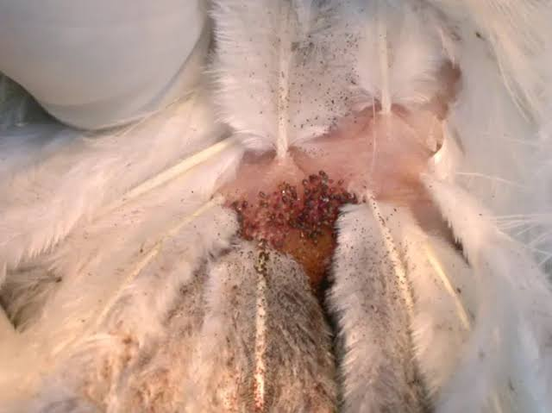  1a | 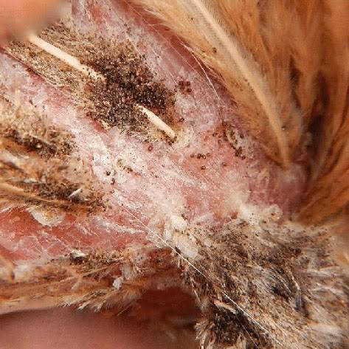  1b
Fig 1a&1b: Birds showing visible black and white deposits of mite feces and groups of mites

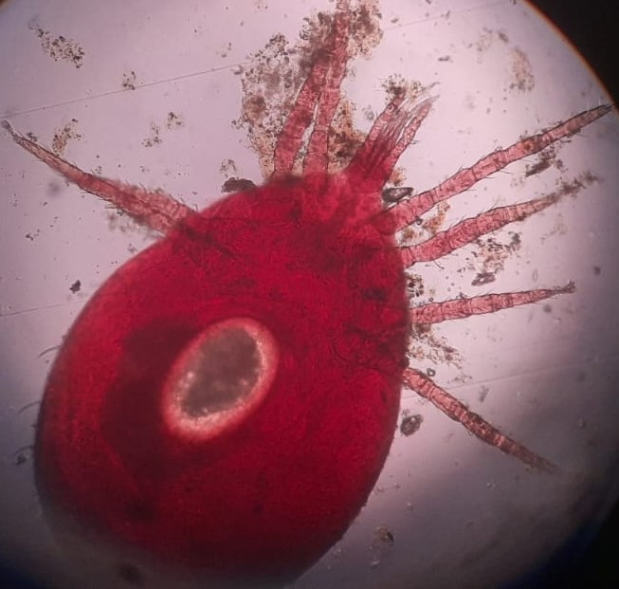  2a | 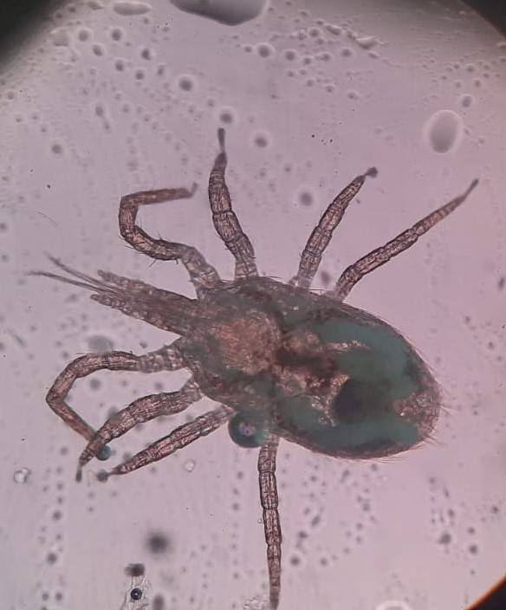  2b
Fig 2a&2b : showing reddish color mite and the dorsal shield did not extend to the posterior end of the body with truncated posterior margin .

deacarizationof cattle, sheep, goats, horses, donkeys, camels, poultry and other animals,
protection of livestock facilities from harmful insects and ticks, the medicine was tested in
livestock farms, its highly effective concentrations and doses were determined.
Cypermethrin isrecommended fordisinsection and
deacarizationof cattle, sheep, goats, horses, donkeys, camels, poultry and other animals,
protection of livestock facilities from harmful insects and ticks, the medicine was tested in
livestock farms, its highly effective concentrations and doses were determined.
Cypermethrin isrecommended fordisinsection and
deacarizationof cattle, sheep, goats, horses, donkeys, camels, poultry and other animals,
protection of livestock facilities from harmful insects and ticks, the medicine was tested in
livestock farms, its highly effective concentrations and doses were determined.

clinicalsignobservedininfestedanimalsissub-acute
anemiaduetorepeatedmitebites.Alayinghencanlose
morethan3%ofitsbloodvolumeeverynight[3].In
extremecases,D. gallinaeinfestation burdens may be so
heavythathensmaydiefromsevereanemia
clinicalsignobservedininfestedanimalsissub-acute
anemiaduetorepeatedmitebites.Alayinghencanlose
morethan3%ofitsbloodvolumeeverynight[3].In
extremecases,D. gallinaeinfestation burdens may be so
heavythathensmaydiefromsevereanemia
linicalsignobservedininfestedanimalsissub-acute
anemiaduetorepeatedmitebites.Alayinghencanlose
morethan3%ofitsbloodvolumeeverynight[3].In
extremecases,D. gallinaeinfestation burdens may be so
heavythathensmaydiefromsevereanemia
linicalsignobservedininfestedanimalsissub-acute
anemiaduetorepeatedmitebites.Alayinghencanlose
morethan3%ofitsbloodvolumeeverynight[3].In
extremecases,D. gallinaeinfestation burdens may be so
heavythathensmaydiefromsevereanemia

