Effects of Cow Dung and Immobilized Lactobacillus sporogens on the Hemato-Immunological Responses of Indian Major Carp (Cirrhinus mrigala, Labeo rohita) and Exotic Carp (Cyprinus carpio)
Abstract
The present study investigates the effects of free and immobilised probiotic supplementation containing Lactobacillus sporogenes with cow dung on the haematological and immunological responses of economically important Indian major carps, Cirrhinus mrigala (11.5 ± 0.4 g), Labeo rohita (8.5 ± 0.5 g), and exotic carp, Cyprinus carpio (10.5 ± 0.6 g), reared in Aliyar Dam water. A total of 125 fingerlings of each fish species were randomly allocated to five treatment groups with triplicates over a 70-day experimental period. The experimental diets consisted of T1 (free probiotics), T2 (cow dung), T3 (cow dung + free probiotics), T4 (cow dung + immobilised probiotics), and a control group fed the basal diet without probiotic supplementation. At the end of the feeding experiment, haematological indices (haemoglobin (Hb), red blood cell (RBC) count, white blood cell (WBC) count, packed cell volume (PCV) or Haematocrit, mean corpuscular volume (MCV), mean corpuscular haemoglobin (MCH), and mean corpuscular haemoglobin concentration (MCHC)) and immunological parameters (Nitroblue tetrazolium (NBT) respiratory burst activity, lysozyme activity, and phagocytic activity) were evaluated. The results revealed a significant (P < 0.05) enhancement in both haematological and immunological parameters in the probiotic-treated groups compared with the control. Among the treatments, fish receiving cow dung supplemented with immobilised probiotics (T4) exhibited the maximum response, followed by cow dung with free probiotics (T3). The improved haematological and immune responses indicate improved physiological status, oxygen-carrying capacity, and disease resistance in the fish (P≤0.05) compared with the control. These findings suggest that immobilised Lactobacillus sporogenes is an effective probiotic supplement for enhancing the survival rate of commercial IMC and exotic carp by enhancing immunity, reducing disease, improving the haematological profile, and supporting sustainable aquaculture through better water quality and reduced mortality.
Key words: Freshwater carps, Lactobacillus Sporogens, Immobilized probiotics, Hematological Parameter, Innate immune response, Organic fertilization
Introduction
Aquaculture is one of the fastest-growing food-production sectors and plays a vital role in meeting the increasing global demand for high-quality animal protein. Fish are an excellent source of nutrients, providing protein-rich food of high biological value that contains all necessary amino acids in suitable proportions, along with essential fatty acids, vitamins, and minerals required for human health (Qubay et al., 2025; Ryu et al., 2021). Therefore, the development of sustainable aquaculture practices is necessary to ensure food security while maintaining environmental quality. Intensive aquaculture practices often lead to deterioration in water quality, increased organic waste, and greater susceptibility to transmissible diseases, resulting in reduced productivity and economic losses. In recent research, probiotics have gained significant attention as a sustainable and eco-friendly alternative to antibiotics for improving fish health and maintaining water quality. The fish species Cirrhinus mrigala (Mrigal), Labeo rohita (Rohu), and Cyprinus carpio (Common Carp) are economically important and widely cultured in India. These fish are the backbone of the country's freshwater and composite fish-culture systems. They grow rapidly compared with other fish, have good taste, provide protein-rich food, consume different types of feed, and do not compete for space, helping fish farmers obtain maximum production from a single pond. These fish are generally used in composite fish farming because of their complementary feeding behaviour, rapid growth, adaptability to diverse ecological conditions, and high consumer demand. Labeo rohita is primarily a column feeder, Cirrhinus mrigala is a bottom feeder, and Cyprinus carpio is an omnivorous bottom feeder, making them suitable for evaluating probiotic effects under polyculture conditions. In addition, these fish are known to respond positively to dietary probiotic supplementation, making them suitable experimental species for evaluating changes in haematological and immunological parameters. Consequently, results obtained from these economically important fish have practical significance for improving fish health, productivity, and sustainable aquaculture practices. The use of selected probiotics instead of conventional chemical agents enhances fish growth, improves immune responses, reduces or inhibits harmful microorganisms, and decreases the risks associated with antimicrobial resistance and chemical residues, making probiotics a sustainable approach to aquaculture (Yousuf et al., 2023). Probiotics are effective alternatives to antibiotics and chemical treatments in aquaculture (Veedu et al., 2026). Probiotics favourably influence the intestinal microbiota, improve nutrient utilisation, inhibit harmful microorganisms, and enhance both innate and adaptive immune responses. In addition, probiotic supplementation has been reported to improve important haematological indices, including red blood cell (RBC) count, white blood cell (WBC) count, haemoglobin concentration, mean corpuscular volume (MCV), mean corpuscular haemoglobin (MCH), and mean corpuscular haemoglobin concentration (MCHC), thereby improving oxygen transport and the overall physiological status of fish (Rachmawati et al., 2021). The efficacy of probiotics depends on the microorganisms, dosage, feeding duration, and culture conditions. Among the commonly used probiotics, Bacillus species, including Bacillus subtilis, Bacillus licheniformis, and Bacillus velezensis, are recognised for their ability to degrade organic matter, reduce ammonia accumulation, and improve water quality in aquaculture systems. These beneficial bacteria also enhance growth performance and haematological characteristics in cultured fish. Similarly, Lactobacillus spp., such as Lactobacillus acidophilus and Lactobacillus plantarum, colonise the gastrointestinal tract (GIT), improve digestive efficiency, and reduce the colonisation of harmful bacteria. The yeast Saccharomyces cerevisiae contributes to improved gut morphology, nutrient assimilation, and mucosal immune responses. In addition, probiotics stimulate the production of immunological agents, including immunoglobulins, lysozymes, and cytokines, which help prepare fish against bacterial infections such as Aeromonas and Vibrio (Kord et al., 2021). Several studies have demonstrated that dietary probiotic supplementation significantly improves haematological and immunological parameters, leading to increased haemoglobin concentration, enhanced blood cell production, and improved disease resistance in cultured fish. These beneficial effects highlight the potential of probiotics as a sustainable feed additive for promoting fish health, improving aquaculture productivity, and reducing dependence on antibiotics. Therefore, the present study was undertaken to evaluate the effects of probiotic supplementation on the haematological responses and immune status of cultured carp under aquaculture conditions. Probiotics improve oxygen transport, helping fish survive under low-oxygen and polluted conditions while maintaining good water quality.
Recent freshwater-fish studies have also evaluated probiotic effects on feed utilisation, growth, and survival in Clarias gariepinus and on haematological and innate immune parameters in Cyprinus carpio haematopterus (Subandiyono et al., 2023; Shivani et al., 2025). Studies in common carp have further reported that dietary Lactobacillus rhamnosus and fengycin-producing Bacillus subtilis can modulate immune-related outcomes and disease resistance under controlled feeding conditions (Hajirezaee et al., 2024; Xia et al., 2024). A recent synthesis of the aquaculture literature emphasises that probiotic performance is influenced by strain selection, host specificity, administration strategy, and culture conditions, which should be considered when interpreting responses across fish species (Fachri et al., 2024).
Within the scope of the present study, a specific research gap concerns the comparative responses of C. mrigala, L. rohita, and C. carpio to free versus immobilised Lactobacillus sporogenes used with cow dung, particularly with respect to haematological and innate immune indicators under the same experimental conditions.
The present study comparatively evaluated the effects of free and immobilised Lactobacillus sporogenes probiotics with cow dung on the haematological and immunological responses of three economically important and commercially available carps: the Indian major carps (IMCs) Cirrhinus mrigala and Labeo rohita, and the exotic carp Cyprinus carpio. Comparing these fish provides a better understanding of species-specific variations in probiotic effectiveness and helps identify the most suitable probiotic application for enhancing fish health status, resistance to disease, and sustainable aquaculture production by improving the haemato-immunological responses of the selected fish.
Materials and Methods
The study was conducted from June to September 2021 using Aliyar Dam water under laboratory conditions. A total of 125 fingerlings of the three carps (Cirrhinus mrigala, Labeo rohita, Cyprinus carpio) were maintained in 150-L aquarium tanks. The freshwater fish were reared for 70 days with probiotics and cow dung. The experiment consisted of four treatment groups—T1, free probiotics; T2, cow dung; T3, cow dung with free probiotics; and T4, cow dung with immobilised bacteria—as well as a control group, each representing a combination of the three fish species (Cirrhinus mrigala, Labeo rohita, Cyprinus carpio).
Preparation of Fish Feed
All feed ingredients listed in Table 1 were procured from the local market and screened to remove impurities. The ingredients were finely powdered using a mechanical grinder and passed through a 250 µm sieve to ensure uniform particle size. The dry ingredients, including soybean meal, groundnut oil cake, fish meal, wheat bran, wheat flour, rice bran, and tapioca flour, were weighed accurately according to the formulation and mixed thoroughly in a mechanical mixer for 20–30 minutes to achieve homogeneity. Subsequently, lipid sources (soybean oil and fish oil) were slowly added to the dry mixture while continuous mixing was maintained to ensure even distribution. The vitamin–mineral premix and sodium chloride were then incorporated. A suitable amount of water (approximately 30–40% of the total weight) was gradually added to form a consistent dough. A commercial binder (2 g/kg diet) was included to improve pellet stability.

Table 1: Basal diet composition (dry weight)
Ingredients | g/kg
Soybean meal | 35
Ground nut oil cake | 12
Fish meal | 15
Wheat bran | 10
Wheat flour | 10
Rice bran | 5
Tapioca flour | 5
Soybean oil | 1.5
Fish oil | 1.5
vitamin miner mix* | 2
NaCl | 1
binder | 2
Total | 100

Preparation of Immobilised Lactobacillus sporogens Probiotic
Cellulose acetate (CA) powder was dissolved in dimethyl sulfoxide (DMSO). Polyethylene oxide (PEO) was added at a ratio of 10% to enhance the spinnability of cellulose acetate. The solution was left on a magnetic stirrer until it became homogeneous, completely dissolved, clear, and viscous. Different concentrations of 12, 15, and 18 wt% CA/PEO solution were prepared. Immobilisation of L.sporogens on CA/PEO was then performed. The isolated bacterial cells were cultured in a flask containing nutrient broth medium and placed in a shaker at 30 °C for growth. The nutrient broth contained peptone from meat (5.0 g), meat extract (3.0 g), and sodium chloride (6.0 g), dissolved in 1 L at pH 7. A volume of 80 mL from the L. sporogens culture was centrifuged, and the cell pellet was collected and added to the CA/PEO solution. The mixture was then stirred at 400 rpm for 2 hours and centrifuged at 3000 rpm for 10 min; the pellets were collected, washed with phosphate-buffered saline, and freeze-dried for further studies. As optical density (OD 600 = 1.27), so the quantity of free bacterial cells in each mL = 1.27 × 5 × 10⁸ cells/mL
Experimental Design
Healthy fingerlings of Indian major carp species, namely Cirrhinus mrigala (11.5 ± 0.4 g), Labeo rohita (8.5 ± 0.5 g), and the exotic carp Cyprinus carpio (10.5 ± 0.6 g), were procured from Tamil Nadu Fisheries Corporation facilities at Aliyar Dam, located on the Pollachi-Valparai Road in Aliyar village, Coimbatore District, Tamil Nadu, India. The experiment was carried out during the monsoon season (June–September 2021) under controlled laboratory conditions. Upon arrival, the fish were carefully examined for signs of disease and physical abnormalities and were subsequently acclimatised in 3000-L cement tanks for two weeks under laboratory conditions. During the acclimation period, all fish were fed a basal control diet (crude protein 30 to 40% and crude lipid 5 to 15%) without supplementation to allow adaptation to the experimental environment. After the two-week acclimation period, fish of each species were randomly distributed among five dietary treatment groups with three replicates per treatment. Each replicate consisted of 25 fingerlings stocked in separate experimental tanks (150 L capacity, reinforced circular tanks). The experiment followed a completely randomised design (CRD) and was conducted for 70 days. The dietary treatments were as follows: diet 1, Control Diet (Basal Diet; CD); diet 2, Free Probiotics Diet (FP); diet 3, Cow Dung Diet (CD); diet 4, Cow Dung + Free Probiotics Diet (CDFP); and diet 5, Cow Dung + Immobilised Probiotics Diet (CDIP). Fish were hand-fed at a daily ration equivalent to 4% of their body weight throughout the experimental period. The daily feed allowance was divided into two equal meals and provided at fixed times each day (09.00 and 17.00 h). To ensure accurate feeding rates, all fish were batch-weighed at 10-day intervals, and feed quantities were adjusted accordingly on the basis of the updated biomass. One hour after feeding, uneaten feed and faecal matter were siphoned from the tanks to maintain water quality and prevent nutrient accumulation. Approximately 40% of the tank water was exchanged daily with Aliyar Dam water. Fish were reared under a 12 h light and 12 h dark photoperiod (12L:12D) throughout the study. Water-quality parameters were maintained within suitable ranges throughout the acclimation period, including a temperature of 25–30°C, dissolved oxygen of 5.0 to 6.7 mg/L, pH of 6.5 to 8.5, and total ammonia nitrogen below 0.05 mg/L. Fish health and feeding behaviour were monitored daily. Water-quality parameters were monitored regularly and maintained within optimal ranges for carp culture throughout the study.
Haematological Parameters of Three Types of Freshwater Fish (C. mrigala, L. rohita , C. Carpio)
Blood samples were collected from the fish at the end of the 70-day feeding period, and the haematological parameters (Hb, RBC, WBC, Hct, MCV, MCH, and MCHC) were measured using a haematology analyser. Ten fish per tank were randomly captured for blood collection. To collect blood, the fish (n=5/tank) were anaesthetised using clove powder (Sarhadi et al., 2020). Blood samples (n=10 fish/tank) were taken from the caudal region using a 25 mL syringe. The blood samples were centrifuged (13,000 × g for 5 min at 4 °C) in non-heparinised tubes, and the separated serum was stored at -80°C.
Haemoglobin Content (Hb)
Haemoglobin was estimated using the Sahli Hellige method (Rouf, 1969). Blood was drawn to the 20 mm 3 mark in the Sahli pipette and transferred into a calibrated (transmission) test tube containing 2 mL of 0.1N HCl. The pipette was rinsed several times in the acid solution, and the sample was allowed to stand for 15 minutes to convert haemoglobin to acid haematin. The acid haematin was then diluted with distilled water until its colour matched that of the standard in the haemoglobinometer.
Total Erythrocyte Count
Neubauer's counting chamber was used for counting RBCs (Baker & Silverton, 1976). Using an RBC pipette, blood was drawn to the 0.5 mark and diluting fluid (Hayem's fluid) to the 101 mark. Although the fluid was drawn to the 101 mark, the actual dilution was 1:200 because the fluid in the capillary tube was discarded before counting. The number of RBCs per sq mm was calculated.
Total Cell Count = Number of Cells Counted X Dilution Factor
Area Counted (mm²) X Depth (mm)
RBC Count = CellsX200/0.02 = Cells counted X 10,000
Total Leucocyte Count
Neubauer's haemocytometer (Baker & Silverton, 1976) was used for counting leucocytes. Using a white-cell pipette, blood was drawn to the 0.5 mark and the diluting fluid (Truck's fluid) to the 11 mark; thus, the dilution was 1:20.
The number of WBCs per sq mm was calculated.
WBC Count = Cells × 20 / 0.4 = Cells counted × 50
PCV or Haematocrit Value
Heparinised blood was filled to the 100 mark of the haematocrit tube with the help of a Pasteur pipette and centrifuged at 3000 rpm for 30 minutes. The relative volume represented by the height of RBCs packed at the bottom of the haematocrit tube was recorded as PCV, expressed as a percentage of the total blood column in the haematocrit tube. The haematocrit value was determined using this method (Schalm, 1975).
PCV (%) = (Height of packed red blood cells/ Total height of the blood column) × 100.
Mean Corpuscular Volume
This parameter provides information on the average size of RBCs, measured in femtolitres.
MCV in fl = (Hematocrit %)/( RBC x 10¹²/L) x 10
Mean Corpuscular Haemoglobin
This parameter indicates the average weight of haemoglobin in the tested RBC population.
MCH in pg = (Hemoglobin in g/dL)/(RBC x 10¹²/L) x 10
Mean Corpuscular Haemoglobin Concentration
This parameter provides information on the average concentration of haemoglobin in the red blood cell.
MCHC in g/dL = (Hemoglobin in g/dL)/(Hematocrit %) x 100
Immunological Optimisation of Three Types of Freshwater Fish (C. mrigala, L. rohita , C. Carpio)
Neutrophil Activity (NBT) Respiratory Burst Activity
RBA was performed using the NitroBlue Tetrazolium (NBT) assay according to the method of Bellinati-Pires et al. (1992). A volume of 100 µL of blood was placed into the wells of “U”-bottom microtitre plates and incubated at 37 °C for 1 h to allow cell adhesion. The supernatant was removed, and the loaded wells were washed three times with phosphate-buffered saline (PBS). After washing, 100 µL of 0.2% NBT was added, and the plate was incubated for a further 1 h. The cells were then mixed with 100% ethanol for 2–3 min and washed three times with 70% ethanol. The plates were then air-dried. Subsequently, 120 µL of 2N KOH and 140 µL of DMSO (dimethyl sulphoxide) were added to each well to form the formazan blue precipitate. The optical density (OD) of the solution was then read using a microplate reader (Cyber lab) at 540 nm (visible range).
Serum Lysozyme Activity
In this technique, 0.03% lyophilised Micrococcus lutetus in 0.05 mM sodium phosphate buffer (pH 6.2) was used as the substrate. A 10 µL volume of fish serum was added to 250 µL of bacterial suspension in a microplate, and the reduction in absorbance at 490 nm was determined after 0.5 and 4.5 min of incubation at 22 °C using a microplate reader. One unit of lysozyme activity was defined as a reduction in absorbance of 0.001 per min. Lysozyme activity was measured by the turbidimetric assay of Parry et al. (1965), with the microplate adaptation of Hutchinson et al. (2003).
Phagocytic Activity
The blood sample was layered over the Histo-paque medium and centrifuged (3000 g at 4 °C for 10 min). The obtained leucocytes were washed twice in RPMI-1640 medium. The cell suspension (1 mL) was mixed with Saccharomyces cerevisiae suspension and incubated at 37 °C for 1 h. A drop of the mixture was applied to a clean glass slide and stained with Giemsa solution. The preparation was examined under a biological microscope (Olympus CX22). Phagocytic activity (%) was calculated by enumerating 100 leucocytes per fish under a microscope. Phagocytic activity was determined according to Guan et al. (1991).
PA (%) = number of cells ingest-ing zymosans/number of cells observed × 100.
Statistical Analysis
Data were collected, documented, and saved in a computer spreadsheet for statistical analysis during the experiment. Statistical variance among the treatment groups was assessed using a one-way analysis of variance (p≤0.05). All data were expressed as the mean and standard deviation (SD).
Results and Discussion:
Haematological Performance of Three Species (C. mrigala, L. rohita , C. Carpio)
Haemoglobin Content (Hb)
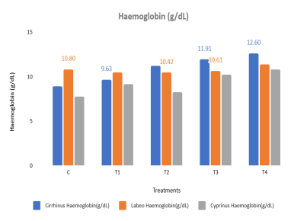
Figure no. 1 The Haemoglobin levels of various fish species subjected to five different treatment groups
The maximum Haemoglobin (Hb) level was observed in T4 (cow dung with immobilised probiotics) of cirrhinus mrigala. The next highest level was observed in T3 (cow dung with free probiotics) in two species. The combination of the traditional method (cow dung) with immobilised probiotics provided better dietary supplementation for the fish.
Haemoglobin (Hb) concentration is considered an important haematological parameter for assessing the physiological and health status of fish because it is an oxygen-transport protein and reflects respiratory efficiency. Shahjahan et al. (2018) reported that diets combined with probiotics significantly increased haemoglobin levels and erythrocyte counts in fish, indicating better physiological status. Vhatkar et al. (2016) reported increased Hb levels in probiotic-treated fish. Haematological indices (Hb and RBC) vary in relation to probiotic diets. Microencapsulated probiotics enhanced haemoglobin levels in fish (Boonanuntanasarn et al., 2019).
Total Erythrocyte Count
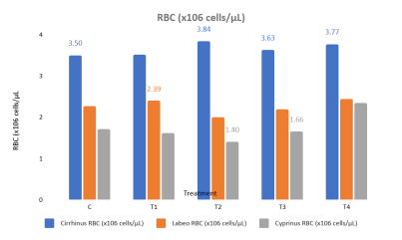
Figure No. 2 Total RBC Count of various fish species subjected to five different treatment groups
The highest RBC (x10⁶ cells/µL) values were recorded for L. rohita and C.carpio in T4. The next highest RBC level for C. mrigala recorded in T4. The lowest RBC level was recorded in T2, which was treated with cow dung. RBCs are important for oxygen transport, and the results showed high RBC values in fish treated with cow dung and immobilised bacteria.
Higher RBC values are generally associated with improved oxygen transport and better health conditions (Fazio et al., 2022; Udoy et al., 2025), and better dietary supplementation has been reported to increase erythrocyte counts in fish. According to Michael et al. (2019), probiotic supplementation has been reported to enhance RBC counts in several cultured fish species. Mohapatra et al. (2014) reported higher Hb and RBC levels in carp due to improved metabolic efficiency under probiotic supplementation. Immobilised probiotics have been reported to enhance RBC counts in host species (Boonanuntanasarn et al., 2019). The increase in haemoglobin and RBC levels in probiotic-treated groups suggests improved blood-cell formation and nutrient utilisation. Nayak et al. (2010) explained that probiotics enhanced digestive enzyme activity and improved the absorption of essential nutrients such as iron and proteins, leading to improved blood formation.
Total Leucocyte Count
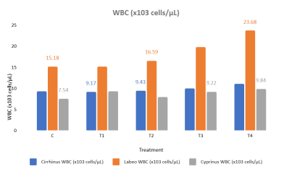
Figure No. 3 Total WBC count of various fish species subjected to five different treatment groups
In comparative analyses of these treatment groups, the maximum WBC (x10³ cells/µL) count was recorded in T4. The next highest WBC (x10³ cells/µL) count was recorded in T3. The lowest WBC value was recorded in the control. Probiotics enhanced leucocyte activity and disease resistance in fish. The results showed that the performance of immobilised probiotics with cow dung was better than that of the other treatments (Fig. No. 3).
The probiotic-treated groups are consistent with Boonanuntanasarn et al. (2019), who reported that microencapsulated probiotics stimulate non-specific immunity and increase leucocyte activity in fish. However, in the current investigation, WBC values showed moderate variation across treatments, which has also been reported by Ashour et al. (2026) and Abdel-Rahim et al. (2025), suggesting that the immune response depends on probiotic strain, dose, and environmental conditions.
PCV or Haematocrit (%)
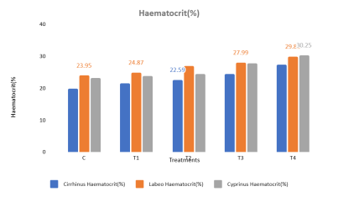
Figure No. 4. The Haematocrit levels of various fish species subjected to five different treatment groups
The maximum Haematocrit value was recorded in T4 for the selected fish. The next highest haematocrit values were recorded in T3. The PCV result indicated improved nutritional status and reduced stress. Haematocrit reflects the proportion of red blood cells in the blood and indicates overall health and oxygen-transport capacity (Abdel-Tawwab et al., 2020).
According to Ashour et al. (2026), increased haematocrit indicated improved nutritional status and reduced stress. Haematocrit values were increased in the treated groups, reflecting improved oxygen-carrying capacity and metabolic activity. Higher PCV values indicate improved physiological condition and stress tolerance in fish cultured under probiotic and organic fertilisation systems, as reported by Abdel-Tawwab et al. (2020).
Mean Corpuscular Volume (MCV)
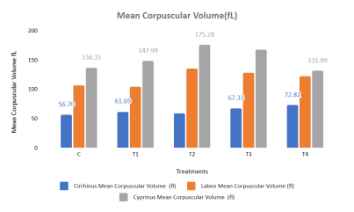
Figure No. 5. The MCV levels of various fish species subjected to five different treatment groups
Comparative studies revealed that the maximum MCV value was recorded in T2. The next highest MCV values were recorded in T3. The lowest MCV value was recorded in the control.
The increase in MCV observed in the treatment group may be attributed to the beneficial effect of microbial supplementation on erythropoiesis, similar to the observations of Vhatkar et al. (2016), who reported improved haematological indices in probiotic-fed catfish. Chen and Luo (2023) noted that Mean Corpuscular Volume (MCV) was higher in fish reared in ponds treated with cow dung and immobilised bacteria than in the control. The increase in MCV indicates improved erythrocyte development and enhanced oxygen-carrying capacity. The beneficial effects were attributed to improved pond productivity through cow dung fertilisation and enhanced microbial activity associated with immobilised probiotics. Similarly, improvements in haematological indices have been reported in probiotic-treated fish by Vhatkar et al. (2016) and Neepa et al. (2022), who observed elevated MCV values and improved physiological status in bacterial-supplemented groups.
Mean Corpuscular Haemoglobin (MCH)
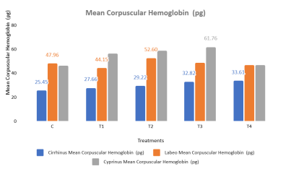
Figure No. 6 Mean Corpuscular haemoglobin (pg) levels of various fish species subjected to five different treatment groups
The current investigation showed that the highest MCH was recorded in T3 and T4. The next highest MCH level was recorded in T2, which was treated with cow dung alone. Among all five treatments, the highest values were observed in fish treated with combinations of cow dung with free probiotics or immobilised probiotics.
The elevated MCV and MCH observed in cow dung-treated groups suggest enlarged erythrocytes and improved nutrient availability. Adeyemo & Enefe (2021) stated that organic fertilisation increases plankton biomass, thereby enhancing fish nutrition and indirectly influencing blood physiology. Wang et al. (2021) and Dawood et al. (2020) found that MCV, MCH, and MCHC values remain within the normal range but improve under balanced probiotic diets. Microencapsulated probiotics enhance haematological values such as MCV and MCH (Boonanuntanasarn et al., 2019).
Mean Corpuscular Haemoglobin Concentration (MCHC)
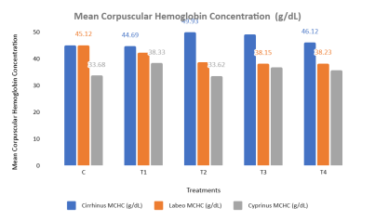
Figure No. 7 MCHC levels of various fish species subjected to five different treatment groups
A moderate level of MCHC was observed in T4. The lowest MCHC value was recorded in T2. According to the results, immobilised bacteria enhanced the MHC value, followed by T2 fish treated with cow dung.
Increased MCHC indicated enhanced haemoglobin concentration within erythrocytes, compensatory physiological responses, or changes in erythrocyte morphology under stress conditions. Fazio et al. (2022) reported that haematological indices such as MCHC are sensitive indicators of fish health and can be used to assess physiological responses to environmental, nutritional, and management-related factors in aquaculture. Cow dung and immobilised bacteria showed a moderate increase in the MHC value compared with the other treatments.
Immunological Optimisation of Three Species (C. mrigala, L. rohita , C. Carpio)
Neutrophil Activity (NBT) Respiratory Burst Activity (RBA)

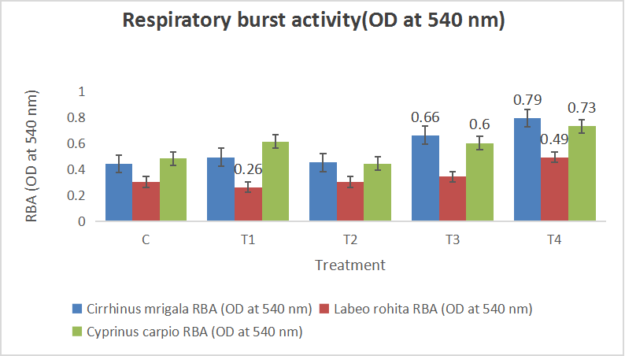
Figure no.8 Respiratory Burst activity (RBA OD at 540 nm) of various fish species subjected to five different treatment groups
In the current study, the highest RBA (OD at 540 nm) was observed in T4 compared with the other treatments. The next highest RBA was observed in T3. RBA plays an important role in the immune system. The results revealed the reaction that occurs in phagocytes to degrade internalised particles and bacteria in the selected fish treated with cow dung and immobilised bacteria.
According to Chan et al. (2024), Lactobacillus rhamnosus FS3051 significantly changed the gut microbial communities and improved fish immune responses. The most prevalent method of probiotic administration is the incorporation of various probiotic formulations into feed. Melo‐Bolívar et al. (2021) indicated that 92.8% of probiotics are administered through feed, 4.8% are directly added to water, and 1.8% are incorporated into live food within fish culture systems. In large-scale aquaculture production, probiotics such as yeast, vital microbial communities, and crucial chemicals are widely used as supplements (Puri et al., 2022). Enhanced immunity and improved fish growth have been reported following dietary supplementation with probiotics (Silarudee et al., 2019). Likewise, other researchers have reported similar results (Akhter et al., 2015; Shadrack et al., 2023). Silarudee et al. (2019) and Boonanuntanasarn et al. (2019) noted that probiotics and microencapsulated probiotics greatly enhance fish immune systems, thereby improving their physiological condition. The present work verified that cow dung containing immobilised probiotics showed a notable improvement in the immune system of the three fish varieties.
Serum Lysozyme Activity
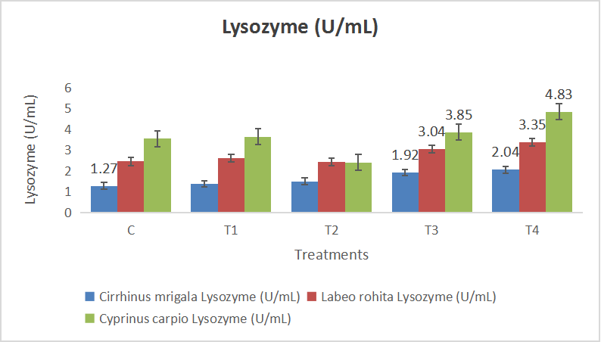
Figure No. 9 Lysozyme activity (U/mL) of various fish species subjected to five different treatment groups
The maximum level of lysozyme activity was observed in T4. The next highest level of lysozyme activity was observed in T3. According to the results, high lysozyme activity was observed in fish fed immobilised probiotics compared with the other treatments, suggesting enhanced phagocytic-cell activity stimulated by dietary supplementation, specifically cow dung with immobilised bacteria.
Under excessive salinity conditions, the administration of probiotics, specifically Lactobacillus plantarum, to tilapia leads to increased lysozyme enzyme activity and a range of immunoglobulins (Abou‐El‐Atta et al., 2019; Mohammadi et al., 2020). Saurabh and Sahoo (2008) noted that lysozyme is an essential component of the fish innate immune system, and lysozyme activity is widely used as an indicator of the non-specific immune response in fish. Lysozyme activity is measured as a non-specific immune defence in fish, while nitroblue tetrazolium (NBT) is monitored as an indicator of innate immunity (Dawood et al., 2020; Mohammadian et al., 2020).
Phagocytic Activity
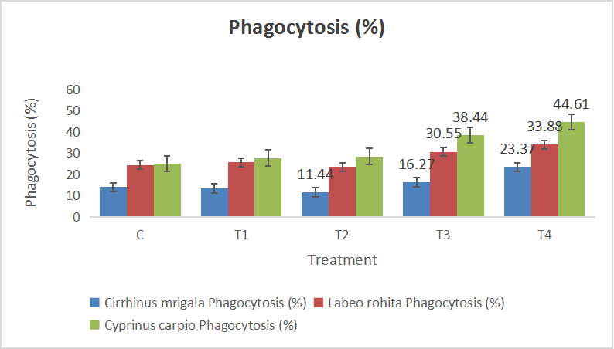
Figure No. 10. Phagocytic activity (%) of three different freshwater species subjected to five different treatment groups
The maximum Phagocytic activity was observed in T4. The next highest level was observed in T3. The Phagocytic activity (Fig. No. 10) showed that the combination of cow dung with immobilised probiotics produced a better result than treatment with cow dung or probiotic alone. Fath El-Bab et al. (2022) and Mohammadian et al. (2020) conducted experiments demonstrating improved phagocytic activity in Nile tilapia farming through the use of probiotic diets related to Bacillus coagulans. Probiotics have the potential to significantly enhance innate immune responses by interacting with immune cells, such as phagocytic cells (macrophages and monocytes), polymorphonuclear leucocytes (neutrophils), and NK cells, as documented by Nayak et al. (2010).
Conclusion
Under the conditions of the 70-day feeding trial, supplementation with free or immobilised Lactobacillus sporogenes, particularly when combined with cow dung, was associated with measurable changes in the haematological and innate immune responses of C. mrigala, L. rohita, and C. carpio. Among the experimental treatments, T4 (cow dung with immobilised probiotics) generally produced the highest responses for haemoglobin, red and white blood cell counts, haematocrit, respiratory burst activity, lysozyme activity, and phagocytic activity, while T3 frequently showed the next highest values. These patterns suggest that immobilisation may support the functional effectiveness of probiotic supplementation under the tested culture conditions. The findings are specific to the experimental design, duration, species, and measured indicators and should therefore be interpreted within those boundaries. Overall, the study provides evidence that the combined use of cow dung and immobilised probiotics may be a useful management approach for supporting haematological condition and innate immune activity in cultured freshwater carps. Further validation under broader culture conditions would be required before wider application.
Limitations
The study was conducted under controlled laboratory conditions for 70 days using three carp species and a defined set of dietary treatments. Interpretation is therefore limited to the measured haematological and innate immune indicators under these experimental conditions. The manuscript does not report pathogen-challenge outcomes or long-term field performance, and the observed responses should not be extrapolated beyond the assessed endpoints. Further studies across culture systems, environmental conditions, and longer production periods would help determine the consistency and practical applicability of the observed effects.

Declaration of AI Use
This manuscript was prepared through the combined contributions of all author(s), including contributions to the study design, data, content development, results, interpretation, and related scholarly work. The author(s) acknowledge the use of Grammarly and ChatGPT to assist with grammar checking, language refinement, and reference formatting. These AI-assisted tools were not used as authors and did not replace the intellectual contributions or scholarly judgment of the author(s). All AI-assisted outputs, including content, references, and interpretations, were carefully reviewed, revised, verified, and approved by the author(s). The author(s) accept full responsibility for the accuracy, integrity, and final content of the manuscript.
References
Abdel-Rahim, M. M., Shahin, S. A., Mansour, A. T., Alsaqufi, A. S., Elshafey, A. E., Omar, A. A., El-Sharkawy, H. A., Mohamed, R. A., & Elhetawy, A. I. G. (2025). The effect of aqueous application of probiotics on growth, heavy metal accumulation, blood biochemistry, and histological alterations of Dicentrarcus labrax. Aquaculture International, 33, Article 222. https://doi.org/10.1007/s10499-025-01900-5
Abdel-Tawwab, M., & Hamed, H. S. (2020). Antagonistic effects of dietary guava (Psidium guajava) leaves extract on growth, hemato-biochemical, and immunity response of cypermethrin-intoxicated Nile tilapia, Oreochromis niloticus, fingerlings. Aquaculture, 529, Article 735668. https://doi.org/10.1016/j.aquaculture.2020.735668
Abou-El-Atta, M. E., Abdel-Tawwab, M., Abdel-Razek, N., & Abdelhakim, T. M. (2019). Effects of dietary probiotic Lactobacillus plantarum and whey protein concentrate on the productive parameters, immunity response, and susceptibility of Nile tilapia, Oreochromis niloticus (L.), to Aeromonas sobria infection. Aquaculture Nutrition, 25(6), 1367–1377. https://doi.org/10.1111/anu.12957
Akhter, N., Wu, B., Memon, A. M., & Mohsin, M. (2015). Probiotics and prebiotics associated with aquaculture: A review. Fish & Shellfish Immunology, 45(2), 733–741. https://doi.org/10.1016/j.fsi.2015.05.038
Ashour, M., Ringø, E., Ali, F. S., Mamoon, A., Abdelzaher, O. F., Mathew, R. T., Mansour, A. T., Alkhamis, Y. A., Mohammed, E. S. I., Hassanien, H. S., Elokaby, M. A., & Mabrouk, M. M. (2026). Seaweed liquid extract improves growth, immunity, and gene expression in Nile tilapia (Oreochromis niloticus). Journal of Applied Phycology. Advance online publication. https://doi.org/10.1007/s10811-026-03910-z
Baker, F. J., & Silverton, R. E. (1976). Introduction to medical laboratory technology (5th ed.). Butterworth-Heinemann. https://doi.org/10.1016/C2013-0-06213-5
Bellinati-Pires, R., Carneiro-Sampaio, M. M., & Colletto, G. M. (1992). Functional evaluation of human neutrophils: Is the bactericidal activity correlated with nitroblue tetrazolium reduction? Journal of Investigational Allergology & Clinical Immunology, 2(3), 146–153. https://pubmed.ncbi.nlm.nih.gov/1342894/
Adeyemo, B. T., & Enefe, N. G. (2021). Haematological and serum biochemical reference intervals of juvenile African bonytongue fish (Heterotis niloticus. Cuvier, 1829) sampled from the River Benue, Nigeria. Mansoura Veterinary Medical Journal, 22(2), 82–90. https://doi.org/10.21608/mvmj.2021.56537.1024
Boonanuntanasarn, S., Ditthab, K., Jangprai, A., & Nakharuthai, C. (2019). Effects of microencapsulated Saccharomyces cerevisiae on growth, hematological indices, blood chemical, and immune parameters and intestinal morphology in striped catfish, Pangasianodon hypophthalmus. Probiotics and Antimicrobial Proteins, 11(2), 427–437. https://doi.org/10.1007/s12602-018-9404-0
Chan, C. H., Chen, L. H., Chen, K. Y., Chen, I. H., Lee, K. T., Lai, L. C., Tsai, M. H., Chuang, E. Y., Lin, M. T., & Yan, T. R. (2024). Single-strain probiotics enhance growth, anti-pathogen immunity, and resistance to Nocardia seriolae in grey mullet (Mugil cephalus) via gut microbiota modulation. Animal Microbiome, 6(1), Article 67. https://doi.org/10.1186/s42523-024-00353-0
Chen, H., & Luo, D. (2023). Application of haematology parameters for health management in fish farms. Reviews in Aquaculture, 15(2), 704–737. https://doi.org/10.1111/raq.12753
Dawood, M. A., AbdEl-Kader, M. F., Moustafa, E. M., Gewaily, M. S., & Abdo, S. E. (2020). Growth performance and hemato-immunological responses of Nile tilapia (Oreochromis niloticus) exposed to deltamethrin and fed immunobiotics. Environmental Science and Pollution Research, 27(11), 11608–11617. https://doi.org/10.1007/s11356-020-07775-8
Fachri, M., Amoah, K., Huang, Y., Cai, J., Alfatat, A., Ndandala, C. B., Shija, V. M., Jin, X., Bissih, F., & Chen, H. (2024). Probiotics and paraprobiotics in aquaculture: A sustainable strategy for enhancing fish growth, health and disease prevention—A review. Frontiers in Marine Science, 11, Article 1499228. https://doi.org/10.3389/fmars.2024.1499228
Fath El-Bab, A. F., Majrashi, K. A., Sheikh, H. M., Shafi, M. E., El-Ratel, I. T., Neamat-Allah, A. N. F., El-Raghi, A. A., Elazem, A. Y. A., Abd-Elghany, M. F., Abdelnour, S. A., Abduh, M. S., Jaremko, M., & Naiel, M. A. E. (2022). Dietary supplementation of Nile tilapia (Oreochromis niloticus) with β-glucan and/or Bacillus coagulans: Synergistic impacts on performance, immune responses, redox status and expression of some related genes. Frontiers in Veterinary Science, 9, Article 1011715. https://doi.org/10.3389/fvets.2022.1011715
Fazio, F., Habib, S. S., Naz, S., Filiciotto, F., Cicero, N., Rehman, H. U., Saddozai, S., Rind, K. H., Rind, N. A., & Shar, A. H. (2022). Effect of fortified feed with olive leaves extract on the haematological and biochemical parameters of Oreochromis niloticus (Nile tilapia). Natural Product Research, 36(6), 1575–1580. https://doi.org/10.1080/14786419.2021.1883606
Guan, E. N., Burgess, W., Robinson, S. L., Goodman, E. B., McTigue, K. J., & Tenner, A. J. (1991). Phagocytic cell molecules that bind the collagen-like region of C1q: Involvement in the C1q-mediated enhancement of phagocytosis. Journal of Biological Chemistry, 266(30), 20345–20355. https://doi.org/10.1016/S0021-9258(18)54929-2
Hajirezaee, S., Ramezani, S., & Ahani, S. (2024). Betaine and the probiotic, Lactobacillus rhamnosus in the diet of the common carp, Cyprinus carpio: Effects on growth, digestive enzyme activities, antioxidant system, humoral and mucosal immunity and resistance to Streptococcus iniae. Aquaculture Reports, 38, Article 102282. https://doi.org/10.1016/j.aqrep.2024.102282
Hutchinson, T. H., Field, M. D., & Manning, M. J. (2003). Evaluation of non-specific immune functions in dab, Limanda limanda L., following short-term exposure to sediments contaminated with polyaromatic hydrocarbons and/or polychlorinated biphenyls. Marine Environmental Research, 55(3), 193–202. https://doi.org/10.1016/S0141-1136(02)00214-3
Kord, M. I., Srour, T. M., Omar, E. A., Farag, A. A., Nour, A. A. M., & Khalil, H. S. (2021). The immunostimulatory effects of commercial feed additives on growth performance, non-specific immune response, antioxidants assay, and intestinal morphometry of Nile tilapia, Oreochromis niloticus. Frontiers in Physiology, 12, Article 627499. https://doi.org/10.3389/fphys.2021.627499
Melo-Bolívar, J. F., Ruiz Pardo, R. Y., Hume, M. E., & Villamil Díaz, L. M. (2021). Multistrain probiotics use in main commercially cultured freshwater fish: A systematic review of evidence. Reviews in Aquaculture, 13(4), 1758–1780. https://doi.org/10.1111/raq.12543
Michael, S. E., Abarike, E. D., & Cai, J. (2019). A review on the probiotic effects on haematological parameters in fish. Journal of FisheriesSciences.com, 13(3), 25–31. https://doi.org/10.36648/1307-234X.13.3.166
Mohammadi, G., Rafiee, G., & Abdelrahman, H. A. (2020). Effects of dietary Lactobacillus plantarum (KC426951) in biofloc and stagnant-renewal culture systems on growth performance, mucosal parameters, and serum innate responses of Nile tilapia Oreochromis niloticus. Fish Physiology and Biochemistry, 46, 1167–1181. https://doi.org/10.1007/s10695-020-00777-w
Mohammadian, T., Dezfuly, Z. T., Motlagh, R. G., Jangaran-Nejad, A., Hosseini, S. S., Khaj, H., & Alijani, N. (2020). Effect of encapsulated Lactobacillus bulgaricus on innate immune system and hematological parameters in rainbow trout (Oncorhynchus mykiss), post-administration of Pb. Probiotics and Antimicrobial Proteins, 12(3), 375–388. https://doi.org/10.1007/s12602-019-09544-7
Mohapatra, S., Chakraborty, T., Prusty, A. K., PaniPrasad, K., & Mohanta, K. N. (2014). Beneficial effects of dietary probiotics mixture on hemato-immunology and cell apoptosis of Labeo rohita fingerlings reared at higher water temperatures. PLOS ONE, 9(6), Article e100929. https://doi.org/10.1371/journal.pone.0100929
Nayak, S. K. (2010). Probiotics and immunity: A fish perspective. Fish & Shellfish Immunology, 29(1), 2–14. https://doi.org/10.1016/j.fsi.2010.02.017
Neepa, N. N., Islam, M. R., Mely, S. S., Mrong, C. E., Kole, K., Sultana, N., & Mostakim, G. M. (2022). Improvement of growth and hematological profile of juvenile silver barb (Barbonymus gonionotus) through dietary probiotic (Bacillus sp.) supplementation. Journal of Survey in Fisheries Sciences, 8(2), 11–25. https://doi.org/10.17762/sfs.v8i2.48
Parry, R. M., Jr., Chandan, R. C., & Shahani, K. M. (1965). A rapid and sensitive assay of muramidase. Proceedings of the Society for Experimental Biology and Medicine, 119(2), 384–386. https://doi.org/10.3181/00379727-119-30188
Puri, P., Sharma, J. G., & Singh, R. (2022). Biotherapeutic microbial supplementation for ameliorating fish health: Developing trends in probiotics, prebiotics, and synbiotics use in finfish aquaculture. Animal Health Research Reviews, 23(2), 113–135. https://doi.org/10.1017/S1466252321000165
Qubay, M., Vegi, M. R., & Mutegoa, E. (2025). Proximate composition and mineral content of the common fish species in the selected lakes of Tanzania. Journal of Food Composition and Analysis, 142, Article 107510. https://doi.org/10.1016/j.jfca.2025.107510
Rachmawati, D., Setyobudi, R. H., Burlakovs, J., Elfitasari, T., & Purnomo, A. H. (2021). Impacts of immunostimulant yeast (Saccharomyces cerevisiae) supplemented feed on growth and blood profile of Java barb (Barbonymus gonionotus). Jordan Journal of Biological Sciences, 14(2), 297–302. https://doi.org/10.54319/jjbs/140215
Rouf, M. A. (1969). Hematology of the leopard frog, Rana pipiens. Copeia, 1969(4), 682–687. https://doi.org/10.2307/1441793
Ryu, B., Shin, K. H., & Kim, S. K. (2021). Muscle protein hydrolysates and amino acid composition in fish. Marine Drugs, 19(7), Article 377. https://doi.org/10.3390/md19070377
Sarhadi, I., Alizadeh, E., Ahmadifar, E., Adineh, H., & Dawood, M. A. (2020). Skin mucosal, serum immunity and antioxidant capacity of common carp (Cyprinus carpio) fed artemisia (Artemisia annua). Annals of Animal Science, 20(3), 1011–1027. https://doi.org/10.2478/aoas-2020-0011
Saurabh, S., & Sahoo, P. K. (2008). Lysozyme: An important defence molecule of fish innate immune system. Aquaculture Research, 39(3), 223–239. https://doi.org/10.1111/j.1365-2109.2007.01883.x
Schalm, O. W., Jain, N. C., & Carroll, E. J. (1975). Veterinary hematology (3rd ed.). Lea & Febiger. https://agris.fao.org/search/en/providers/122535/records/65dde0324c5aef494fd6493e
Shadrack, R. S., Kotra, K. K., Gereva, S., Teiba, I. I., El-Ratel, I. T., & El Basuini, M. F. (2023). Utilizing dietary probiotics can boost amberjack (Seriola dumerili) lysozyme activity, antioxidant capacity, and gut microbiota. Scientific African, 22, Article e01905. https://doi.org/10.1016/j.sciaf.2023.e01905
Shahjahan, M., Uddin, M. H., Bain, V., & Haque, M. M. (2018). Increased water temperature altered hemato-biochemical parameters and structure of peripheral erythrocytes in striped catfish Pangasianodon hypophthalmus. Fish Physiology and Biochemistry, 44(5), 1309–1318. https://doi.org/10.1007/s10695-018-0522-0
Shivani, D. G., Ganapathi Naik, M., Amogha, K. R., Dheeraj, S. B., Jaya Naik, Girisha, S. K., Manjappa, N., & Lakshmipathi, M. T. (2025). Probiotic potential of dietary Bacillus amyloliquefaciens in enhancing health parameters of Amur common carp (Cyprinus carpio haematopterus). Journal of Advances in Biology & Biotechnology, 28(4), 1041–1056. https://doi.org/10.9734/jabb/2025/v28i42260
Silarudee, S., Tongpim, S., Charoensri, N., & Doolgindachbaporn, S. (2019). Effect of a probiotic Lactobacillus plantarum CR1T5 dietary supplement on non-specific immunity in black eared catfish (Pangasius larnaudii). Journal of Pure and Applied Microbiology, 13(1), 289–296. https://doi.org/10.22207/JPAM.13.1.31
Subandiyono, Lestari, N. D., Chilmawati, D., & Nugroho, R. A. (2023). Influence of probiotic on feed utilization efficiency, growth performance and survival of Clarias gariepinus. Asian Journal of Research in Biology, 6(1), 87–93. https://doi.org/10.56557/ajrib/2023/v6i121
Udoy, F. R., Jebin, M., Bristy, F. S., Gias, T., Rahman, N., & Hossain, M. A. (2025). Comparative analysis of hematological characteristics of some freshwater fish species from wild and cultured environments. Ecology Journal, 7(2), 93–101. https://doi.org/10.59619/ej.7.2.2
Veedu, A. K., & Thomas, J. (2026). Probiotics and prebiotics as alternatives to antibiotics in aquaculture: A systematic and bibliometric review of antimicrobial and antioxidant mechanisms. Frontiers in Microbiology, 17, Article 1784036. https://doi.org/10.3389/fmicb.2026.1784036
Vhatkar, A., Chavan, B., & Prasad, K. P. (2016). Study of haematological parameters in catfish Pangasianodon hypophthalmus fed with probiotics supplemented diets. International Journal of Science and Research, 5(8), 1865–1868. https://doi.org/10.21275/ART20161330
Wang, Z., Dong, Z., Zhang, D., Liang, L., & Mu, W. (2021). Histopathological parameters, antioxidant enzyme levels, transcriptome, and hematology parameters of Amur minnow (Phoxinus lagowskii) infection with Tetrahymena pyriformis. Aquaculture International, 29(6), 2635–2659. https://doi.org/10.1007/s10499-021-00772-9
Xia, R., Li, S., Yang, H., Zhao, Y., Teame, T., Hao, Q., Xie, M., Li, M., Chen, Q., Song, C., Ran, C., Yang, Y., Zhang, Z., & Zhou, Z. (2024). Effects of dietary bacterial culture of fengycin-producing Bacillus subtilis on growth performance, intestinal and hepatopancreas health, intestinal microbiota and disease resistance of common carp (Cyprinus carpio). Aquaculture, 585, Article 740725. https://doi.org/10.1016/j.aquaculture.2024.740725
Yousuf, S., Tyagi, A., & Singh, R. (2023). Probiotic supplementation as an emerging alternative to chemical therapeutics in finfish aquaculture: A review. Probiotics and Antimicrobial Proteins, 15(5), 1151–1168. https://doi.org/10.1007/s12602-022-09971-z

