Original Research Article
Molecular Systematics and Phylogeography of Hemidactylus Geckos (Reptilia: Gekkonidae) from Manipur, the Indo-Myanmar Biodiversity Hotspot

.
ABSTRACT

Background: North-eastern India occupies a major biogeographic transition zone, yet the evolutionary relationships and spatial distribution of Hemidactylus geckos in Manipur remain insufficiently resolved.
Aims: The present study was undertaken to investigate the evolutionary history, molecular phylogenetic relationships, divergence patterns, and historical biogeography of the genus Hemidactylus (family Gekkonidae) in north-eastern India. The study also aimed to examine the influence of past geological barriers and environmental changes on species diversification using geographic information systems (GIS).
Place and Duration of Study: The study was conducted in Manipur, north-eastern India, from December 2021 to November 2025. Laboratory analyses were carried out at the Department of Zoology, University of Delhi, and the School of Life Sciences, Manipur University.
Methodology: Molecular phylogenetic analyses employing representative species of Hemidactylus were undertaken to estimate evolutionary relationships and divergence histories. Historical biogeographic reconstruction was performed to reveal ancestral distribution patterns. GIS-based spatial analyses were used to evaluate the roles of topographical features, river systems, and historical landscape changes in species radiation and distribution.
Results: Phylogenetic analysis revealed isolated evolutionary lineages of Hemidactylus in north-eastern India, indicating historical genetic isolation from peninsular Indian populations. Biogeographic reconstruction and GIS analysis suggested that geological barriers, shifting ecosystems, and the complex physiography of the Indo-Myanmar region had probably contributed to independent evolutionary radiation and diversification within the genus.
Conclusion: The results emphasise the evolutionary importance of north-eastern India as a centre of diversification for Hemidactylus. Molecular phylogenetics, combined with historical biogeography and GIS, provides useful tools for understanding the processes underlying reptilian evolution in this biodiversity hotspot. The findings contribute to knowledge of the evolutionary history of Indian geckos and provide a scientific basis for future taxonomic, ecological, and conservation investigations in the region.

Keywords: Hemidactylus; molecular phylogenetics; phylogeography; cytochrome b; historical biogeography; geographic information systems; Indo-Myanmar biodiversity hotspot; reptile diversity; conservation genetics

1. INTRODUCTION
The genus Hemidactylus (Gekkonidae) represents approximately 10% of gekkonid diversity and is widely distributed across tropical Asia, Africa, and the New World (Agashe et al., 2025; Uetz et al., 2024). However, because of contested taxonomy and an inadequate understanding of classification and distribution, the precise species diversity remains undetermined. Smith (1935) recognised 17 species of Hemidactylus from the Indian subcontinent. Subsequent taxonomic work, including recent species descriptions, has increased this number to at least 28 (Giri, 2008; Giri & Bauer, 2008). Of these, three species—H. frenatus, H. flaviviridis, and H. brookii—are widely distributed across India and the tropical Old World, occur commensally with humans, and have been widely introduced beyond their native ranges. Previous phylogenetic studies of Hemidactylus included limited sampling from the Indian subcontinent, restricting tests of tropical Asian monophyly (Carranza & Arnold, 2006). Ecological competition between the invasive tropical house gecko (H. mabouia) and the native Dutch leaf-toed gecko (Phyllodactylus martini) on Curaçao, in the Kingdom of the Netherlands, confirms the systematic displacement of the native gecko by the invasive gecko, which possesses morphological advantages, including larger body and head sizes (Lamb et al., 2021). The arrival of H. mabouia has fundamentally altered the ecological “rules of engagement”, favouring a biological toolkit optimised for the high-energy environments created by human development. The yellow-bellied house gecko, H. flaviviridis, has recently emerged as an invasive species in Assam, India, and was probably introduced from western India through human-mediated trade routes (Das et al., 2011). Preliminary evidence indicates a decline in native gecko populations, particularly Hemidactylus frenatus (Das et al., 2011), suggesting competitive displacement in invaded areas. Continued monitoring is required to evaluate long-term ecological impacts and potential range expansion. H. garnotii and H. frenatus are two of the most common Hemidactylus species found in north-eastern India. They are native to tropical Asia but have also expanded into and become naturalised in many other parts of the world (Lever, 2003; Kraus, 2009). Direct examination of stomach contents and stable-isotope signatures showed that invasive species occupied higher trophic levels, based on diverse prey and a Schoener index greater than 0.60. From a conservation biology perspective, this supports direct exploitative competition and indicates that invasive success can frequently result from a combination of advantages, including intraguild predation, morphological superiority, exploitative competition, and parasitic pressure (Bissattini et al., 2021). Recent integrative taxonomic studies from India have continued to delimit genetically and morphologically distinct Hemidactylus lineages, indicating that the documented diversity of the genus remains incomplete across several Indian landscapes (Khandekar et al., 2023; Patel et al., 2026).
In rapidly changing environments, comprehensive mapping is a crucial step towards informed conservation management. When species exhibit morphological similarities resulting from convergent evolution, genetic markers facilitate species identification by generating well-resolved trees with high nodal support for shallow-level relationships. For a subset of taxa, two nuclear loci were sequenced to infer an nDNA phylogeny. Combined mitochondrial and nuclear phylogenies were used to test the monophyly of Indian, Southeast Asian, and tropical Asian clades and to examine the evolutionary origins and biogeography of the commensal species H. brookii, H. frenatus, and H. flaviviridis. Most remaining species are restricted to the Indian subcontinent, with limited extensions into neighbouring regions from north-eastern India. The ND2 gene (NADH dehydrogenase subunit 2) is the primary marker used in Hemidactylus (Carranza & Arnold, 2006), whereas other markers, such as RAG1, PDC, and MXRA5, are also used to study more extensive branches (Joshi & Karanth, 2013). The mitochondrial cytochrome b (Cyt b) gene is extensively used in evolutionary and phylogeographic research because of its relatively rapid evolutionary rate, maternal inheritance, and ease of amplification across several taxa (Avise, 2000; Hillis, 1996). Diversity appears to be skewed in most studies; for example, only three countries—Myanmar, Vietnam, and Malaysia—account for 48% of all recent descriptions of Cyrtodactylus (Grismer et al., 2021; Uetz et al., 2024). This skewed pattern suggests insufficient survey effort in areas such as north-eastern India rather than a lack of diversity elsewhere. Because many geckos are narrow-range endemics restricted to particular habitats, such studies assist in identifying cryptic diversity (Bansal & Karanth, 2013; Agarwal et al., 2019). Thus, even in a genus such as Hemidactylus, hidden variation among closely related species may shed light on their evolution and adaptation. However, reliance on a single mitochondrial marker may lack scientific validity because it reflects only the history of the maternal lineage and may not represent species phylogenies when processes such as introgression, incomplete lineage sorting, and substitution saturation are considered (Ballard & Whitlock, 2004; Yang, 2006). Mitochondrial DNA barcoding has also supported reptile species identification from non-invasive material in India, demonstrating its value for preliminary taxonomic verification when interpreted within a broader phylogenetic framework (Kumar et al., 2026). The recent description of six Cyrtodactylus species from north-eastern India further demonstrates that focused molecular and morphological sampling can reveal previously undocumented gekkonid diversity in the region (Boruah et al., 2024).
North-eastern India, part of the Indo-Myanmar biodiversity hotspot, supports a rich assemblage of herpetofauna, with more than 274 species of amphibians and reptiles known from the region. India’s northward drift and collision with mainland Asia approximately 55 Mya greatly influenced biotic evolution through faunal interaction, subcontinental dispersal, isolation, and diversification. Thus, north-eastern India is a crucial biotic transition zone that facilitates faunal migration between the Indian and Asian plates. The Eastern Himalaya and Indo-Burma biodiversity hotspots encompass diverse habitats, complex terrain, and marked climatic variation (Rodgers & Panwar, 1988; Myers et al., 2000). Elevation ranges from lowland plains to montane forests more than 3,000 m above sea level. These areas support diverse forests, ranging from tropical evergreen and semi-evergreen forests to subtropical and temperate conditions (Mittermeier et al., 2011). These characteristics make the region an ideal location for studying lizard diversity, endemism, and biogeography (Mani, 1974; Karanth, 2021). Moreover, different anthropogenic pressures on the same land area have varying effects on the landscape, biodiversity, and forest cover, making the region an important setting for evaluation. Field-based herpetofaunal inventories in India also demonstrate the value of systematic surveys for documenting local reptile assemblages and identifying conservation priorities (Raj et al., 2025). However, the phylogenetic relationships, spatial structure, and historical biogeographic affinities of Hemidactylus populations in Manipur remain insufficiently resolved because region-specific molecular sampling integrated with georeferenced landscape information is limited. This study therefore aimed to investigate the phylogeography and evolution of the genus Hemidactylus in Manipur through molecular phylogenetic analysis, divergence data, and area reconstruction.

2. MATERIALS AND METHODS

2.1. Study Area
The study was conducted at various locations in Manipur, north-eastern India, a biogeographically complex region situated at the confluence of the Indian subcontinent and Southeast Asia. The state lies between 23°83′ N and 25°68′ N latitude and 93°03′ E and 94°78′ E longitude. It covers 22,347 km², and its elevation ranges from 40 m at Jiribam to 2,994 m at Mt Iso Peak near Mao Songsong (Department of Town Planning, Government of Manipur, n.d.). Figure 1 outlines the complex geography and tectonic heterogeneity of the Indo-Myanmar region. More than 200 Hemidactylus specimens from 26 localities in Manipur were used in this study. Table 1 summarises the distribution of sampled species across the study locations in Manipur, together with collection details and local identities.
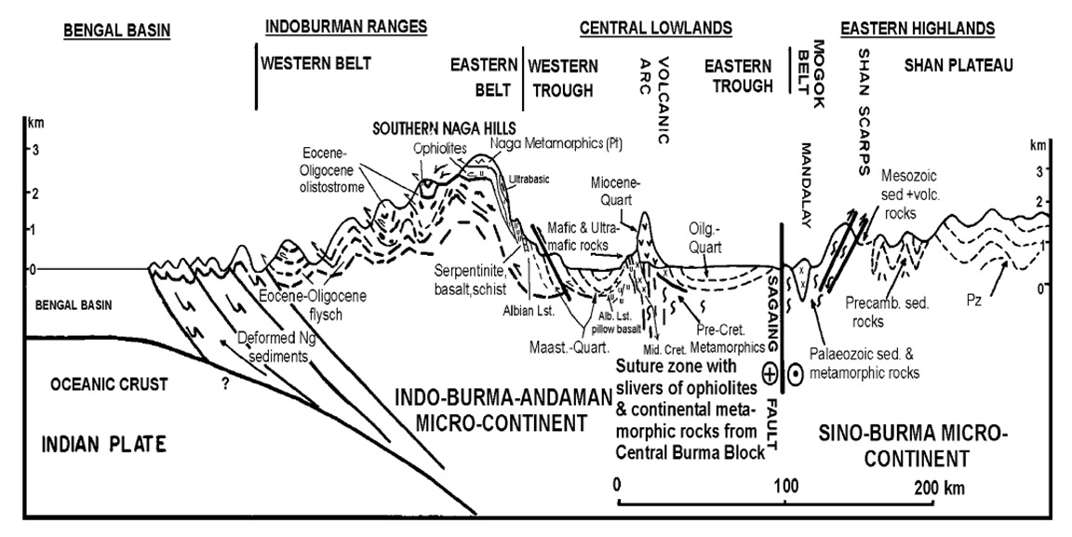
Fig. 1. Geological cross-section from the Bengal Basin to the Sino–Burma microcontinent showing the tectonic structure and evolution of the convergent boundary forming Indo–Burma–Andaman microcontinent.
(Source: Acharyya, 2010)

Table 1. Summary of sampling sites in Manipur providing geographical coordinates, environmental factors (elevation, temperature, humidity and habitat type), species documented, local names (as collected from indigenous groups) and habitat characteristics.

S.No. | Specimen Code | Location | Latitude | Longitude | Elevation (m) | Temperature (18⁰C – 35⁰C) & Humidity (85%-99%) | Species, local name | Habitat type
1 | MDK0101 | Ningthoukhong, Bishnupur dist. | N24º34’18.44” | E093º46’03.36” | 729 | 30⁰C, 87% | H.frenatus,  Chum | Residential
2 | MDK0201 | Thanga Kwatham, Bishnupur dist. | N24º31’47.64” | E093º49’52.37” | 765 | 28⁰C, 92% | H.frenatus,  Chum | Bamboo houses
3 | MDK0301 | Karang island, Bishnupur dist. | N24º32’46.75” | E093º50’03.97” | 765 | 28⁰C, 92% | H.frenatus,  Chum | Mud house with metal roof
4 | MDK0401 | Keibul lamjao, Bishnupur dist. | N24º28’47.68” | E093º48’25.95” | 756 | 26⁰C, 90% | H.frenatus,  Chum | Keibul Lamjao National Park
5 | MDK0501 | Khuga dam, Churachandpur dist. | N24º17’13.28” | E093º41’00.85” | 801 | 32⁰C, 88% | H.bowringii,  Sapi/Inngah | Elevated wooden house
6 | MDK0602 | Teisang, Churachandpur dist. | N24º21’33.98” | E093º41’08.02” | 871 | 27⁰C, 92% | H.bowringii,  Diadep | Residential
7 | MDK0701 | Kwakta Bazaar, Bishnupur dist. | N24º21’33.68” | E093º41’07.57” | 824 | 25⁰C, 90% | H.frenatus,  Chum | Residential mud house near market
8 | MDK0801 | Kangchup Kharang Koireng, Imphal west dist. | N24º51’38.81” | E093º48’23.68” | 824 | 24⁰C, 91% | H.bowringii,  Chum | Foothill around near Sinda dam
9 | MDK0901 | Leimatak Silen Bazaar, CCP dist. | N24º51’38.99” | E093º48’23.70” | 453 | 26⁰C, 99% | H.bowringii,  Diadep | Small market near NHPC power house
10 | MDK1001 | Tadubi, Senapati dist. | N24º35’25.21” | E093º40’07.50” | 1504 | 22⁰C, 85% | H.frenatus,  Shikri | Abandoned government quarter
11 | MDK1005 | Karong, Senapati dist. | N24º35’25.23” | E093º40’07.52” | 1504 | 20⁰C, 85% | H.frenatus,  Diadep | Govt. Office near market
12 | MDK1101 | T. Kullen, Kangpokpi dist. | N25º09’16.21” | E093º58’25.91” | 1062 | 20⁰C, 86% | H.bowringii,  Bhitti | Mud wall near National highway-2
13 | MDK1201 | Ramrei Village, Kamjong dist. | N24º52’45.53” | E094º08’00.87” | 960 | 32⁰C, 90% | H.bowringii,  Kangjabi | Mud houses
14 | MDK1201A | Pureitang, Tongou, Ukhrul dist. | N25º05’52.13” | E094º21’41.34” | 1912 | 18⁰C, 98% | H.bowringii,  Chirang | Grocery shop
15 | MDK1201B | Finch Corner, Ukhrul dist. | N25º00’52.68” | E094º18’39.26” | 1350 | 22⁰C, 98% | H.bowringii,  Chirang | Traffic point wooden shop
16 | MDK1204X | Litan, Ukhrul dist. | N24º57’04.40” | E094º12’14.04” | 908 | 25⁰C, 94% | H.frenatus,  Bhitti | Mud wall in market area
17 | MDK1301 | Kakching khunou, Kakching dist. | N24º24’10.48” | E093º54'06.75” | 779 | 28⁰C, 92% | H.frenatus,  Chum | Grocery shop
18 | MDK1401 | Oinam Lamkhai, Imphal west dist. | N24º41’11.91” | E093º54'07.01” | 769 | 31⁰C, 93% | H.frenatus,  Chum | Residential
19 | MDK1501 | Charoi Tupul, Tamenglong dist. | N24º46’57.98” | E093º39'47.75” | 428 | 31⁰C, 91% | H.bowringii,  Dangkhonpui | Residential area near NH-37
20 | MDK1601 | Nungba, Tamenglong dist. | .N24º44’44.56” | E093º25'30.73” | 775 | 25⁰C, 86% | H.frenatus,  Dangkhonpui | Market area
21 | MDK1701 | Jiribam Babupara, Jiribam dist. | N24º48’21.24” | E093º06'50.10” | 14 | 35⁰C, 99% | H.frenatus,  Chum | Market area
22 | MDK1801 | Jiribam Tower, Jiribam dist. | N24º26’54.90” | E093º12'03.17” | 119 | 35⁰C, 99% | H.frenatus,  Chum | Shop on NH-37
23 | MDK1901 | Kamperon, Tamenglong dist. | N24º45’00.59” | E093º23'04.31” | 388 | 32⁰C, 98% | H.bowringii,  Japuanpui | Ramrei river bank with cemented floor and bamboo wall
24 | MDK2001 | Noney Bazaar, Noney dist. | N24º51’36.90” | E093º37'26.98” | 343 | 28⁰C, 96% | H.bowringii,  Dangkhonpui | Residential
25 | MDK2101 | Lamphel, Imphal west dist. | N24º49’11.36” | E093º55'47.21” | 782 | 26⁰C, 98% | H.frenatus,  Chum | Quarter in AIR staff colony
26 | MDK2201 | Nambol Bazaar, Bishnupur dist. | N24º43’06.03” | E093º50'17.30” | 776 | 24⁰C, 94% | H.frenatus,  Chum | Vacant shopping complex

2.2. Samples, DNA Extraction, and Amplification
All animals were handled, and samples were collected, in accordance with the approved protocols. Standard PCR conditions and procedures were followed to amplify and sequence partial regions of the mitochondrial cytochrome b (cyt b) gene (Carranza & Arnold, 2006). The primers used for amplification and sequencing were the forward primer Cytb_mcb 398-TACCATGAGGACAAATATCATTCTG and the reverse primer Cytb_mcb 869-CCTCCTAGTTTGTTAGGGATTGATCG. Genomic DNA was extracted from tail tissues stored in ethanol using the Qiagen DNeasy extraction kit. A 450–500-nucleotide region of the mitochondrial cyt b gene was amplified using the primers Cytb_mcc 398 and Cytb_mcb 869, and the resulting product was sequenced according to the protocol of Macey et al. (1997). Commercial sequencing was provided by the UniPath sequencing facility. MEGA 5.2.2 (Tamura et al., 2011) was used to align the sequences and calculate uncorrected percentage pairwise sequence divergence. Ten separate maximum-likelihood (ML) runs were used to generate the phylogeny, and 1,000 quick bootstrap replicates were performed to evaluate its support.
2.3. Mapping Using GIS and Remote-Sensing Techniques
To analyse faunal diversity and verify the accuracy of the ground data, we conducted a field survey from October 2019 to November 2024. To document faunal diversity in the sampling plots, we employed various traditional methods and field-survey techniques, including trail sampling, variable-radius point counts, visual-encounter surveys, opportunistic records, and non-invasive sampling. The faunal-richness map of the study landscape was developed in QGIS (version 3.38.3) using geospatial data from all collected samples recorded with a Garmin eTrex 10.2.4. For phylogenetic analyses, the sequences for each gene were individually aligned using ClustalW v. 1.6 (Thompson et al., 1994), as implemented in MEGA (Tamura et al., 2011), with the default parameters. The individual genes for each taxon were concatenated to establish a comprehensive dataset. PartitionFinder v. 1.1.1 (Lanfear et al., 2012) was used to identify the appropriate partitioning scheme and models of sequence evolution for each partition.
3. RESULTS AND DISCUSSION
The state of Manipur, India, has rich faunal and floral diversity, with a high degree of endemism encompassing both the “Himalaya” and “Indo-Burma” biodiversity hotspots. However, the region has experienced rapid changes caused by development and resource exploitation, which have led to its declaration as one of the global biodiversity hotspots. The sampling sites were therefore not randomly distributed but were clustered. Figure 2 illustrates the spatial distribution of sampling sites (MDK-coded points) in Manipur on a comprehensive topographic base map incorporating elevation gradients, river networks, and topography. Most specimens were concentrated in the central valley surrounding Imphal and extended into the northern and north-eastern hill ranges, whereas the western and southern hill tracts were comparatively under-represented. This spatial pattern suggests a strong influence of topography: lower-elevation areas, particularly around Loktak Lake, comprise flat terrain, wetlands, and dense river systems and are likely to support greater sampling density because of better accessibility, higher habitat productivity, and possibly greater species abundance or diversity. By contrast, high-elevation hill regions had fewer but selectively distributed sampling sites, suggesting logistical constraints and the occurrence of species adapted to montane habitats. Overall, the map shows a clear valley–hill gradient in species distribution, with lowland areas supporting generalist species and highland locations perhaps harbouring specialist or unique species. The distribution pattern underlines the importance of topography, hydrology, and sampling accessibility in determining spatial heterogeneity and biodiversity patterns in the region.
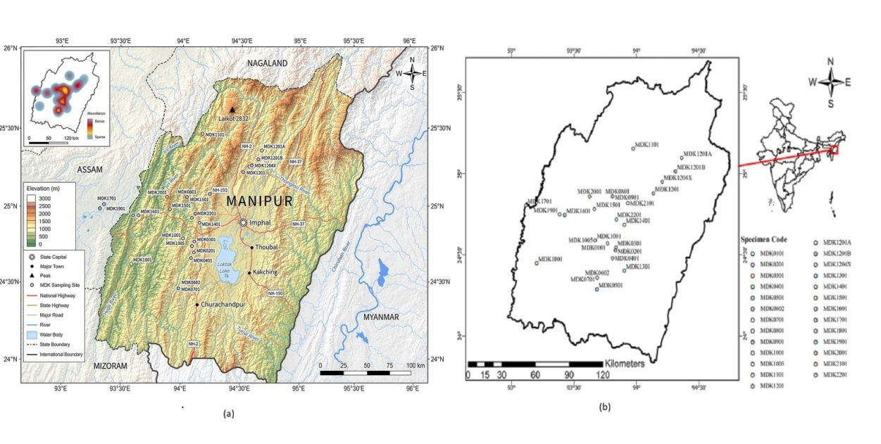

Fig. 2. (a) GIS-based physiographic map of Manipur showing elevation gradients, major river systems, road systems, and sample sites (MDK codes) overlaid on the topography; inset shows relative sampling abundance. (b) Simplified map illustrating spatial distribution of MDK sample sites within the state boundary. The figure shows the distribution of sampling sites in the context of topographic features and regional landscape structure.

Manipur, situated within the Indo-Burma biodiversity hotspot, harbours a rich but incompletely documented reptile fauna. Recent taxonomic studies and biodiversity surveys from north-eastern India continue to report new reptile records and previously undescribed gecko species, suggesting that the region remains an important centre of herpetofaunal diversity. Current national checklists recognise 58 reptile species from Manipur, whereas discoveries from neighbouring states indicate that additional gecko diversity is likely to be documented through systematic field surveys and integrative taxonomic approaches (Mohapatra et al., 2025). Among the herpetofauna, Basfore et al. (2024) documented 126 snake species representing 12 families and 46 genera, together with their distribution across states in north-eastern India and their IUCN Red List status. The Green Catsnake, Boiga cyanea, was also recently recorded in Manipur (Elangbam et al., 2024). Although no new gecko species has yet been described from Manipur, several have been described from neighbouring states, including Meghalaya (Bharali et al., 2026) and Assam (Sayyed et al., 2025). Accordingly, this study specifically documents Hemidactylus geckos from Manipur, a region characterised by highly varied geographical landscapes.

Figure 3 highlights species of the genus Hemidactylus from different habitats, including urban built-up areas, areas near hydropower projects, reservoir margins, and wetland ecosystems. Synanthropic populations in anthropogenic structures are shown in panel (a), whereas occurrences in semi-natural and altered hill habitats with rocky substrates and mixed vegetation are shown in panels (b) and (c). Panel (d) shows populations associated with lowland wetland and lacustrine settings. The figure suggests habitat-specific occurrence patterns and indicates the ecological adaptability of the documented gecko species, with their distribution influenced by microhabitat availability, moisture regimes, and the degree of human disturbance across the region.
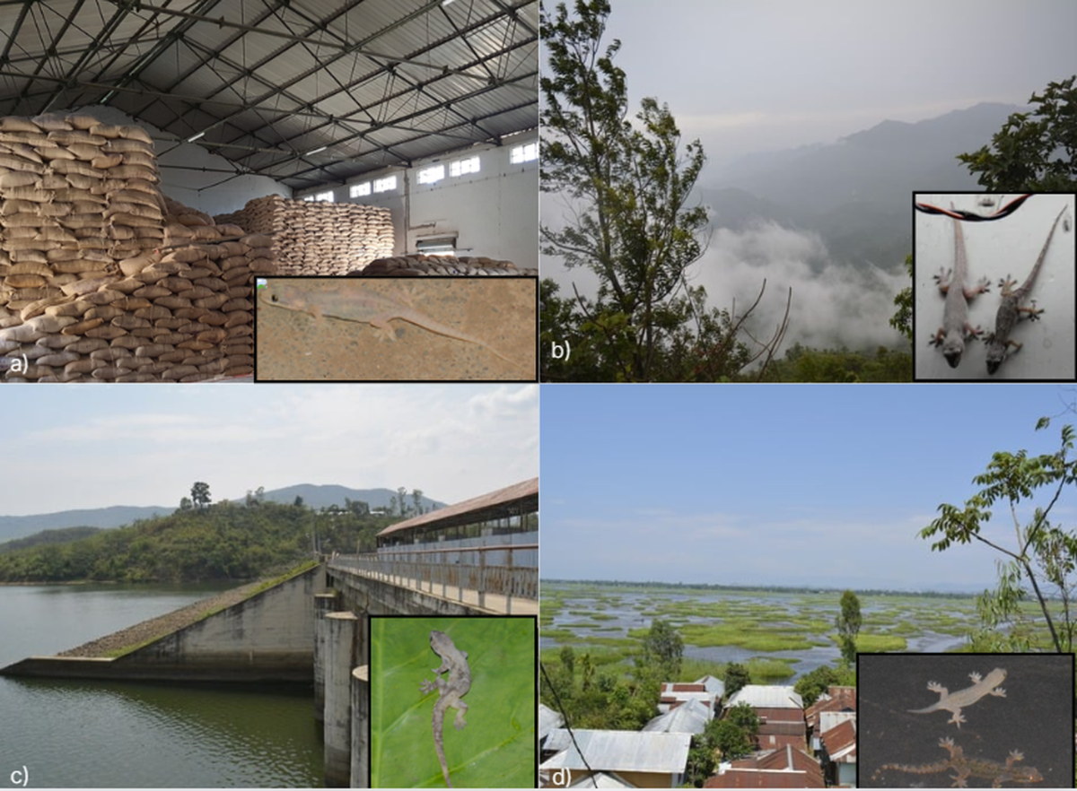
Fig. 3. Representative images of recorded species from diverse locations of Manipur: (a) FCI Godown, Imphal West, (b) Leimatak, CCP, (c) Khuga Dam, CCP, and (d) Thanga, Bishnupur district. The image illustrates the species prevalence across different habitats and ecological settings.

As shown in Figure 4, a molecular phylogenetic tree of geckos, primarily from the genus Hemidactylus, was constructed using mitochondrial Cyt b gene sequences. The rooted tree includes two outgroup taxa, Cyrtodactylus collegalensis and Cyrtodactylus triedrus, which serve as reference points for inferring evolutionary relationships within Hemidactylus. The numbers adjacent to the nodes are bootstrap support values (for example, 60%), which indicate the confidence associated with each clade. The Hemidactylus frenatus clade includes samples MDK 1601, 2201, 2101, 1701, 1401, 1001, and 0201. These samples are genetically similar, indicating that they probably represent the same species or closely related lineages. The moderate bootstrap support (approximately 51–60%) indicates some genetic variation within the species. The Hemidactylus bowringii clade, comprising samples MDK 1201A, 1501, 1901, 1201B, and 0901, forms a distinct cluster separate from H. frenatus. This indicates that the species are unambiguously distinct, although the internal branching suggests that the population may be structured and that minor variation may occur among samples. This pattern may indicate a closely related evolutionary lineage or a misidentified or cryptic lineage, suggesting the need for additional markers to establish the evolutionary lineage precisely. The phylogenetic tree displays two parallel sets of samples, and both datasets exhibit analogous clustering patterns. This supports consistency in the phylogenetic signal and indicates comparable in situ diversification patterns. Very short branch lengths within clusters (e.g., 0.000–0.01) indicate minor genetic divergence, suggesting that the species may have diverged recently or may represent the same species. Longer branch lengths within clades indicate species-level separation. Bootstrap values range from 40% to 60%, indicating moderate confidence. This may be attributable to the use of only one marker (Cyt b), its short sequence length, and the inclusion of closely related taxa. H. frenatus and H. bowringii form separate clades, supporting their taxonomic validity as distinct species-level clusters. Multiple sub-branches within each species support population divergence and potential early-stage speciation. The similar topology of both MCB groups indicates parallel structure across the datasets, suggesting a stable evolutionary pattern and reinforcing phylogenetic reliability. However, this tree has limitations, particularly the low bootstrap values, which indicate weak confidence, the use of a single mitochondrial marker (Cyt b), and limited geographical sampling, which prevent the complete resolution of deep evolutionary relationships.
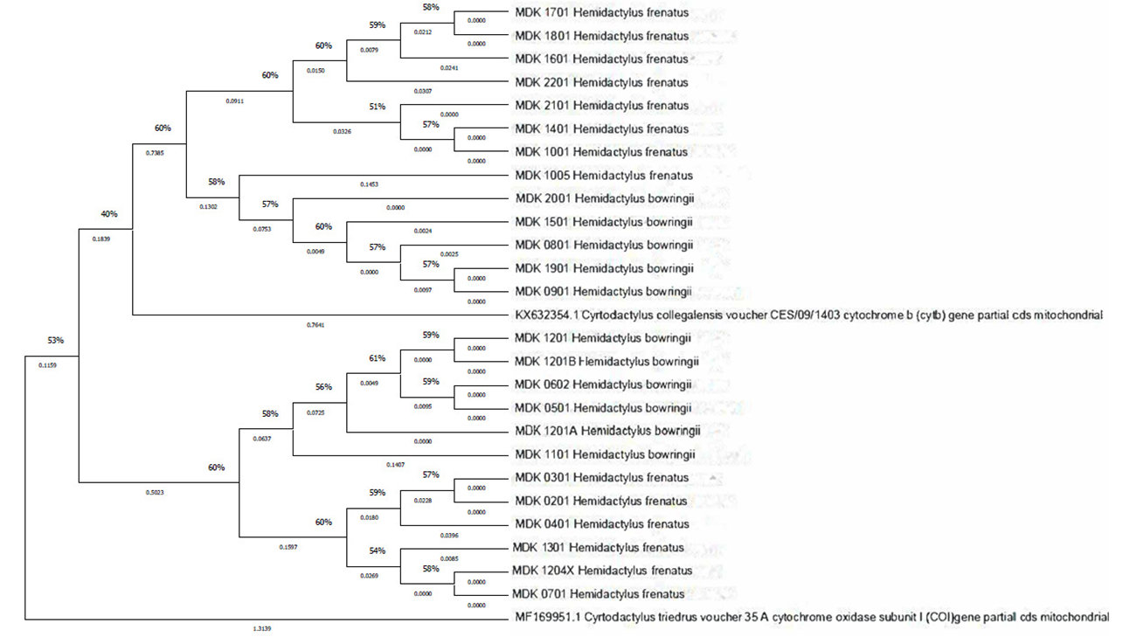
Fig. 4. Maximum Likelihood phylogenetic tree of the endemic radiation of Hemidactylus geckos from various locations of Manipur, Northeast India. A phylogenetic analysis utilizing two partial mitochondrial sequences (excluding the third codon position) resulted in strongly supported clades. The maximum likelihood bootstrap values and the Bayesian posterior probability are the support values for internal branches. Values less than 50/0.5 are left out, except for one.

Research in systematics, historical biogeography, and phylogenetic analysis indicates that the biodiversity of the Indian subcontinent developed over hundreds of millions of years through an assemblage of ancient and contemporary lineages with diverse biogeographic affinities. The complex geological history of the Indian plate had a major influence on the diversity, distribution, and evolution of species. Ancient lineages with Gondwanan affinities that originated through plate-tectonic vicariance form part of the Indian biota. Although some lineages dispersed from India, many others spread into India from adjacent landmasses during different periods. Other lineages underwent in situ speciation within India (Karanth, 2015; Cyriac et al., 2024). Hemidactylus groups have diversified independently into multiple species while exhibiting similar evolutionary trends across locations.

This study elucidates a small component of India’s remarkable biodiversity and habitat and ecosystem variability, which remain largely unexplored and understudied, particularly in north-eastern India. Whether these patterns apply universally across taxa remains to be determined. Integrated biogeographic analyses linking patterns and processes to conservation initiatives across taxa and environments are limited. For example, the presence of endangered, endemic, or evolutionarily unique species could help to identify areas of high conservation priority and areas requiring attention. Accurate data on species distributions are essential for identifying diversity and endemism hotspots, reconstructing biogeographic histories, and analysing diversification patterns. Georeferenced occurrence data support species-distribution modelling, conservation prioritisation, and environmental-impact assessment, particularly in ecologically sensitive and dynamic areas such as Manipur in north-eastern India, which forms a crucial biogeographic transition zone between the Asian and Indian plates. Recent taxonomic and phylogenetic research has revealed substantial undocumented diversity in north-eastern India, indicating that the region’s gecko fauna remains poorly documented (Boruah et al., 2024; Karanth, 2021). These findings emphasise the importance of systematic sampling and integrative taxonomic techniques and highlight north-eastern India as an important centre of cryptic and endemic gekkonid diversity.

Prioritising areas containing distinct lineages rather than common taxa can be achieved by shifting the focus from species counts to “evolutionary potential”, which is particularly important for a genus distributed across the most imperilled landscapes of north-eastern India. Major obstacles, including the publication of localised phylogenies that resisted integration and the use of inconsistent genetic markers, hindered conservation efforts. Because of this fragmentation, reciprocally monophyletic relationships across political boundaries could not be identified, resulting in low nodal support and sampling errors. We attempted to improve conservation accuracy by combining these different data into a comprehensive, genus-wide phylogeny. Government environmental policy should consider “undescribed candidate species” in land-use planning. A site should be considered a high-biodiversity zone when it possesses particular geological features—such as north–south ridges, river basins, wetlands, and valleys—that are known to support species radiations. However, a scientific and systematic biodiversity-conservation plan is still lacking, and most efforts focus on a few charismatic large mammals. In addition, the complex interplay between natural and human-induced factors shaping the distribution, composition, and functioning of ecosystems in India remains to be explored.

4. CONCLUSION

This study provides a molecular and spatial assessment of Hemidactylus geckos from Manipur, a biogeographically complex part of north-eastern India. Mitochondrial cytochrome b analysis separated the examined H. frenatus and H. bowringii samples into distinct species-level clusters, while internal branching indicated population-level variation within the sampled lineages. The generally moderate bootstrap support and short branch lengths within several clusters suggest that the present dataset is more informative for recognising shallow relationships than for resolving deeper evolutionary history. Geographic information system mapping further showed a marked valley–hill pattern, with most sampling localities concentrated in the central valley and adjoining northern and north-eastern hills. Together, these results highlight the importance of combining molecular evidence with georeferenced occurrence data when evaluating gecko diversity in heterogeneous landscapes. The study also reinforces the need to include evolutionary distinctiveness in regional biodiversity assessment. Future investigations should expand sampling across under-represented hill tracts, incorporate nuclear and additional mitochondrial markers, and use integrative morphological and ecological evidence to clarify population structure, identify possible cryptic lineages, and strengthen conservation planning for Manipur’s herpetofauna.

Limitations
This study was limited by uneven geographic coverage, with fewer sampling locations in the western and southern hill regions of Manipur. Phylogenetic inference was based mainly on a short mitochondrial cytochrome b sequence, which may restrict the resolution of deeper evolutionary relationships. The moderate bootstrap support also limits firm interpretation of some internal branches. Broader sampling and additional mitochondrial and nuclear markers would strengthen future assessments of population structure and cryptic diversity.

Ethical approval (where ever applicable)

Animal handling and sample protocols were performed in accordance with the standards of the Committee for the Purpose of Control and Supervision of Experiments on Animals (CPCSEA). Field sampling was carried out with the requisite authorization from the Forest Department, Government of Manipur, Office of Principal Chief Conservator of forest (Wildlife) & Chief Wildlife Warden, Approval No. 3/22/2018-WL(Vol-II) with minimum disturbance to animals and their habitat. All experiments have been examined and approved by the appropriate ethics committee.

Declaration of AI Use

This manuscript was prepared through the combined contributions of all author(s), including contributions to the study design, data, content development, results, interpretation, and related scholarly work. The author(s) acknowledge the use of Grammarly and ChatGPT to assist with grammar checking, language refinement, reference formatting. These AI-assisted tools were not used as authors and did not replace the intellectual contributions or scholarly judgment of the author(s). All AI-assisted outputs, including content, references, and interpretations, were carefully reviewed, revised, verified, and approved by the author(s). The author(s) accept full responsibility for the accuracy, integrity, and final content of the manuscript.

COMPETING INTERESTS DISCLAIMER:
Authors have declared that they have no known competing financial interests OR non-financial interests OR personal relationships that could have appeared to influence the work reported in this paper.

References
Acharyya, S. K. (2010). Tectonic evolution of the Indo-Burma Range with special reference to the Naga-Manipur Hills. Memoirs of the Geological Society of India, 75, 25–43. https://www.geosocindia.org/GSI/publications/m-75-indo-myanmar-ranges-in-the-tectonic-framework-of-the-himalaya-and-southeast-of-asia
Agashe, M., Šmíd, J., Janák, V., Biswas, A., & Karanth, K. P. (2025). Twin cradles of diversity: Parallel in situ radiations in India and Africa drive the evolution of Hemidactylus geckos. Journal of Biogeography, 52(8), e15165. https://doi.org/10.1111/jbi.15165
Agarwal, I., Khandekar, A., Giri, V. B., Ramakrishnan, U., & Karanth, K. P. (2019). The hills are alive with geckos! A radiation of a dozen species on sky islands across peninsular India (Squamata: Gekkonidae, Hemiphyllodactylus), with the description of three new species. Organisms Diversity & Evolution, 19(2), 341–361. https://doi.org/10.1007/s13127-019-00392-5
Avise, J. C. (2000). Phylogeography: The history and formation of species. Harvard University Press. https://www.hup.harvard.edu/books/9780674666382
Ballard, J. W. O., & Whitlock, M. C. (2004). The incomplete natural history of mitochondria. Molecular Ecology, 13(4), 729–744. https://doi.org/10.1046/j.1365-294x.2003.02063.x
Bansal, R., & Karanth, K. P. (2013). Phylogenetic analysis and molecular dating suggest that Hemidactylus anamallensis is not a member of the Hemidactylus radiation and has an ancient Late Cretaceous origin. PLOS ONE, 8(5), e60615. https://doi.org/10.1371/journal.pone.0060615
Basfore, B., Kalita, M. J., Sharma, N., & Boro, A. R. (2024). An updated checklist of snakes (Reptilia: Squamata) in northeastern India derived from a review of recent literature. Journal of Threatened Taxa, 16(11), 26131–26149. https://doi.org/10.11609/jott.8741.16.11.26131-26149
Bharali, M., Swargiary, P., Mariswamy, T., Das, M., Purkayastha, J., & Bohra, S. C. (2026). From the heart of Urpad: Records of Cyrtodactylus bapme Kamei & Mahony, 2021 (Reptilia: Squamata: Gekkonidae) from Assam, India, with comments on the pre-cloacal region in males. Journal of Threatened Taxa, 18(5), 28998–29002. https://doi.org/10.11609/jott.9735.18.5.28998-29002
Bissattini, A. M., Haubrock, P. J., Buono, V., Balzani, P., Borgianni, N., Stellati, L., Inghilesi, A. F., Tancioni, L., Martinoli, M., Tricarico, E., & Vignoli, L. (2021). Trophic structure of a pond community dominated by an invasive alien species: Insights from stomach content and stable isotope analyses. Aquatic Conservation: Marine and Freshwater Ecosystems, 31(4), 948–963. https://doi.org/10.1002/aqc.3530
Boruah, B., Narayanan, S., Aravind, N. A., Lalronunga, S., Deepak, V., & Das, A. (2024). Description of six new species of Cyrtodactylus Gray (Squamata: Gekkonidae) from northeastern India. Vertebrate Zoology, 74, 453–486. https://doi.org/10.3897/vz.74.e124752
Carranza, S., & Arnold, E. N. (2006). Systematics, biogeography, and evolution of Hemidactylus geckos (Reptilia: Gekkonidae) elucidated using mitochondrial DNA sequences. Molecular Phylogenetics and Evolution, 38(2), 531–545. https://doi.org/10.1016/j.ympev.2005.07.012
Cyriac, V. P., Ganesh, S. R., Madani, Z., Ghosh, A., Kulkarni, V., & Shanker, K. (2024). Phylogenetic systematics of the shieldtail snake genus Teretrurus Beddome, 1886 (Squamata: Uropeltidae) reveals extensive cryptic diversity and novel geographic spread in the Western Ghats of India. Bulletin of the Society of Systematic Biologists, 3(2), 1–25. https://doi.org/10.18061/bssb.v3i2.9630
Das, M., Purkayastha, J., Bauer, A. M., & Sengupta, S. (2011). Hemidactylus flaviviridis Rüppell, 1835 (Sauria: Gekkonidae): An invasive gecko in Assam. North-Western Journal of Zoology, 7(1), 98–104.
Department of Town Planning, Government of Manipur. (n.d.). Profile of the state. Retrieved July 31, 2026, from https://www.tpmanipur.mn.gov.in/en/home_content/profile-of-the-state/
Elangbam, P. S., Singh, N. H., & Naorem, M. M. (2024). First record of the Green Catsnake, Boiga cyanea Duméril, Bibron, and Duméril, 1854 (Squamata: Colubridae), from Manipur, India. Reptiles & Amphibians, 31(1), e21508. https://doi.org/10.17161/randa.v31i1.21508
Giri, V. B. (2008). A new rock-dwelling Hemidactylus (Squamata: Gekkonidae) from Maharashtra, India. Hamadryad, 32(1), 25–33. https://reptile-database.reptarium.cz/Hemidactylus/aaronbaueri
Giri, V. B., & Bauer, A. M. (2008). A new ground-dwelling Hemidactylus (Squamata: Gekkonidae) from Maharashtra, with a key to the Hemidactylus of India. Zootaxa, 1700(1), 21–34. https://doi.org/10.11646/zootaxa.1700.1.2
Grismer, L. L., Wood, P. L., Jr., Poyarkov, N. A., Le, M. D., Kraus, F., Agarwal, I., Oliver, P. M., Nguyen, S. N., Nguyen, T. Q., Karunarathna, S., Welton, L. J., Stuart, B. L., Luu, V. Q., Bauer, A. M., O’Connell, K. A., Quah, E. S. H., Chan, K. O., Ziegler, T., Ngo, H., … Grismer, J. L. (2021). Phylogenetic partitioning of the third-largest vertebrate genus in the world, Cyrtodactylus Gray, 1827 (Reptilia: Squamata: Gekkonidae), and its relevance to taxonomy and conservation. Vertebrate Zoology, 71, 101–154. https://doi.org/10.3897/vz.71.e59307
Hillis, D. M. (1996). Inferring complex phylogenies. Nature, 383(6596), 130–131. https://doi.org/10.1038/383130a0
Joshi, J., & Karanth, K. P. (2013). Did the southern Western Ghats of peninsular India serve as refugia for its endemic biota during the Cretaceous volcanism? Ecology and Evolution, 3(10), 3275–3282. https://doi.org/10.1002/ece3.603
Karanth, K. P. (2015). An island called India: Phylogenetic patterns across multiple taxonomic groups reveal endemic radiations. Current Science, 108(10), 1847–1851. https://ces.iisc.ac.in/?q=node%2F549
Karanth, K. P. (2021). Dispersal vs. vicariance: The origin of India’s extant tetrapod fauna. Frontiers of Biogeography, 13(1), e48678. https://doi.org/10.21425/F5FBG48678
Khandekar, A., Thackeray, T., Mariappan, R., Gangalmale, S., Waghe, V., Pawar, S., & Agarwal, I. (2023). A remarkable new species of gecko (Squamata: Gekkonidae: Hemidactylus) from scrublands at the southern tip of India. Vertebrate Zoology, 73, 433–450. https://doi.org/10.3897/vz.73.e101871
Kraus, F. (2009). Alien reptiles and amphibians: A scientific compendium and analysis. Springer. https://doi.org/10.1007/978-1-4020-8946-6
Kumar, V. M. S., Kumar, A., & Jaiswal, T. (2026). Molecular identification of snake species from shed skin using DNA barcoding (mitochondrial COI) in agro-ecosystems of Bihar: A case study. Journal of Global Ecology and Environment, 22(2), 61–69. https://doi.org/10.56557/jogee/2026/v22i210454
Lamb, A. D., Lippi, C. A., Watkins-Colwell, G. J., Jones, A., Warren, D. L., Iglesias, T. L., Brandley, M. C., & Dornburg, A. (2021). Comparing the dietary niche overlap and ecomorphological differences between invasive Hemidactylus mabouia geckos and a native gecko competitor. Ecology and Evolution, 11(24), 18719–18732. https://doi.org/10.1002/ece3.8401
Lanfear, R., Calcott, B., Ho, S. Y. W., & Guindon, S. (2012). PartitionFinder: Combined selection of partitioning schemes and substitution models for phylogenetic analyses. Molecular Biology and Evolution, 29(6), 1695–1701. https://doi.org/10.1093/molbev/mss020
Lever, C. (2003). Naturalized reptiles and amphibians of the world. Oxford University Press. https://doi.org/10.1093/oso/9780198507710.001.0001
Macey, J. R., Larson, A., Ananjeva, N. B., & Papenfuss, T. J. (1997). Evolutionary shifts in three major structural features of the mitochondrial genome among iguanian lizards. Journal of Molecular Evolution, 44(6), 660–674. https://doi.org/10.1007/PL00006190
Mani, M. S. (1974). Biogeographical evolution in India. In M. S. Mani (Ed.), Ecology and biogeography in India (pp. 698–724). Springer. https://doi.org/10.1007/978-94-010-2331-3_24
Mittermeier, R. A., Turner, W. R., Larsen, F. W., Brooks, T. M., & Gascon, C. (2011). Global biodiversity conservation: The critical role of hotspots. In F. E. Zachos & J. C. Habel (Eds.), Biodiversity hotspots (pp. 3–22). Springer. https://doi.org/10.1007/978-3-642-20992-5_1
Mohapatra, P. P., Ray, S., Bhupathy, B., Deuti, K., & Sethy, P. G. S. (2025). Checklist of fauna of India: Reptilia (Version 2.0). Zoological Survey of India. https://doi.org/10.26515/Fauna/2/2025/Chordata:Reptilia
Myers, N., Mittermeier, R. A., Mittermeier, C. G., da Fonseca, G. A. B., & Kent, J. (2000). Biodiversity hotspots for conservation priorities. Nature, 403(6772), 853–858. https://doi.org/10.1038/35002501
Patel, H., Thackeray, T., Vyas, R., & Mirza, Z. A. (2026). A new species of Hemidactylus Goldfuss, 1820 (Squamata: Sauria: Gekkonidae) of the H. persicus complex from the Aravalli Hills, India. Zootaxa, 5759(5), 526–542. https://doi.org/10.11646/zootaxa.5759.5.2
Raj, R., Singh, M., Shahbaz, M., Zafar, M. M., Abhishek, Mall, A. K., & Yasmin, S. (2025). Species richness and conservation status of herpetofauna and mammals in Bhimbandh Wildlife Sanctuary, Bihar, India. Asian Journal of Environment & Ecology, 24(7), 198–213. https://doi.org/10.9734/ajee/2025/v24i7762
Rodgers, W. A., & Panwar, H. S. (1988). Planning a wildlife protected area network in India (Vols. 1–2). Food and Agriculture Organization and Wildlife Institute of India. https://portals.iucn.org/library/node/25283
Sayyed, A., Das, M., Amarasinghe, A. A. T., Bhattacharjee, R., & Purkayastha, J. (2025). A new day gecko of the Cnemaspis podihuna (Reptilia: Gekkonidae) clade from Northeast India. Taprobanica, 14(2), 107–120. https://doi.org/10.47605/tapro.v14i2.363
Smith, M. A. (1935). The fauna of British India, including Ceylon and Burma: Reptilia and Amphibia (Vol. 2, Sauria). Taylor & Francis. https://www.biodiversitylibrary.org/bibliography/100737
Tamura, K., Peterson, D., Peterson, N., Stecher, G., Nei, M., & Kumar, S. (2011). MEGA5: Molecular evolutionary genetics analysis using maximum likelihood, evolutionary distance, and maximum parsimony methods. Molecular Biology and Evolution, 28(10), 2731–2739. https://doi.org/10.1093/molbev/msr121
Thompson, J. D., Higgins, D. G., & Gibson, T. J. (1994). CLUSTAL W: Improving the sensitivity of progressive multiple sequence alignment through sequence weighting, position-specific gap penalties, and weight matrix choice. Nucleic Acids Research, 22(22), 4673–4680. https://doi.org/10.1093/nar/22.22.4673
Uetz, P. H., Patel, M., Gbadamosi, Z., Nguyen, A., & Shoope, S. (2024). A reference database of reptile images. Taxonomy, 4(4), 723–732. https://doi.org/10.3390/taxonomy4040038
Yang, Z. (2006). Computational molecular evolution. Oxford University Press. https://doi.org/10.1093/acprof:oso/9780198567028.001.0001

