A checklist and distribution information on the short-horned grasshoppers (Acrididae and Pyrgomorphidae: Orthoptera) found in Telangana, India

Abstract
This study presents a checklist and zonal distribution account of short-horned grasshoppers associated with major crop ecosystems in Telangana, India. The inventory was prepared using data generated from extensive field surveys conducted across the North Telangana Zone, Central Telangana Zone and South Telangana Zone, representing the major agro-climatic regions of Telangana, together with authenticated specimens preserved in the Insect Biosystematics Laboratory, Department of Agricultural Entomology, College of Agriculture, Professor Jayashankar Telangana State Agricultural University (PJTSAU), Rajendranagar, Hyderabad. The checklist was further updated in accordance with the current nomenclature and classification provided by the Orthoptera Species File. A total of 21 species belonging to 18 genera, 11 subfamilies and two families, Acrididae and Pyrgomorphidae, were documented from the major crop ecosystems of Telangana. Among the recorded taxa, species of Atractomorpha, Chrotogonus, Poekilocerus, Oxya, Hieroglyphus, Acrida and Cyrtacanthacris were widely distributed across the three agro-climatic zones, whereas a few species exhibited restricted zonal distributions. The checklist provides updated information on the taxonomy, type locality, type depository and distribution of each species within Telangana. This is the first comprehensive checklist of short-horned grasshoppers associated with the major crop ecosystems of Telangana and provides baseline information for future taxonomic, biodiversity, ecological and pest-management studies in the state.

Keywords

Short-horned grasshoppers; Acrididae; Pyrgomorphidae; Orthoptera; faunal checklist; agro-climatic zones; crop ecosystems; species distribution; biodiversity; Telangana

Introduction
Orthoptera is one of the largest and most evolutionarily diverse insect orders, comprising grasshoppers, locusts, crickets and katydids. According to the Orthoptera Species File, more than 29,530 valid species and subspecies have been described worldwide, making Orthoptera one of the largest extant polyneopteran insect orders (Cigliano et al., n.d.). The order is divided into two suborders, Caelifera and Ensifera, of which Caelifera comprises the short-horned grasshoppers. These insects are important components of terrestrial ecosystems and agricultural landscapes, where several species are recognised as economically important pests of cereals, millets, oilseeds, pulses, vegetables and forage crops (Dirsh, 1975; Uvarov, 1966). Besides their economic importance, grasshoppers contribute significantly to ecosystem functioning as primary herbivores, prey for higher trophic levels and indicators of habitat quality and environmental change (Samways et al., 2026). Recent advances in integrative taxonomy, combining morphological, molecular and phylogenomic evidence, have considerably improved the understanding of orthopteran systematics and evolutionary relationships. These approaches have strengthened species delimitation and facilitated more robust classifications within major orthopteran families, including Acrididae and Pyrgomorphidae (Shin et al., 2024; Song, 2010; Song et al., 2015).
The short-horned grasshoppers belong primarily to the superfamilies Acridoidea and Pyrgomorphoidea, represented mainly by the families Acrididae and Pyrgomorphidae, respectively. Acrididae is the largest family of Orthoptera, comprising approximately 6,765 valid species distributed among 28 subfamilies, whereas Pyrgomorphidae includes about 149 genera and 488 species worldwide (Cigliano et al., n.d.). Members of these families occupy diverse habitats, ranging from forests and grasslands to wetlands and cultivated agroecosystems. Genera such as Oxya, Hieroglyphus, Acrida, Aiolopus, Gastrimargus, Chrotogonus and Poekilocerus are widely distributed in tropical Asia, and several species are known pests of economically important crops (Chand et al., 2021). Recent studies have also highlighted the ecological significance of short-horned grasshoppers as indicators of habitat quality and environmental change, emphasising the importance of documenting their diversity and distribution through regional faunal inventories (Castro-Souza et al., 2024; Chand et al., 2024).
India harbours one of the richest orthopteran faunas in the Oriental Region owing to its diverse climatic conditions, vegetation types and agroecological regions. Approximately 1,033 species and subspecies belonging to 400 genera and 21 families have been reported from the country, of which Acrididae and Pyrgomorphidae contribute 285 species in 135 genera and 47 species in 21 genera, respectively (Shishodia et al., 2010). The taxonomy and systematics of Indian short-horned grasshoppers have been developed through classical monographs and subsequent national and regional syntheses (Bhowmik, 1985; Chand et al., 2024; Kirby, 1914; Shishodia et al., 2010). These works have progressively refined the classification, nomenclature and known distribution of Indian Orthoptera. Recent state-level work from Bihar similarly illustrates the value of regional Orthoptera inventories for consolidating taxonomic and distributional information (Ranjan et al., 2025).

Telangana, located on the Deccan Plateau of peninsular India, comprises three distinct agro-climatic regions: the North Telangana Zone, Central Telangana Zone and South Telangana Zone. The state supports diverse cropping systems, including rice, maize, cotton, sorghum, pearl millet, pigeonpea, chickpea, soybean, groundnut and several horticultural crops. These varied agroecosystems provide favourable habitats for numerous species of short-horned grasshoppers. Despite their ecological and agricultural importance, information on the taxonomy and distribution of grasshoppers associated with the major crop ecosystems of Telangana remains fragmentary, and no comprehensive checklist has previously been prepared for the state.
Regional checklists of grasshoppers also contribute to national and global biodiversity databases, improve taxonomic accuracy and facilitate future ecological, biogeographical and conservation studies of Orthoptera (Bao et al., 2025; Castro-Souza et al., 2024; Chand et al., 2024; Hossain et al., 2023; Samways et al., 2026). Accurate taxonomic inventories also facilitate future studies on species diversity, distributional changes, invasive species and climate-driven shifts in insect communities (Samways et al., 2026). Furthermore, updated nomenclature based on internationally accepted taxonomic databases is essential for maintaining consistency in biodiversity documentation and systematic research. Long-term and habitat-stratified studies further indicate that grasshopper assemblages differ across vegetation types and modified agroecosystems, supporting the need for geographically explicit regional inventories (Mariottini et al., 2024; Oumarou Ngoute et al., 2026).
Therefore, the present investigation was undertaken to prepare a comprehensive checklist of short-horned grasshoppers associated with the major crop ecosystems of Telangana. The checklist provides updated nomenclature, taxonomic position, type locality, type depository and distribution records for each species across the North Telangana, Central Telangana and South Telangana agro-climatic zones. The information generated through this study will serve as valuable baseline data for future taxonomic, ecological, biodiversity and integrated pest-management studies in Telangana.

Materials and Methods

Compilation of checklist
A comprehensive checklist of short-horned grasshoppers associated with the major crop ecosystems of the three agro-climatic zones of Telangana was prepared by integrating information obtained from extensive field surveys. Specimens collected during the present investigation were examined and compared with available taxonomic references.

Sampling and morphological identification
Comprehensive field surveys were conducted across the North Telangana Zone, Central Telangana Zone and South Telangana Zone. Adult short-horned grasshoppers were collected using sweep nets from cultivated fields, fallow lands and grass bunds. Collections were conducted for two hours at designated sampling locations in each area, once per month from October 2020 to May 2021. The collected specimens were transported to the laboratory, euthanised using ethyl acetate and preserved following the standard entomological procedures described by Richards and Davies (1977). Specimens were pinned, labelled and allowed to dry before detailed examination.
Morphological identification was performed using a Zeiss Stemi 508 stereo zoom microscope. Diagnostic external morphological characters were examined, and species were identified using standard taxonomic keys, original descriptions and relevant literature. The scientific names, higher classification and taxonomic status of all species included in the checklist were verified and updated using the Orthoptera Species File Online (Cigliano et al., n.d.).

Results and Discussion
According to the Orthoptera Species File, approximately 29,530 valid species and subspecies of Orthoptera have been described worldwide (Cigliano et al., n.d.). In India, about 1,033 species and subspecies belonging to 400 genera and 21 families have been reported (Shishodia et al., 2010). Despite the rich orthopteran diversity of India, comprehensive information on short-horned grasshoppers associated with the agricultural ecosystems of Telangana has remained limited.
The present investigation represents one of the first consolidated checklists of short-horned grasshoppers associated with the major crop ecosystems of Telangana. The checklist comprises 21 species belonging to 18 genera, 11 subfamilies and two families, namely Acrididae and Pyrgomorphidae. Of these, 17 species (80.95%) belong to Acrididae, whereas four species (19.05%) belong to Pyrgomorphidae, indicating the predominance of Acrididae in the agricultural landscapes of Telangana (Tables 1 and 2; Figure 1).
Within Pyrgomorphidae, the subfamily Pyrgomorphinae was represented by three species (Atractomorpha crenulata crenulata, Chrotogonus trachypterus and Poekilocerus pictus), accounting for 75.0% of the pyrgomorphid fauna, whereas Orthacridinae was represented by a single species (Neorthacris acuticeps acuticeps), contributing 25.0% (Table 1).
Table.1 Checklist of Pyrgomorphids associated with major crop ecosystem from Telangana

Among Acrididae, Acridinae and Oedipodinae were the dominant subfamilies, each represented
Subfamily: Pyrgomorphinae
Tribe: Atractomorphini Bolivar, 1905
Genus: Atractomorpha Saussure, 1862 : 474 ; Type Species: Atractomorpha crenulata Fabricius
Atractomorpha crenulata crenulata Fabricius 1793:28 | Type locality: Indian Subcontinent, Nepal  Type deposited : Zoological Museum, University of Copenhagen, Denmark | Distribution:  North Telangana Zone, South Telangana Zone, Central Telangana Zone
Subamily: Pyrgomorphinae
Tribe: Chrotogonini Bolívar, 1904

Genus: Chrotogonus Serville, 1838 : 702 ; Type Species: Chrotogonus trachypterus Blanchard
Chrotogonus trachypterus Blanchard 1836:618 | Type locality: Asia-Tropical, Indian Subcontinent, Pakistan, Baluchistan  Type deposited : BMNH London NH Mu | Distribution:  North Telangana Zone, South Telangana Zone, Central Telangana Zone
Subamily: Pyrgomorphinae
Tribe: Poekilocerini Burmeister, 1840

Genus: Poekilocerini Burmeister, 1840; Type species: Poekilocerus sonneratii Serville, 1831
Poekilocerus pictus (Fabricius, 1775) | Type locality: Asia-Tropical, Indian Subcontinent.  Type deposited : Zoological Museum, University of Copenhagen (ZMUC), Denmark | Distribution:  North Telangana Zone, South Telangana Zone, Central Telangana Zone
Subamily: Orthacridinae
Tribe: Orthacridini Kevan & Singh, 1964
Genus: Neorthacris Kevan & Singh, 1964; Type species: Orthacris acuticeps Bolívar, 1902
Neorthacris acuticeps acuticeps (Bolívar, 1902) | Type locality: Asia-Tropical, Indian Subcontinent, Tiruchirappalli (Trichinopoly), Tamil Nadu  Type deposited: Museo Nacional de Ciencias Naturales (MNCN), Madrid, Spain (Type material of Bolívar) | Distribution:  North Telangana Zone, South Telangana Zone, Central Telangana Zone
by three species (17.65%), followed by Catantopinae, Eyprepocnemidinae, Hemiacridinae and
Oxyinae, each represented by two species (11.76%). Calliptaminae, Cyrtacanthacridinae and
Spathosterninae were represented by one species each (5.88%) (Table 2). This distribution indicates that Acridinae and Oedipodinae are the major components of the short-horned grasshopper fauna associated with cultivated ecosystems in Telangana. The overall subfamily composition of all recorded species is presented in Figure 2.
Most species were widely distributed across the North Telangana, Central Telangana and South Telangana agro-climatic zones. Species such as Atractomorpha crenulata crenulata, Poekilocerus pictus, Neorthacris acuticeps acuticeps, Acrida exaltata, Acrida turrita, Diabolocatantops pinguis, Cyrtacanthacris tatarica, Hieroglyphus banian, Hieroglyphus nigrorepletus, Gastrimargus africanus, Oxya hyla and Oxya nitidula occurred in all three zones. In contrast, species including Phlaeoba infumata, Xenocatantops karnyi, Cataloipus indicus, Eyprepocnemis alacris alacris, Aiolopus thalassinus and Spathosternum prasiniferum were confined to two agro-climatic zones, whereas Acorypha glaucopsis and Acrotylus humbertianus exhibited restricted distributions. The widespread occurrence of several dominant acridid species across multiple agro-climatic zones is consistent with recent biodiversity assessments indicating that many generalist grasshopper species possess broad ecological tolerances, whereas a smaller number of taxa remain habitat-restricted (Samways et al., 2026).
The checklist provides updated information on the taxonomy, type locality, type depository and regional distribution of all recorded species. This baseline inventory will facilitate future studies on taxonomy, biodiversity assessment, ecological monitoring and integrated pest management of grasshoppers in Telangana.

Table.2 Checklist of Acridids associated with major crop ecosystem from Telangana
Subfamily: Acridinae MacLeay, 1821
Tribe: Acridini MacLeay, 1821

Genus: Acrida Linnaeus, 1758 : 427 ; Type Species: Acrida exaltata Walker
Acrida exaltata Walker 1859 : 222 | Type locality: Asia-Tropical, Indian Subcontinent, Sri Lanka  Type deposited: BMNH London NH Mus. | Distribution:  North Telangana Zone , South Telangana Zone, Central Telangana Zone
Subfamily: Acridinae MacLeay, 1821
Tribe: Acridini MacLeay, 1821

Genus: Acrida Linnaeus, 1758 : 427 ; Type Species: Acrida turrita Linnaeus
Acrida turrita Linnaeus 1758 | Type locality: Africa Type deposited: LSUK London Linnean Society | Distribution :  North Telangana Zone , South Telangana Zone, Central Telangana Zone

Subfamily: Acridinae MacLeay, 1821

Tribe: Phlaeobini Brunner von Wattenwyl, 1893

Genus: Phlaeoba Stål, 1861:60; Type Species: Phlaeoba infumata Brunner von Wattenwyl
Phlaeoba infumata Brunner von Wattenwy, 1893 : 124 | Type locality: Asia-Tropical, Indo-China, Myanmar, Bhamó  Type deposited: BMNH London NH Mus. | Distribution :  North Telangana Zone , South Telangana Zone
Subfamily: Catantopinae Brunner von Wattenwyl, 1893

Tribe: Catantopini Brunner von Wattenwyl, 1893

Genus: Diabolocatantops Jago 1984 : 295 ; Type Species: Diabolocatantops pinguis stol
Diabolocatantops pinguis stol 1860:330 | Type locality: Asia-Tropical, Indian Subcontinent, Sri Lanka  Type deposited: BMNH London NH Mu | Distribution :  North Telangana Zone , South Telangana Zone, Central Telangana Zone
Subfamily: Catantopinae Brunner von Wattenwyl, 1893
Tribe: Catantopini Brunner von Wattenwyl, 1893

Genus: Xenocatantops Dirsh 1953 :237; Type Species: Xenocatantops karnyi Kirby
Xenocatantops karnyi Kirby 1910: 483 | Type locality: East India  Type deposited: British Museum of Natural History, London or London Natural History Museum | Distribution :  North Telangana Zone , South Telangana Zone
Subfamily: Calliptaminae Jacobson, 1905
Tribe: Acoryphini Brunner von Wattenwyl, 1893

Genus: Acorypha Krauss, 1877 : 38 ; Type Species: Acorypha glaucopsis Walker
Acorypha glaucopsis Walker 1870:702 | Type locality: Africa  Type deposited: BMNH London NH Mus. | Distribution :  South Telangana Zone
Subfamily: Cyrtacanthacridinae Kirby, 1910
Tribe: Cyrtacanthacridini Kirby, 1910

Genus: Cyrtacanthacris Walker 1870 : 21; Type Species: Cyrtacanthacris tatarica Linnaeus
Cyrtacanthacris tatarica Linnaeus 1758 : 432 | Type locality: Asia-Tropical, Indian Subcontinent, Sri Lanka  Type deposited: UZIU Uppsala | Distribution :  North Telangana Zone , South Telangana Zone, Central Telangana Zone
Subfamily: Eyprepocnemidinae Brunner von Wattenwyl, 1893
Tribe: Eyprepocnemidini Brunner von Wattenwyl, 1893

Genus: Eyprepocnemis Fieber, 1853 : 98 ; Type Species: Eyprepocnemis alacris alacris Serville
Eyprepocnemis alacris alacris Serville 1839 : 682 | Type locality: Asia-Tropical, Indian Subcontinent, India, S. India  Type deposited: MNHN Paris | Distribution :  North Telangana Zone , South Telangana Zone.
Subfamily: Eyprepocnemidinae Brunner von Wattenwyl, 1893
Tribe: Cataloipini Brunner von Wattenwyl, 1893

Genus: Cataloipus Bolivar 1890 : 321; Type Species: Cataloipus indicus Uvarov
Cataloipus indicus Uvarov 1942 : 601 | Type locality: Asia-Tropical, Indian Subcontinent, India, Delhi  Type deposited: BMNH London NH Mus. | Distribution :  North Telangana Zone , South Telangana Zone.
Subfamily: Hemiacridinae Dirsh, 1956
Tribe: Hieroglyphini Bolivar, 1912

Genus: Hieroglyphus Krauss 1877 : 41 ; Type Species: Hieroglyphus banian Fabricius
Hieroglyphus banian Fabricius 1798 :194 | Type locality: Asia-Tropical, Indian Subcontinent, India  Type deposited: ZMUC Copenhagen | Distribution :  North Telangana Zone , South Telangana Zone, Central Telangana Zone
Subfamily: Hemiacridinae Dirsh, 1956
Tribe: Hemiacridinae Dirsh, 1956
Genus: Hieroglyphus Kraus 1877 : 41; Type Species: Hieroglyphus nigrorepletus Bolivar
Hieroglyphus nigrorepletus Bolivar 1912 : 56 | Type locality: Asia-Tropical, Indian Subcontinent, India, Karnataka, Bellary  Type deposited: MNCN Madras id Mus | Distribution :  North Telangana Zone , South Telangana Zone, Central Telangana Zone
Subfamily: Spathosterninae Rehn, 1957
Tribe: Spathosternini Rehn, 1957
Genus: Spathosternum Krauss 1877 : 44; Type Species: spathosternum prasiniferum Walker
spathosternum prasiniferum Walker 1871 : 65 | Type locality: Asia-Tropical, Indian Subcontinent, India, Maharashtra, Bombay [Mumbai]  Type deposited: BMNH London NH Mus. | Distribution :  North Telangana Zone , South Telangana Zone.
Subfamily: Oedipodinae Walker, 1871
Tribe: Epacromiini Brunner von Wattenwyl, 1893

Genus: Aiolopus Fieber 1853 : 100 ; Type Species: Aiolopus thalassinus Fabricius
Aiolopus thalassinus Fabricius 1781:195 | Type locality: Europe, Middle Europe, Switzerland, Locarno, Maggia Delta  Type deposited: BMNH London NH Mus. | Distribution :  North Telangana Zone , South Telangana Zone.
Subfamily: Oedipodinae Walker, 1871
Tribe: Locustini Kirby, 1825

Genus: Gastrimargus Saussure, 1884 : 109,110 ; Type Species: Gastrimargus africanus Saussure
Gastrimargus africanus Saussure 1888 : 39 | Type locality: Africa, Southern Africa, Cape Province  Type deposited: MHNG Geneva Museum | Distribution :  North Telangana Zone , South Telangana Zone, Central Telangana Zone
Subfamily: Oedipodinae Walker, 1871
Tribe: Acrotylini Johnston, 1956

Genus: Acrotylus Fieber 1853 : 125 ; Type Species: Acrotylus humbertianus Saussure
Acrotylus humbertianus Saussure 1884 : 189 | Type locality: Asia-Tropical, Indian Subcontinent, Sri Lanka  Type deposited: MHNG Geneva Museum | Distribution :  North Telangana Zone
Subfamily: Oxyinae Brunner von Wattenwyl, 1893
Tribe: Oxyini Brunner von Wattenwyl, 1893

Genus: Oxya Serville 1831 : 286 ; Type Species: Oxya hyla Serville
Oxya hyla Serville 1831 : 287 | Type locality: Africa, West Tropical Africa, Senegal  Type deposited: MNHN Paris | Distribution :  North Telangana Zone , South Telangana Zone, Central Telangana Zone

Subfamily: Oxyinae Brunner von Wattenwyl, 1893
Tribe: Oxyini Brunner von Wattenwyl, 1893
Genus: Oxya Serville 1831 : 286 ; Type Species: Oxya nitidula Walker
Oxya nitidula Walker 1870 : 631 | Type locality: Asia-Tropical, Indian Subcontinent, India, Maharashtra, Hindustan  Type deposited: BMNH London NH Mus. | Distribution :  North Telangana Zone , South Telangana Zone, Central Telangana Zone

Figure 1. Percentage composition of short-horned grasshopper families recorded from the major crop ecosystems of Telangana
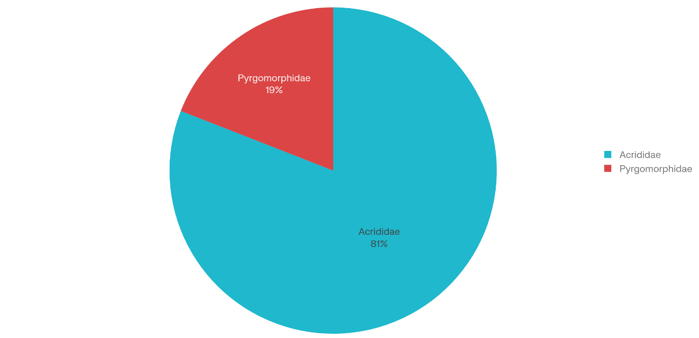

Figure 2. Percentage composition of subfamilies of short-horned grasshoppers recorded from the major crop ecosystems of Telangana
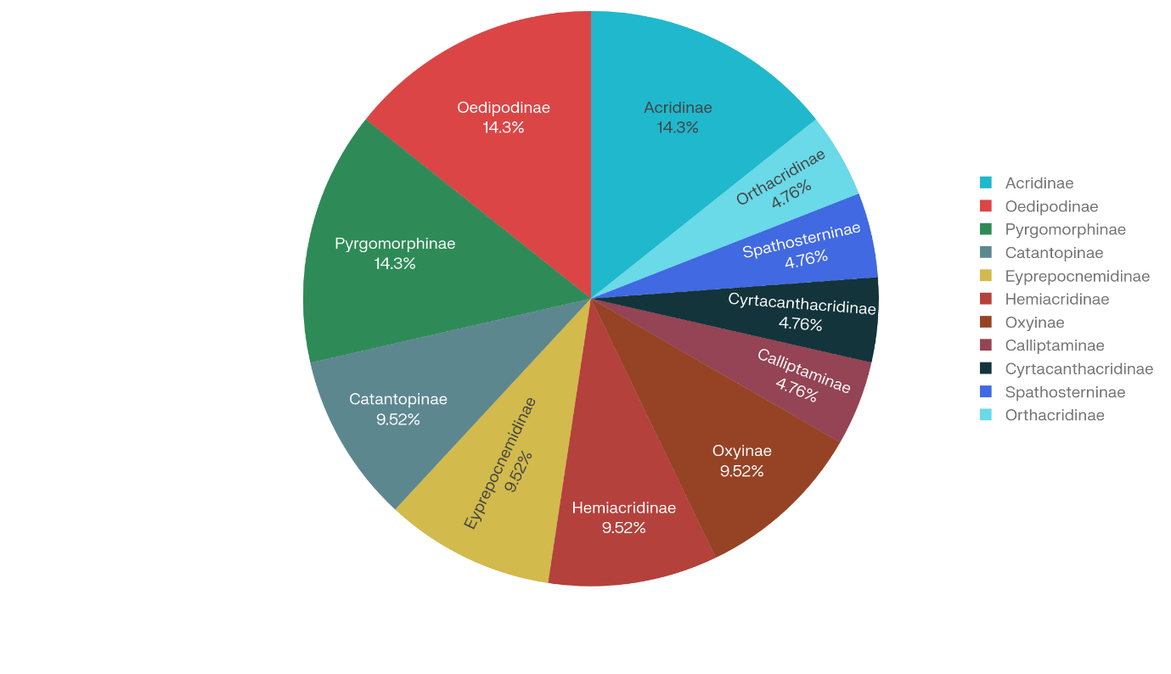

Conclusion
The study consolidates taxonomic and distributional information on short-horned grasshoppers associated with the major crop ecosystems of Telangana. The recorded fauna comprised 21 species representing 18 genera, 11 subfamilies and two families. Acrididae accounted for 17 species and was therefore the dominant family, whereas Pyrgomorphidae was represented by four species. Twelve species were recorded across the North Telangana, Central Telangana and South Telangana agro-climatic zones, while the remaining taxa displayed distributions restricted to one or two zones. The documented variation in zonal occurrence indicates that the grasshopper assemblage contains both widely distributed and comparatively restricted taxa. By presenting updated nomenclature, taxonomic position, type locality, type depository and regional distribution, the checklist provides an organised baseline for Telangana. The inventory may support subsequent taxonomic verification, biodiversity assessment, ecological monitoring and pest-management planning. Additional surveys incorporating district-level locality data, geographic coordinates, specimen abundance, habitat information and voucher accession numbers are required to strengthen and refine the present faunal account.

Limitations
The study is limited to zonal distribution records and does not provide district-level coordinates, specimen counts, collection dates for individual records, detailed habitat information or voucher accession numbers. Seasonal variation and species abundance were not analysed. Some taxonomic entries and the graphical presentation require further verification and formatting refinement. Broader surveys across multiple seasons, districts and agroecosystems are needed to confirm the recorded distributions and provide a more complete assessment of short-horned grasshopper diversity in Telangana.

Declaration of AI Use

This manuscript was prepared through the combined contributions of all author(s), including contributions to the study design, data, content development, results, interpretation, and related scholarly work. The author(s) acknowledge the use of Grammarly and ChatGPT to assist with grammar checking, language refinement, reference formatting. These AI-assisted tools were not used as authors and did not replace the intellectual contributions or scholarly judgment of the author(s). All AI-assisted outputs, including content, references, and interpretations, were carefully reviewed, revised, verified, and approved by the author(s). The author(s) accept full responsibility for the accuracy, integrity, and final content of the manuscript.

COMPETING INTERESTS:
Authors have declared that they have no known competing financial interests OR non-financial interests OR personal relationships that could have appeared to influence the work reported in this paper.

References
Bao, B., Wang, X., Peng, Z., Zhu, Q., Li, X., & Zhang, D. (2025). Pattern of diversity and prediction of suitable areas of grasshoppers from the Qinghai–Tibet Plateau in China (Orthoptera: Acridoidea). Insects, 16(2), 191. https://doi.org/10.3390/insects16020191
Bhowmik, H. K. (1985). Outline of distribution with an index-catalogue of Indian grasshoppers (Orthoptera: Acrididae): Subfamilies Acridinae, Truxalinae, Gomphocerinae and Oedipodinae (Records of the Zoological Survey of India, Occasional Paper No. 78). Zoological Survey of India. https://archive.org/details/dli.zoological.occpapers.078
Castro-Souza, R. A., Tessarolo, G., Stropp, J., Diniz-Filho, J. A. F., Ladle, R. J., Szinwelski, N., Hortal, J., & Sobral-Souza, T. (2024). Mapping ignorance to uncover shortfalls in the knowledge on global Orthoptera distribution. npj Biodiversity, 3, Article 22. https://doi.org/10.1038/s44185-024-00059-1
Chand, D. S., Das, S. K., & Kumar, H. (2021). Diversity of short-horned grasshoppers (Insecta: Orthoptera) in the Sunderban Biosphere Reserve, West Bengal, India. Records of the Zoological Survey of India, 121(4), 473–481. https://doi.org/10.26515/rzsi/v121/i4/2021/143669
Chand, D. S., Das, S. K., Chakraborty, R., & Kumar, H. (2024). Checklist of fauna of India: Arthropoda: Insecta: Orthoptera (Version 1.0). Zoological Survey of India. https://doi.org/10.26515/Fauna/1/2023/Arthropoda:Insecta:Orthoptera
Cigliano, M. M., Braun, H., Eades, D. C., & Otte, D. (n.d.). Orthoptera Species File. Retrieved July 29, 2026, from https://orthoptera.speciesfile.org/
Dirsh, V. M. (1975). Classification of the acridomorphoid insects. E. W. Classey. https://archive.org/details/classificationof0000dirs
Hossain, M. A., Lahoz-Monfort, J. J., & Kearney, M. R. (2023). Developing a database of Australian grasshopper occurrences from historic field survey notebooks spanning 54 years (Orthoptera: Acrididae, Morabidae, Pyrgomorphidae, Tetrigidae). Austral Entomology, 62(1), 64–76. https://doi.org/10.1111/aen.12628
Kirby, W. F. (1914). The fauna of British India, including Ceylon and Burma: Orthoptera (Acridiidae). Taylor and Francis. https://doi.org/10.5962/bhl.title.8268
Mariottini, Y., De Wysiecki, M. L., Cepeda, R., Marinelli, C., Bardi, C. J., & Lange, C. E. (2024). Grasshopper (Orthoptera: Acridoidea) diversity in the Pampas region of Argentina: Status as revealed by long-term sampling. Journal of Insect Conservation, 28, 1265–1283. https://doi.org/10.1007/s10841-024-00622-y
Oumarou Ngoute, C., Kouahou Chekep, I. D., Ngameni Tchatak, O. R., Nohen Mam, M., Kameni, G. F., Simeu Noutchom, A., Otiobo Atibita, E. N., Missoup, A. D., Mbida Mbida, J. A., Tindo, M., Akono Ntonga, P., & Lehman, L. G. (2026). Grasshopper community structure and the rising dominance of generalist species across vegetation types in a biodiversity hotspot. Journal of Orthoptera Research, 35(1), 215–232. https://doi.org/10.3897/jor.35.178306
Ranjan, R., Kumar, R. S., Kumar, R., & Kumari, V. (2025). Diversity and distribution of orthopteran insects in Bihar, India. Journal of Applied Life Sciences International, 28(4), 46–53. https://doi.org/10.9734/jalsi/2025/v28i4696
Richards, O. W., & Davies, R. G. (1977). Imms' general textbook of entomology (10th ed.). Chapman and Hall. https://doi.org/10.1007/978-94-011-6514-3
Samways, M. J., Lecoq, M., & Deacon, C. (2026). Orthoptera biodiversity for environmental assessment and agroecological advancement. Agronomy, 16(1), 57. https://doi.org/10.3390/agronomy16010057
Shin, S., Baker, A. J., Enk, J., McKenna, D. D., Foquet, B., Vandergast, A. G., Weissman, D. B., & Song, H. (2024). Orthoptera-specific target enrichment (OR-TE) probes resolve relationships over broad phylogenetic scales. Scientific Reports, 14, Article 21377. https://doi.org/10.1038/s41598-024-72622-6
Shishodia, M. S., Chandra, K., & Gupta, S. K. (2010). An annotated checklist of Orthoptera (Insecta) from India (Records of the Zoological Survey of India, Occasional Paper No. 314). Zoological Survey of India. https://zsi.gov.in/PDFVolumes/occpapers/314/index.pdf
Song, H. (2010). Grasshopper systematics: Past, present and future. Journal of Orthoptera Research, 19(1), 57–68. https://doi.org/10.1665/034.019.0112
Song, H., Amédégnato, C., Cigliano, M. M., Desutter-Grandcolas, L., Heads, S. W., Huang, Y., Otte, D., & Whiting, M. F. (2015). 300 million years of diversification: Elucidating the patterns of orthopteran evolution based on comprehensive taxon and gene sampling. Cladistics, 31(6), 621–651. https://doi.org/10.1111/cla.12116
Uvarov, B. P. (1966). Grasshoppers and locusts: A handbook of general acridology (Vol. 1). Cambridge University Press. https://archive.org/details/grasshopperslocu0001uvar

