Original research paper
Management of Sitophilus oryzae in Stored Wheat Using Ethanolic Leaf Extract of Ocimum kilimandscharicum

ABSTRACT
Growing concern about the environmental and health risks associated with synthetic pesticides has increased interest in plant-based pesticides for controlling stored-grain pests. This study evaluated the efficacy of an ethanolic leaf extract of Ocimum kilimandscharicum against the rice weevil, Sitophilus oryzae, a major pest of stored wheat. Wheat grains were treated with different concentrations of the ethanolic extract (20%, 30%, 40%, and 50% v/v), and mortality was recorded at 1, 3, 7, 14, and 21 days. The experiment was conducted with three replicates, and an untreated group was maintained as the control. Mortality increased progressively with extract concentration and exposure time, with the highest mortality (57.78%) observed at 50% concentration after 21 days. One-way analysis of variance followed by Tukey’s post hoc test showed significant differences among treatments during the later observation periods (p < 0.05). The bioefficacy of the ethanolic leaf extract was also assessed by measuring grain weight loss caused by S. oryzae infestation. The extract exhibited dose- and time-dependent insecticidal activity and correspondingly increased grain protection. These findings indicate that O. kilimandscharicum has promising insecticidal properties and may offer an environmentally compatible option for managing stored-grain insect pests.
Keywords : Ocimum kilimandscharicum, Sitophilus oryzae, ethanolic leaf extract, botanical insecticide, stored wheat, adult mortality, grain weight loss, concentration–response relationship, exposure duration, stored-grain protection
1. INTRODUCTION
Losses caused by insects in stored grain remain a major challenge to global food security, with storage insects estimated to account for 20–40% of global post-harvest losses. The rice weevil (Sitophilus oryzae L.) is considered one of the most damaging insect pests of stored cereals, including wheat, causing substantial post-harvest damage and threatening global food safety and trade systems (Nagpal et al., 2025). Both adults and larvae feed within the grain, causing quantitative losses through reduced grain weight and qualitative losses through diminished nutritional value, germinability, and marketability. Losses may range from 10% to 65% under moderate storage conditions and may reach 80% during prolonged storage (Rajarushi et al., 2024). Infestation increases the temperature and moisture content of the grain mass, thereby favouring fungal development. Although chemical insecticides are widely used to control these pests, their use has serious limitations, including environmental pollution, residues in stored products, the development of insect resistance, and toxic effects on non-target organisms. Botanical pesticides have therefore emerged as potentially sustainable alternatives because of their biodegradability, generally lower toxicity, and diverse bioactive compounds.
Historically, management of S. oryzae has relied on chemical fumigants and protective grain insecticides. However, continued use of these chemicals has been associated with documented problems, including insecticide resistance, resurgence of primary pests, outbreaks of secondary pests, and risks to human health and the environment (Khan et al., 2016). These concerns have increased interest in environmentally compatible options, particularly botanicals with insecticidal properties. Botanicals such as neem, eucalyptus, Vitex negundo, Ageratum conyzoides, and Ocimum spp. have been tested for controlling adult S. oryzae in stored wheat. Given its phytochemical content and reported activity against stored-grain beetles, an ethanolic leaf extract of O. kilimandscharicum represents a potentially useful but less extensively studied natural protectant for stored grains. The present experiment therefore evaluated the insecticidal effect of the ethanolic leaf extract of O. kilimandscharicum against adult S. oryzae in stored wheat. The effects of concentration and exposure time on mortality were assessed to determine its potential as a natural protectant for stored wheat.
Plant-derived insecticides composed of plant secondary metabolites may provide an ecologically compatible and cost-effective alternative to synthetic insecticides. Plants in the family Lamiaceae, particularly those in the genus Ocimum, have received considerable attention as sources of terpenoids, phenolics, flavonoids, and essential oils with insecticidal, repellent, fumigant, and antifeedant activities (Bakkali et al., 2008; Bincy et al., 2023). Ocimum kilimandscharicum Guerke, commonly known as camphor basil or African basil, is a perennial aromatic plant native to East Africa.
Recent studies have also reported insecticidal activity of plant essential oils, medicinal-plant extracts, and essential-oil-based formulations against S. oryzae, supporting their continued evaluation as botanical options for stored-grain protection (Mohammad et al., 2024; Mojarab-Mahboubkar et al., 2023; Patole et al., 2024; Sheikh et al., 2024).
The essential oil of this plant is rich in camphor and 1,8-cineole, compounds with reported insecticidal and acetylcholinesterase-inhibitory activities (Abdelgaleil et al., 2009; Obeng-Ofori et al., 1998). Although several bioassay studies have evaluated the essential oil of O. kilimandscharicum, information on the insecticidal activity of its crude solvent extracts against the storage pest S. oryzae remains limited. Moreover, an ethanolic extract may provide a more stable and cost-effective preparation than the essential oil. Therefore, the present work was undertaken to assess the insecticidal efficacy of ethanolic leaf extract of O. kilimandscharicum at different concentrations (20%, 30%, 40%, and 50% v/v) against adult S. oryzae over time.
Research gap: Despite the reported bioactivity of O. kilimandscharicum products against stored-product insects, the performance of its crude ethanolic leaf extract against adult S. oryzae in stored wheat across the tested concentrations and exposure periods remains insufficiently characterised.
Objective: Therefore, the present study aimed to assess the insecticidal efficacy of ethanolic leaf extract of O. kilimandscharicum at 20%, 30%, 40%, and 50% (v/v) against adult S. oryzae in stored wheat over time and to evaluate the associated grain weight loss.
2. MATERIALS AND METHODS
Plant Material Collection and Identification
Fresh, mature leaves of Ocimum kilimandscharicum were collected from a botanically authenticated source. The collected leaves were washed thoroughly under running tap water, surface-dried, and then shade-dried at room temperature for 10–14 days until a constant dry weight was achieved. The dried leaves were ground into a fine powder using a mechanical grinder and stored in airtight containers away from light and moisture until further use.

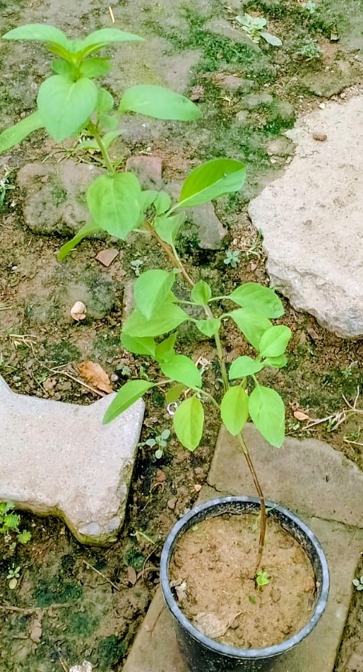
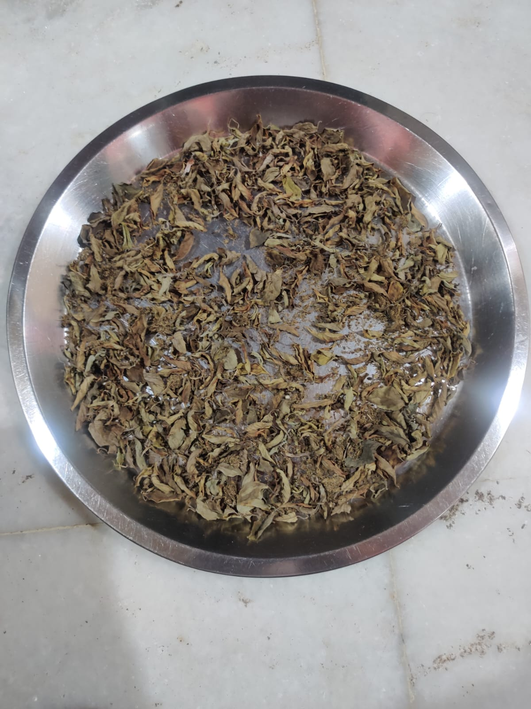
a. b
Picture - 1, a – Kapoor Tulsi Plant, b – shade dried leaves of test plant

Preparation of Ethanolic Leaf Extract
The extract was prepared using the maceration technique. Thirty grams of powdered leaf material was soaked in 100 mL of 95% ethanol in a conical flask and macerated at room temperature for 72 h with intermittent shaking. The macerated material was then filtered through Whatman No. 1 filter paper. The filtrate was concentrated by evaporation for 2–3 days until its volume was reduced by half, producing a dark-green concentrated ethanolic leaf extract. The extract was then standardised across several parameters to ensure batch-to-batch consistency and chemical reliability. Qualitative phytochemical screening, using biochemical tests and thin-layer chromatography, confirmed the presence of alkaloids, flavonoids, tannins, saponins, terpenoids, and phenolic compounds. The extract was stored in a refrigerator until further laboratory experiments. Working solutions containing 20%, 30%, 40%, and 50% (v/v) ethanolic leaf extract in distilled water were freshly prepared before each experiment.

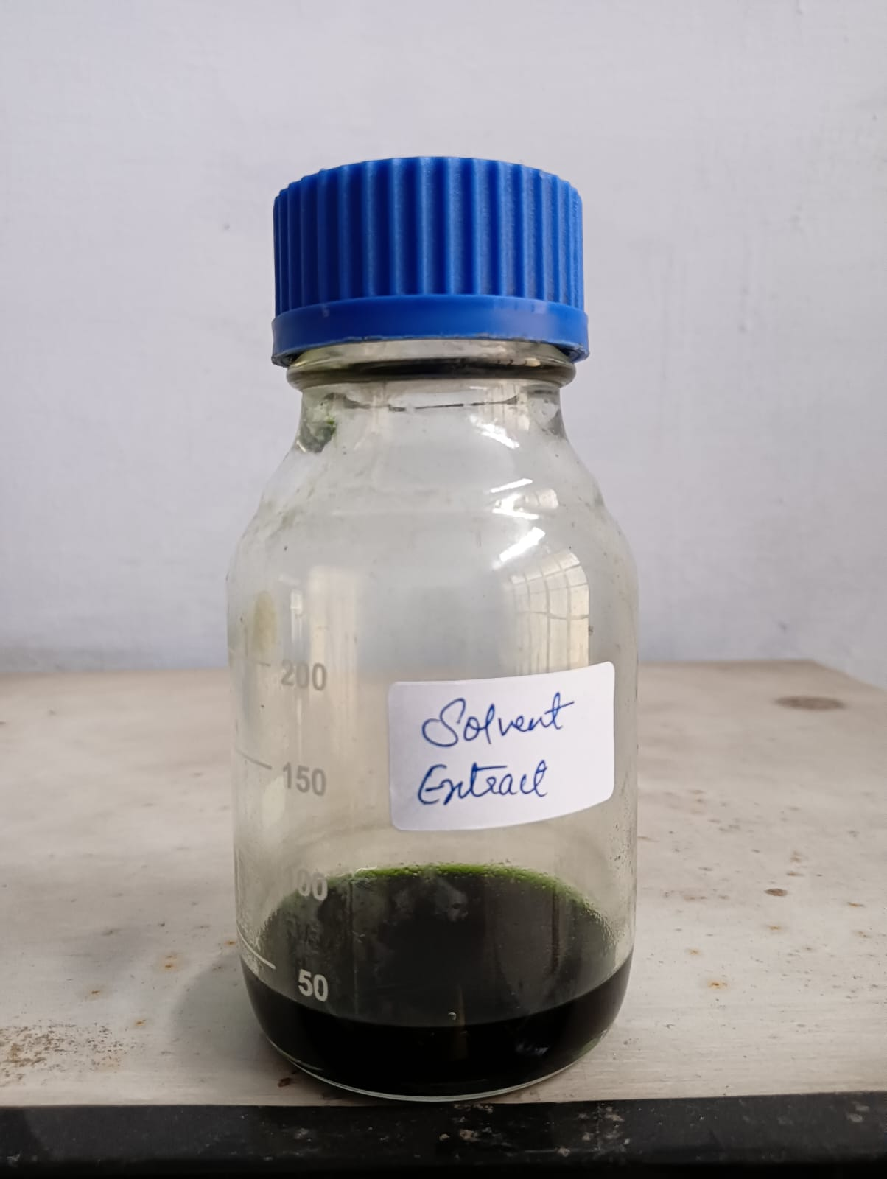
Picture = 2, Ethanolic leaf extract of Ocimum kilimandscharicum
Insect Culture
The laboratory culture of Sitophilus oryzae was established using naturally infested wheat grains. Adult weevils were reared in glass vials containing sterile wheat grains that had been sterilised by incubation at 100 °C. Adult weevils aged 3–5 days were used in the bioassays.
Bioassay Procedure
Each 100 mL glass jar containing 30 g of uncontaminated wheat grain served as an experimental unit. Each prepared extract solution was applied to obtain concentrations of 20%, 30%, 40%, and 50% (v/v). Treatments were applied using the thin-film residual method. The required volume of extract solution was pipetted into each glass jar, which was gently rotated and swirled by hand to coat its inner surface with a uniform thin film. The jars were then left open under ambient laboratory conditions for a short period to allow the ethanol carrier to evaporate, leaving a uniform residual film of the active extract on the glass surface before the addition of wheat and insects. After the jars had been coated with each concentration, 30 adult S. oryzae were introduced into each jar. Glass jars treated with an appropriate volume of pure ethanol served as controls. All treatments were replicated three times. The jars were maintained at 27 ± 2 °C and 65 ± 5% relative humidity. Adult mortality was recorded at 1, 3, 7, 14, and 21 days after treatment. Mortality was confirmed by the absence of a response to gentle prodding with a fine camel-hair brush. Abbott’s (1925) formula was used to correct treatment mortality for control mortality. The mean mortality across the three replicates was used for subsequent statistical analysis.

$$Corrected \% Mortality=\frac{T - C}{100-C}x 100$$
Where T = % mortality in treatment;
C = % mortality in control
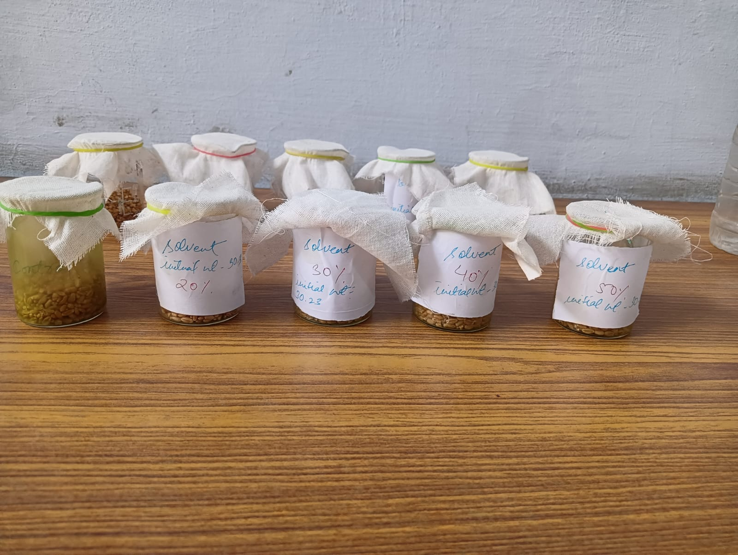
Picture – 3, Bioassay for mortality and weight loss with test extract treated wheat grains

Assessment of Weight Loss
Grain weight loss after 21 days of treatment was calculated as the difference between the initial and final weights of treated or untreated grain and was expressed as a percentage of the initial grain weight. The following equation was used:
$$\%WL=\frac{IW-FW}{IW} X 100$$
Where, WL = Weight Loss Index
IW= Initial weight
FW= Final weight
Statistical Analysis
All data were expressed as the mean ± standard deviation (SD) of three independent replicates. Statistical analysis was performed using one-way analysis of variance (ANOVA). When significant differences were detected, treatment means were compared using Tukey’s honestly significant difference (HSD) post hoc test at a significance threshold of p ≤ 0.05.
3. RESULTS
Effect of Ethanolic Leaf Extract of Ocimum kilimandscharicum on the Mortality of Sitophilus oryzae
At the tested concentrations and exposure periods, the ethanolic leaf extract of Ocimum kilimandscharicum showed a concentration- and time-dependent insecticidal effect against S. oryzae in stored wheat. Table 1 presents the corrected percentage mortality at each concentration and observation time, and Figure 1 illustrates the same data.

Table – 1, Effect of Ethanolic extract of Ocimum kilimandscharicum on the mortality of Sitophilus oryzae on wheat
S. no. | Day | Mean % mortality of Ethanolic extract (v/v %) |  |  |  | F value | P value
S. no. | Day | 20% | 30% | 40% | 50% | F value | P value
1 | 1 | 4.44±3.845ª | 8.883±3.850 ª | 33.33±6.67 ª | 15.55±10.183ª | 1.638 | 0.256
2 | 3 | 11.106±3.850 ª | 17.776±3.850^{ab} | 22.22±3.845^{b} | 22.22±3.845^{b} | 5.588 | 0.023
3 | 7 | 15.553±3.850 ª | 22.22±3.845 ª | 24.44±3.845ª | 37.776±3.850^{b} | 17.594 | 0.0007
4 | 14 | 26.66±0 ª | 28.883±3.850^{ab} | 35.553±3.850^{b} | 55.553±3.850^{c} | 46.632 | 0.00002
5 | 21 | 28.883±3.850 ª | 33.33±6.67 ª | 51.106±3.850^{b} | 57.776±3.850^{b} | 25.923 | 0.0002

Note: The values of % mortality after correction of control mortality represent the mean ± SD of triplet experiments. Statistical analysis through one way ANOVA at value p<0.05 followed by Tukey’s Post Hoc test with p≤0.05 was used. The means with different alphabets are significantly different with each other as indicated by Tukey’s Post Hoc test (row by row analysis) at alpha = 0.05.

Figure – 1, Effect of Ethanolic extract of Ocimum kilimandscharicum on the mortality of Sitophilus oryzae on wheat

Mortality Trends over Time
On Day 1, no significant differences were observed among the four concentrations (F = 1.638, p = 0.256). Mortality ranged from 4.44 ± 3.845% at 20% concentration to 33.33 ± 6.67% at 40% concentration. The relatively high standard deviations indicated substantial variability in insect susceptibility to the treatments. By Day 3, concentration had a significant effect on mortality (F = 5.588, p = 0.023), with mortality increasing from 11.106 ± 3.850% at 20% concentration to 22.22 ± 3.845% at both 40% and 50% concentrations. Tukey’s post hoc test indicated that the 40% concentration belonged to a different statistical group (b) from the 20% concentration (a), whereas the 30% concentration was intermediate (ab).
On Day 7, the effect of concentration became highly significant (F = 17.594, p = 0.0007), with 50% concentration producing 37.776 ± 3.850% mortality, significantly higher than the other treatments. This trend continued on Day 14, when 50% concentration produced the highest mortality of 55.553 ± 3.850% (group c), followed by 40% concentration (35.553 ± 3.850%, group b) and the 20% and 30% concentrations (groups a and ab, respectively). The one-way ANOVA yielded the highest F value in the experiment on Day 14 (F = 46.632, p = 0.00002), indicating the greatest separation among treatment groups. On Day 21, the 50% concentration again produced the highest mortality (57.776 ± 3.850%) and was statistically grouped with 40% concentration (51.106 ± 3.850%) as group b, whereas 20% and 30% concentrations formed group a, with mortalities of 28.883 ± 3.850% and 33.33 ± 6.67%, respectively. The ANOVA result for Day 21 was highly significant (F = 25.923, p = 0.0002), confirming sustained and progressive insecticidal activity.

Concentration–Response Relationship
From Day 7 onwards, a clear positive concentration–response relationship was observed: increasing the extract concentration from 20% to 50% increased mortality of S. oryzae. At Days 14 and 21, the 50% ethanolic extract was the most effective, producing mortality rates of 55.553% and 57.776%, respectively. However, none of the tested concentrations achieved complete (100%) mortality.

Weight Loss Assessment
Mortality increased progressively with extract concentration and exposure duration. This temporal mortality pattern was consistent with the pattern of wheat weight loss measured after 21 days (Table 2 and Figure 2). The untreated control showed the greatest weight loss (20.87 ± 0.331%), reflecting continued insect feeding and relatively low mortality. As extract concentration increased, weight loss decreased steadily and significantly (F = 146.529), reaching its minimum value of 10.59 ± 0.92% at 50% concentration. This pattern corresponded with the Day 21 mortality results, in which the highest mortality also occurred at 50% concentration (57.776%). The association suggests that grain protection may have resulted from both a reduction in the surviving insect population and possible suppression of feeding by the extract.
One-way ANOVA yielded a highly significant F value (146.529), indicating a significant treatment effect (p < 0.05). Tukey’s post hoc test showed significant differences among treatment means denoted by different letters (a, b, c, and d), except between the 30% and 40% treatments, which did not differ significantly. Thus, efficacy generally increased with concentration, although the improvement from 30% to 40% was smaller than that observed at 50%.
These results indicate that ethanolic leaf extract of O. kilimandscharicum may act as a natural protectant against S. oryzae infestation in wheat, with the highest tested concentration providing the greatest reduction in grain weight loss.

Table – 2, Effect of Ethanolic extract of Ocimum kilimandscharicum on the weight loss in wheat caused by Sitophilus oryzae after 21 days

S. no. | Mean % wt loss in control | Mean % wt loss in wheat with crude extract (v/v %) |  |  |  | F value
S. no. | Mean % wt loss in control | 20% | 30% | 40% | 50% | F value
1 | 20.87±0.331ª | 15.04±0.466^{b} | 12.93±0.347^{c} | 12.256±0.564^{c} | 10.59±0.92^{d} | 146.529

Note: The values of % weight loss in wheat represent the mean ± SD of triplet experiments. Statistical analysis through one way ANOVA at value p<0.05 followed by Tukey’s Post Hoc test with p≤0.05 was used. The means with different alphabets are significantly different with each other as indicated by Tukey’s Post Hoc test (row by row analysis) at alpha = 0.05.

Figure – 2, Effect of Ethanolic extract of Ocimum kilimandscharicum on the weight loss in wheat caused by Sitophilus oryzae after 21 days

4. DISCUSSION
The present results demonstrate insecticidal activity of O. kilimandscharicum leaf extract against S. oryzae in stored wheat. The dose- and time-dependent mortality observed across the treatments is consistent with the concentration–response relationships commonly reported for botanical insecticides (Isman, 2006). Insecticidal activity of Ocimum species against stored-grain insects has been reported by several investigators. Ogendo et al. (2008) demonstrated the bioactivity of O. gratissimum oil against several stored-product insect pests, whereas Bincy et al. (2023) reported fumigant and contact toxicity of O. basilicum essential oil against S. oryzae.
The comparatively low mortality at 20% concentration (28.883% on Day 21) relative to that at 50% concentration (57.776% on Day 21) may indicate that the toxic constituents of the ethanolic extract act within a concentration-dependent lethal range. The absence of a significant treatment effect on Day 1 (F = 1.638, p = 0.256) may reflect a delay in the uptake or action of toxic constituents. The increasing F values from Day 3 to Day 14 (5.588, 17.594, and 46.632), followed by a value of 25.923 on Day 21, reflect increasing separation among treatment responses over time.
Bioactive compounds reported in O. kilimandscharicum and associated with insecticidal activity include camphor, 1,8-cineole, linalool, eugenol, and phenolic compounds such as rosmarinic acid. Camphor, a major monoterpenoid of O. kilimandscharicum, has demonstrated toxic and protective activity against stored-product beetles (Obeng-Ofori et al., 1998). In addition, 1,8-cineole has been reported to have fumigant and contact insecticidal activity against stored-product Coleoptera (Tripathi et al., 2009). The combined action of these phytochemicals may contribute to the prolonged insecticidal activity observed through Day 21.
Ethanol can extract phytochemicals across a broad polarity range, including alkaloids, flavonoids, terpenoids, tannins, and saponins, which may have contributed to the insecticidal activity observed in the present study (Harborne, 1973). Such a multicomponent mode of action may offer an advantage over single-molecule synthetic insecticides by potentially reducing selection pressure for resistance. Nevertheless, the incomplete mortality observed even at 50% concentration after 21 days indicates the need to evaluate higher concentrations or formulation approaches such as microencapsulation (Isman & Grieneisen, 2014).
An acetylcholinesterase (AChE)-mediated mode of action for camphor and 1,8-cineole remains uncertain. AChE inhibition has been investigated as a possible mechanism by which monoterpenoids cause mortality in S. oryzae, Rhyzopertha dominica, and Cryptolestes pusillus (Abdelgaleil et al., 2009; López & Pascual-Villalobos, 2010). Evidence specific to constituents of O. kilimandscharicum indicates that camphor-treated grain can inhibit the development of eggs and immature stages within kernels and can strongly repel adult beetles (Obeng-Ofori et al., 1998).
Synergistic interactions among constituents of O. kilimandscharicum essential oil have also been demonstrated experimentally. Bekele and Hassanali (2001) reported that blends of essential-oil constituents from O. kilimandscharicum and O. kenyense affected their combined toxicity against two post-harvest insect pests. The increasing potency of the ethanolic whole-leaf extract observed in the present study may therefore reflect interactions among multiple constituents, including camphor and 1,8-cineole, rather than the activity of a single compound.
Regarding grain protection, the 20.87% weight loss recorded in the untreated control after 21 days is consistent with substantial feeding damage caused by uncontrolled S. oryzae. The concentration-dependent reduction to 10.59% at 50% (v/v) is also consistent with reports that phytochemicals can protect stored grains from insect damage and may provide alternatives to synthetic grain protectants (Rajashekar et al., 2012; Lakshmi Soujanya et al., 2016).
Gupta and Gupta (2025) reported insecticidal activity of Catharanthus roseus leaf powder against S. oryzae and a reduction in rice-grain weight loss at concentrations of 1%, 1.5%, 2%, and 2.5%. Their findings also support the potential use of plant-derived materials in environmentally compatible stored-grain pest management.
Sharma and Gupta (2026) evaluated Citrus reticulata peel powder as a botanical protectant for stored maize against S. oryzae. Shade-dried peel powder was incorporated into sterilised maize at 1%, 1.5%, 2%, and 2.5%. Insect mortality increased with concentration and exposure duration, indicating that citrus peel powder may have potential as an alternative to chemical pesticides for managing stored-product pests.
The corresponding patterns of increased mortality and reduced weight loss suggest that O. kilimandscharicum ethanolic extract, particularly at 40–50% (v/v), may protect grain through both delayed insect mortality and possible antifeedant or repellent effects.
Taken together, the findings indicate that ethanolic leaf extract of O. kilimandscharicum has both insecticidal and grain-protective activity under the laboratory conditions of this study, consistent with previous research on the bioactivity of this plant. Jembere et al. (1995) reported that dried ground leaves and essential oil of O. kilimandscharicum caused 100% mortality in related stored-grain pests within 48 h and reduced progeny survival in treated grain. Camphor, a major terpenoid of O. kilimandscharicum, has also shown toxic and protective properties against several stored-product beetle species (Obeng-Ofori et al., 1998), suggesting that it may contribute to the mortality and reduction in grain damage observed in the present study.
5. CONCLUSION
The findings demonstrate that ethanolic leaf extract of Ocimum kilimandscharicum has measurable insecticidal and grain-protective activity against adult Sitophilus oryzae under the laboratory conditions evaluated. Mortality generally increased with both extract concentration and exposure duration, reaching 57.776 ± 3.850% at 50% (v/v) after 21 days. Over the same period, wheat grain weight loss declined from 20.87 ± 0.331% in the control to 10.59 ± 0.92% at the highest concentration. The parallel increase in mortality and reduction in grain loss suggest that the extract may limit damage through insect mortality and possible suppression of feeding. Nevertheless, none of the tested concentrations achieved complete mortality, and the results do not establish suitability for routine storage use. The extract should therefore be regarded as a promising laboratory-stage botanical protectant rather than a ready-to-use treatment. Further studies should standardise the applied dose, characterise the active constituents, estimate lethal concentrations, and evaluate grain quality, residues, non-target safety, formulation stability, and performance under semi-field and storage conditions.

Limitations
The study was limited to a laboratory bioassay with three replicates, adult S. oryzae, four extract concentrations, and a 21-day observation period. The applied extract volume per jar was not reported, and the chemical composition and concentration of active constituents were not quantified. Behavioural effects, progeny suppression, grain germination, residue safety, non-target effects, formulation stability, and efficacy under semi-field or storage conditions were not assessed. These constraints limit dose reproducibility and generalisability. Future studies should use chemically standardised extracts, larger replicated trials, longer storage periods, and safety and grain-quality evaluations.

CONSENT
It is not applicable.
ETHICALAPPROVAL
It is not applicable.

Declaration of AI Use

This manuscript was prepared through the combined contributions of all author(s), including contributions to the study design, data, content development, results, interpretation, and related scholarly work. The author(s) acknowledge the use of Grammarly and ChatGPT to assist with grammar checking, language refinement, reference formatting. These AI-assisted tools were not used as authors and did not replace the intellectual contributions or scholarly judgment of the author(s). All AI-assisted outputs, including content, references, and interpretations, were carefully reviewed, revised, verified, and approved by the author(s). The author(s) accept full responsibility for the accuracy, integrity, and final content of the manuscript.

COMPETING INTERESTS:
Authors have declared that they have no known competing financial interests OR non-financial interests OR personal relationships that could have appeared to influence the work reported in this paper.

REFERENCES
Abbott, W. S. (1925). A method of computing the effectiveness of an insecticide. Journal of Economic Entomology, 18(2), 265–267. https://doi.org/10.1093/jee/18.2.265a
Abdelgaleil, S. A. M., Mohamed, M. I. E., Badawy, M. E. I., & El-Arami, S. A. A. (2009). Fumigant and contact toxicities of monoterpenes to Sitophilus oryzae (L.) and Tribolium castaneum (Herbst) and their inhibitory effects on acetylcholinesterase activity. Journal of Chemical Ecology, 35(5), 518–525. https://doi.org/10.1007/s10886-009-9635-3
Bakkali, F., Averbeck, S., Averbeck, D., & Idaomar, M. (2008). Biological effects of essential oils—A review. Food and Chemical Toxicology, 46(2), 446–475. https://doi.org/10.1016/j.fct.2007.09.106
Bekele, J., & Hassanali, A. (2001). Blend effects in the toxicity of the essential oil constituents of Ocimum kilimandscharicum and Ocimum kenyense (Labiatae) on two post-harvest insect pests. Phytochemistry, 57(3), 385–391. https://doi.org/10.1016/S0031-9422(01)00067-X
Bincy, K., Remesh, A. V., Prabhakar, P. R., & Vivek Babu, C. S. (2023). Chemical composition and insecticidal activity of Ocimum basilicum (Lamiaceae) essential oil and its major constituent, estragole against Sitophilus oryzae (Coleoptera: Curculionidae). Journal of Plant Diseases and Protection, 130, 529–541. https://doi.org/10.1007/s41348-022-00695-4
Gupta, J., & Gupta, S. (2025). Insecticidal efficacy of Catharanthus roseus leaf extract against Sitophilus oryzae in stored rice grain. Uttar Pradesh Journal of Zoology, 46(22), 127–134. https://doi.org/10.56557/upjoz/2025/v46i225366
Harborne, J. B. (1973). Phytochemical methods: A guide to modern techniques of plant analysis. Chapman & Hall.
Isman, M. B. (2006). Botanical insecticides, deterrents, and repellents in modern agriculture and an increasingly regulated world. Annual Review of Entomology, 51, 45–66. https://doi.org/10.1146/annurev.ento.51.110104.151146
Isman, M. B., & Grieneisen, M. L. (2014). Botanical insecticide research: Many publications, limited useful data. Trends in Plant Science, 19(3), 140–145. https://doi.org/10.1016/j.tplants.2013.11.005
Jembere, B., Obeng-Ofori, D., Hassanali, A., & Nyamasyo, G. N. N. (1995). Products derived from the leaves of Ocimum kilimandscharicum (Labiatae) as post-harvest grain protectants against the infestation of three major stored product insect pests. Bulletin of Entomological Research, 85(3), 361–367. https://doi.org/10.1017/S0007485300036099
Khan, T., Shahid, A. A., & Khan, H. A. A. (2016). Could biorational insecticides be used in the management of aflatoxigenic Aspergillus parasiticus and its insect vectors in stored wheat? PeerJ, 4, e1665. https://doi.org/10.7717/peerj.1665
Lakshmi Soujanya, P., Sekhar, J. C., Kumar, P., Sunil, N., Vara Prasad, C., & Mallavadhani, U. V. (2016). Potentiality of botanical agents for the management of post harvest insects of maize: A review. Journal of Food Science and Technology, 53(5), 2169–2184. https://doi.org/10.1007/s13197-015-2161-0
López, M. D., & Pascual-Villalobos, M. J. (2010). Mode of inhibition of acetylcholinesterase by monoterpenoids and implications for pest control. Industrial Crops and Products, 31(2), 284–288. https://doi.org/10.1016/j.indcrop.2009.11.005
Mohammad, M. Y., Haniffa, H. M., Shakya, A. K., Naik, R. R., & Sivaranjan, T. (2024). Evaluation of five medicinal plants for the management of Sitophilus oryzae in stored rice and identification of insecticidal compound. Heliyon, 10(10), e30793. https://doi.org/10.1016/j.heliyon.2024.e30793
Mojarab-Mahboubkar, M., Afrazeh, Z., Azizi, R., & Jalali Sendi, J. (2023). Efficiency of Artemisia annua L. essential oil and its chitosan/tripolyphosphate or zeolite encapsulated form in controlling Sitophilus oryzae L. Pesticide Biochemistry and Physiology, 195, 105544. https://doi.org/10.1016/j.pestbp.2023.105544
Nagpal, K., Jasrotia, P., Jaglan, M. S., Kashyap, P. L., Maanju, S., & Kumar, S. (2025). Molecular detection tool for prompt, reliable and precise diagnosis of the rice weevil, Sitophilus oryzae (Linnaeus) infestation in wheat. Frontiers in Plant Science, 16, 1628692. https://doi.org/10.3389/fpls.2025.1628692
Obeng-Ofori, D., Reichmuth, C. H., Bekele, A. J., & Hassanali, A. (1998). Toxicity and protectant potential of camphor, a major component of essential oil of Ocimum kilimandscharicum, against four stored product beetles. International Journal of Pest Management, 44(4), 203–209. https://doi.org/10.1080/096708798228112
Ogendo, J. O., Kostyukovsky, M., Ravid, U., Matasyoh, J. C., Deng, A. L., Omolo, E. O., Kariuki, S. T., & Shaaya, E. (2008). Bioactivity of Ocimum gratissimum L. oil and two of its constituents against five insect pests attacking stored food products. Journal of Stored Products Research, 44(4), 328–334. https://doi.org/10.1016/j.jspr.2008.02.009
Patole, R. P., Reddy, J. P., Murthy, P. S. K., & Babu, C. S. V. (2024). Insecticidal property of Ocimum essential oil embedded polylactic acid packaging films for control of Sitophilus oryzae and Callosobruchus chinensis. International Journal of Biological Macromolecules, 256(Pt 2), 128298. https://doi.org/10.1016/j.ijbiomac.2023.128298
Rajarushi, C. N., Nebapure, S. M., Biswas, A., Rajna, S., & Subramanian, S. (2024). Contact toxicity of insecticides against rice weevil, Sitophilus oryzae L. and its effect on progeny production. Scientific Reports, 14, 28404. https://doi.org/10.1038/s41598-024-80157-z
Rajashekar, Y., Bakthavatsalam, N., & Shivanandappa, T. (2012). Botanicals as grain protectants. Psyche: A Journal of Entomology, 2012, Article 646740. https://doi.org/10.1155/2012/646740
Sharma, P., & Gupta, S. (2026). Assessment of Citrus reticulata powder extract on the control of Sitophilus oryzae in stored maize grains. Uttar Pradesh Journal of Zoology, 47(2), 52–60. https://doi.org/10.56557/upjoz/2026/v47i25461
Sheikh, M. A., Yaqoob, M., Wani, F. J., Bhat, T. A., Gani, M., & Bhat, M. A. (2024). Insecticidal activity of different doses of Acorus calamus essential oil against Sitophilus oryzae. Journal of Scientific Research and Reports, 30(6), 666–670. https://doi.org/10.9734/jsrr/2024/v30i62084
Tripathi, A. K., Upadhyay, S., Bhuiyan, M., & Bhattacharya, P. R. (2009). A review on prospects of essential oils as biopesticide in insect-pest management. Journal of Pharmacognosy and Phytotherapy, 1(5), 52–63. https://academicjournals.org/app/webroot/article/article1379417589_Tripathi%20et%20al.pdf

