Original Research Article

Diversity, distribution and conservation status of freshwater fishes of Andaman and Nicobar Islands

ABSTRACT
The present study investigated the species diversity, distribution patterns and conservation status of the freshwater fish fauna of the Andaman and Nicobar Islands. Sampling was conducted from October 2022 to August 2024 across six islands, and specimens were captured using cast nets and hand nets. A total of 3,552 specimens, comprising 46 fish species belonging to 13 orders, 19 families and 33 genera, were recorded. Gobiiformes showed the highest species richness (41%), followed by Cypriniformes (13%), Anabantiformes (11%) and Cyprinodontiformes (7%). Among the families, Oxudercidae had the greatest species richness, with six species. Of the 46 species, one was categorised as Endangered (Clarias magur), two as Vulnerable (Microphis insularis and Oreochromis mossambicus), and one as Near Threatened (Anguilla bicolor). Three exotic species were also recorded, of which Oreochromis mossambicus was the most abundant. The inventory documented five new distributional records from freshwater bodies of the Andaman and Nicobar Islands: Chanda ranga (Hamilton, 1822), Labeo bata (Hamilton, 1822), Poecilia reticulata Peters, 1859, Oreochromis niloticus (Peters, 1852) and Oryzias dancena (Hamilton, 1822) (Adrianichthyidae).
Keywords: Freshwater ichthyofauna; island biodiversity; species richness; fish distribution; conservation status; endemic fishes; introduced fishes; Andaman Islands; Nicobar Islands; freshwater habitats

INTRODUCTION
Freshwater ecosystems, including lakes, swamps, marshes, temporary pools, rivers, streams, and other wetland environments, constitute some of the most biologically diverse and ecologically productive habitats on Earth (Nelson et al., 2016).
Fishes are the most diverse vertebrate group and occupy aquatic habitats such as oceans, rivers, lakes, canals, reservoirs and estuaries. The Catalog of Fishes enumerates 37,424 valid fish species worldwide, of which 19,138 occur in freshwater (Fricke et al., 2025). India has rich freshwater fish diversity, with numerous rivers, lakes, ponds and reservoirs supporting a wide variety of species. Freshwater fishes play important roles in food security, livelihoods and ecological balance. A total of 3,919 fish species belonging to 1,207 genera, 286 families and 57 orders have been recorded from India; of these, 1,075 occur in freshwater (Kosygin et al., 2025). The Andaman and Nicobar Islands, situated in the Bay of Bengal between 6°45′–13°45′N and 92°10′–94°15′E, comprise 836 islands. The archipelago comprises two groups: the Andaman Islands in the north and the Nicobar Islands in the south. A total of 1,584 fish species occur in the Andaman and Nicobar Islands (Kosygin et al., 2025). However, reports on freshwater fishes from both island groups remain very limited. Annandale and Hora (1925) recorded five species from freshwater streams, including the pipefish Doryichthys insularis, which was reported as endemic to the Andaman Islands. Mukerji (1935) recorded five species, including descriptions of two new gobiid species, namely Raogobius andamanicus and Vaimosa koumansi, from rocky or muddy streams. Herre (1939) recorded 22 primary freshwater and diadromous fish species from freshwater streams of the Andaman Islands and described Eleotris andamensis as endemic to the islands. Koumans (1940) recorded eight species from freshwater streams, including two eleotrid and six gobiid species. Sen (1975) recorded 19 species from the inland water bodies of the Andaman Islands. Palavai and Davidar (2009) recorded 33 species from South, Middle and North Andaman, comprising 11 freshwater and 17 diadromous species. Rajan and Sreeraj (2013) recorded 23 species from the freshwater streams of Mount Harriet, South Andaman. Rajan and Sreeraj (2014) recorded two eleotrids from the Andaman Islands. Praveenraj et al. (2017) recorded Redigobius oyensi (de Beaufort, 1913) from Car Nicobar Island, and Katwate et al. (2018) validated the status of Aplocheilus andamanicus from the Andaman Islands. Rajan et al. (2018) reported 24 freshwater fishes from the Andaman and Nicobar Islands. Bineesh et al. (2018) compiled available data and recorded 34 freshwater fish species from the Andaman and Nicobar Islands. More recently, Das and Sivaperuman (2023) reported one freshwater fish species from Great Nicobar Island, while three fish species were reported from the Andaman group of islands (Das & Sivaperuman, 2024, 2025).
Recent freshwater fish assessments have used locality-based inventories and conservation-status evaluations to characterise assemblage composition and support biodiversity monitoring (Paunikar, 2026; Talmale & Bansod, 2026). Studies from coastal wetlands and tropical islands also demonstrate the value of spatially explicit assemblage data for monitoring fish diversity across heterogeneous and geographically isolated freshwater systems (Chanu et al., 2024; Teichert et al., 2025; Jannel et al., 2026).
Several streams, nallahs and rivers occur across these island groups. Most previous reports concern the Andaman group of islands, whereas information from the Nicobar group remains limited. Therefore, the present study aimed to assess the diversity, distribution and conservation status of freshwater fish fauna across the Andaman and Nicobar Islands.

MATERIALS AND METHODS
Study area
The study was conducted from October 2022 to August 2024 in the Andaman and Nicobar Islands (Figure 1). Sampling localities were selected on the basis of water availability and accessibility during the post-monsoon season. The geographical coordinates of each sampling point were recorded during the survey. The study covered nallahs, streams, ponds and rivers in the Andaman group of islands (Middle Andaman, North Andaman, South Andaman and Little Andaman) and the Nicobar group of islands (Great Nicobar and Nancowry).

Fish sampling and identification
Fish sampling was conducted at nine locations on each of the six islands—Middle Andaman, North Andaman, South Andaman, Little Andaman, Great Nicobar and Nancowry—from October 2022 to August 2024. Fish specimens were collected using cast nets of different mesh sizes (1.2–2.6 cm) and hand nets. The collected specimens were photographed alive and fresh in the field and were then preserved in 10% formaldehyde solution. Fishes were identified to species level using the diagnostic characters provided by Talwar and Jhingran (1991), Menon (1999) and Jayaram (1999). Current nomenclature followed FishBase (Froese & Pauly, 2025) and the Catalog of Fishes (Fricke et al., 2025). The conservation status of each specimen identified to species level was determined using the IUCN Red List database (International Union for Conservation of Nature [IUCN], 2026). Identified specimens were labelled with collection data and species names and deposited in the National Zoological Collections of the Andaman and Nicobar Regional Centre, Zoological Survey of India, Port Blair.

RESULTS AND DISCUSSION
Abundance
A total of 3,552 fish specimens representing 46 species were recorded from freshwater habitats on six islands between October 2022 and August 2024. These species belonged to 13 orders, 19 families and 33 genera, indicating considerable fish diversity in the study area. The systematic position, distribution and conservation status of the recorded species are presented in Table 1. Among the recorded orders, Gobiiformes was the most species-rich, with 19 species (41%), followed by Cypriniformes with six species (13%), Anabantiformes with five species (11%) and Cyprinodontiformes with three species (7%). Perciformes, Siluriformes, Centrarchiformes and Cichliformes were each represented by two species, whereas Anguilliformes, Osteoglossiformes, Elopiformes, Syngnathiformes and Beloniformes were each represented by one species (Figure 2). Oxudercidae was the most species-rich family, with six species, followed by Gobiidae and Eleotridae, with five species each. Butidae, Channidae, Danionidae, Cyprinidae and Aplocheilidae each contributed three species. Anguillidae, Kuhliidae and Cichlidae each comprised two species, while the remaining families were represented by one species each (Figure 3). The inventory documented five species as first records from freshwater bodies of the Andaman and Nicobar Islands: Chanda ranga (Hamilton, 1822) (Ambassidae), Labeo bata (Hamilton, 1822) (Cyprinidae), Poecilia reticulata Peters, 1859 (Aplocheilidae), Oreochromis niloticus (Peters, 1852) (Cichlidae) and Oryzias dancena (Hamilton, 1822) (Adrianichthyidae).
Conservation status
According to the IUCN Red List of Threatened Species, 37 species were assessed as Least Concern (81%), one as Near Threatened (2%), two as Vulnerable (4%), one as Endangered (2%) and two as Data Deficient (4%); three species (7%) had not been evaluated (Figure 4). Four recorded species were identified as being of conservation concern: one Endangered species, Clarias magur Hamilton, 1822; two Vulnerable species, Microphis insularis (Hora, 1925) and Oreochromis mossambicus Trewavas, 1983; and one Near Threatened species, Anguilla bicolor McClelland, 1844. Three Data Deficient species—Awaous melanocephalus (Bleeker, 1849), Stenogobius gymnopomus (Bleeker, 1837) and Megalops cyprinoides (Broussonet, 1782)—were recorded during the study period. Of the 46 recorded species, four were identified as endemic: Aplocheilus andamanicus (Köhler, 1906), Sicyopterus garra Hora, 1925, Eleotris fusca (Hamilton, 1822) and Microphis insularis (Hora, 1925). The distribution of the 46 species across the Andaman and Nicobar Islands is presented in Table 1.
The recorded fishes represented 19 families. Glossogobius giuris was the most widely distributed goby and was recorded at all sampling sites in both island groups. Eleotridae was represented by five species, of which Giuris margaritaceus and Eleotris fusca were the most common and occurred at all sampling sites. Butidae was represented by three species, and Ophiocara porocephala was recorded at most sampling sites in both island groups. Other common fishes included Rasbora daniconius, Aplocheilus panchax, Heteropneustes fossilis, Awaous grammepomus and Butis butis. Three gobies—Redigobius tambujon, Redigobius bikolanus and Redigobius oyensi—were recorded rarely and only from Great Nicobar Island, while Chanda ranga, Stenogobius gymnopomus and Microphis insularis were very rarely recorded. Among the non-native species, Oreochromis mossambicus was common in nallahs and streams in both the Andaman and Nicobar island groups. Palavai and Davidar (2009) recorded 33 species from South, Middle and North Andaman, including brackish-water and marine fishes. Rajan et al. (2018) recorded 24 fish species, including 12 native freshwater species and two endemic species. In comparison, the present study recorded 46 species, including four endemic species, from the Andaman and Nicobar island groups. The findings indicate that additional distributional records may be obtained from jungle streams passing through protected tribal forest reserves.

Conclusions
The survey recorded 46 fish species from freshwater habitats across six Andaman and Nicobar Islands, demonstrating substantial taxonomic and distributional variation among the sampled islands. Gobiiformes contributed the largest proportion of recorded species, while several species showed restricted island-level occurrence. The inventory included endemic, conservation-priority and introduced fishes, emphasising the ecological and management importance of the archipelago’s streams, rivers, ponds and nallahs. The records provide a useful baseline for future biodiversity monitoring. Nevertheless, the claimed new distributional records and endemicity assignments require voucher-based taxonomic verification. Continued standardised surveys, habitat assessments and monitoring of introduced species are required to clarify distribution patterns and support the conservation of native freshwater fish communities. Environmental change, habitat destruction and overexploitation may adversely affect freshwater fish populations. The present study provides a basis for future biodiversity monitoring, taxonomic research and island ecosystem management.

Limitations
Sampling was limited to accessible freshwater habitats on six islands and may not represent the entire Andaman and Nicobar archipelago. Differences in habitat size, seasonal conditions and sampling effort among sites were not quantified, limiting comparisons between islands. Species abundance, detection probability and standard diversity indices were not assessed. The inclusion of diadromous and euryhaline fishes may also influence interpretation of freshwater assemblage composition. Furthermore, molecular identification was not undertaken. Future studies should use standardised, seasonally replicated sampling across additional islands and integrate habitat measurements, voucher verification and molecular methods.

Declaration of AI Use

This manuscript was prepared through the combined contributions of all author(s), including contributions to the study design, data, content development, results, interpretation, and related scholarly work. The author(s) acknowledge the use of Grammarly and ChatGPT to assist with grammar checking, language refinement, reference formatting. These AI-assisted tools were not used as authors and did not replace the intellectual contributions or scholarly judgment of the author(s). All AI-assisted outputs, including content, references, and interpretations, were carefully reviewed, revised, verified, and approved by the author(s). The author(s) accept full responsibility for the accuracy, integrity, and final content of the manuscript.

COMPETING INTERESTS:
Authors have declared that they have no known competing financial interests OR non-financial interests OR personal relationships that could have appeared to influence the work reported in this paper.

REFERENCES
Annandale, N., & Hora, S. L. (1925). The freshwater fish from the Andaman Islands. Records of the Indian Museum, 27(2), 33–41. https://doi.org/10.26515/rzsi/v27/i2/1925/163457
Bineesh, K. K., Mishra, S. S., & Gopi, K. C. (2018). Freshwater fishes. In K. Chandra & C. Raghunathan (Eds.), Faunal diversity of biogeographic zones: Islands of India (pp. 473–476). Zoological Survey of India. https://zsi.gov.in/rc-publications/en?rc=52
Chanu, T. N., Gogoi, P., Koushlesh, S. K., Jana, C., Nair, S. M., Das, S. K., Sinha, A., Devi, H. M., & Das, B. K. (2024). Revealing the temporal dynamics of fish assemblage pattern, feeding guilds in relation to habitat quality parameters in a coastal wetland of the Indian Sundarban eco-region. Environmental Monitoring and Assessment, 196, 1094. https://doi.org/10.1007/s10661-024-13249-y
Das, M. K., & Sivaperuman, C. (2023). First record of snakehead gudgeon Giuris tolsoni (Bleeker, 1854) (Gobiiformes: Eleotridae) from Indian waters. Biological Forum – An International Journal, 15(8), 305–309. https://www.researchtrend.net/bfij/first-record-of-snakehead-gudgeon-giuris-tolsoni-bleeker-1854-gobiiformes-eleotridae-from-indian-waters-7170
Das, M. K., & Sivaperuman, C. (2024). First record of the olive barb Systomus sarana (Hamilton, 1822) (Cyprinidae: Smiliogastrinae) from Andaman and Nicobar Islands, India. Records of the Zoological Survey of India, 124(2), 153–157. https://researcharchive.calacademy.org/research/ichthyology/catalog/getref.asp?id=41718
Das, M. K., & Sivaperuman, C. (2025). First record of two freshwater fishes, Trichogaster fasciata Bloch and Schneider, 1801 (Anabantiformes: Osphronemidae) and Notopterus notopterus (Pallas, 1769) (Osteoglossiformes: Notopteridae) from Andaman Islands, India. Records of the Zoological Survey of India, 125(2), 193–199. https://doi.org/10.26515/rzsi/v125/i2/2025/172879
Fricke, R., Eschmeyer, W. N., & Van der Laan, R. (Eds.). (2025). Eschmeyer’s Catalog of Fishes: Genera, species, references. California Academy of Sciences. Retrieved January 24, 2026, from https://researcharchive.calacademy.org/research/ichthyology/catalog/fishcatmain.asp
Froese, R., & Pauly, D. (Eds.). (2025). FishBase. Retrieved February 1, 2026, from https://www.fishbase.se
Herre, A. W. C. T. (1939). On a collection of littoral and freshwater fishes from the Andaman Islands. Records of the Indian Museum, 41(4), 327–372. https://zsi.gov.in/PDFVolumes/records/041/04/0327-0372.pdf
International Union for Conservation of Nature. (2026). The IUCN Red List of Threatened Species. Retrieved January 23, 2026, from https://www.iucnredlist.org
Jannel, L.-A., Jourand, P., Chabanet, P., & Valade, P. (2026). Taxonomic and functional differentiation of freshwater fish communities in Western Indian Ocean islands: Implications for eDNA-based biomonitoring. Aquatic Ecology, 60, 13. https://doi.org/10.1007/s10452-025-10252-4
Jayaram, K. C. (1999). The freshwater fishes of the Indian region. Narendra Publishing House. https://mulibrary.manipuruniv.ac.in/cgi-bin/koha/opac-detail.pl?biblionumber=41062
Katwate, U., Kumkar, P., Britz, R., Raghavan, R., & Dahanukar, N. (2018). The identity of Aplocheilus andamanicus (Köhler, 1906) (Teleostei: Cyprinodontiformes), an endemic killifish from the Andaman Islands, with notes on Odontopsis armata van Hasselt. Zootaxa, 4382(1), 159–174. https://doi.org/10.11646/zootaxa.4382.1.6
Kosygin, L., Mohapatra, A., Bineesh, K. K., Sharma, I., Jadhav, S. S., Khynriam, D., & Mishra, S. S. (2025). Checklist of fauna of India: Pisces (Version 2.0). Zoological Survey of India. https://doi.org/10.26515/Fauna/2/2025/Chordata:Pisces
Koumans, F. P. (1940). On the collection of gobioid fishes from Andamans. Records of the Indian Museum, 42, 15–18. https://zsi.gov.in/PDFVolumes/records/042/01/0015-0018.pdf
Menon, A. G. K. (1999). Check list—Fresh water fishes of India (Occasional Paper No. 175). Zoological Survey of India. https://archive.org/details/dli.zoological.occpapers.175
Mukerji, D. D. (1935). Notes on some rare and interesting fishes from the Andaman Islands, with descriptions of two new freshwater gobies. Records of the Indian Museum, 37(3), 259–277. https://zsi.gov.in/PDFVolumes/records/037/03/0259-0277.pdf
Nelson, J. S., Grande, T. C., & Wilson, M. V. H. (2016). Fishes of the world (5th ed.). Wiley. https://doi.org/10.1002/9781119174844
Palavai, V., & Davidar, P. (2009). A survey of freshwater fishes of Andaman Islands. Journal of the Bombay Natural History Society, 106(1), 11–14. https://www.biodiversitylibrary.org/part/154912
Paunikar, S. (2026). Exploring freshwater fish diversity from Kuno River, Sheopur District of Madhya Pradesh, Central India. Asian Journal of Fisheries and Aquatic Research, 28(8), 125–137. https://doi.org/10.9734/ajfar/2026/v28i81129
Praveenraj, J., Kiruba-Sankar, R., Kumar, L., Angel, J. R. J., & Roy, S. D. (2017). A first report of Redigobius oyensi (de Beaufort, 1913) (Teleostei: Gobionellinae) from Car Nicobar Island, India. Journal of Threatened Taxa, 9(10), 10853–10855. https://doi.org/10.11609/jott.3702.9.10.10853-10855
Rajan, P. T., & Sreeraj, C. R. (2013). Diversity, distribution and conservation of freshwater fishes in Mount Harriet National Park, Andaman and Nicobar Islands. Records of the Zoological Survey of India, 113(4), 35–55. https://recordsofzsi.com/index.php/zsoi/article/view/121732
Rajan, P. T., & Sreeraj, C. R. (2014). New record of two species of Belobranchus (Teleostei: Gobioidei: Eleotridae) from Andaman Islands. Records of the Zoological Survey of India, 114(1), 185–188. https://zsi.gov.in/PDFVolumes/records/114/01/0185-0188.pdf
Rajan, P. T., Vijay, P., & Praveenraj, J. (2018). Diversity, distribution and conservation of freshwater fishes in Andaman and Nicobar Islands. In C. Sivaperuman & K. Venkataraman (Eds.), Indian hotspots: Vertebrate faunal diversity, conservation and management (pp. 127–137). Springer. https://doi.org/10.1007/978-981-10-6605-4_6
Sen, T. K. (1975). Further light on freshwater fish fauna of Andaman Islands. Sea Food Export Journal, 7(2), 31–33. https://scholar.google.com/scholar?q=%22Further+light+on+freshwater+fish+fauna+of+Andaman+Islands%22
Talmale, A. D., & Bansod, D. S. (2026). Diversity, threats, and conservation of catfishes (Siluriformes) at the Wainganga–Chulbandh River confluence, Soni-Chapral, Maharashtra, India. Journal of Biology and Nature, 18(2), 257–269. https://doi.org/10.56557/joban/2026/v18i210863
Talwar, P. K., & Jhingran, A. G. (1991). Inland fishes of India and adjacent countries (Vols. 1–2). Oxford & IBH Publishing. https://catalogue.nla.gov.au/catalog/1719925
Teichert, N., Lagarde, R., Faivre, L., Valade, P., Grondin, H., Labeille, M., Keith, P., & Feunteun, E. (2025). Fish and macro-crustacean assemblages are relevant ecological indicators for monitoring rivers of tropical islands. Ecological Indicators, 175, 113585. https://doi.org/10.1016/j.ecolind.2025.113585

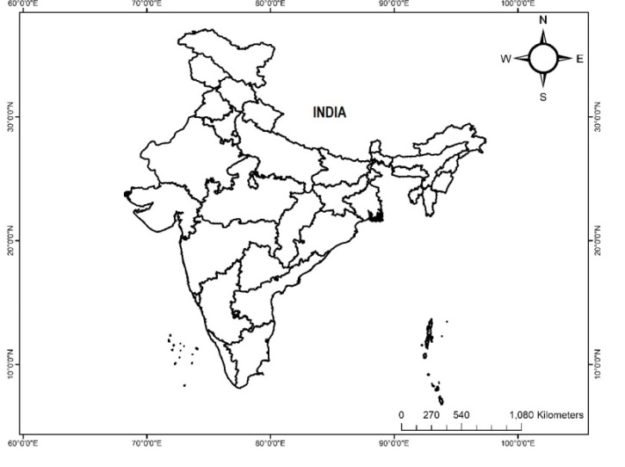

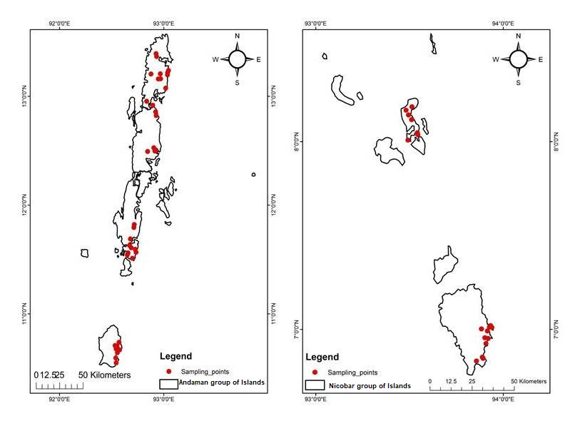
Figure 1. Map of the study area in the Andaman and Nicobar Islands. Red circles indicate the sampling sites.

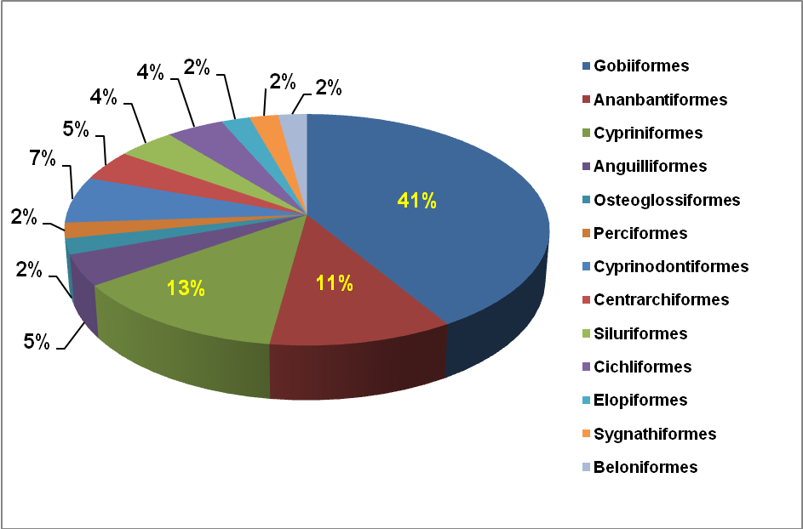
Figure 2. Order-wise percentage distribution of the recorded fish species in the Andaman and Nicobar Islands.

Figure 3. Family-wise numbers of the recorded fish species.

Figure 4. Percentage distribution of IUCN Red List categories among the recorded fish species of the Andaman and Nicobar Islands, India. LC = Least Concern; NE = Not Evaluated; DD = Data Deficient; VU = Vulnerable; NT = Near Threatened; EN = Endangered.

Table 1: List of freshwater fishes recorded in the Andaman and Nicobar Islands, with their distribution and conservation status
Sl.  No | Order | Family | Species | IUCN  Status | SAI | NAI | MAI | LAI | GNI | NI
1 | Anguilliformes | Anguillidae | Anguilla bicolor McClelland, 1844 | NT | + | + | - | - | + | -
2 |  |  | Anguilla marmorata Quoy&Gaimard, 1824 | LC | + | + | - | - | - | -
3 | Osteoglossiformes | Notopteridae | Notopterus notopterus (Pallas,1769) | LC | - | - | + | - | - | -
4 | Perciformes | Ambassidae | Chanda ranga Hamilton 1822 | LC | + | + | + | + | + | -
5 | Cypriniformes | Danionidae | Rasbora daniconius (Hamilton, 1822) | LC | - | - | + | - | - | -
6 |  |  | Esomus danrica (Hamilton, 1822) | LC | - | + | - | - | - | -
7 |  |  | Danio rerio (Hamilton,1822) | LC | + | + | + | + | + | -
8 |  | Cyprinidae | Systomus sarana (Hamilton,1822) | LC | + | + | - | - | - | -
9 |  |  | Labeo bata (Hamilton,1822) | LC | - | - | + | - | - | -
10 |  |  | Labeo catla (Hamilton,1822) | LC | - | - | + | - | + | -
11 | Cyprinodontiformes | Aplocheilidae | Aplocheilus panchax (Hamilton, 1822) | LC | - | - | + | - | - | -
12 |  |  | Aplocheilus andamanicus (Köhler, 1906) | NE | - | + | - | - | - | -
13 |  |  | Poecilia reticulata Peters ,1859 | LC | + | + | + | + | + | +
14 | Centrarchiformes | Kuhliidae | Kuhlia marginata (Cuvier,1829) | LC | - | + | + | + | + | -
15 |  |  | Kuhlia rupestris (Lacepede, 1802) | LC | + | + | + | + | + | +
16 | Siluriformes | Claridae | Clarias magur (Hamilton, 1822) | EN | - | + | + | + | + | +
17 |  | Heteropneustidae | Heteropneustes fossilis (Bloch, 1794) | LC | + | + | - | - | - | -
18 | Ananbantiformes | Anabantidae | Anabas testudineus (Bloch, 1792) | LC | + | - | - | - | - | -
19 |  | Channidae | Channa punctata (Bloch, 1793) | LC | + | + | + | - | + | -
20 |  |  | Channa striata (Bloch, 1793) | LC | - | - | - | + | - | -
21 |  |  | Channa gachua (Hamilton,1822) | LC | + | + | + | + | + | -
22 |  | Osphronemidae | Trichogaster fasciata Bloch & Schneider, 1801 | LC | - | - | + | - | + | -
23 | Gobiiformes | Gobiidae | Glossogobius giuris (Hamilton, 1822) | LC | + | + | - | - | - | -
24 |  |  | Glossogobius aureus Akihito & Meguro, 1975 | LC | + | + | - | - | - | -
25 |  |  | Sicyopterus garra Hora, 1925 | NE | + | + | + | + | + | -
26 |  |  | Sicyopterus microcephalus (Bleeker, 1855 | LC | + | - | - | + | - | -
27 |  |  | Exyrias puntang (Bleeker,1851) | LC | - | + | - | - | + | -
28 |  | Oxudercidae | Awaous grammepomus (Bleeker, 1849) | LC | + | + | - | - | - | -
29 |  |  | Awaous melanocephalus (Bleeker 1849) | DD | - | - | - | - | + | -
30 |  |  | Redigobius tambujon (Bleeker 1854) | LC | - | - | - | - | + | -
31 |  |  | Redigobius bikolanus (Herre 1927) | LC | - | - | - | - | + | -
32 |  |  | Redigobius balteatus (Herre 1935) | LC | + | + | + | + | + | +
33 |  |  | Stenogobius gymnopomus (Bleeker 1853) | LC | - | - | - | - | + | -
34 |  | Eleotridae | Giuris margaritaceus (Valenciennes, 1837) | LC | - | - | - | + | - | -
35 |  |  | Giuris tolsoni (Blekker, 1854) | LC | - | - | - | - | + | -
36 |  |  | Eleotris fusca (Hamilton, 1822) | NE | + | + | + | + | + | -
37 |  |  | Belobranchus belobranchus (Valenciennes, 1837) | LC | - | - | - | - | + | -
38 |  |  | Bunaka gyrinoides (Bleeker, 1853) | LC | + | + | + | + | + | +
39 |  | Butidae | Butis butis (Hamilton, 1822) | LC | + | + | + | + | + | -
40 |  |  | Butis amboinensis (Bleeker, 1853) | LC | - | + | + | + | + | -
41 |  |  | Ophiocara porocephala (Valenciennes, 1837) | LC | - | + | + | + | + | -
42 | Cichliformes | Cichlidae | Oreochromis mossambica Trewavas, 1983 | VU | - | - | - | + | + | -
43 |  |  | Oreochromis niloticus (Peters, 1852) | LC | + | + | + | + | + | +
44 | Elopiformes | Megalopidae | Megalops cyprinoides (Broussonet, 1782) | DD | - | + | + | + | + | -
45 | Sygnathiformes | Sygnathidae | Microphis insularis (Hora, 1925) | VU | - | - | - | + | + | -
46 | Beloniformes | Adrianichthyidae | Oryzias dancena (Hamilton1822) | LC | + | + | + | + | + | +
‘+’ indicates present/recorded; ‘−’ indicates absent/not recorded.
SAI = South Andaman Island; NAI = North Andaman Island; MAI = Middle Andaman Island; LAI = Little Andaman Island; GNI = Great Nicobar Island; NI = Nancowry Island. EN = Endangered; VU = Vulnerable; NT = Near Threatened; DD = Data Deficient; LC = Least Concern; NE = Not Evaluated.

