Karyotypic profiles of Puntius sophore (Hamilton,1822) and Plesiopuntius bimaculatus (Bleeker, 1863) from the Gadana River, Western Ghats

ABSTRACT
Cytogenetic characterisation of native cyprinid fishes is important for understanding chromosomal variation and supporting taxonomic comparisons within biodiversity-rich freshwater systems. This study aimed to determine and compare the diploid chromosome number, karyotype formula, fundamental arm number, and chromosome morphometry of Puntius sophore and Plesiopuntius bimaculatus collected from the Gadana River in the Western Ghats. The karyotypic and cytological characteristics of these two species were examined using Giemsa-stained metaphase chromosome preparations. Kidney and spleen tissues were processed following acclimatisation, phytohaemagglutinin stimulation, colchicine treatment, hypotonic exposure, fixation, and air-drying. Twenty metaphase spreads were analysed for each species. Both species exhibited a modal diploid chromosome number of 2n = 50, but their karyotype composition and fundamental arm numbers differed. Puntius sophore possessed the karyotype formula 8m + 2sm + 26st + 14t, with FN = 60, whereas Plesiopuntius bimaculatus showed 28m + 22t, with FN = 78. Chromosome lengths ranged from 0.43 to 1.08 µm in P. sophore and from 0.43 to 0.89 µm in P. bimaculatus. No visibly differentiated sex chromosomes were detected in the metaphase preparations. The shared diploid number, together with differences in chromosome morphology and arm number, indicates karyomorphological differentiation within a conserved cyprinid chromosome-number framework. These locality-specific data provide a cytogenetic baseline for comparative studies of the two species in the Western Ghats. Broader population sampling and the application of chromosome banding, fluorescence in situ hybridisation, and molecular cytogenetic markers are required to determine whether the observed differences are population-level variants or stable species-specific characteristics.
Keywords: Karyotype; Cytogenetics; Metaphase chromosomes; Cyprinidae; Puntius sophore; Plesiopuntius bimaculatus; Diploid chromosome number; Fundamental number; Chromosome morphology.

1. INTRODUCTION
Fish exhibit remarkable diversity in morphology, habitat, and behaviour, which has evolved over millions of years across more than 32,000 recognised species (van der Laan et al., 2014). As the primary carriers of genetic material in the nuclei of eukaryotic cells, chromosomes are the basic units of inheritance and have evolved continuously alongside these organisms (Jablonka & Lamb, 2014). The ability of an organism to adapt to different environments depends on the potential of its genome, and documenting chromosomes provides a vital record of its adaptation to habitats such as streams and wetlands (Shanthipreya et al., 2016). Native ornamental fishes, also known as “coloured fishes” or “Phedim fishes”, are defined by their vivid colours, which act as phenopositive genetic indicators. These agile swimmers produce distinctive acoustic signals and can even help purify the surrounding water through forced respiration. Fishes are characterised either by stable karyotypic structures and conserved chromosome numbers or by belonging to diverse groups that exhibit broad chromosomal variability. Although nearly 3,000 fish species have been karyologically analysed, approximately 435 belong to the family Cyprinidae, likely owing to the family’s extensive species diversity and economic importance (Shanthipreya et al., 2016). The genus Puntius is considered synapomorphic (Yu et al., 1987) and is karyologically composed primarily of smaller or telocentric chromosomes. The genus comprises 220 nominal species, approximately 120 of which are currently recognised as valid, and its genome correlates directly with phenotypic evolution (Pethiyagoda et al., 2012). Cyprinids represent the largest and most diversified group of freshwater fishes, inhabiting headwater streams, rivers, wetlands, and brackish waters (Lowe-McConnell, 1987; Winfield & Nelson, 1991). Natural selection operates on variation in fitness (Futuyma, 2009) within these populations; genotypic polymorphism results from mutation, random stochastic factors (Vannote et al., 1980), and directional selection, leading to adaptation and phenotypic plasticity. The Western Ghats, a global biodiversity hotspot, harbour over 250 species of freshwater fishes, including numerous endemic and endangered species. Among these are the ornamental fishes Puntius sophore (Hamilton, 1822) and Plesiopuntius bimaculatus (Bleeker, 1863), which reach maximum lengths of 5–7 cm. Plesiopuntius bimaculatus is identified by a spot on its third to seventh dorsal rays and an additional spot at the base of the caudal fin (Pethiyagoda, 1991), while Puntius sophore also exhibits both caudal and dorsal spots. These benthopelagic fishes inhabit plains and submontane regions and are often found shoaling in abundance (Arunachalam et al., 2000, 2005; Dahanukar, 2010). Because evolutionary relationships among species cannot be established without a thorough understanding of their cytogenetic make-up, cytogenetic studies remain a simple tool for examining genetic variation (Renner et al., 2017). This investigation was motivated by the importance of chromosomal analysis and the current lack of karyotypic information for these endemic species. Considering the wide geographical distribution and complex geological context of the Tamiraparani River Basin, this karyological investigation provides the first report on Puntius sophore and Plesiopuntius bimaculatus from the Gadana stream, elucidating their chromosomal structures and providing insights into their taxonomy and evolutionary relationships. Recent reviews of freshwater fish diversity in Indian river systems have emphasised the value of updated taxonomic and genetic information for documenting native fishes and informing conservation planning (Shah et al., 2026). Recent molecular cytogenetic evidence from Asian cyprinids shows that similar diploid chromosome numbers can accompany marked differences in chromosome morphology and repetitive-DNA organisation (Khensuwan et al., 2024). Chromosome-scale genomic research in Cypriniformes further demonstrates the value of complete chromosomal resources for reconstructing rearrangements and interpreting karyotype evolution (Bian et al., 2025).
Research gap: Previous studies provide locality-specific karyotypic records for Puntius sophore; however, no previous karyotypic record is presented for Plesiopuntius bimaculatus, and no comparative account is available for both species from the Gadana River. This limits locality-specific cytotaxonomic comparisons within the Western Ghats.
Objective: This study aimed to determine and compare the diploid chromosome numbers, karyotype formulae, fundamental arm numbers, and chromosome morphometry of Puntius sophore and Plesiopuntius bimaculatus collected from the Gadana River.
2. MATERIALS AND METHODS
2.1 Sample Collection
A total of 11 specimens of Plesiopuntius bimaculatus (six females and five males) and 13 specimens of Puntius sophore (seven males and six females) were sacrificed for karyotypic analysis. Fish specimens were collected from the Gadana River in the Western Ghats (8° 47′ 47″ N; 77° 19′ 17″ E), in the Tamiraparani River Basin, Tamil Nadu (Fig. 1), using cast and gill nets. To ensure survival during transit, the fishes were placed in air-filled, well-aerated polythene bags and brought to the Research Centre. Upon arrival, the specimens were stocked in 1.5 m × 1 m polyvinyl plastic tanks for four days to ensure adequate acclimatisation. During this holding period, the fishes were maintained under laboratory conditions and provided with artificial feed. Because fish exhibit remarkable diversity in morphology and habitat, no single tissue is always ideal for every species; therefore, chromosome preparations are typically obtained from actively growing tissues such as the kidney, spleen, and gill epithelium. Following successful acclimatisation, the specimens were prepared for the induction of metaphase chromosome spreads to elucidate their chromosomal structures.

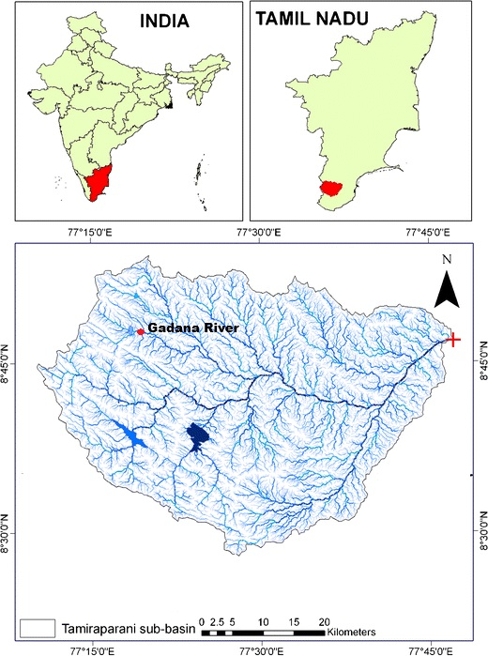

Figure 1. Map showing the sampling location at the Gadana River, Tamiraparani River basin, Western Ghats, India.

2.2 Karyotyping
Chromosome preparations for both species were carried out according to the method of Kligerman and Bloom (1977). Each fish was injected with 0.01 mg of phytohaemagglutinin (PHA) and allowed to swim for 2 h (Padilla et al., 1993). As these fishes were small, lower concentrations and shorter exposure durations were considered sufficient. Subsequently, they were injected intraperitoneally with colchicine at a dosage of 0.01 mg/g body weight and allowed to swim freely in a well-aerated tank for an additional 2 h. The fishes were anaesthetised and sacrificed, and their kidneys and spleens were excised and stored in a 0.5% KCl solution for 30 min, followed by fixation in Carnoy’s fluid for 10 min. The samples were then stored at −4 °C for 24 h. Subsequently, they were treated with 0.15 M NaCl solution for 10 min and 0.015 M trisodium citrate for 30 min. The tissues were then treated with acetic acid for a few minutes, minced thoroughly with scissors, and dissociated into a homogeneous cell suspension using a Pasteur pipette. The slides were warmed at 50 °C, and chromosome spreads were prepared using the co-ordinate air-drying technique. The slides were then stained with 5% Giemsa for 30 min, rinsed with distilled water, air-dried, and examined under a microscope at 100× magnification (Nikon Alpha pot-4 microscope). The chromosomes were measured using an ocular micrometer, photographed, and analysed. A standard idiogram was constructed according to Levan et al. (1964). The mean lengths of the short and long arms of the chromosomes, as well as the centromeric index, were calculated. Chromosome sets were grouped according to Macgregor (1993).
3. RESULTS
Twenty metaphase images obtained from kidney cells were analysed for each species. The diploid chromosome number was determined to be 2n = 50 for both Puntius sophore (Figure 2A) and Plesiopuntius bimaculatus (Figure 2C). The karyotype formula of Puntius sophore was 8m + 2sm + 26st + 14t, with NF = 60 (Figure 2B), whereas that of Plesiopuntius bimaculatus was 28m + 22t, with NF = 78 (Figure 2D). The total chromosome length in Plesiopuntius bimaculatus ranged from 0.43 to 0.89 µm, whereas that in Puntius sophore ranged from 0.43 to 1.08 µm. The chromosome morphometric data are presented in Tables 1 and 2. Representative metaphase spreads are shown in Figures 2A and 2C, and the standard idiograms are presented in Figures 3 and 4.
The consistent diploid number of 2n = 50 observed in both species is congruent with the conserved chromosome number frequently reported across many cyprinid lineages; however, differences in the fundamental arm number and chromosome morphology indicate that structural rearrangements may occur without altering the diploid chromosome count (Buasriyot et al., 2024; Khensuwan et al., 2023). This interpretation supports the cautious use of karyotype formulae as comparative cytotaxonomic characters because conventional staining can establish chromosome number and gross morphology but may not resolve cryptic genomic differences, such as rDNA-site variation or repetitive-DNA redistribution (Khensuwan et al., 2023; Rossi, 2021).

Table1. Karyomorphology and chromosomal morphometric data of Plesiopuntius bimaculatus (Bleeker, 1863) from the Gadana River. ( LA-Long arm, SA- Short arm, TL-Total length, AL-Average length RL-Relative length, CI- Centromeric index. T- Telocentric)
Sl.No. | LA | SA | TL | AL | RL (%) | A/R=r | CI
1 | 0.488 | 0.399 | 0.887 | 0.4435 | 6.296 | 1.223 | 44.983
2 | 0.385 | 0.385 | 0.77 | 0.385 | 5.466 | 1.000 | 50.000
3 | 0.427 | 0.214 | 0.641 | 0.3205 | 4.550 | 1.995 | 33.385
4 | 0.427 | 0.214 | 0.641 | 0.3205 | 4.550 | 1.995 | 33.385
5 | 0.385 | 0.256 | 0.641 | 0.3205 | 4.550 | 1.504 | 39.938
6 | 0.385 | 0.256 | 0.641 | 0.3205 | 4.550 | 1.504 | 39.938
7 | 0.342 | 0.256 | 0.598 | 0.299 | 4.245 | 1.336 | 42.809
8 | 0.299 | 0.299 | 0.598 | 0.299 | 4.245 | 1.000 | 50.000
9 | 0.342 | 0.214 | 0.556 | 0.278 | 3.947 | 1.598 | 38.489
10 | 0.299 | 0.256 | 0.555 | 0.2775 | 3.940 | 1.168 | 46.126
11 | 0.299 | 0.256 | 0.555 | 0.2775 | 3.940 | 1.168 | 46.126
12 | 0.256 | 0.256 | 0.512 | 0.256 | 3.634 | 1.000 | 50.000
13 | 0.256 | 0.214 | 0.47 | 0.235 | 3.336 | 1.196 | 45.532
14 | 0.256 | 0.214 | 0.47 | 0.235 | 3.336 | 1.196 | 45.532
15 | 0.641 | 0.000 | 0.641 | 0.3205 | 4.550 | T | 0.000
16 | 0.556 | 0.000 | 0.556 | 0.278 | 3.947 | T | 0.000
17 | 0.556 | 0.000 | 0.556 | 0.278 | 3.947 | T | 0.000
18 | 0.513 | 0.000 | 0.513 | 0.2565 | 3.641 | T | 0.000
19 | 0.513 | 0.000 | 0.513 | 0.2565 | 3.641 | T | 0.000
20 | 0.51 | 0.000 | 0.51 | 0.255 | 3.620 | T | 0.000
21 | 0.47 | 0.000 | 0.47 | 0.235 | 3.336 | T | 0.000
22 | 0.47 | 0.000 | 0.47 | 0.235 | 3.336 | T | 0.000
23 | 0.47 | 0.000 | 0.47 | 0.235 | 3.336 | T | 0.000
24 | 0.427 | 0.000 | 0.427 | 0.2135 | 3.031 | T | 0.000
25 | 0.427 | 0.000 | 0.427 | 0.2135 | 3.031 | T | 0.000

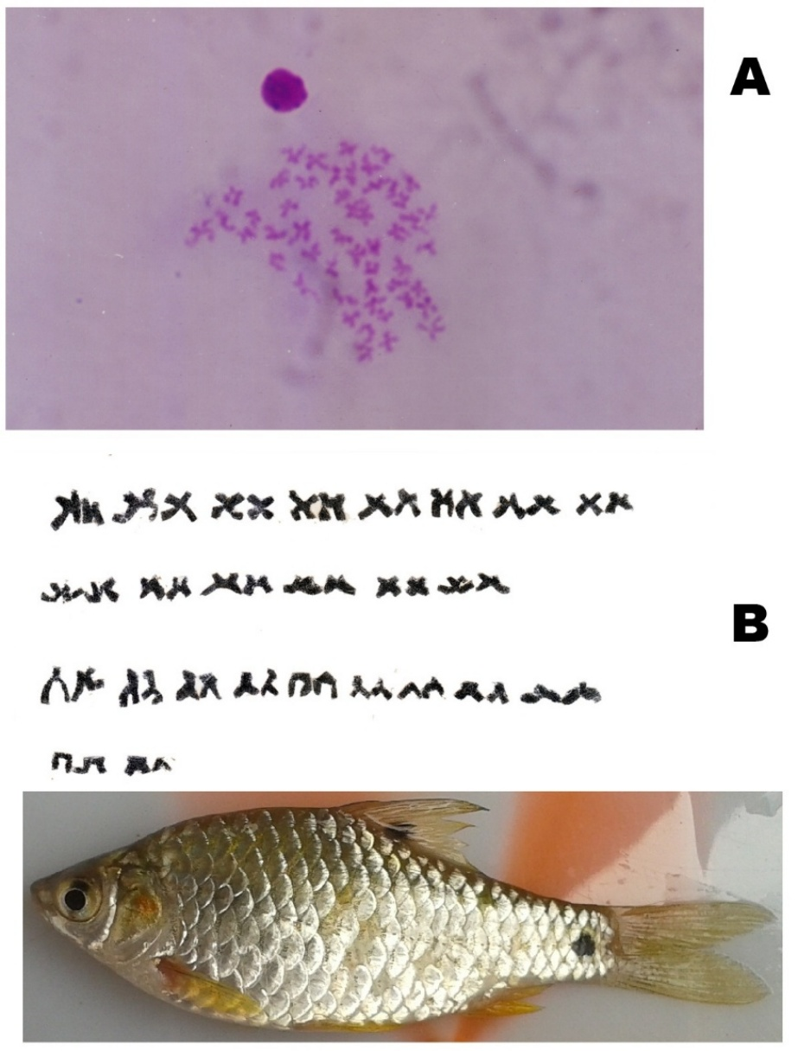

Figure 2: Metaphase chromosome spreads and standard karyotypes of the studied cyprinids. (A) Giemsa-stained mitotic metaphase spread of Puntius sophore.
(B) Standard karyotype of Puntius sophore (2n=50; 8m+2sm+26st+14t).

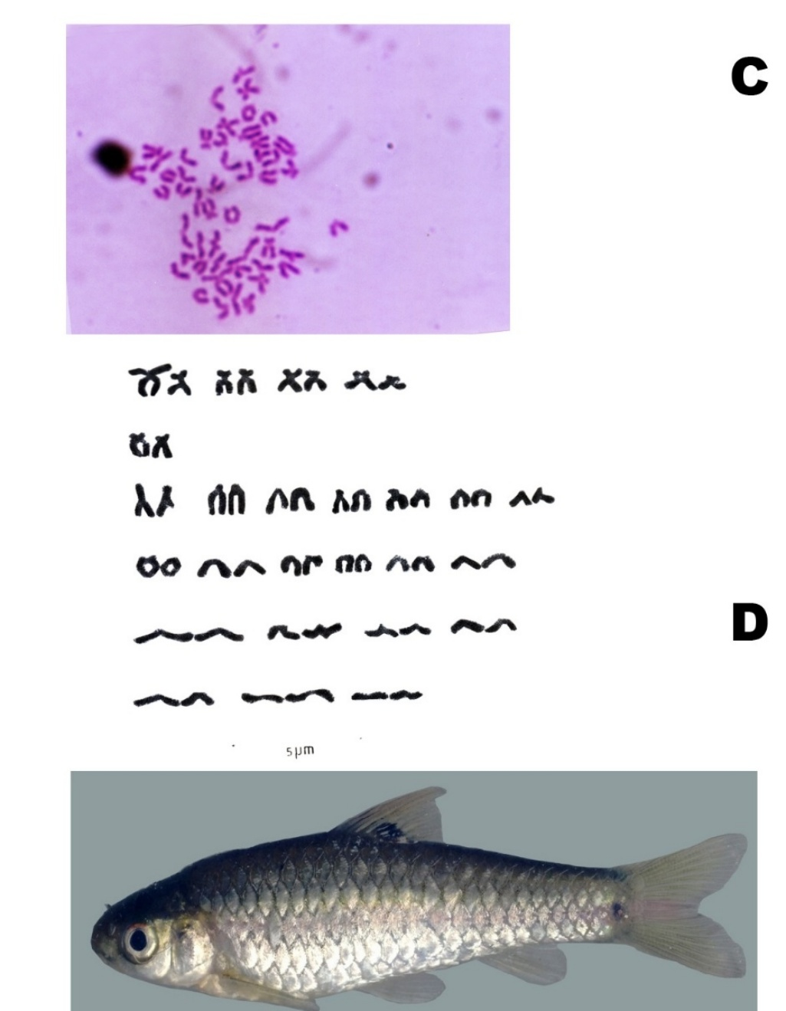

Figure 2: Metaphase chromosome spreads and standard karyotypes of the studied cyprinids.
(C) Giemsa-stained mitotic metaphase spread of Plesiopuntius bimaculatus .
(D) Standard karyotype of Plesiopuntius bimaculatus (2n=50; 28m+22t).

Table 2. Karyomorphology and chromosomal morphometric data of Puntius sophore (Hamilton, 1822) from the Gadana River. ( LA-Long arm, SA- Short arm, TL-Total length, AL-Average length RL-Relative length, CI- Centromeric index. T- Telocentric).

S.No | LA | SA | TL | AL | RL(%) | A/R=r | CI
1 | 0.86 | 0.220 | 1.080 | 0.54 | 6.379 | 3.909 | 20.370
2 | 0.5 | 0.360 | 0.860 | 0.43 | 5.080 | 1.389 | 41.860
3 | 0.36 | 0.360 | 0.720 | 0.36 | 4.253 | 1.000 | 50.000
4 | 0.46 | 0.250 | 0.710 | 0.355 | 4.194 | 1.840 | 35.211
5 | 0.43 | 0.290 | 0.720 | 0.36 | 4.253 | 1.483 | 40.278
6 | 0.36 | 0.290 | 0.650 | 0.325 | 3.839 | 1.241 | 44.615
7 | 0.71 | 0.290 | 1.000 | 0.5 | 5.907 | 2.448 | 29.000
8 | 0.65 | 0.210 | 0.860 | 0.43 | 5.080 | 3.095 | 24.419
9 | 0.57 | 0.210 | 0.780 | 0.39 | 4.607 | 2.714 | 26.923
10 | 0.5 | 0.210 | 0.710 | 0.355 | 4.194 | 2.381 | 29.577
11 | 0.5 | 0.210 | 0.710 | 0.355 | 4.194 | 2.381 | 29.577
12 | 0.5 | 0.150 | 0.650 | 0.325 | 3.839 | 3.333 | 23.077
13 | 0.47 | 0.250 | 0.720 | 0.36 | 4.253 | 1.880 | 34.722
14 | 0.43 | 0.210 | 0.640 | 0.32 | 3.780 | 2.048 | 32.813
15 | 0.43 | 0.210 | 0.640 | 0.32 | 3.780 | 2.048 | 32.813
16 | 0.29 | 0.210 | 0.500 | 0.25 | 2.953 | 1.381 | 42.000
17 | 0.29 | 0.210 | 0.500 | 0.25 | 2.953 | 1.381 | 42.000
18 | 0.25 | 0.190 | 0.440 | 0.22 | 2.599 | 1.316 | 43.182
19 | 0.72 | 0.000 | 0.720 | 0.36 | 4.253 | T | 0.000
20 | 0.68 | 0.000 | 0.680 | 0.34 | 4.017 | T | 0.000
21 | 0.64 | 0.000 | 0.640 | 0.32 | 3.780 | T | 0.000
22 | 0.57 | 0.000 | 0.570 | 0.285 | 3.367 | T | 0.000
23 | 0.57 | 0.000 | 0.570 | 0.285 | 3.367 | T | 0.000
24 | 0.43 | 0.000 | 0.430 | 0.215 | 2.540 | T | 0.000
25 | 0.43 | 0.000 | 0.430 | 0.215 | 2.540 | T | 0.000

Figure 3. Standard idiogram of Plesiopuntius bimaculatus constructed from mean chromosomal arm lengths and centromeric indices.
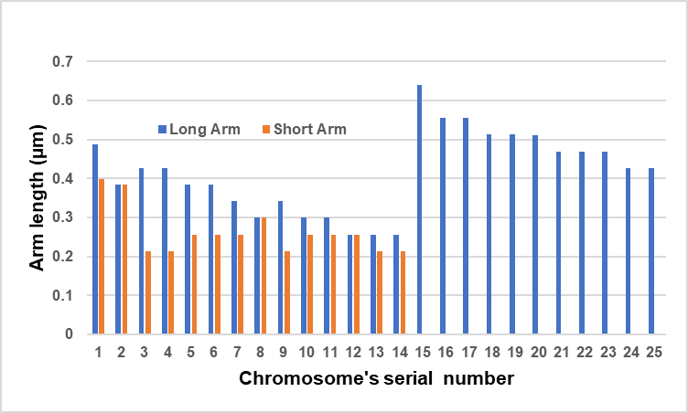

Figure 4. Standard idiogram of Puntius sophore constructed from mean chromosomal arm lengths and centromeric indices.
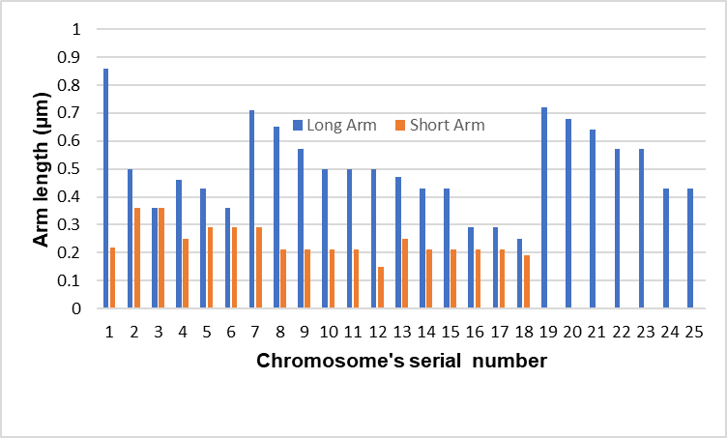

4. DISCUSSION
The genus Puntius has been extensively studied karyologically, as evidenced by numerous investigations (Manna & Prasad, 1971; Rishi & Rishi, 1981; Sharma et al., 1990; Saroniya et al., 2013). Fishes serve as important model systems for comparative chromosome analysis and often exhibit a diploid number of 2n = 50 (Sukham et al., 2013). The chromosomal data for the species studied here are summarised in Table 3.
Table 3. Karyotype characteristics in P.sophore and P. bimaculatus from different localities of India.

Species name | Chromosomal formula | No.of chromosomes | Fundamental arm number | Region | Reference
P.sophore | 4m+4st+40t | 48 | 52 | West Bengal | Manna and Prasad, 1973
P.sophore | 4m+2st+42t | 48 | 52 | Haryana | Rishi and Rishi, 1981
P.sophore | 2m+1st+21t | 48 | 52 | Madyapradesh | Saroniya et al., 2013)
P.sophore | 2m+4sm+44t | 50 | 54 | West Bengal | Barat, 1985
P.sophore | 2m+46t | 48 | 50 | Orissa | Biswal et al., 2010
P.sophore | 2m+1st+21t | 48 | 54 | Assam | Talukdar et al., 2016
P.sophore | 8m+2sm+26st+14t | 50 | 60 | Gadana River, Tamil Nadu | Present study
P.bimaculatus | 28m+22t | 50 | 78 | Gadana River  Tamil Nadu | Present study

In Puntius sophore, the chromosome complement includes 2–8 metacentric, 2–4 submetacentric, 1–26 subtelocentric, and 14–46 telocentric chromosomes, with differences also observed among the chromosomal formulae. The fundamental arm number for this species varies among the reported values of 50, 52, 54, and 60. A decrease in the number of metacentric chromosomes alongside an increase in subtelocentric chromosomes in Puntius sophore is consistent with the pattern observed in Erythrinus erythrinus (Bertollo et al., 2004).
The ability of an organism to adapt to different environments depends on the potential of its genome, and documenting chromosomes provides a record of its adaptation to habitats such as streams and wetlands (Shanthipreya et al., 2016). Chromosome number and structure have been correlated with various morphological and environmental traits, leading to habitat divergence and adaptation (Hoffmann & Rieseberg, 2008; Barat & Sahoo, 2001). Inherited genetic diversity reflects meiotic crossing-over events and the rearrangement of genes within chromosomes. The centromere is the chromosomal region responsible for chromosome segregation during meiosis and mitosis (Shanthipreya et al., 2016). The architectural organisation of the genome involves evolutionary mechanisms such as pericentric inversion, translocation, chromosomal fission, and chromosomal fusion. Specifically, pericentric inversion is a key factor involved in chromosomal differentiation (Sukham et al., 2013).
Intraspecific variation is observed in many fish species owing to geographical differentiation and enhanced adaptability. This phenomenon has been documented in various populations, including loaches (Sember et al., 2015), European smelt, Osmerus eperlanus (Ocalewicz et al., 2007), the teleost fish Potamorhina altamazonica (Feldberg et al., 1993), Devario aequipinnatus (Shanthipreya et al., 2016), Mystus vittatus (Manna & Khuda-Bukhsh, 1978), and the cichlid family (Poletto et al., 2010). Although nearly 3,000 fish species have been karyologically analysed, approximately 435 belong to the family Cyprinidae, likely owing to the family’s extensive species diversity and economic importance. However, many cytogenetic analyses reveal similar karyotypic patterns across numerous species, which can restrict their use for taxonomic and phylogenetic inference (Molina, 2007). To date, karyology has made only a modest contribution to resolving taxonomic problems in fishes because the available data remain relatively sparse (Sola et al., 1981; Buth et al., 1991).
In Plesiopuntius bimaculatus, the diploid chromosome number was found to be 2n = 50 (28m + 22t), with an FN of 78; notably, prior documentation for this species was unavailable. The higher representation of acrocentric chromosomes in these two species is considered an ancestral character (Saroniya et al., 2013). Although Puntius conchonius has more metacentric chromosomes (22m + 16sm + 12t) (Ganai & Yousuf, 2011), Plesiopuntius bimaculatus also has a high number of metacentric chromosomes, whereas submetacentric and subtelocentric chromosomes are absent. Based on the fundamental arm number (FN), the genus Puntius is classified into two distinct groups. The two species in this study, Puntius sophore and Plesiopuntius bimaculatus, belong to the first group, which is characterised by an FN range of 52–80 (Sharma et al., 1990).
The differences in the relative proportions of metacentric, submetacentric, subtelocentric, and telocentric chromosomes are best interpreted as karyomorphological differentiation within a broadly conserved cyprinid 2n framework, a pattern increasingly reported by conventional and molecular cytogenetic studies of Asian cyprinids (Buasriyot et al., 2024; Khensuwan et al., 2023). Classical information regarding chromosome number, morphology, and banding patterns remains vital for applications ranging from cytotaxonomy to karyotype evolution (Cioffi et al., 2012). Although no heteromorphic sex chromosomes were observed in the analysed metaphase spreads, this result is specifically described as an absence of visibly differentiated sex chromosomes rather than a complete genomic absence because small or cryptic sex-linked regions may require molecular cytogenetic or genomic markers for detection (Buasriyot et al., 2024; Rossi, 2021). Ultimately, this study documents the karyology of these fishes and strengthens the baseline for cytotaxonomy and conservation-oriented population comparisons in the Western Ghats. These outcomes provide useful information for addressing taxonomic questions and developing conservation strategies for native species inhabiting the streams and rivers of this biodiversity hotspot. Future investigations using advanced techniques, such as rDNA-FISH or comparative genomic approaches, will be useful for determining whether the observed karyotype differences represent population-level variants or species-specific chromosomal rearrangements (Khensuwan et al., 2023; Rossi, 2021).
The difference between Puntius sophore and Plesiopuntius bimaculatus in the relative proportions of metacentric, submetacentric, subtelocentric, and telocentric chromosomes is best interpreted as karyomorphological differentiation within a broadly conserved cyprinid 2n framework, a pattern increasingly reported by conventional and molecular cytogenetic studies of Asian cyprinids (Buasriyot et al., 2024; Khensuwan et al., 2023). Because no heteromorphic sex chromosomes were observed in the analysed metaphases, the present result should be described as an absence of visibly differentiated sex chromosomes rather than a complete genomic absence because small or cryptic sex-linked regions may require molecular cytogenetic or genomic markers for detection (Buasriyot et al., 2024; Rossi, 2021). Overall, the cytogenetic profile strengthens the baseline for cytotaxonomy and conservation-oriented population comparisons in Western Ghats cyprinids, while future banding, rDNA-FISH, or comparative genomic approaches would be useful for testing whether the observed karyotype differences are population-level variants or species-specific chromosomal rearrangements (Khensuwan et al., 2023; Rossi, 2021).
5. CONCLUSIONS
The cytogenetic assessment of Puntius sophore and Plesiopuntius bimaculatus from the Gadana River demonstrated that both species share a modal diploid chromosome number of 2n = 50, while differing clearly in chromosome morphology and fundamental arm number. Puntius sophore exhibited a karyotype of 8m + 2sm + 26st + 14t with FN = 60, whereas Plesiopuntius bimaculatus exhibited 28m + 22t with FN = 78. The chromosome-length ranges also differed between the species, although no visibly differentiated sex chromosomes were observed in the analysed metaphase spreads. These findings establish locality-specific baseline information for cytotaxonomic comparison of the two cyprinids within the Western Ghats. The observed variation should be interpreted cautiously because the analysis was based on conventional Giemsa staining and specimens from a single river system. Additional sampling across populations, together with chromosome banding, fluorescence in situ hybridisation, and genomic approaches, is needed to determine whether the recorded karyotypic differences represent stable species-level features or geographically structured population variation.
6. LIMITATIONS
This study was limited to specimens collected from a single river system and relied on conventional Giemsa-stained chromosome preparations. The sample comprised 13 Puntius sophore and 11 Plesiopuntius bimaculatus, without detailed sex-specific comparisons. Advanced approaches, including chromosome banding, fluorescence in situ hybridisation, and genomic analysis, were not applied; therefore, cryptic chromosomal variation and broader population-level differences could not be fully assessed.
ACKNOWLEDGEMENTS
The authors express sincere gratitude to the Science and Engineering Research Board (SERB) for financial support through the Core Research Grant (Sanction No. SERB/CRG/2021/001711, dated 04.01.2022). We also thank Dr. K.G. Sivaramakrishnan and Dr. K. Venkatraman for their valuable encouragement, which enabled the successful completion of this work.

DECLARATION OF AI USE

This manuscript was prepared through the combined contributions of all author(s), including contributions to the study design, data, content development, results, interpretation, and related scholarly work. The author(s) acknowledge the use of Grammarly and ChatGPT to assist with grammar checking, language refinement, and reference formatting. These AI-assisted tools were not used as authors and did not replace the intellectual contributions or scholarly judgement of the author(s). All AI-assisted outputs, including content, references, and interpretations, were carefully reviewed, revised, verified, and approved by the author(s). The author(s) accept full responsibility for the accuracy, integrity, and final content of the manuscript.

COMPETING INTERESTS

Authors have declared that they have no known competing financial interests OR non-financial interests OR personal relationships that could have appeared to influence the work reported in this paper.
DECLARATION
The species investigated, Puntius sophore and Plesiopuntius bimaculatus, are widely distributed, highly abundant shoaling fishes that are commonly harvested for human consumption. As the study utilized common food fish obtained from a commercial source and does not involve endangered or protected fauna, formal institutional animal ethics clearance was not mandatory for this research. Nevertheless, the authors ensured that the specimens were treated humanely: they were transported in aerated bags, acclimatized in laboratory tanks for four days with artificial feed, and anaesthetized prior to sacrifice to minimize distress, following standard protocols for fish cytogenetic preparations
COLLECTION PERMISSIONS
The fish specimens were collected from the Gadana River at specific sites located outside of protected areas, such as National Parks or Wildlife Sanctuaries. The specimens were procured directly from local fishermen as part of their routine commercial catch of common food fish. Because the sampling was conducted in non-restricted public waters and involved only common, non-endangered species, formal field collection permits from the Forest Department were not required for this study.

REFERENCES
Arunachalam, M., Johnson, J. A., Sathyanarayanappa, S. N., Sankaranarayanan, A., & Sornam, R. (2000). Cultivable and ornamental fishes from Hemavathi and Ekachi rivers, South Karnataka. In A. G. Ponniah and A. Gopalakrishnan (Eds.), Endemic fish diversity of Western Ghats (pp. 226–227). National Bureau of Fish Genetic Resources. https://www.msuniv.ac.in/faculty_details.php?department_id=41&faculty_id=229&menu=Publications
Arunachalam, M., Sivakumar, P., & Muralidharan, M. (2005). Habitat evaluation of pristine headwater streams of the Western Ghats mountain ranges, Peninsular India. In M. S. Johal (Ed.), New trends in fishery development in India (pp. 253–286). Panjab University.
Barat, A. (1985). A study of chromosomes in some Indian teleosts (Pisces) [Doctoral dissertation, University of Kalyani]. https://mail.nbfgr.res.in/Fish_Karyome/detailview.php?358=
Barat, A., & Sahoo, P. K. (2001). Chromosomal polymorphism in fish. In G. K. Manna and S. C. Roy (Eds.), Perspectives in cytology and genetics (Vol. 10, pp. 591–598). AICCG Publications.
Bertollo, L. A. C., Oliveira, C., Molina, W. F., Margarido, V. P., Fontes, M. S., Pastori, M. C., Falcão, J. das N., & Fenocchio, A. S. (2004). Chromosome evolution in the erythrinid fish, Erythrinus erythrinus (Teleostei: Characiformes). Heredity, 93(2), 228–233. https://doi.org/10.1038/sj.hdy.6800511
Bian, C., Huan, R., & Shi, Q. (2025). Telomere-to-telomere chromosome-scale genome assemblies of black and golden koi carp variants support construction of an ancient karyotype of Cypriniformes. GigaScience, 14, giaf073. https://doi.org/10.1093/gigascience/giaf073
Biswal, J. R., Sahoo, P. K., & Mohanty, P. K. (2010). Karyotypic diversity of some freshwater fish species in rural ponds of Orissa, India. Cytologia, 75(3), 237–242. https://doi.org/10.1508/cytologia.75.237
Buasriyot, P., Sassi, F. de M. C., Donbundit, N., Supiwong, W., Kaewsri, S., Jumrusthanasan, S., Seetapan, K., Pinthong, K., Tanomtong, A., Yanukun, K., Muanglen, N., Liehr, T., & Cioffi, M. de B. (2024). Comparative karyotypic study of fifteen cyprinids (Cyprinidae, Cyprininae) species: An insight into the chromosomal evolution of the tribe Systomini. PLOS ONE, 19(7), e0305828. https://doi.org/10.1371/journal.pone.0305828
Buth, D. G., Dowling, T. E., & Gold, J. R. (1991). Molecular and cytological investigations. In I. J. Winfield and J. S. Nelson (Eds.), Cyprinid fishes: Systematics, biology and exploitation (pp. 83–126). Chapman & Hall. https://doi.org/10.1007/978-94-011-3092-9_4
Cioffi, M. de B., Molina, W. F., Artoni, R. F., & Bertollo, L. A. C. (2012). Chromosomes as tools for discovering biodiversity: The case of the Erythrinidae fish family. In P. Tirunilai (Ed.), Recent trends in cytogenetic studies: Methodologies and applications. IntechOpen. https://doi.org/10.5772/35890
Dahanukar, N. (2010). Puntius sophore. The IUCN Red List of Threatened Species 2010, e.T166623A6249514. https://doi.org/10.2305/IUCN.UK.2010-4.RLTS.T166623A6249514.en
Feldberg, E., Porto, J. I. R., Nakayama, C. M., & Bertollo, L. A. C. (1993). Karyotype evolution in Curimatidae (Teleostei, Characiformes) from the Amazon region. II. Centric fissions in the genus Potamorhina. Genome, 36(2), 372–376. https://doi.org/10.1139/g93-051
Futuyma, D. J. (2009). Evolution (2nd ed.). Sinauer Associates. https://biblioteca.izt.uam.mx/vufind/Record/000128697?lng=en&sid=30022860
Ganai, F. A., & Yousuf, A. R. (2011). A karyological analysis of Puntius conchonius (Hamilton, 1822) (Pisces, Cyprinidae), a new cytotype from Dal Lake Srinagar Kashmir, Jammu and Kashmir (J&K), India. International Journal of Fisheries and Aquaculture, 3(11), 213–217https://doi.org/10.5897/IJFA.9000002
Hamilton, F. (1822). An account of the fishes found in the River Ganges and its branches. Archibald Constable and Company. https://doi.org/10.5962/bhl.title.59540
Hoffmann, A. A., & Rieseberg, L. H. (2008). Revisiting the impact of inversions in evolution: From population genetic markers to drivers of adaptive shifts and speciation? Annual Review of Ecology, Evolution, and Systematics, 39, 21–42. https://doi.org/10.1146/annurev.ecolsys.39.110707.173532
Jablonka, E., & Lamb, M. J. (2014). Evolution in four dimensions: Genetic, epigenetic, behavioral, and symbolic variation in the history of life (Rev. ed.). MIT Press. https://doi.org/10.7551/mitpress/9689.001.0001
Khensuwan, S., Sassi, F. de M. C., Moraes, R. L. R., Jantarat, S., Seetapan, K., Phintong, K., Thongnetr, W., Kaewsri, S., Jumrusthanasan, S., Supiwong, W., Ráb, P., Tanomtong, A., Liehr, T., & Cioffi, M. de B. (2023). Chromosomes of Asian cyprinid fishes: Genomic differences in conserved karyotypes of Poropuntiinae (Teleostei, Cyprinidae). Animals, 13(8), 1415. https://doi.org/10.3390/ani13081415
Khensuwan, S., Sassi, F. de M. C., Moraes, R. L. R., Ráb, P., Liehr, T., Supiwong, W., Seetapan, K., Tanomtong, A., Tantisuwichwong, N., Arunsang, S., Buasriyot, P., Tongnunui, S., & Cioffi, M. de B. (2024). Chromosomes of Asian cyprinid fishes: Novel insight into the chromosomal evolution of Labeoninae (Teleostei, Cyprinidae). PLOS ONE, 19(2), e0292689. https://doi.org/10.1371/journal.pone.0292689
Kligerman, A. D., & Bloom, S. E. (1977). Rapid chromosome preparations from solid tissues of fishes. Journal of the Fisheries Research Board of Canada, 34(2), 266–269. https://doi.org/10.1139/f77-039
Levan, A., Fredga, K., & Sandberg, A. A. (1964). Nomenclature for centromeric position on chromosomes. Hereditas, 52(2), 201–220. https://doi.org/10.1111/j.1601-5223.1964.tb01953.x
Lowe-McConnell, R. H. (1987). Ecological studies in tropical fish communities. Cambridge University Press. https://doi.org/10.1017/CBO9780511721892
Macgregor, H. C. (1993). Introduction to animal cytogenetics. Chapman & Hall. https://ci.nii.ac.jp/ncid/BA22407151
Manna, G. K., & Khuda-Bukhsh, A. R. (1978). Karyomorphological studies in three species of teleostean fishes. Cytologia, 43(1), 69–73. https://doi.org/10.1508/cytologia.43.69
Manna, G. K., & Prasad, R. (1971). A new perspective in the mechanism of evolution of chromosomes in fishes. In Proceedings of the First All India Congress of Cytology and Genetics (pp. 237–240). Journal of Cytology and Genetics Congress Supplement. https://www.fishbase.se/references/SummaryRefList.php?GenusName=Pangasius&ID=292&SpeciesName=pangasius
Manna, G. K., & Prasad, R. (1973). Somatic and germinal chromosomes in two species of fishes belonging to the genus Puntius. Journal of Cytology and Genetics, 8, 145–152. https://mail.nbfgr.res.in/Fish_Karyome/chromview.php?fid=328&id=225+
Molina, W. F. (2007). Chromosomal changes and stasis in marine fish groups. In E. Pisano, C. Ozouf-Costaz, F. Foresti, and B. G. Kapoor (Eds.), Fish cytogenetics (pp. 69–110). CRC Press. https://doi.org/10.1201/b10746-4
Ocalewicz, K., Hliwa, P., Król, J., Rábová, M., Stabiński, R., & Ráb, P. (2007). Karyotype and chromosomal characteristics of Ag-NOR sites and 5S rDNA in European smelt, Osmerus eperlanus. Genetica, 131(1), 29–35. https://doi.org/10.1007/s10709-006-9110-9
Padilla, J. A., Fernández-García, J. L., Rabasco, A., Martínez-Trancón, M., Rodríguez de Ledesma, I., & Pérez-Regadera, J. J. (1993). Characterization of the karyotype of the tench (Tinca tinca L.) and analysis of its chromosomal heterochromatic regions by C-banding, Ag-staining, and restriction endonuclease banding. Cytogenetics and Cell Genetics, 62(4), 220–223. https://doi.org/10.1159/000133481
Pethiyagoda, R. (1991). Freshwater fishes of Sri Lanka. Wildlife Heritage Trust of Sri Lanka. https://agris.fao.org/search/en/providers/122535/records/65ddd6427c7033e84be8415a
Pethiyagoda, R., Meegaskumbura, M., & Maduwage, K. (2012). A synopsis of the South Asian fishes referred to Puntius (Pisces: Cyprinidae). Ichthyological Exploration of Freshwaters, 23(1), 69–95.
Poletto, A. B., Ferreira, I. A., Cabral-de-Mello, D. C., Nakajima, R. T., Mazzuchelli, J., Ribeiro, H. B., Venere, P. C., Nirchio, M., Kocher, T. D., & Martins, C. (2010). Chromosome differentiation patterns during cichlid fish evolution. BMC Genetics, 11, 50. https://doi.org/10.1186/1471-2156-11-50
Renner, S. S., Heinrichs, J., & Sousa, A. (2017). The sex chromosomes of bryophytes: Recent insights, open questions, and reinvestigations of Frullania dilatata and Plagiochila asplenioides. Journal of Systematics and Evolution, 55(4), 333–339. https://doi.org/10.1111/jse.12266
Rishi, K. K., & Rishi, S. (1981). Giemsa banding in fish chromosome. In G. K. Manna and U. Sinha (Eds.), Perspectives in cytology and genetics (Vol. 3, pp. 103–106). Hindasia Publishers. https://mail.nbfgr.res.in/Fish_Karyome/ecosys.php
Rossi, A. R. (2021). Fish cytogenetics: Present and future. Genes, 12(7), 983. https://doi.org/10.3390/genes12070983
Saroniya, R. K., Nagpure, N. S., Saksena, D. N., Kushwaha, B., & Kumar, R. (2013). Cytotaxonomic studies in four species of the genus Puntius (Hamilton, 1822) from central India. National Academy Science Letters, 36(4), 411–418. https://doi.org/10.1007/s40009-013-0148-9
Sember, A., Bohlen, J., Šlechtová, V., Altmanová, M., Symonová, R., & Ráb, P. (2015). Karyotype differentiation in 19 species of river loach fishes (Nemacheilidae, Teleostei): Extensive variability associated with rDNA and heterochromatin distribution and its phylogenetic and ecological interpretation. BMC Evolutionary Biology, 15, 251. https://doi.org/10.1186/s12862-015-0532-9
Shah, A., Hafeez, M., Bazaz, A., Bazaz, A. I., Andleeb, S., Qazi, D., Arif, F., Rather, M. A., Bhat, I. A., Asimi, O., Waheed, T., Farooq, U., Fatima, A., Sameem, A., & Ahmad, I. (2026). Water resources and fish diversity of Kashmir Himalayas: Current status, challenges, and conservation. Asian Journal of Fisheries and Aquatic Research, 28(7), 101–117. https://doi.org/10.9734/ajfar/2026/v28i71113
Shanthipreya, N., Arunachalam, M., Sukumaran, N., Sivakumar, P., & Esakkiammal, B. (2016). Karyotypic analysis of Devario aequipinnatus (McClelland, 1839) from the Gadana River, South India, with NOR banding and C-banding. Asian Journal of Microbiology, Biotechnology & Environmental Sciences, 18(1), 185–188.
Sharma, O. P., Tripathi, N. K., Agrawal, A., & Tripathi, S. (1990). Karyotypic diversity in the genus Puntius (Cyprinidae: Pisces). The Nucleus, 33(1–2), 81–83.
Sola, L., Cataudella, S., & Capanna, E. (1981). New developments in vertebrate cytotaxonomy III. Karyology of bony fishes: A review. Genetica, 54(3), 285–328. https://doi.org/10.1007/BF00135048
Sukham, S., Chingakham, B., Thoidingjam, L., & Waikhom, G. (2013). Cytogenetic characterization of Devario aequipinnatus (McClelland, 1839) and Devario yuensis (Arunkumar and Tombi, 1998) (Cypriniformes: Cyprinidae) from Manipur, northeast India. Turkish Journal of Zoology, 37, 706–712. https://doi.org/10.3906/zoo-1211-12
Talukdar, B., Mili, S., Kalita, H. K., & Sarma, D. (2016). Karyology of Puntius sophore (Pisces: Cypriniformes) from the Brahmaputra River, Assam, India. Poultry, Fisheries & Wildlife Sciences, 4(2), 167. https://doi.org/10.4172/2375-446X.1000167
van der Laan, R., Eschmeyer, W. N., & Fricke, R. (2014). Family-group names of recent fishes. Zootaxa, 3882(1), 1–230. https://doi.org/10.11646/zootaxa.3882.1.1
Vannote, R. L., Minshall, G. W., Cummins, K. W., Sedell, J. R., & Cushing, C. E. (1980). The river continuum concept. Canadian Journal of Fisheries and Aquatic Sciences, 37(1), 130–137. https://doi.org/10.1139/f80-017
Winfield, I. J., & Nelson, J. S. (Eds.). (1991). Cyprinid fishes: Systematics, biology and exploitation. Chapman & Hall. https://doi.org/10.1007/978-94-011-3092-9
Yu, X., Zhou, T., Li, K., Li, Y., & Zhou, M. (1987). On the karyosystematics of cyprinid fishes and a summary of chromosome studies in China. Genetica, 72(3), 225–236. https://doi.org/10.1007/BF00116227

