Preparation of Cellulose Scaffolds from Leaves for Wound Regeneration

ABSTRACT
Plant-derived tissue decellularisation offers a potentially accessible route for producing cellulose-rich scaffolds for regenerative research. This study prepared leaf-based scaffolds through sequential surface decutinisation and chemical decellularisation. Fresh leaves were treated with an n-hexane-diethyl ether mixture, followed by 4% sodium dodecyl sulphate for 120 h, 2% Triton X-100 for 48 h, and 4% sodium hypochlorite for 12 h. The processed leaves were washed repeatedly with sterile deionised water. Scaffold decellularisation and structural preservation were assessed by gross examination, haematoxylin and eosin staining, DAPI fluorescence staining, scanning electron microscopy, DNA quantification, and an in vitro haemocompatibility assay. Native and decellularised dry leaf tissues contained 105.36 ± 1.03 ng/mg and 35.27 ± 0.52 ng/mg total DNA, respectively. Histological and DAPI observations indicated substantial removal of cellular and nuclear material, while scanning electron microscopy showed preservation of the general porous architecture and stomatal features. Haemolysis was significantly lower for decellularised leaf tissue than for native leaf tissue, with values of 1.90 ± 0.53% and 30.71 ± 3.67%, respectively. These findings indicate that sequential treatment with sodium dodecyl sulphate and Triton X-100 can produce cellulose-rich leaf scaffolds with reduced residual DNA and preliminary blood compatibility. Further mechanical, cytocompatibility, degradation, antimicrobial, and in vivo wound-healing evaluations are required before practical regenerative use can be considered.

Keywords: Plant-derived scaffold; leaf decellularisation; cellulose matrix; wound regeneration; tissue engineering; sodium dodecyl sulphate; Triton X-100; DAPI staining; scanning electron microscopy; haemocompatibility

- Introduction
The development of scaffolds has substantially advanced tissue engineering. Decellularised tissues may be recellularised with host-derived cells to create patient-specific constructs. However, mammalian tissues used for decellularisation are expensive and difficult to obtain, and further research is required before decellularised tissues can be regarded as established clinical alternatives (Badylak et al., 2011). Consequently, a readily available and reasonably priced tissue source for decellularisation could increase scaffold availability at a lower cost. Cross-kingdom approaches may help address this challenge because, although plants and mammals transport fluids and macromolecules through different biological mechanisms, their vascular-network topologies share useful structural similarities. Plant cell walls contain several polysaccharides, principally cellulose, hemicellulose, and pectin (Pettolino et al., 2012). Cellulose, a major structural component of leaves, is biocompatible and has been investigated for wound-healing applications (Czaja et al., 2006). Hemicellulose-based materials have also been studied as biomaterials for tissue repair (Ferreira et al., 2010). Plant leaves additionally contain biologically active compounds associated with antimicrobial and wound-healing research, although such extract-based applications differ from the use of decellularised structural matrices (Nachiya et al., 2021). More broadly, polymeric scaffolds provide three-dimensional environments that can support cell adhesion, migration, and tissue regeneration (Switha et al., 2022). Recent studies and reviews have further emphasised the structural versatility, accessibility, and potential biomedical value of plant-derived scaffolds (Abbasi et al., 2025; Vargas-Ovalle et al., 2025). Several plant species are widely available, inexpensive, and sustainable because of their rapid growth and abundance. Before decellularisation, the selected chemical agent, its concentration, treatment duration, and the age and structural robustness of the plant material should be considered. Resistant materials, such as spinach leaves or parsley stems, may require longer incubation periods and higher reagent concentrations (Gershlak et al., 2017; Salehi et al., 2020), whereas fragile apple tissue can be decellularised using a lower SDS concentration (Contessi Negrini et al., 2020). The yield strength of some decellularised plant tissues has also been reported to be comparable to that of selected human biological tissues (Lacombe et al., 2020). Plant-tissue decellularisation commonly involves sequential exposure to an ionic detergent, such as aqueous SDS, followed by a surfactant and bleaching solution. Because these chemicals may damage scaffold architecture, as observed during animal-tissue decellularisation (Crapo et al., 2011, Chakravarti, S. P et al, 2026), residual agents should be removed by repeated washing with phosphate-buffered saline under continuous agitation. Despite growing interest in plant-derived scaffolds, evidence remains limited regarding whether the specific sequential use of SDS and Triton X-100 can adequately remove cellular material from leaf tissue while preserving architecture and maintaining preliminary blood compatibility for wound-regeneration research. Therefore, the objective of this study was to assess the effectiveness of SDS and Triton X-100 in producing a plant-derived cellulose scaffold from leaves for potential wound-regeneration applications.
- Materials and methods
  - Preparation of leaf scaffold
Fresh plant leaves were collected, and their surface cuticles were removed by incubation for 10 min in a mixture of n-hexane and diethyl ether. Each leaf was immersed in 100 mL of a 4% sodium dodecyl sulphate (SDS) solution prepared in deionised water for 120 h. The leaves were then soaked in 2% Triton X-100 for 48 h and bleached in a 4% sodium hypochlorite solution prepared in deionised water for 12 h. Subsequently, the leaves were washed six times with sterile deionised water for 2 h per wash. Control leaves were immersed in sterile deionised water for the same period under identical conditions. Following decellularisation, the leaves were stored in sterile deionised water at 4 °C.
  - Gross observations
The colour, consistency, and elasticity of the control and decellularised leaves were examined macroscopically.
  - Microscopic observations
Random specimens (1 cm²) were trimmed from native and decellularised leaves (n = 3), fixed in 10% neutral buffered formalin, embedded in paraffin, and sectioned at 12 µm. The tissue sections were deparaffinised in xylene, rehydrated through decreasing ethanol concentrations from 99.99% to 30%, and stained with haematoxylin and eosin (H&E). The sections were dehydrated in 70% ethanol followed by absolute ethanol and cleared in two changes of xylene for 2 min per step. The samples were examined using a DMLB2 upright microscope (Leica Microsystems, Buffalo Grove, IL, USA).
  - DAPI (4,6-diamidino-2-phenylindole 2HCl) fluorescent immunostaining
Sections of native (control) and decellularised leaves were deparaffinised, rehydrated, and washed in 0.2% Tris-buffered saline containing Tween-20 (TBST). The rehydrated sections were incubated with DAPI fluorescent stain (Elabscience® buffered saline solution, India) at 37 °C for 15 min and examined under a fluorescence microscope for blue nuclear fluorescence.
  - Scanning electron microscopy
Surface topographical changes following leaf decellularisation were examined by scanning electron microscopy (SEM) using a Carl Zeiss EVO 18 instrument. The tissues were fixed in 1.5% glutaraldehyde and transferred through graded ethanol concentrations of 30%, 50%, 80%, and 95% in deionised water. Complete dehydration was achieved using hexamethyldisilazane (HMDS) in ascending ethanol-HMDS solutions from 30% to 95%. Following dehydration, the samples were sputter-coated with gold. Electron micrographs were obtained from different regions at an accelerating voltage of 10 kV.
  - DNA quantification
Native and decellularised leaves (n = 3) were ground using a mortar and pestle. DNA was extracted from both native (control) and decellularised leaves using the BioLit Plant DNA Extraction Mini Kit (SRL Pvt. Ltd.). The isolated double-stranded DNA was quantified spectrophotometrically using a NanoDrop ND-1000 instrument.
  - In vitro hemocompatibility
The in vitro haemocompatibility of three 1 cm² samples of native and decellularised leaf tissue was evaluated using a modified form of the method described by Liu et al. (2014). Briefly, the leaf scaffolds were washed with normal saline (NS) and immersed in anticoagulated red blood cells obtained from New Zealand White rabbit blood. Red blood cells diluted with NS and distilled water served as the negative and positive controls, respectively. Each sample was incubated in a water bath at 37 °C for 1 h. After the leaf samples had been removed, the tubes were centrifuged at 100 × g for 5 min. The supernatant was collected, and its optical density was measured at 540 nm. Haemolysis was calculated using the following formula.
$$Hemolysis \left(\%\right)=\frac{( A_{test}-A_{NS})}{( A_{DW}-A_{NS})}×100$$
  - Statistical analysis
The data were analysed using SPSS version 18.0 (SPSS Inc., Chicago, IL, USA). Statistical comparisons were performed using Student's t-test or one-way analysis of variance followed by Duncan's post hoc test, as appropriate.
- Results and discussion
  - Gross observations
After 10 min of solvent treatment, the adaxial and abaxial surfaces of the leaves lost their cuticular layer and appeared bright green. The leaves became greenish-brown during treatment with SDS and Triton X-100. Following decolourisation with 4% sodium hypochlorite, the decellularised leaves became transparent (Fig. 1). Plant-derived cellulose scaffolds have recently been investigated as alternatives to acellular scaffolds derived from animal tissues in several tissue-engineering applications (Shang et al., 2024). Cuticular waxes contain very-long-chain fatty acids and their derivatives, including alkanes, primary alcohols, and ketones. The cuticular layer must be removed to permit effective penetration of the decellularising agents into the leaf tissue. Previous investigators have used organic solvents such as petroleum ether, n-hexane, methanol, and chloroform for this purpose (Gershlak et al., 2017). However, n-hexane alone did not completely remove the cuticle. Therefore, a 9:1 mixture of n-hexane and diethyl ether was used to improve wax penetration and removal. Hexane combined with Dulbecco's phosphate-buffered saline or 1× PBS has also been used for cuticle removal (Jones et al., 2021).
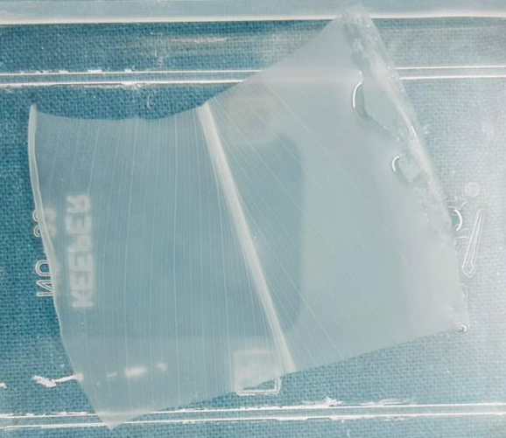
Fig. 1: Gross observations of decellularized leaf
  - Histological observations
Well-organised parenchyma and epidermal layers were visible in H&E-stained micrographs of fresh leaves. In contrast, the decellularised leaf tissue remained structurally organised, lacked visible nuclei, and was free of cuticle on both the adaxial and abaxial surfaces, with only superficial disruption of the extracellular matrix. Removal of nuclei and chlorophyll from the leaf stroma indicated decellularisation (Fig. 2). Triton X-100 is used during plant-leaf decellularisation to remove cellular components while preserving the structural matrix for tissue-engineering applications. It is frequently combined with agents such as sodium chlorite and SDS to improve cellular removal while limiting disruption of the remaining matrix (Ahangar Salehani et al., 2023). The immersion method can decellularise leaves efficiently because stomata on the leaf surface facilitate detergent entry without requiring a perfusion system (Zhu et al., 2021). Nevertheless, simultaneous treatment of several leaves in one container should be avoided because it may lead to uneven decellularisation.
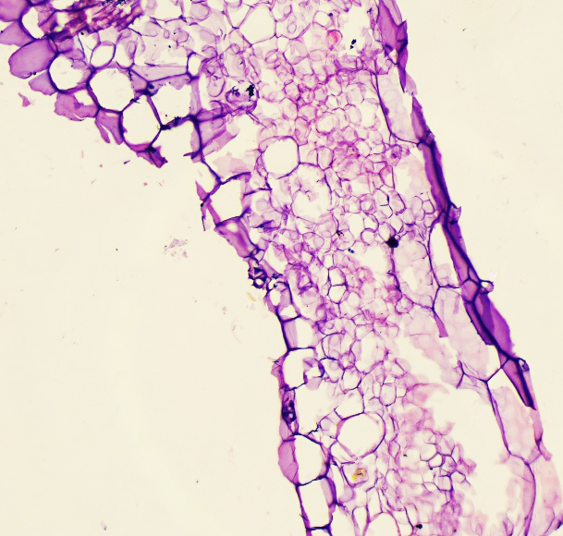
Fig. 2: Histological observations of decellularized leaf revealed complete decellularization
  - DAPI staining
The histological findings for the decellularised leaf samples were further assessed by DAPI fluorescence staining. The absence of blue fluorescence indicated removal of nuclear DNA from the original leaf tissue. Removal of cellular DNA is an important criterion for evaluating a decellularisation procedure (Piccoli et al., 2016). Successful decellularisation was supported by a plant DNA concentration below 50 ng of double-stranded DNA per milligram of tissue and by the absence of blue fluorescence in DAPI-labelled sections of the leaf scaffold (Bullington et al., 2021). DAPI (4′,6-diamidino-2-phenylindole) binds preferentially to adenine-thymine-rich regions of double-stranded DNA and was therefore used to detect residual nuclear material (Crapo et al., 2011). The absence of DAPI-positive nuclei indicated effective removal of plant cells while preserving the cellulose-rich structure (Gershlak et al., 2017). Limiting residual nuclear material is important for reducing the potential immunogenicity of biological scaffolds intended for implantation (Crapo et al., 2011). Quantitative DNA measurement supported these observations by demonstrating a marked reduction in residual DNA following treatment. Previous plant-decellularisation studies have reported substantial DNA removal while retaining scaffold architecture (Gershlak et al., 2017). Similar findings have been reported in decellularised Ficus benjamina leaves, which showed little or no DAPI fluorescence (Singh et al., 2024). Collectively, the histological, DAPI, and SEM findings support the effectiveness of the decellularisation protocol.
  - Scanning electron microscopy
SEM images of native leaves (control) showed epidermal cells with indistinct boundaries, while the stomata were obscured by the cuticular wax layer. Following decellularisation, the cuticle and cellular contents were removed, revealing stomatal openings surrounded by guard cells and well-defined cellular boundaries (Fig. 3). The overall architecture of the leaf tissue was largely retained. SEM is commonly used to assess cellular removal and preservation of the native cellulose architecture in decellularised leaf scaffolds. Native leaf tissue typically shows intact epidermal and mesophyll cells, dense tissue organisation, and distinct vascular bundles. After decellularisation, removal of intracellular material reveals an interconnected porous cellulose network while preserving stomatal architecture and the structural integrity of leaf veins (Gershlak et al., 2017; Adamski et al., 2018). Preservation of the vascular network is important because these channels may facilitate nutrient transport and cellular infiltration in wound-regeneration applications (Fontana et al., 2017).
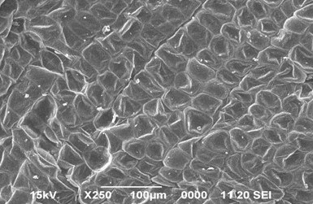
Fig. 3: SEM examination of decellularized leaf showed absence of nuclei and undisturbed leaf architecture (Scale bars: 100 µm, ×250)
  - DNA quantification
Compared with native leaf tissue, the decellularised leaf scaffold showed a significant reduction in residual DNA concentration (P < 0.001; Fig. 4). In dry leaf tissue, the total DNA contents of native (C) and decellularised leaf scaffolds were 105.36 ± 1.03 ng/mg and 35.27 ± 0.52 ng/mg, respectively. Removal of cellular DNA is an important component of the decellularisation process (Piccoli et al., 2016). The reduction in plant-cell DNA to below 50 ng of double-stranded DNA per milligram of tissue, together with the absence of blue fluorescence in DAPI-stained leaf sections, supported effective decellularisation, consistent with previous leaf-scaffold research (Kian et al., 2025).
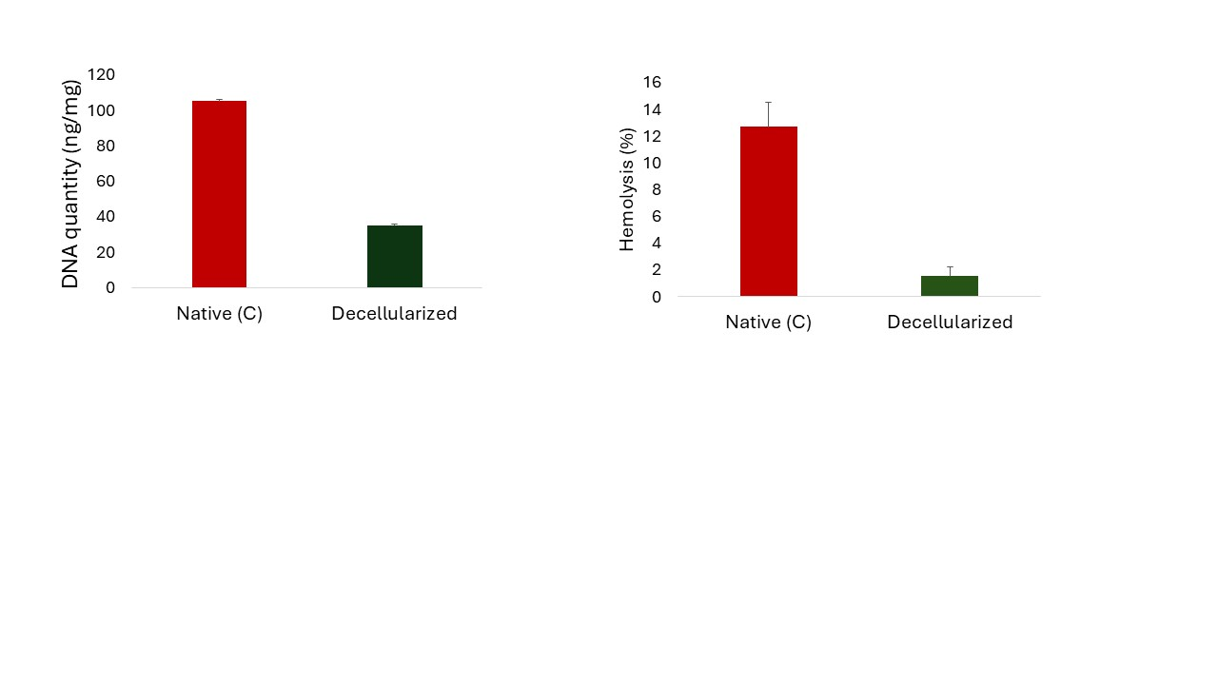
Fig. 4: Decellularized leaf scaffold revealed a significant (P<0.001) decrease in DNA concentration as compared to native (C) leaf
  - Hemocompatibility
Haemolysis caused by decellularised leaves was significantly lower than that caused by native control leaves (P < 0.05): 30.71 ± 3.67% for native leaf tissue and 1.90 ± 0.53% for decellularised leaf tissue. The decellularised cellulose scaffolds therefore showed preliminary compatibility with New Zealand White rabbit red blood cells (Fig. 5). According to the reported classification based on the percentage of red-blood-cell lysis, materials may be categorised as haemolytic (>5%), slightly haemolytic (2-5%), or non-haemolytic (<2%) (Dikici, 2024). Haemocompatibility is an important property of biomaterials intended for implantation because scaffolds may contact blood during the early stages of tissue repair. An appropriate scaffold should minimise erythrocyte damage, platelet activation, clot formation, and inflammatory responses. The low haemolysis observed for the decellularised scaffold suggests that the treatment removed cellular residues while retaining the cellulose matrix. The hydrophilic and chemically stable nature of cellulose may help limit erythrocyte membrane disruption and nonspecific protein adsorption (Modulevsky et al., 2014; Hickey et al., 2018). Thorough removal of residual detergents and plant-cell debris may also have contributed to the observed blood compatibility because such residues can promote erythrocyte damage and thrombotic responses (Crapo et al., 2011; Adamski et al., 2018).
Fig. 5: Decellularized leaf scaffold demonstrated a significant (P<0.001) decrease in haemolysis (%) as compared to native (C) leaf

Conclusions
The study demonstrated that leaf tissue can be converted into a cellulose-rich scaffold through sequential decutinisation, detergent treatment, bleaching, and extensive washing. Gross examination, histology, DAPI staining, and scanning electron microscopy collectively indicated substantial removal of visible cellular material while retaining the general porous organisation and surface architecture of the leaf matrix. DNA quantification further showed a marked reduction in residual DNA after decellularisation. The decellularised scaffold also produced considerably less haemolysis than native leaf tissue during preliminary testing with rabbit red blood cells, indicating improved blood compatibility after processing. Taken together, the findings support the feasibility of using leaves as an accessible plant-derived source of structural cellulose scaffolds for further wound-regeneration research. Nevertheless, the present evidence is preliminary and does not establish clinical or veterinary efficacy. Mechanical properties, degradation behaviour, cell adhesion and proliferation, antimicrobial performance, inflammatory responses, and in vivo wound closure must be evaluated using standardised protocols before the scaffold can be considered for practical regenerative applications.

Limitations
The plant species used for scaffold preparation was not clearly identified, which limits reproducibility and comparison with other leaf-derived matrices. The study evaluated only structural preservation, residual DNA, and preliminary haemocompatibility using a limited sample size. Mechanical strength, porosity, degradation, detergent residues, cytocompatibility, antimicrobial activity, inflammatory response, and in vivo wound-healing performance were not assessed. Consequently, the findings should be interpreted as preliminary evidence requiring validation through standardised biological and mechanical testing.

Declaration of AI Use

This manuscript was prepared through the combined contributions of all author(s), including contributions to the study design, data, content development, results, interpretation, and related scholarly work. The author(s) acknowledge the use of Grammarly and ChatGPT to assist with grammar checking, language refinement, reference formatting. These AI-assisted tools were not used as authors and did not replace the intellectual contributions or scholarly judgment of the author(s). All AI-assisted outputs, including content, references, and interpretations, were carefully reviewed, revised, verified, and approved by the author(s). The author(s) accept full responsibility for the accuracy, integrity, and final content of the manuscript.

Ethical Approval
The current research was carried out in accordance with ethical guidelines for animal experimentation, as approved by the Institutional Animal Ethics Committee at the College of Veterinary Science and Animal Husbandry, Acharya Narendra Deva University of Agriculture and Technology, Kumarganj, Ayodhya, Uttar Pradesh, India. (Approval number- IAEC/CVSc-ANDUAT/2025/1/22).

COMPETING INTERESTS:
Authors have declared that they have no known competing financial interests OR non-financial interests OR personal relationships that could have appeared to influence the work reported in this paper.

References

Adamski, M., Fontana, G., Gershlak, J. R., Gaudette, G. R., Le, H. D., & Murphy, W. L. (2018). Two methods for decellularization of plant tissues for tissue engineering applications. Journal of Visualized Experiments, (135), e57586. https://doi.org/10.3791/57586
Badylak, S. F., Taylor, D., & Uygun, K. (2011). Whole-organ tissue engineering: Decellularization and recellularization of three-dimensional matrix scaffolds. Annual Review of Biomedical Engineering, 13, 27–53. https://doi.org/10.1146/annurev-bioeng-071910-124743
Bullington, L. S., Lekberg, Y., & Larkin, B. G. (2021). Insufficient sampling constrains our characterization of plant microbiomes. Scientific Reports, 11, 3645. https://doi.org/10.1038/s41598-021-83153-9
Contessi Negrini, N., Toffoletto, N., Farè, S., & Altomare, L. (2020). Plant tissues as 3D natural scaffolds for adipose, bone and tendon tissue regeneration. Frontiers in Bioengineering and Biotechnology, 8, 723. https://doi.org/10.3389/fbioe.2020.00723
Crapo, P. M., Gilbert, T. W., & Badylak, S. F. (2011). An overview of tissue and whole-organ decellularization processes. Biomaterials, 32(12), 3233–3243. https://doi.org/10.1016/j.biomaterials.2011.01.057
Czaja, W., Krystynowicz, A., Bielecki, S., & Brown, R. M., Jr. (2006). Microbial cellulose—The natural power to heal wounds. Biomaterials, 27(2), 145–151. https://doi.org/10.1016/j.biomaterials.2005.07.035
Dikici, S. (2024). Enhancing wound regeneration potential of fibroblasts using ascorbic acid-loaded decellularized baby spinach leaves. Polymer Bulletin, 81, 9995–10016. https://doi.org/10.1007/s00289-024-05185-1
Ferreira, L. M., Sobral, C. S., Blanes, L., Ipolito, M. Z., & Horibe, E. K. (2010). Proliferation of fibroblasts cultured on a hemi-cellulose dressing. Journal of Plastic, Reconstructive & Aesthetic Surgery, 63(5), 865–869. https://doi.org/10.1016/j.bjps.2009.02.008
Fontana, G., Gershlak, J. R., Adamski, M., Lee, J.-S., Matsumoto, S., Le, H. D., Binder, B., Wirth, J., Gaudette, G. R., & Murphy, W. L. (2017). Biofunctionalized plants as diverse biomaterials for human cell culture. Advanced Healthcare Materials, 6(8), 1601225. https://doi.org/10.1002/adhm.201601225
Gershlak, J. R., Hernandez, S., Fontana, G., Perreault, L. R., Hansen, K. J., Larson, S. A., Binder, B. Y. K., Dolivo, D. M., Yang, T., Dominko, T., Rolle, M. W., Weathers, P. J., Medina-Bolivar, F., Cramer, C. L., Murphy, W. L., & Gaudette, G. R. (2017). Crossing kingdoms: Using decellularized plants as perfusable tissue engineering scaffolds. Biomaterials, 125, 13–22. https://doi.org/10.1016/j.biomaterials.2017.02.011
Hickey, R. J., Modulevsky, D. J., Cuerrier, C. M., & Pelling, A. E. (2018). Customizing the shape and microenvironment biochemistry of biocompatible macroscopic plant-derived cellulose scaffolds. ACS Biomaterials Science & Engineering, 4(10), 3726–3736. https://doi.org/10.1021/acsbiomaterials.8b00178
Jones, J. D., Rebello, A. S., & Gaudette, G. R. (2021). Decellularized spinach: An edible scaffold for laboratory-grown meat. Food Bioscience, 41, 100986. https://doi.org/10.1016/j.fbio.2021.100986
Kian, M., Hashemi, S. S., Derakhshanfar, A., Darya, G.-H., Shahhossein, Z., & Saharkhiz, M. J. (2025). Decellularized Persian walnut leaf (Juglans regia) as a potential wound dressing scaffold: An experimental study. Frontiers in Bioengineering and Biotechnology, 13, 1524956. https://doi.org/10.3389/fbioe.2025.1524956
Lacombe, J., Harris, A. F., Zenhausern, R., Karsunsky, S., & Zenhausern, F. (2020). Plant-based scaffolds modify cellular response to drug and radiation exposure compared to standard cell culture models. Frontiers in Bioengineering and Biotechnology, 8, 932. https://doi.org/10.3389/fbioe.2020.00932
Liu, Y., Cai, D., Yang, J., Wang, Y., Zhang, X., & Yin, S. (2014). In vitro hemocompatibility evaluation of poly(4-hydroxybutyrate) scaffold. International Journal of Clinical and Experimental Medicine, 7(5), 1233–1243. https://e-century.us/files/ijcem/7/5/ijcem0000496.pdf
Modulevsky, D. J., Lefebvre, C., Haase, K., Al-Rekabi, Z., & Pelling, A. E. (2014). Apple-derived cellulose scaffolds for 3D mammalian cell culture. PLOS ONE, 9(5), e97835. https://doi.org/10.1371/journal.pone.0097835
Pettolino, F. A., Walsh, C., Fincher, G. B., & Bacic, A. (2012). Determining the polysaccharide composition of plant cell walls. Nature Protocols, 7(9), 1590–1607. https://doi.org/10.1038/nprot.2012.081
Piccoli, M., Urbani, L., Alvarez-Fallas, M. E., Franzin, C., Dedja, A., Bertin, E., Zuccolotto, G., Rosato, A., Pavan, P., Elvassore, N., De Coppi, P., & Pozzobon, M. (2016). Improvement of diaphragmatic performance through orthotopic application of decellularized extracellular matrix patch. Biomaterials, 74, 245–255. https://doi.org/10.1016/j.biomaterials.2015.10.005
Ahangar Salehani, A., Rabbani, M., Biazar, E., Heidari Keshel, S., & Pourjabbar, B. (2023). The effect of chemical detergents on the decellularization process of olive leaves for tissue engineering applications. Engineering Reports, 5(2), e12560. https://doi.org/10.1002/eng2.12560
Salehi, A., Mobarhan, M. A., Mohammadi, J., Shahsavarani, H., Shokrgozar, M. A., & Alipour, A. (2020). Efficient mineralization and osteogenic gene overexpression of mesenchymal stem cells on decellularized spinach leaf scaffold. Gene, 757, 144852. https://doi.org/10.1016/j.gene.2020.144852
Shang, L., Wang, S., & Mao, Y. (2024). Recent advances in plant-derived polysaccharide scaffolds in tissue engineering: A review. International Journal of Biological Macromolecules, 277, 133830. https://doi.org/10.1016/j.ijbiomac.2024.133830
Singh, P. K., Gangwar, A. K., Khangembam, S. D., Verma, R. K., Yadav, V. K., Singh, Y., Shekher, C., Goyal, R. P., & Kumar, N. (2024). Development of cellulose scaffolds derived from Ficus benjamina leaves for tissue engineering applications. Trends in Biomaterials and Artificial Organs, 38(2), 85–98. https://doi.org/10.5281/zenodo.12183830
Zhu, Y., Zhang, Q., Wang, S., Zhang, J., Fan, S., & Lin, X. (2021). Current advances in the development of decellularized plant extracellular matrix. Frontiers in Bioengineering and Biotechnology, 9, 712262. https://doi.org/10.3389/fbioe.2021.712262

Abbasi, M., Sahami Gilan, P., Zandian, M., Sanjabi, G., Sadegh Malvajerd, S., Bahrami, G., Khirehgesh, M. R., Derakhshankhah, H., Pourmanouchehri, Z., & Izadi, Z. (2025). Fabrication and evaluation of a 3D decellularized-plant scaffold modified with composite hydrogel for bone tissue engineering. Journal of Materials Science: Materials in Engineering, 20, 114. https://doi.org/10.1186/s40712-025-00336-2
Nachiya, R. A. M. J., Sangeetha, G., Ragunathan, R., Shahanawaz, S. D., & Bhattacharya, S. (2021). Anti-microbial and wound healing properties of leaf extracts of Spermacoce verticillata L. Journal of Pharmaceutical Research International, 33(59A), 191–197. https://doi.org/10.9734/jpri/2021/v33i59A34263
Switha, D., Khaleel Basha, S., & Sugantha Kumari, V. (2022). Biopolymeric nanocomposite scaffolds for nerve tissue engineering applications: A review. Journal of Applied Chemical Science International, 13(4), 25–50. https://doi.org/10.56557/jacsi/2022/v13i47709
Vargas-Ovalle, M. I., Demitri, C., & Madaghiele, M. (2025). Plant-based scaffolds for tissue engineering: A review. Polymers, 17(19), 2705. https://doi.org/10.3390/polym17192705
Chakravarti, S. P., Gangwar, A. K., Khangembam, S. D., Saxena, S., Singh, Y., Yadav, V. K., Verma, R. K., Singh, P. K., Shrivastava, S., Kumar, R., & Shekhar, C. (2026). Transforming Curcuma longa leaf waste into cellulose scaffolds. Journal of Bioscience and Bioengineering. Advance online publication. https://doi.org/10.1016/j.jbiosc.2026.06.006

