Tissue-Specific Variation in DNA and RNA Content of Disco Rani Fish Using Classical Colorimetric Methods

ABSTRACT
Quantitative estimation of nucleic acids can provide comparative information on tissue composition and physiological activity. This study estimated DNA and RNA contents in the liver and gill tissues of Disco Rani fish (Priacanthus hamrur) using classical colorimetric procedures. DNA was measured using the diphenylamine method, whereas RNA was measured using the orcinol method. Absorbance was recorded with a colorimeter, and tissue concentrations were calculated from standard solutions. The estimated DNA concentration was higher in the liver (5.90 mg/ml) than in the gills (4.28 mg/ml). Conversely, RNA concentration was higher in the gills (7.40 mg/ml) than in the liver (5.80 mg/ml). The calculated RNA/DNA ratio was 0.98 in the liver and 1.73 in the gills, indicating greater RNA abundance relative to DNA in gill tissue under the experimental conditions. The DNA standard curve showed a progressive increase in absorbance with concentration, while the RNA standard curve displayed an overall increasing trend with minor deviations. These findings demonstrate descriptive tissue-specific differences in nucleic acid content. The higher DNA value in the liver may reflect differences in tissue architecture and cellular composition, whereas the higher RNA concentration and RNA/DNA ratio in the gills may be associated with their continuous physiological functions. The results remain preliminary because biological replication, inferential statistical analysis and molecular validation were not included.

Keywords: DNA estimation; RNA estimation; RNA/DNA ratio; diphenylamine method; orcinol method; liver tissue; gill tissue; Priacanthus hamrur; colorimetric analysis; fish physiology
INTRODUCTION
Nucleic acids, namely DNA and RNA, play a central role in the storage, transmission, and expression of genetic information. DNA acts as the hereditary material, whereas RNA is directly involved in protein synthesis and the regulation of gene expression. Quantitative estimation of nucleic acids provides insight into cellular activity, growth, and the metabolic status of tissues (Berg et al., 2015; Nelson & Cox, 2017; Voet & Voet, 2011).
In biochemical and molecular studies, DNA is usually interpreted as a relatively stable indicator of cellular genomic material, whereas RNA is more responsive to protein-synthetic demand and short-term physiological conditions (Buckley et al., 1999; Foley et al., 2015).
Foundational biochemical and molecular biology texts also support the use of nucleic acid estimation as a basic laboratory approach for relating cellular composition to growth, metabolism, and gene expression (Brown, 2016; Elliott & Elliott, 2005; Gupta, 2013; Jayaram, 1981; Lodish et al., 2016; Plummer, 1988; Sambrook & Russell, 2001; Sawhney & Singh, 2000).
In fish, nucleic acid content varies among tissues according to their physiological functions. The liver is a metabolically active organ involved in protein synthesis, detoxification, and enzymatic processes and is generally expected to exhibit higher RNA content. In contrast, the gills are primarily involved in respiration, osmoregulation, and ion exchange and may exhibit comparatively lower biosynthetic activity, although functional demands can influence RNA levels (Buckley, 1984; Buckley et al., 1999; Evans et al., 2005).
The fish gill is a multifunctional epithelium involved not only in gas exchange but also in ion regulation, acid-base balance, and nitrogenous waste excretion; therefore, its nucleic acid profile may reflect continuous cellular turnover and transporter-related biosynthetic activity (Bury et al., 2022; Evans et al., 2005; Koppang et al., 2023; Seebacher et al., 2021). Recent work in common carp has shown that the RNA/DNA ratio can vary with dietary treatment and growth performance, supporting its cautious use as a comparative biochemical index when interpreted alongside other physiological measurements (Dhotre et al., 2024). Proteomic approaches provide complementary molecular information on growth, environmental stress, and disease responses in fish, but these methods operate at a different analytical scale from the classical tissue-level assays used here (Sathiamoorthi et al., 2026). Recent single-cell transcriptomic studies have revealed marked cellular heterogeneity within fish gills, including diverse immune and ion-regulatory cell populations and metabolically active proliferating cells (Hou et al., 2025; Zheng & Wang, 2023).
Classical colorimetric methods remain widely used because of their simplicity, low cost, and satisfactory accuracy for comparative biochemical studies. These methods are based on the acid hydrolysis of nucleic acids and the subsequent formation of coloured complexes that can be measured using a colorimeter (Almog & Shirey, 1978; Burton, 1956; Wilson & Walker, 2010).
The interpretation of the present study is therefore restricted to comparative tissue-level differences in DNA, RNA, and the RNA/DNA ratio rather than gene-specific transcriptional regulation or absolute cellular activity (Gao et al., 2022).
Although colorimetric methods are less sensitive than modern fluorometric or molecular assays, they remain suitable for basic comparative tissue analysis when standard curves are prepared carefully and the results are interpreted within the limitations of the method (Almog & Shirey, 1978; Buckley et al., 1999; Burton, 1956). Accordingly, a direct comparison of liver and gill DNA, RNA, and RNA/DNA values is needed within the present experimental framework to establish preliminary tissue-level information for the sampled Disco Rani fish. The present study aims to estimate and compare the DNA and RNA contents of liver and gill tissues from Disco Rani fish and to interpret the results in relation to tissue-specific metabolic activity.

MATERIALS AND METHODS
Sample Collection and Preparation
Healthy specimens of Disco Rani fish (Priacanthus hamrur) were obtained from the local market and transported to the laboratory under chilled conditions. A total of 2 specimens were used in the study. The specimens had total lengths of 19 cm and 18 cm and body weights of 80.2 g and 65.0 g, respectively. The fish specimens used in the present study were purchased from a local fish market and were neither collected through experimental capture nor maintained under laboratory culture conditions. Tissue samples were obtained from the market-acquired specimens solely for biochemical analysis. Tissue homogenates were prepared in cold distilled water and centrifuged at 3000 rpm for 10 minutes. The supernatant was used for analysis.

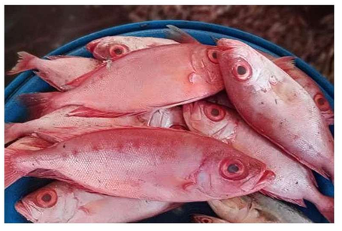

Fig. 1. Fresh specimens of Disco Rani fish used for liver and gill tissue collection.
DNA Estimation (Diphenylamine Method)
DNA concentration was estimated using Burton's diphenylamine method (Burton, 1956). Absorbance was measured at approximately 595 nm.

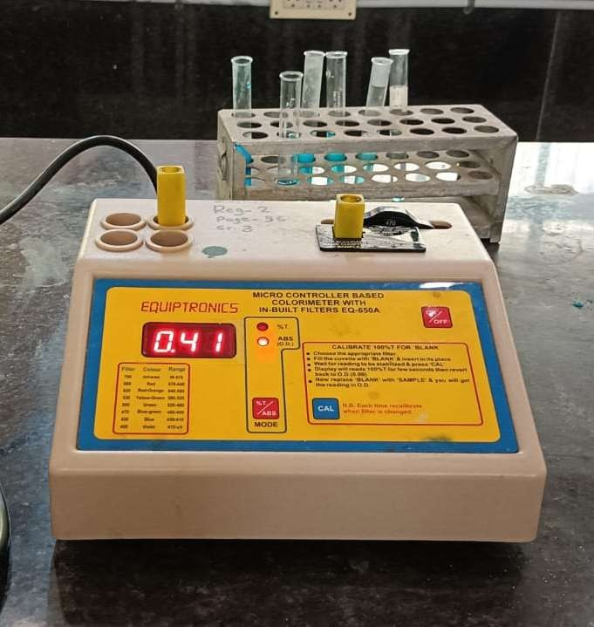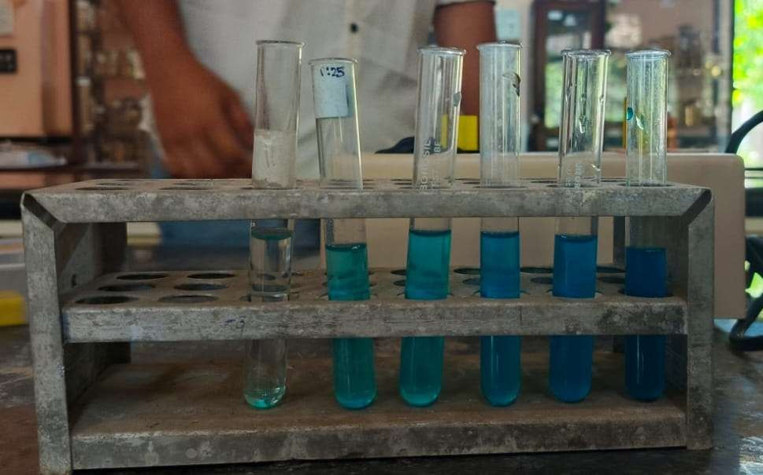

Fig 2. DNA estimation & Absorbance calculation

RNA Estimation (Orcinol Method)
RNA concentration was estimated using the orcinol method described by Almog and Shirey (1978), in which ribose forms furfural under acidic conditions and reacts with orcinol to produce a green-coloured complex. Absorbance was recorded at 660-665 nm.

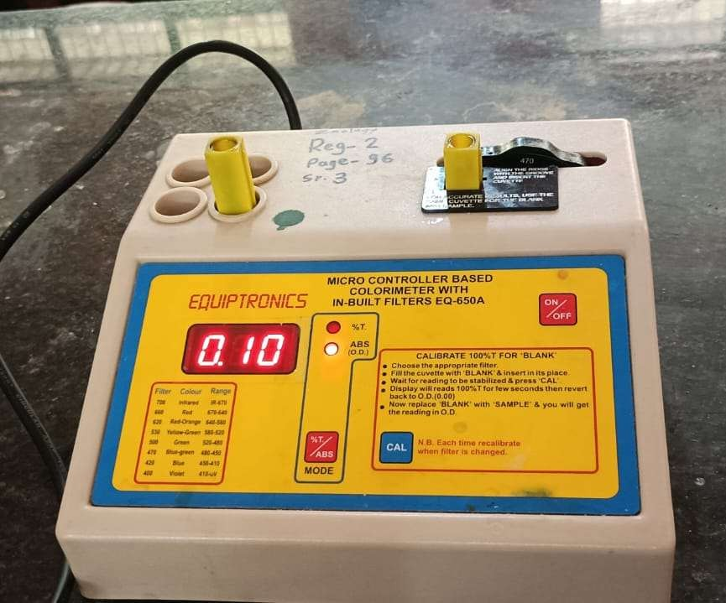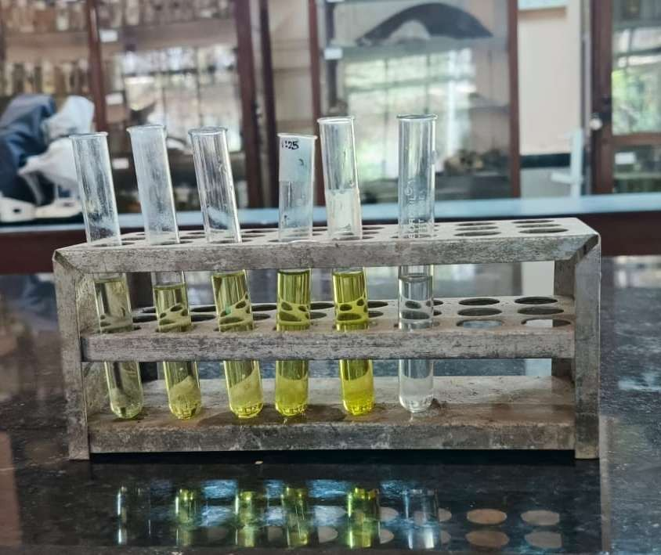

CALCULATION
Fig 3.RNA estimation & Absorbance calculation

Concentration was calculated using:

Concentration =
OD of Sample
OD of Standard

× Standard Concentration

RESULTS AND DISCUSSION

A. Standard Curve Observations

The standard curve generated for DNA estimation using the diphenylamine method exhibited a progressive increase in absorbance with increasing DNA standard concentrations, indicating a nearly linear relationship between DNA concentration and optical density. The DNA standards showed a gradual increase in absorbance with increasing concentration, indicating a positive correlation and approximate adherence to the Beer-Lambert law. The increasing colour intensity observed with increasing DNA concentration further supports the reliability of the assay for estimating nucleic acid content in fish tissues (Burton, 1956; Wilson & Walker, 2010).
The observed increase in absorbance is consistent with the principle that the diphenylamine reaction produces a measurable colour complex with deoxyribose under acidic conditions, thereby allowing DNA concentration to be estimated against a standard reference (Burton, 1956; Wilson & Walker, 2010).
Similarly, RNA estimation using the orcinol method showed an overall increase in absorbance with increasing concentrations of RNA standards. Although minor deviations from linearity were observed at intermediate concentrations, the overall trend remained sufficiently consistent for quantitative estimation. Some irregularities were observed, possibly because of minor experimental inaccuracies (Almog & Shirey, 1978; Plummer, 1988).
For the RNA assay, small deviations from linearity should be interpreted cautiously because the orcinol reaction depends on controlled acid hydrolysis, reagent stability, and consistent heating conditions; nevertheless, a monotonic overall trend supports its use for approximate comparative estimation (Almog & Shirey, 1978; Jayaram, 1981; Sawhney & Singh, 2000).
B. Graphical Representation

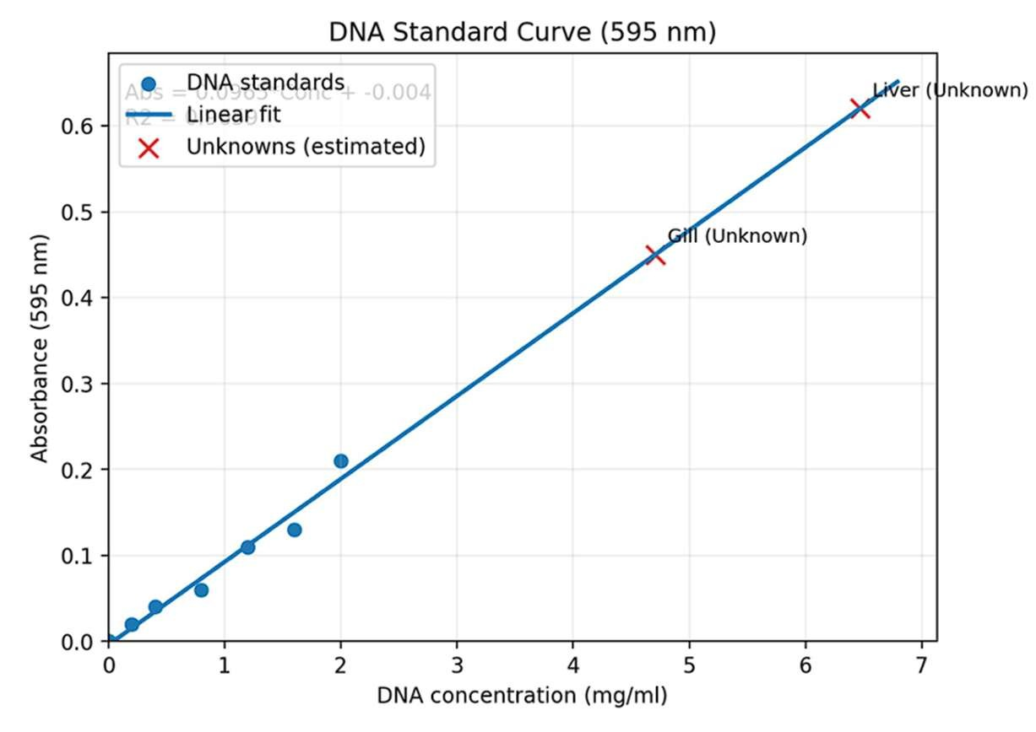

Fig. 4. DNA standard curve showing the relationship between DNA concentration and absorbance at 595 nm.
The absorbance values for the DNA standards increased gradually with increasing concentration (0.2-2.0 mg/ml), confirming a positive relationship between DNA concentration and colour intensity (Burton, 1956; Wilson & Walker, 2010).
This graphical pattern supports the suitability of the prepared DNA standard series for estimating sample concentration, provided that readings are taken within the linear working range of the assay (Burton, 1956; Wilson & Walker, 2010).
• Lowest OD (0.02) at 0.2 mg/ml

• Highest OD (0.21) at 2.0 mg/ml
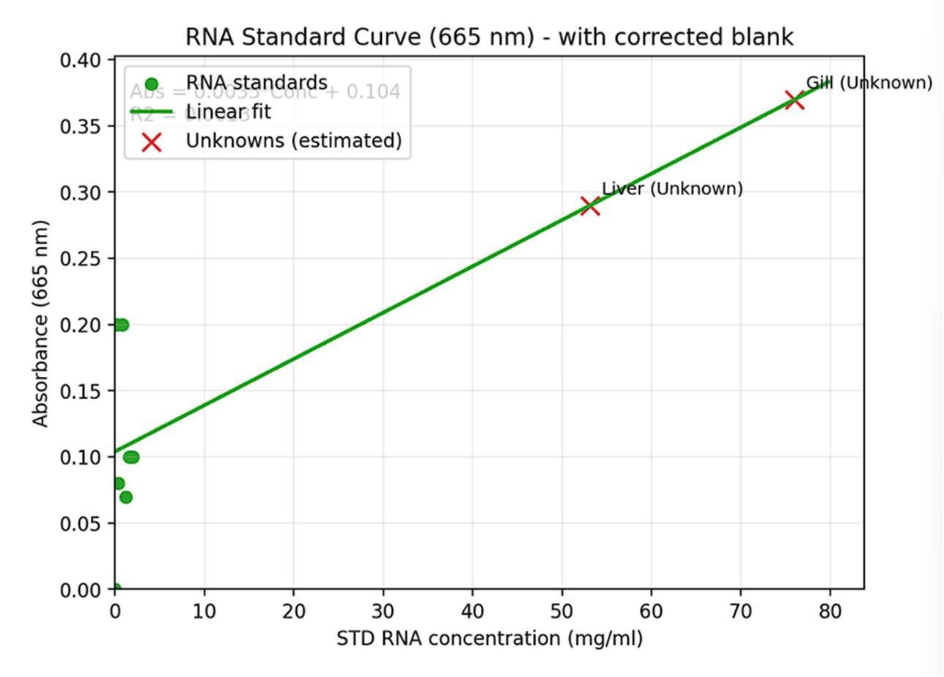
Fig. 5. RNA standard curve showing the relationship between RNA concentration and absorbance at 665 nm.
The RNA standards varied but showed an overall increasing trend in absorbance values (Almog & Shirey, 1978; Wilson & Walker, 2010). Because colorimetric RNA readings may be affected by handling and reaction conditions, the graph should be treated as a supportive calibration tool rather than definitive evidence of the exact RNA concentration (Almog & Shirey, 1978; Buckley et al., 1999).

• OD ranged from 0.00 (blank) to 0.10–0.20 range

• Some irregularity was observed (experimental error), but still usable for estimation

Table 1. Estimated Nucleic Acid Concentrations

Tissue | DNA (mg/ml) | RNA (mg/ml)
Liver | 5.90 | 5.80
Gills | 4.28 | 7.40
The higher DNA value recorded in the liver and the higher RNA value recorded in the gills indicate tissue-specific biochemical differentiation. In comparative fish studies, RNA/DNA indices are commonly interpreted as reflecting protein-synthetic capacity because DNA is comparatively stable, whereas RNA varies with growth and physiological condition (Buckley, 1984; Buckley et al., 1999; Foley et al., 2015).

D. RNA/DNA Ratio
The RNA/DNA ratio differed markedly between the tissues. The liver exhibited a ratio of 0.98, indicating moderate metabolic activity. In contrast, the gill tissue showed a higher ratio of 1.73, suggesting increased protein synthesis and functional activity associated with respiration and ion exchange. This difference reflects the tissue-specific physiological roles in the fish (Buckley, 1984; Buckley et al., 1999; Foley et al., 2015).
The higher gill RNA/DNA ratio should be interpreted as an index of greater apparent biosynthetic demand per unit of DNA, but not as direct proof of specific gene upregulation because the present colorimetric design did not measure individual transcripts (Buckley et al., 1999; Foley et al., 2015).

These observations collectively demonstrate that nucleic acid composition is tissue-dependent and reflects the specialised physiological functions of individual organs. The comparatively higher DNA concentration in the liver may indicate greater cellular density or increased genomic content associated with hepatocyte polyploidy. The elevated RNA concentration and RNA/DNA ratio in the gills suggest enhanced biosynthetic activity required to support respiration, osmoregulation, ion transport, and continuous interaction with the external aquatic environment (Evans et al., 2005; Filipiak et al., 2009; Zhang et al., 2019).

The liver result is biologically plausible because hepatocytes in vertebrates may exhibit increased nuclear DNA content through polyploidy or binucleation, whereas fish hepatocyte nuclei have also been shown to differ in DNA content from erythrocyte nuclei in flow cytometric studies (Filipiak et al., 2009; Matsumoto, 2022; Zhang et al., 2019).

DISCUSSION
The present study revealed tissue-specific variation in nucleic acid content between the liver and gills of Disco Rani fish. The higher DNA concentration observed in liver tissue is consistent with the central metabolic role of this organ. The liver is the primary site of carbohydrate, lipid, and protein metabolism, detoxification, glycogen storage, and plasma protein synthesis. In addition, fish hepatocytes are frequently polyploid and multinucleated, which contributes to greater nuclear abundance per unit of tissue mass. Therefore, the higher DNA concentration observed in liver homogenates is likely to reflect differences in tissue architecture, cellular density, and hepatocyte ploidy rather than an increase in DNA content within individual cells (Donne et al., 2020; Filipiak et al., 2009; Zhang et al., 2019).
The comparatively higher RNA concentration recorded in gill tissue reflects the continuous physiological demands placed on this organ. Fish gills are responsible for respiration, ion transport, acid-base balance, and osmoregulation, processes that require the constant synthesis of membrane transport proteins, respiratory enzymes, and structural proteins. Consequently, metabolically active gill tissue is expected to exhibit elevated RNA levels associated with increased protein synthesis, a pattern reported in previous studies of fish physiology (Buckley et al., 1999; Evans et al., 2005).
The RNA/DNA ratio provides an integrated biochemical indicator of recent physiological condition because DNA content remains relatively stable, whereas RNA content varies according to protein-synthetic activity (Buckley, 1984; Buckley et al., 1999; Foley et al., 2015). In the present study, the higher RNA/DNA ratio observed in the gills suggests greater biosynthetic activity than in liver tissue, supporting the multifunctional physiological role of the branchial epithelium. However, this interpretation should be considered cautiously because the study was limited to two tissue samples and lacked biological replication, inferential statistical analysis, and molecular validation. In addition, minor irregularities observed during RNA estimation may have resulted from experimental factors such as pipetting variation, reagent instability, or temperature fluctuations during colour development.
Overall, the tissue-specific differences in DNA concentration, RNA concentration, and the RNA/DNA ratio reflect the functional specialisation of fish organs and demonstrate the usefulness of nucleic acid composition as a biochemical indicator of cellular activity. Although preliminary, these findings provide baseline information for future investigations into fish growth, nutrition, environmental stress, and aquatic toxicology.
Future studies should include a larger number of biological replicates, taxonomic confirmation of the Disco Rani fish, validation of standard-curve regression parameters, and complementary protein or gene expression analyses to strengthen the physiological interpretation of tissue-specific nucleic acid variation.

Conclusion
The study identified descriptive differences in DNA and RNA content between the liver and gill tissues of Disco Rani fish. The estimated DNA concentration was higher in the liver (5.90 mg/ml) than in the gills (4.28 mg/ml), whereas RNA concentration was higher in the gills (7.40 mg/ml) than in the liver (5.80 mg/ml). Accordingly, the RNA/DNA ratio was greater in the gills (1.73) than in the liver (0.98). These findings indicate that nucleic acid distribution differed between the two tissues under the conditions examined. The comparatively higher liver DNA value may be related to tissue architecture, cellular density or hepatocyte nuclear characteristics. In contrast, the higher gill RNA concentration and RNA/DNA ratio may reflect the continuous biosynthetic requirements associated with respiration, osmoregulation, ion transport and tissue maintenance. Classical diphenylamine and orcinol methods therefore provided a simple basis for preliminary tissue-level comparison. However, the findings should be interpreted cautiously because the study lacked biological replication, inferential statistical testing, detailed standard-curve validation and molecular confirmation.

Limitations
This study was limited to two market-acquired fish and lacked biological replication, replicate absorbance measurements, standard deviations, and inferential statistical analysis. Tissue weights, detailed quality-control procedures, and standard-curve regression parameters were not reported. In addition, the taxonomic identity of the specimens was not independently confirmed. Therefore, the findings should be interpreted as preliminary, descriptive comparisons of liver and gill nucleic acid content rather than definitive evidence of broader physiological patterns.

Declaration of AI Use
This manuscript was prepared through the combined contributions of all author(s), including contributions to the study design, data, content development, results, interpretation, and related scholarly work. The author(s) acknowledge the use of Grammarly and ChatGPT to assist with grammar checking, language refinement, and reference formatting. These AI-assisted tools were not used as authors and did not replace the intellectual contributions or scholarly judgement of the author(s). All AI-assisted outputs, including content, references, and interpretations, were carefully reviewed, revised, verified, and approved by the author(s). The author(s) accept full responsibility for the accuracy, integrity, and final content of the manuscript.

COMPETING INTERESTS:
Authors have declared that they have no known competing financial interests OR non-financial interests OR personal relationships that could have appeared to influence the work reported in this paper.

REFERENCES
Almog, R., & Shirey, T. L. (1978). A modified orcinol test for the specific determination of RNA. Analytical Biochemistry, 91(1), 130–137. https://doi.org/10.1016/0003-2697(78)90823-0
Berg, J. M., Tymoczko, J. L., & Stryer, L. (2015). Biochemistry (8th ed.). W. H. Freeman.
Brown, T. A. (2016). Gene cloning and DNA analysis: An introduction (7th ed.). Wiley-Blackwell.
Buckley, L. J. (1984). RNA-DNA ratio: An index of larval fish growth in the sea. Marine Biology, 80(3), 291–298. https://doi.org/10.1007/BF00392824
Buckley, L. J., Caldarone, E. M., & Ong, T.-L. (1999). RNA-DNA ratio and other nucleic acid-based indicators for growth and condition of marine fishes. Hydrobiologia, 401, 265–277. https://doi.org/10.1023/A:1003798613241
Burton, K. (1956). A study of the conditions and mechanism of the diphenylamine reaction for the colorimetric estimation of deoxyribonucleic acid. Biochemical Journal, 62(2), 315–323. https://doi.org/10.1042/bj0620315
Bury, N. R., Grosell, M., Wood, C. M., & Wilson, R. W. (2022). Fish physiology in a changing aquatic environment. Journal of Experimental Biology, 225, jeb243770. https://doi.org/10.1242/jeb.243770
Dhotre, M. A., Nalle, D. A., & Kadam, S. (2024). Investigation of potential probiotic bacterium (Bacillus subtilis CCI3) in the formulated diets on immunity, growth performance and nutritional quality of Cyprinus carpio. Asian Journal of Fisheries and Aquatic Research, 26(7), 25–42. https://doi.org/10.9734/ajfar/2024/v26i7781
Donne, R., Saroul-Ainama, M., Cordier, P., Celton-Morizur, S., & Desdouets, C. (2020). Polyploidy in liver development, homeostasis and disease. Nature Reviews Gastroenterology & Hepatology, 17, 391–405. https://doi.org/10.1038/s41575-020-0284-x
Elliott, W. H., & Elliott, D. C. (2005). Biochemistry and molecular biology. Oxford University Press.
Evans, D. H., Piermarini, P. M., & Choe, K. P. (2005). The multifunctional fish gill: Dominant site of gas exchange, osmoregulation, acid-base regulation, and excretion of nitrogenous waste. Physiological Reviews, 85(1), 97–177. https://doi.org/10.1152/physrev.00050.2003
Filipiak, M., Tylko, G., & Kilarski, W. (2009). DNA content of hepatocyte and erythrocyte nuclei of the spined loach (Cobitis taenia L.) and its polyploid forms. Fish Physiology and Biochemistry, 35, 523–529. https://doi.org/10.1007/s10695-009-9322-x
Foley, C. J., Bradley, D. L., & Hook, T. O. (2015). A review and assessment of the potential use of RNA:DNA ratios to assess the condition of entrained fish larvae. Ecological Indicators, 60, 346–357. https://doi.org/10.1016/j.ecolind.2015.07.005
Gao, Y., Jin, Q., Gao, C., Chen, Y., Sun, Z., Guo, G., & Peng, J. (2022). Unraveling differential transcriptomes and cell types in zebrafish larvae intestine and liver. Cells, 11(20), 3290. https://doi.org/10.3390/cells11203290
Gupta, P. K. (2013). Genetics. Rastogi Publications.
Hou, Z.-G., Xing, M.-C., Luo, J.-X., Xu, Y.-H., Zhang, L.-H., Gao, X.-W., Wang, J.-J., Hanafiah, F., Khor, W., Hao, X., Zhao, X., & Wu, C.-B. (2025). Single-cell transcriptome sequencing analysis of physiological and immune profiling of crucian carp (Carassius auratus) gills. Fish & Shellfish Immunology, 157, 110087. https://doi.org/10.1016/j.fsi.2024.110087
Jayaram, J. (1981). Laboratory manual in biochemistry. New Age International.
Koppang, E. O., Kvellestad, A., & Fischer, U. (2023). Fish mucosal immunity and gill physiology in changing aquatic environments. Frontiers in Immunology, 14, 1180890. https://doi.org/10.3389/fimmu.2023.1180890
Lodish, H., Berk, A., Kaiser, C. A., Krieger, M., Bretscher, A., Ploegh, H., Amon, A., & Martin, K. C. (2016). Molecular cell biology (8th ed.). W. H. Freeman.
Matsumoto, T. (2022). Implications of polyploidy and ploidy alterations in hepatocytes in liver injuries and cancers. International Journal of Molecular Sciences, 23(16), 9409. https://doi.org/10.3390/ijms23169409
Nelson, D. L., & Cox, M. M. (2017). Lehninger principles of biochemistry (7th ed.). W. H. Freeman.
Plummer, D. T. (1988). An introduction to practical biochemistry (3rd ed.). Tata McGraw-Hill.
Sambrook, J., & Russell, D. W. (2001). Molecular cloning: A laboratory manual (3rd ed.). Cold Spring Harbor Laboratory Press.
Sathiamoorthi, M., Parvathiraj, P., Sornalatha, S., & Esakkiammal, M. (2026). Proteomic approaches in fish biology: Insights into aquaculture, stress responses, and disease: A mini-review. Journal of Biology and Nature, 18(1), 517–524. https://doi.org/10.56557/joban/2026/v18i110524
Sawhney, S. K., & Singh, R. (2000). Introductory practical biochemistry. Narosa Publishing House.
Seebacher, F., White, C. R., & Franklin, C. E. (2021). Physiological plasticity increases resilience of ectothermic animals to climate change. Nature Reviews Earth & Environment, 2, 21–34. https://doi.org/10.1038/s43017-020-00115-8
Voet, D., & Voet, J. G. (2011). Biochemistry (4th ed.). Wiley.
Wilson, K., & Walker, J. (2010). Principles and techniques of biochemistry and molecular biology (7th ed.). Cambridge University Press.
Zhang, S., Lin, Y.-H., Tarlow, B., & Zhu, H. (2019). The origins and functions of hepatic polyploidy. Cell Cycle, 18(12), 1302–1315. https://doi.org/10.1080/15384101.2019.1618123
Zheng, S., & Wang, W.-X. (2023). Physiological and immune profiling of tilapia Oreochromis niloticus gills by high-throughput single-cell transcriptome sequencing. Fish & Shellfish Immunology, 141, 109070. https://doi.org/10.1016/j.fsi.2023.109070

