Original Research Article
PCR-Based Monitoring of Short-Term Response to Quinapyramine Treatment in Naturally Occurring Equine Surra in Eastern Uttar Pradesh, India

Abstract
Equine surra, caused by Trypanosoma evansi, is an important haemoprotozoan disease of working equids. This prospective descriptive pilot field study evaluated short-term changes after quinapyramine treatment and monitored T. evansi DNA detection during follow-up. Twelve indigenous horses from Ghazipur district, Uttar Pradesh, India, were included. Six naturally infected PCR-positive horses received a commercial quinapyramine preparation at 5.0 mg/kg body weight by subcutaneous injection, and six PCR-negative horses served as contemporaneous comparison animals. Blood collected on Days 0, 3, 7, 14, and 21 was examined by the microhaematocrit centrifugation technique, Giemsa-stained blood-smear examination, conventional PCR targeting a 196-bp invariable surface glycoprotein sequence, and indirect antibody ELISA. No parasites were detected microscopically in treated horses from Day 3 onward. PCR-negative status was recorded in 2/6 horses on Day 3, 4/6 on Day 7, and 3/6 on Days 14 and 21. The greatest observed PCR-negative proportion was therefore 66.7% on Day 7, followed by 50.0% on Days 14 and 21. The recorded group-level antibody relative percentage positivity increased from 75 on Day 0 to 90 and 91 on Days 3 and 7, respectively, and declined to 50 and 51 on Days 14 and 21. The findings indicate rapid suppression of microscopically detectable parasitaemia but incomplete and non-sustained PCR-negative conversion in some horses during the 21-day follow-up. Conventional PCR provided additional post-treatment information beyond microscopy, whereas antibody ELISA reflected continuing antibody reactivity rather than immediate parasitological cure. Larger controlled studies with longer follow-up and quantitative molecular testing are required to define treatment effectiveness more precisely.
Keywords: Trypanosoma evansi; equine surra; quinapyramine; treatment monitoring; ISG-PCR; antibody ELISA

1. Introduction
Surra is a mechanically transmitted animal trypanosomosis caused by Trypanosoma evansi. Recent evidence indicates that equine trypanosomiasis remains concentrated in low- and middle-income countries and contributes substantially to equine morbidity and mortality, reinforcing its continuing importance for the health and welfare of working equids (Raftery et al., 2026a). The parasite has a broad geographical distribution and infects numerous domestic and wild mammals, with clinically important disease particularly reported in equids, camels, and dogs. Transmission is principally associated with haematophagous flies, especially tabanids and stomoxyine flies, although iatrogenic and vertical routes may also occur. Clinical manifestations in horses are variable and may include intermittent fever, progressive anaemia, weakness, loss of body condition, petechial haemorrhages, dependent oedema, ocular lesions, and, in some cases, neurological involvement (Aregawi et al., 2019; Desquesnes et al., 2013a, 2013b). A recent investigation involving horses demonstrated marked variation in clinical presentation and incomplete agreement among microscopic, serological, and molecular findings, supporting the complementary rather than interchangeable use of these diagnostic approaches (Javanshir et al., 2023). Equine trypanosomosis remains diagnostically challenging because clinical signs are not pathognomonic and parasitaemia may fluctuate below the detection threshold of direct microscopic methods (Büscher et al., 2019).
Diagnosis and post-treatment assessment are strengthened by combining parasite detection, DNA detection, and antibody detection. Microscopy provides direct evidence of circulating parasites but has limited sensitivity when parasitaemia is low. Molecular assays can detect parasite DNA at lower apparent parasitaemia, whereas antibody assays are useful for documenting exposure but may remain positive after treatment and cannot, by themselves, establish active infection or parasitological cure (Desquesnes et al., 2022; Kim et al., 2024). Recent molecularly confirmed equine infections have further demonstrated that PCR can establish the presence of T. evansi while clinicopathological measurements characterise the associated systemic effects, illustrating the value of integrating molecular and clinical laboratory evidence (Shoraba et al., 2024). Chemotherapy remains central to surra management, but the limited number of trypanocidal compounds, variable field efficacy, possible reinfection, tissue persistence, and treatment-associated recurrence complicate interpretation of short-term response (Giordani et al., 2016; Raftery et al., 2026b). Experimental work with a pony-derived T. evansi isolate has shown that exposure to quinapyramine methyl sulphate alters the expression of parasite genes involved in cellular homeostasis and metabolic regulation, although these molecular effects should not be interpreted as evidence of clinical cure (Gupta et al., 2022).
However, evidence remains limited regarding the short-term agreement among microscopy, conventional ISG-PCR, and antibody ELISA after quinapyramine treatment in naturally infected horses under field conditions in eastern Uttar Pradesh. In particular, the persistence or re-detection of T. evansi DNA during early follow-up requires further characterisation alongside parasitological and serological findings.
The present study aimed to describe the 21-day parasitological, molecular, and serological changes after quinapyramine treatment in naturally infected horses and to assess whether conventional ISG-PCR provided additional information beyond direct microscopy during short-term follow-up.

2. Materials and Methods

2.2 Recruitment of Study Animals
Study animals were selected in Ghazipur district, Uttar Pradesh, India. On the basis of information provided by local field veterinarians, horses showing clinical signs compatible with surra were identified, and blood samples were transported to the Department of Veterinary Parasitology, Acharya Narendra Deva University of Agriculture and Technology, Kumarganj, Ayodhya, for laboratory examination. Initial parasitological assessment included Giemsa-stained blood-smear examination. Horses reported by their owners to have received trypanocidal treatment during the preceding month, animals showing neurological manifestations, and animals with other severe concurrent illnesses were excluded to reduce avoidable clinical risk and major confounding during follow-up. Representative nonspecific clinical findings compatible with surra are shown in Figure 1.
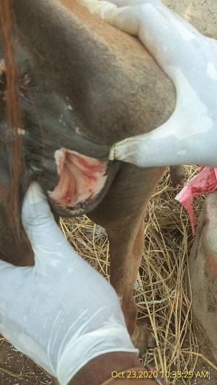 | 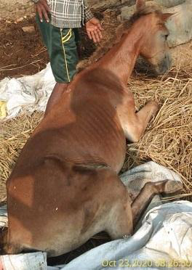
Figure 1. Petechial haemorrhages on the vaginal mucosa and a horse showing nonspecific clinical signs compatible with surra.

2.3 Study Design and Treatment
This was a prospective descriptive pilot field study with an uninfected comparison group. A total of 12 indigenous horses older than two years were enrolled. Six horses confirmed as PCR-positive for T. evansi formed the treatment group (T-1), and six PCR-negative horses formed the comparison group (C). The PCR-negative group provided contemporaneous negative comparison samples and was not an infected treatment control group. Horses in group T-1 received a commercial quinapyramine preparation (Triquin®, Vetoquinol) at the recorded dose of 5.0 mg/kg body weight by subcutaneous injection in the neck region. The comparison group remained untreated. The administered preparation, dose, recorded concentration, injection site, and route are summarised in Table 1. Supportive nutritional and symptomatic management was provided to treated animals when clinically required. Clinical observations and laboratory assessments were recorded before treatment and at the scheduled post-treatment sampling times.
Table 1. Trypanocidal preparation, dose, recorded concentration, injection site, and route of administration on Day 0.
Group (no. of animals) | Preparation | Dose | Recorded concentration | Injection site | Route of administration
T-1 (n = 6) | Commercial quinapyramine preparation (Triquin®, Vetoquinol) | 5.0 mg/kg body weight | 10% | Neck region | Subcutaneous, using a 20 G, 1.5-inch needle
C (n = 6) | None | - | - | - | -
Note. The chemical designation is reported as documented in the original study treatment record; interpretation in this article is limited to the administered commercial preparation and recorded dose.

2.4 Estimation of Body Weight for Dose Calculation
Body weight was estimated from body length and heart-girth measurements in centimetres using the equation described by Carroll and Huntington (1988):
Estimated body weight (kg) = [heart girth (cm)]² × body length (cm) / 11,900

2.5 Parameters Assessed Before and After Drug Administration
Parasitological, molecular, and serological observations were obtained before treatment on Day 0 and after treatment on Days 3, 7, 14, and 21, as summarised in Table 2.
Table 2. Laboratory observations and sampling schedule.
S. No. | Parameter | Method | Sampling schedule
1 | Parasitological examination | MHCT and Giemsa-stained blood-smear examination | Day 0 before treatment; Days 3, 7, 14, and 21 after treatment
2 | Molecular diagnosis | ISG-PCR | Day 0 before treatment; Days 3, 7, 14, and 21 after treatment
3 | Serological diagnosis | Indirect antibody ELISA | Day 0 before treatment; Days 3, 7, 14, and 21 after treatment

2.6 Blood-Sample Collection
Approximately 5 mL of blood was collected aseptically from the jugular vein of each horse at each of the five sampling occasions using sterile disposable syringes and 20 G, 1.5-inch needles. Samples were divided between K3-EDTA tubes for parasitological examination and DNA extraction and clot-activator tubes for serum separation and antibody ELISA. The same sampling schedule was applied to treatment and comparison animals (Table 2; Figure 2).
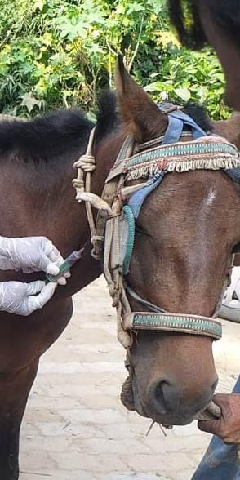 | 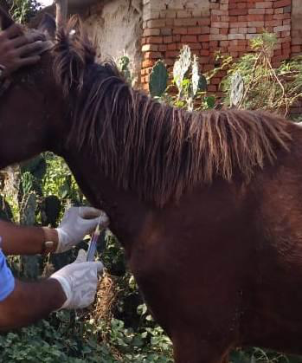
Figure 2. Jugular blood-sample collection from study horses.

2.7 Parasitological Examination

2.7.1 Microhaematocrit Centrifugation Technique
Anticoagulated blood was examined for motile trypanosomes using the microhaematocrit centrifugation technique described by Woo (1970). The buffy-coat region was examined microscopically (Figure 3).

2.7.2 Blood-Smear Examination
Thin blood smears were prepared from approximately 3–5 µL of blood, air-dried, fixed in absolute methanol for 10 minutes, and stained for 45 minutes with Giemsa stain diluted 1:10 in phosphate-buffered saline (pH 7.2). Stained smears were examined by oil-immersion microscopy for haemoprotozoan parasites (Figure 3).
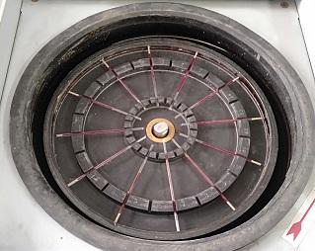 | 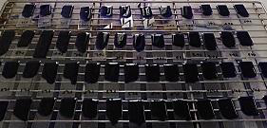
Figure 3. Equipment and prepared samples used for microhaematocrit centrifugation and Giemsa-stained blood-smear examination.

2.8 Molecular Diagnosis

2.8.1 DNA Extraction
Total genomic DNA was extracted from 100 µL of EDTA-anticoagulated whole blood using a DNeasy Blood and Tissue Kit (Qiagen India Pvt. Ltd., New Delhi) according to the manufacturer's instructions. Blood was mixed with 20 µL of proteinase K, adjusted to 220 µL with phosphate-buffered saline, combined with 200 µL of buffer AL, and incubated at 56°C for 10 minutes. After addition of 200 µL of absolute ethanol, the lysate was transferred to a DNeasy spin column. Columns were washed sequentially with buffers AW1 and AW2, and DNA was eluted in 30 µL of buffer AE and stored at -40°C until analysis.

2.8.2 Invariable Surface Glycoprotein PCR
Molecular detection was performed using conventional PCR with the ISG196-F and ISG196-R primers, which target a conserved invariable surface glycoprotein sequence and generate a 196-bp amplicon (Kumar et al., 2016). Primer sequences are presented in Table 3. Each 25 µL reaction contained 12.5 µL of 2× TopTaq Master Mix (Qiagen), 1.0 µL of each primer, 2.0 µL of template DNA, and 8.5 µL of nuclease-free water. The thermal-cycling conditions are presented in Table 4. Amplified products were resolved on a 1.5% agarose gel containing an appropriate nucleic-acid stain and visualised under ultraviolet illumination. A distinct band at 196 bp was interpreted as PCR-positive.
Table 3. Primer sequences used for ISG-PCR.
Primer | Sequence (5' to 3') | Length (bp) | Amplicon size
ISG196-F | AAAGCCACCGAAGATGCAGA | 20 | 196 bp
ISG196-R | TTGTCCCAATCCAGCCACTC | 20 | 196 bp
Table 4. Reaction mixture and thermal-cycling conditions for ISG-PCR.
A. Reaction mixture
Component | Quantity
2× TopTaq Master Mix | 12.5 µL
Forward primer (10 µM) | 1.0 µL
Reverse primer (10 µM) | 1.0 µL
Nuclease-free water | 8.5 µL
Template DNA | 2.0 µL
Total reaction volume | 25.0 µL
B. Thermal-cycling programme
Step | Temperature | Time | Cycles
Initial denaturation | 95°C | 5 min | 1
Denaturation | 95°C | 30 s | 32
Annealing | 58°C | 30 s | 32
Extension | 72°C | 30 s | 32
Final extension | 72°C | 10 min | 1

2.9 Serological Diagnosis

2.9.1 Indirect Antibody ELISA
Serum was separated by centrifugation and stored at -20°C until analysis. Antibodies against T. evansi were detected using an indirect ELISA based on whole-cell lysate antigen, following the procedure reported for equids by Kumar et al. (2013). Microplates were coated overnight at 4°C with 500 ng of whole-cell lysate antigen in carbonate-bicarbonate buffer (0.1 M, pH 9.6). After washing with phosphate-buffered saline containing 0.05% Tween 20, plates were blocked with 5% skimmed milk in washing buffer for one hour at 37°C. Serum samples diluted 1:100 were tested in duplicate. Anti-horse IgG conjugate diluted 1:15,000 was then added, and colour was developed with tetramethylbenzidine substrate. The reaction was stopped with 1 M sulphuric acid, and optical density was measured at 450 nm. Recent validation of in vitro-produced and freeze-dried T. evansi whole-cell lysate antigens in a camel ELISA demonstrated that antigen production and preservation can materially influence assay reproducibility, emphasising the importance of standardised antigen preparations and plate-level controls in whole-cell lysate serology (Bossard & Desquesnes, 2023).

RPP (%) = [(mean OD of test sample - mean OD of negative control) / (mean OD of positive control - mean OD of negative control)] × 100

Relative percentage positivity (RPP) was calculated using the reference-control-corrected formula reported by Kumar et al. (2013). An RPP value greater than 15% was interpreted as seropositive, consistent with the cut-off established for the equine whole-cell lysate antibody ELISA. Because antibodies can persist after treatment, the ELISA findings were interpreted as evidence of antibody reactivity rather than as an immediate measure of parasitological cure (Monzon et al., 2003; Yadav et al., 2014).

2.10 Data Analysis
The study was analysed descriptively because only six infected horses received treatment. PCR results are reported as animal counts and percentages at each sampling time, with fractions presented to show the underlying denominators. ELISA findings are reported as the recorded group-level RPP values; individual-animal dispersion measures were not available. GraphPad Prism version 8.0.2 was used for data organisation and graphical presentation. No inferential comparisons were used to support treatment-effect claims.

3. Results and Discussion

3.1 Parasitological Findings
All six treated horses were parasitologically positive before treatment. From Day 3 to Day 21, T. evansi was not detected in treated horses by either microhaematocrit centrifugation or Giemsa-stained blood-smear examination. The comparison horses remained negative. Representative pre-treatment blood-smear fields are shown in Figure 4.
The early disappearance of microscopically detectable parasitaemia is compatible with a rapid reduction in circulating parasite numbers after treatment. Nevertheless, microscopy has limited sensitivity when parasitaemia is low or fluctuating, and a negative microscopic result should not be equated with complete elimination of infection. This limitation is particularly relevant in equine trypanosomosis, for which combined diagnostic approaches are recommended (Büscher et al., 2019; Desquesnes et al., 2022; Kim et al., 2024).
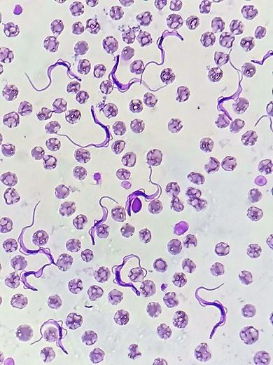 | 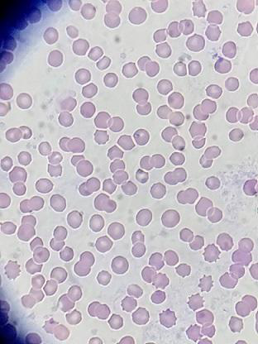
Figure 4. Representative Giemsa-stained blood-smear fields from the T-1 and C groups before treatment.

3.2 ISG-PCR Findings
All six horses in group T-1 were PCR-positive on Day 0, whereas all six comparison horses were PCR-negative throughout the observation period. Following treatment, 2/6 treated horses (33.3%) were PCR-negative on Day 3 and 4/6 (66.7%) were PCR-negative on Day 7. On Days 14 and 21, 3/6 horses (50.0%) were PCR-negative and 3/6 (50.0%) remained PCR-positive (Table 5). Thus, the maximum observed PCR-negative count occurred on Day 7, and the group-level number of PCR-negative horses subsequently decreased from four to three. The study records also documented re-detection of PCR positivity after an intervening negative result. Representative longitudinal gel findings are presented in Figure 5.
Table 5. ISG-PCR results in comparison and treated horses before and after treatment.
Treatment phase | Day | C (n = 6), PCR-negative | T-1 (n = 6), PCR-positive | T-1 (n = 6), PCR-negative | Recorded PCR re-detection after an earlier negative result
Pre-treatment | D-0 | 6 | 6 | 0 | 0
Post-treatment | D-3 | 6 | 4 | 2 | 0
Post-treatment | D-7 | 6 | 2 | 4 | 0
Post-treatment | D-14 | 6 | 3 | 3 | 1
Post-treatment | D-21 | 6 | 3 | 3 | 1
The difference between microscopy and PCR results is biologically and analytically plausible because PCR can detect parasite DNA at lower apparent parasitaemia than direct microscopy. ISG-based PCR has been developed for sensitive detection of T. evansi, and quantitative molecular methods can further characterise changes in parasite load (Kankar et al., 2016; Kumar et al., 2016). However, endpoint PCR detects DNA rather than parasite viability. Persistent or re-detected PCR positivity may therefore reflect continuing low-level infection, intermittent circulation of parasite DNA, sampling variation, or reinfection under field exposure. The present design cannot distinguish among these explanations.
Post-treatment recurrence or reinfection has been reported in equine trypanosomosis. Reinfection after treatment with a quinapyramine sulphate-chloride preparation was documented under endemic field conditions in eastern India, and neurological disease has also been observed after apparent clinical recovery in quinapyramine-treated horses (Laha & Sasmal, 2008; Ranjithkumar et al., 2014). More broadly, available equine treatment studies are heterogeneous, and a recent systematic review found that favourable short-term blood-parasitaemia responses do not exclude later clinical recurrence (Raftery et al., 2026b). Field trials likewise demonstrate the value of molecular follow-up when trypanocidal regimens are evaluated (Raftery et al., 2019). Accordingly, the present results support post-treatment monitoring but do not establish the anatomical source, viability, or drug susceptibility of the detected parasite material. Concerns regarding limited therapeutic options and possible resistance further justify carefully designed comparative studies (Giordani et al., 2016).
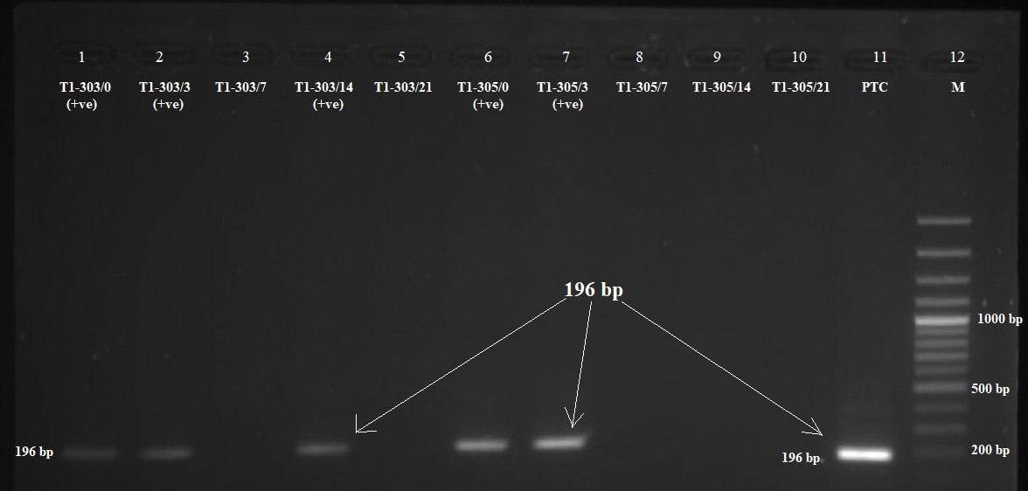
Figure 5. Agarose gel electrophoresis showing ISG-PCR amplification of the 196 bp T. evansi-specific fragment in two naturally infected horses (TI-303 and TI-305) before and after quinapyramine treatment. Lanes 1-5 represent horse TI-303: lane 1, Day 0; lane 2, Day 3; lane 3, Day 7; lane 4, Day 14; and lane 5, Day 21. Lanes 6-10 represent horse TI-305: lane 6, Day 0; lane 7, Day 3; lane 8, Day 7; lane 9, Day 14; and lane 10, Day 21. The 196 bp fragment was observed in lanes 1, 2, and 4 for TI-303 and lanes 6, 7, and 10 for TI-305, showing persistent or intermittently re-detected T. evansi DNA at the indicated sampling times. Lane 11, positive control; lane 12, 100 bp DNA ladder.

3.3 Indirect Antibody-ELISA Findings
Before treatment, the recorded group-level RPP value was 75 in group T-1 and 3 in the comparison group. In treated horses, RPP increased to 90 on Day 3 and 91 on Day 7, then declined to 50 on Day 14 and 51 on Day 21. Comparison-group RPP values remained low throughout follow-up, with recorded values of 3, 5, 8, 11, and 7 on Days 0, 3, 7, 14, and 21, respectively (Table 6; Figure 6). All recorded treatment-group values remained above the 15% seropositivity threshold.
The early increase and subsequent decline in RPP are compatible with an evolving humoral response after treatment, but group-level ELISA data do not demonstrate immediate parasitological cure. Antibody responses may remain detectable for prolonged periods after treatment. Recent Indian work in equids has also demonstrated broad antibody recognition of immunodominant T. evansi whole-cell lysate components, supporting the use of ELISA for exposure assessment while confirming that antibody reactivity does not directly demonstrate viable circulating parasitaemia (Sharma et al., 2022). Monzon et al. (2003) observed a progressive decline in antibody levels in treated horses, although seropositivity persisted for months in some animals and increased again in horses with post-treatment recurrence. Similarly, Yadav et al. (2014) documented antibody persistence for several months after treatment in equids. The present 21-day follow-up is therefore too short to expect seronegative conversion or to use ELISA alone as a treatment endpoint.
Table 6. Recorded group-level relative percentage positivity values obtained by antibody ELISA before and after treatment.
Treatment phase | Day | C (n = 6), recorded RPP | T-1 (n = 6), recorded RPP
Pre-treatment | D-0 | 3 | 75
Post-treatment | D-3 | 5 | 90
Post-treatment | D-7 | 8 | 91
Post-treatment | D-14 | 11 | 50
Post-treatment | D-21 | 7 | 51
Note. Values are the group-level RPP records available for the study; individual-animal dispersion measures were not available.
Taken together, microscopy, PCR, and ELISA provided complementary information. Microscopy indicated suppression below the direct-detection threshold, PCR showed that sustained PCR-negative status was not achieved in all horses, and ELISA documented continuing antibody reactivity. The findings therefore support multimodal post-treatment assessment rather than reliance on a single diagnostic method.
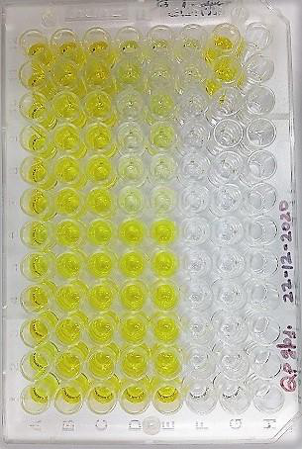 | 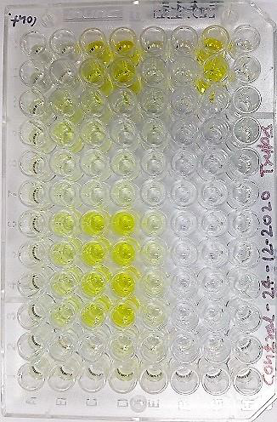
Figure 6. Representative antibody-ELISA plates for pre-treatment and post-treatment serum samples from the T-1 and C groups.

4. Conclusion
Quinapyramine treatment was followed by the disappearance of microscopically detectable parasitaemia from Day 3 onward in the six naturally infected horses. The number of PCR-negative horses increased to 4/6 on Day 7 but decreased to 3/6 on Days 14 and 21. Antibody RPP values remained positive throughout the 21-day period despite declining after Day 7. These findings indicate a rapid short-term reduction below the microscopic detection threshold but incomplete and non-sustained PCR-negative conversion in some animals. ISG-PCR added useful post-treatment information beyond microscopy, while antibody ELISA was most appropriately interpreted as a marker of exposure and humoral response. Longer molecular follow-up and adequately powered comparative studies are required before firm conclusions can be drawn regarding cure rates or optimal treatment regimens.

5. Limitations
This pilot study included only six treated PCR-positive horses, which limits precision and generalisability. Follow-up ended at Day 21 and may not have captured delayed recurrence. The study did not include an untreated infected group or an alternative-treatment comparator, and randomisation and blinding were not described. The exact chemical formulation of the commercial preparation could not be independently evaluated beyond the designation documented in the treatment record. Supportive management, when required, may have influenced clinical recovery. Conventional endpoint PCR provided qualitative detection but did not quantify parasite burden or establish parasite viability. Possible tissue persistence, including central nervous system involvement, was not investigated directly. ELISA findings were available as group-level RPP values without individual dispersion, and antibodies may persist after successful treatment. Reinfection could not be excluded under field conditions. Future studies should include larger cohorts, individual longitudinal datasets, longer follow-up, quantitative molecular assays, clinical and haematological outcomes, and comparative treatment protocols.

Declaration of AI Use
The authors used Grammarly and ChatGPT for grammar checking, language refinement, and reference formatting. These tools were not used as authors and did not replace the intellectual contributions or scholarly judgement of the authors. All AI-assisted outputs were reviewed, revised, and verified by the authors, who accept full responsibility for the accuracy, integrity, and final content of the manuscript.

Ethical Approval and Consent
Prior to commencement of the study, ethical approval was obtained from the Institutional Animal Ethics Committee of Acharya Narendra Deva University of Agriculture and Technology, Kumarganj, Ayodhya, Uttar Pradesh, India (Approval No. IAEC/CVSc/2/P-32/2020/26). The horses were examined and sampled with the informed consent of their owners, and all procedures were undertaken with due consideration for animal welfare.

Competing Interests
The authors declare that they have no known competing financial interests, non-financial interests, or personal relationships that could have appeared to influence the work reported in this paper.

References
Aregawi, W. G., Agga, G. E., Abdi, R. D., & Büscher, P. (2019). Systematic review and meta-analysis on the global distribution, host range, and prevalence of Trypanosoma evansi. Parasites & Vectors, 12(1), Article 67. https://doi.org/10.1186/s13071-019-3311-4
Bossard, G., & Desquesnes, M. (2023). Validation of in vitro-produced and freeze-dried whole-cell lysate antigens for ELISA Trypanosoma evansi antibody detection in camels. Veterinary Parasitology, 320, Article 109980. https://doi.org/10.1016/j.vetpar.2023.109980
Büscher, P., Gonzatti, M. I., Hébert, L., Inoue, N., Pascucci, I., Schnaufer, A., Suganuma, K., Touratier, L., & Van Reet, N. (2019). Equine trypanosomosis: Enigmas and diagnostic challenges. Parasites & Vectors, 12(1), Article 234. https://doi.org/10.1186/s13071-019-3484-x
Carroll, C. L., & Huntington, P. J. (1988). Body condition scoring and weight estimation of horses. Equine Veterinary Journal, 20(1), 41–45. https://doi.org/10.1111/j.2042-3306.1988.tb01451.x
Desquesnes, M., Dargantes, A., Lai, D.-H., Lun, Z.-R., Holzmuller, P., & Jittapalapong, S. (2013a). Trypanosoma evansi and surra: A review and perspectives on transmission, epidemiology and control, impact, and zoonotic aspects. BioMed Research International, 2013, Article 321237. https://doi.org/10.1155/2013/321237
Desquesnes, M., Gonzatti, M., Sazmand, A., Thévenon, S., Bossard, G., Boulangé, A., Gimonneau, G., Truc, P., Herder, S., Ravel, S., Sereno, D., Jamonneau, V., Jittapalapong, S., Jacquiet, P., Solano, P., & Berthier, D. (2022). A review on the diagnosis of animal trypanosomoses. Parasites & Vectors, 15(1), Article 64. https://doi.org/10.1186/s13071-022-05190-1
Desquesnes, M., Holzmuller, P., Lai, D.-H., Dargantes, A., Lun, Z.-R., & Jittaplapong, S. (2013b). Trypanosoma evansi and surra: A review and perspectives on origin, history, distribution, taxonomy, morphology, hosts, and pathogenic effects. BioMed Research International, 2013, Article 194176. https://doi.org/10.1155/2013/194176
Giordani, F., Morrison, L. J., Rowan, T. G., de Koning, H. P., & Barrett, M. P. (2016). The animal trypanosomiases and their chemotherapy: A review. Parasitology, 143(14), 1862–1889. https://doi.org/10.1017/S0031182016001268
Gupta, S., Vohra, S., Sethi, K., Gupta, S., Kumar, S., & Kumar, R. (2022). Gene expression study to elucidate the anti-trypanosomal activity of quinapyramine methyl sulphate (QPS). Parasitology International, 91, Article 102632. https://doi.org/10.1016/j.parint.2022.102632
Javanshir, A., Tavassoli, M., & Esmaeilnejad, B. (2023). Morphological, serological, molecular detection, and phylogenetic analysis of Trypanosoma evansi in horses of different regions in Iran. Parasitology Research, 122(8), 1873–1881. https://doi.org/10.1007/s00436-023-07888-2
Kankar, S. K., Kumar, R., Goyal, S. K., Gaur, D. K., Sharma, P., Bera, B. C., Garg, R., Kumar, S., & Yadav, S. C. (2016). Quantification of Trypanosoma evansi parasitic load in experimentally infected mice using real-time PCR assay and its comparative evaluation with conventional parasitological techniques. The Indian Journal of Animal Sciences, 86(12), 1378–1384. https://doi.org/10.56093/ijans.v86i12.65949
Kim, J., Álvarez-Rodríguez, A., Li, Z., Radwanska, M., & Magez, S. (2024). Recent progress in the detection of surra, a neglected disease caused by Trypanosoma evansi with a One Health impact in large parts of the tropic and sub-tropic world. Microorganisms, 12(1), Article 44. https://doi.org/10.3390/microorganisms12010044
Kumar, R., Gaur, D. K., Goyal, S. K., Sharma, P., Kankar, S. K., Jain, S., & Kumar, S. (2016). Sensitive detection of Trypanosoma evansi infection by polymerase chain reaction targeting invariable surface glycoprotein gene. The Indian Journal of Animal Sciences, 86(6), 639–642. https://doi.org/10.56093/ijans.v86i6.59148
Kumar, R., Kumar, S., Khurana, S. K., & Yadav, S. C. (2013). Development of an antibody-ELISA for seroprevalence of Trypanosoma evansi in equids of North and North-western regions of India. Veterinary Parasitology, 196(3–4), 251–257. https://doi.org/10.1016/j.vetpar.2013.04.018
Laha, R., & Sasmal, N. K. (2008). Endemic status of Trypanosoma evansi infection in a horse stable of eastern region of India: A field investigation. Tropical Animal Health and Production, 40(5), 357–361. https://doi.org/10.1007/s11250-007-9107-0
Monzon, C. M., Mancebo, O. A., & Russo, A. M. (2003). Antibody levels by indirect ELISA test in Trypanosoma evansi-infected horses following treatment with quinapyramine sulphate. Veterinary Parasitology, 111(1), 59–63. https://doi.org/10.1016/S0304-4017(02)00331-X
Raftery, A. G., Gummery, L., Garcia, K., Mohite, D., Capewell, P., & Sutton, D. G. M. (2026a). Equine trypanosomiasis, a systematic review and meta-analyses: Prevalence, morbidity and mortality. Equine Veterinary Journal, 58(2), 291–319. https://doi.org/10.1111/evj.70101
Raftery, A. G., Gummery, L., Garcia, K., Mohite, D., Capewell, P., & Sutton, D. G. M. (2026b). Equine trypanosomiasis, a systematic review: Disease management. Equine Veterinary Journal, 58(2), 320–332. https://doi.org/10.1002/evj.70136
Raftery, A. G., Jallow, S., Rodgers, J., & Sutton, D. G. M. (2019). Safety and efficacy of three trypanocides in confirmed field cases of trypanosomiasis in working equines in The Gambia: A prospective, randomised, non-inferiority trial. PLOS Neglected Tropical Diseases, 13(3), Article e0007175. https://doi.org/10.1371/journal.pntd.0007175
Ranjithkumar, M., Saravanan, B. C., Yadav, S. C., Kumar, R., Singh, R., & Dey, S. (2014). Neurological trypanosomiasis in quinapyramine sulfate-treated horses: A breach of the blood–brain barrier? Tropical Animal Health and Production, 46(2), 371–377. https://doi.org/10.1007/s11250-013-0498-9
Sharma, D., Gupta, S., Sethi, K., Kumar, S., & Kumar, R. (2022). Seroprevalence and immunological characterization of Trypanosoma evansi infection in livestock of four agro-climatic zones of Himachal Pradesh, India. Tropical Animal Health and Production, 54, Article 60. https://doi.org/10.1007/s11250-022-03069-y
Shoraba, M., Shoulah, S. A., Arnaout, F., & Selim, A. (2024). Equine trypanosomiasis: Molecular detection, hematological, and oxidative stress profiling. Veterinary Medicine International, 2024, Article 6550276. https://doi.org/10.1155/2024/6550276
Woo, P. T. K. (1970). The haematocrit centrifuge technique for the diagnosis of African trypanosomiasis. Acta Tropica, 27(4), 384–386. https://pubmed.ncbi.nlm.nih.gov/4396363/
Yadav, S. C., Kumar, R., Manuja, A., Goyal, L., & Gupta, A. K. (2014). Early detection of Trypanosoma evansi infection and monitoring of antibody levels by ELISA following treatment. Journal of Parasitic Diseases, 38(1), 124–127. https://doi.org/10.1007/s12639-012-0204-2

