Successful Eradication of Poultry Red Mite (Dermanyssus gallinae) in backyard Poultry Using an Integrated Control Program- A Case Report

Abstract

Poultry red mite Dermanyssus gallinae is one of the most economically important ectoparasites affecting laying hens worldwide, causing anemia, reduced egg production, poor welfare and more economic losses. Increased resistance to synthetic acaricides has highlighted the need for sustainable integrated pest management (IPM) approaches. This case report aimed to evaluate the long term control of poultry red mite infestation in backyard poultry using a combination of chemical acaricides, herbal extracts, and improved sanitation practices. A flock of 49 hens and 3 cocks showing severe anemia, weight loss, feather pecking, cannibalism reduced egg production and mortality. Mites collected from the birds and poultry house were processed and identified morphologically as D.gallinae based on characteristic microscopic features. The poultry premises were dry cleaned and disinfected before treatment. Birds were initially treated with 0.25% cypermethrin dust, followed by followed by repeated applications of herbal extracts containing Annona squamosa and Sphaeranthus indicus. Poultry sheds were treated with cypermethrin and herbal formulation containing Acorus calamus, Annona squamosa and Allium sativum, with monthly applications of four months. Approximately 90% reduction in mite population was observed, and effective control was maintained for more than one year. The finding demonstrate that an integrated pest management programme combing chemical treatment, and botanical extracts, an regular cleaning and disinfection provides aa effective and sustainable strategy for long term control of poultry red mite infestations in backyard poultry.

Keywords: Dermanyssus gallinae, poultry red mite, integrated pest management, herbal extracts.

INTRODUCTION
Poultry production is one of the most important sectors of livestock farming, contributing greatly to the worldwide food supply. As an inexpensive and efficient source of high quality animal protein, poultry meat plays a crucial role in bridging the gap between the requirement and readiness of animal protein.
The poultry red mite Dermanyssus gallinae, is a widely distributed ectoparasite that poses a major threat to poultry production worldwide. This mite mainly parasitizes laying hens, sheltering in cracks and crevices of poultry houses during the day and becoming active at night to acquire blood meals from the birds (Sigognault Flochlay et al., 2017). The poultry Red mite completes its life cycle in approximately. These mites induces irritation, decreased feed consumption, tissue damage and general discomfort which can progress to weight loss, anemia and a consequent decline in poultry productivity (Soulsby, 1982). Furthermore poultry red mites are linked to allergic reactions and dermatitis, adversely affecting bird welfare as well as the quality and productivity of both meat and egg production. As a result, they impose substantial economic burdens to the global egg industry. De Jong and van Emous (2017) reported that the current annuall cost of poultry red mite infestation yr in the Netherlands is approximately €0.60 per laying hen, indicating an increase of about 40% in the total expenditure on mite control since 2005. The poultry red mite Dermanyssus gallinae functions as both a reservoir and vector for numerous bacterial and viral pathogens, some of which have zoonotic significance. It has been associated with the spread of Newcastle disease, salmonellosis and avian influenza. Furthermore, accidental infestation of humans by these mites can result in dermatitis and other skin lesions, raising concerns regarding public health (George et al., 2015).
Synthetic acaricides have long been the primary method for controlling these mites. Still their continued use has led to the development of resistance, environmental contamination, potential health hazard to both humans and animals. These limitations have provoked the search for sustainable alternatives. Such as botanical products, vaccines biological control agents and physical control methods. Plant based pesticides, in particular, are considered economical and safer options for integrated pest management. Integrated pest management is a sustainable pest control strategy that employs a combination of biological, physical, chemical and cultural methods to prevent and control pest infestations while reducing the use of synthetic pesticides. Overall PRM infestation poses a significant threat to poultry health, production efficacy, and public health, emphasizing the need for sustainable and integrated management strategies (Zhou et al., 2024). This case report demonstrates the successful long term management of PRM infestations in backyard poultry through an integrated pest management strategy that combined an initial acaricidal treatment with the subsequent application of herbal extracts, along with routine cleaning and disinfection of poultry premises.
CASE PRESENTATION
The birds were presented to the clinic with a history of severe anemia, weight loss, aggressive feather pecking, cannibalistic behavior, and increased feed and water consumption. Farm examination revealed that a total of 49 hens and 3 cocks were affected, with visible black and white deposits of mite feces, groups of mites (Fig.1) and cast-off skins on the birds and within the housing. The flock also exhibited increased noise levels, reduced egg production, a higher proportion of downgraded eggs, and elevated mortality, with death rates ranging from 1 to 3%. The birds were thoroughly examined , and samples were collected during daylight hours from various locations within the poultry house, including beneath feed troughs and under manure accumulations. The mites on chickens were carefully collected from the fluffy down feathers and vent region using a fine brush and transferred into zip lock plastic bags for further examination. The collected were transported to the laboratory for processing and detailed morphological examination . The specimens are cleared by boiling in (10%) Potassium hydroxide KOH for 15 minutes , followed by gentle washing . These were gently dehydrated through graded series of alcohol , cleared in xylol, and mounted on glass slide using DPX mounting medium . The mounted specimens were examined under a light microscope for species identification. The engorged adult female mites measured approximately 1mm in length and reddish in color (Fig.2) .The dorsal shield did not extend to the posterior end of the body and exhibited a truncated posterior margin , while the anus located in the posterior half of the anal plate (Fig.2) .Based on these characteristic morphological features, these mites were identified as Dermanyssus gallinae , commonly known as Poultry red mite.
TREATMENT
Initially dry cleaned the poultry premises followed by disinfection with phenolic compounds . The effected birds were treated with 0.25% cypermethrin Poultry dust for 3 days followed by a combination of leaf extract of Annona squamosa and Sphaeranthus indicus sprayed on the effected birds :10ml extract/1 litre:three repeated applications within 1 week. The poultry sheds and premises are sprayed with cypermethrin 10% solution : 15 mlL of water followed by a combinationof Acorus calamus+leaves extract of Annona squamosa+Juice of Allium sativum (30ml extract/1 litre) to the entire shed by paying special attention to the areas where these mites like to hide to prevent reinfestation (crack and crevice, as behind nest boxes ,walls, and ceilings). A 90% reduction in the mite numbers were observed. Re-treated the poultry house as well as the birds for every one month upto 4 months with the above herbal extracts along with proper cleaning and disinfection because adult mites can survive without feeding for up to six months and to prevent larval stages also. The above treatment resulted in efficient poultry red mite control over a period of more than one year.
DISCUSSION
The findings are consistent with other studies that showed acaricidal efficacies of more than 92 % with herbal extracts of Azadirachtin (Lundh et al., 2005). Similarly Ruster et al., (2023) recorded 99.8% reduction of PRM (Dermanyssus gallinae) by treatment with fluralaner followed by combined use of disinfection with synthetic silica based acaricide application. According to Ranjbar-Bahadori et al. (2014), garlic extract is efficient in controlling infestations of blood-sucking mites. The results obtained by the authors showed that on days 1 and 7 after administration of the extract, the efficacy rate was 92.05% and 74.62%, respectively. Irwan et al. (2021) revealed Annona Squamosa and Annona Muricata extract is most effective in killing leaf mealworms and opined that correct dose of these plant extracts were powerful environmentally friendly pesticides with low cost. Crude ethanolic extract of S. indicus demonstrated a significant concentration dependent effect on adult mortality and inhibition of fecundity in ticks Divya et al. (2019).
Integrated control and environmental management
The approximately 90% reduction observed after combined treatment of the birds and poultry premises is consistent with the rationale of poultry red mite integrated pest management, because Dermanyssus gallinae spends most of its time off the host in cracks, crevices, and equipment, where protected populations may escape treatment directed only at birds. Reviews of poultry red mite control emphasize sanitation, monitoring, and the integration of interventions with different modes of action, while laboratory evidence supports silica-based products as environmental acaricides (Decru et al., 2020; Harrington et al., 2011; Ulrichs et al., 2020). The maintenance of control for more than one year is therefore compatible with repeated suppression of residual environmental populations; however, the contribution of each component cannot be separated in this uncontrolled case report.
Botanical acaricides and treatment interpretation
The use of botanical preparations has biological plausibility because laboratory studies have demonstrated contact, fumigant, or repellent activity of several plant essential oils against D. gallinae. Garlic, thyme, clove, cinnamon, and related oils have shown activity against adult and juvenile stages, although efficacy varies with concentration, exposure conditions, life stage, and chemical composition (George et al., 2009, 2010; Kim et al., 2004). These findings support further evaluation of the herbal phase of the programme, but they do not directly establish the efficacy of the exact Annona squamosa, Sphaeranthus indicus, Acorus calamus, and Allium sativum mixture used in this case. Standardized extract composition, dose-response testing, safety assessment, and controlled field comparisons are needed before this botanical combination can be recommended broadly.
Resistance management and study limitations
Limiting repeated exposure to a single synthetic acaricide is important because field populations of D. gallinae have shown reduced susceptibility to permethrin and other acaricides, and inappropriate chemical use can create residue concerns in poultry tissues (Marangi et al., 2009, 2012). Accordingly, the initial cypermethrin treatment followed by sanitation and non-chemical measures is conceptually aligned with resistance-management principles (Harrington et al., 2011). Nevertheless, the reported 90% reduction was not accompanied by a described counting method, baseline and follow-up mite numbers, an untreated comparison, or statistical analysis; therefore, the outcome should be interpreted as a descriptive field observation rather than proof of efficacy of any single intervention.
CONCLUSION
Once poultry become infested, effective control can be achieved by spraying or dusting the birds and litter, as well as treating the poultry house thoroughly with a high pressure sprayer. Particular attention should be given to areas where poultry red mites hide, such as cracks, crevices, and spaces behind nest boxes.Regular monitoring of mite populations is essential for detecting increases in PRM numbers and implementing timely control measures to minimize infestation related losses. Integrating continuous surveillance with multiple preventive strategies enables the targeted and reduced use of acaricidal agents, thereby lowering the risk of resistant development. The finding of this case report demonstsrate that poultry Red mite infestation in back yard flocks can be effectively and sustainably managed through an Integrated Pest Management (IPM) Programme.
Declaration of AI Use

This manuscript was prepared through the combined contributions of all author(s), including contributions to the study design, data, content development, results, interpretation, and related scholarly work. The author(s) acknowledge the use of Grammarly and ChatGPT to assist with grammar checking, language refinement, reference formatting. These AI-assisted tools were not used as authors and did not replace the intellectual contributions or scholarly judgment of the author(s). All AI-assisted outputs, including content, references, and interpretations, were carefully reviewed, revised, verified, and approved by the author(s). The author(s) accept full responsibility for the accuracy, integrity, and final content of the manuscript.

References
De Jong, I. C., & van Emous, R. A. (2017). Poultry red mite (Dermanyssus gallinae) infestation: A broad impact parasitological disease that still remains a significant challenge for the egg-laying industry in Europe. Parasites & Vectors, 10(357)
Decru, E., Mul, M., Nisbet, A. J., Vargas Navarro, A. H., Chiron, G., Walton, J., Norton, T., Roy, L., & Sleeckx, N. (2020). Possibilities for IPM strategies in European laying hen farms for improved control of the poultry red mite (Dermanyssus gallinae): Details and state of affairs. Frontiers in Veterinary Science, 7, 565866. https://doi.org/10.3389/fvets.2020.565866
Divya, T. M., et al. (2019). Acaricidal activity of crude ethanolic extract of Sphaeranthus indicus, its fractions and subfractions against Rhipicephalus (Boophilus) annulatus (Acari: Ixodidae). International Journal of Current Microbiology and Applied Sciences, 8(8), 787-797.
George, D. R., Smith, T., Shiel, R. S., Sparagano, O. A. E., & Guy, J. H. (2009). Mode of action and variability in efficacy of plant essential oils showing toxicity against the poultry red mite, Dermanyssus gallinae. Veterinary Parasitology, 161(3-4), 276-282. https://doi.org/10.1016/j.vetpar.2009.01.010
George, D. R., Sparagano, O. A. E., Port, G., Okello, E., Shiel, R. S., & Guy, J. H. (2010). Toxicity of plant essential oils to different life stages of the poultry red mite, Dermanyssus gallinae, and non-target invertebrates. Medical and Veterinary Entomology, 24(1), 9-15. https://doi.org/10.1111/j.1365-2915.2009.00856.x
George, S. D., Sparagano, O. A. E., Port, G., Blakey, J., Mulcahy, G., & A E Sparagano, O. (2015). Mite-borne microbial diseases and their vectors in poultry. Avian Pathology, 44(2), 76-80
Harrington, D. W. J., George, D. R., Guy, J. H., & Sparagano, O. A. E. (2011). Opportunities for integrated pest management to control the poultry red mite, Dermanyssus gallinae. World's Poultry Science Journal, 67(1), 83-94. https://doi.org/10.1017/S0043933911000079
Irwan, Z., Sazali, N., & Azit, F. A. (2021). Effectiveness of Annona squamosa and Annona muricata seed extracts as ingredients in bio-pesticides spray. IOP Conference Series: Materials Science and Engineering, 1176(012007).
Kim, S.-I., Yi, J.-H., Tak, J.-H., & Ahn, Y.-J. (2004). Acaricidal activity of plant essential oils against Dermanyssus gallinae (Acari: Dermanyssidae). Veterinary Parasitology, 120(4), 297-304. https://doi.org/10.1016/j.vetpar.2003.12.016
Kumar, J. A., Rekha, T., Devi, S. S., Kannan, M., Jaswanth, A., & Gopal, V. (2010). Insecticidal activity of ethanolic extract of leaves of Annona squamosa. Journal of Chemical and Pharmaceutical Research, 2(5), 177-180. [1, 2, 3]
Lundh J, Wiktelius D, Chirico J. Azadirachtin-impregnated traps for the control of Dermanyssus gallinae. Veterinary Parasitology 2005;130(3-4):337-42. https://doi.org/10.1016/j.vetpar.2005.02.012.
Marangi, M., Cafiero, M. A., Capelli, G., Camarda, A., Sparagano, O. A. E., & Giangaspero, A. (2009). Evaluation of the poultry red mite, Dermanyssus gallinae (Acari: Dermanyssidae), susceptibility to some acaricides in field populations from Italy. Experimental and Applied Acarology, 48, 11-18. https://doi.org/10.1007/s10493-008-9224-0
Marangi, M., Morelli, V., Pati, S., Camarda, A., Cafiero, M. A., & Giangaspero, A. (2012). Acaricide residues in laying hens naturally infested by red mite Dermanyssus gallinae. PLOS ONE, 7(2), e31795. https://doi.org/10.1371/journal.pone.0031795
Ranjbar-bahadori S., Farhadifar N., Mohammadyar L. Assessment of susceptibility of the poultry red mite, Dermanyssus gallinae (Acari: Dermanyssidae) to some plant preparations with focus on exposure time. World Academy of Science, Engineering and Technology, International Journal of Animal and Veterinary Sciences 2014;1:573-6
Rüster, M., Morawietz, S., Roß, A., & Krüger, A. (2023). Successful long-term control of poultry red mite (Dermanyssus gallinae) infestations in floor-kept laying hens via integrated pest management—A case report. Parasitology Research, 122(10), 2371–2377
Sigognault Flochlay, A., Thomas, E., & Sparagano, O. (2017). Poultry red mite (Dermanyssus gallinae) infestation: a broad impact parasitological disease that still remains a significant challenge for the egg-laying industry in Europe. Parasites & vectors, 10(1), 357. https://doi.org/10.1186/s13071-017-2292-4.
Soulsby, E. J. L. (1982). Helminths, arthropods and protozoa of domesticated animals (7th ed.). Baillière Tindall.
Ulrichs, C., Han, Y. J., Abdelhamid, M. T., & Mewis, I. (2020). Management of the poultry red mite, Dermanyssus gallinae, using silica-based acaricides. Experimental and Applied Acarology, 82, 243-254. https://doi.org/10.1007/s10493-020-00541-y
Zhou, W., Arcot, Y., Medina, R. F., Bernal, J., Cisneros-Zevallos, L., & Akbulut, M. E. S. (2024). Integrated Pest Management: An Update on the Sustainability Approach to Crop Protection. ACS omega, 9(40), 41130–41147.
IMAGES
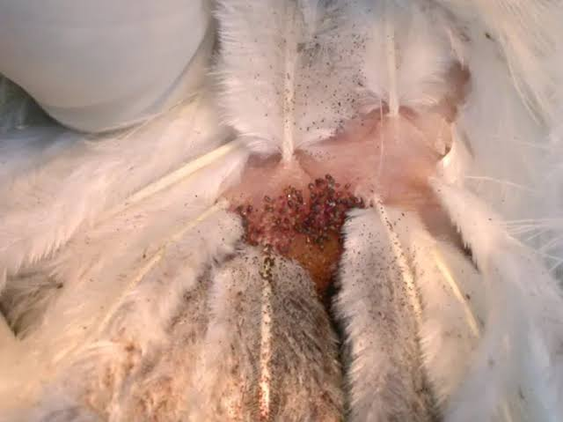 | 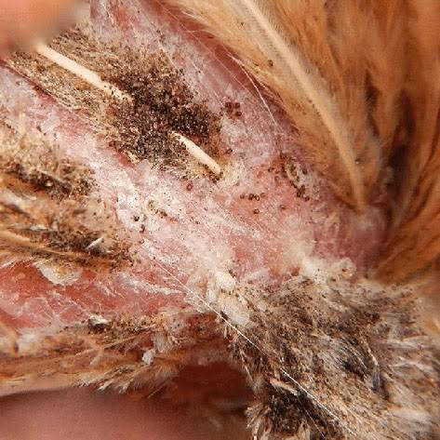
Fig.1 Birds showing visible black and white deposits of mite feces and groups of mites

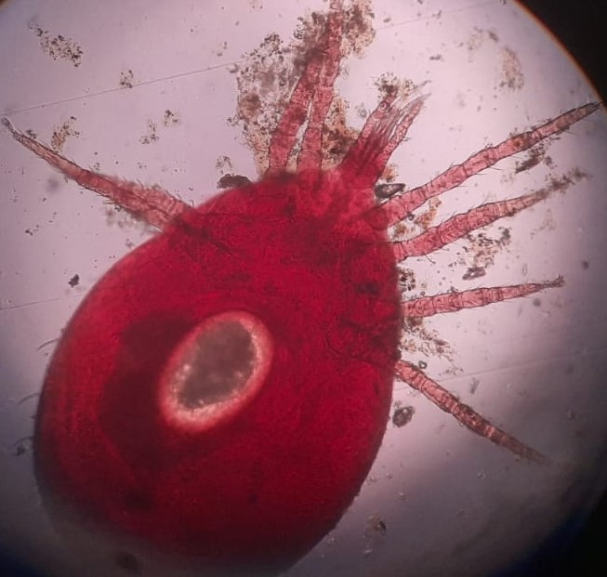 | 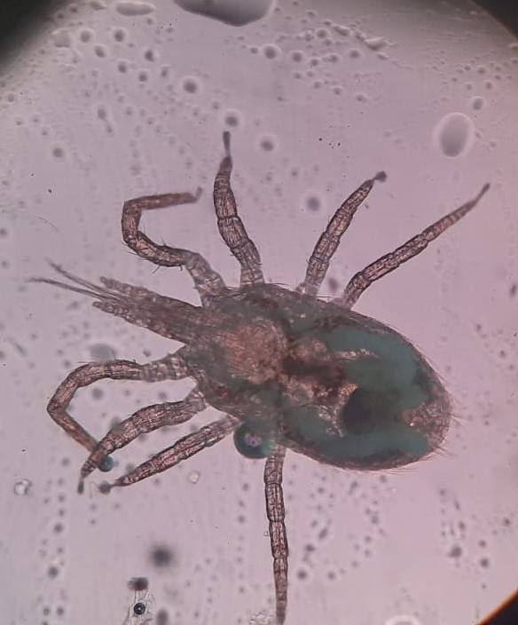
Fig.2 showing reddish color mite and the dorsal shield did not extend to the posterior end of the body with truncated posterior margin .

deacarization of cattle, sheep, goats, horses, donkeys, camels, poultry and other animals,
protection of livestock facilities from harmful insects and ticks, the medicine was tested in
livestock farms, its highly effective concentrations and doses were determined.
Cypermethrin is recommended for disinsection and
deacarization of cattle, sheep, goats, horses, donkeys, camels, poultry and other animals,
protection of livestock facilities from harmful insects and ticks, the medicine was tested in
livestock farms, its highly effective concentrations and doses were determined.
Cypermethrin is recommended for disinsection and
deacarization of cattle, sheep, goats, horses, donkeys, camels, poultry and other animals,
protection of livestock facilities from harmful insects and ticks, the medicine was tested in
livestock farms, its highly effective concentrations and doses were determined.

clinical sign observed in infested animals is sub-acute
anemia due to repeated mite bites. A laying hen can lose
more than 3% of its blood volume every night [3]. In
extreme cases, D. gallinae infestation burdens may be so
heavy that hens may die from severe anemia
clinical sign observed in infested animals is sub-acute
anemia due to repeated mite bites. A laying hen can lose
more than 3% of its blood volume every night [3]. In
extreme cases, D. gallinae infestation burdens may be so
heavy that hens may die from severe anemia
linical sign observed in infested animals is sub-acute
anemia due to repeated mite bites. A laying hen can lose
more than 3% of its blood volume every night [3]. In
extreme cases, D. gallinae infestation burdens may be so
heavy that hens may die from severe anemia
linical sign observed in infested animals is sub-acute
anemia due to repeated mite bites. A laying hen can lose
more than 3% of its blood volume every night [3]. In
extreme cases, D. gallinae infestation burdens may be so
heavy that hens may die from severe anemia

