Original Research Article
Phytochemical Investigation and Assessment of the CNS Stimulant Potential of the Ethanolic Extract of Cassia auriculata Flowers in Swiss Albino Mice

Abstract
Background: Cassia auriculata L. is a medicinal plant traditionally used for the treatment of various ailments and is known to contain diverse bioactive phytoconstituents. However, its central nervous system (CNS) stimulant potential has received limited scientific attention.
Objective: The present study aimed to investigate the phytochemical constituents and to evaluate the CNS-stimulant activity of the ethanolic extract of Cassia auriculata flowers in Swiss albino mice.
Methods: Dried flowers were extracted using ethanol in a Soxhlet apparatus and subjected to preliminary phytochemical screening. Acute oral toxicity was evaluated according to OECD Guideline 423. CNS stimulant activity was assessed using the digital actophotometer, Rotarod, and open field tests. Mice were divided into four groups (n = 6): vehicle control, caffeine (20 mg/kg), and ethanolic extract-treated groups (200 and 400 mg/kg). Data were analyzed using one-way ANOVA followed by Tukey's multiple comparison test.
Results: The extract yielded 5.14% (w/w) and contained alkaloids, flavonoids, phenolic compounds, glycosides, tannins, terpenoids, saponins, proteins, amino acids, and carbohydrates. No mortality or treatment-related toxicity was observed at 2000 mg/kg. The extract significantly increased spontaneous locomotor activity, prolonged Rotarod retention time, enhanced line crossings and rearing behaviour, and reduced immobility time in a dose-dependent manner (P < 0.05–0.001). The 400 mg/kg dose produced effects comparable to those of caffeine.
Conclusion: The ethanolic extract of Cassia auriculata flowers exhibited significant CNS stimulant activity with a favourable acute safety profile. These findings suggest that the plant is a promising source of naturally occurring neuroactive compounds and warrants further phytochemical isolation and mechanistic investigations.
Keywords: Cassia auriculata, central nervous system stimulant, phytochemical screening, locomotor activity, Rotarod test, open field test.

1. Introduction
The central nervous system (CNS) integrates sensory inputs and coordinates motor, cognitive, behavioural, and autonomic functions essential for maintaining physiological homeostasis. Neuronal communication within the CNS is mediated by neurotransmitters including dopamine, norepinephrine, serotonin, glutamate, acetylcholine, and γ-aminobutyric acid (GABA), which collectively regulate alertness, movement, learning, memory, and emotional responses. Alterations in these signalling pathways contribute to several neurological and psychiatric disorders, making the CNS an important target for therapeutic intervention (Bigbee, 2023; Guidolin et al., 2022; Davis et al., 2023).
Central nervous system stimulants are a class of pharmacological agents that enhance neuronal activity, leading to increased wakefulness, attention, psychomotor performance, and cognitive function. Drugs such as caffeine, amphetamine, methylphenidate, and modafinil have demonstrated considerable clinical utility in disorders including attention-deficit/hyperactivity disorder (ADHD), narcolepsy, and excessive daytime sleepiness (Fredholm et al., 1999; Hersey and Tanda, 2024; Parlatini et al., 2024). Nevertheless, prolonged administration of these synthetic stimulants is frequently associated with adverse reactions such as insomnia, anxiety, cardiovascular complications, tolerance, and dependence, which restrict their long-term therapeutic use (Awuchi, 2023; Isfandnia et al., 2024). Consequently, there is growing interest in identifying naturally occurring compounds capable of enhancing CNS function with improved safety profiles.
Natural products have historically served as an important source of therapeutic agents, and medicinal plants continue to provide structurally diverse molecules with significant pharmacological potential. Plant-derived secondary metabolites, particularly flavonoids, phenolic compounds, alkaloids, terpenoids, and saponins, have been reported to exhibit antioxidant, anti-inflammatory, neuroprotective, and neuromodulatory activities. These phytochemicals can influence neurotransmitter signalling, attenuate oxidative stress, and preserve neuronal integrity, thereby contributing to improved behavioural and cognitive performance (Islam et al., 2023; Bellavite, 2023; Shoaib et al., 2023; Melrose, 2023). Such findings have encouraged systematic evaluation of medicinal plants as potential sources of novel CNS-active agents.
Cassia auriculata L. (syn. Senna auriculata), a member of the family Fabaceae, is widely distributed throughout the Indian subcontinent and has long been utilized in traditional medicine. Different parts of the plant are employed for the management of diabetes mellitus, inflammatory conditions, liver disorders, microbial infections, skin diseases, and urinary ailments. The flowers are commonly consumed as herbal infusions and are considered a rich source of bioactive phytoconstituents (Nille et al., 2021; Ariyarathna, 2024; Tietel et al., 2024). Phytochemical investigations have revealed the presence of flavonoids, phenolic acids, tannins, alkaloids, glycosides, terpenoids, anthraquinones, and other secondary metabolites that may account for the plant's diverse biological activities (Parani, 2024; Revathi et al., 2025).
Previous pharmacological studies have established antioxidant, antidiabetic, antimicrobial, anti-inflammatory, hepatoprotective, nephroprotective, antihyperlipidaemic, and wound-healing properties of C. auriculata extracts (Nille et al., 2021; Ariyarathna, 2024; Tietel et al., 2024). Since flavonoids and phenolic compounds are known to modulate neuronal signalling and protect against oxidative neuronal damage, the flower extract may also possess CNS stimulant activity (Ramezani et al., 2023; Wang et al., 2023; Wu et al., 2024). However, despite the extensive pharmacological investigations on this plant, studies specifically evaluating the CNS stimulant potential of the ethanolic flower extract remain limited.
Therefore, the present study aimed to investigate the phytochemical constituents of the ethanolic extract of Cassia auriculata flowers and to evaluate its CNS stimulant activity in Swiss albino mice (add the scientific name) using validated behavioural models. The findings are expected to provide experimental evidence regarding the neuropharmacological potential of this medicinal plant and support its future development as a plant-derived CNS stimulant.

2. Materials and Methods

2.1 Plant material
Fresh flowers of Cassia auriculata L. were collected from Avapadu village, Nallajerla Mandal, East Godavari District, Andhra Pradesh, India, during December 2025. The plant was taxonomically authenticated at Dr. Y.S.R. Horticultural University, Horticultural College and Research Institute, Venkataramannagudem, Andhra Pradesh. A voucher specimen was deposited in the herbarium of A.K.R.G. College of Pharmacy for future reference. The flowers were washed with water, shade-dried at ambient temperature for approximately 15 days, pulverized using a mechanical grinder, and preserved in airtight containers until extraction (Harborne, 1998).

2.2 Preparation of ethanolic extract
The powdered flower material (30 g) was extracted with 300 mL of ethanol using a Soxhlet extraction apparatus. Extraction was continued until the solvent in the siphon tube became colourless, indicating complete extraction of soluble constituents. The extract was concentrated under reduced pressure using a rotary vacuum evaporator to obtain a semisolid residue. The dried extract was stored at 4°C in airtight containers until further use. The extraction yield was determined as the percentage of dried extract relative to the initial weight of the powdered plant material (Mukherjee, 2019).

2.3 Preliminary phytochemical screening
Qualitative phytochemical analysis of the ethanolic flower extract was carried out using established pharmacognostic procedures to detect the presence of major classes of secondary metabolites, including alkaloids, flavonoids, phenolic compounds, tannins, glycosides, terpenoids, saponins, carbohydrates, amino acids, coumarins, and gums and mucilage. Characteristic colour changes or precipitate formation were considered indicative of positive reactions (Harborne, 1998; Kokate et al., 2018).

2.4 Experimental animals
Healthy Swiss albino mice of either sex weighing 20–30 g were used for the pharmacological evaluation. Animals were housed under standard laboratory conditions (22 ± 2°C, relative humidity 55 ± 5%, 12 h light/12 h dark cycle) with unrestricted access to a standard pellet diet and drinking water. Before experimentation, the animals were acclimatized for one week. The study protocol was approved by the Institutional Animal Ethics Committee (Approval No. AKRGCP/CPCSEA/IAEC/2026/03-1373, dated 28/02/2026) and all experimental procedures were conducted in accordance with the CCSEA guidelines for the care and use of laboratory animals.

2.5 Acute oral toxicity study
The safety profile of the ethanolic extract was assessed according to OECD Guideline 423 (OECD, 2001). Following overnight fasting, mice received a single oral dose of 2000 mg/kg of the extract and were monitored for behavioural abnormalities, clinical signs of toxicity, and mortality during the first 24 h and thereafter for 14 days. Since no treatment-related mortality was observed, doses of 200 and 400 mg/kg body weight were selected for subsequent pharmacological investigations.

2.6 Experimental design
Twenty-four Swiss albino mice were randomly allocated into four groups containing six animals each (n = 6).
- Group I: Vehicle control (1% CMC, 10 mL/kg, p.o.)
- Group II: Caffeine (20 mg/kg, p.o.)
- Group III: Ethanolic extract of Cassia auriculata flowers (200 mg/kg, p.o.)
- Group IV: Ethanolic extract of Cassia auriculata flowers (400 mg/kg, p.o.)
All treatments were administered orally using an intragastric feeding cannula.

2.7 Assessment of CNS stimulant activity

Actophotometer test
Spontaneous locomotor activity was determined using a digital actophotometer following the procedure described by Kulkarni (2016). Thirty minutes after oral administration of the respective treatments, each mouse was placed individually inside the activity chamber, and locomotor activity was recorded for 10 min. The number of photo-beam interruptions was automatically recorded as locomotor counts. An increase in activity counts relative to the control group was interpreted as evidence of CNS stimulant activity.

Rotarod test
Motor coordination and neuromuscular performance were evaluated using the Rotarod method described by Dunham and Miya (1957). Prior to testing, mice were trained to remain on the rotating rod. Thirty minutes after treatment administration, each animal was placed on the rod rotating at 20 rpm, and the latency to fall was recorded. A maximum cut-off time of 300 s was applied to prevent fatigue.

Open field test
Exploratory behaviour and spontaneous locomotion were assessed using the open field paradigm according to Archer (1973) and Walsh and Cummins (1976). Each mouse was placed individually in the centre of the apparatus 30 min after treatment and observed for 5 min. The number of line crossings, rearing episodes, grooming frequency, and immobility time were recorded. Increased locomotor and exploratory activities accompanied by reduced immobility were considered indicative of CNS stimulation.

2.8 Statistical analysis

Experimental data were expressed as mean ± standard deviation (SD). Statistical comparisons among groups were performed using one-way analysis of variance (ANOVA) followed by Tukey's multiple comparison test using GraphPad Prism software. A value of P < 0.05 was considered statistically significant.

3. RESULTS

3.1 Percentage Yield of the Ethanolic Extract
The ethanolic extraction of dried Cassia auriculata flowers by Soxhlet apparatus yielded 5.14% (w/w) extract based on the dry weight of the plant material. The obtained extract was dark brown, semisolid in consistency, and possessed a characteristic odour. The extract was stored under refrigerated conditions until further phytochemical and pharmacological investigations.

3.2 Preliminary Phytochemical Screening
Qualitative phytochemical analysis of the ethanolic extract revealed the presence of several bioactive secondary metabolites. As presented in Table 1, alkaloids, glycosides, carbohydrates, saponins, proteins and amino acids, tannins, terpenoids, phenolic compounds, and flavonoids were detected in the extract, whereas gums and mucilages and coumarins were not observed.
Table 1. Preliminary phytochemical constituents of the ethanolic extract of Cassia auriculata flowers.
S. No. | Phytoconstituent | Result
1 | Alkaloids | Present (+)
2 | Glycosides | Present (+)
3 | Carbohydrates | Present (+)
4 | Saponins | Present (+)
5 | Proteins and Amino Acids | Present (+)
6 | Tannins | Present (+)
7 | Terpenoids | Present (+)
8 | Gums and Mucilages | Absent (−)
9 | Coumarins | Absent (−)
10 | Phenolic Compounds | Present (+)
11 | Flavonoids | Present (+)

3.3 Acute Oral Toxicity Study
The safety profile of the ethanolic extract was evaluated by acute oral toxicity testing. As summarized in Table 2, oral administration of the extract at a dose of 2000 mg/kg body weight did not produce mortality or any observable toxic manifestations during the study period. No abnormalities were observed in skin and fur appearance, salivation, tremors, convulsions, respiratory function, locomotor activity, or general behaviour. Based on the absence of treatment-related toxicity, doses of 200 mg/kg and 400 mg/kg were selected for the subsequent evaluation of CNS stimulant activity.

Table 2. Acute oral toxicity observations of the ethanolic extract of Cassia auriculata flowers.
Parameter | Observation
Mortality | Nil
Changes in Skin and Fur | Nil
Salivation | Nil
Tremors | Nil
Convulsions | Nil
Respiratory Distress | Nil
Behavioral Abnormalities | Nil
Coma | Nil
Locomotor Impairment | Nil

3.4 Effect of the Ethanolic Extract of Cassia auriculata Flowers on Spontaneous Locomotor Activity
The effect of the ethanolic extract on spontaneous locomotor activity was evaluated using a digital actophotometer. The results are presented in Table 3 and Figure 1. The control group exhibited a percentage increase in locomotor activity of 3.68 ± 2.22%. Administration of caffeine (20 mg/kg) significantly increased locomotor activity to 46.49 ± 2.57% (***P < 0.001 vs. control). Treatment with the ethanolic extract also produced a significant increase in locomotor activity at both dose levels. Animals receiving 200 mg/kg showed a percentage increase of 48.56 ± 2.67% (***P < 0.001), while administration of 400 mg/kg resulted in the highest increase (58.12 ± 2.89%, ***P < 0.001). The increase in locomotor activity was dose dependent, with the higher dose producing greater activity counts than the lower dose.
Table 3. Effect of the ethanolic extract of Cassia auriculata flowers on spontaneous locomotor activity.
Group | Basal Activity Score (Mean ± SD) | Activity Score After 30 min (Mean ± SD) | % Increase (Mean ± SD)
Control | 326 ± 5.62 | 338 ± 4.29 | 3.68 ± 2.22
Caffeine (20 mg/kg) | 342 ± 5.46 | 501 ± 3.64 | 46.49 ± 2.57***
EECA (200 mg/kg) | 348 ± 4.19 | 517 ± 6.92 | 48.56 ± 2.67***
EECA (400 mg/kg) | 351 ± 5.24 | 555 ± 5.87 | 58.12 ± 2.89***
Values are expressed as mean ± SD (n = 6). Statistical analysis was performed using one-way ANOVA followed by Tukey's multiple comparison test. ***P < 0.001 compared with the control group.
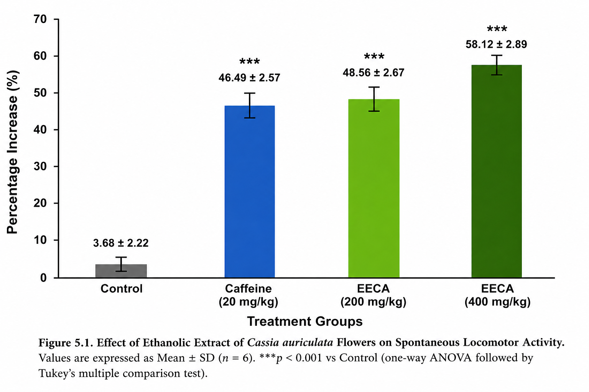
Figure 1. Effect of the ethanolic extract of Cassia auriculata flowers on spontaneous locomotor activity.

3.5 Effect of the Ethanolic Extract of Cassia auriculata Flowers on Rotarod Performance
The effect of the ethanolic extract on motor coordination was assessed using the Rotarod test, and the results are summarized in Table 4 and Figure 2. The mean retention time recorded for the control group was 112.5 ± 8.4 s. Caffeine (20 mg/kg) significantly increased the retention time to 186.8 ± 10.7 s (***P < 0.001 vs. control). Administration of the ethanolic extract at 200 mg/kg significantly increased the retention time to 154.6 ± 9.2 s (**P < 0.01), whereas treatment with 400 mg/kg further increased the retention time to 178.4 ± 11.3 s (***P < 0.001). The increase in retention time was greater with the higher dose than with the lower dose.
Table 4. Effect of the ethanolic extract of Cassia auriculata flowers on Rotarod performance.
Group | Retention time (s) (Mean ± SD)
Control | 112.5 ± 8.4
Caffeine (20 mg/kg) | 186.8 ± 10.7***
EECA (200 mg/kg) | 154.6 ± 9.2**
EECA (400 mg/kg) | 178.4 ± 11.3***
Values are expressed as mean ± SD (n = 6). Statistical analysis was performed using one-way ANOVA followed by Tukey's multiple comparison test. **P < 0.01, and ***P < 0.001 compared with the control group.

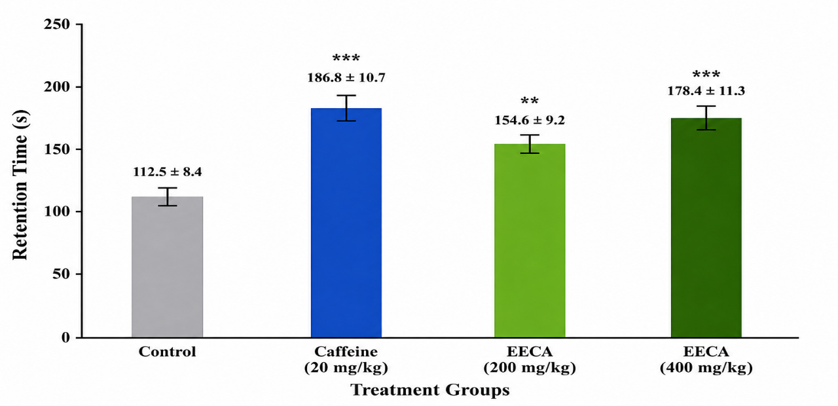
Figure 2. Effect of the ethanolic extract of Cassia auriculata flowers on Rotarod performance.

3.6 Effect of the Ethanolic Extract of Cassia auriculata Flowers in the Open Field Test
The effect of the ethanolic extract on exploratory behaviour was evaluated using the open field test. The results are presented in Table 5 and Figure 3. The control group exhibited 38.4 ± 3.2 line crossings and 7.5 ± 1.1 rearings, whereas caffeine (20 mg/kg) significantly increased these parameters to 81.6 ± 5.8 (***P < 0.001) and 18.3 ± 1.9 (***P < 0.001), respectively. Treatment with the ethanolic extract at 200 mg/kg increased the number of line crossings to 67.8 ± 4.7 (***P < 0.001) and rearings to 14.6 ± 1.5 (***P < 0.001). Administration of 400 mg/kg further increased line crossings to 77.2 ± 5.1 (***P < 0.001) and rearings to 17.1 ± 1.8 (***P < 0.001).
Grooming frequency was 6.8 ± 0.9 in the control group and decreased to 5.2 ± 0.8 (*P < 0.05) following caffeine administration. The ethanolic extract produced grooming frequencies of 5.9 ± 0.7 (*P < 0.05) and 5.3 ± 0.6 (*P < 0.05) at doses of 200 and 400 mg/kg, respectively.
The mean immobility time in the control group was 62.4 ± 5.7 s. Caffeine significantly reduced the immobility time to 21.8 ± 3.4 s (***P < 0.001). The ethanolic extract also significantly reduced immobility time to 33.7 ± 4.1 s (**P < 0.01) at 200 mg/kg and 24.6 ± 3.8 s (***P < 0.001) at 400 mg/kg.

Table 5. Effect of the ethanolic extract of Cassia auriculata flowers on exploratory behaviour in the open field test.
Group | Line Crossings | Rearings | Grooming Frequency | Immobility Time (s)
Control | 38.4 ± 3.2 | 7.5 ± 1.1 | 6.8 ± 0.9 | 62.4 ± 5.7
Caffeine (20 mg/kg) | 81.6 ± 5.8*** | 18.3 ± 1.9*** | 5.2 ± 0.8* | 21.8 ± 3.4***
EECA (200 mg/kg) | 67.8 ± 4.7*** | 14.6 ± 1.5*** | 5.9 ± 0.7* | 33.7 ± 4.1**
EECA (400 mg/kg) | 77.2 ± 5.1*** | 17.1 ± 1.8*** | 5.3 ± 0.6* | 24.6 ± 3.8***
Values are expressed as mean ± SD (n = 6). Statistical analysis was performed using one-way ANOVA followed by Tukey's multiple comparison test. *P < 0.05, **P < 0.01, and ***P < 0.001 compared with the control group.
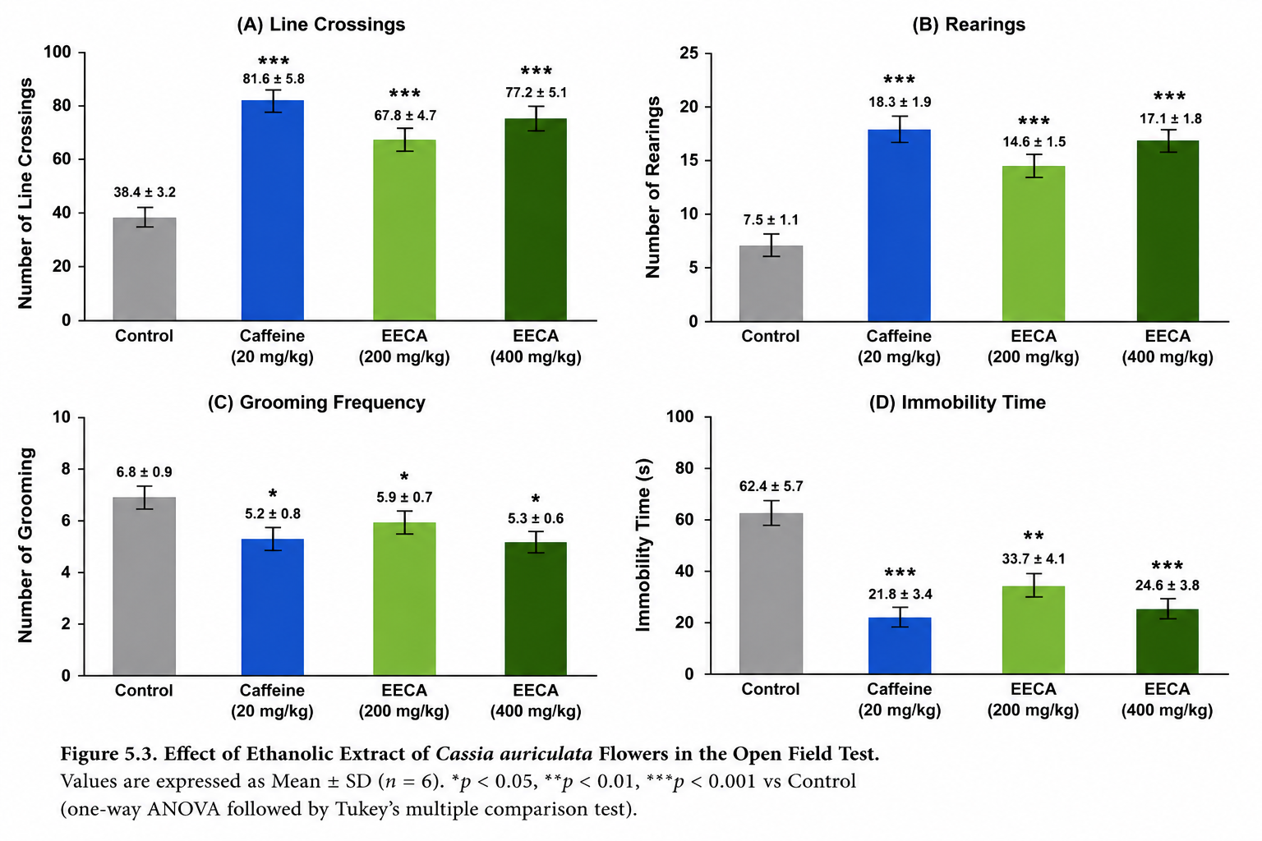
Figure 3. Effect of the ethanolic extract of Cassia auriculata flowers on exploratory behaviour in the open field test.

4. Discussion
The present investigation evaluated the phytochemical composition and central nervous system (CNS) stimulant activity of the ethanolic extract of Cassia auriculata flowers using established behavioural models in Swiss albino mice. The findings demonstrated that the extract contained several biologically active secondary metabolites, including alkaloids, flavonoids, phenolic compounds, tannins, terpenoids, glycosides, saponins, proteins, and carbohydrates. Furthermore, the extract enhanced spontaneous locomotor activity, improved motor performance in the Rotarod test, and increased exploratory behaviour in the open field test, suggesting dose-dependent CNS stimulant activity.
Phytochemical screening confirmed the presence of flavonoids and phenolic compounds, which are widely recognized for their antioxidant and neuromodulatory properties. These compounds have been reported to reduce oxidative stress, protect neuronal cells from free radical-mediated damage, and regulate neurotransmitter signalling pathways involved in cognitive and behavioural functions (Islam et al., 2023; Bellavite, 2023). In addition, alkaloids and terpenoids have been shown to interact with dopaminergic, adrenergic, and cholinergic neurotransmission, thereby influencing locomotor activity and behavioural responses (Shoaib et al., 2023). The combined action of these phytoconstituents may contribute to the pharmacological activity observed in the present study.
The acute oral toxicity study revealed no mortality or observable toxic manifestations following administration of the extract at 2000 mg/kg body weight, indicating a favourable safety profile under the experimental conditions. According to OECD Guideline 423, the absence of mortality at the limit dose suggests that the extract possesses relatively low acute oral toxicity and supports its suitability for further pharmacological investigations (OECD, 2001). Similar safety profiles have been reported for extracts of C. auriculata in previous experimental studies (Nille et al., 2021).
Locomotor activity is a widely accepted indicator of CNS stimulation because it reflects increased neuronal excitation and enhanced neurotransmitter release. In the present study, treatment with the ethanolic extract significantly increased locomotor activity in comparison with the control group, with the 400 mg/kg dose producing the greatest response. The observed effect was comparable to that of caffeine, a well-established CNS stimulant that primarily acts through antagonism of adenosine A₁ and A₂A receptors, resulting in enhanced dopaminergic and noradrenergic neurotransmission (Fredholm et al., 1999). Although the precise mechanism of action of the extract was not investigated, the increased locomotor activity suggests that its phytochemical constituents may influence similar neurotransmitter pathways responsible for behavioural activation.
The Rotarod test provides information regarding motor coordination, balance, and neuromuscular performance. Administration of the ethanolic extract significantly increased the retention time of mice on the rotating rod, indicating improved motor performance. The higher dose produced a greater increase in retention time than the lower dose, demonstrating a dose-dependent response. Unlike sedative agents, which generally impair motor coordination and reduce Rotarod performance, CNS stimulants enhance alertness and neuromuscular function, thereby increasing the duration for which animals remain on the rotating rod (Kulkarni, 2016). The present findings therefore support the stimulant-like behavioural profile of the extract.
The open field test is a well-established behavioural model for assessing spontaneous locomotion and exploratory activity. Animals treated with the ethanolic extract exhibited increased line crossings and rearing frequency together with reduced immobility time, indicating enhanced exploratory behaviour. Similar behavioural changes have been associated with increased dopaminergic and noradrenergic activity within the CNS (Archer, 1973). The reduction in immobility observed in extract-treated animals further supports the behavioural activation produced by the extract. Since locomotor stimulation occurred without evidence of acute toxicity or motor impairment, the extract appears to promote behavioural activation rather than producing nonspecific toxic effects.
Several pharmacological properties previously reported for C. auriculata, including antioxidant and anti-inflammatory activities, may also contribute indirectly to its neuropharmacological effects. Oxidative stress and neuroinflammation are recognized contributors to neuronal dysfunction and behavioural impairment. Flavonoids and polyphenolic compounds present in C. auriculata have been reported to suppress oxidative damage, reduce inflammatory mediators, and preserve neuronal integrity (Ariyarathna, 2024; Wang et al., 2023; Wu et al., 2024). Although these mechanisms were not directly evaluated in the present investigation, they may partly explain the observed CNS stimulant activity.
The dose-dependent behavioural responses observed throughout the study suggest that the pharmacological activity of the extract is related to the concentration of its bioactive constituents. The higher dose (400 mg/kg) consistently produced greater locomotor activity, improved Rotarod performance, and enhanced exploratory behaviour than the lower dose (200 mg/kg). This dose-response relationship strengthens the evidence supporting the CNS stimulant potential of the ethanolic flower extract.
The present investigation has certain limitations. The study primarily relied on behavioural models and preliminary phytochemical screening. The individual bioactive constituents responsible for the observed effects were not isolated or quantified, and neurotransmitter levels were not determined. Future studies employing chromatographic characterization, receptor-binding assays, neurotransmitter estimation, and molecular investigations would provide a better understanding of the mechanisms underlying the CNS stimulant activity of C. auriculata. In addition, chronic toxicity studies and detailed neurochemical evaluations are warranted before considering its therapeutic application.
Overall, the findings of the present study demonstrate that the ethanolic extract of Cassia auriculata flowers possesses promising CNS stimulant activity in Swiss albino mice. The observed pharmacological effects are likely associated with the combined action of flavonoids, phenolic compounds, alkaloids, and other secondary metabolites present in the extract. These findings provide scientific support for the neuropharmacological potential of C. auriculata and indicate that the plant may serve as a promising source of naturally occurring CNS stimulant molecules for future investigation.

5. Conclusion
The present study demonstrated that the ethanolic extract of Cassia auriculata flowers possesses promising central nervous system (CNS) stimulant activity in Swiss albino mice. Preliminary phytochemical screening confirmed the presence of several bioactive constituents, including flavonoids, phenolic compounds, alkaloids, tannins, terpenoids, glycosides, and saponins, which may collectively contribute to the observed pharmacological effects. Acute oral toxicity evaluation indicated that the extract was well tolerated at the tested dose, suggesting a favourable safety profile.
Behavioural assessment using the actophotometer, Rotarod, and open field tests showed that the extract produced dose-dependent increases in spontaneous locomotor activity, motor coordination, and exploratory behaviour. The higher dose (400 mg/kg) consistently exhibited greater activity than the lower dose (200 mg/kg), with responses approaching those produced by the standard CNS stimulant, caffeine.
These findings provide experimental evidence supporting the neuropharmacological potential of C. auriculata flowers and suggest that the plant may serve as a valuable source of naturally occurring CNS stimulant compounds. However, further studies involving isolation and characterization of the active phytoconstituents, neurochemical investigations, receptor-binding studies, and chronic toxicity evaluations are required to elucidate the precise mechanism of action and establish its therapeutic potential. The present study lays a scientific foundation for future investigations aimed at developing safe and effective plant-derived CNS stimulant agents.

Declaration of AI Use

This manuscript was prepared through the combined contributions of all author(s), including contributions to the study design, data, content development, results, interpretation, and related scholarly work. The author(s) acknowledge the use of Grammarly and ChatGPT to assist with grammar checking, language refinement, reference formatting. These AI-assisted tools were not used as authors and did not replace the intellectual contributions or scholarly judgment of the author(s). All AI-assisted outputs, including content, references, and interpretations, were carefully reviewed, revised, verified, and approved by the author(s). The author(s) accept full responsibility for the accuracy, integrity, and final content of the manuscript.

COMPETING INTERESTS DISCLAIMER:
Authors have declared that they have no known competing financial interests OR non-financial interests OR personal relationships that could have appeared to influence the work reported in this paper.

References
Akyuz E, Celik BR, Aslan FS, Sahin H, Angelopoulou E (2023) Exploring the role of neurotransmitters in multiple sclerosis: An expanded review. ACS Chemical Neuroscience 14(4):527–553. https://doi.org/10.1021/acschemneuro.2c00589
Archer J. Tests for emotionality in rats and mice: A review. Animal Behaviour. 1973;21(2):205–235. https://doi.org/10.1016/S0003-3472(73)80065-X
Ariyarathna P (2024) Cassia auriculata: A comprehensive review of the nutritional, phytochemical and pharmacological properties. World Journal of Pharmaceutical Sciences 12(1):1–8.
Awuchi CG (2023) Plants, phytochemicals, and natural practices in complementary and alternative system of medicine for treatment of central nervous system disorders. International Journal of Food Properties 26(1):1190–1213. https://doi.org/10.1080/10942912.2023.2205039
Bellavite P (2023) Neuroprotective potentials of flavonoids: Experimental studies and mechanisms of action. Antioxidants 12(2):280. https://doi.org/10.3390/antiox12020280
Bigbee JW (2023) Cells of the central nervous system: An overview of their structure and function. Advances in Neurobiology 29:41–64. https://doi.org/10.1007/978-3-031-12390-0_2
Davis SE, Cirincione AB, Jimenez-Torres AC, Zhu J (2023) The impact of neurotransmitters on the neurobiology of neurodegenerative diseases. International Journal of Molecular Sciences 24(20):15340. https://doi.org/10.3390/ijms242015340
Fredholm BB, Bättig K, Holmén J, Nehlig A, Zvartau EE (1999) Actions of caffeine in the brain with special reference to factors that contribute to its widespread use. Pharmacological Reviews 51(1):83–133.
Guidolin D, Tortorella C, Marcoli M, Maura G, Agnati LF (2022) Intercellular communication in the central nervous system. International Journal of Molecular Sciences 23(10):5805. https://doi.org/10.3390/ijms23105805
Harborne JB (1998) Phytochemical Methods: A Guide to Modern Techniques of Plant Analysis. 3rd edition. Chapman & Hall, London.
Hersey M, Tanda G (2024) Modafinil, an atypical CNS stimulant? Advances in Pharmacology 99:287–326. https://doi.org/10.1016/bs.apha.2023.10.006
Isfandnia, F., El Masri, S., Radua, J. and Rubia, K. (2024) ‘The effects of chronic administration of stimulant and non-stimulant medications on executive functions in ADHD: A systematic review and meta-analysis’, Neuroscience and Biobehavioral Reviews, 162, 105703. https://doi.org/10.1016/j.neubiorev.2024.105703
Islam A, Mishra A, Ahsan R, Fareha S (2023) Phytopharmaceuticals and herbal approaches to target neurodegenerative disorders. Drug Research 73(7):388–407. https://doi.org/10.1055/a-2076-7939
Kirtikar KR, Basu BD (2006) Indian Medicinal Plants. International Book Distributors, Dehradun.
Kokate CK, Purohit AP, Gokhale SB (2018) Pharmacognosy. 56th edition. Nirali Prakashan, Pune.
Kulkarni SK (2016) Handbook of Experimental Pharmacology. 4th edition. Vallabh Prakashan, New Delhi.
Mukherjee PK (2019) Quality Control and Evaluation of Herbal Drugs. 2nd edition. Elsevier India, New Delhi.
Nille GC, Mishra SK, Chaudhary AK, Reddy KRC (2021) Ethnopharmacological, phytochemical, pharmacological and toxicological review on Senna auriculata (L.) Roxb. Frontiers in Pharmacology 12:647887. https://doi.org/10.3389/fphar.2021.647887
OECD (2001) OECD Guideline for the Testing of Chemicals No. 423: Acute Oral Toxicity – Acute Toxic Class Method. Organisation for Economic Co-operation and Development, Paris.
Panche AN, Diwan AD, Chandra SR (2016) Flavonoids: An overview. Journal of Nutritional Science 5:e47. https://doi.org/10.1017/jns.2016.41
Parlatini V, Bellato A, Murphy D, Cortese S (2024) From neurons to brain networks, pharmacodynamics of stimulant medication for ADHD. Neuroscience & Biobehavioral Reviews 164:105841. https://doi.org/10.1016/j.neubiorev.2024.105841
Revathi S, Altemimi AB, Sutikno S, Cacciola F (2025) Phytochemical screening along with in vitro antioxidant, antibacterial and anticancer activity of Senna auriculata (L.) bark extracts. International Journal of Environmental Health Research 35(6):1557–1570. https://doi.org/10.1080/09603123.2024.2395446
Sheffler ZM, Reddy V, Pillarisetty LS (2023) Physiology, Neurotransmitters. StatPearls Publishing, Treasure Island, FL.
Shoaib S, Ansari MA, Fatease AA et al. (2023) Plant-derived bioactive compounds in the management of neurodegenerative disorders. Pharmaceutics 15(3):749. https://doi.org/10.3390/pharmaceutics15030749
Spencer JPE (2008) Flavonoids: Modulators of brain function? British Journal of Nutrition 99(S1):S60–S77.
Tietel Z, Ananth DA, Sivasudha T, Klipcan L (2024) Cassia auriculata L.: A mini review of phytochemical compounds and their antidiabetic mechanisms. AIMS Agriculture and Food 9(1):374–392. https://doi.org/10.3934/agrfood.2024022
Turner RA (1965) Screening Methods in Pharmacology. Academic Press, New York.
Vogel HG (2008) Drug Discovery and Evaluation: Pharmacological Assays. 3rd edition. Springer, Berlin.
Walsh RN, Cummins RA (1976) The open-field test: A critical review. Psychological Bulletin 83(3):482–504.
Wang C, Yang S, Deng J et al. (2023) The research progress on the anxiolytic effect of plant-derived flavonoids by regulating neurotransmitters. Drug Development Research 84(3):458–469. https://doi.org/10.1002/ddr.22038
Wu X, Zhou Y, Xi Y et al. (2024) Polyphenols: Natural food-grade biomolecules for the treatment of nervous system diseases from a multi-target perspective. Pharmaceuticals 17(6):775. https://doi.org/10.3390/ph17060775
Zibaee E, Javadi B, Sobhani Z et al. (2023) Cassia species: A review of traditional uses, phytochemistry and pharmacology. Pharmacological Research – Modern Chinese Medicine 9:100325. https://doi.org/10.1016/j.prmcm.2023.100325

