Echinostoma revolutum infection in native ducks from the Cauvery delta region of Tamil Nadu, India

ABSTRACT
Duck farming is one of the viable enterprise for poor nomadic farmers around the Cauvery delta region of Tamil Nadu due to the presence of extensive paddy fields. Generally, the ducks are highly susceptible to various pathogens, including trematode parasites, due to their aquatic feeding behavior and are easily accessible to snail intermediate hosts. Two dead native ducks were brought to the Department of Veterinary Pathology, Veterinary College and Research Institute, Orathanadu, Thanjavur, by a nomadic farmer for post-mortem examination. The duck farmer reported that the birds had bloody diarrhoea, off-fed nature, and dullness before death. Necropsy of the duck carcasses revealed haemorrhagic enteritis, the presence of flukes in the large intestine, and operculated eggs in gut contents. Borax carmine was used for staining of the flukes and was identified as Echinostoma revolutum based on their morphological features using standard taxonomical keys. Microscopical examination of the flukes showed an elongated body with a spiny cuticle in the anterior region. A well-developed head-collar around the oral sucker is provided with 37 spines, of which a group of five corner spines is on either side. The ventral sucker was much larger than the oral sucker and was located near the anterior region. The mid-region of the body showed uterine coils filled with operculated eggs, followed by two slightly branched tandem testes and an ovary. Vitelline follicles were well developed and laterally placed, extending from the level of the ventral sucker up to the posterior end of the body. Microbiological investigation revealed no bacterial or viral pathogens in the ducks. This study reports the occurrence of Echinostoma revolutum in native ducks from the Cauvery delta region of Tamil Nadu, India.
Key words: Echinostoma revolutum, Native ducks, Cauvery delta, Tamil Nadu.

1. INTRODUCTION
The Cauvery Delta is a highly fertile and historic agricultural area in Tamil Nadu and is generally called the "Rice Bowl of South India”. This region is rich in rivers, canals, and extensive paddy fields (Paramasivan & Pasupathi, 2016). This unique agro-climatic zone is highly conducive to integrated rice-duck farming systems. Native duck breeds, particularly the Chara and Chemballi types, are raised by the local farmers for their livelihood. The ducks raised in this region are continuously exposed to the aquatic environment, which makes them highly susceptible to helminthic infections such as Echinostoma revolutum, a prominent intestinal trematode that significantly affects waterfowl, ducks, and geese (Toledo and Esteban, 2016). The freshwater snails, such as Lymnaea species, are abundant in the Cauvery delta region and commonly act as intermediate hosts. However, fish and other molluscs can also act as intermediate hosts (Huffman and Fried, 1990). This trematode has a three-host life cycle with aquatic snails as first intermediate hosts in which sporocysts, rediae, and cercariae develop. Emerged cercariae freely swim and infect the second intermediate hosts, such as snails, frogs, and fish. Finally, the definitive host becomes infected by ingestion of the second intermediate host harbouring the encysted metacercariae. The adult fluke produces unembryonated eggs that are released in the host’s faeces. The infected birds are usually asymptomatic; however, heavy infection leads to catarrhal inflammation with mild ulceration, haemorrhagic diarrhea, weight loss, and death (Toledo et al., 1995). Comprehensive epidemiological data on E. revolutum infection in the native ducks of the Cauvery delta are sparse. This paper deals with the occurrence of Echinostoma revolutum infection in nomadic ducks from the Cauvery delta region of Tamil Nadu.

The epidemiological relevance of this observation is strengthened by the biology of the Echinostoma revolutum species complex, which depends on aquatic intermediate hosts and is commonly associated with waterfowl and other wetland-linked definitive hosts. Studies on free-grazing ducks and integrated poultry-aquaculture systems have shown that ducks can maintain intestinal trematodes where aquatic foraging, snails, and fish or amphibian intermediate hosts are present (Saijuntha et al., 2013; Anh et al., 2010). Recent molecular work also indicates that E. revolutum sensu stricto has broad Eurasian connectivity, probably facilitated by movement of waterfowl hosts, which supports the need for local documentation of infections in duck-rearing landscapes (Enabulele et al., 2023). Because members of the 37-collar-spined Echinostoma group are morphologically similar, field reports based on morphology should be interpreted carefully and, when possible, complemented by molecular confirmation (Chai et al., 2020; Mohanta et al., 2019).
2. Methodology
A nomadic duck farmer from the Cauvery delta region with a flock of 800 ducks reported the death of 30 ducks within a period of one month after the introduction of ducks in a freshly harvested paddy field for foraging. Two dead native ducks were brought to the Department of Veterinary Pathology, Veterinary College and Research Institute, Orathanadu, Thanjavur, for post-mortem examination. The duck farmer reported that the birds had bloody diarrhoea, off-fed nature, and dullness before death.
During necropsy, the intestines were incised longitudinally, and the contents were washed and sieved. Post-mortem examination of ducks revealed enteritis and adult flukes in the large intestine. The recovered flukes were collected in normal saline, flattened between two slides, and fixed in 10% formalin for morphological studies. The flattened flukes were stained with borax carmine staining, dehydrated in different grades of ethanol (50, 70, 90, and 100%), cleared in xylol, and mounted in Canada balsam (Saijuntha et al., 2013; Mohanta et al., 2019). The stained flukes were identified based on their morphological features using standard taxonomical keys given by Soulsby (1982) and Enabulele et al. (2023). Intestinal contents were collected and processed using the standard sedimentation technique to identify the characteristic eggs of Echinostoma species.

3. RESULTS AND DISCUSSION
Duck farming is one of the viable enterprises for poor nomadic farmers around Cauvery delta region of Tamil Nadu due to the presence of extensive paddy fields. Generally, the ducks are highly susceptible to various pathogens including trematode parasites due to their aquatic feeding behavior and easily accessible to snail intermediate hosts (Fig. 1). Echinostoma revolutum is the commonest parasitic infection in domestic as well as wild ducks and geese. Ducks raised in the Cauvery delta region of Tamil Nadu are mostly free-range scavenging and easily susceptible to various parasite infections such as helminthiasis (Gajendran and Karthickeyan, 2011). Parasitic infection in ducks can cause reduced growth, decreased egg production, decreased weight gain, anaemia, gastroenteritis, villous atrophy, catarrhal enteritis, villi desquamation, submucosal gland congestion and vacuolization (Mohammed, 2009).
The present case is consistent with the ecological pattern described for echinostome transmission in free-grazing and aquatic-feeding ducks, where exposure increases when birds forage in wet fields and consume or contact infected intermediate hosts. Comparable studies from Thailand and Vietnam have reported intestinal trematodes in ducks from wetland or integrated farming systems, indicating that duck management practices can sustain transmission cycles when aquatic intermediate hosts are available (Saijuntha et al., 2013; Anh et al., 2010). Therefore, the observation of adult flukes in ducks introduced into freshly harvested paddy fields should be interpreted as biologically plausible, although a larger epidemiological survey would be required to estimate prevalence or risk factors in the Cauvery delta region.
Microscopic examination of the fluke showed leaf like elongated body with spiny cuticle in the anterior region (Fig. 2). A well-developed kidney shaped head-collar around the oral sucker provided with 37 spines, of which, a group of five corner spines on either side (Fig. 3). The suckers are close to each other. The ventral sucker is much larger than the oral sucker and located near the anterior region. The cirrus sac is oval and located transversely between the level of intestinal bifurcation and anterior border of ventral sucker. Mid-region of the body contains
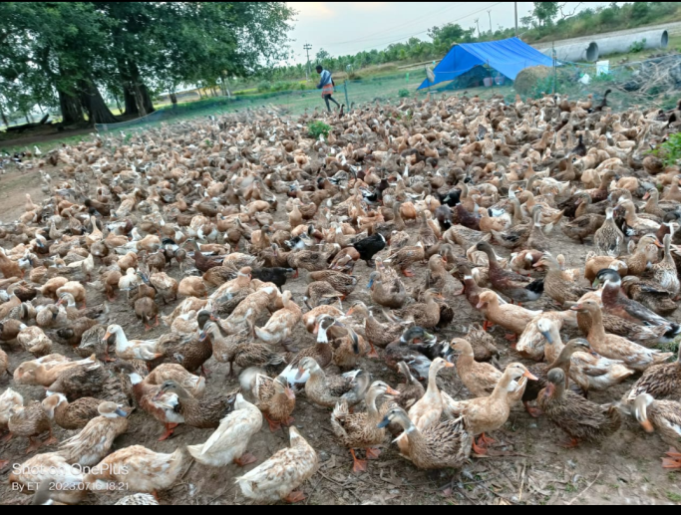  Fig. 1. Duck rearing in Cauvery delta region of Tamil  Nadu - Thanjavur | 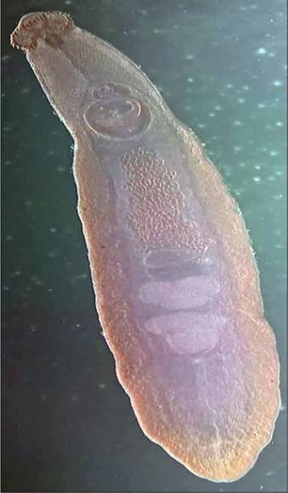  Fig. 2. Morphological characters of Echinost  oma revolutum from ducks (X 20)
  Fig. 3. Head-collar spines around the oral sucker  of Echinostoma revolutum X 400 | 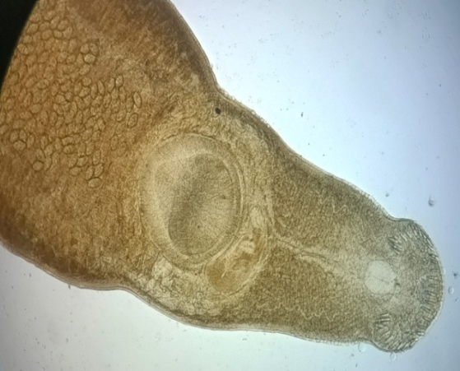  Fig. 4. Anterior end of Echinostoma revolutum, X 100
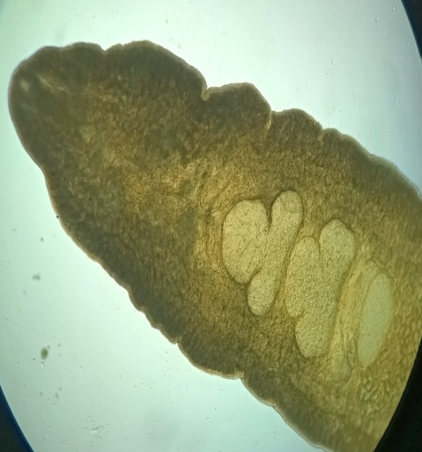  Fig. 5. Posterior end of Echinostoma  revolutum, X 100 | 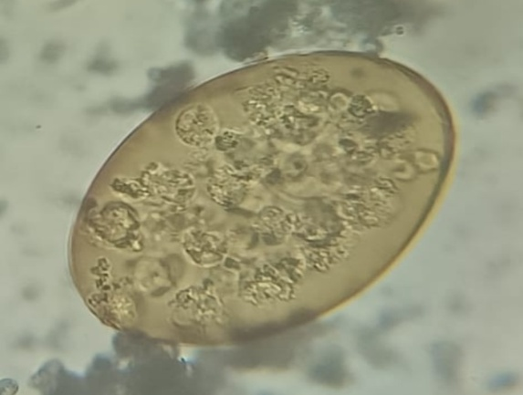  Fig. 6. Unstained egg of Echinostoma revolutum, X 400

uterine coils filled with yellowish operculated eggs (Fig. 4). Two testes lie in the midline, branched, tandem in position, and slightly separated from each other. The ovary is single, round or oval and situated in the middle just above the testes (Fig. 5). Vitelline follicles were well developed and laterally placed, extending from the level behind the ventral sucker up to the posterior end of the body. Gut content examination of the ducks revealed typical yellowish oval operculated eggs with compact yolk mass (Fig. 6).
The morphological diagnosis is supported by the combination of a prominent head collar with 37 spines, a larger ventral sucker, tandem testes, and operculated eggs; however, these features should be assessed together because several taxa within the E. revolutum group share overlapping characters (Chai et al., 2020). Molecular characterization of duck-derived echinostomes from Bangladesh has demonstrated that morphology combined with ITS2 and mitochondrial nad1 sequence data can improve species-level discrimination between E. revolutum and closely related species (Mohanta et al., 2019). Accordingly, the present morphology-based identification is suitable for a preliminary case record, while molecular confirmation and intermediate-host identification would strengthen future surveillance in this region (Enabulele et al., 2023; Toledo & Esteban, 2016).
Based on the location of the parasite in the large intestine of ducks and morphological characteristics, the trematode was identified as Echinostoma revolutum, which was similar to the study carried out by Latchumikanthan et al. (2015) and Yousuf et al. (2009), who reported heavy infection of echinostomes causing emaciation, catarrhal enteritis, and death in young ducks. The morphology of Echinostoma species resembles that of the adult worm of Clonorchis sinensis and Opisthorchis felineus, but differs in egg morphology and size. The eggs of Echinostoma species resemble the eggs of F. hepatica, F. gigantica (Periago et al., 2006; Sah et al., 2017), F. buski (Mohanty et al., 2012) and G. hominis (Mas-Coma et al., 2005) in shape, color, content and their measurement. The presence of an inconspicuous thin operculum and thickened posterior end of ova of Echinostoma species facilitates the differentiation from the ova of other trematodes. Further confirmation by molecular studies and identification of snail species are warranted. Duck farmers were advised to deworm their birds regularly to avoid trematode infection

4. Conclusion
The present case documents Echinostoma revolutum infection in native ducks from the Cauvery delta region of Tamil Nadu. Diagnosis was based on adult flukes recovered from the large intestine, operculated eggs in intestinal contents, and characteristic morphological features, including a head collar with 37 spines, tandem testes, and well-developed vitellaria. The finding suggests that ducks foraging in harvested paddy fields may be exposed to echinostome infection where aquatic intermediate hosts are present. Further epidemiological studies are required to determine the prevalence, intermediate hosts, and risk factors for echinostome infection in ducks from this region.
Limitations
The report is based on two dead ducks and therefore cannot estimate prevalence or flock-level risk. Identification was based on morphology without molecular confirmation. Intermediate hosts were not examined, and no systematic epidemiological survey was conducted. Microbiological exclusion of other pathogens was stated but not fully described. Further studies with larger samples, molecular tools, and snail/fish host assessment are needed.
Declaration of AI Use

This manuscript was prepared through the combined contributions of all author(s), including contributions to the study design, data, content development, results, interpretation, and related scholarly work. The author(s) acknowledge the use of Grammarly and ChatGPT to assist with grammar checking, language refinement, reference formatting. These AI-assisted tools were not used as authors and did not replace the intellectual contributions or scholarly judgment of the author(s). All AI-assisted outputs, including content, references, and interpretations, were carefully reviewed, revised, verified, and approved by the author(s). The author(s) accept full responsibility for the accuracy, integrity, and final content of the manuscript.

COMPETING INTERESTS DISCLAIMER:
Authors have declared that they have no known competing financial interests OR non-financial interests OR personal relationships that could have appeared to influence the work reported in this paper.

7. REFERENCES
Gajendran, K., & Karthickeyan, S.M.K. (2011). Indigenous technical knowledge in duck production in Tamil Nadu. Indian Journal of Traditional Knowledge, 10, 307-310.
Enabulele, E.E., Lawton, S.P., Walker, A.J., & Kirk, R.S. (2023). Molecular epidemiological analyses reveal extensive connectivity between Echinostoma revolutum (sensu stricto) populations across Eurasia and species richness of zoonotic echinostomatids in England. PLOS One, 18(2), e0270672. https://doi.org/10.1371/journal.pone.0270672
Huffman, J.E., & Fried, B. (1990). Echinostoma and Echinostomiasis. Advances in Parasitology, 29, 215-269.
Latchumikanthan,A., Tamileniyan, E., Vijayasarathi, M.K., Thilagavathi, K., Velusamy, R., & Meenakshisundaram, A. (2025). Concurrent infection of Tetrameres sp. and Echinostoma sp. in nomadic ducks from Thanjavur region of Tamil Nadu. Indian Journal of Veterinary and Animal Sciences Research, 53(6), 84-90.
Mas-Coma, S., Bargues, M.D., & Valero, M.A. (2005) Fascioliasis and other plant-borne trematode zoonoses. International Journal of Parasitology, 35, 1255–78.
Mohammed, N.H. (2009). Detection of Cryptosporidium sp. in faeces of ducks in Nineveh governorate. Iraqi Journal of Veterinary Sciences, 23 (1), 1-5.
Mohanta UK, Wantanabe T, Anisuzzaman OY, Itagaki T. (2019). Characterization of Echinostoma revolutum and Echinostoma robustum from ducks in Bangladesh based on morphology, nuclear ribosomal ITS2 and mitochondrial nad1 sequences. Parasitology International, 69, 1–7. https://doi.org/10.1016/j.parint.2018.11.002
Mohanty, I., Narasimham, M.V., Sahu, S., Panda, P., & Parida, B. (2012). Live Fasciolopsis buski vomited out by a boy. Annals of tropical medicine and public health, 5, 403–5.
Paramasivan, C., & Pasupathi, R. (2016). An overview of Cauvery delta zone in Tamil Nadu. International Journal of Trend in Research and Development, 3 (5), 399-403. URL: http://www.ijtrd.com/papers/IJTRD4269.pdf
Periago, M.V., Valero, M.A., Panova, M., & Mas-Coma, S. (2006). Phenotypic comparison of allopatric populations of Fasciola hepatica and Fasciola gigantica from European and African bovines using a computer image analysis system. Parasitology Research, 9,368-78.
Saijuntha, W., Duenngai, K., & Tantrawatpan, C. (2013). Zoonotic echinostome infections in free-grazing ducks in Thailand. Korean Journal of Parasitology, 51(6), 663-7. doi: 10.3347/kjp.2013.51.6.663.
Sah, R., Khadka, S., Khadka, M., Gurubacharya, D., Sherchand, J.B., Parajuli, K., Shah, N.P., Kattal,H.P.,Pokharel,P.M., & Rijal, B. (2017). Human fascioliasis by Fasciola hepatica: the first case report in Nepal. BMC Research notes, 10(1),439.
Soulsby, E.J.L. (1982). Helminths, Arthropods and Protozoa of Domesticated Animals, 7th edn., Bailliere and Tindall, The English Book Society, London. pp. 300-302.
Toledo, R., Esteban, J.G, & Fried, B. (1995). Current status of food-borne trematode infections.
European Journal of Clinical Microbiology and Infectious Diseases. 31 (8), 1705-1718.
Toledo, R., & Esteban, J.G. (2016). An update on human echinostomiasis. Transactions of the Royal Society of Tropical Medicine and Hygiene, 110(1),37–45. https://doi.org/10.1093/trstmh/trv099
Yousuf, M.A., Das, P.M., Anisuzzaman, & Banowary, B. (2009). Gastro-intestinal helminths of ducks: Some epidemiologic and pathologic aspects. Journal of Bangladesh Agricultural University, 7, 91-97.

Anh, N. T. L., Madsen, H., Dalsgaard, A., Phuong, N. T., Thanh, D. T. H., & Murrell, K. D. (2010). Poultry as reservoir hosts for fishborne zoonotic trematodes in Vietnamese fish farms. Veterinary Parasitology, 169(3-4), 391-394. https://doi.org/10.1016/j.vetpar.2010.01.010
Chai, J.-Y., Cho, J., Chang, T., Jung, B.-K., & Sohn, W.-M. (2020). Taxonomy of Echinostoma revolutum and 37-collar-spined Echinostoma spp.: A historical review. The Korean Journal of Parasitology, 58(4), 343-371. https://doi.org/10.3347/kjp.2020.58.4.343

