Management of Sitophilus oryzae in Stored Wheat Using Ethanolic Leaf Extract of Ocimum kilimandscharicum

ABSTRACT
The growing concern about the environmental and health risks of synthetic pesticides has led to a greater interest in the use of plant-based pesticides in the control of stored grain pests. This study looked at the efficacy of ethanolic leaf extract of Ocimum kilimandscharicum against the rice weevil, Sitophilus oryzae, which is a major pest of stored wheat grains. Treatments of wheat grains were done with different concentrations of the ethanolic extract (20%, 30%, 40%, and 50% v/v) and recorded mortality at intervals (1, 3, 7, 14, and 21 days). Mortality increased progressively with both concentration and exposure time where the highest mortality rate (57.78%) was observed at a 50% concentration after 21 days. Statistical analysis using one-way ANOVA followed by Tukey's post hoc test showed significant differences among treatments at the later observation periods (p < 0.05). In this study the efficacy of ethanolic leaf extract of O. kilimandscharicum was also determined for controlling rice weevil, Sitophilus oryzae, infestation in stored wheat in terms weight loss of grains. It was observed that there was a dose- and time-dependent activity of insecticide with respective grain protection. These findings indicate that O. kilimandscharicum has promising insecticidal properties and could be an eco-friendly option for managing stored-grain insect pests.

Keywords - : Kapoor tulsi (Ocimum kilimandscharicum), Sitophilus oryzae, ethanolic extract, biopesticides, Insecticides, stored grain, wheat.
1. INTRODUCTION
Losses due to grain stored by insects continue to be one of the major problems faced by world food security, with grain storage insects estimated to account for 20–40% of world post-harvest losses. Rice weevil (Sitophilus oryzae L.) is considered one of the most harmful insect pests that attack stored cereals such as wheat, resulting in heavy post-harvest damage and threatening world food safety and trading systems (Nagpal,et.al 2025). Both the adult and the larvae feed inside the grain, resulting in quantitative loss through reduction in grain weight and qualitative loss through reduction in nutritional value, germ inability, and marketability of the grains, with losses varying between 10-65% in moderate storage and up to 80% in prolonged storage (Rajarushi.et.al2024). Infestation causes an increase in temperature and moisture content of the grain mass, thus favoring the development of fungi. Despite the extensive use of chemical insecticides to control such pests, there are some serious limitations in the use of chemicals, such as environmental pollution, residue formation in the product, resistance development among insects, and toxic effects on non-target organisms. Botanical pesticides have emerged as sustainable alternatives owing to their biodegradability, lower toxicity, and diverse bioactive compounds.
S. oryzae management in the past has been based on chemical fumigation and protective grain insecticides. However, the continued use of these chemicals has been associated with some documented problems such as insecticide resistance, resurgence of the primary pest, outbreak of secondary pests, and health and environmental hazards (khan.et.al 2016). These have led to much focus on developing environmentally friendly options, especially those involving insecticidal properties of botanicals, which are known to be environmentally friendly and cause no toxicity while providing for efficient mortality among the stored-product beetles. There are many botanicals such as neem, eucalyptus, Vitex negundo, Ageratum conyzoides, Ocimum spp, and others that have been tested on stored wheat as a means to control S. oryzae adults. Considering the high phytochemical content of the plant and its effectiveness against stored grain beetle species, ethanolic leaf extract is an interesting but less explored avenue for a natural pest repellent in stored grains. The objective of this experiment was to test the insecticidal effect of ethanolic leaf extract of O. kilimandscharicum on adult S. oryzae in stored wheat. We tested the effects of dosage and time on mortality in order to establish its potential for use as a natural pest repellent in stored wheat.
Plant-derived insecticides composed of secondary metabolites from the plant serve as an ecologically sound and cost-effective alternative to chemical insecticides. Various plants of the family Lamiaceae, particularly those that are from the genus Ocimum, have received considerable attention in literature as excellent sources of terpenoids, phenolics, flavonoids, and essential oils that exhibit insecticidal, repellent, fumigant, and antifeedant activity (Bakkali et al., 2008; Prabhuet al., 2011). This includes the plant species called Ocimum kilimandscharicum Guerke, commonly known as Camphor Basil or African Basil, which is a perennial aromatic plant endemic to East Africa.
The essential oil extracted from this plant is rich in camphor and 1,8-cineole that exhibit remarkable neurotoxin and acetylcholinesterase inhibitory activities against various insects (Mkenda et al., 2020; Janneh& Sey, 2018).Although several bioassay studies for the essential oils of O. kilimandscharicum have been carried out in the past, there is little information available in the literature regarding the study of the insecticidal activity of crude solvent extracts of O. kilimandscharicum against the storage pest S. oryzae. In addition, the preparation of ethanolic extract can provide a stable as well as cost-effective preparation compared with the essential oils. Hence, the present work was carried out with an objective to assess the insecticidal efficacy of ethanolic leaf extract of O. kilimandscharicum in different concentrations (20%, 30%, 40%, and 50% v/v) against S. oryzae adults with time.
2. Materials and Methods
Plant Material Collection and Identification
Fresh, mature leaves of Ocimum kilimandscharicum were collected from a botanically authenticated source. Collected leaves were washed thoroughly under running tap water, surface-dried, and shade-dried at room temperature for 10–14 days until a constant dry weight was achieved. Dried leaves were ground to a fine powder using a mechanical grinder and stored in airtight containers away from light and moisture until further use.

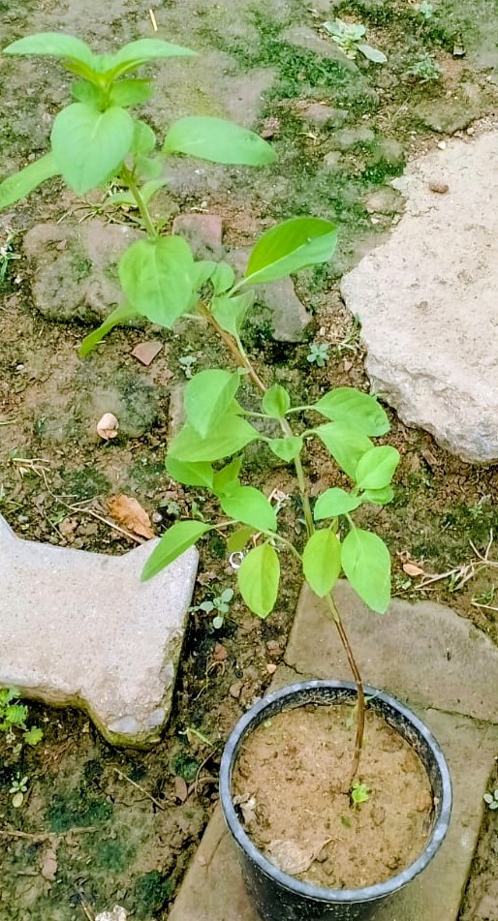
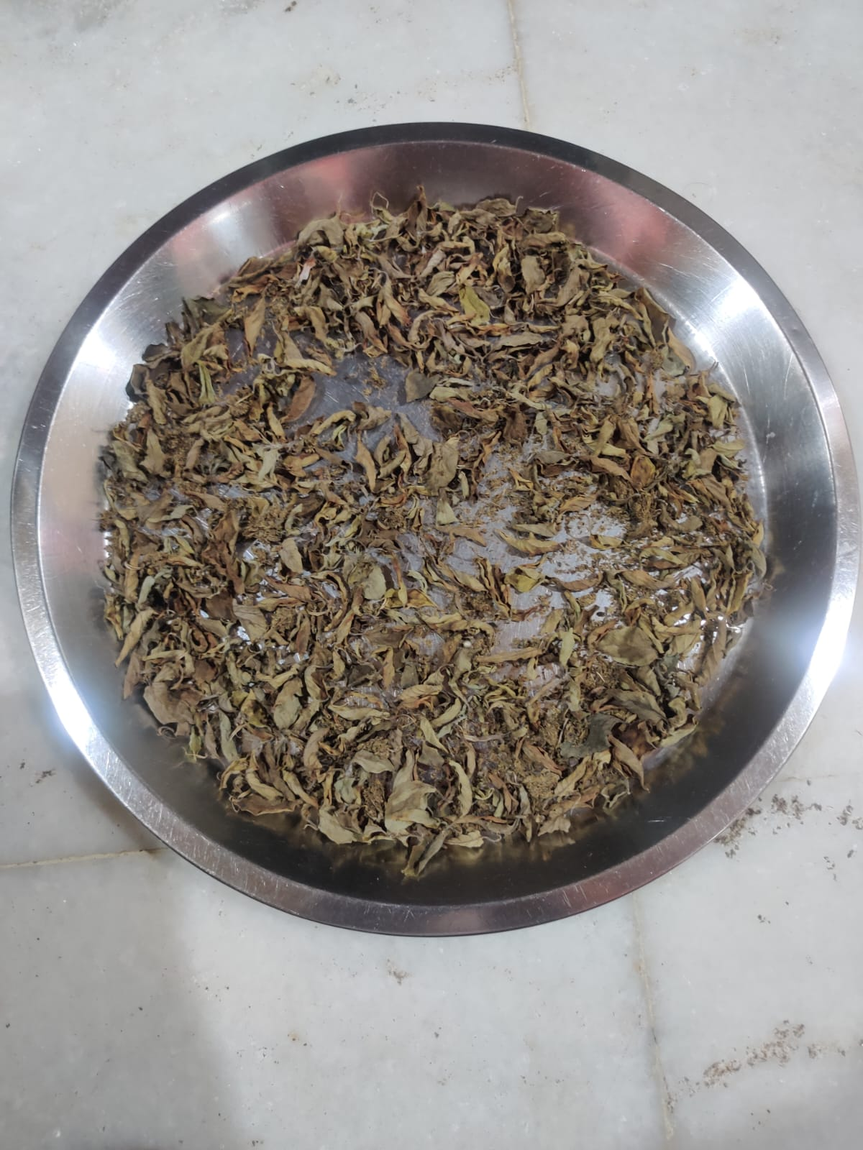
a. b
Picture - 1, a – Kapoor Tulsi Plant, b – shade dried leaves of test plant

Preparation of Ethanolic Leaf Extract
This was done using maceration technique. 30 g of powdered leaf materials was soaked in100 mL of 95% ethanolic in conical flasks and macerated for 72 hours in room temperature, while shaking intermittently. The macerated material was then filtered through Whatman filter paper No.1 or muslin cloth. The extract was concentrated by leaving the filtered material evaporate for 2-3 days till it reached half its volume resulting into dark green colored concentrated ethanolic leaf extract. This was then stored in a refrigerator awaiting further laboratory experiments. Working solutions of 20%, 30%, 40%, and 50% (v/v) ethanolic leaf extract and distilled water were freshly prepared before every experiment.

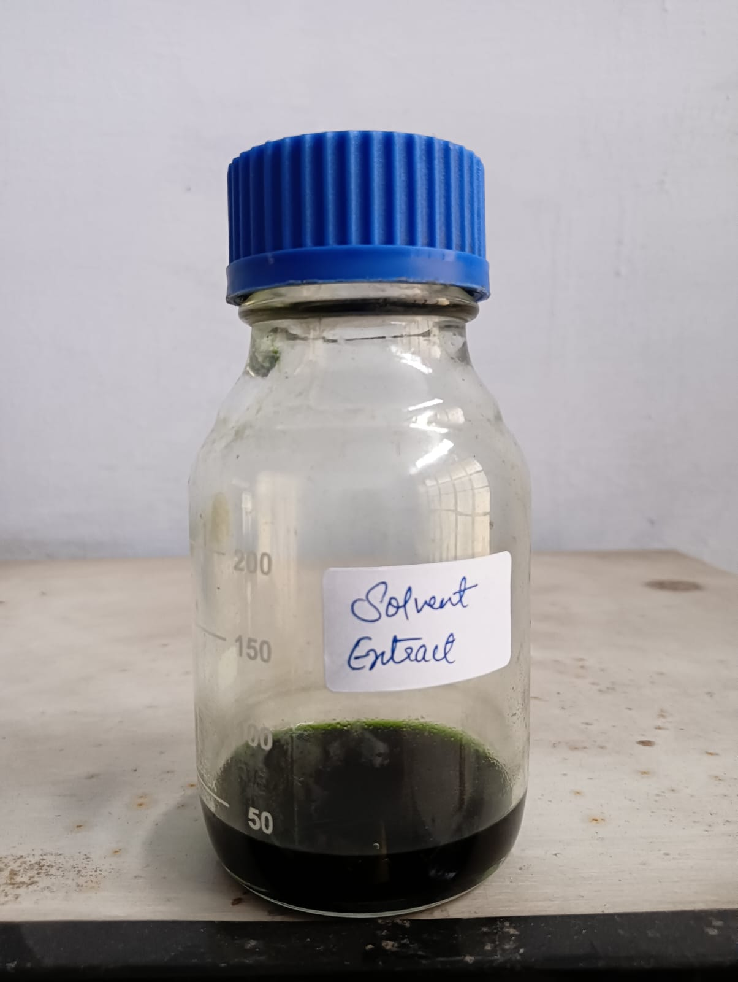
Picture = 2, Ethanolic leaf extract of Ocimum kilimandscharicum
Insect Culture
The laboratory culture of Sitophilus oryzae was done using wheat grains infested naturally. Adult weevils were raised in glass vials with sterile wheat grains that were sterilized by incubation at controlled temperature of 100 degrees centigrade. Bioassays were conducted with adult weevils ranging in age between 3 to 5 days.
Bioassay Procedure
Each glass jar (100mL capacity), containing 30 g of uncontaminated wheat grain was used as an experimental unit. Each of the prepared extract solution was applied appropriately into the grains to make the concentrations 20%, 30%, 40%, and 50% (v/v). After coating of the glass jar with each of the concentrations to ensure uniformity of the solutions, 30 adult S. oryzae were placed in each jar. Glass jars treated with appropriate amount of pure ethanol were used as controls. All the treatments were carried out three times. The jars were kept at 27 ± 2°Ctemperature and 65 ± 5% RH. Mortality of the adult was measured after one day, three days, seven days, 14 days and 21 days of application. Mortality was determined by lack of response of the dead insect to gentle prodding with a fine camel-hair brush. Abbott’s (1925) formula was used to correct the mortality for the control group.
$$Corrected \% Mortality=\frac{T - C}{100-C}x 100$$
Where T = % mortality in treatment;
C = % mortality in control
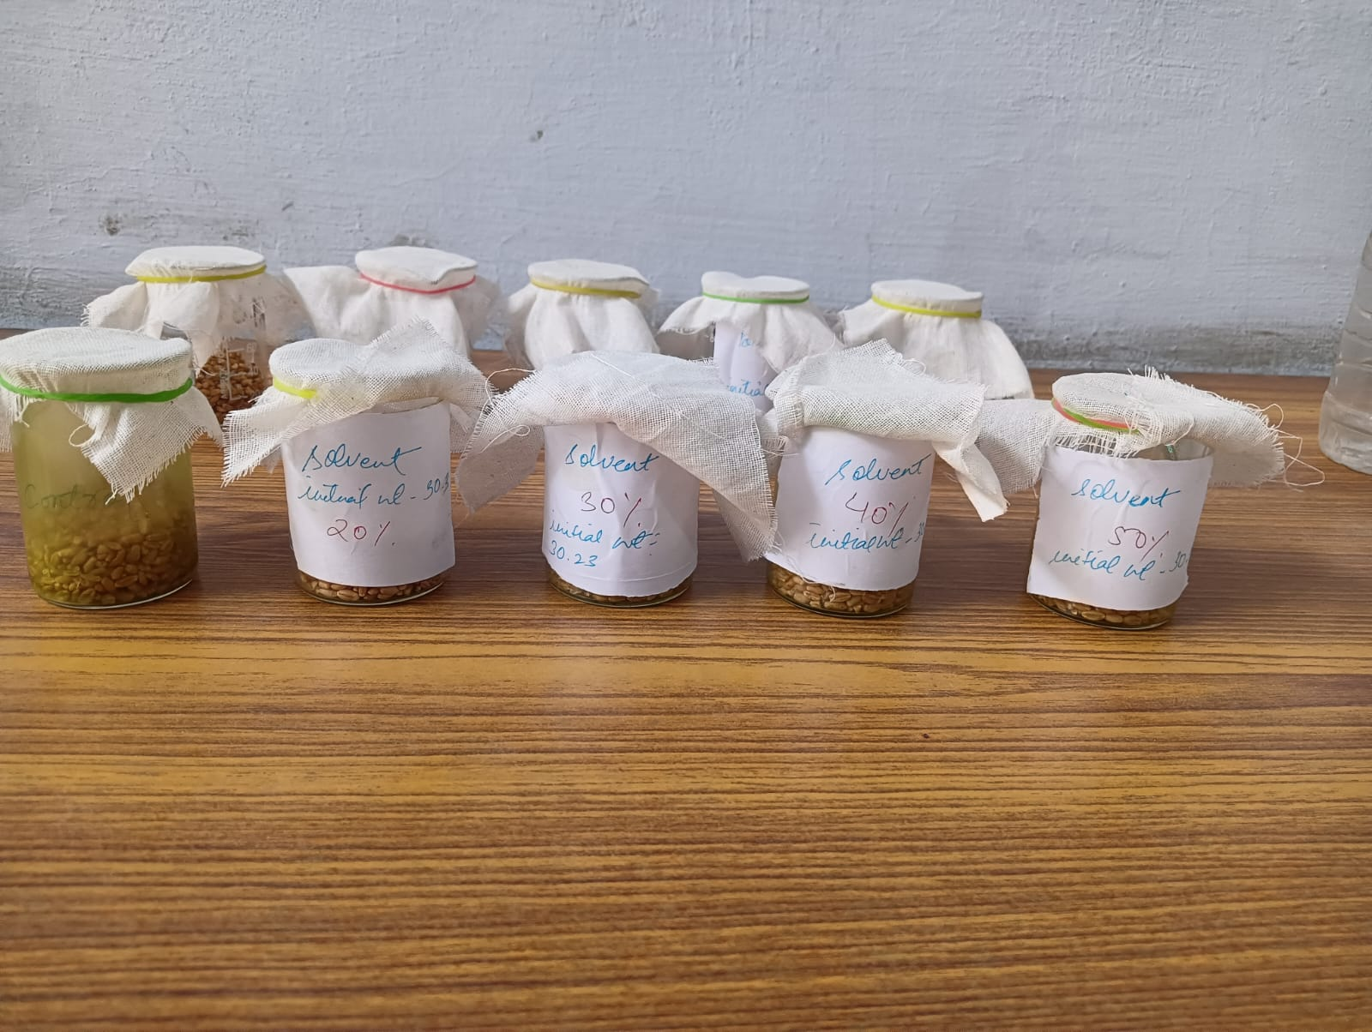
Picture – 3, Bioassay for mortality and weight loss with test extract treated wheat grains

Assessment of weight loss
The weight losses after 21 days of treatment were calculated as the difference between the final and initial weights of treated or untreated grain and expressed as a percentage of initial weight of grains. The following equation was used:
$$\%WL=\frac{IW-FW}{IW} X 100$$
Where, WL = Weight Loss Index
IW= Initial weight
FW= Final weight
Statistical Analysis
All data were expressed as mean ± standard deviation (SD) of three independent replicates. Statistical analysis was performed using one-way Analysis of Variance (ANOVA). Where significant differences were detected, means were further compared using Tukey's Honestly Significant Difference (HSD) Post Hoc test at a significance threshold of p ≤ 0.05.
3. results
Effect on Mortality of S. oryzae with ethanolic leaf extract of Ocimum kilimandscharicum
At various concentrations and exposure time periods the ethanolic leaf extract of Ocimum kilimandscharicum showed a significant concentration-time dependence for its insecticidal effect on S. oryzae in stored wheat. Table 1 presented the corrected percent mortality at various concentrations and observation days while Figure 1 illustrated the same.

Table – 1, Effect of Ethanolic extract of Ocimum kilimandscharicum on the mortality of Sitophilus oryzae on wheat
S. no. | Day | Mean % mortality of Ethanolic extract (v/v %) |  |  |  | F value | P value
S. no. | Day | 20% | 30% | 40% | 50% | F value | P value
1 | 1 | 4.44±3.845ª | 8.883±3.850 ª | 33.33±6.67 ª | 15.55±10.183ª | 1.638 | 0.256
2 | 3 | 11.106±3.850 ª | 17.776±3.850^{ab} | 22.22±3.845^{b} | 22.22±3.845^{b} | 5.588 | 0.023
3 | 7 | 15.553±3.850 ª | 22.22±3.845 ª | 24.44±3.845ª | 37.776±3.850^{b} | 17.594 | 0.0007
4 | 14 | 26.66±0 ª | 28.883±3.850^{ab} | 35.553±3.850^{b} | 55.553±3.850^{c} | 46.632 | 0.00002
5 | 21 | 28.883±3.850 ª | 33.33±6.67 ª | 51.106±3.850^{b} | 57.776±3.850^{b} | 25.923 | 0.0002

Note: The values of % mortality after correction of control mortality represent the mean ± SD of triplet experiments. Statistical analysis through one way ANOVA at value p<0.05 followed by Tukey’s Post Hoc test with p≤0.05 was used. The means with different alphabets are significantly different with each other as indicated by Tukey’s Post Hoc test (row by row analysis) at alpha = 0.05.

Figure – 1, Effect of Ethanolic extract of Ocimum kilimandscharicum on the mortality of Sitophilus oryzae on wheat

Mortality Trends over Time
The first day showed no significant differences between the four concentrations (F = 1.638, p = 0.256). Mortality rates ranged from 4.44 ± 3.845% for the 20% group to 33.33 ± 6.67% forth 40%. High standard deviation values indicated the presence of great variability in the susceptibility of insects to treatments. However, on Day 3, significant effect of the concentration on the mortality was proven (F = 5.588, p = 0.023), and the mortality rates changed from 11.106 ± 3.850% for the 20% group to 22.22 ± 3.845% for the 40% and 50%.Post hoc analysis by means of Tukey's method demonstrated the fact that the 40%concentration formed a different statistical group (b) compared to the 20% and 30% groups(a) and (ab).
Day 7 is when the effect of the concentration became highly significant (F= 17.594; p=0.0007), with the 50% concentration producing 37.776 ± 3.850% mortality, which is significantly higher than any other group. This trend continued on Day 14, whereby the 50%concentration produced the highest mortality rate of 55.553 ± 3.850% (group c), followed by40% (35.553 ± 3.850%, group b) and 20% and 30% (group a and ab respectively). The one-way ANOVA gave the highest value of F in the experiment (F= 46.632; p= 0.00002) on this day, suggesting that Day 14 was the maximum difference in treatment groups. For Day 21, the 50% concentration again gave the highest mortality rate (57.776 ± 3.850%), constituting a separate statistical group (b) along with 40% concentration (51.106 ± 3.850%), while the 20% and 30% concentrations constituted a separate group (a) at mortality rates of28.883 ± 3.850% and 33.33 ± 6.67% respectively. For Day 21, ANOVA test gave an extremely significant result (F = 25.923, p = 0.0002), confirming sustained and progressive insecticidal activity.

Concentration–Response Relationship
For all observation times starting on Day 7, there was a definite positive dose response effect: Increasing the concentration of the extract from 20% to 50% led to a higher percentage mortality for S. oryzae. For Days 14 and 21, respectively, the 50% ethanolic extract was most effective with 55.553% and 57.776% mortality rates, but total mortality (100%) was not attained with any of the tested concentrations, implying that higher concentrations and/or increased exposure time are needed to reach the LC50/LC100 values.

Weight loss Assessment
Mortality data revealed a progressive increase in percent mortality with both rising extract concentration and extended exposure duration. This pattern of mortality based on time shows close similarity to the results of weight loss of wheat (Table, 2 and Figure 2), which was obtained after21 days. In the control sample of weevils, without extract, there is the greatest weight loss (20.87 ± 0.331%) because of the feeding of insects, which is not stopped, and the relatively low mortality of insects. With the increase of extract concentration, there was steady and significant decrease of weight loss (F = 146.529), with the minimal value at 50% of concentration - 10.59 ±0.92%. It is worth mentioning that this correlation reflects the similar mortality on 21-day, when the greatest mortality occurred in 50% concentration too (57.776%). Therefore, this similarity implies that the protective effect of the extract on grain is achieved due to two processes – the reduction of insect’s population and, possibly, suppression of their feeding by extract.
One-way ANOVA produced a highly significant F value (146.529) meaning that there was significant treatment effect (p<0.05). From Tukey post hoc test, it can be observed that there was significant difference between all treatment means indicated by different letters (a,b,c,d) except for 30% and 40% which did not differ significantly. In other words, the efficacy increases gradually as efficacy levels increase from 30% but the increase in efficacy from 30% to 40% is comparatively smaller than the increase in efficacy from 50%.
From the above results, it is evident that the ethanolic extract from O. kilimandscharicum leaves may be an effective natural protectant against S. oryzae attack on wheat, especially at high concentration levels that proved most effective in reducing weight losses.

Table – 2, Effect of Ethanolic extract of Ocimum kilimandscharicum on the weight loss in wheat caused by Sitophilus oryzae after 21 days

S. no. | Mean % wt loss in control | Mean % wt loss in wheat with crude extract (v/v %) |  |  |  | F value
S. no. | Mean % wt loss in control | 20% | 30% | 40% | 50% | F value
1 | 20.87±0.331ª | 15.04±0.466^{b} | 12.93±0.347^{c} | 12.256±0.564^{c} | 10.59±0.92^{d} | 146.529

Note: The values of % weight loss in wheat represent the mean ± SD of triplet experiments. Statistical analysis through one way ANOVA at value p<0.05 followed by Tukey’s Post Hoc test with p≤0.05 was used. The means with different alphabets are significantly different with each other as indicated by Tukey’s Post Hoc test (row by row analysis) at alpha = 0.05.

Figure – 2, Effect of Ethanolic extract of Ocimum kilimandscharicum on the weight loss in wheat caused by Sitophilus oryzae after 21 days

4. discussions
The results from the current study confirm the insecticidal activity of Ocimum kilimandscharicum leaf extract against Sitophilus oryzae in stored wheat. The dose- and time-dependent mortality response witnessed among all test groups aligns with the dose response relationship typical of botanical insecticides (Isman, 2006). Insecticidal activities of Ocimum species against stored grain insects have been documented by several investigators. Oparaeke et al. (2006) showed the mortality of S. zea-mais through the use of Ocimum gratissimum plant extract, whereas Prabhu et al. (2011) recorded fumigant toxicity of Ocimum basilicum oil to S. oryzae, citing eugenol and linalool as major components.
The low rate of mortality at 20% (highest mortality was observed on Day 21 with a value of 28.883% when compared with 50% concentration which had a highest mortality of 57.776%) could imply that there are some toxic substances contained in the ethanolic extracts with a concentration-dependent lethal range. The lack of significance in the statistics on Day 1 (F =1.638, p = 0.256) was due to the lag period when the toxin would be absorbed by the organism. The increased values of F (5.588 → 17.594 → 46.632 → 25.923) starting from Day 3 onwards implied increasing toxic effect.
These bioactive compounds in O. kilimandscharicum ethanolic extract that are known for their insecticidal activities include camphor, 1,8-cineole, linalool, eugenol, and many other phenolics, including rosmarinic acid. Camphor, which is a main monoterpenoid in O. kilimandscharicum, is a known acetylcholinesterase (AChE) inhibitor and it interferes with neuromuscular conduction resulting in paralysis and insect mortality (Mkenda et al., 2020). In addition, 1,8-cineole has been shown to be both a fumigant and contact insecticide in Coleoptera (Tripathi et al., 2009). The synergistic effect of these phytochemicals could explain the prolonged insecticidal activity throughout Day 21.
The solvent ethanol is noted to extract a wider range of polarities of phytocompounds than water or petroleum, ether solvents such as alkaloids, flavonoids, terpenoids, tannins, and saponins, which could be responsible for the insecticidal activity demonstrated by the sample (Harborne, 1973). This multiplicative mode of operation is a great strength compared to the synthetic insecticide based on a single molecule since it greatly minimizes chances of developing resistance by the target pests. The partial killing even at 50%concentration after 21 days shows the need to increase concentrations or microencapsulation (Isman & Grieneisen, 2014).
The proposed acetylcholinesterase (AChE)-mediated mode of action for camphor and 1,8-cineole is not supported by several independent lines of monoterpenoid research. Inhibition of AChE activity has been examined as a possible mode of action for monoterpenoids causing high mortality in S. oryzae, R. dominica, and Cryptolestespusillus (Abdelgaleil et al., 2009; López & Pascual-Villaloboset al., 2010).Complementary evidence comes from work specifically on O. kilimandscharicum constituents: development of eggs and immature stages within grain kernels was completely inhibited in camphor-treated grain, and camphor also proved highly repellent to treated beetles, with repellency in the80–100% range (Obeng-Ofori et al., 1997).
The synergistic interaction among the essential oils from O. kilimandscharicum is itself proven experimentally, since blend effects among the constituents of the essential oil from Ocimum kilimandscharicum and Ocimum kenyense are known to affect their combined toxicity towards two post-harvest insect pests (Bekele & Hassanali, 2001). It is thus possible that the increasing potency of the ethanolic whole leaf extract in this study – not a single chemical but a mixture of several constituents including camphor and 1,8-cineole – results from synergy.
Regarding the grain protection aspect, the 20.87% loss in the weight recorded within the first 21days by the control treatment is in line with the high losses normally observed for uncontrolled wheat under the influence of S. oryzae, whereas the dose-dependently reduced value of 10.59%at 50% v/v aligns with results obtained from other Lamiaceae extracts which are known to serve as protectants for stored grains. These results are in agreement with literature reports highlighting the broad screening and use of phytochemicals against stored insect pests of grains based on their insecticidal properties as an alternative to synthetic grain protectants (Rajashekar et al., 2012; Soujanya et al., 2016).
The patterns observed in mortality and reduction in weight loss correlate with each other to provide evidence for the dual-mode action of O. kilimandscharicum ethanolic extract, especially within the 40-50 % v/v concentration, as a grain protection agent. The dual mechanism includes delayed and increasing mortality coupled with antifeedant and repellent actions.
On combining all the above findings, it can be inferred that the ethanolic extract of O. kilimandscharicum is effective both as an insecticide as well as a grain preservative, which is in agreement with previous research done on the bioactivity of the plant. Extracts from the leaves as well as essential oil of the plant have been found to cause mortality of 100% in closely related stored grain beetles within 48 hours along with reduction in the survival of the offspring in the grain (Weaver et al., 1991).Camphor, in particular, which is the major terpenoid in O. kilimandscharicum, has been shown to have toxic as well as protective properties against several stored-product beetle species, thus corroborating that it could be one of the main reasons for the mortality and weight reduction noted in the current study.

5. CONCLUSION
The ethanolic leaf extract of Ocimum kilimandscharicum showed measurable activity against adult Sitophilus oryzae under laboratory conditions. Mortality generally increased with concentration and exposure duration, reaching 57.776 ± 3.850% in the 50% treatment after 21 days. Grain weight loss also declined from 20.87 ± 0.331% in the control to 10.59 ± 0.92% at the highest tested concentration. These observations suggest that the extract may have potential as a botanical grain protectant. However, mortality remained incomplete, and the study did not assess extract composition, behavioural effects, residue safety or storage-scale performance. Therefore, practical application cannot yet be recommended. Further work should standardise the applied dose, estimate lethal concentrations and evaluate grain quality, non-target safety and efficacy under semi-field and storage conditions.

Limitations
The experiment used only three replicates per treatment and evaluated adult insects under laboratory conditions. Extract concentrations were expressed volumetrically without chemical standardisation or determination of extraction yield. Grain moisture, seed quality, offspring production, repellency and feeding deterrence were not independently assessed. Weight loss was measured only after 21 days and was not corrected using insect-free grain controls. The study also lacked a recognized positive-control insecticide and did not determine the chemical constituents of the tested extract.

CONSENT
It is not applicable.
ETHICALAPPROVAL
It is not applicable.

Declaration of AI Use

This manuscript was prepared through the combined contributions of all author(s), including contributions to the study design, data, content development, results, interpretation, and related scholarly work. The author(s) acknowledge the use of Grammarly and ChatGPT to assist with grammar checking, language refinement, reference formatting. These AI-assisted tools were not used as authors and did not replace the intellectual contributions or scholarly judgment of the author(s). All AI-assisted outputs, including content, references, and interpretations, were carefully reviewed, revised, verified, and approved by the author(s). The author(s) accept full responsibility for the accuracy, integrity, and final content of the manuscript.

COMPETING INTERESTS DISCLAIMER:
Authors have declared that they have no known competing financial interests OR non-financial interests OR personal relationships that could have appeared to influence the work reported in this paper.

REFERENCES
- Abbott, W.S. (1925). A method of computing the effectiveness of an insecticide. Journal of Economic Entomology, 18(2), 265–267.
- Abdelgaleil, S. A. M., Mohamed, M. I. E., Badawy, M. E. I., & El-Arami, S. A. A. (2009). Fumigant and contact toxicities of monoterpenes to Sitophilus oryzae (L.) and Tribolium castaneum (Herbst) and their inhibitory effects on acetylcholinesterase activity. Journal of Chemical Ecology, 35(5), 518–525.
- Bakkali, F., Averbeck, S., Averbeck, D., & Idaomar, M. (2008). Biological effects of essential oils – A review. Food and Chemical Toxicology, 46(2), 446–475.
- Harborne, J.B. (1973). Phytochemical Methods: A Guide to Modern Techniques of Plant Analysis Chapman and Hall, London.
- Isman, M.B. (2006). Botanical insecticides, deterrents, and repellents in modern agriculture and an increasingly regulated world. Annual Review of Entomology, 51, 45–66.
- Isman, M.B., & Grieneisen, M.L. (2014). Botanical insecticide research: many publications, limited useful data. Trends in Plant Science, 19(3), 140–145.
- Jembere, B., Obeng-Ofori, D., Hassanali, A., & Nyamasyo, G. H. N. (1995). Products derived from the leaves of Ocimum kilimandscharicum (Labiatae) as post-harvest grain protectants against the infestation of three major stored product insect pests. Bulletin of Entomological Research, 85(3), 361–367.
- Khan, T.,Ahmad Ali Shahid,A.A., and Ali Khan,H.A.(2016).Could biorational insecticides be used in the management of aflatoxigenic Aspergillus parasiticus and its insect vectors in stored wheat?PeerJ 4:e1665; DOI 10.7717/peerj.1665
- Lakshmi Soujanya, P., Sekhar, J. C., Kumar, P., Sunil, N., Vara Prasad, C., & Mallavadhani, U. V. (2016). Potentiality of botanical agents for the management of post-harvest insects of maize: A review. Journal of Food Science and Technology, 53(5), 2169–2184.
- López, M. D., & Pascual-Villalobos, M. J. (2010).Mode of inhibition of acetylcholinesterase by monoterpenoids and implications for pest control.Industrial Crops and Products, 31(2), 284–288.
- Mkenda, P., Mwanauta, R., Stevenson, P.C., Ndakidemi, P., Mtei, K., & Belmain, S.R. (2020). Extracts from field margin weeds provide economically viable and environmentally benign pest control compared to synthetic pesticides. PLoS ONE, 15(1), e0228155.
- Nagpal,K.,Jasrotia,P., Jaglan,M.S., Kashyap,P.L.,Maanju,S. and Kumar,S.(2025).Molecular detection tool for prompt, reliable and precise diagnosis of the rice weevil, Sitophilus oryzae (Linnaeus) infestation in wheat. Frontiers in Plant Science.16:1628692. doi:10.3389/fpls.2025.1628692
- Obeng-Ofori, D., Reichmuth, C. H., Bekele, A. J., & Hassanali, A. (1998). Toxicity and protectant potential of camphor, a major component of essential oil of Ocimum kilimandscharicum, against four stored product beetles. International Journal of Pest Management, 44(4), 203–209. https://doi.org/10.1080/096708798228112
- Oparaeke, A.M., Dike, M.C., & Amatobi, C.I. (2006). Insecticidal potential of extracts of Ocimum gratissimum (L.) seeds for management of Callosobruchus maculatus (F.) on stored cowpea. Journal of Plant Protection Research, 46(2), 171–179.
- Prabhu, S., Sivakumar, R., & Murali-Baskaran, R.K. (2011). Fumigant toxicity of essential oils from Ocimum basilicum, Eucalyptus globulus and Mentha piperita against stored grain pest, Sitophilus oryzae. Journal of Stored Products Research, 47(4), 371–376.
- Rajarushi,C.N., Nebapure,S.M., Biswas, A.,S. Rajna, S. &Subramanian,S.(2024). Contact toxicity of insecticides against rice weevil, Sitophilus oryzae L. and its effect on progeny production.Scientific Reports .14:28404
- Rajashekar, Y., Bakthavatsalam, N., & Shivanandappa, T. (2012). Botanicals as Grain Protectants. Psyche: A Journal of Entomology, 2012, Article ID 646740.
- Tripathi, A.K., Upadhyay, S., Bhuiyan, M., & Bhattacharya, P.R. (2009). A review on prospects of essential oils as biopesticides in insect-pest management. Journal of Pharmacognosy and Phytotherapy, 1(5), 52–63.

