Original Research Article
Taxonomic study of Geometrinae moths (Lepidoptera: Geometridae) from the Northernmost Western Ghats of Nashik, Maharashtra, India

Abstract
The northernmost Western Ghats of Maharashtra harbour diverse geometrid assemblages, yet the data of species composition and distribution of Geometrinae moth is insufficient. The present study provides a first taxonomic account of Geometrinae from northernmost Western Ghats of Nashik district based on external morphology, wing venation, and external genitalia. A field survey conducted from June 2021 to December 2023 across seven localities documented 17 species belonging to 13 genera and five tribes viz. Agathiini, Comibaenini, Geometrini, Hemitheini and Pseudoterpnini. Tribe Hemitheini is recorded as most species-rich tribe (Seven species). The recorded species exhibited considerable variation in morphology, but, no significant deviation was observed among the studied taxa, representing taxon specific conserved structural uniformity of venation within the subfamily Geometrinae.
As much as 13 species are reported as new record for Nashik district, expanding their known local distributions. The study provides baseline taxonomic and distributional information on Geometrinae from the study area and highlights the importance of continued systematic surveys for documenting moth diversity in this biodiversity-rich area.
Keywords: Geometridae, Geometrinae, Wing venation, Taxonomy, Northernmost Western Ghats, Maharashtra, India.

Introduction
The northernmost Western Ghats of Maharashtra, particularly within the Nashik district, represent an ecologically diverse yet comparatively underexplored region for the lepidopteran studies. The present study focuses on geometrid moth diversity across this landscape, characterizing a network of mountain ranges and associated habitats. The field surveys were undertaken between June 2021 to December 2023 across selected key localities including Salher-Mulher in the north, Vikramgad and Jawhar in the west, Bhandardara and Akole in the south, and Chandwad in the east. Sampling locations such as Peth-Harsul, Kasara, Kalmuste, Kalsubai, Belgaon Dhaga, Waghere-Harsul, and Saptashrungi-Gad (Vani) were selected to represent a gradient of ecological conditions. These locations encompass semi-evergreen, moist deciduous, and high-altitude forest patches, thereby providing a heterogenous landscape suitable for assessing moth diversity and distribution in the northern Western Ghats.
The superfamily Geometroidea is among the most diverse group within Lepidoptera comprising more than 24,000 described species distributed worldwide (Ding et al., 2023). A distinguishing synapomorphy that sets moths of superfamily Geometroidea apart from other lepidopteran lineage is the paired abdominal tympanal organs. Geometroidea embraces five families viz. Geometridae, Uraniidae, Sematuridae, Epicopeiidae, and Pseudobistonidae (Wang et al. 2019). Of all these families, Geometridae Stephens, 1829 is the second most species-rich family of Lepidoptera and globally represented by nine subfamilies viz. Sterrhinae, Larentinnae, Archiearinae, Desmobathrinae, Oenochrominae, Geometrinae, Orthostixinae, Epidesmiinae and Ennominae (Ding et al. 2023). The family demonstrates exceptional morphological and ecological variation, with larvae frequently referred to as inchworms or loopers due to their distinctive movement style caused by the reduction of prolegs.
Among all subfamilies Geometrinae, known as emerald moths, because of the vibrant, light to bluish green coloration, which closely resembles the gemstone emerald. (Cook,1993). The green colour helps them in camouflage, to blend into leafy environments for protection from their predators (Ude et.al 2024). Globally, subfamily Geometrinae includes over 2600 described species, mostly tropical, slender bodied and delicate wings often help flat at rest. Among these 294 species reported from India (Shubhalaxmi, 2018; Kirti et al., 2019; Kaur & Qayoom, 2021). Moreover, Geometrinae is under dynamic taxonomic revisions and new species descriptions highlighting its dynamic and evolving classification (Plotkin & Kawahara, 2020; Plotkin et al. 2025).
The foremost documentation of the geometrid moth in India date back in 17th century, when Linnaeus described the species Militarius in 1758. Later on, Hampson (1895, 1896) in fauna of British India described over 1061 species belonging to 160 genera representing six subfamilies (Kaur & Qayoom, 2021). Afterward Hampson (1895, 1898, 1902, 1907, and 1912) made several publications and largely contributed to Indian geometrid fauna. Recently, Singh et al. 2026, have given comprehensive and detailed account of family Geometridae in catalogue of Geometroidea and reported that family Geometridae is well represented over 2,100 species in India, wherein subfamily Geometrinae account for total 309 species from 82 genera. Geometrid moths are indicators of habitat quality and environmental alterations owing to their sensitivity to vegetation composition and climate factors. Despite its ecological significance, the taxonomic knowledge of Geometrinae is inconsistent across various regions, with several biodiversity-rich landscapes still inadequately explored.
Western ghats, a globally recognized biodiversity hotspot, supports great endemism and species richness due to its complex topography, climatic factors and lush diverse vegetation. Northern Western Ghats of Maharashtra serve as a transitional zone characterized by diverse array of habitats, including moist deciduous forest, semi-evergreen, and montane ecosystems. Recent faunal assessments have showed that this area contains a diverse assemblage of geometrid moths, including varied species from several subfamilies, highlighting its importance for lepidopteran diversity (Shubhalaxmi et al. 2011; Kirti et al. 2012; Gurule and Nikam, 2013; Gurule et al. 2025). However, focused taxonomic studies specifically addressing Geometrinae from this region remain limited. In this context, the present study aims to provide a taxonomic account of Geometrinae from northernmost Western Ghats of Maharashtra by studying wing morphology, venation and external genitalia so as to contribute in understanding Geometrinae diversity.

Material and Methods
Field Survey and collection:
The study was conducted across seven localities in northernmost Western Ghats of Maharashtra: Saptashrungi Vani (SV), Waghere–Harsul (WH), Kalmuste (KM), Belgaon Dhaga (BD), Kasara (KS), Peth–Harsul (PT), and Kalsubai (KL). All the field observations, specimen collection were carried out under valid research permits issued by the Principal Chief Conservator of Forest (PCCF), Maharashtra (Ref. No. Desk-22(8)/Research/CR-47/3098/22-23) and the Maharashtra State Biodiversity Board (Ref. No. MSBB/Desk-5/Research 617/2023-24).
Table 1: Details of sites of observation.
Sites | Abbreviation | Latitude | Longitude | Elevation | No. of Visits
Saptashrungi Vani | SV | 20.3911°N | 73.9167°E | 1179 | 8
Waghere–Harsul | WH | 20.1058°N | 73.4592°E | 369 | 8
Kalmuste | KM | 20.1036°N | 73.3883°E | 628 | 15
Belgaon Dhaga | BD | 19.9669°N | 73.7036°E | 655 | 7
Kasara | KS | 19.6427°N | 73.4689°E | 309 | 8
Peth–Harsul | PT | 20.2589°N | 73.5058°E | 619 | 6
Kalsubai | KL | 19.6003°N | 73.7064°E | 1243 | 8

Nocturnal surveys were conducted between 18:30 and 02:30 h using a non-invasive light-sheet method (Gurule & Nikam, 2013) in selected localities in Nothernmost Western Ghats of Maharashtra in Nashik district. Mercury vapour lamps (240 W; Philips and Osram), powered by a petrol generator, along with a LepiLED Maxi light powered by a powerbank, were employed for moth attraction. Opportunistic photographic records were obtained using a Nikon D7500 DSLR camera with a Tamron 90 mm macro lens. Selected specimens were collected using entomological vials. Data were recorded over from June 2021–December 2023.

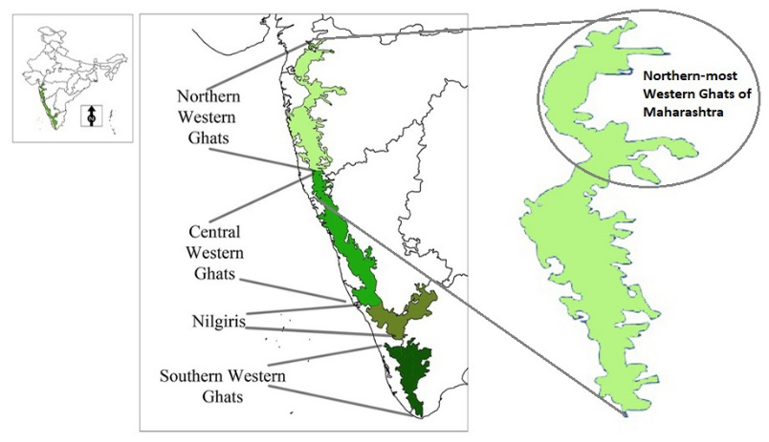
Figure 1: Map showing the study area the Northern Western Ghats of Maharashtra.
(Source: Edited from image available on lotusarise.com).

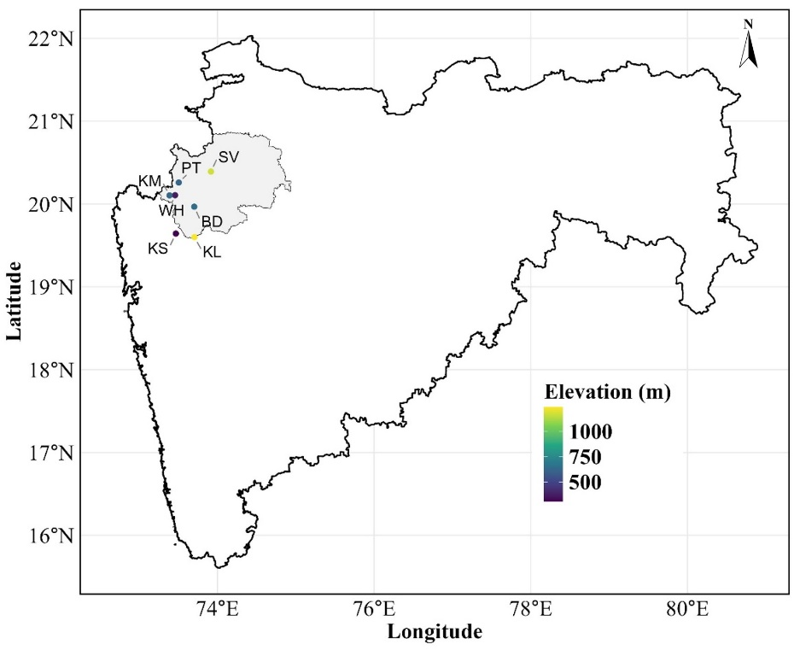
Figure 2. Sampling sites from Northernmost Western Ghats of Maharashtra, India. Abbreviations: Saptashrungi Vani (SV), Waghere–Harsul (WH), Kalmuste (KM), Belgaon Dhaga (BD), Kasara (KS), Peth–Harsul (PT), and Kalsubai (KL).
Specimen Handling and preservation:
Collected specimens were euthanized using Chloroform, and pinned through the mesothorax using entomological pins (000 and 00 size), and mounted in spreading board. Wings and appendages appropriately stretched on spreading boards using butter paper and setting pins, and curated specimens dried in an electric oven at 60°C for 48 hours. (Gurule 2013). Dried specimens were sorted taxonomically, labelled, and preserved in airtight insect cabinets along with naphthalene balls under controlled conditions for long-term storage and examination.
Wing Venation and external genitalia Preparation and examination:
Permanent slide preparations of the wings were made to facilitate detailed venational analysis. For this purpose, the method outlined by Common (1970) and later supported by Zimmerman (1978) were followed. The right or left undamaged pair of wings were removed from the dry specimens and processed for venation studies. The detached wings were first softened in 70% alcohol for 1 h, then subjected to descaling using a 4% sodium hypochlorite solution for 1 minute. Following this, the wings were rinsed with distilled water and subsequently stained in 70% alcohol eosin for a period of 12-14 h. After staining, wings are dehydrated using ascending grades of alcoholic, cleared in xylene and mounted in DPX putting coverslip. Permanent slide of wing venation was photographed using Nikon DSLR D3000 camera mounted on a stereomicroscope, slides were labelled and stored in slide boxes and submitted in Museum of Department of Zoology & Research Center of K.T.H.M. College, Nashik for future reference. The terminology used for of wing venation proposed by Comstock and Needham (1898-1899), with subsequent modification as per Imms (1957), and Miller (1970).
Genitalia of all 17 species were dissected following Clarke (1941) and Robinson (1976). The abdomen was removed and macerated in 10% KOH, followed by thorough washing using distilled water and removal of the soft tissues using fine forceps and camel hair brush under COSLAB stereomicroscope. The genital structures were dissected and examined in glycerol, and diagnostic character were compared with published taxonomic descriptions and illustrations for species confirmation. The examined genitalia were preserved in glycerol in Eppendorf tubes associated with the respective voucher speciemens.

Identification
Identification of specimens was carried out using standard keys, checklists, and available references Hampson (1895, 1896); Holloway (1996); Shubhalaxmi (2011, 2018); Gurule and Nikam (2013); Gurule (2013); Kirti et al. (2019); Gurule and Brookes (2021), and Sondhi (2024). Photographic documentation supported the diagnostic process, and species confirmation was validated through expert taxonomic consultation.

Results
The present study documented a total of 17 species of the subfamily Geometrinae from the northernmost Western Ghats of Maharashtra (Nashik district), representing 13 genera and five tribes, viz. Agathiini, Comibaenini, Geometrini, Hemitheini, and Pseudoterpnini. Among these, Hemitheini was the most species-rich tribe, contributing seven species to the total Geometrinae assemblage.
Taxonomic illustration
Family Geometridae Leach, 1815
Key to major subfamilies of family Geometridae
- Vein M₂ absent in Hindwing ………………….………………. Ennominae
- Vein M₂ present in Hindwing …………………………………. 2
- Vein M₂ arising from just above the middle of discocellulars… Geometrinae
- Vein M₂ arising from below middle of discocellulars ………… Sterrhinae
Systematic account of Geometrinae
Note: Species marked with an asterisk (*) indicate new regional records.
Subfamily Geometrinae Stephens, 1829
Moths Geometrinae are characterised by emerald green pigment scales. Forewing with medial vein M₂ from upper angle of cell, radial vein (R₂-R₅) stalked, often M₁ and R₁ with them, without areole. Hindwing with medial vein M₂ arising just above the middle of discocellulars, Sc+R₁ bent down and touching the cell at base, then rapidly diverge.
Tribe: Agathiini
- *Agathia angustilimes Prout, 1926 (Photo Plate 1:1; 2:18; 4:35)
Agathia angustilimes Prout, 1926, Mem. Dep. Agric. India (Ent.) 9(8): 247. Type-locality: Pusa, Bihar, India.
Material Examined: India. 1♀; Belgaon Dhaga, Nashik; 19.9669°N; 73.7036°E; 655 m a.s.l.; Light sheet method; 23-vii-2022; SG91. 1♀; Saptashrungi Vani, Nashik; 20.3911°N; 73.9167°E; 1179 m a.s.l.; Light sheet method; 09 xi 2022; SGA215.
Diagnosis: Wing span: ♀, 32 mm. Head and wings are emerald green; thorax and abdomen with brown. Fore wings are with basal rufous patch; costa greyish; the medial band somewhat outwardly oblique, slightly angled below cell then runs straight to inner margin; rufous postmedial line outwardly oblique meeting marginal fascia; the green patch below apex of fore wing is oval. This species is distinguished from other being having narrower marginal band. Hind wings are without medial line; submarginal rufous fascia with dentate inner edge; large green patch on centre of margin; the green spots towards inner margin rarely developed; margin at centre is produced with triangular black spot on it.
Distribution in India: Bihar (Pusa), Nilgiris, Delhi Tamil Nadu (Nilgiri Hills).
Elsewhere: Unkown.
*Remark: First record from Nashik (Belgaon Dhaga, Saptashrungi Vani), Maharashtra.

- Agathia laetata (Fabricius, 1794) (Photo Plate 1:2; 2:19; 4:36)
Phalaena laetata Fabricius, 1794; Ent. Syst. 3(2): 164; Moore, Lep. Ceyl. 3, Pl. 197, Figs. 1a, b (larva); C.&S. no. 3522. Type-locality: India.
Material Examined: India. 1♀; Belgaon Dhaga, Nashik; 19.9669°N; 73.7036°E; 655 m a.s.l.; Light sheet method; 23-vii-2022; SG92.
Diagnosis: Wing span: ♀, 31 mm. Thorax and abdomen with pale brown; wings are emerald green. Fore wings are with costa greyish; basal rufous patch; the medial band of forewing is reduced to a small tooth from costal fascia; slightly dentate, rufous postmedial line outwardly oblique meeting marginal fascia; inner edge of the outer rufous area being evenly curved on fore wing; the green patch below apex of fore wing is oval. Hind wings are without medial line; submarginal rufous fascia with dentate inner edge; green patch at centre of margin; the green spots towards inner margin of hind wing rarely developed; hind wing margin is produced at centre with black spot on it.
Distribution in India: Arunachal Pradesh, Assam, Chhattisgarh, Goa, Karnataka, Maharashtra, Meghalaya, Tamil Nadu, West Bengal, Andaman and Nicobar Islands.
Elsewhere: Askold Island, Siberia, Japan, Sri Lanka, Myanmar (Burma); Borneo, New Guinea, Australia.

Tribe: Comibaenini
- *Argyrocosma inductaria (Guenée, 1857) (Photo Plate 1:3; 2:20; 4:37)
Phodoresma [sic] inductaria Guenée, 1857; Hist. nat. Ins., Spec. gén. Lépid. 9: 370. Type-locality: Sarawak (Borneo).
Material Examined: India. 1♀; Saptashrungi Vani, Nashik; 20.3911°N; 73.9167°E; 1179 m a.s.l.; Light sheet method; 31-x-2021; SG191. 1♂; Kalmuste, Nashik; 20.1036°N; 73.3883°E; 628 m a.s.l.; Light sheet method; 23-vii-2022; SG857.
Diagnosis: Wing span: ♀, 18 mm. Wings are yellowish green coloured; frons pink and white. Vertex of head and abdomen pink with white spots. Forewing with pinkish costa having a white strip, which is expanding at antemedial and postmedial white spots; pink-ringed white antemedial spot on M₃; a marginal pink band embracing white spots, of which spot on M₃ and inner margin is larger. Hindwing with a pink speck on discal cell.
Distribution in India: Arunachal Pradesh, Himachal Pradesh, Nagaland, Tamil Nadu, Uttarakhand, West Bengal, Andra Pradesh, Assam, Karnataka, Kerala, Meghalaya, Tripura, Nilgiri Hills, Dalhousie, Dharmasala.
Elsewhere: Borneo, Sri Lanka, Peninsular Malaysia.
*Remark: First record from Nashik (Saptashrungi Vani, Kalmuste), Maharashtra.

- *Comibaena attenuata (Warren,1896) (Photo Plate 1:4; 2:21; 4:38)
Probolosceles attenuate Warren, 1896; Novit. Zool. 3: 369. Type-locality: Mt. Mulu, North Borneo.
Material Examined: India. 1♀; Kalsubai foothills, Nashik; 19.6003°N; 73.7064°E; 1243 m a.s.l.; Light sheet method; 10-ix-2023; SG1560.
Diagnosis: Wing span: ♀, 26 mm. Wings are deep emerald-green coloured. Fore wing with white costa; forewing and hind wing having dark speak at end of the discal cell, and large black-brown patch at out angle of fore wing and apex of the hind wing varying in shape and size; both wings with slightly waved marginal band with series of white specks on it; obscure pale lines on hindwing are lacking on forewing. Female has a black-brown submarginal patch on forewing above vein M₃. Underside is whitish, with a small tuft of rufous scales at the end of discal cell of forewing.
Distribution in India: Tamil Nadu, Tripura, Arunachal Pradesh, Assam, Meghalaya, West Bengal, Karnatak, Maharashtra.
Elsewhere: Sri Lanka, Myanmar (Burma), Borneo, Sundaland, Philippines, Indonesia.
*Remark: First record from Nashik (Saptashrungi Vani, Kalmuste), Maharashtra.

- *Comibaena cassidara (Guenée, 1858) (Photo Plate 1:5; 2:22; 4:39)
Phodoresma [= Phorodesma] cassidara Guenée, 1857; Hist. nat. Ins., Spec. gén. Lépid. 9: 370. Type-locality: Inde centrale (Central India).
Geometra detenta Walker, 1861; List Spec. Lepid. Insects Colln. Br. Mus. 22: 521. Type-locality: Nepal.
Material Examined: India. 2♂; Waghere Harsul, Nashik; 20.1058°N; 73.4592°E; 369 m a.s.l.; Light sheet method; 29-x-2022; SG1086 & SG1121. India. 1♂; Kalmuste, Nashik; 20.1036°N; 73.3883°E; 628 m a.s.l.; Light sheet method; 1-i-2022; SG545.
Diagnosis: Wing span: ♂, 18 mm. Wings are bright yellow-green coloured; palpi and abdomen with rufous tinge. Fore wing with white costa; Outwardly oblique antemedial and postmedial lines can be mark; postmedial line is slightly recurved to costa; both wings with slightly waved marginal band with series of white specks on it, and it expand at outer angle of forewing and apex of the hindwing. Forewing and hind wing having dark speak at end of the discal cell. Underside is whitish, with a small tuft of rufous scales at the end of discal cell of forewing; both wings with indistinct postmedial green line.
Distribution in India: Assam, Gujarat, Karnataka, Maharashtra, Rajasthan, Tamil Nadu, Uttar Pradesh, Uttarakhand, West Bengal, Punjab; North India; Central India.
Elsewhere: China, Thailand, Singapore, Indonesia, Malaysia (Borneo).
*Remark: First record from Nashik (Saptashrungi Vani, Kalmuste), Maharashtra.

Tribe: Geometrini
- *Chlorozancla falcatus (Butler, 1889) (Photo Plate 1:6; 2:23; 4:40)
Tanaorrhinus falcatus Hampson, 1895; Fauna Br. India (Moths) 3: 494. Type-locality: Sikkim (India).
Material Examined: India. 1♂; Kalmuste, Nashik; 20.1036°N; 73.3883°E; 628 m a.s.l.; Light sheet method; 1-i-2022; SG538.
Diagnosis: Wing span: ♂, 27 mm. Wings are dull grey-green coloured; vertex of the head is white; forewing with costa and basal part up to antemedial region yellowish; a pale straight, erect postmedial line; a yellow fascia below costa towards apex of wing having a hyaline spot. Hindwing with a hyaline medial band, wider and with yellow edges towards inner margin; obscured submarginal straight line. Both wings having thin paler marginal line with grey-green cilia.
Distribution in India: Sikkim, Maharashtra (Bombay), Kerala (Travancore), Chhattisgarh, Karnataka.
Elsewhere: Nepal.
*Remark: First record from Nashik (Kalmuste), Maharashtra.

Tribe: Hemitheini
- *Comostola chlorargyra (Walker, 1861) (Photo Plate 1:7; 3:24; 4:41)
Comibaena chlorargyra Walker, 1861; List Spec. Lepid. Insects Colln Br. Mus. 22: 577. Type-locality: Sarawak (Borneo).
Material Examined: India. 1♀; Waghere Harsul, Nashik; 20.1058°N; 73.4592°E; 369 m a.s.l.; Light sheet method; 29-x-2022; SG1085.
Diagnosis: Wing span: ♀, 26 mm. Wings are bright emerald-green, opaque with silver-white tinge. Vertex of thorax and Abdomen is pinkish with thin dorsal white stripe. Costa of forewing and cilia ochreous; some fuscous at base of costa. A pale-red-white beaded border on margin on both wings. An oblique band from middle of costa towards the expansion of the marginal markings at the outer angle; this oblique band may be broken up into two spots; a costal spot near apex, to which sometimes the marginal band runs right round and is conjoined. Hindwing is uniform and without speck at end of cell.
Distribution in India: Andaman and Nicobar Islands, Maharashtra, West Bengal, Andhra Pradesh, Assam, Meghalaya, Tamil Nadu.
Elsewhere: Borneo, Java, Philippines, Sulawesi, Sri Lanka.
*Remark: First record from Nashik (Kalmuste), Maharashtra.

- *Episothalma robustaria (Guenée, 1858) (Photo Plate 1:8; 3:25; 4:42)
Hemithea robustaria Guenée, 1857; Hist. nat. Ins., Spec. gén. Lépid. 9: 383. Type-locality: Central India.
Material Examined: India. 1♀; Kalmuste, Nashik; 20.1036°N; 73.3883°E; 628 m a.s.l.; Light sheet method; 23-xii-2022; SG836.
Diagnosis: Wing span: ♀, 42 mm. Wings with ground colour blue-green. Both wings have brown cell-specks; a crenulate olive postmedial line angled at M₃ in both wings; cilia without dark tips. Underside of wings is greenish-white, with faded cell-specks and crenulate postmedial line.
Distribution in India: Arunachal Pradesh, Chhattisgarh, Karnataka, Kerala, Maharashtra, Manipur, Meghalaya, Mizoram, West Bengal, Uttar Pradesh, Himachal Pradesh, Central India.
Elsewhere: Sundaland, China, Myanmar, Thailand, Vietnam, Nepal, Malaysia, Indonesia.
*Remark: First record from Nashik (Kalmuste), Maharashtra.

- *Hemithea marina (Butler, 1878) (Photo Plate 1:9; 3:26; 4:43)
Thalassodes marina Butler, 1878; Ann. Mag. Nat. Hist. (5) 1 (5): 399. Type-locality: Yokohama, Japan.
Material Examined: India. 1♂; Kalmuste, Nashik; 20.1036°N; 73.3883°E; 628 m a.s.l.; Light sheet method; 4-xii-2021; SG429.
Diagnosis: Wing span: ♂, 28 mm. Wings are yellow bluish-green; vertex of the head is white; abdomen with some red and white patch dorsally on 3rd to 5th segment. Costa of forewing is ochreous and dark speckled; a waved white antemedial line; and, both wings with waved white postmedial line somewhat obscure. Forewing having obscure speak at middle end of the discal cell. This species differs from tritonaria being lacking dark marginal line on both wings; the marginal specks white and greenish-grey cilia.
Distribution in India: Himachal Pradesh, Indian Sub-region.
Elsewhere: Japan, Indochina, China, Sundaland, Sulawesi and Seram, Sri Lanka.
*Remark: First record from Nashik (Kalmuste), Maharashtra.

- *Idiochlora caudularia (Guenée, 1857) (Photo Plate 1:10; 3:27; 4:44)
Nemoria caudularia, Guenée [1858] Phal. i, p. 349; C. & S. no. 3488. Type-locality: Northern India.
Material Examined: India. 1♂; Kalmuste, Nashik; 20.1036°N; 73.3883°E; 628 m a.s.l.; Light sheet method; 11-xii-2021; SG481. 1♀; Waghere Harsul, Nashik; 20.1058°N; 73.4592°E; 369 m a.s.l.; Light sheet method; 29-x-2022; SG1128.
Diagnosis: Wing span: ♂, 14 mm. Wing with ground colour is yellow-green. Frons olive; vertex of the head is white; both wings with dentate white antemedial and postmedial lines; postmedial line of hindwing excurved between vein Cu₂ and M₃. Underside is whitish.
Distribution in India: Northern India, Maharashtra, Central India, Sikkim, Nilgiris.
Elsewhere: Sri Lanka.
*Remark: First record from Nashik (Kalmuste), Maharashtra.

- Maxates acutissima (Walker, 1861) (Photo Plate 1:11; 3:28; 4:45)
Thalera acutissima Walker, 1861, List Spec. Lepid. Ins. Colln. Br. Mus., 22: 596. Type-locality: Ceylon (Sri Lanka).
Material Examined: India. 2♀; Waghere Harsul, Nashik; 20.1058°N; 73.4592°E; 369 m a.s.l.; Light sheet method; 16-vii-2023; SG1308 & SG1311. 1♀; Saptashrungi Vani, Nashik; 20.3911°N; 73.9167°E; 1179 m a.s.l.; Light sheet method; 1-vi-2023; SG1380. 1♀; Peth, Nashik; 20.2589°N; 73.5058°E; 618 m a.s.l.; Light sheet method; 13-viii-2023; SG1412. 2♀; Kasara, Nashik; 19.6427°N; 73.4689°E; 309 m a.s.l.; Light sheet method; 20-viii-2023; SG1499 & SG1509. 1♀; Kalmuste, Nashik; 20.1036°N; 73.3883°E; 628 m a.s.l.; Light sheet method; 24-vi-2022; SG689.
Diagnosis: Wing span: ♀, 31 mm. Wings are greenish-white, semihyaline; frons and fore legs are crimson; vertex of head white. Abdomen suffused with brown scales. Forewing with costa ochreous; an indistinct straight oblique antemedial pale line; both wings with oblique pale postmedial line; a fine dark marginal line; cilia ochreous; underside is white. Hindwing with ground colour same as in forewing.
Distribution in India: Meghalaya (Khasis), West Bengal (Kolkata), Maharashtra (Khandala), Karnataka, Gujrat, Nilgiris.
Elsewhere: Sri Lanka, China, South-East Asia.

- *Maxates veninotata (Warren, 1894) (Photo Plate 1:12; 3:29; 4:46)
Thalerura veninotata Warren, 1894; Novit. Zool. 1(4): 678. Type-locality: Khasi Hills.
Material Examined: India. 1♀; Kalmuste, Nashik; 20.1036°N; 73.3883°E; 628 m a.s.l.; Light sheet method; 1-x-2022; SG1024.
Diagnosis: Wing span: ♀, 27 mm. Wings are green, translucent. Vertex of the head white; abdomen suffused with brown scales. Forewing with costa ochreous. Both wings with wavy postmedial line sometimes reduced to specks; and obscure speak at end of the discal cell. The hindwing tail is acute, with fine, even ochreous marginal line and cilia on both wings.
Distribution in India: North-East Himalaya, Assam, Arunachal Pradesh, Nagaland, Meghalaya (Khasi Hills).
Elsewhere: Borneo, South-East Asia.
*Remark: First record from Nashik (Kalmuste), Maharashtra.

- *Microloxia indecretata (Walker, [1863]) (Photo Plate 2:13; 3:30; 4:47)
Nemoria indecretata (Walker, [1863] 1862): 1555; C. & S. no. 3529. (Geometra?) Type-locality: South Hindostan.
Material Examined: India. 2♀, 2♂; Belgaon Dhaga, Nashik; 19.966978°N; 73.703611°E; 655 m a.s.l.; Light sheet method; 18-ix-2021 & 8-xi-2021; SG261, SG263, SG1119 & SGA09.
Diagnosis: Wing span: ♀, 18 mm. Wings are pale green; frons and forelegs reddish-brown; vertex of the head white. Forewing with costa pale white; an oblique postmedial pale white line across both wings, which may be narrow or developed into a band and is usually straight, rarely slightly curved at costa of forewing.
Distribution in India: Maharashtra, Himachal Pradesh (Dharamshala, Shimla), Chandigarh, Chhattisgarh, Gujrat, Karnataka, Nilgiris.
Elsewhere: Southwest Asia (Pakistan).
*Remark: First record from Nashik (Kalmuste), Maharashtra.

- Thalassodes quadraria (Guenée, [1858]) (Photo Plate 2:14; 3:31; 4:48)
Thalassodes quadraria Guenée, [1858]; Hist. nat. Ins., Spec. gén. Lépid.), 9: 360. Type-locality: Inde centrale (Central India).
Material Examined: India. 1♀; Waghere Harsul, Nashik; 20.1058°N; 73.4592°E; 369 m a.s.l.; Light sheet method; 16-vii-2023; SG1301. 1♀; Peth, Nashik; 20.2589°N; 73.5058°E; 618 m a.s.l.; Light sheet method; 13-viii-2023; SG1431.
Diagnosis: Wing span: ♀, 30 mm. frons and palpi reddish; vertex of head white; Wings are green with numerous pale striae. Forewing with costa fulvous; antemedial and postmedial indistinct pale straight oblique lines. Hindwing with indistinct postmedial line, produced to a point and angled at vein Cu₁; both wings with the cilia ochreous at tips or completely ochreous.
Distribution in India: Throughout India, Sikkim (Tadong, E. Sikkim), Manipur (Chandel, Tamenglong districts).
Elsewhere: Sri Lanka, Myanmar, Malayan sub-region and Australian region.

Tribe: Pseudoterpnini
- Pingasa chlora (Stoll, 1782) (Photo Plate 2:15; 3:32; 4:49)
Phalaena chlora Stoll, 1782, in Cramer, Uitl. Kapellen (Papillons exot.), 4 (32-32): 233, 248, pl. 398. Type-locality: Amboina, Moluccas, Indonesia.
Material Examined: India. 1♀; Waghere-Harsul, Nashik; 20.1058°N; 73.4592°E; 369 m a.s.l.; Light sheet method; 29-ix-2023; SG1617. 1♂; Saptashrungi Vani, Nashik; 20.3911°N; 73.9167°E; 1179 m a.s.l.; Light sheet method; 9-xi-2022; SGA212.
Diagnosis: Wing span: ♀, 41 mm. Wings are white, densely irrorated with brown. Forewing with crenulate antemedial line; postmedial lines excurved from vein M₃ to Cu₂ regularly crenulate; the area beyond it slightly suffused with pink. Underside without or with hardly a trace of yellow at the base of wings; the outer black narrow band, with patches of white on the outer margin; forewing with a black band on discocellulars.
Distribution in India: Sikkim, Mizoram, Meghalaya (Khasi Hills), Chhattisgarh, Jharkhand, Madhya Pradesh, Uttarakhand, West Bengal, Karnataka, Kerala.
Elsewhere: Sri Lanka, Myanmar (Burma), Indonesia (Nias-Island, Java), N. Australia, Papua New Guinea (Duke of York Island).

- *Cacochloris uvidula (Swinhoe, 1885) (Photo Plate 2:16; 3:33; 4:50)
Stegania uvidula Swinhoe, 1885, Proc. Zool. Soc. Lond., 1885, 860, Euchloris. Type-locality: Poona (Pune, Maharashtra).
Material Examined: India. 2♂; Belgaon Dhaga, Nashik; 19.966978°N; 73.703611°E; 655 m a.s.l.; Light sheet method; 18-ix-2021 & 8-xi-2021; SG81 & SG1120.
Diagnosis: Wing span: ♂, 20 mm. Wings are Ochreous, striated with orange. Forewings with curved antemedial fulvous line; both wings with dark lunule on discal cell; curved postmedial fulvous line bent inwards at vein Cu₂, and fulvous marginal line.
Distribution in India: Maharashtra (Poona, Bombay), Rajasthan (Ajmer), Madhya Pradesh (Jabalpur), Himachal Pradesh (Subathu).
Elsewhere: Sri Lanka.
*Remark: First record from Nashik (Belgaon Dhaga), Maharashtra.

- *Cyclothea disjuncta (Walker, 1861) (Photo Plate 2:17; 3:34; 4:51)
Thalera disjuncta Walker, 1861, List. Lep. Ins. B.M., 22:22; 595; Moore, Lep. Ceyl. iii, pl. 196, fig.5; C.&S. no.3480. Type-locality: Sri Lanka.
Material Examined: India. 1♂; Belgaon Dhaga, Nashik; 19.966978°N; 73.703611°E; 655 m a.s.l.; Light sheet method; 8-xi-2021; SG235. 1♂; Saptashrungi Vani, Nashik; 20.3911°N; 73.9167°E; 1179 m a.s.l.; Light sheet method; 31-x-2021; SGA172.
Diagnosis: Wing span: 19 mm. Wings are emerald green; Palpi red; vertex of the head and shaft of antennae white. Forewing with the costa ochreous and dark speckled; both wings with brown ochreous-ringed cell spots; a postmedial series of white specks at the veins; the cilia and underside whitish.
Distribution in India: Sikkim, Meghalaya (Khasi Hills), Odisha (Ganjam), Karnataka (Canara), Kerala, Maharashtra, Nilgiri Hills.
Elsewhere: Japan, Sri Lanka.
*Remark: First record from Nashik (Belgaon Dhaga, Saptashrungi Vani), Maharashtra.

In the present study taxonomic investigation was carried out using morphological studies, wing venation, and, dissections of external genitalia. The wing span of the recorded species ranged from 14 mm (Idiochlora caudularia) to 42 mm (Episothalma robustaria). Most species fell within the medium wingspan category (25-35 mm), indicating dominance of moderately sized moths in the study area. Detailed examination of wing morphology revealed a consistent venation pattern across all species. The forewing showed the presence of vein C, Sc, R₁, R₂, R₃, R₄, R₅, M₁, M₂, M₃, Cu₁, Cu₂, and 2A. Similarly, hindwing exhibited Sc+R₁, Rs, M₁, M₂, M₃, Cu₁, Cu₂, and 2A veins. Uniformity in wing venation (Photo plate 2 & 3) across all species was a key result, confirming the diagnostic feature of Geometrinae and also support their systematic classification. No significant deviation in venation was observation among the studied taxa, suggesting structural uniformity within the subfamily. The species were distributed across multiple genera, including Agathia, Comibaena and Maxates indicating a diverse taxonomic composition.
External genitalia were examined for all 17 Geometrinae species recorded during the study. Comparative examination of the dissected structures, together with published diagnostic descriptions and illustrations, confirmed the identification of species. Species-specific variation in configuration of the uncus, gnathos, valvae, aedeagus and associated structures were useful in corroborating identifications. Particularly where external morphology and wing patterns showed similarities. The genitalia of the examined species are provided in Photo Plate 4: 35–51, providing supplementary evidence for the taxonomic treatment.

Discussion
The findings of this study highlight the ecological importance of the Western Ghats as a habitat for Geometrinae moths. The presence of 17 species of Geometrinae representing 13 genera and five tribe within the survey area suggest that the region supports suitable microhabitat, host plant, and climatic condition for these moths. Agathiini, Comibaenini, Geometrini, Hemitheini, and Pseudoterpnini representatives are found in the surveyed terrain, indicating a significant taxonomic representation. Hemitheini was the most species-rich tribe, accounting for seven of the 17 recorded species.
Several species recorded in the study have been previously known from different parts of India, including the northeastern region, southern India, central India, and the Himalayas. For instance, Cominaena cassidara, Episothalma robustaria, Idiochlora caudularia, and Microloxia indecretata exhibit rather extensive distributions across India, whereas taxa such as Maxates veninotata have been previously associated mainly in northeastern and Himalayan regions. Their occurrence in Nashik extends the known distribution of these species within peninsular India. The existence of taxa exhibiting such divergent distribution patterns indicates that the northern Western Ghats could serve as a significant regional interface for Geometrinae diversification.
Composition of Geometrinae in the northern Western Ghats has gradually improved as compared to earlier regional inventories. Shubhalaxmi et al. (2011) identified 418 moth taxa from 28 families over eight sites in the northern Western Ghats, with Geometridae accounting for 65 species. With Geometrinae, their inventory included representatives of Dysphaniini, Pseudoterpnini, Geometrini, and Comibaenini, but several taxa were identified only at genus reflecting the taxonomic limitations of a broad regional inventory. Kirti et al. (2012) subsequently reported 101 species of Geometridae from various localities of Western Ghats including all major subfamilies; however, the study was not specifically focused on northernmost sector or on resolving Geometrinae at a detailed taxonomic level. Further, Gurule (2013); Gurule and Nikam (2013) has provided broader taxonomic assessment of moths from North Maharashtra and reported 405 moth species, with the principal objective of establishing a regional baseline data in the form of checklist and resolving the taxonomic status of the area’s moth fauna. Their studies reported total 31 Geometridae species of which Geometrinae account for only seven species. In comparison, the present study specifically targets Geometrinae and documented 17 species representing 13 genera and five tribes, providing species-level diagnoses. Furthermore, this result agrees with the 17 Geometrinae species reported in the recent comprehensive inventory of the northernmost Western Ghats (Gurule et al. 2025), while the present treatment provides a more detailed taxonomic framework for these species. Importantly, the present study combines external morphology with detailed wing-venation, external genitalia and illustrate species diagnoses, thereby providing greater taxonomic resolution than earlier broad inventories. Singh et al. (2026) recognized 309 species of Geometrinae in 82 genera from India and emphasized the need for contined exploration and documentation of Indian Geometroidea. In this context, the present study provides a focused regional contribution through specimen-based taxonomic identification, documenting 17 species from northernmost Western Ghats of Maharashtra.
A noteworthy outcome of the present study is the documentation of several species as new records for Northernmost Western Ghats in Nashik district. These includes Agathia angustilimes, Argyrocosma inductaria, Comibaena attenuate, Comibaena cassidara, Chlorozancla falcatus, Comostola chlorargyra, Episothalma robustaria, Hemithea marina, Idiochlora caudularia, Maxates veninotata, Microloxia indecretata, Cacochloris uvidula and Cyclothea disjuncta. This number of new regional records demonstrates how incomplete the distributional knowledge for Geometrinae in northern Western Ghats of Maharashtra currently is. Importantly, these records do not always imply recent range expansion; instead, they could reflect insufficient earlier sampling and poor taxonomic examination of the region. The occurrence of Cacochloris uvidula in the present study is important because its type locality is Pune, Maharashtra, extending its range to Nashik. Similarly, Agathia angustilimes, was originally described from Pusa, Bihar, and also known from northern and southern parts of India, is herewith recorded from Belgaon Dhaga and Saptashrungi-Vani. This locality-level information is valuable for refining data of species distribution and establishing more accurate regional checklist.
Flight is undoubtedly a key characteristic of all lepidoptera. (Davis & Holden, 2015). Wing venation is one of the most stable morphological characteristics used in insect taxonomy. In moths the arrangement of the veins in the wing provides valuable information about their classification, identify species, distinguish genera, compare morphological differences among taxa and understand evolutionary relationship. The vein serves several important functions structural support, circulation of hemolymph, flight mechanism, and taxonomic identification (Salcedo & Socha, 2020).
Morphological examination further demonstrated the diagnostic value of wing venation in the identification and systematic assessment of the studied taxa. The forewing consistently exhibits C, Sc, R₁, R₂, R₃, R₄, R₅, M₁, M₂, M₃, Cu₁, Cu₂, and 2A while hindwing possessed Sc+R₁, Rs, M₁, M₂, M₃, Cu₁, Cu₂, and 2A veins. The uniform wing venation pattern observed across all taxa emphasizes the conserved morphological traits within the subfamily. Such structural consistency is crucial for taxonomic identification and supports existing classifications in Geometrinae. It also suggests evolutionary stability in wing structure despite diversity in size and genus. However, the conserved venation pattern also indicated that species-level identification should not rely exclusively on wing venation and should be integrated with external morphology and genital characters. Taxonomic identification of all 17 Geometrinae species was further validated through examining external genitalia. The dissected genital structure was compared with diagnostic descriptions and illustrations in the available literature (Holloway, 1996; Kirti et al. 2019), confirming the species-level identifications. This approach strengthened the reliability of the present dataset and provides a robust morphological basis for future taxonomic studies of Geometrinae in the northern Western Ghats of Maharashtra.
The findings highlight the value of targeted taxonomic surveys in the northern Western Ghats, where focused subfamily-level studies remain limited. The present study complements broader geometrid inventories by providing locality-specific records and morphological documentation of Geometrinae. Further survey across seasons, localities and elevations, combined with larval host-plant data and molecular tools such as DNA barcoding, will help resolve cryptic diversity and improve understanding of Geometrinae distribution and taxonomy in the Western Ghats.

Conclusion
The present study documents 17 species of Geometrinae belonging to 13 genera and five tribes from northernmost Western Ghats in Nashik district of Maharashtra. the occurrence of several new records for Nashik highlights the region’s underexplored Geometrinae diversity and the value of focused taxonomic surveys. The study provides a useful baseline data for future research on the taxonomy, distribution and biodiversity of Geometrinae in the Northern Western Ghats.

Declaration of AI Use

This manuscript was prepared through the intellectual contributions of the author(s) to the study design, data analysis, interpretation of results, and scholarly content. Grammarly and ChatGPT were used solely to assist with grammatical refinement and reference formatting during manuscript revision. The author(s) accept full responsibility for the accuracy, integrity, and final content of the manuscript.

COMPETING INTERESTS DISCLAIMER:
Authors have declared that they have no known competing financial interests OR non-financial interests OR personal relationships that could have appeared to influence the work reported in this paper.

Reference
Clarke, J.F.G. (1941). The preparation of slides of the genitalia of Lepidoptera. Bulletin of the Brooklyn Entomological Society, 36(4), 149-161.
Common, I. F. B. (1970). Lepidoptera (Moths and butterflies) in the insect of Australia.
Comstock, J. H., & Needham, J. G. (1899). The wings of insects. The American Naturalist, 33(395), 845-860.
Cook, M. (1993). The systematics of Emerald moths (Geometridae, Geometrinae) (Doctoral dissertation, University of Oxford).
Davis, A. K., & Holden, M. T. (2015). Measuring intraspecific variation in flight‐related morphology of monarch butterflies (Danaus plexippus): Which sex has the best flying gear? Journal of Insects, 2015(1), 591705.
Ding, W., Xu, H., Wu, Z., Hu, L., Huang, L., Yang, M., Wang, L., 2023. The mitochondrial genomes of the Geometroidea (Lepidoptera) and their phylogenetic implications. Ecology and Evolution 13, e9813. https://doi.org/10.1002/ece3.9813.
Gurule, S. A., & Nikam, S. M. (2013). The moths (Lepidoptera: Heterocera) of northern Maharashtra: a preliminary checklist. Journal of Threatened Taxa, 5(12), 4693-4713.
Gurule, S.A. (2013). Taxonomic study of moths (Lepidoptera: Heterocera) from North Maharashtra (India). Ph.D. Thesis. Submitted to Savitribai Phule Pune University. 1–252.
Gurule, S.A. and Brookes, R.D. (2021). A preliminary study of moths (Insecta: Lepidoptera) of Goa University Campus, Goa. Records of Zoological Survey of India, 121(1), 101–116. https://doi.org/10.26515/rzsi/v121/i1/2021/152996
Gurule, S.A., Rajput, J.A., Shere-Kharwar A.S. (2025). Diversity of geometrid moths (Lepidoptera: Geometroidea) from northernmost Western Ghats of Maharashtra, India, with notes on range extension. Gokhale Education Society. Occurrence dataset. https://doi.org/10.15468/cdma93 accessed via GBIF.org on 2026-20-04.
Hampson, G. F. (1895). Fauna of British India Moths. Vol. 3. Taylor and Francis, London, pp. 517.
Hampson, G. F. (1896). Fauna of British India Moths. Vol. 4. Taylor and Francis, London, pp. 595.
Hampson, G. F. (1898). The moths of India. Supplementary paper to the volumes in the Fauna of British India, Part III. Journal of Bombay Natural History Society. 11, 698-724.
Hampson, G. F. (1902). The moths of India. Supplementary paper to the volumes in the Fauna of British India Series II, Part V. Journal of Bombay Natural History Society. 11, 103-117.
Hampson, G. F. (1907). The moths of India. Supplementary paper series III, Part IX. Journal of Bombay Natural History Society. 18, 27-53.
Hampson, G. F. (1912). The moths of India. Supplementary paper to the volumes in the Fauna of British India Series IV, Part V. Journal of Bombay Natural History Society. 21, 411-446, 878-911, 1222-1272.
Hollowy, J.D. (1996). The Moths of Borneo, Part 9: Family Geometridae, Subfamilies Oenochrominae, Desmobathrinae, Geometrinae. Malayan Nature Journal, 50, 1-375.
Imms, A.D. 1957. A general text book of Entomology. 1-886, Chapman & Hall, London.
Kaur, R., Qayoom, I. (2021). Composition and diversity of geometrid moth fauna in india: a review. Annals of Entomology. 39, 7–14.
Kirti, J.S., Chandra, K. Saxena, A., and Singh, N. (2019). Geometrid Moths of India: Nature Books India, New Delhi. 1-296.
Kirti, J.S., Goyal, T. Kaur, M. (2012). An inventory of family Geometridae (Lepidoptera) from Western Ghats of India. Journal of Entomological Research, 36(1), 83-94.
Miller, L. D. (1970). Nomenclature of wing veins and cells. Journal of Research on the Lepidoptera, 8(2), 37-48.
Plotkin, D., Breinholt, J. W., & Kawahara, A. Y. (2025). A target capture‐based phylogeny of emerald moths (Lepidoptera: Geometridae: Geometrinae) provides new insights into tribal‐level classification. Systematic Entomology, 50(4), 920-939.
Plotkin, D., Kawahara, A.Y. (2020). Review of recent taxonomic changes to the emerald moths (Lepidoptera: Geometridae: Geometrinae). Biodiversity Data Journal. 8: e52190. https://doi.org/10.3897/BDJ.8.e52190
Robionson, G.S. (1976). The preparation of slides of Lepidoptera genitalia with special reference to the Microlepidoptera. Entomologist’s Gazette, 27(2), 127-132.
Salcedo, M. K., & Socha, J. J. (2020). Circulation in insect wings. Integrative and comparative biology, 60(5), 1208-1220.
Shubhalaxmi, V. (2018). Birdwing field guide to Indian Moths. Birdwing Publishers.
Shubhalaxmi, V., Kendrick, R. C., Vaidya, A., Kalagi, N. and Bhagwat, A. 2011. Inventory of moth fauna (Lepidoptera: Heterocera) of the northern western Ghats, Maharashtra, India. Journal of the Bombay Natural History Society, 108(3), 183.
Singh, N., Sarkar, A., Mollah, K.B., Singh, M., Singh, H., Lenka, R., and Joshi, R. (2026). A catalogue of Geometroidea (Lepidoptera) from India. Zootaxa. 5850 (1): 001-294. https://doi.org/10.11646/zootaxa.5850.1.1
Sondhi, S. (2024). Moths of India: A Field Guide. Titli Trust, xii+280.
Ude, K., Õunap, E., Kaasik, A., Davis, R. B., Javoiš, J., Nedumpally, V., ... & Tammaru, T. (2024). Evolution of wing shape in geometrid moths: phylogenetic effects dominate over ecology. Journal of Evolutionary Biology, 37(5), 526-537.
Wang, H., Holloway, J.D., Wahlberg, N., Wang, M., & Nylin, S. (2019). Molecular phylogenetic and morphological studies on the systematic position of Heracula discivitta reveal a new subfamily of Pseudobistonidae (Lepidoptera: Geometroidea). Systematic Entomology, 44(1), 211-225.
Zimmerman, E.C. (1978). Microlepidoptera Insects of Hawaii. Univ. Press Hawaii Honolulu, 9: 1903.
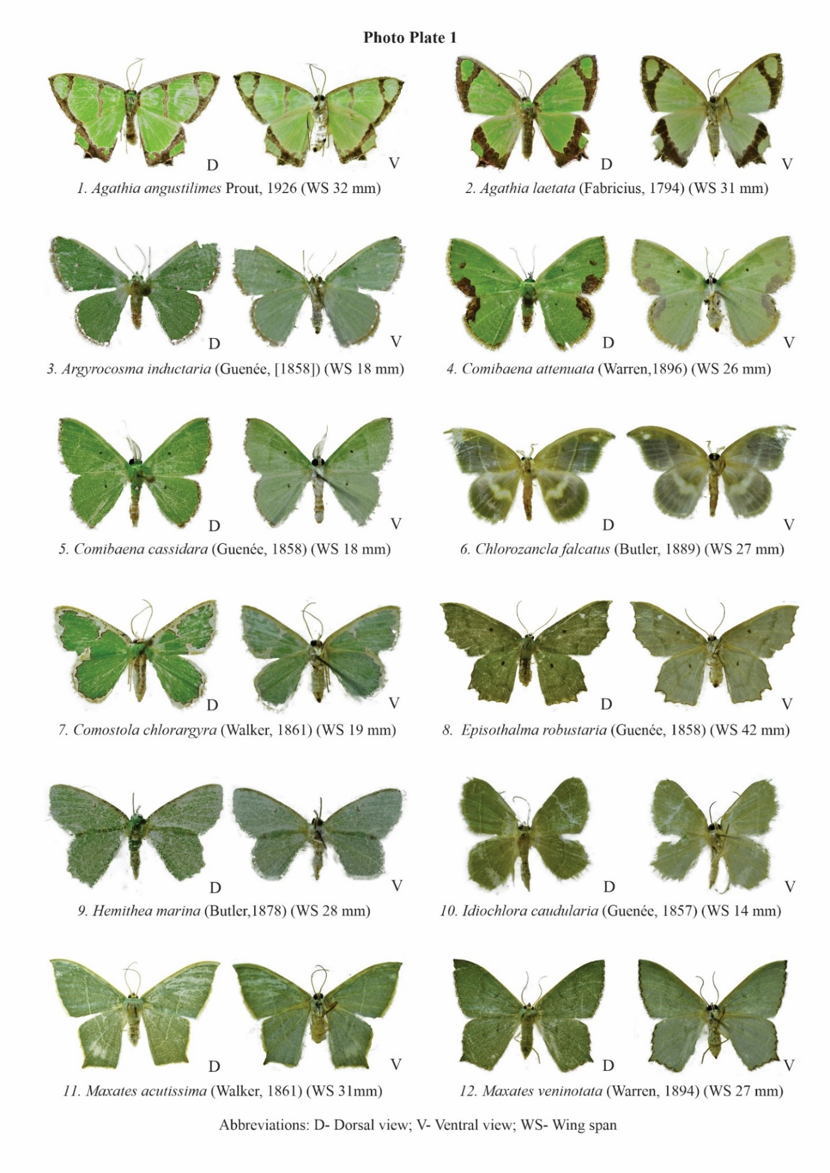
Photo Plate 1. Adult morphology of Geometrinae moths recorded from the northernmost Western Ghats of Maharashtra: 1. Agathia angustilimes; 2. Agathia laetata; 3. Argyrocosma inductaria; 4. Comibaena attenuata; 5. Comibaena cassidara; 6. Chlorozancla falcatus; 7. Comostola chlorargyra; 8. Episothalma robustaria; 9. Hemithea marina; 10. Idiochlora caudularia; 11. Maxates acutissima; 12. Maxates veninotata. D = dorsal view; V = ventral view; WS = wing span.
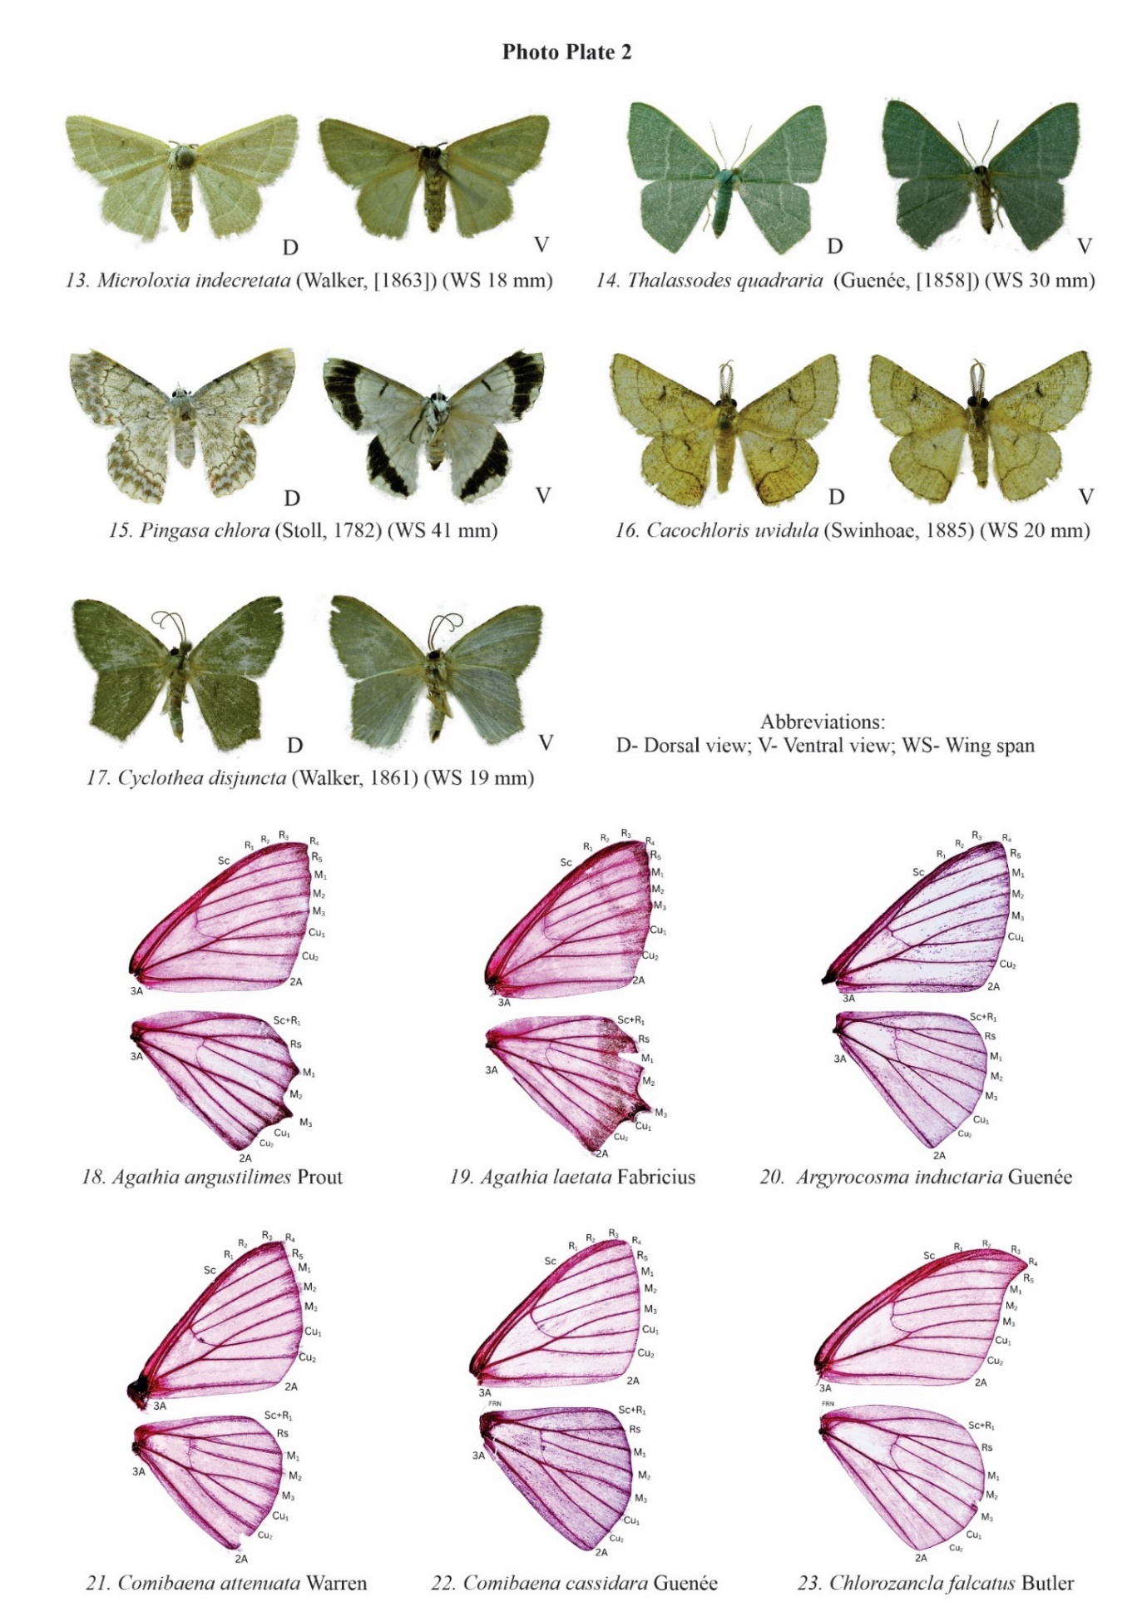
Photo Plate 2. Adult morphology and wing venation of Geometrinae moths recorded from the northernmost Western Ghats of Maharashtra: 13. Microloxia indecretata; 14. Thalassodes quadraria; 15. Pingasa chlora; 16. Cacochloris uvidula; 17. Cyclothea disjuncta; wing venation of 18. Agathia angustilimes; 19. Agathia laetata; 20. Argyrocosma inductaria; 21. Comibaena attenuata; 22. Comibaena cassidara; 23. Chlorozancla falcatus. D = dorsal view; V = ventral view; WS = wing span.
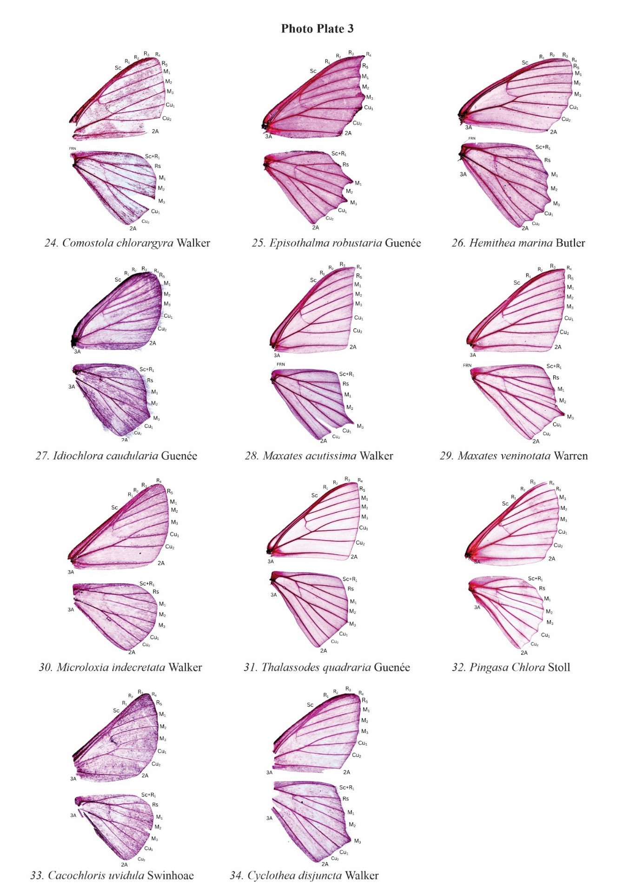
Photo Plate 3. Wing venation of Geometrinae moths recorded from the northernmost Western Ghats of Maharashtra: 24. Comostola chlorargyra; 25. Episothalma robustaria; 26. Hemithea marina; 27. Idiochlora caudularia; 28. Maxates acutissima; 29. Maxates veninotata; 30. Microloxia indecretata; 31. Thalassodes quadraria; 32. Pingasa chlora; 33. Cacochloris uvidula; 34. Cyclothea disjuncta.
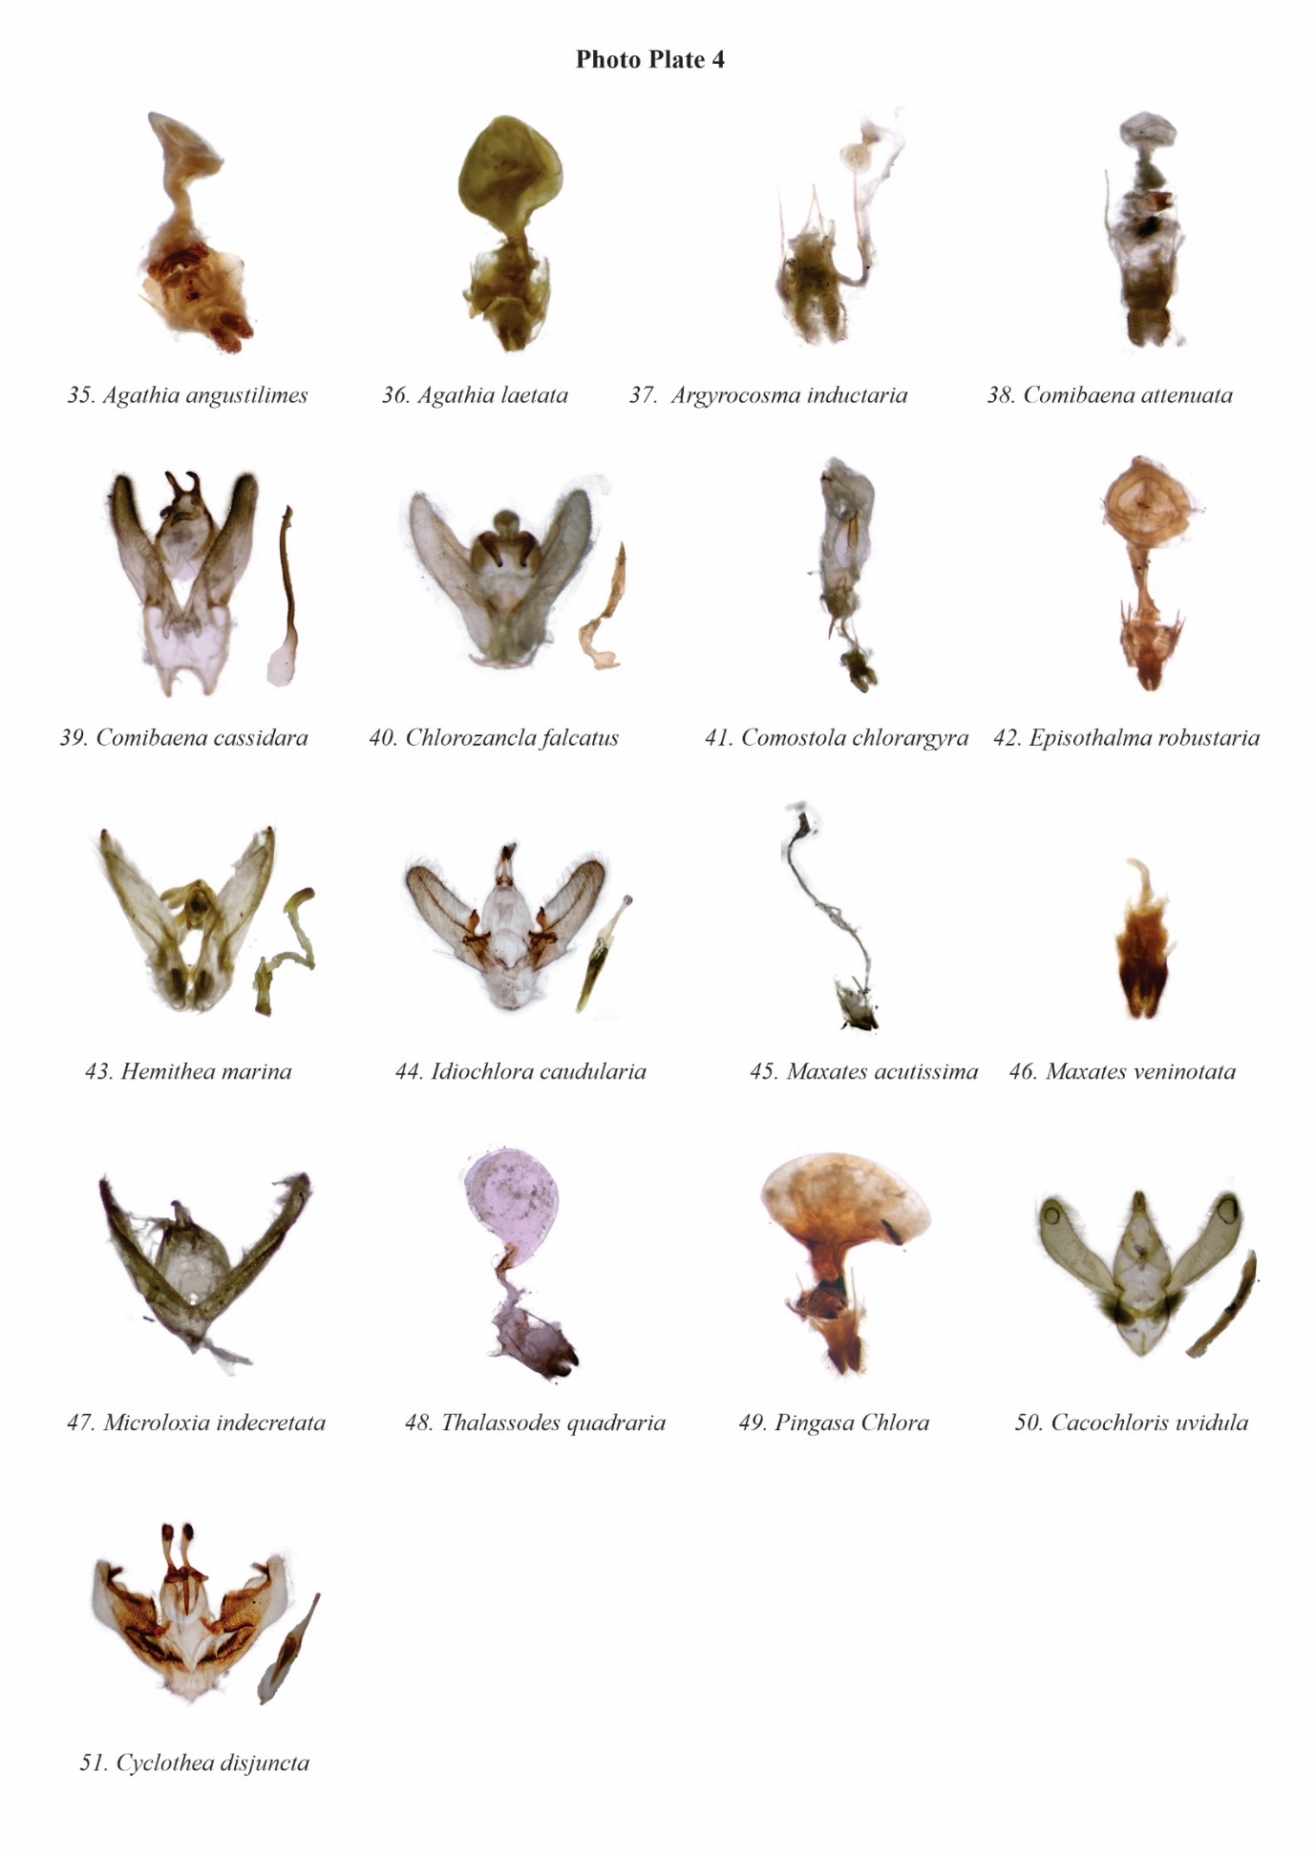
Photo Plate 4. External genitalia of Geometrinae moths recorded from the northernmost Western Ghats of Maharashtra: 35. Agathia angustilimes; 36. Agathia laetata; 37. Argyrocosma inductaria; 38. Comibaena attenuata; 39. Comibaena cassidara; 40. Chlorozancla falcatus; 41. Comostola chlorargyra; 42. Episothalma robustaria; 43. Hemithea marina; 44. Idiochlora caudularia; 45. Maxates acutissima; 46. Maxates veninotata; 47. Microloxia indecretata; 48. Thalassodes quadraria; 49. Pingasa chlora; 50. Cacochloris uvidula; 51. Cyclothea disjuncta.

