Original Research Article
Evaluation of antistress and neuroprotective potential of Ichnocarpus frutescens (L.) W. T. Aiton root extract in Drosophila melanogaster

ABSTRACT
Oxidative stress is a major contributor to aging and the development of several chronic disease and medicinal plants rich in antioxidant phytochemicals have gained increasing attention as natural antistress agents. Ichnocarpus frutescens is a traditionally important medicinal plant known for its diverse pharmacological properties, although its antistress potential remains insufficiently explored. The present study investigated the anti-stress potential of the ethyl acetate (EA) root extract of I. frutescens using Drosophila melanogaster as an experimental model. HPLC analysis identified five major phytoconstituents rutin, kaempferol, lupeol, colchicine and quercetin. Rutin and Kaempferol are the predominant compounds identified, indicating that the root is a rich source of antioxidant flavonoids. The safety of the extract was evaluated through survivorship and developmental assays. Behavioural analysis showed a concentration dependent improvement in locomotor activity with the 2.0 mg mL⁻¹ treatment producing the highest crawling and climbing act in D. melanogaster. Molecular analysis further supported the antioxidant and anti-stress effects of the extract, as the stress related genes AchE and GstD1 and the antioxidant genes Cu/Zn-SOD and Mn-SOD were downregulated in treated flies. The EA root extract of I. frutescens exhibited significant antioxidant and antistress activity without causing developmental toxicity, highlighting its potential as a natural neuroprotective and stress modulating agent.
Key words: Drosophila melanogaster, Oxidative stress, Ichnocarpus frutescens, HPLC, Crawling, negative geotaxis, RT-qPCR
1. INTRODUCTION
Stress has become an unavoidable part of modern life, arising from environmental pressures, lifestyle changes and psychological burdens. When the body is exposed to prolonged stress, it disrupts normal physiological balance and triggers the excessive production of reactive oxygen species (ROS). This condition, known as oxidative stress, oxidative stress is a major contributor to aging and the development of several chronic disease, including neurodegenerative disorders, diabetes, cardiovascular disease and cancer and it damages vital biomolecules such as lipids, proteins and DNA (Premnath and Veerappappilai, 2026). Because of its wide-ranging impact of health, there is growing interest in identifying safe and effective agents that can help the body deal with stress and restore redox balance.
In this context, medicinal plants have long been recognized as a natural source of healing and resilience. Traditional medicine systems continue to play a crucial role in disease prevention and primary healthcare, with nearly 80% of the global population relying on plant based medicine in the form of crude dugs, extracts or herbal formulations (Latif and Nawaz, 2026). More than fifty thousand plant species are used worldwide as traditional medicine and many of these have also contributed to the development of modern allopathic medicines (Kumar et al., 2026). Among the various medicinal plant families, Apocynacaea holds a special place due to its abundance of pharmacologically active compounds. And also, this family have been widely reported to exhibit antioxidant, antidiabetic, anti inflammatory, antimicrobial, anticancer and neuroprotective properties, making them valuable in both traditional and modern medicine (Naik, 2026; Sureshrao and Sharma, 2026). One such important medicinal plant is Ichnocarpus frutescens (L.) W.T.Aiton, commonly known as Black creeper belonging to Apocynaceae family. In Ayurvedic medicine it is recognized as Sariva which has been widely used since ancient times for its therapeutic properties. In ayurveda, it is regarded as a substitute for Hemidesmus indicus (Kumarappan et al., 2015). The roots of I. frutescens contains a wide range of bioactive compounds including phenols, flavonoids, sterols, coumarins, saponins, glycosides and triterpenoids. These phytoconstituents in the plant exhibit a wide range of pharmacological activities, including hepatoprotective, analgesic, anti-diabetic and ant-tumorigenic activities (Dwivedi et al., 2025). Moreover, they have shown potential in managing complex conditions such as cancer, cardiovascular disease and neurological disorders (Mohsina et al., 2022). Among these biological properties antioxidants play a crucial role in protecting cell from oxidative stress. Natural antioxidants derived from medicinal plants can reduce oxidative stress by scavenging reactive oxygen species and enhancing endogenous defense mechanisms. Consequently, plant derived antioxidant compounds have gained increasing attention as potential anti-aging and anti-stress agents (Nowak-Perlak et al., 2025).
To evaluate such biological effects, Drosophila melanogaster (Common fruit fly) has emerged as a powerful and reliable experimental model for evaluating the biological effects of natural products because of its strong genetic similarity to humans. Approximately 60% of Drosophila genome is homologous to the human genome and nearly 77 % of human disease related genes have homologs in D. melanogaster, and also the fly possesses a short life cycle, high reproductive rate, ease of maintenance, and well characterized genetics (Mizoyan et al., 2019; Adhikary and Deb, 2022). These features make D. melanogaster particularly suitable for lifespan, stress resistance, developmental toxicity and behavioral studies. Therefore, the present study aimed to characterize the phytochemical constituents of the ethyl acetate (EA) root extract of I. frutescens and evaluate its antistress potential using D. melanogaster as an experimental model through developmental, behaviour and stress related gene expression analysis.

2. MATERIALS AND METHODS
2.1 Quantification of phytocompounds
2.1.1 Extraction method
The root extract of Ichnocarpus frutescens was prepared following the successive solvent extraction procedure described in our previous study (Kattilaparambil et al., 2025). In that study, the root extracts were subjected to phytochemical quantification to determine the secondary metabolite content and their antioxidant activity was evaluated using DPPH and ABTS radical scavenging assays. Based on the phytochemical composition and antioxidant activity result, the ethyl acetate (EA) root extract exhibited the highest antioxidant potential and was therefore selected for the present study to evaluate its antistress activity in Drosophila melanogaster.
2.1.2 High- Performance Liquid Chromatography (HPLC) Analysis
The EA root extract of I. frutescens were analyzed using High Performance Liquid Chromatography (HPLC), Shimadzu, Japan. Separation was carried out on a C18 column (4.6 × 250 mm, 5 µm particle size). The mobile phase consisted of solvent A (water: formic acid, 99.9:0.1 v/v) and solvent B (methanol: acetonitrile, 45:40 v/v). The gradient program was initiated with 95% solvent A and 5% solvent B and maintained for the first 2 min. The proportion of solvent B was then gradually increased to 25%, 40%, 50%, 60%, 70% and 80% at 10, 20, 30, 40, 0, an 80 min respectively., following method described by Das et al. (2018) with slight modifications. The flow ate was maintained at 0.8 mL min⁻¹ and the injection volume was 20 µL. Detection performed using Diode Array Detector (DAD) with wavelength of 210 nm as well as standards (Fig 1).
2.2 Drosophila Toxicity study
2.2.1 Drosophila melanogaster media preparation
An agar yeast medium used for the culture and maintenance of Drosophila Melanogaster. The medium was prepared by dissolving 800mg agar, 1.5 g malt extract, 8 g corn flour, 4 g sucrose, 1.5 g yeast and 70 mg methyl paraben in 100 mL of distilled water. The mixture was heated with continuous stirring until all the components were completely dissolved and thoroughly blended. After cooling slightly, propionic acid and orthophosphoric acid were added and the final volume was adjusted appropriately. Approximately 15 mL of the prepared medium was dispensed into each of seven culture vials. The medium was allowed to solidify completely, after which the vials were plugged with sterile cotton and used for the experimental studies.
2.2.2 Fly collection
Ripe banana and tomato were peeled and placed in an uncovered container. Which was kept in an open environment to attract fruit flies. After 2-3 h, adult Drosophila were observed around the fruits. The flies were collected carefully using an aspirator or suitable collection method and transferred into a culture container. The container was then Covered with a paper towel secured with a rubber band and maintained until use in the experiments.
2.2.3 Experimental design and treatment for Laval D. melanogaster
The studies carried out using wild type D. melanogaster at the larval stage. Larvae were maintained on standard artificial diet prepared with agar yeast medium. The test compound used in this study was EA root extract of Ichnocarpus frutescens. The extract was incorporated into the diet at four concentrations 1.0, 1.5, 2.0, 2.5 mg mL⁻¹ per vial. A total six experimental groups were established, four treatment groups of I. frutescens EA extract, a solvent control group containing EA solvent, and an untreated control group receiving the standard diet only. Each concentration was tested in a single replicate, with ten larvae introduced into each vial.
2.3 Behavioural assays
2.3.1 Crawling assay
larvae were gently collected using fine forceps and transferred to a petri dish containing distilled water for washing. The cleaned larvae were then placed individually on petri dish containing 2% agarose positioned over graph paper. The number of grid lines crossed by each larva within 1 min was recorded. Peristaltic contractions, defined as one complete anterior to posterior body movement, were also counted for 1 min under a dissection microscope. To ensure accuracy, larvae were washed thoroughly after selection or treatment to remove any residual food and were allowed to acclimatize on the agar surface for 1 min before recording. The agar plates were maintained at room temperature for at least 1 h prior to the assays, as low temperatures may influence larval locomotor activity (Nichols et al., 2012).
2.3.2 Climbing assay (Negative Geotaxis)
The climbing assay was performed using Drosophila flies to assess locomotor behaviour. A group of flies from each treatment was transferred into a graduated measuring cylinder. The cylinder was gently tapped 2-4 times to bring all flies to the bottom simultaneously. Immediately after tapping, the climbing activity of the flies was recorded using a mobile phone camera for 10- 15 s (Manjila and Hasan, 2018). The measuring cylinder was divided into five equal sections based on 10 mL graduations and numbered from 0 to 5. The number of flies present in each section at the end of the observation period was recorded. A climbing score was calculated based on the distribution of flies across the sections. This assay was used to evaluate the effect of I. frutescens root EA extract on the locomotor performance of D. melanogaster.
2.4 Molecular analysis
2.4.1 RNA isolation
Total RNA was isolated from D. melanogaster collected from the 2.5 mg mL⁻¹ extract treated group and the untreated control group. Ten flies from each group were homogenized in 1 mL of RDP trio reagent using a sterile mortar and pestle. The homogenate was mixed with an additional 300 µL of RDP reagent and 200 µL of chloroform, followed by vigorous vortexing to ensure thorough mixing. The mixture was allowed to stand at room temperature for 10 min. the samples were then transferred to fresh microcentrifuge tubes and centrifuged at 12000 rpm for 10 min at 4 ⁰C. After centrifugation the upper aqueous phase containing RNA was carefully transferred to new tubes, while the interphase was retained separately for subsequent DNA isolation. To precipitate the RNA, 0.5 mL of isopropanol was added to each sample and mixed gently. The samples were incubated at room temperature for 10 min and centrifuged again at 12000 rpm for 10 min at 4 ⁰C. the supernatant was discarded and the resulting RNA pellet was washed with 75% ethanol. After centrifugation at 10,000 pm for 10 min at room temperature, ethanol was removed and the RNA pellets were air dried briefly. Finally, the purified RNA was resuspended in 100 µL of RNase free water and stored for further analysis (Allen, 2016).
2.4.2 cDNA synthesis
Complementary DNA (cDNA) was synthesized from the isolated RNA using a reverse transcription reaction. Initially, 2 µL of random hexamer primer was added to 8 µL of RNA sample, and the mixture was incubated at 70 ⁰C for 4 min in a thermal cycler. The tubes were immediately placed on ice for 2 min and briefly centrifuged to collect the condensed liquid. The reverse transcription reaction mixture was then prepared by adding the required reverse transcription reagents according to the manufacturer’s protocol. The reaction mixture was carried out under appropriate thermal conditions, followed by incubation at 95 ⁰C for 5-10 min to inactivate the reverse transcriptase enzyme. The synthesized cDNA was either stored at 20 ⁰C used immediately for PCR amplification (Stahlberg et al., 2004).
2.4.3 RT-qPCR amplification
Reverse transcription quantitative PCR (RT-qPCR) was performed according to the method described by Pfattl (2001), with slight modifications. To assess the expression of stress-related and antioxidant genes in D. melanogaster. Total RNA was extracted and converted to cDNA, which as the template for RT-qPCR analysis. Gene-specific primers were used to amplify target genes including the stress related genes acetylcholinesterase (AchE) and Glutathione S- transferase D1 (GstD1), as well as the antioxidant genes Cu-Zn superoxide dismutase (Cu-Zn SOD) and Mn- superoxide dismutase (Mn- SOD) (Table 1). The PCR reaction mixture was prepared in a total volume of 50 µL containing 5.0 µL of 10x PCR buffer with 15 mM Mgcl₂, 0.5 µL each of forward and reverse primers, 1.0 µL of dNTP mixture, template DNA/cDNA with nuclease free water, and 0.10 µL of Taq DNA polymerase (5 U µL⁻¹). The reaction mixture was mixed thoroughly and centrifuged then subjected to amplification in a thermal cycler. Th PCR program consisted of an initial denaturation at 94 ⁰C for 1 min, followed by 30 cycles of denaturation at 94 ⁰C for 1 min, annealing at 55 ⁰C for 1 min and extension at 72 ⁰C for 1 min for products less than 500 bp or 3 min for products greater than 500 bp. A final extension was carried out at 72 ⁰C for 7 min. After amplification 2.5 µL of loading dye was added to each PCR sample and the amplified fragments were analyzed by agarose gel electrophoresis using an appropriate agarose concentration. The PCR products were either analyzed immediately or stored at 4 ⁰C for subsequent use.
Table :1 Gene specific primer sequence used for quantitative PCR (qPCR) analysis of stress related and antioxidant genes in Drosophila melanogaster
Name of the gene | Primer Sequence
GstD1 | Forward5’ GACTCCCTGTACCCTAAGTGC 3’  Reverse5’ TCGGCTACGGTAAGGGAGTCA 3’
AChE | Forward 5’ GTGGAAAACCAGGATTGGAA 3’  Reverse 5’ TGCGCAAAGTTCTGAATGTC 3’
Cu-Zn SOD | Forward 3’ GCGGCGTTATTGGCATTG 5’  Reverse 3’ ACTAACAGACCACAGGCTATG 5’
Mn- SOD | Forward 3’ CACATCAACCACACCATCTTC 5’  Reverse 3’ CGTCTTCCACTGCGACTC 5’

2.4.4 Agarose gel Electrophoresis
Agarose gel electrophoresis was performed to analyze the PCR amplified products. A 1 x TAE (Tris acetate EDTA) buffer was prepared by diluting 0.4 mL of 50 x TAE stock solution to a final volume of 200 mL with distilled or demineralized water. A 1% agarose gel was prepared by dissolving 0.5 g of agarose in 50 mL of 1 x TAE buffer. The mixture was heated until the agarose dissolved completely and a clear solution was obtained. The gel casting tray was assembled and the comb was positioned approximately 2 cm from the cathode end of the tray. Ethidium bromide (EtBr) was added to the molten agarose to obtain a final concentration of 0.5 µg mL⁻¹ from a 10 mg mL⁻¹ stock solution. The solution was mixed gently and allowed to cool to approximately 60 ⁰C before being poured into the casting tray. The gel was allowed to solidify at room temperature resulting in a gel thickness of approximately 0.5 – 0.9 cm. after solidification the gel was placed in the electrophoresis tank and submerged in 1 x TAE buffer until the buffer level was approximately 0.5- 0.8 cm above the gel surface. The comb was carefully removed to create intact sample wells. The electrophoresis unit was connected to the power supply with the red lead connected to the anode and the black lead connected to the cathode. PCR sample were mixed with 6 x Tri track loading dye and loaded into the wells in the desired order, which was recorded for reference. Electrophoresis was caried out at 50 V until the tracking dye migrated approximately three- fourths of the length of the gel. After electrophoresis, the DNA bands wee visualized under a UV transilluminator, where the ethidium bromide stained DNA appeared as fluorescent bands.
2.5 Statistical analysis
All experiments were caried out in triplicate (n=3) and data were expressed as mean ± standard deviation (SD).
3. RESULTS AND DISCUSSION
3.1 Phytocompound characterization by HPLC analysis
In the root EA extract five bioactive compounds were detected including rutin, colchicine, quercetin, kaempferol and lupeol (Fig 2). Rutin exhibited the highest concentration 9.230 mg g⁻¹ among all compounds analyzed, indicating that it is major phenolic constituent of the root extract. Kaempferol is the second abundant compound 3.1765 mg g⁻¹. Lupeol was in concentration of 0.3480 mg g⁻¹, while colchicine and quercetin were present in comparatively lower amounts with concentrations of 0.1127 mg g⁻¹and 0.0530 mg g⁻¹ respectively (Table 2). Overall, the HPLC profiling revealed marked differences in the phytochemical composition of the root EA extracts of I. frutescens. The predominance of rutin suggests that the root is ich source of flavonoids. Rutin, lupeol and kaempferol have been extensively reported to possess antioxidant, anti inflammatory and anti stress activities (Alrumaihi et al., 2024; Al Hoque et al., 2025). While quercetin is recognized for its strong free radical scavenging and neuroprotective potential (Adnan et al., 2025).
Table 2: HPLC quantification of bioactive compounds in I. frutescens root EA extract
Bioactive compounds | Retention Time (RT) | Area | Height | Mg g⁻¹
Rutin | 4.088 | 147454 | 41799 | 9.230037
Colchicine | 4.519 | 68239 | 10297 | 0.112672
Quercetin | 5.284 | 39802 | 12461 | 0.053047
Kaempferol | 21.302 | 499448 | 48100 | 3.17648
Lupeol | 42.647 | 21209 | 20359 | 0.348029

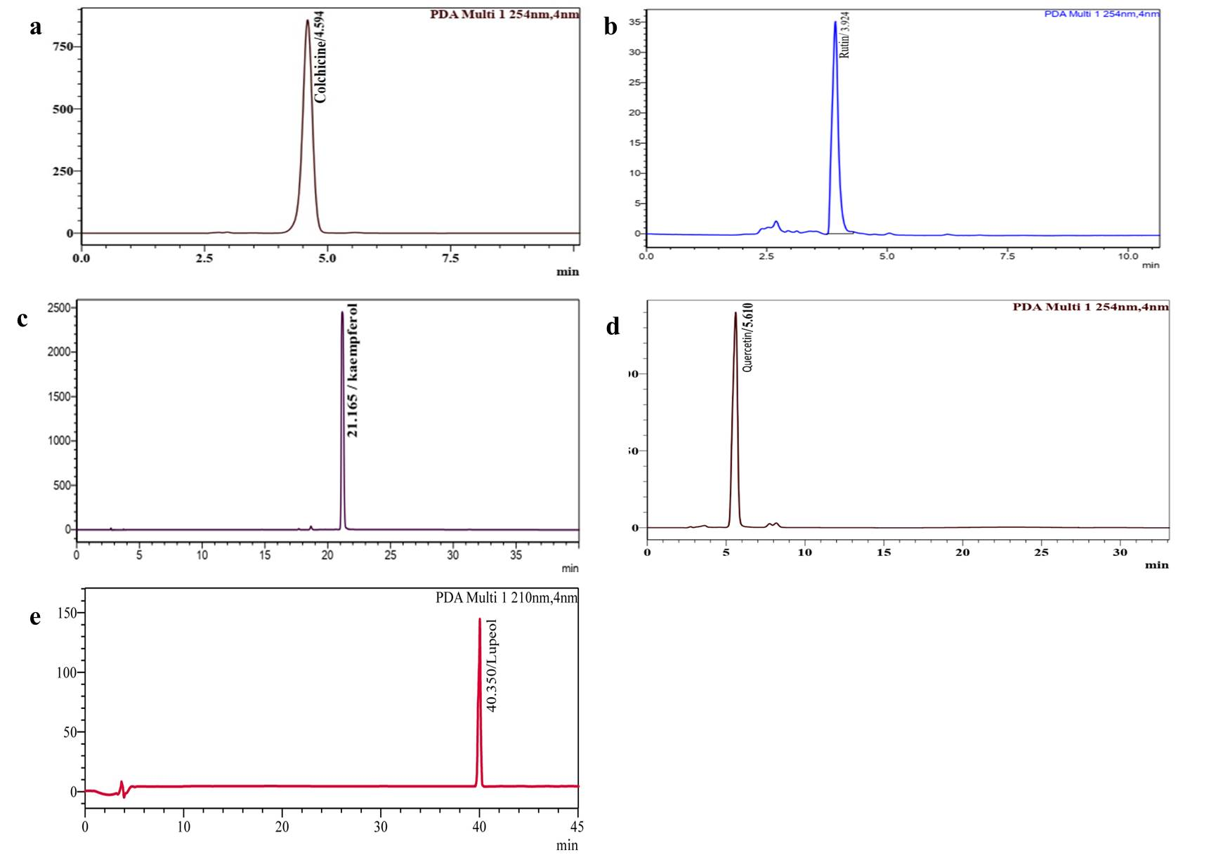
Fig. 1. HPLC chromatogram of standards. (a) Colchicine (b) Rutin (c) Kaempferol (d) Quercetin (e) Lupeol
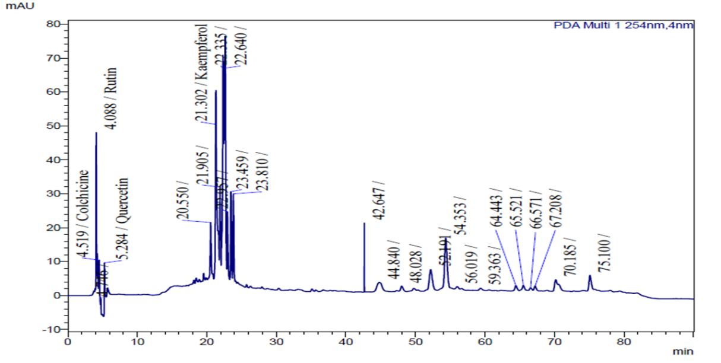

Fig. 2. HPLC chromatogram of ethyl acetate extract of I. frutescens root

3.2 Effect of EA root extract of I. frutescens on the viability and survival of D. melanogaster
The survivorship and development of D. melanogaster was evaluated over an 8 days period in larvae and pupae fed with different concentrations of I. frutescens root EA extract. The survivorship of both the untreated, control and solvent control (EA) groups was also recorded. The percentage survival of larvae and pupae is presented (Table 3) representative developmental stages are shown in Fig. 3. Ten larvae were introduced into each vial containing different concentrations of the EA extract (1.0, 1.5, 2.0 and 2.5 mg mL⁻¹). Throughout the first six days of observation, all larvae remained viable in every treatment and control group, indicating that none of the tested extract concentrations caused larval mortality. From day 7 onward, the onset of metamorphosis was observed in all groups, with a gradual transition from larval to pupal stages. In the 1.0 mg mL⁻¹ and 1.5 mg mL⁻¹ treatments 9 larvae and 1 pupa were recorded, while the 2.0 and 2.5 mg mL⁻¹ treatments showed a slightly higher rate of pupation, with 8 larvae and 2 pupae each. The EA control group remained largely unaffected, showing 10 larvae with no significant development shift, whereas the untreated control exhibited 9 larvae and 1 pupa. By day 8, a marked progression toward pupation was evident in all experiment groups. The 1.0 mg mL⁻¹, 1.5 mg mL⁻¹ and 2.0 mg mL⁻¹ treatments each showed an equal distribution of 5 larvae and 5 pupae, indicating synchronized developmental advancement. Importantly no larval mortality was recorded in any of the treatment or control vials throughout the experimental period the findings demonstrate that the EA root extract of I. frutescens did not exhibit toxic effects on D. melanogaster Larvae treated with the highest concentration (2.5 mg mL⁻¹) exhibited developmental progression comparable to that of the untreated control, whereas the solvent control showed relatively delayed pupation. Since developmental progression in Drosophila is highly sensitive to oxidative stress and metabolic disturbances, the maintenance of normal pupation rates suggests that the extract does not disrupt cellular homeostasis. The absence of developmental toxicity in the present study establishes the safety of the root extract and supports its suitability for further behaviroual and molecular investigations.
Table 3: Survival and developmental progression of Drosophila melanogaster larvae treated with EA root extract of Ichnocarpus frutescens over a one-week observation period
Survival and Development Data (10 Larvae introduced into each treatment vial)
Days | Vial 1  1mg | Vial2 1.5mg mL⁻¹ | Vial 3  2 mg mL⁻¹ | Vial 4 2.5mg mL⁻¹ | Negative control  (Ethyl acetate) | Control
Day 1 | 10 | 10 | 10 | 10 | 10 | 10
Day 2 | 10 | 10 | 10 | 10 | 10 | 10
Day 3 | 10 | 10 | 10 | 10 | 10 | 10
Day 4 | 10 | 10 | 10 | 10 | 10 | 10
Day 5 | 10 | 10 | 10 | 10 | 10 | 10
Day 6 | 10 | 10 | 10 | 10 | 10 | 10
Day 7 | 9 Larvae;  1 Pupa | 9 Larvae; 1  Pupa | 8 Larvae;  2 Pupae | 8 Larvae;  2 Pupae | 10 | 9 Larvae;1  Pupa
Day 8 | 5 Larvae;  5 Pupae | 5 Larvae; 5  Pupae | 5 Larvae; 5  Pupae | 4 Larvae; 6  Pupae | 9 Larvae; 1  Pupa | 4 Larvae;6  Pupae
Values represent the number of surviving larvae and pupae observed on each day of the experiment. Negative control: EA (Ethyl acetate solvent); Control: Standard culture medium without extract or solvent.
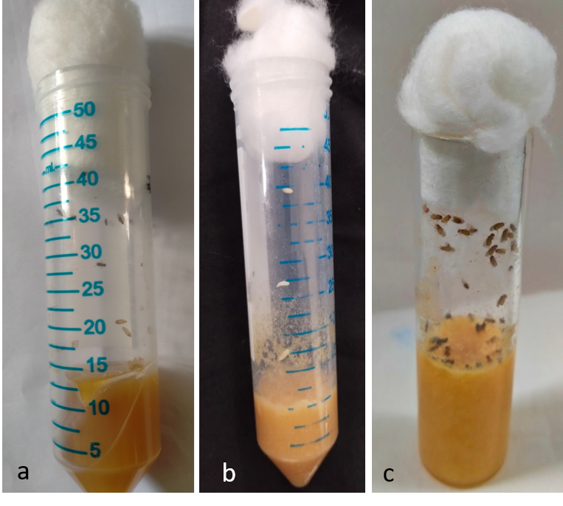
Fig. 3. Developmental stages of Drosophila melanogaster. (a) Larval stage, (b) Pupal stage, (c) Adult stage.

3.3 Behavioural assay
3.3.1 Crawling assay
In the present study, D. melanogaster larvae were eared on culture media supplemented with different concentrations of I. frutescens root extract. The crawling activity of the larvae was assessed after treatment and the results ae presented in Table 4. The crawling activity increased progressively with time in all treatment groups. Among the tested concentrations the 2.0 mg mL⁻¹ extract treatment exhibited the highest crawling performance throughout the observation period (Fig 4a). At 5 min, larvae treated with 2.0 mg mL⁻¹ showed crawling distance of 1.2 ±0.30 cm which increased to 2.3 ±0.17 cm at 10 min and reached 4.3± 0.41 cm at 15 min. this markedly higher than the untreated control, which recorded 0.8 ± 0.25cm, 1.4 ±0.26 cm and 2.6 ±0.10 cm at the corresponding time intervals. The increase in crawling activity indicates improved larval locomotion following treatment with the extract. Overall, the results indicate that treatment with 2.0 mg mL⁻¹ of I. frutescens root EA extract significantly enhanced larval crawling performance compared with the control and solvent control groups, suggesting a positive effect of the extract on larval locomotor activity. This improvement in locomotor behaviour is likely associated with the antioxidant flavonoids identified in the root extract particularly rutin, kaempferol and quercetin. These compounds have been reported to reduce oxidative damage in neuronal tissues, preserve mitochondrial function and improve cellular energy metabolism, there by supporting normal neuromuscular activity (Debnath et al., 2025; Shadman et al., 2025).
Table 4: Crawling performance of Drosophila melanogaster larvae treated with EA root extract of Ichnocarpus frutescens
Time (cm/minutes) | Concentrations
Time (cm/minutes) | 1(mg/mL) | 1.5(mg mL⁻¹) | 2(mg mL⁻¹) | 2.5(mg mL⁻¹) | EA (100%) | Control
5 | 0.6±0.05 | 0.8±0.35 | 1.2±0.30 | 0.6±0.15 | 0.3±0.57 | 0.8±0.25
10 | 1.5±0.26 | 2.6±0.20 | 2.3±0.17 | 2.2±0.20 | 0.7±0.15 | 1.4±0.26
15 | 2.1±0.3 | 2.4±0.25 | 4.3±0.41 | 3.5±0.25 | 1.3±0.20 | 2.6±0.1
Values are expressed as mean±SD (n=3). Crawling distance was measured in centimeters (cm) at 5,10 and 15 minutes. Negative control: EA (Ethyl acetate solvent); Control: Standard culture medium without extract or solvent.
3.3.2 Climbing assay
The climbing ability of adult D. melanogaster flies was evaluated approximately one week after adult emergence. The locomotor performance of the flies was recorded by observing the height reached within a graduated measuring cylinder (Fig 4 b) and the results are presented in Table 5. Among all the treatment groups, flies treated with 2.0 mg mL⁻¹ of I. frutescens root extract showed the highest climbing activity (5.2 ± 0.64 cm) compared with both the untreated control and the solvent control groups. The solvent control exhibited the poorest climbing activity, with the highest number of flies remaining in the 0-10 mL level (3.6 ± 0.57). The untreated control group showed intermediate climbing ability, small proportion of flies reaching the upper level. Overall, the results demonstrated that treatment with 2.0 mg mL⁻¹ of I. frutescens root EA extract significantly improved the climbing performance of D. melanogaster compared with the controls. Improved climbing behaviour reflects enhanced locomotor function and better preservation of neuronal integrity. Oxidative stress is a major contributor to locomotor impairment in Drosophila (Patel and Nagda, 2026). The flavonoids and triterpenoids detected in the root extract are capable of scavenging reactive oxygen species, reducing lipid peroxidation and protecting neuronal cells from oxidative damage.
Table 5: Climbing performance of Drosophila melanogaster larvae treated with EA root extract of Ichnocarpus frutescens
Level of measuring cylinder (cm) | Concentrations
Level of measuring cylinder (cm) | 1(mg mL⁻¹) | 1.5(mg mL⁻¹) | 2(mg mL⁻¹) | 2.5(mg mL⁻¹) | EA (100%) | Control
0-10 | 4.0±0.57 | 4.3±0.23 | 5.2±0.64 | 5.11±0.21 | 3.6±0.57 | 4.6±0.57
10-20 | 3.3±0.57 | 3.3±0.57 | 3.3±0.08 | 2.6±0.57 | 2.6±0.57 | 2.6±0.52
20-30 | 2.3±0.57 | 2.6±0.57 | 2.5±0.57 | 2.3±0.57 | 1.0±0.01 | 2.3±0.57
30-40 | 1.0±0.11 | 2.2±0.13 | 1.1±0.73 | 1.36±0.57 | 0±0.00 | 0.6±0.57
40-50 | 0±0.00 | 0.3±0.57 | 1.6±0.15 | 0.5±0.00 | 0±0.00 | 0.6±0.15
Values are expressed as mean±SD (n=3). Negative control: EA (Ethyl acetate solvent); Control: Standard culture medium without extract or solvent.

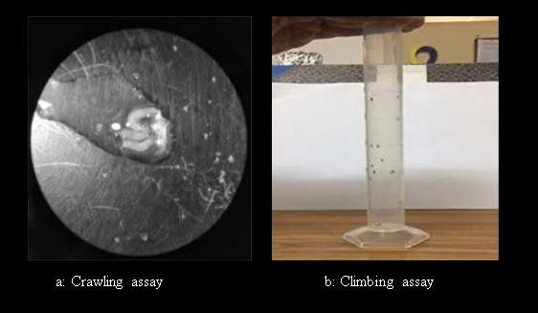
Fig. 4. Behavioural assays of Drosophila melanogaster treated with the EA root extract of Ichnocarpus frutescens. (a) Crawling assay, (b) Climbing assay.

3.4 cDNA synthesis and stress gene expression analysis
The stress related genes AChE and GstD1 showed strong expression in the control flies, whereas their expression was markedly reduced or absent in flies treated with 2.0 mg mL⁻¹ of I. frutescens root extract. PCR analysis revealed distinct bands at 147 bp for AChE and 172 bp for GstD1 in the control group, while these bands were faint o undetectable in the treated flies. The reduced expression of these stress responsive genes suggests that the phytoconstituents present in the root extract may suppress or modulate stress related gene activity. Similarly, the antioxidant genes Cu/Zn -SOD and Mn-SOD exhibited higher expression in the control flies than in the extract treated group (Fig. 5). superoxide dismutase genes are typically upregulated when intracellular reactive oxygen species accumulate. Therefore, their reduced expression following treatment indicates that the extract likely diminished oxidative stress either through direct free radical scavenging or limiting reactive oxygen species generation. The lower expression of these genes in treated flies may indicate that the phytochemicals present in the root extract reduced oxidative stress, thereby decreasing the requirement for elevated antioxidant enzyme expression (Sanni et al., 2025). This interpretation is consistent with the HPLC results, which identified potent antioxidant compounds including rutin, kaempferol and quercetin. Previous studies have shown that flavonoid rich plant extracts can regulate antioxidant gene expression by maintaining intracellular redox balance and reducing oxidative stress (sarkar et al., 2022; Bas, 2026).
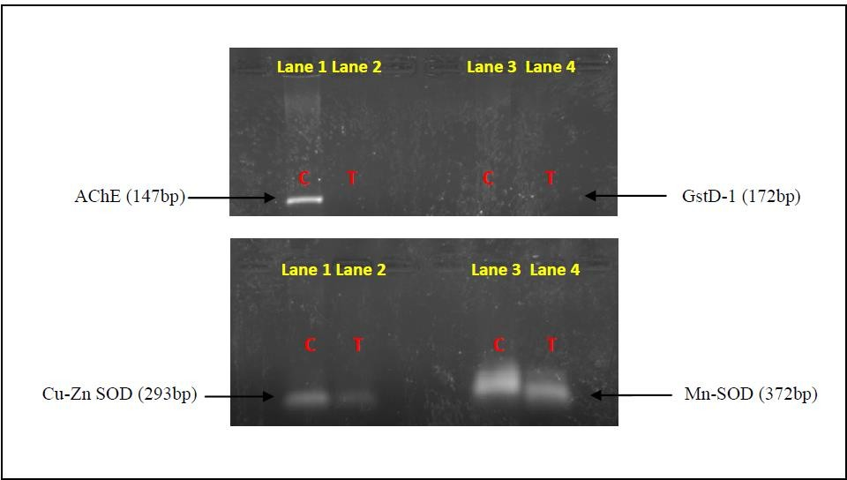
Fig. 5. Agarose gel electrophoresis of stress and antioxidant gene amplification in Drosophila melanogaster treated with Ichnocarpus frutescens root extract.
(a) Amplification of stress related gens, acetylcholinesterase (AchE) and glutathione S-transferase D1 (GstD-1). (b)Amplification of antioxidant genes, Cu-Zn superoxide dismutase (Cu-Zn SOD); and Mn superoxide dismutase (Mn- SOD). C- Control; T- 2.0 mg mL⁻¹ EA root treated.

4. CONCLUSION
The present study demonstrates that the EA root extract of I. frutescens contains significant antioxidant phytochemicals, including rutin, kaempferol, and lupeol. Which play an important role in mitigating oxidative stress in D. melanogaster model. The behavioural and molecular findings provide strong evidence that I. frutescens root EA extract exerts protective effects against oxidative stress and supports neuronal function. These results highlight I. frutescens as a promising natural source of antioxidant and neuroprotective compounds with potential applications in the prevention and management of oxidative stress related and neurodegenerative disorders.

Declaration of AI Use

This manuscript was prepared through the intellectual contributions of the author(s) to the study design, data analysis, interpretation of results, and scholarly content. Grammarly and ChatGPT were used solely to assist with grammatical refinement and reference formatting during manuscript revision. The author(s) accept full responsibility for the accuracy, integrity, and final content of the manuscript.

COMPETING INTERESTS DISCLAIMER:
Authors have declared that they have no known competing financial interests OR non-financial interests OR personal relationships that could have appeared to influence the work reported in this paper.

REFERENCES
Adhikary, A., & Deb, D. (2022). A Preliminary Study on the Behaviour of Drosophila melanogaster Larva to Different Oil Samples. Uttar Pradesh Journal of Zoology, 43(24), 311-315.
Adnan, M., Siddiqui, A. J., Bardakci, F., Surti, M., Badraoui, R., & Patel, M. (2025). Neuroprotective potential of quercetin in Alzheimer’s disease: Targeting oxidative stress, mitochondrial dysfunction, and amyloid-β aggregation. Frontiers in Pharmacology, 16, 1593264.
Allen, E. (2016). RNA extraction from Drosophila tissues using TRIzol reagent.
Alrumaihi, F., Almatroodi, S. A., Alharbi, H. O. A., Alwanian, W. M., Alharbi, F. A., Almatroudi, A., & Rahmani, A. H. (2024). Pharmacological potential of kaempferol, a flavonoid in the management of pathogenesis via modulation of inflammation and other biological activities. Molecules, 29(9), 2007.
Bas, T. G. (2026). Dietary polyphenols (flavonoids) derived from plants for use in therapeutic health: Antioxidant performance, ROS, molecular mechanisms, and bioavailability limitations. International journal of molecular sciences, 27(3), 1404.
Das, N., Bhattacharya, A., Mandal, S.K., Debnath, U., Dinda, B., Mandal, S.C., Palit, P., 2018. Ichnocarpus frutescens (L.) R. Br. root derived phyto-steroids defends inflammation and algesia by pulling down the pro-inflammatory and nociceptive pain mediators: An in-vitro and in-vivo appraisal. Steroids, 139, 18-27.
Debnath, I., Ghosh, S., Bhunia, S., Nayak, A., Basak, S., Nandi, S., & Bhattacharjee, S. (2025). Mechanistic insights and therapeutic potential of quercetin in neuroprotection: a comprehensive review of pathways and clinical perspectives. BIO Integration, 6(1), 978.
Dwivedi, J., Wal, P., Gupta, A., Chakraborthy, G., Srivastava, A., Sharma, M. C., & Gunjal, S. D. (2025). A Delve into the Chemical Diversity, Pharmacological Targets, and Biological Mechanisms of Ichnocarpous frutescens Linn R. Br.: A Review on the Current Status of Knowledge. Current Organic Chemistry, 29(14), 1092-1106.
Kattilaparambil, R., Sathasivam, V., Muthukrishnan, S., Vedagiri, H., Iyaswamy, A., Muthukrishnan, A., Raman, A., Gunasangkaran, G., Murugesan, J., Packiaraj, G., 2025. Antiproliferative effects of phytocompounds from Ichnocarpus frutescens (L.) WT Aiton against breast cancer cell line MDA MB-231 by in vitro and in silico analysis. Pharmacological Research-Reports, 4, 100058, 1-15.
Kumar, I., Vishwakarma, S. K., Singh, P. K., Kumar, U., Singh, R. P., Madheshiya, P., & Sharma, R. K. (2026). Ethnopharmacological exploration of Indian medicinal plants: from traditional knowledge to modern medicine. Phytochemistry Reviews, 1-37.
Kumarappan, C., Srinivasan, R., Jeevathayaparan, S., Rajinikanth, R., Naveen Kumar, H. S., Senthilrajan, S., Subhash, C. M., 2015. Ichnocarpus frutescens: A valuable medicinal plant. Pharmacology Online, 19, 18-37.
Latif, R., & Nawaz, T. (2026). Medicinal plants and human health: a comprehensive review of bioactive compounds, therapeutic effects, and applications. Phytochemistry Reviews, 25(3), 2299-2342.
Manjila, S. B., and Hasan. G. (2018). Flight and Climbing Assay for Assessing Motor Functions in Drosophila. Bio‐protocol 8, no. 5: e2742.
Mirzoyan Z, Sollazzo M, Allocca M, Valenza AM, Grifoni D, Bellosta P (2019). Drosophila melanogaster: A Model Organism to Study Cancer. Frontiers Genetics, 10:51.
Mohsina, F. P., Quazi, A., Faheem, I. P., Anuradha, M., Mukim, M., & Patil, A. (2022). Botanical, Ethnopharmacological, phytochemical & pharmacological standards of plant Ichnocarpus frutescens. Research & Review: Drugs and Drugs Development, 4(1), 1-12.
Naik, D. L. (2026). Exploring phytochemistry and pharmacology of the Apocynaceae family: A comprehensive review.
Nichols CD, Becnel D, Pandey UB (2012) Methods to assay Drosophila behavior. Journal of Visualized Experiments (61).
Nowak-Perlak, M., Olszowy, M., & Woźniak, M. (2025). The natural defense: anti-aging potential of plant-derived substances and technological solutions against photoaging. International Journal of Molecular Sciences, 26(16), 8061.
Patel, P., & Nagda, G. (2026). Behavioural and physiological impacts of varying doses of methotrexate on Drosophila melanogaster. Naunyn-Schmiedeberg's Archives of Pharmacology, 399(9), 13245-13256.
Premnath, V., & Veerappapillai, S. (2026). Basic Understanding of Oxidative Stress and the Pathophysiology of Chronic Diseases in Human. In Recent Advances in Oxidative Stress Associated Chronic Diseases Volume 1: A Review of The Health Benefits and Risks of The Substance, 199-218.
Pfaffl, M. (2001). A new mathematical model for relative quantification in real-time RT-PCR. Nucleic Acids Research 29, 2002–2007
Sanni, J. A., Saliu, J. A., Apata, S. A., Olubode, S. O., Adenuga, O. O. O., Adenuga, V. O., & Atibor, R. A. (2024). Influence of Ethyl Acetate Fraction of Cananga Odorata on Diabetic Model of Drosophila Melanogaster. Available at SSRN.
Sarkar, C., Chaudhary, P., Jamaddar, S., Janmeda, P., Mondal, M., Mubarak, M. S., & Islam, M. T. (2022). Redox activity of flavonoids: Impact on human health, therapeutics, and chemical safety. Chemical Research in Toxicology, 35(2), 140-162.
Shadman, J., Haghi-Aminjan, H., Alipour, M. R., & Panahpour, H. (2025). The neuroprotective mechanisms of kaempferol in experimental ischemic stroke: a preclinical systematic review. Molecular Neurobiology, 62(8), 9527-9544.
Stahlberg, A., Hakansson, J., Xian, X., Semb, H., & Kubista, M. (2004). Properties of the reverse transcription reaction in mRNA quantification. Clinical chemistry, 50(3), 509-515.
Sureshrao, G. A., & Sharma, B. P. (2026). Cardioprotective metabolites of Apocynaceae: therapeutic potential and future perspectives. Journal of Biodiversity and Conservation, 10(2), 212-222.

