Original Research Article
A checklist of birds recorded from Lal Bahadur Shastri Mahavidyalaya, Dharmabad, Nanded, Maharashtra, India

.
ABSTRACT

The present research work was undertaken to assess bird diversity in the campus of Lal Bahadur Shastri Mahavidyalaya, Dharmabad, Nanded, Maharashtra, India. A well-organized survey was conducted at various location in campus from August 2025 to July 2026. A total 41 different bird species representing 12 orders, 27 families and 36 genera were reported during the study period. The order Passiformes was dominated with 16 various bird species. The family Sylviinae was most abundant. Birds are an important biotic unit of an ecosystem and take part in various ecological services like pollination, dispersal of seeds, biocontrol agent and food chain. Birds have a crucial role in ecological functioning. They are the most sensitive towards climate change and habitat destruction. Birds reside in distinct kind of habitation like agricultural land, grassland, scrubland, woodland, water bodies, natural cliffs, rural and urban places and many more. Most of the bird species feeding guild were found to be insectivore followed by omnivore, carnivore and least by nectivore, furthermore, three feeding guild were found they consume both granivore –frugivore, granivore - insectivore and frugivore - insectivore. The IUCN statues of birds show Least concern (LC) status as it reveals species are well adaptable, stable and protected in college campus area. As the campus rich in diverse habitat so it provides all necessary feeding areas, proper nesting site and breeding habitat and also have large foraging grassland for many unique bird species residing in it. This research article set a proper baseline about bird diversity, habitat, migratory status, occurrence, feeding guild, endemicity and IUCN status of birds residing in the campus area. The plenty of birds present in the campus shows the richness of its habitat, healthy eco-friendly environment and availability of great natural resources such as water bodies (pond, lakes), grassland area, teak wood plantation, amla tree plantation and some forest area.

Keywords: Avifauna, habitat, feeding guild, endemicity, breeding birds Marathi name, IUCN status.

1. INTRODUCTION

Birds are an important bio-indicators of environment as they are ecologically well adaptable and inhabit in diverse habitat (Marinov et al., 2026). The Lal Bahadur Shastri Mahavidyalaya, Dharmabad is located in Nanded district of State Maharashtra. This college is located near the Godavari river basin so it has a great diversity of flora and fauna. Naturally the college campus has the most ecologically rich habitat and has large vegetation area. A new bird checklist recognizes 11,131 species of birds in the world, classified within 252 families (BirdLife International, 2025). The total number of bird species for the Indian Subcontinent is 1,458 (Praveen & Jayapal, 2025). According to Avibase 2026, there are 682 bird species of which 39 are globally threatened species inhabiting in Maharashtra state. Many research work has taken place on the topic on assessing the bird diversity in different regions of India, Maharashtra and Nanded district. Researcher Bagal et al.,2025 found nearly 103 different bird species inhabiting in the Tillari conservation reserve in Maharashtra, 237 bird species were recorded from Pench tiger reserve, Madhya Pradesh (Wagh et al., 2026), 150 bird species were found from Mangalore University, Karnataka (Rodrigues et al., 2023), 129 bird species were from Ramdhari village, Bhavnagar, Gujarat (Gohil et al., 2024), 224 bird species were from Loharghat Forest Range, Assam (Talwar et al., 2024) and 168 bird species were recorded from Godavari River Basin in Nanded District of Maharashtra (Chavan et al., 2015) and many more.

Birds serve as an essential agent for pollination, dispersal of seeds and in controlling insect population (Talwar et al., 2024; Malik et al., 2023). Regular bird-count enables ornithologist and researches to monitor bird population, bird migration, various environmental factors and to carry out different conservational approaches (Quyoom et al., 2024; Martínez‑Núñez et al., 2023). Some bird species like vultures found in nature have an important role as scavengers in maintaining ecosystem clean and healthy (Wagh et al., 2026). The presence of water bodies either flowing or static attract large number of birds (Singh et al., 2020). Birds are the major indicators of water quality (Zala et al., 2022; Rao et al., 2019). Wetland ecosystem provides an essential habitat for planktonic organism which attract most of the migratory birds (Ali et al., 2026). Also, wetland is a shelter for many waterbirds, their active involvement indicates health of the wetland ecosystem (Hussain et al., 2025). Some bird species are seasonal migratory and other bird species are resident to a specific region (Sayyed, 2016). Migratory birds have positive impact on environment as they have its own ecological importance (Ali et al., 2024; Chetry et al., 2024). Birds are well adapted in natural as well as many made habitat (Mahanta et al., 2025).

Man made activities like mining, deforestation, agricultural upsurge, urbanization, poaching and hunting leads to a severe loss of Avifauna diversity (Bharos et al., 2023). Human-wildlife conflict results in habitat destruction, increasing threats to vulnerable group and eventually reduction in their population size (Sureja et al., 2022). As vegetation cover changes it directly alters the population of bird species inhabiting in that area (Vinayak et al., 2018). There is also a fluctuation in the population of bird species as the season change (Satose et al., 2018). Also, environmental factors like temperature, humidity, light, rainfall, air, etc. affect the distribution of birds (Sharma et al., 2018).

A checklist of birds from this region provides an inventory for forest department, Government of Maharashtra state and various wildlife conservation organization to implement their conservational plan, strategy, schemes and various wildlife project to safeguard natural flora and fauna. So, it is a First report on checklist of bird species from college campus with bird’s scientific name, authority name and local name (Marathi) were described. It will provide a great Avifaunal database for ornithologist, scientist, research scholar, teachers and students in their study and research purpose.

Objectives:

- To prepare a preliminary checklist of birds from Lal Bahadur Shastri Mahavidyalaya, Campus.
- To know migratory status, occurrence and various habitat utilized by bird species.
- To understand feeding guild of different bird species.
- To know the endemicity and IUCN status of birds.

2. Materials and methods

2.1 Study area:
The present research work was executed at various sites inside the Lal Bahadur Shastri Mahavidyalaya campus in the city of Dharmabad, Maharashtra (18.90°N 77.85°E) by https://lbsmd.ac.in. The college campus is wealthy in its natural habitat such as open grasslands, scrubland, water bodies, teakwood plantation, neem tree plantation, amla tree plantation and some mixed forest area. These different habitat offers an ideal niche to the Avifauna. It has abundant flora and fauna. This campus is a home for many endemic plant and animal species. So, this area has a significant role in maintaining ecological balance.

2.2 Bird Survey:
The study was carried out from August 2025 to July 2026. The bird counts were conducted at different habitat such as open grassland, shrubland, water bodies, teakwood plantation, amla tree plantation, neem tree plantation and some forest area present in the campus. The observation of birds done during its active time from early morning 6:00am to 10:00am and in the evening from 4:00pm to 6:00pm using Olympus Explorer S Binoculars. The bird species were identified and classified up to species level by expert ornithologist and also birds were identified on online mode using different authentic websites such as https://maharashtanaturepark.org , https://avibase.bsc-eoc.org, https://birdcount.in , https://ebird.org , https://www.birdsofindia.org and also with the help of books such as ‘The book of INDIAN BIRDS’ by Salim Ali. On field bird identification was done by using various field guides such ‘BIRDS OF INDIA’ by Zoological Survey of India and ‘Birds of the Indian Subcontinent’ by Bombay Natural History Society.

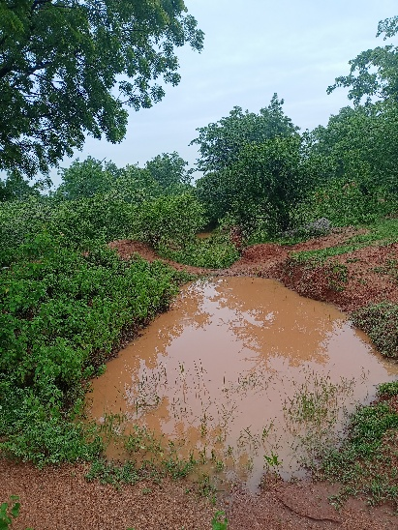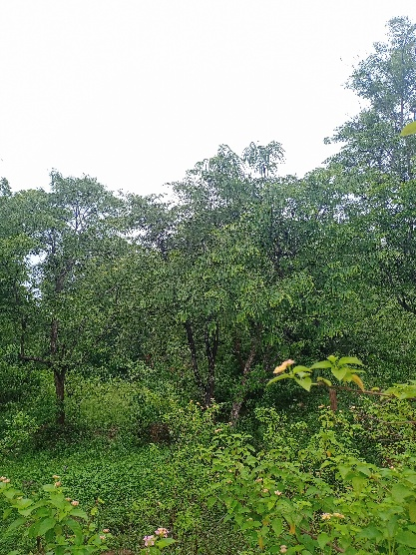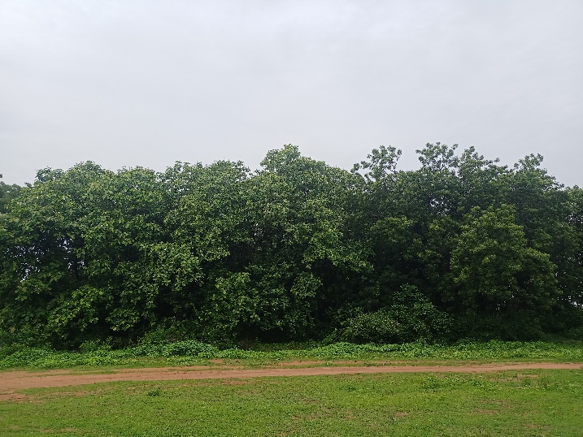
Fig 1. Water body Fig 2. Amla tree plantation Fig 3. Teakwood plantation

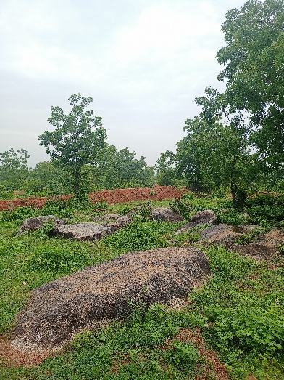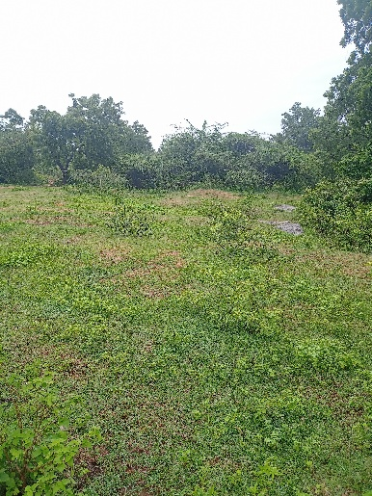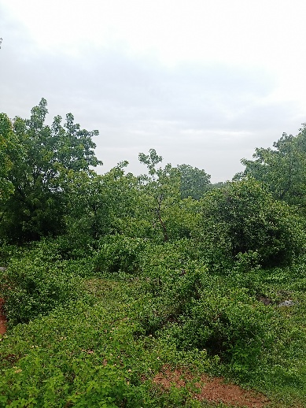
Fig 4. Natural Cliff with rocky area Fig 5. Grassland Fig 6. Forest area

3. results and discussion

A total 41 different bird species belonging to 12 orders 27 families and 36 genera were reported in the study area. Among all order, the order Passeriformes (16 species) was found most abundant and dominant followed by order Coraciiformes (4 species), Gruiformes (3 species), Ciconiformes (3 species), Falconiformes (3 species), Columbiformes (3 species), Cuculiformes (3 species), Charadriformes (2 species), Podicipediformes (1 species), Psittaformes (1 species), Stigiformes (1 species) and Apodiformes (1 species).

In the context of habitat utilized by bird species, nearly 11 species were found in agriculture field, 10 species were observed in open grassland, 5 species were found in scrubland, 3 species were in woodland and water bodies and 1 species found in each natural cliff, stony and Rocky ground.

The feeding guild was varied from species to species. Nearly 18 species were found to be insectivore, 6 species were found to be omnivore, 6 species were carnivore, 3 species were granivore, 3 species were Granivore-insectivore and 1 species of each nectivore, Granivore – frugivore, insectivore-carnivore and Frugivore-insectivore.

Nearly 26 bird species were common in occurrence, 8 species were occasional, 4 species were abundant and 2 species were rare.

The bird species such as Pavo cristatus, Venellus mulbaricus, Ammomanes phoenicura, Dicrurus caerulescens, Acredotheres tristis, Corvus splendens, Pycnonotus cafer, Argya malcolmi, Prinia socialis, Copsychus fulicata and Leptocoma zeylonica were endemic to the Indian-subcontinent and found in this area more commonly.

According to IUCN status all birds were found to be in Least concern (LC) status, as it indicates a good, healthy and stable ecosystem for growth, development and breeding purpose for bird species.

Many species utilized their habitat as their own breeding home such as Pavo cristatus, Venellus mulbaricus, Francolinus pondicerianus, Eudynamys scolopacea, Copsychus fulicata, Ammomanes phoenicura, Pycnonotus cafer, Argya malcolmi, Orthotomus sutorius and ploceus philippinus.

Due to rich in biodiversity and availability of plenty resources in the study area almost all species are adaptable to local environment and becomes resident and non- migratory. The Lal bahadur Shastri Mahavidyalaya, Campus is home for different bird species as they get plenty of natural food and water resources. So, this campus has a special attraction for ornithologist and bird lovers to watch their amazing sight. Moreover, the campus has its own natural beauty and rich in biodiversity. Besides bird diversity the college campus is shelter of various insects, amphibians, reptiles and mammals. To protect this natural amazing habitat is our accountability and is need of the hour to protect from various harmful anthropogenic activities. So, it is the responsibility of every individual to take part in various wildlife protection activities to protect our mother earth.

Following is the checklist of bird species recorded from Lal Bahadur Shastri Mahavidyalaya, Dharmabad Campus:

Table 1. Checklist of bird species recorded from Lal Bahadur Shastri Mahavidyalaya, Dharmabad Campus, with their taxonomic classification, local names, IUCN status, habitat, feeding guild, occurrence, and endemicity.
Sr. No. | Order | Family | Scientific name | Authority | Common name | Local name  (Marathi) | IUCN status | Habitat | Feeding guild | Occurrence | Endemicity
1 | Apodiformes | Apodidae | Apus affinis | (J. E. Grey, 1830) | Little Swift | पाकोळी | LC | Natural cliffs | Insectivore | Common | Non-endemic
2 | Charadriformes | Charadriidae | Venellus indicus | (Linnaeus, 1758) | Red Wattled Lapwing | टिटवी | LC | Agricultural field | Insectivore | Common | Non-endemic
2 | Charadriformes |  | Venellus mulbaricus | (Linnaeus, 1758) | Yellow Wattled  Lapwing | माळटिटवी | LC | Grasslands | Insectivore | Occasional | Indian  Subcontinent
3 | Ciconiformes | Ardeidae | Ardeola grayii | (Sykes, 1832) | Indian Pond Heron | ढोकरी | LC | Water bodies | Carnivore | Abundant | Non-endemic
3 | Ciconiformes | Ardeidae | Bubulcus ibis | (Linnaeus, 1758) | Cattle Egret | गाय बगळा | LC | Grassland | Insectivore | Abundant | Non-endemic
3 | Ciconiformes | Ardeidae | Mesophoyx intermedia | (Wagler, 1829) | Median Egret | मध्यम बगळा | LC | Grassland | Carnivore | Abundant | Non-endemic
4 | Columbiformes | Columbidae | Columba livia | (J. F. Gmelin, 1789) | Blue Rock Pigeon | कबूतर | LC | Agricultural Field | Granivore | Common | Non-endemic
4 | Columbiformes | Columbidae | Streptopelia decaocto | (Frivaldszky, 1838) | Eurasian Collared  Dove | राण होला | LC | Agricultural Field | Granivore | Common | Non-endemic
4 | Columbiformes | Columbidae | Streptopelia senegalensis | (Linnaeus, 1766) | Laughing Dove | भोवरी | LC | Agricultural Field | Granivore | Common | Non-endemic
5 | Coraciiformes | Alcidinidae | Alcedo atthis | (Linnaeus, 1758) | Common Kingfisher | छोटा खंड्या | LC | Water bodies | Carnivore | Common | Non-endemic
5 | Coraciiformes | Alcidinidae | Halcyon smyrnensis | (Linnaeus, 1758) | White Breasted  Kingfisher | खंड्या | LC | Agricultural field | Insectivore-carnivore | Common | Non-endemic
5 | Coraciiformes | Coraciidae | Coracias benghalensis | (Linnaeus, 1758) | Indian Roller | नीलकंठ | LC | Agricultural field | Insectivore | Occasional | Non-endemic
5 | Coraciiformes | Meropidae | Merops orientalis | (Lathum, 1801) | Little Green Bee eater | रानपोपट | LC | Grasslands | Insectivore | Common | Non-endemic
6 | Cuculiformes | Cuculidae | Centropus sinensis | (Stephens, 1815) | Greater Coucal | भारद्वाज | LC | Lowland | Omnivore | Common | Non-endemic
6 | Cuculiformes | Cuculidae | Eudynamys scolopacea | (Linnaeus, 1758) | Common koel | कोकीळ | LC | Woodland | Frugivore | Common | Non-endemic
6 | Cuculiformes | Cuculidae | Hierococcyx varius | (Vahl, 1797) | Brain Fever Bird | पावशा | LC | Woodland | Insectivore | Common | Non-endemic
7 | Falconiformes | Accipitridae | Accipiter badius | (Gmelin, 1788) | Shikra | शिक्रा | LC | Dense forest | Carnivore | Rare | Non-endemic
7 | Falconiformes | Accipitridae | Malvus migrans | (Boddaert, 1783) | Black Kite | घार | LC | Open grassland | Carnivore | Common | Non-endemic
7 | Falconiformes | Falconidae | Falco perigrinus | (Tunstall, 1771) | Pregrine Falcon | बहिरी ससाणा | LC | High cliffs | Carnivore | Rare | Non-endemic
8 | Gruiformes | Phasinidae | Francolinus pondicerianus | (Linnaeus, 1766) | Gray Francolin | चित्तर | LC | Grassland | Omnivore | Common | Non-endemic
8 | Gruiformes | Phasinidae | Pavo cristatus | (Linnaeus, 1758) | Indian Peafowl | मोर | LC | Scrubland | Omnivore | Abundant | Indian Subcontinent
8 | Gruiformes | Rallidae | Amauromis phoenicurus | (Pennant,1769) | White breasted waterhen | लाजरी पाणकोंबडी | LC | Water bodies | Omnivore | Common | Non-endemic
9 | Passeriformes | Alaudidae | Ammomanes phoenicura | (Franklin, 1831) | Rufous tailed Finch lark | तांबूस-शेपटीचा चंडोल | LC | Stony and rocky ground | Granivore-insectivore | Common | Indian  Subcontinent
9 | Passeriformes | Corvidae | Corvus splendens | (Vieillot, 1817) | House Crow | कावळा | LC | Woodland | Omnivore | Common | Indian  Subcontinent
9 | Passeriformes | Dicruridae | Dicrurus caerulescens | (Linnaeus, 1758) | White Bellied Drongo | पांढरपोट्या कोतवाल | LC | Scrublands | Insectivore | Occasional | Indian  Subcontinent
9 | Passeriformes |  | Dicrurus macrocercus | (Vieillot, 1817) | Black Drongo | कोतवाल | LC | Agricultural field | Insectivore | Common | Non-endemic
9 | Passeriformes | Hirundinidae | Hirundo smithii | (Leach, 1818) | Wire tailed Swallow | तारवाली पाकोळी | LC | Grasslands | Insectivore | Occasional | Non-endemic
 |  | Leiothrichidae | Argya malcolmi | (Sykes, 1832) | Large Grey Babbler | सातभाई | LC | Scrublands | Insectivore | Common | Indian  Subcontinent
 |  | Muscicapidae | Copsychus fulicata | (Linnaeus, 1776) | Indian Robin | चीरक | LC | Grasslands | Insectivore | Common | Indian Subcontinent
 |  | Nactariniidae | Leptocoma zeylonica | (Sykes, 1832) | Purple- rumped Sunbird | शिंजीर | LC | Scrublands | Nectarivore | Common | Indian  Subcontinent
 |  | Passeridae | Passer domesticus | (Linnaeus, 1758) | House Sparrow | चिमणी | LC | Urban and rural places | Granivore-insectivore | Common | Non-endemic
 |  | Ploceidae | Ploceus philippinus | (Linnaeus, 1766) | Baya weaver | सुगरण पक्षी | LC | Grasslands | Granivore-insectivore | Common | Non-endemic
 |  | Pycnonotidae | Pycnonotus cafer | (Linnaeus, 1766) | Red-Vented Bulbul | लाल बुडाचा बुलबुल | LC | Agricultural field | Frugivore-insectivore | Common | Indian  Subcontinent
 |  | Sturnidae | Acredotheres tristis | (Linnaeus, 1766) | Common Myna | साळुंकी | LC | Agricultural field | Omnivore | Common | Indian  Subcontinent
 |  | Sylviinae | Prinia buchanani | (Blyth, 1844) | Rufus fronted  Prinia | तांबूस डोक्याचा वटवट्या | LC | Scrublands | Insectivore | Occasional | Non-endemic
 |  | Sylviinae | Prinia inornata | (Sykes, 1832) | Plain Prinia | साधा वटवट्या | LC | Grasslands | Insectivore | Occasional | Non-endemic
 |  | Sylviinae | Prinia socialis | (Sykes, 1832) | Ashy Wren Warble | राखी वटवट्या | LC | Agricultural field | Insectivore | Occasional | Indian  Subcontinent
10 | Podicipediformes | Podicipidae | Tachybaptus ruficollis | (Pallas, 1764) | Little Grebe | टिबुकली | LC | Water bodies | Insectivore | Common | Non-endemic
11 | Psittaciformes | Psittacidae | Psittacula krameri | (Scopoli, 1769) | Rose Ringed Parakeet | पोपट | LC | Agricultural Field | Granivore-frugivore | Occasional | Non-endemic
12 | Stigiformes | Strigidae | Athene brama | (Temminck, 1821) | Spotted Owlet | पिंगळा | LC | Agricultural field | Insectivore | Common | Non-endemic

Fig 7. Column graph representing number of bird species present in each order

Fig 8. Pie-chart representing Feeding guild of different bird species

4. Conclusion

This bird checklist reveals its greater diversity in the Lal Bahadur Shastri Mahavidyalaya campus. Many bird species show its uniqueness to certain habitat and becomes adapt to a certain feeding guild. So, the results and observation given in this research paper will help to understand it’s diversity, various habitat use, feeding diet, migratory status, occurrence, endemicity, IUCN status and the ecological importance of birds in maintaining a healthy and productive ecosystem. There is no any checklist of birds available from this region so the present study represents a first complete checklist of bird species. Hence this research will encourage ornithologist, researchers, college teachers, students, bird enthusiastic and wildlife admirer to widen their perspective about importance and conservation of birds in their natural habitat.

Declaration of AI Use

This manuscript was prepared through the intellectual contributions of the author(s) to the study design, data analysis, interpretation of results, and scholarly content. Grammarly and ChatGPT were used solely to assist with grammatical refinement and reference formatting during manuscript revision. The author(s) accept full responsibility for the accuracy, integrity, and final content of the manuscript.

COMPETING INTERESTS DISCLAIMER:
Authors have declared that they have no known competing financial interests OR non-financial interests OR personal relationships that could have appeared to influence the work reported in this paper.

References
Ali S. (1996). The Book of Indian Birds. BNHS, Mumbai. PP: 1-354

Avibase (2026). The World Bird Database. https://avibase.bsc-eoc.org

Bagal, A., Thakur, R., Kamble, A. (2025). The Checklist of Bird Species around the “Tillari Conservation Reserve” in Maharashtra, India. Sustainability and Biodiversity Conservation, 4(1): 62-73. DOI: https://doi.org/10.5281/zenodo.14968108

Bharos, A.M.K., A. Vishwakarma, A. Bharos & R. Naidu (2023). Diversity and conservation status of avifauna in the Surguja region, Chhattisgarh, India. Journal of Threatened Taxa 15(8): 23710–23728.
https://doi.org/10.11609/jott.7314.15.8.23710-23728

Bird life International (2025). https://www.birdlife.org

Chavan, Shivaji & Dudhmal, Dilip & Hambarde, Shrikrishna & Kulkarni, A (2015). Birds from Godavari River Basin in Nanded District of Maharashtra State, India: Annotated status and new reports. International Journal of Current Research and Academic Review. 3. 328-351.

Chetry V, Saikia PK, Mahananda P, Saikia MK, Sarma K (2024) An annotated avian checklist of Bor‑nadi Wildlife Sanctuary, Assam, India. Check List 20 (3): 665-691.
https://doi.org/10.15560/20.3.665

Gajanan Wagh, Nikhil Borode, Raju Kasambe and Pratik Chaudhari. Bird diversity of pench tiger reserve, Madhya Pradesh, India, with a significant record of the lesser adjutant stork (Leptoptilos javanicus horsfield, 1821). Int. J. Fauna Biol. Stud. 2026;13(3):73-84.
DOI: https://doi.org/10.22271/23940522.2026.v13.i3a.1217

Gohil, B., Kanabar, R., Trambadiya, K., Poriya, P. & Visavadia, M. 2024. An annotated checklist of Avifauna from Ramdhari village, Bhavnagar, Gujarat, India. Munis Entomology & Zoology, 19 (suppl.): 3176-3189
Hussain, A., Z. Hussain & M. Ali (2025). An avifaunal checklist of the Zanskar Region, Ladakh Himalaya, India. Journal of Threatened Taxa 17(3): 26669–26679.
https://doi.org/10.11609/jot.9288.17.3.26669-26679

International Union for Conservation of Nature (2026). IUCN Red List of Threatened Species
https://www.iucnredlist.org

Mahanta G., Panda R.M. & Palita S.K., 2025. Avian Diversity and Habitat Preferences in Scrubland Ecosystems of the Eastern Ghats of Southern Odisha, India. Land, 14: 511.
https://doi.org/10.3390/land14030511

Malik, W.S., I. Quyoom & T. Sheikh (2023). Study on avian diversity in the forests of district Ramban, Jammu and Kashmir, India. Munis Entomology and Zoology 18(2): 1723–1735.

Marinov M, Doroșencu A-C, Alexe V, Bolboacă L-E, Kiss JB (2026) An updated checklist of bird species in the Danube Delta Biosphere reserve (Romania). Scientific Annals of the Danube Delta Institute 31: 1–14. https://doi.org/10.3897/Saddi.31.161357

Martínez-Núñez C, Martínez-Prentice R, García-Navas V (2023) Land-use diversity predicts regional bird taxonomic and functional richness worldwide. Nature Communications 14(1): 1320. https://doi.org/10.1038/s41467-023-37027-5

Praveen, J., & Jayapal, R., 2025. Taxonomic updates to the checklists of birds of India and the South Asian region—2026. Indian BIRDS 21 (6): 165–166

Quyoom, I, B.A. Bhat, W.S. Malik, T. Sheikh & A.N. Lone (2024). An avifaunal checklist of the Bani Wildlife Sanctuary, Jammu & Kashmir, India. Journal of Threatened Taxa 16(5): 25137–25146.
https://doi.org/10.11609/jot.8894.16.5.25137-25146

Rao, G.B., S. Babu, G. Quadros & V. Anoop (2019). Bird diversity in the coastal talukas of Sindhudurg District, Maharashtra, India. Journal of Threatened Taxa 11(9): 14166–14186.
https://doi.org/10.11609/jot.4007.11.9.14166–14186

Rodrigues, K.M., K.V. Kumar, V. Hasyagar, M.C.P. Krishna & D. Naik (2023). A checklist of avifauna of Mangalore University, Karnataka, India. Journal of Threatened Taxa 15(1): 22430–22439.
https://doi.org/10.11609/jot.7503.15.1.22430-22439

Satose, V., V. Choursiya, R. Deulkar & S. Menon (2018). Avian fauna of Amboli Ghat, Sindhudurg District, Maharashtra State, India. Journal of Threatened Taxa 10(13): 12805–12816;
https://doi.org/10.11609/jott.2886.10.13.12805-12816

Sayyed, A. (2016). Faunal diversity of Satara District, Maharashtra, India. Journal of Threatened Taxa 8(13): 9537–9561;
http://dx.doi.org/10.11609/Jott.3162.8.13.9537-9561

Sharma, N., S.K. Rana, P. Raina, R. Amir & M.A. Kichloo (2018). An annotated checklist of the birds of upper Chenab catchment, Jammu & Kashmir, India.Journal of Threatened Taxa 10(7): 11869–11894;
http://doi.org/10.11609/jott.3464.10.7.11869-11894

Sureja, N., H. Radadia, B. Trivedi, D. Varagiya & M. Gadhavi (2022). The checklist of birds of Rajkot district, Gujarat, India with a note on probable local Extinction. Journal of Threatened Taxa 14(8): 21508–21528. https://doi.org/10.11609/jot.6458.14.8.21508-21528

Singh, J., S. Antl, V. Goyal & V. Malik (2020). Avifaunal diversity of Tilyar Lake, Rohtak, Haryana, India. Journal of Threatened Taxa 12(8): 15909–15915.
https://doi.org/10.11609/jot.4700.12.8.15909-15915

Talwar, T., L.M. Abraham, B. Rabha & M. Rabha (2024). An annotated checklist of the birds in Loharghat Forest Range, Assam, India. Journal of Threatened Taxa 16(1): 24568-24583.
https://doi.org/10.11609/jot.8638.16.1.24568-24583

Vinayak, D.C. & S.V. Mali (2018). A checklist of bird communites In Tamhini Wildlife Sanctuary, the northern Western Ghats, Maharashtra, India. Journal of Threatened Taxa 10(3): 11399–11409;
http://doi.org/10.11609/jot.3377.10.3.11399-11409

Zainab K Ali, Gajanan A Wagh and Murtuza S Ali. Assessment of wetland bird diversity and species richness at Chatri Lake, Amravati, Maharashtra. Int. J. Fauna Biol. Stud. 2026;13(3):28-37.
DOI: https://doi.org/10.22271/23940522.2026.v13.i3a.1207

Zainab K Ali, Gajanan Wagh and Pratik Chaudhari. Diversity and abundance of wetland avifauna at Malkhed lake of Amravati region, Maharashtra, India..Int. J. Fauna Biol. Stud. 2024;11(4):50-58. DOI: https://doi.org/10.22271/23940522.2024.v11.i4a.1038

Zala, U. J., Raval, J. V., Nimavat, R. S. & Hun, N. K. 2022. A study of Avifauna from Girnar Wildlife Sanctuary, Junagadh, Gujarat, India. Journal of Animal Diversity, 4 (4): 74-90.

