Original Research Article
Evaluation of the Microbiological Quality of Water in Different Tilapia Rearing Structures in Côte d’Ivoire

Abstract
The intensification of tilapia aquaculture in Côte d’Ivoire has increased the need for effective monitoring of water quality and microbial hazards in rearing systems. This study aimed to evaluate the microbiological quality of water in different tilapia Rearing Structures in Côte d’Ivoire. This study assessed the microbiological quality of water used to rear Nile tilapia (Oreochromis niloticus) in three structures (earthen ponds, concrete tanks and aquariums). Water samples were analysed for bacterial indicators, potentially pathogenic bacteria and microfungal groups using culture-based methods. Results showed that microbial loads varied among the rearing structures. The rearing water contained several bacterial and microfungal groups, including., Escherichia coli, Staphylococcus aureus, Aeromonas spp., Salmonella spp., total coliforms, Saprolegnia spp., and Aspergillus spp., as well as unidentified yeasts and moulds. Tank water showed the highest bacterial contamination, with Salmonella spp. reaching 14,000 ± 350 CFU/100 ml. Tank water also recorded the highest total coliform, Staphylococcus aureus, unidentified yeast and unidentified mould loads. Pond water showed intermediate bacterial contamination and the highest Saprolegnia spp. load (200 ± 10 CFU/100 ml). Aquarium water showed the lowest detection of the investigated microorganisms. Total coliforms were detected at 500 ± 40 CFU/100 ml, whereas the other bacterial and microfungal groups were recorded at 0 ± 0 CFU/100 ml. The observed microbial profiles differed among the rearing structures. Regular sanitation, adequate water renewal and systematic microbiological monitoring are recommended to support fish health and improve biosafety in tilapia production systems.
Keywords: Aquaculture; microbiological qualities; Oreochromis niloticus; pond, tank.

1. Introduction
Aquaculture is increasingly recognized as a key sector for food security and income generation in sub-Saharan Africa. In Côte d’Ivoire, fish is the main source of animal protein. However, national production remains far below domestic demand. According to FAO (2025), Côte d’Ivoire produced about 92,000 tonnes of fish in 2023, whereas national consumption reached about 534,000 tonnes. This gap explains the growing interest in aquaculture development. Among farmed species, Nile tilapia (Oreochromis niloticus) occupies a central place because of its rapid growth, hardiness, and high market acceptance (Reyes et al., 2024 ; FAO, 2025).
The success of tilapia farming depends strongly on water quality. In aquaculture systems, water is not only a physical medium. It is also a biological environment that directly affects fish growth, health, and survival. Most farm monitoring programs focus on physico-chemical parameters such as temperature, pH, and dissolved oxygen. However, microbiological quality is equally important. Culture water may contain indicator bacteria, opportunistic pathogens, and other microorganisms of sanitary importance. Under intensive or poorly managed conditions, microbial proliferation may increase fish stress and disease risk.
Recent studies have highlighted this issue in tilapia farming. In Côte d’Ivoire, Kra et al. (2026) reported the presence of cultivable opportunistic bacteria in both rearing water and O. niloticus from semi-intensive systems. Their study showed that water can act as an important reservoir of microorganisms of sanitary concern. These findings support the need for regular microbiological monitoring in local aquaculture systems.
The type of rearing structure may also influence microbial water quality. Ponds, tanks, and aquariums differ in water renewal, sediment interaction, organic matter accumulation, and management intensity. Delamare-Deboutteville et al. (2025) showed that pond- and tank-reared tilapia harbor different microbial communities, confirming that the rearing environment shapes microbiological dynamics. Similarly, studies on managed aquarium systems have shown that these environments remain biologically dynamic and may also present sanitary risks if maintenance is inadequate (Vanderzwalmen et al., 2022).
In Côte d’Ivoire, comparative information on the microbiological quality of water in different tilapia rearing structures remains limited. Yet such information is essential for improving biosecurity and health management. Therefore, the present study aimed to assess the microbiological quality of water in ponds, tanks, and aquariums used for Oreochromis niloticus culture in Côte d’Ivoire.

2. Materials and Methods

2.1 Study Area
The study was conducted at SRPAC, located in the Kongodékro classified forest of Bouaké, Côte d’Ivoire, 3 km from the Bouaké-Abidjan highway (Assémien et al., 2025). The station encompasses 80 earthen ponds, 50 concrete tanks and an aquarium facility (Figure 1). Ponds and tanks are supplied by surface water from the Kan dam, while aquariums use borehole water (Assémien et al., 2025). The region has a tropical savanna climate with a rainy season from April to October (Konan, 2017).
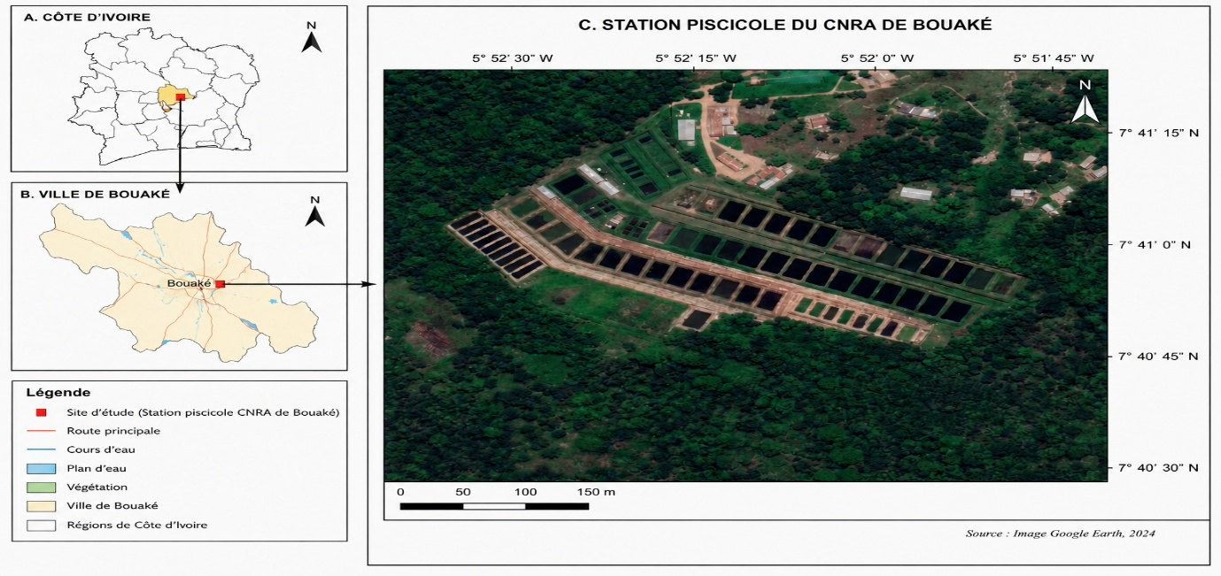
Figure 1: Localization of Study area (SRPAC).

2.2 Water Sampling
Water samples were collected from all three rearing structures (Pond, Tank and aquarium) in March 2026. The fish had a similar mean body weight of 45 ± 3.5 g and received the same ration. Ponds, tanks and aquariums were stocked at 3, 15 and 100 fish/m², respectively. The ponds were stocked at a density of 3 fish/m². The tanks were stocked at 15 fish/m². The aquariums were stocked at 100 fish/m². All rearing structures were supplied with borehole water and water from Lake Kan. Samples were collected in sterile 500-mL polypropylene bottles. Each bottle was sealed and labelled with the sampling date, site and rearing structure. The samples were immediately placed in an insulated cooler maintained at 1–8 °C and transported to the Central Soils, Water and Plants Laboratory for analysis.

2.3 Microbiological Analysis
Bacteriological analysis targeted total coliforms, Escherichia coli (E. coli), intestinal enterococci, Aeromonas spp., Salmonella spp.. and Staphylococcus aureus. Total coliforms and E. coli were enumerated by membrane filtration on RAPID’E. coli 2 agar according to NF EN ISO 9308-1. Intestinal enterococci were detected and enumerated by membrane filtration according to NF ISO 7899-2. Salmonella spp. were detected according to ISO 19250. Aeromonas spp. were isolated and enumerated by membrane filtration using selective ampicillin-dextrin agar with vancomycin, following EPA Method 1605. Presumptive Aeromonas hydrophila (A. hydrophila) colonies were purified and biochemically confirmed by Gram staining, motility, oxidase and catalase reactions, indole production, citrate utilization, glucose fermentation, TSI profile, and API 20E characterization. Isolates showing a compatible biochemical profile were identified as A. hydrophila (Janda and Abbott, 2010). Presumptive Staphylococcus aureus colonies grown on Baird-Parker agar were confirmed by Gram staining, catalase, coagulase, and DNase tests. Gram-positive cocci in clusters showing positive catalase, coagulase, and DNase reactions were identified as S. aureus (ISO, 2021).

Yeasts and moulds were enumerated by membrane filtration. Water samples were filtered through sterile 0.45 µm membranes, which were placed on Sabouraud dextrose agar supplemented with chloramphenicol and incubated at 25 ± 2 °C for 5 to 7 days. Results were expressed as colony-forming units per 100 milliliters (CFU/100 mL). Colonies with morphological characteristics of Aspergillus were purified and identified microscopically after lactophenol cotton blue staining. For Saprolegnia detection, a hemp-seed baiting technique was used. Colonized baits were transferred onto selective agar and examined for typical coenocytic hyphae. Because molecular confirmation was not performed, isolates were reported as Aspergillus spp. and Saprolegnia spp.In the absence of molecular confirmation, isolates were reported as Aspergillus spp. and Saprolegnia spp. (Eszterbauer et al., 2020 ).

Microbial load was calculated using:
Ml = Nc × d / V
where Ml = microbial load (CFU/100 ml); Nc = number of colony-forming units; d = dilution factor; V = volume of inoculated water (ml).

2.4 Statistical Analysis
Data were entered in Microsoft Excel and analysed using R software (version 4.5.1). Comparisons between structures were performed using non-parametric tests. Results were considered significant at p < 0.05. Spearman rank correlations were calculated for 15 quantitative variables using n = 9 rows. Statistical significance was assessed at α = 0.05.

3. Results

3.1 Physicochemical parameters of water according to rearing structures
Physicochemical parameters of water from the three rearing structures presented in Table 1, showed that there was no significant difference for dissolved oxygen, temperature and pH. However, conductivity differed significantly among the rearing structures. Mean dissolved oxygen varied from 4.18 ± 1.62 to 5.53 ± 2.08 mg/L. The highest mean value was recorded in tank water, whereas pond water showed the lowest value. Mean pH values were 7.80 ± 0.21, 7.94 ± 0.19 and 6.98 ± 0.08 in pond, tank and aquarium water, respectively. Temperatures ranged from 25.73 ± 0.33 in aquarium to 26.38 ± 0.87°C in tank water. The highest mean value was recorded in tank water, whereas the aquarium water showed the lowest value of temperature. Regarding the conductivity, pond and tank water showed similar values of 359.3 ± 4.0 and 363.7 ± 5.1 µS/cm, respectively. Aquarium water showed a significantly lower conductivity value of 140.0 ± 15.0 µS/cm.

Table 1. Physicochemical parameters of water according to rearing structures
Parameters | Pond water | Tank water | Aquarium water
Dissolved oxygen (mg/L) | 4.18 ± 1.62 | 5.53 ± 2.08 | 4.95 ± 1.52
pH | 7.80 ± 0.21 | 7.94 ± 0.19 | 6.98 ± 0.08
Temperature (°C) | 26.10 ± 0.77 | 26.38 ± 0.87 | 25.73 ± 0.33
Conductivity (µS/cm) | 359.3 ± 4.0ª | 363.7 ± 5.1ª | 140.0 ± 15.0^{b}
Values are means of three replicates ± standard deviation. Within the same row, values bearing different letters are significantly different (ANOVA, P < 0.05).

3.2. Diversity of Pathogenic Microorganisms
Microbiological analyses of the three tilapia rearing structures identified bacterial and microfungal groups of sanitary importance. The bacteria detected were total coliforms, Intestinal enterococci, Aeromonas spp., Salmonella spp., Aeromonas hydrophila, Escherichia coli, Staphylococcus aureus. Microfungal included Saprolegnia spp., Aspergillus spp., Yeasts (unidentified), Moulds (unidentified).

3.3. Bacterial Loads by Rearing Structure
Bacterial loads varied according to the rearing structure (Table 2). The highest value was recorded for Salmonella spp. in tank water (14 000 ± 350 CFU/100 ml), whereas the corresponding pond-water value was 400 ± 33 CFU/100 ml and the aquarium-water value was 0 ± 0 CFU/100 ml. Total coliform loads were 560 ± 45, 860 ± 105 and 500 ± 40 CFU/100 ml in pond, tank and aquarium water, respectively.
Aeromonas hydrophila was detected at 510 ± 33 CFU/100 ml in pond water, 500 ± 67 CFU/100 ml in tank water and 0 ± 0 CFU/100 ml in aquarium water. Escherichia coli loads were 100 ± 52, 150 ± 31 and 0 ± 0 CFU/100 ml in pond, tank and aquarium water, respectively. Staphylococcus aureus loads were 450 ± 19, 600 ± 37 and 0 ± 0 CFU/100 ml in pond, tank and aquarium water, respectively.
Intestinal enterococci were measured at 150 ± 27, 100 ± 15 and 0 ± 0 CFU/100 ml in pond, tank and aquarium water, respectively. Aeromonas spp. were measured at 430 ± 41, 500 ± 30 and 0 ± 0 CFU/100 ml, respectively.

Table 2. Bacterial loads in water according to rearing structures
Microorganism | Pond water (CFU/100 ml) | Tank water (CFU/100 ml) | Aquarium water (CFU/100 ml)
Total coliforms | 560±45ᵃ | 860±105ᵇ | 500±40ᵃ
Aeromonas hydrophila | 510±33ᵃ | 500±67ᵃ | 0±0ᵇ
Escherichia coli | 100±52ᵃ | 150±31ᵃ | 0±0ᵇ
Staphylococcus aureus | 450±19ᵃ | 600±37ᵃ | 0±0ᵇ
Intestinal enterococci | 150±27ᵃ | 100±15ᵃ | 0±0ᵇ
Unidentified Aeromonas spp. | 430±41ᵃ | 500±30ᵃ | 0±0ᵇ
Salmonella spp. | 400±33ᵃ | 14 000±350ᵇ | 0±0ᶜ
Values are means of three replicates ± standard deviation. Within the same row, values bearing different letters are significantly different (ANOVA, P < 0.05).

3.4. Microfungal loads
Microfungal loads presented in Table 3 differed among the rearing structures. Yeasts (unidentified) showed the highest load in tank water (400 ± 100 CFU/100 ml), followed by moulds (unidentified) (350 ± 100 CFU/100 ml). Their corresponding pond-water values were 100 ± 0 and 100 ± 0 CFU/100 ml, respectively, whereas both groups were recorded as 0 ± 0 CFU/100 ml in aquarium water. Saprolegnia spp. loads were 200 ± 10 CFU/100 ml in pond water, 150 ± 20 CFU/100 ml in tank water and 0 ± 0 CFU/100 ml in aquarium water. Aspergillus spp. loads were 10 ± 0 CFU/100 ml in pond water, 25 ± 0 CFU/100 ml in tank water and 0 ± 0 CFU/100 ml in aquarium water.

Table 3. Microfungal loads in water according to rearing structures
Microfungal group | Pond water (CFU/100 ml) | Tank water (CFU/100 ml) | Aquarium water (CFU/100 ml)
Saprolegnia spp. | 200±10ᵃ | 150±20ᵇ | 0±0ᶜ
Aspergillus spp. | 10±0ᵃ | 25±0ᵇ | 0±0ᶜ
Yeasts (unidentified) | 100±0ᵃ | 400±100ᵇ | 0±0ᶜ
Moulds (unidentified) | 100±0ᵃ | 350±100ᵇ | 0±0ᶜ
Values are means of three replicates ± standard deviation. Within the same row, values bearing different letters are significantly different (ANOVA, P < 0.05).

3.5. Correlation rank between parameters
Spearman analysis identified predominantly positive monotonic associations among the physicochemical, bacterial and microfungal variables (Figure 2). The strongest relationships included pH–conductivity (ρ = 0.983, p = 0.000002), Staphylococcus aureus - Salmonella spp. (ρ = 1.000, p < 0.001), intestinal enterococci - Saprolegnia spp. (ρ = 1.000, p < 0.001) and unidentified yeasts - unidentified moulds (ρ = 1.000, p < 0.001). These associations should be interpreted as exploratory because n = 9 rows were analysed and the data may reflect differences among rearing structures. No causal inference can be drawn from the correlations. Dissolved oxygen was strongly and positively associated with temperature. Positive monotonic relationships were also observed between temperature and pH, temperature and conductivity, and pH and conductivity. pH showed strong positive monotonic associations with total coliforms, Aeromonas hydrophila, Escherichia coli, Staphylococcus aureus, Aeromonas spp. and Salmonella spp.. Conductivity was similarly associated with total coliforms, A. hydrophila, E. coli, S. aureus, Aeromonas spp. and Salmonella spp.. The strongest relationships included Staphylococcus aureus with Aeromonas spp. and Salmonella spp., E. coli with Aeromonas spp., and Aeromonas spp. with Salmonella spp.. Total coliforms were also strongly associated with E. coli, S. aureus, unidentified Aeromonas spp. and Salmonella spp.. pH was positively correlated with Saprolegnia spp., Aspergillus spp., unidentified yeasts and unidentified moulds. Conductivity was associated with Saprolegnia spp., Aspergillus spp., unidentified yeasts and unidentified moulds.

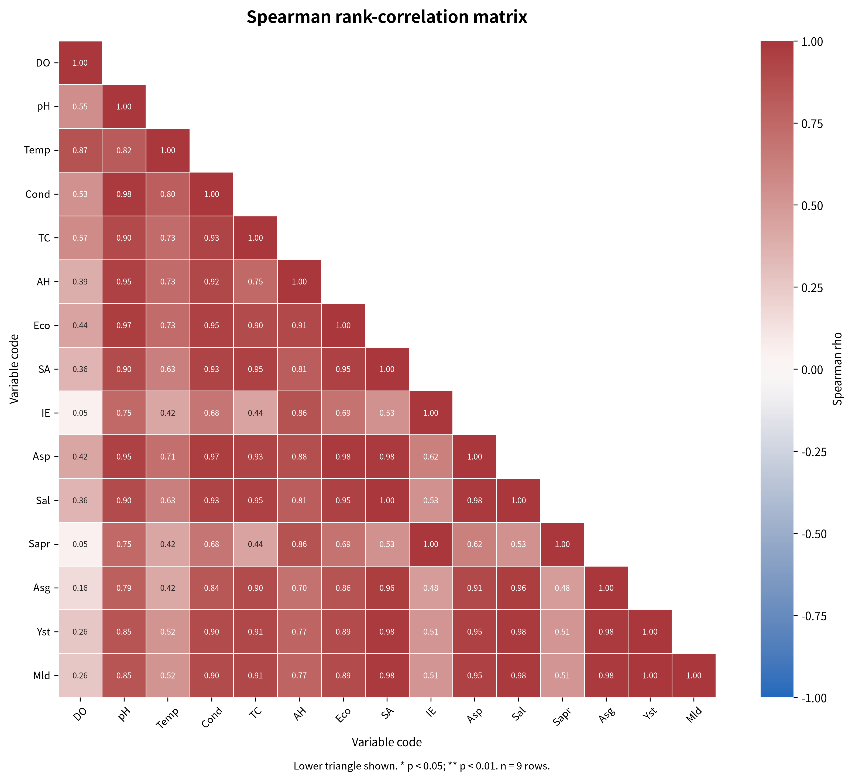
Figure 2. Spearman rho heatmap with variable
Dissolved oxygen (DO), pH (pH), Temperature (Temp), Conductivity (Cond), Total coliforms (TC), Aeromonas hydrophila (AH), Escherichia coli (Eco), Staphylococcus aureus (SA), Intestinal enterococci (IE), Unidentfied Aeromonas spp. (Asp), Salmonella spp. (Sal), Saprolegnia spp. (Sapr), Aspergillus spp. (Asg), Unidentified yeasts (Yst), Unidentified moulds (Mld)

4. Discussion
Overall, the observed dissolved oxygen, pH and temperature values were within the ranges considered suitable for Nile tilapia growth and culture, as reported by Makori et al. (2017). No significant differences were observed for dissolved oxygen, pH or temperature. This similarity is likely related to the fact that all structures were supplied from the same water source, which would provide a broadly similar initial chemical composition. In contrast, conductivity differed significantly among the rearing structures. Because all structures received water from the same source, this difference was unlikely to result solely from the initial water supply. It may instead reflect differences in water substrate interactions, contact with pond sediment, tank-wall materials, organic matter accumulation, mineral release, water volume or water-renewal conditions. The similar conductivity values observed in pond and tank water suggest comparable ionic enrichment, whereas the lower value in aquarium water may indicate lower mineral exchange or more controlled water management.
The three structures held fish of similar mean weight and received the same feeding ration. They were supplied with the same borehole and Lake Kan water. Differences in microbial loads may therefore reflect structure-specific conditions, including stocking density, water retention, sediment contact, biofilm development and organic matter accumulation. Tank water showed the highest bacterial contamination. Stocking density alone cannot explain this pattern, since tanks contained 15 fish/m², whereas aquariums contained 100 fish/m² but showed no detectable Aeromonas, Escherichia coli, Staphylococcus aureus or Salmonella spp. Water management and system design may therefore have influenced microbial accumulation more strongly than density alone. Aquarium water showed the lowest overall microbial detection despite its higher stocking density. This pattern suggests that controlled water handling, reduced contact with sediments and more effective water renewal may have limited microbial persistence. Water-quality management, including regular cleaning, organic-matter control, adequate water renewal and microbiological monitoring, is essential for reducing disease risks in tilapia aquaculture (Kelany et al., 2024). The influence of system design and environmental conditions on microbial communities and fish health has also been highlighted in tilapia aquaculture (Debnath et al., 2023). Pond water had the highest Saprolegnia spp. load, whereas tank water had the highest yeast and mould loads. These patterns may reflect differences in organic substrates, sediment contact and biofilm development. Saprolegnia is an important oomycete pathogen in aquaculture, particularly under stressful environmental conditions (Lindholm-Lehto and Pylkkö, 2024).
The Spearman analysis identified predominantly positive monotonic associations among the physicochemical parameters and the bacterial and microfungal variables. These associations indicate that the physicochemical variables tended to vary in the same order across the nine rows. Such co-variation is compatible with the recognised importance of temperature, dissolved oxygen, pH and conductivity in tilapia culture, where non-optimal water conditions can affect fish stress and susceptibility to disease (Kelany et al., 2024; Mukwabi et al., 2019). These results suggest that higher pH and conductivity values occurred in the same observations as higher bacterial counts. Studies of farmed Nile tilapia have similarly treated temperature, pH, dissolved oxygen and electrical conductivity as relevant environmental variables when assessing bacterial pathogens and fish health (Mukwabi et al., 2019; Kelany et al., 2024). The bacterial variables formed a coherent positive association pattern. This is consistent with the interpretation of several organisms as indicators of common contamination or common exposure pathways rather than as independent events. The co-occurrence of Aeromonas and other bacterial groups may reflect shared organic enrichment or water-management conditions. Research on tilapia aquaculture has emphasised the interaction between environmental conditions, potential pathogens and fish health, particularly for Aeromonas-related disease (Mukwabi et al., 2019; Abdella et al., 2024). The microfungal variables were positively associated with several physicochemical and bacterial indicators. Among microbial groups, the association between intestinal enterococci and Saprolegnia spp. was perfect in the present dataset (ρ = 1.000000, p < 0.001), as was the association between unidentified yeasts and unidentified moulds (ρ = 1.000000, p < 0.001). The observed associations are therefore useful for generating hypotheses about shared environmental conditions, but they require confirmation with independent samples and taxonomically resolved fungal measurements.

5. Conclusion
This study assessed the microbiological quality of water used to rear Oreochromis niloticus in ponds, concrete tanks and aquariums. Bacterial and microfungal groups were detected in the rearing water, including Aeromonas hydrophila, Escherichia coli, Staphylococcus aureus, intestinal enterococci, unidentified Aeromonas spp., Salmonella spp., Saprolegnia spp., Aspergillus spp., unidentified yeasts and unidentified moulds. Microbial loads varied among the rearing structures. Concrete tanks showed the highest overall bacterial and microfungal loads, particularly for Salmonella spp., unidentified yeasts and unidentified moulds. Pond water showed the highest Saprolegnia spp. load. Aquarium water showed the lowest detection of most investigated microorganisms. Regular cleaning and disinfection of tanks and ponds, adequate water renewal, control of organic matter and systematic microbiological monitoring are recommended to reduce potential disease risks and support fish production. Further studies should include physicochemical parameters, ammonia, nitrite, organic matter, biofilm assessment, molecular confirmation of isolates and antimicrobial-susceptibility testing. The findings provide baseline information for strengthening biosafety and water-quality management in tilapia aquaculture systems in Côte d’Ivoire.

6. Limitations

The study was conducted at one research station and used a limited number of rows. Microbial enumeration was culture-based, and several isolates were not confirmed molecularly. Physicochemical drivers and multiple-testing corrections were not fully documented. These limitations should be considered when generalizing the findings.

Declaration of AI Use

This manuscript was prepared through the intellectual contributions of the author(s) to the study design, data analysis, interpretation of results, and scholarly content. Grammarly and ChatGPT were used solely to assist with grammatical refinement and reference formatting during manuscript revision. The author(s) accept full responsibility for the accuracy, integrity, and final content of the manuscript.

COMPETING INTERESTS DISCLAIMER:
Authors have declared that they have no known competing financial interests OR non-financial interests OR personal relationships that could have appeared to influence the work reported in this paper.

References
Abdella, B., Shokrak, N.M., Abozahra, N.A. (2024). Aquaculture and Aeromonas hydrophila: a complex interplay of environmental factors and virulence. Aquacult Int 32, 7671–7681 https://doi.org/10.1007/s10499-024-01535-y
Assémien, O. E. D., Anvo, M. P. M., Ani, A. P., & Sotti, K. S. (2025). Reproductive performance of Nile tilapia Oreochromis niloticus Akosombo strain in a controlled environment in Côte d’Ivoire. World Journal of Advanced Research and Reviews, 28(2), 912–921. https://wjarr.com/sites/default/files/fulltext_pdf/WJARR-2025-3780.pdf
Debnath, S. C., McMurtrie, J., Temperton, B., Delamare-Deboutteville, J., Mohan, C. V., & Tyler, C. R. (2023). Tilapia aquaculture, emerging diseases, and the roles of the skin microbiomes in health and disease. Aquaculture International, 31(5), 2945–2976. https://doi.org/10.1007/s10499-023-01117-4
Delamare-Deboutteville J, Mahmuddin M, Gan HM, Rodde C, Khor L, Verner-Jeffreys D, Mohan CV and Benzie JAH (2025) Microbiome dynamics in tank- and pond-reared Genetically Improved Farmed Tilapia (GIFT). Front. Microbiomes 4:1567816. doi: 10.3389/frmbi.2025.1567816
Eszterbauer, E., Hardy, T., Rónai, Z., Sipos, D., et al. (2020). Cryopreservation of three Saprolegnia species (Oomycota). Journal, volume and pages to be completed by the authors. https://pubmed.ncbi.nlm.nih.gov/32540191

FAO/FISH4ACP. (2025). Pisciculture : le programme FISH4ACP de la FAO incite les bailleurs à investir dans un secteur à fort potentiel. FAO Côte d’Ivoire. (Fish farming: FAO’s FISH4ACP program encourages donors to invest in a sector with high potential. FAO Côte d’Ivoire) https://www.fao.org/cote-divoire/actualites/detail/pisciculture---le-programme-fish4acp-de-la-fao-incite-les-bailleurs-à-investir-dans-un-secteur-à-fort-potentiel/fr
International Organization for Standardization. (2021). ISO 6888-1:2021: Microbiology of the food chain—Horizontal method for the enumeration of coagulase-positive staphylococci. Part 1: Method using Baird–Parker agar medium.
Janda, J. M., & Abbott, S. L. (2010). The genus Aeromonas: Taxonomy, pathogenicity, and infection. Clinical Microbiology Reviews, 23(1), 35–73. https://doi.org/10.1128/CMR.00039-09

Kelany, N. F., Abdel-Mohsein, H. S., Kotb, S., & Ismail, A. E.-M. A. (2024). Significant impact of physicochemical water parameters in tilapia aquaculture. Journal of Advanced Veterinary Research, 14(6), 1060–1064. https://advetresearch.com/index.php/AVR/article/view/1926
Konan, J.-M. K. A. (2017). Compétition entre bâti et agriculture dans la conquête des bas-fonds de la ville de Bouaké. (Competition between built-up areas and agriculture in the encroachment upon the lowlands of the city of Bouaké.) VertigO, 28. https://journals.openedition.org/vertigo/18302

Kra, O. K., Konan, F. K., et al. (2026). Cultivable opportunistic bacterial diversity and seasonal patterns in water and tilapia (Oreochromis niloticus) from semi-intensive aquaculture systems in Côte d’Ivoire: Case of Anyama and Aboisso. Journal of Applied & Environmental Microbiology. 2026, 14(1), 24-29.

Lindholm-Lehto, P. C., & Pylkkö, P. (2024). Saprolegniosis in aquaculture and how to control it? Aquaculture, Fish and Fisheries. https://doi.org/10.1002/aff2.200
Makori, A. J., Abuom, P. O., Kapiyo, R., Anyona, D. N., & Dida, G. O. (2017). Effects of water physicochemical parameters on tilapia (Oreochromis niloticus) growth in earthen ponds in Teso North Sub-County, Busia County. Fisheries and Aquatic Sciences, 20, Article 30. https://doi.org/10.1186/s41240-017-0075-7
Mukwabi, D. M., Okemo, P. O., Otieno, S. O., et al. (2019). Temperature and pH influence on bacterial pathogens infecting farmed Nile tilapia in aquaculture systems in Bungoma County, Kenya. International Journal of Fisheries and Aquatic Studies. https://ir-library.ku.ac.ke/bitstreams/0d6c911a-a294-4436-b29e-f220d0f82370/download
Reyes, A. T. (2024). Comparison of Fulton’s condition factor of Nile tilapia (Oreochromis niloticus) reared in ponds in Lubao, Pampanga, Philippines during the dry season. Uttar Pradesh Journal of Zoology, 45(15), 406–416.
Vanderzwalmen, M., et al. (2022). The effect of substrate on water quality in ornamental fish tanks. Animals, 12(19), 2679. https://doi.org/10.3390/ani12192679

