Original Research Article
Spatio-temporal patterns and habitat selection of the Great Slaty Woodpecker (Mulleripicus pulverulentus harterti) in a fragmented landscape: A year-long study in Garbhanga Reserve Forest, Guwahati, Assam
Abstract
Birds serve as practical bio-indicators for forest health which reflectsstructural quality and ecosystem stability across tropical landscapes. In Northeastern India, limited field data exists regarding how the threatened Great Slaty Woodpecker (Mulleripicus pulverulentus harterti) utilizes fragmented forest reserves under human pressure. This study evaluated the spatial presence, foraging habits, and social behavior of the species in the Garbhanga Reserve Forest, Assam, while assessing local disturbance impacts. Over a 12-month period, we conducted systematically spaced line transects, visual encounter surveys, and focal animal observations across four seasons. We recorded 50 independent sightings, with birds showing a clear preference for mature forest stands over degraded trails. The species demonstrated strong microhabitat specialization; spending 86% of observed foraging time on large Sal (Shorea robusta) trees, with an average trunk diameter of 47.46 cm. Birds typically moved in nuclear family units of four individuals and maintained dedicated lookout behaviours in high-canopy trees. However, sudden human activity along forest trails caused complete nest abandonment during the breeding season. These results establish an important baseline showing that while small family groups tolerate routine human presence along trail edges for feeding, quiet core areas are vital for successful breeding. These findings provide practical guidance for protecting key old-growth trees and designing effective conservation plans for forest specialists in Northeast India.
Keywords:Avian bio-indicators . Foraging specialization . Nuclear family units . Anthropogenic disturbance . Oldforests

- Introduction
Birds are very intriguing and fascinating components of nature. They are trusted to be important bioindicators of environmental quality of a location and are useful for studying various environmental problems as they are very sensitive to environmental changes. An estimate of 1313 bird species are found in the Indian subcontinent with the major support from the state of Assam which harbors 950 species of birds out of which 17 species are endemic to Assam (Thapa et al., 2024). Out of all the birds found in Assam, Woodpecker is one such bird which is truly magnificent and behaviorally rare due to its nature of making cavities in the tree trunk with its beak. They are very well known for their contribution in providing cavities for secondary cavity nesters (Virkkala, 2006). Some of the prominent woodpecker species found in Assam is Fulvous-breasted woodpecker, Black-rumped Flameback, Bay Woodpecker, Great Slaty Woodpecker etc. However, in our study area i.e. Garbhanga Reserve Forest, the onlyvulnerable and largest woodpecker is observed which is the Great Slaty Woodpecker (GSW hereafter) belonging to the family Picidae which contains over 240-250 species (Mahananda et al., 2023). The Great Slaty Woodpecker (GSW) is the last and fourth largest woodpecker which weighs about 400 grams and is found to be vulnerable according to the International Union for Conservation of Nature (IUCN) red list (BirdLife International, 2023). Two subspecies are recognized in the Great Slaty Woodpeckers which are the Mulleripicus pulverulentus pulverulentus and Mulleripicus pulverulentus harterti. The M. pulverulentusharterti is considered to be the subspecies of M. pulverulentus and is found across Southeast and South Asia which is also our subject for this study (Lammertink et al., 2009). The Great Slaty Woodpecker is highly dependent on tall and mature trees for foraging and nesting which our study area i.e. Garbhanga Reserve Forest(GRF hereafter) is highly rich in. Their cavity making behaviour is highly essential for supporting biodiversity of the forest (Thakuri et al., 2025). The Sal tree (Shorea robusta) is preferred most by our study subject for their day-to-day activities (Baral &Huettmann, 2020). However, the main reason for their vulnerability is their own preference for Sal trees, which are cut down and used as firewood and as a livelihood source in many places as well as in our study area (Kumar et al., 2020). Due to logging, there is a significant decline in overall global GSW population by about 90% (Lammertink et al., 2009). Also, there are records of clear sightings of GSW from GRF and the forest is also dominated by Sal trees which are preferred by GSW (Mahananda et al., 2023).Therefore, the objective of this study is to investigate the spatial and temporal patterns and habitat selection of M.p.hartertiin GRF. Specifically, our study aims to assess the occurrence and season wise sighting patterns of the species, identifying the characteristics of its preferable habitat and also to evaluate the extent of human activities inside and around the forest influencing its distribution and habitat use. Furthermore, this study seeks to bridge the regional knowledge gap on the ecology of M.p.hartertiin Northeast India. The findings of this study will help us by providing baseline ecological data regarding the species which will contribute to a better understanding of its habitat requirements and probable threats and aid in formulation of evidence-based mitigation strategies. And lastly, this study will serve as a reference for future long term monitoring programs and help identify priority areas for conservation efforts and restoration withinGRF.
2. Methodology:
2.1 Study Area:
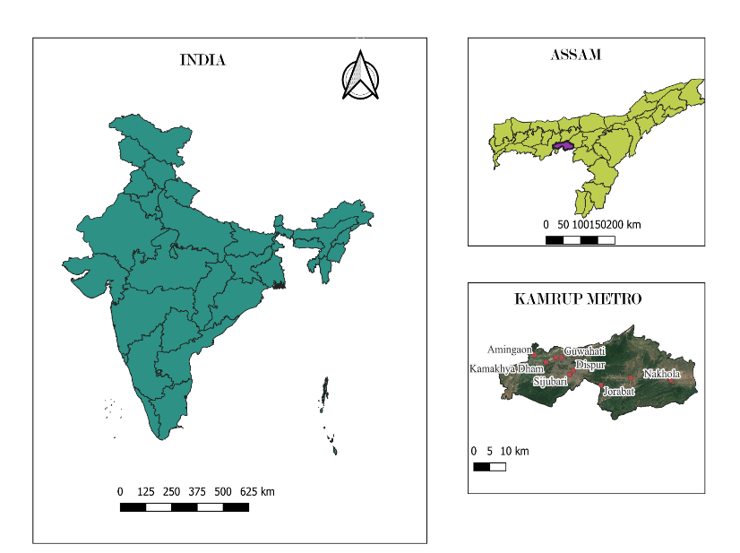

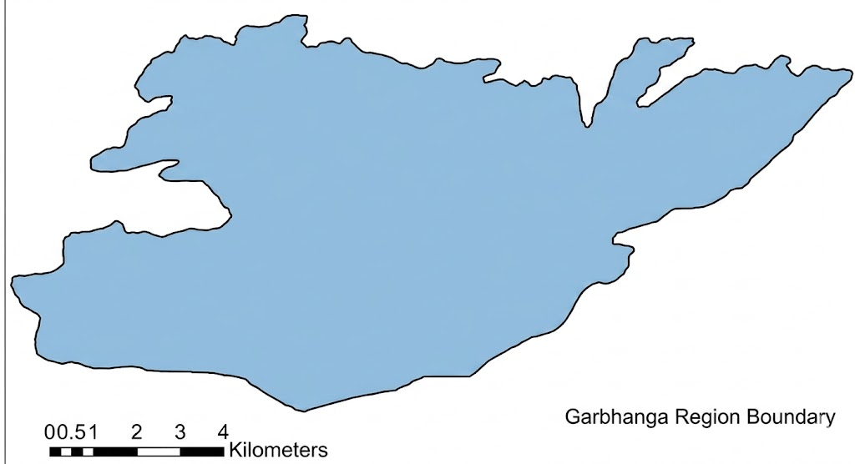

Garbhanga Reserve Forest

Fig. 1 Study area map showing Garbhanga Reserve Forest

The GRF is a tropical mixed moist deciduous forest, located on the southern bank of the river Brahmaputra. Meghalaya borders the reserve in the north and east direction, while the Deeporbeel Wildlife Sanctuary borders its northwestern side. It is located close to the Nongkhyllem Wildlife Sanctuary and they represent one of the important repositories of the rich biodiversity within the Indo-Burma biodiversity hotspot (Mahananda et al., 2023; Fig. 1). The GRFis a mosaic of core, edge, and anthropogenically disturbed habitats serving as a crucial site for addressing this regional knowledge gap regarding GSW (Champion &Seth, 1968).
The tree species commonly found in the forest are Shorea robusta, Tectona grandis, Schima wallichii, Michelia champaca, Ficus religiosa, and Tetrameles nudiflora (Mahananda et al., 2023). The reserve was once dominated by Sal (Shorea robusta), strongly preferred by GSW, as they prefer foraging on large diameter, old growth trees (Thakuri et al., 2025). However, excessive logging has replaced the forest vegetation by secondary bamboo thickets (Champion & Seth 1968). The bamboo species most commonly found within the forest isDendrocalamushamiltonii (Barua, 2008). The forest experiences four distinct seasons: pre-monsoon, monsoon, retreating monsoon, and winter. The reserve receives an annual rainfall of 3,000-4,500 mm, with temperatures ranging from 11°C to 36°C and the maximum humidity frequently reaching 80-90% (Kakati, 2002; Mahananda et al., 2023). This tropical monsoon climate supports the dense decayed wood ecosystems preferred by species like the GSW.
2.2 Sampling Design:
We spent 12 months from 18 May, 2025 to 30 April, 2026, recording the foraging, feeding and breeding data for four seasons: pre-monsoon, monsoon, retreating monsoon, and winter (Basile et al., 2020; Mahananda et al., 2023; Wynia et al., 2025). Our study utilised line transects method (Crum et al., 2021) and visual encounter surveys (Boynton et al., 2021). The study was conducted along three core transects Garbhanga-Lokhra trail, Garbhanga-Basistha trail, and Garbhanga-Satargaon trail. The Lokhra trail consisted of five distinct 5 km transects, with a total transect length of approximately 25 km (T1-T5). The Basistha trail was approximately 5 km (T6) and the Satargaon trail consisted of two distinct trails of approximately 5 km each (T7 & T8) (Fig 2). Observation and sampling were conducted mostly on the edge and disturbed regions. Due to accessibility constraints and difficult terrain, the study was restricted to only the forest peripheries and established trails, excluding the primary core regions.

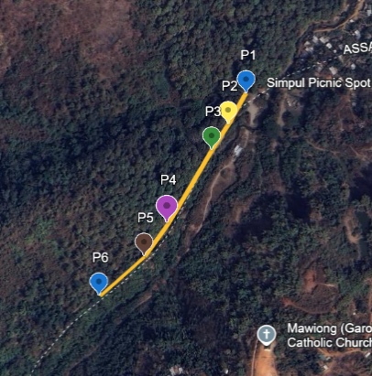
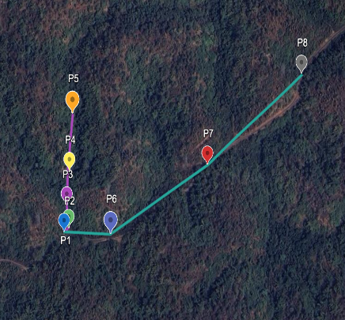
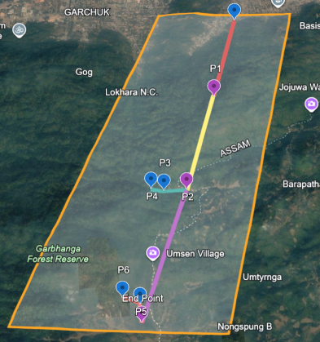
c
a
b
Fig. 2(a)Detailed view of the Lokhra core transects divided into specific sampling segments(b)Detailed view of the Basistha core transect divided into specific sampling segments(c) Detailed view of the Satargaon core transect divided into specific sampling segments

2.3 Data Collection and Documentation
Data was collected during peak avian activity hours, between 7-9 am in the morning and 3-5 pm in the evening. Upon detection of the GSW (Mulleripicus pulverulentus), localized focal observations were conducted. Temporal and spatial parameters such as exact date, month, calendar year and specific trail identity, were systematically logged. The number of individuals and microhabitat characteristics of the tree occupied were recorded. The tree species and its physical traits such as Diameter at Breast Height in cm (DBH hereafter) and estimating total tree height (m) were documented.
To assess behavioural and foraging ecology, focal animal sampling was maintained from the moment of detection. Activities such as foraging, feeding, or nest-building were log-recorded precisely using a stopwatch. To measure the impact of human encroachment, distance to the nearest anthropogenic disturbance (e.g., foot trails, forest edges) was estimated and recorded in meters. Group counts and behavioural study were done without causing stress or flush-flight behaviours in the birds. All observations were kept at a non-disruptive distance. Photographic evidence was collected using a Nikon D7500 paired with an AF-P DX NIKKOR 70-300mm f/4.5-6.3G ED VR telephoto lens and a SOLOGNAC 8x42 field binocular. All photographic documentation and field observations strictly adhered to ethical birding practices and standard eBird documentation protocols.

3. Results
3.1 Spatiotemporal Occurrence and Group Dynamics
We recorded 50 sightings of Mulleripicus pulverulentus harterti across 7 of the 10 surveyed transects. All of these sightings were recorded in GRF over 12 months (18 May, 2025 to 30 April, 2026). These records were distributed across Lokhra, Basistha, and Satargaon sectors, though they remained highly localized along the Lokhra trail (Table 1). The species is usually found across the reserve (eBird, 2021), but during our study, very few sightings were recorded across the Basistha and Satargaon sectors, indicating the impact of both habitat preferences and logistical constraints. Access to Satargaon trails was further restricted due to the presence and movement of mega herbivores (Asian Elephants), while the Basistha sector showed the highest levels of human encroachment and activity. This limited sampling consistency in these sectors rendered these habitats unsuitable during the survey period
The most encounters occurred in July 2025 and April 2026, with cumulative counts of 24 and 20 individuals, respectively. This surge in activity corresponds to the species' broader breeding and post-breeding period, i.e., March to August (Lammertink, 2004; Kaur et al., 2024). Increased vocalization and foraging intensity during this phase made the species more detectable within the forest canopies. While transect-based surveys accounted for the majority of observations, opportunistic sightings provided vital information regarding group dynamics and social behaviour.
Table 1: Sampling Effort and Site-Specific Occurrence
Trail Site | Total Survey Length (km) | Number of Transects | Sightings Recorded
Lokhra | 25 | 5 (5 km each) | 44
Basistha | 2 | 2 (1 km each) | 2
Satargaon | 6 | 3 (2 km each) | 4

The highest group size (n=5) was recorded in May, 2025. These demonstrate the prevalence of post-breeding behaviour, characterized by intact family units engaged in collective foraging. The consistently abundant social groups throughout the monsoon suggest that the Lokhra sector serves as a stable refuge for the species. This is likely due to the greater abundance of mature Shorea robusta and Tetrameles nudiflora trees in comparison to the fragmented and encroached peripheral regions of the forest.
A unique social structure indicating the complex foraging behaviour was observed in the species. In many encounters, particularly with groups of 4-5, distinct “sentry” behaviour was observed, i.e., at least one group member was at a distance of 5-20m away from the foraging members. These birds were usually slightly higher in the vegetation and often frequently uttered “whiny” sounds, acting as sentries (Short, 1973). During our study, we found that the frequency of patch sharing increased as the group size grew from two to three or four individuals. When the group size increased to five individuals, we observed that sharing a single foraging patch decreased (Lammertink, 2004). This suggests a transition towards separate foraging substrates within the same vicinity to avoid competition as the group size grew.
3.2 Foraging Ecology and Habitat Preference
During our study, thespecies showed a high preference towards mature forest stands within the reserve. Our observations showed that about 86% of foraging activities occurred on Shorea robusta (n=43), while the remaining 14% was on Tetrameles nudiflora (n=7) as illustrated in (Fig. 3). The morphometric features of selected trees had a mean DBH of 47.46 cm and a mean height of 37.06 m, which indicates that the species prefers mature and old-growth trees with larger diameters (Lammertink, 2009). This is likely due to the greater availability of concentrated invertebrate food sources, such as ant, termite, and stingless bee colonies, in such structurally mature trees (Lammertink, 2004).
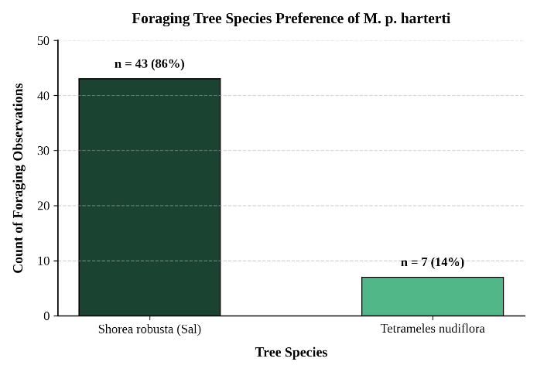
Fig. 3 Foraging tree species preference of Mulleripicus pulverulentus harterti within the study area, demonstrating a strong specialization toward mature Shorea robusta stands over Tetrameles nudiflora
3.3 Behavioural Patterns
The recorded activities of the species were based on behavioural observations. It was observed that foraging was the most frequently recorded activity (n=28) averaging 27.36 minutes per session. Feeding sessions were shorter with an average duration of 17.10 minutes per session. Nest building was the rarest behaviour of the three (n=2), averaging only 7.5 minutes (Fig. 4). This behaviour might be due to several reasons. First, the documented behaviour of nest abandonment or discontinuation of nesting activity in response to the observer-induced disturbance or human proximity (Lammertink, 2004). Second, specialized species like Mulleripicus pulverulentus prefer interior forest zones, where predation pressure and anthropogenic disturbance are minimized (Kaur et al., 2024). The access to core forest zones was hindered by difficult terrain and the presence of mega-herbivores, thereby limiting the detection of nesting activity during the study period.
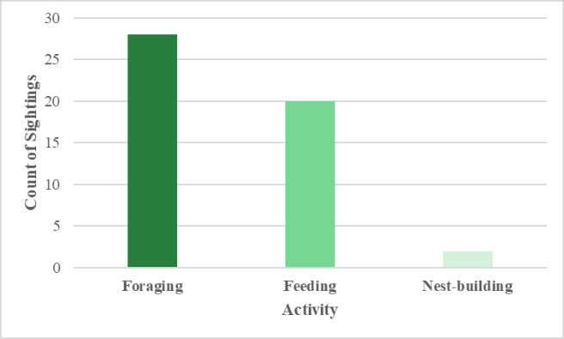
Fig.4 Frequency of observed behaviours, illustrating the dominance of foraging and feeding in the daily activity budget
3.4 Encounter Rate and Sociality Patterns
During our study, we recorded a total of 50 sightings with variable group sizes. This considerable variation in group size shows the complex social characteristics of the species (Lammertink, 2004; Kumar & Shahabuddin, 2012). The most commonly recorded group size during our study consisted of four individuals (n=19), as illustrated in (Fig5).
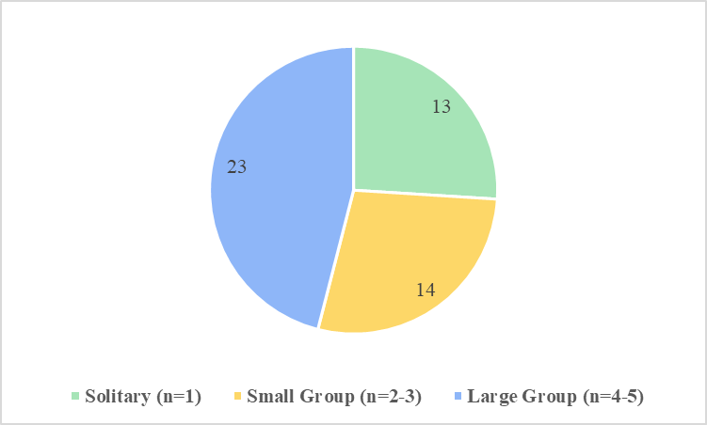
Fig. 5Social Organization and Group Size Frequency
This is consistent with documented group size of 3-6 individuals in the Great Slaty Woodpecker by Lammertink (2004). It was followed by solitary individuals (n=13). Larger groups of five individuals were recorded only in 4 instances, mostly during the post-breeding period. These patterns indicate that the species is highly social, and collective foraging and sentry behaviour are strategies likely developed to avoid predators and to efficiently utilise resources (Lammertink, 2004).
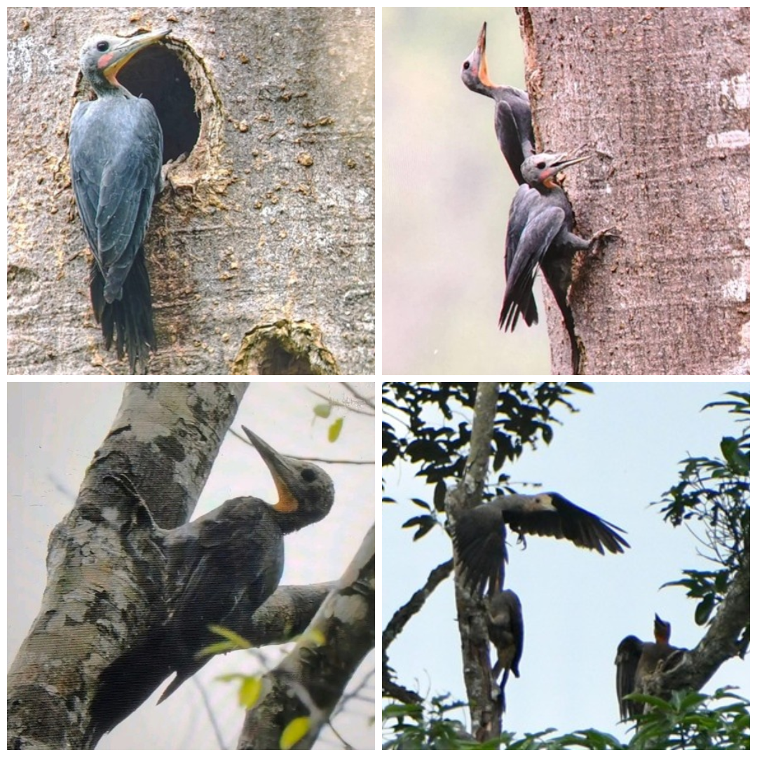
b
a
c
d
Fig.6 Multi-panel field documentation plate illustrating key behavioural facets and social dynamics of Mulleripicus pulverulentus harterti within the GRF(a) An individual inspecting a primary nesting cavity on a mature tree trunk(b) Cohesive family-group vertical forage-sharing(c) Individual demonstrating alert posture on a large-diameter branch(d) Active group coordination and canopy-landing manoeuvre within upper foliage
3.5 Tolerance to Anthropogenic Disturbance
Our findings suggest a resource-disturbance trade-off in the habitat selection behaviour of M. pulverulentus. The most number of sightings (27) were recorded within 300 m of disturbance (trails or forest edges). The mean distance from disturbance was 453.6 m and family groups were recorded at up to 1,000 m within core forest regions (Fig.6). This indicates a capacity for flexible disturbance tolerance. The consistent sightings recorded across Lokhra sector despite its closeness to human activities, suggest that resource quality, mostly the availability of structurally mature Shorea robusta, may overturn moderate disturbance avoidance. This is a common pattern displayed in other large, forest-dependent woodpecker species as well (Lammertink et al., 2009).

Fig.7 Distribution of M. p. harterti sightings across different proximity zones to human disturbance
4. Discussion
Our 12-month survey confirms that Mulleripicus pulverulentus harterti maintains a highly localized and specialized presence within the GRF. The distinct seasonal surge in sightings during July and April aligns with peak breeding and post-breeding periods, when increased vocalizations and active family-group foraging significantly raise their detectability in the canopy (Lammertink, 2004). The clear dominance of four-individual groupsin reflects classic nuclear family units (Fig. 5). Our observation that patch-sharing declines sharply in groups of five suggest an adaptive foraging strategy meant to minimize intra-familial competition. Furthermore, the distinct "sentry" behaviour observed in these larger flocks highlights a vital, complex anti-predator social mechanism necessary for the species' survival along the vulnerable forest fringes (Lammertink, 2004).
Our structural vegetation analysis highlights a strict, uncompromising reliance on old-growth forest characteristics. The high preference for mature Shorea robusta and Tetrameles nudiflora featuring substantial trunk diameters as shown in Fig. 3 highlights why the species is uniquely vulnerable to localized logging and habitat degradation (Lammertink, 2009). The high concentration of sightings within 300 meters of human-use paths in Figure 6reveals a subtle resource-disturbance trade-off. M. p. harterti appears capable of tolerating moderate peripheral human presence, provided that these large, old-growth foraging trees remain completely intact. However, this tolerance has a clear breaking point; the near-total absence of sightings along the heavily encroached Basistha trail in Table 1demonstrates that intense anthropogenic pressure and structural tree removal ultimately render the habitat entirely unsuitable (Lammertink, 2004; Kaur et. al., 2024).
As a preliminary assessment for this region, the study highlights critical conservation gaps and logistical limitations that shape our current findings. The high concentration of data along the Lokhra trail compared to the other sectors (Table 1) reflects severe habitat fragmentation in some zones (Basistha) and extreme safety constraints in the interior zones (Satargaon), particularly due to the seasonal movements of Asian Elephants. The rarity of recorded nest-building behaviour (Fig.4) is a direct consequence of this restriction, as breeding pairs likely retreat into the inaccessible, difficult to survey interior core zones to escape human proximity and minimize predation risks. This vulnerability to edge-driven disturbance was distinctly illustrated during our field surveys at the 13–14 km mark of the Lokhra trail, where breeding pairs completely abandoned an active nesting and roosting site following a sudden spike in local anthropogenic activity and foot traffic. This abandonment occurred despite the region acting as a critical habitat stronghold for the species. This demonstrates that even within areas of high resource quality close to permanent human settlements like Garbhanga village, acute breeding season disturbances can override long-term site fidelity. Consequently, while peripheral trails serve as vital day-to-day foraging corridors, future conservation and management strategies must prioritize mapping and protecting the primary core zones of the reserve to ensure these essential nesting sanctuaries are preserved.
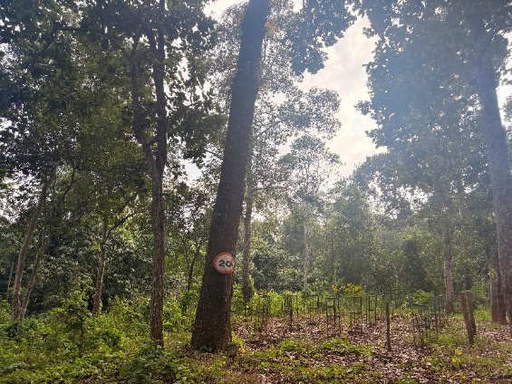
Fig.8 Structural habitat profile at the 13–14 km mark along the Lokhra trail corridor. The image illustrates a high-quality, mature Shorea robusta stand acting as a resource stronghold, while simultaneously displaying peripheral management signs and sub-canopy clearing indicative of proximity to human activity from Garbhanga village
Beyond these nesting failures, our observations reveal a clear pattern in how M. p. harterti uses forest areas near human activity. The high number of sightings along the Lokhra trail shows that birds do not automatically avoid areas near roads or footpaths. Instead, as long as large, mature Shorea robusta and Tetrameles nudiflora trees remain standing, these woodpeckers can continue foraging nearby. However, this adaptability has strict limits. While birds comfortably forage along these trail edges during routine daily movements, sudden human intrusions during sensitive periods like nest building cause them to abandon the site entirely. In short, the species tolerates low-level human presence during daily feeding, but cannot handle direct disturbance when breeding. This boundary is even clearer along the heavily degraded Basistha trail, where past logging removed the canopy trees and broke forest continuity. Without those large trees, foraging becomes inefficient, leading to the complete absence of the species from that sector. Keeping unbroken canopy corridors between the core and edge areas of Garbhanga is therefore crucial to prevent family groups from becoming isolated in small, unsuitable patches.
5. Conclusion
This year-long study provides much-needed field data on how the Great Slaty Woodpecker (Mulleripicus pulverulentus harterti) uses the Garbhanga Reserve Forest in Assam. Our results confirm that the species relies heavily on old-growth forest, spending 86% of its foraging time on large Sal (Shorea robusta) trees, alongside major softwoods like Tetrameles nudiflora (mean DBH = 47.46 cm). Although family groups regularly forage along moderately used forest edges like the Lokhra trail, sudden human activity during the breeding season causes complete nest abandonment. This proves that rich feeding grounds cannot make up for human disturbance when birds are trying to raise young ones.
Protecting this species in Garbhanga requires strict, targeted action. Forest managers must focus on mapping and strictly protecting the quiet, undisturbed core zones of the reserve where these birds nest. Along edge trails, management should focus on preventing the removal of large-diameter trees that provide essential feeding and roosting sites. Because dense terrain and elephant movements limited our access to the deep interior, future work should use passive acoustic recorders and tracking methods. These tools will help map deep-forest home ranges and daily movements without disturbing the birds, offering clearer guidance for long-term habitat protection across Northeast India.
Declaration of AI Use

This manuscript was prepared through the combined contributions of all author(s), including contributions to the study design, data, content development, results, interpretation, and related scholarly work. The author(s) acknowledge the use of Grammarly and ChatGPT to assist with grammar checking, language refinement, reference formatting. These AI-assisted tools were not used as authors and did not replace the intellectual contributions or scholarly judgment of the author(s). All AI-assisted outputs, including content, references, and interpretations, were carefully reviewed, revised, verified, and approved by the author(s). The author(s) accept full responsibility for the accuracy, integrity, and final content of the manuscript.

COMPETING INTERESTS DISCLAIMER:
Authors have declared that they have no known competing financial interests OR non-financial interests OR personal relationships that could have appeared to influence the work reported in this paper.
References:
Barua, K. K. (2008). Diversity and habitat selection of Papilionidae in a protected forest reserve in Assam, Northeast India.
BirdLife International. (2023). Mulleripicus pulverulentus. The IUCN Red List of Threatened Species 2023: e. T22681585A241500854. Retrieved from https://www.iucnredlist.org/fr/species/22681585/241500854
eBird. 2021. eBird: An online database of bird distribution and abundance [web application]. eBird, Cornell Lab of Ornithology, Ithaca, New York. Available: http://www.ebird.org. (Accessed: July28, 2026)
Kakati, D. (2002). Studies on conservation biology of Swallowtail Butterflies of Kamrup district, Assam (Doctoral dissertation, PhD Thesis. Department of Zoology, Guwahati University).
Lammertink, M. (2004). Grouping and cooperative breeding in the Great Slaty Woodpecker. The Condor, 106(2), 309-319.
Short, L. L. (1973). Habits of some Asian woodpeckers (Aves, Picidae). Bulletin of the AMNH; v. 152, article 5.
Virkkala, R. (2006). Why study woodpeckers? The significance of woodpeckers in forest ecosystems. In Annales ZoologiciFennici (pp. 82–85). Finnish Zoological and Botanical Publishing Board.
Champion, H.G. & S.K. Seth (1968). A revised survey of the forest types of India. The Manager of Publications, Delhi, India, 404 pp.
Kumar, R., & Shahabuddin, G. (2012). Assessing the status and distribution of the Great Slaty Woodpecker Mulleripicus pulverulentus (Temminck, 1826) in sub-Himalayan Uttarakhand, India. Journal of the Bombay Natural History Society, 109(1–2), 17–22. https://www.bnhsjournal.in/index.php/bnhs/article/view/156167
Crum, N.J., Neyman, L.C. and Gowan, T.A.(2021). Abundance estimation for line transect sampling. PLoS
ONE, 16(5), p.e0252231.
Kaur, S., Gopi, G. V., & Uniyal, V. P. (2024). Grouping and home-range of the Vulnerable Great Slaty Woodpecker Mulleripicus pulverulentus in the western Himalaya. Indian Birds, 19, 180-184.
Boynton, M.K., Toenies, M., Cornelius, N. and Rich, L.N., 2021. Comparing camera traps and visual encounter
surveys for monitoring small animals. California Fish and Wildlife, 107(2), pp.99–117. https://doi.org/10.51492/cfwj.107.9

Wynia, A. L., R. Rozzi, and J. E. Jiménez. 2025. The Magellanic Woodpecker’s role in its assemblage: A case study of cavity provisioning and habitat selection in the world’s southernmost forests. Avian Conservation and Ecology 20(1):3. https://doi.org/10.5751/ACE-02786-200103
Thakuri, D. C., Basnet, H., Poudyal, L. P., & Aryal, P. C. (2025). Investigating the trend of the Great Slaty Woodpecker (Mulleripicus pulverulentus) population status in western Nepal. Ecology and Evolution, 15(7), e71671. https://doi.org/10.1002/ece3.71671
Basile, M., Asbeck, T., Pacioni, C., Mikusiński, G., & Storch, I. (2019). Woodpecker cavity establishment in managed forests: Relative rather than absolute tree size matters. Wildlife Biology, 2020(1), 1-9. https://doi.org/10.2981/wlb.00564
Lammertink, M., Prawiradilaga, D. M., Setiorini, U., Naing, T. Z., Duckworth, J. W., & Menken, S. B. (2009). Global population decline of the Great Slaty Woodpecker (Mulleripicus pulverulentus). Biological Conservation, 142(1), 166-179.
Mahananda, P., Jelil, S. N., Bohra, S. C., Mahanta, N., Saikia, R. B., & Purkayastha, J. (2023). Terrestrial vertebrate and butterfly diversity of Garbhanga Landscape, Assam, India. Journal of Threatened Taxa, 15(4), 23029–23046. https://doi.org/10.11609/jott.8334.15.4.23029-23046
Sullivan, B.L., C.L. Wood, M.J. Iliff, R.E. Bonney, D. Fink, and S. Kelling. 2009. eBird: a citizen-based bird observation network in the biological sciences. Biological Conservation 142: 2282-2292
Thapa, M. K., Dutta, S., Das, H. J., Pradhan, T. K., Mahanta, D., Tossa, S., Sharma, K. (2024). Avifaunal diversity and status in and around Ranga Reserve Forest, Lakhimpur, Assam, India. Munis Entomology & Zoology, 19(2), 543–555.

