Original Research Article

A Study of Butterfly Diversity in and around Bongaigaon Tea Estate, Bongaigaon, Assam, India
____________________________________________________________________________
Abstract
Butterflies are one of the important and fascinating groups of organisms under the order lepidoptera. They are known to be very good bio-indicators as well. As there was no previous study regarding our study area, our aim was to record the butterfly species found in and around the Bongaigaon Tea Estate, Bongaigaon, Assam which is one of the rapidly developing cities of Assam. For this study line transects and visual encounter surveys were employed for gathering quantitative data and photographic evidences were collected using iPhone 16 and Canon 3000D paired with 300mm zoom lens. Our study resulted in recording 42 butterfly species belonging to six families among which most of the individuals were recorded from the Nymphalidae family. The individuals that were most commonly observed were Lemon Pansy (Junonia lemonias), Common Mormon (Papilio polytes), Common Evening Brown (Melanitis leda) and Great Eggfly (Hypolimnas bolina). Even though all the observed species are commonly found but it was a fascinating fact that a tea estate could harbor the mentioned number of species. This study is preliminary for this area and will help to provide baseline information. Also, it is important to note that prominent habitat fragmentation and loss was observed around our study area, which requires immediate attention to conserve the current biodiversity.
Keywords: Butterflies . bio-indicators . habitat loss . tea estate . urban ecology

- INTRODUCTION
The order Lepidoptera, containing butterflies and moths, stands among the most taxonomically and ecologically prominent components of terrestrial biodiversity. With approx. 160,000–174,250 described species distributed across 126 families and 46 super families, the order constitutes 10% of all known species of living organisms and occurs on every continent except Antarctica (Adams et al., 2016; Perveen & Khan, 2024). Lepidoptera is the second largest insect order after Coleoptera and its evolutionary radiation has been closely intertwined with angiosperm diversification and long standing plant-herbivore co-evolutionary dynamics (Adams et al., 2016; Narango et al., 2020). Also the members of this order have become one of the most widely used as bio-indicators of environmental quality across both natural and human-modified landscapes as they are very sensitive to changes in surroundings (Ray et al., 2025).
Throughout their global distribution, Lepidoptera is responsible for a broad suite of ecological functions. Butterflies are important pollinators of nature that help many flowering plants, while their predominantly herbivorous larvae helps in transfer of energy from plants to higher trophic levels than all other insect herbivores combined, anchoring the structure of terrestrial food webs in temperate and tropical regions (Bazinet et al., 2013; Adams et al., 2016; Narango et al., 2020). Apart from herbivory and pollination, Lepidoptera constitute a major prey base for insectivorous birds, bats, reptiles, amphibians and predatory arthropods and also helps in nutrient cycling through frass mediated transfer of carbon and nitrogen from canopy to soil (Kagata & Ohgushi, 2012; Habel et al., 2019; Narango et al., 2020). Moreover, the order's sensitivity to microclimate, vegetation structure and a range of anthropogenic factors has been formally documented, supporting its long established role in biodiversity monitoring programmes (Kremen, 1992; Rocha et al., 2010; Chowdhury et al., 2023; Bhawnani et al., 2025). These functions are intimately conditioned by specialized larval–host plant relationships, as conservation of particular plant genera helps to maintain local Lepidopteran richness (Futuyma, 1976; Altermatt & Pearse, 2011; Narango et al., 2020).
The ecological importance of Lepidoptera has pointed to their well-documented global declines, a matter of considerable scientific and societal concern. Long-term bio-monitoring in protected areas has revealed reductions over 75% in total flying insect biomass over 27 years. Also, it was noted that there is 50% decline in European grassland butterfly population between 1990 and 2011 (Hallmann et al., 2017). The primary factors for these losses are found to be habitat loss, habitat fragmentation, agricultural intensification, use of pesticide, climate change, introduction of invasive species and atmospheric nitrification. These factors do not act in separately but interact across spatial scales to erode ecosystem resilience (Wagner, 2020). The resulting effects threatens ecosystem by hampering pollination services, food-web stability and the maintenance of vertebrate insectivore populations and has emerged as a defining dimension of the anthropocene biodiversity crisis (Habel et al., 2019; Narango et al., 2020; Wagner, 2020).
India is recognized as a diversity rich nation, hosting 1,501 butterfly species and over 13,199 Lepidoptera in total. But the country's northeastern region functions as a particularly species rich reservoir by contributing about about two-third species i.e. 962 species (Bhuyan et al., 2005; Sidhu, 2023; Singh et al., 2025). Although, the eight northeastern states occupy only about 8% of India's land area but they collectively support about 32.92% of the country's documented Lepidoptera which justifies the inclusion of the region within the Indo-Burma Biodiversity Hotspot, where Palaearctic and Oriental bio-geographic elements converge (Soibam et al., 2016; Gogoi et al., 2023; Malsawmtluanga et al., 2025;). Situated on the north bank of the Brahmaputra, our state of Assam, justifies this richness. Studies from eastern Assam have recorded up to 237 butterfly species within which 33 are protected under the Indian Wildlife Act, 1972. Also, individual protected areas such as Dehing Patkai National Park and Borajan Bherjan Podumani Wildlife Sanctuary host diverse populations of 92 and 89 species, respectively (Bhuyan et al., 2005; Singh, 2017; Gogoi et al., 2023; Das, 2026). Despite this growing numbers, considerable gaps in taxonomic and ecological knowledge persist and locality specific baseline data remain scarce for many places in Assam.
In the Bongaigaon district of Assam, which is famous for the endangered and endemic Golden Langur (Trachypithecus geei) and its mosaic of moist deciduous forest, wetlands and riverine habitat? A preliminary checklist of 46 butterfly species including five families has recently been compiled encompassing three main forest regions of this district, with Nymphalidae (19 species) being the dominant family, followed by Lycaenidae, Papilionidae, Pieridae, and Hesperiidae (Ray et al., 2025). However district level data cannot capture the butterfly assemblages within a given tea estate and as for Bongaigaon Tea Estate, no earlier study was done and our study would be the first one to record butterfly species found in and around Bongaigaon Tea Estate. Therefore, our objectives are to (a) prepare a checklist of butterflies occurring in and around the tea estate (b) assess family level dominance (c) provide site specific baseline data for long term monitoring. Our findings are expected to enhance regional biodiversity databases and also support landscape level conservation planning.
- MATERIALS AND METHODS
2.1 STUDY AREA
Bongaigaon city is situated within the Aie Valley of Brahmaputra river basin (Ray et al., 2025) and North Eastern Himalayan sub region of India (Government of Assam, 2026). Our study area (Figure 1) comprises of the Bongaigaon Tea Estate and its surrounding locality having an area of 1.55 km² (approx). Coordinates of our study location are 26°28'37.3"N 90°34'07.8"E . Our study area experiences a humid subtropical climate followed by heavy monsoon and hot summers. By an estimate, it experiences a minimum temperature of 13ºC and maximum temperature of 32ºC along with an average annual rainfall of 2500-3500 mm (Government of Assam, 2026). The rainfall peaks from June to September. On to the west of our study location lays the Bongaigaon Police Station, in the south direction there is the Bageswari Hill Temple and on the north side there lays the Bongaigaon crematorium. Some of the prominent flora that supports the butterfly assemblages observed in this location includes Gulmohar (Delonix regia), Hill glory bower (Clerodendrum infortunatum), Jamun tree (Syzygium cumini), Pinwheel flower (Tabernaemontana divaricata) and many more (Figure 2).

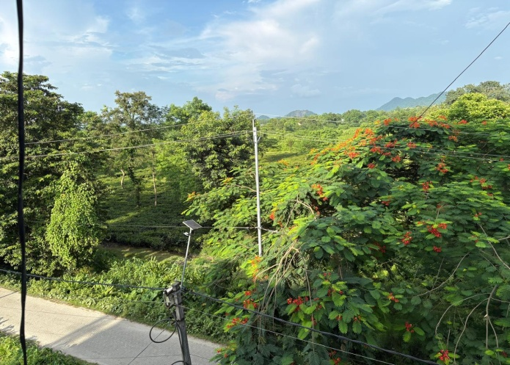
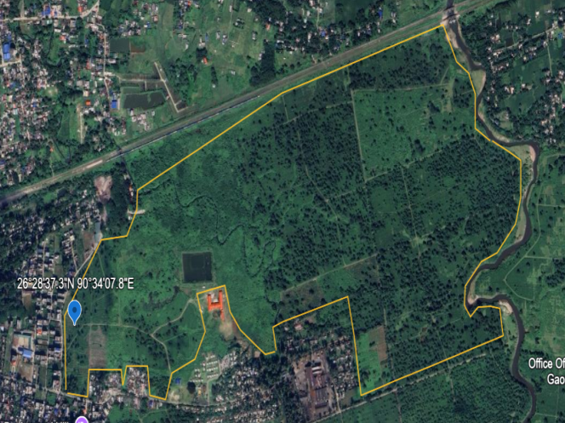
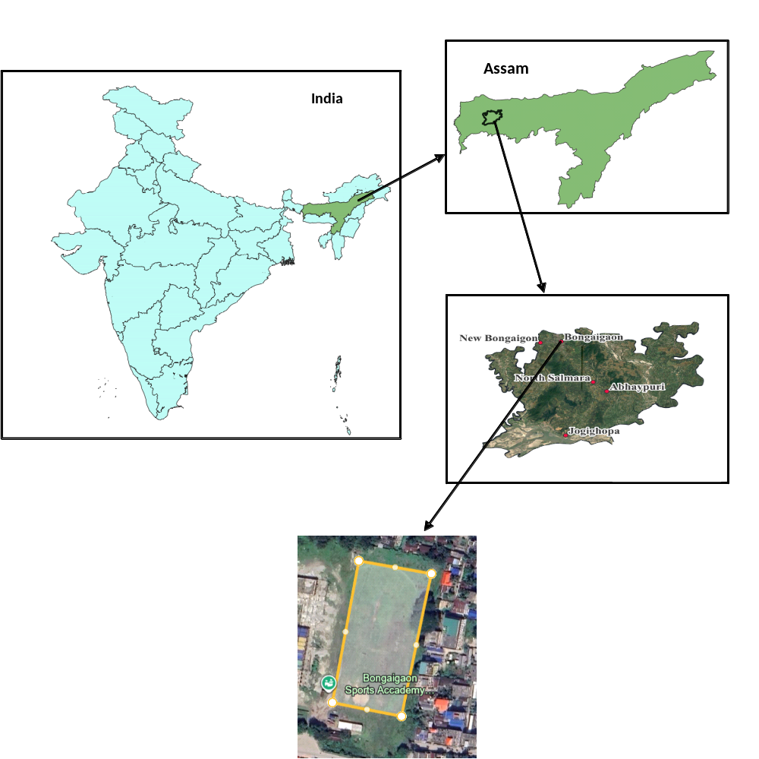

Figure 1. Map showing in and around of the Bongaigaon Tea Estate

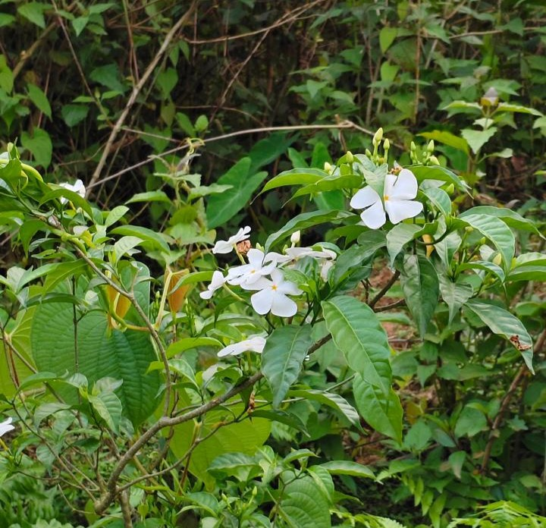
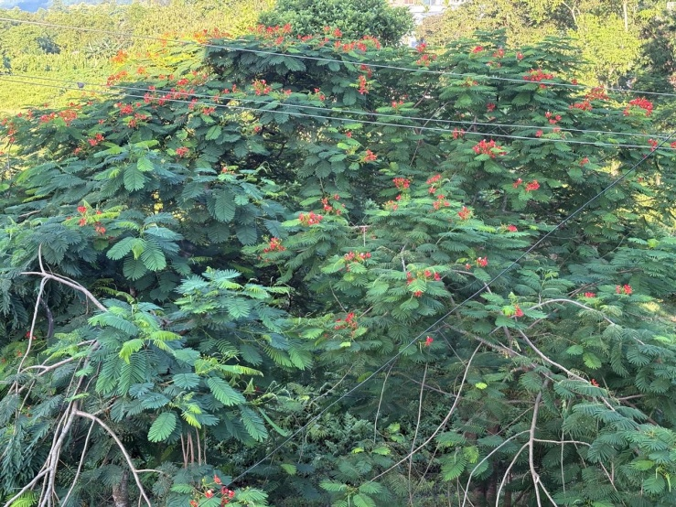
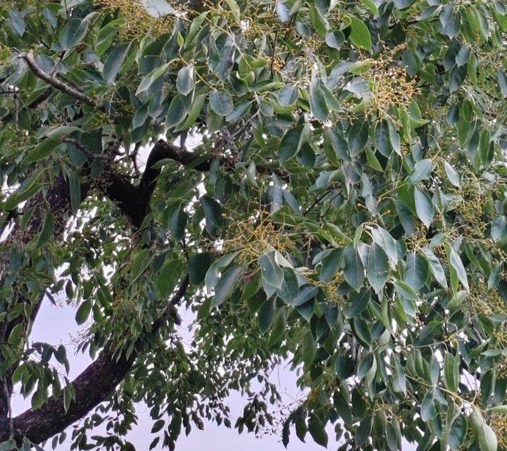
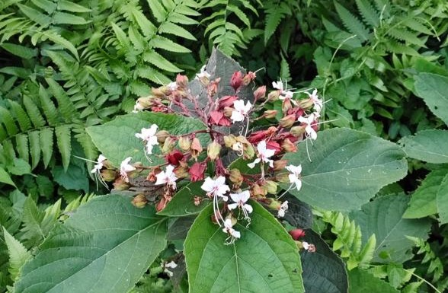
(a) (b)
(c) (d)
Figure 2. Some of the prominent flora observed in and around Bongaigaon Tea Estate (a) Gulmohar (Delonix regia) (b) Pinwheel flower (Tabernaemontana divaricata) (c) Hill glory bower (Clerodendrum infortunatum) (d) Jamun tree (Syzygium cumini)

2.2 METHOD OF THE STUDY
Our study was conducted to record the butterflies present in and around Bongaigaon Tea Estate. We used the Line Transect method (Crum et al., 2021) and Visual Encounter Surveys (Boynton et al., 2021) to accomplish our aims and gather quantitative data.

2.3 STUDY DESIGN
We spent twelve months recording the butterflies in this area from August 2025- July 2026. Data was recorded everyday in the early morning when butterflies are the most active with Saturdays and Sundays off. A total of three hours of survey was targeted each day.
2.4 DATA COLLECTION AND IDENTIFICATION
Data collection was carried out systematically noting the species. Photographic evidence was captured using an iPhone 16 and Canon 3000D paired with 300mm zoom lens. Observed butterflies were categorized using family and identified with the help of field guide (Neog, 2026) and published articles. Also, in some instances personal knowledge was also applied.
- 3. RESULTS AND DISCUSSION
3.1 Species richness and family-wise composition

Our study ended up recording 42 butterfly species belonging to six families of the order Lepidoptera (Table 1). The families are Nymphalidae, Lycaenidae, Papilionidae, Pieridae, Riodinidae and Hesperiidae. Majority of the individuals were recorded for the family Nymphalidae i.e 18. The count pattern goes like Nymphalidae>Lycaenidae>Papilionidae>Pieridae>Hesperiidae>Riodinidae (Figure 3). Interestingly, majority of the individuals that were most commonly observed were Lemon Pansy (Junonia lemonias), Common Mormon (Papilio polytes), Common Evening Brown (Melanitis leda) and Great Eggfly (Hypolimnas bolina). All of the recorded species are under common category and no species of conservation concern was recorded. However, the potential of our study area to harbor 42 species, even though they are common, is itself fascinating and efforts should be made to maintain or even more the same in future.
The finding of 42 species across six families indicates that the tea estate and adjacent habitats support a measurable but preliminary butterfly assemblage within a human-modified landscape. Similar use of modified or urban-associated landscapes by butterfly communities has been reported from organic tea estates and urban landscapes in northeastern India, where the availability of nectar plants, larval host plants and semi-natural vegetation influenced observed richness (Pradhan & Khaling, 2020; Bohra & Purkayastha, 2021; Dutta et al., 2025). Therefore, the present checklist should be interpreted as baseline evidence of local species occurrence rather than as a complete estimate of regional butterfly diversity.
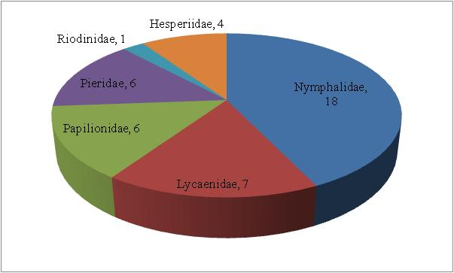

Figure 3. Pie chart showing number of species recorded for each family.
Table 1. Annotated list of observed butterflies
Family | Common Name | Scientific name
Papilionidae | - Common Mormon | Papilio polytes
Papilionidae | - Golden Birdwing | Troides aeacus
Papilionidae | - Common Mime | Papilio clytia
Papilionidae | - Paris Peacock | Papilio paris
Papilionidae | - Common Lime Butterfly | Papilio demoleus
Papilionidae | - Common Birdwing | Troides helena
Pieridae | - Common Emigrant | Catopsilia pomona
Pieridae | - Mottled Emigrant | Catopsilia pyranthe
Pieridae | - Common Grass Yellow | Eurema hecabe
Pieridae | - Three Spot Grass Yellow | Eurema blanda
Pieridae | - Psyche | Leptosia nina
Pieridae | - Indian Cabbage White | Pieris canidia
Lycaenidae | - Dark Grass Blue | Zizeeria karsandra
Lycaenidae | - Pale Grass Blue | Pseudozizeeria maha
Lycaenidae | - Lesser Grass Blue | Zizina otis
Lycaenidae | - Common Pierrot | Castalius rosimon
Lycaenidae | - Slate Flash | Rapala manea
Lycaenidae | - Copper Flash | Rapala pheretima
Lycaenidae | - Common Climate Blue | Anthene definita
Riodinidae | - Punchinello | Zemeros flegyas
Nymphalidae | - Tawny Coster | Acraea terpsicore
Nymphalidae | - Common Five-ring | Ypthima baldus
Nymphalidae | - Peacock Pansy | Junonia almana
Nymphalidae | - Grey Pansy | Junonia atlites
Nymphalidae | - Yellow Pansy | Junonia hierta
Nymphalidae | - Chocolate Pansy | Junonia iphita
Nymphalidae | - Common Evening Brown | Melanitis leda
Nymphalidae | - Dark Evening Brown | Melanitis phedima
Nymphalidae | - Duffer | Discophora sp.
Nymphalidae | - Knight | Lebadea martha
Nymphalidae | - Commander | Moduza procris
Nymphalidae | - Common Sergeant | Athyma perius
Nymphalidae | - Common Sailer | Neptis hylas
Nymphalidae | - Lemon pansy | Junonia lemonias
Nymphalidae | - Great Eggfly | Hypolimnas bolina
Nymphalidae | - Striped Blue crow | Euploea mulciber
Nymphalidae | - Colour Sergeant | Athyma nefte
Nymphalidae | - Bushbrowns | Mycalesis sp.
Hesperiidae | - Fulvous Pied Flat | Pseudocoladenia dan
Hesperiidae | - Paintbrush swift | Baoris farri
Hesperiidae | - Common Bush Hopper | Ampittia dioscorides
Hesperiidae | - Common Red-eye | Matapa aria

The Indo-Burma biodiversity hotspot is well known to sustain numerous fascinating life forms and play a major role in contributing to diversity and our study area in Bongaigaon also falls under this same hotspot and characterizes the same theory with the results of our study. Our study was preliminary for this particular location but the results were fascinating. Our study resulted in recording 42 species of butterflies within our study year. However, we did not record any endemic or conservationally critical species but the diversity was good as far as a tea estate is concerned. The family that contributed majorly to the diversity of this location is the Nymphalidae family. 18 individuals were recorded for Nymphalidae family followed by Lycaenidae>Papilionidae>Pieridae>Hesperiidae>Riodinidae.
3.2 Regional comparison and dominance of Nymphalidae
This trend of results is similar to many other studies from different regions of Assam like Thapa et al., (2025) also reported in the study regarding diversity and distribution of butterflies in Rani-Garbhanga Reserve Forest that the Nymphalidae family dominance is prevalent there also. In another study regarding butterfly diversity of Dehing-Patkai National Park, Gogoi et al. (2023) reported the same thing. There are various studies from different parts of Assam done by Joshi & Dhyani (2014); Konwar & Bortamuly (2021) and many more; as well as, outside of Assam as like by Lodh & Agarwala (2016); Pradhan & Khaling (2020) that reported the similar family dominance. This trend is also prevalent in studies from other parts of the world too. The study regarding lepidopteran diversity carried out by Ray et al. (2025) concerning three forest areas of Bongaigaon district resulted in recording 46 butterfly species with Nymphalidae family being the most dominant similar to our results. But the fact that our single study area could alone harbor 42 species is fascinating. However, as reported by Pradhan & Khaling (2020), it is evident that tea estates have potential to retain large biodiversity.
The dominance of Nymphalidae in the present assemblage is consistent with regional studies from Assam and eastern Himalayan tea landscapes, where Nymphalidae frequently represents the largest proportion of recorded butterfly species (Gogoi et al., 2023; Pradhan & Khaling, 2020; Dutta et al., 2025). This pattern may be related to the wide habitat breadth and diverse larval host-plant associations of many nymphalid species, although the present study did not quantify host-plant use or seasonal abundance. Hence, family-level dominance should be treated as a descriptive community pattern and not as evidence of habitat preference without further ecological sampling.
3.3 Habitat condition and conservation implications
Also, our study area is an organic tea estate and lies in the corner of the city where disturbance is low to medium with less built-up area which is very important for retention of diversity (Bisht & Arya, 2024). It also contains diverse flora which provides important micro-habitats for butterflies. These factors altogether have significantly influenced our results. As butterflies are bio-indicators of environmental stress (Ray et al., 2025), our results point towards the fact that environmental quality in and around our study area is comparatively good. Our results also indicate that even if there is rapid urbanization going on everywhere, our study is still very lowly affected which is a good thing but to our concern it will not be so in the upcoming years as patches of the tea estate are being sold out slowly, which in turn reduces the availability of habitats and divides the habitats which are proven factors for loss of diversity (Wagner, 2020). If this persists the current diversity will be lost in the future and this concern needs immediate attention.
The association of butterflies with heterogeneous vegetation and less-disturbed habitat patches is consistent with broader evidence that habitat complexity, forest fragments, and managed green spaces can retain butterfly assemblages in human-modified landscapes (Koh & Sodhi, 2004; Hamer et al., 1997; Tscharntke et al., 2005). At the same time, butterflies should be used as environmental indicators with caution because indicator value can vary among species, spatial scales and disturbance types (Thomas, 2005; Fleishman & Murphy, 2009; Bonebrake et al., 2010). For Bongaigaon Tea Estate, retention of nectar resources, larval host plants, shaded edges and small uncultivated patches would be a practical basis for future monitoring and conservation-oriented management.
- CONCLUSION
Butterflies are those aspects of the environment which are both intriguing and important. They are intriguing due to their eye catchy color, shapes and sizes; and important because they act as excellent bio-indicators of environmental quality as they are very sensitive to changes. Our aim for this study was to record the butterfly species found in and around the Bongaigaon Tea Estate, which is an excellent habitat for butterflies to thrive due to its open environment and less disturbances compared to other parts of the city. Our study ended up recording 42 species of butterfly belonging to six families with individuals from Nymphalidae family being the most abundant. All of the species that were recorded were common species but it was interesting for the fact that our study area was alone capable of harboring 42 species. This point towards the fact that the environmental quality in and around our study area is good. Also, this data is preliminary for this area and will provide baseline information. But, the problems of habitat fragmentation and loss were observed which requires immediate attention.

Declaration of AI Use

This manuscript was prepared through the combined contributions of all author(s), including contributions to the study design, data, content development, results, interpretation, and related scholarly work. The author(s) acknowledge the use of Grammarly and ChatGPT to assist with grammar checking, language refinement, reference formatting. These AI-assisted tools were not used as authors and did not replace the intellectual contributions or scholarly judgment of the author(s). All AI-assisted outputs, including content, references, and interpretations, were carefully reviewed, revised, verified, and approved by the author(s). The author(s) accept full responsibility for the accuracy, integrity, and final content of the manuscript.

COMPETING INTERESTS DISCLAIMER:
Authors have declared that they have no known competing financial interests OR non-financial interests OR personal relationships that could have appeared to influence the work reported in this paper.

REFERENCES
Adams, M. O., Seifert, C. L., Lehner, L., Truxa, C., Wanek, W., & Fiedler, K. (2016). Stable isotope signatures reflect dietary diversity in European forest moths. Frontiers in Zoology, 13(1), 37. https://doi.org/10.1186/s12983-016-0170-0
Altermatt, F., & Pearse, I. S. (2011). Similarity and specialization of the larval versus adult diet of European butterflies and moths. The American Naturalist, 178(3), 372-382.
Bazinet, A. L., Cummings, M. P., Mitter, K. T., & Mitter, C. W. (2013). Can RNA-Seq resolve the rapid radiation of advanced moths and butterflies (Hexapoda: Lepidoptera: Apoditrysia)? An exploratory study. PloS one, 8(12), e82615. https://doi.org/10.1371/journal.pone.0082615

Bhawnani, J., Mahur, M., & Sankhla, V. (2025). ECOLOGICAL IMPORTANCE AND FACTORS INFLUENCING DIVERSITY DISTRIBUTION AND ABUNDANCE PATTERN OF LEPIDOPTERA (BUTTERFLIES) AT THE GLOBAL LEVEL: A REVIEW. Annals of Entomology, 43(2), 81. 10.59467/AE.2025.43.81
Bhuyan, M. (2005). Butterflies of the regional research laboratory campus, Jorhat, Assam. Zoos' Print Journal.
Bisht, S., & Arya, M. K. (2024). Lepidopteran diversity and seasonal variations in a mountainous scrubland ecosystem of Kumaun Himalaya, India. Journal of Animal Diversity, 6(4), 38- 50.
Boynton, M. K., Toenies, M., Cornelius, N., & Rich, L. N. (2021). Comparing camera traps and visual encounter surveys for monitoring small animals. California Fish and
Wildlife, 107(2), 99–117.
Chowdhury S, Dubey VK, Choudhury S, Das A, Jeengar D, Sujatha B, Kumar A, Kumar N, Semwal A and Kumar V (2023) Insects as bioindicator: A hidden gem for environmental monitoring. Front. Environ. Sci. 11:1146052. https://doi.org/10.3389/fenvs.2023.1146052
Crum, N. J., Neyman, L. C., & Gowan, T. A. (2021). Abundance estimation for line transect sampling: A comparison of distance sampling and spatial capture-recapture models. PLoS ONE, 16(5), e0252231. https://doi.org/10.1371/journal.pone.0252231
Da Rocha, J. R. M., De Almeida, J. R., Lins, G. A., & Durval, A. (2010). Insects as indicators of environmental changing and pollution: a review of appropriate species and their monitoring. Holos environment, 10(2), 250-262. https://doi.org/10.14295/holos.v10i2.2996
Das, N. (2026). Patterns of Diversity, Abundance and Species Richness of Butterfly Fauna in Borajan-Bherjan-Podumani Wildlife Sanctuary, Assam. In Himalayan Journal of Basic & Applied Sciences (Vol. 2, Issue 1, pp. 1–14). Orchid Society of Assam. https://doi.org/10.5281/zenodo.19939948
David L. Wagner. (2020). Insect Declines in the Anthropocene. Annual Review of Entomology 65:457-480. https://doi.org/10.1146/annurev-ento-011019-025151
Futuyma, D. J. (1976). Food plant specialization and environmental predictability in Lepidoptera. The American Naturalist, 110(972), 285-292.
Gogoi, R., Chetry, A., & Bhuyan, A. (2023). Diversity and species richness of butterfly in soraipung range of Dehing Patkai National Park, Assam, India. The Journal of Basic and Applied Zoology, 84(1), 6. https://doi.org/10.1186/s41936-023-00327-9
Habel, J. C., Trusch, R., Schmitt, T., Ochse, M., & Ulrich, W. (2019). Long-term large-scale decline in relative abundances of butterfly and burnet moth species across south-western Germany. Scientific reports, 9(1), 14921. https://doi.org/10.1038/s41598-019-51424-1
Hallmann CA, Sorg M, Jongejans E, Siepel H, Hofland N, Schwan H, et al. (2017) More than 75 percent decline over 27 years in total flying insect biomass in protected areas. PLoS ONE 12(10): e0185809. https://doi.org/10.1371/journal.pone.0185809
Joshi, B. K., & Dhyani, S. (2014). Butterflies diversity, distribution and threats in dibru- saikhowa biosphere reserve Assam North-East India: A review. World Journal of Zoology 9, 240–259.
Kagata, H., & Ohgushi, T. (2012). Carbon to nitrogen excretion ratio in lepidopteran larvae: relative importance of ecological stoichiometry and metabolic scaling. Oikos, 121(11), 1869-1877. https://doi.org/10.1111/j.1600-0706.2012.20274.x
Konwar, A., & Bortamuly, M. (2021). Observation on butterflies of non-protected area of Titabar, Assam India. Journal of Threatened Taxa 13(5), 18364–18377.
Kremen, C. (1992). Assessing the indicator properties of species assemblages for natural areas monitoring. Ecological applications, 2(2), 203-217. https://doi.org/10.2307/1941776
Lodh, R., & Agarwala, B. K. (2016). Rapid assessment of diversity and conservation of butterflies in Rowa Wildlife Sanctuary: An Indo-Burmese hotspot Tripura, North-East. India. Tropical Ecology 57, 231–242.
Malsawmtluanga, H., Chitra, N., Soundararajan, R. P., Santosh, G. P., Kumaraperumal, R., Balasubramani, V., & Dilipsundar, N. (2025). A review on lepidopteran studies in Mizoram: Overview, present status, hurdles and prospects, along with a compiled checklist of moths. https://doi.org/10.14719/pst.8997
Narango, D. L., Tallamy, D. W., & Shropshire, K. J. (2020). Few keystone plant genera support the majority of Lepidoptera species. Nature communications, 11(1), 5751. https://doi.org/10.1038/s41467-020-19565-4
Neog, S. (2026). Butterflies of Gibbon Wildlife Sanctuary (2nd ed.).
Perveen, F. K., & Khan, A. (2024). Introductory Chapter: Lepidoptera Biodiversity and Conservation in. Biodiversity and Ecology of Lepidoptera-Insights and Advances: Insights and Advances, 3.
Pradhan, A., & Khaling, S. (2020). Butterfly diversity in an organic tea estate of Darjeeling Hills, eastern Himalaya, India. Journal of Threatened Taxa, 12(11), 16521-16530. 10.11609/jott.5716.12.11.16521-16530
Ray, M. K., Dutta, A. V., Sarmah, A. A., & Deka, H. (2025). A preliminary Checklist of Butterfly Fauna from Bongaigaon District of Assam, India. UTTAR PRADESH JOURNAL OF ZOOLOGY, 46(11), 305-312. https://doi.org/10.56557/upjoz/2025/v46i115031
Sidhu, A. K. (2023). Lepidoptera of India: A review. Journal of Entomology and Zoology Studies, 11(2), 105-114. https://www.doi.org/10.22271/j.ento.2023.v11.i2b.9162
Singh, A. P. (2017). Butterflies of eastern Assam, India. Journal of Threatened Taxa, 9(7), 10396-10420. 10.11609/jot.3177.9.7.10396–10420
Singh, N., Sidhu, A. K., Pathania, P. C., Kalawate, A., Palot, J., Talukdar, A., Lenka, R., & Joshi, R. (2025). Checklist of Fauna of India: Arthropoda: Insecta: Lepidoptera (Version 2.0). Zoological Survey of India. https://doi.org/10.26515/Fauna/2/2025/Arthropoda:Insecta:Lepidoptera
Soibam, B. S., Huidrom, H., & Irungbam, J. S. (2016). A CENTURY LATER: TRICOLORED PIED FLAT COLADENIA INDRANI UPOSATHRA FRUHSTORFER, 1911 (HESPERIIDAE: PYRGINAE) AND CRENULATE OAKBLUE APPORASA ATKINSONI HEWITSON, 1869 (LYCAENIDAE: THECLINAE) REPORTED FROM MANIPUR, INDIA. Journal of threatened taxa, 8(7), 9030. https://doi.org/10.11609/jott.2732.8.7.9030-9033
Thapa, M. K., Saikia, M. K., & Saikia, P. K. (2025). Diversity and distribution of butterflies (Lepidoptera: Rhopalocera) in Rani-Garbhanga Reserve Forest of Kamrup, Assam, India. Asian Journal of Conservation Biology, 14(2), 183-194.
Government of Assam. (2026, July 4). District profile. Bongaigaon District. https://bongaigaon.assam.gov.in/about-us/district-profile

Bohra, S. C., & Purkayastha, J. (2021). An insight into the butterfly (Lepidoptera) diversity of an urban landscape: Guwahati, Assam, India. Journal of Threatened Taxa, 13(2), 17741-17752. https://doi.org/10.11609/jott.6122.13.2.17741-17752
Bonebrake, T. C., Ponisio, L. C., Boggs, C. L., & Ehrlich, P. R. (2010). More than just indicators: A review of tropical butterfly ecology and conservation. Biological Conservation, 143(8), 1831-1841. https://doi.org/10.1016/j.biocon.2010.04.044
Dutta, U., Dey, S., & Moran, D. (2025). A study on the diversity of butterflies in selected landscapes of the Indian Institute of Technology, Guwahati campus, Assam, India. Journal of Threatened Taxa, 17(2), 26515-26529. https://doi.org/10.11609/jott.8254.17.2.26515-26529
Fleishman, E., & Murphy, D. D. (2009). A realistic assessment of the indicator potential of butterflies and other charismatic taxonomic groups. Conservation Biology, 23(5), 1109-1116. https://doi.org/10.1111/j.1523-1739.2009.01246.x
Hamer, K. C., Hill, J. K., Lace, L. A., & Langan, A. M. (1997). Ecological and biogeographical effects of forest disturbance on tropical butterflies of Sumba, Indonesia. Journal of Biogeography, 24(1), 67-75. https://doi.org/10.1111/j.1365-2699.1997.tb00051.x
Koh, L. P., & Sodhi, N. S. (2004). Importance of reserves, fragments, and parks for butterfly conservation in a tropical urban landscape. Ecological Applications, 14(6), 1695-1708. https://doi.org/10.1890/03-5269
Thomas, J. A. (2005). Monitoring change in the abundance and distribution of insects using butterflies and other indicator groups. Philosophical Transactions of the Royal Society B: Biological Sciences, 360(1454), 339-357. https://doi.org/10.1098/rstb.2004.1585
Tscharntke, T., Klein, A. M., Kruess, A., Steffan-Dewenter, I., & Thies, C. (2005). Landscape perspectives on agricultural intensification and biodiversity-ecosystem service management. Ecology Letters, 8(8), 857-874. https://doi.org/10.1111/j.1461-0248.2005.00782.x

PIC 1. Photographic evidence of recorded species (Family wise)
Family: Papilionidae
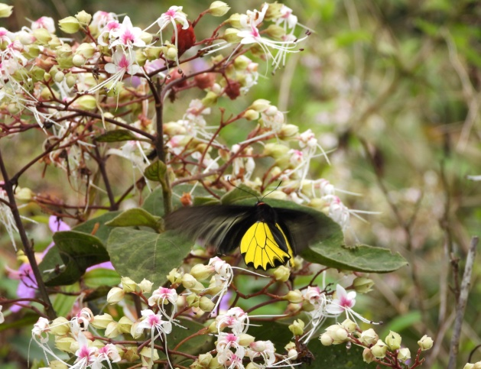
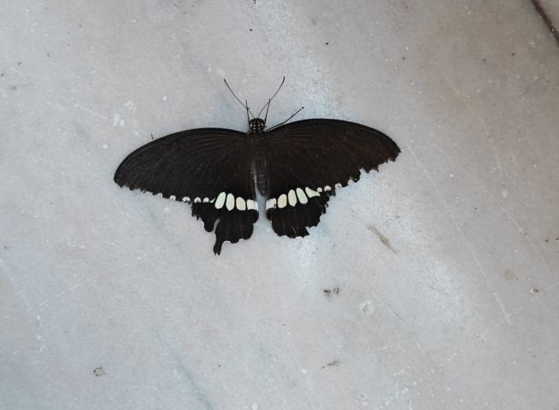

Common Mormon Golden Birdwing

Family: Pieridae
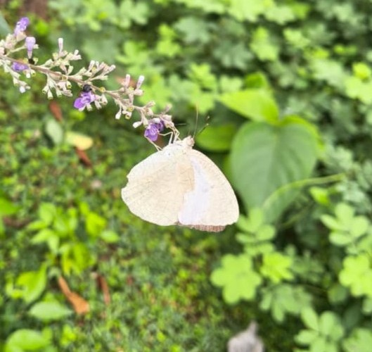
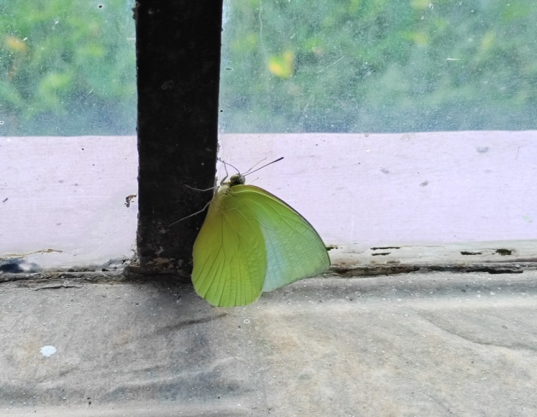

Common Emigrant Mottled Emigrant

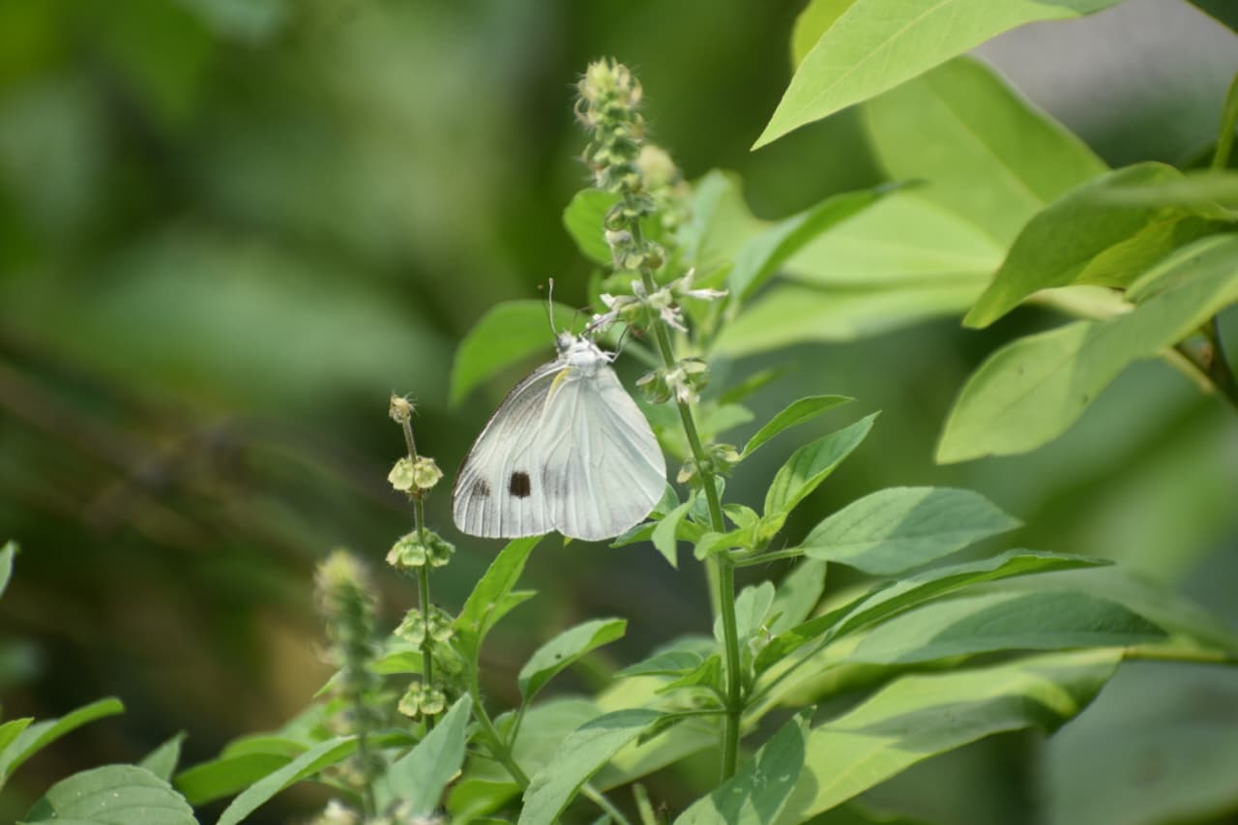
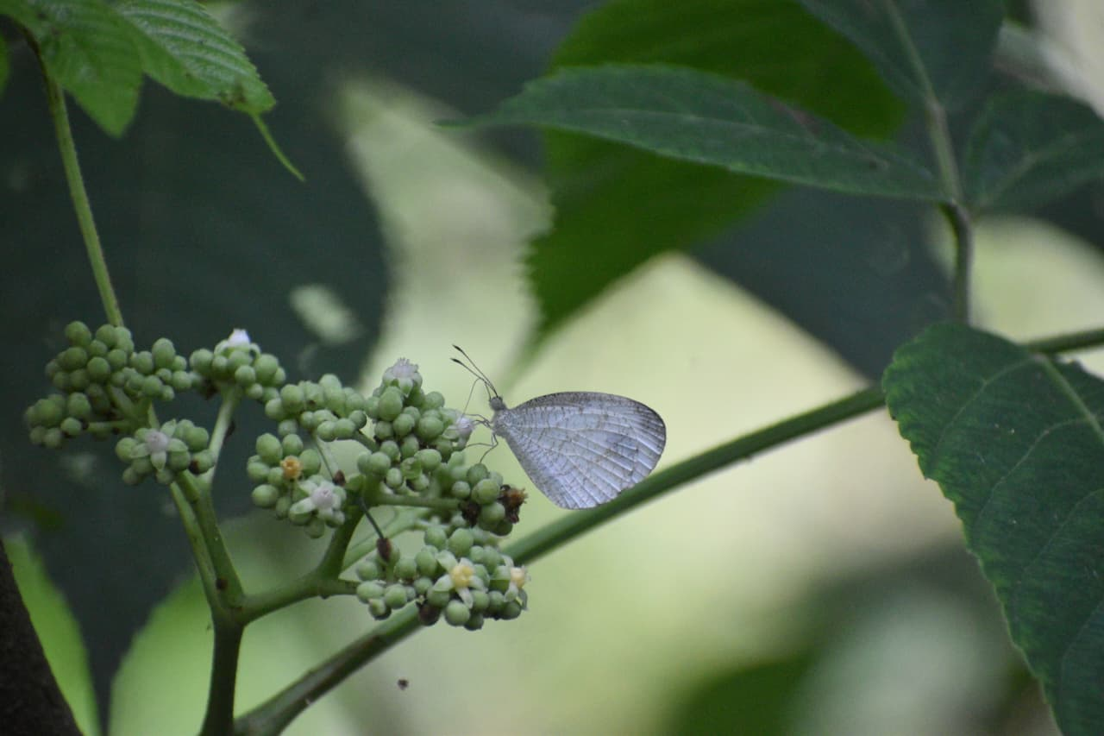

Psyche Indian Cabbage White
Family: Lycaenidae
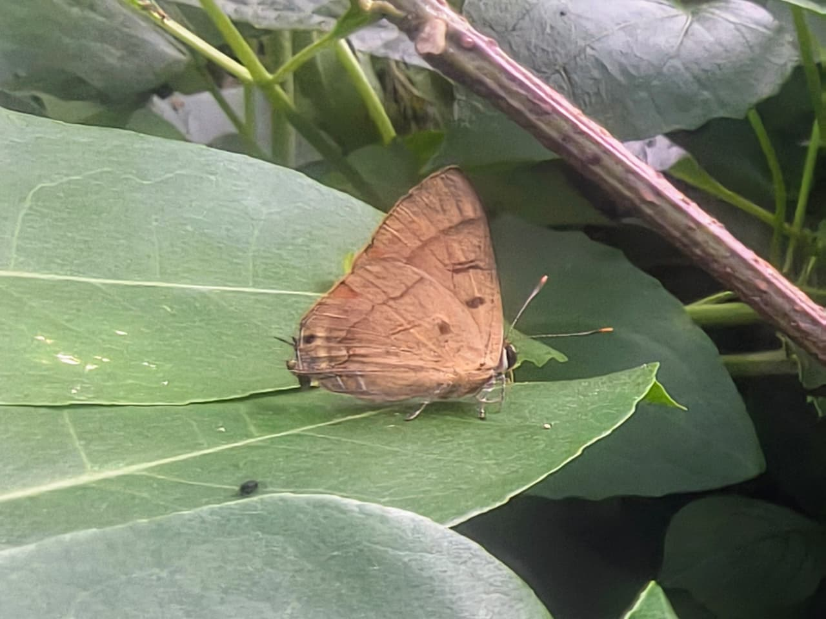
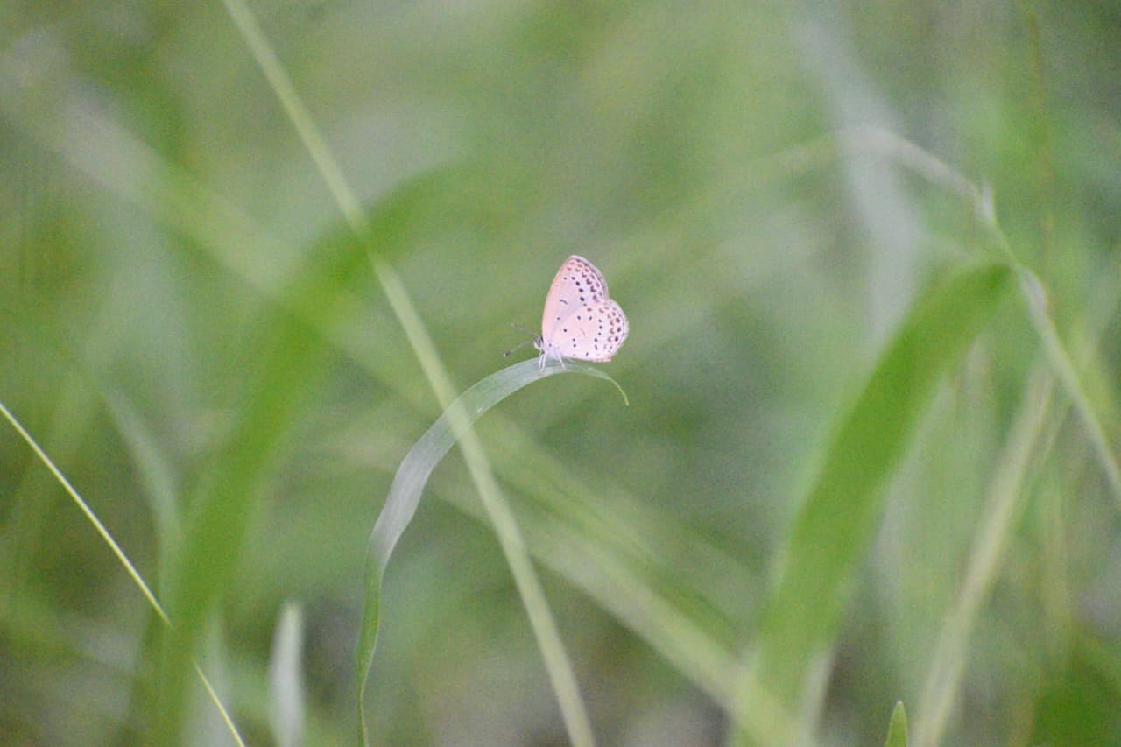

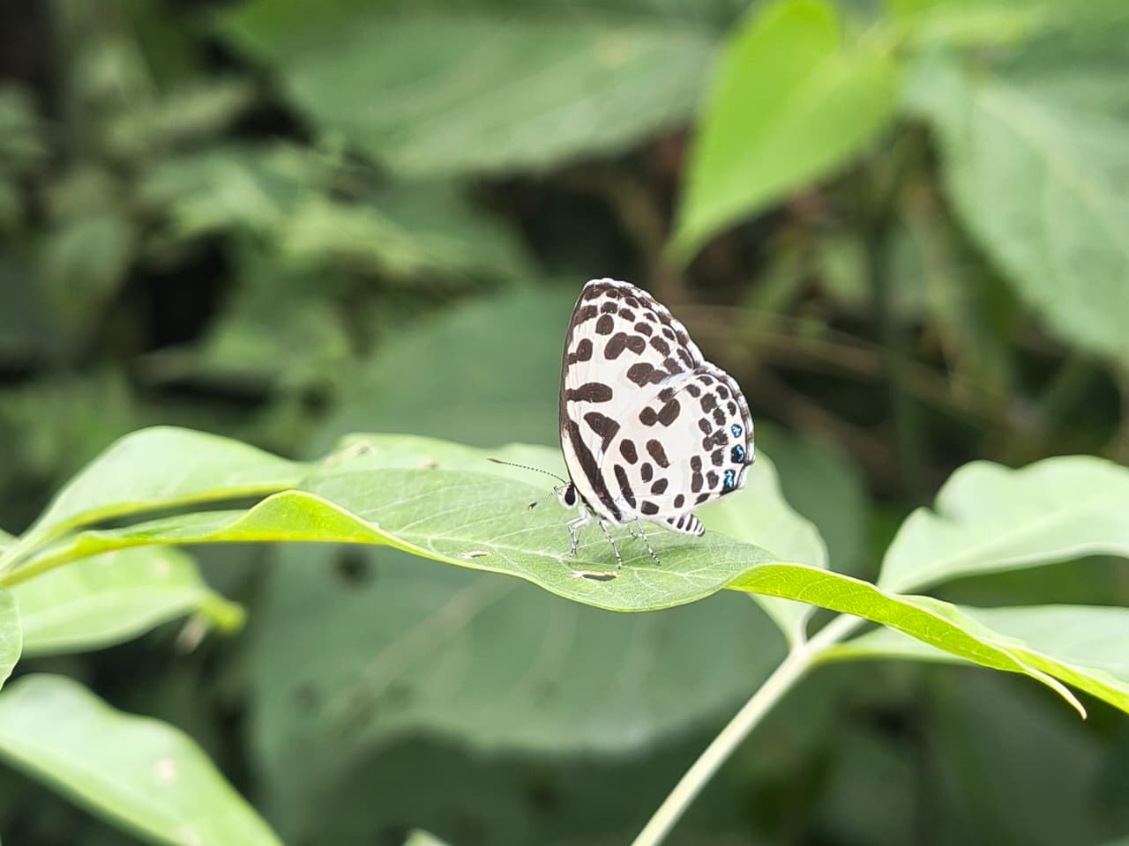
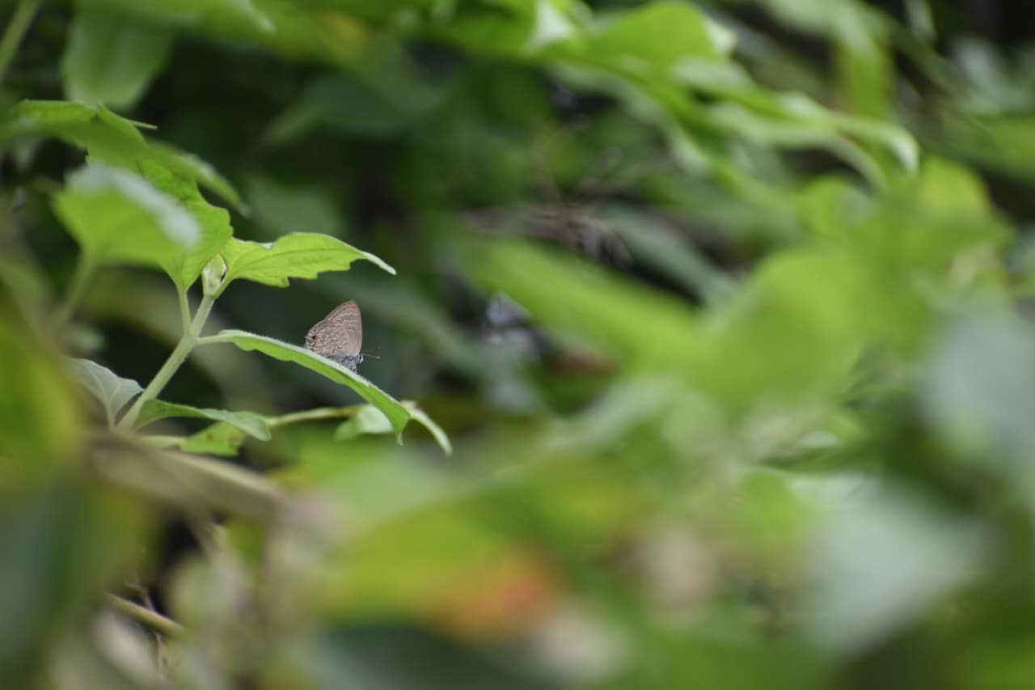
Pale Grass Blue Copper Flash

Common Pierrot Common Climate Blue
Family: Nymphalidae
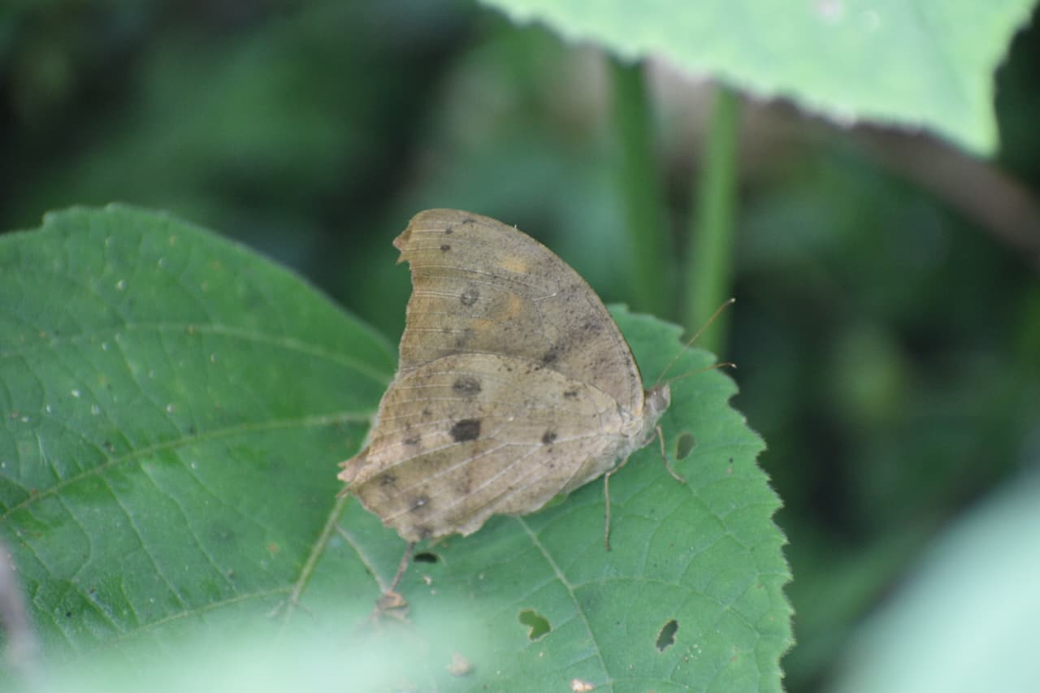
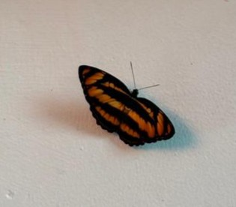

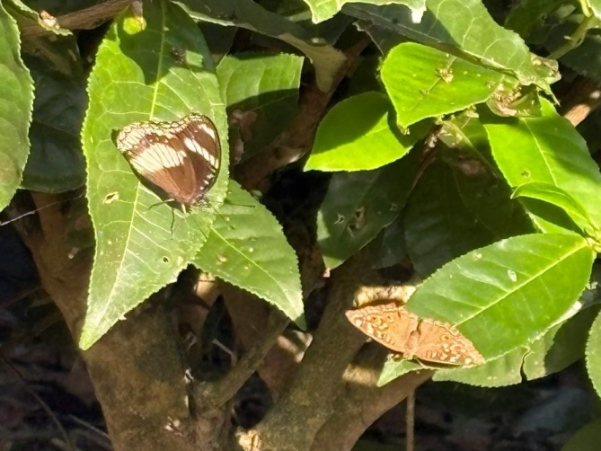
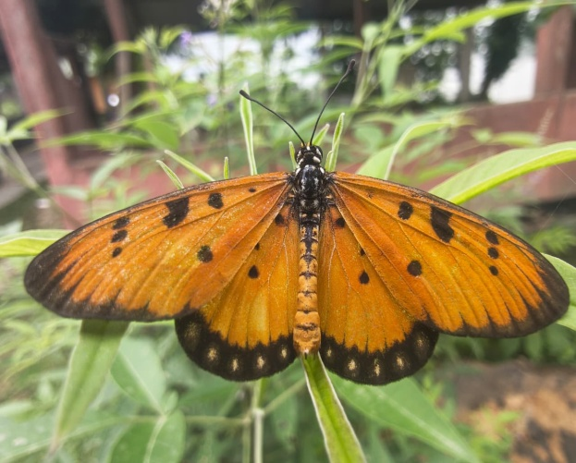
Colour Sergeant Common Evening Brown

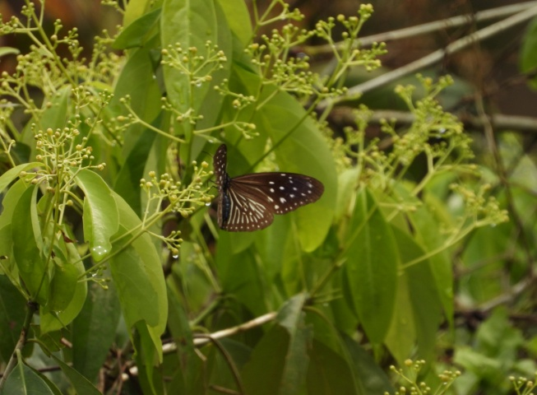
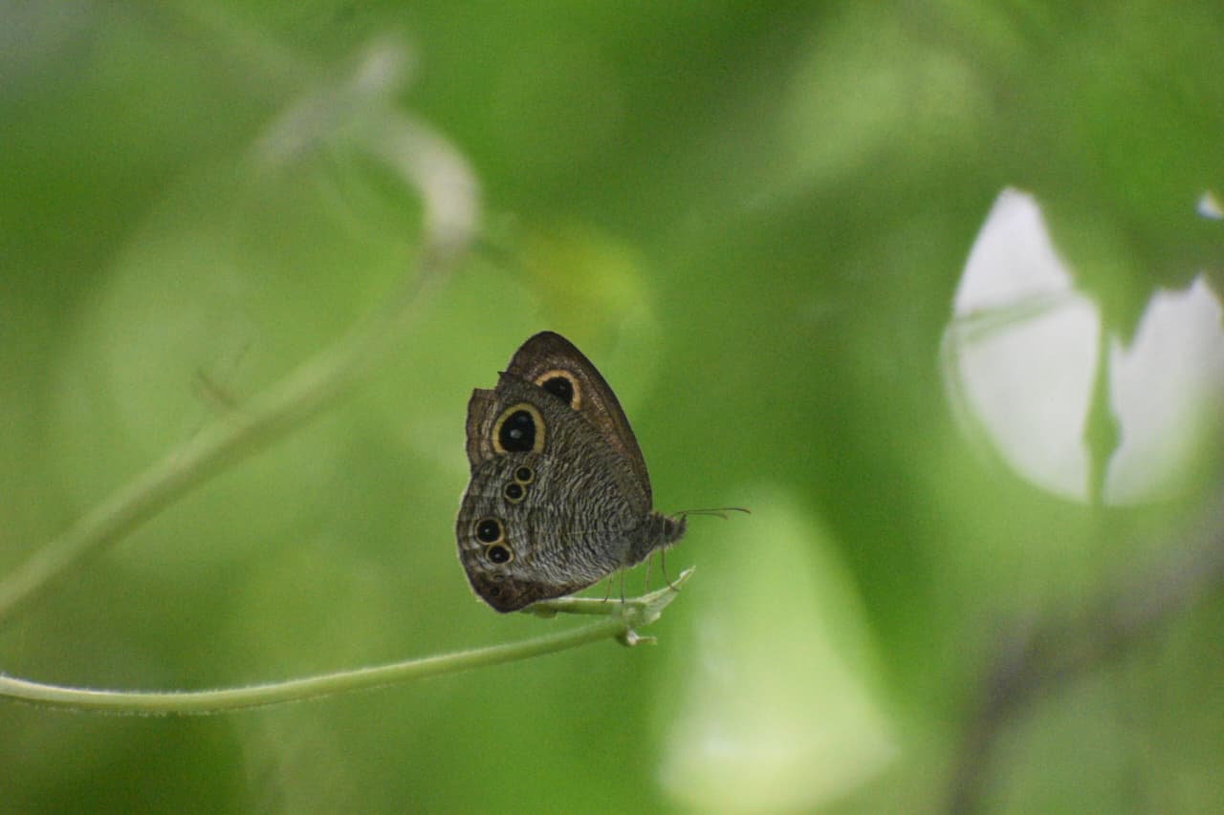
Tawny Coster Great Eggfly & Lemon Pansy

Common Five-ring Striped Blue Crow
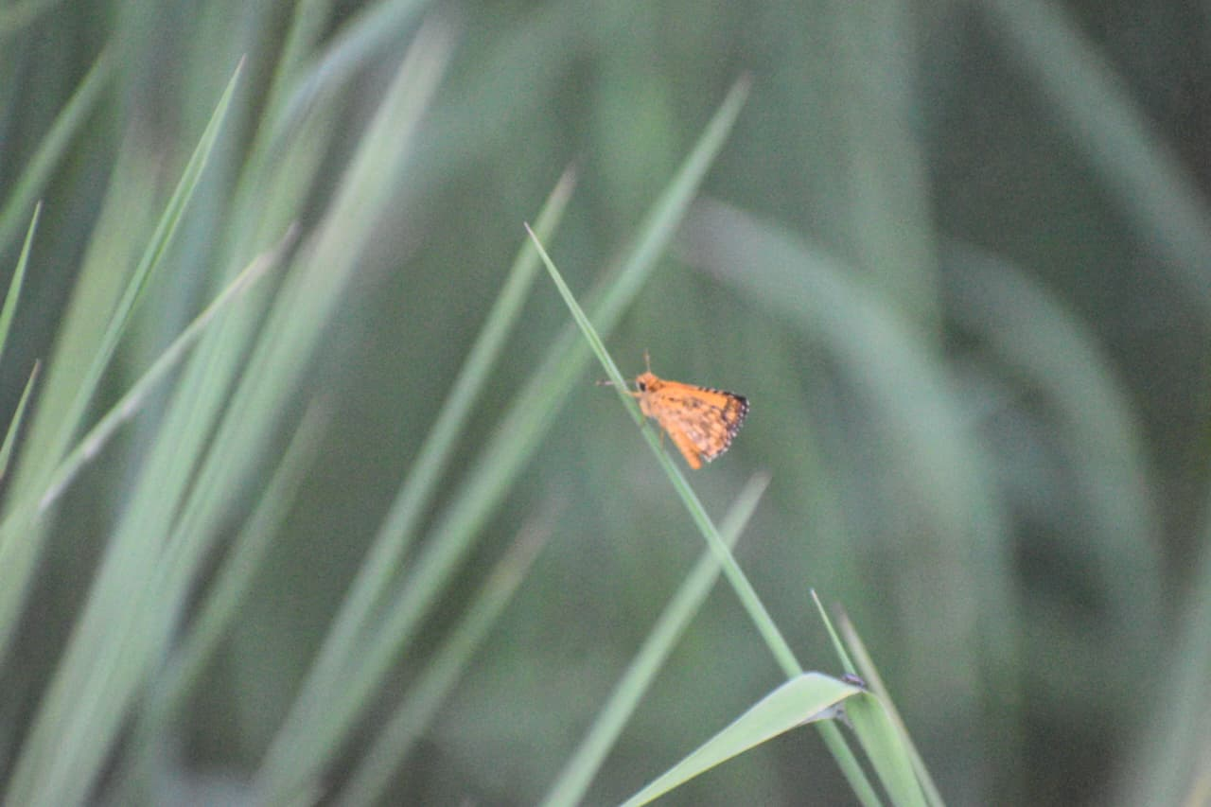
Family: Hesperiidae
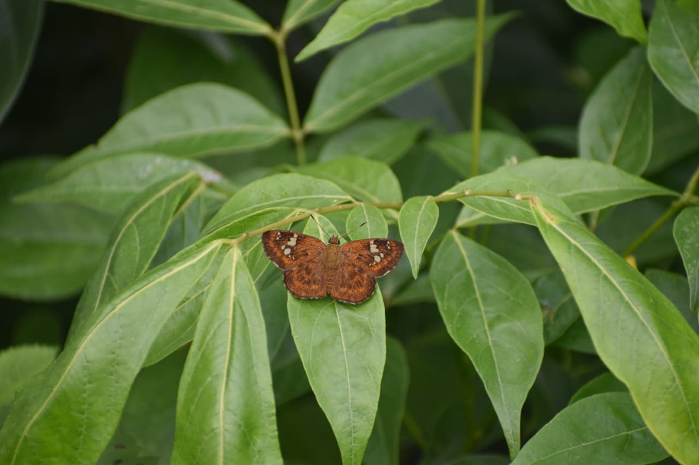
Fulvous Pied Flat Common Bush Hopper

