Original Research Article
Range Extension and New Record of Labeo rajasthanicus (Datta & Majumdar, 1970) (Cypriniformes: Cyprinidae) in the Bhima River Basin, Maharashtra, India

Abstract
Labeo rajasthanicus (Datta & Majumdar, 1970) was originally described from Jaisamand Lake, Rajasthan, and was later considered taxonomically uncertain due to the absence of subsequent records and loss of the original type material. The species was subsequently confirmed as valid following reassessment of the Labeo gonius subgroup and designation of a neotype. The present study reports the occurrence of L. rajasthanicus from the Bhima River basin, Maharashtra, India, based on two specimens collected from the confluence region of the Mula Mutha and Bhima rivers at 18°34'01.7"N and 74°20'34.1"E. Morphometric and meristic characters were examined using standard taxonomic procedures. The specimens measured 172.88–179.61 mm standard length and showed diagnostic characters consistent with L. rajasthanicus, including 57–58 lateral-line scales, 19–20 predorsal scales, 24–26 circumpeduncular scale rows, 41–47 circumferential scale rows, and a dorsal fin formula of iii-12. These features distinguish the specimens from closely related congeners such as L. shivamogaensis, L. dussumieri, L. boggut, and L. gonius. The present record extends the known distribution of L. rajasthanicus from its previously documented range in Rajasthan to the Bhima River basin in Maharashtra. This finding adds to current knowledge of the species’ distribution and highlights the need for further ichthyofaunal surveys in Indian river systems.
KEYWORDS: Cyprinidae, Labeo, taxonomy, Bhima River, Western Ghats, Peninsular India.

- INTRODUCTION
The genus Labeo Cuvier, 1816, comprises 28 species widely distributed across South and South-East Asia (Jayaram, 2010). Within this genus, the gonius subgroup is characterized by high lateral line scale counts exceeding 50 (Jayaram and Dhas, 2000). Labeo rajasthanicus was first described by Datta and Majumdar (1970) based on a single specimen from Jaisamand Lake, Udaipur, Rajasthan. For many years, its taxonomic status was unstable due to the lack of subsequent reports and the loss of the original holotype, leading some authorities to synonymize it with L. boggut (Talwar and Jhingran, 1991; Jayaram and Dhas, 2000). However, detailed morphological and molecular analyses (Lal et al., 2015) confirmed its status as a valid species, distinct from L. gonius and L. boggut. While previously thought to be endemic to Western Rajasthan, it is considered rare and difficult to capture (Pethiyagoda, 1991; Jayaram and Dhas, 2000).
Key words. Cyprinidae, Labeo, Western Ghats, Peninsular India, Maharashtra
Research Gap:
The primary research gap lies in the undocumented distribution of Labeo rajasthanicus outside its historically assumed endemic range in Western Rajasthan, which has limited the understanding of its biogeography and conservation needs in Peninsular India.

Objective:
The objective of this study is to report a significant new record and major range extension of L. rajasthanicus from the Bhima River basin in Maharashtra, providing essential morphological and meristic evidence to confirm its taxonomic presence within the Western Ghats biodiversity hotspot

2. STUDY AREA
The occurrence of L. rajasthanicus is reported from the Bhima River, Maharashtra, with specimens collected from the Western Ghats at coordinates 18°34'01.7"N and 74°20'34.1"E, situated just above the confluence of Mula Mutha and Bhima River (Figure 1). This location is geographically distant from the species' previously known habitats, which included the Mahi-Som River system (Tidi River and Jaisamand Lake) and the Yamuna-Ganga tributary system (Chambal River) in Rajasthan.
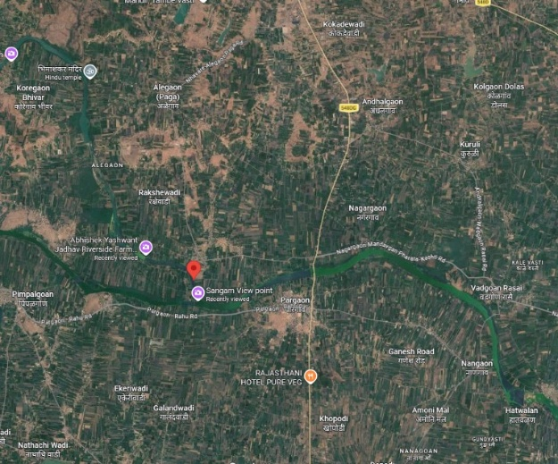

Figure 1. Sampling location of Bhima River, Maharashtra, India.

3. METHODOLOGY
Fish specimens were collected using cast nets and gill nets of varying mesh sizes (8–16 mm) and preserved in 10% formalin. Morphometric measurements were performed point-to-point using digital calipers following the methods of Hubbs and Lagler (1964). Fish collections were made between 2022 and 2023 at river sites by P. Sivakumar and J. Anusha. Preanal scales (Jayaram, 1991) are the scales from the anus to the isthmus. The meristic character of lateral transverse scale (L.tr.) rows described by Day (1889) is “number of longitudinal rows of scales between the back and abdomen, usually counted, unless some other part of the side is specified, from the anterior end of the dorsal fin to the ventral”.
Morphometric characters of 9, 18-25, 29-31 and 35-36 are the additional truss characters (Strauss and Bookstein, 1982). Body measurements are expressed as a percentage of standard length (%SL), and head measurements as a percentage of head length (%HL). Total length (TL) was also used for comparison.
Abbreviations used: ZSI/SRS (Zoological Survey of India, Southern Regional Station, Chennai), CUKMNHF (Central University of Kerala, Museum of Natural History, Kasargod), MCMNH (Madura College, Museum of Natural History, Madurai) and from CPSK (Collection of P. Sivakumar).

Materials Examined and comparative materials:
Labeo rajasthanicus MCMNH, 354 (2 ex.), 172.88 - 179.61 mm SL., confluence of Mula Mutha and Bhima River, Maharashtra, (18°34'01.7"N and 74°20'34.1"E ) collected by P. Sivakumar and J. Anusha, 2023.
Labeo shivamogaensis sp. nov: CUKMNHF1, 138.7mm SL;India: Bhadra Reservoir, Shimoga, Karnataka, Collected by Arunachalam and P. Sivakumar
Labeo shivamogaensis: CPSK 397, F 4, 108.2-131.74 mm SL; India: Bhadra Reservoir, Shimoga, Karnataka, Collected by Arunachalam and P. Sivakumar.
Labeo dussumieri: CMA 355 (12 ex.), 84.61- 97.98 mm SL. Alappuzha, Kerala (N 9° 29' 53 .43”, E 76° 20’03.52”), collected by M. Arunachalam, P. Sivakumar, and C. Vijayakumar, 22nd November 2011.
Labeo boggut : ZSI/SRS unregistered (1 ex.), 189.5 mm SL, Fish market at Wari Satara District, Krishna River, Maharashtra. (N 17° 41', E 74° 0' 3.3768''), collected by KCJ & Party, 9th March 1990.
Labeo gonius: CPSK 351 (6 ex.), 113.21 – 142.12 mm SL. Charadwar market, Dhemaji District, Brahmaputra River, Assam (N 27° 17’11”, E 94º 35' 05''), collected by M. Arunachalam, P. Sivakumar, and C. Vijayakumar, 12th November, 2010.
Labeo gonius: CPSK 353 (1 ex.), 90.34mm SL. Manorama River, Pakhra post, Basti District, Uttar Pradesh (N 26º 44' 19.3'', E 82º38' 02.7''), collected by M. Arunachalam, P. Sivakumar, and C. Vijayakumar, 26th March, 2011.

4. RESULTS
Labeo rajasthanicus
(Figure 2., Tables 1-3)
4.1 Diagnosis: Labeo rajasthanicus is distinguished from its congeners by possessing 57–58 lateral-line scales without a red tinge, whereas L. shivamogaensis, L. dussumieri, L. boggut, and L. gonius exhibit counts of 50–51, 52–54, 62, and 76–82, respectively. It is specifically differentiated from L. shivamogaensis (Arunachalam et al., 2018) by having fewer predorsal scales (19–20 vs. 22–24), fewer circumpeduncular scale rows (24–26 vs. 26–29), and fewer circumferential scale rows (41–47 vs. 56–63). From L. dussumieri, it is distinguished by a higher number of circumpeduncular scale rows (24–26 vs. 22–23) and more upper transverse rows (10.5–11.5 vs. 8.5–9.5). Compared to L. boggut, this species possesses fewer predorsal scales (19–20 vs. 23–24), fewer circumpeduncular scale rows (24–26 vs. 30), and significantly fewer pre-anal scale rows (43–45 vs. 65–66). It is further separated from L. gonius by its lower counts of upper transverse scale rows (10.5–11.5 vs. 15.5–17.5) and circumpeduncular scale rows (24–26 vs. 30–35). Additionally, morphometric characters distinguish it from L. gonius, specifically a shorter distance from the dorsal-fin origin to the pectoral-fin insertion (19.17–19.99% vs. 21.95–26.79% SL) and a shorter upper jaw length (24.60–25.89% vs. 24.64–31.95% HL).
The specimens collected from Maharashtra (172.88–179.61 mm SL) exhibit a gently arched dorsal profile and a body depth of 23.27–24.78% SL

Figure 2. Labeo rajasthanicus: (a) Original drawing by Datta and Majumdar (1970), (b) lateral view, (c) ventral view of mouth, SL. 172.88 mm.

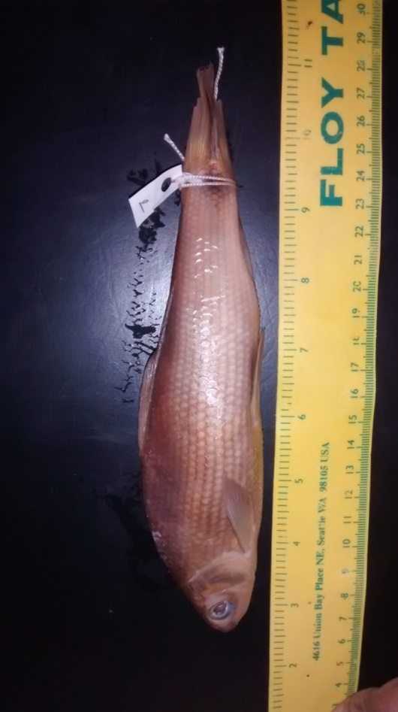
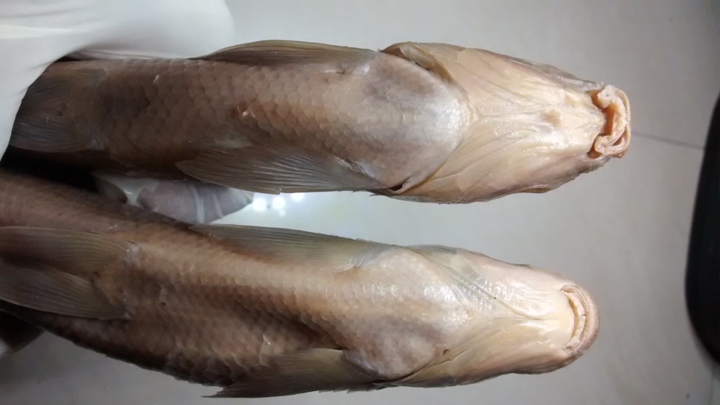
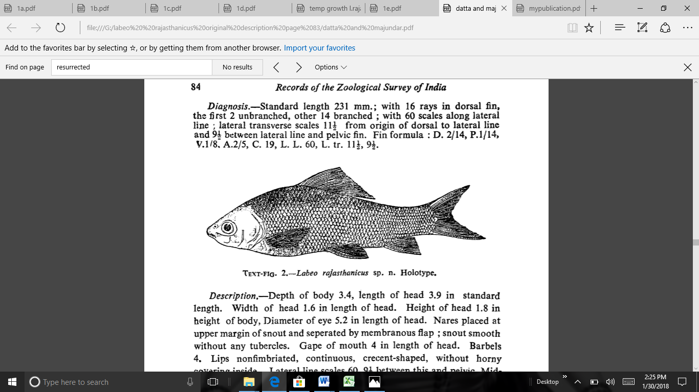
aigures 3 Labeo gonius: (a) Original drawing by Hamilton (1822), (b) Lateral view,
(c) Ventral view .of mouth
.
b
c

4.2 Description
Counts and measurements are from 2 specimens from 172.88 to 179.61 mm SL (Table 1). Dorsal profile gently arched and its depth is 23.27 - 24.78 (24.03±0.76) %SL, dorsal fin origin anterior to pelvic-fin insertion vertically by a distance of 4 scale rows; pre-dorsal distance 43.87 - 46.58 (45.23±1.36) %SL, pre-pelvic distance 49.58 - 52.26 (50.92±1.34) %SL; pre-anal length 76.25 - 78.75 (77.50±1.25)% SL and pre-pectoral length 23.94 - 24.73 (24.34±0.40) % SL; pelvic fin insertion to anal fin origin 21.41 - 23.91 (22.66±1.25)%SL. Nape convex following a concavity in margin with occiput. Caudal peduncle is moderately deep, depth at narrowest region 10.39 - 11.31 (10.85±0.46) %SL; length of caudal peduncle is 14.03 - 14.95 (14.49±0.46) %SL.
Head short 25.54 - 25.89 (25.72±0.18) %SL with short cranium of 69.67 - 75.51 (72.59±2.92) %HL, head depth at nostril 29.99 - 34.96 (32.48±2.49) %HL, at orbit 53.32 - 54.53 (53.93±0.61) %HL and at occiput 66.70 - 68.54 (67.62±0.92) %HL respectively. Pre opercle straight with 66.87 - 66.89 (66.88±0.01) % HL, inter orbital space is more or less flat, distance 47.13 - 48.08 (47.61±0.47) %HL. Eye moderate, 22.83 - 24.85 (23.84±1.01) % HL. Snout produced and depressed with tubercles and snout length is 34.43 - 36.08 (35.26±0.82) % HL and it has numerous pores on the snout. Lips thick, with a distinct inner fold in its entire circumference, both of which are fringed. Gape width is 21.09 - 23.96 (22.53±1.44) %HL. A cartilaginous covering to inner side of both jaws. Length of maxillary barbel is 9.01 - 12.36 (10.69±1.68) %HL and rostral barbel is 1.36 - 4.34 (2.85±1.49) %HL (Table 2).

Table 1 Proportional values of morphometric body characters are represented as % standard length of Labeo rajasthanicus from the confluence of Mula Mutha and Bhima River (n=2).

Measurements from point to point | 1 | 2 | Min. | Max. | Avg. | SD.
Standard length (mm) | 179.61 | 172.88 | 172.88 | 179.61
% of Standard length
Snout to urocentrum | 95.31 | 96.24 | 95.31 | 96.24 | 95.78 | 0.46
Pre-anal length | 76.25 | 78.75 | 76.25 | 78.75 | 77.50 | 1.25
Pre-dorsal length | 43.87 | 46.58 | 43.87 | 46.58 | 45.23 | 1.36
Pre-pelvic length | 52.26 | 49.58 | 49.58 | 52.26 | 50.92 | 1.34
Pre-pectoral length | 24.73 | 23.94 | 23.94 | 24.73 | 24.34 | 0.40
Caudal peduncle length | 14.95 | 14.03 | 14.03 | 14.95 | 14.49 | 0.46
Dorsal-fin origin to pelvic-fin insertion | 25.72 | 25.27 | 25.27 | 25.72 | 25.50 | 0.23
Dorsal spinous height | 11.13 | 13.08 | 11.13 | 13.08 | 12.11 | 0.98
Anal fin height | 17.17 | 16.84 | 16.84 | 17.17 | 17.01 | 0.17
Depth of caudal peduncle | 10.39 | 11.31 | 10.39 | 11.31 | 10.85 | 0.46
Caudal fin length | 28.59 | 31.09 | 28.59 | 31.09 | 29.84 | 1.25
Dorsal fin height | 20.28 | 20.84 | 20.28 | 20.84 | 20.56 | 0.28
Pectoral fin length | 18.97 | 21.11 | 18.97 | 21.11 | 20.04 | 1.07
Pelvic fin length | 17.08 | 18.75 | 17.08 | 18.75 | 17.92 | 0.84
Pelvic axillary scale length | 3.89 | 5.95 | 3.89 | 5.95 | 4.92 | 1.03
Occiput to dorsal origin | 24.84 | 29.48 | 24.84 | 29.48 | 27.16 | 2.32
Occiput to pectoral-fin insertion | 19.17 | 19.99 | 19.17 | 19.99 | 19.58 | 0.41
Occiput to pelvic-fin insertion | 41.63 | 42.14 | 41.63 | 42.14 | 41.89 | 0.25
Dorsal-fin insertion to pelvic-fin insertion | 22.60 | 22.40 | 22.40 | 22.60 | 22.50 | 0.10
Dorsal-fin origin to pectoral-fin insertion | 25.52 | 26.98 | 25.52 | 26.98 | 26.25 | 0.73
Dorsal-fin origin to anal origin | 39.52 | 42.02 | 39.52 | 42.02 | 40.77 | 1.25
Dorsa-fin insertion to caudal fin | 32.51 | 33.70 | 32.51 | 33.70 | 33.11 | 0.60
Dorsal-fin insertion to anal-fin origin | 20.82 | 20.92 | 20.82 | 20.92 | 20.87 | 0.05
Dorsal-fin insertion to anal-fin insertion | 23.86 | 24.70 | 23.86 | 24.70 | 24.28 | 0.42
Dorsal-fin base length | 20.87 | 24.64 | 20.87 | 24.64 | 22.76 | 1.89
Anal-fin base length | 7.09 | 6.74 | 6.74 | 7.09 | 6.92 | 0.18
Pectoral-fin insertion to pelvic-fin insertion | 29.09 | 25.84 | 25.84 | 29.09 | 27.47 | 1.63
Pectoral-fin insertion to anal-fin origin | 50.59 | 50.42 | 50.42 | 50.59 | 50.51 | 0.09
Pelvic-fin insertion to anal-fin origin | 21.41 | 23.91 | 21.41 | 23.91 | 22.66 | 1.25
Total length (mm) | 123.77 | 127.71 | 123.77 | 127.71 | 125.74 | 1.97
Post-dorsal length | 52.49 | 57.84 | 52.49 | 57.84 | 55.17 | 2.68
Body depth | 23.27 | 24.78 | 23.27 | 24.78 | 24.03 | 0.76
Distance between pectoral fin and vent | 48.04 | 49.58 | 48.04 | 49.58 | 48.81 | 0.77
Distance between pelvic fin and vent | 20.20 | 23.52 | 20.20 | 23.52 | 21.86 | 1.66

Table 2 Proportional values of morphometric head characters are represented as % head length of Labeo rajasthanicus from the confluence of Mula Mutha and Bhima River (n=2).
Measurements from point to point | 1 | 2 | Min. | Max. | Avg. | SD.
Head length (mm) | 46.51 | 44.15 | 44.15 | 46.51
% of Head length
Pre-occipital length | 75.51 | 69.67 | 69.67 | 75.51 | 72.59 | 2.92
Snout to opercle | 66.87 | 66.89 | 66.87 | 66.89 | 66.88 | 0.01
Upper jaw length | 24.60 | 25.89 | 24.60 | 25.89 | 25.25 | 0.65
Snout length | 36.08 | 34.43 | 34.43 | 36.08 | 35.26 | 0.82
Pre- nasal length | 25.74 | 25.39 | 25.39 | 25.74 | 25.57 | 0.17
Orbit width | 24.85 | 22.83 | 22.83 | 24.85 | 23.84 | 1.01
Inter-orbital width | 48.08 | 47.13 | 47.13 | 48.08 | 47.61 | 0.47
Inter -nasal width | 30.38 | 31.60 | 30.38 | 31.60 | 30.99 | 0.61
Head width | 58.85 | 59.23 | 58.85 | 59.23 | 59.04 | 0.19
Gape width | 21.09 | 23.96 | 21.09 | 23.96 | 22.53 | 1.44
Lower jaw to isthmus | 56.59 | 49.24 | 49.24 | 56.59 | 52.92 | 3.68
Head depth at nostril | 34.96 | 29.99 | 29.99 | 34.96 | 32.48 | 2.49
Head depth at pupil | 54.53 | 53.32 | 53.32 | 54.53 | 53.93 | 0.61
Head depth at occiput | 66.70 | 68.54 | 66.70 | 68.54 | 67.62 | 0.92
Maxillary barbel length | 12.36 | 9.01 | 9.01 | 12.36 | 10.69 | 1.68
Rostral barbel length | 4.34 | 1.36 | 1.36 | 4.34 | 2.85 | 1.49

4.3 Fins
Dorsal fin rays iii-12 (2); pectoral fin rays i-15 (2); pelvic fin rays i-8 (2); anal fin rays iii-5 (2); caudal fin rays 10+9 (2) (Table 3). Dorsal fin height 20.28 - 20.84 (20.56±0.28 ) %SL and sharply pointed at its apex, commences much nearer to the snout than to the base of caudal and length of dorsal spine 11.13 - 13.08 (12.11±0.98) %SL. Anal fin short 16.84 - 17.17 (17.01±0.17) %SL, when depressed not reaches the caudal fin base. Distal margin of anal fin is straight when fin is erect, the last two posterior rays are equal in length and the tip of the longest ray is not rounded. Length of the anal fin base 6.74 - 7.09 (6.92±0.18)%SL. Pelvic fin moderately long, 17.08 - 18.75 (17.92±0.84) %SL; pectoral fin moderately long, 18.97 - 21.11 (20.04±1.07) %SL, extending to 5 scales anterior to pelvic fin origin. Caudal fin long and moderately forked 28.59 - 31.09 (29.84±1.25) %SL, just 2.53 - 2.75 times, the length of the shortest ray at fin median.

Table 3 Meristic characters of Labeo rajasthanicus from the confluence of Mula Mutha and Bhima River (n=2).

Meristic counts | 1 | 2 | Min. | Max.
Unbranched dorsal fin rays | 3 | 3 | 3 | 3
Branched dorsal fin rays | 12 | 12 | 12 | 12
Unbranched anal fin rays | 3 | 3 | 3 | 3
Branched anal fin rays | 5 | 5 | 5 | 5
Unbranched pelvic fin rays | 1 | 1 | 1 | 1
Branched pelvic fin rays | 8 | 8 | 8 | 8
Unbranched pectoral fin rays | 1 | 1 | 1 | 1
Branched pectoral fin rays | 15 | 15 | 15 | 15
Caudal fin upper lobe | 6+9 | 6+9 | 6+9 | 6+9
Caudal fin lower lobe | 5+8 | 5+8 | 5+8 | 5+8
Lateral line scales | 57 | 58 | 57 | 58
Pre-dorsal scales | 20 | 19 | 19 | 20
Upper transverse rows | 10.5 | 11.5 | 10.5 | 11.5
Lateral line to pelvic scale rows | 7.5 | 7.5 | 7.5 | 7.5
Circumpeduncular scale rows | 24 | 26 | 24 | 26
Circumferential scale rows | 41 | 47 | 41 | 47
Transverse breast scale rows | 13 | 14 | 13 | 14
Anal scale rows | 3 | 3 | 3 | 3
Pre-anal scale rows | 43 | 45 | 43 | 45
Pre- pelvic scale rows | 26 | 27 | 26 | 27
Anal fin to lateral line scale rows | 7.5 | 8.5 | 7.5 | 8.5
Lateral transverse rows(L.tr.) | 11/7 | 12/8 | 11/7 | 12/8

4.4 Scales
Scales are bigger in size; lateral-line scales 57(1), 58(1); pre-dorsal scales 19 (1), 20 (1); upper transverse scale rows 10.5 (1), 11.5 (1); scales from lateral-line to pelvic fin 7.5 (2); scales from lateral-line to anal fin 7.5 (1), 8.5 (1); circumpeduncular scale rows 24 (1), 26 (1); circumferential scale rows 41 (1), 47 (1); transverse breast scale rows 13 (1), 14 (1); pre-anal scales (anus to isthmus) 43 (1), 45 (1); anal scales (anus to anal fin) 3 (2) (Table 3).

4.5 Colour
In preserved specimen, the colour is dark brown and light yellow beneath. In the dorsal surface scales densely pigmented with fine melanophores, with a crescent of closely spaced melanophores at the posterior border of exposed part of scale whereas all scales were pigment free along the ventral scale row. Parallel to lateral line stripes passing from shoulder to the tip of caudal peduncle with a black blotch at the either side of the caudal fin base. Dorsal and caudal fin were dusky (Figure 2).
Distribution: India: Mahi-Som River system (Tidi River and Jaisamand Lake) and the Yamuna-Ganga tributary system (Chambal River) in Rajasthan. Currently this species has been recorded for the first time in the Bhima River, an east-flowing river in the Western Ghats of peninsular India.
Habitat and Ecology: Big sized species in the genus Hypselobarbus, Tor and Labeo prefer deep pools habitats in rivers (Sivakumar et al., 2024; 2025). Species of Labeo are essentially benthic feeders. Present collection of Labeo rajasthanicus is also from a deep pool with a depth range of 0.5-2.0 m.
5. DISCUSSION
The documentation of Labeo rajasthanicus in the Bhima River basin represents a major extension of its known geographical range into Peninsular India, fundamentally challenging the previous assumption that the species was endemic to isolated river systems in Western Rajasthan (Lal et al., 2015). Originally described by Datta and Majumdar (1970) from a single specimen in Jaisamand Lake, the species remained taxonomically unrecognized for nearly half a century and was frequently treated as a synonym of L. boggut (Jayaram and Dhas, 2000). The recent resurrection of the species and the designation of a neotype from the Tidi River by Lal et al. (2015) confirmed its status as a valid and distinct member of the gonius subgroup.
Morphologically, the specimens obtained from the confluence of the Mula Mutha and Bhima Rivers, exhibit a high degree of consistency with the neotype description provided by Lal et al. (2015). Notably, both the Maharashtra specimens and the neotype possess a dorsal fin formula of iii, 12 (3 unbranched and 12 branched rays), showing no deviation in this critical meristic character despite the vast geographical distance between the populations. This alignment reinforces the taxonomic stability of the species across its expanded range. Furthermore, diagnostic characters such as 57–58 lateral line scales and 19–20 predorsal scales distinguish it from related congeners like L. shivamogaensis, L. dussumieri L. boggut and L. gonius (Arunachalam et al., 2018).
Ecologically, L. rajasthanicus prefers specialized deep pool habitats (0.5–2.0 m) characterized by rocky substrates and low water velocity, a trait shared with other large benthic-feeding Labeo species (Arunachalam et al., 2005; Sivakumar et al., 2025). The broader genus Labeo is globally significant, representing nearly 19.6% of Asian cyprinid composition, yet natural populations are declining due to anthropogenic pressures such as overfishing and habitat degradation (Gupta and Banerjee, 2015; Sarma et al., 2017; Sivakumar et al., 2024;2025). Additionally, laboratory studies by Paliwal et al. (2016) indicate that the species, locally known as "sarsi," has specific thermal requirements, with optimal growth occurring at temperatures near 30°C. This discovery in the Western Ghats suggests a much wider adaptive capacity and biogeographical presence than previously understood, making the preservation of these specialized riverine habitats a priority for regional biodiversity conservation.
6. CONCLUSION
The present study reports the occurrence of Labeo rajasthanicus from the Bhima River basin in Maharashtra, based on two specimens examined through morphometric and meristic characters. The diagnostic features observed in the specimens, including lateral-line scale count, predorsal scale count, circumpeduncular scale rows, and dorsal fin ray formula, support their identification as L. rajasthanicus. This record extends the known distribution of the species beyond its previously documented range in Rajasthan and provides additional information on its occurrence in Peninsular India. Further surveys using larger sample sizes, broader geographic coverage, and, where possible, molecular confirmation are required to better understand the distribution, population status, and conservation relevance of this species.

DECLARATION
The species investigated, Labeo rajasthanicus (locally known as "sarsi"), is a common minor carp that is regularly harvested for human consumption and holds significant market value in its regional fisheries. As the study utilized common food fish obtained from local fishermen (commercial sources) and does not involve the use of endangered or protected fauna for laboratory experimentation, formal institutional animal ethics clearance was not mandatory for this research.

COLLECTION PERMISSIONS:
Field collections for this study were conducted at riverine sites within the Bhima River basin in Maharashtra. Forest permission was not required as the collection sites are situated in open water bodies and do not fall under the jurisdiction of any protected area, national park, or reserved forest. All specimens were obtained through traditional collection methods.

Declaration of AI Use

This manuscript was prepared through the combined contributions of all author(s), including contributions to the study design, data, content development, results, interpretation, and related scholarly work. The author(s) acknowledge the use of Grammarly and ChatGPT to assist with grammar checking, language refinement, reference formatting. These AI-assisted tools were not used as authors and did not replace the intellectual contributions or scholarly judgment of the author(s). All AI-assisted outputs, including content, references, and interpretations, were carefully reviewed, revised, verified, and approved by the author(s). The author(s) accept full responsibility for the accuracy, integrity, and final content of the manuscript.

COMPETING INTERESTS DISCLAIMER:
Authors have declared that they have no known competing financial interests OR non-financial interests OR personal relationships that could have appeared to influence the work reported in this paper.

REFERENCES
Arunachalam, M., Aunsha, J., & Sivakumar, P. (2018). New species of Labeo Cuvier (Cypriniformes: Cyprinidae) from Bhadra River, Karnataka region of Western Ghats, peninsular India. Trends in Fisheries Research, 7 (3); 50-56.
Arunachalam, M., Sivakumar, P., & Muralidharan, M. (2005). Habitat Evaluation of Pristine headwater streams of Western Ghat Mountain Ranges, peninsular India, M.S.Johal (ed.) Proceedings of the National Seminar New Trends in Fishery Development in India‟ Punjab University. 253-286.
Datta, A. K., & Majumdar,N. (1970). Fauna of Rajasthan, India. Part 7. Fishes. Records of the Zoological Survey of India, 62 (1 & 2), 63-100
Day, F. (1889). The Fauna of British India including Ceylon and Burma. Fishes, Taylor & Francis, London, vols. I and II: 548 and 509.
Deraniyagala, P.E.P. (1929). Two new freshwater fishes. Spolia Zeylanica. 15(2): 73-77. Pl XXii
Deraniyagala, P.E.P. (1952). A coloured atlas of some vertebrates from Ceylon. I. Fishes. Ceylon nat. Mus.12: 1-149, Pls. 1-34.
Gupta, S., & Banerjee, S. (2015). A review on Labeo calbasu (Hamilton) with an emphasis on its conservation. Journal of Fisheries, 3 (3), 301-308.
Hamilton, F. (1822). An account of the fishes found in the river Ganges and its branches. Edinburgh, London: Archibald Constable and Company. Pp 405.
Hubbs, C.L., & Lagler, K.F. (1964). Fishes of the Great Lakes region. University of Michigan Press, Ann Arbor, USA, Pp 213.
Jayaram, K.C. & Dhas J.C. (2000). Revision of the genus Labeo (Cuvier) from the Indian region (Pisces; Cyprinniformes, Cyprinidae, Cyprininae). Rec. Zool. Surv. India. 183: 1-143.
Jayaram, K.C. (1991). Revision of the genus Puntius Hamilton from the Indian region (Pisces: Cypriniformes, Cyprinidae, Cyprininae). Rec. Zool. Surv. India. 135: 1–178.
Jordan, D.S., & Starks, E.C. (1917). Notes on collection of fishes from Ceylon with description of new species. Ann. Carneg. Mus. 11: Pp 436.
Lal, K.K., Gupta,B.K., Punia,P., Mohindra,V., Saini, V.P., Dwivedi,A.K., Singh,R.K., Dhwan, S., Luhariya,R.K., Basheer, V. S., & Jena, J. K. (2015). Revision of gonius subgroup of the Genus Labeo Cuvier, 1816 and confirmation of species status of Labeo rajasthanicus (Cypriniformes: Cyprinidae) with designation of a neotype. Indian J. Fish., 62(4): 10-22.
Paliwal, D., Saini,V. P., Sharma, O. P., Ojha, M. L., & Jain, H. K. (2016). The effect of rearing temperature on growth and survival of Labeo rajasthanicus spawn. International Journal of Fisheries and Aquatic Studies, 4 (3), 599-603.
Pethiyagoda, R. (1991). Freshwater fishes of Sri Lanka. Wild life Heritage Trust of Sri Lanka, Colombo.Pp 362.
Sarma, K. J., Prajapati, M., & Mankodi,P. C. (2017). Morphological description and taxonomic account of Labeo species (Cypriniformes, Family: Cyprinida e) from Gujarat, India. Journal of Entomology and Zoology Studies, 5 (4), 1120-1125.
Sivakumar, P., Anusha, J., Vijayakumar, C., Prasada Rao, A.V., Premjith Jinham, A., & Koshal Kumar, (2024). Fish Assemblages and Stream Habitat Types in South Indian Streams. Journal of Advanced Zoology, 45 (S3), 44-54.
Sivakumar, P., Anusha, J., Walter Devaa, J. C., & Shanthipreya,N. (2025). Fish Assemblages and Stream Habitat Types in South Indian Streams. Journal of Advanced Zoology, 46 (2), 109-125,
Sivakumar, P., Jagmohan Anusha, Walter Devaa, J.C., & Shanthipreya, N. (2025). Habitat utilization and preference of cyprinid fishes in the Western Ghats streams of South India
Strauss, R. E., & Bookstein, F. L. (1982). The truss: Body form reconstructions in morphometrics. Sys. Zool. 31 (2): 113-135.
Talwar, P. K., & Jhingran, A. G. (1991). Inland fishes of India and adjacent countries, vol 1&2. Oxford and IBH Publishing, New Delhi, 1097 pp.

