Acute Cadmium Toxicity and Behavioural Responses in Channa gachua (Hamilton): A 96-h Probit Bioassay

Abstract
Background: Cadmium (Cd) is a persistent, non-essential heavy metal that enters aquatic ecosystems through industrial, agricultural, and urban effluents, posing a severe threat to freshwater fish. Channa gachua (Hamilton), a facultative air-breathing snakehead widely distributed across South and Southeast Asian wetlands, is repeatedly exposed to surface-water contaminants owing to its aerial respiration behaviour, yet no published study has determined the acute toxicity of cadmium chloride (CdCl₂) in this species. Methods: A static-renewal 96-h acute toxicity bioassay was conducted using five nominal CdCl₂ concentrations (28, 30, 32, 34 and 36 mg/L), with 10 fish per aquarium. Mortality was recorded at 24, 48, 72 and 96 h, and median lethal concentrations (LC50) were estimated by Finney’s probit method (Finney, 1971). Behavioural and morphological alterations were monitored qualitatively throughout the exposure period, and representative photographs were recorded. Results: Mortality increased in a clear concentration- and time-dependent manner. The 96-h LC50 was estimated at 28.8 mg/L (regression: y = −18.82 + 16.32x; log-probit basis), with LC50 declining progressively from 38.7 mg/L (24 h, extrapolated) to 34.1 mg/L (48 h) and 31.5 mg/L (72 h). Exposed fish showed concentration-dependent behavioural disturbances consistent with those reported for the congener Channa punctatus (Singh & Saxena, 2020; Bishop & McIntosh, 1981). Conclusion: Channa gachua displays a clear dose- and time-dependent acute toxicity response to CdCl₂, with a 96-h LC50 of 28.8 mg/L – markedly higher than the 14.95–26.88 mg/L range reported for the congeneric Channa punctata (Verma, 2023), suggesting a genuine species-level difference in cadmium sensitivity within the genus Channa that merits further mechanistic investigation.
Keywords: Channa gachua; Cadmium chloride; LC50; Probit analysis; Acute toxicity; Behavioural toxicology; Air-breathing fish

1. Introduction
Heavy metal contamination of freshwater ecosystems has become a major environmental concern worldwide, driven by industrial discharge, mining effluents, agricultural run-off and untreated urban waste. Among these pollutants, cadmium (Cd) is of particular toxicological significance: it is non-essential to biological systems, persists indefinitely in aquatic sediments, bioaccumulates along the food chain, and exerts toxic effects on fish even at low, environmentally realistic concentrations (Yu et al., 2024; World Health Organization, 1992). Fish are especially vulnerable to waterborne cadmium because of continuous gill-mediated exposure, and acute cadmium toxicity has been documented to disrupt osmoregulation, haematopoiesis, hepatic and renal function, and neurobehavioural performance across numerous freshwater species.
Comparative evidence indicates that acute cadmium sensitivity in freshwater fishes is influenced by both intrinsic and extrinsic factors, including body size, respiratory strategy, ionic conditions, and branchial physiology. A systematic analysis of freshwater-fish LC50 data found substantial variation among respiratory groups, while experimental studies have shown that waterborne cadmium can interfere with branchial calcium uptake and ion regulation. Accordingly, species-specific LC50 values are most appropriately interpreted within the physicochemical and physiological context of the test system rather than as fixed properties of the toxicant alone (Ferro et al., 2021; Garcia-Santos et al., 2006; Verbost et al., 1987).
Channa gachua (Hamilton, 1822), commonly known as the dwarf/frail snakehead, is a small, facultatively air-breathing fish widely distributed across the wetlands, ponds, and slow-moving streams of the Indian subcontinent and Southeast Asia. It possesses a suprabranchial accessory respiratory chamber that permits atmospheric air-breathing, supplementing branchial respiration under hypoxic conditions (Olson et al., 1994). This physiological trait, combined with its benthic, sluggish habit in shallow, often anthropogenically disturbed waters, makes Channa gachua both ecologically important as a bio-indicator species and physiologically distinct from obligate water-breathers (Tarigan et al., 2016). Because air-breathing fish must periodically surface to gulp air, they experience repeated direct contact with the air–water interface, a zone in which many waterborne contaminants – including heavy metals – tend to concentrate; comparative toxicological work has shown that air-breathing fish can display distinct, and sometimes heightened, ethological and haematological responses to metal toxicants relative to non-air-breathing species (Dhara et al., 2021).
Several previous studies have examined the toxicological responses of Channa gachua to other environmental stressors, including nickel (Kawade, 2020), mercuric chloride and copper chloride (Deore & Wagh, 2012), agricultural pesticides (Singh & Siddique, 2018; “Histopathological Study of Channa gachua Exposed to Malathion,” 2021), and biofertilizer run-off (“Histopathological Changes in the Liver of Channa gachua,” 2018–2019), collectively establishing this species as a responsive and ecologically relevant bioindicator for aquatic pollution. However, despite cadmium being one of the most widespread and hazardous heavy metal contaminants of Indian freshwater systems, no published study to date has determined the acute (96-h) median lethal concentration (LC50) of cadmium chloride specifically for Channa gachua, nor systematically documented its behavioural and morphological toxicity syndrome in this species. This represents a clear and significant gap in the species-specific ecotoxicological literature.
The present study therefore aimed to (i) determine the 24, 48, 72 and 96-h median lethal concentrations (LC50) of cadmium chloride (CdCl₂) for Channa gachua using the internationally recognised probit analysis method of Finney (Finney, 1971), conducted in accordance with the general framework of OECD Test Guideline No. 203 for acute fish toxicity testing (OECD, 2019); and (ii) qualitatively characterise the concentration-dependent behavioural and morphological alterations exhibited by the fish during the exposure period, supported by photographic documentation. These findings are intended to establish reference toxicity data for Channa gachua and to enable a comparative assessment of cadmium sensitivity within the genus Channa.

2. Materials and Methods

2.1 Test Animal and Acclimatization
Healthy, uniformly sized specimens of Channa gachua total length 6-9 cm, body weight 8-15 g (mean ± SD); obtained from local fish vendor from Bazar Samiti, Patna, Bihar, India; n = 60 total fish used were collected and subjected to a prophylactic dip treatment in potassium permanganate (KMnO₄) solution to eliminate surface dermal and gill parasites/pathogens prior to laboratory introduction. Fish were then acclimatized to laboratory conditions in dechlorinated, well-aerated freshwater for 14 days prior to the start of the experiment, during which no mortality or signs of disease were observed. Fish were fed high nutrition food, once daily, with feeding withheld 24 h before and throughout the exposure trials, following standard toxicological practice. The overall experimental workflow – fish collection, KMnO₄ prophylactic treatment, acclimatization, and the definitive 96-h bioassay – together with representative photographs of each stage, is illustrated in Figure 1.

2.2 Test Chemical
Analytical-grade cadmium chloride (CdCl₂) was used to prepare a stock solution in dechlorinated water, from which the required nominal test concentrations were obtained by serial dilution.

2.3 Experimental Design
A static-renewal acute toxicity bioassay was conducted broadly following the OECD 203 guideline for fish acute toxicity testing (OECD, 2019). Ten acclimatized fish were randomly distributed into each of five glass test aquaria containing CdCl₂ at nominal concentrations of 28, 30, 32, 34 and 36 mg/L, alongside an untreated control group. Mortality was recorded at 24, 48, 72 and 96 h of exposure; dead fish (identified by cessation of opercular movement and absence of response to gentle mechanical stimulation) were removed immediately upon observation to prevent water quality deterioration. No feeding was carried out during the exposure period.

Figure 1
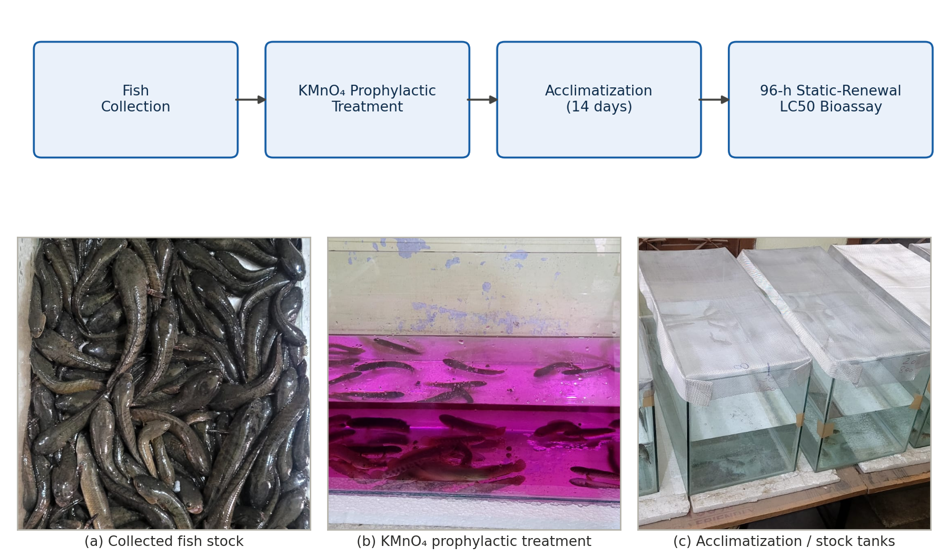
Figure 1. Experimental workflow and setup. Top: schematic of the bioassay protocol (fish collection → KMnO₄ prophylactic treatment → 14-day acclimatization → 96-h static-renewal LC50 bioassay). Bottom: representative photographs of (a) the collected Channa gachua stock, (b) the KMnO₄ prophylactic treatment tank, and (c) fish held in glass aquaria during acclimatization/exposure.

2.4 Water Quality Parameters
Physicochemical parameters of the test medium were monitored throughout the exposure period following standard methods (American Public Health Association, 2017): temperature 26-28 °C, pH 7.1, dissolved oxygen 6.5 mg/L, and total hardness 145 mg/L as CaCO₃; all parameters were maintained within the range considered optimal for freshwater channid species.

2.5 Behavioural and Morphological Observation
Fish in each concentration group were continuously observed throughout the 96-h exposure period for concentration-dependent behavioural and morphological alterations, following criteria adapted from established cadmium-toxicity ethograms reported for the congener Channa punctatus and other freshwater teleosts (Singh & Saxena, 2020; Bishop & McIntosh, 1981; Atchison et al., 1987). Parameters monitored included: swimming pattern (normal, erratic, or loss of equilibrium), surfacing/air-gulping frequency, opercular (ventilatory) movement rate, mucus secretion, body coloration and pigmentation, skin/fin integrity, and overall responsiveness to external stimuli. Representative photographs of control and exposed fish were taken at each observation interval to document external morphological change.

2.6 Statistical Analysis
Percentage mortality at each concentration and time point was corrected for 0% and 100% response using the standard Bliss correction [0% → 100 × (0.25/n); 100% → 100 × (n−0.25)/n; n = 10] and converted to probit values using Finney’s standard probit table (Finney, 1971). A linear regression of probit (y) against log₁₀ concentration (x) was fitted for each exposure duration (y = a + bx), and the LC50 was obtained by solving for x at y = 5 (the probit value for 50% mortality), followed by back-transformation: LC50 = antilog[(5 − a)/b]. All calculations were performed in Python (NumPy/Matplotlib).

3. Results & Discussion

3.1 Mortality Response
Cumulative mortality of Channa gachua increased progressively with both increasing CdCl₂ concentration and increasing exposure duration (Table 1, Table 2). No mortality was observed in the control group throughout the 96-h period.
The observed increase in mortality with concentration and exposure time is consistent with the general pattern of acute cadmium toxicity reported in freshwater fishes. However, direct comparison of LC50 values among species requires caution because body size, respiratory strategy, water chemistry, and ionoregulatory physiology can materially influence apparent cadmium sensitivity. This context is particularly relevant for air-breathing channids and for comparisons with tilapia and other teleosts tested under different hardness and exposure conditions (Ferro et al., 2021; Garcia-Santos et al., 2006; Liu et al., 2022).
Table 1. Raw cumulative mortality data recorded (number of dead fish out of 10)
Aq. No. | No. of test fish | Concⁿ (mg/L) | 24 h | 48 h | 72 h | 96 h
1 | 10 | 28 | 0 | 1 | 3 | 5
2 | 10 | 30 | 0 | 1 | 4 | 6
3 | 10 | 32 | 3 | 5 | 6 | 7
4 | 10 | 34 | 3 | 5 | 6 | 8
5 | 10 | 36 | 2 | 6 | 7 | 10
Table 2. Percentage mortality of Channa gachua exposed to CdCl2
Concⁿ (mg/L) | 24 h | 48 h | 72 h | 96 h
28 | 0% | 10% | 30% | 50%
30 | 0% | 10% | 40% | 60%
32 | 30% | 50% | 60% | 70%
34 | 30% | 50% | 60% | 80%
36 | 20% | 60% | 70% | 100%

3.2 Probit Regression and Median Lethal Concentration
Linear regression of probit mortality against log₁₀ concentration yielded highly consistent fits at all four exposure durations (Table 3, Table 4; Figure 2). The 96-h LC50 was estimated at 28.8 mg/L. LC50 values declined progressively with increasing exposure duration, from an extrapolated 38.7 mg/L at 24 h to 28.8 mg/L at 96 h (Figure 4), consistent with the expected time-dependent nature of acute metal toxicity.
The progressive reduction in estimated LC50 with longer exposure is biologically plausible because lethal response may increase as toxicant exposure is prolonged. Comparable acute cadmium studies in freshwater fishes also report marked interspecific differences in 96-h lethality, reinforcing the need to interpret the present estimate as species- and test-condition specific (Ferro et al., 2021; Garcia-Santos et al., 2006; Galiba et al., 2024). Because the 24-h LC50 lies outside the tested concentration interval, that value should remain explicitly identified as an extrapolated estimate rather than being treated as equivalent in certainty to estimates obtained within the experimental concentration range. The observed 96-h concentration-mortality relationship is additionally presented in Figure 3.
Table 3. Log-concentration and corrected probit values used for regression
Concⁿ (mg/L) | log₁₀(Concⁿ) | 24 h probit | 48 h probit | 72 h probit | 96 h probit
28 | 1.447 | 3.04 | 3.72 | 4.48 | 5.00
30 | 1.477 | 3.04 | 3.72 | 4.75 | 5.25
32 | 1.505 | 4.48 | 5.00 | 5.25 | 5.52
34 | 1.531 | 4.48 | 5.00 | 5.25 | 5.84
36 | 1.556 | 4.16 | 5.25 | 5.52 | 6.96
Table 4. Regression equations and estimated LC50 at each exposure duration
Exposure time | Regression equation (y = a + bx) | LC50 (mg/L) | Remarks
24 h | y = −16.77 + 13.71x | ≈ 38.7* | Extrapolated – max. observed mortality only 30%
48 h | y = −19.49 + 15.98x | ≈ 34.1 | Within tested range
72 h | y = −9.24 + 9.51x | ≈ 31.5 | Within tested range
96 h | y = −18.82 + 16.32x | ≈ 28.8 | Most reliable – full 50–100% mortality spread
*24-h value falls outside the tested concentration range and should be treated as an approximate extrapolation.

Figure 2
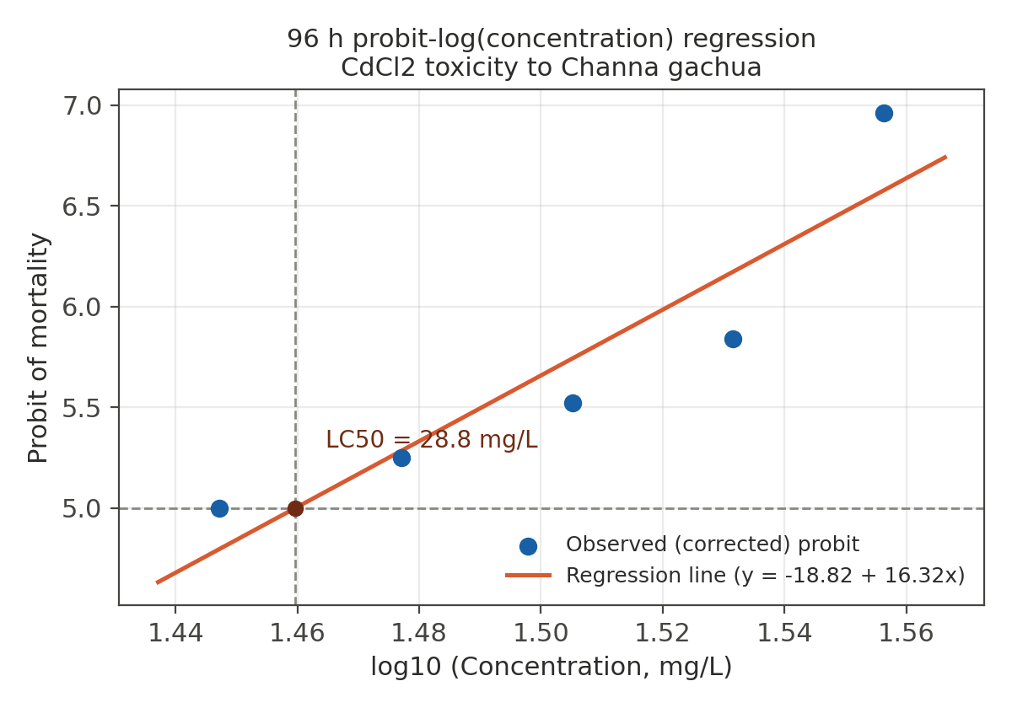
Figure 2. Log(concentration)–probit regression line for 96-h mortality data. Dashed lines mark the probit-5 (50% mortality) level, intersecting the regression line at LC50 = 28.8 mg/L.

Figure 3
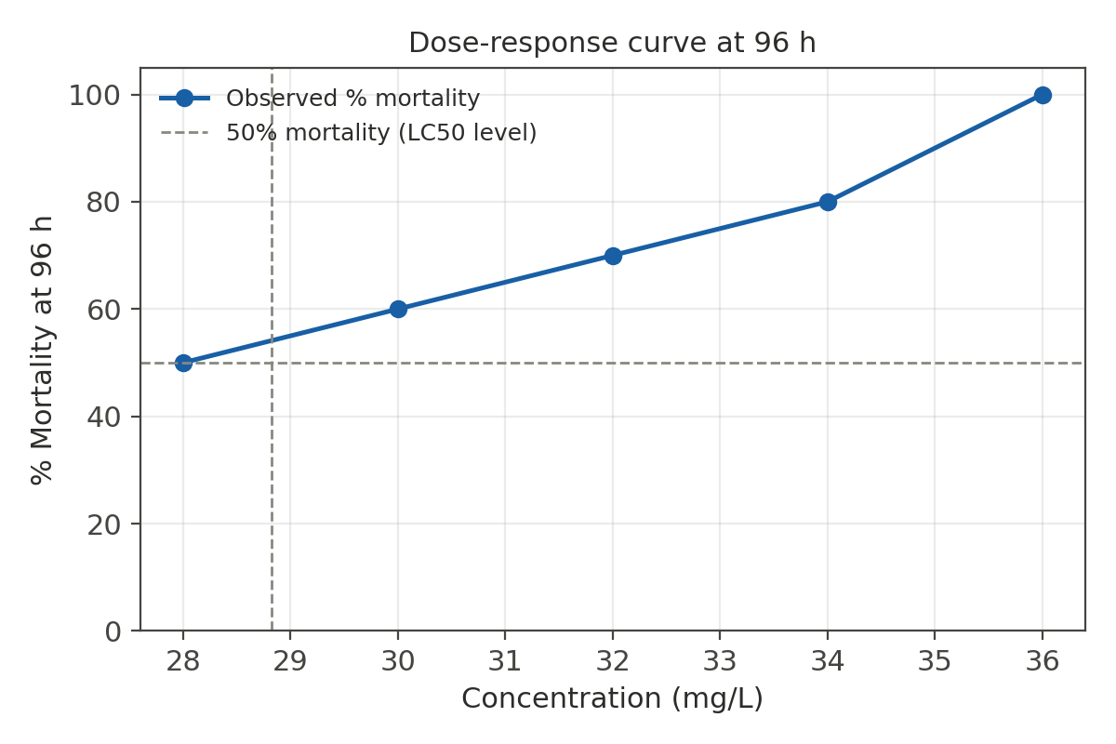
Figure 3. Observed dose-response (% mortality) curve of Channa gachua exposed to CdCl2 for 96 h.

Figure 4
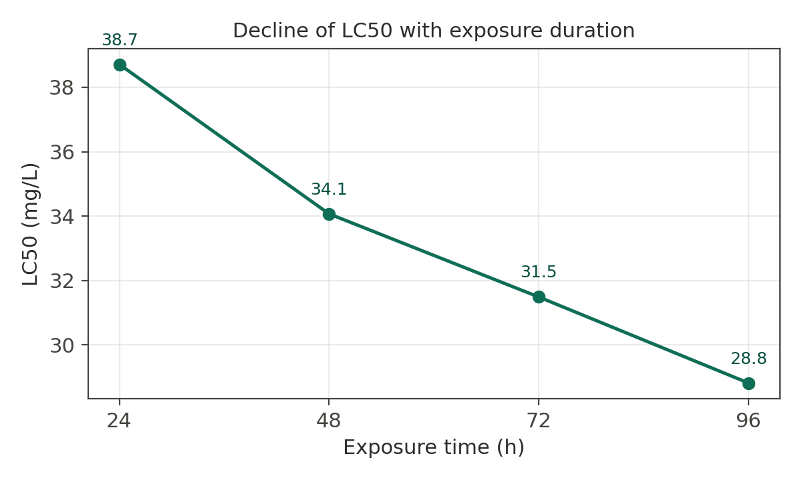
Figure 4. Decline in LC50 with increasing exposure duration, illustrating the time-dependence of acute cadmium toxicity.

3.3 Behavioural and Morphological Alterations
Fish exposed to CdCl₂ exhibited a clear, concentration-dependent progression of behavioural and morphological disturbance, broadly consistent with the cadmium-toxicity syndrome previously described for the congener Channa punctatus (Singh & Saxena, 2020; Salibián, 2009; Almeida et al., 2009).
Behavioural disturbances such as loss of equilibrium, altered activity, respiratory difficulty, frequent surfacing, and increased mucus secretion have been reported in other fish exposed to cadmium, although the intensity and sequence of responses vary among species and exposure conditions. Mechanistically, branchial cadmium exposure can impair calcium transport and alter gill epithelial function, providing a plausible physiological basis for ventilatory and stress-related responses without implying a specific mechanism from behavioural observations alone (Galiba et al., 2024; Verbost et al., 1987; Wong & Wong, 2000).
Table 5. Behavioural and morphological observation record (template – to be completed with author’s field data)
Sign observed | Control | Low (~28–30 mg/L) | Mid (~32–34 mg/L) | High (~36 mg/L)
Erratic / darting swimming | Absent | - | + | ++
Loss of equilibrium | Absent | − | + | ++
Surfacing / air-gulping frequency | Normal | + | ++ | ++
Opercular (ventilatory) rate | Normal | + | ++ | +++
Excess mucus secretion | Absent | + | ++ | +++
Body discoloration / pigmentation change | Absent | + | ++ | ++ (pigmented patches)
Skin/fin haemorrhage or lesion | Absent | − | − | +
Response to external stimuli | Normal | Slightly reduced | Reduced | Markedly reduced
Lying motionless at surface (pre-mortality sign) | Absent | − | + | ++
Grade using a simple scale, e.g., – (absent), + (mild/occasional), ++ (moderate/frequent), +++ (severe/persistent), consistent with the scoring approach used in comparable cadmium-behavioural studies.

3.4 Photographic Observations
Representative photographs recorded during the exposure period are presented in Figure 5, illustrating the external morphological condition of control fish alongside fish exposed to sub-maximal and near-lethal CdCl₂ concentrations at 96 h.
The photographs provide qualitative visual documentation of external condition across the exposure groups and are best interpreted as complementary evidence to the mortality and behavioural observations. Published cadmium-exposure studies have documented concentration-related behavioural abnormalities and structural gill injury, but external photographs alone cannot establish histopathological lesions or tissue-specific mechanisms. Accordingly, the visible changes in Figure 5 should be described conservatively as external morphological observations pending histological or tissue-level confirmation (Galiba et al., 2024; Liu et al., 2022; Wong & Wong, 2000).

Figure 5
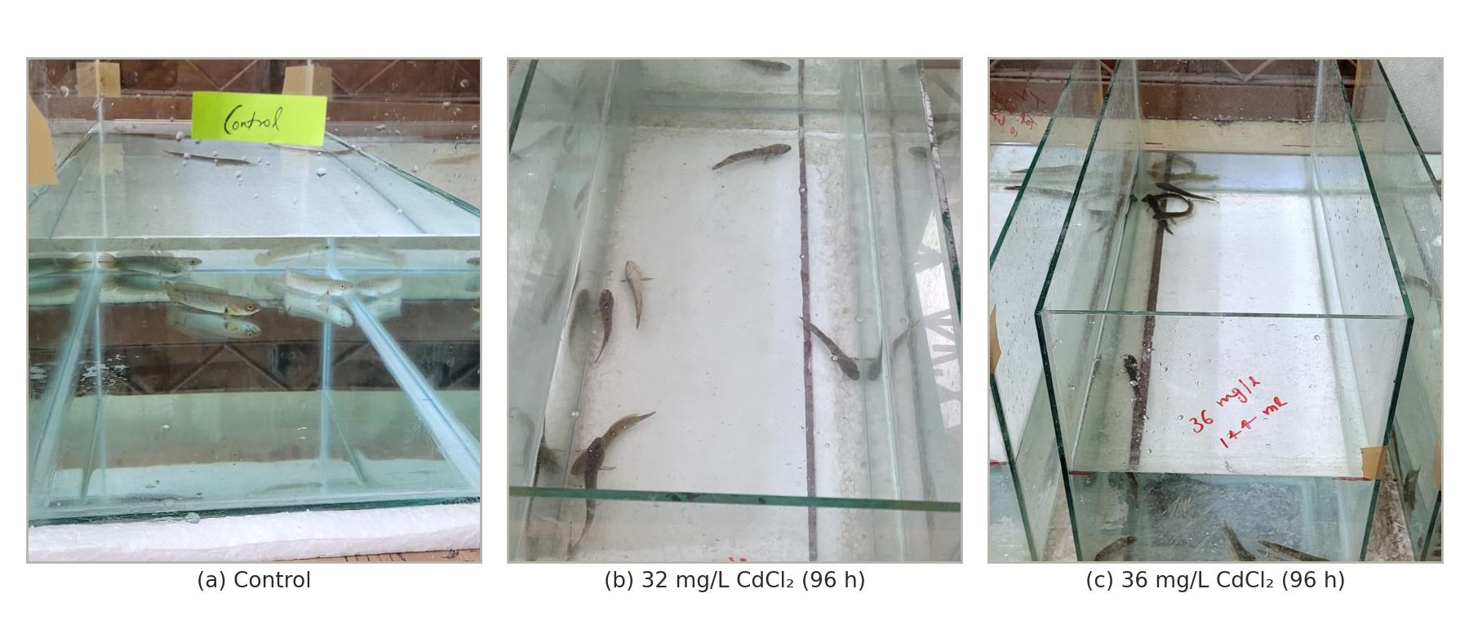
Figure 5. Representative photographs of Channa gachua at 96 h: (a) control, (b) 32 mg/L CdCl₂, and (c) 36 mg/L CdCl₂, illustrating concentration-dependent external morphological changes.

The present study establishes, for the first time, the acute toxicity profile of cadmium chloride in Channa gachua, with a 96-h LC50 of 28.8 mg/L. Mortality increased in a clear concentration- dependent and time-dependent manner, consistent with the classical acute toxicity pattern reported for cadmium across freshwater teleosts (Yu et al., 2024; World Health Organization, 1992).
Comparison with the congeneric species Channa punctata is particularly informative. Verma (Verma, 2023) reported 24, 48, 72 and 96-h LC50 values of 26.88, 18.76, 16.70 and 14.95 mg/L respectively for CdCl₂ in C. punctata – approximately half the 96-h LC50 obtained here for Channa gachua (28.8 mg/L). A broadly comparable pattern of higher tolerance in Channa gachua is also suggested when set against cadmium toxicity data for other freshwater species, such as Oreochromis niloticus (Al-Asgah et al., 2015). This apparent inter- and intra-generic difference in cadmium sensitivity may reflect genuine physiological factors – including differences in body size, gill surface area to body mass ratio, mucus production, or the relative contribution of accessory air-breathing to overall gas exchange and metal uptake pathways – rather than a methodological artefact, and merits dedicated comparative investigation. It is also possible that differences in water hardness, temperature, or fish size between studies contributed to the observed variation, as these factors are well known to modulate the acute toxicity of cadmium to fish.
The concentration-dependent behavioural alterations noted in the present study – including surfacing/air-gulping changes, altered opercular movement, and abnormal swimming – mirror the toxicity syndrome described in C. punctatus exposed to cadmium (Singh & Saxena, 2020), and are consistent with the broader literature on cadmium’s disruptive effects on fish ventilatory and locomotory behaviour (Bishop & McIntosh, 1981; Atchison et al., 1987; Salibián, 2009). Cadmium is known to interfere with branchial ion transport and gill epithelial integrity, provoking compensatory increases in ventilation and surfacing behaviour, while central and peripheral neurotoxic effects likely underlie the loss of equilibrium and erratic swimming observed at higher concentrations (Yu et al., 2024). Increased mucus secretion and surface discoloration, when observed, are consistent with a generalized stress and epidermal irritation response reported across cadmium-exposed fish species, including aggressive-behaviour and stress-marker changes documented in cadmium-exposed tilapia (Almeida et al., 2009).
Because Channa gachua relies on periodic surfacing for aerial respiration through its suprabranchial chamber (Olson et al., 1994), it is plausible that this species experiences disproportionate exposure to cadmium concentrated at the air–water interface relative to strictly water-breathing fish, an ecological consideration previously highlighted in comparative toxicity work on this species (Dhara et al., 2021). This physiological trait strengthens the ecological relevance of Channa gachua as a sentinel species for surface-water metal contamination in shallow wetland habitats, even though its acute LC50 in the present study did not indicate exceptional sensitivity relative to its congener.
Limitations of the present study include the absence of internal (tissue) cadmium bioaccumulation data and histopathological confirmation of the observed external signs; these represent natural extensions for future work, alongside the planned sub-lethal, 15-day chronic exposure trial at 1/4th of the determined LC50 to characterise haematological, hepatic and renal biomarker responses in this species.

4. Conclusion
The present 96-h bioassay demonstrated acute mortality and behavioural disturbance in Channa gachua exposed to nominal cadmium chloride concentrations of 28–36 mg/L. The estimated LC50 decreased from 38.7 mg/L at 24 h to 28.8 mg/L at 96 h, indicating greater mortality with increasing exposure duration. Behavioural changes included altered swimming, equilibrium, surfacing, opercular activity and mucus production. These findings characterize the acute response of C. gachua under the laboratory conditions used in this study. Comparisons with other species should be made cautiously because cadmium toxicity can vary with experimental conditions, fish characteristics and water chemistry. Further replicated studies incorporating verified exposure concentrations, tissue measurements and histopathological assessment would help clarify the toxicological response of this species.
Declaration of AI Use

This manuscript was prepared through the combined contributions of all author(s), including contributions to the study design, data, content development, results, interpretation, and related scholarly work. The author(s) acknowledge the use of Grammarly and ChatGPT to assist with grammar checking, language refinement, reference formatting. These AI-assisted tools were not used as authors and did not replace the intellectual contributions or scholarly judgment of the author(s). All AI-assisted outputs, including content, references, and interpretations, were carefully reviewed, revised, verified, and approved by the author(s). The author(s) accept full responsibility for the accuracy, integrity, and final content of the manuscript.

COMPETING INTERESTS DISCLAIMER:
Authors have declared that they have no known competing financial interests OR non-financial interests OR personal relationships that could have appeared to influence the work reported in this paper.

References

Al-Asgah, N. A., Abdel-Warith, A. W. A., Younis, E. S. M., & Allam, H. Y. (2015). Haematological and biochemical parameters and tissue accumulations of cadmium in Oreochromis niloticus exposed to various concentrations of cadmium chloride. Saudi Journal of Biological Sciences, 22(5), 543–550. https://doi.org/10.1016/j.sjbs.2015.01.002

Almeida, J. A., Barreto, R. E., Novelli, E. L. B., Castro, F. J., & Moron, S. E. (2009). Oxidative stress biomarkers and aggressive behavior in fish exposed to aquatic cadmium contamination. Neotropical Ichthyology, 7(1), 103–108. https://doi.org/10.1590/S1679-62252009000100013

American Public Health Association. (2017). Standard methods for the examination of water and wastewater (23rd ed.). American Public Health Association. https://www.standardmethods.org/

Atchison, G. J., Henry, M. G., & Sandheinrich, M. B. (1987). Effects of metals on fish behavior: A review. Environmental Biology of Fishes, 18(1), 11–25. https://doi.org/10.1007/BF00002324

Bishop, W. E., & McIntosh, A. W. (1981). Acute lethality and effects of sublethal cadmium exposure on ventilation frequency and cough rate of bluegill (Lepomis macrochirus). Archives of Environmental Contamination and Toxicology, 10, 519–530. https://doi.org/10.1007/BF01054876

Deore, S. V., & Wagh, S. B. (2012). Effect of heavy metals (mercuric chloride and copper chloride) on histopathology of liver of Channa gachua (Ham.). https://scholar.google.com/scholar?q=%22Effect+of+heavy+metals%22+%22Channa+gachua%22+Deore+Wagh

Dhara, K., Saha, S., Mukherjee, D., & Saha, N. C. (2021). Comparative acute toxicity of mercury to air breathing fish, Channa gachua (Ham.) and non-air breathing fish Cyprinus carpio (Linn.): Ethological and haematological consideration. Indian Journal of Ecology, 48(5), 1243–1253. https://indianjecol.org/

Ferro, J. P., Ferrari, L., & Eissa, B. L. (2021). Acute toxicity of cadmium to freshwater fishes and its relationship with body size and respiratory strategy. Comparative Biochemistry and Physiology Part C: Toxicology & Pharmacology, 248, 109109. https://doi.org/10.1016/j.cbpc.2021.109109

Finney, D. J. (1971). Probit analysis (3rd ed.). Cambridge University Press. https://www.cambridge.org/

Galiba, A., Eshik, M. M. E., & Rahman, M. S. (2024). Toxic effects of cadmium chloride on behavior and histopathology of butter catfish Ompok pabda (Hamilton, 1822). Journal of Bangladesh Academy of Sciences, 48(2), 217–230. https://doi.org/10.3329/jbas.v48i2.73000

Garcia-Santos, S., Fontaínhas-Fernandes, A., & Wilson, J. M. (2006). Cadmium tolerance in the Nile tilapia (Oreochromis niloticus) following acute exposure: Assessment of some ionoregulatory parameters. Environmental Toxicology, 21(1), 33–46. https://doi.org/10.1002/tox.20152

Histopathological changes in the liver of Channa gachua (Bloch) exposed to biofertilizer (mustard oil cake). (2018–2019). https://www.researchgate.net/publication/336401730_Histopathological_Changes_in_the_Liver_of_Channa_Gachua_Bloch_Exposed_to_Biofertilizer

Histopathological study of Channa gachua exposed to Malathion. (2021). International Journal of Fisheries and Aquatic Studies, 9(3). https://www.fisheriesjournal.com/

Kawade, S. (2020). Histopathological alterations in the liver of freshwater fish, Channa gachua (Ham.) on acute exposure to nickel. Journal of Emerging Technologies and Innovative Research, 7, 1025–1030. https://www.jetir.org/papers/JETIR2010137.pdf

Liu, Y., Chen, Q., Li, Y., Bi, L., Jin, L., & Peng, R. (2022). Toxic effects of cadmium on fish. Toxics, 10(10), 622. https://doi.org/10.3390/toxics10100622

OECD. (2019). Test No. 203: Fish, acute toxicity test. OECD Guidelines for the Testing of Chemicals, Section 2. OECD Publishing. https://doi.org/10.1787/9789264069961-en

Olson, K. R., Roy, P. K., Ghosh, T. K., & Munshi, J. S. D. (1994). Microcirculation of gills and accessory respiratory organs from the air-breathing snakehead fish, Channa punctata, C. gachua, and C. marulius. The Anatomical Record, 238(1), 92–107. https://doi.org/10.1002/ar.1092380111

Salibián, A. (2009). Quantitative behavioral parameters as toxicity biomarkers: Fish responses to waterborne cadmium. Archives of Environmental Contamination and Toxicology. https://doi.org/10.1007/s00244-009-9434-4

Singh, N., & Saxena, B. (2020). Behavioral and morphological changes in fresh water fish, Channa punctatus under the exposure of cadmium. Environment Conservation Journal, 21(3). https://doi.org/10.36953/ECJ.2020.21323

Singh, N. P., & Siddique, N. A. (2018). Effects of certain pesticides on the histopathology of gills of an air breathing fish Channa gachua (Bloch). https://scholar.google.com/scholar?q=%22Effects+of+certain+pesticides%22+%22Channa+gachua%22

Tarigan, R. R., et al. (2016). Physiological studies of snakehead fish (Channa gachua) reared in different substrate treatments. International Journal of ChemTech Research, 9(7), 404–411. https://scholar.google.com/scholar?q=%22Physiological+studies+of+snakehead+fish%22+%22Channa+gachua%22

Verbost, P. M., Flik, G., Lock, R. A. C., & Wendelaar Bonga, S. E. (1987). Cadmium inhibition of Ca2+ uptake in rainbow trout gills. American Journal of Physiology-Regulatory, Integrative and Comparative Physiology, 253(2), R216–R221. https://doi.org/10.1152/ajpregu.1987.253.2.R216

Verma, A. K. (2023). Impact of cadmium on haematological parameters of freshwater snakeheaded fish, Channa punctata (Bloch). Journal of Experimental Zoology India, 26(1), 345–348. https://doi.org/10.51470/jez.2023.26.1.345

Wong, C. K. C., & Wong, M. H. (2000). Morphological and biochemical changes in the gills of tilapia (Oreochromis mossambicus) to ambient cadmium exposure. Aquatic Toxicology, 48(4), 517–527. https://doi.org/10.1016/S0166-445X(99)00060-0

World Health Organization. (1992). Cadmium: Environmental aspects (Environmental Health Criteria 135). World Health Organization. https://iris.who.int/

Yu, Y. B., Lee, J. W., Jo, A. H., Choi, Y. J., Choi, C. Y., Kang, J. C., & Kim, J. H. (2024). Toxic effects of cadmium exposure on hematological and plasma biochemical parameters in fish: A review. Toxics, 12(10), 699. https://doi.org/10.3390/toxics12100699

