MOLECULAR DETECTION AND PHYLOGENETIC ANALYSIS OF CPB2 GENE OF CLOSTRIDIUM PERFRINGENS ISOLATED FROM NECROTIC ENTERITIS CASES OF POULTRY

ABSTRACT
Necrotic enteritis (NE) is a common and economically important intestinal disease of poultry caused primarily by Clostridium perfringens. C. perfringens, is a gram-positive spore forming anaerobe. It affects broiler chickens most commonly between 2 and 6 weeks of age, although other poultry species can also be affected.
C. perfringens produces variety of toxins and on the basis of production of toxins, it has been classified into seven toxinotypes namely toxinotype A to toxinotype G. Apart from this, some minor toxins like CPB2 is also produced. CPB2 is a pore forming toxin responsible for enteritis commonly in piglets. In the present study, total 62 intestinal samples and cloacal swabs were collected from poultry showing the signs of necrotic enteritis. Isolation of C. perfringens was performed using standard bacteriological methods, and the isolates were confirmed molecularly by 16S rRNA gene PCR. Of the 57 confirmed C. perfringens isolates, all were screened for the presence of the cpb2 gene using PCR. Five isolates were found to harbor the cpb2 gene. Multiple sequence alignment of the cpb2 gene from two representative isolates revealed that the CPB2 toxin sequence is highly conserved among most C. perfringens isolates, whereas one isolate exhibited comparatively greater genetic variability. Phylogenetic analysis demonstrated that one isolate clustered closely with previously reported cpb2-positive poultry-derived C. perfringens strains from India as well as other countries, rather than forming a distinct evolutionary lineage. These findings suggest that Indian cpb2-positive C. perfringens isolates share close genetic relatedness with globally circulating poultry-associated strains, indicating a high degree of conservation of the cpb2 gene across geographically diverse isolates.
Keywords: Necrotic enteritis, Poultry, PCR, 16SrRNA , cpb2, Phylogenetic analysis
Introduction
Necrotic Enteritis is a disease of major economic importance affecting the poultry industry worldwide. Globally, the cost of the disease estimated to be over US$2 billion per year due to decrease in production performance, disease treatment expenses and condemnation of carcasses in production plants due to cholangiohepatitis (Immerseel et.al., 2004, and Timbermont et.al., 2011).
Necrotic enteritis causes the inflammation of the intestine leading to sudden increase in mortality without any significant clinical symptoms in poultry birds. Meanwhile, the subclinical form becomes more prevalent and is characterized by decreased nutrient digestibility, absorption, feed conversion rate and intestinal mucosal damage. It primarily affects chickens of 2 weeks to 6 months of age.
Clostridium perfringens, the main causative agent of necrotic enteritis, is a boxcar-shaped, Gram-positive, encapsulated, non-motile rod that forms spores and is an aero-tolerant anaerobe. It is a natural resident in the soil and the intestinal tract of warm-blooded mammals. C.perfringens is a major toxin producing organisms. These toxins are virulent and are responsible for causing different forms of enteric disease and enterotoxaemia in various hosts including human beings and animals. Based on the production of these major toxins i.e alpha, beta, epsilon, iota, enterotoxin, and necrotic enteritis B-like toxin, C. perfringens is been classified into seven toxinotypes namely types A, B, C, D, E, F, and G (Baums et al., 2004). The detection of C. perfringens toxin types and subtypes is necessary for a better understanding of the epidemiology and the virulence factor associated with C. perfringens infections (Baums et al., 2004).
Along with the major toxins, one of the minor toxin which is commonly seen associated with C. perfringens is Beta2 toxin (CPB2), with a molecular weight (MW) of approximately 28 kDa, and it was initially identified in a C. perfringens strain isolated from a piglet that died of necrotizing enterocolitis (Gibert M et al., 1997). The cpb2 gene is plasmid-borne, which suggest the potential for mobility and the subsequent transfer of cpb2 among strains of C. perfringens (Shimizu et al. 2002b). The biological activity of the 28kDa mature beta2 toxin is well comparable with that of the beta toxin. The CPB2 toxin may act as a potential pore forming toxin normally seen associated with non foodborne diaarhoea and is highly susceptible to proteolytic digestion. The toxin may also act in the synergy with other major toxins of C. perfringens in production of necrotic and haemorrhagic enteritis (Schotte et al., 2004) and CPB2 toxin is widely associated as a contributor to C. perfringens related enteric diseases in different animal species (Garmory et al., 2000). Subsequently, several studies have reported its presence in C. perfringens strains isolated from cases of enteritis and enterotoxaemia in both humans and animals (Manteca C et al., 2002, Waters et al., 2005).

MATERIAL AND METHODS
Collection of the samples:
Total 54 intestinal sections showing the gross lesions of necrotic enteritis were collected aseptically from dead poultry birds and 08 cloacal swabs were collected from ailing and affected birds showing the signs of depression, diarrhoea. Intestinal samples were collected from post-mortem cases of necrotic enteritis poultry showing the characteristic lesion of balloning of intestine, sloughing of mucosa and thin friable wall. Samples were collected from different regions of Maharashtra, India. Samples collected in a sterile sample bottle, labelled, and directly sent to the laboratory in an ice-cooled containers. On arrival samples were stored at -20ºC until further use.
Isolation and Identification of C. perfringens
For isolation of Clostridium perfringens, freshly prepared Robertson’s cooked meat medium (RCCM) was used. All the collected intestinal content and cloacal swabs were inoculated in the RCMM and incubated anaerobically in an anaerobic jar with an anaero gas pack (AnaeroGas Pack, Himedia) at 37°C for 48 hrs. After incubation, loopful of inoculum from RCMM were streaked on selective agar plates. Perfringens agar base with Tryptose Sulphite Cycloserine supplement (Himedia, India) was used as selective agar. The inoculated plates were incubated for 24 hours at 37°C anaerobically with an anaerogas pack. The characteristic appearance of black colonies was considered presumptive for C. perfringens. Pure cultures thus obtained were further processed for conventional biochemical analysis and molecular characterization. The identification of isolated bacteria was carried out by Gram’s staining. Presumptive isolates of C. perfringens were further subjected to biochemical characterization using biochemical tests viz. Oxidase test, Catalase test, Stormy clot fermentation test (Koneman et al.,1992 and Macfaddin et al., 2000).
Extraction of bacterial genomic DNA
Bacterial genomic DNA was prepared from each isolates of C. perfringens for their molecular characterization, following the method described by Titball et al., (1989) with slight modification.
After confirming the identity of an isolate to be C. perfringens, about 4-5 suspected colonies from each C. perfringens isolate grown on Perfringens agar after 48 hours of inoculation were directly suspended in 100 μl of sterile nuclease free water. The suspension was boiled for 10 minutes, snap chilled on ice for 10 minutes and then centrifuged at 12,000 rpm for 10 minutes. The supernatants were used as templates and stored at -20ºC for further use. The extracted DNA concentration was measured in Nanodrop Spectrophotometer (Thermofisher Scientific, USA). A volume of 3μl of the supernatant (100-150 ng) was used as templates for the PCR reactions.

Molecular detection of Clostridium perfringens by 16S rRNA gene
Phenotypically positive isolates of C. perfringens were confirmed by amplifying the 16S rRNA gene of the C. perfringens as per Nazki et al., (2017). The oligonucleotide sequence of the primers used in the experiment is given in Table 1.

Table 1 Oligonucleotide sequences of primers for detection of 16S rRNA gene of Clostridium perfringens

Target gene | Primer sequence (5′-3′) | Product  Size (bp) | Reference
16S rRNA (F) | TAACCTGCCTCATAGAGT | 481 | Nazki et al., (2017)
16S rRNA (R) | TTTCACATCCCACTTAATC | 481 | Nazki et al., (2017)

Uniplex PCR was performed in a 96-well Thermal cycler PCR system (Applied biosystem). PCR was performed by preparing final reaction volume of 20μl in 0.2 ml thin walled PCR tubes. It was prepared by taking 12μl master mix supplied with Taq DNA, MgCl2 and dNTPs; adding 1μM each of forward and reverse primers, 100ng template DNA and 5μl nuclease free water. Samples were subjected to 35 PCR cycles, each consisting of initial denaturation for 02 min at 94°C; 30 sec of denaturation at 94°C; 30 sec of annealing at 56°C, and 1 min of elongation at 72°C. The final amplified PCR products were subjected to electrophoresis in 1.5% agarose gel after staining with ethidium bromide (5μl /100 ml).

Molecular detection of cpb2 toxin of C. perfringens
PCR reaction was performed according to Nazki et al. (2017) for the genes cpb2 encoding for C. perfringens minor Beta toxin. PCR mixture was performed in 25 μl containing 12.5 μl of PCR Mastermix containing dNTPs, Taq DNA polymerase, buffer, MgCl2 (M/s. HiMedia Pvt. Ltd. Mumbai), 6.5 μl of nuclease free water, 1 μl of each reverse and forward primers with a concentration of 10 pmol and 4 μl of DNA template. This reaction mixture was further subjected to thermal cycling (Applied biosystem) using cyclic conditions each consisting of initial denaturation for 15 min at 95°C; 30 sec of denaturation at 94°C; 90 sec of annealing at 49°C, and 90 sec of elongation at 72°C. The final extension was set up to 72°C 10 min. The final amplified PCR products were subjected to electrophoresis in 1.5% agarose gel after staining with ethidium bromide (5μl /100 ml).

Table 2 Oligonucleotide sequence of the primers of cpb2 gene Clostridium perfringens

Target gene | Primer sequence (5′-3′) | Product  Size (bp) | Reference
CPB2 (F) | AAATATGATCCTAACCAACAA | 548 | Nazki et al., (2017)
CPB2 (R) | CCAAATACTCTAATYGATGC | 548 | Nazki et al., (2017)

Multiple sequence alignment and Phylogenetic analysis of cpb2 toxin gene
The widespread distribution of cpb2 toxin gene in C. perfringens isolates and its role in causing enteric disease in animals is very well recorded (Garmory et al., 2000). The cpb2 toxin is plasmid-borne, which suggests that there is an opportunity for mobility and subsequent transmission of the cpb2 toxin gene among C. perfringens strains. To study the evolutionary status, a cpb2 toxin gene, PCR product of two cpb2 toxin genes of C. perfringens isolates were selected from separate diseased flocks, and were submitted to Genomic, Pune, Pvt. Ltd India for sequencing.
Multiple amino acid sequence alignment was performed to compare the deduced CPB2 protein sequences of the two Indian C perfringens isolates (PZ547700 and PZ547701) with seven reference sequences retrieved from GenBank (AY884035–AY884041) and one additional reference sequence (MF471364). The alignment comprised approximately 270 amino acid positions and demonstrated an overall high degree of sequence conservation among the reference strains. The multiple sequence alignment image was generated using Jalview 2.11.5.2.
Sequences of the present isolate and 20 selected GenBank sequences with 96–99% homology from different parts of the world were manually trimmed and subjected to multiple sequence analysis using BioEdit 7.2.5 software (Hall 1999). The sequences were aligned against the Sequences of C. perfringens isolated from poultry birds from other parts of the world and India. The sequences showed 96-99% homology against the sequences used. The aligned sequences were subjected to phylogenetic analysis using the Maximum Parsimony method in MEGA 11 (Hall 1999). Similarly, the to-be-published partial sequences of the cpb2 gene (PZ547700 and PZ547701) were subjected to multiple sequence analysis against selected GenBank sequences with 98–99% homology from different parts of the world. All multiple-aligned partial cpb2 amino acid sequences were subjected to phylogenetic analysis by the Maximum Parsimony method using MEGA.11 software (Tamura and Kumar 2021). The sequence data were submitted to GenBank under the accession numbers PZ547700 and PZ547701. The following accession numbers for C. perfringens beta2-toxin gene sequences were employed for multiple alignment and phylogenetic analyses: AY609162 (JGS1604 strain, a non-porcine isolate representative of atypical beta2-toxin sequence), L77965 (CWC245 strain, a porcine isolate representative of consensus beta2-toxin sequence), AY884035 (ARS-CP13 strain, a poultry isolate), AY884036 (ARS-CP25 strain, isolated from poultry), AY884037 (ARS-CP30 strain, a poultry isolate), AY884038 (ARS-CP38 strain, also a poultry isolate), AY884039 (ARS- CP39 strain, a poultry isolate), AY884040 ( ARS-CP39 strain, also a poultry isolate) MF471364 (Clostridium perfringens strain Ind_AP_GCpa1 beta2 toxin), MF471365 (Clostridium perfringens strain Ind_AP_GCpa1 beta2)AJ537533 (CF5 strain, a porcine isolate), DQ525205 (47001c12 strain, an isolate from enterotoxemic cattle), AJ537534 (E482/97 strain, a horse isolate), AY730631(F4406 strain, an isolate from a human with gastrointestinal disease) and AY730634 (F4589 strain, an isolate from a human with gastrointestinal disease), KX924463 (Isolate from Goat Pakistan), HQ853334 (Isolate from Sheep, Iran), GU581183, GU581184 and GU581185 (Isolates from poultry Iran).

Results and Discussion:
Occurrence of Clostridium perfringens
Out of a total of 62 samples comprising 54 intestinal content samples and 08 cloacal swabs, 57 samples were culturally positive for Clostridium perfringens, including 52/54 (96.29%) intestinal content samples and 05/08 (62.5%) cloacal swabs. Confirmation was based on cultural and biochemical characteristics. Initially, inoculation in RCMM resulted in heavy turbidity turning the meat particle pink in colour after 24 hours of incubation. Following incubation, growth on Clostridium perfringens selective agar with supplements (TSC) produced black colonies with sulphite reduction (Photo 1). Similar findings of black coloured colonies were observed by Shoukat et al.,(2018) on perfringens agar base with TSC supplement. Gram staining of the isolates revealed Gram-positive rods. Organisms failed to produce purple colour on filter paper containing Oxidase reagent and proved that the organisms were Oxidase negative. None of the isolates produced effervescence and hence were Catalase negative. The hanging drop method for motility, revealed that all the organisms of C. perfringens were nonmotile. All isolates exhibited stormy fermentation in litmus milk medium confirming their biochemical identity as C. perfringens. These isolates were subsequently subjected to molecular based identification of C. perfringens by 16S rRNA species specific PCR.
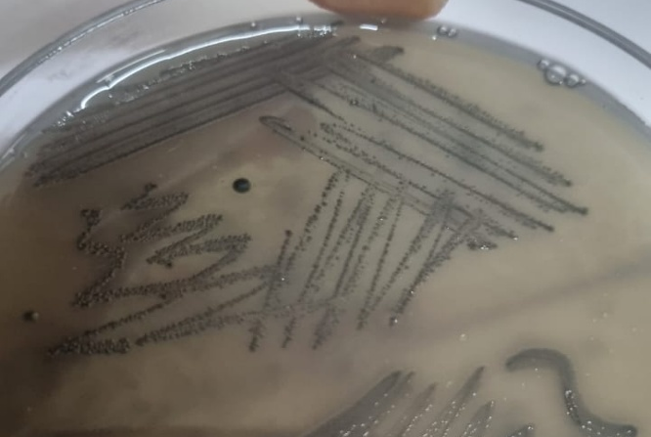

Photo: 1 Black colonies of C. perfringens on Clostridial agar with TSC supplement

Molecular detection of Clostridium perfringens by species-specific PCR
The morphologically and biochemically identified isolates were further confirmed by 16S rRNA species-specific PCR using specified primers. All the 57 culturally positive isolates were subjected to 16S rRNA species-specific PCR of C. perfringens. Molecular characterization proved that all 57 (100%) isolates were positive for C. perfringens 16Sr RNA PCR showing an amplicons size of 481 bp (Fig:1). These present findings are in close association with Shoukat et al, .(2018) and Rasool et al.,(2017) who reported amplicon of 481bp by the species-specific 16S rRNA PCR from all the isolates which were culturally identified as C. perfringens from the samples of necrotic enteritis cases of poultry birds.
Our findings demonstrate that 16S rRNA PCR is an effective tool for confirming C. perfringens isolates. Similar molecular approaches have been widely employed in previous studies for bacterial identification because the 16S rRNA gene contains highly conserved regions suitable for genus- and species-level identification. Although the study by Wang et al., (2025) focused primarily on the seroprevalence, isolation, comprehensive characterization, and pathogenicity of C. perfringens isolated from yaks in Xizang, China, it also highlighted the importance of accurate molecular confirmation as part of the characterization process. Our findings are in agreement with these reports and support the incorporation of molecular confirmation alongside conventional bacteriological methods to improve the accuracy of C. perfringens identification
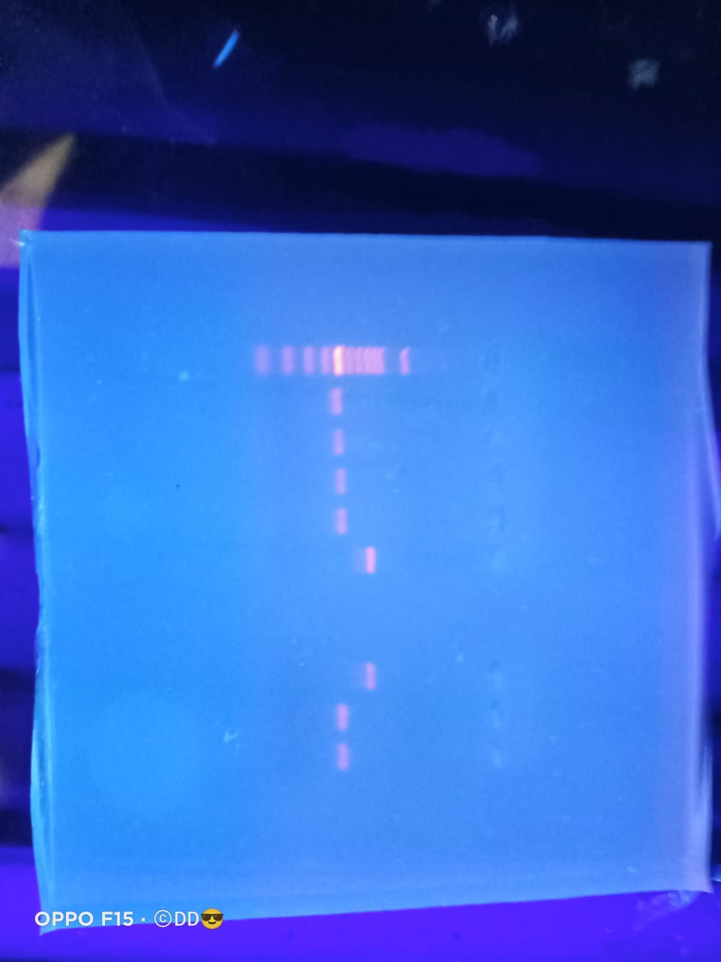
N
L
P
1
2
3

Fig: 1 Agarose gel showing 481 bp of C.perfringnes (Species specific PCR)
Lane L- 100 bp DNA Ladder
Lane P- Positive Control
Lane 1,2,3,- Positive samples

Genotypic detection of cpb2 gene Clostridium perfringens
Several epidemiological studies had recorded the presence of cpb2 toxins in different animal species like cattle, pigs, horses, small ruminant animals, domestic carnivores, many wildlife species and humans (Schotte et al.,2004). In the present study, 57 molecularly confirmed Clostridium perfringens isolates were screened for the presence of the cpb2 gene, of which 05 (8.8%) isolates were found to be positive and showed an amplicon size of 548bp (Fig:2) Considerable variation has been reported in the prevalence of the cpb2 gene among C. perfringens isolates recovered from poultry affected with necrotic enteritis. Tolooe et al., (2011) reported the highest prevalence (94.4%) of the cpb2 gene in avian necrotic enteritis isolates, whereas Praveen Kumar et al., (2019) observed a prevalence of 57.25%. In contrast, Dar et al., (2017) and Rana et al., (2023) did not detect the cpb2 gene in any of the C. perfringens isolates obtained from poultry with necrotic enteritis.
The marked discrepancies in the reported prevalence of the cpb2 gene among different studies may be attributed to variations in geographical location, poultry management practices, sample size, strain diversity, and molecular detection methods employed. The low prevalence (8.8%) observed in the present study further supports the inconsistent distribution of the cpb2 gene among poultry-derived C. perfringens isolates. Since the role of CPB2 in the pathogenesis of avian necrotic enteritis remains controversial, further investigations involving gene expression analysis, toxin production, and pathogenicity studies are needed to know the exact role of the same in disease production.
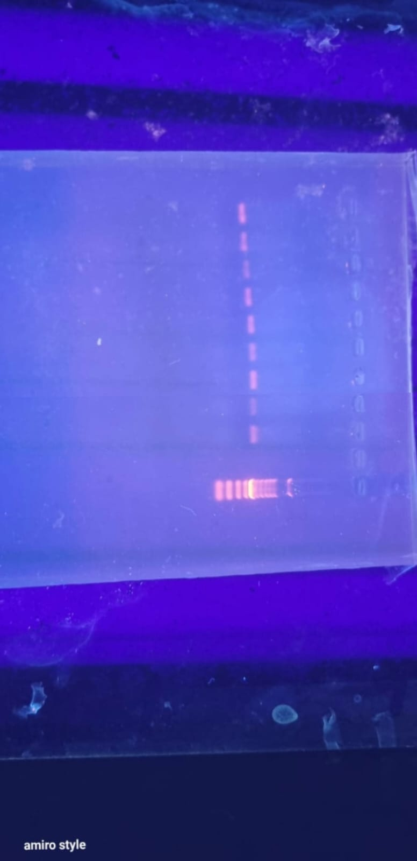
4
3
2
1
P
N
L

Fig: 2 Agarose gel showing 548 bp of cpb2 gene of C. perfringens
Lane L- 100 bp DNA Ladder
Lane N- Negative control
Lane P- Positive Control
Lane 1,2,3,4- Positive samples of cpb2 gene

Multiple sequence alignment
Multiple amino acid sequence alignment was performed to compare the deduced CPB2 protein sequences of the two Indian Clostridium perfringens isolates (PZ547700 and PZ547701) with seven reference sequences retrieved from GenBank (AY884035–AY884041) and one additional reference sequence (MF471364). The alignment comprised approximately 270 amino acid positions and demonstrated an overall high degree of sequence conservation among the reference strains (Fig: 3).
The seven GenBank reference sequences (AY884035–AY884041) showed almost identical amino acid sequences in the aligned region, with only minor differences. Key conserved motifs, such as KYDPNQKLKSYEITGSRKIDNGEIF, MEFTVSYIDNKLMVSNMNRISIVNEGK, and several conserved residues at the C-terminal, were consistently present across these isolates, highlighting the strong evolutionary preservation of the CPB2 toxin among previously characterized strains.
Among the Indian isolates, PZ547701 was highly similar to the reference sequences, retaining most of the conserved amino acids throughout the alignment. Only a few amino acid changes and ambiguous residues were found, indicating a close relationship with globally reported CPB2 sequences.
In contrast, PZ547700 showed more sequence variation, with several amino acid substitutions, ambiguous residues, and small insertions/deletions, especially in regions corresponding to positions 60–120 and 180–240. Despite these differences, it still contained several conserved amino acid blocks typical of CPB2 proteins, confirming it as a CPB2 homologue. Comparison with sequence MF471364 revealed that the Indian isolates are more similar to the highly conserved GenBank reference sequences than to this more divergent sequence. The C-terminal region remained highly conserved among the reference strains and PZ547701, while PZ547700 had more substitutions and gaps in this region.
Overall, the multiple sequence alignment showed that the CPB2 toxin is highly conserved among most C. perfringens isolates. The Indian isolate PZ547701 clustered closely with the conserved reference sequences at the amino acid level, whereas PZ547700 displayed more genetic variation. These results suggest limited genetic diversity among Indian CPB2-positive isolates, with conserved regions characteristic of the toxin preserved.

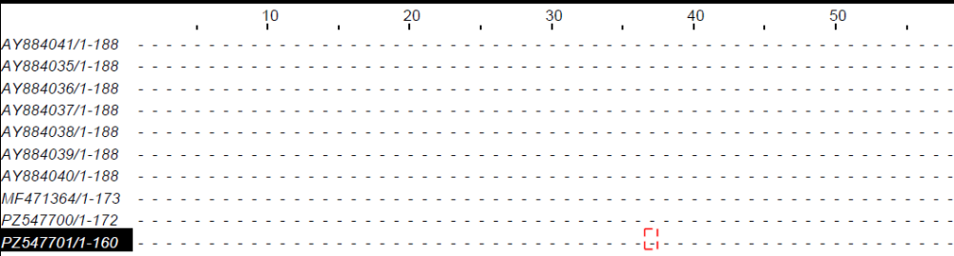

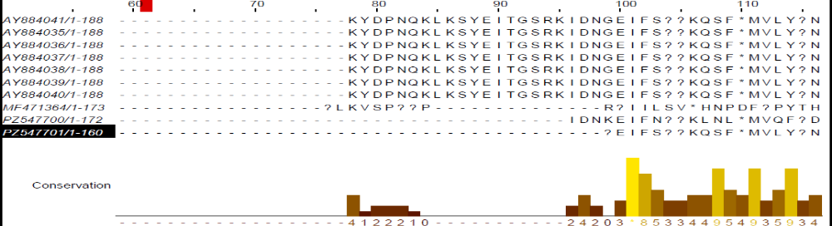

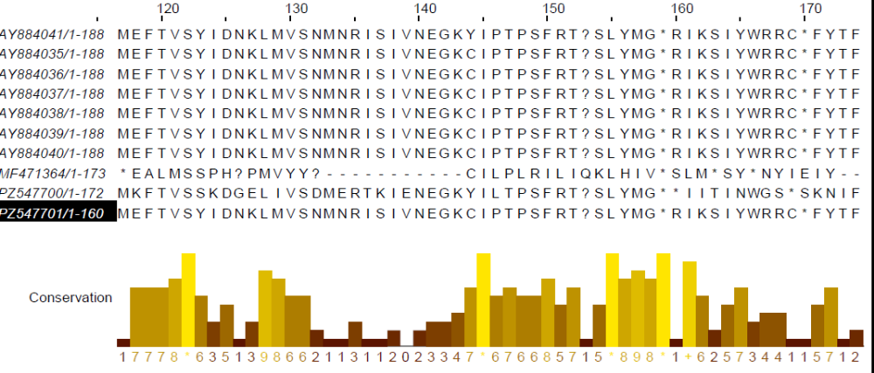

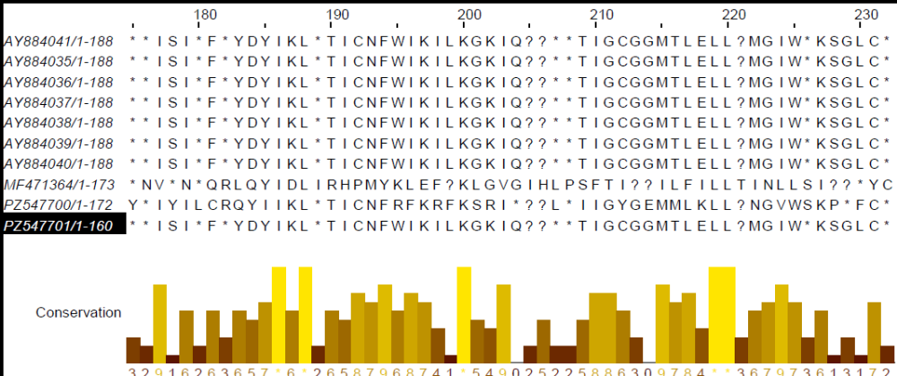
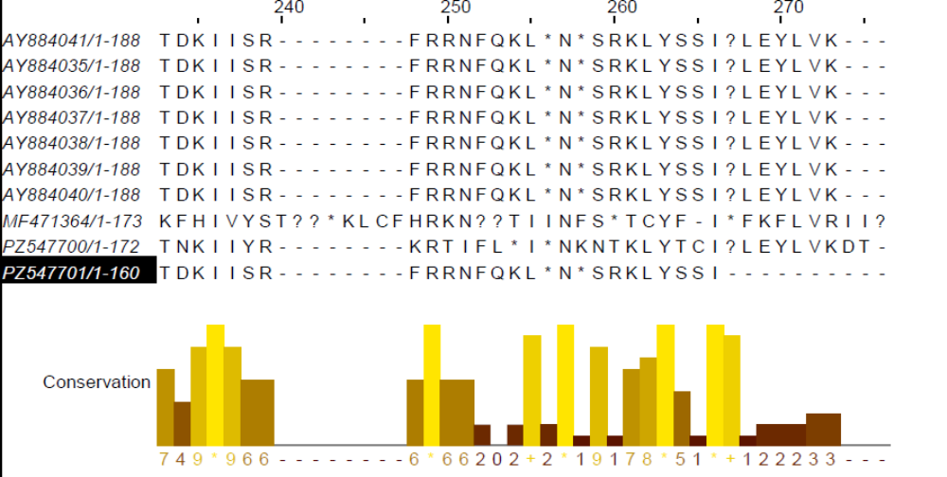

Figure 3. Amino acid sequence alignment of beta2-toxin proteins from two Satara isolates of poultry C. perfringens and the representative sequences with other CPB-2 C. perfringens poultry isolates from other countries.
Phylogenetic analysis of cpb2
Sequence analysis against the Poultry isolates confirmed the sequences are of C.perfringens and are specific to poultry (Figure 1). Phylogenetic analysis of the cpb2 gene sequences of Clostridium perfringens revealed that the isolates clustered into several distinct evolutionary groups, regardless of host species or geographic origin. The tree included isolates from poultry, goats, horses, humans, and non-porcine sources from India, the USA, Iran, Pakistan, Belgium, France, and Switzerland (Figure 4).
The Indian poultry isolate (PZ547701; Satara, India) was closely related to a U.S. poultry isolate (AY884035), forming a well-supported subgroup (bootstrap value = 77%). This cluster also included an Iranian sheep isolate (HQ853334) and another Indian broiler isolate (MF471365), indicating a close genetic connection among poultry isolates from different regions. The moderate bootstrap support (44%) suggested that these share a common ancestor.
Another Indian poultry isolate, PZ547700 (Satara, India), grouped with a Belgian goat isolate (DQ525205), with 89% bootstrap support. This cluster was closely related to a Swiss horse isolate (AJ537534), showing that similar cpb2 variants occur across different hosts. The high bootstrap value (93%) reinforces the reliability of this broader cluster.
Iranian poultry isolates (GU581184 and GU581185) formed a separate subcluster with moderate bootstrap support (44%), indicating a relatively conserved lineage circulating within Iranian poultry populations.
Several U.S. poultry isolates (AY884037, AY884036, AY884038, AY884039, AY884034, and AY884040) were spread across different branches, rather than forming a single monophyletic group. Similarly, isolates from humans (AY730631), non-porcine sources (AY609162), goats (KX924463), horses (AJ537534), Belgian goats (DQ525205), and French poultry (L77965) were intermingled among poultry isolates, suggesting cpb2 sequences are not host-specific.
Bootstrap support across the tree ranged from 9% to 100%. Some internal branches had low support (9–31%), reflecting limited resolution among closely related isolates. However, several major clades had strong support (89%, 93%, 100%), confirming their robustness.
Overall, the phylogenetic analysis shows a high degree of genetic similarity among C. perfringens cpb2 sequences from various hosts and countries, indicating the gene is highly conserved. Notably, the Satara poultry isolates clustered with other reported poultry strains from India and abroad, rather than representing an independent lineage. This suggests Indian isolates are genetically related to globally circulating cpb2-positive C. perfringens strains.

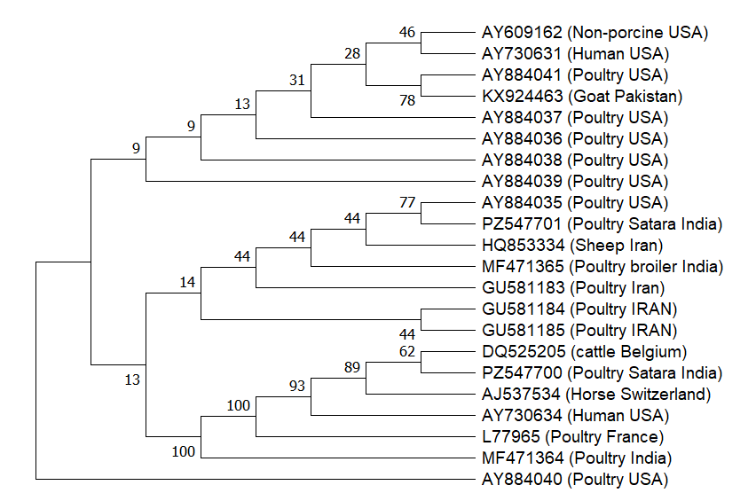

Fig: 4 Phylogenetic analysis of the partial CPB2 gene sequence of the present isolate with selected GenBank sequences. The cpb gene sequence was retrieved from the NCBI GenBank database. The tree was constructed using the Maximum Parsimony method in MEGA11 from 440 multiple-aligned nucleotide sequences of the CPB2 gene. Branch numbers indicate the percentage of bootstrap support from 1000 replicates

Conclusion:
Necrotic enteritis of poultry birds in the present study is caused by Toxin type A. Cpb2 which is one of the minor toxin was also detected in the some of the isolates indicating some sort of virulence relationship among the two. Further study on the association of Toxintype A along with cpb2 need to be studied in detail.
Phylogenetic analysis of the cpb2 gene sequences of C perfringens revealed that the cpb2 gene is highly conserved and Indian isolates are genetically related to globally circulating cpb2-positive C. perfringens strains.

Declaration of AI Use

This manuscript was prepared through the combined contributions of all author(s), including contributions to the study design, data, content development, results, interpretation, and related scholarly work. The author(s) acknowledge the use of Grammarly and ChatGPT to assist with grammar checking, language refinement, reference formatting. These AI-assisted tools were not used as authors and did not replace the intellectual contributions or scholarly judgment of the author(s). All AI-assisted outputs, including content, references, and interpretations, were carefully reviewed, revised, verified, and approved by the author(s). The author(s) accept full responsibility for the accuracy, integrity, and final content of the manuscript.

COMPETING INTERESTS DISCLAIMER:
Authors have declared that they have no known competing financial interests OR non-financial interests OR personal relationships that could have appeared to influence the work reported in this paper.

References

Baums, C. G., Schotte, U., Amtsberg, G., and Goethe, R. (2004). Diagnostic multiplex PCR for toxin genotyping of Clostridium perfringens isolates. Veterinary Microbiology, 100(1-2), 11-16 https://doi.org/10.1016/S0378-1135(03)00126-3

Dar, P. S., Wani, S. A., Wani, A. H., Hussain, I., Maqbool, R., Ganaie, M. Y., Kashoo, Z. A., and Qureshi S. (2017). Isolation, identification and molecular characterization of Clostridium perfringens from poultry in Kashmir valley, India. Journal of Entomology and Zoology Studies. 5(5), 409-414.

Dongjing, Wang., Jiangyong, Zeng., Chunfa, Liu., and Jun, Chu (2026). Seroprevalence, isolation, comprehensive characterization, and pathogenicity of Clostridium perfringens strain from yak in Xizang, China. Scientific Reports, 16(1),12312. doi: 10.1038/s41598-026-42837-w.

Eaftekhar, Ahmed. Rana., Tanvir, Ahmad, Nizami., Md, Sayedul. Islam,, Himel Barua and Md, Zohorul. Islam. (2023) Phenotypical Identification and Toxinotyping of Clostridium perfringens Isolates from Healthy and Enteric Disease-Affected Chickens. Veterinary Medicine International, 8;2023:2584171. doi: 10.1155/2023/258417
Garmory, H.S., Chanter, N., French, N.P., Bueschel, D., Songer, J.G., and Titball, R.W. (2000). Occurrence of Clostridium perfringens beta2 toxin amongst animals determined using genotyping and subtyping PCR assays. Epidemiology and Infection, 124,61-67. https://doi.org/10.1017/S0950268899003295

Gibert, M., Jolivet-Reynaud C., and Popoff, M.R. (1997). Beta2 toxin, a novel toxin produced by Clostridium perfringens. Gene, 203(1),65–73. https://doi.org/10.1016/S0378-1119(97)00493-9.

Hall, T. A. 1999 BioEdit: a user-friendly biological sequence alignment editor and analysis program for Windows 95/98/NT. Nucleic Acids Symposium Series. 41, 95-98

Koneman, E.W., Allen, S.D., Janda, W.M., Schreckenberger, P.C., and Winn WC: Color atlas and textbook of Diagnostic Microbiology. 4th edn., J.B. Lippincott Company, Philadelphia, Pa, 1992.

Macfaddin, J.F.,(2000) Biochemical test for identification of medical bacteria 3rd edn., LippinCott Willians & Wilkins, Philadelphia, Pa.

Manteca, C., Daube, G., Jauniaux, T., Linden, A., Pirson, V., and Detilleux, J.(2002). A role for the Clostridium perfringens beta2 toxin in bovine enterotoxaemia? Veterinary Microbiology, 86(3),191–202. https://doi.org/10.1016/S0378-1135(02)00008-1

Nazki, S., Wani, S. A., Parveen, R., Ahangar, S. A., Kashoo Z. A., Hamid S., Dar Zahoor A., Dar T. A., and Dar, P. A. (2017). Isolation, molecular characterization and prevalence of Clostridium perfringens in sheep and goats of Kashmir Himalayas, India. Veterinary World,10(12), 1501-1507. https://doi.org/10.14202/vetworld.2017.1501-1507.
Praveen Kumar, N., Vinod Kumar, N., and Karthik, A. (2019). Molecular detection and characterization of Clostridium perfringens toxin genes causing necrotic enteritis in broiler chickens. Tropical animal health and production, 51(6), 1559-1569. https://doi.org/10.1007/s11250-019-01847-9
Rasool, S., Hussain, I., Wani, S.A., Kashoo, Z.A., Beigh, Q., Nyrah, Q., Nazir, N., Hussain T., Wani, A.H., and Qureshi, S. (2017). Molecular Typing of Clostridium perfringens Isolates from Faecal Samples of Healthy and Diarrheic Sheep and Goats in Kashmir, India. International Journal of Current Microbiology and Applied Sciences, 6(10), 3174-3184. https://doi.org/10.20546/ijcmas.2017.610.372

Schotte, U., Truyen, U., and Neubauer, H. (2004). Significance of beta 2-toxigenic Clostridium perfringens infections in animals and their predisposing factors - A Review. J. Vet. Med. B: Infectious Diseases and Veterinary Public Health, 51, 423-426. https://doi.org/10.1111/j.1439-0450.2004.00792.x

Shimizu, T., Shima, K., Yoshino, K., Yonezawa, K., and Hayashi; H. (2002b). Proteome and transcriptome analysis of the virulence genes regulated by the VirR/VirS system in. Clostridium perfringens. Journal of Bacteriology, 184, 2587- 2594. https://doi.org/10.1128/JB.184.10.2587-2594.2002

Shoukat, S., Munshi, Z. H., Wani, S. A., Ali, M., Kashoo, Z. A., Shah, S. A., and Bukhari, S. (2018). Isolation, prevalence and molecular toxinotyping of Clostridium perfringens from healthy and diseased sheep of Kashmir, India Journal of Entomology and Zoology Studies, 6(6), 805-810.

Tamura K., Stecher G., and Kumar S. (2021). MEGA 11: Molecular Evolutionary Genetics Analysis Version 11. Molecular Biology and Evolution 38(7), 3022–3027 https://doi.org/10.1093/molbev/msab120.

Timbermont, L., Haesebrouck, F., Ducatelle, R., and Van Immerseel, F. (2011). Necrotic enteritis in broilers: An updated review on the pathogenesis. Avian Pathology, 40, 341–347. https://doi.org/10.1080/03079457.2011.590967

Titball, R.V., Naylor, C.E., and Basak, A.K. (1999) The Clostridium perfringens alpha-toxin. Anaerobe., 5, 51–64. https://doi.org/10.1006/anae.1999.0191.

Tolooe, A., Shojadoost, B. and Peighambari, SM. (2011). Molecular detection and characterization of cpb2 gene in Clostridium perfringens isolates from healthy and diseased chickens. The Journal of Venomous Animals and Toxins including Tropical Diseases, 17,59-65. https://doi.org/10.1590/S1678-91992011000100008
Waters, M., Raju, D., Garmory, H.S., Popoff, M.R.,and Sarker, M.R.(2005). Regulated expression of the beta2-toxin gene (cpb2) in Clostridium perfringens type A isolates from horses with gastrointestinal diseases. Journal of Clinical Microbiology, 43(8),4002–4009. https://doi.org/10.1128/JCM.43.8.4002-4009.2005

Van, Immerseel., F., J. De, Buck., and F. Pasmans. (2004). Clostridium perfringens in poultry: An emerging threat for animal and public health. Avian Pathology, 33, 537-549. https://doi.org/10.1080/03079450400013162

