Original Research Article
Molecular Systematics and Phylogeography of Hemidactylus Geckos (Reptilia: Gekkonidae) from Manipur, the Indo-Myanmar Biodiversity Hotspot

.
ABSTRACT

Aims: The present study was undertaken to address the evolutionary history, molecular phylogenetic linkages, divergence pattern and historical biogeography of the genus Hemidactylus (Family: Gekkonidae) of North-eastern India. The study also aimed at examining the influence of past geological barriers and environmental changes on species diversification using Geographic Information Systems (GIS).
Place and Duration of Study: The study was conducted in Manipur, North East India from December 2021 to November 2025. Laboratory analyses were carried out at Department of Zoology, University of Delhi and School of Life Sciences, Manipur University.
Methodology: Molecular phylogenetic analysis employing representative species of Hemidactylus were undertaken to estimate evolutionary relationships and divergence histories. Historical biogeographic reconstruction was performed to reveal ancestral distribution patterns. GIS-based spatial studies were used to evaluate the role of topographical features, river systems and historical landscape changes in species radiation and distribution.
Results: Phylogenetic analysis revealed isolated evolutionary lineages of Hemidactylus in North-eastern India indicating past genetic isolation from Peninsular Indian populations. Biogeographic reconstruction and GIS analysis suggested that geological obstacles, shifting ecosystems and complex physiography of Indo-Myanmar region had likely contributed to independent evolutionary radiation and diversification within the genus.
Conclusion: The results emphasize the evolutionary importance of North-eastern India as a diversification center of Hemidactylus. Molecular phylogenetics combined with historical biogeography and GIS are powerful tools to understand the processes underlying the reptilian evolution in this biodiversity hotspot. The results contribute to the knowledge of the evolutionary history of Indian geckos and give a scientific basis for future taxonomic, ecological and conservation investigations in the region.

Keywords: Reptilia; Geographic Information Systems (GIS); Biogeography; molecular phylogenetics; invasive species; illegal wildlife trade (IWT); tropical ecology; urbanization.

1. INTRODUCTION
The genus Hemidactylus (Gekkonidae) represents ~10% of gekkonid diversity, and is widely distributed across tropical Asia, Africa, and the New World (Agashe et al., 2025; Uetz et al., 2024). However, because of contested taxonomy and inadequate understanding of classification and distribution, the precise diversity of species remains undetermined. Smith (1935) recognised 17 species of Hemidactylus from the Indian subcontinent. Subsequent taxonomic work, including recent species descriptions, has increased this number to at least 28 (Giri, 2008; Giri & Bauer, 2008). Of these, three species—H. frenatus, H. flaviviridis, and H. brookii—are widely distributed across India and the tropical Old World, occur commensally with humans, and have been widely introduced beyond their native ranges. Previous phylogenetic studies of Hemidactylus included limited sampling from the Indian subcontinent, restricting tests of tropical Asian monophyly (Carranza & Arnold, 2006). The ecological competition between the invasive tropical house gecko (H. mabouia) and the native Dutch leaf-toed gecko (Phyllodactylus martini) on the island of Curaçao, the Kingdom of Netherland (April D. Lamb et al., 2021) confirm a systematic displacement by invasive gecko which possesses morphological advantages, including larger body and head sizes. The arrival of H. mabouia has fundamentally altered the ecological "rules-of-engagement," favoring a biological toolkit optimized for the high-energy environments created by human development. The yellow-bellied house gecko, H. flaviviridis, has recently emerged as an invasive species in Assam, India, likely introduced from western India via human-mediated trade routes (Das et al., 2011). Preliminary evidence indicates a decline in native gecko populations, particularly Hemidactylus frenatus, (Das et al., 2011) suggesting competitive displacement in invaded areas. Continued monitoring is required to evaluate long-term ecological impacts and potential range expansion. H. garnotii and H. frenatus are two of the most common types of Hemidactylus found in North East India. They are native to tropical Asia, but they have also expanded to and been naturalized in many other parts of the world (Lever, 2003; Kraus, 2009). Scientists looked directly at stomach contents and stable isotope signatures, and found that invasive species were more common at higher trophic levels, based on a variety of prey and a Schoener Index that was higher than 0.60. In terms of conservation biology, this supports direct exploitative competition and indicate that invasive success can frequently be the consequence of a combination of advantages, including intraguild predation, morphological superiority, exploitative competition, and parasitic pressure (Bissattini et al., 2021).
In environments that are changing rapidly, comprehensive mapping is a crucial step toward informed conservation management. When these species show morphological similarities as a result of convergent evolution, genetic markers enable in identifying species by generating the best-resolved trees with highest nodal support for shallow-level relationships. For a subset of taxa, two nuclear loci were sequenced to infer an nDNA phylogeny. Combined mitochondrial and nuclear phylogenies were used to test the monophyly of Indian, Southeast Asian, and tropical Asian clades, and to examine the evolutionary origins and biogeography of the commensal species of H. brookii, H. frenatus, and H. flaviviridis. Most remaining species are restricted to the Indian subcontinent, with limited extensions into neighbouring regions from northeast India. The ND2 gene (NADH dehydrogenase subunit 2) is the primary marker used in Hemidactylus (Carranza & Arnold, 2006), while other markers like RAG1, PDC, and MXRA5 are also used to study more extensive branches (Karanth et al., 2013). The mitochondrial cytochrome b (Cyt b) gene is extensively used in evolutionary and phylogeographic research owing to its relatively rapid evolutionary rate, maternal inheritance, and the simplicity of amplification across several taxa (Avise, 2000; Hillis et al., 1996). The diversity seems to be skewed in most studies; for instance, only three countries—Myanmar, Vietnam, and Malaysia—account for 48% of all recent descriptions of Cyrtodactylus (Le et al., 2021; Uetz et al., 2024). This skewness suggests a lack of survey effort in areas such as the northeastern parts of India; and not due to lack of diversity elsewhere. Since many geckos are narrow-range endemics that are limited to a particular habitat, such studies assist in identifying "Cryptic" diversity (Bansal & Karanth, 2013; Agarwal et al., 2014–2019). Thus, even in genus like Hemidactylus; hidden variation among closely related species may shed light on their evolution and adaptation. However, depending on just one mitochondrial marker may lack scientific validity as it only shows the history of the maternal lineage and may not show the phylogenies of species considering processes like introgression, incomplete lineage sorting, and substitution saturation (Soltis & Soltis, 2026; Yang, 2006).
North-eastern India, a part of the Indo-Myanmar biodiversity hotspot, supports a rich assemblage of Herpetofauna, with more than 274 species of amphibians and reptiles known from the region. India's northward drift and collision with mainland Asia about ~55 Mya greatly influenced biotic evolution through faunal interaction and subcontinental spread, isolation, and diversification. Thus, Northeast India is a crucial biotic transition zone that facilitates animals to migrate between the Indian and Asian plates. Eastern Himalaya and Indo-Burma biodiversity hotspot has a lot of different types of habitats, complicated terrain, and big differences in climate (Rodgers and Panwar, 1998; Myers et al., 2000). The elevation goes from lowland plains to montane forests that are more than 3,000 m high. These areas are habitat to a wide diversity of forests, from tropical evergreen and semi-evergreen forests to subtropical and temperate condition (Mittermeier et al., 2011). These characteristics make it an ideal location to study lizard diversity, endemism, and biogeography (Mani, 1974; Karanth, 2021). Moreover, different anthropogenic stresses on the same piece of land have different effects on the landscape, biodiversity and the forest cover, making it an intriguing canvas to evaluate. In this study, we have tried to understand the phylogeography and evolution of genus Hemidatylus of Manipur via molecular phylogenetic analysis, divergence data and area reconstruction.

2. material and methods

2.1. Study Area
The study was carried out in various locations of Manipur, Northeast India, a biogeographically intricate region situated at the confluence of the Indian subcontinent and Southeast Asia. The state is located between 23°83'N and 25°68'N latitude and 93°03'E and 94°78'E longitude. The state covers 22,347 km² and has an elevation range of 40 m in Jiribam to 2,994 m at Mt. Iso Peak near Mao Songsong (EUROSTAT Planning Department, Government of Manipur https://www.tpmanipur.mn.gov.in/). Figure 1 outlines the complex geography and tectonic heterogeneity in the Indo-Myanmar region. For this research, over 200 Hemidactylus specimens from 26 different Manipur localities were used. Table 1 gives an account of the distribution of sampled species collected across diverse study locations of Manipur with corresponding collection details and their local identity.
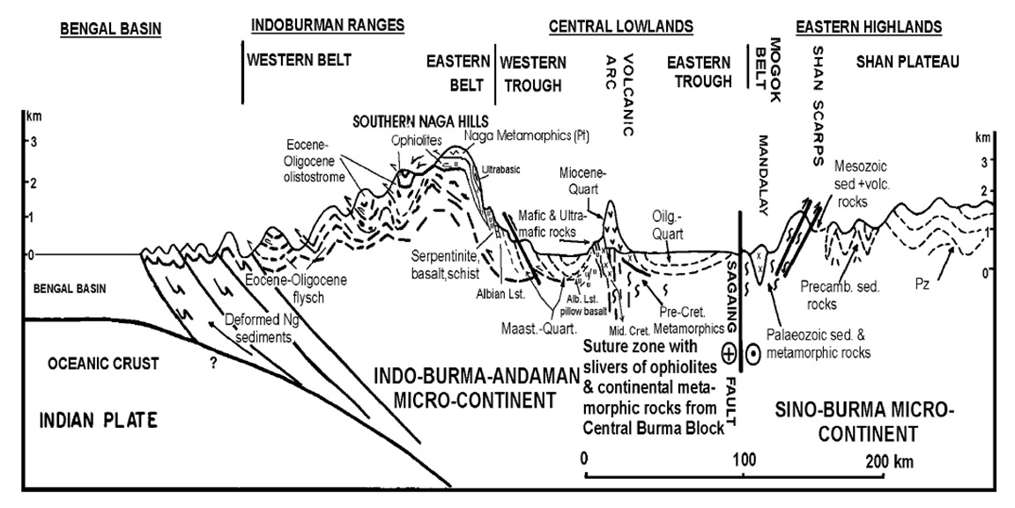
Fig. 1. Geological cross-section from the Bengal Basin to the Sino–Burma microcontinent showing the tectonic structure and evolution of the convergent boundary forming Indo–Burma–Andaman microcontinent.
(Source: Acharyya et al. 2010)

Table 1. Summary of sampling sites in Manipur providing geographical coordinates, environmental factors (elevation, temperature, humidity and habitat type), species documented, local names (as collected from indigenous groups) and habitat characteristics.

S.No. | Specimen Code | Location | Latitude | Longitude | Elevation (m) | Temperature (18⁰C – 35⁰C) & Humidity (85%-99%) | Species, local name | Habitat type
1 | MDK0101 | Ningthoukhong, Bishnupur dist. | N24º34’18.44” | E093º46’03.36” | 729 | 30⁰C, 87% | H.frenatus,  Chum | Residential
2 | MDK0201 | Thanga Kwatham, Bishnupur dist. | N24º31’47.64” | E093º49’52.37” | 765 | 28⁰C, 92% | H.frenatus,  Chum | Bamboo houses
3 | MDK0301 | Karang island, Bishnupur dist. | N24º32’46.75” | E093º50’03.97” | 765 | 28⁰C, 92% | H.frenatus,  Chum | Mud house with metal roof
4 | MDK0401 | Keibul lamjao, Bishnupur dist. | N24º28’47.68” | E093º48’25.95” | 756 | 26⁰C, 90% | H.frenatus,  Chum | Keibul Lamjao National Park
5 | MDK0501 | Khuga dam, Churachandpur dist. | N24º17’13.28” | E093º41’00.85” | 801 | 32⁰C, 88% | H.bowringii,  Sapi/Inngah | Elevated wooden house
6 | MDK0602 | Teisang, Churachandpur dist. | N24º21’33.98” | E093º41’08.02” | 871 | 27⁰C, 92% | H.bowringii,  Diadep | Residential
7 | MDK0701 | Kwakta Bazaar, Bishnupur dist. | N24º21’33.68” | E093º41’07.57” | 824 | 25⁰C, 90% | H.frenatus,  Chum | Residential mud house near market
8 | MDK0801 | Kangchup Kharang Koireng, Imphal west dist. | N24º51’38.81” | E093º48’23.68” | 824 | 24⁰C, 91% | H.bowringii,  Chum | Foothill around near Sinda dam
9 | MDK0901 | Leimatak Silen Bazaar, CCP dist. | N24º51’38.99” | E093º48’23.70” | 453 | 26⁰C, 99% | H.bowringii,  Diadep | Small market near NHPC power house
10 | MDK1001 | Tadubi, Senapati dist. | N24º35’25.21” | E093º40’07.50” | 1504 | 22⁰C, 85% | H.frenatus,  Shikri | Abandoned government quarter
11 | MDK1005 | Karong, Senapati dist. | N24º35’25.23” | E093º40’07.52” | 1504 | 20⁰C, 85% | H.frenatus,  Diadep | Govt. Office near market
12 | MDK1101 | T. Kullen, Kangpokpi dist. | N25º09’16.21” | E093º58’25.91” | 1062 | 20⁰C, 86% | H.bowringii,  Bhitti | Mud wall near National highway-2
13 | MDK1201 | Ramrei Village, Kamjong dist. | N24º52’45.53” | E094º08’00.87” | 960 | 32⁰C, 90% | H.bowringii,  Kangjabi | Mud houses
14 | MDK1201A | Pureitang, Tongou, Ukhrul dist. | N25º05’52.13” | E094º21’41.34” | 1912 | 18⁰C, 98% | H.bowringii,  Chirang | Grocery shop
15 | MDK1201B | Finch Corner, Ukhrul dist. | N25º00’52.68” | E094º18’39.26” | 1350 | 22⁰C, 98% | H.bowringii,  Chirang | Traffic point wooden shop
16 | MDK1204X | Litan, Ukhrul dist. | N24º57’04.40” | E094º12’14.04” | 908 | 25⁰C, 94% | H.frenatus,  Bhitti | Mud wall in market area
17 | MDK1301 | Kakching khunou, Kakching dist. | N24º24’10.48” | E093º54'06.75” | 779 | 28⁰C, 92% | H.frenatus,  Chum | Grocery shop
18 | MDK1401 | Oinam Lamkhai, Imphal west dist. | N24º41’11.91” | E093º54'07.01” | 769 | 31⁰C, 93% | H.frenatus,  Chum | Residential
19 | MDK1501 | Charoi Tupul, Tamenglong dist. | N24º46’57.98” | E093º39'47.75” | 428 | 31⁰C, 91% | H.bowringii,  Dangkhonpui | Residential area near NH-37
20 | MDK1601 | Nungba, Tamenglong dist. | .N24º44’44.56” | E093º25'30.73” | 775 | 25⁰C, 86% | H.frenatus,  Dangkhonpui | Market area
21 | MDK1701 | Jiribam Babupara, Jiribam dist. | N24º48’21.24” | E093º06'50.10” | 14 | 35⁰C, 99% | H.frenatus,  Chum | Market area
22 | MDK1801 | Jiribam Tower, Jiribam dist. | N24º26’54.90” | E093º12'03.17” | 119 | 35⁰C, 99% | H.frenatus,  Chum | Shop on NH-37
23 | MDK1901 | Kamperon, Tamenglong dist. | N24º45’00.59” | E093º23'04.31” | 388 | 32⁰C, 98% | H.bowringii,  Japuanpui | Ramrei river bank with cemented floor and bamboo wall
24 | MDK2001 | Noney Bazaar, Noney dist. | N24º51’36.90” | E093º37'26.98” | 343 | 28⁰C, 96% | H.bowringii,  Dangkhonpui | Residential
25 | MDK2101 | Lamphel, Imphal west dist. | N24º49’11.36” | E093º55'47.21” | 782 | 26⁰C, 98% | H.frenatus,  Chum | Quarter in AIR staff colony
26 | MDK2201 | Nambol Bazaar, Bishnupur dist. | N24º43’06.03” | E093º50'17.30” | 776 | 24⁰C, 94% | H.frenatus,  Chum | Vacant shopping complex

2.2. Samples, DNA extraction, and Amplification
All animals were handled and sample collection was performed in accordance to the approved protocols. Standard PCR conditions and procedures were followed in order to amplify and sequence partial sequences of the mitochondrial cytochrome b (cyt b) genes (Carranza et al. 2006). The cyt b primers used for both amplification and sequencing have the forward primer: Cytb_mcb 398-TACCATGAGGACAAATATCATTCTG and backward primer: Cytb_mcb 869- CCTCCTAGTTTGTTAGGGATTGATCG. Genomic DNA was extracted using the Qiagen DNeasy extraction kit from tail tissues stored in ethanol. A 450–500 nucleotide section of the mitochondrial cyt b gene was amplified using the primers Cytb_mcc 398 and Cytb_mcb 869, and was then used to sequence the result as per the protocol by Macey et al. 1997. The UniPath sequencing facility provided the commercial sequences. MEGA 5.2.2 (Tamura et al., 2011) was used to align the sequences and compute the uncorrected percentage pairwise sequence divergence. Ten separate maximum likelihood (ML) runs were used to generate the phylogeny, and 1000 quick bootstraps were run to evaluate its support.
2.3. Mapping using GIS and Remote sensing Technique
To analyze faunal diversity and verify the accuracy of ground data, we carried out a field survey from October 2019 to November 2024. In order to document the faunal diversity in the sampling plots, we employed a variety of traditional methods and field survey techniques, including, trail sampling, variable radius point count, visual encounter surveys, opportunistic records, and non-invasive sampling. The map of faunal richness of the study landscape was developed in QGIS (version- 3.38.3) utilizing the geospatial data of all the samples collected using Garmin eTrex 10.2.4. For phylogenetic analyses, the sequences for each gene were individually aligned with ClustalW v. 1.6 (Thompson et al., 1994), included in MEGA (Tamura et al., 2011) applying default parameters. The individual genes for each of the taxon were concatenated to establish a comprehensive dataset. We applied PartitionFinder v. 1.1.1 (Lanfear et al., 2012) to identify the suitable partitioning scheme and the models of evolutionary sequence evolution for each partition.
3. results and discussion
The sampling sites are not randomly distributed but are rather clustered. Figure 2 illustrates the spatial distribution of sampling sites (MDK-coded points) in Manipur on a comprehensive topographic base map incorporating elevation gradients, river networks and topography. Most of the specimens are located concentrated in the central valley area surrounding Imphal and extend into the northern and north-eastern hill ranges, whereas the western and southern hill tracts are comparatively less represented. This spatial pattern suggests a strong influence of topography, where low elevation areas, especially around Loktak Lake, show flat terrain, wetlands, and dense river systems, which are likely to support higher sampling density because of better accessibility, greater habitat productivity and possibly higher species abundance or diversity. By contrast, high elevation hill regions are characterized by fewer, but selectively distributed sample sites, suggestive of logistical restrictions and occurrence of species adapted to montane habitats. Overall, the map shows a clear valley–hill gradient in species distribution, with lowland areas supporting generalist and highland locations perhaps harbouring specialist or unique species. The pattern of distribution underlines the importance of topography, hydrology and accessibility of sampling in the determination of spatial heterogeneity and biodiversity pattern in the region.
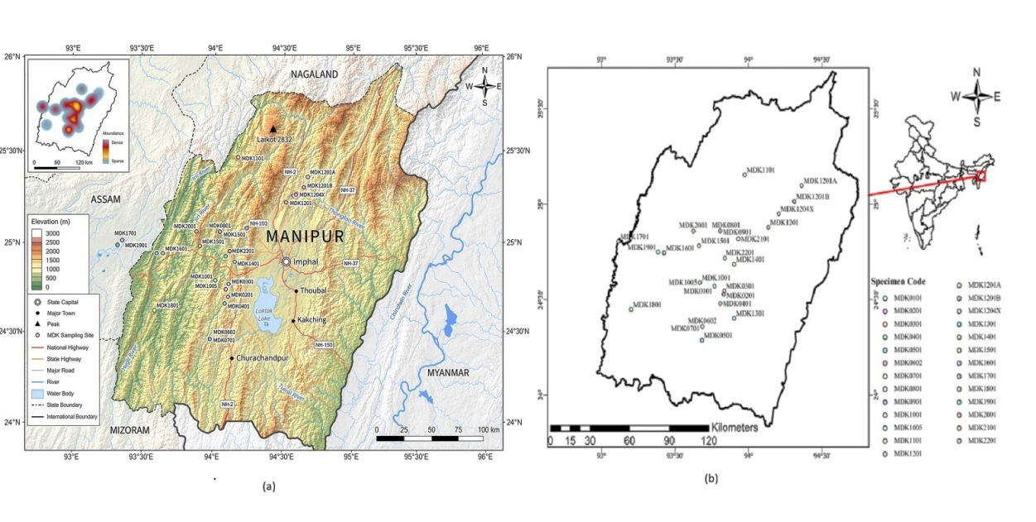

Fig. 2. (a) GIS-based physiographic map of Manipur showing elevation gradients, major river systems, road systems, and sample sites (MDK codes) overlaid on the topography; inset shows relative sampling abundance. (b) Simplified map illustrating spatial distribution of MDK sample sites within the state boundary. The figure shows the distribution of sampling sites in the context of topographic features and regional landscape structure.

Figure 3, highlight species of the genus Hemidactylus from different habitats such urban built-up areas, areas located near hydropower projects, reservoir edges and wetland ecosystems. Synanthropic populations in anthropogenic structures are shown in panel (a) and occurrences in semi-natural and altered - hill habitats with rocky substrates and mixed vegetation are shown in panels (b) and (c). Panel (d) indicates populations affiliated with lowland wetland and lacustrine settings. The graphic suggests habitat-specific occurrence patterns and indicates ecological adaptability of the documented gecko species, with distribution impacted by microhabitat availability, moisture regimes and degree of human disturbance across the region.
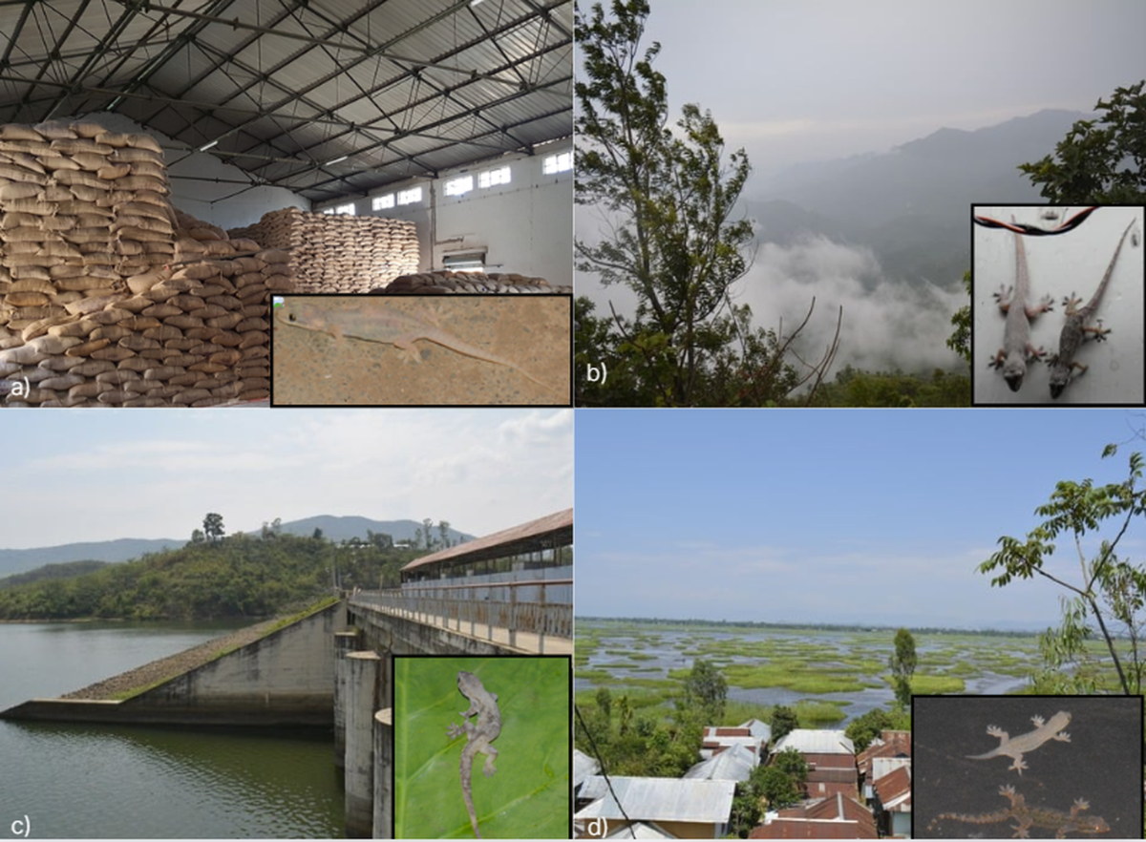
Fig. 3. Representative images of recorded species from diverse locations of Manipur: (a) FCI Godown, Imphal West, (b) Leimatak, CCP, (c) Khuga Dam, CCP, and (d) Thanga, Bishnupur district. The image illustrates the species prevalence across different habitats and ecological settings.

As depicted in figure 4, molecular phylogenetic tree of geckos, primarily from the genus Hemidactylus, was constructed using mitochondrial Cyt b gene sequences. The tree is rooted and has two outgroup taxa: Cyrtodactylus collegalensis and Cyrtodactylus triedrus. These serve as reference points to deduce evolutionary relationships within Hemidactylus. Bootstrap support values are the numbers next to nodes (for example, 60%), which show how confident you are of each clade. The Hemidactylus frenatus clade has several samples with the following labels: MDK 1601, 2201, 2101, 1701, 1401, 1001 and 0201. These groups are genetically similar, which means they are probably the same species or closely related groups. The Bootstrap support is only moderate (around 51–60%), which means that there is some genetic variation within the species. The Hemidactylus bowringii clade, comprising samples MDK 1201A, 1501, 1901, 1201B and 0901, constitutes a unique cluster, different from H. frenatus. It shows that the species are unambiguously distinct, but the internal branching shows that the population may be structured and that there may be minor variations between samples. This indicates a potential close evolutionary lineage or misidentification/cryptic lineage. That suggests the necessity of additional markers to precisely establish the evolutionary lineage. The phylogenetic tree displays two parallel sets of samples. Both datasets exhibit analogous clustering patterns. This corroborates the consistency in phylogenetic signal and indicates comparable in situ diversification patterns. Very small branch lengths within clusters (e.g., 0.000–0.01) indicate minor genetic divergence, which means that the species may have separated recently or are the same species. Larger branch lengths within clades indicate species-level separation. Bootstrap values range from 40% to 60%, which means there is moderate confidence. This could be because only one marker (Cyt b) was used, which has a short sequence length and comes from closely related taxa. H. frenatus and H. bowringii are separate clades, affirming their taxonomic validity as distinct species-level clusters. Multiple sub-branches within each species reinforce population divergence and potential early-stage speciation. The similar topology in both MCB groups indicates a parallel structure across datasets, suggesting a stable evolutionary pattern and reinforce phylogenetic reliability. There are, however, limitations with this tree. Specifically, the low bootstrap value indicating weak confidence, the use of single mitochondrial marker (Cyt b) and limited geographical sampling indicating that the results do not fully resolve deep evolutionary relationships.
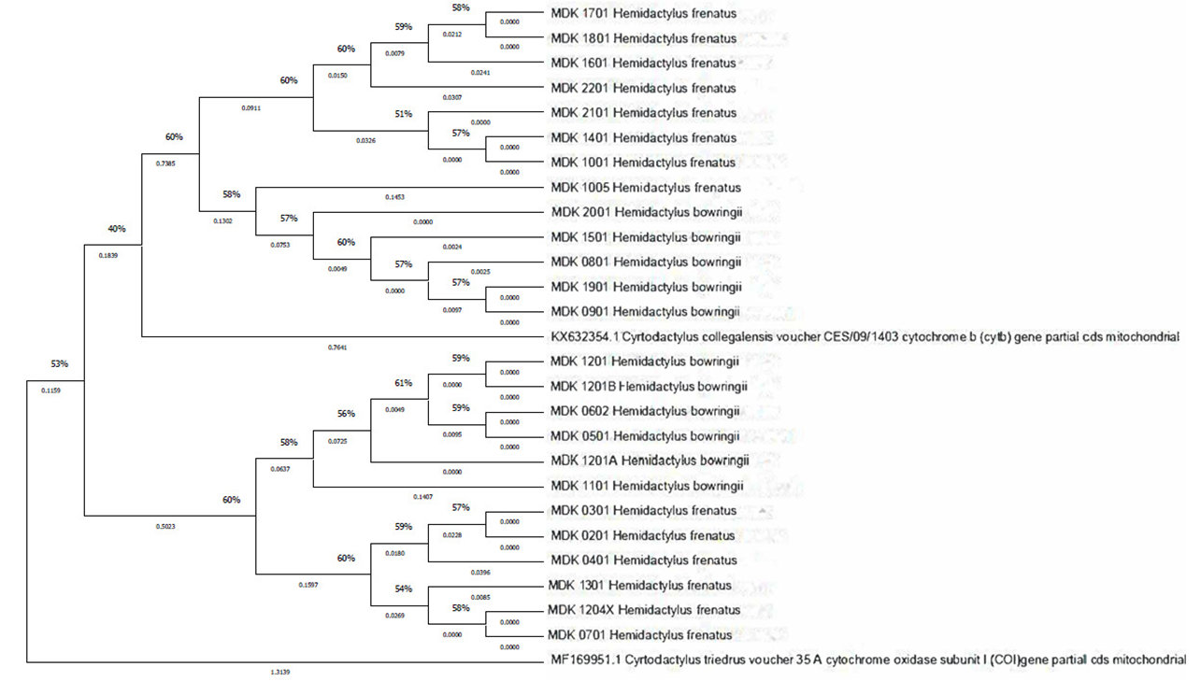
Fig. 4. Maximum Likelihood phylogenetic tree of the endemic radiation of Hemidactylus geckos from various locations of Manipur, Northeast India. A phylogenetic analysis utilizing two partial mitochondrial sequences (excluding the third codon position) resulted in strongly supported clades. The maximum likelihood bootstrap values and the Bayesian posterior probability are the support values for internal branches. Values less than 50/0.5 are left out, except for one.

Research in systematics, historical biogeography, and phylogenetic analysis indicates that the biodiversity of the Indian subcontinent has developed over hundreds of millions of years, by an assemblage of both ancient and contemporary lineages having various biogeographical affinities. The Indian plate's complex geological past had a major impact on the variety, distribution, and evolution of species. Ancient lineages with Gondwanan affinity that originated from plate tectonic-mediated vicariance are part of the Indian biota; just as some of the lineages dispersed from India, many other lineages spread into India from adjacent landmasses during a variety of time periods. However, many other lineages have endured in situ speciation within India (Karanth, 2015; Cyriac et al., 2024; Joshi et al., 2025). The Hemidactylus groups have diversified into multiple species independently, yet exhibit similar trend of evolution across the places.

This study primarily elucidates a small part of India's remarkable biodiversity and habitat/ecosystem variability, which remains mostly unexplored and understudied, particularly in the context of Northeast India. It has to be ascertained whether these patterns are universally relevant across taxa. There is a shortage of integrated biogeographical patterns and processes connected to conservation initiatives across taxa and environments. For example, the presence of endangered, endemic or evolutionarily unique species could be used to identify high conservation priority areas as well as areas that need attention. In order to identify diversity and endemic hotspots, reconstruction of biogeographic histories, and analysis of diversification pattern, and accurate data acquisition on species geographic distributions is essential. Species distribution modelling, conservation prioritization, and environmental impact assessments are supported by georeferenced occurrence data, especially in ecologically sensitive and dynamic areas like the country's northeast state of Manipur, which form a crucial biogeographic transition zone between the Asian plate and the Indian plate. Recent taxonomic and phylogenetic research have shown significant undocumented diversity in Northeast India, indicating that the region's gecko fauna is still poorly documented (Joshi, 2025; Karanth, 2021). These results emphasize the importance of systematic sampling and integrative taxonomic techniques while highlighting Northeast India as a significant centre of cryptic and endemic gekkonid diversity.

Prioritizing areas that include distinct lineages rather than common taxa can be achieved by changing the focus from species counts to "evolutionary potential," which is crucial for a genus that spans the most imperilled landscapes of North East India. Significant "stumbling blocks," namely the publication of localized phylogenies that resisted integration and the use of inconsistent genetic markers, impeded conservation efforts. Due to this fragmentation, it was not possible to find reciprocally monophyletic links across political boundaries, which resulted in low nodal support and sampling errors. We transformed conservation accuracy by combining these different data into a thorough, genus-wide phylogeny. In land-use planning, "undescribed candidate species" must be taken into consideration by government environmental policy. A site must be considered a high-biodiversity zone if it has the particular geological features—such as north-south ridges, river basins, wetland areas, and valleys—that are known to host species radiations. However, there still lacks a scientific or systematic biodiversity conservation plan, with most efforts focused on a few charismatic large mammals. Additionally, the complex interplay between natural and human-induced factors that shape the distribution, composition, and functioning of ecosystems in India remains to be explored.

4. Conclusion

The Indian subcontinent is a globally significant zone of biodiversity established through a complicated geological history, many biogeographic dispersal events, and long-term in situ diversification. Northeast India, especially Manipur, is an important biogeographic transition zone with a large but poorly described variety including cryptic and unique species of Hemidactylus. Accurately reconstructing evolutionary histories, identifying centers of endemism and prioritizing conservation are fundamental to integrative methods to systematics, phylogenetics, historical biogeography and georeferenced distribution data. Integrating evolutionary distinctiveness and undescribed candidate species into conservation planning will enhance biodiversity management and environmental policy. The future study should be focused on extensive sampling, standardization of DNA databases and multidisciplinary analysis to improve the conservation strategies of the unique herpetofauna and ecosystems of Northeast India.

Ethical approval (where ever applicable)

Animal handling and sample protocols were performed in accordance with the standards of the Committee for the Purpose of Control and Supervision of Experiments on Animals (CPCSEA). Field sampling was carried out with the requisite authorization from the Forest Department, Government of Manipur, Office of Principal Chief Conservator of forest (Wildlife) & Chief Wildlife Warden, Approval No. 3/22/2018-WL(Vol-II) with minimum disturbance to animals and their habitat. All experiments have been examined and approved by the appropriate ethics committee.

Declaration of AI Use

This manuscript was prepared through the combined contributions of all author(s), including contributions to the study design, data, content development, results, interpretation, and related scholarly work. The author(s) acknowledge the use of Grammarly and ChatGPT to assist with grammar checking, language refinement, reference formatting. These AI-assisted tools were not used as authors and did not replace the intellectual contributions or scholarly judgment of the author(s). All AI-assisted outputs, including content, references, and interpretations, were carefully reviewed, revised, verified, and approved by the author(s). The author(s) accept full responsibility for the accuracy, integrity, and final content of the manuscript.

COMPETING INTERESTS DISCLAIMER:
Authors have declared that they have no known competing financial interests OR non-financial interests OR personal relationships that could have appeared to influence the work reported in this paper.

References

Agashe, M., Šmíd, J., Janák, V., Biswas, A., & Karanth, K. P. (2025). Twin cradles of diversity: Parallel in-situ radiations in India and Africa drive the evolution of Hemidactylus geckos. Journal of Biogeography, 52(8), e15165. https://doi.org/10.1111/jbi.15165
Uetz PH, et al. 2024. A reference database of reptile images. Taxonomy. 4(4):723–732.
Smith, M. A. (1935). The Fauna of British India, Including Ceylon and Burma. Reptilia and Amphibia. Vol. II: Sauria. Taylor & Francis, London.
Giri C, et al. (2008). Mangrove forest distributions and dynamics (1975–2005) of the tsunami-affected region of Asia. Journal of Biogeography. 35(3):519–528.
Giri, V. B., & Bauer, A. M. (2008). A new ground-dwelling Hemidactylus (Squamata: Gekkonidae) from Maharashtra, with a key to the Hemidactylus of India. Zootaxa, 1700(1), 21–34. https://doi.org/10.11646/zootaxa.1700.1.2
Carranza S, Arnold EN. (2006). Systematics, biogeography and evolution of Hemidactylus geckos (Reptilia: Gekkonidae) elucidated using mitochondrial DNA sequences. Molecular Phylogenetics and Evolution. 38(2):531-545.
Lamb, April D., et al. (2021):"Comparing the dietary niche overlap and ecomorphological differences between invasive Hemidactylus mabouia geckos and a native gecko competitor." Ecology and Evolution 11.24:18719-18732.
Das M, et al. (2011). Hemidactylus flaviviridis Rüppell, 1835 (Sauria: Gekkonidae): An invasive gecko in Assam. North-Western Journal of Zoology. 7(1).
Lever C. 2003. Naturalized Reptiles and Amphibians of the World. Oxford University Press, Oxford, UK.
Kraus F. 2009. Alien Reptiles and Amphibians: A Scientific Compendium and Analysis. Springer, Dordrecht, The Netherlands.
Bissattini, A. M., Haubrock, P. J., Buono, V., Balzani, P., Borgianni, N., Stellati, L., & Vignoli, L. (2021). Trophic structure of a pond community dominated by an invasive alien species: insights from stomach content and stable isotope analyses. Aquatic Conservation: Marine and Freshwater Ecosystems, 31(4), 948-963.
Joshi J, Karanth KP. 2013. Did southern Western Ghats of peninsular India serve as refugia for its endemic biota during the Cretaceous volcanism? Ecology and Evolution. 3(10):3275–3282.
Avise JC. (2000). Phylogeography: The History and Formation of Species. Harvard University Press, Cambridge, Massachusetts, USA.
Hillis DM. (1996). Inferring complex phylogenies. Nature. 383(6596):130–131.
Lee Grismer, L., et al. (2021). "Phylogenetic partitioning of the third-largest vertebrate genus in the world, Cyrtodactylus Gray, 1827 (Reptilia; Squamata; Gekkonidae) and its relevance to taxonomy and conservation." Vertebrate Zoology 71:101-154.
Bansal R, Karanth KP. (2013). Phylogenetic analysis and molecular dating suggest that Hemidactylus anamallensis is not a member of the Hemidactylus radiation and has an ancient Late Cretaceous origin. PLoS ONE. 8(5):e60615.
Agarwal, I., Khandekar, A., Giri, V. B., Ramakrishnan, U., & Karanth, K. P. (2019). The hills are alive with geckos! A radiation of a dozen species on sky islands across peninsular India (Squamata: Gekkonidae, Hemiphyllodactylus) with the description of three new species. Organisms Diversity & Evolution, 19(2), 341-361.
White E, Soltis PS, Soltis DE. 2026. Origins of diversity in the Eastern Gulf Coastal Plain of North America: High endemism within a biodiversity hotspot. Molecular Ecology. 35(5):e70276.
Yang Z. (2006). Computational Molecular Evolution. Oxford University Press, Oxford, UK.
Rodgers, W. A. and Panwar, H. S. (1988). Planning a Wildlife Protected Area Network in India. Vol. I and II. Wildlife Trust of India, Dehra Dun, India
Myers N, Mittermeier RA, Mittermeier CG, da Fonseca GAB, Kent J. (2000). Biodiversity hotspots for conservation priorities. Nature. 403(6772):853–858.
Mani MS. (1974). Biogeographical evolution in India. In: Mani MS (Ed.), Ecology and Biogeography in India. Springer, Dordrecht, The Netherlands. pp. 698–724.
Karanth KP. (2021). Dispersal vs. vicariance: The origin of India's extant tetrapod fauna. Frontiers of Biogeography. 13(1).
Eurostat. (2018). Eurostat Regions. Publications Office of the European Union, Luxembourg.
Acharyya, S. K. (2010). Tectonic evolution of Indo-Burma range with special reference to Naga-Manipur Hills. Mem. Geol. Soc. India, 75, 25-43.
Macey JR, et al. (1997). Evolutionary shifts in three major structural features of the mitochondrial genome among iguanian lizards. Journal of Molecular Evolution. 44(6):660–674.
Tamura K, Peterson D, Peterson N, Stecher G, Nei M, Kumar S. (2011). MEGA5: Molecular evolutionary genetics analysis using maximum likelihood, evolutionary distance and maximum parsimony methods. Molecular Biology and Evolution. 28(10):2731–2739.
Thompson, J. D., Higgins, D. G., & Gibson, T. J. (1994). CLUSTAL W: improving the sensitivity of progressive multiple sequence alignment through sequence weighting, position-specific gap penalties and weight matrix choice. Nucleic acids research, 22(22), 4673-4680.
Lanfear, R., Calcott, B., Ho, S. Y., & Guindon, S. (2012). PartitionFinder: combined selection of partitioning schemes and substitution models for phylogenetic analyses. Molecular biology and evolution, 29(6), 1695-1701.
Cyriac V, Ganesh S, Madani Z, Ghosh A, Kulkarni V, Shanker K. (2024). Phylogenetic systematics of the shieldtail snake genus Teretrurus Beddome, 1886 (Squamata: Uropeltidae) reveals extensive cryptic diversity and novel geographic spread in the Western Ghats of India. Bulletin of the Society of Systematic Biologists. 3(2). https://doi.org/10.18061/bssb.v3i2.9630.
Joshi, M., Patel, S., Das, B. P., Oinam, G., Srivastava, T., & Kumar, A. (2025). P–T Evolution of Paleoproterozoic Dangoli Pelitic Gneisses, Baijnath Klippe, NW Himalaya: Insights From the Geochemistry and Zircon U–Pb Geochronology. Island Arc, 34(1), e70008.

