Diversity and Abundance of Pollinators Visiting Ridge Gourd (Luffa acutangula L.) Agroecosystems

Abstract
Pollination is an important ecosystem service that directly influences fruit set, seed production, and yield in cucurbit crops. Ridge gourd (Luffa acutangula L.), a monoecious and predominantly cross-pollinated vegetable crop, depends mostly on insect pollinators due to its short flowering duration and limited pollen viability. The present study was conducted during 2023-24 at the Vegetable Research Station, Agricultural Research Institute, Rajendranagar, Hyderabad, Telangana, India, to investigate the diversity and abundance of insect pollinators associated with ridge gourd flowers. Pollinator sampling was carried out using trapping methods like water pan traps, sweep netting, and aspirator from 10 % to 90% flowering. A total of 428 insect pollinators belonging to 22 species, 10 families, and 3 orders were recorded. Hymenoptera was the dominant order, accounting for 88.78% of the total pollinator abundance, followed by Diptera (6.78%) and Lepidoptera (4.44%). Whereas Apidae (33.88%) and Formicidae (33.87%) were reported as the most abundant families, followed by Halictidae (18.69%). Among the recorded species, Nomia sp. was the most abundant pollinator (18.69%), whereas Xylocopa pubescens, Colotis danae, and Belenois aurota were the least abundant species (0.47% each). The pollinator community was dominated by bees and other hymenopteran insects, highlighting their significant role in ridge gourd pollination. The findings provide valuable baseline information on the diversity and composition of insect pollinators associated with ridge gourd and emphasise the importance of conserving pollinator communities through pollinator-friendly crop management practices to ensure sustainable crop production and enhanced pollination services.
Keywords: Apidae, Diversity, Luffa acutangula, Pollinator, Ridge gourd, Luffa acutangula.
Introduction
Pollination is a fundamental ecological process that ensures the reproduction of flowering plants and contributes directly to biodiversity and ecosystem stability. In agroecosystems, pollination substantially enhances crop productivity, fruit quality, and seed set. It has been estimated that 75% of cultivated crops benefit from animal pollinators, and roughly 35% of global food production depends directly on pollination services (Klein et al., 2007). Insect pollination is therefore widely regarded as a cost-effective and environmentally sustainable approach for improving yields in cross-pollinated crops (Free, 1970).
The Cucurbitaceae is a globally and economically important family of vegetable crops that includes ridge gourd (Luffa acutangula L. Roxb.), bottle gourd, sponge gourd, pumpkin, cucumber, bitter gourd, and chayote. These crops are extensively cultivated across tropical and subtropical regions and contribute significantly to nutritional security and rural livelihoods. Ridge gourd, in particular, is valued for its nutritive properties, being a good source of carbohydrates, proteins, vitamins, and essential minerals (Hussain et al., 2010). Successful fruit set in cucurbits depends on efficient pollen transfer. Most cucurbit species are monoecious, bearing separate male and female flowers on the same plant, which necessitates biotic pollen transfer for fertilization (Kalloo and Bergh, 1993). Wind dispersal is generally ineffective because cucurbit pollen grains are relatively large, heavy, and adhesive. Therefore, insect visitors are critical for achieving optimum fruit set, seed development, and marketable yield in cucurbit crops. Ridge gourd exhibits unique floral biology that further highlights the role of insect pollinators. Flowers typically open in the late afternoon or evening and remain receptive for a brief period, usually lasting a single night. Pollen viability peaks immediately after anthesis and declines rapidly thereafter (Keasar, 2010; Nepi and Pacini, 1993). This narrow temporal window for effective pollen transfer can limit visitation by conventional diurnal pollinators such as managed honey bees and elevates the importance of native and crepuscular pollinator species. Despite the agronomic importance of ridge gourd, detailed information on the diversity, abundance, and relative contributions of its insect pollinators remains limited. Characterizing pollinator community composition is therefore essential for designing effective conservation measures and pollination management practices. This study was undertaken to document the diversity and abundance of insect pollinators visiting ridge gourd flowers and to identify the dominant pollinator groups, to inform pollinator-friendly management strategies that enhance crop productivity and sustainability.
Material and methods
The field study was carried out during 2023-24 at the Vegetable Research Station (VRS), Agricultural Research Institute, Rajendranagar, Hyderabad, Telangana, India. The experimental site is located at 17°20′ N latitude and 78°30′ E longitude, at an elevation of 573 meters above mean sea level. The experiment was conducted in a 500 m² plot laid out in a Randomized Block Design (RBD). The crop was maintained following the recommended agronomic practices, with a plant-to-plant spacing of 0.75 meters. Investigations on insect pollinator diversity and abundance were conducted throughout the flowering period of the crop. Trapping methods like water pan traps, sweep netting, and aspirators were used for sampling. Observations were recorded at weekly intervals from 10% flowering to 90% flowering to capture temporal variation in visitation. The collected insect specimens were preserved using standard entomological preservation techniques. Hard-bodied insects were maintained as dry specimens, whereas soft-bodied insects were preserved in wet collections. Taxonomic identification of the specimens was carried out to the lowest possible taxonomic level with the assistance of experts from the National Centre for Biological Sciences (NCBS), GKVK Campus, Bengaluru, and the Indian Institute of Rice Research (IIRR), Rajendranagar, Hyderabad.
The relative abundance of species was calculated using the formula given below.
Relative abundance (%) = Ni ÷ NA × 100 (MacArthur, 1960)
Where,
Ni = Total number of individual pollinator species
NA = Total number of pollinator species
Shannon-Wiener Diversity Index
It was used to quantify community diversity, incorporating both the number of individuals and the number of taxa (Shannon, 1948)
The formula used for calculation-
H = – Σ Pi ln Pi
Where,
Pi = S / N
S = number of species
N = total number of individuals
ln = logarithm to base e
Simpson index
The Simpson index, which accounts for both species richness and the relative abundance of each species, was calculated as 1 – D (Simpson, 1949)
The formula used for calculation -
D = Σni (ni -1) / N(N-1)
where,
ni = Total number of individuals of a particular species
N = Total number of individuals of all species
Statistical analysis: The abundance and diversity of insect pollinators collected from four cucurbitaceous vegetables at ARI were computed by the following indices using the software PAST (Paleontological Statistics Tool) version 3.25.
Result and discussion
Insect pollinator diversity in ridge gourd flowers
Ridge gourd (Luffa acutangula L.) is a predominantly monoecious crop that relies extensively on insect pollinators for successful cross-pollination and seed set. A total of 428 insect pollinators representing 22 species, 10 families, and 3 orders were recorded visiting ridge gourd flowers during the study. Hymenopteran order was reported to be dominant, comprising 380 individuals across 13 species and four families (Apidae, Halictidae, Megachilidae, Formicidae). Apidae species recorded included Tetragonula sp. (50 individuals), Apis florea (15), Apis dorsata (20), Xylocopa sp. (5), Xylocopa pubescens (2), Amegilla sp. (35), Amegilla violacea (10), and Ceratina binghami (8). Halictidae was represented primarily by Nomia sp. (80 individuals), Megachilidae by Lithurgus sp. (10), and Formicidae by Camponotus compressus (65), Crematogaster sp. (55), and Solenopsis sp. (25) (Table 1).
Diptera was documented as the second most abundant order (29 individuals, four species, three families), comprising Ischiodon scutellaris (8) and Eristalinus quinquestriatus (10) from Syrphidae, Chrysoma sp. (5) from Calliphoridae, and Musca sp. (6) from Muscidae. Whereas Lepidoptera comprised 19 individuals across five species: Danaus chrysippus (4) from Nymphalidae, Eurema hecabe (6), Colotis danae (2), Belenois aurota (2) from Pieridae, and Baoris sp. (5) from Hesperiidae.
Family-level abundance was highest for Apidae and Formicidae (145 individuals each), followed by Halictidae (80), Syrphidae (18), Pieridae and Megachilidae (10 each), Muscidae (6), Calliphoridae and Hesperiidae (5 each), and Nymphalidae (4). These results indicate a strong predominance of hymenopteran visitors, particularly Apidae, Halictidae, and Formicidae, highlighting their major contribution to the pollinator diversity of ridge gourd and their potential importance in crop pollination and reproductive success.
The present study findings align with several previous studies that identified hymenopterans as the principal pollinators of ridge gourd. Gautam and Kumar (2018) recorded eight insect species (five Hymenoptera, two Diptera and one Odonata) at Pusa, Samastipur and identified Apis dorsata, Xylocopa sp., Apis florea, Eristalinus sp. and Musca sp. as key visitors. Similarly, Swarajya Lakshmi and Kuberappa (2017) findings were on par with the present study, as they observed 33 species of insect pollinators as frequent visitors, of which 22 species belonged to the order Hymenoptera, five to Diptera, four to Coleoptera and two to Lepidoptera in ridge gourd at Bangalore. Pollinators included C. binghami, Amegilla sp., C. compressus, Xylocopa sp. and Nomia sp. Kumar and Rai (2020) also noted Apidae and dipteran families (Syrphidae, Muscidae) as major floral visitors, finding Apidae to be dominant. In contrast, some studies have reported different dominant groups viz., Chowdhury et al. (2018) found Lepidoptera predominant among 12 species across eight families and five orders, and Patil and Jagdale (2021) similarly observed greater lepidopteran visitation, with Formicidae emerging as the principal hymenopteran family. These variations likely reflect local agroecological differences, floral phenology, and sampling methods, but collectively they highlight the central role of hymenopteran taxa, particularly Apidae, Halictidae and Formicidae in ridge gourd pollination across diverse regions.
Table 1: List of insect pollinators from ridge gourd flowers (Lagenaria siceraria)
S.No. | Order | family | Common name | Scientific name | No. of individuals
1. | Hymenoptera | Apidae | Stingless bee | Tetragonula sp. | 50
1. | Hymenoptera | Apidae | Indian little bee | Apis florea Fabricus | 15
1. | Hymenoptera | Apidae | Rock bee | Apis dorsata Fabricius | 20
1. | Hymenoptera | Apidae | Carpenter bee | Xylocopa sp. | 5
1. | Hymenoptera | Apidae | Pubescent carpenter bee | Xylocopa (Koptortosoma) pubescens | 2
1. | Hymenoptera | Apidae | Blue banded bee | Amegilla sp. | 35
1. | Hymenoptera | Apidae | Digger bees | Amegilla violacea (Lepeletier) | 10
1. | Hymenoptera | Apidae | Small carpenter bee | Ceratina binghami Cockerell | 8
1. | Hymenoptera | Apidae |  | Sub total | 145
1. | Hymenoptera | Halictidae | Alkali bee | Nomia sp. | 80
1. | Hymenoptera | Halictidae |  | Sub total | 80
1. | Hymenoptera | Megachilidae | Woodborer bee | Lithurgus sp. | 10
1. | Hymenoptera | Megachilidae |  | Sub total | 10
1. | Hymenoptera | Formicidae | Common black ant | Camponotus compressus Fab. | 65
1. | Hymenoptera | Formicidae | Acrobat ant | Crematogaster sp. | 55
1. | Hymenoptera | Formicidae | Tropical fire ants | Solenopsis sp. | 25
1. | Hymenoptera | Formicidae |  | Sub total | 145
1. | Hymenoptera | Formicidae |  | Total of families | 380
2. | Lepidoptera | Nymphalidae | Plain tiger | Danaus chrysippus Linn. | 4
2. | Lepidoptera | Nymphalidae |  | Sub total | 4
2. | Lepidoptera | Pieridae | Common grass yellow | Eurema hecabe Linn. | 6
2. | Lepidoptera | Pieridae | Crimson tip | Colotis danae Fabricius | 2
2. | Lepidoptera | Pieridae | Pioneer white | Belenois aurota | 2
2. | Lepidoptera | Hesperiidae |  | Sub total | 10
2. | Lepidoptera | Hesperiidae | Paint brush swift | Baoris sp. | 5
2. | Lepidoptera | Hesperiidae |  | Sub total | 5
2. | Lepidoptera |  |  | Total of families | 19
3. | Diptera | Syrphidae | Common hover fly | Ischidon scutellaris Fabricius | 8
3. | Diptera | Syrphidae | Hover fly | Eristalinus quinquestriatus Fabricius | 10
3. | Diptera | Syrphidae |  | Sub total | 18
3. | Diptera | Calliphoridae | Blow fly | Chrysoma sp. | 5
3. | Diptera | Calliphoridae |  | Sub total | 5
3. | Diptera | Muscidae | House fly | Musca sp. | 6
3. | Diptera | Muscidae |  | Sub total | 6
3. | Diptera | Muscidae |  | Total of families | 29
3. | Diptera |  |  | Overall Total | 428

Relative Abundance of Insect pollinators on Ridge gourd
Ridge gourd flowers are receptive for only a single day and undergo senescence shortly after anthesis, making pollination dependent on floral visitors due to a limited period of flower receptivity. The relative abundance of insect pollinators recorded on ridge gourd flowers is presented in (Table.2). Among the documented insect orders, Hymenoptera was reported as dominant with relative abundance 88.78%, followed by Diptera (6.78%) and Lepidoptera (4.44%) (Figure 1). This highlights the important role of hymenopterans in ridge gourd pollination. In contrast, Apidae (33.88%), Formicidae (33.87%) and Halictidae (18.69%) were documented as the most abundant families. At the same time, the remaining families contributed comparatively little. At the species level, Nomia sp. was the most abundant pollinator (18.69% of individuals), while Xylocopa pubescens, Colotis danae and Belenois aurota were the least frequent (0.47% each). Overall, the results demonstrate a clear dominance of hymenopteran pollinators, particularly Apidae, Formicidae and Halictidae, highlighting their likely importance for effective pollination and reproductive success in ridge gourd.
The predominance of hymenopteran pollinators observed here is in close agreement with earlier studies. Swarajya Lakshmi and Kuberappa (2017) reported that honey bees comprised 76.46% of ridge gourd visitors, with A. florea, A. dorsata and A. cerana as major species, while other families made up only 23.54% of visitors, reflecting the strong contribution of Apidae in our study. Gautam and Kumar (2018) likewise found Apis mellifera (20.0%), A. dorsata (16.7%) and Xylocopa fenestrata (15.9%) to be dominant, and several of these taxa (A. dorsata, Xylocopa sp., Musca sp.) were recorded in the present work. Bodlah and Waqar (2013) also reported Apis spp. as frequent ridge gourd visitors and noted higher abundances of Xylocopa spp., Megachilidae and Syrphidae on ridge gourd than on other crops; the exclusive occurrence of Megachilidae in our data supports a possible crop-specific association. Similarly, Bhardwaj and Srivastava (2012) documented Hymenoptera as nearly 80% of pollinators, followed by Diptera and Lepidoptera, reflecting our results. Contrasting findings, such as those of Chowdhury et al. (2018), who reported Lepidoptera as the dominant group, likely reflect differences in location, climate, cropping systems and seasonal floral resources. Taken together, these studies highlight the vital role of hymenopterans, particularly Apidae, in ridge gourd pollination and highlight the need to conserve bee communities to sustain crop productivity.
Table 2: Relative abundance of insect pollinators on ridge gourd flowers
S.No. | Order | Family | Species | Species Abundance within Order (%) | Species Abundance among the Order (%) | Total Abundance (%)
1. | Hymenoptera | Apidae | Tetragonula sp. | 13.16 | 11.68 | 88.78
1. | Hymenoptera | Apidae | Apis florea Fabricus | 3.95 | 3.50 | 88.78
1. | Hymenoptera | Apidae | Apis dorsata Fabricius | 5.26 | 4.67 | 88.78
1. | Hymenoptera | Apidae | Xylocopa sp. | 1.32 | 1.17 | 88.78
1. | Hymenoptera | Apidae | Xylocopa  (Koptortosoma)  pubescens | 0.53 | 0.47 | 88.78
1. | Hymenoptera | Apidae | Amegilla sp. | 9.21 | 8.18 | 88.78
1. | Hymenoptera | Apidae | Amegilla violacea  (Lepeletier) | 2.63 | 2.34 | 88.78
1. | Hymenoptera | Apidae | Ceratina binghami  Cockerell | 2.1 | 1.87 | 88.78
1. | Hymenoptera |  | Sub total | 38.16 | 33.88 | 88.78
1. | Hymenoptera | Megachilidae | Lithurgus sp. | 21.05 | 2.34 | 88.78
1. | Hymenoptera |  | Sub total | 21.05 | 2.34 | 88.78
1. | Hymenoptera | Halictidae | Nomia sp. | 2.63 | 18.69 | 88.78
1. | Hymenoptera |  | Sub total | 2.63 | 18.69 | 88.78
1. | Hymenoptera | Formicidae | Camponotus  compressus Fab. | 17.11 | 15.18 | 88.78
1. | Hymenoptera | Formicidae | Crematogaster sp. | 14.47 | 12.85 | 88.78
1. | Hymenoptera | Formicidae | Solenopsis sp. | 6.58 | 5.84 | 88.78
1. | Hymenoptera |  | Sub total | 38.16 | 33.87
2. | Lepidoptera | Nymphalidae | Danaus chrysippus  Linn. | 21.05 | 0.93 | 4.44
2. | Lepidoptera |  | Sub total | 21.05 | 0.93 | 4.44
2. | Lepidoptera | Pieridae | Eurema hecabe Linn. | 31.58 | 1.4 | 4.44
2. | Lepidoptera | Pieridae | Colotis danae Fabricius | 10.53 | 0.47 | 4.44
2. | Lepidoptera | Pieridae | Belenois aurota | 10.53 | 0.47 | 4.44
2. | Lepidoptera |  | Sub total | 52.64 | 2.34 | 4.44
2. | Lepidoptera | Hesperiidae | Baoris sp. | 26.31 | 1.17 | 4.44
2. | Lepidoptera |  | Sub total | 26.31 | 1.17
3. | Diptera | Syrphidae | Ischidon scutellaris  Fabricius | 27.59 | 1.87 | 6.78
3. | Diptera | Syrphidae | Eristalinus  quinquestriatus  Fabricius | 34.48 | 2.34 | 6.78
3. | Diptera |  | Sub total | 62.07 | 4.21 | 6.78
3. | Diptera | Calliphoridae | Chrysoma sp. | 17.24 | 1.17 | 6.78
3. | Diptera |  | Sub total | 17.24 | 1.17 | 6.78
3. | Diptera | Muscidae | Musca sp. | 20.69 | 1.40 | 6.78
3. | Diptera |  | Sub total | 20.69 | 1.40
 |  |  |  | Total | 100

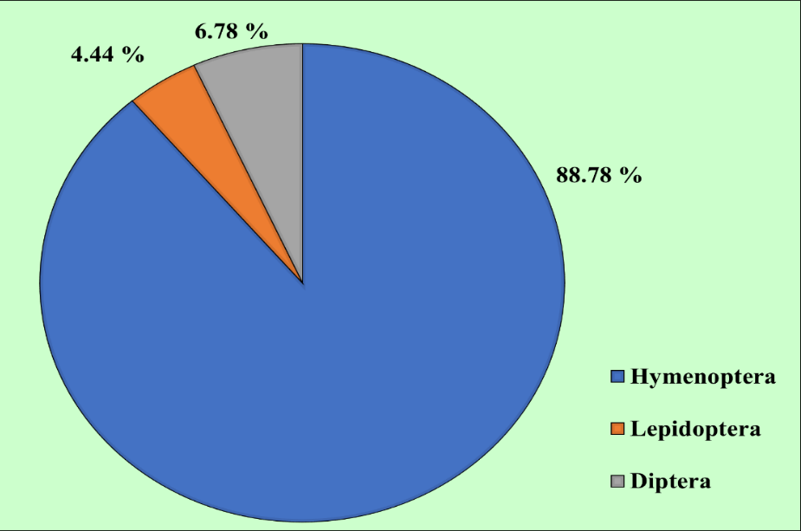
Fig. 1. Relative abundance of insect pollinator orders recorded on ridge gourd flowers
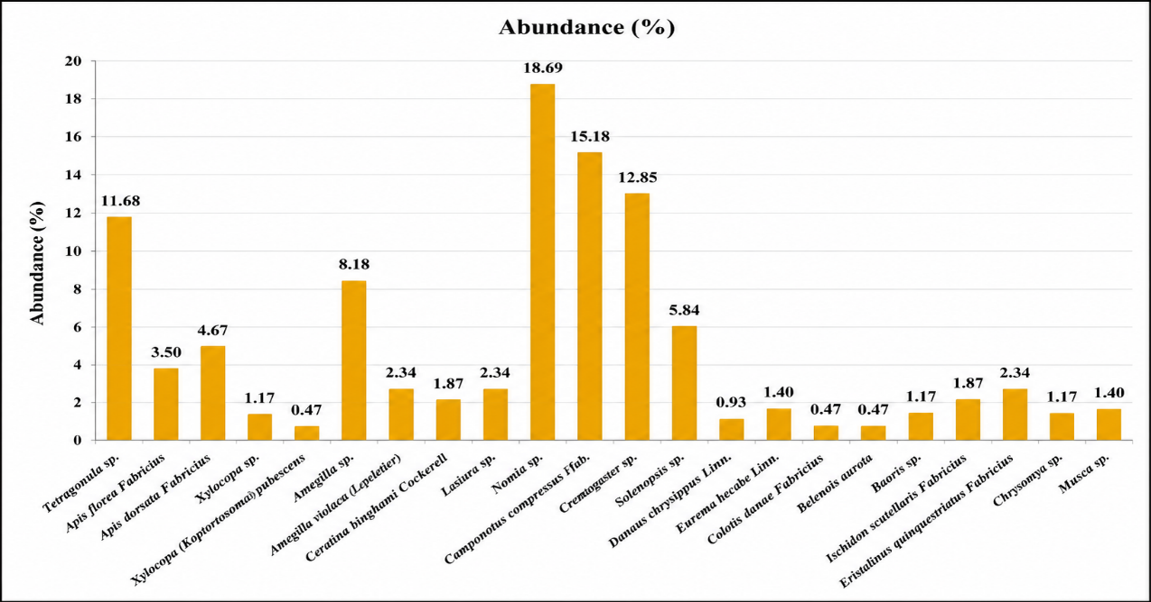
Fig. 2. Species-wise relative abundance of insect pollinators recorded on ridge gourd flowers
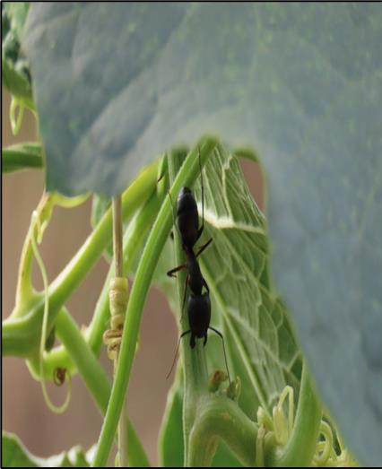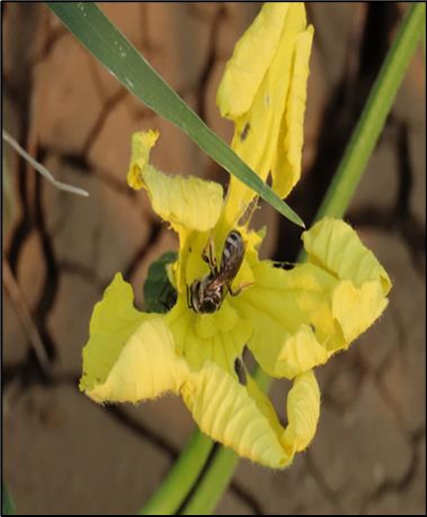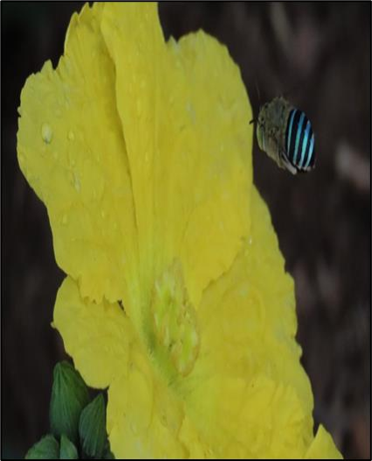
Camponotus compressus Fab. Nomia sp. Amigella sp.
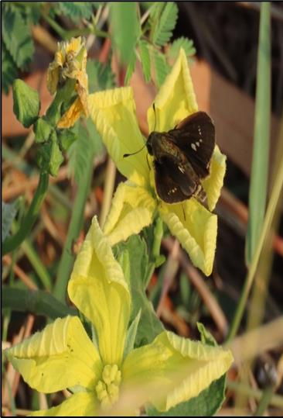
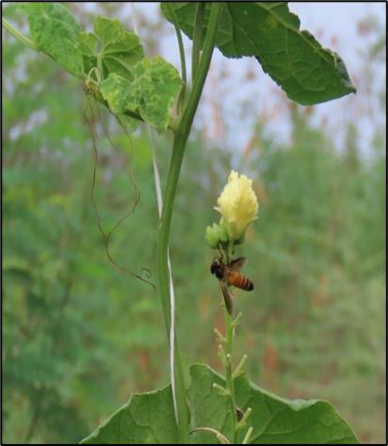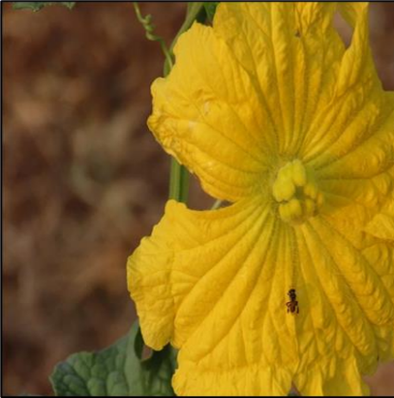
Baoris sp. Apis dorsata Fabricius Tetragonula sp.
Fig. 3. Representative insect pollinators visiting ridge gourd flowers
Shannon-Wiener Diversity Index and Simpson Index (D)
The insect pollinator community in bottle gourd exhibited a Shannon-Wiener diversity index (H′) of 2.55, suggesting considerable species diversity and a relatively even distribution of individuals among species. Simpson’s diversity index (1-D) was 0.89, indicating a highly diverse pollinator community with a low probability of dominance by any single species. The present findings are in accordance with Yogapriya et al. (2022), who reported a maximum Shannon diversity index of 2.52 for insect pollinators in bitter gourd, which is nearly similar to the current study.

Conclusion
This study presents a comprehensive assessment of insect pollinators of ridge gourd under the agro-climatic conditions of Hyderabad, India. Twenty-two pollinator species from 10 families and three orders were recorded, with Hymenoptera being the dominant order and Apidae, Formicidae, and Halictidae being the principal families. Within the species, Nomia sp. was observed as the most abundant species, while Tetragonula sp., Apis sp., Amegilla sp., and Xylocopa sp. were consistently frequent visitors. The dominance of hymenopteran pollinators indicates their pivotal role in facilitating effective pollen transfer within the limited flowering period of ridge gourd, emphasising the need for pollinator conservation in agroecosystems. These results provide baseline data for Hyderabad agro-climatic conditions and highlight the importance of conserving key pollinator groups through pollinator-friendly management, habitat enhancement, and prudent pesticide use.

Declaration of AI Use

This manuscript was prepared through the combined contributions of all author(s), including contributions to the study design, data, content development, results, interpretation, and related scholarly work. The author(s) acknowledge the use of Grammarly and ChatGPT to assist with grammar checking, language refinement, reference formatting. These AI-assisted tools were not used as authors and did not replace the intellectual contributions or scholarly judgment of the author(s). All AI-assisted outputs, including content, references, and interpretations, were carefully reviewed, revised, verified, and approved by the author(s). The author(s) accept full responsibility for the accuracy, integrity, and final content of the manuscript.

COMPETING INTERESTS DISCLAIMER:
Authors have declared that they have no known competing financial interests OR non-financial interests OR personal relationships that could have appeared to influence the work reported in this paper.

References
Bhardwaj, H and Srivastava, M. 2012. A study on insect visitors of certain cucurbit vegetable crops in an agro-ecosystem near Bikaner, Rajasthan, India. Journal Academica. 2(3): 99-126.
Bodlah, I and Waqar, M. 2013. Pollinators visiting summer vegetables ridge gourd (Luffa acutangula), bitter gourd (Momordica charantia L.) and brinjal (Solanum melongena). Asian Journal of Agriculture and Biology. 1(1): 8-12.
Chowdhury, S., Boopathi, T., Das, A., Layak, J., Chakraborty, A and Dey, D. 2018. Pollinator diversity and relative abundance in ridge gourd in mid altitude of Meghalaya. Innovative Farming. 3(3): 110-112.
Chowdhury, S., Boopathi, T., Das, A., Layak, J., Chakraborty, A. and Dey, D., 2018. POLLINATOR DIVERSITY AND RELATIVE ABUNDANCE IN RIDGE GOURD IN MID ALTITUDE OF MEGHALAYA.
Free, J. B. 1970. Insect Pollination of Crops. 2nd edi., London Academic Press., p. 544.
Gautam, P.P and Kumar, N. 2018. Pollinator diversity and relative abundance of insect pollinators on ridge gourd (Luffa acutangula) flowers in Bihar (India). Journal of Entomology and Zoology studies. 6(2): 1177-1181.
Gautam, P.P. and Kumar, N., 2018. Pollinator diversity and relative abundance of insect pollinators on ridge gourd (Luffa acutangula) flowers in Bihar (India). Journal of Entomology and Zoology studies, 6(2), pp.1177-1181.
Gautam, P.P., Kumar, N and Nishad, M.K. 2018. Foraging behaviour of Carpenter bee (Xylocopa fenestrata) on Ridge gourd (Luffa acutangula) flowers. Journal of Entomology and Zoology Studies. 6(3): 188-193
Hussain, J., Rehman, N.U., Khan, A. L., Hamayun, M., Hussain, M.S. and Shinwari, Z.K. 2010. Proximate and essential nutrients evaluation of selected vegetables species from Kohat region. Pak. J. Bot., 42: 2847-55.
Kalloo, G. and Bergh, B.O. 1993. Loofah-Luffa spp. In: Genetic Improvement of Vegetable Crops. (eds.), Pergamon Press, pp. 265-266.
Kelin, A. M., B. E. Vaissiere, J. H. Cane, I. Steffan- Dewenter, S. A. Cunninghum, C. Keremen and T. Tscharntke. 2007. Importance of pollinators in changing landscapes for world crops. Proc. R. Soc. B, 274: 303-313.
Kumar, M and Rai, C.P. 2020. Foraging activity and pollination diversity of insect pollinators on ridge gourd (Luffa acutangula L.). Journal of Entomology and Zoology Studies. 8(5): 2373-2375.
MacArthur R. On the relative abundance of species. The American Naturalist.1960; 94(874): 25-36.
Nepi, M. and Pacini, E. 1993. Pollination, pollen viability and pistil receptivity in Cucurbita pepo. Ann. Bot., 72: 527-36.
Patel, D.H and Pastagia, J.J. 2022. Abundance of different flower visitors and their foraging behaviour in cucumber (Cucumis sativus L.) The Pharma Innovation Journal. 11(2): 1817-182
Shannon, C.E and Weaver, W. 1949. The Mathematical Theory of Communication. University of Illinois Press, Urbana. 108-114.
Simpson, E.H. 1949. Measurement of diversity. Nature. 163(4148): 688-688.
Swarajya Lakshmi, K and Kuberappa, G.C. 2017. Pollinator fauna, relative abundance and for aging activity of honeybees in ridge gourd (Luffa acutangula L.). Progressive Research – An International Journal. 12(4): 419-423.
Yogapriya, A., Usharani, B and Suresh, K. 2022. Diversity and foraging activity of flower visitors/pollinators of Momordica charantia L., in Tamil Nadu, India. Entomon. 47(1): 41-50.

