Original Research Article

Diversity, Status, and Habitat Use of Predatory Birds (Raptors) in Pandharpur Tehsil, Solapur District, Maharashtra, India

Abstract
Predatory birds (raptors) play a crucial role in maintaining ecological balance by regulating prey populations, facilitating nutrient cycling, and serving as indicators of ecosystem health. The present study documents the diversity, status, and habitat use of predatory birds in Pandharpur Tehsil, Solapur District, Maharashtra, India. Field surveys were conducted over a one-year period from December 2024 to November 2025 using transect walks and point count methods across diverse habitats, including agricultural fields, wetlands, scrublands, and human-dominated landscapes. Observations were carried out during peak activity periods, and data on species identity, abundance, habitat preference, feeding behaviour, residential status, and conservation category were recorded. A total of 16 species of raptors were recorded, representing three orders Accipitriformes, Falconiformes, and Strigiformes. Five families, namely Accipitridae, Falconidae, Pandionidae, Strigidae, and Tytonidae. The majority of species (11) were residents, while 5 species were identified as winter migrants, indicating the ecological importance of Pandharpur as both a year-round and seasonal refuge for raptors. Habitat preferences varied from wetlands and riverine systems supporting fish-eating species like Brahminy Kite and Osprey, to open farmlands, grasslands, and human settlements hosting generalist predators such as Black Kite, Shikra, and Spotted Owlet. Conservation assessment revealed that most species (1) are listed as Least Concern, while the Pallid Harrier is Near Threatened and the Greater Spotted Eagle is Vulnerable, emphasizing the need for habitat protection, especially wetlands and grasslands. This study highlights the rich taxonomic and functional diversity of predatory birds in Pandharpur, underlining the region’s significance for both resident and migratory raptor species, and provides a baseline for future conservation and ecological studies.
Keywords:
Habitat preference; IUCN conservation status; Maharashtra; Pandharpur; Predatory birds; Raptors; Residential status; Solapur District; Species diversity
I.INTRODUCTION
Birds form an essential component of global biodiversity and are present in nearly all natural environments, from land-based ecosystems to open oceans. Within this diverse group, predatory birds—commonly known as raptors occupy the highest levels of ecological food chains. Species such as eagles, hawks, falcons, vultures, kites, and owls possess distinct structural and functional traits, including sharply curved beaks, strong grasping claws, advanced visual acuity, and highly efficient flight abilities. These features allow them to hunt live prey or feed on carrion with remarkable efficiency, making them key regulators of ecological systems (Newton, 1979).
By preying on rodents, insects, and other small animals, raptors help prevent imbalances that could otherwise lead to habitat degradation and economic losses in agriculture (Sergio et al., 2008). Scavenging species, particularly vultures, provide additional benefits by rapidly consuming animal remains, thereby limiting the spread of disease and facilitating nutrient recycling within ecosystems (Markandya et al., 2008). Because predatory birds are highly sensitive to environmental disturbances and depend on healthy food webs, changes in their populations often reflect broader ecological conditions, establishing them as valuable indicators of ecosystem health (Donázar et al., 2016).
Despite their ecological importance, many predatory bird species are experiencing population declines across the world. Expansion of human activities, habitat modification, intensive pesticide use, poisoning, illegal persecution, and climate-related changes have significantly reduced suitable habitats and food availability for raptors (BirdLife International, 2021). The widespread collapse of vulture populations in South Asia due to exposure to the veterinary drug diclofenac stands as a striking example of how human-induced factors can rapidly threaten entire groups of predatory birds (Green et al., 2004). While targeted conservation actions have enabled the recovery of certain species, including the Peregrine Falcon and Bald Eagle, numerous raptors continue to remain at risk, especially in developing regions (Cade and Burnham, 2003).
In India, predatory birds contribute substantially to the functioning of ecosystems ranging from forests and grasslands to wetlands and urban landscapes. However, accelerating urban growth, fragmentation of natural habitats, and chemical contamination have intensified pressures on raptor populations, leaving several species vulnerable or insufficiently studied (Naoroji, 2006). A detailed understanding of the biology, ecological roles, and conservation challenges of predatory birds is therefore essential. This study seeks to examine these aspects in order to support informed conservation planning and promote the long-term survival of raptors within changing landscapes.

II. MATERIAL AND METHODS-
STUDY AREA
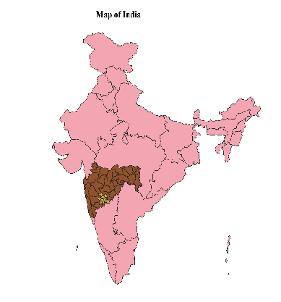
India
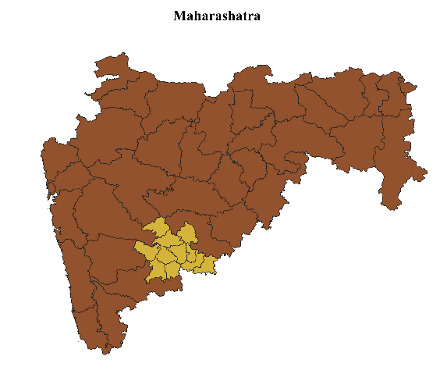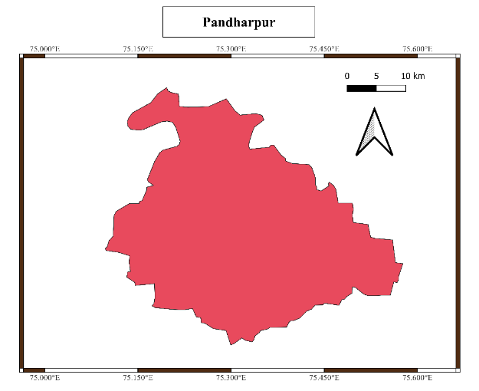
Maharashtra
The study was conducted in Pandharpur Tehsil located at 17.67°N latitude and 75.32°E longitude, Solapur District, Maharashtra, India, a region characterized by agricultural landscapes interspersed with small forest patches, scrublands, and seasonal as well as perennial water bodies. This habitat heterogeneity provides suitable feeding, roosting, and nesting conditions for both resident and migratory predatory birds. The diversity of open farmlands and wetland-associated habitats makes the area favourable for raptor observations.

METHODOLOGY
Field surveys were carried out over a one-year period from December 2024 to November 2025, covering winter, summer, and monsoon seasons to document seasonal variations in raptor diversity and behaviour. Bird surveys were conducted using transect walks and point count methods, which are widely used and effective techniques for studying raptor populations across different habitats (Bibby et al., 2000; Fuller and Mosher, 1987). Observations were made during peak activity periods in the early morning (6:00–10:00 am) and late afternoon (4:00–6:00 pm), when detectability of predatory birds is highest (Newton, 1979).
Field equipment included 8×40 binoculars, field guides, datasheets, notebooks, a digital camera, and a GPS device to record precise locations of sightings, roosting sites, and nesting areas. For each observation, species identity, number of individuals, habitat type, and activity (perching, soaring, hunting, or feeding) were recorded. Species identification followed standard field guides and authoritative online databases (Naoroji, 2006).
Information on residential or migratory status and IUCN Red List conservation status was documented for all recorded species. Feeding behaviour and hunting strategies were observed following methods suggested for raptor ecological studies (Sergio et al., 2008). Potential threats such as habitat disturbance, pesticide use, poisoning, and electrocution from power lines were noted through direct observations and informal interactions with local residents and forest officials, as recommended in raptor conservation assessments (Donázar et al., 2016).
The collected data were analysed to prepare a checklist of predatory birds, including common name, scientific name, family, order, IUCN status, residential status, and feeding habits. Descriptive tables and charts were used to interpret habitat use, seasonal occurrence, and threat patterns, forming the basis for suggesting appropriate conservation measures for raptors in Pandharpur Tehsil.

IV. RESULTS & DISCUSSION
Table No1- Checklist of the Predatory birds in Pandharpur area, Solapur (MS)
Common Name | Scientific Name | Order | Family | Status in Maharashtra | Habitat Preference | IUCN Category | Feeding Habit
Brahminy Kite | Haliastur indus | Accipitriformes | Accipitridae | Resident | Inland water bodies, riversides, wetlands | Least Concern | Feeds mainly on fish, aquatic animals, carrion
Black Kite | Milvus migrans | Accipitriformes | Accipitridae | Resident | Human settlements, agricultural land, open water sources | Least Concern | Scavenger; also takes small animals
Shikra | Accipiter badius | Accipitriformes | Accipitridae | Resident | Cultivated land, gardens, forest edges | Least Concern | Hunts small birds, rodents, reptiles
Black-winged Kite | Elanus caeruleus | Accipitriformes | Accipitridae | Resident | Open grasslands and farmlands | Least Concern | Primarily preys on rodents
Greater Spotted Eagle | Clanga clanga | Accipitriformes | Accipitridae | Winter visitor (rare) | Marshes, wetlands, open plains | Vulnerable | Small mammals, birds, fish
Bonelli’s Eagle | Aquila fasciata | Accipitriformes | Accipitridae | Resident (rare) | Rocky terrain, dry forests | Least Concern | Medium-sized birds and mammals
Osprey | Pandion haliaetus | Accipitriformes | Pandionidae | Winter migrant | Lakes, rivers, reservoirs | Least Concern | Exclusively feeds on fish
Western Marsh Harrier | Circus aeruginosus | Accipitriformes | Accipitridae | Winter migrant | Wetlands, marshy areas | Least Concern | Birds, amphibians, rodents
Pallid Harrier | Circus macrourus | Accipitriformes | Accipitridae | Winter migrant | Dry grasslands, open plains | Near Threatened | Small mammals and birds
Montagu’s Harrier | Circus pygargus | Accipitriformes | Accipitridae | Winter migrant | Agricultural fields and grasslands | Least Concern | Rodents, insects, small birds
Common Kestrel | Falco tinnunculus | Falconiformes | Falconidae | Resident / seasonal visitor | Open countryside, farmland | Least Concern | Rodents, insects, reptiles
Red-necked Falcon | Falco chicquera | Falconiformes | Falconidae | Resident (uncommon) | Open dry habitats with scattered trees | Least Concern | Small birds, lizards, rodents
Spotted Owlet | Athene brama | Strigiformes | Strigidae | Resident | Villages, orchards, tree hollows | Least Concern | Insects, small vertebrates
Barn Owl | Tyto alba | Strigiformes | Tytonidae | Resident | Farmland, buildings, barns | Least Concern | Mainly rodents
white-eyed buzzard | Butastur teesa | Accipitriformes | Accipitridae | Resident | Open dry habitats, cultivations | Least Concern | Rodents, insects, reptiles, Amphibians
Oriental Honey Buzzard | Pernis ptilorhynchus | Accipitriformes | Accipitridae | Resident | Cultivated land, gardens, forest edges | Least Concern | Feeds mainly on larvae and adults of bees and wasps; also, insects, reptiles, amphibians, and small vertebrates

Table No. 1 provides a comprehensive overview of the predatory bird species recorded from the Pandharpur region of Solapur district, Maharashtra. The checklist documents 16 species of raptors belonging to three avian orders, namely Accipitriformes, Falconiformes, and Strigiformes, indicating a rich and well-structured raptor community within the study area.
The order Accipitriformes was the most dominant, contributing the highest number of species, including kites, eagles, harriers, and buzzards. This dominance reflects the suitability of the local landscape, which consists of open plains, agricultural fields, wetlands, and riverine habitats. The presence of Falconiformes, represented by falcons and kestrels, highlights the availability of open hunting grounds, while Strigiformes, represented by owls, confirms the existence of suitable nocturnal foraging and nesting conditions.
Analysis of the residency status shows that a majority of the species are resident, suggesting that the Pandharpur area provides stable food resources and favorable habitats throughout the year. The occurrence of several winter migrants, particularly harriers and the Osprey, indicates that the region also functions as an important seasonal habitat for migratory raptors. The record of the Greater Spotted Eagle, a rare winter visitor, emphasizes the ecological importance of wetlands and marshy areas in the region.
Habitat preference data reveal that predatory birds in Pandharpur utilize a wide range of environments. Wetland-dependent species such as Brahminy Kite, Osprey, and Western Marsh Harrier were closely associated with rivers, lakes, and marshes. In contrast, species like Black Kite, Shikra, and Spotted Owlet were commonly found in cultivated lands, villages, and human-dominated landscapes, indicating a high degree of adaptability. Raptors such as Bonelli’s Eagle and Red-necked Falcon preferred rocky terrain and dry open habitats, reflecting habitat specialization among certain species.
The feeding habits of the recorded raptors show considerable trophic diversity. Fish-eating species depend largely on aquatic ecosystems, while most other raptors primarily prey on rodents, insects, reptiles, amphibians, and small birds. Owls, especially the Barn Owl and Spotted Owlet, play a significant role in controlling rodent populations in agricultural areas. The presence of scavenging species like the Black Kite contributes to environmental cleanliness by consuming carrion and organic waste. The Oriental Honey Buzzard represents a specialized feeder, relying mainly on insects such as bees and wasps, which adds to the functional diversity of the raptor assemblage.
According to the IUCN Red List categories, the majority of species recorded fall under Least Concern, indicating relatively stable populations. However, the presence of Vulnerable and Near Threatened species, such as the Greater Spotted Eagle and Pallid Harrier, highlights the conservation value of the study area and the need for protection of key habitats like wetlands, grasslands, and agricultural mosaics.
Overall, the checklist reflects that the Pandharpur region supports a diverse and ecologically significant assemblage of predatory birds. The variety of habitats and feeding strategies observed suggests a balanced ecosystem capable of sustaining both resident and migratory raptors. Conservation and sustainable management of local habitats are essential to maintain this raptor diversity and the ecological services they provide.

Order | Number of Species
Accipitriformes | 12
Falconiformes | 2
Strigiformes | 2
Total | 16
Table 2. Taxonomic order composition of predatory birds recorded from the Pandharpur area

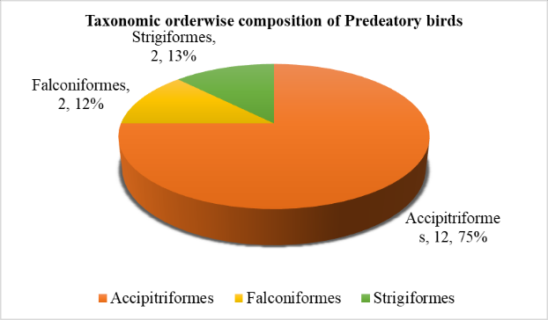
Graph 1. Taxonomic order composition of predatory birds recorded from the Pandharpur area

The predatory bird community in Pandharpur comprises 16 species across three orders. Accipitriformes dominate, including kites, eagles, harriers, and buzzards, reflecting the availability of open habitats, wetlands, and agricultural fields. Falconiformes, represented by falcons and kestrels, occupy open hunting grounds, while Strigiformes, including owls, utilize nocturnal niches in farmlands, orchards, and tree hollows. This composition highlights a balanced raptor assemblage with both diurnal and nocturnal predators.

Table 3. Predatory Birds Family Wise Composition in Pandharpur
Taxonomic Family | Species belonging in Family
Accipitridae | 11
Falconidae | 2
Pandionidae | 1
Strigidae | 1
Tytonidae | 1
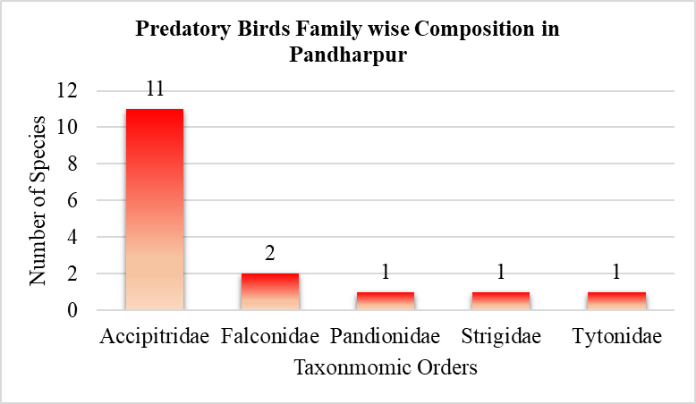
Graph 2. Predatory Birds Family Wise Composition in Pandharpur

A total of 16 predatory bird species recorded from the Pandharpur region belong to five families. The family Accipitridae dominates with 11 species, including kites, eagles, harriers, and buzzards, reflecting their widespread presence in open fields, wetlands, and riverine habitats. Falconidae is represented by 2 species, mainly kestrels and falcons, which prefer open landscapes and specialize in hunting small birds and reptiles. The remaining families Pandionidae, Strigidae, and Tytonidae each include a single species: the fish-eating Osprey (Pandion haliaetus), and nocturnal owls (Strigidae and Tytonidae), highlighting the presence of both specialized and nocturnal predators. This family-wise distribution demonstrates the taxonomic diversity and ecological balance of raptors in the Pandharpur area.

Table 4. Residential status of predatory bird species in the Pandharpur area
Residential Status | Number of Species
Resident | 11
Winter Migrant | 5
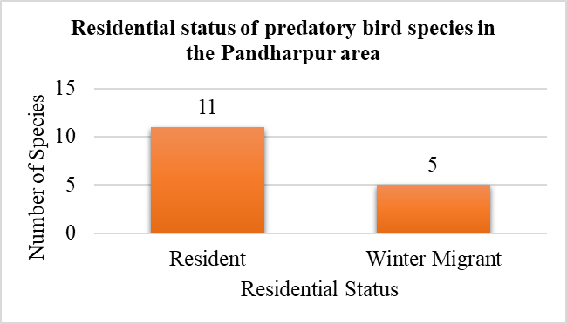
Graph 3. Residential status of predatory bird species in the Pandharpur area

The 16 predatory bird species recorded from Pandharpur show a clear pattern of residency. Resident species dominate with 11 species, indicating that the region provides stable habitats, abundant prey, and suitable nesting or roosting sites throughout the year. Winter migrants account for 5 species, including harriers and Osprey, reflecting the role of Pandharpur as an important seasonal refuge for migratory raptors. This distribution highlights the area’s importance in supporting both year-round and seasonal predatory bird populations.
Table 5. IUCN conservation categories of predatory birds recorded from the Pandharpur area
IUCN Category | Number of Species
Least Concern | 14
Near Threatened | 1
Vulnerable | 1
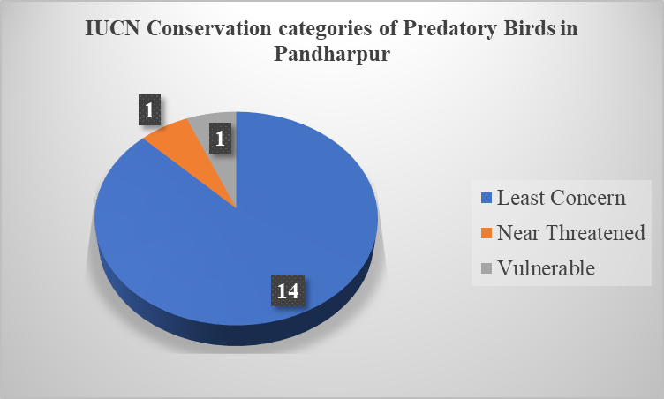
Graph 4. IUCN conservation categories of predatory birds recorded from the Pandharpur area
The conservation assessment of the 16 predatory bird species in Pandharpur shows that the majority, 14 species, are listed as Least Concern, indicating that their populations are currently stable in the region. One species, the Pallid Harrier, is classified as Near Threatened, and the Greater Spotted Eagle falls under the Vulnerable category, highlighting that certain habitats such as wetlands and open grasslands require protection to ensure the survival of these sensitive species. This distribution emphasizes the need for habitat conservation alongside the management of human-modified landscapes to maintain the raptor diversity in the area.
Graph 5. Habitat Preferences of Predatory Birds in the Study Area
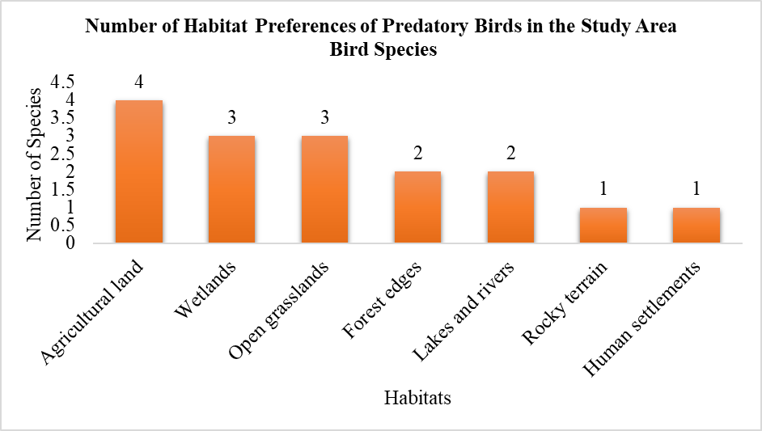
Predatory birds in the study area occupied a range of habitats that reflected their hunting strategies and ecological needs. Species such as the Brahminy Kite and Osprey were mainly observed near lakes, rivers, and wetlands, where fish and other aquatic prey are readily available, while the Greater Spotted Eagle and Western Marsh Harrier also favored marshy landscapes that support diverse prey communities. The Black Kite showed considerable flexibility in habitat use and was frequently encountered around agricultural fields and nearby human settlements. In contrast, Shikra and Oriental Honey Buzzard were associated with cultivated areas, gardens, and forest margins, which offer a balance of tree cover and open space for foraging. Open grasslands and farmlands were particularly important for species like the Black-winged Kite, Pallid Harrier, and Montagu’s Harrier, as these environments allow effective prey detection and capture. Bonelli’s Eagle was largely confined to rocky terrain and dry forest patches, consistent with its nesting and hunting preferences. Collectively, these patterns suggest that both natural habitats and modified landscapes contribute significantly to sustaining predatory bird diversity.
V. DISCUSSION
The composition of predatory birds observed in the Pandharpur area follows trends commonly reported in raptor studies from different parts of the world. The strong representation of species belonging to the order Accipitriformes is consistent with observations from many regional surveys, where diurnal raptors such as kites, hawks, and eagles tend to form the core of raptor communities. Their dominance is often linked to their adaptability, wide prey spectrum, and effective hunting behavior, which allow them to thrive across varied landscapes (Dobrev and Demerdzhiev, 2023). The presence of multiple raptor orders within the same area further indicates that the landscape offers a range of ecological conditions capable of supporting species with different foraging and behavioral traits.
Raptors are widely recognized for their ability to utilize diverse habitats, and this ecological flexibility likely contributes to the coexistence of resident and migratory species in the Pandharpur region. Seasonal movements in birds of prey are largely influenced by changes in climate and prey availability, prompting many species to shift between breeding and wintering areas across established flyways (Panuccio et al., 2022). The occurrence of winter migrants alongside year-round residents in the present study suggests that the Pandharpur area serves multiple ecological roles, functioning both as a permanent habitat for local raptors and as a suitable seasonal refuge for migratory species. An examination of conservation categories adds further importance to the findings of this study. While most of the recorded species fall under the Least Concern category, global assessments indicate that raptors as a group are increasingly exposed to threats such as habitat degradation, human disturbance, and reduced prey populations. McClure et al. (2018) reported widespread population declines among raptors worldwide, with several regions in Asia supporting a disproportionately high number of threatened species. The detection of both Near Threatened and Vulnerable species within the Pandharpur assemblage aligns with these global concerns and highlights the role of modified landscapes in providing refuge for species with higher conservation sensitivity. Landscape structure has a strong influence on raptor communities because differences in habitat types directly affect prey availability and hunting conditions. Evidence from subtropical regions of India indicates that the presence and diversity of raptors change across seasons and locations, largely due to variations in land use and habitat composition. Areas that include a mix of forests, wetlands, farmlands, and open landscapes tend to support a greater variety of raptor species, as these environments offer diverse foraging grounds and suitable ecological conditions for different hunting strategies (Kumar et al., 2022). The mixture of agricultural land, wetlands, and open grasslands in the Pandharpur area likely contributes to the variety of predatory birds recorded during the study. Taken together, the findings emphasize the ecological value of the Pandharpur area for predatory birds. The combination of common and conservation-sensitive species reflects a functioning raptor community and underscores the need for continued habitat conservation and informed land-use practices to ensure the long-term persistence of both resident and migratory raptors in this region of Maharashtra. Predatory bird species in the study area showed clear differences in habitat use that reflect their feeding ecology and adaptability. Wetland-associated species such as the Brahminy Kite, Osprey, Greater Spotted Eagle, and Western Marsh Harrier depended largely on aquatic and marshy habitats with high prey availability (Newton, 1979). The importance of wetlands and water bodies for supporting raptor foraging and prey diversity has also been emphasized in broader ecological studies (Bildstein, 2006). The Black Kite demonstrated strong adaptability by frequently using agricultural landscapes and human settlements, a pattern commonly observed in human-dominated environments (Donázar et al., 2016). Cultivated land, gardens, and forest edges supported species like Shikra and Oriental Honey Buzzard by providing suitable hunting cover (Thiollay, 1994). Open grasslands and farmlands were important for Black-winged Kite and harrier species, which rely on open habitats for efficient prey detection (del Hoyo et al., 1994), while rocky terrain and dry forests were preferred by Bonelli’s Eagle for nesting and hunting activities (Real & Mañosa, 1997). The results highlight the importance of both natural and modified habitats in sustaining predatory bird diversity.

VI. Conclusion
The survey recorded 16 raptor species representing three orders and five families in Pandharpur Tehsil. Accipitriformes contributed most of the recorded species, while the assemblage included both resident and migratory birds. Raptors were observed in wetlands, agricultural land, grasslands, scrublands, rocky areas, gardens, and human settlements, demonstrating the importance of habitat heterogeneity within the study area. Most recorded species were categorized as Least Concern, whereas the Pallid Harrier and Greater Spotted Eagle had higher global conservation concern. These observations provide a preliminary inventory of raptors in Pandharpur and identify habitats that warrant continued field monitoring. Repeated standardized surveys, supported by abundance estimates and habitat-specific sampling, are required to determine population trends and clarify the relative importance of different habitats for resident and migratory raptors.

Limitations
The survey did not estimate detection probability, and sampling effort by season, site, and habitat was not quantified in the reported results. Abundance, encounter rates, population trends, and habitat availability were not analysed. Consequently, habitat associations were based mainly on observed occurrence rather than formal habitat-selection analysis. No dedicated nocturnal survey protocol was described for owl species. Some uncommon records also lacked detailed dates, coordinates, and diagnostic evidence. These limitations restrict conclusions concerning local population status, habitat preference, seasonal variation, and long-term conservation trends.

Declaration of AI Use

This manuscript was prepared through the combined contributions of all author(s), including contributions to the study design, data, content development, results, interpretation, and related scholarly work. The author(s) acknowledge the use of Grammarly and ChatGPT to assist with grammar checking, language refinement, reference formatting. These AI-assisted tools were not used as authors and did not replace the intellectual contributions or scholarly judgment of the author(s). All AI-assisted outputs, including content, references, and interpretations, were carefully reviewed, revised, verified, and approved by the author(s). The author(s) accept full responsibility for the accuracy, integrity, and final content of the manuscript.

COMPETING INTERESTS DISCLAIMER:
Authors have declared that they have no known competing financial interests OR non-financial interests OR personal relationships that could have appeared to influence the work reported in this paper.

APPENDIX
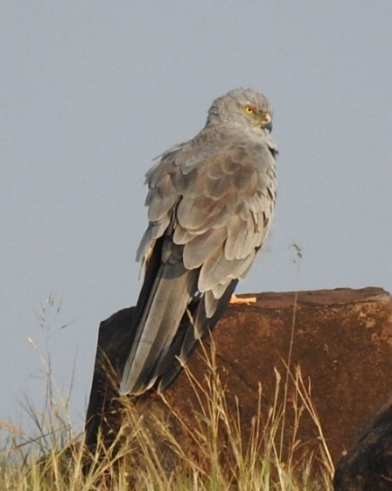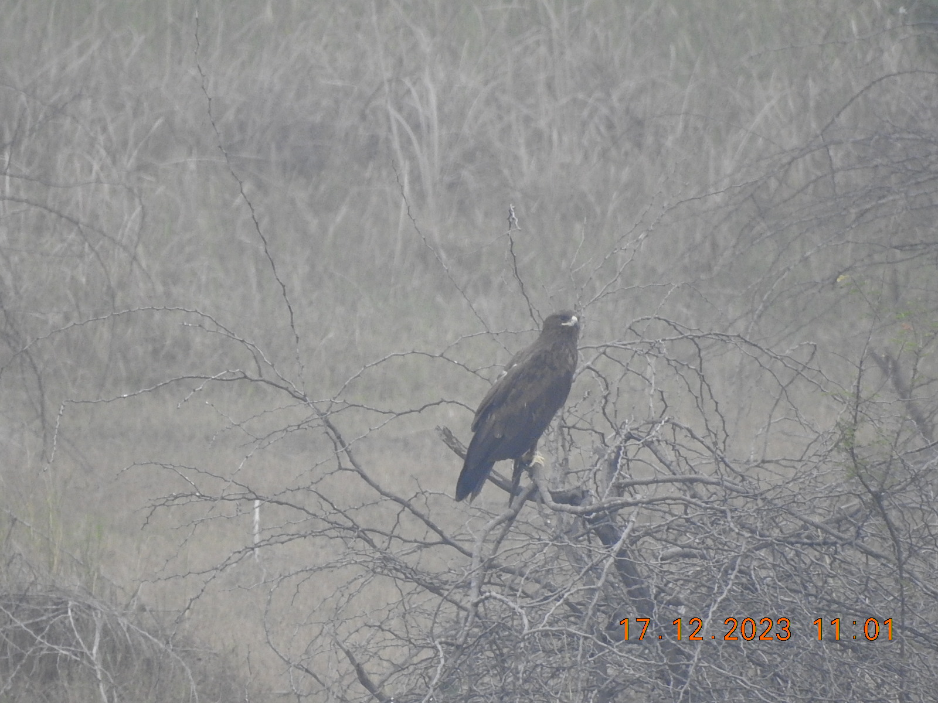
©KPA
©KPA
Fig No.1 Montagues Harrier Fig No.2 Greater Spotted Eagle
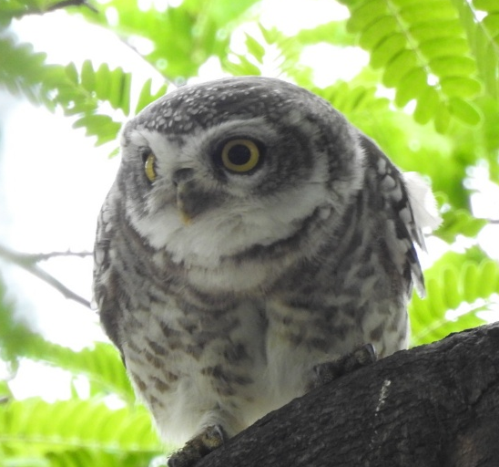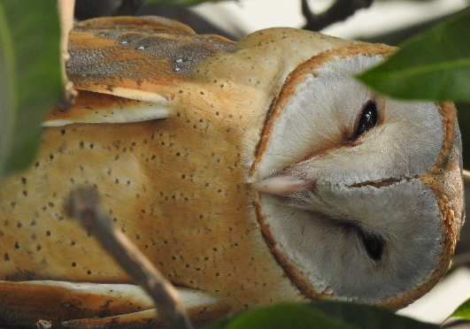
©KPA
©KPA
Fig No.3 Spotted Owlet Fig No.4 Barn Owl
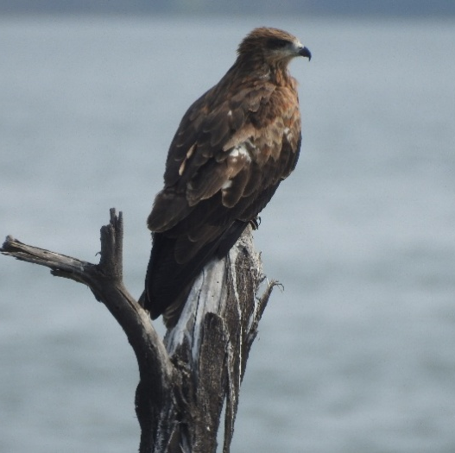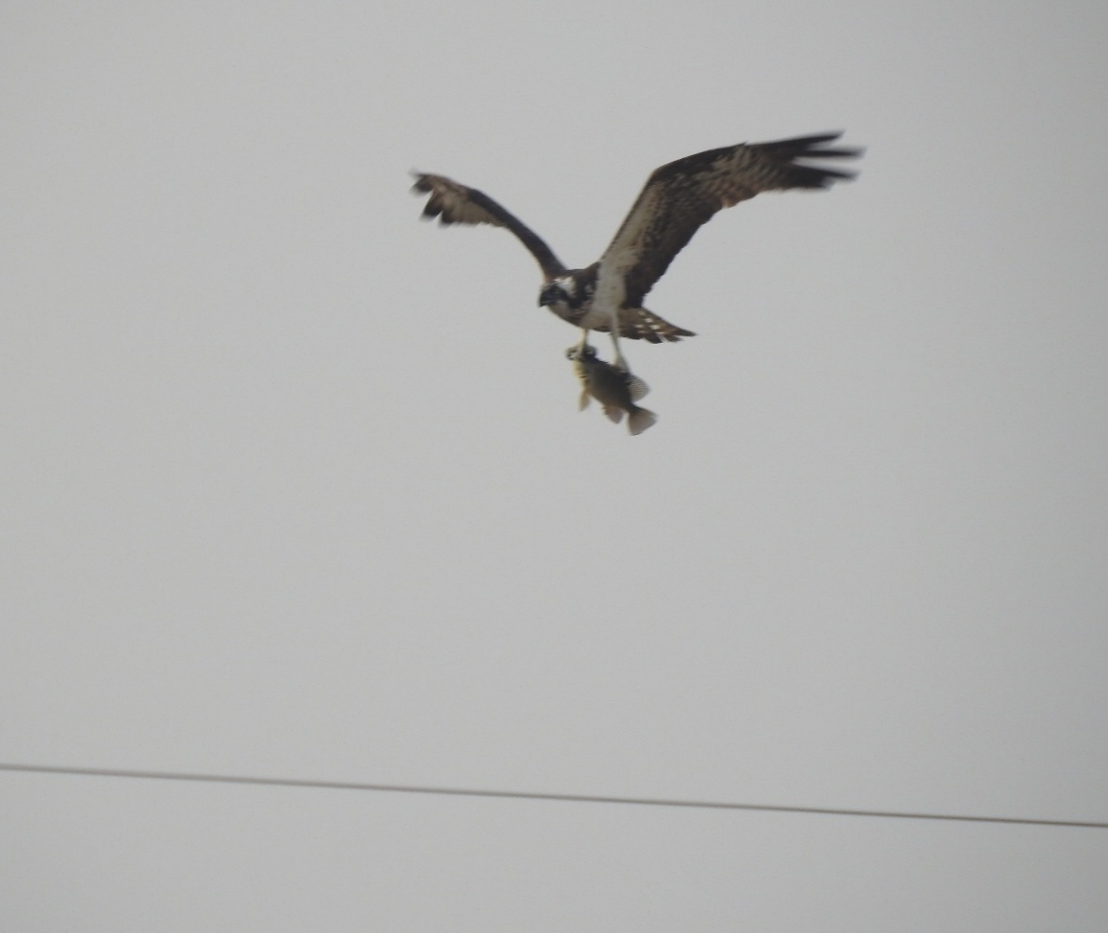
©KPA
©KPA
Fig No.5 Black Kite Fig No.6 Osprey
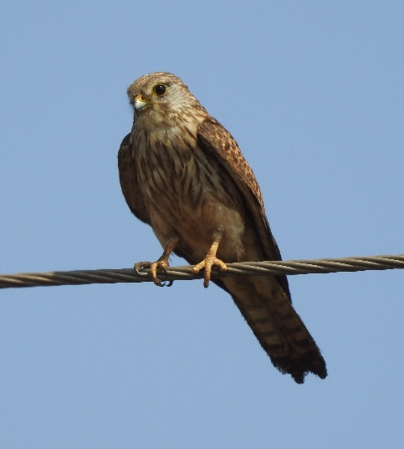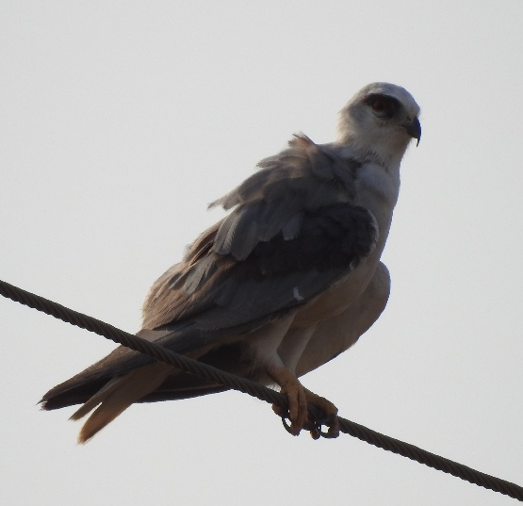
©KPA
©KPA
Fig No. 07 Common Kestrel Fig No.08 Black winged kite
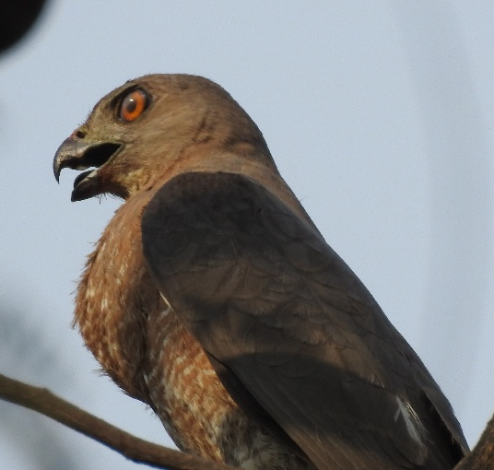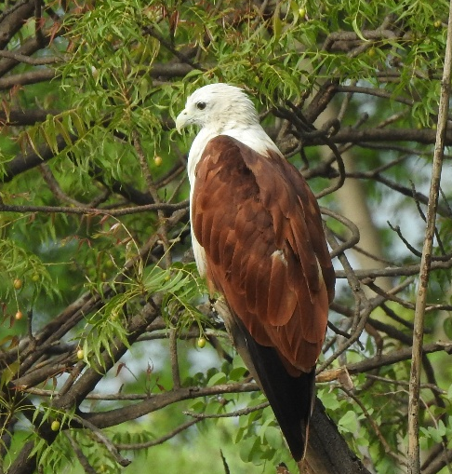
©KPA
©KPA
Fig No.09 Shikra Fig No.10 Brahminy Kite
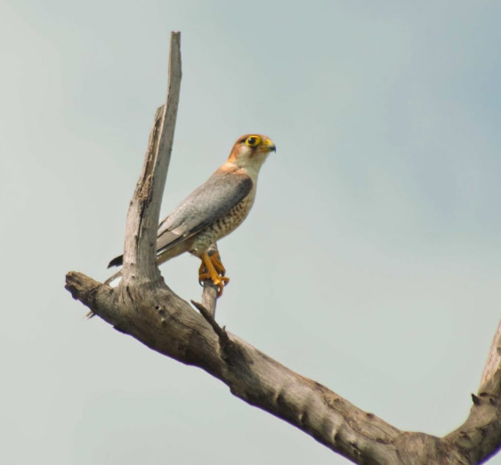
©KPA
Fig No. 11 Red-necked Falcon

REFERENCES
- Bibby, C. J., Burgess, N. D., Hill, D. A., and Mustoe, S. H. (2000). Bird census techniques (2nd ed.). Academic Press.
- Bildstein, K. L. (2006). Migrating raptors of the world: Their ecology and conservation. Cornell University Press.
- BirdLife International. (2021). State of the world’s birds 2021: Taking the pulse of the planet. BirdLife International.
- Cade, T. J., and Burnham, W. (2003). Return of the peregrine: A North American saga of tenacity and teamwork. The Peregrine Fund.
- del Hoyo, J., Elliott, A., & Sargatal, J. (1994). Handbook of the birds of the world (Vol. 2: New World vultures to guineafowl). Lynx Edicions.
- Dobrev, V., and Demerdzhiev, D. (2023). Conservation and ecology of raptors: Introduction to the special issue. Diversity, 15(8), 889. https://doi.org/10.3390/d15080889
- Donázar, J. A., Cortés-Avizanda, A., & Fargallo, J. A. (2016). Effects of human activities on raptors. Bird Conservation International, 26(1), 1–21.
- Donázar, J. A., Cortés-Avizanda, A., Fargallo, J. A., Margalida, A., Moleón, M., Morales-Reyes, Z., Moreno-Opo, R., Pérez-García, J. M., Sánchez-Zapata, J. A., Zuberogoitia, I., and Serrano, D. (2016). Roles of raptors in a changing world: From flagships to providers of key ecosystem services. Ardeola, 63(1), 181–234.
- Fuller, M. R., and Mosher, J. A. (1987). Raptor survey techniques. In B. A. Giron Pendleton, B. A. Millsap, K. W. Cline, and D. M. Bird (Eds.), Raptor management
- techniques manual (pp. 37–65). National Wildlife Federation.
- Green, R. E., Newton, I., Shultz, S., Cunningham, A. A., Gilbert, M., Pain, D. J., and Prakash, V. (2004). Diclofenac poisoning as a cause of vulture population declines across the Indian subcontinent. Journal of Applied Ecology, 41(5), 793–800.
- Kumar, S., Sohil, A., Kichloo, M. A., & Sharma, N. (2022). Landscape heterogeneity affects diurnal raptor communities in a sub-tropical region of northwestern Himalayas, India. PLOS ONE, 17(4), e0246555.
- Markandya, A., Taylor, T., Longo, A., Murty, M. N., Murty, S., and Dhavala, K. (2008). Counting the cost of vulture decline—An appraisal of the human health and economic impacts of vulture loss in India. Ecological Economics, 67(2), 194–204.
- McClure, C. J. W., Buij, R., Thorstrom, R., Vargas, F. H., and Virani, M. Z. (2018). The state of the world’s raptors: Distributions, threats, and conservation recommendations. Biological Conservation, 227, 390–402. https://doi.org/10.1016/j.biocon.2018.08.012
- Naoroji, R. (2006). Birds of prey of the Indian subcontinent. Om Books International.
- Newton, I. (1979). Population ecology of raptors. T and AD Poyser.
- Panuccio, M., Mellone, U., and Agostini, N. (2022). Migration strategies of birds of prey in the Western Palearctic. CRC Press.
- Real, J., & Mañosa, S. (1997). Demography and conservation of Bonelli’s eagle (Hieraaetus fasciatus) in western Europe. Biological Conservation, 79(1), 59–66.
- Sarà, M., et al. (2018). Diet and habitat affinities in six raptor species in India. Avian Research, 9, Article 36.
- Sergio, F., Caro, T., Brown, D., Clucas, B., Hunter, J., Ketchum, J., McHugh, K., and Hiraldo, F. (2008). Top predators as conservation tools: Ecological rationale, assumptions, and efficacy. Annual Review of Ecology, Evolution, and Systematics, 39, 1–19.
- Thiollay, J. M. (1994). Family Accipitridae (hawks and eagles). In J. del Hoyo, A. Elliott, & J. Sargatal (Eds.), Handbook of the birds of the world (Vol. 2, pp. 52–205). Lynx Edicions.

