Karyotypic profiles of Puntius sophore (Hamilton,1822) and Puntius bimaculatus (Bleeker, 1863) from the Gadana River, Western Ghats

ABSTRACT

The karyotypic and cytological characteristics of two cyprinid fishes from Gadana River, Western Ghats, were taxonomically analysed by developing metaphase chromosome spreads using Giemsa staining strategy. Ornamental fishes serve as valuable genetic tools for investigating systematics, evolution, and ecological adaptations. Puntius sophore and Puntius bimaculatus are ornamental cyprinid fishes exhibiting a modal diploid chromosome number of 50. The karyotype formula of Puntius sophore is 8m + 2sm + 26st + 14t chromosomes, with FN=60, and that of Puntius bimaculatus is 28m + 22t chromosomes, with FN=78. In Puntius bimaculatus, chromosome lengths ranged from 0.43 to 0.89µ, whereas in Puntius sophore, they ranged from 0.43 to 1.08 µ. These findings provide valuable cytogenetic insights that may facilitate gene manipulation studies, assessment of population structure, taxonomic clarification, and conservation strategies for native fish species inhabiting the streams and rivers of the Western Ghats.
Keywords: Karyotypes, Metaphase, Chromosomes, Ornamental fishes, Puntius, Genetic tool

1. INTRODUCTION
Native ornamental fishes, otherwise known as coloured fishes and Phedim fishes. Coloures are described as Phenopositive genetic ambiter with optic hofomer. These are agile swimmers and produce distinctive acoustic signals. Moreover, they can purify the surrounding water through their forced respiration. Fishes are characterized either by the presence of stable karyotypic structure and conserved chromosome numbers or by diverse groups exhibiting broad chromosomal variability (De Rosa et al., 2007). The genus Puntius is considered synapomorphic (Yu et al., 1987) and is karyologically composed of smaller or telocentric chromosomes. The genus Puntius comprises 220 nominal species, of which about 120 are currently recognized as valid (Pethiyagoda et al., 2012). The genome of these fishes is represented by the total number of chromosomes, which correlates with the evolution of their phenotypes. The vivid colouration exhibited by numerous species of Puntius has contributed to their popularity as freshwater aquarium fishes. Cyprinids—representing the most diversified and largest freshwater fishes—inhabit headwater streams, rivers, wetlands and brackish water, and include economically important carps, minnows and ornamental fishes (Nelson, 1991). They exploit the available food resources and occupy diverse ecological niches (Lowe-McConnell, 1987). Variation acts as an evolutionary force influencing both the phenotype and genotype of an organism. Genotypic polymorphism observed within the population are not only due to mutation and random stochastic factors (Vannote et al., 1980) but also sue to directional selection that results in adaptation or phenotypic plasticity. Natural selection operates whenever there is variation in fitness (Futuyma, 2009). The Western Ghats, recognized as one of the popular biodiversity hotspots, harbours numerous endemic and endangered species of fauna and flora, including more than 250 species of freshwater fishes. The ornamental fishes Puntius sophore (Hamilton, 1822) and Puntius bimaculatus (Bleeker, 1863), with Puntius sophore being a freshwater to brackish water cyprinid widely distributed across Asia, have been reported for the first time from the Gadana River basin of the Western Ghats based on karyological analysis. Individuals of these species attain a maximum length of 5-7c.m. In Puntius bimaculatus, a spot is present on the third to seventh dorsal rays, with an additional single spot at the base of the caudal fin (Pethiyagoda, 1991). These fishes are benthopelagic, feeding primarily on green algae and detritus (Arunachalam et al., 2000). Puntius sophore also exhibits both caudal and dorsal spots. It inhabits plains and submontane regions and is a highly abundant shoaling fish, commonly found in ponds across West Bengal, India (Dhanukar, 2010). Cytogenetic studies provide a fundamental approach to study genetic variation. Fishes are aquatic animals that rely on water for their physiological functions and behaviour, with their adaptations and survival linked to aquatic environment (enobus—sound). The importance of chromosomal analysis in fishes, coupled with the lack of karyotypic information on endemic fishes, motivated this investigation. For the karyotypic study, two species belonging to the family Cyprinidae were selected and confirmed as Puntius sophore (Hamilton, 1822) and Puntius bimaculatus (Bleeker, 1863). Considering the wide geographical distribution and complex geological context of the Tamirabarani River basin, a karyological investigation was conducted on Puntius sophore and Puntius bimaculatus from the previously unstudied Gadana stream, India, to elucidate their chromosomes and provide insights into their taxonomy and evolutionary relationships.
2. MATERIALS AND METHODS
2.1 Sample Collection
A total of 11 specimens of Puntius bimacultus (six females and five males) and 13 specimens of Puntius sophore (seven males and six females) were sacrificed for karyotypic analysis . Fish specimens were collected from Gadana River (8° 47´ 47´´ N; 77°19´17´´E), Western Ghats (Fig.1), using cast and gill nets, and subsequently transferred to the laboratory in well-aerated polythene bags. The fishes were maintained in 1.5m×1m plastic tanks to ensure adequate acclimatization.
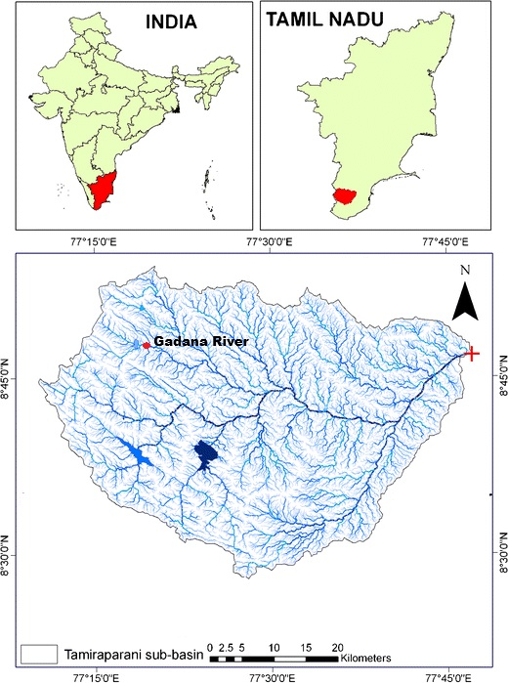

Figure 1. Sampling location of Gadana river, Tamiraparani River, Western Ghats, India.

2.2 Karyotyping
Chromosome preparations for both species were carried out according to the method of Kliggerman and Bloom (1977). Each fish was injected with 0.01 mg of phytohemagglutinin (PHA) and allowed to swim for 2 hrs (Padilla et.al 1993). As these fishes were smaller in size, lower concentrations and shorter exposure durations were considered sufficient. Subsequently, they were injected intraperitonially with colchicine at a dosage of 0.01mg/g body weight of the fish and allowed to swim freely in a well-aerated tank for an additional 2 hr. The fishes were anaesthetized and sacrificed, and their kidneys and spleens were excised and stored in a 0.5% KCl solution for 30 min, followed by fixation in Carnoy’s fluid for 10 minutes. The samples were then stored at -4ºC for 24 hrs. Subsequently, they were treated with 0.15 M NaCl₂ solution for 10 minutes and 0.015 M trisodium citrate for 30 min. The tissues were then treated with acetic acid for few minutes and minced thoroughly with scissors and fillers. The slides were warmed at 50º C and chromosome spreads were made by coordinate air-drying technique. The slides were then stained with 5% Giemsa for 30 min, rinsed with distilled water, air-dried, and examined under a microscope at 100x magnification (Nikon Alpha pot-4microscope). The chromosomes were measured using an ocular micrometer, photographed, and analysed. A standard idiogram was constructed according to Levan et al. (1964). The mean lengths of the short and long arms of chromosomes, as well as centromeric index, were calculated. Chromosome sets were grouped according to Macgregor (1993).
3. RESULTS
Twenty metaphase images obtained from kidney cells were analysed for each species and the results were as follows. The diploid chromosome number was determined to be 2n=50 for both Puntius sophore (Figure 2A) and Puntius bimaculatus (Figure 2 C). The karyotype formula of Puntius sophore was 8m+2sm+26st+14t with NF=60 (Figure 2B) and that of Puntius bimaculatus was 28m+22t with NF=78 (Figure 2D). The total chromosome length in Puntius bimaculatus ranged from 0.43 to 0.89 µm, and in Puntius sophore, it was 0.43-1.08µm. The chromosome morphometric data are given in Tables 1 and 2. Representative metaphase spreads are shown in Figure 2A and 2C and the standard ideograms are given in Figures 3 and 4.
The consistent diploid number of 2n = 50 observed in both species is congruent with the conserved chromosome number frequently reported across many cyprinid lineages; however, the differences in fundamental arm number and chromosome morphology indicate that structural rearrangements may occur without altering the diploid chromosome count (Buasriyot et al., 2024; Khensuwan et al., 2023). This interpretation supports cautious use of the karyotype formulae as comparative cytotaxonomic characters, because conventional staining can establish chromosome number and gross morphology but may not resolve cryptic genomic differences such as rDNA-site variation or repetitive-DNA redistribution (Khensuwan et al., 2023; Rossi, 2021).
Table1. The karyomorphology of Puntius bimaculatus
Sl.No. | LA | SA | TL | AL | RL (%) | A/R=r | CI
1 | 0.488 | 0.399 | 0.887 | 0.444 | 5.2 | 1.22 | 45
2 | 0.385 | 0.385 | 0.77 | 0.385 | 4.5 | 1 | 50
3 | 0.427 | 0.214 | 0.641 | 0.321 | 3.76 | 1.99 | 33.44
4 | 0.427 | 0.214 | 0.641 | 0.321 | 3.76 | 1.99 | 33.44
5 | 0.385 | 0.256 | 0.641 | 0.321 | 3.76 | 1.5 | 40
6 | 0.385 | 0.256 | 0.641 | 0.321 | 3.76 | 1.5 | 40
7 | 0.342 | 0.256 | 0.598 | 0.299 | 3.5 | 1.34 | 42.74
8 | 0.299 | 0.299 | 0.598 | 0.299 | 3.5 | 1 | 50
9 | 0.342 | 0.214 | 0.556 | 0.278 | 3.25 | 1.6 | 38.46
10 | 0.299 | 0.256 | 0.555 | 0.278 | 3.25 | 1.17 | 46.08
11 | 0.299 | 0.256 | 0.555 | 0.278 | 3.25 | 1.17 | 46.08
12 | 0.256 | 0.256 | 0.512 | 0.256 | 2.99 | 1 | 50
13 | 0.256 | 0.214 | 0.47 | 0.235 | 2.75 | 1.2 | 45.45
14 | 0.256 | 0.214 | 0.47 | 0.235 | 2.75 | 1.2 | 45.45
15 | 0.641 |  |  | 0.641 | 7.5
16 | 0.556 |  |  | 0.556 | 6.5
17 | 0.556 |  |  | 0.556 | 6.5
18 | 0.513 |  |  | 0.513 | 6
19 | 0.513 |  |  | 0.513 | 6
20 | 0.51 |  |  | 0.51 | 5.97
21 | 0.47 |  |  | 0.47 | 5.5
22 | 0.47 |  |  | 0.47 | 5.5
23 | 0.47 |  |  | 0.47 | 5.5
24 | 0.427 |  |  | 0.427 | 4.99
25 | 0.427 |  |  | 0.427 | 4.99
LA-Long arm, SA- Short arm, TL-Total length, AL-Average length
RL-Relative length, CI- Centromeric index.

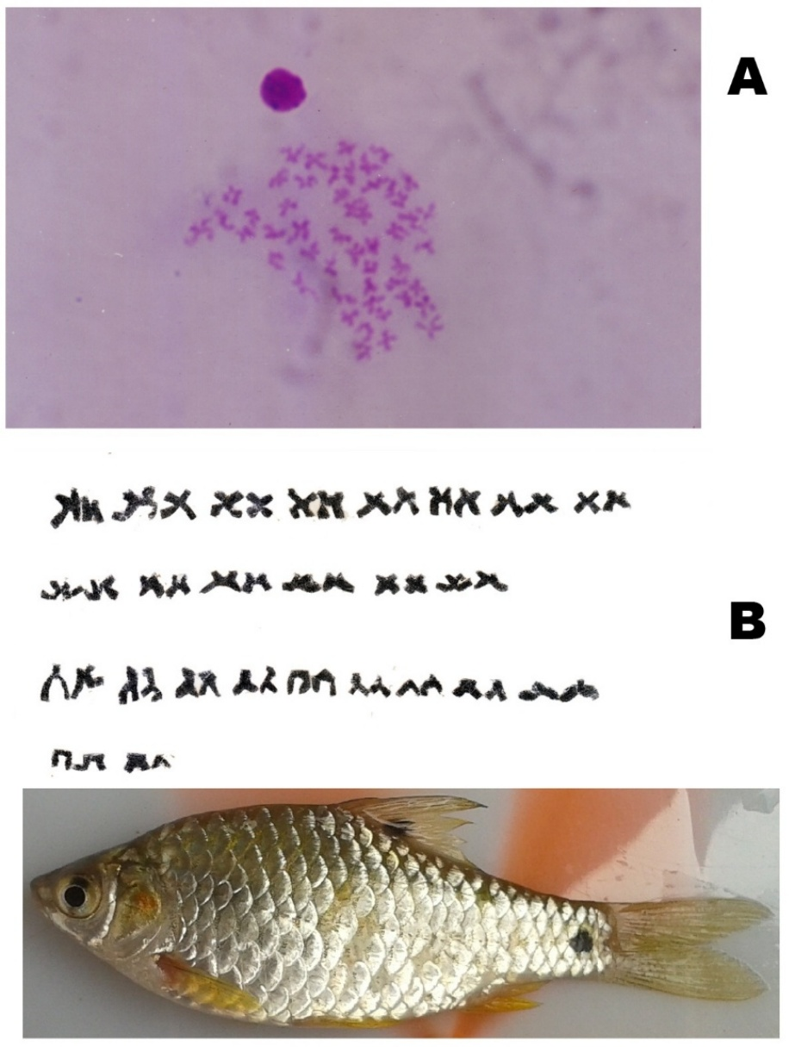

Figure 2. (A) Mitotic chromosome (at metaphase) of P.sophore from the Gadana river. (B) Karyotype of P. sophore

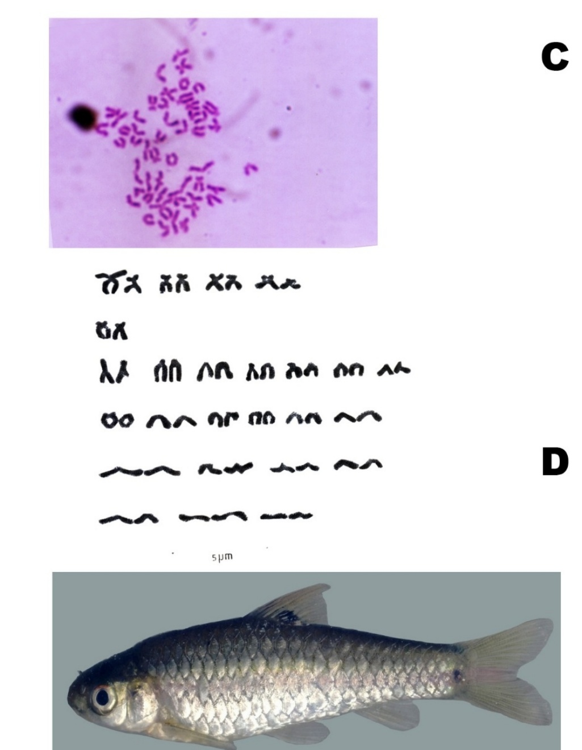

Figure 2. (C) Mitotic chromosome (at metaphase) of P.bimaculatus from the Gadana river. (D) Karyotype of P. bimaculatus

Figure 3. Idiogram of Puntius bimaculatus

Figure 4 Idiogram of Puntius sophore

Table 2. The Karyomorphology of Puntius sophore
S.No | LA | SA | TL | AL | RL(%) | A/R=r | CI
1 | 0.86 | 0.22 | 1.08 | 0.54 | 0.632 | 3.91 | 20.36
2 | 0.5 | 0.36 | 0.86 | 0.43 | 0.503 | 1.39 | 41.84
3 | 0.36 | 0.36 | 0.72 | 0.36 | 0.421 | 1 | 50
4 | 0.46 | 0.25 | 0.71 | 0.36 | 0.421 | 1.84 | 35.21
5 | 0.43 | 0.29 | 0.72 | 0.36 | 0.421 | 1.48 | 40.32
6 | 0.36 | 0.29 | 0.65 | 0.33 | 0.386 | 1.24 | 44.64
7 | 0.71 | 0.29 | 0.86 | 0.5 | 0.59 | 2.45 | 28.99
8 | 0.65 | 0.21 | 0.78 | 0.43 | 0.503 | 3.1 | 24.39
9 | 0.57 | 0.21 | 0.71 | 0.39 | 0.456 | 2.71 | 26.95
10 | 0.5 | 0.21 | 0.71 | 0.36 | 0.421 | 2.38 | 29.59
11 | 0.5 | 0.21 | 0.65 | 0.36 | 0.421 | 2.38 | 29.59
12 | 0.5 | 0.15 | 0.72 | 0.33 | 0.386 | 3.33 | 23.09
13 | 0.47 | 0.25 | 0.64 | 0.36 | 0.421 | 1.88 | 34.72
14 | 0.43 | 0.21 | 0.64 | 0.32 | 0.374 | 2.05 | 32.79
15 | 0.43 | 0.21 | 0.5 | 0.32 | 0.374 | 2.05 | 32.79
16 | 0.29 | 0.21 | 0.5 | 0.25 | 0.293 | 1.38 | 42.02
17 | 0.29 | 0.21 | 0.44 | 0.25 | 0.293 | 1.38 | 42.02
18 | 0.25 | 0.19 |  | 0.22 | 0.257 | 1.32 | 43.1
19 | 0.72 |  |  | 0.72 | 0.842
20 | 0.68 |  |  | 0.68 | 0.78
21 | 0.64 |  |  | 0.64 | 0.75
22 | 0.57 |  |  | 0.57 | 0.667
23 | 0.57 |  |  | 0.57 | 0.667
24 | 0.43 |  |  | 0.43 | 0.503
25 | 0.43 |  |  | 0.43 | 0.503
LA-Long arm, SA- Short arm, TL-Total length, AL-Average length
RL-Relative length, CI- Centromeric index
4. DISCUSSION
The genus Puntius is karyologically well studied (Manna and Prasad, 1971; Rishi and Rishi, 1981; Sharma et al., 1990; Saroniya et al., 2013). The karyological information is given in table 3. The minimum to maximum representation of chromosomes in Puntius sophore 2-8 metacentric, 2 to 4 submetacentric, 1-26 sub-telocentric and 14-46 telocentric and in between differences also observed in the chromosomal formula. The fundamental arm number varies from 50, 52.54 and 60. Decreasing the number of metacentric chromosomes and increasing the number of sub-telocentric chromosomes in Puntius sophore is synonymous to the fish Erythrinus erythrinus (Bertello et al., 2004). Chromosome number and structure have been correlated with number of morphological and environmental traits leading to habitat divergence and adaptation (Hoffman and Rieseberg, 2008; Barat and Sahoo, 2001). The acquired inherited genetic diversity elucidated the crossing over event of meiosis and the rearrangement of genes in the chromosome and its architectural alignment included the evolutionary tools pericentric inversion, translocation the fission and fusion concept. The intraspecific variation of this species is also observed in other fish populations Loaches (Alexander et al., 2015), European smelt Osmerus eperlanus (Ocaleviez et.al., 2007) the teleost fish Potamorhina altamazonica (Feldberg, 1993), Devario aequipinnatus (Shanthipreya et al., 2016), Mystus vittatus (Manna and Buksh, 1978) and in the Cichlid family (Poletto et al., 2010) etc., Cytogenetic techniques show a vast number of species sharing the same karyotyping patterning which restrict their use for taxonomic and phylogenetic inferences (Molina, 2007). In Puntius bimaculatus the diploid chromosomal number 50, 28m+22telocentric FN= 78 and the pre documentation of the fish species is not available. The representation of more acrocentric chromosomes in these two species is an ancestral character (Saroniya et al., 2013). More metacentric chromosomes are represented in Puntius conchonius 22m+16sm+12t (Ganai and Yousuf, 2013) and in Puntius bimaculatus represents more metacentrics but the submeta, sub-telocentric chromosomes are absent. The genus Puntius is classified based on the fundamental arm number into two groups and the above two species (Sharma et al., 1990) belong to the first group ranges from FN = 52-80. Classic information regarding chromosome number and morphology and banding data is not out dated and therefore applied aspects ranging from cytotaxonomy to Karyotype evolution (Cioffi et al., 2012). No sex chromosomes are identified in these species. The present study confirms the fishes Karyology, evolution and systematics. The outcomes might be valuable for population study, taxonomic problems and conservation of these native fishes of the streams and rivers of Western Ghats.
The difference between Puntius sophore and Puntius bimaculatus in the relative proportions of metacentric, submetacentric, subtelocentric and telocentric chromosomes is best interpreted as karyomorphological differentiation within a broadly conserved cyprinid 2n framework, a pattern increasingly reported by conventional and molecular cytogenetic studies of Asian cyprinids (Buasriyot et al., 2024; Khensuwan et al., 2023). Because no heteromorphic sex chromosomes were observed in the analysed metaphases, the present result should be described as absence of visibly differentiated sex chromosomes rather than complete genomic absence, since small or cryptic sex-linked regions may require molecular cytogenetic or genomic markers for detection (Buasriyot et al., 2024; Rossi, 2021). Overall, the cytogenetic profile strengthens the baseline for cytotaxonomy and conservation-oriented population comparison in Western Ghats cyprinids, while future banding, rDNA-FISH or comparative genomic approaches would be useful to test whether the observed karyotype differences are population-level variants or species-specific chromosomal rearrangements (Khensuwan et al., 2023; Rossi, 2021).

Conclusions
The karyotypic analysis of Puntius sophore and Puntius bimaculatus from the Gadana River showed that both species possess a modal diploid chromosome number of 2n = 50. Despite sharing the same diploid chromosome number, the two species differed in chromosome morphology and fundamental number. P. sophore exhibited the karyotype formula 8m + 2sm + 26st + 14t with FN = 60, while P. bimaculatus showed 28m + 22t with FN = 78. These differences indicate karyomorphological differentiation within a conserved cyprinid chromosome-number framework. No visibly differentiated sex chromosomes were detected in the examined metaphase spreads. The study provides useful baseline cytogenetic data for two native cyprinid fishes from the Western Ghats. Further studies using chromosome banding, molecular cytogenetic markers, and broader population sampling are needed to confirm whether the observed karyotypic differences represent species-specific characters or population-level variation.

Limitations
This study was based on conventional Giemsa-stained metaphase chromosome preparations and did not include chromosome banding, FISH, molecular cytogenetic markers, or genomic validation. The sample size was limited to 13 specimens of Puntius sophore and 11 specimens of Puntius bimaculatus from a single river system. Sex-wise karyotypic comparisons were not presented in detail. Some chromosome morphometric tables require verification because several values are incomplete. The study did not assess population-level variation across other Western Ghats streams. Broader sampling and advanced cytogenetic methods are required for stronger taxonomic and evolutionary interpretation.

Declaration of AI Use

This manuscript was prepared through the combined contributions of all author(s), including contributions to the study design, data, content development, results, interpretation, and related scholarly work. The author(s) acknowledge the use of Grammarly and ChatGPT to assist with grammar checking, language refinement, reference formatting. These AI-assisted tools were not used as authors and did not replace the intellectual contributions or scholarly judgment of the author(s). All AI-assisted outputs, including content, references, and interpretations, were carefully reviewed, revised, verified, and approved by the author(s). The author(s) accept full responsibility for the accuracy, integrity, and final content of the manuscript.

COMPETING INTERESTS DISCLAIMER:
Authors have declared that they have no known competing financial interests OR non-financial interests OR personal relationships that could have appeared to influence the work reported in this paper.

REFERENCES
Alexander, S., Jorg, B., Vendula, S., Maric, A., Radka, S., & Rab P. (2015). Karyotype differentiation in 19 species of river loach fishes (Nemacheilidae, Teleostei) extensive variability associated rDNA and heterochromatin distribution and its phylogenetic and ecological interpretation, BMC Evol. Biology, 15, 251-256
Arunachalam M., Sivakumar, P., & Muralidharan, M. (2005). Habitat Evaluation of Pristine headwater streams of Western Ghat Mountain Ranges, peninsular India, M.S.Johal (ed.) Proceedings of the National Seminar ‘New Trends in Fishery Development in India’ Punjab University. 253-286.
Arunachalam, M., Johnson, J.A., Sathyanarayanappa, S.N., Sankaranarayanan, A., & Sornam, R. (2000). Cultivable and ornamental fishes from Hemavathi and Kali rivers South Karnataka. NBFGR-NATP Publication.
Barat, A. (1985). A study of chromosomes in some Indian Teleost (Pisces). Ph.D thesis Kalyani University West Bengal, India.
Bertello LAC., Oliveira, C., Molina, W.F., Margarido, V.P., Fontes, M.S., Pastori, M.S., Das, J., Falcao, N., & Fenocchio, A.S. (2004). Chromosome evolution in the erythrinid fish Erythrinus erythrinus(Teleosti:Characiformes). Heredity, 93, 228-233
Bharat, A., & Sahoo, P.K. (2001). Chromosomal polymorphism in fish. Perspective in Cytology and Genetics Manna GK, Roy SC AICCG Publications. Kalyani University.
Biswal, J.R., Sahoo, P.K., & Mohanty, & P.K. (2010). Karyotypic diversity of some freshwater fish species in rural ponds of Orissa, India. Cytologia, 75 (3), 237-242.
Cioffi MB, Molina WF, Artoni RF Bertollo LAC.2012. Chromosomes as tools for discovering biodiversity the case of erythrinidae fish family. Recent Trends in Cytogenetic Studies, Methodologies and application.
Dahanukar, N. (2010). Puntius sophore, The IUCN Redlist of Threatened species. http://dxidoi.org/10.2305.
Eliana Feldberg, J., Porto, I.R., & Nakayama, C.M. (1993). Karyotype evolution in Curimatidae
Futuyma, D.J. (2009) .Natural selection and Adaptation in Evolution. Sinaur Associates Inc. www.sinaur.com.
Ganai, F.A., & Yousuf, A.R. (2013). A karyological analysis of Puntius conchonius (Hamilton, 1822) (Pisces, Cyprinidae), a new cytotype from Dal Lake Srinagar Kashmir, Jammu and Kashmir (J&K), India. Afr.J.Water Conserv. Sustain, 1(5), 067-070.
Hamilton, F. (1822). An account of the fishes found in the river Ganges and it branches. Edinburg and London.
Hoffman, A.A., & Rieseberg, L.H. (2008). Revisiting the impact of inversion in evolution from population genetic markers to drivers of adaptive shift and speciation. Annual Review of ecology and systematics, 39, 21-42.
Kliggerman, A.D., & Bloom, S.E. (1977). Rapid chromosome preparation from solid tissues of fishes. J.Fish.Res.Bd.Can, 34, 286-289.
Levan, A., Fredga, K., & Sandberg, A.A. (1964). Nomenclature of centromeric position on chromosomes. Heriditas, 52, 201-220.
Lowe-McConnell, R.H. (1987). Ecological studies in tropical fish communities. Cambridge University Press. London.
Macgregor, U.C. (1993). Chromosome preparation and analysis. Chapter 6:177-186.
Manna, G.K., & Khuda Buksh, A.R. (1978). Karyomorphological studies in three species of Teleosteanfishes. Cytologia, 43, 69-73.
Manna, G.K., & Prasad, R. (1971). A new perspective in the mechanism of evolution of chromosomes in fishes. J.Cytol.Genet.Cong, 237-239.
Manna, G.K., & Prasad, R. (1973). Somatic and germinal chromosomes in two species of fishes belonging to the genus Puntius. J.Cytol.Genet, 7, 145-149.
Molina, W.F. (2007). Chromosomal changes and stasis in marine fish groups. Fish Cytogenetics. Enfield Publication.
Ocalewicz, K., Hiwa, P., Krol, J., Rabova, M., Stabinski, R., & Rab, P. (2007). Karyotype and chromosomal characteristic of Ag NOR sites and 5SrDNA in European smelt Osmerus eperlanus. Genetica, 131(1), 29-35.
Padilla, J.A., Fernandez Garcia, J.L., Rabasco, A., Martinez Trancon, M., Rodriguez de Ledesma, I., & Perez Regadera, J.J. (1993). Characterization of the Karyotype of the tench (Tincatinca L.) and analysis of its chromosomal heterochromatin regions by C-banding Ag staining and restriction endonuclease banding. Cytogenet.Cell.Genet., 62, 220-223.
Pethiyagoda, R., Mergaskumbura, M., & Maduwage, K. (2012). A Synopsis of the South Asian fishes referred to Puntius (Pisces: Cyprinidae). Icthyol.Explor.Freshwaters, 23 (1), 69-95.
Pethiyagoda, R. (1991). Freshwater fishes of Srilanka. The Wild life heritage of Srilanka, Colombo.
Poletto, A.B., Aferreira, I., Cabral-de-Mello, C., Nakajima, R.T., Mazzuchelli, J., Ribero, B., Venere, P.C., Nirchio, M., Kocher, T.D., & Martins, C. (2010). Chromosome differentiation pattern during Chiclid fish evolution. BMC Genetics, 11, 50.
Rishi, K.K., & Rishi, S. (1981). Giemsa banding in fish chromosome, Proceedings of 3rd All India Congress. Cytol.Genet, 3, 103-106.
Saroniya, R.K., Nagpure, N.S., Saksena, D.N., Kushwaha, B., & Kumar, R. (2013). Cytotaxonomic studies in four species of genus Puntius (Hamilton, 1822) from central India. National Academy of Sciences, 36 (4), 411-418.
Shanthipreya, N., Arunachalam, M., & Sivakumar, P. (2016). Karyotypic analysis of Devario aequipinnatus (Mcclelland, 1839) from Gadana River south India with Nor Banding and C-Banding. Asian journal of Microbiology, Biotechnology & Environmental Sciences. 18 (1), 185-188.
Sharma, O.P., Tripathi, N.K., Agrawal, A., & Tripathi, S. (1990). Karyotypic diversity in Genus Puntius (Cyprinidae: Pisces). The Nucleus, 33 (1,2), 81-83.
Talukdar, B., Sangeetha, M., Himangshu, K.R.K., & Dandhadar, S. (2016). Karyology of Puntius sophore (Pisces:Cypriniformes) from the Brahmaputra River Assam, India. Poultry Fishery and Wildlife Sciences, 4(2), 167-172.
Vannote, R.L., Minshall, W.G., Sedell, J.R., Cushing, C.E. (1980). The River Continum Concept. Can.J.Fish,Aquat.Sci, 17, 130-137.
Winfield, I.J., & Nelson, J.S. (1991). Cyprinid fishes: Systematics, Biology and exploitation. Chapman and Hall, London 1991.
Yu, X., Zhou, T., Li, K., Li, Y., & Zhou, M. (1987). On the Karyosystematics of Cyprinid fishes and the summary of chromosome studies in China. Genetica, 72, 225-36.

Buasriyot, P., Sassi, F. de M. C., Donbundit, N., Supiwong, W., Kaewsri, S., Jumrusthanasan, S., Seetapan, K., Pinthong, K., Tanomtong, A., & Yanukun, K. (2024). Comparative karyotypic study of fifteen cyprinids (Cyprinidae, Cyprininae) species: An insight into the chromosomal evolution of the tribe Systomini. PLOS ONE, 19(7), e0305828. https://doi.org/10.1371/journal.pone.0305828
Khensuwan, S., Sassi, F. de M. C., Moraes, R. L. R., Jantarat, S., Seetapan, K., Phintong, K., Thongnetr, W., Kaewsri, S., Jumrusthanasan, S., Supiwong, W., Rab, P., Tanomtong, A., Liehr, T., & Cioffi, M. B. (2023). Chromosomes of Asian cyprinid fishes: Genomic differences in conserved karyotypes of Poropuntiinae (Teleostei, Cyprinidae). Animals, 13(8), 1415. https://doi.org/10.3390/ani13081415
Rossi, A. R. (2021). Fish cytogenetics: Present and future. Genes, 12(7), 983. https://doi.org/10.3390/genes12070983

