Preparation of Cellulose Scaffolds from Leaves for Wound Regeneration

ABSTRACT
Decellularization of plant-derived tissues is emerging as a potential approach for creating biocompatible scaffolds. The need for organs and tissues for transplantation is rapidly rising. In this work, cellulose scaffolds for wound healing are made from leaf biomass. After decutinization with n-hexane–diethyl ether, leaves are sequentially decellularized with 4% sodium dodecyl sulphate (SDS), 2% triton-X-100, and decoloured with 4% sodium hypochlorite. Successful elimination of antigenic cellular material while maintaining the native leaf structures was confirmed by a standard gross examination, histology (H&E and DAPI), and SEM. Decellularized leaf scaffolds' haemolysis evaluation shows non-immunogenic behaviour. It was determined that SDS and triton-X-100 may be used to create leaf scaffolds, which could then be utilized for wound regeneration.

Keywords: Leaf, Decellularization, H&E, DAPI, SEM Hemocompatibility
- Introduction
The creation of scaffolds has greatly enhanced tissue engineering. Decellularized tissues can be recellularized utilizing the host's natural cells to create an autologous transplant. Mammalian tissues that have been decellularized are expensive and hard to get. In addition, a great deal more study needs to be done before decellularized tissues may be considered a feasible clinical alternative (Badylak et al., 2011). Thus, a readily available, reasonably priced tissue reservoir for decellularization would boost the quantity of useful scaffolds at a far lower cost. This important challenge may be overcome by employing cross-kingdom initiatives inside the same bioengineered substrate. Even though plants and mammals move fluids and macromolecules in completely different ways, their vascular network topologies are very similar. Plant tissue cell walls are made up of a range of polysaccharides, the most abundant of which are cellulose, hemicellulose and pectin (Pettolino et al., 2012). Cellulose, a major structural component of leaves, has been found to be biocompatible and to enhance wound healing (Czaja et al., 2006). Also, hemicellulose has been investigated as biomaterials for bone tissue wound healing (Ferreira et al., 2010). Several species of plants are available in a more widespread, inexpensive and sustainable way, due to their rapid growth and abundance. Prior to decellularization, the chemical employed, its concentration, the duration of treatment, and the age of the plant material should be considered. More resistant materials such as spinach leaves or parsley stems required a longer time of incubation and a higher concentration (Gershlak et al., 2017; Salehi et al., 2020). However, a low level of SDS was necessary to decellularize fragile apple tissue (Contessi Negrini et al., 2020). Moreover, it has been proven that the yield strength of some parts of human biological tissue is equivalent to decellularized plant tissue (Lacombe et al., 2020). The gold standard for decellularization is successive exposure of chemicals of plant tissue. Usually a detergent, e.g. aqueous sodium dodecyl sulphate (SDS), followed by a surfactant-bleach solution. It has been demonstrated that these chemicals damage the scaffold during decellularization in animal tissue (Crapo et al., 2011). Therefore, the decellularizing agents have to be removed from the scaffold by rinsing it several times with PBS under continuous agitation. To create a plant-based cellulose scaffold for wound healing, we assessed the effectiveness of sodium dodecyl sulphate (SDS) and Triton-X-100 for decellularizing leaves.
- Materials and methods
  - Preparation of leaf scaffold
Fresh plant leaves were collected and the cuticles on their surface were removed by incubating for ten minutes in a mixture of n-hexanes and diethyl ether. Each leaf was dipped in 100 ml solution of 4% sodium dodecyl sulphate (SDS) in deionized water for 120 h. It was then soaked with 2% Triton-X-100 for 48 hr, and bleached with 4% sodium hypochlorite in deionized water solution for 12 hr. The leaves were then washed 6 times with sterile deionised water, for 2 h each. Control leaves were immersed in sterile deionised water for the same period side-by-side. Following decellularization, the leaves were stored in sterile deionised water at 4°C.
  - Gross observations
The coloration, consistency, and elasticity of control and decellularized leaves were investigated grossly.
  - Microscopic observations
Random specimens (1 cm2) were trimmed from native and decellularized leaves (n=3), fixed in 10% formal saline solution, embedded in paraffin and sliced at 12 mm. Tissue sections were deparaffinized by xylene, rehydrated with decreasing ethanol concentrations from 99.99% to 30% and stained with haematoxylin and eosin (H&E). Sections were dehydrated in 70% then absolute alcohol, cleared in two changes of xylene (2 min/step). Samples were visualized with a DMLB2 upright microscope (Leica Microsystems, Buffalo Grove, IL).
  - DAPI (4,6-diamidino-2-phenylindole 2HCl) fluorescent immunostaining
The native (control) and decellularized leaf sections were deparaffinized and rehydrated and washed in 0.2% Tris buffered saline Tween-20 (TBST). The rehydrated sections were incubated with DAPI fluorescent stain (Elabscience® Buffer saline solution, India) in incubator at 37°C for 15 minutes and analyzed under fluorescent microscope for the cold blue fluorescence.
  - Scanning electron microscopy
The surface topographic changes after decellularization of leaf were observed by scanning electron microscopy (SEM) using CaRl-Zeiss model EVO-18. The tissues were fixed in 1.5% glutaraldehyde and then transferred to a series of graded ethanol concentrations of 30, 50, 80 and 95% in deionized water and then completely dehydrated by hexamethyl disilazane (HMDS) in ascending ethanol serial solutions from 30% to 95%. Following dehydration, the samples were coated with a gold sputter. Ultra micrographs were taken from different places at 10 kV. Moreover, stomatal pore size was estimated as stomatal pore length (nm), width (nm) and area (nm 2) from SEM images.
  - DNA quantification
A mortar and pestle were used to grind both native and decellularized leaves (n=3). The BioLit plant DNA extraction mini kit (SRL Pvt. Ltd.) was used to extract DNA from both the natural (control) and decellularized leaves. Spectrophotometry was then used to quantify the dsDNA that had been isolated from both tissues (NanoDrop ND1000).
  - In vitro hemocompatibility
Using a modified version of Liu et al.'s methodology, the in vitro hemocompatibility of three 1 cm2 native and decellularized leaf tissue samples was evaluated as per the method described by Liu et al. (2014). In short, the leaf scaffolds were washed with normal saline (NS) and submerged in anticoagulated red blood cells that were extracted from New Zealand white rabbit blood. NS and distilled water, which serve as negative and positive controls, respectively, were used to dilute the RBCs. Every sample was incubated for one hour at 37°C in the water bath. Following the removal of the leaf samples from the tubes, the tubes were centrifuged for five minutes at 100 × g. After collecting the supernatant, the O.D. was measured at a wavelength of 540 nm. The following formula was used to evaluate the haemolysis
$$Hemolysis \left(\%\right)=\frac{( A_{test}-A_{NS})}{( A_{DW}-A_{NS})}×100$$
  - Statistical analysis
SPSS software version 18.0 (SPSS, Inc., Chicago, IL) was used to analyze the data. A student's t-test or a one-way ANOVA with a Duncan's post-hoc test were used for statistical comparisons.
- Results and discussion
  - Gross observations
After ten minutes, the leaves' adaxial and abaxial regions lost their cuticle and turned a vivid green. The leaves turned greenish brown while being treated with SDS and triton X-100. Following discoloration with 4% sodium hypochlorite, the decellularized leaves were clear (Fig. 1). In a number of tissue engineering applications, cellulose scaffolds made from plants have recently been employed in place of acellular scaffolds created from animal tissue (Shang et al., 2024). Alkanes, primary alcohols, and ketones are hydrophilic molecules that are similar to the extremely long-chain fatty acids that comprise cuticular waxes. To ensure that the decellularizing chemical successfully reaches the leaf tissue, the cuticle layer needs to be eliminated. To remove this layer, investigators employed a variety of organic solvents, such as petroleum ether, n-hexane, methyl alcohol, and chloroform (Gershlak et al., 2017). However, n-hexane by itself failed to completely remove cuticles due to the hydrophobic nature. In order to efficiently permeate and remove all waxes, we employed a 9:1 mixture of n-hexane and diethyl ether. Hexanes mixed with Dulbecco's phosphate-buffered saline (DPBS) and 1X PBS may be used for elimination of cuticles (Jones et al., 2021).
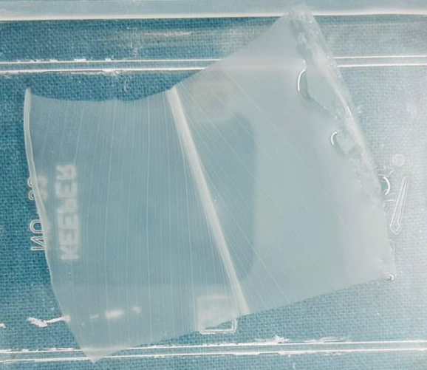
Fig. 1: Gorss observations of decellularized leaf
  - Histological observations
Well-organized parenchyma and epidermis were visible in fresh leaf micrographs stained with H&E. On the other hand, the tissue of decellularized leaves was likewise well-structured, nucleus-free, and free of cuticle on both the adaxial and abaxial sides, with just superficial damage to the extracellular matrix. Decellularization was shown when nuclei and chlorophyll were removed from the leaf stroma (Fig. 2). Triton X-100 is used in plant leaf decellularization to remove cellular components while maintaining the plant's structural extracellular matrix (ECM) in order to create scaffolds for tissue engineering. Triton X-100 is frequently used with other substances like sodium chlorite and SDS to improve decellularization with the least amount of ECM disruption (Salehani et al., 2022). The fundamental immersing method efficiently decellularizes the leaves due to the presence of stomata on the leaf surface, enabling rapid detergent washes without the need for a perfusion device (Zhu et al., 2021). Because this could result in uneven decellularization, it is advisable to avoid treating several leaves simultaneously in one container.
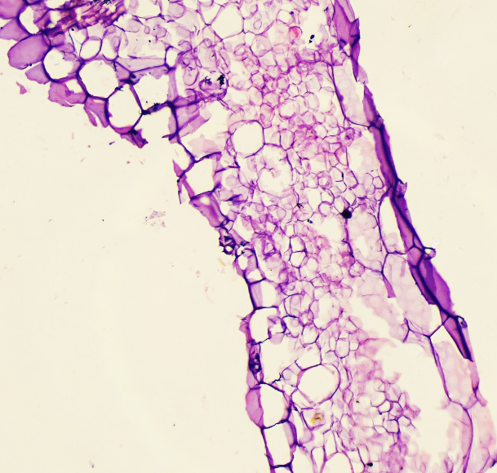
Fig. 2: Histological observations of decellularized leaf revealed complete decellularization
  - DAPI staining
The histological findings of decellularized leaf samples were further confirmed by fluorescent immunostaining with DAPI. The results demonstrated the absence of fluorescence, which indicates the removal of DNA from the initial leaf tissues. The removal of nearly all cellular DNA is a crucial step in this decellularization procedure (Piccoli et al., 2016). Successful decellularization was confirmed by a significant decrease in plant DNA concentration (below 50 ng double-stranded DNA/mg tissue) and the absence of cold blue fluorescence in the DAPI-labelled tissue slices of the leaf scaffold (Bullington et al., 2021). By identifying any remaining nuclear DNA, DAPI (4′,6-diamidino-2-phenylindole) staining was used to assess how well the leaf decellularization technique worked. A dependable marker for cellular nuclei, DAPI is a fluorescent dye that binds specifically to A–T-rich areas of double-stranded DNA (Crapo et al., 2011). The decellularization procedure effectively removed plant cells while maintaining the cellulose-rich extracellular structure, as evidenced by the absence of DAPI-positive nuclei (Gershlak et al., 2017). One important need for lowering the immunogenic ability of biological scaffolds meant for implantation is the dearth of nuclear material (Crapo et al., 2011). Quantitative DNA measurement, which demonstrates a significant decrease in leftover DNA following therapy, usually supports these findings. Efficient decellularization eliminates around 90–95% of native DNA while preserving the scaffold's structural integrity, according to earlier research (Gershlak et al., 2017). Similar results have been seen in decellularized Ficus benjamina leaves with little to no DAPI fluorescence (Singh et al., 2024). Histology and SEM results also confirm the significant decrease in DAPI fluorescence validates the decellularization protocol's efficacy.
  - Scanning electron microscopy
The SEM pictures of the native leaf (control) revealed epidermal cells with hazy boundaries, and the stomata were hidden by the cuticular wax coating. The cuticles and nuclei were totally removed after decellularization, leaving stomatal openings surrounded by guard cells and well-defined cellular borders (Fig. 3). The structure of the leaf tissue was essentially the same as that of the fresh leaf. By evaluating the effectiveness of cellular elimination and the maintenance of the native cellulose architecture, scanning electron microscopy (SEM) is frequently employed to determine the ultrastructural features of decellularized leaf scaffolds. Native leaf SEM pictures reveal intact mesophyll and epidermal cells, dense tissue architecture, and distinct vascular bundles. After decellularization, intracellular elements are efficiently eliminated, revealing a network of linked porous cellulose while preserving the stomatal architecture and leaf veins' structural integrity (Gershlak et al., 2017; Adamski et al., 2018). Maintenance of the vascular network is a critical aspect of decellularized leaf scaffolds, as these pathways can allow nutrient transfer and cellular infiltration, which renders them appropriate for wound regeneration (Fontana et al., 2021).
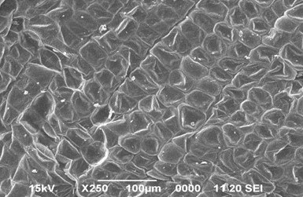
Fig. 3: SEM examination of decellularized leaf showed absence of nuclei and undisturbed leaf architecture
  - DNA quantification
As contrasted with natural leaf tissues, the leftover DNA in decellularized leaf scaffold revealed a significant (P<0.001) decrease in DNA concentration (Fig. 4). In dry leaf tissue, the total DNA of native (C) and decellularized leaf scaffolds was 105.36±1.03 ng/mg and 35.27±0.52 ng/mg, respectively. An essential part of this decellularization process is the elimination of almost all cellular DNA (Piccoli et al., 2016). A notable drop in plant cell DNA concentration (below 50 ng double-stranded DNA/mg tissue) and the lack of cold blue fluorescence in the DAPI-stained leaf tissue sections, as earlier demonstrated by investigators working on leaf tissue decellularization, verified the leaf's effective decellularization (Kian et al., 2025).
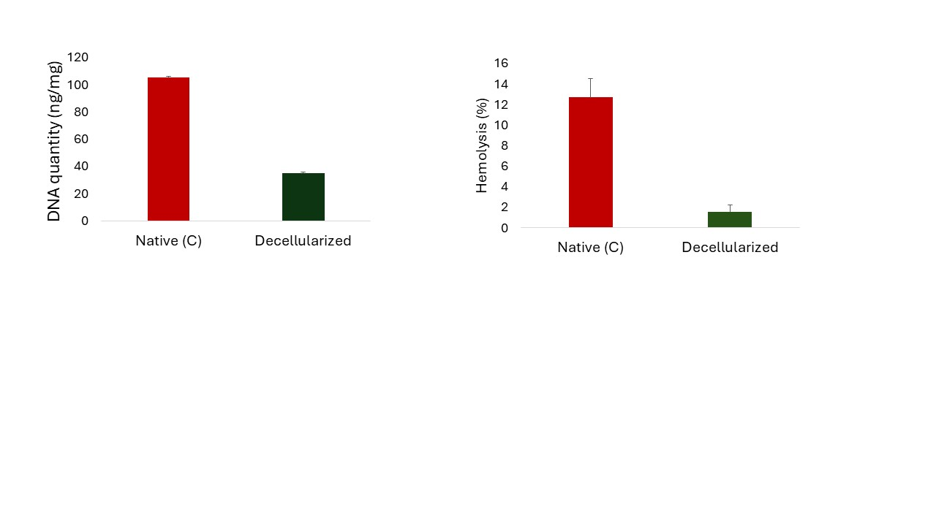
Fig. 4: Decellularized leaf scaffold revealed a significant (P<0.001) decrease in DNA concentration as compared to native (C) leaf
  - Hemocompatibility
When contrasted with leaves in the control group, the haemolysis generated by decellularized leaves was significantly (P<0.05) lower; it was 1.90±0.53% for native leaf tissue and 30.71±3.67% for decellularized leaf tissue. New Zealand white rabbit blood proved to be biocompatible with the cellulose scaffolds (Fig. 5). Significantly (P<0.05) less haemolysis was induced by decellularized leaf scaffolds than was allowed. Decellularized scaffolds derived from plants showed a markedly reduced haemolysis ratio. According to the percentage of RBC lysis, the scaffolds are classified as immunologic (> 5%), somewhat immunologic (2-5%), and not immunologic (< 2%) (Ghasemi et al., 2018; Dikici, 2024). Since implanted scaffolds invariably come into contact with blood during the initial phases of tissue repair, hemocompatibility is an essential need for biomaterials meant for graft. A perfect scaffold should minimize blood clotting, activation of platelets, and inflammatory reactions while showing very little haemolysis. The decellularized plant-based scaffold in this work showed outstanding hemocompatibility, suggesting that the decellularization technique successfully removed immunogenic cellular parts while maintaining the friendly cellulose matrix. Because cellulose is hydrophilic and chemically inert, it restricts erythrocyte membrane rupture and decreases nonspecific protein adsorption, which accounts for the low haemolytic activity seen (Modulevsky et al., 2014; Hickey et al., 2018). Successful elimination of detergents residues and plant cellular debris also contributed to the excellent blood compatibility, as these traces are known to trigger erythrocyte destruction and thrombotic reactions (Crapo et al., 2011; Adamski et al., 2018).
Fig. 5: Decellularized leaf scaffold demonstrated a significant (P<0.001) decrease in haemolysis (%) as compared to native (C) leaf

Conclusions
The present study demonstrates that leaves can be processed into cellulose-rich scaffolds through sequential decutinization, detergent treatment, and bleaching. The decellularization protocol removed visible cellular components, reduced DNA content, and preserved the general structural organization of the leaf matrix. Histological, DAPI, and scanning electron microscopic observations supported the removal of nuclei and maintenance of the porous architecture. The reduction in DNA content further indicated effective decellularization of the plant tissue. Preliminary haemocompatibility assessment was included to evaluate the scaffold response in contact with rabbit red blood cells. These findings suggest that decellularized leaf scaffolds may serve as a simple and accessible biomaterial platform for further wound regeneration research. However, additional biological, mechanical, and in vivo evaluations are required before such scaffolds can be considered suitable for practical regenerative applications.

Limitations
This study has some limitations. The plant source used for scaffold preparation requires clear identification to improve reproducibility. The work was limited to structural characterization, DNA quantification, and preliminary haemocompatibility testing. Mechanical strength, degradation behaviour, cytocompatibility, antimicrobial response, and in vivo wound healing performance were not evaluated. The sample size was limited, and further validation using standardized biological assays is needed before drawing broader conclusions about clinical or veterinary wound regeneration potential.

Declaration of AI Use

This manuscript was prepared through the combined contributions of all author(s), including contributions to the study design, data, content development, results, interpretation, and related scholarly work. The author(s) acknowledge the use of Grammarly and ChatGPT to assist with grammar checking, language refinement, reference formatting. These AI-assisted tools were not used as authors and did not replace the intellectual contributions or scholarly judgment of the author(s). All AI-assisted outputs, including content, references, and interpretations, were carefully reviewed, revised, verified, and approved by the author(s). The author(s) accept full responsibility for the accuracy, integrity, and final content of the manuscript.

Ethical Approval
The current research was carried out in accordance with ethical guidelines for animal experimentation, as approved by the Institutional Animal Ethics Committee at the College of Veterinary Science and Animal Husbandry, Acharya Narendra Deva University of Agriculture and Technology, Kumarganj, Ayodhya, Uttar Pradesh, India. (Approval number- IAEC/CVSc-ANDUAT/2025/1/22).

COMPETING INTERESTS DISCLAIMER:
Authors have declared that they have no known competing financial interests OR non-financial interests OR personal relationships that could have appeared to influence the work reported in this paper.

References
Adamski, M., Fontana, G., Gershlak, J., Gaudette, G., Le, H.D. and Murphy, W.L. (2018). Two methods for decellularization of plant tissues for tissue engineering applications. J. Vis. Exp. 135, e57054. https://doi.org/10.3791/57054
Badylak, S.F., Taylor, D. and Uygun, K. (2011). Whole-organ tissue engineering: decellularization and recellularization of three-dimensional matrix scaffolds. Annu. Rev. Biomed. Eng. 13(1), 27-53. https://doi.org/10.1146/annurev-bioeng-071910-124743
Bullington, L.S., Lekberg, Y. and Larkin, B.G. (2021). Insufficient sampling constrains our characterization of plant microbiomes. Sci. Rep. 11(1), 3645. https://doi.org/10.1038/s41598-021-83177-9
Contessi Negrini, N., Toffoletto, N., Farè, S. and Altomare, L. (2020). Plant tissues as 3D natural scaffolds for adipose, bone and tendon tissue regeneration. Front. Bioeng. Biotechnol. 8, 723. https://doi.org/10.3389/fbioe.2020.00723
Crapo, P.M., Gilbert, T.W. and Badylak, S.F. (2011). An overview of tissue and whole organ decellularization processes. Biomaterials. 32(12), 3233-3243. https://doi.org/10.1016/j.biomaterials.2011.01.057
Czaja, W., Krystynowicz, A., Bielecki, S. and Brown Jr, R.M. (2006). Microbial cellulose—the natural power to heal wounds. Biomaterials. 27(2), 145-151. https://doi.org/10.1016/j.biomaterials.2005.07.035
Dikici, S. (2024). Enhancing wound regeneration potential of fibroblasts using ascorbic acid-loaded decellularized baby spinach leaves. Polym. Bull. 81, 9995-10016. https://doi.org/10.1007/s00289-024-05257-3
Ferreira, L.M., Sobral, C.S., Blanes, L., Ipolito, M.Z. and Horibe, E.K. (2010). Proliferation of fibroblasts cultured on a hemi-cellulose dressing. JPRAS. 63(5), 865-869. https://doi.org/10.1016/j.bjps.2009.02.008
Fontana, G., Gershlak, J., Adamski, M., Lee, J., Matsumoto, S., Le, H.D., Binder, B., Wirth, J., Gaudette, G. and Murphy, W.L. (2017). Biofunctionalized plants as diverse biomaterials for human cell culture. Adv. Healthc. Mater. 6(8), 1601225. https://doi.org/10.1002/adhm.201601225
Gershlak, J.R., Hernandez, S., Fontana, G., Perreault, L.R., Hansen, K.J., Larson, S.A. and Gaudette, G.R. (2017). Crossing kingdoms: Using decellularized plants as perfusable tissue engineering scaffolds. Biomaterials. 125, 13-22. https://doi.org/10.1016/j.biomaterials.2017.02.011
Ghasemi, M., Alexandridis, P. and Tsianou, M. (2018). Dissolution of cellulosic fibers: Impact of crystallinity and fiber diameter. Biomacromolecules. 19(2), 640-651. https://doi.org/10.1021/acs.biomac.7b01660
Hickey, R.J., Modulevsky, D.J., Cuerrier, C.M. and Pelling, A.E. (2018). Customizing the shape and microenvironment biochemistry of biocompatible macroscopic plant-derived cellulose scaffolds. ACS Biomater. Sci. Eng. 4(10), 3726-3736. https://doi.org/10.1021/acsbiomaterials.8b00885
Jones, J.D., Rebello, A.S. and Gaudette, G.R. (2021). Decellularized spinach: An edible scaffold for laboratory-grown meat. Food Biosci. 41, 100986. https://doi.org/10.1016/j.fbio.2021.100986
Kian, M., Hashemi, S.S., Derakhshanfar, A., Darya, G.-H., Shahhossein, Z. and Saharkhiz, M.J. (2025). Decellularized Persian walnut leaf as a potential wound dressing scaffold. Front. Bioeng. Biotechnol. 13, 1524956. https://doi.org/10.3389/fbioe.2025.1524956
Lacombe, J., Harris, A.F., Zenhausern, R., Karsunsky, S. and Zenhausern, F. (2020). Plant-based scaffolds modify cellular response to drug and radiation exposure compared to standard cell culture models. Front. Bioeng. Biotechnol. 8, 932. https://doi.org/10.3389/fbioe.2020.00932
Liu, Y., Cai, D., Yang, J., Wang, Y., Zhang, X. and Yin, S. (2014). In vitro hemocompatibility evaluation of poly(4-hydroxybutyrate) scaffold. Int. J. Clin. Exp. Med. 7(5), 1233-1238.
Modulevsky, D.J., Lefebvre, C., Haase, K., Al-Rekabi, Z. and Pelling, A.E. (2014). Apple derived cellulose scaffolds for 3D mammalian cell culture. PLoS One. 9(5), e97835. https://doi.org/10.1371/journal.pone.0097835
Pettolino, F.A., Walsh, C., Fincher, G.B. and Bacic, A. (2012). Determining the polysaccharide composition of plant cell walls. Nat. Protoc. 7(9), 1590-1607. https://doi.org/10.1038/nprot.2012.081
Piccoli, M., Urbani, L., Alvarez-Fallas, M.E., Franzin, C., Dedja, A., Bertin, E. and Pozzobon, M. (2016). Improvement of diaphragmatic performance through orthotopic application of decellularized extracellular matrix patch. Biomaterials. 74, 245-255. https://doi.org/10.1016/j.biomaterials.2015.09.028
Salehani, A., Rabbani, M., Biazar, E., Heidari Keshel, S. and Pourjabbar, B. (2022). The effect of chemical detergents on decellularization of olive leaves for tissue engineering applications. Eng. Rep. 5(2), e12560. https://doi.org/10.1002/eng2.12560
Salehi, A., Mobarhan, M.A., Mohammadi, J., Shahsavarani, H., Shokrgozar, M.A. and Alipour, A. (2020). Efficient mineralization and osteogenic gene overexpression of mesenchymal stem cells on decellularized spinach leaf scaffold. Gene. 757, 144852. https://doi.org/10.1016/j.gene.2020.144852
Shang, L., Wang, S. and Mao, Y. (2024). Recent advances in plant-derived polysaccharide scaffolds in tissue engineering: A review. Int. J. Biol. Macromol. 277, 133830. https://doi.org/10.1016/j.ijbiomac.2024.133830
Singh, P.K., Gangwar, A.K., Khangembam, S.D., Verma, R.K., Yadav, V.K., Singh, Y., Shekher, C., Goyal, R.P. and Kumar, N. (2024a). Development of cellulose scaffolds derived from Ficus benjamina leaves for tissue engineering applications. Trends Biomater. Artif. Organs. 38(2), 85-98.
Zhu, Y., Zhang, Q., Wang, S., Zhang, J., Fan, S. and Lin, X. (2021). Current advances in the development of decellularized plant extracellular matrix. Front. Bioeng. Biotechnol. 9, 650. https://doi.org/10.3389/fbioe.2021.650049

