Assessment of Benzo[a]pyrene-Induced Immunotoxicity in the Estuarine Mud Crab Scylla serrata

Abstract
Aquatic ecosystems are increasingly threatened by anthropogenic organic contaminants originating from industrialization, urbanization, and improper waste management. Among these contaminants, polycyclic aromatic hydrocarbons (PAHs) are of particular environmental concern because of their persistence, bioaccumulation potential, and toxicity. Estuarine environments receive substantial inputs of BaP through industrial effluents, urban runoff, oil spills, and atmospheric deposition, posing significant risks to resident aquatic organisms. The mud crab Scylla serrata is considered an excellent sentinel organism for ecotoxicological studies because of its wide distribution in estuarine habitats, semipelagic behaviour, sensitivity to environmental contaminants, ease of laboratory acclimatization, and considerable commercial importance. The present study was undertaken to evaluate the impact of BaP exposure on selected haematological and immunological biomarkers in S. serrata. Specifically, alterations in total haemocyte count (THC), differential haemocyte count (DHC), phagocytic activity, and antibacterial activity of haemolymph were investigated as indicators of immune competence. The results of present study revealed that THC, differential count were modulated following BaP exposure even at 10 µg/L compare to the respective control group. Further phagocytosis and antibacterial activity reduced significantly compare to control group. It is anticipated that exposure to BaP will induce significant changes in haemocyte profiles and innate immune responses, reflecting immunosuppression and compromised defence mechanisms. The findings of this study will contribute to understanding the immunotoxicological effects of benzo[a]pyrene in estuarine crustaceans and support the use of S. serrata as a reliable bioindicator for monitoring organic pollution and ecological risk assessment in coastal and estuarine ecosystems.
Key Words: BaP, Scylla serrata, THC, Phagocytosis, antibacterial activity.
- Introduction
Organic compounds are widely used in household and industrial applications, and regardless of their specific purposes, they often find their way into aquatic systems through multiple routes, including industrial effluents, surface runoff, atmospheric deposition, and inadequate waste management practices. The accelerating rate of industrialization and urban expansion has significantly increased the discharge of human-derived contaminants into the environment, thereby intensifying the pressure on aquatic ecosystems.
Once these pollutants enter water bodies, they can exert both direct and indirect effects on aquatic organisms by interfering with physiological, biochemical, and ecological functions. Such interference may compromise the normal functioning of organisms and reduce their capacity to cope with environmental changes (Adams et al., 1990). Benzo(a)pyrene (BaP) is a five-ring PAH primarily produced during the incomplete combustion of organic materials such as coal, petroleum products, wood, and tobacco (IARC, 2012). Estuarine ecosystems are dynamic transitional zones that receive substantial inputs of organic contaminants originating from land-based anthropogenic activities. These contaminants include a wide range of polycyclic aromatic hydrocarbons (PAHs), which are introduced into coastal environments through industrial effluents, urban runoff, oil spills, and emissions from oil refineries. Among these compounds, benzo[a]pyrene (BaP) is of particular concern due to its persistence, lipophilicity, and well-documented carcinogenic and mutagenic properties. BaP is frequently detected in estuarine and coastal waters as a consequence of incomplete combustion processes and petroleum-related discharges. Despite extensive research on PAHs as a group, comparatively limited information is available regarding the specific toxicological effects and mechanisms of action of benzo[a]pyrene across different aquatic species, especially in invertebrates.
Mud crabs have emerged as valuable sentinel organisms in ecotoxicological investigations, particularly in estuarine habitats where contaminant loads are often elevated. However, there is a notable scarcity of studies focusing on immunotoxicological biomarkers in these organisms. Among mud crab species, Scylla serrata is widely recognized as an effective bioindicator for environmental monitoring and toxicological assessments. This is attributed to several ecological and biological characteristics. Firstly, S. serrata exhibits a broad distribution across estuarine environments, which serve as critical nursery grounds supporting feeding, growth, and developmental processes. Secondly, its semipelagic lifestyle increases its exposure to both benthic and waterborne contaminants, making it highly representative of environmental conditions. Thirdly, the species demonstrates considerable sensitivity to pollutants, thereby providing measurable physiological and biochemical responses upon exposure.
In addition, S. serrata is abundantly available throughout the year, facilitating consistent sampling and reducing logistical constraints associated with field collection. The species can also be readily acclimatized to laboratory conditions, allowing controlled experimental studies to be conducted with relative ease. Furthermore, S. serrata holds substantial economic importance as a commercially valuable seafood resource due to its high nutritive value and consumer demand. These combined attributes make it an ideal model organism for investigating the toxicological impacts of environmental contaminants, including PAHs such as benzo[a]pyrene, and for developing reliable biomarkers to assess ecological health and pollution stress in estuarine ecosystems. The study aimed to understand the impact of BaP on haematological components of the Scylla seratta.

- Materials and Methods
Adult mud crabs (Scylla serrata) with an average body weight of 250 ± 30 g were procured from a commercial aquaculture farm and acclimatized under laboratory conditions for seven days prior to the experiment. During the acclimation period, the crabs were maintained in aerated seawater and fed fresh tilapia daily to ensure normal physiological condition. Following acclimatization, the animals were randomly assigned to three experimental groups, each consisting of six individuals, with duplicate tanks maintained for each treatment. The control group was maintained in clean filtered seawater without chemical exposure, whereas the treatment groups were exposed to sublethal concentrations of benzo[a]pyrene (BaP) at 10 μg L⁻¹ and 20 μg L⁻¹, respectively. Exposure was conducted under controlled environmental conditions, including a temperature of 28 ± 1 °C, salinity of 34 ppt, pH 8.2 ± 0.1, and a 12 h light:12 h dark photoperiod. To maintain stable water quality and exposure concentrations, the seawater in both the control and treatment tanks was completely renewed every 24 h throughout the experimental period.
The exposure experiment continued for 40 days, and biological samples were collected after 20 and 40 days of exposure. Subsequently, the remaining crabs were transferred to uncontaminated seawater and maintained for an additional 20-day depuration period, after which haemolymph samples were collected for biochemical and immunological analyses. For each sampling interval, three crabs were randomly selected from each replicate tank. Haemolymph was withdrawn aseptically from individual crabs using sterile syringes preloaded with anticoagulant solution to minimize clotting. Plasma, serum, and haemocyte fractions were isolated separately from each individual following standardized centrifugation procedures. Samples obtained from individual crabs were processed independently, and no pooling of haemolymph or cellular fractions was performed to preserve biological variability and ensure accurate assessment of individual physiological responses
Total Hemocyte Count (THC) and Differential Hemocyte Count (DHC)
Total hemocyte count (THC) was determined immediately after haemolymph collection to minimize cellular deterioration. Fresh haemolymph was mixed gently with an anticoagulant solution, and an aliquot from each individual crab was loaded onto a Bürker haemocytometer for manual enumeration under a light microscope following the standard haemocytometric procedure described by Blaxhall and Daisley (1973). The total number of circulating hemocytes was expressed as cells mL⁻¹ of haemolymph.
Differential hemocyte count (DHC) was performed by examining at least 100 hemocytes from each specimen. The proportion of each hemocyte type was recorded, and the absolute number of each cell population was calculated by multiplying the percentage of individual hemocyte types by the corresponding THC. Hemocytes were classified into hyaline, semigranular, and granular cells according to their morphological characteristics, including cell size, nuclear-to-cytoplasmic ratio, and cytoplasmic granularity, following the criteria described by Matozzo et al. (2001) and supported by recent reviews on crustacean hemocyte classification and hematopoiesis (Söderhäll & Söderhäll, 2022; Li et al., 2022).
For morphological examination, three drops of freshly collected haemolymph were smeared onto clean glass slides and fixed with absolute methanol for 3 min. The smears were subsequently stained with Giemsa–Romanowski stain for 30 min, rinsed gently with distilled water, air dried, and observed under a light microscope. Hemocyte populations were identified and differentiated based on staining characteristics, cell morphology, and the presence of cytoplasmic granules, consistent with current recommendations for crustacean immunological investigations.

Phagocytic Activity Assay
The phagocytic activity of circulating hemocytes was evaluated using heat-killed yeast cells (Saccharomyces cerevisiae) as target particles following the method described by Wang et al. (2023), with minor modifications. Fresh haemolymph (50 μL) obtained from each crab was evenly spread onto sterile glass microscope slides and incubated at 25 °C for 20 min to allow hemocyte adhesion. After incubation, the slides were gently rinsed with Tris-buffered saline (TBS) to remove non-adherent cells while preserving the attached hemocyte monolayer. Subsequently, 50 μL of a 0.5% yeast cell suspension was added to each slide, and the preparations were incubated for an additional 15 min at 25 °C to facilitate phagocytic uptake. Following incubation, excess yeast cells were removed by gently washing the slides with sterile filtered seawater. The adhered hemocytes were then fixed with 2.5% glutaraldehyde for 5 min, rinsed with TBS, mounted with coverslips, and examined using a phase-contrast light microscope. Three independent observations were performed for each crab, and approximately 200 hemocytes were examined in each replicate. Hemocytes containing one or more engulfed yeast cells were considered phagocytic. Phagocytic activity was expressed as the percentage of phagocytic hemocytes relative to the total number of hemocytes counted using the following equation:

Antibacterial Activity Assay
The antibacterial activity of haemolymph was evaluated using a turbidimetric bacterial growth inhibition assay following the method of Wootton and Pipe (2003), with slight modifications. Briefly, 100 μL of haemolymph collected from each experimental and control crab was dispensed into individual wells of a sterile 96-well microtiter plate. Control wells received an equal volume of sterile phosphate-buffered saline (PBS) in place of haemolymph. Aeromonas hydrophila was cultured overnight in sterile nutrient broth (NB) at 28 °C with continuous shaking until the logarithmic growth phase was reached. The bacterial suspension was adjusted to approximately 1 × 10⁸ CFU mL⁻¹ (OD₆₀₀ = 0.509), and 100 μL of the standardized bacterial culture was added to each well containing haemolymph or PBS. The microplates were incubated at room temperature, and bacterial growth was monitored spectrophotometrically by measuring absorbance at 540 nm. Antibacterial activity was determined from the reduction in bacterial growth relative to the positive control, with lower absorbance values indicating stronger bactericidal or bacteriostatic activity of the haemolymph.

Statistical Analysis
All statistical analyses were performed using SPSS. Prior to hypothesis testing, the data were examined for normality using the Shapiro–Wilk test and for homogeneity of variances using Levene's test. Depending on whether the assumptions of normality and homoscedasticity were satisfied, differences among experimental groups were analyzed using either one-way analysis of variance (ANOVA) followed by an appropriate post hoc multiple comparison test (Tukey's HSD), or the Kruskal–Wallis non-parametric test for data that did not meet parametric assumptions. All experimental results are presented as mean ± standard deviation (SD). Statistical significance was established at p < 0.05.

3.0 Results

Total Hemocyte Count (THC)
The effects of benzo[a]pyrene (BaP) on the total hemocyte count (THC) of Scylla serrata are presented in Figure 1. The control group maintained relatively constant THC values throughout the experimental period, ranging from approximately 7.8 × 10⁶ to 8.2 × 10⁶ cells mL⁻¹, indicating stable physiological and immunological conditions. After 20 days of exposure, crabs exposed to 10 μg L⁻¹ and 20 μg L⁻¹ BaP exhibited slight reductions in THC compared with the control; however, these differences were not statistically significant (p > 0.05). In contrast, prolonged exposure for 40 days resulted in a significant decline in circulating hemocyte numbers in both treatment groups (p < 0.05), with the greatest reduction occurring in crabs exposed to 20 μg L⁻¹ BaP, where THC decreased by approximately 38–40% relative to the control. Following a 20-day depuration period, THC increased in both BaP-treated groups, suggesting recovery of the hemocyte population after transfer to uncontaminated seawater. Nevertheless, THC values remained significantly lower than those of the control group (p < 0.05), particularly in crabs previously exposed to 20 μg L⁻¹, indicating incomplete restoration of immune homeostasis.

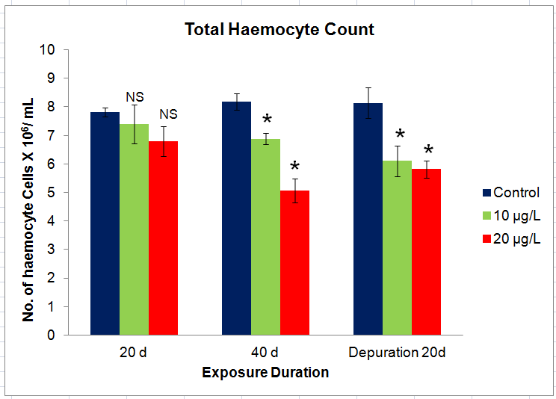
Figure 1 Total Haemocyte Count in crabs exposed to different concentration of B[a]P for 40 d and followed by the depuration of 20 d. Values are expressed mean ± S.D

Differential Hemocyte Count (DHC)
The differential hemocyte count (DHC) of Scylla serrata exposed to benzo[a]pyrene (BaP) for 20 and 40 days and after a 20-day depuration period is presented in Figure 2. Hyalinocytes constituted the predominant circulating hemocyte population in all experimental groups, followed by granulocytes and semigranulocytes. After 20 days of exposure, only slight differences were observed among treatments. Crabs exposed to 10 μg L⁻¹ BaP exhibited a marginal reduction in granulocyte abundance compared with the control, whereas exposure to 20 μg L⁻¹ BaP resulted in a small decrease in hyalinocytes accompanied by a corresponding increase in granulocytes and semigranulocytes. Following 40 days of exposure, these alterations became more evident, with the higher BaP concentration producing a greater shift in hemocyte composition characterized by reduced hyalinocyte proportion and increased granular cell populations. Following the 20-day depuration period, the proportions of the three hemocyte types approached those observed in the control group, indicating partial restoration of circulating hemocyte composition after the removal of BaP exposure. Nevertheless, crabs previously exposed to 20 μg L⁻¹ BaP continued to exhibit a slightly elevated proportion of granulocytes compared with the control.

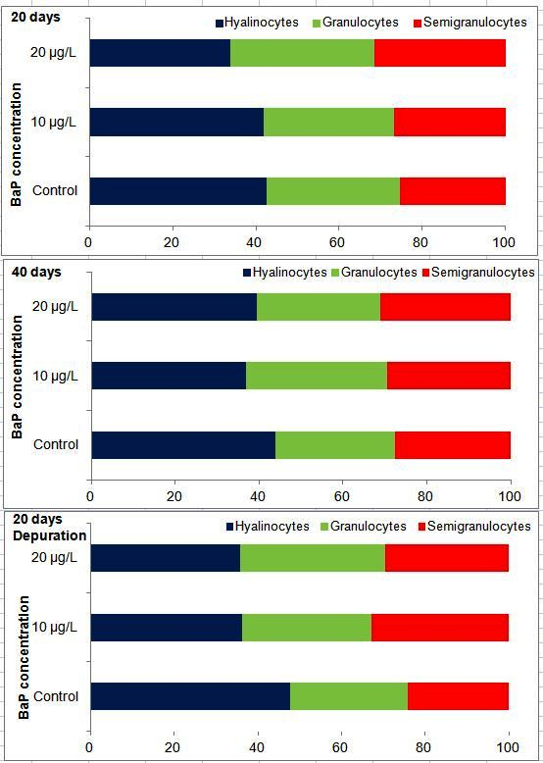
Figure 2 Differential Count in crabs exposed to different concentration of B[a]P for 40 d and followed by the depuration of 20 d. Values are expressed mean ± S.D

Phagocytic activity
The effects of benzo[a]pyrene (BaP) exposure on the phagocytic activity of the mud crab Scylla serrata are presented in the figure. Phagocytic activity was expressed as percentage (%) and compared among the control, 10 µg/L BaP, and 20 µg/L BaP exposure groups after 20 days, 40 days of exposure, and following 20 days of depuration (Figure 3). The control group exhibited consistently high phagocytic activity throughout the experimental period, with values ranging between approximately 38–42%. At 20 days of exposure, the control animals showed a phagocytic activity of approximately 42%, whereas crabs exposed to 10 µg/L BaP exhibited a significant reduction to approximately 31% (P < 0.05), representing nearly a 26% decrease relative to the control. A further decline was observed in the 20 µg/L BaP group, where phagocytic activity decreased to approximately 26% (P < 0.05), corresponding to an approximately 38% reduction compared with the control. These findings demonstrate a clear dose-dependent suppression of phagocytic function following short-term BaP exposure. After 40 days of exposure, the control group maintained phagocytic activity at approximately 40%. The 10 µg/L BaP group remained significantly lower, with a mean value of approximately 30% (P < 0.05), while the 20 µg/L BaP group showed a further reduction to approximately 27% (P < 0.05). Although the decrease between the two exposure durations was relatively small, prolonged BaP exposure maintained immunosuppression without evidence of physiological adaptation.
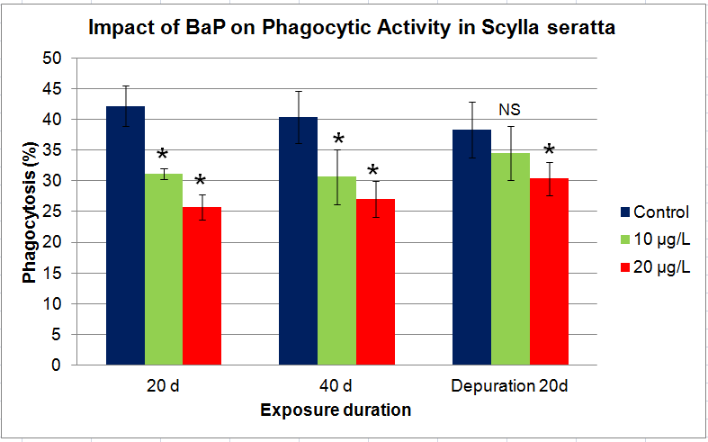
Figure 3 Phagocytic Activity in crabs exposed to different concentration of B[a]P for 40 d and followed by the depuration of 20 d. Values are expressed mean ± S.D
Following 20 days of depuration, phagocytic activity in the 10 µg/L BaP group increased to approximately 34–35%, and the statistical analysis indicated no significant difference (NS) from the control group, suggesting substantial recovery of immune function after removal of the contaminant. In contrast, the 20 µg/L BaP group exhibited only partial recovery, reaching approximately 30%, which remained significantly lower than the control (P < 0.05). The control animals maintained phagocytic activity at approximately 38% throughout the depuration period.
Antibacterial activity
The antibacterial activity of the haemolymph of Scylla serrata following exposure to benzo[a]pyrene (BaP) was assessed by measuring the optical density (OD) after 24 h of bacterial incubation (Figure 4). The antibacterial activity exhibited a concentration- and exposure-dependent response. At 20 days of exposure, the control group showed an OD value of approximately 0.19 ± 0.01, whereas the 10 µg/L BaP-treated group exhibited a slightly higher OD (0.20 ± 0.02). The 20 µg/L BaP-treated group showed a lower OD value (0.165 ± 0.01) compared with both the control and the 10 µg/L treatment.
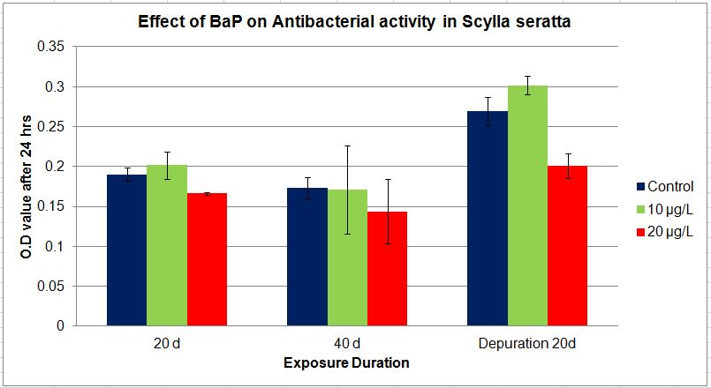
Figure 4 Antibacterial activity in crabs exposed to different concentration of B[a]P for 40 d and followed by the depuration of 20 d. Values are expressed mean ± S.D
Similar results were observed for 40 days exposure. Following 20 days of depuration, partial recovery of antibacterial activity was observed in the control and low-dose treatment. The control group increased to approximately 0.27 ± 0.02, whereas the 10 µg/L group exhibited the highest OD value (0.30 ± 0.01). In contrast, the 20 µg/L group showed only a modest recovery (0.20 ± 0.02), remaining substantially lower than the control and the low-dose treatment.

4.0 Discussion
Total hemocyte count is one of the most sensitive biomarkers of crustacean health because hemocytes constitute the primary cellular component of the innate immune system. They participate in phagocytosis, encapsulation, melanization, clotting, wound repair, and the production of antimicrobial molecules (Söderhäll & Söderhäll, 2022). Consequently, alterations in THC provide valuable information regarding the immunotoxic effects of environmental contaminants. The absence of significant changes after 20 days of exposure suggests that the selected sublethal concentrations of BaP were initially tolerated by S. serrata, allowing physiological compensation to maintain circulating hemocyte numbers. Similar transient responses have been reported in crustaceans exposed to organic pollutants, where antioxidant defense systems initially counteract contaminant-induced oxidative stress before immune impairment becomes evident (Hauton, 2012). Excessive oxidative stress promotes hemocyte apoptosis, membrane damage, impaired hematopoiesis, and increased migration of circulating hemocytes toward damaged tissues, collectively resulting in decreased THC (Livingstone, 2001; Regoli & Giuliani, 2014). The greater decline observed at 20 μg L⁻¹ demonstrates a clear concentration-dependent toxic response. Reduced hemocyte numbers have been widely reported in crustaceans exposed to polycyclic aromatic hydrocarbons, heavy metals, pesticides, and other environmental pollutants, and are generally associated with diminished phagocytic activity, reduced lysosomal membrane stability, impaired antibacterial defense, and suppression of the prophenoloxidase system (Le Moullac & Haffner, 2000; Wang et al., 2023).
The partial restoration of THC after the 20-day depuration period demonstrates the capacity of S. serrata to recover following the removal of contaminant exposure. Recovery is likely associated with renewed hematopoiesis and replacement of damaged hemocytes by newly differentiated cells. However, the persistence of significantly lower THC values in the BaP-treated groups indicates that complete recovery had not yet occurred, suggesting either residual accumulation of BaP within tissues or prolonged oxidative and inflammatory responses. Similar incomplete recovery has been documented in crustaceans following chronic exposure to persistent organic pollutants, emphasizing that immune restoration often requires longer depuration periods than those necessary for physiological detoxification (Li et al., 2022).
Hemocytes constitute the principal cellular component of the crustacean innate immune system and play essential roles in phagocytosis, encapsulation, melanization, wound healing, and the production of antimicrobial molecules (Söderhäll & Söderhäll, 2022). The slight decline in hyalinocyte percentage observed following BaP exposure may be attributed to their rapid recruitment into immune defense processes or increased susceptibility to oxidative stress-induced apoptosis. Hyalinocytes are highly phagocytic cells and are often the first hemocyte population to respond to xenobiotic-induced tissue damage. Consequently, their reduction in circulation may reflect migration toward damaged tissues or enhanced cellular turnover during detoxification (Li et al., 2022).
Conversely, the modest increase in granulocytes and semigranulocytes observed at the higher BaP concentration may represent a compensatory immune response. Increased proportions of these cells have frequently been reported in crustaceans exposed to polycyclic aromatic hydrocarbons and other environmental contaminants, reflecting activation of innate immune mechanisms (Wang et al., 2023). The relatively small magnitude of the changes observed in the present study suggests that sublethal BaP concentrations did not markedly disrupt hemocyte differentiation but instead induced subtle redistribution of circulating hemocyte populations. Similar responses have been reported in marine crustaceans exposed to PAHs, heavy metals, and pesticides, where changes in differential hemocyte count occurred together with reductions in total hemocyte count, lysosomal membrane stability, phagocytic activity, and antibacterial capacity (Hauton, 2012; Le Moullac & Haffner, 2000).
Phagocytosis is one of the primary innate immune defense mechanisms in crustaceans, involving the recognition, engulfment, and destruction of invading microorganisms by circulating haemocytes. Therefore, alterations in phagocytic activity serve as a sensitive biomarker of environmental contaminant-induced immunotoxicity (Le Moullac & Haffner, 2000; Cerenius & Söderhäll, 2013). The present study demonstrates that exposure to BaP significantly reduced the phagocytic activity of Scylla serrata in a dose-dependent manner. Both 10 and 20 µg/L BaP treatments produced significant suppression after 20 and 40 days of exposure, with the greatest reduction occurring in the higher concentration group. These observations indicate that prolonged BaP exposure compromises the functional competence of haemocytes, thereby reducing the ability of crabs to eliminate invading pathogens.
The sustained reduction in phagocytic activity observed after 40 days suggests that chronic BaP exposure causes persistent immunosuppression rather than transient physiological stress. Similar reductions in haemocyte functions have been reported in crustaceans exposed to PAHs and other organic contaminants. BaP-induced immunotoxicity has been associated with decreased total haemocyte count, lysosomal membrane destabilization, impaired respiratory burst, and reduced pathogen clearance (Pipe & Coles, 1995; Cheng et al., 2018). The present findings therefore confirm that phagocytic activity is a sensitive indicator of BaP-induced immunotoxicity in Scylla serrata. Reduced phagocytosis increases susceptibility to opportunistic bacterial, fungal, and viral infections, ultimately affecting survival, growth, and aquaculture productivity.
The present investigation demonstrates that exposure to benzo[a]pyrene (BaP) adversely influences the antibacterial activity of Scylla serrata, with the effect becoming more pronounced at higher concentrations and longer exposure durations. The reduced antibacterial activity observed in the 20 µg/L BaP-treated crabs suggests that chronic exposure compromises the humoral immune defence mechanisms responsible for eliminating invading microorganisms. Polycyclic aromatic hydrocarbons (PAHs), particularly BaP, are known immunotoxic contaminants capable of disrupting crustacean immune functions by inducing oxidative stress, impairing haemocyte metabolism, and suppressing the synthesis and release of antimicrobial molecules such as antimicrobial peptides, lysozyme, and other humoral defence factors (Livingstone, 2001; Pipe and Coles, 1995). Consequently, exposed animals exhibit reduced capacity to inhibit bacterial proliferation, which is reflected by the altered optical density measurements observed in the present study.
The progressive decline in antibacterial activity between 20 and 40 days indicates that continuous BaP exposure produces cumulative immunosuppressive effects. Long-term exposure to PAHs increases intracellular reactive oxygen species (ROS), leading to lipid peroxidation, mitochondrial dysfunction, DNA damage and apoptosis of haemocytes. Since haemocytes are the primary immune cells responsible for phagocytosis and secretion of antimicrobial compounds, their impairment directly reduces antibacterial defence (Le Moullac and Haffner, 2000; Hauton, 2012). Delayed immune recovery following PAH exposure has been documented in marine crustaceans and other aquatic invertebrates (Holth et al., 2006; Fabbri and Franzellitti, 2016). The observed reduction in antibacterial activity is also consistent with reports demonstrating that environmental contaminants suppress the innate immune responses of decapod crustaceans by decreasing haemocyte viability and reducing the production of immune-related enzymes and antimicrobial proteins (Rowley and Powell, 2007). Since crustaceans rely entirely on innate immunity, impairment of antibacterial defence may increase susceptibility to opportunistic bacterial infections and negatively affect survival in polluted coastal ecosystems.
Following the depuration period, the tendency of hemocyte proportions to return toward control values demonstrates the capacity of S. serrata to restore immune homeostasis after removal of the contaminant. This partial recovery is likely associated with renewed hematopoiesis and replacement of damaged hemocytes by newly differentiated cells. Nevertheless, the persistence of slight alterations in crabs previously exposed to the higher BaP concentration indicates that complete immunological recovery may require a longer depuration period or may depend on the extent of contaminant accumulation within tissues.
conclusion:
The present study showed that exposure to benzo[a]pyrene affected selected haemolymph-based immune biomarkers in the estuarine mud crab Scylla serrata. Prolonged exposure to BaP reduced total haemocyte count and altered differential haemocyte profiles, indicating disruption of circulating immune cell populations. Phagocytic activity was also suppressed, particularly at the higher exposure concentration, suggesting impairment of cellular immune defence. Changes in haemolymph antibacterial activity further indicate that BaP may influence humoral immune responses. The 20-day depuration period allowed partial recovery of some immune parameters, especially in the lower exposure group, but complete restoration was not evident in crabs previously exposed to 20 µg L⁻¹ BaP. Overall, the findings suggest that BaP exposure can compromise innate immune competence in S. serrata. Further work with clearer exposure verification and extended recovery assessment is needed to strengthen ecological interpretation.
limitations:
This study was limited to laboratory exposure using two BaP concentrations and a fixed depuration period. Actual BaP concentrations in the water and tissues were not reported, which limits exposure confirmation. The sample-size structure and replicate use require clearer explanation. Only selected haemolymph-based immune biomarkers were assessed, while molecular, oxidative stress, histopathological, and survival endpoints were not included. The antibacterial assay also requires clearer interpretation in relation to optical density and bacterial inhibition. Field validation is needed before broader ecological conclusions can be made.

Declaration of AI Use

This manuscript was prepared through the combined contributions of all author(s), including contributions to the study design, data, content development, results, interpretation, and related scholarly work. The author(s) acknowledge the use of Grammarly and ChatGPT to assist with grammar checking, language refinement, reference formatting. These AI-assisted tools were not used as authors and did not replace the intellectual contributions or scholarly judgment of the author(s). All AI-assisted outputs, including content, references, and interpretations, were carefully reviewed, revised, verified, and approved by the author(s). The author(s) accept full responsibility for the accuracy, integrity, and final content of the manuscript.

COMPETING INTERESTS DISCLAIMER:
Authors have declared that they have no known competing financial interests OR non-financial interests OR personal relationships that could have appeared to influence the work reported in this paper.

5.0 Reference
Adams, S. M., Shugart, L. R., Southworth, G. R., & Hinton, D. E. (1990). Application of bioindicators in the assessment of the health of fish populations experiencing contaminant stress. Environmental Health Perspectives, 86, 171–175.
Bado-Nilles, A., Quentel, C., Thomas-Guyon, H., Le Floch, S., & Gagnaire, B. (2008). Effects of two PAHs on the immune responses of the Pacific oyster Crassostrea gigas. Aquatic Toxicology, 90(3), 179–187. https://doi.org/10.1016/j.aquatox.2008.08.003
Blaxhall, P. C., & Daisley, K. W. (1973). Routine haematological methods for use with fish blood. Journal of Fish Biology, 5(6), 771–781. https://doi.org/10.1111/j.1095-8649.1973.tb04510.x
Cerenius, L., & Söderhäll, K. (2013). Variable immune molecules in invertebrates. Journal of Experimental Biology, 216(3), 431–438. https://doi.org/10.1242/jeb.076976
Chen, J. C., Yeh, S. T., Lee, W. C., & Chen, C. Y. (2010). Immune responses of the mud crab Scylla serrata exposed to environmental stressors: Characterization of haemocyte functions and serum immune parameters. Fish & Shellfish Immunology, 28(4), 587–595.
Cheng, W., Hsiao, I. S., Hsu, C. H., & Chen, J. C. (2018). Immune responses of crustaceans to environmental pollutants: A review. Fish & Shellfish Immunology, 76, 126–136.
Fabbri, E., & Franzellitti, S. (2016). Human pharmaceuticals in the marine environment: Focus on exposure and biological effects in animal species. Environmental Toxicology and Chemistry, 35(4), 799–812. https://doi.org/10.1002/etc.3131
Hauton, C. (2012). The scope of the crustacean immune system for disease control. Journal of Invertebrate Pathology, 110(2), 251–260. https://doi.org/10.1016/j.jip.2012.03.005
Holth, T. F., Tollefsen, K. E., et al. (2006). Effects of water accommodated fractions of crude oil and polycyclic aromatic hydrocarbons on biomarkers in marine crustaceans. Marine Environmental Research, 62(Suppl.), S242–S246.
International Agency for Research on Cancer (IARC). (2012). Chemical agents and related occupations. IARC Monographs on the Evaluation of Carcinogenic Risks to Humans (Vol. 100F). Lyon, France: International Agency for Research on Cancer.
Lacaze, E., Geffard, O., Goyet, D., Bony, S., Devaux, A., & Garric, J. (2015). Linking genotoxic responses to population-level effects in aquatic organisms exposed to PAHs. Environmental Science and Pollution Research, 22, 14648–14660. https://doi.org/10.1007/s11356-015-4577-5
Le Moullac, G., & Haffner, P. (2000). Environmental factors affecting immune responses in crustacea. Aquaculture, 191(1–3), 121–131. https://doi.org/10.1016/S0044-8486(00)00422-1
Li, C., Li, E., Chen, K., et al. (2022). Recent advances in crustacean hematopoiesis and hemocyte-mediated immune responses. Developmental & Comparative Immunology, 137, 104515.
Liu, C. H., Tseng, M. C., Cheng, W., & Chen, J. C. (2010). The immune response of the mud crab Scylla serrata: Haemocyte isolation, haemocyte lysate preparation, and evaluation of immune-related parameters. Fish & Shellfish Immunology, 28(1), 34–42.
Livingstone, D. R. (2001). Contaminant-stimulated reactive oxygen species production and oxidative damage in aquatic organisms. Marine Pollution Bulletin, 42(8), 656–666. https://doi.org/10.1016/S0025-326X(01)00060-1
Martínez-Gómez, C., Benedicto, J., Campillo, J. A., Moore, M. N., & Pipe, R. K. (2008). Application and evaluation of the neutral red retention (NRR) assay for lysosomal stability in marine invertebrates as a biomarker of environmental contamination. Marine Environmental Research, 66(5), 545–552.
Matozzo, V., Ballarin, L., Pampanin, D. M., & Marin, M. G. (2001). Effects of copper and cadmium exposure on functional responses of haemocytes in the clam Tapes philippinarum. Marine Biology, 138, 449–458.
Pipe, R. K., & Coles, J. A. (1995). Environmental contaminants influencing immune function in marine bivalve molluscs. Fish & Shellfish Immunology, 5(8), 581–595. https://doi.org/10.1016/S1050-4648(95)80045-2
Regoli, F., & Giuliani, M. E. (2014). Oxidative pathways of chemical toxicity and oxidative stress biomarkers in marine organisms. Marine Environmental Research, 93, 106–117. https://doi.org/10.1016/j.marenvres.2013.07.006
Rowley, A. F., & Powell, A. (2007). Invertebrate immune systems—Specific, quasi-specific, or nonspecific? Journal of Immunology, 179(11), 7209–7214. https://doi.org/10.4049/jimmunol.179.11.7209
Söderhäll, I., & Söderhäll, K. (2022). Blood cell formation in crustaceans. Fish & Shellfish Immunology, 131, 1335–1342. https://doi.org/10.1016/j.fsi.2022.10.008
Wang, W., Zhang, X., Li, C., & Chen, L. (2023). Hemocyte immune biomarkers for evaluating pollutant-induced immunotoxicity in marine crustaceans. Aquatic Toxicology, 258, 106529.
Whyte, J. J., Jung, R. E., Schmitt, C. J., & Tillitt, D. E. (2000). Ethoxyresorufin-O-deethylase (EROD) activity as a biomarker of contaminant exposure in fish and aquatic organisms. Critical Reviews in Toxicology, 30(4), 347–570. https://doi.org/10.1080/10408440091159239
Wootton, E. C., & Pipe, R. K. (2003). Structural and functional characterization of the blood cells of the mussel Mytilus edulis and assessment of haemolymph antibacterial activity using a turbidimetric assay. Fish & Shellfish Immunology, 15(4), 351–365.

