Tissue-Specific Variation in DNA and RNA Content in Disco Rani Fish: A Colorimetric Study

ABSTRACT

This estimation of nucleic acids is an important biochemical approach to assess cellular activity and metabolic status in organisms. The present study was conducted to quantitatively estimate DNA and RNA content in liver and gill tissues of Disco Rani fish using classical colorimetric methods. DNA was quantified by the Diphenylamine reaction, while RNA was quantified by the Orcinol method. Absorbance values were recorded using a colorimeter, and concentrations were calculated using standard solutions. The results indicated that DNA concentration was higher in liver tissue (5.90 mg/ml) compared to gills (4.28 mg/ml). In contrast, RNA content was higher in gills (7.40 mg/ml) than in liver (5.80 mg/ml). The RNA/DNA ratio was also greater in gills (1.72) than in liver (0.98), suggesting relatively higher metabolic activity in gill tissue under the given experimental conditions. Minor irregularities observed in RNA standard readings may be attributed to experimental variation. The study demonstrates tissue-specific differences in nucleic acid distribution and supports the applicability of classical biochemical methods for comparative analysis in fish physiology.

Keywords: DNA estimation, RNA estimation, Diphenylamine method, Orcinol method, RNA/DNA ratio
INTRODUCTION

Nucleic acids, namely DNA and RNA, play a central role in the storage, transmission, and expression of genetic information. DNA acts as the hereditary material, whereas RNA is directly involved in protein synthesis and the regulation of gene expression. Quantitative estimation of nucleic acids provides insight into cellular activity, growth, and metabolic status of tissues. (Nelson & Cox, 2017; Berg et al., 2015; Voet & Voet, 2011).
In biochemical and molecular studies, DNA is usually interpreted as a relatively stable indicator of cellular genomic material, whereas RNA is more responsive to protein synthetic demand and short-term physiological condition (Buckley et al., 1999; Foley et al., 2015).
Foundational biochemical and molecular biology texts also support the use of nucleic acid estimation as a basic laboratory approach for relating cellular composition to growth, metabolism and gene expression (Plummer, 1988; Jayaram, 1981; Sawhney & Singh, 2000; Elliott & Elliott, 2005; Lodish et al., 2016; Brown, 2016; Sambrook & Russell, 2001; Gupta, 2013).

In fish, different tissues exhibit variation in nucleic acid content depending on their physiological functions. The liver is a metabolically active organ associated with protein synthesis, detoxification, and enzymatic processes, and is generally expected to exhibit higher RNA content. In contrast, gills are primarily involved in respiration, osmoregulation, and ion exchange, and may show comparatively lower biosynthetic activity, although functional demands can influence RNA levels. (Evans et al., 2005; Buckley, 1984; Buckley et al., 1999).
The fish gill is a multifunctional epithelium involved not only in gas exchange but also in ion regulation, acid-base balance and nitrogenous waste excretion; therefore, its nucleic acid profile may reflect continuous cellular turnover and transporter-related biosynthetic activity (Evans et al., 2005; Buckley et al., 1999).

Classical colorimetric methods, such as the Diphenylamine method for DNA estimation and the Orcinol method for RNA estimation, are widely used due to their simplicity and cost- effectiveness. These methods are based on acid hydrolysis of nucleic acids and subsequent formation of coloured complexes measurable using a colorimeter. The present study aims to estimate and compare DNA and RNA content in liver and gill tissues of Disco Rani fish and to interpret the results in relation to tissue-specific metabolic activity. (Burton, 1956; Almog & Shirey, 1978; Wilson & Walker, 2010).
The interpretation of the present study is therefore restricted to comparative tissue-level differences in DNA, RNA and RNA/DNA ratio rather than gene-specific transcriptional regulation or absolute cellular activity.
Although colorimetric methods are less sensitive than modern fluorometric or molecular assays, they remain suitable for basic comparative tissue analysis when standard curves are prepared carefully and results are interpreted within the limitations of the method (Burton, 1956; Buckley et al., 1999; Almog & Shirey, 1978).

MATERIAL AND METHOD

Sample Collection and Preparation

Fresh specimens of Disco Rani fish were obtained and dissected under laboratory conditions. Liver and gill tissues were excised, washed with distilled water, blotted dry, and weighed. Tissue homogenates were prepared in cold distilled water and centrifuged at 3000 rpm for 10 minutes. The supernatant was used for analysis.

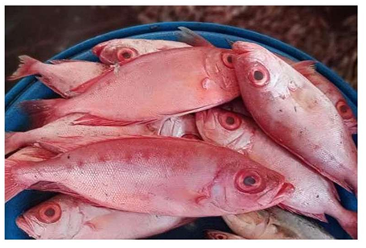

Fig. 1. Fresh specimens of Disco Rani fish used for liver and gill tissue collection.
DNA Estimation (Diphenylamine Method)

DNA estimation was carried out using the Diphenylamine reaction, in which deoxyribose is converted into a reactive aldehyde under acidic conditions, forming a blue-colored complex. Absorbance was measured at approximately 595 nm.

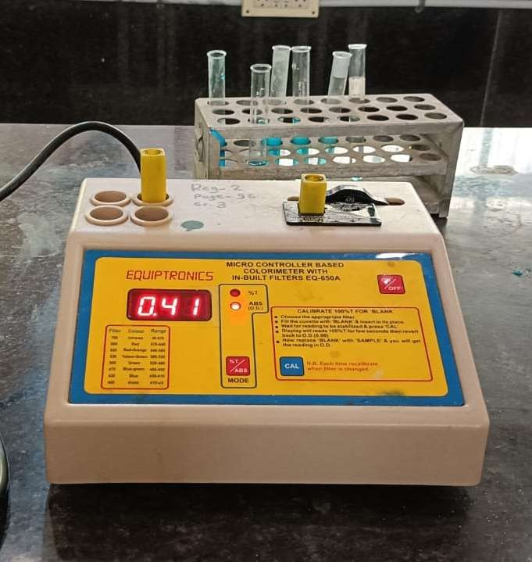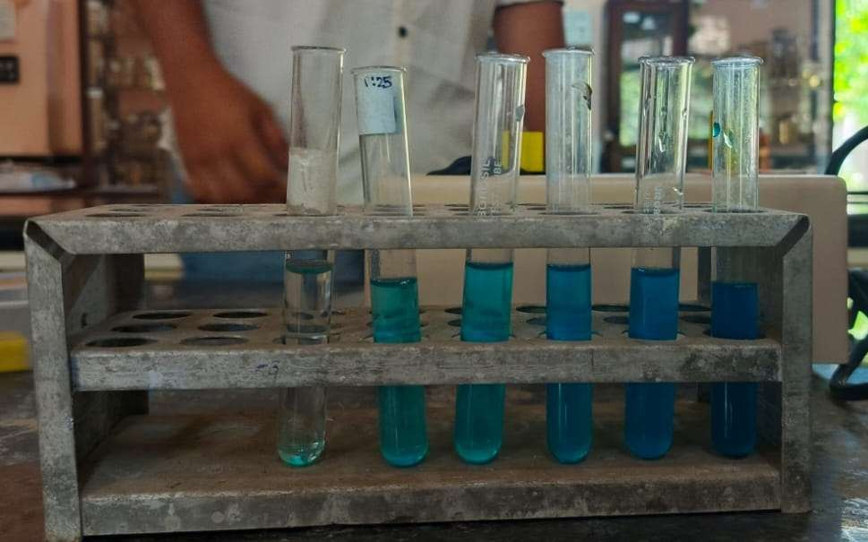

Fig 2. DNA estimation & Absorbance calculation

RNA Estimation (Orcinol Method)

RNA estimation was performed using the Orcinol method, where ribose forms furfural under acidic conditions, which reacts with Orcinol to produce a green-colored complex. Absorbance was recorded at 660-665 nm.

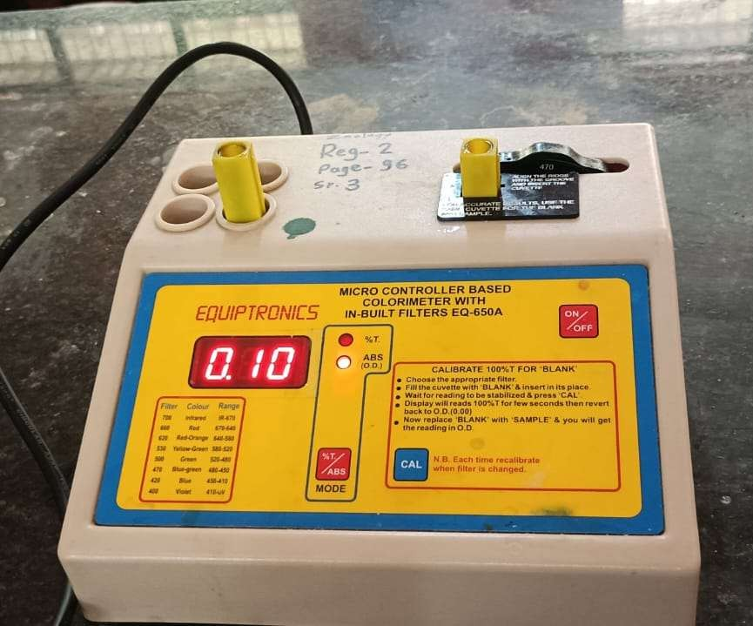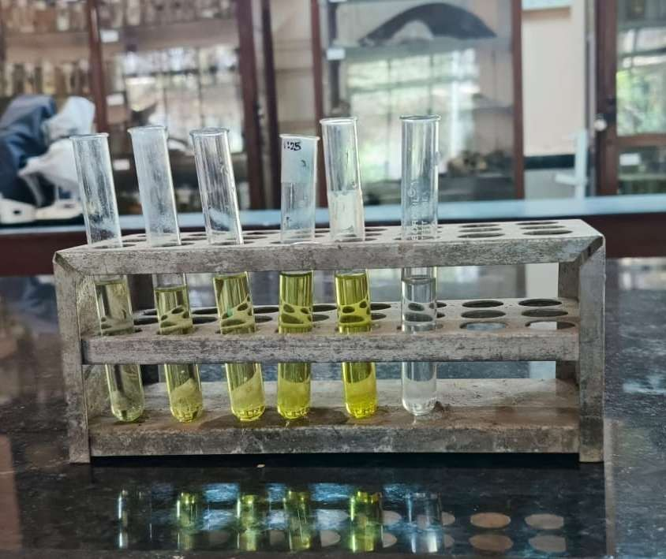

CALCULATION
Fig 3.RNA estimation & Absorbance calculation

Concentration was calculated using:

Concentration =
OD of Sample
OD of Standard

× Standard Concentration
RESULT AND DISCUSSION

A. Standard Curve Observation

The standard curve generated for DNA estimation using the Diphenylamine method exhibited a progressive increase in absorbance with increasing DNA standard concentrations, indicating a nearly linear relationship between DNA concentration and optical density. DNA standards showed a gradual increase in absorbance with increasing concentration, indicating a positive correlation and approximate adherence to the Beer-Lambert law. The increasing colour intensity observed with increasing DNA concentration further validates the reliability of the assay for estimating nucleic acid content in fish tissues (Burton, 1956; Wilson & Walker, 2010). (Burton, 1956; Wilson & Walker, 2010).
The observed increase in absorbance is consistent with the principle that the diphenylamine reaction produces a measurable colour complex with deoxyribose under acidic conditions, allowing DNA concentration to be estimated against a standard reference (Burton, 1956; Wilson & Walker, 2010).
Similarly, RNA estimation using the Orcinol method showed an overall increase in absorbance with increasing concentration of RNA standards. Although minor deviations from linearity were observed at intermediate concentrations, the overall trend remained sufficiently consistent for quantitative estimation. Some irregularities were observed, possibly due to slight experimental inaccuracies. (Almog & Shirey, 1978; Plummer, 1988).
For the RNA assay, small deviations from linearity should be interpreted cautiously because the orcinol reaction depends on controlled acid hydrolysis, reagent stability and consistent heating conditions; nevertheless, a monotonic overall trend supports its use for approximate comparative estimation (Almog & Shirey, 1978; Jayaram, 1981; Sawhney & Singh, 2000).
B. Graphical Representation

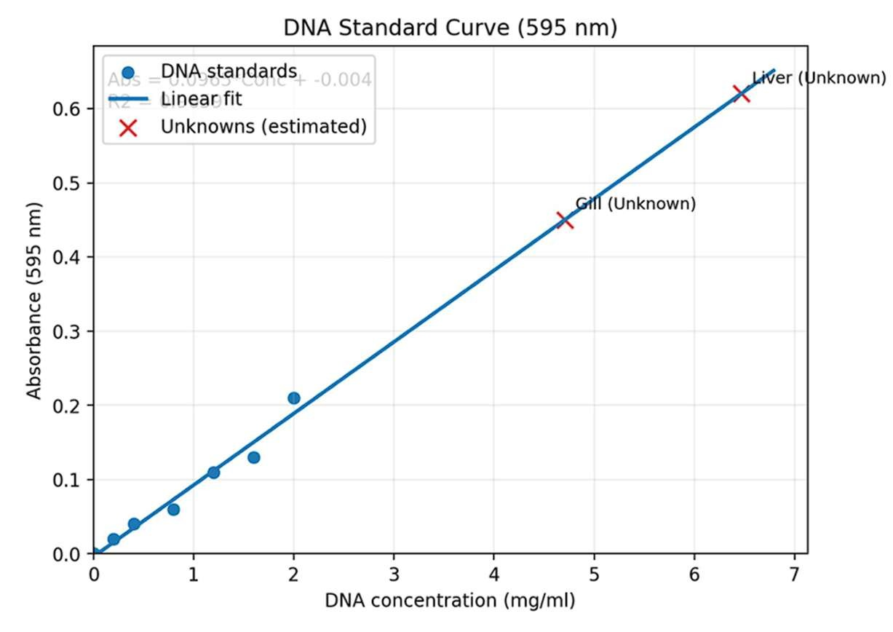

Fig. 4. DNA standard curve showing the relationship between DNA concentration and absorbance at 595 nm.
The absorbance values for DNA standards showed a gradual increase with increasing concentration (0.2–2.0 mg/ml), confirming a positive relationship between DNA concentration and colour intensity. (Burton, 1956; Wilson & Walker, 2010).
This graphical pattern supports the suitability of the prepared DNA standard series for estimating sample concentration, provided that readings are taken within the linear working range of the assay (Burton, 1956; Wilson & Walker, 2010).
• Lowest OD (0.02) at 0.2 mg/ml

• Highest OD (0.21) at 2.0 mg/ml
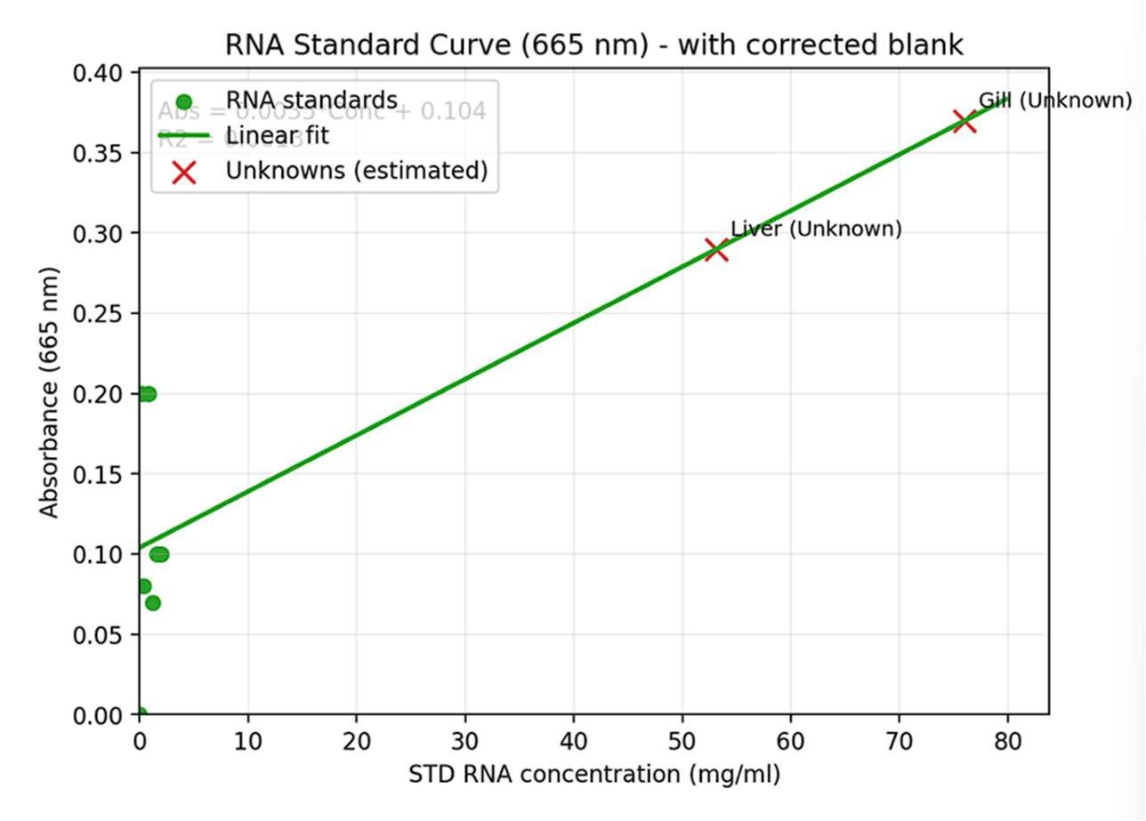
Fig. 5. RNA standard curve showing the relationship between RNA concentration and absorbance at 665 nm.
The RNA standards showed variation but an overall increasing trend in absorbance values. (Almog & Shirey, 1978; Wilson & Walker, 2010).
Because RNA colorimetric readings may be affected by handling and reaction conditions, the graph should be treated as a supportive calibration tool rather than as definitive evidence of exact RNA concentration (Almog & Shirey, 1978; Buckley et al., 1999).

• OD ranged from 0.00 (blank) to 0.10–0.20 range

• Some irregularity was observed (experimental error), but still usable for estimation

Table 1. Estimated Nucleic Acid Concentrations

Tissue | DNA (mg/ml) | RNA (mg/ml)
Liver | 5.90 | 5.80
Gills | 4.28 | 7.40
The higher DNA value recorded in liver and the higher RNA value recorded in gills indicate tissue-specific biochemical differentiation. In comparative fish studies, RNA/DNA indices are commonly interpreted as reflecting protein synthetic capacity because DNA is comparatively stable while RNA varies with growth and physiological condition (Buckley, 1984; Buckley et al., 1999; Foley et al., 2015).

D. RNA/DNA Ratio

The RNA/DNA ratio differed markedly between tissues. The liver exhibited a ratio of 0.98, indicating moderate metabolic activity. In contrast, gill tissue showed a higher ratio of 1.72, suggesting increased protein synthesis and functional activity associated with respiration and ion exchange. This reflects tissue-specific physiological roles in the fish. (Buckley, 1984; Buckley et al., 1999; Foley et al., 2015).
The higher gill RNA/DNA ratio should be interpreted as an index of greater apparent biosynthetic demand per unit DNA, but not as direct proof of specific gene up-regulation because the present colorimetric design did not measure individual transcripts (Buckley et al., 1999; Foley et al., 2015).

These observations collectively demonstrate that nucleic acid composition is tissue-dependent and reflects the specialised physiological functions of individual organs. The comparatively higher DNA concentration in the liver may indicate greater cellular density or increased genomic content associated with hepatocyte polyploidy. The elevated RNA concentration and RNA/DNA ratio in gills suggest enhanced biosynthetic activity required to support respiration, osmoregulation, ion transport, and continuous interaction with the external aquatic environment. (Evans et al., 2005; Filipiak et al., 2009; Zhang et al., 2019).
The liver result is biologically plausible because hepatocytes in vertebrates may show increased nuclear DNA content through polyploidy or binucleation, while fish hepatocyte nuclei have also been shown to differ in DNA content from erythrocyte nuclei in flow-cytometric studies (Filipiak et al., 2009; Zhang et al., 2019).
DISCUSSION

The present study reveals variation in nucleic acid content between liver and gill tissues of Disco Rani fish. The higher DNA concentration observed in liver tissue may be attributed to greater cellular density and the presence of metabolically active cells. Since DNA content per cell is relatively constant, the observed variation likely reflects differences in tissue structure and cell number. (Buckley et al., 1999; Foley et al., 2015).
This interpretation agrees with the broader use of nucleic acid indices in fish physiology, where RNA/DNA ratio is treated as a rapid biochemical indicator of growth condition and recent physiological status rather than a fixed species-level trait (Buckley, 1984; Buckley et al., 1999; Foley et al., 2015).

The comparatively higher DNA concentration observed in liver tissue is consistent with the central metabolic role of this organ. Fish liver serves as the primary site for carbohydrate, lipid and protein metabolism, detoxification of xenobiotics, storage of glycogen, synthesis of plasma proteins and regulation of numerous biochemical pathways. Hepatocytes are frequently polyploid and multinucleated, resulting in increased DNA content per unit tissue mass. Consequently, higher DNA concentrations in liver homogenates may reflect greater nuclear abundance rather than increased DNA content per individual cell. (Filipiak et al., 2009; Zhang et al., 2019; Donne et al., 2020).
Accordingly, the liver DNA value in the present study may reflect differences in nuclear density, hepatocyte ploidy, tissue architecture and extraction efficiency, and should not be interpreted as evidence that individual liver cells contain more DNA under all physiological circumstances (Filipiak et al., 2009; Donne et al., 2020).

The RNA estimation results indicate a higher RNA concentration in the gill tissue compared to the liver. RNA collectively regulates the translation of proteins required for cellular function. This suggests increased protein synthesis activity in gills, possibly related to their role in respiration, ion transport, and osmoregulation. These functions require continuous synthesis of membrane transport proteins, respiratory enzymes and structural proteins, thereby explaining the elevated RNA levels observed in the present study. Similar observations have been reported in studies where metabolically active tissues exhibit elevated RNA levels. (Evans et al., 2005; Buckley et al., 1999).
The elevated gill RNA value is consistent with the constant requirement for proteins involved in branchial ion transport, epithelial maintenance and metabolic regulation, which are central to the multifunctional role of the fish gill (Evans et al., 2005; Buckley et al., 1999).

The RNA/DNA ratio further supports this interpretation, with gills showing a higher ratio, indicating greater metabolic activity per cell. DNA content generally remains relatively constant because it represents the genomic complement of cells, whereas RNA content varies according to protein synthetic activity. However, it is important to consider that RNA estimation showed some irregularity in standard readings. This may be due to pipetting errors, reagent instability, or temperature variation during the reaction. (Buckley, 1984; Foley et al., 2015).
However, because only two tissues were compared and the study did not include biological replication, inferential statistics or molecular validation, the RNA/DNA ratio should be reported as a descriptive biochemical index rather than a definitive measure of metabolic rate (Buckley et al., 1999; Foley et al., 2015).

Overall, the observed tissue-specific variation in DNA, RNA and DNA/RNA ratio reflects functional specialisation of fish organs and demonstrates how nucleic acid composition can serve as a biochemical indicator of metabolic activity. These findings contribute to understanding the physiological adaptation of fish tissues and provide baseline information for future studies investigating environmental stress, nutrition, growth and aquatic toxicology. (Evans et al., 2005; Buckley et al., 1999; Foley et al., 2015).
Future work should include replicate fish, species-level taxonomic confirmation of “Disco Rani” fish, standard-curve regression statistics, and complementary protein or gene-expression assays to strengthen the physiological interpretation of tissue-specific nucleic acid variation.

Conclusion
The study demonstrated tissue-specific differences in DNA and RNA content between liver and gill tissues of Disco Rani fish. Liver tissue showed a higher estimated DNA concentration (5.90 mg/ml) than gill tissue (4.28 mg/ml), indicating comparatively greater DNA content in the liver sample analysed. In contrast, gill tissue showed a higher RNA concentration (7.40 mg/ml) than liver tissue (5.80 mg/ml). The RNA/DNA ratio was also higher in gills (1.72) than in liver (0.98), suggesting greater apparent RNA abundance relative to DNA in gill tissue. These findings indicate that nucleic acid content may vary among tissues according to their structural and physiological roles. The higher RNA/DNA ratio in gills may be associated with the functional demands of respiration, ion exchange, and tissue maintenance. However, the interpretation should remain descriptive because the study did not include biological replication, statistical testing, or molecular confirmation. Overall, the work provides preliminary comparative information on nucleic acid distribution in fish tissues using simple colorimetric techniques.

Limitations
The study has several limitations. The scientific identity of “Disco Rani fish” was not clearly stated, which limits taxonomic clarity and reproducibility. The number of fish, biological replicates, tissue weights, and detailed experimental conditions were not adequately described. Standard-curve regression values, replicate absorbance readings, standard deviation, and statistical analysis were not provided. The interpretation is therefore limited to descriptive comparison of liver and gill tissues. Further studies should include confirmed species identification, adequate replication, detailed methodology, statistical validation, and complementary biochemical or molecular assays.

Declaration of AI Use

This manuscript was prepared through the combined contributions of all author(s), including contributions to the study design, data, content development, results, interpretation, and related scholarly work. The author(s) acknowledge the use of Grammarly and ChatGPT to assist with grammar checking, language refinement, reference formatting. These AI-assisted tools were not used as authors and did not replace the intellectual contributions or scholarly judgment of the author(s). All AI-assisted outputs, including content, references, and interpretations, were carefully reviewed, revised, verified, and approved by the author(s). The author(s) accept full responsibility for the accuracy, integrity, and final content of the manuscript.

COMPETING INTERESTS DISCLAIMER:
Authors have declared that they have no known competing financial interests OR non-financial interests OR personal relationships that could have appeared to influence the work reported in this paper.

REFERENCES
Almog, R., & Shirey, T. L. (1978). A modified orcinol test for the specific determination of RNA. Analytical Biochemistry, 91(1), 130-137. https://doi.org/10.1016/0003-2697(78)90823-0
Berg, J. M., Tymoczko, J. L., & Stryer, L. (2015). Biochemistry (8th ed.). W. H. Freeman. https://www.macmillanlearning.com
Brown, T. A. (2016). Gene cloning and DNA analysis: An introduction (7th ed.). Wiley-Blackwell. https://www.wiley.com
Buckley, L. J. (1984). RNA-DNA ratio: An index of larval fish growth in the sea. Marine Biology, 80, 291-298. https://doi.org/10.1007/BF00392824
Buckley, L. J., Caldarone, E. M., & Ong, T.-L. (1999). RNA-DNA ratio and other nucleic acid-based indicators for growth and condition of marine fishes. Hydrobiologia, 401, 265-277. https://doi.org/10.1023/A:1003798613241
Burton, K. (1956). A study of the conditions and mechanism of the diphenylamine reaction for the colorimetric estimation of deoxyribonucleic acid. Biochemical Journal, 62(2), 315-323. https://doi.org/10.1042/bj0620315
Donne, R., Saroul-Ainama, M., Cordier, P., Celton-Morizur, S., & Desdouets, C. (2020). Polyploidy in liver development, homeostasis and disease. Nature Reviews Gastroenterology & Hepatology, 17, 391-405. https://doi.org/10.1038/s41575-020-0284-x
Elliott, W. H., & Elliott, D. C. (2005). Biochemistry and molecular biology. Oxford University Press. https://global.oup.com
Evans, D. H., Piermarini, P. M., & Choe, K. P. (2005). The multifunctional fish gill: Dominant site of gas exchange, osmoregulation, acid-base regulation, and excretion of nitrogenous waste. Physiological Reviews, 85(1), 97-177. https://doi.org/10.1152/physrev.00050.2003
Filipiak, M., Tylko, G., & Kilarski, W. (2009). DNA content of hepatocyte and erythrocyte nuclei of the spined loach (Cobitis taenia L.) and its polyploid forms. Fish Physiology and Biochemistry, 35, 523-529. https://doi.org/10.1007/s10695-009-9322-x
Foley, C. J., Bradley, D. L., & Hook, T. O. (2015). A review and assessment of the potential use of RNA:DNA ratios to assess the condition of entrained fish larvae. Ecological Indicators, 60, 346-357. https://doi.org/10.1016/j.ecolind.2015.07.005
Gupta, P. K. (2013). Genetics. Rastogi Publications. https://rastogipublications.com
Jayaram, J. (1981). Laboratory manual in biochemistry. New Age International Ltd. https://www.newagepublishers.com
Lodish, H., Berk, A., Kaiser, C. A., Krieger, M., Bretscher, A., Ploegh, H., Amon, A., & Martin, K. C. (2016). Molecular cell biology (8th ed.). W. H. Freeman. https://www.macmillanlearning.com
Nelson, D. L., & Cox, M. M. (2017). Lehninger principles of biochemistry (7th ed.). W. H. Freeman. https://www.macmillanlearning.com
Plummer, D. T. (1988). An introduction to practical biochemistry (3rd ed.). Tata McGraw-Hill Publishing Co. https://www.mheducation.co.in
Sambrook, J., & Russell, D. W. (2001). Molecular cloning: A laboratory manual (3rd ed.). Cold Spring Harbor Laboratory Press. https://www.cshlpress.com
Sawhney, S. K., & Singh, R. (2000). Introductory practical biochemistry. Narosa Publishing House. https://www.narosapublishing.com
Voet, D., & Voet, J. G. (2011). Biochemistry (4th ed.). Wiley. https://www.wiley.com
Wilson, K., & Walker, J. (2010). Principles and techniques of biochemistry and molecular biology (7th ed.). Cambridge University Press. https://www.cambridge.org
Zhang, S., Lin, Y.-H., Tarlow, B., & Zhu, H. (2019). The origins and functions of hepatic polyploidy. Cell Cycle, 18(12), 1302-1315. https://doi.org/10.1080/15384101.2019.1618123

